Department of Health Logo


**Indigenous Australians’ Health Programme Primary Health Care Funding Model Technical Factsheet**

**Location and Need: How to find the correct multiplier**

**Purpose**

This Factsheet provides step-by-step instructions on how to find the location and need multipliers for a clinic. It should be read in conjunction with other Funding Model Technical Factsheets.

## Overview

The cost of delivering Primary Health Care varies widely across Australia. The location of clinics and the health care needs of clients strongly affect the cost of service delivery.

The Funding Model uses the location of service delivery (based on the Remoteness Structure component of the Australian Bureau of Statistics’ Australian Statistical Geography Standard, ASGS) and an estimate of the health care needs of clients (based on the Indigenous Relative Socioeconomic Outcomes index, IRSEO, and a measure of Years of Potential Life Lost, YPLL) to adjust the amount of funding each service is calculated to receive.

Adjustment is calculated using ‘multipliers’ which express the relative differences between locations and health care need groups, as shown in Table 1.

Table 1. Multipliers (location and need)

|  | 5  (least need) | 4 | 3 | 2 | 1  (most need) |
| --- | --- | --- | --- | --- | --- |
| Major Cities of Australia | 1.00 | 1.18 | 1.77 | 2.52 | 3.22 |
| Inner Regional Australia | 1.11 | 1.30 | 1.96 | 2.78 | 3.56 |
| Outer Regional Australia | 1.26 | 1.48 | 2.23 | 3.17 | 4.06 |
| Remote Australia | 1.73 | 2.03 | 3.05 | 4.34 | 5.55 |
| Very Remote Australia | 1.75 | 2.05 | 3.09 | 4.38 | 5.61 |

## Step one – Finding the location multiplier

The Australian Bureau of Statistics’ (ABS) website includes an interactive map displaying all elements of the Australian Statistical Geography Standard (ASGS). The map is available at the following link:

[ABS Maps](https://itt.abs.gov.au/itt/r.jsp?ABSMaps)

Begin by locating the target address on this map. For this example, the address is:

Tennant Creek Hospital  
 45 Schmidt St,   
 Tennant Creek, NT, 0860

Click on the ‘Geocoder Search’ button, as shown in Figure 1, and enter the address. As you type, the autofill function will find and return similar addresses. Choose the correct address from the list, as shown in Figure 2. The location will be displayed (Figure 3).

Figure 1. Entering an address into ABS maps

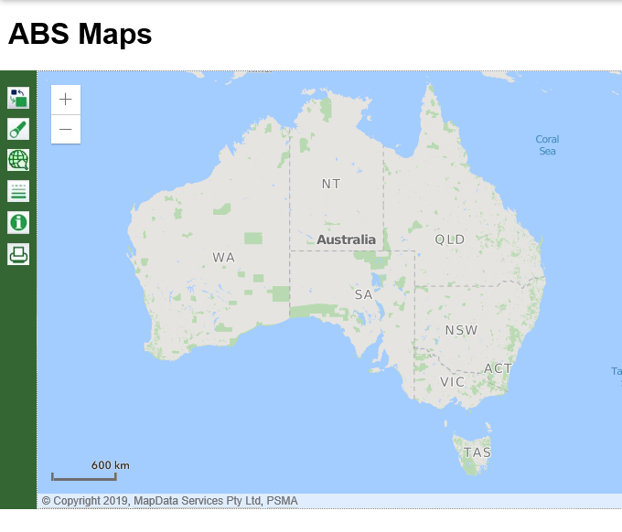

Click here to enter the address

Figure 2. Address autofill function

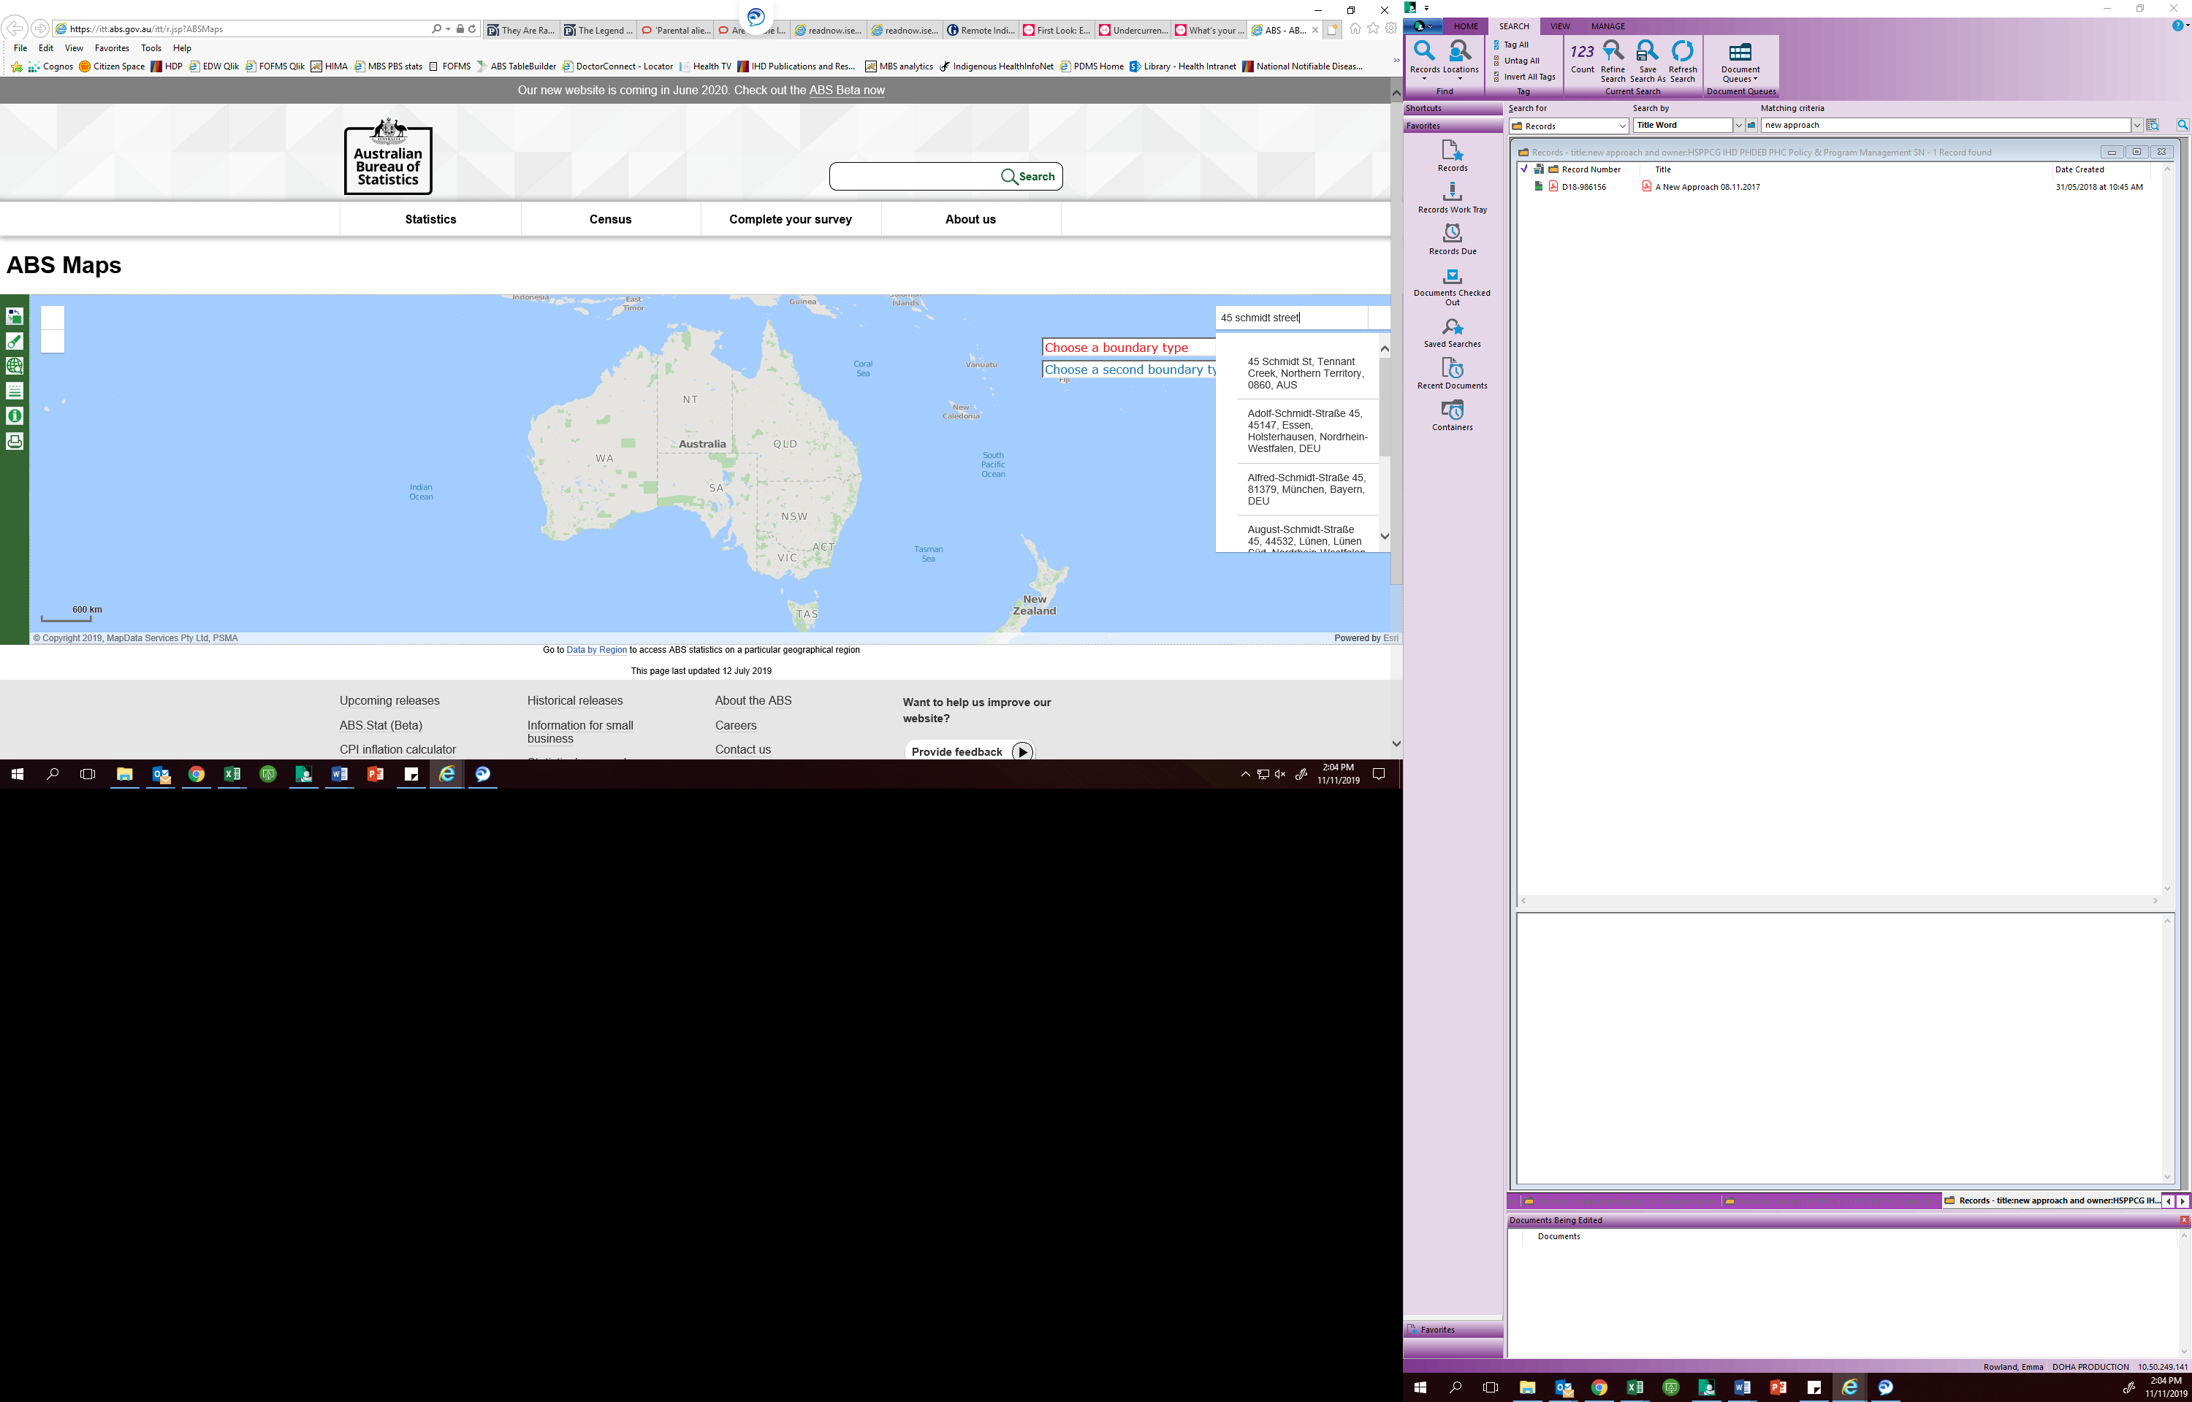

Figure 3. Address located

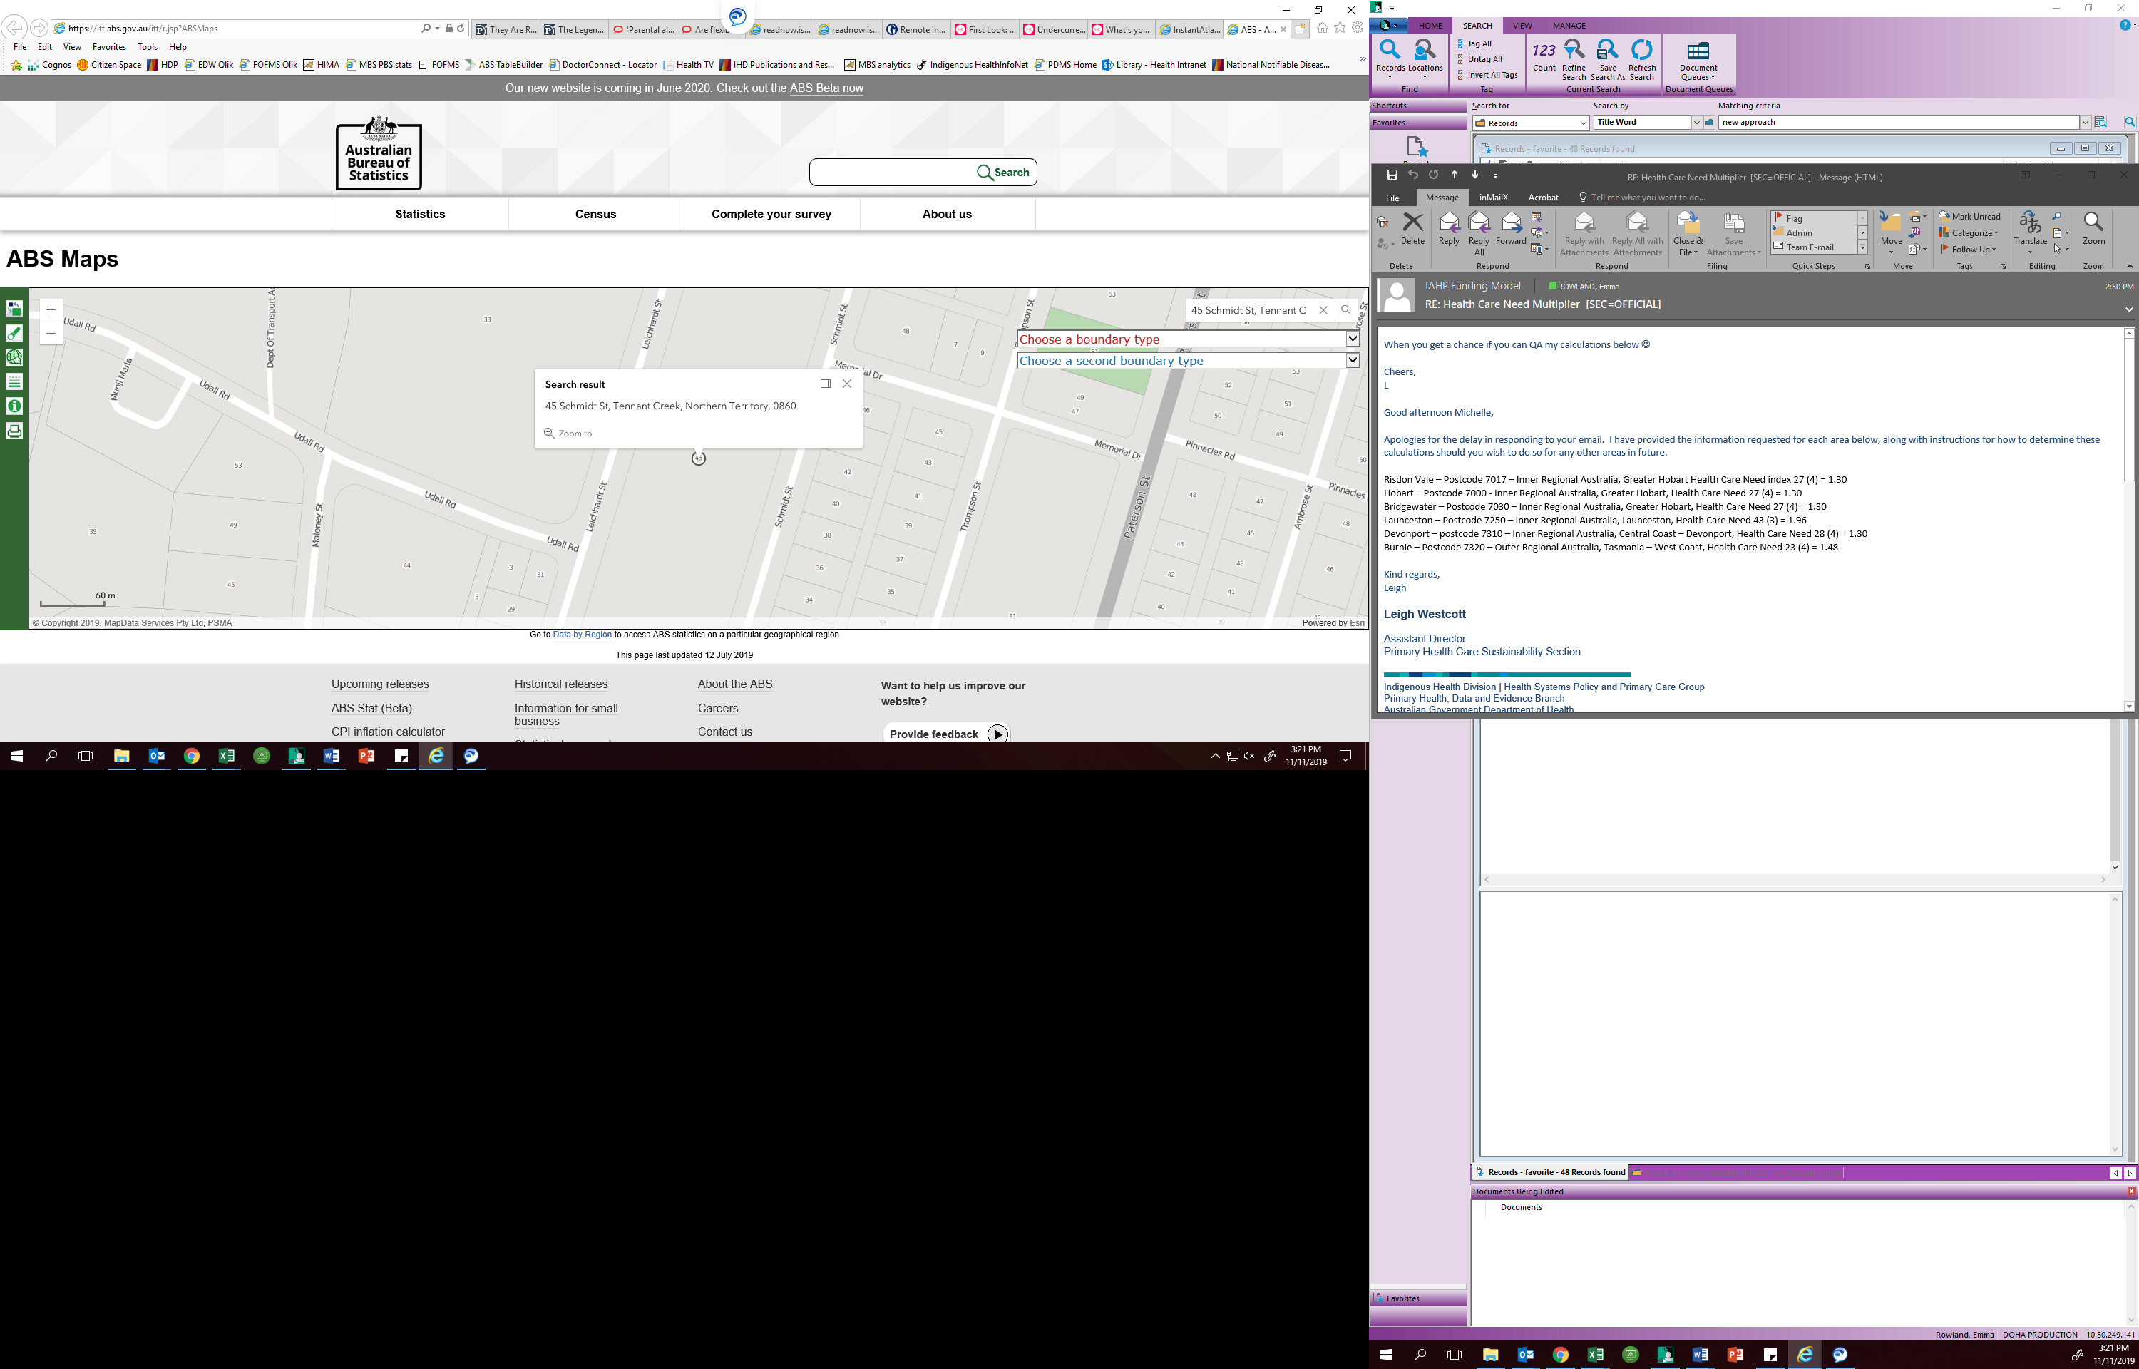

Next, click on ‘Choose a boundary type’ and select 2016 Remoteness Area (RA), as shown in Figure 4. It is important that the 2016 version of the geographic boundaries is chosen.

Figure 4. Select boundary type ‘2016 Remoteness Area (RA)’

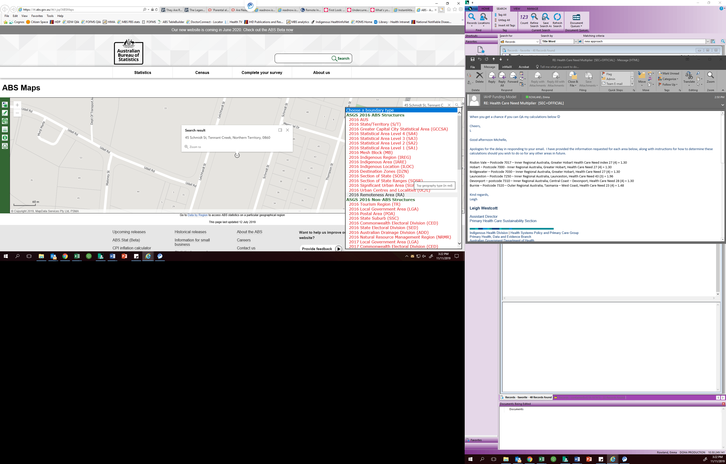

Click on the map close to the address chosen. This will bring up a box with the Remoteness Area category for this address, as shown in Figure 5. The address “45 Schmidt St, Tennant Creek” is located in Very Remote Australia.

Translating this into the table of location and need multipliers shows that the relevant figure will appear on the bottom line of

Table 2.

Figure 5. Remoteness Area classification

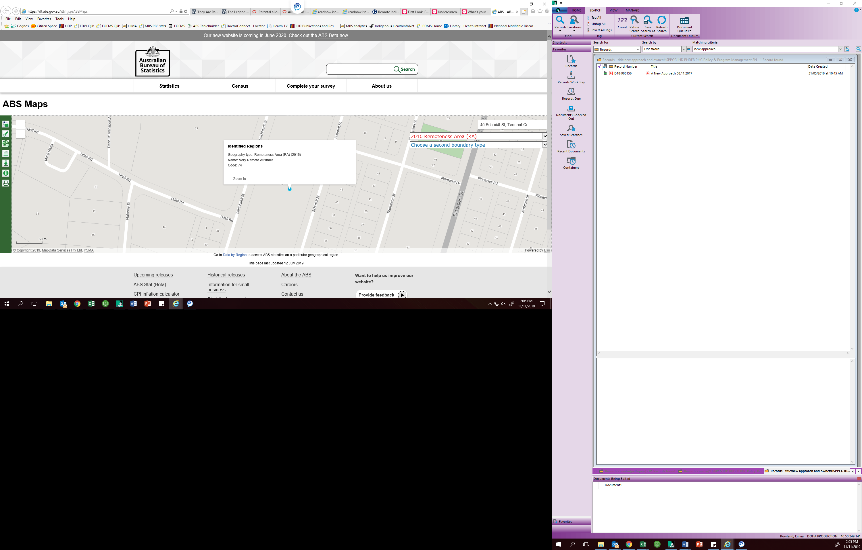

Table 2. Location and need multipliers, Very Remote Australia highlighted

|  | 5  (least need) | 4 | 3 | 2 | 1  (most need) |
| --- | --- | --- | --- | --- | --- |
| Major Cities of Australia | 1.00 | 1.18 | 1.77 | 2.52 | 3.22 |
| Inner Regional Australia | 1.11 | 1.30 | 1.96 | 2.78 | 3.56 |
| Outer Regional Australia | 1.26 | 1.48 | 2.23 | 3.17 | 4.06 |
| Remote Australia | 1.73 | 2.03 | 3.05 | 4.34 | 5.55 |
| Very Remote Australia | 1.75 | 2.05 | 3.09 | 4.38 | 5.61 |

## Step two – Finding the need multiplier

Returning to the ABS map, select ‘Choose a second boundary type’ and select ‘2016 Indigenous Area (IARE)’, as shown in Figure 6.

Figure 6. Select boundary type ‘2016 Indigenous Area (IARE)’

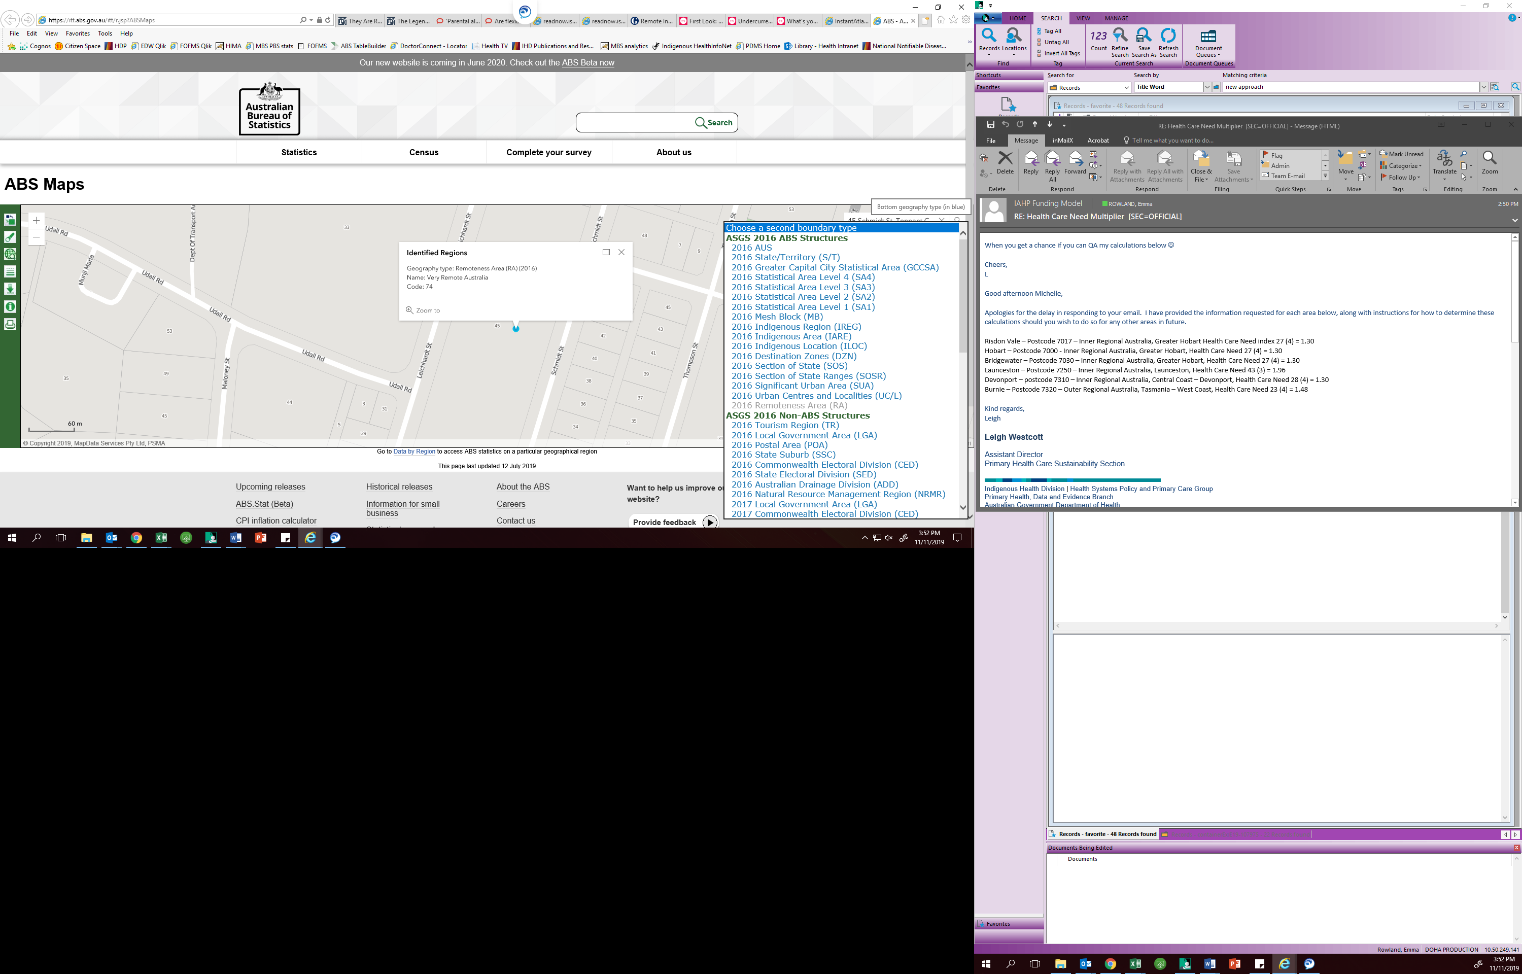

Again, click on a location on the map close to the original address. A dialogue box will show both the Remoteness Area and Indigenous Area classifications, as shown in Figure 7. In this case, the target address is located in the Tennant Creek Town Indigenous Area.

Figure 7. Indigenous Area classification

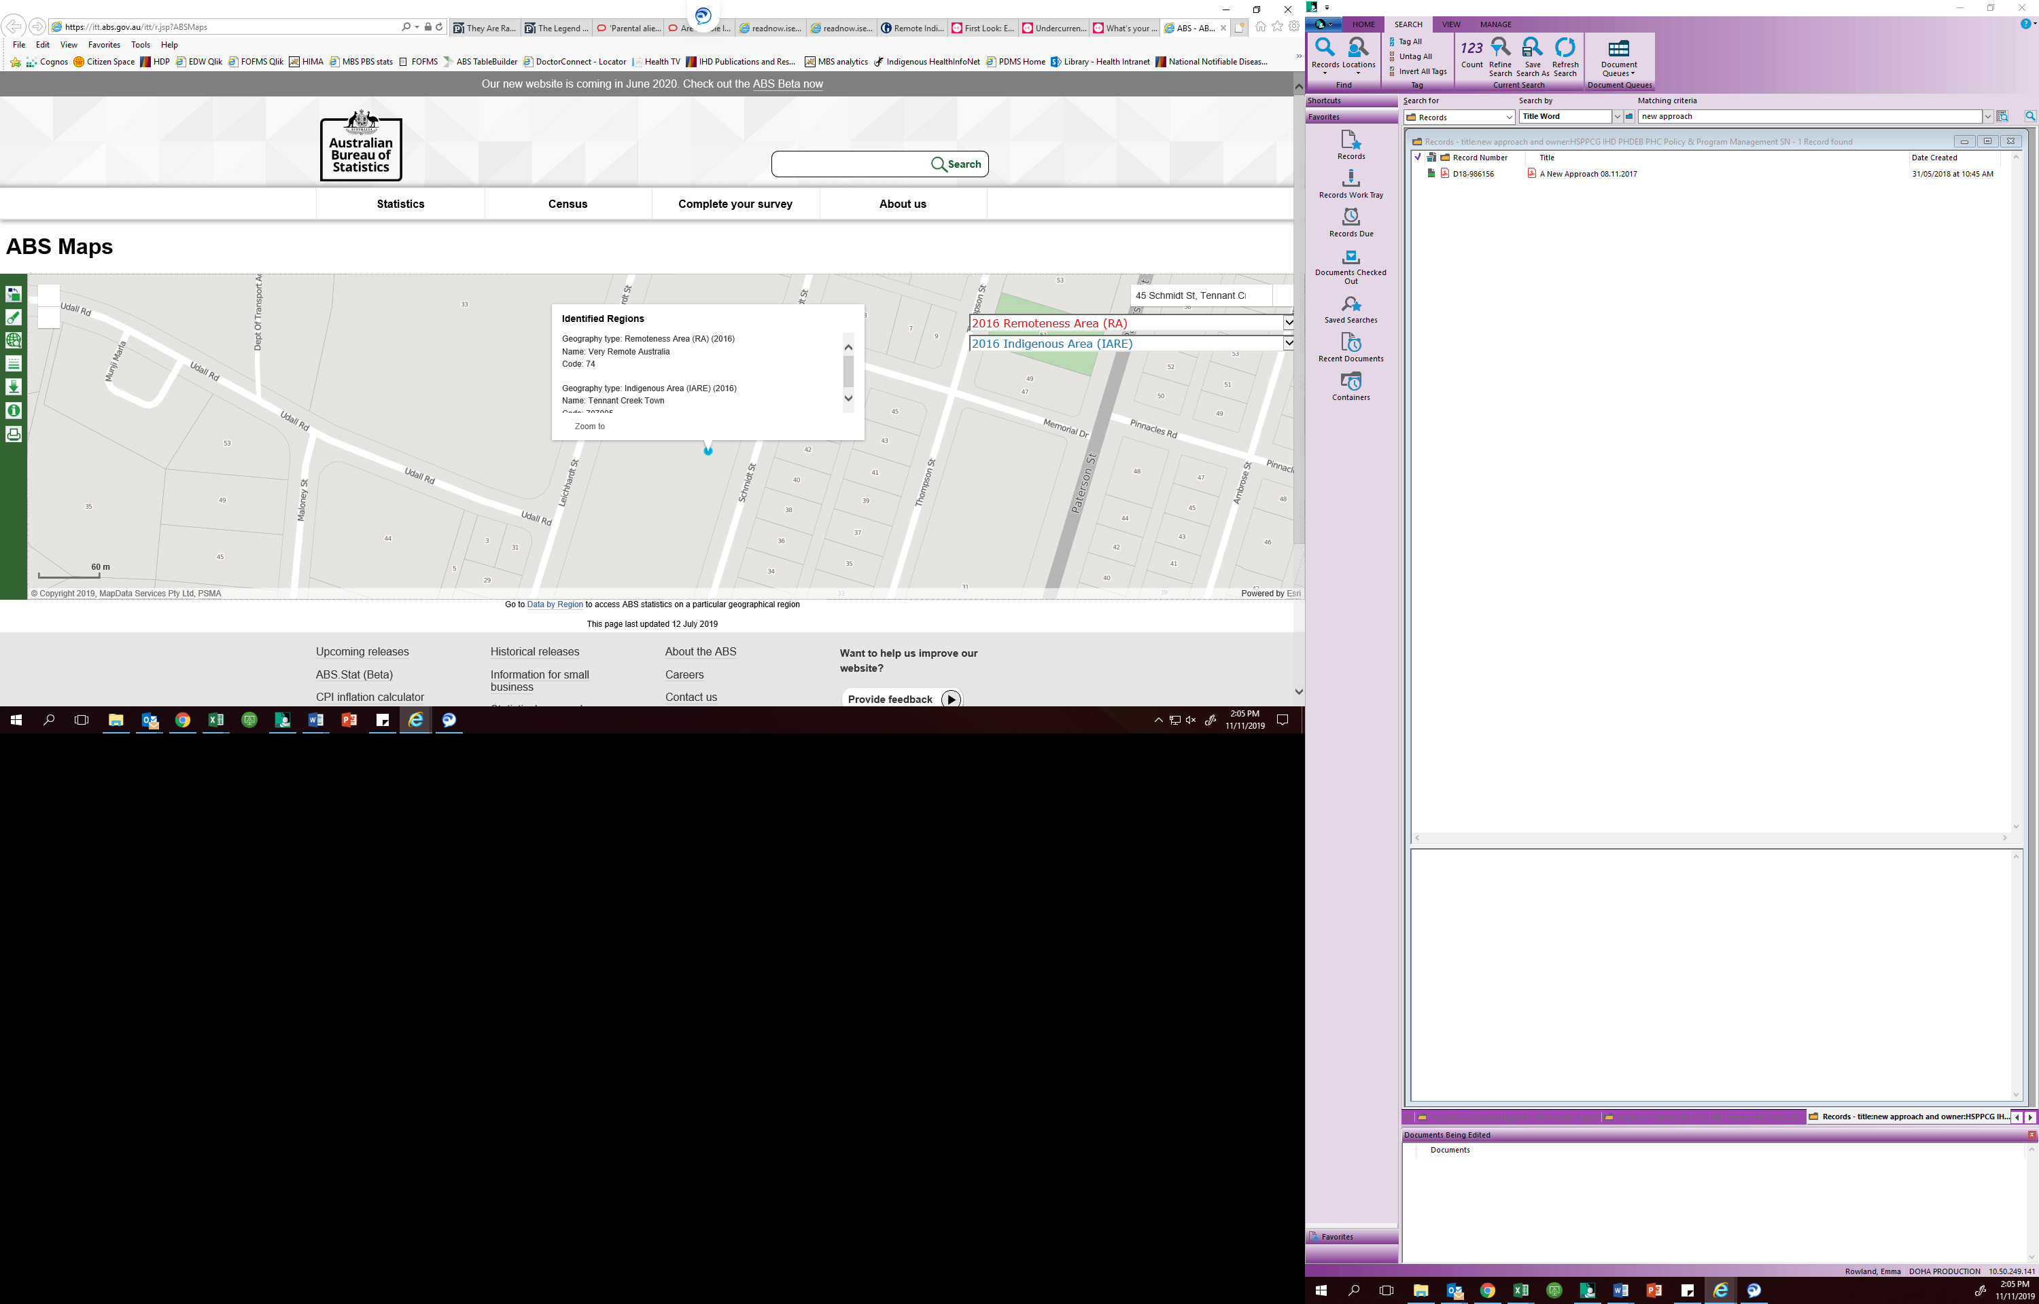

In order to determine the health care need group for this location, open the Aboriginal and Torres Strait Islander Atlas, produced by the Public Health Information Development Unit (PHIDU) at Torrens University. The Atlas is available at the following link:

[Aboriginal and Torres Strait Islander Atlas](http://phidu.torrens.edu.au/current/maps/atsi-sha/single-map/atlas.html)

The Atlas contains a large number of data indicators for the Aboriginal and Torres Strait Islander population covering health topics and some of the social determinants of health such as education and housing. In order to determine the correct health need multiplier for the Funding Model, locate data on the Indigenous Relative Socioeconomic Outcomes (IRSEO) index.

Choose ‘Filter to an area’, ‘State/Territory’ and the relevant state or territory, as shown in Figure 8.

Figure 8. Filter to an area – Northern Territory

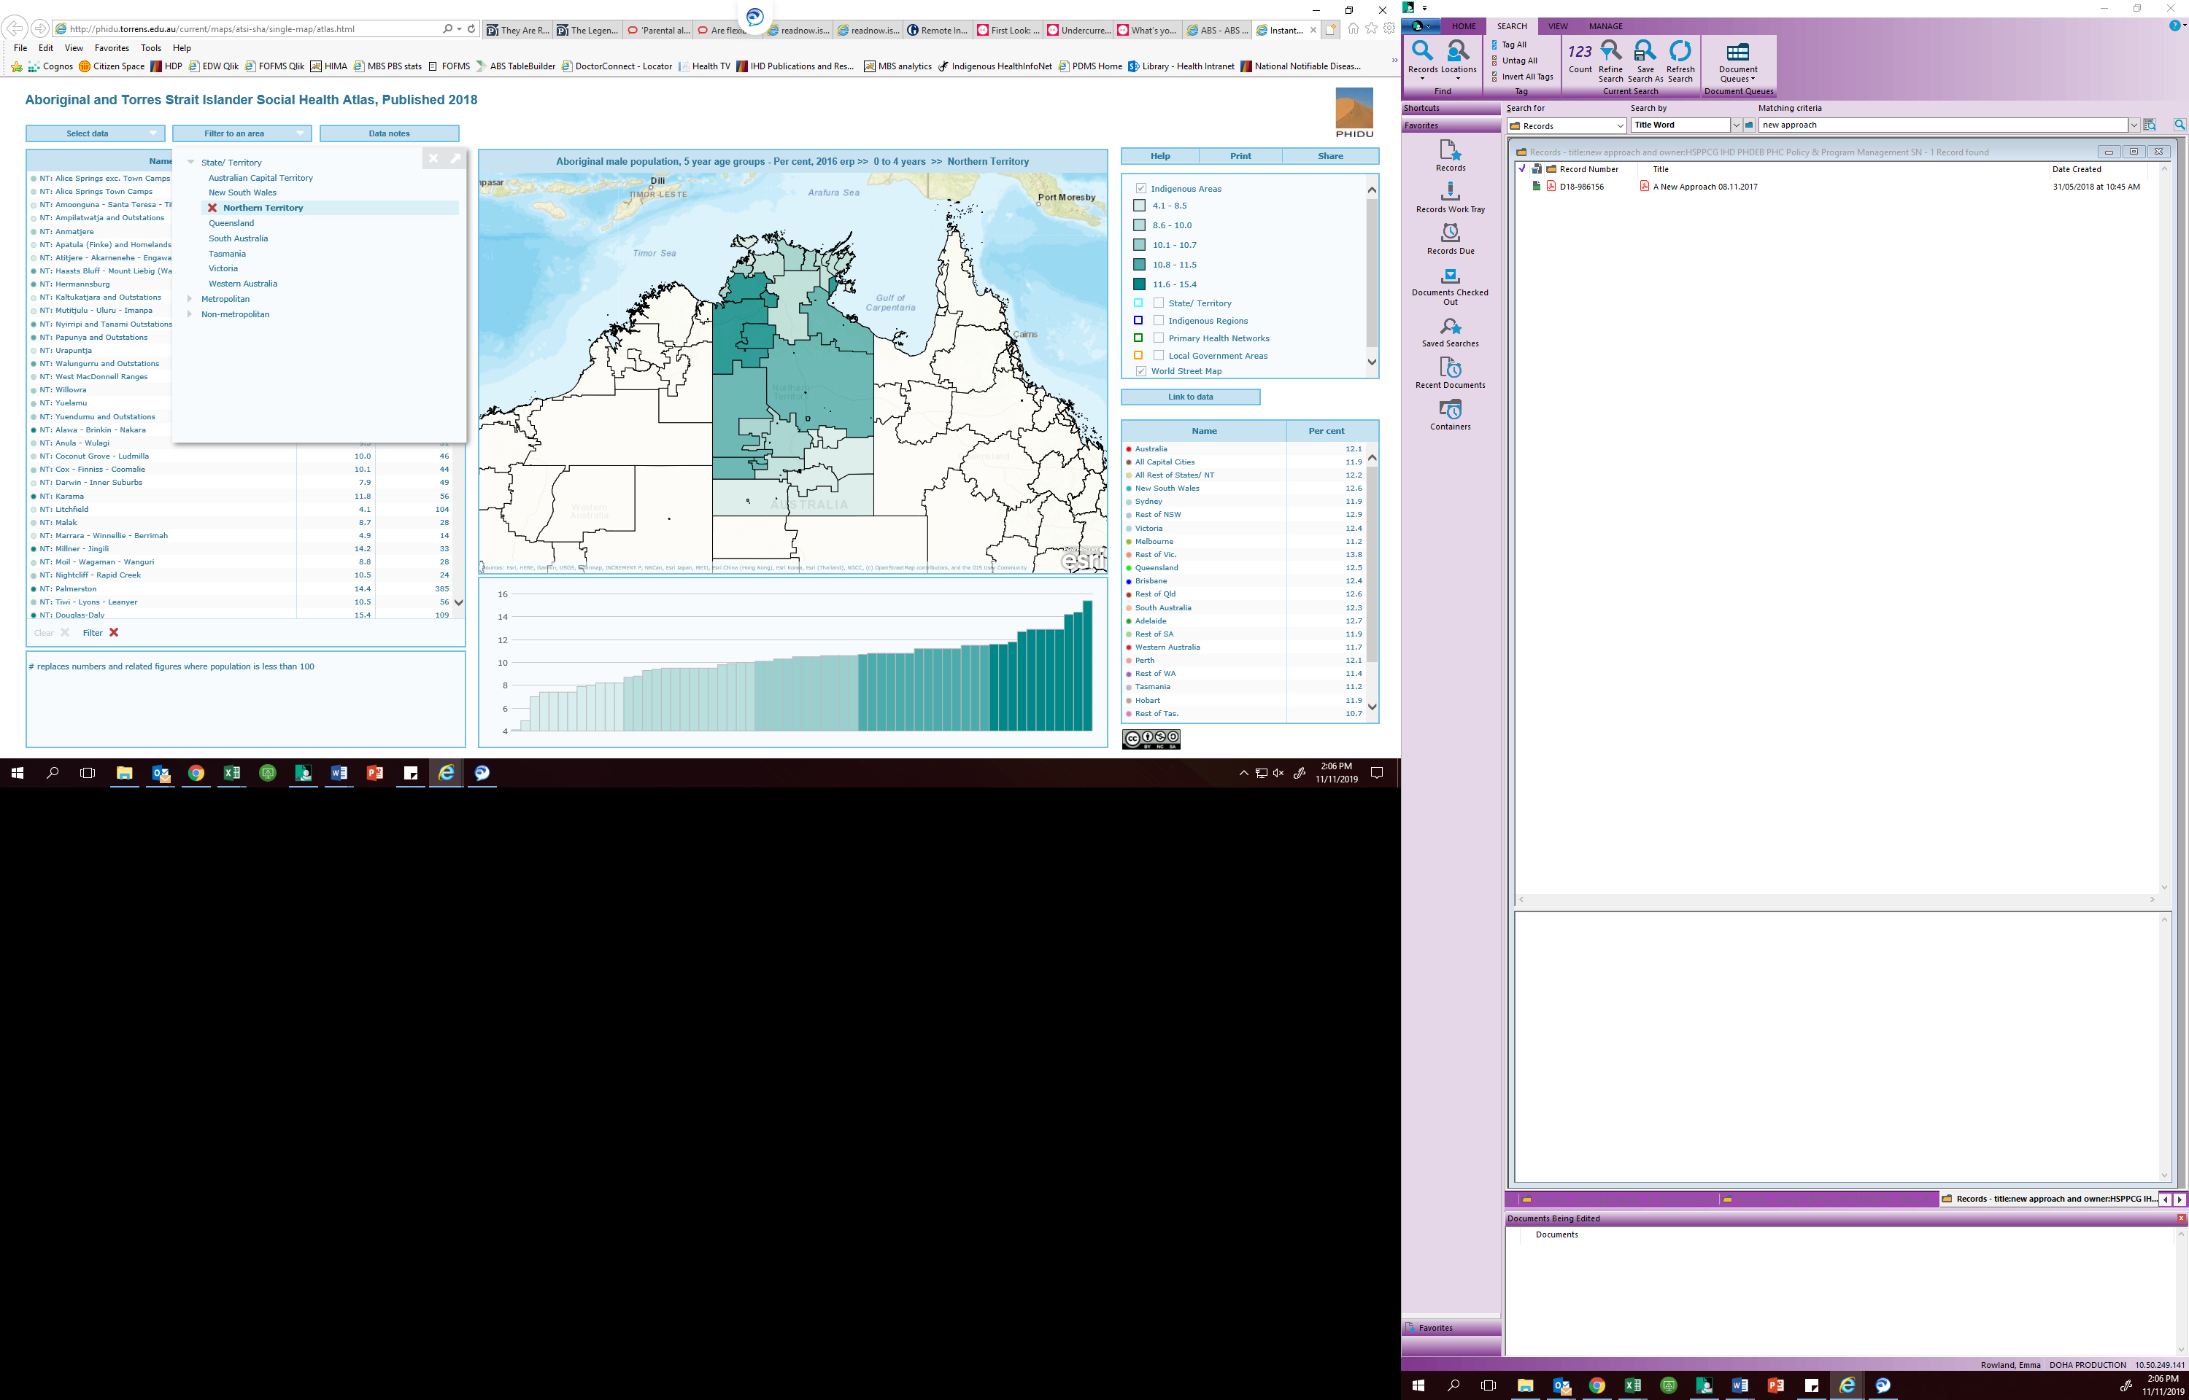

Choose ‘Select data’ and select ‘Summary measures of Indigenous outcomes, 2016’. Choose the item under this heading, ‘Indigenous Relative Socioeconomic Outcomes Index’, as shown in Figure 9.

Figure 9. Select data – IRSEO 2016

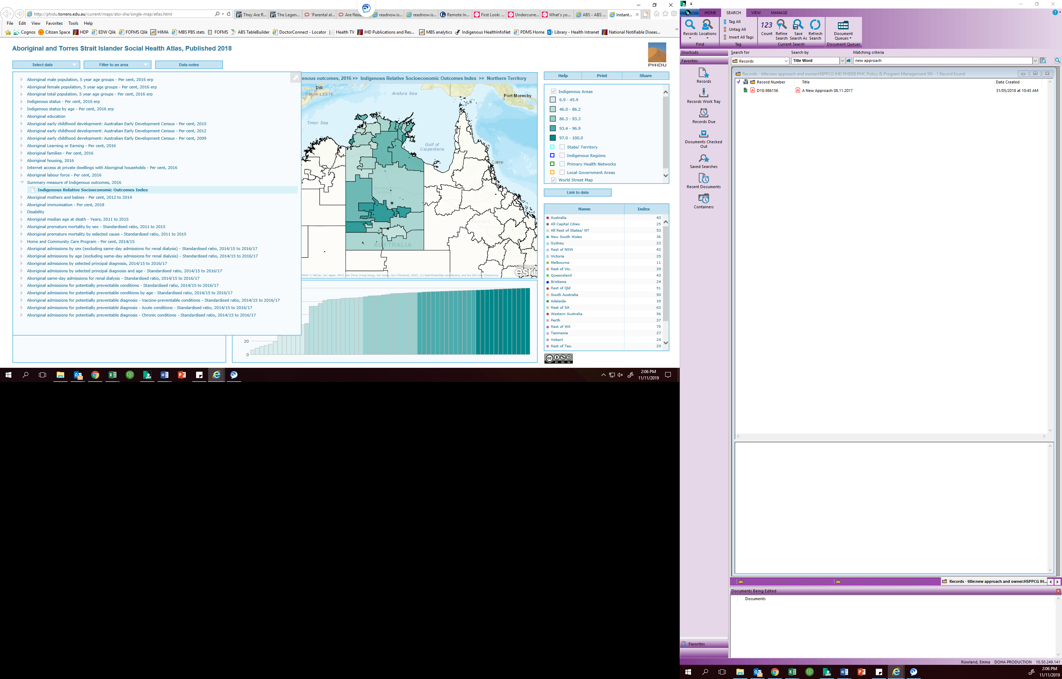

Locate the correct Indigenous Area in the list – in this case, Tennant Creek Town. As shown in Figure 10, the index figure for this location is 85.

Figure 10. Select the Indigenous Area – Tennant Creek Town

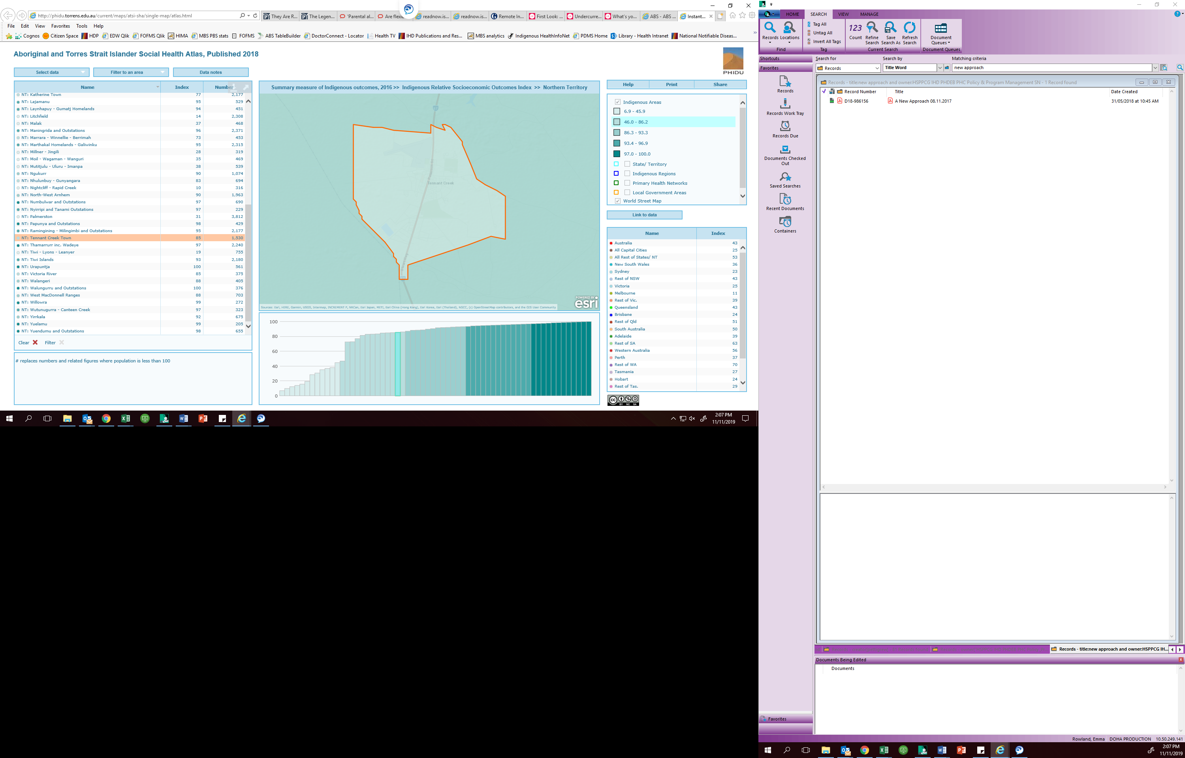

For the Funding Model, index numbers are categorised into one of five groups, as shown in Table 3. This shows that an index of 85 is in category 1, most relative health care need.

Table 3. IRSEO index numbers and groups

|  | Index numbers |
| --- | --- |
| 5  (least need) | 0 – 20 |
| 4 | 21 – 40 |
| 3 | 41 – 60 |
| 2 | 61 – 80 |
| 1  (most need) | 81 - 100 |

Using this information, the correct multiplier will be found in the far right column of Table 4.

Table 4. Location and need multipliers, most need highlighted

|  | 5  (least need) | 4 | 3 | 2 | 1  (most need) |
| --- | --- | --- | --- | --- | --- |
| Major Cities of Australia | 1.00 | 1.18 | 1.77 | 2.52 | 3.22 |
| Inner Regional Australia | 1.11 | 1.30 | 1.96 | 2.78 | 3.56 |
| Outer Regional Australia | 1.26 | 1.48 | 2.23 | 3.17 | 4.06 |
| Remote Australia | 1.73 | 2.03 | 3.05 | 4.34 | 5.55 |
| Very Remote Australia | 1.75 | 2.05 | 3.09 | 4.38 | 5.61 |

## Step three – Finding the location and need multiplier

With the information from the ABS and PHIDU maps, we now know that 45 Schmidt Street, Tennant Creek is located in Very Remote Australia and is in category 1 of the IRSEO. The correct multiplier for services in this location is 5.61, as shown in Table 5.

Table 5. Location and need multipliers, Very Remote and most need highlighted

|  | 5  (least need) | 4 | 3 | 2 | 1  (most need) |
| --- | --- | --- | --- | --- | --- |
| Major Cities of Australia | 1.00 | 1.18 | 1.77 | 2.52 | 3.22 |
| Inner Regional Australia | 1.11 | 1.30 | 1.96 | 2.78 | 3.56 |
| Outer Regional Australia | 1.26 | 1.48 | 2.23 | 3.17 | 4.06 |
| Remote Australia | 1.73 | 2.03 | 3.05 | 4.34 | 5.55 |
| Very Remote Australia | 1.75 | 2.05 | 3.09 | 4.38 | 5.61 |

For more information on multipliers, please see the **Funding Model Technical Factsheet – Location** the **Funding Model Technical Factsheet – Health care need**.

**Who do I contact for more information?**

For further information about the IAHP Funding Model, please email [IAHPFundingModel@health.gov.au](mailto:xx@health.gov.au).