

**Guide to the OSR Online Form (2018-19) in the Health Data Portal**

# Section 1- Organisation Profile

## Physical Location

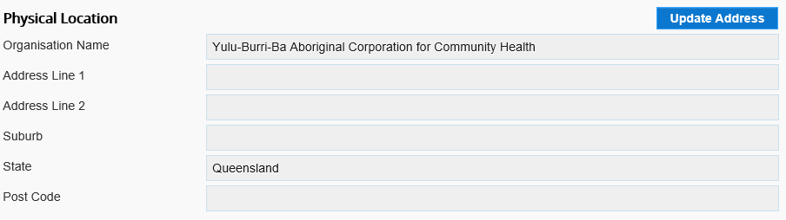

**PURPOSE:** The information displayed here is populated from your organisation record in the Health Data Portal, and ensures that the Department of Health and the AIHW have up-to-date location information for all organisations. The information is also used to assign remoteness categories to health services. If the location information is incorrect, you can ask for it to be updated.

## Accreditation

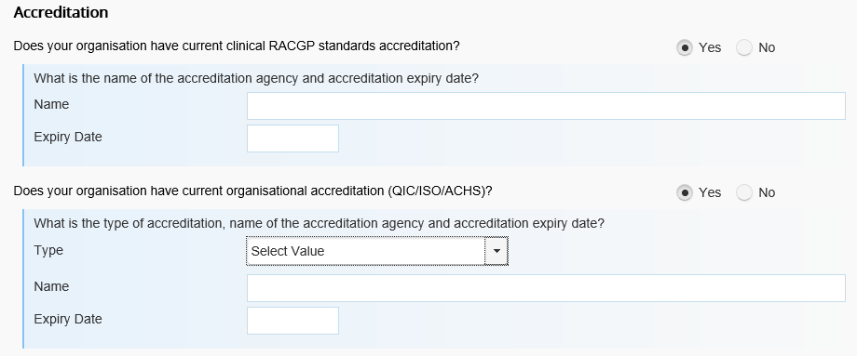

**PURPOSE:** The information collected may be used for the following purpose:

* To inform national reporting to demonstrate the proportion of services that have achieved appropriate accreditation. The embedding of Continuous Quality Improvement (CQI) processes and the achievement of appropriate formal quality accreditation are recognised as key comprehensive primary health care activities

## Reporting picture of the Reporting section of the Organisation Profile screen. This section is used by services to nominate a contact for their OSR reporting

**PURPOSE:** In this section you nominate the best contact person for your health service for OSR reporting. The dropdown list shows all the registered Portal users for the organisation. The AIHW and the Department of Health may use this information to contact this person regarding your OSR data if needed.

Governance Model



**PURPOSE:** The information displayed here is populated from your organisation’s profile in the Health Data Portal. If the governance model information is incorrect, you can ask for it to be updated.

**DEFINITION**: Aboriginal Community Controlled Health Organisation

* Aboriginal Community Controlled Health Organisations are primary health care services operated by local Aboriginal and Torres Strait Islander communities through an elected board of management to deliver comprehensive and culturally appropriate health care to communities.

Smoke Free Workplace

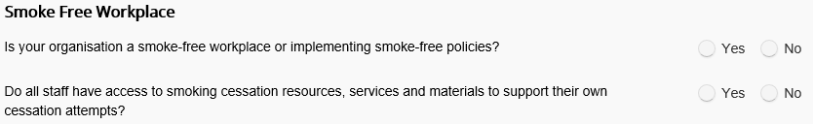

**PURPOSE:** The Smoke Free Workplace section asks you to provide information regarding the “smoke free” status of your organisation

# Section 2- Clinical Services Activity Profile

Clinical Services are those services delivered to individual clients and/or families, in both clinic and home/community settings, including treatment, prevention and early detection, rehabilitation and recovery, and clinical support systems.

**PURPOSE**: This section provides a basic measure of activity and volume of services delivered. These questions have been used in the OSR for many years and can provide a long term time series. The data collected can provide measures of effort and service load by provider type and for transport.

Good clinical practice requires that a service's medical records be reviewed regularly and records of deceased clients, clients who have migrated from the area, and any other clients who have become 'inactive' should be archived.

For all questions requiring quantitative data on client counts or activity, include clients who died, or who have migrated out of the area or whose records are archived at the reporting date, but who had recorded contact with the organisation during the reporting period.

Episodes of Care

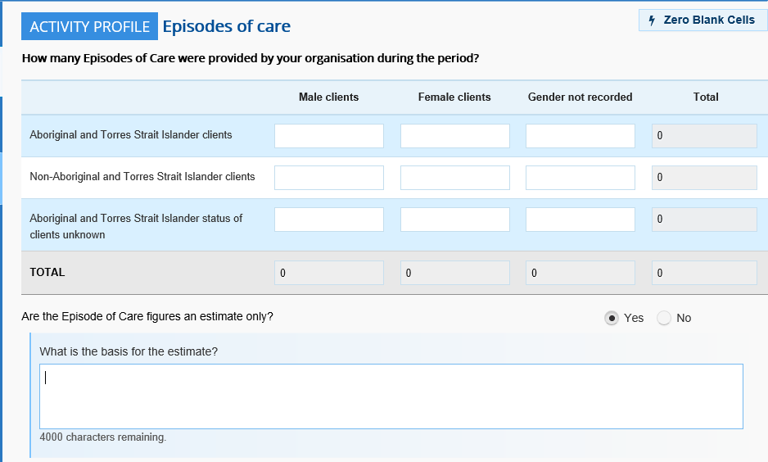

**DEFINITIONS:** An episode of care is a contact between an individual client and service, with one or more staff, to provide health care (e.g. for sickness, injury, counselling, health education, screening) within one calendar day. All contacts on the one day are treated holistically as one episode of care.

For example:

* If a patient came to the service and is seen by an Aboriginal Health Worker (AHW) and nurse this counts as one episode of care.
* If a person has a wound treated one day and then has the dressing changed the following day, this counts as two episodes of care.

**Include:**

* Health care provided through all sources of funding (e.g. IHD, State government etc.);
* Health care provided through the health service where the staff are volunteers or funded by another organisation;
* Outreach (care delivered at outstation visits, park clinics, satellite clinics etc.);
* Care delivered over the phone which results in an update to the patient's individual record;
* Transport only if it also involves direct provision of health care/information by your staff;
* Care delivered to visitors or transients;
* Telephone-clinical contact with clients that is of a clinical nature;
* Hospital contact with clients when they are in hospital;
* Other clinical consultation in ‘other’ location (such as tents/car/under a tree, etc).

**Do not include:**

* Residential care
* Groups (e.g. antenatal classes, men's groups, support groups)
* Administration contacts with clients (e.g. receptionist making a booking, arranging transport to a hospital clinic)
* For family / relationship counselling, only include clients who have their own record or file, even if seen as a couple or family group.
* If the gender of the patients has not been recorded indicate this number in the “Not Recorded” column provided.
* **Transport**. Example: If a man is driven to the health service to take part in a diabetes support group and then driven to the local hospital for a specialist output clinic appointment, this is not recorded as an episode of care. This should be recorded as two transport contacts in the Client Contacts section
* **Estimation:** If accurate data are not available for the full year, please estimate based on a representative part of the year. For example, if figures can be derived for three months, then multiply these counts by four to get estimates for the year. Organisations are asked to indicate the basis for any estimates used.

Client Contacts

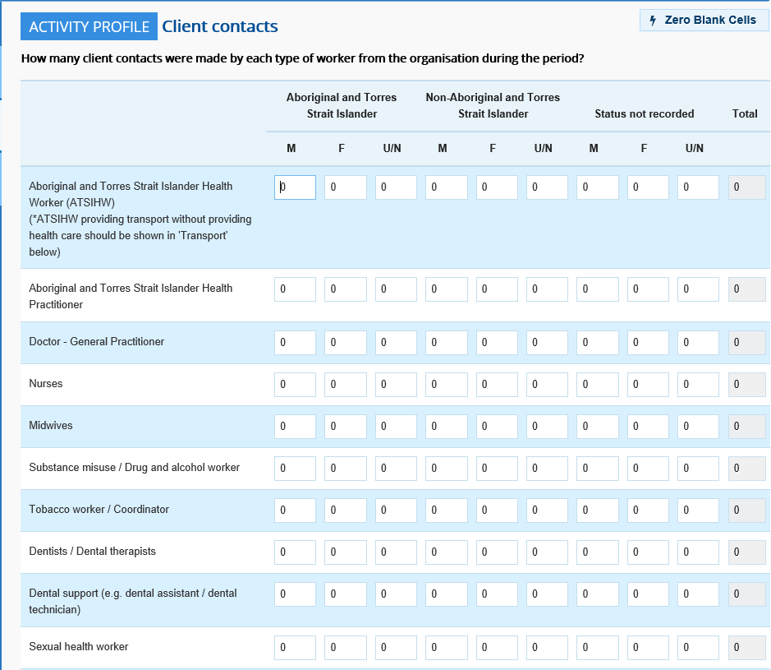

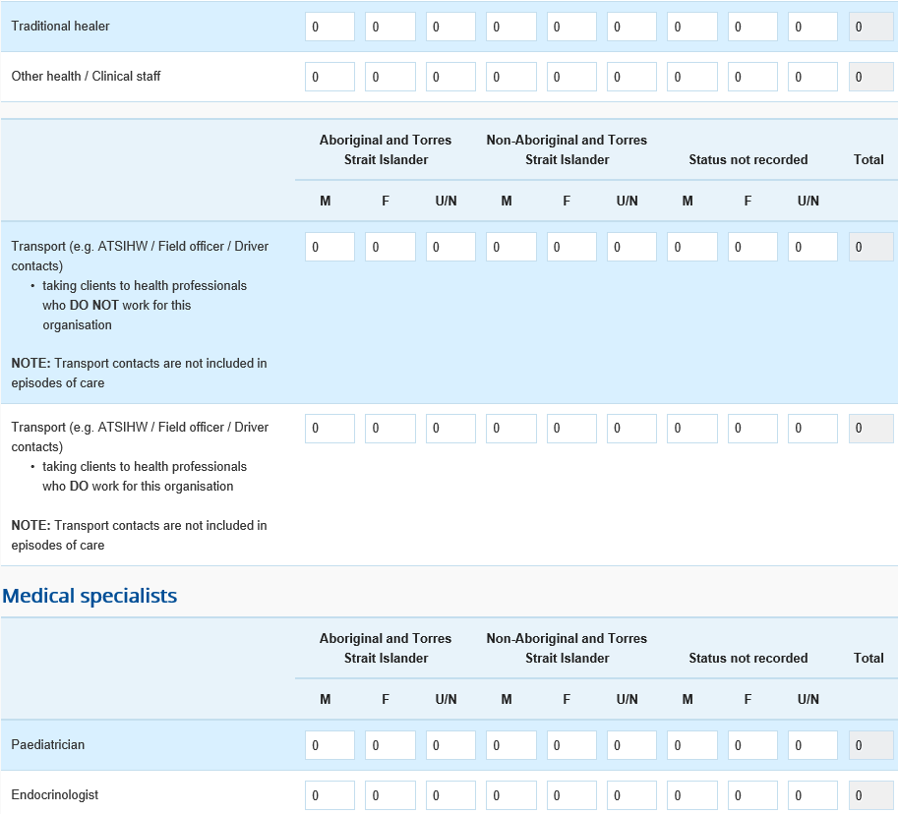

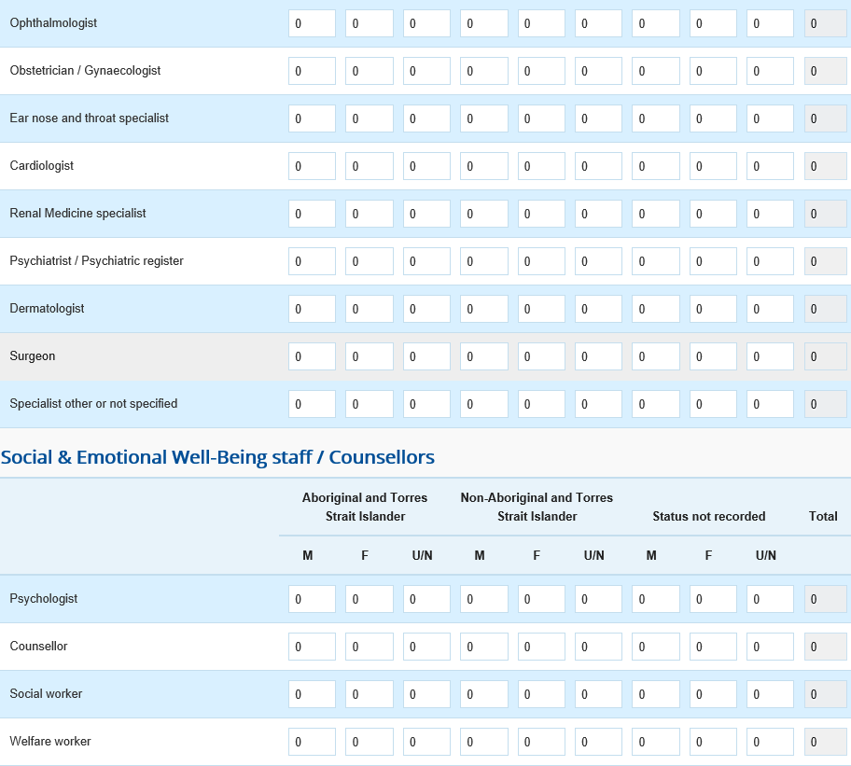

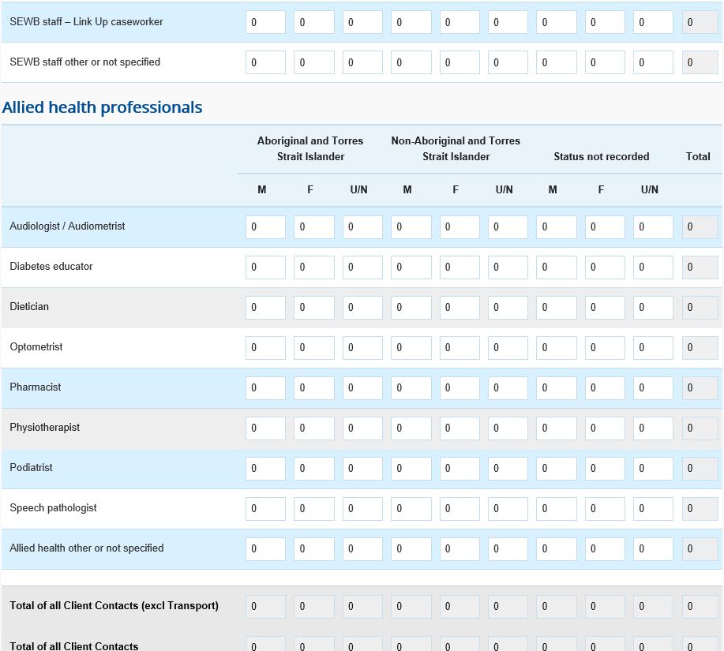

**DEFINITION: The** count of the number of client contacts with health workers from your organisation during the period 1 July 2018 to 30 June 2019.

**Include:**

* Contacts with staff and visiting health professionals whether or not paid by your service;
* All contacts involving transport;
* Ensure all staff listed in Client contacts are also recorded in questions relating to Workforce (see Workforce section)

**Do not include:**

* Those contacts solely part of a group or health promotional activity;
* Residential care;
* Administrative contacts (e.g. the receptionist making an appointment for a client).

Where an Aboriginal Health Worker (AHW) provides health care and transport as part of the one contact, record this as an AHW contact.

**U/N:** Unknown

Client Numbers

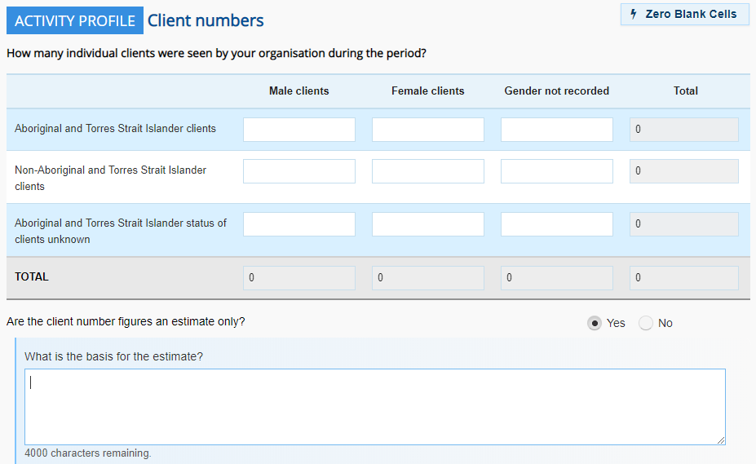

**DEFINITION:** The count of how many individual clients received health care from staff or visiting health professionals at your organisation during the period 1 July 2018 to 30 June 2019. Count each client once only, no matter how many times they attended.

**Include:**

* Visitors and transients

**Do not include:**

* A client if they only attended groups and did not receive any individual care during the year;
* A client if they were transported but did not receive any individual care during the year.
* For family groups, only count people who have their own file / record.
* Estimate numbers if accurate figures are not available

# Section 3- Workforce Profile

**PURPOSE:** Data captured with the workforce questions serves the following purposes:

* It provides a picture of the numbers of staff falling into various professional categories which may be used for longer term workforce planning.
* It provides data on the number of FTE by staff function which may help identify gaps in service capability by geographic area.
* It provides data on unfilled positions and staff turnover which in turn may provide information on the key issues faced by services.

### Calculating FTE:

Full-time equivalent (FTE) is the ratio of the total number of paid hours during a period (part time, full time, contracted) by the number of working hours in that period Mondays through Fridays. The ratio units are FTE units or equivalent employees working full-time. In other words, one FTE is equivalent to one employee working full-time.

For convenience, the Health Data Portal OSR form includes an FTE calculator.

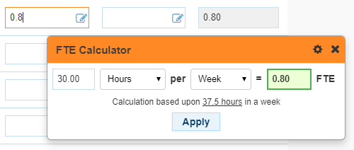

The calculator can be configured to suit your health service’s standard working hours.

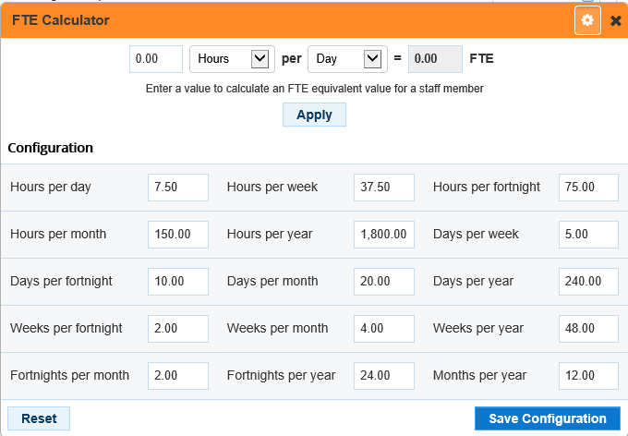

***For how many full-time equivalent (FTE) positions did your organisation pay the wages/ salaries/ fees as at 30 June 2019?***

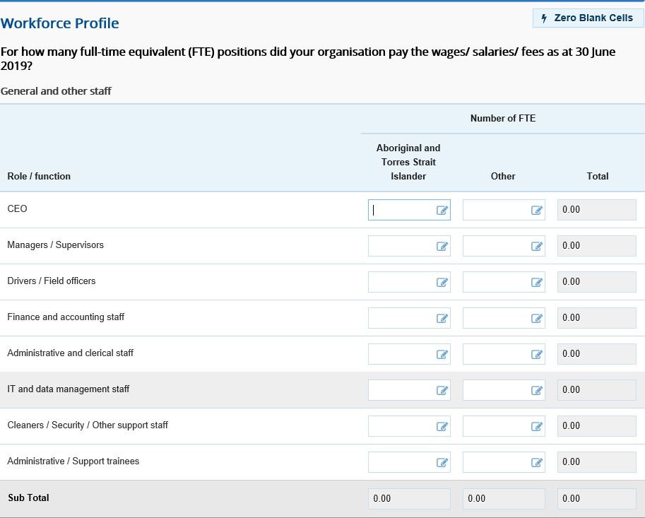

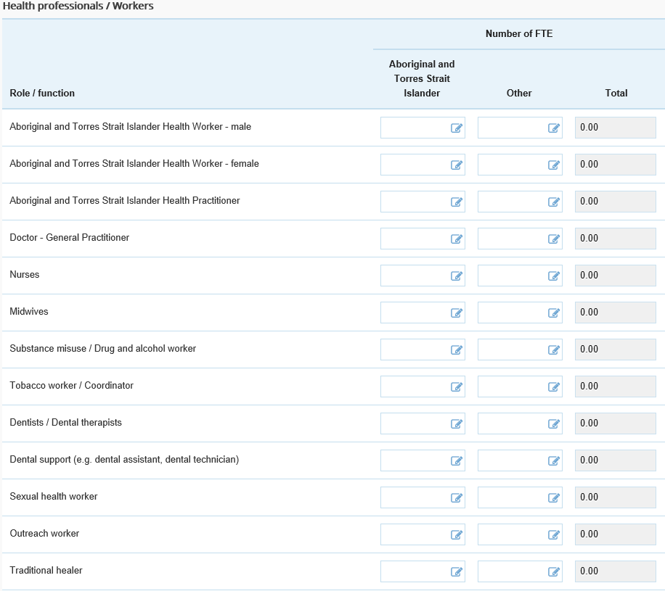

**Include:**

* Health and related administrative positions where your organisation pays the wages/salary/fees through all sources of funding (e.g. Medicare, Department of Health, State/ Territory Government)
* Short term and recurrent positions
* Contract workers paid by your service

**Do not include:**

* Visiting health professionals where payments are not made by your health service. These are reported separately below
* Staff located at your service who are part of other programs (e.g. housing, employment, HACC, child care)

Ensure that all staff recorded in this question that have contact with individual clients have their client contacts recorded in the Clinical Services Activity Profile section, using the same staff categories.

Records the number of occupied full time equivalent (FTE) position, by their role, paid for by your health service as at 30 June 2019. Visiting health professionals where payments are not made by your organisation and vacant positions are each reported separately below.

***How many other people (FTE) worked at your organisation who were not paid by your organisation during the year ending 30 June 2019?***

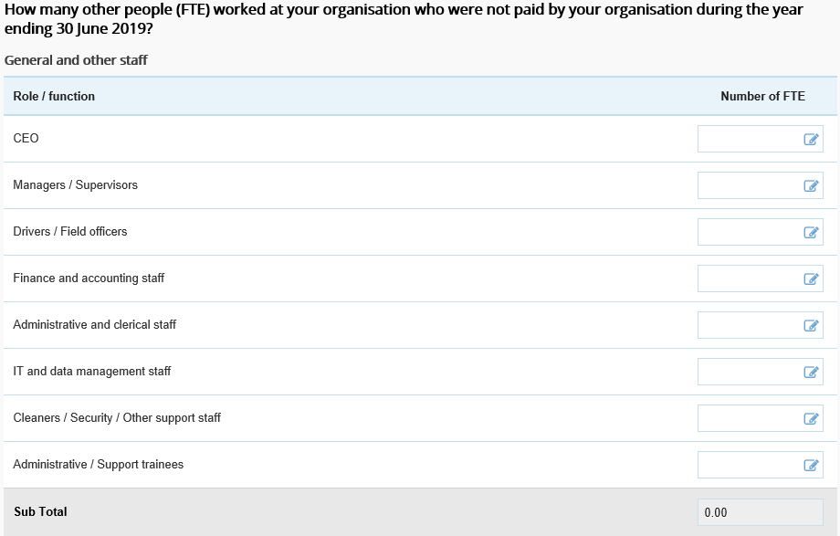

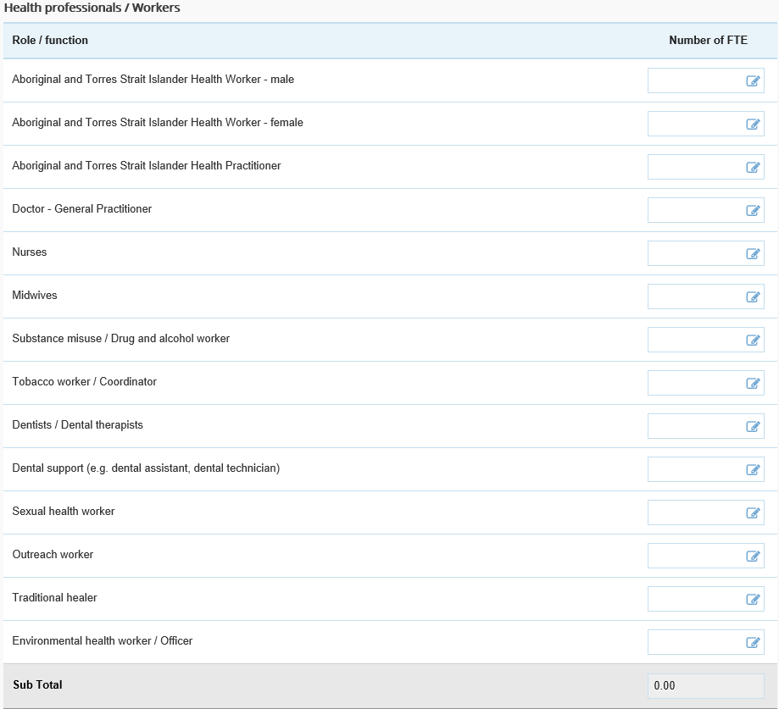

Please ensure all staff listed here who see individual clients have their contacts recorded in the Clinical Services Activity Profile section. If the corresponding contact data has not been electronically extracted from your system then you will need to manually enter the data.

Record here staff who have provided health/clinical services for your organisation and who have NOT been paid directly or indirectly by your organisation. This may include such cases as specialists funded through a visiting specialist scheme or dentists from a university dental school.

**Include:**

* Visiting health professionals where payments are not made by your health service.

**Do not include:**

* Health and related administrative positions where your health service pays the wages/salary/fees through all sources of funding (e.g. Medicare, Department of Health, State/ Territory Government)- these are reported separately above

***Does your organisation have any vacant staff positions as at 30 June 2019?***

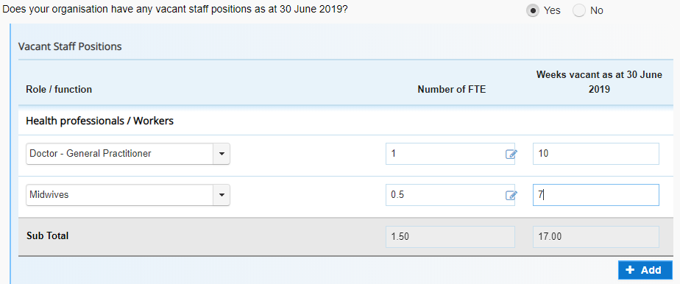

**PURPOSE:** Record in this question funded positions that were vacant as at 30 June 2019 and were not filled by another person. For each vacant position, record the FTE equivalent and for how many weeks the position has been vacant. The intent of this question is to record positions vacant that could have an impact on your capacity to deliver clinical services. It is not necessary to record vacant minor clerical and support positions.

# Section 4- Data Sharing Consent

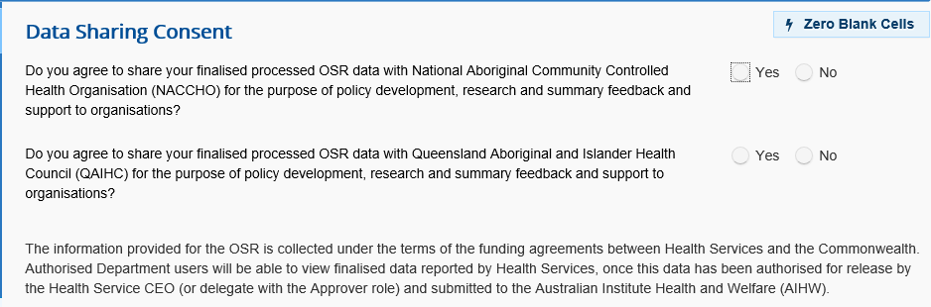

**PURPOSE:** The Data Sharing Consent screen contains two important data sharing questions. The responses will determine whether or not your health service’s finalised data can be shared with NACCHO and/or the relevant Sector Support Affiliate organisation (note that the example shown in the screen shot is for a Queensland-based organisation).