

SURGE Critical Care   
Specialised Upskilling and RN Growth through Education in Critical Care

Evaluation Report

November 2020



**Disclaimer**

This Report was prepared by Medcast Pty Ltd. Medcast and its subsidiary, Critical Care Education Services, were engaged by The Australian Government Department of Health, Health Workforce Reform Branch.

The Report is solely for the use of the Department and is not intended to and should not be used or relied upon by anyone else. Medcast does not accept any duty of care, to any other person or entity other than the Department. The Report has been prepared for the purpose set out in the contract between Medcast and the Department dated 31st March 2020.

Information contained in the Report is current as at the date of the Report, and may not reflect any event or circumstances which occur after the date of the Report.

All queries related to the content, or to any use of this report must be addressed to Kate Clutton, Medcast General Manager.

Medcast acknowledge the Traditional Custodians of the lands and seas on which we work and live, and pay our respects to Elders, past, present and future.

Table of Contents

**Executive Summary** **4**

**1.** **Background** **6**

**2.** **Education & Audience** **8**

**3.** **Project Roll Out** **11**

**4. Geographical & Hospital Coverage** **16**

**5. Course Completions** **19**

**6. Educational Outcomes** **22**

**7. Feedback** **31**

**8. Workplace Impact** **35**

**9. Summar****y 42**

**Appendix A: Critical Care and High Dependency Nursing Course Content** **43**

**Appendix B: Follow Up Survey Additional Data** **47**

# 

# 

# Executive Summary

The SURGE Critical Care (Specialised Upskilling and RN Growth through Education in Critical Care) education project was delivered between April and August 2020. The following are the key achievements of this project.

* **Highly effective:** In March 2020, in response to the pandemic, the Commonwealth Department of Health swiftly identified, and acted on, the need to upskill nurses to meet potential workforce demand due to COVID-19.
* **Trusted partners:** Medcast and its subsidiary, Critical Care Education Services, were engaged to assist in creating workforce capacity through the rapid deployment of flexible, scalable, online learning on key critical care topics. Through the SURGE Critical Care (Specialised Upskilling and RN Growth through Education in Critical Care) project the Australian Government funded up to 20,000 new online education places to upskill Registered Nurses in critical care nursing.
* **High-quality education:** Over a 2 week period, 2 online courses were created and deployed for the SURGE Critical Care project: High Dependency Nursing (HDN) and Critical Care Nursing (CCN), totalling 32.5 hours of high-quality online education.
* **Significant uptake & completions:** A total of 22,229 unique Registered Nurses were enrolled in the courses, totalling 36,907 course enrolments. Over 74.05% of these participants completed at least one course, with the equivalent of over 400,000 hours of learning achieved.
* **Excellent educational outcomes:** The Department of Health funded program enabled world-class upskilling for registered nurses. The learners reported an increased knowledge and confidence to deploy to HDN or CCN roles on completion of the education. In addition, participants rated both the content and online delivery methods highly.
* **Improved practice & quality of care:** In a follow-up survey, 94% of participants who completed the courses reported that they sometimes, often or always use the knowledge gained from the courses in their jobs. In addition, 95% said that the courses have sometimes, often or always improved the quality of care they deliver to patients.
* **Workforce impact:** Participants were surveyed 1-2 months after completing the course and 32% of respondents reported that there has been a change in their nursing scope of practice. Of the respondents who had not been redeployed to a Critical Care / High Dependency setting, 41% indicated that they would pursue a role in this area in the future.
* **National reach:** The SURGE program was successfully delivered under significant time pressure with a national reach, enabling access in regional and remote areas, as well as significant coverage in key metropolitan areas. All states and territories were represented in the course and participants were a mix of both public and private hospital nurses.
* **Efficient delivery:** The program was delivered online via a scalable delivery platform, ensuring rapid access, cost-efficient delivery and consistent education across multiple health networks and hospitals. There have been significant benefits in delivering the program at a national level including the avoidance of (potentially significant) duplication of cost/effort within the state and local health systems and hospital networks.
* **Enhanced capability:** The SURGE project rapidly enhanced Australia’s health systems’ capability by upskilling the nursing workforce in the area of critical care (essential to care for patients in Intensive Care Units and High Dependency Units) as well as assisting in providing staff to replace those in quarantine.

# Background

* In March 2020, the coronavirus (COVID-19) pandemic was occurring across the globe, and the experience internationally indicated that there would, in the absence of any other control measures, be a significant demand for ICU (Intensive Care Unit) beds to treat patients infected with the virus.
* The Australian Commonwealth Department of Health (the Department), having made a significant investment in ICU beds and ventilators, swiftly identified and acted on the need to upskill nurses to meet potential increased workforce demand due to COVID-19.
* Medcast and Critical Care Education Services (Medcast) were engaged to assist in building the workforce capacity to respond to COVID-19 through upskilling registered nurses via the rapid deployment of flexible, scalable, online learning on key critical care topics.
* The SURGE Critical Care (Specialised Upskilling and RN Growth through Education in Critical Care) courses were developed and deployed to over 22,000 Registered Nurses (RNs) across Australia.

In March 2020, in response to the pandemic the Department swiftly identified, and acted on, the need to upskill nurses to meet potential workforce demand due to COVID-19.

With the insights gained from observing events internationally, and the impact of COVID-19 on the health care system in countries with large numbers of cases, it was anticipated that there would be a need to increase the number of ICU beds to meet the demand created by the virus. Modelling reported in the Medical Journal of Australia[1], indicated that more than 40,000 Australian nurses could be needed, in order to appropriately staff the increased capacity in both ICUs and High Dependency Units (HDUs).

Medcast was engaged by the Department to deliver education to 20,000 RNs to provide them with the knowledge and skills needed to work in HDUs and ICUs.

### Why Medcast?

Medcast is focussed on the delivery of independent, innovative, high-quality education for health professionals and organisations. Critical Care Education Services is part of the Medcast Group of companies and has extensive expertise and high-quality courses in the field of critical care education.

Critical Care Education Services, established in 1985 by Ken Hambrecht, has been delivering Critical Care education for more than 30 years. The team includes highly credentialed leaders in their clinical field who deliver multiple courses a year across Australia to healthcare professionals. The courses include public courses and tailored in-house programs on a range of topics including Critical Care and Anaesthesia Nursing, Basic & Advanced Life Support, Acute Life-Threatening Emergencies, Recognition and Treatment.

Since inception more than 150,000 healthcare professionals have been educated by Critical Care Education Services.

Medcast founded by Associate Professor Stephen Barnett in 2013, has extensive experience working with a range of organisations to deliver e-learning solutions and services for the health industry including primary care, critical care, aged care and hospitals.

The combination of the Critical Care educational content and the Medcast online learning expertise and platform meant that Medcast was able to deliver the SURGE Critical Care education program in a scalable, consistent, national education program to over 22,000 RNs.

### Aim

The aim of the SURGE Critical Care education initiative was to quickly and efficiently upskill nurses to ensure they have the necessary minimum knowledge and skills in HDU and ICU nursing.

The key principles underpinned the course development and delivery:

* **Rapid deployment:** the education was required to be developed and deployed in a short timeframe. Education was converted to an online platform from courses previously delivered face-to-face. It was re-designed to ensure delivery by the target date.
* **High quality content:** the course content was adapted from the Critical Care Nursing and High Dependency Nursing courses that had been developed, refined and delivered over many years by a team of expert critical care educators.
* **Effective elearning design**: education was designed to facilitate interactivity and maximise learning outcomes through the inclusion of interactive quizzes, knowledge checks and an online forum to deliver an engaging learning experience.
* **Accessibility**: education was available to RNs across Australia regardless of location or availability of local educators.
* **Flexibility**: learning was designed to be accessed ‘on-demand’ so that learners could complete at any time. The content was broken down into topics to enable learners to access in a way that suited their learning needs.
* **Scalability**: delivery was via a responsive learning platform that enabled large numbers of learners to access the content concurrently.
* **Efficiency**: cost-efficiency stemmed from a reduction in the price per-head for large intakes of RNs and high quantum of education; plus significant material benefits were likely to have occurred resulting in potential duplication of cost/effort within the state and local health and hospital systems, thereby freeing up education resources in the health system to focus on other priorities.
* **Consistency / equity**: nurses were able to access the same high-quality content delivered by critical care experts regardless of their location.

# Education & Audience

* Two (2) courses were created - High Dependency Nursing and Critical Care Nursing, totalling 32.5 hours of learning, covering a range of clinical topics broken into interactive components.
* The target audience was Registered Nurses currently working in clinical areas, to increase their knowledge and skills to work in ICUs, Coronary Care Units, HDUs and Emergency Departments.
* The courses were built in a scalable digital platform enabling flexible delivery of online courseware including recorded lectures, quizzes, workbooks, resources, videos & forums.

### Courseware

The education was delivered as 2 key courses, comprising approximately 32.5 hours of education:

* Critical Care Nursing (20 hours)
* High Dependency Nursing (12.5 hours)

Participants were given the option to enrol in one or both of the courses at sign up.

The courses were designed to assist staff to move to higher acuity wards within hospital settings, as demonstrated in the figure below.

Figure 2.1 SURGE Critical Care courses alignment with staff moving between hospital wards

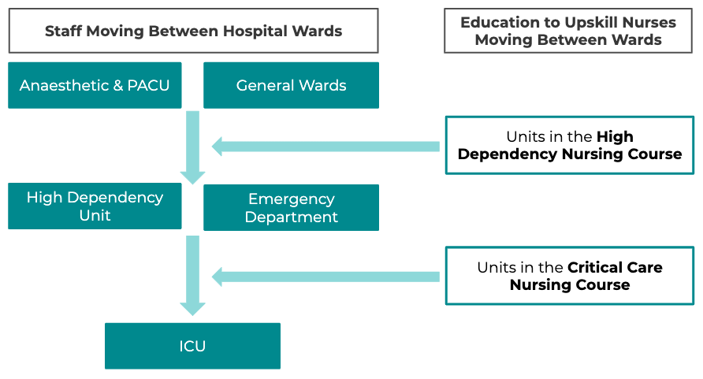

Each course comprised a series of units, divided into short topics ranging between 10 and 60 minutes in length, able to be accessed flexibly, depending on the needs of the individual clinician, the hospital or health service. The education topics build on previous knowledge, skills and experience to prepare nurses to move into higher acuity settings. The details of the units and topics in each course can be viewed in Appendix A of this document.

The course content includes:

* Recorded presentations incorporating interactive case based learning activities, and short videos.
* Quizzes to apply the knowledge both during the topic and at the end of each topic.
* Resources - comprising handouts, readings and references.
* Each course had a discussion forum monitored on an ongoing basis, by a senior critical care educator.
* A certificate of completion was issued which stated the number of compulsory professional development points claimable for completion of the activity.

### Target Audience

The target audience for the education was RNs currently working in the acute care setting that needed to increase their knowledge and skills in HDU and Critical Care Nursing, so that they may be deployed to these areas. The inclusion criteria for nurses to complete the training:

* Australian Rns (a valid AHPRA number required at sign up);
* Requires additional skills and knowledge to assist in delivering care in a HDU; or
* Requires additional skills and knowledge to assist in delivering care in an ICU or other Critical Care areas such as Emergency or Coronary Care/Cardiology;
* Employed by an Australian Public Hospital or an Australian Private Hospital that has been contracted by a state or territory, or the Australian Government to provide COVID-19 related healthcare services;
* Support from a manager to undertake the Courses (managers details to be collected at sign up and manager will be emailed to confirm enrolment); and
* Were able to commence and complete the Courses within 28 days of enrolment.

Other groups granted access that did not meet the original eligibility criteria include:

* Nurses working in Correctional Services / Justice Health.
* Nurses working for government nursing agencies.

People ineligible to participate in the education included:

* Enrolled Nurses or Graduate Nurses.
* RNs not working in a hospital e.g. Aged Care, Community Health, Aboriginal Health, Primary Care, Specialist Centers, Retrieval Services.
* RNs employed by an Agency.
* Unemployed RNs.

### Other groups that accessed the education

There were a range of other nurses who accessed the education including:

* 115 Pacific Islanders were granted access via an arrangement between The Pacific Community organisation and the Department of Foreign Affairs and Trade.
* 113 Australian Defence Force Nurses and contractor places were purchased by Joint Health Command, Department of Defence.
* 15 New Zealand Defence Force nurses.

The data from these groups has not been include in the analysis for this report. These numbers have been reported to demonstrate the courseware was distributed beyond the participants eligible for government funding.

### Endorsements

The SURGE Critical Care courses were endorsed by the:

* Australian Nursing and Midwifery Foundation (ANMF).
* Australian College of Critical Care Nurses (ACCCN).

These organisations assisted in promoting the courses to their members and other nurses across Australia, which was beneficial in achieving the level of response in a short time frame.

# Project Roll Out

* The SURGE Critical Care project was successfully delivered in a very short space of time to ensure readiness of the Australian health system to respond to coronavirus.
* The target number of 20,000 enrolments was reached within 15 days of opening course enrolments. An additional 10% of places were subsequently made available to meet the additional demand for the courses.
* Overall the project received 24,112 expressions of interest from Australian nurses.
* Of those expressions of interest, Medcast screened for eligibility and this resulted in 22,229 eligible course participants. Some participants enrolled in both of the courses which resulted in a total of 36,907 course enrolments.

## Timeline

On 31st March 2020, Medcast signed a contract with The Department to deliver the SURGE Critical Care courses. On 1st April 2020, enrolments were opened and 9 days later Medcast launched the online courses. The following table sets out the timeline of key project activities between March and August 2020.

Table 3.1 Timeline of key project activities

| **Date** | **Activity** |
| --- | --- |
| 25th March 2020 | Proposal submitted to the Office of Chief Nursing and Midwifery Officer and the Health Workforce Reform Branch, Australian Government Department of Health |
| 31st March 2020 | Contract Signed |
| 1st April 2020 | Enrolments Opened via Medcast website |
| 2nd April 2020 | Press release and conference - Minister Hunt & Ken Hambrecht (Medcast) |
| 9th April 2020 | Course content available to be accessed by participants |
| 20th April 2020 | Target enrolments achieved - closed enrolments via the website |
|  | Collected EOIs from RNs who were unsuccessful in the first round |
| 29th April 2020 | Places offered to select hospitals using coupon code |
|  | Places offered to eliminate people who had submitted EOIs via the Medcast website |
| 31st May | First round enrolments course completion date |
| 10th July 2020 | Second round enrolments (coupons and EOIs) completion date - extension for first round |
| 3rd August | Follow-up Survey sent to participants who completed the education |
| 17th August 2020 | Follow-up survey closed |
| 1st September 2020 | Draft report sent to the Department |
| 6th November 2020 | Final Report |

## 

## Uptake

Following a press conference on 2nd April 2020 with The Hon. Greg Hunt MP and Ken Hambrecht, Principal Consultant, Critical Care Education Services (Medcast), there was a significant uptake of the course. The majority of SURGE enrolments were taken prior to the course opening on the 9th April, and the target number of 20,000 participants was achieved within 15 days of the official launch.

Course enrolments in excess of the target 20,000 were accepted, to account for withdrawals and the removal of participants who did not meet the eligibility criteria. Given the rapid response, enrolments were paused on 20th April 2020. At that stage 22,207 course enrolments had been received. This was the total number of enrolments prior to eligibility screening.

The chart below shows the cumulative and daily enrolments in the course in April 2020. An additional, 1,718 enrolments occurred on or after 1 May 2020.

Figure 3.1: Unique Enrolments in SURGE Critical Care April 2020

After the initial intake second round places were offered to targeted hospitals to ensure that there was an equitable distribution of the places across Australia. Hospitals submitted their requests for training places to the Office of the Chief Nursing and Midwifery Officer and Medcast allocated places via online coupon codes accordingly.

The following table shows the additional places that were distributed through May to July 2020, either through hospital coupon codes or to nurses who had previously submitted an EOI via the Medcast website after the courses were closed.

Table 3.2 Number of SURGE enrolments by month (eligible participants)

| Month | Enrolments | Cumulative | % Total | % Target |
| --- | --- | --- | --- | --- |
| Apr-2020 | 20,511 | 20,511 | 92.3% | 102.6% |
| May-2020 | 1,523 | 22,034 | 6.9% | 7.6% |
| Jun-2020 | 142 | 22,176 | 0.6% | 0.7% |
| Jul-2020 | 53 | 22,229 | 0.2% | 0.3% |
|  | 22,229 |  | 100.0% | 111.1% |

## 

## Learner Demographics

When enrolling in SURGE Critical Care participants were asked to provide the following information:

* First and Last Name
* Mobile number
* Email
* Hospital name
* Unit Manager Name
* Unit Manager Email
* AHPRA Number: the AHPRA Practitioner Information Exchange API web service was used to confirm a participant's AHPRA number and returns additional information, including:
  + Profession
  + Gender
  + Qualifications
  + Workplace postcode
* Nursing Area of Practice (drop down list)

The following graphs and tables include an overview of the demographics of the nurses that enrolled in the education.

Figure 3.2 SURGE participants by gender

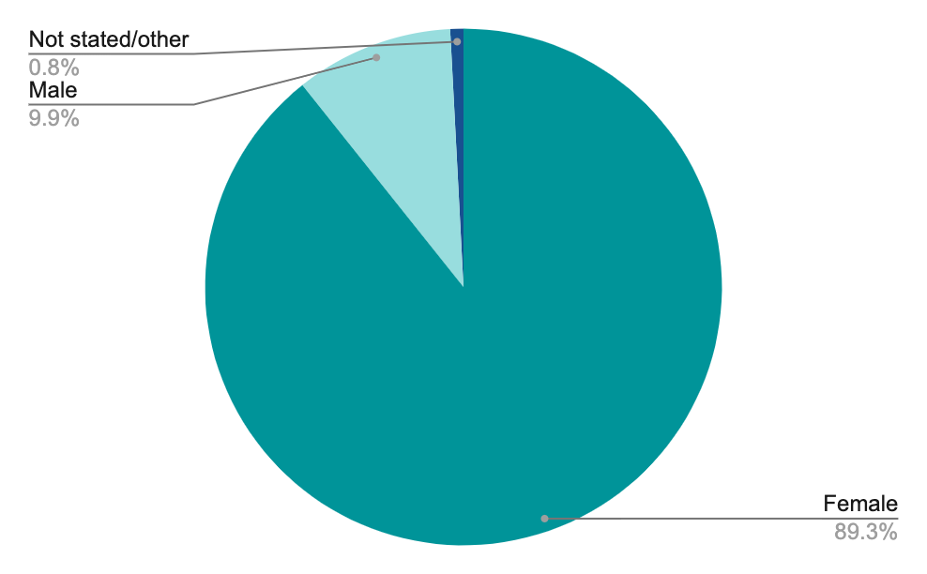

Table 3.3 SURGE Participants by nursing area of practice

|  | Participants | % Participants |
| --- | --- | --- |
| Perioperative | 4,560 | 20.5% |
| Emergency | 4,290 | 19.3% |
| Medical | 2,665 | 12.0% |
| Other | 2,497 | 11.2% |
| Mixed medical / surgical | 2,476 | 11.1% |
| Surgical | 2,436 | 11.0% |
| Critical care | 2,375 | 10.7% |
| Rehabilitation & disability | 456 | 2.1% |
| Paediatrics | 366 | 1.6% |
| Palliative care | 104 | 0.5% |
| Not stated | 4 | 0.0% |
|  | 22,229 | 100.0% |

# 

Figure 3.4 SURGE participants by state, based on AHPRA details

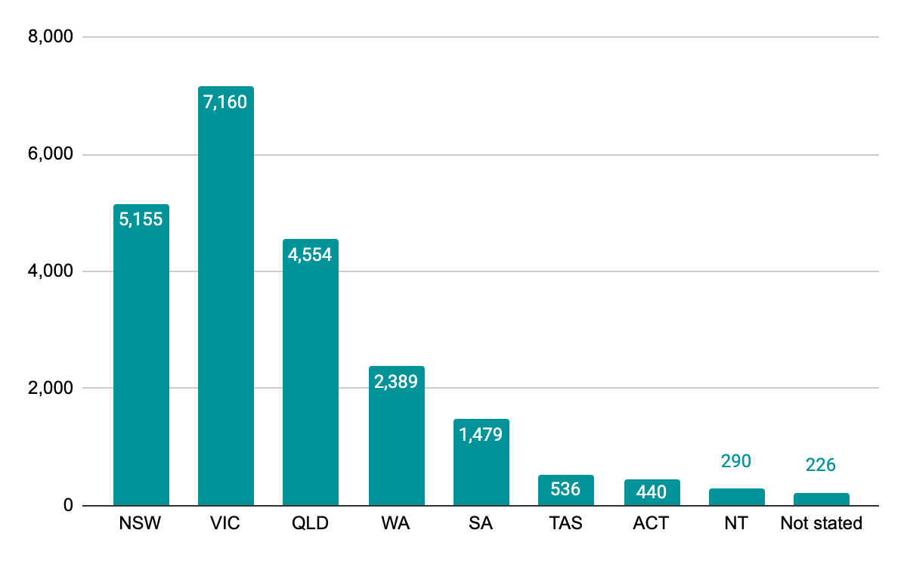

Table 3.5 SURGE Participants by remoteness classification

| Level | Classification | Participants | % Participants |
| --- | --- | --- | --- |
| 1 | Metropolitan areas | 14,468 | 65.09% |
| 2 | Regional centres | 2,572 | 11.57% |
| 3 | Large rural towns | 1,466 | 6.59% |
| 4 | Medium rural towns | 725 | 3.26% |
| 5 | Small rural towns | 2,262 | 10.18% |
| 6 | Remote communities | 354 | 1.59% |
| 7 | Very remote Communities | 382 | 1.72% |
|  |  | 22,229 | 100.0% |

## 

## 

# 

# 4. Geographical & Hospital Coverage

* All States and Territories were well represented in the SURGE Critical Care course participants.
* Victoria had the greatest number of nurse enrolments with 7,160, making up 32% of participants. New South Wales and Queensland had 23% and 20% respectively.
* Hospital type analysis revealed that 71.6% of participants were from public and 28.4% from private facilities.
* Nurses from over 800 hospitals enrolled - across public and private hospitals. Excellent hospital coverage was achieved with 80% (394 of 499) of Australian acute public hospitals having participants in the courses.
* Strong hospital coverage was achieved in regional and remote communities with 299 / 387 acute public hospitals outside of metropolitan areas (MMN 2-7) having participants in the courses.

The SURGE Critical Care project achieved an excellent result in distributing the education across Australia. The following data shows the distribution of the participants by state, remoteness classification and hospital type.

## Hospital Coverage

The collection of information about hospitals enabled analysis of hospital type. The following table shows the distribution between public and private facilities and acute and non-acute facilities. Hospitals were classified using a combination of the latest Australian Institute of Health and Welfare hospital peer group classification[2] and The Department Listing of Commonwealth declared hospitals[3].

Nurses from over 800 hospitals - across public and private, enrolled in the SURGE courses.

Table 4.1 - SURGE Participants - Hospital Coverage by Type

| Public/Private |  |  | Hospitals | Participants | % Learners |
| --- | --- | --- | --- | --- | --- |
|  | Public |  | 505 | 15,914 | 71.6% |
|  | Private |  | 301 | 6,315 | 28.4% |
|  | Total |  | 806 | 22,229 | 100.0% |
| Acute / Non-Acute |  |  | Hospitals | Participants | % Learners |
|  | Acute | Public | 394 | 15,204 | 68.4% |
|  |  | Private | 177 | 5,711 | 25.7% |
|  | Sub-total Acute |  | 571 | 20,915 | 94.1% |
|  |  |  | Hospitals | Participants | % Learners |
|  | Other (Non-acute) | Public | 111 | 710 | 3.2% |
|  |  | Private | 124 | 604 | 2.7% |
|  | Sub-total Non-acute |  | 235 | 1,314 | 5.9% |
|  | Total All Hospitals |  | 806 | 22,229 | 100.0% |

The hospital distribution above excludes nurses from the Pacific Islands, Australian Defence Force and New Zealand.

Table 4.2 - SURGE Participants - Hospital Coverage by State

|  | All Hospitals | Acute Public | Acute Private | Other Public | Other Private |
| --- | --- | --- | --- | --- | --- |
| NSW | 242 | 119 | 52 | 27 | 44 |
| VIC | 193 | 84 | 44 | 27 | 38 |
| QLD | 162 | 93 | 37 | 12 | 20 |
| WA | 95 | 40 | 16 | 25 | 14 |
| SA | 75 | 41 | 16 | 15 | 3 |
| TAS | 21 | 9 | 7 | 3 | 2 |
| ACT | 11 | 2 | 4 | 2 | 3 |
| NT | 7 | 6 | 1 | 0 | 0 |
|  | 806 | 394 | 177 | 111 | 124 |

Table 4.3 - Hospitals by Remoteness Classification (based on hospitals with participants)

|  |  | All Hospitals | Acute Public | Acute Private | Other Public | Other Private |
| --- | --- | --- | --- | --- | --- | --- |
| 1 | Metropolitan areas | 373 | 95 | 129 | 41 | 108 |
| 2 | Regional centres | 53 | 20 | 20 | 3 | 10 |
| 3 | Large rural towns | 46 | 28 | 15 | 1 | 2 |
| 4 | Medium rural towns | 29 | 28 | 0 | 1 | 0 |
| 5 | Small rural towns | 211 | 157 | 12 | 38 | 4 |
| 6 | Remote communities | 51 | 32 | 1 | 18 | 0 |
| 7 | Very remote Communities | 43 | 34 | 0 | 9 | 0 |
|  |  | 806 | 394 | 177 | 111 | 124 |

* The Modified Monash Model (MMM) was used to classify hospital remoteness.
* Table 4.3 shows the distribution of hospitals with nurses enrolled in the SURGE courses, across the MMM classifications, and further broken out into broad hospital types.

Table 4.4 - Hospital Coverage: Acute Public Hospitals by State & Remoteness Classification

|  | All Areas | Metropolitan areas | Regional centres | Large rural towns | Medium rural towns | Small rural towns | Remote communities | Very remote Communities |
| --- | --- | --- | --- | --- | --- | --- | --- | --- |
| NSW | 119 / 158 | 36 / 40 | 0 / 1 | 12 / 13 | 5 / 5 | 56 / 81 | 7 / 11 | 3 / 4 |
| VIC | 84 / 106 | 26 / 33 | 6 / 8 | 5 / 6 | 12 / 12 | 34 / 46 | 1 / 1 | 0 / 0 |
| QLD | 93 / 105 | 14 / 14 | 8 / 8 | 4 / 4 | 8 / 8 | 32 / 36 | 13 / 18 | 14 / 17 |
| WA | 40 / 51 | 10 / 11 | 2 / 3 | 2 / 2 | 2 / 2 | 12 / 14 | 2 / 4 | 10 / 15 |
| SA | 41 / 58 | 7 / 8 | 0 / 2 | 4 / 4 | 1 / 1 | 20 / 29 | 5 / 9 | 4 / 4 |
| TAS | 9 / 13 | 0 / 0 | 2 / 3 | 1 / 1 | 0 / 0 | 3 / 5 | 2 / 3 | 1 / 1 |
| ACT | 6 / 6 | 0 / 0 | 2 / 2 | 0 / 0 | 0 / 0 | 0 / 0 | 2 / 2 | 2 / 2 |
| NT | 2 / 2 | 2 / 2 | 0 / 0 | 0 / 0 | 0 / 0 | 0 / 0 | 0 / 0 | 0 / 0 |
|  | 394 / 499 | 95 / 108 | 20 / 27 | 28 / 30 | 28 / 28 | 157 / 211 | 32 / 48 | 34 / 43 |
|  | 80% | 88% | 74% | 93% | 100% | 74% | 67% | 79% |

* The above table sets out the number of acute public hospitals with nurses enrolled in SURGE expressed as a fraction of the total number of acute public hospitals within that state/MMM classification.
* Overall, the program achieved enrolments of RNs from 80% (394 of 499) of acute public hospitals across the country, with:
  + particularly strong coverage in large and medium rural towns (93% and 100% respectively) and
  + Excellent participation rates in small rural towns, remote and very remote communities.

# 5. Course Completions

* By the conclusion of SURGE, 16,461 / 22,229 participants completed at least one of the SURGE courses - this equates to a 74.05% completion rate of at least one course
* 7,757 participants completed both courses
* 8,704 participants completed one course
* Completion rates by hospital type, state or MMM remote classification were broadly consistent with the overall completion rate of 74.1% (+/- 5%)

Table 5.1 - Completions by course

|  | Participants who Completed the Course | Participants who enrolled in the course | Completion Rate |
| --- | --- | --- | --- |
| Critical Care Nursing | 11,371 | 18,214 | 62.4% |
| High Dependency Nursing | 12,847 | 18,693 | 68.7% |

* Some participants enrolled in both courses and therefore the total course enrolments is greater that the number of unique participants in the project.

Figure 5.1 - Enrolment and completions overtime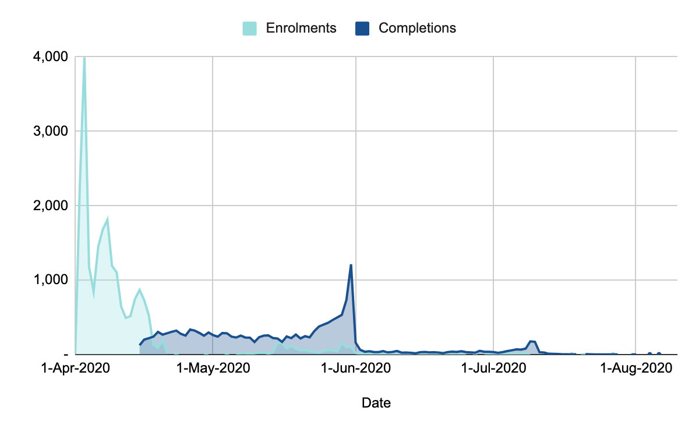

Table 5.2: Completions by month

| Month | Participants Enrolled | Completions |
| --- | --- | --- |
| Apr-2020 | 20,511 | 4,294 |
| May-2020 | 1,523 | 10,158 |
| Jun-2020 | 142 | 1,139 |
| Jul-2020 | 53 | 865 |
| Aug-2020 | - | 5 |
|  | 22,229 | 16,461 |

* The majority of participants (14,452) completed the courses on or before the 31st May 2020.
* Another 2,009 participants completed the course between June and August 2020.

Figure 5.2: Completion Rate by Hospital Type

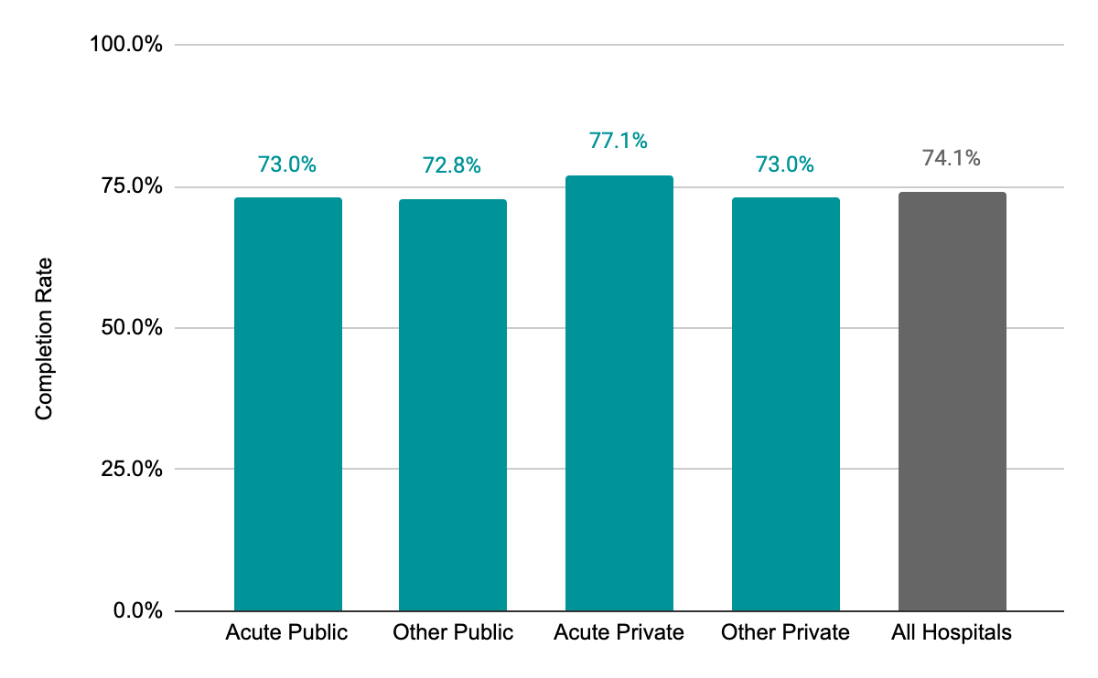

* Acute private hospital nurses achieved the best course completion rate of 77.1%, this was 3% above the average for all participants.

Figure 5.3: Completion Rate by State

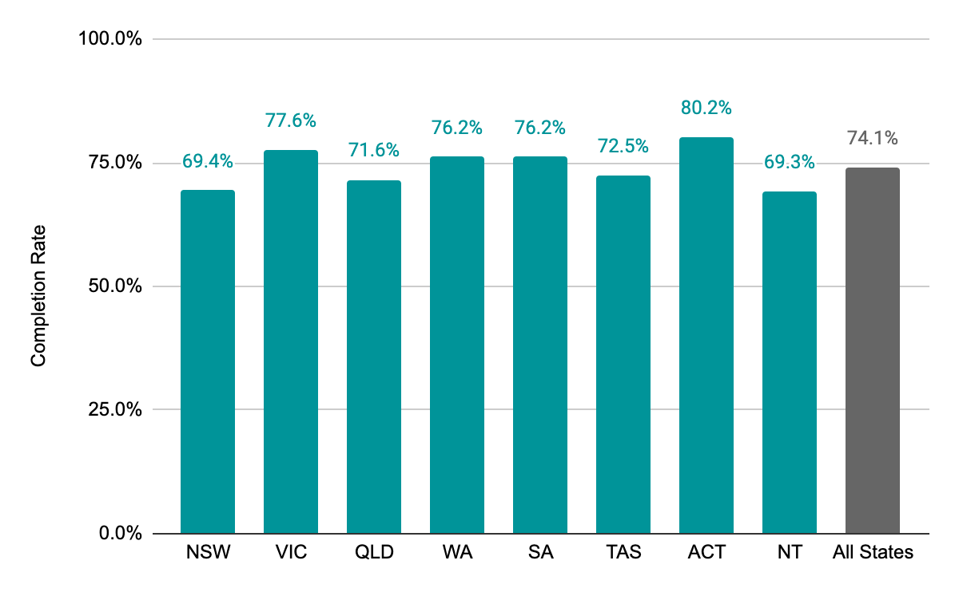

Figure 5.4: Completion Rate by Remoteness Classification

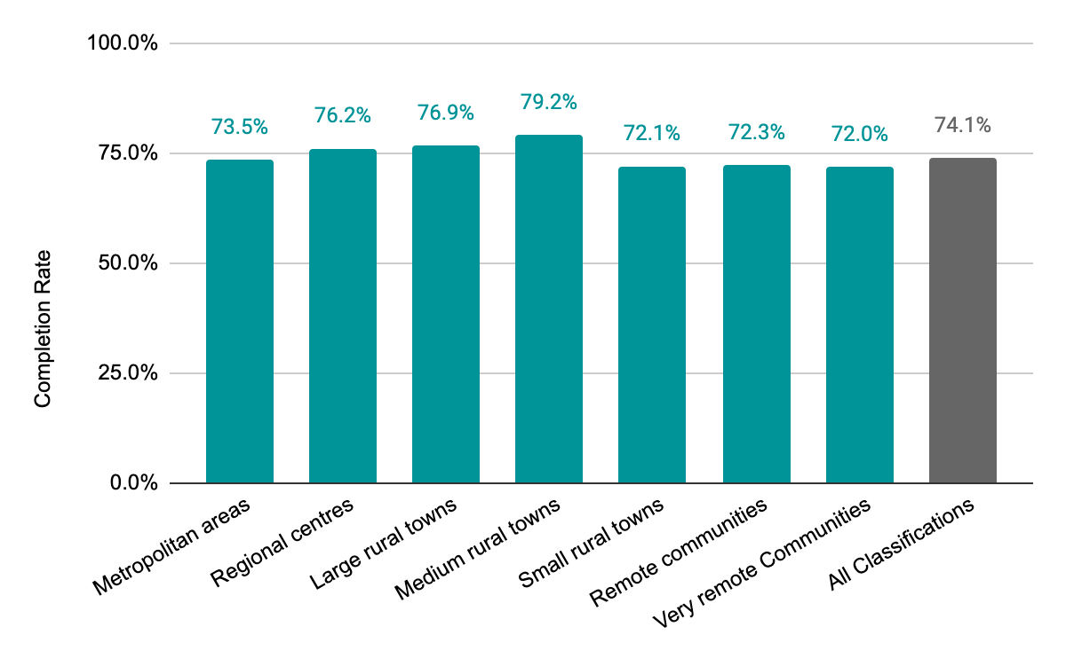

# 

# 6. Educational Outcomes

* Educational outcomes were measured comparing responses to pre and post course and topic surveys.
* Successful outcomes include a +30% increase in participants' reporting high or very high knowledge and confidence to be deployed to High Dependency or Critical Care nursing roles.
* The **course content** was rated high or very high by 89% (CCN) and 91% (HDN) of participants.
* The **online delivery** format was rated high or very high by 85% (CCN) and 86% (HDN) of participants.

The following table is a summary of the key findings from the surveys.

Figure 6.1: Pre and Post Course Survey Summary Statistics

*NB – the number of surveys completed was slightly less than the total number of participants that completed the training. 11,366 / 11,371 for the CCN course and 12,814 / 12,847 for the HDN course.

## Survey Approach

Mandatory pre and post surveys were included as part of the Critical Care Nursing (CCN) and High Dependency Nursing (HDN) education to measure the change in knowledge and confidence of the course participants and to gather qualitative feedback about the most useful aspects of the course and areas of improvement. A 5 point Likert scale was used for all questions, except for free text fields in the post course survey.

At the course level, Medcast analysed the impact of the course on participants’ self-reported knowledge and confidence pre and post-training, as well as participants’ ratings of course content and delivery post-training by comparing percentage of responses at each point on the Likert scales.

At a topic level, Medcast undertook statistical analysis to assess the impact on participant’s self-reported knowledge and confidence by comparing the pre and post-training means for each topic in each course.

**Note** - the analysis included only participants who completed the courses in their entirety. Therefore the pre-survey responses for participants who did not complete the post-survey were excluded from the analysis.

**Pre / post course questions available for quantitative analysis included:**

1. How would you rate your confidence to redeploy to a CCN or HDN nursing role (pre and post)?
2. How do you rate your knowledge to redeploy to a CCN or HDN nursing role (pre and post)?
3. How likely are you to be redeployed to a CC or HD nursing role (pre-training only)?
4. Overall how would you rate the course content (post-training only)?
5. Overall how would you rate the online course delivery (post-training only)?

**The unit level questions included the following (for each of the 10 and 9 units within the CCN and HDN courses, respectively):**

1. How do you rate your knowledge in this topic (pre and post)?
2. How do you rate your confidence in this topic (pre and post)?

## Summary of Key Findings

### Findings - Critical Care Nursing (CCN) Course

The following momentum charts illustrate the overall success of the CCN course   
(survey responses = 11,366):

* The proportion of participants that rated their confidence to redeploy as high/very high: increased from 20% in the pre survey to 52% in the post-training survey
* The proportion of participants that rated their knowledge to redeploy as high/very high: increase from 15% in the pre-training survey to 54% in the post-training survey
* Course content rating of high/very high: 89%
* Online course delivery rating of high/very high: 85%
* Approximately 81% of participants reported a moderate to very high likelihood that they will redeploy to a CC nursing role.

Figure 6.2: Change in confidence Critical Care Nursing - comparing pre and post survey responses

Figure 6.3: Change in knowledge Critical Care Nursing comparing pre and post survey responses

Figure 6.4: Critical Care Nursing course rating of course content and online course delivery

### Findings - High Dependency Nursing (HDN) Course

The following momentum charts illustrate the overall success of the HDN course in terms of the following (Total survey responses = 12,814)

* The proportion of participants that rated their confidence to redeploy as high/very high: increased from 21% in the pre-training survey to 55% in the post-training survey
* The proportion of participants that rated their knowledge to redeploy as high/very high: increased from 16% in the pre-training survey to 57% in the post-training survey
* Course content rating of high/very high: 91%
* Online course delivery rating of high/very high: 86%
* Approximately 82% of participants reported a moderate to very high likelihood that they will redeploy to a HD nursing role.

Figure 6.5: Change in confidence High Dependency Nursing - comparing pre and post survey responses

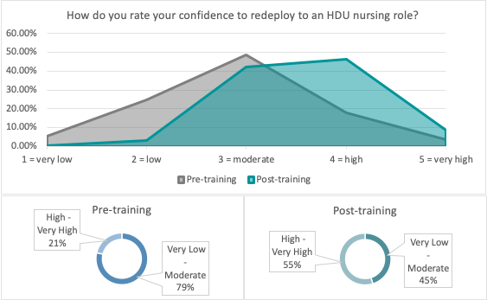

Figure 6.6: Change in knowledge High Dependency Nursing - comparing pre and post survey responses

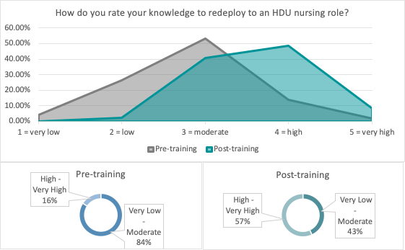

Figure 6.7: High Dependency Nursing course rating of course content and online course delivery

### 

### Unit Level Findings - Critical Care Nursing

As shown in the table below, the difference between the pre and post training mean results for participants’ self-reported knowledge and confidence across all CCN units shows a **statistically significant increase.**

The top 3 units with the most statistically significant increases in both knowledge and confidence include the following.

* Endocrine & metabolic
* Respiratory - assessment & mechanical ventilation
* Neurological disorders

| Unit | **Knowledge** |  |  | **Confidence** |  |  |
| --- | --- | --- | --- | --- | --- | --- |
|  | Pre-training mean | Post- training mean | P value | Pre-training mean | Post- training mean | P value |
| 1. Fundamental cardiac physiology | 2.96 | 3.53 | p<.001 | 2.90 | 3.51 | p<.001 |
| 2. Cardiovascular pathophysiology - assessment & management of the patient with chest pain | 2.96 | 3.70 | p<.001 | 2.91 | 3.69 | p<.001 |
| 3. Cardiovascular pathophysiology - shock states - assessment & management | 2.86 | 3.69 | p<.001 | 2.83 | 3.67 | p<.001 |
| 4. Respiratory physiology | 2.88 | 3.59 | p<.001 | 2.84 | 3.56 | p<.001 |
| 5. Monitoring techniques for the critically ill patient | 2.89 | 3.62 | p<.001 | 2.86 | 3.59 | p<.001 |
| 6. Respiratory - assessment and mechanical ventilation | 2.64 | 3.56 | p<.001 | 2.60 | 3.51 | p<.001 |
| 7. Respiratory - airway management | 2.96 | 3.65 | p<.001 | 2.93 | 3.59 | p<.001 |
| 8. Renal | 2.67 | 3.20 | p<.001 | 2.64 | 3.13 | p<.001 |
| 9. Neurological disorders | 2.63 | 3.51 | p<.001 | 2.60 | 3.47 | p<.001 |
| 10. Endocrine & metabolic | 2.66 | 3.58 | p<.001 | 2.64 | 3.56 | p<.001 |

Notes on the analysis:

* Anything with a p value <.001 means that the result is statistically significant, i.e. for all topics within the course, the reported increases in knowledge and confidence pre and post-training are statistically significant.
* T Tests were conducted using the excel data analysis tool (two sample t tests assuming unequal variances) with alpha=.05 (i.e. 95% confidence interval).
* The very large sample size can affect the p value downward (more likely to see a statistically significant difference pre and post-training the larger the sample).

### 

### Unit Level Findings - High Dependency Nursing

Similar to the CCN course, the difference between the pre and post-training mean results for participants’ self-reported knowledge and confidence across all HDN units shows a **statistically significant increase.**

The top 3 units with the most statistically significant increases in both knowledge and confidence include the following:

* Cardiac - shock states
* Cardiac - acute coronary syndromes
* Fluid & electrolyte imbalances

| Unit | **Knowledge** |  |  | **Confidence** |  |  |
| --- | --- | --- | --- | --- | --- | --- |
|  | Pre-training mean | Post-training mean | P value | Pre-training mean | Post-training mean | P value |
| 1. Cardiac - electrocardiography | 2.64 | 3.52 | p<.001 | 2.57 | 3.49 | p<.001 |
| 2. Cardiac - physiology | 2.77 | 3.50 | p<.001 | 2.69 | 3.45 | p<.001 |
| 3. Cardiac - shock states | 2.62 | 3.65 | p<.001 | 2.56 | 3.61 | p<.001 |
| 4. Cardiac - arrhythmias | 2.59 | 3.48 | p<.001 | 2.52 | 3.41 | p<.001 |
| 5. Cardiac - acute coronary syndromes | 2.60 | 3.63 | p<.001 | 2.56 | 3.61 | p<.001 |
| 6. Fluid & electrolyte imbalances | 2.81 | 3.71 | p<.001 | 2.78 | 3.69 | p<.001 |
| 7. The infected patient | 3.04 | 3.89 | p<.001 | 3.02 | 3.87 | p<.001 |
| 8. Monitoring | 3.21 | 3.67 | p<.001 | 3.20 | 3.64 | p<.001 |
| 9. Respiratory - assessment & management | 2.86 | 3.60 | p<.001 | 2.82 | 3.57 | p<.001 |

Notes on the analysis:

* Anything with a p value <.001 means that the result is statistically significant, i.e. for all topics within the course, the reported increases in knowledge and confidence pre and post-training are statistically significant.
* T Tests were conducted using the excel data analysis tool (two sample t tests assuming unequal variances) with alpha=.05 (i.e. 95% confidence interval).
* The very large sample size can affect the p value downward (more likely to see a statistically significant difference pre and post-training the larger the sample).

# 7. Feedback

* Feedback about the courses, collected through free text responses, was thematically analysed to draw out the common themes.
* Themes were grouped according to content, delivery, design and presentation.
* The common themes with regards to the most beneficial aspects of the course were the flexible online delivery and high quality content. The presenters and their expertise were rated highly as were the interactive elements.
* Participants were appreciative of the opportunity to participate in the course to enhance their knowledge and prepare for a potential COVID-19 outbreak.

## Thematic analysis

A thematic analysis was conducted of the free text post-training qualitative survey questions for both the Critical Care Nursing (CCN) and High Dependency Nursing (HDN) courses. The objective was to identify, analyse and summarise common themes in the responses.

The qualitative (i.e. free text) questions in the CCN and HDN post-training course surveys included:

1. What did you find most beneficial about the course?
2. What improvements would you suggest?
3. Do you have any other comments or feedback?

The themes were identified based on groupings of key areas and approximate response counts for each question. (There were 11,366 total responses to the CCN post-training survey and 12,814 total responses to the HDN post-training survey).

The high-level themes that emerged were related to course:

* + Content
  + Delivery
  + Design
  + Presentation

## Key Findings

### Critical Care Nursing

In terms of what participants found **most beneficial** about the CCN course, an overwhelming majority said that the *content* and *design* aspects were beneficial. This included themes such as

* The course was a good refresher and review / update.
* Participants enjoyed the lectures and presentations.
* The cardiac and respiratory topics were the most popular (which also aligns with the quantitative analysis in terms of self-reported increases in knowledge and confidence to redeploy to a CC nursing role, as well as statistically significant increases in those individual topic areas within the CCN course.)
* Participants found the notes and handouts beneficial because they could refer back to them throughout the course.
* Participants found the overall interactivity of the course to be very beneficial, in particular the diagrams, drawings and use of the interactive whiteboard.

Regarding the course aspects that **could be improved,** most participants’ responses centered on *delivery*, which could be expected in the context of how rapidly the course was developed and deployed in light of the unfolding COVID-19 pandemic. This included themes such as

* Participants noted that they would have appreciated more time to complete the course and access the materials.
* Some participants suggested improvements in the speakers/presenters, with the most common theme focused on presentation skills.
* Some participants reported inconsistent video quality and made suggestions to improve the editing post-production.

The following table shows the qualitative questions grouped into content, delivery (e.g. audio, video, online learning), design (e.g. interactive cases and quizzes, diagrams, whiteboard, etc.) and presentation.

Table 7.1 - CCN Course Thematic Analysis

|  | Content | Delivery | Design | Presentation | All course aspects |
| --- | --- | --- | --- | --- | --- |
| 1. What did you find most beneficial about the course? | 1,476 | 451 | 1,358 | 216 | 241 |
| 2. What improvements would you suggest? | 273 | 1,925 | 465 | 448 | N/A |

### High Dependency Nursing

In terms of what participants found **most beneficial** about the HDN course, an overwhelming majority said that the *content* and *delivery* aspects were beneficial. This included themes such as

* Participants found the information on and interpretation of the arterial blood gases, acid base disorders, and interpretation of electrocardiogram topics most beneficial.
* A significant portion of the participants said that the course was a great refresher overall, and noted specific topics around reading of ECGs, CPAP and BiPAP, and the use of notes coupled with the presentations to be very beneficial.
* HDN participants praised the delivery of the course in terms of its interactivity, informative nature, length of lectures, and quizzes as a tool to consolidate the learning.

Similar to the CCN course, regarding the course aspects that **could be improved,** most participants’ responses centered on *delivery*, which could be expected in the context of how rapidly the course was developed and deployed in light of the unfolding COVID-19 pandemic. This included themes such as

* Opportunity to improve audio quality in some videos.
* Suggestions for a more streamlined approach to navigate the course: some participants found it disjointed or confusing to be taken back to the home page and then need to “search“for the quizzes.
* Some participants suggested improvements to the presenters’ delivery.
* Participants suggested the need for more clinical practical examples and case studies to reinforce the learning and apply the biochemical/science and theoretical components in a practical HDN setting.

The following table shows the qualitative questions grouped into content, delivery (e.g. audio, video, online learning), design (e.g. interactive cases and quizzes, diagrams, whiteboard, etc.) and presentation.

Table 7.2 - HDN Course Thematic Analysis

|  | Content | Delivery | Design | Presentation | All course aspects |
| --- | --- | --- | --- | --- | --- |
| 1. What did you find most beneficial about the course? | 3,020 | 2,534 | 1,854 | 734 | 1,945 |
| 2. What improvements would you suggest? | - | 2,045 | 555 | 556 | N/A |

The following quotes are from a selection of participants that participated in either the Critical Care or High Dependency nursing course.

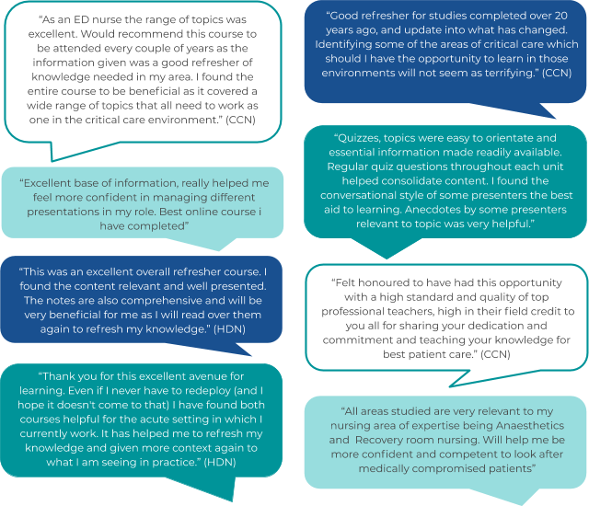

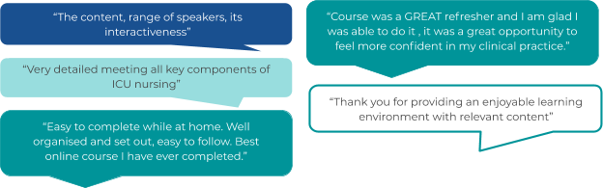

# 8. Workplace Impact

* A follow up survey to assess impact on work was distributed on 3rd August 2020 to all participants who completed the courses. 22.1% (3,634) people responded.
* The majority (58.8%) of survey respondents identified that their primary motivation for participating in the training was to prepare for COVID-19.
* 92.6% of survey respondents have indicated that the knowledge gained in the SURGE courses has been used in the workplace sometimes, often or always. Very few (7.4%) reported rarely or never using the knowledge.
* 95.3% of survey respondents indicated that the knowledge gained in the SURGE courses has **improved the quality of care they delivered to patients**, sometimes, often or always. Very few (4.7%) reported rarely or never using the knowledge.
* 31% of all respondents noted a moderate change in working scope of practice, which was found to be similar across both public and private hospitals.
* 41% who had not redeployed to a High Dependency / Critical Care setting indicated that they plan to pursue a role in this area in the future.

A follow-up survey was sent on 3rd August 2020, to participants who completed at least one of the SURGE courses. This survey was designed to investigate how the knowledge gained in the SURGE Critical Care program was applied in the workplace, as well as the impact on scope of practice and setting.

Survey distribution and response:

* **16,461** nurses who completed one or both of the SURGE Critical Care Courses were sent the survey
* **3,634** participants responded to the survey
* this equates to a **22.1%** survey completion rate.

## Survey Respondents

Table 8.1 - Age Overall of Survey Respondents (and by Hospital Type)

|  | Number | % | Public | Private |
| --- | --- | --- | --- | --- |
| Under 25 | 184 | 5.0% | 5.9% | 3.2% |
| 25-34 | 972 | 27.0% | 26.7% | 26.8% |
| 35-44 | 961 | 26.0% | 26.9% | 25.4% |
| 45-54 | 949 | 26.0% | 25.2% | 28.4% |
| 55-64 | 539 | 15.0% | 14.6% | 15.5% |
| 65-74 | 29 | 1.0% | 0.8% | 0.8% |
| 75 and over | - | 0.0% | 0.0% | 0.0% |
|  | 3,634 | 100.0% | 100.0% | 100.0% |

Table 8.2 - What was your primary motivation to do the course?

|  | Number | % |
| --- | --- | --- |
| Prepare for COVID | 2,138 | 58.8% |
| Career Development | 1,085 | 29.9% |
| Free CPD | 191 | 5.3% |
| Other | 114 | 3.1% |
| Employer Request | 106 | 2.9% |
|  | 3,634 | 100.0% |

The majority (58.8%) of survey respondents identified that their **primary motivation for participating in the training was to prepare for COVID-19**. This response was consistent across states and between private and public hospitals. Further analysis of this response can be found in Appendix B.

Table 8.3 - Do you use the knowledge gained in the High Dependency / Critical Care Nursing Course in your job?

|  | Number | % |
| --- | --- | --- |
| Never | 29 | 0.8% |
| Rarely | 205 | 5.6% |
| Sometimes | 1,368 | 37.6% |
| Often | 1,384 | 38.1% |
| Always | 648 | 17.8% |
|  | 3,634 | 100.0% |

55.9% of survey respondents have indicated that the **knowledge gained in the SURGE courses has been used in the workplace** often or always. Very few (7.4%) reported rarely or never using the knowledge.

Table 8.4 - Has the course improved the quality of care you deliver to patients?

|  | Number | % |
| --- | --- | --- |
| Never | 27 | 0.7% |
| Rarely | 144 | 4.0% |
| Sometimes | 1,168 | 32.1% |
| Often | 1,456 | 40.1% |
| Always | 839 | 23.1% |
|  | 3,634 | 100.0% |

63.2% of survey respondents indicated that the knowledge gained in the SURGE courses has **improved the quality of care delivered to patients**, either often or always. Very few (4.7%) reported rarely or never using the knowledge.

Table 8.5 - Have you had practical skills training in your workplace to enhance the knowledge gained in the SURGE critical Care courses?

|  | Number | % |  | Public | Private |
| --- | --- | --- | --- | --- | --- |
| None | 1,482 | 41.0% | None | 40.7% | 41.0% |
| A Little | 531 | 15.0% | A Little | 14.7% | 14.5% |
| Some | 826 | 23.0% | Some | 22.5% | 23.2% |
| Moderate amount | 551 | 15.0% | Moderate amount | 15.2% | 15.0% |
| A Lot | 244 | 7.0% | A Lot | 6.9% | 6.3% |
|  | 3,634 | 100.0% |  | 100.0% | 100.0% |

Based on survey responses, there appears to have been **some practical skills training** offered to SURGE course participants in their workplaces (22% a moderate amount or more), with 56% receiving none or little. Survey responses were consistent across both public and private hospitals.

Table 8.6 - As a result of doing this training has there been a change in your working scope of practice?

|  | **Overall:** |  |  | **By Hospital:** |  |
| --- | --- | --- | --- | --- | --- |
|  | Number | % |  | Public | Private |
| Yes | 1,143 | 31.0% | Yes | 31.8% | 30.6% |
| No | 2,491 | 69.0% | No | 68.2% | 69.4% |
|  | 3,634 | 100.0% |  | 100.0% | 100.0% |

Based on survey responses, there appears to be some **moderate change in working scope of practice** (31% of all respondents), which is similar across both public and private hospitals. Of note, the most change was identified in ACT and NT (40.5% and 42.9%) and the lowest in Victoria (29.2%), Queensland (28.9%) and Tasmania (26.9%).

Table 8.7 - As a result of doing this training has there been a change in your hours of employment?

|  | Overall: |  |  | By Hospital: |  |
| --- | --- | --- | --- | --- | --- |
|  | Number | % |  | Public | Private |
| Increase | 199 | 5.0% | Increase | 5.4% | 5.7% |
| Decrease | 18 | 0.0% | Decrease | 0.5% | 0.5% |
| No change | 3,417 | 94.0% | No change | 94.1% | 93.8% |
|  | 3,634 | 100.0% |  | 100.0% | 100.0% |

Respondents identified no meaningful change in **hours of employment** (~94% no change).

Table 8.8 - Which of the following statements best apply to you regarding the impact of the SURGE Critical Care training on where you work?

|  | Number | % |
| --- | --- | --- |
| Already HDU/CC & No Change | 902 | 25.0% |
| Acute Ward & No Change | 938 | 26.0% |
| Acute Ward & Possible Future Deployment | 740 | 20.0% |
| Already HDU/CC & Increase Responsibility | 129 | 4.0% |
| Already HDU/CC & Mentoring Responsibility | 75 | 2.0% |
| Acute Ward & Redeployed to HDU/CCN | 148 | 4.0% |
| Other | 702 | 19.0% |
|  | 3,634 | 100.0% |

“No change to work allocation was already doing occasional HDU CCU shifts. Course has improved my critical thinking and problem solving with the expanded and more in depth knowledge gained”

There appears to have been a moderate impact of SURGE on work setting. 51% of respondents indicated that there has been no change in the workplace. However, 25% of these people were already working in an HDU / ICU setting. A fifth (20%) of respondents indicated that there is a possibility of future deployment to a higher acuity area.

Respondents who selected ‘other’ provided a range of responses to this question, including:

* Working in Anaesthetics / PACU / Theatres / Periop / Recovery - no change
* Nurses Educators
* Working in subacute setting, day surgery, rehabilitation or geriatrics

Many respondents indicated that there were plans for them to move to higher acuity settings when the need arose and this scenario is yet to eventuate in most states.

Table 8.9 If you have not redeployed to a High Dependency / Critical Care setting, do you plan to pursue a role in this area in the future?

|  | Number | % |
| --- | --- | --- |
| Yes | 1,472 | 41.0% |
| No | 798 | 22.0% |
| na | 1,364 | 38.0% |
|  | 3,634 | 100.0% |

41% who had not redeployed to a High Dependency / Critical Care setting indicated that they plan to pursue a role in this area in the future.

Table 8.10 - Free text questions from follow-up survey

The following tables summarise the free text responses in the survey. The responses were grouped into themes and example quotes are provided according to each theme.

| On reflection, what has been the most useful thing about the High Dependency / Critical Care Nursing Course? |
| --- |
| **Increased Confidence** |
| “Everything! I was so ready to take the next step in learning about the patient/care in ICU systematically. The ventilation subjects have been especially useful and allowed me to take the next step in my current role.” |
| “The course increased my confidence in the knowledge I had and was a great update. I gained new knowledge as well which is very helpful particularly in regards to latest best practice.” |
| **Increased Knowledge** |
| “The teachers were explaining difficult concepts in a way that made them easier and less overwhelming to understand and apply to our everyday practice.” |
| “Everything. The high dependency course provided a refresher for the knowledge i already learnt during bachelor study, things that i might have forgotten, and the intensive care course taught me new and more in depth knowledge of things that i've never learnt before. The course all assisted me with re-evaluating my current practice and help me improve my patient care.” |
| “Accessibility to a great range of diverse trainers fully experienced and current knowledge based. i have printed out all the resources and read through them as a cne to assist with teaching and use them to support staff in my unit.” |
| “The most useful thing out of this course would be the respiratory & ventilation package! my confidence has increased whilst operating ventilators & my knowledge has expanded immensely! so thank you !!” |
| **Delivery Mode and Presenters** |
| “Both courses were delivered in an easy to understand format and the presenters were fantastic in the way they delivered the key concepts and training modules.” |
| “Very easy to navigate course found the content really interesting and helpful for my jobs.” |
| “The course was structured well and most of the speakers were engaging, explained things well so the content really stuck. The diagrams drawn during presentations were excellent, it was a very effective way of learning. a+ for that! I would highly recommend this course to any nurse, it's a revision of things we learnt back at university and probably don't get to use much depending of area of work. i sadly missed out on the high dependency unit due to time constraints but will consider it in the future. thank you kindly for this opportunity!” |
| **Refresher** |
| “it has been a great refresher of information learnt back in university days plus gaining new knowledge. it has also made me think more critically when their are abnormalities in my patients bloods or observations.” |
| “I thoroughly enjoyed the courses and found it really beneficial to my learning experience. and getting me back into icu. The majority of the pdf documents have been fantastic to be able to write additional notes whilst listening to the lectures.” |
| “Great revision. I feel that I could be redeployed comfortably to our new ICU (not open yet). info sheets have been printed and knowledge shared with anesthetic colleagues.” |
| “The refreshing of knowledge that i had once learnt and had not used in recent years. the ability to complete a lengthy course at home, in my own time ( i would definitely do a similar refresher online in the future ). The bonus of my Commonwealth paying for a course that i might not have been able to afford.” |

| On reflection, what areas in the course could have been improved to better prepare you for the workplace? |
| --- |
| **Case Scenarios** |
| “Case scenarios would have been great.. loved the questions thru out the course.” |
| “A few more practical case scenarios that reinforced the science explanation. I loved the male lecturer who made us draw flow charts and interacted with us. maybe a case study after his lecture to help make it a little more practical and consolidate the theory.” |
| **Practical Component** |
| “More practical training in the workplace in complement of the medcast course.” |
| “A component linked to practical setting. maybe an agreement with my workplace to provide practical education based on the course content. in my case perhaps the opportunity to attend ALS, resus or triage training after completion in order to solidify my learning.” |
| “I would have liked an opportunity for some hands on training at around the time of undertaking the online modules as i feel this would have provided some consolidation of the theoretical knowledge gained through the surge course.” |
| “It would be fantastic to have practical workshops related to the course.” |
| **Extra Time** |
| “More time for the course to be completed.” |
| “I would appreciate ongoing access to the content to enable me to re visit content in my own time” |
| “I think you covered most things as far as I am aware. high flow was new to me so that was very beneficial and i did the free webinar on that as well. so really, as i said on completion of the course, thank you so much for putting the course out there. i just wish i could have kept on in icu to keep skills going. We made need it later. |
| **Ongoing Training / Access** |
| “I felt there was a good flow of information and it was well thought out. i would be interested in further education in this format.” |
| “i think the course was great. maybe some extra reading or worksheets to go through?” |
| “I would love lifetime access or at least access to download and keep the recordings to replay and review the whole course content again not under pressure. I found the course fantastic. if i was to ask for something it would be about some of the pdf docs where uploaded in a different format to the rest. Overall I thoroughly enjoyed this course, very well presented and very professional. well done medcast it was an absolute pleasure to do both courses.” |
| “The course covered a vast amount of information across all the topics, i think i would have liked to study diabetes in more depth. it would be awesome to have some linking or follow through to my actual practice, especially if we have be redeployed in the event of a covid wave, but i realise how difficult that would be for each individual. mostly i really wish i could still access the online lectures even though i completed the course, because i’ve been going back over it all to consolidate and refine my notes and it would have been so helpful to listen again to the experts.” |
| “It was great training, not sure how it could have been improved other than have more of it!” |

Table 8.11 - How would you like to maintain and improve your knowledge and confidence in High Dependency / Critical Care Nursing? (You may select more than one answer.)

|  | Number | % |
| --- | --- | --- |
| Ongoing access to course content | 2,378 | 65.0% |
| Regular education updates | 2,274 | 63.0% |
| Ongoing clinical skills training in workplace | 1,895 | 52.0% |
| Annual refresher | 1,770 | 49.0% |
| More in-depth training (particular topics) | 1,013 | 28.0% |
| Undertake formal qualification | 884 | 24.0% |
| Other | 30 | 1.0% |

Survey respondents indicated a high level of interest in ongoing access to the course content (65%), regular education updates (63%) and an annual refresher (49%) to maintain and improve knowledge and skills.

Clinical skills training in the workplace was reported by 52% of respondents as important ongoing education.

# 9. Summary

The SURGE Critical Care project has been an extraordinary success in terms of implementation and educational outcomes. It has achieved its aim to build capacity in the nursing workforce to respond to increased demand for ICU beds. The program was rapidly deployed to over 22,000 registered nurses across Australia and has thus resulted in the development of a significant national asset including:

* a database of 22,229 nurses with training in High Dependency and Critical Care Nursing, 16,461 who have completed a SURGE course
* high-quality online critical care education that is able to be delivered flexibly, equitably and at scale
* a contact list of Nurse Unit Managers, and of nurses who are upskilled in High Dependency and Critical Care Nursing
* demographic information on the nurses hospital, qualifications, gender, current ‘area of practice’ and dates of registration
* information about the national, coverage of public and private hospitals undertaking the SURGE upskilling course for their RNs..

# Appendix A: Critical Care and High Dependency Nursing Course Content

The education will be delivered as 2 key courses, across topics, comprising 32.5 hours of education:

* Critical Care Nursing
* High Dependency Nursing

The course content includes:

* Recorded presentations incorporating interactive case based learning activities, and short videos.
* Quiz to apply the knowledge both during the topic and at the end of each topic.
* Resources - comprising handouts, readings and references.
* Each course will have a discussion forum monitored on an ongoing basis, by a senior critical care educator.
* A certificate of completion will be issued that states the number of CPD points claimable for completion of the activity.

### Critical Care Nursing

This course is designed to provide nurses with current knowledge and skills to be applied to any Critical Care setting. Includes the following units and topics:

| **Critical Care Nursing** |  |
| --- | --- |
| Unit | Topic |
| Fundamental Cardiac Physiology | Cardiac Muscle Physiology |
|  | Innervation of the Myocardium |
|  | Adrenergic Receptors |
|  | Regulation of Cardiac Output & Blood Pressure |
| Cardiovascular Pathophysiology | Introduction, pathophysiology, classification of acute coronary syndromes |
| Assessment & Management of the Patient with Chest Pain, Acute Coronary Syndromes | Diagnosis of myocardial ischaemia/infarction - history, physical examination, ECG interpretation, laboratory testing |
|  | Management of ischaemic chest pain - fibrinolytics, PCI, CABG’s |
| Cardiovascular Pathophysiology | Overview, classification of shock, pathophysiology |
| Shock States - Assessment & Management | Clinical features, treatment - hypovolaemic, cardiogenic, septic shock, inotropic support |
| Respiratory Physiology | The Control of Ventilation, Dynamics of Spontaneous Breathing, Lung volumes and capacities |
|  | Gas transport - O₂ delivery & metabolism, physiology of O₂ saturation. CO₂ production & elimination |
|  | Arterial Blood Gas Interpretation - primary acid-base disturbances |
| Monitoring Techniques for the critically ill patient | Introduction to Haemodynamic Monitoring |
|  | Arterial Lines |
|  | Central Lines |
|  | Pulmonary Artery Catheters |
|  | Pulse Oximetry -SpO₂ |
|  | Capnography - EtCO₂ |
| Respiratory - assessment and mechanical ventilation | Respiratory assessment including Lung Sounds |
|  | Chest X-ray Interpretation |
|  | Indications & Goals for Mechanical Ventilation |
|  | Ventilator Modes |
|  | Care of the Mechanically Ventilated Patient |
| Respiratory - Oxygen Therapy | High Flow Humidified Nasal Oxygen Therapy |
| Respiratory - Difficult Airway management | Assessment & Management of the Difficult Airway - The Vortex approach |
| Renal | Physiology |
|  | Acute Kidney Injury - Assessment, Complications |
|  | Acute Kidney Injury - Management including renal replacement therapies |
| Neurological Disorders | Review of anatomy and physiology |
|  | Neurological Assessment |
|  | Care of the Patient with a neurological disorder - common presentations |
| Endocrine & Metabolic | Hepatic Failure |
|  | Diabetic Emergencies |

### High Dependency Nursing

This course is designed to increase the knowledge and skills of RNs to work in a high dependency unit. The course covers the following units and topics:

| **High Dependency Nursing** |  |
| --- | --- |
| Unit | Topic |
| Cardiac - electrocardiography | Fundamental electrocardiography |
|  | Getting the most from Your Cardiac Monitoring System |
| Cardiac - physiology | Cardiovascular Physiology: Innervation of the Myocardium & Introduction to Adrenergic receptors |
|  | Cardiovascular Physiology: Regulation of Cardiac Output and Blood Pressure |
| Cardiac - Shock States | Introduction |
|  | Hypovolaemic |
|  | Cardiogenic |
|  | Septic Shock |
| Cardiac - Arrhythmias | An Introduction to Cardiac Arrhythmias |
| A Systematic Approach to Interpretation & Management. Abnormalities in Rate, Regularity or Conduction. | Arrhythmias Originating in the Atria |
|  | Arrhythmias Originating in the AV Junction including AV Conduction Blocks |
|  | Arrhythmias Originating in the Ventricles |
| Cardiac - Acute coronary syndromes | Pathophysiology of Myocardial Ischaemia/Infarction |
| Assessment and Management of the Patient with Chest Pain, Angina, AMI | Chest Pain Assessment - History, Physical examination, ECG |
|  | Differential Diagnosis of Chest Pain - Angina Pectoris, Acute Myocardial Infarction |
|  | Management of Ischaemic Chest Pain |
| Fluid & Electrolyte Imbalances | Distribution of fluids and electrolytes in the body |
| Assessment and management of the patient with fluid and electrolyte imbalances | Fluid and Electrolyte Imbalances |
|  | Intravenous Solutions & Their Usage |
| Infection and Allergy | The Infected Patient – Recognising the Signs & Symptoms of Sepsis  Anaphylaxis - Recognition and Management |
| Monitoring | Pulse oximetry - Oxygen Saturation Monitoring |
|  | Care of the Patient with a Central Line |
|  | Care of the Patient with an Arterial Line |
|  | Interpreting common blood tests: what do they measure & if abnormal, why? |
| Respiratory | Regulation of respiration |
| Assessment & Management of the Patient with Respiratory Problems | Lung volumes and capacities |
|  | Respiratory assessment including Lung Sounds |
|  | Oxygen Therapy, and Humidification – Getting it Right |
|  | Essential Respiratory Physiology: O₂ delivery & metabolism, physiology of O₂ saturation. CO₂ production & elimination |
|  | Assessment & Management of the Patient with Respiratory Problems including Hypoxaemia & Hypercarbia |
|  | Acute Pulmonary Oedema, Pathogenesis & Management including the use of CPAP & BiPAP. |
|  | High Flow Humidified Nasal Oxygenation |
|  | Blood Gas Interpretation Made Easy |

# 

# Appendix B: Follow Up Survey Additional Data

Figure B.1 - Primary motivation by hospital

|  | Public | Private |
| --- | --- | --- |
| Prepare for COVID | 58.4% | 59.8% |
| Career Development | 31.3% | 26.5% |
| Free CPD | 5.0% | 6.0% |
| Other | 3.4% | 2.4% |
| Employer Request | 1.9% | 5.3% |
|  | 100.0% | 100.0% |

Figure B.2 - Primary motivation by state

|  | NSW | VIC | QLD | WA | SA | TAS | ACT | NT |
| --- | --- | --- | --- | --- | --- | --- | --- | --- |
| Prepare for COVID | 54.3% | 65.6% | 53.9% | 56.8% | 53.0% | 65.6% | 59.5% | 34.3% |
| Career Development | 33.5% | 25.9% | 31.5% | 30.9% | 33.1% | 23.7% | 29.7% | 57.1% |
| Free CPD | 4.7% | 3.9% | 8.4% | 5.8% | 4.5% | 6.5% | 4.1% | 8.6% |
| Other | 3.5% | 2.3% | 4.7% | 3.6% | 2.6% | 2.2% | 2.7% | 0.0% |
| Employer Request | 3.9% | 2.4% | 1.5% | 2.9% | 6.8% | 2.2% | 4.1% | 0.0% |
|  | 100% | 100% | 100% | 100% | 100% | 100% | 100% | 100% |

Figure B.3 - Primary motivation by remoteness classification

|  | 1 | 2 | 3 | 4 | 5 | 6 | 7 |
| --- | --- | --- | --- | --- | --- | --- | --- |
| Prepare for COVID | 58.9% | 57.8% | 58.2% | 60.0% | 59.9% | 46.0% | 67.2% |
| Career Development | 29.3% | 31.8% | 30.8% | 25.4% | 30.6% | 44.0% | 23.0% |
| Free CPD | 5.6% | 4.1% | 5.0% |  | 4.5% | 4.0% | 6.6% |
| Other | 2.6% | 3.8% | 4.0% | 5.4% | 4.2% | 2.0% | 3.3% |
| Employer Request | 3.5% | 2.6% | 2.0% | 3.1% | 0.8% | 4.0% | 0.0% |
|  | 100.0% | 100.0% | 100.0% | 100.0% | 100.0% | 100.0% | 100.0% |

Figure B1 - Use of knowledge gained by hospital type

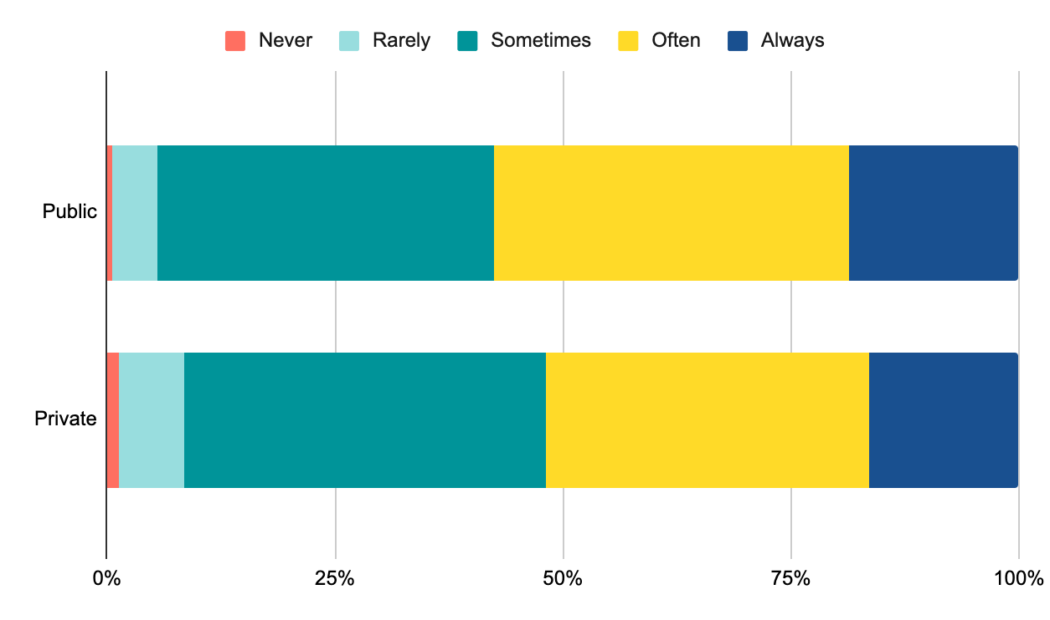

1. [Surge capacity of intensive care units in case of acute increase in demand caused by COVID‐19 in Australia](https://www.mja.com.au/journal/2020/212/10/surge-capacity-intensive-care-units-case-acute-increase-demand-caused-covid-19)
2. Australian Institute of Health and Welfare 2015. Australian hospital peer groups. Health services

   series no. 66. Cat. no. HSE 170. Canberra: AIHW.
3. [Department of Health: Hospitals webpage](https://www1.health.gov.au/internet/main/publishing.nsf/Content/hospitals2.htm)