New Zealand – Situation update 16 December 2020

16 December 2020

**Information presented in this assessment is based on data presented on the   
New Zealand Ministry of Health website.**

| **Summary of Cases as at 1100h, 16 December 2020** | | |
| --- | --- | --- |
|  | **Total** | **Change in last 7 days** |
| **Confirmed cases** | 1,744 | 12* |
| **Probable cases** | 356 | 0 |
| **Total (confirmed and probable)** | **2,100** | **12** |
| **Recovered cases** | 2,032 | 24 |
| **Deaths** | 25 | 0 |
| **Active cases** | 43 | -12 |
| **Current hospitalised** | 0 | 0 |

*\* New Zealand reported 14 new cases in the past seven days but reclassified two previous cases as historical resulting in the reported change of 12 additional cases.*

| **Source of acquisition of cases for the 7 days to 16 December 2020** | |
| --- | --- |
| **Overseas acquired/associated\*** | 14 |
| **Locally acquired** | 0 |

*\*Cases acquired while in managed isolation in New Zealand (e.g. family groups) are recorded as overseas associated.*

# New Zealand quarantine-free travel criteria

* New Zealand currently has no hotspots according to the definition: rolling 3-day average of daily new locally acquired cases is 3 or more by District Health Board.

# Summary of locally acquired cases

| **Date** | **Locally acquired cases** | **Rolling 3-day average** |
| --- | --- | --- |
| **10 December 2020** | 0 | 0 |
| **11 December 2020** | 0 | 0 |
| **12 December 2020** | 0 | 0 |
| **13 December 2020** | 0 | 0 |
| **14 December 2020** | 0 | 0 |
| **15 December 2020** | 0 | 0 |
| **16 December 2020** | 0 | 0 |

|  | **Notification Date\*** | **Number of days** |
| --- | --- | --- |
| Last locally acquired case | 18/11/20 | 28 days |
| Last locally acquired case of unknown source | 1/09/20 | 106 days |

*\*Date of notification to NZ Ministry of Health has been used, which may differ from the date reported in media releases*

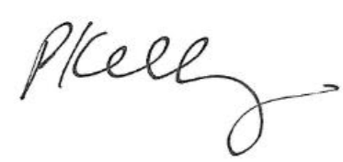

A/g Chief Medical Officer

Professor Paul Kelly

16 December 2020

DT0001127