COVID advice for carers

COVID-19 has been challenging for all of us. As a carer you have done a great job keeping the person you care for, and yourself, safe.
With restrictions continuously changing and the prospect of interacting more with support workers and others, it’s important that you still practise COVIDSafe behaviours.

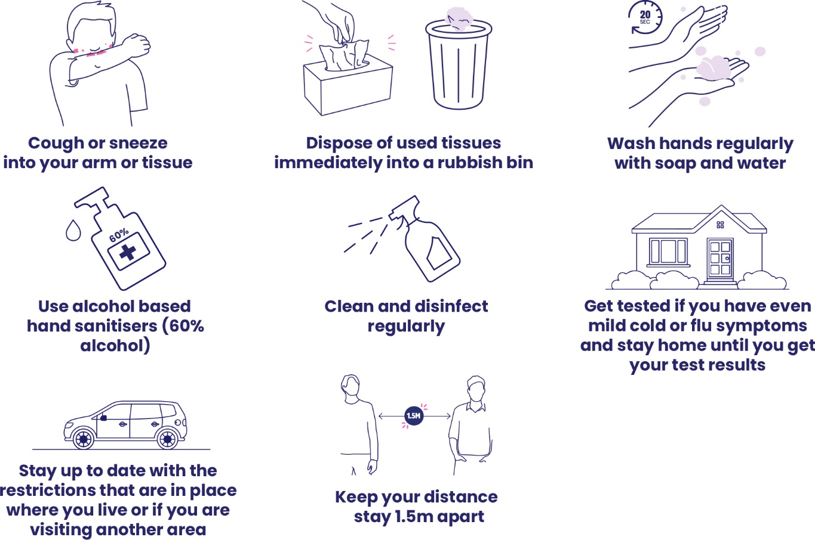
Protect yourself against COVID-19

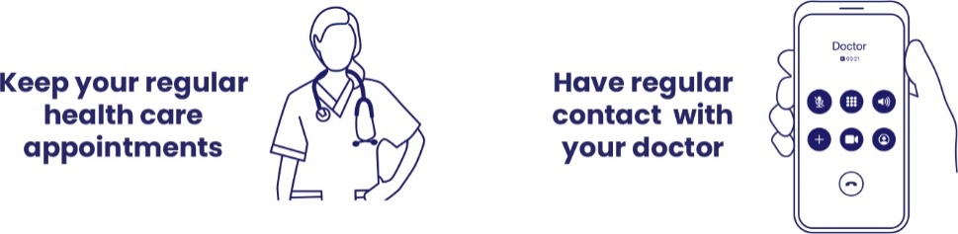
Look after your health

Further advice
Phone the National Coronavirus Helpline on 1800 020 080 or go to health.gov.au
For information on state and territory restrictions: australia.gov.au/#state-and-territory-government-information
For carer services and support go to the carergateway.gov.au

