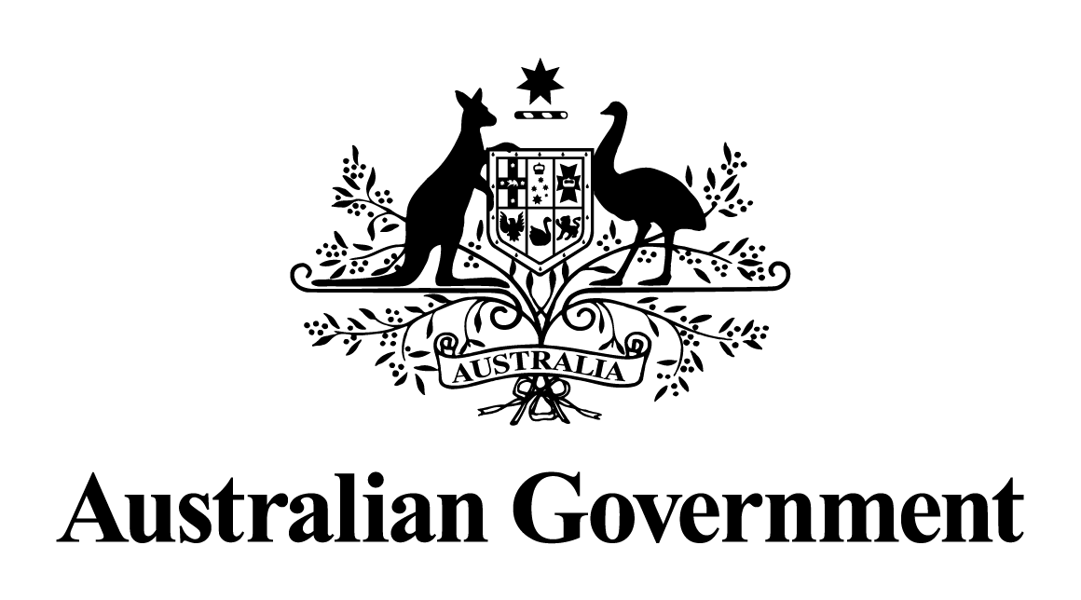

## Australian Government response to the Senate Community Affairs References Committee Report:

Inquiry into the Effectiveness of Special Arrangements for the Supply of Pharmaceutical Benefits Scheme (PBS) Medicines to Remote Area Aboriginal Health Services

March 2018

## RECOMMENDATION 1

**The committee considers that to the extent that compliance with privacy laws and obligations can be maintained, Medicare Australia and DOHA should facilitate the release of information to parties requesting it to ensure that opportunities to understand the impact of the program are not wasted.**

Response

The Australian Government supports this recommendation.

The Australian Government collects data in relation to Medicare and the Pharmaceutical Benefits Scheme (PBS) and this is published on the Department of Health and the Department of Human Services websites.

The Department of Health also publishes Remote Area Aboriginal Health Services (RAAHS) Program annual expenditure data on its website, broken down by State/Territory: ([Department of Health PBS Indigenous Information](http://www.health.gov.au/internet/main/publishing.nsf/Content/health-pbs-indigenous-info)).

In addition, and consistent with long-standing procedures, other statistical material may be released to applicants where an appropriate request is received by the Department of Health.

## RECOMMENDATION 2

**The committee recommends that the Commonwealth Government undertake an evaluation to ascertain whether the increased supply of PBS medicines provided by the program is having a clinical impact on the health of Aboriginal and Torres Strait Islander people in remote communities.**

Response

The Australian Government supports the intent of this recommendation.

The PBS is the mechanism through which the Australian Government provides timely access to affordable, subsidised medicines for all Australian residents. The RAAHS Program specifically supports the delivery of PBS-listed medicines to Aboriginal and Torres Strait Islander Australians residing in remote communities under section 100 (s100) of the *National Health Act 1953*.

The linking of medicine dispensing data with clinical outcomes is not undertaken. Each medicine listed on the PBS undergoes significant evaluation to determine its clinical efficacy for use by Australians as part of the rigorous Therapeutic Goods Administration approval process as set out in the *Therapeutic Goods Act 1989*. Medicines also go through a rigorous cost-effectiveness analysis as part of the Pharmaceutical Benefits Advisory Committee listing process set out in the *National Health Act 1953*.

The RAAHS Program was not designed to collect clinical data or monitor health outcomes. Clients of RAAHS are able to obtain PBS medicines for free, without requiring a Medicare card or a PBS prescription.

The Australian Government acknowledges that, while an assessment of the clinical impact of the program may be beneficial, an evaluation of any links between PBS medicine supply and clinical outcomes would be a major undertaking, requiring considerable research expertise and ethics clearance. Such research is likely to impose a significant reporting burden on relevant practitioners in participating Aboriginal Health Services (AHSs), whose primary role is the provision of healthcare to Aboriginal and Torres Strait Islander people.

A regular biennial review of health outcomes and the determinants of health is reported through the *Aboriginal and Torres Strait Islander Health Performance Framework*. Data analysis of 68 different measures by the Australian Institute of Health and Welfare is used to report on progress made under the framework.

## RECOMMENDATION 3

**The committee recommends that the Commonwealth Government provide specific funding for remote area AHSs to be able to provide dose administration aids (DAAs) to their patients.**

Response

The Australian Government notes this recommendation.

At present, the Australian Government funds the provision of Dose Administration Aids (DAAs) through programs and initiatives under the Sixth Community Pharmacy Agreement (6CPA). The Government has supported the provision of DAA services to the general population through incentive payments under successive CPAs.

As part of the historic compact reached between the Government and the Pharmacy Guild of Australia, announced in the 2017-18 Budget, from 1 July 2017, community pharmacies participating in the DAA program will receive a fee of $6 per patient per week as a contribution towards the cost of providing DAAs to eligible patients, in place of an incentive payment.

As part of the 6CPA, the Australian Government also supports DAA services to clients of rural and urban AHSs through the Quality Use of Medicines Maximised for Aboriginal and Torres Strait Islander Peoples (QUMAX) Program.

The Australian Government also continues to fund the s100 Support Allowance Program, allowing pharmacists to visit remote area AHSs and to provide quality use of medicines and medication management services to suit individual AHS needs.

The Indigenous Australians Health Program Integrated Team Care (ITC) Activity aims to contribute to improving health outcomes for Aboriginal and Torres Strait Islander people with chronic health conditions through better access to coordinated and multidisciplinary care. ITC Supplementary Services funding can be used to expedite a patient’s access to an urgent and essential health service, such as a DAA, where the service is not otherwise available in a clinically acceptable timeframe.

The RAAHS program provides for the supply of PBS medicines to RAAHS through a bulk supply arrangement. In addition to these bulk supply arrangements, some states and territories require pharmacies to provide PBS medicines labelled for individual RAAHS clients with chronic conditions. Many of these are supplied through a DAA. In November 2016, the Australian Government agreed to provide an additional payment to eligible pharmacists from 1 January 2017, in recognition of the additional effort required by pharmacists to provide medicines for individual RAAHS clients. This payment will be continued through the 2017‑18 Budget measure *Improving Access to Medicines — maintaining Remote Area Aboriginal Health Services pharmaceutical dispensing.*

## RECOMMENDATION 4

**The committee agrees with submitters and recommends that program flexibility be implemented to give remote area AHSs increased and direct access to the services of a pharmacist. This could be done by AHSs engaging a pharmacist directly or in collaboration with other stakeholders or service providers. Options for funding and operating these services could include cashing-out existing program funding, access to alternative funding measures, expansion of the Practice Nurse Incentive Program to include pharmacists, remunerating remote pharmacists for services though the Medicare Benefits Schedule, and removal of legislative barriers that prevent the operation of pharmacy businesses in remote areas.**

Response

The Australian Government supports this recommendation.

The Australian Government provides a range of funding to AHSs for various activities, including the employment of pharmacists, where this is deemed appropriate by the individual AHS. More than 130 Aboriginal Community Controlled Health Services (ACCHSs) in urban and rural areas have access to funding flexibility under the Indigenous Australians Health Program, which was established in July 2014. Activities that support primary healthcare service delivery are eligible for this funding, including development, employment and enhancement of workforce capacity.

The 6CPA s100 Support Allowance Program provides funding for pharmacists to provide a range of quality use of medicines and medication management services to remote area AHSs.

An individual AHS may employ health professionals, such as pharmacists, subject to its operational needs. However, the remoteness of some AHSs, the low population and lack of community amenities continue to present a challenge in attracting and retaining pharmacists in some areas. These issues are consistent with the wider issues of attracting and retaining other health professionals in regional and remote locations.

Commonwealth legislation does not limit the operation of pharmacies in remote areas. State and Territory legislation determines where a pharmacist can dispense medicines. For example, in the Northern Territory, a pharmacist is only authorised to dispense PBS medicines from an approved community pharmacy, not from an AHS.

Through the 6CPA, the Australian Government has committed $50 million to support a Pharmacy Trial Program, to fund a number of trials to improve patient outcomes and expand the role of pharmacy in delivering a wider range of primary healthcare services. A particular focus of the trials is on programs which would benefit Aboriginal and Torres Strait Islander peoples, and consumers in rural and remote areas. One of the first trials is a feasibility study that aims to improve medication management for Aboriginal and Torres Strait Islander people through pharmacist advice and culturally appropriate services. The feasibility study, to be jointly led by the Pharmacy Guild of Australia and the National Aboriginal Community Controlled Health Organisation (NACCHO), commenced in late 2017.

In July 2017, the Minister for Health, the Hon Greg Hunt MP, announced plans for a trial that will see a pharmacist working directly as part of a primary care team within ACCHSs. This trial aims to improve patients’ understanding of and use of their medicines and will leverage existing relationships with community pharmacies to improve patients’ access to programs under the 6CPA. This trial will be jointly led by the Pharmaceutical Society of Australia and NACCHO and is expected to commence in early 2018.

## RECOMMENDATION 5

**The committee recommends that the Commonwealth Government establish a consultative body of relevant stakeholders to develop proposals and options to increase direct access to pharmacists for remote area AHSs, consult program participants and others, and provide support to AHSs to allow them to make informed choices about options.**

Response

The Australian Government supports the intent of this recommendation.

The Australian Government provides funding for remote area AHSs to obtain direct access to pharmacists through the Section 100 Pharmacy Support Allowance Program under the 6CPA. This program provides funding to pharmacies to provide services to support a remote area AHS in its implementation of, and ongoing participation in, the RAAHS Program. These services include provision of education services to AHS staff in relation to the Quality Use of Medicines.

The Australian Government undertakes a range of stakeholder consultation activities for programs supporting AHSs and the delivery of healthcare for Aboriginal and Torres Strait Islander peoples.

The Australian Government is committed to ensuring that the views of stakeholders are heard and meetings with a range of stakeholders are held regularly to enable their views to be heard by Government. This includes ongoing discussions with NACCHO, a peak stakeholder organisation representing community controlled AHSs across Australia.

Under the 6CPA, wide-ranging consultation with stakeholders is designed to assess how well current arrangements work and how they can be improved. This includes consultation to improve clinical outcomes for consumers and extend the role of pharmacists in the primary healthcare setting. The Review of Pharmacy Remuneration and Regulation (the Review) was an independent assessment of pharmacy services provided under, and outside of, the community pharmacy agreement model. As part of the Review, stakeholder views were sought on programs responsible for delivering PBS medicines to remote communities and the arrangements for distribution and guarantee of supply to community pharmacies across Australia. This occurred through ‘town hall’ type meetings, targeted consultation meetings, written submissions, on line surveys and a national interactive webcast consultation.

Remuneration for supplying government-subsidised medicines and rules governing the location of pharmacies were also examined under the Review. In addition, how existing arrangements contribute to patient health outcomes and improved quality use of medicines, including for Aboriginal and Torres Strait Islander people, was examined. Aboriginal Health Services and other peak groups were provided with opportunities to contribute to the Review. The Final Report on the Pharmacy Remuneration and Regulation Review is currently being considered by Government.

## RECOMMENDATION 6

**The committee is surprised to note that there is no universal system in place to provide for accurate and legible labelling and recording of medicines. The committee therefore recommends that the Commonwealth Government urgently support the development and introduction of efficient standardised systems for accurate labelling of medicines in remote area AHSs, and that these systems are developed to ensure accurate collection of medicine data and use.**

Response

While the Australian Government supports the intent of this recommendation, labelling of dispensed medicines is a state and territory responsibility.

The Australian Government provides funding to the States and Territories, and to ACCHSs under the Indigenous Australians Health Program, to support the provision of clinical and cost-effective health services. This may include the purchase and development of relevant systems. The Australian Government does not generally direct how this funding is used.

Aboriginal Health Services in remote Australia participating in the RAAHS Program can access the s100 Support Allowance Program, which provides AHSs with the opportunity to negotiate arrangements with ‘support pharmacists’ to provide a range of quality use of medicines and medication management services to suit the individual AHS’ needs.

Each State and Territory has its own legislation concerning the labelling and recording of medicines dispensed by community pharmacies and hospital authorities throughout Australia. Commonwealth law requires collection of certain information about medicines that are funded under the PBS. Pharmacies and AHSs participating in the RAAHS Program must adhere to the relevant State and Territory laws which vary between jurisdictions, which limit the implementation of a universal system for labelling and recording medicines for the RAAHS Program.

## RECOMMENDATION 7

**The committee recommends that the Commonwealth Government publish information on the status of recommendations from previous reports, making it clear which recommendations will be implemented, timeframes and responsibility for implementation.**

Response

The Australian Government supports this recommendation.

The Department of Health submission to the inquiry, available at [Parliament House Parliamentary Senate Community Affairs](http://www.aph.gov.au/Parliamentary_Business/Committees/Senate/Community_Affairs/Completed_inquiries/2010-13/pbsmedicines/submissions), provided a significant amount of detail on the way in which the Government has responded to the recommendations of previous reports.

The independent Review of Pharmacy Remuneration and Regulation considered programs designed to improve access to, and affordability of, medicines, for Aboriginal and Torres Strait Islander people. The interim Review Report was released in July 2017 and included a proposal that access to medicines programs for Indigenous Australians under the RAAHS Program and the Closing the Gap PBS Co-Payment Measure be reformed so that the benefits to the individual follow that individual, regardless of where the prescription is written or dispensed. The Final Report on the Pharmacy Remuneration and Regulation Review is currently being considered by Government.

## RECOMMENDATION 8

**The committee recommends that the Commonwealth Government ensure that participants in the section 100 program have sufficient opportunities to participate in the implementation process.**

Response

The Australian Government supports this recommendation and will build on the existing range of mechanisms to ensure this recommendation is realised.

The independent Review of Pharmacy Remuneration and Regulation considered programs designed to improve access to, and affordability of, medicines, for Aboriginal and Torres Strait Islander people. The interim Review Report was released in July 2017 and included a proposal that access to medicines programs for Indigenous Australians under the RAAHS Program and the Closing the Gap PBS Co-Payment Measure be reformed so that the benefits to the individual follow that individual, regardless of where the prescription is written or dispensed. The Final Report on the Pharmacy Remuneration and Regulation Review is currently being considered by Government.

## RECOMMENDATION 9

**The committee would like to see greater integration of existing programs to provide complementary services to patients of AHSs. The evidence the committee received during the course of this inquiry supports this. Therefore the committee recommends that DOHA develop a process for integrating existing programs, and that a clear policy and program logic is published to show how these programs will work together.**

Response

The Australian Government supports this recommendation in principle and is committed to the development and implementation of programs and services that are well integrated.

The PBS medicine supply programs and related measures have the same intended aim, to overcome barriers that inhibit access to PBS medicines by Aboriginal and Torres Strait Islander people, wherever they reside. In order to ensure programs meet the varying needs of the community, such as geographic isolation, socio-economic factors, and/or the availability of health infrastructure, flexibility needs to be built in to allow for different ways to access medicines.

## RECOMMENDATION 10

**The committee recommends that the Commonwealth Government clarify the application of the section 100 supply program to remote aged care facilities, and advise operators of these facilities accordingly.**

Response

The Australian Government agrees to this recommendation.

Commonwealth funded residential aged care facilities (RACFs) are not included within the definition of an AHS under the RAAHS Program. That is, they cannot receive bulk supply of medicines and store them for resident use. Accordingly, they are not eligible to participate in the RAAHS Program. PBS medicines in RACFs are provided under normal PBS arrangements. The operators of aged care facilities that have contacted the Australian Government for advice on this matter have been advised accordingly. The Department of Health will ensure that this and other related information continues to be made available to RACFs.