Over 100 people joined the Prime Minister, the Minister for Health and the Prime Minister’s Suicide Prevention Adviser in Canberra on 13 November to design new ways to address the complex issues contributing to Australia’s suicide rate.

The *Towards Zero Suicide Prevention Forum* brought together a range of government, non-government and community stakeholders in a series of workshops. The Forum was one mechanism used to inform Ms Morgan’s interim advice to the Prime Minister, with representatives included those from the Aboriginal and Torres Strait Islander community, the LGBTQI+ community, veterans, young people, business, researchers, suicide prevention experts, all levels of government and people with lived experience of suicide.

The Forum was attended by the Prime Minister, the Hon Scott Morison, and the Minister for Health, the Hon. Greg Hunt, who affirmed the priority that suicide prevention had been given by the Commonwealth Government and by all Governments under COAG. They encouraged participants to find common ground and a unified voice that would speak to the solutions that would have the greatest impact. They challenged people attending the forum to use their diverse perspectives to drive new thinking and to bring forward practical responses that can be implemented.

Through a series of workshops, participants considered better responses to the needs of specific target groups, ways to address social determinants through policy and program levers and enhanced coordination across multiple agencies at all levels of government. The forum also asked participants to consider how to better support and empower families and communities, develop practical solutions to better integrate health and non-health services and ways to ensure local planning and response is based on data and evidence.

The diversity of perspectives and areas of specialisation combined with the lived experiences of some participants meant that there was a range of views about how to achieve outcomes. The challenge ahead is to ensure that these ideas can inform practical changes to policy as well as community and system-driven responses.

Some of the key themes that emerged through discussions at the Forum included to:

1. Further leverage lived experience, peer workers and community networks to reach people where they are, especially those who may not be engaging with health services.
2. Invest in the workforce, including to upskill and empower non-health sectors to play a vital role in suicide prevention.
3. Respond early to those experiencing distress rather than waiting for a crisis and support communities impacted by adverse events.
4. Prioritise care-coordination for all people in suicidal distress to ensure they get the right service at the right time with alternatives to Emergency Departments urgently needed.
5. Create tools, resources and supports that enable families and communities to support the people around them.
6. Invest in local solutions informed by local data.
7. Elevate the response to social determinants of suicide, considering a prevention in all policies approach.
8. Harness existing bipartisan support to embed a long-term strategic direction.

Those attending the forum have been invited to send further details to the Taskforce following the forum, with a broader call for submissions to occur in 2020 to inform the ongoing work of the National Suicide Prevention Taskforce.

In preparing for the forum, Ms Morgan met with several Ministers who shared their commitment to working towards zero suicides and in supporting a whole-of-government approach to suicide prevention. Several of these Ministers recorded their support in a video message that can be viewed [here](https://publish.viostream.com/play/bfxgwognir9z58).

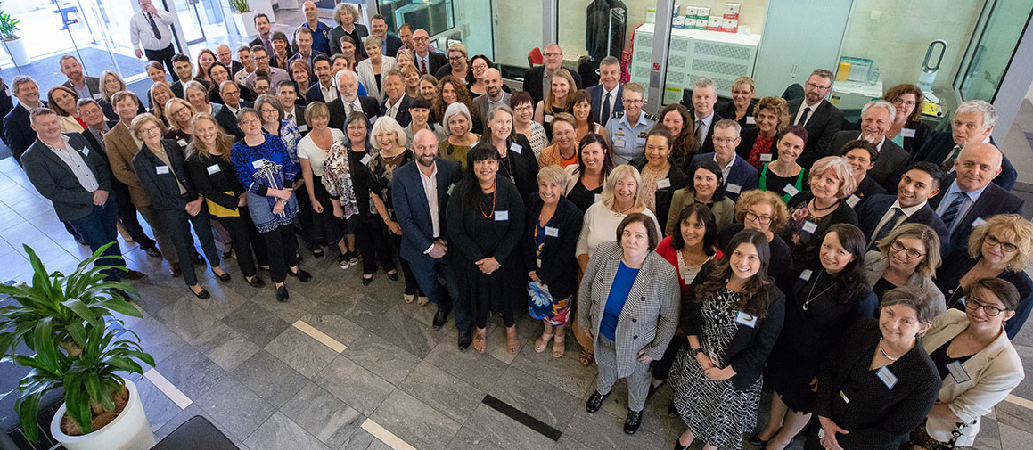

*Participants at the Towards Zero Suicide Prevention Forum: Opportunities for a Coordinated Response*