National Contact Tracing Review
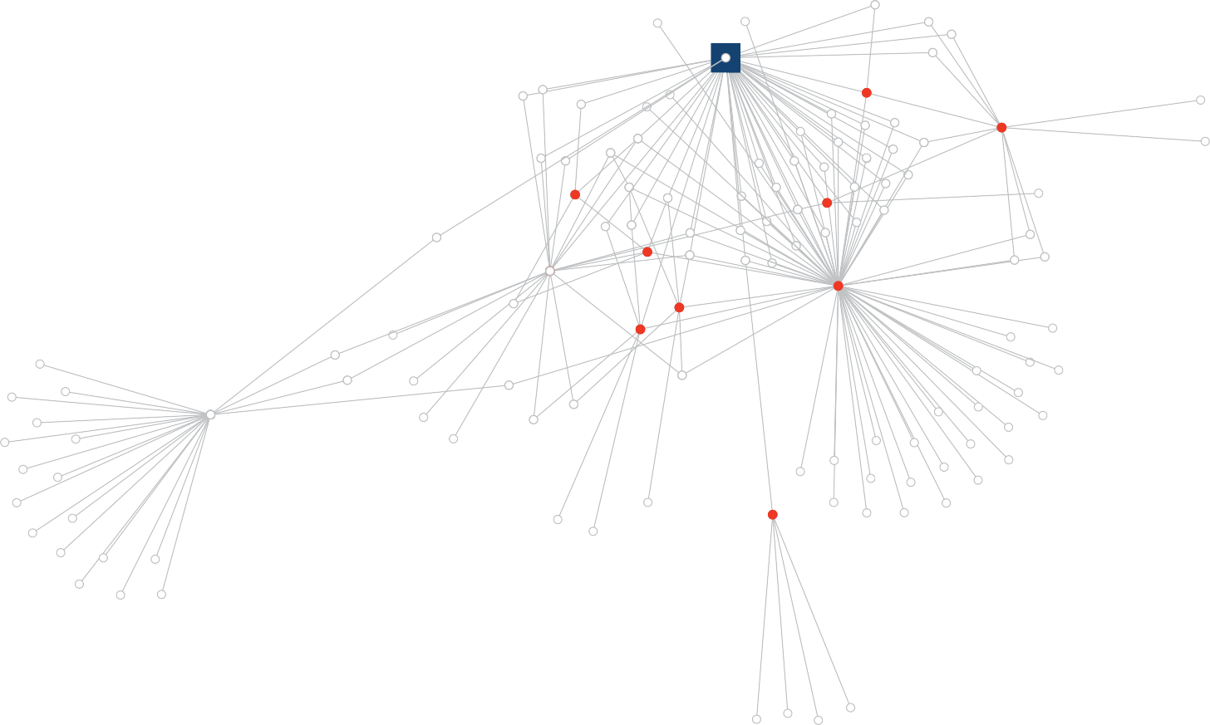
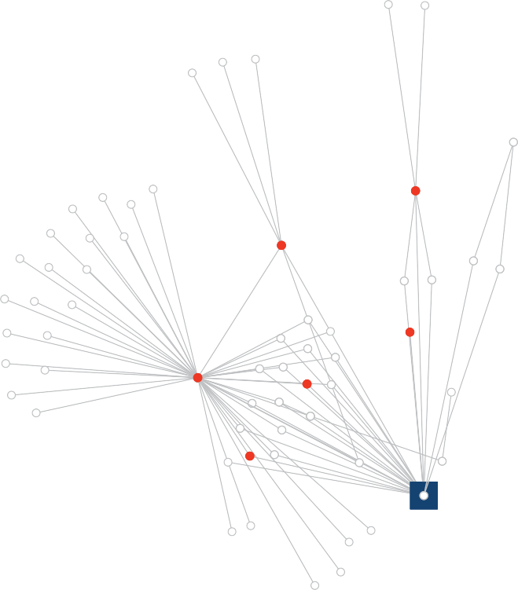

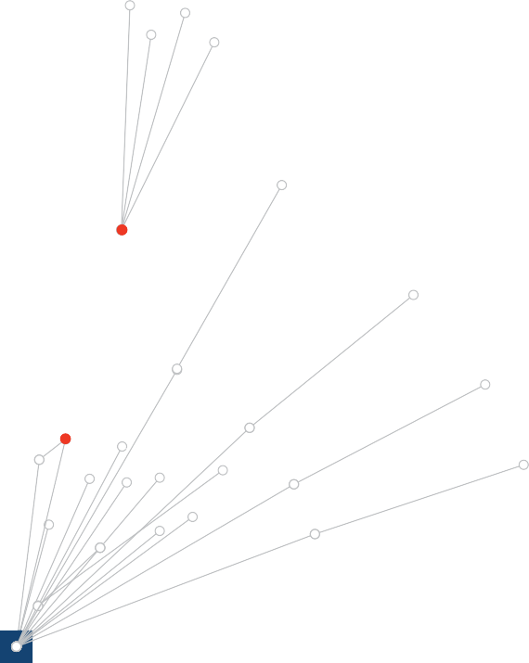

A report for Australia’s National Cabinet
November 2020

© Commonwealth of Australia 2020 Creative Commons
Attribution 4.0 International Licence CC BY 4.0

Unless otherwise noted, copyright (and any other intellectual property rights, if any) in this publication is owned by the Commonwealth of Australia.

All material in this publication is licensed under a Creative Commons Attribution 4.0 International Licence, save for content supplied by third parties, logos, any material protected by trademark or otherwise noted in this publication, and the Commonwealth Coat of Arms.

Creative Commons Attribution 4.0 International Licence is a standard form licence agreement that allows you to copy, distribute, transmit and adapt this publication provided you attribute the work. A summary of the licence terms is available from https://creativecommons.org/licenses/by/4.0/.

The full licence terms are available from https://creativecommons.org/licenses/by/4.0/legalcode

Content contained herein should be attributed as National Contact Tracing Review, A report for National Cabinet, Australian Government Department of Health.

Cover graphic courtesy of Victorian Department of Health and Human Services.

Disclaimer

The Australian Government as represented by the Department of Health has exercised due care and skill in the preparation and compilation of the information and data in this publication. Notwithstanding, the Commonwealth of Australia, its officers, employees, or agents disclaim any liability, including liability for negligence, loss howsoever caused, damage, injury, expense or cost incurred by any person as a result of accessing, using or relying upon any of the information or data in this publication to the maximum extent permitted by law. No representation expressed or implied is made as to the currency, accuracy, reliability or completeness of the information contained in this publication. The reader should rely on their own inquiries to independently confirm the information and comment on which they intend to act. This publication does not indicate commitment by the Australian Government to a particular course of action.

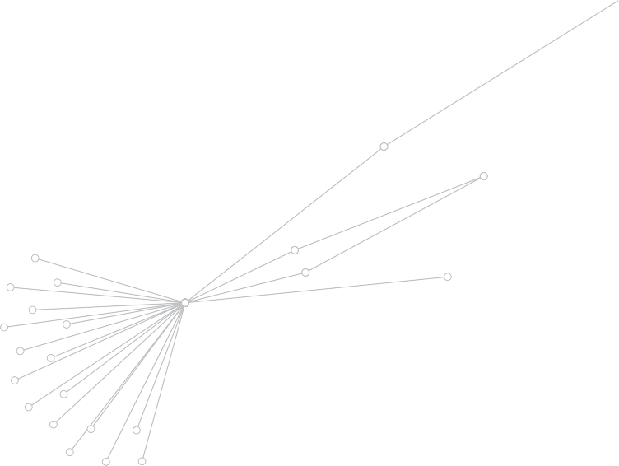
Vision

A mobile, healthy community and active economy, in the presence of COVID-19, made possible by public health preventative and control measures.

Rationale
In the absence of a vaccine or effective treatment for COVID-19, an important means to bring about a return to normal economic and community activity is rapid testing, contact tracing, isolation and outbreak management.
This is supported by modeling that indicates reducing the duration from patient testing to quarantine of their close contacts to fewer than 48 hours, substantially lowers community transmission.

LETTER
FROM THE CHAIR
Dear Prime Minister, Premiers and Chief Ministers,
In this extraordinary year Australia has been confronted by fires, floods and a pandemic. Through the combination of long term preparation, collegiate governance and respected public health advice, Australia has done better dealing with the pandemic than most comparable countries, but the cost and disruption have been substantial. My fellow Panel members and I trust that our review will assist the Commonwealth, state and territory governments and Australia’s public health systems to further strengthen management of the pandemic and ensure our prosperity.
To prepare our review, the Panel visited every state and territory, most in person but two by video link. We were warmly received by Premiers, Ministers, Heads of Department, Chief Health Officers, Police Commissioners, Heads of Emergency Services, Chief Information Officers and others.
I collectively thank them all for their patience and their openness.
Our overwhelming impression was that wherever we looked we saw excellence and commitment. Each jurisdiction runs its pandemic health response its own way, but they are all willing to share and to learn.

I am confident in Australia’s ability to achieve and maintain the vision of a prosperous and mobile society even in the presence of COVID-19. The secret is preparation. The most effective responses have been achieved through long term investment in public health and other emergency capabilities. Through preparation, when faced with a fast emerging public health emergency we can efficiently activate the machinery of preventative public health and control measures. This pandemic is far from over – we must remain vigilant against the possibility of outbreaks, mutations or entirely new pandemics.
The genesis of this review was the response by National Cabinet to the review covering NSW and Victoria that Commodore Mark Hill and I presented to National Cabinet in September. I thank Mark for the experienced and analytical thinking he brought to that effort.

For the current review, the Panel needed expertise in public health and policy, and in digital technology and delivery. These skills have been admirably provided by Tarun Weeramanthri and Leigh Jasper, respectively. We were supported by a highly capable taskforce drawn from the Australian Public Service.

I take this opportunity to thank the Prime Minister and other government leaders for the opportunity to chair a number of significant reviews in my five years as Australia’s Chief Scientist. It has been a privilege to lead the development of evidence based reviews across low emissions strategies, science education and research systems, and now public health. One standout factor that has made my work possible has been the invisible work of public servants. When the task is huge, the time is short and the public good is calling, they work as hard and as astutely as the teams I used to lead when I ran a company in Silicon Valley.
Prime Minister, Premiers and Chief Ministers, I commend to you our review on optimising COVID-19 contact tracing and outbreak management across our nation.
Yours sincerely, Dr Alan Finkel
Australia’s Chief Scientist
Chair of the National Contact Tracing Review Panel

CONTENTS
Overview from the panel 9
Recommendations 13
Characteristics of an optimal contact tracing
and outbreak management system 19
Chapter 1 Constant Preparation 25
Chapter 2 End to end contact tracing 51
Chapter 3 Outbreak investigation and management 59
Chapter 4 Data exchange 63
Chapter 5 Technology 67
Chapter 6 A conversation with communities 77
Chapter 7 Earning community confidence 81
Glossary 85
Members 90
Acknowledgments 91

OVERVIEW

FROM THE PANEL

Strengthen capacity, build confidence, avoid complacency
We were tasked by National Cabinet with reviewing COVID-19 contact tracing and outbreak management systems in each state and territory to determine their ability to support an active economy by Christmas 2020. This includes systems for testing and tracing, quarantine and isolation, outbreak management, data exchange, and surge capacity. Although our remit was the current COVID-19 pandemic, we note that most of our recommendations may be relevant to managing future pandemics caused by other infectious diseases.
As we visited each jurisdiction in October 2020, it became clear to us that internal borders will only reopen and remain open if state and territory leaders have confidence in how their interstate counterparts are managing the pandemic. By the same token, the economy will only bounce back if Australians feel confident they can participate and travel safely. Many of our recommendations are aimed at building this confidence and ensuring it is well founded.

The states and territories have decision making authority for public health and will remain responsible for their own contact tracing and outbreak management systems. Our review acknowledges this autonomy while identifying areas where changes to processes, information sharing and technology will improve national capability.

Our remit was contact tracing and outbreak management. These systems must perform extremely well if we are to successfully live with COVID-19 until a vaccine or an effective therapeutic arrives, and perhaps longer. However, contact tracing and outbreak management are necessary but not sufficient components of an overall response and they are measures we would prefer never to have to activate. Crucially important in the first line of defence are measures relating to physical distancing, personal hygiene, staying away from work and gatherings if unwell, testing if symptomatic, mask wearing where required, limiting access to vulnerable communities where appropriate, COVID Safety Plans, attendance limits at public events, and quarantine for international travellers and others at risk of having been exposed.
Overall, we found very strong commitment to prevention and control measures across the country. All jurisdictions are committed to implementing effective COVID-19 contact tracing and outbreak management systems, have increased their investment and are training and preparing constantly. Across all states and territories the information technology systems used for contact tracing have improved significantly over recent months.

However, we found processes that can be improved. In some jurisdictions, interviews with contacts are recorded on paper before being entered into a database, causing delays and the potential for error. Contact information is inconsistently collected when people visit venues. Text messages to people with COVID-19 and contacts are not always in the preferred language of the person. Domestic airline passenger lists and contact details are not always accurate. Real time performance metrics are not sufficiently ambitious.
Our report sets out the characteristics of an optimal contact tracing and outbreak management system, and invites every jurisdiction to evaluate its performance against this blueprint.

We also recommend clear, measurable and transparent metrics that should be published by each state and territory to allow the public to track performance.

The two key performance metrics we recommend relate to fast testing and fast notifications to contacts. The currently agreed national target of 48 hours from reporting a positive test result to directing close contacts to quarantine is inadequate from the point of view of suppressing community transmission.

We recommend that test results should be available within 24 hours of a sample being taken, maximising the likelihood that people will isolate themselves while awaiting test results. We recognise this may be difficult in remote parts of Australia, but it is an important stretch goal and confirmation of our
national capability.
Further, we recommend no more than 48 hours in total from the time a test sample is first taken to the point at which close contacts of a confirmed case are notified to quarantine. Advice to us is that if this turnaround time is achieved, we can substantially reduce community transmission.

Across the jurisdictions we discovered quite different digital solutions for case management and contact tracing, developed in isolation. In some instances, the digital systems are built on similar underlying platforms, but they are heavily configured and require different training for users.

However, the panel does not recommend the creation of a single integrated national contact tracing system. The important thing is that information is shared efficiently, where necessary. States and territories must be able to access and transfer information about cases and contacts where people have crossed borders. Currently, such information is conveyed through phone calls or emails, a practice that would not withstand high case numbers.
For this reason, we recommend the development of a digital data exchange mechanism. Building this capability now would prepare the states and territories for coordinated contact tracing to more effectively manage future outbreaks.
The mechanism we suggest would allow the states and territories to share contact tracing data, and incorporate contact tracing data from sources such as airline and shipping passenger manifests, registries of test results and relevant government agency data stores. Only data relevant to contact tracing would be transferred, such as phone numbers, addresses, case interviews and diagnostic test results. No data would be held or stored in the data exchange. As such, we are confident the data exchange can be consistent with privacy requirements and community expectations.
We make a number of recommendations to improve the use of technology.
In that context, we recommend that the states and territories share information about new and emerging technologies, such as electronic venue and workplace attendance registration systems, smartphone apps to monitor self-quarantine, new diagnostic tests and wastewater surveillance. For example, the venue attendance app used in the ACT is as simple as “click and enter”, the only information shared is an email or phone number, no information is used for marketing and data are purged every 28 days.
Patient testing, contact tracing and case management should be fully digital end to end, starting at the point of testing. This includes collection of information, reporting of results, contact tracing, case management and outbreak management.

However, while a fully digital system dramatically improves the efficiency of contact tracing, it will never replace the need for well trained contact tracers and expert public health oversight, especially for difficult interviews, cluster analysis and outbreak responses. All states and territories should employ a permanent workforce for tracing and outbreak management, with senior public health leadership, and should have an additional surge workforce trained and at the ready. Digital case management and contact tracing systems should allow easy and secure onboarding of contact tracers from other states and territories and from the Commonwealth.
In the event of an outbreak, every effort should be made to go hard and go early. The driving principle for contact tracing must be to never fall behind, which means operating procedures should allow a risk based prioritisation of contact tracing practices that if the surge workforce becomes overwhelmed. These would include, for example, initial notification of close contacts by text instead of by phone.
Desktop exercises and field rehearsals should be run regularly to ensure the system can deal with a sustained surge of around four new cases per day per million population and be able to rapidly scale up should there be a further escalation.
As Australia takes steps to reopen, we emphasise that a national testing and contact tracing system is only as good as its weakest link. No jurisdiction can afford to let down its guard. Each must have a strong focus on continuous improvement, including regular stress testing, a highly trained workforce, high functioning technology, and a commitment to transparency on performance metrics. We must keep awareness high and the safety message front and centre if we are to avoid the complacency that can be a dangerous companion to low case numbers.
COVID-19 remains a complex and highly communicable disease. Even with the best systems in place, outbreaks are likely to be unavoidable. We are acutely aware of the lockdowns being imposed once again in many countries as the world struggles to find a way to live with the pandemic. However, we believe that Australia’s internal borders and economy can safely, confidently and successfully reopen, and the nation can manage an early cluster or outbreak and a moderate number of confirmed cases in the community without resorting to wide area lockdowns. To ensure this, each state and territory needs to be well aligned to the characteristics of an optimal contact tracing and outbreak management system as outlined in this report, alongside important measures to prevent transmission.





Alan Finkel | Leigh Jasper | Tarun Weeramanthri






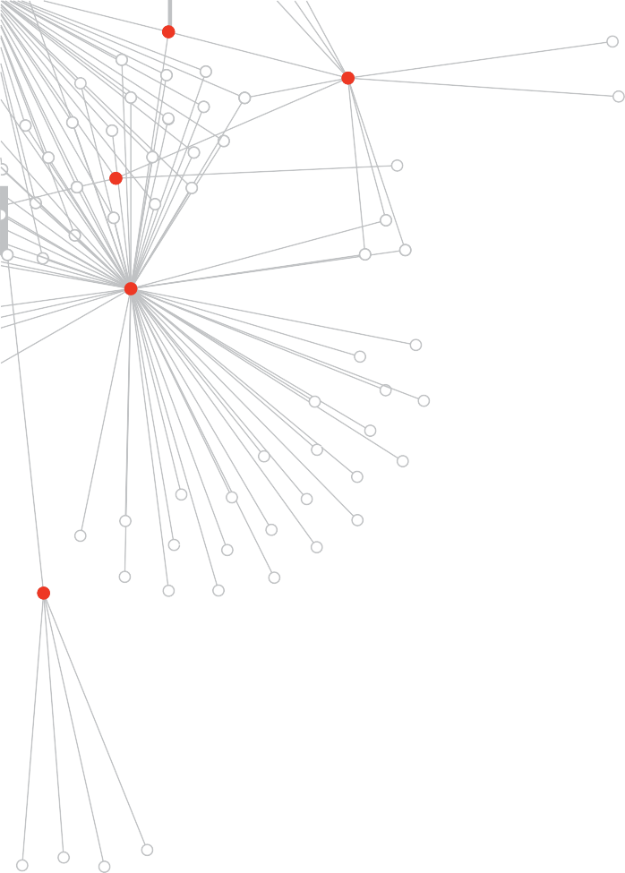
Assumptions
A number of key assumptions have guided the consultation process and findings of this review.
- Each state and territory will exercise its constitutional obligation to ensure the health of its citizens by managing its own contact tracing and outbreak management within its borders.

- Each state and territory will be willing to support cross border contact tracing and outbreak management through digitally sharing contact tracing information.

- In a time of need, provision of surge support from other states and territories will be provided, wherever possible, by temporarily recruiting staff to work in the service of the state or territory in need and enabling remote access by signing in to that state or territory’s contact tracing system.

RECOMMENDATIONS

The bigger picture
- Continuous improvement
  - All jurisdictions should aspire to continuous improvement and reflect upon, evaluate and externally communicate their performance against the list of ‘Characteristics of an Optimal Contact Tracing and Outbreak Management System’.
- Preventative public health measures
  - Maintain the focus on preventative public health measures, including those that were agreed by National Cabinet early in the course of the pandemic.

Constant preparation
- Workforce and training
  - Ensure ongoing investment in the medium to long term in accredited training programs for applied epidemiology and applied public health training.
  - The Commonwealth, states and territories should consider increasing the number of public health training positions in all jurisdictions.
  - All states and territories should continually invest in training surge workforces to be employed in a reserve capacity.
  - Ensure there is capacity for the Commonwealth to mobilise a trained contact tracing surge workforce through the Australian Public Service to assist states and territories with contact tracing should the need arise.
  - Continue funding rapid deployment capability to coordinate a standby pool of equipment (including personal protective equipment and transportable laboratory equipment) and senior clinical and public health experts for extreme situations requiring surge capacity anywhere in Australia.
  - Undertake forward planning for the pathology laboratory workforce, given the ongoing requirement for high volume testing in the near and medium term.
- Stress tests
  - States and territories should undertake desktop and functional simulation exercises to verify the performance of their contact tracing and outbreak management systems.
  - Desktop and functional simulation exercises should be based on four new confirmed cases (not in quarantine) per day per million population (but no fewer than four per day per jurisdiction) for a week or more. This daily case number is consistent with the Framework for National Reopening adopted by National Cabinet.
  - Extreme stress testing should be based on up to ten times the standard stress testing numbers.

End to end contact tracing
- Never fall behind
  - An effective contact tracing and case management system will cope with high case numbers. In extreme conditions, the jurisdiction should in the first instance recruit workforce assistance from other jurisdictions and the Commonwealth. If this proves insufficient, it is nevertheless essential to keep up with managing new cases. In order to never fall behind, the extent of contact tracing measures should be reduced on a risk minimisation basis.

  - COVID-19 testing resources and strategies
  - Continue to fund COVID-19 pathology tests through the Medicare Benefits Schedule and other funding arrangements.
  - Continue to ensure adequate supplies of testing reagents and build stockpiles during quiet times.
  - Ensure that pop-up test sites can be rapidly deployed, in under six hours in metropolitan locations, and in under 24 hours in regional locations.
  - Pathology laboratories should use diagnostic instruments from multiple vendors to ensure resilience during times of global shortages of reagents.
- Support for maintaining national standards
  - Ensure Commonwealth epidemiological and public health expert support is provided to the Communicable Diseases Network Australia for ongoing work for COVID-19 and other notifiable diseases, including development and maintenance of the Series of National Guidelines.

Data Exchange
- Technical capability
  - Develop a ‘Data Exchange’ capability to facilitate contact tracing, through the exchange of data between states and territories, and access to contact tracing data from relevant government agencies.
  - Data should not be stored in the Data Exchange itself, thereby allowing a simplified, decentralised design with high levels of privacy and security.
  - The exchange of data would ideally be as near to real time as is practical and consistent with Commonwealth, state and territory security and privacy requirements.
- Data sources
  - The Data Exchange would access a variety of data sources such as appropriate administrative databases, airline and shipping passenger contact tracing information, other relevant government agency databases, contact tracing databases from other states and territories, and COVID-19 diagnostic test result repositories.
  - Evaluate the possibility of the Data Exchange in the medium term accessing the Australian Immunisation Register for relevant vaccine status.
  - In all instances data requests must be restricted to data that are relevant to a public health response, such as phone numbers, addresses, case interviews and diagnostic test results.
  - Domestic airlines should supply accurate passenger contact tracing information on request, accessible by the Data Exchange. Accuracy would be improved by requiring photo ID checks for all domestic passengers.
  - Australian Border Force should work with international airlines and shipping companies, supported by bilateral travel agreements, to provide accurate passenger contact tracing information on request, accessible by the Data Exchange.
- Implementation
  - For efficiency in implementing the Data Exchange:
    - Limit the initial implementation to a pilot involving Victoria, NSW, ACT and the Commonwealth.
    - Development of the pilot should be based on an indicative scope of technical work developed by these jurisdictions and others that wish to contribute.
    - Deployment in other jurisdictions would proceed if an evaluation of this pilot implementation concludes that it is successful.

  - Implementation of the Data Exchange should not delay any existing plans for sharing of contact tracing data, such as may be provided by airlines and Australian Border Force.

Outbreak management
- Identify sources
  - At low case numbers, epidemiologists and other public health experts should strive to identify the source of infection for all confirmed cases. Where the source of infection is unknown, detailed upstream mapping of contacts to identify the source of infection should be undertaken.
- Predictive analytics
  - Develop, evaluate and share advanced analytics software for outbreak analysis and predicting risks, to support existing expertise.

Technology
- Pathology test technologies
  - Researchers and public pathology laboratories should continue to invest in developing and validating new COVID-19 specimen collection and diagnostic methods.
  - A framework should be developed on the role and use of rapid antigen tests, to support the public health response to COVID-19 and enable tracking of all positive and negative test results by public health authorities.
- Automation and digital support
  - Fully digital and partially automated end to end systems should be implemented within each state and territory to support collection of case information, reporting of COVID-19 test results to the health department, allocation of confirmed cases, contact tracing, digitally issued quarantine directions, case management and outbreak management.
- Attendance registration
  - Recording of contact tracing information of attendees should be a condition of entry to restaurants and other public venues, institutions and workplaces. Electronic data collection should be strongly encouraged, with pen and paper only being used if the former is unavailable.
  - Where attendance data are recorded for contact tracing, only the minimum information required for that purpose should be collected. Data collected for contact tracing should only be used for contact tracing purposes, kept securely and permanently deleted after 28 days.
  - Contact tracing information must be made available to health authorities in a timely manner, at most within 24 hours of request, to assist contact tracing.
  - Where smartphone apps are used, they should have simple “click and enter” functionality to encourage compliance.
  - To maximise participation, ensure effective communication of the benefits of attendance registration.
  - States and territories should consider using a single smartphone app within their jurisdiction, or require that all smartphone apps adhere to the above requirements.

- Other technology solutions
  - Evaluate consent based systems that can download contact tracing information from smartphones.
  - The Commonwealth should lead the development of arrangements between states and territories and payment card providers so that contact tracers from the states and territories will be able to request contact details of persons who have made a transaction at a hotspot venue, noting that privacy rules will apply and in some jurisdictions legislative change may be required.
  - Develop, use and share proven web portals and smartphone apps for quarantine monitoring and tracking entry into high risk settings, such as residential aged care homes.
- COVIDSafe app
  - The Commonwealth should continue to enhance the functionality of the COVIDSafe proximity app, particularly with respect to the duration for identifying contacts and enhancing notifications to users on the status and operation of the app.
  - The Commonwealth should consult with the states and territories on ways to optimise incorporation of COVIDSafe contact information early in the contact tracing process.
  - The Commonwealth should consult with the states and territories on the best means to report usage of the app in contact tracing.
- Wastewater testing
  - The public health, clinical and wastewater sectors should build on existing research and field testing of wastewater detection to validate its role as an early signal of potential outbreaks.
  - Determine whether a goal of 50% coverage of the Australian population is practical and useful, with appropriate coverage of urban and rural areas. If so, aim to achieve this level of coverage in the medium term.
  - States and territories should publish results regularly.

A conversation with communities
- Involve communication experts early and throughout
  - Integrate and embed communications and media experts in health, emergency, police, customer service and other relevant government departments to ensure that public health messages are pitched appropriately for state wide and local audiences, and vulnerable communities.
  - Work with community leaders to ensure that public health messages are culturally and linguistically tailored to each community, and understood and amplified through existing formal and informal networks.
- Avoidance of confusion
  - All messages to affected communities, families and individuals should be evaluated to minimise any risk they could be misinterpreted.
  - Consistent messages should be given to all individuals in affected families, and consistent guidance provided to leaders and staff in affected settings, such as workplaces, schools, and places of worship.
  - Automated text and web messages provided to people in isolation and quarantine should be offered in their preferred language.

Earning community confidence
- Reporting confirmed cases
  - Confirmed cases identified in quarantine are a sign of a well functioning system that is able to mitigate community exposure and transmission. Confirmed cases identified in the community are cases that are more complex and have to be actively traced and managed. States and territories should publicly report daily on:
    - New confirmed cases identified in the community. If zero cases, the number of days since the last confirmed community case.
    - New confirmed cases identified in quarantine. If zero cases, the number of days since the last confirmed case.
- Performance metrics reporting
  - The Commonwealth, states and territories should agree and publicly report weekly national performance metrics, including:
    - The number of hours from collecting the COVID-19 specimen to notifying all people of their results, with the target being fewer than 24 hours at the 90th percentile.
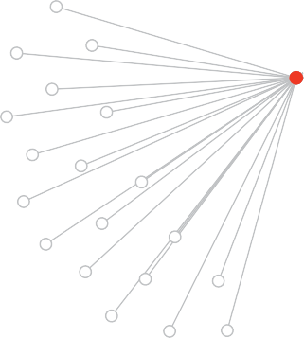
    - The number of hours from collecting the patient’s COVID-19 specimen to notifying their close contacts that they must quarantine, with the target being fewer than 48 hours at the 90th percentile.

Enduring investment in public health expertise

Clear governance

Surge capacity

Surveillance

Testing

End to end contact tracing

Data Exchange

Isolation and quarantine

Outbreak management

Public communication

Publicly reported performance metrics




18 NATIONAL CONTACT TRACING REVIEW

Characteristics of an optimal contact tracing and outbreak management system

Enduring investment in public health expertise
- Local knowledge and community engagement are key to effective contact tracing, thus the role of regional public health units is fundamentally important. Decentralised contact tracing teams have access to centralised technology for case allocation, interviews and outbreak management.
- Where local health districts are of sufficient size, public health units are embedded into local health districts.
- Vulnerable groups within the community are actively identified. Targeted engagement, response planning and implementation of preventative measures are undertaken with the community to help ensure their safety.
- A multidisciplinary public health capability, including public health physicians, expert public health staff and epidemiologists with practical experience, is permanently embedded in Commonwealth, state and territory health departments and health systems.
- There are clear career pathways and succession plans for senior public health experts.
- There are adequate numbers of graduate trainees in the pipeline to meet the needs of states and territories’ public health response in the near, medium and long term.
- An ongoing partnership is active between the key decision making committee for health emergencies (Australian Health Protection Principal Committee; AHPPC) and researchers to ensure new knowledge is acted upon in a timely fashion.

Clear governance
- Clearly articulated, non-conflicting leadership roles are well identified in public health emergency legislation and broader emergency management plans.
- Chief Health Officers or equivalent have an appropriate level of authorisation to make directions and oversee public health operations.
- Final decision making authority under the relevant acts rests with senior leaders who have operational and emergency management experience.
- There is a well functioning crisis command centre, in which experts from multiple agencies work collaboratively to coordinate responses.

Surge capacity
- A scaled surge response activates based on case numbers and complexity.
- Permanently employed contact tracing officers and outbreak management teams help train and direct the surge workforce.
- Digital systems allow easy but secure onboarding of the surge workforce from within the state and territory, and from other jurisdictions.
- Desktop simulations and functional simulation exercises are regularly run to ensure that the system can deal with sustained surge and extreme case numbers.
- Surge capacities are planned between jurisdictions to allow for additional support to be provided before a state or territory reaches capacity.
- The surge capacity for COVID-19 RT-PCR tests is at least 3,000 tests per million population per day, consistent with the Framework for National Reopening.

Surveillance
- Wastewater testing, having proven its utility, is used to identify potential outbreaks within appropriately sized catchment areas covering 50% of the Australian population, across rural and urban areas.
- All states and territories have in place an efficient digital system to extract and systematically collect important COVID-19 surveillance data. Systems are flexible, to enable the timely capture of agreed additional surveillance data, and to minimise human effort.
- Continuity of reporting is assured in the event of a substantial rise in case numbers.
- Improvements to COVID-19 specific surveillance are assessed and considered for relevance to other notifiable diseases in the medium to long term.

Testing
- COVID-19 testing strategies are based on testing frameworks developed by public health experts and aligned to national standards, appropriate to the prevalence in the community and the community demographic. The testing framework includes:
  - Capacity to rapidly deploy mobile and pop up test sites.
  - Access to rapid, low volume diagnostic equipment in remote communities.
  - Testing at outbreak sites.
  - Testing for priority populations, including asymptomatic close contacts of confirmed cases.
  - Targeted testing of workforces in high risk settings.

- All patient and basic symptom information is gathered digitally at the place of specimen collection and the time and date of collection is recorded:
  - Demographic data of tested patients is used to optimise COVID-19 testing strategies and ensure that population coverage is as intended.
  - Symptom descriptions and date of onset of symptoms are used to assist subsequent contact tracing.
  - Phone numbers of patients or their guardians are verified before specimens are collected, where possible.
- COVID-19 testing is available free of charge and easy to access:
- All test results are transmitted to the health department immediately after they are verified.
- Notification of test results to patients occurs rapidly.
  - All negative test results are transmitted automatically by text to the patient or guardian.
  - Confirmed cases are rapidly notified by a phone call from an authorised officer or health practitioner and issued a direction to immediately isolate.
  - In times of high daily new case numbers where the contact tracing workforce is unable to meet timeframes to make calls, confirmed cases are notified of a positive test result and directed to isolate through an automated text system, and followed up with a phone call from an authorised officer as soon as possible.
- Rapid whole genome sequencing of the viral genome and serological antibody testing are integrated into upstream contact tracing.

End to end contact tracing
- The overriding intention is to never fall behind.
- Political and departmental leadership are committed to continuous improvement of the contact tracing and outbreak management capabilities in their state or territory.
- Well trained staff, ideally with an understanding of the local area and communities, are available to perform upstream and downstream contact tracing for all confirmed cases.
- Experienced public health experts are employed as team leads and are available for decision making in complex situations.
- There is an effective end to end digital platform for recording cases, and performing contact tracing and case management, with capability for workload prioritisation and automatic case allocation.
- A high degree of end to end automation supports the contact tracing effort, such as daily monitoring and report generation.
- Baseline criteria for classifying close contacts are consistent with the COVID-19 Series of National Guidelines and are expanded as necessary.

- At low case numbers, consideration is given to extending contact tracing to include secondary contacts and casual contacts, and requiring them to quarantine where appropriate.
- Innovation in contact tracing practices is encouraged, evaluated, incorporated into daily practices and shared with other jurisdictions to assist continuous improvement.
- Technology is appropriately leveraged, and shared between jurisdictions, to assist the contact tracing process.
- Access to information from electronic venue attendance registration systems and smartphone apps and the COVIDSafe proximity app is timely.
- Other attendance data is made available to contact tracers when required. These records, subject to all applicable privacy requirements, may include the location and time of financial transactions.

Data Exchange
- A digital ‘Data Exchange’ capability provides interoperability between state and territory contact tracing systems, the National Incident Room and other government data stores, to assist in contact tracing where cases and contacts have recently crossed borders or contact details are missing.
- No data are stored in the Data Exchange. All information sharing meets regulatory and privacy requirements.
- Contact tracing data are made available in a timely manner from a variety of sources such as airlines and shipping companies, government agency databases, and
COVID-19 diagnostic test result registries to support contact tracing.
- The exchange of data is as near to real time as possible and is consistent with Commonwealth, state and territory security and privacy requirements.

Isolation and quarantine
- Confirmed cases are strictly isolated either at home or in a hospital or supervised hotel in line with the currently applicable recommendations in the COVID-19 Series of National Guidelines.
- Authorities monitor home quarantine compliance, and symptom development, in an efficient and friendly way, supported by technology, including intelligent smartphone apps where appropriate.
- Daily health monitoring in quarantine facilities is optionally assisted through wearable health monitors.
- Barriers to quarantine or isolation are identified and addressed. Financial, welfare, clinical and mental health support are offered and provided as appropriate.
- End of quarantine tests are requested and, if refused, quarantine is extended by 10 days.
- When multiple persons from one family are in quarantine or isolation, a single case manager works with all family members.

Outbreak management
- Where outbreaks occur, rapid suppression is achieved by an efficient regime of testing, contact tracing, isolation and outbreak management.
- Every effort is made to go hard and go early.
- Experienced epidemiologists and other public health experts are employed to identify clusters in time and place, by mapping the upstream and downstream infection transmission pathways to link outbreaks and clusters, assisted by interviews from the contact tracing teams, rapid viral genome sequencing, antibody testing, and advanced data analytics software.
- Rapid control measures are instigated while investigation continues. These measures are supported by relevant regulators, such as from health, fair trading, work safety, food authority and local councils, to ensure that businesses and others in the outbreak area have effective mitigation strategies in place.

Public communication
- Ongoing communication is understood to be key to preventing community complacency in the absence of an actual outbreak.
- Public health messages are:
  - Consistent, transparent, frequent and easily accessible from official web sites, traditional media and social media.
  - Culturally and linguistically tailored to each community, and where possible, developed and distributed cooperatively with and through community leaders.
  - Appropriately targeted to encourage COVID safe behaviour.
- All non-English messages and resources are updated regularly to ensure they are current. The accuracy of the translations is routinely confirmed.
- Automated messages to people in quarantine are sent in their preferred language.
- Notifications of COVID-19 test results are explicit in reporting the detection or not of the virus in the sample and do not use terms that could be misunderstood, such as ‘positive’ and ‘negative’.

Publicly reported performance metrics
- Each state and territory consistently reports daily case numbers, including:
  - Number of new confirmed cases identified in the community; and
  - Number of new confirmed cases identified in quarantine.
- Nationally agreed performance metrics for each state and territory are publicly reported weekly, including:
  - The number of hours from collecting the COVID-19 specimen to notifying people of their results is fewer than 24 hours at the 90th percentile.
  - The number of hours from collecting the patient’s COVID-19 specimen to notifying their close contacts that they must quarantine is fewer than 48 hours at the 90th percentile.i

i At least 80% of close contacts have been notified. Cases in quarantine are not relevant to this metric.




0 0
0 0 0 0
0
0
0
0

0
0

0
• •
•
0
•
0
0 0

•
/ .---1-a 0 • •
0 •
•
•
0

0
0
0
0
- 0
•
0
0
0 0
0 0 0 0
0 0 0 0
0 0 0 0
0
0 a-e 0
0 0 0 0 0
0
0 0 0 0

0 0
0 0 0
0
0 0 0
0
0 0 0
0 0 0
0 0 0 0
- 0 0 0 0

0 0 0 0

24 NATIONAL CONTACT TRACING REVIEW

CHAPTER 1

CONSTANT PREPARATION
States and territories have primary responsibility for managing communicable disease emergencies. They control most of the functions essential for effective prevention, preparedness, response and recovery, including operational aspects of surveillance, identification, containment and treatment of communicable diseases.

Effective emergency response plans are underpinned by local and national health authorities and operational agencies being in a constant state of preparedness. This includes enduring investment in public health expertise, coordination of public health response, and regularly maintained digital surge support registers and outbreak management plans.

Investment in public health expertise
Australia’s public health experts across all states and territories have been instrumental in safely stewarding Australia’s response through the COVID-19 pandemic. A highly qualified public health workforce with appropriate training, skills and subject matter expertise is the foundation of an effective public health response.

It is the responsibility of the states and territories to control the operational aspects of surveillance, detection and containment of communicable diseases within their jurisdiction. Having strong public health capability embedded in the health systems, prior to the pandemic, along with a clear understanding of where this expertise lies has proven to be the most effective way to successfully navigate the COVID-19 pandemic.

An effective response relies on multidisciplinary expertise, including: public health physicians, public health nurses, public health officers, epidemiologists, laboratory scientists, medical microbiologists, infection prevention and control consultants, infectious disease specialists, and communications staff.


CASE STUDY – NSW PUBLIC HEALTH UNITS

In NSW, public health units are responsible for protecting the health of people who live, work in or visit the geographical area of a local health district.

The NSW public health units form part of the local health district with central coordination, strategy and guidance provided by NSW Health.

Experienced public health leadership across the local health districts has been identified as a significant strength of the NSW public health system.

There are 12 public health units in NSW, with nine of 15 local health districts having their own public health unit, and the remaining six local health districts each sharing a public health unit across two districts. Public health units are responsible for implementing:
- Surveillance, monitoring and control of communicable diseases.
- Immunisation advice and programs, including the School Vaccination Program.
- Control of environmental health hazards and assessment of environmental health risks.
- Tobacco control and smoke-free environment compliance.
- Public health emergency planning and management.
- Applied epidemiology and public health research.
The regional approach to oversight and coordination is important to ensure strong understanding of local environmental and health protection risks and engagement with the community. Regionalisation of the public health units promotes seamless integration with the local health district and coordination with other government agencies including Councils, Education, and Family and Community Services.
For COVID-19, case interviews and initial close contact tracing are undertaken by the public health units, supported where necessary by NSW Health, with local health districts responsible for case and contact management. Local knowledge provides an opportunity for public health units to link cases that may have been infected in their area.
During the COVID-19 emergency, NSW Health has provided additional surge capacity, along with a central coordination capacity to provide the local health districts with information and guidance for local implementation. If a public health unit is under strain, additional staff and support can be provided from within the local health district, from neighbouring public health units, or from the central public health response team in NSW Health.

26 NATIONAL CONTACT TRACING REVIEW

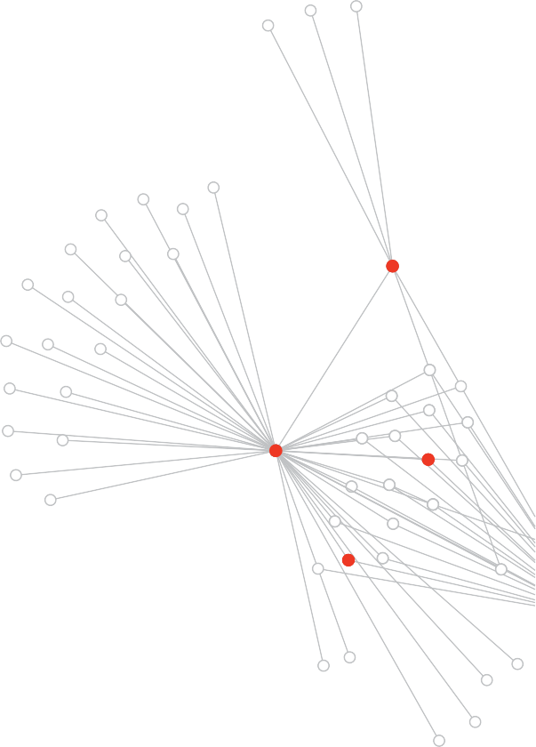

Local public health expertise is essential
Close engagement at a local population level is a critical element of any public health response. In particular, community engagement and local knowledge are fundamental to contact tracing and outbreak management. States and territories, who have invested in a decentralised model, staffed with public health experts, are able to draw on teams embedded in their local communities to manage contact tracing and surveillance.

A decentralised model allows local teams to work independently while still being able to access resources from the central health department and other public health units. For example, in NSW 12 of the 15 local health districts have public health units enabling a more localised approach to contact tracing. Victoria has recently moved to a decentralised approach for regional cases, establishing six regional public health units, and is in the process of establishing suburban units in metropolitan Melbourne.
In a decentralised model, oversight and control reverts to the central health department in the event of an emergency, enabling a central coordination capacity to provide local health districts with information and expectations for locally appropriate implementation. This model also enables twinning of public health units to meet surge demands.

Decentralised contact tracing teams should have access to centralised technology for case allocation, interviews and outbreak management. Whichever model – centralised or decentralised or mix of the two – local knowledge must be balanced with contact tracing expertise to achieve rapid and high quality outcomes.


CASE STUDY – EPIDEMIOLOGY TRAINING PROGRAMS IN AUSTRALIA

There are three complementary workplace-based epidemiology training programs available in Australia. Each contributes a different set of expert skills to build public health capacity and networks at jurisdictional, national or global levels.

Masters of Philosophy in Applied Epidemiology (MAE Program)
The MAE program at the Australian National University is Australia’s only Field Epidemiology Training Program, is internationally accredited and has produced over 240 highly skilled applied epidemiologists since 1991. This expertise is a critical resource and has strengthened Australia’s capacity to prepare, protect and respond to communicable diseases and other threats.
Graduates have risen to be leaders in the field with senior positions in research institutions, government and international organisations such as the World Health Organization.
NSW Public Health Training Program
The NSW Public Health Training Program has been running for 30 years. It is a three year competency based training program for public health graduates and trains up to 28 full time trainees each year. The program also provides
an emergency surge capacity for the NSW health system and trainees can be mobilised at short notice to work on issues of immediate concern.
Trainees undertake a range of population health placements, developing public health competencies and professional networks within the NSW health system. Through this advanced level training program, trainees
develop skills in leading outbreak investigations; planning epidemiological studies; conducting public health surveillance, analyses and evaluations; scientific communication and evidence based decision making.
Australasian Faculty of Public Health Medicine Advanced Training Program
The Australasian Faculty of Public Health Medicine Advanced Training Program is a training and continuing education program of the Royal Australasian College of Physicians. It is the pathway for medical doctors to specialise in public health medicine. Public health physicians are trained to take leadership roles, working collaboratively with other members of the public health workforce to solve complex population health issues. They integrate their medical and public health expertise, with a focus on evidence, equity, and advocacy.
The three year training requires clinicians to undertake work based placements to achieve the competencies required of a public health physician.

28 NATIONAL CONTACT TRACING REVIEW



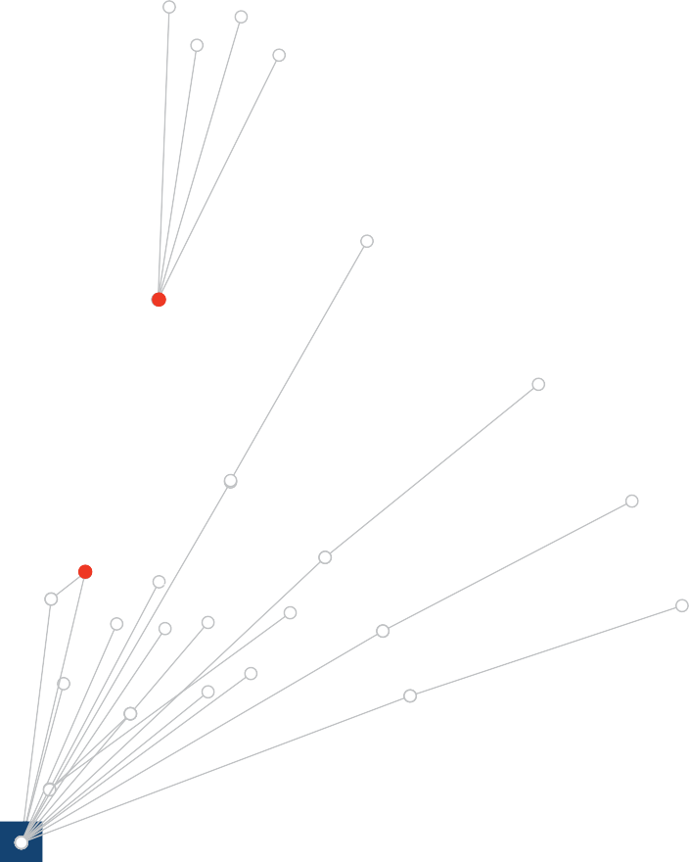

Maintaining a strong public health workforce
A key factor for Australia’s continued success will be the ongoing availability of a trained and competent multidisciplinary workforce, with skilled public health physicians, trained public health staff, epidemiologists, and laboratory scientists. It is widely recognised that this critical workforce in Australia is finite and stretched under the current circumstances. The need to expand and develop a cadre of those with relevant expertise and training is recognised in the plan for Australia’s Public Health Capacity developed by the AHPPC and agreed by National Cabinet.1
In particular, senior public health leaders are integral to a successful response as they have greater understanding and experience in emergency management. To date, the COVID-19 response has been supported by the current public health leadership working extraordinary hours, due to the limited pool of senior public health officials. Training and succession planning is vital for continuity and transference of knowledge.

Australia’s existing applied epidemiology and workplace based training programs include the internationally accredited Masters of Applied Epidemiology (MAE) at the Australian National University (ANU), and the work-place based NSW Public Health training program. These programs have provided an important pipeline for a skilled, flexible and sustainable public health workforce. The ANU course has been modelled on the internationally recognised US Centre of Disease Control’s Epidemic Intelligence Service program and focuses on learning by doing.2 In both systems, trainees are positioned within health departments or public health institutes, and their activities are designed to address practical priority public health issues. These programs stress the principle of training through service, and they provide close supervision and mentoring by trained epidemiologists.
The National Critical Care and Trauma Response Centre (NCCTRC) funded by the Commonwealth Government is an essential component of Australia’s rapid deployment capability for outbreak management. The NCCTRC training program offers a range of nationally and internationally accredited courses, including the suite of Australian Medical Assistance Teams training packages.3

National coordination of public health response
Whilst states and territories have primary responsibility for the management of communicable disease emergencies, national coordination is activated if necessary. Australia’s Chief Medical Officer is able to stand up the National Incident Room, which supports the coordination of expertise across the Commonwealth, states and territories and advances guidelines for national consistency.

At the request of Australia’s Chief Medical Officer, the Commonwealth Government activated the National Communicable Disease Plan on 25 January 2020.4 On 27 February 2020, the National Security Committee of Cabinet initiated implementation of the COVID-19 Response Plan designed to guide the Australian health sector response.i

The Commonwealth plays an essential role in bringing together leading experts to provide advice to National Cabinet and to develop and refine nationally consistent guidelines for the public health response to COVID-19. The Commonwealth has also taken a leading role in ensuring Australia will have ready access to vaccines for SARS-CoV-2 when they are developed, as well as ensuring national emergency supplies of ventilators and personal protective equipment through the National Medical Stockpile.

Australian Health Protection Principal Committee
Under the COVID-19 Response Plan, the Commonwealth Department of Health is responsible for national coordination of the health sector emergency response, under the direction of the Australian Health Protection Principal Committee (AHPPC).

The AHPPC includes all state and territory Chief Health Officers, or equivalent, and is chaired by Australia’s Chief Medical Officer. Other members include the Surgeon-General and Commander of Joint Health, the Chief Nursing and Midwifery Officer, and the Commonwealth Deputy Chief Medical Officers. The AHPPC is supported by a number of standing and time-limited committees and provides advice to National Cabinet. More information about AHPPC and its key supporting committees is found in Table 1.
The Communicable Diseases Network Australia (CDNA) and the Public Health Laboratory Network (PHLN) are two standing committees of AHPPC that have played a central role in the national coordination of the COVID-19 response.

These committees provide the principal mechanism by which states and territories share resources, information, expertise and decision making. For example, CDNA is responsible for the development of the COVID-19 Series of National Guidelines for Public Health Units (COVID-19 SoNG) and the Australian National Disease Surveillance Plan for COVID-19.5

PHLN provides strategic advice to AHPPC on testing capability and capacity, recommended testing methods, identification of laboratory gaps, pressures and needs, and plans to ensure optimal use of existing public health pathology laboratory resources for the COVID-19 response.

Adequate resourcing of Australia’s national coordinating mechanism is critical to ensuring up to date, consistent and evidence based approaches are available to guide the management of COVID-19 and future public health emergencies.

i The COVID-19 response plan was adapted from the Pandemic Influenza Plan, and was endorsed by AHPPC.

Evidence based decision making
The COVID-19 pandemic has highlighted the need for decision making to be supported by up to date evidence and emerging research findings.

To inform decision making and advice to the state or territory emergency controller, the Chief Health Officer or equivalent in each jurisdiction should have access to updated summaries of the evidence on particular topics. For example, in South Australia, the Chief Public Health Officer is supported by the South Australian Health and Medical Research Institute (SAHMRI), who provide evidence summaries with a rapid turnaround.

At a national level, groups such as the AHPPC, CDNA, the PHLN, and the Infection Control Expert Group have been rapidly developing advice and supporting policies. It is important these groups have access to up to date evidence summaries to support their decision making. Evidence based and peer reviewed summaries have been made rapidly available through the Rapid Research Information Forum (RRIF) and the National COVID-19 Health and Research Advisory Committee.6,7 Expert decision making bodies such as the AHPPC and CDNA are key in integrating evidence into policy and advice.

Emergency management

Emergency management plans
Emergency management plans should promote the coordination and effective utilisation of resources and capabilities across multiple government agencies and give clear directions on the roles and responsibilities of each agency.

Most states and territories utilised existing emergency management plans for the COVID-19 pandemic. States and territories that have experience dealing with frequent emergencies, especially those covering the north of Australia, were well positioned to handle the pandemic by drawing on existing arrangements set out in their respective emergency management plans.

Integration of the public health emergency response within a broader state emergency response has been critical to the success of states and territories’ response to COVID-19. In the event of a public health emergency, states and territories implement AHPPC advice at the jurisdictional level, generally led by the health department. Most states have mobilised existing state coordination centres to assist with the coordination and management of the emergency response.

A clear chain of command and clear responsibilities are essential to effective preparedness and support quick mobilisation, integration and efficient use of resources, should an incident occur. In addition, a state coordination centre is established to coordinate the operational management of the emergency response.

All states and territories have a crisis control centre or equivalent. A crucial element of a well functioning control centre is to have embedded liaison officers from other government agencies. This helps to ensure a well coordinated response across all sectors of government. Inclusion of personnel from the Police and the Australian Defence Force can be particularly important.

Table 1. Australian Health Protection Principal Committee and supporting committees

Committee | Key functions relevant to communicable disease emergency | Summary of membership
Australian Health Protection Principal Committee (AHPPC) | Coordinate national emergency operational activity.  Promote alignment of state and territory strategic plans.  Coordinate national response. | Australia’s Chief Medical Officer  State and territory Chief Health Officers (or equivalent)  Clinical experts  Commonwealth Government representatives
Communicable Disease Network Australia (CDNA) | Leads national action on how the public health system can monitor, prevent and control notifiable communicable diseases by providing evidence based advice to AHPPC.  Develops and coordinates national surveillance programs for communicable diseases including: policy, strategy, and advice on the prevention and control of communicable diseases, coordinates the investigation and control of multi-jurisdictional outbreaks and works with a range of national and international partners to prevent and control communicable diseases.  Responsible for developing a series of national guidelines (SoNGs) for dealing with communicable disease. | Communicable disease experts from each state and territory (normally Deputy Chief Health Officer level)  Clinical experts  Commonwealth Government representatives
Public Health Laboratory Network (PHLN) | Advises AHPPC on national laboratory capacity and capability.  Develops plans to ensure optimal use of existing pathology laboratory resources for the COVID-19 response.  Monitors the public health laboratory system to identify any gaps and pressures, and provides advice on testing strategies for communicable disease surveillance and national outbreaks. | Pathology and medical laboratory science experts from each state and territory

Committee | Key functions relevant to communicable disease emergency | Summary of membership
National Health Emergency Management Standing Committee | Addresses the operational aspects of disaster medicine and health emergency management including the deployment of Australian Medical Assistance Teams. | Commonwealth Government representatives  State and territory government representatives
Environmental Health Standing Committee | Provides agreed environmental health policy and implementation of the National Environmental Health Strategy. | Commonwealth Government representatives  State and territory government representatives  New Zealand Ministry of Health representatives
Infection Control Expert Group  (time limited) | Advises AHPPC and its other standing committees on infection prevention and control issues.  Provides expert advice and information to support best practice related to infection prevention and control in community, hospital and other institutional settings. | Practising doctors, nurses and researchers with extensive experience and expertise in their fields.
Aged Care Advisory Group  (time limited) | Advises AHPPC about aged-care policy related to COVID-19 bringing together expertise about aged care, infection control, emergency preparedness and public health response. | Brings together expertise about aged care, infection control, emergency preparedness, and public health response.
Aboriginal and Torres Strait Islander Advisory Group on COVID-19  (time limited) | Liaises with AHPPC and its standing committees.  Provides advice to the Commonwealth Department of Health. | National Aboriginal Community Controlled Health Organisation and jurisdictional affiliates.  State and territory representatives and Commonwealth Government representatives.

Clear governance
An effective, resilient response requires coordinated governance from the top. This starts with the early formation of a high level committee, such as a State Emergency Management Committee or Crisis Cabinet, meeting daily during the worst of the pandemic. These committees are generally comprised of the Premier, Ministers, Secretaries and other senior public servants across relevant departments and emergency agencies critical to coordinating a whole of government response. Coordination across multiple departments and agencies including First Ministers departments, health departments, Emergency Services, Treasury and service delivery agencies has been integral in responding effectively to COVID-19.
As problems are identified, the state emergency management agencies should have clear understandings of priorities, operational roles and accountabilities. For example, when establishing health quarantine hotels and police quarantine hotels, specific priorities and roles for the health departments and police agencies should be assigned.

State emergencies declared in response to the COVID-19 pandemic have required health departments to assume the role of the lead agency, or the ‘combat agency’. The health departments are operating within the constructs of each state and territory’s state of emergency governance structure.

In response to COVID-19, most states and territories declared a public health emergency followed by a broader state emergency, based on existing legislation (Table 2). In general, the declaration of a State of Emergency or State of Disaster (Victoria) enacted additional emergency powers for Police Commissioners, Chief Health Officers, Health Ministers or equivalents alongside existing public health legislation. This has mostly been an effective mechanism, however due to the extended duration of the pandemic some jurisdictions have had to extend the emergency period a number of times. For example, South Australia has extended their major emergency declaration eight times since it was first declared in March 2020.
The Commonwealth declared a human biosecurity emergency under the Biosecurity Act 2015 on 18 March 2020. This declaration provided the Health Minister with the ability to set requirements and give directions as necessary to manage the COVID-19 pandemic on a national scale. This is the first time such an emergency has been declared since the commencement of the
Biosecurity Act 2015, and its use has been guided by the advice of the AHPPC, the Chief Human Biosecurity Officer and the CDNA.

The power to issue public health directions differs between states and territories. In most instances, health emergency powers are delegated to the Chief Health Officer, or equivalent, and the Health Minister. However, in some instances, it was recognised that the existing legislation did not provide the Chief Health Officer with adequate authority. For example, on 18 March 2020, the Queensland Parliament passed amendments to the Public Health Act 2005 to strengthen the powers of the Chief Health Officer and emergency officers. Additionally, Victoria was required to operate under a State of Emergency or State of Disaster to enable the Chief Health Officer to issue necessary orders.
Within the health system, clear lines of accountability for the public health response and the broader pandemic health system response is critical. This is best achieved with the Chief Health Officer, or equivalent, in states and territories leading the public health response, and the Director General or Secretary of health departments leading the pandemic health system response. Furthermore, collaboration and joint reporting to the Health Minister ensures a well coordinated health system approach.

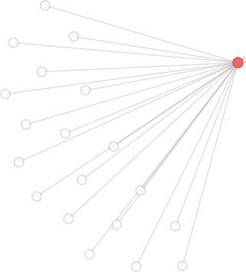
National Incident Room
The National Incident Room (NIR) is the Commonwealth Government’s emergency operations centre for health emergencies. The NIR is an operational response capability located within the Office of Health Protection in the Commonwealth Department of Health. The NIR supports Australia’s Chief Medical Officer and the Commonwealth Government to coordinate the national health sector emergency response to COVID-19 by organising response operations between:
- Commonwealth, and state and territory, government health authorities
- Other Commonwealth operations centres
- Australia and the international health community.
The NIR provides public health and other technical support to the AHPPC and its subcommittees to support the development and refinement of nationally consistent public health advice.

It is also responsible for undertaking duties in relation to Australia’s National Focal Point, as designated by the International Health Regulations (2005).8

The NIR has also distributed personal protective equipment held by the National Medical Stockpile, and funds the National Critical Care and Trauma Response Centre (NCCTRC) in Darwin. The NCCTRC has been essential in assisting states and territories through the deployment of Australian Medical Assistance Teams (AUSMAT).

Table 2: State and territory legislative and governance arrangements

Jurisdiction | Legislative Framework | Additional Legislation and Emergency Powers | Emergency Lead | Disaster Management Plan
Commonwealth | Biosecurity Act 2015  National Health Security Act 2007 | Governor General declared a biosecurity emergency on 18 March, providing powers to the Minister for Health to make emergency requirements and directions  Emergency period extended for three months on 15 May and 4 September. | Australian Health Protection Principal Committee chaired by Australia’s Chief Medical Officer | Australian Health Sector Emergency Response Plan for Novel Coronavirus9
NSW | Public Health Act 2010 | The NSW Health Minister has broad standing powers. | State Emergency Operations Centre led by the Police Commissioner | NSW State Emergency Management Plan10
Victoria | Public Health and Wellbeing Act 2008  Emergency Management Act 1986  Health Services Act 1988 | State of Emergency declared on 16 March, providing extraordinary powers to the Chief Health Officer.  State of Disaster was declared on 2 August, providing police greater powers to enforce public health directions.  The Secretary of DHHS also has broad powers to direct health services | State Control Team led by Emergency Management Commissioner | State Health Emergency Response Plan11  COVID-19 Pandemic Plan for the Victorian Health Sector12
Queensland | Public Health Act 2005  Disaster Management Act 2003 | Public Health emergency declared on 29 January and currently extended until 31 December, providing emergency powers to the Chief Health Officer.  Amendments to the Public Health Act 2005 pass Parliament 18 March to strengthen the powers of the Chief Health Officer.  Disaster situation declared on 22 March under Disaster Management Act 2003, and extended to 31 December 2020. | State Health Emergency Coordination Centre led by the Chief Health Officer  Queensland Disaster Management Cabinet Committee (specific purpose Cabinet subcommittee) | Queensland State Disaster Management Plan13  Queensland Whole of Government Pandemic Plan14  Queensland Health Pandemic Influenza Plan15 in conjunction with the Queensland Health Disaster and Emergency Incident Plan16
Western Australia | Emergency Management Act 2005  Public Health Act 2016 | State of Emergency declared on 15 March 2020.  Public Health State of Emergency declared on 16 March 2020. | State Health Incident Coordination Centre led by the Incident Controller (Deputy Chief Health Officer) appointed by the Hazard Management Agency. | Western Australia Government Pandemic Plan17  State Hazard Plan  – Human Biosecurity18  State Emergency Management Plan19

Jurisdiction | Legislative Framework | Additional Legislation and Emergency Powers | Emergency Lead | Disaster Management Plan
South Australia | South Australian Public Health Act 2011  Emergency Management Act 2004 | Declaration of a Public Health Emergency was made under the South Australian Public Health Act on 15 March for a period of 14 days (now ceased).  Declaration of a Major Emergency was made under the Emergency Management Act 2004 on  22 March.  Major Emergency Declaration was extended for 28 days on 4 April,  2 May, 30 May, 27 June, 25 July,  22 August, 19 September and  17 October. | SA Health is the Control Agency.  The State Control Centre  - SA Health is led by the State Controller which is currently the Chief Public Health Officer | State Emergency Management Plan20  Public Health Emergency Management Plan21  Health Viral Respiratory Disease Pandemic Response Plan22
Tasmania | Public Health Act 1997  Emergency Management Act 2006 | Public Health Emergency declared on 17 March and Declaration of State of Emergency on 19 March (expired on 25 October), provided wide range of emergency powers to the Director of Public Health.  Even with the expiry of the State of Emergency the State Controller can exercise most powers under the Act. | State Emergency Management Controller  / State Controller and Director of Public Health have governance responsibility for the directions they issue. | Tasmanian Emergency Management Arrangements23  COVID-19 Case and outbreak management framework for Tasmanian settings24
ACT | Public Health Act 1997 | Public Health (Emergency) Declaration was made on 16 March. Provided broad powers to the Chief Health Officer.  Public Health (Emergency) Declaration was extended for 90 days on 19 August. | Public Health, Protection and Regulation Division led by the Chief Health Officer | ACT Emergency Plan25
Northern Territory | Public and Environmental Health Act 2011 | Public Health Emergency declared on 18 March. Provided broad ranging emergency powers to the Chief Health Officer.  Emergency Legislation Amendment Act 2020 commenced on 26 March amending the Public and Environmental Health Act 2011 to allow the duration of a public health emergency declaration to be indefinitely extended by periods of up to 90 days.  Extension of public health emergency on 23 March (5 days),  28 March (90 days), 26 June (90  days) and 24 September (90 days). | The Chief Health Officer makes directions and advises the Security and Emergency Management Subcommittee of Cabinet, who in turn direct the Territory Emergency Management Council jointly led by the Commissioner for Police (Territory Emergency Controller) and the CEO Department of the Chief Minister and Cabinet (Territory Recovery Coordinator) | Territory Emergency Plan26


CASE STUDY – SOUTH AUSTRALIA SURGE PLAN
South Australia identified very early in the COVID-19 pandemic that the contact tracing workforce would be a key limiting factor in their public health system’s ability to respond to a substantial increase in cases.

A large outbreak would potentially see various areas within government competing for the same human resources to support the multifaceted COVID-19 response efforts.

South Australia engaged an external consultant to support a coordinated assessment of the entire workforce requirement across all
COVID-19 response work streams to identify workforce pressure points. This included challenging existing planning assumptions and the way work was done, in various situations. For contact tracing, this approach has enabled system capacity to be expanded to a point where 100 new cases per day (approximately 55 cases per million citizens), and their contacts, can be managed for sustained periods.
The Department of Health has provided comprehensive training for its surge contact tracing workforce. In addition to their standing contact tracing taskforce, employees with a strong background in human sciences have been identified and provided with three weeks face to face training. This includes one week training in the classroom and two weeks on the job, where the students ‘learn, do, and teach’. A one day refresher is provided every two weeks to ensure maintenance of the skillset. A further tier of surge workforce has also been trained from across the South Australian public service and is preparing for mobilisation.

38 NATIONAL CONTACT TRACING REVIEW

Active preparedness

Surge and outbreak management plans
State and territory health departments have developed a number of outbreak response plans to assist with the COVID-19 pandemic. A successful outbreak management plan should:
- prevent ongoing transmission
- preserve business continuity
- identify sources to prevent future transmission.
Rapid outbreak response plans are essential to enable a swift and well considered public health action. This includes overarching state or territory plans, and plans that are tailored to manage outbreaks in a broad range of settings, including in high risk settings such as aged care facilities.

Most states and territories have developed tiered outbreak response and surge plans for use in the event of increasing numbers of cases and degrees of complexity.

These tiered plans are designed to help jurisdictions to effectively mobilise a surge contact tracing workforce as necessary. Some states and territories have an identified space that is ready for swift occupation by a surge workforce in the event of an outbreak. An important component of a surge or outbreak plan is consideration of how the finite senior public health leadership would be distributed in the event of multiple concurrent outbreaks.

For the purpose of this review, surge is defined as four new confirmed cases (not in quarantine) per day per million population, but no fewer than four per day per jurisdiction. Super surge is defined as up to 40 new confirmed cases (not in quarantine) per day per million population.
Surge testing
In addition to surge plans for contact tracing workforces, states and territories have surge response plans in place for healthcare systems and testing requirements. For example, South Australia has a clearly articulated surge plan for testing, including number of tests required per day and the number of test sites and the workforce capacity to support the testing needs. Some states are training significant numbers of personnel to be able to undertake specimen collection if there was a broad outbreak.
Surge test rates are partly limited by workforce capacity and test instruments, but also by the availability of reagents. Diversification of testing platforms and reducing reliance on a few proprietary reagents and cartridges, as well as movement to open source platforms compatible with a variety of manufacturers’ reagents should be an important part of surge testing plans.
Further, rapid access to ‘pools’ of trained scientists and technicians should be considered at both state and national levels.
COVID safety plans
COVID prevention and response plans are also increasingly in place in businesses, educational institutions, venues and government buildings. Part of the plan includes shifting operations to enable business to operate in a COVID safe environment. Queensland has expended significant effort to help businesses adopt COVID safety plans. There is recognition that these plans should enable as much business continuity as possible in the event of an outbreak or cluster.

Precautions are also being taken across critical industries, such as segregating workforce rosters to mitigate the risk of a single case or outbreak impacting the entire workforce.

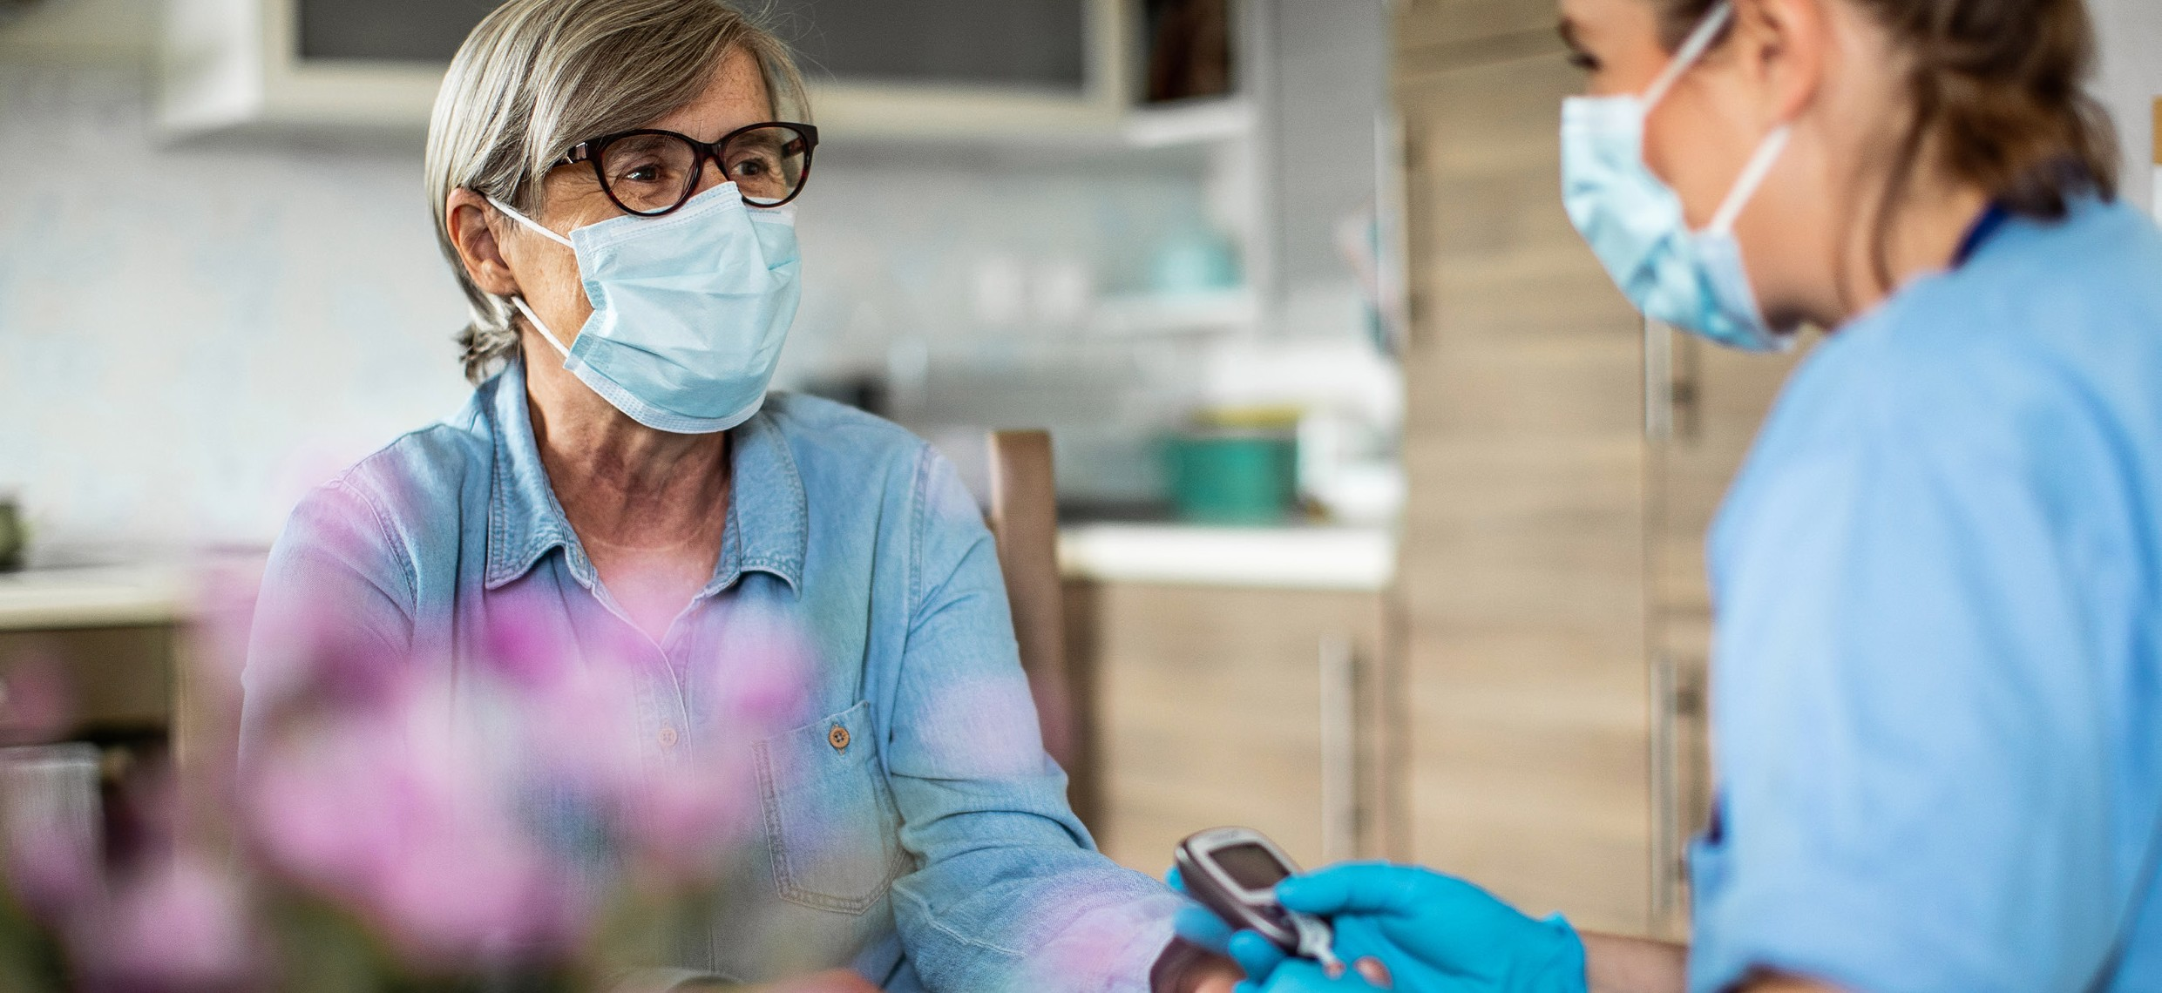
CASE STUDY – TASMANIAN RESPONSE AND PREPARATION IN RESIDENTIAL AGED CARE FACILITIES
Early in the pandemic, the Tasmanian Department of Premier and Cabinet identified the need for close collaboration with residential aged care facilities.

Regular meetings with peak bodies and members were established in March 2020 and continue on a weekly or fortnightly schedule. These meetings are chaired by the Department of Premier and Cabinet and supported by the Tasmanian Department of Health, the Commonwealth Department of Health and other key stakeholders. This engagement established necessary foundational relationships between government and the sector, which have been strengthened over time through the comprehensive outbreak preparation processes.
In August 2020, the Aged Care Emergency Response Centre was established. The centre has embedded public health expertise to stand up a response and recovery function in the event of an outbreak in a residential aged care facility. Strong working relationships with the sector are fundamental to enhance existing planning and preparedness. Key activities include:
- Orientating nurses to undertake health system support visits to residential aged care facilities, utilising a self assessment tool completed by staff in advance. The information gathered by the assessment tool shapes robust discussions on strengths and gaps in the facilities
Outbreak Management Plan and other areas of concern. The facilities receive a summary of their preparedness, with options for additional support for improvement, focusing on PPE, education and training and clinical models of care in an outbreak.
- Working in partnership with Primary Health Tasmania to develop clinical models of care for outbreak management in aged care. This includes regional consultation with residential aged care facilities, general practitioners, Public Health and the Tasmanian Health Service.
- Developing a ‘Building Capability Framework in infection, prevention and control’ to enhance skills and knowledge of the workforce.
- Collaborating with the Commonwealth to establish Tasmania’s surge workforce capability and the triggers for escalation. This includes identification of available support from the State as a component of local surge workforce planning.
- Commenced a program of scenario exercises with residential aged care facilities.

40 NATIONAL CONTACT TRACING REVIEW

No one size fits all
There is a broad set of principles to be applied during outbreak investigation and management in high risk settings, outlined in the CDNA COVID-19 SoNG. A number of specific plans have also been developed including plans for residential aged care facilities, correctional and detention facilities, and remote Aboriginal and Torres Strait Islander communities. In addition, states and territories have developed specific plans suited to their unique populations and geography.

Specific outbreak response plans for high risk settings have been developed in line with challenges that may be unique to each jurisdiction. These include plans for cargo ships, remote industrial sites and many others.

Further, individual state and territory outbreak plans have embedded nuances. For example, in South Australia, the plan for residential aged care facilities includes mobilisation of a specific extraction team to safely and quickly move confirmed cases to a designated hospital.

In Queensland, preparation and planning has been undertaken for potential concurrent disasters. This would include circumstances where a substantial outbreak of COVID-19 occurs simultaneously with an adverse weather event.

The Northern Territory has drawn on existing relationships with Aboriginal leaders and communities, to develop a specific disaster management plan for Central and Top End Services to handle COVID-19. The plan recognises the geographic and cultural barriers in remote areas and highlights the importance of on the ground contact tracing and case management processes led by local Aboriginal health practitioners. This involves extensive practical training of remote health care workers in contact tracing and case management.



The Commonwealth has developed a number of COVID-19 management plans for specific subpopulations, particularly those at higher risk of morbidity and mortality, and for rapid spread of disease. Specific surveillance and epidemiological considerations for Aboriginal and Torres Strait Islander populations are included in the Management Plan for Aboriginal and Torres Strait Islander Populations, the Remote Framework, and the CDNA National Guidance for remote Aboriginal and Torres Strait Islander communities for COVID-19.27,28,29 The Commonwealth has also developed a COVID-19 management and operational plan for people with disability.30

Surge workforce
The COVID-19 pandemic has required an unprecedented rapid upscale of contact tracing capacity. For all states and territories, the primary responsibility for ensuring sufficient numbers of appropriately skilled staff to support contact tracing lies within their respective health departments.

During high new daily case numbers, jurisdictions are required to surge their workforce to support an increasing contact tracing workload. In NSW, initial surge workforce for public health units is provided from within the local health district. This provides the advantage of local knowledge and understanding of the community already embedded within the surge workforce. Having a contextualised knowledge of the area and people is particularly important for contact tracing in remote Aboriginal and Torres Strait Islander communities. Currently more than
160 people are available throughout regional centres in the Northern Territory, ready to provide contact tracing support.
Where local public health workforce capacity is exhausted, surge workforce reserves can be accessed through other public sector departments or agencies. For example, staff from other government departments, including the Commonwealth public service, or universities and medical research institutes, can be brought under the supervisory umbrella of the health department. In NSW, employees from large employers such as Qantas, or retired health workers were also seconded into the NSW Department of Health to assist with contact tracing.

In Victoria, surge workforce was enlisted through contracted providers, such as healthdirect, who provided surge support for contact tracing and non contact tracing roles. Surge support through contracted providers allowed existing health department experts to focus on complex aspects of contact tracing. However, this model presents a challenge to give contracted providers direct access to jurisdictional database systems to enter contact tracing data.

When support from other states and territories or from the Commonwealth has been enlisted, the enlisted staff should be formally seconded to work in the services of the health department in need, using the contact tracing digital system or paper based forms of that health department.

There is a willingness for states, territories and the Commonwealth to provide interjurisdictional contact tracing and outbreak support, as evidenced during the Victorian outbreak. As each state and territory has a standing and surge contact tracing workforce that could be called upon by any jurisdiction, we should be confident that there is a national standing surge capacity. Ideally, this will be tested at surge and super surge levels.

42 NATIONAL CONTACT TRACING REVIEW

Training a surge workforce
Surge support staff must be well trained. In some jurisdictions, surge staff receive several weeks of training and ongoing mentoring. In preparation for outbreaks where cross jurisdictional surge is required, it may be of benefit to identify ways to quickly train, acquire logins, and on board contact tracing staff from other states or territories to a jurisdiction’s digital systems.

Having enough team leaders is an important consideration, and challenge, when scaling up the contact tracing workforce. Optimal surge preparedness includes leadership training for the experienced standing workforce, who will be elevated to team leaders when surge staff are called upon. Western Australia has planned their surge workforce around ‘pods’ of contact tracing teams of a constant size. In the event of high new daily case numbers, the number of ‘pods’ are increased to support the increased workforce needs, each with an experienced team leader with public health expertise.
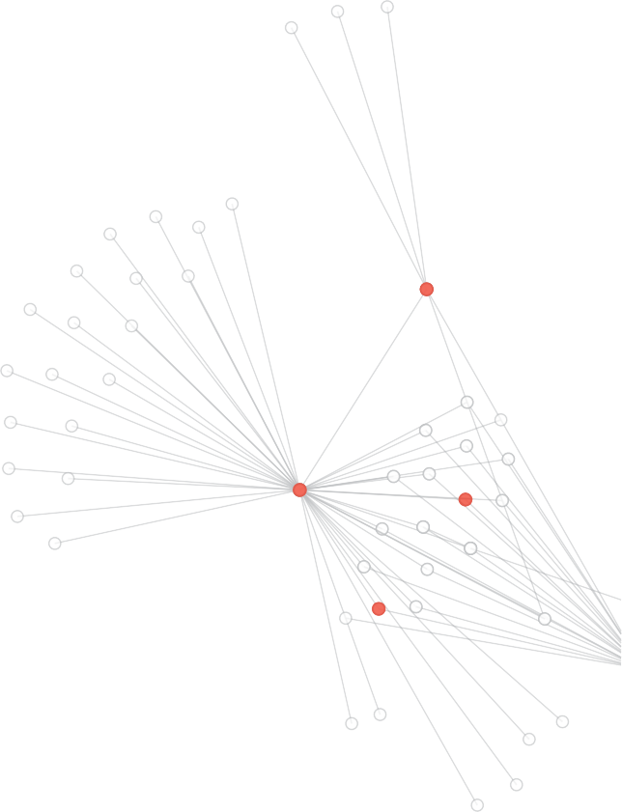
Experienced epidemiologists, public health physicians and nurses, and contact tracers with fundamental training in public health, are essential for an optimal contact tracing and outbreak management system. These positions require years of training and applied experience unattainable through short term training. In the event of high new daily case numbers, states and territories should have the capacity to load share across intrajurisdictional public health units. Surge support for leadership positions may also require assistance from other states and territories. The National Critical Care and Trauma Response Centre have expertise in rapid deployment of medical teams, and could be leveraged in a coordinating role for the interjurisdictional surge of public health leadership.


CASE STUDY – DOMESTIC DEPLOYMENT OF AUSTRALIAN MEDICAL ASSISTANCE TEAMS

The Commonwealth funded National Critical Care and Trauma Response Centre is a key component of Australia’s disaster and emergency medical preparedness and response capability.

A key role of the National Critical Care and Trauma Response Centre is the coordination and delivery of the Australian Medical Assistance Team Teams (AUSMAT) program.

The AUSMAT program is a capable, flexible and autonomous asset configured to manage complex health emergencies. AUSMAT members are selected from all states and territories and are considered some of the best clinicians and logisticians Australia has to offer. AUSMAT provides hybrid deployment teams of both public health and acute care medical expertise. In addition, to direct patient care, AUSMAT can also offer immunisation providers, logistics teams, surveillance and epidemiology teams, and public health emergency operation teams.
AUSMAT’s capacity to quickly and effectively respond to emergencies is complemented by the National Critical Care and Trauma Centre’s operational capability to maintain a constant state of readiness by being equipped, prepared and ready to respond swiftly upon request by the Commonwealth.
Since October 2019, AUSMAT has played a critical role in Australia’s response to COVID-19, through supporting the management of:
- The outbreak on board the German cruise ship MS Artania in Western Australia, involving 441 passengers and crew of whom 81 tested positive for COVID-19.
- The outbreak in Tasmania’s north west through providing clinical leadership and essential emergency care services.
- Victoria’s aged care COVID-19 outbreak through completing 169 visits to 75 aged care facilities to assess existing personal protective equipment and infection control procedures and boost infection prevention and control measures in the facilities.
- COVID-19 quarantine facilities on Christmas Island, Howard Springs and in the Northern Territory.
The National Critical Care and Trauma Centre also specialises in delivering COVID-19 Rapid Response Team Training. The interactive training includes fundamentals of outbreak response in reference to isolation and quarantine of multiple individuals (cohorting), infection prevention and control, and personal protective equipment.

44 NATIONAL CONTACT TRACING REVIEW

Emergency response exercises
Conducting drills and simulation exercises is the most effective way to test and evaluate emergency preparedness plans. There are a variety of ways to test emergency preparedness plans, including orientation exercises, stress tests, desktop exercises, drills, and functional simulation exercises.

In the absence of new cases outside of quarantine, jurisdictions such as Western Australia, Northern Territory, ACT, South Australia and Tasmania have been in continuous preparation mode. In addition, states with a low number of cases such as Queensland and NSW have been constantly stress testing systems against actual outbreaks when they occur, allowing them to be better prepared for the future. Until recently, Victoria has been continuously refining their system while dealing with ongoing outbreaks.
Some states and territories are also actively running desktop simulations, and functional simulation exercises to test their capacity to deal with outbreaks, including multiple simultaneous outbreaks. In some instances, functional simulation exercises using actors and increasingly complex outbreak scenarios with rising new case numbers have been used to stress test outbreak management plans.

The Commonwealth Department of Health has also led a number of emergency response exercises, including exercises designed to practise the powers under the Biosecurity Act 2015, promote familiarisation with policies and identify gaps. These exercises involve key Commonwealth Government agencies and state and territory partners.

For example, ‘Exercise EmergenSea Detour’ explored the differences between responding to cruise ship outbreaks of listed versus non listed human diseases. This desktop exercise tested key processes such as pre-arrival reporting, AHPPC involvement, re-routing of ships, and Biosecurity and Human Biosecurity Officer assessments. It also stress tested challenges such as resource provision and the medivac of passengers.

To complement the collaborations at the Commonwealth level, parallel exercises are held regularly with state and territory officers who are appointed, under the Biosecurity Act, as Chief Health Biosecurity Officers (CHBO). Internal CHBO exercises are held regularly and are designed to practise the powers under the Biosecurity Act, to promote familiarisation with policies and procedures, and identify gaps. These desktop exercises are attended by the CHBOs from each state and territory.

In addition, the Commonwealth has funded the National Critical Care and Trauma Centre based in Darwin. The centre is internationally recognised for its excellence in training and disaster response simulation exercises.

In the future, functional simulations at local, state and national levels based at the ‘surge’ and ‘super surge’ levels will be an important mechanism to verify the performance of contact tracing and outbreak management systems.

Surveillance
Surveillance is the ongoing, systematic collection, analysis and interpretation of health related data. This used to inform public health measures for the control of communicable diseases.
COVID-19 surveillance supports public health measures through timely reporting and description of cases and clusters, testing patterns, and disease severity. This key epidemiological information is needed to inform public health actions at the local, state and territory, and national levels.

The Australian National Disease Surveillance Plan for COVID-19 (COVID-19 Surveillance Plan) describes a national approach to disease surveillance for COVID-19.31 Surveillance in Australia occurs in partnerships between the Commonwealth, states and territories, health research institutions, clinicians, public and private laboratories, and other health sector stakeholders. National reporting against components of the plan are reliant on states and territories collecting

and sharing data with the Commonwealth. Enhancing and expanding existing automated reporting systems would further minimise human effort in collecting and extracting relevant data, and ensure continuity of reporting in the event of a substantial rise in case numbers.

CDNA is responsible for the COVID-19 Surveillance Plan, with each new iteration of the plan developed in conjunction with states and territories. The COVID-19 Surveillance Plan is updated to support responses proportionate to the level of risk over time, geographic regions and for different population groups.
A number of disease surveillance approaches are adopted in the COVID-19 Surveillance Plan, including:
- Case based reporting from states and territory communicable disease control groups.
- Active case finding through targeted testing to provide confidence that cases will be detected as control measures evolve.
- Surveillance to collect data on the prevalence of respiratory symptoms in the community and enhanced data on clinical presentation.
- Antibody surveillance to understand previous infection at a population level.
- Molecular epidemiology utilising genomic data to characterise circulating virus and patterns of disease transmission, and assist in the investigation of outbreaks and clusters.

National Notifiable Diseases Surveillance System
The National Notifiable Diseases Surveillance System (NNDSS) was established in 1990 under the auspices of the CDNA. NNDSS coordinates the national surveillance of more than 65 communicable diseases or disease groups, and supports Australia’s national case based reporting surveillance approach by integrating core reporting requirements from state and territory public health units. This system is used to report nationally on all new diagnoses of infection with SARS- CoV-2, and is supported by a number of other systems that monitor important aspects of
COVID-19 surveillance and management such as disease severity, extent of testing for SARS-CoV-2 in the community, outbreaks in particular settings, and timeliness of contact tracing activities.
De-identified notification data are supplied to the Commonwealth Department of Health on a daily basis from all states and territories. Notification data includes a unique record reference number, state or territory identifier, disease code, date of onset of symptoms, date of notification to the relevant health authority, sex, age, Indigenous status and postcode of residence, as well as enhanced fields that are collected for some diseases, including COVID-19. For COVID-19, these enhanced fields are used to understand source of infection and co-morbidities, with further relevant additional fields able to be incorporated to inform the epidemic picture. Ideally, all enhanced data fields should be endorsed through the National Surveillance Committee, a subcommittee of CDNA.
The NNDSS data are collated and used for analysis, publication on the official NNDSS website (updated daily), and in the Commonwealth Department of Health peer reviewed journal Communicable Diseases Intelligence.32 The NNDSS is the key mechanism through which government, the public and researchers can access nationally collated data on cases of notifiable conditions, including COVID-19. For COVID-19, analyses from NNDSS are used to inform epidemiological trend analyses and reporting. Additionally, data from NNDSS are also presented on the COVID-19 situation and case numbers website and across various Commonwealth app platforms.33

46 NATIONAL CONTACT TRACING REVIEW

The Commonwealth Department of Health is working to modernise existing outdated systems through the development of a new National Interoperable Notifiable Disease Surveillance System (NINDSS). The Department has released an approach to market to engage a provider with the capability to provide a secure cloud based Software as a Service (SaaS) solution, for the NINDSS project with the completion of a minimum viable product delivered by 30 June 2021.34 The new solution will replace and decommission current outdated Commonwealth systems, migrating and securing all existing data before expanding to offer services, including contact tracing capability, to jurisdictions. The NINDSS will also provide a means for all jurisdictions to provide regular data uploads, as seamlessly as possible and in real time, and be available to replace state systems as it suits them.

Wastewater testing
In addition to surveillance methods in the COVID-19 Surveillance Plan, a number of states and territories are actively considering novel surveillance mechanisms, including testing of wastewater to support their enhanced surveillance strategies.

Development of wastewater-based epidemiology techniques for the detection of SARS-CoV-2 is an active area of research, with some states and territories piloting wastewater surveillance programs for COVID-19.35 Water Research Australia is leading a collaborative project across much of Australia to integrate reliable results of sewage testing for the SARS-CoV-2 virus with health data for COVID-19 on a national basis. The Collaboration on Sewage Surveillance of SARS-CoV-2 (ColoSSoS) Project will track and monitor the presence of SARS-CoV-2 and its persistence in the Australian sewerage network, providing information about where the virus is present in the population.
Implementation of wastewater surveillance programs in a low prevalence environment can identify regions that may require increased community testing. A positive RT-PCR result from a wastewater sample would need to be considered carefully alongside other information. It may provide an early warning that the virus has been introduced into an area, allowing a more targeted testing and public health response. Wastewater surveillance could also be used to screen international flights, freight ships, and cruise ships on arrival when international travel resumes.

As an emerging surveillance system for SARS-CoV-2 in Australia, wastewater testing for SARS- CoV-2 should be properly evaluated.36 Limitations of wastewater testing include lack of confidence in equating a negative test result to the absence of SARS-CoV-2 in a community. As methods for sample concentration are enhanced, the ability to detect low levels of SARS-CoV-2 in wastewater is likely to improve over time. Initial estimates suggest that the sensitivity of wastewater surveillance is approximately one confirmed case per 10,000 to 20,000 people. A more accurate figure will be known when current analyses are completed.
Further work through collaborations between water experts and public health authorities could lead to increased confidence in the use of wastewater testing to identify potential outbreaks.
Specifically, public health, clinical and wastewater sectors should build on existing research and field testing of wastewater detection to determine whether a goal of 50% coverage of the Australian population is practical.

CASE STUDY – QUEENSLAND WASTEWATER SURVEILLANCE
Queensland Health partnered with researchers from the University of Queensland and CSIRO to pilot a wastewater surveillance program for SARS-CoV-2.

Monitoring took place in 27 wastewater treatment plants across Queensland representing approximately 50% of Queensland’s population. The aim of the program was to complement Queensland Health’s broader surveillance and management of the COVID-19 pandemic.
The 13 week pilot commenced in late July 2020 and concluded on 26 October 2020. Samples were collected weekly and analysed at the CSIRO Brisbane laboratory.
During this time SARS-CoV-2 was detected in 40 wastewater samples, with one or more detected at 20 of the 27 sites. Genomic sequencing was carried out on 25% of the detections and all results were confirmed.

Queensland has made a decision to fund an expanded program to look for evidence of SARS-CoV-2 re-emergence in Queensland’s population, until 30 June 2021. Planning is underway for the identification of sites.



48 NATIONAL CONTACT TRACING REVIEW


CASE STUDY – WASTEWATER TESTING ON REPATRIATION FLIGHTS

Qantas has partnered with researchers from the University of Queensland and CSIRO to pilot a wastewater surveillance program on repatriation flights.

The program builds on methods published in the Journal of Travel Medicine in July 2020.i

Samples are collected from aircraft after landing, on outgoing legs and incoming (repatriation) legs of the journey. Improved sampling technologies are being used for collection, concentration, extraction and analysis of virus fragments.

In October 2020, a repatriation flight from India landed in Darwin with 183 passengers (including 62 children) on board. All passengers older than 12 tested negative two days prior to boarding the flight. However, five passengers, including two toddlers, tested positive on day one of quarantine at the Howard Springs quarantine facility.

i Journal of Travel Medicine, 2020, 1–11. Detection of
SARS-CoV-2 RNA in commercial passenger aircraft and cruise ship wastewater: a surveillance tool for assessing the presence of COVID-19 infected travellers, doi: 10.1093/jtm/ taaa116 (April May Qantas flights).
Wastewater samples collected from the aircraft upon landing in Darwin tested positive for SARS CoV-2 (samples were collected within approximately 70 hours of passengers’ pre flight tests). Wastewater samples taken on the outgoing flight all tested negative.
The study will continue for an initial tranche of eight flights, each with approximately 175 passengers, from London, New Delhi and Johannesburg.

The application of wastewater based epidemiology, coupled with other forms of data, including point of care and clinical testing, and well coordinated open reporting, could provide public health officials with an additional means of assessing the presence or absence of COVID-19 infections among incoming tourists and citizens when routine international flights resume.

CONSTANT PREPARATION 49

References

- National Cabinet Statement 26 Jun 2020. https://www.pm.gov.au/media/national-cabinet-statement-0, accessed 5 November 2020

- US Centers for Disease Control and Prevention Epidemic Intelligence Service. https://www.cdc.gov/eis/index.html accessed 5 November 2020.
- https://www.nationaltraumacentre.nt.gov.au/what-we-do/education-and-training accessed 7 Nov 2020.

- National Communicable Disease Plan. https://www1.health.gov.au/internet/main/publishing.nsf/Content/ohp-nat-CD-plan.htm accessed 6 Nov 2020.
- Australian Government Department of Health. Australian National Disease Surveillance Plan for COVID-19. https://www.health.gov.au/ resources/publications/australian-national-disease-surveillance-plan-for-covid-19 accessed 6 Nov 2020.
- https://www.science.org.au/covid19/rapid-research-information-forum accessed 7 Nov 2020.

- https://www.nhmrc.gov.au/about-us/leadership-and-governance/committees/national-covid-19-health-and-research-advisory-committee accessed 7 Nov 2020.
- World Health Organization. International Health Regulations (2005) Third Edition. https://www.who.int/publications/i/item/9789241580496 accessed 6 Nov 2020.
- Australian Health Sector Emergency Response Plan for Novel Coronavirus, https://www.health.gov.au/sites/default/files/ documents/2020/02/australian-health-sector-emergency-response-plan-for-novel-coronavirus-covid-19_2.pdf

- NSW State Emergency Management Plan, https://www.emergency.nsw.gov.au/Pages/publications/plans/EMPLAN.aspx, accessed 5 November 2020.
- Victoria State Health Emergency Response Plan, https://www2.health.vic.gov.au/-/media/health/files/collections/policies-and-guidelines/s/ state-health-emergency-response-plan-edition-4-pdf.

- COVID-19 Pandemic Plan for the Victorian Health Sector, https://www2.health.vic.gov.au/about/publications/researchandreports/covid-19- pandemic-plan-for-vic

- Queensland State Disaster Management Plan, https://www.disaster.qld.gov.au/cdmp/Documents/Queensland-State-Disaster-Management- Plan.pdf

- Queensland Whole of Government Pandemic Plan, https://www.qld.gov.au/ data/assets/pdf_file/0025/124585/FINAL-QLD-WoG- Pandemic-Plan.pdf

- Queensland Health Pandemic Influenza Plan, https://www.health.qld.gov.au/ data/assets/pdf_file/0030/444684/influenza-pandemic-plan. pdf

- Queensland Health Disaster and Emergency Incident Plan, https://www.health.qld.gov.au/ data/assets/pdf_file/0031/628267/disaster- emergency-incident-plan.pdf

- Western Australia Government Pandemic Plan, https://www.wa.gov.au/sites/default/files/2020-06/Western%20Australia%20 Government%20Pandemic%20Plan.pdf

- Western Australia State Hazard Plan – Human Biosecurity, https://semc.wa.gov.au/emergency-management/plans/state-hazard-plans/ Documents/StateHazardPlanHumanBiosecurity.pdf

- Western Australia State Emergency Management Plan, https://semc.wa.gov.au/emergency-management/plans/state-em-plan/Documents/ StateEMPlan.pdf

- South Australia State Emergency Management Plan, https://www.dpc.sa.gov.au/responsibilities/security-and-emergency-management/ state-emergency-management-plan

- South Australia Public Health Emergency Plan, https://www.sahealth.sa.gov.au/wps/wcm/connect/d71be800426fefedb5acb7adc5e910c3/ Public+Health+Emergency+Management+Plan+2015.pdf?MOD=AJPERES&amp;CACHEID=ROOTWORKSPACE- d71be800426fefedb5acb7adc5e910c3-niQ715b

- South Australia Health Viral Respiratory Disease Pandemic Response Plan, https://www.sahealth.sa.gov.au/wps/wcm/connect/a7539fe7- 7d39-43e0-920d-94ac63983796/SAH_Viral_Respiratory_Disease_Pandemic_Response_Plan_final.pdf?MOD=AJPERES&amp;CACHEID=R OOTWORKSPACE-a7539fe7-7d39-43e0-920d-94ac63983796-niRcgJQ,

- Tasmanian Emergency Management Arrangements, https://d2kpbjo3hey01t.cloudfront.net/uploads/2020/02/DPFEM-TEMA-Issue1-13-Feb- 2020-DIGITAL-ART.pdf

- COVID-19 Case and outbreak management framework for Tasmanian settings, https://www.health.tas.gov.au/ data/assets/pdf_ file/0003/414489/COVID-19_Case_and_outbreak_management_framework_for_Tasmanian_settings.pdf

- ACT Emergency Plan, http://www.legislation.act.gov.au/ni/2014-442/current/pdf/2014-442.pdf
- Northern Territory Emergency Plan, https://pfes.nt.gov.au/sites/default/files/uploads/files/2019/TEP%20April%202019.pdf

- Australian Government Department of Health. Management Plan for Aboriginal and Torres Strait Islander Populations. https://www.health.gov. au/sites/default/files/documents/2020/07/management-plan-for-aboriginal-and-torres-strait-islander-populations.pdf accessed 6 Nov 2020.

- Australian Government Department of Health. Remote framework – conditions for easing remote area travel restrictions. https://www.health. gov.au/sites/default/files/documents/2020/05/remote-framework-conditions-for-easing-remote-area-travel-restrictions_0.pdf accessed 6 Nov 2020.
- Australian Government. CDNA Interim National Guidance for remote Aboriginal and Torres Strait Islander communities for COVID-19. https:// www.health.gov.au/sites/default/files/documents/2020/08/cdna-national-guidance-for-remote-aboriginal-and-torres-strait-islander- communities-for-covid-19.pdf accessed 6 Nov 2020.

- Australian Government Department of Health. Management and Operational Plan for People with Disability. April 2020. https://www.health. gov.au/resources/publications/management-and-operational-plan-for-people-with-disability accessed 7 Nov 2020.

- Australian Government Department of Health. Australian National Disease Surveillance Plan for COVID-19. https://www.health.gov.au/ resources/publications/australian-national-disease-surveillance-plan-for-covid-19 accessed 6 Nov 2020.

- http://www9.health.gov.au/cda/source/cda-index.cfm

- https://www.health.gov.au/news/health-alerts/novel-coronavirus-2019-ncov-health-alert/coronavirus-covid-19-current-situation-and-case- numbers

- https://www.tenders.gov.au/Atm/Show/95d40b00-58e7-493f-b3ac-0d7b6bb60ee1

- Rapid Research Information Forum. Monitoring wastewater to detect COVID-19. 21 Apr 2020. https://www.science.org.au/covid19/monitoring- waste-water accessed 6 Nov 2020.

- US Center of Disease Control. Updated Guidelines for Evaluating Public Health Surveillance Systems. https://www.cdc.gov/mmwr/PDF/rr/ rr5013.pdf accessed 6 Nov 2020.

CHAPTER 2

END TO END CONTACT TRACING

Never fall behind
The ability to detect and isolate cases of COVID-19 and quarantine their close contacts is central to preventing ongoing community transmission of COVID-19 in Australia.

Testing

COVID-19 testing framework
A high rate of targeted testing is the cornerstone of protecting the public during a pandemic, and essential to providing confidence that cases will be detected as control measures are adjusted. Nationally, testing for COVID-19 is based on the epidemiological and clinical criteria described in the CDNA COVID-19 SoNG.1

The CDNA Testing Framework for COVID-19, developed as a companion to the Australian National Disease Surveillance Plan for COVID-19, lays out the primary approach for identifying people with active SARS-CoV-2 infection. This approach includes testing people with clinical symptoms first, followed by groups that are likely to reveal the presence of undetected community transmission.

Large scale non-clinically indicated testing of asymptomatic people is not recommended for Australia’s low incidence of COVID-19.2 However, PHLN notes that there is a role for asymptomatic testing in specific contexts for disease control and surveillance. This may include during an outbreak in a high risk setting where there is evidence of a risk of spread and ongoing chains of infection.

In some circumstances, states and territories implement their own testing regimens beyond this national testing framework. PHLN advises Australia’s testing strategies should be targeted to strike the right balance between maintaining epidemic control and protecting the sustainability of laboratory capacity.3

COVID-19 RT-PCR test
COVID-19 diagnostic tests detect the presence of the SARS-CoV-2 virus in a specimen sample. Currently, detection of the SARS-CoV-2 nucleic acid – RNA – in a specimen sample by Reverse Transcriptase Polymerase Chain Reaction (RT-PCR) remains the gold standard early detection diagnostic test. Rapid antigen tests are an emerging diagnostic testing method, and are discussed in Chapter 5.

Testing across most states and territories is supported by a mixture of public and private pathology laboratories, equipped with high throughput nucleic acid extraction platforms and PCR machines. The COVID-19 pandemic has significantly increased demand on laboratory throughput and reagents required for RT-PCR testing. Overreliance on a small number of overseas suppliers for laboratory reagents and consumables across states and territories presents a risk.
Most states and territories also have some capacity to undertake a limited number of rapid diagnostic tests in remote and special clinically relevant locations, using highly sensitive point of care RT-PCR systems such as the Cepheid GeneXpert platforms. However, broader use of these instruments is currently limited by availability of customised testing cartridges manufactured overseas.

Specimen collection
Specimen collection is generally conducted across the community at dedicated testing clinics, or in a hospital setting. Most states and territories have also incorporated pop up and mobile specimen collection sites to support outbreak management. Approximately 150 General Practice led Respiratory Clinics have also been established by the Commonwealth to support assessment and testing for people with mild to moderate respiratory symptoms. Traditionally, specimen collection is undertaken using a nasopharyngeal swab to collect a respiratory sample. This technique is invasive, and PHLN continues to monitor emerging literature with regard to the performance of saliva collection as an alternative specimen for RT-PCR tests.4
Pathology labs are increasingly able to transmit COVID-19 results to health departments electronically, who then notify patients of their negative results by text message. Rapid turnaround of tests from specimen collection to notification of test results (negative results and confirmed cases) is critical to ensure the efficiency and effectiveness of the contact tracing process. Rapid notification of confirmed cases will ensure downstream transmission risk is mitigated as quickly as possible.
Importantly, notification of negative results within 24 hours is likely to increase testing compliance across a population.

Contact tracing
Contact tracing is one of many tools that has been used to successfully curtail COVID-19 in multiple countries. This has been achieved through manual contact tracing systems in some instances, and automated technology in others.5

The contact tracing process has not been as effective in some countries, such as the United Kingdom and the United States of America, due to under resourcing and relaxation of physical distancing measures while there was ongoing community transmission. In addition, delays in testing and obtaining results also hindered the process.6 This highlights the importance of our review encouraging states and territories to aspire to achieve the goal of specimen collection to notification within 24 hours. When tracking, tracing, and isolating, every hour counts.
It is important to note that strong contact tracing capability is one component of what should be a multifaceted public health response to cases of COVID-19.

The primary goal of contact tracing is to halt further transmission of the virus when a case is identified. Contact tracing has two purposes: to identify close contacts (downstream contact tracing) and to identify potential sources of infection (upstream contact tracing).

The first, and always necessary purpose, is to identify exposed contacts of the confirmed case who may be incubating the virus, and notify the close contacts that they must immediately quarantine. The term ‘contact tracing’ usually refers to ‘downstream contact tracing’ which is the identification of close contacts and directing them to quarantine and inhibit further spread of the virus.

The second purpose of contact tracing is to identify how the confirmed case might have contracted the virus. This is known as ‘identification of potential source contacts’ or ‘upstream’ contact tracing. It is undertaken by expert analysts and is crucially important in order to map connections between various cases, outbreaks, and clusters and to identify any alternative chains of transmission. Upstream contact tracing usually extends 14 days prior to the date of first symptoms. Modelling indicates that upstream contact tracing is an effective and efficient strategy to identify clusters and prevent transmission of SARS-CoV-2.7,8

In certain circumstances, upstream contact tracing may not be possible, this includes where:
- Daily new case numbers are very high and the contact tracing workforce is under strain. By not performing upstream contact tracing, this will enable staff to concentrate efforts on immediate downstream contact tracing.
- There is evidence of substantial community transmission. If a confirmed case could have acquired their infection from anywhere within the community, then broader public health action is likely to be required to suppress ongoing chains of transmission, and upstream contact tracing may not be an efficient use of finite public health resources.

‘Close contacts’ refer to people who have been in contact with a confirmed case and require quarantine. This is based on whether the confirmed case is likely to have been infectious at the time of contact and the duration and type of exposure.
CDNA currently define a close contact as:
- Face to face contact in any setting with a confirmed or probable case, for greater than 15 minutes cumulative duration over the course of a week, in the period extending from 48 hours before onset of symptoms in the confirmed or probable case, or
- Sharing of a closed space with a confirmed or probable case for a prolonged period (e.g. more than 2 hours) in the period extending from 48 hours before onset of symptoms in the confirmed or probable case.9
Where contact tracing capacity allows, and public health discretion indicates it may be of use, contact tracing may be extended to include identification and quarantine of household contacts or close contacts of close contacts, known as secondary contacts.

Alongside contact and case definitions, guidance on other aspects of public health response including contact and case management is provided in the CDNA COVID-19 SoNG. Guidance in the COVID-19 SoNG is regarded as the minimum standard, with public health units taking more stringent or risk averse approaches where they have cause. It is important these guidelines align with the rapidly evolving evidence base.

In contact tracing, having a contextualised knowledge of the area, people and resultant approach is a key to success. This is particularly applicable in remote Aboriginal and Torres Strait Islander communities. Modelling indicates that in these communities, different strategies of contact tracing and management, such as identifying and quarantining extended household members of a confirmed case, may be more useful than history based strategies.10

In Tasmania, strong relationships between the central public health unit and personnel (e.g. local government officials and police officers) in regional emergency coordination centres helps to provide local knowledge for contact tracing.

Contact tracing, particularly upstream contact tracing, is not straightforward and requires a great deal of contextualised information. A critical piece of information is the confirmed case’s date of symptom onset, which is needed to determine the confirmed case’s infectious period. This can be exceedingly difficult to determine, considering that COVID-19 may manifest as a mild and non specific symptom such as fatigue. Contact tracers in some jurisdictions receive a lot of training specifically on identifying symptom onset. Any claims by a case that they are asymptomatic would be treated with caution by experienced contact tracers.

The operating mantra of contact tracing should be to never fall behind. An effective contact tracing and case management system will cope with high case numbers. In extreme surge conditions, the jurisdiction should in the first instance surge with their own human resources and recruit workforce assistance from other jurisdictions and the Commonwealth. If this proves insufficient, it is nevertheless essential to keep up with managing new cases. In order to never fall behind, measures such as, but not limited to, the following should be considered:
- Use risk based prioritisation algorithms to allocate confirmed case interviews.
- Use text messages to replace phone calls for initial notification to close contacts that they must quarantine.
- Reduce the number of days prior to symptom onset that close contact information is sought,
i.e. ceasing upstream contact tracing.
- Forgo optional tracing of secondary contacts.
- Forgo the necessity to reach 100% of close contacts. Stop the interview if the last few contacts are difficult to identify. Move onto the next case.
- Ask cases to notify their own close contacts in the first instance, with follow up from authorities when feasible.

Contact tracing is largely dependent on the recall of the case being interviewed. The expertise of the officer conducting the interview and their ability to prompt the case’s memory during the interview is also key. In some public health units, contact tracing and the clinical aspects of case management are integrated. This means that the first contact with a case is by a clinician, with the view to build trust, facilitate openness, and subsequently increase quality of information received during the case interview.

Proximity apps such as COVIDSafe can help with identifying contacts, although the rate of novel contacts identified is currently low. Attendance recording is also important for finding potential close contacts, including through attendance apps. There is also potential to use specialised smartphone download systems to identify locations at which the case or close contact has spent time. These contact tracing assistance tools are described in Chapter 5. There is scarce evidence on the effectiveness of digital or automated contact tracing.11
Efficiency is enhanced if contact tracers follow digital interview forms and record the responses directly into computer systems rather than rely on paper based forms and subsequent data entry. A fully digital contact tracing system dramatically improves the efficiency of contact tracing but is dependent on well trained contact tracers and expert public health oversight in important interpretive phases such as complex cases, difficult interviews, cluster analysis and outbreak responses.

Some states and territories with low or no case numbers do not have frequent opportunities for contact tracing staff to practice case interviews and utilise their skillset for real cases. A couple of jurisdictions noted that providing support to Victoria during the state’s outbreak was a good opportunity for their contact tracing staff to practice and refine their skills.

It is important that jurisdictions are able to uniquely identify individuals as a case or contact. Domestically this could be achieved through a combination of name, date of birth, address and phone number.

Isolation and quarantine
The effectiveness of contact tracing depends on achieving high isolation and quarantine compliance.12 Contact tracing that extends to secondary contacts can reduce the growth rate of an outbreak, but comes at the cost of quarantining a large proportion of the population.

Terminology on isolation and quarantine is inconsistently used outside of public health. The requirements of quarantine and isolation are fundamentally similar but the duration of quarantine and isolation differ.

Isolation refers to the restrictions placed on confirmed cases, and those who are suspected to have the disease based on a combination of symptoms and an epidemiological factor.i

Quarantine refers to the restrictions placed on a person who has an epidemiological link and may potentially be incubating the virus, such as a returning international traveller, a close contact, or in some cases a secondary contact of a confirmed case.

The duration of quarantine is currently 14 days (the upper length of the incubation period) from the last close contact with a confirmed case, or since leaving a high risk geographical area as defined by whichever jurisdiction a person is entering. The duration of isolation is a relatively complex determination based on symptom onset, duration and severity – detailed advice is available in the COVID-19 SoNG.

Confirmed cases are either isolated in hospitals, quarantine or hotels, or the person’s usual facility or residence if a risk assessment deems that is suitable. The status of hotel quarantine has recently been reviewed.13

Confirmed cases are generally offered a variety of support including clinical, mental health, and conditional financial and welfare support to assist them during their isolation or quarantine.

It can be difficult to achieve full segregation from other household members when an individual needs to isolate or quarantine, particularly if it is a small residence with multiple occupants. If physical distancing is not practical or patients are considered high risk, alternative locations for quarantine or isolation, such as hotel quarantine, can be arranged.

Some states and territories, such as the Northern Territory and the ACT have also mobilised welfare teams who can assist with addressing impediments to preventing people from properly quarantining and isolating at their place of choice.
A variety of techniques are used to monitor self isolation and self quarantine and include:
- Calls from health department staff.
- Daily text messages to remind the subject about their obligations to remain in isolation or quarantine.
- Required visits to web sites to inform the health department about symptoms and wellbeing
- Police, the Australian Defence Force or other authorised officers check by phone calls or door knocks.
- Specialised smartphone software such as G2G NOW used in Western Australia. Refer to Chapter 5 for further information.

i As defined in the COVID-19 SoNG.

End of quarantine day 10–12 specimen collection for COVID-19 testing is not usually compulsory, but if not taken, often requires the case to quarantine for an additional 10 days.

In some jurisdictions, secondary contacts are increasingly being asked to quarantine when case numbers are very low and the risk tolerance of public health authorities has shifted. This creates a significant economic burden on individuals and communities, as it is similar to a targeted small lockdown within a specified local area. For example, if on average each case has 10 close contacts and each close contact has 10 secondary contacts, a single case leads to 100 persons being asked to self quarantine, which can have financial, emotional and health impacts on the person and affect the mobility of their household members for 14 days.

Performance targets for end to end contact tracing

<24 hours
[90th percentile]
Specimen collection
Pathology lab
Notification to all patients
Isolation of confirmed cases
Interview of confirmed
case
Quarantine of close contacts
<48 hours
[90th percentile]

Time between symptom onset and testing, level of contact tracing coverage and the speed of contact tracing are critical determinants in controlling virus transmission. Delays in any step of the sequence of symptom onset, getting tested, receiving the results and identifying and quarantining contacts can have a significant impact on the transmission potential of SARS-CoV-2.14

A systematic review of the available evidence has found that the effectiveness of contact tracing is maximised when the time from symptom onset to isolation occurs within two to three days and around 80% of close contacts are quarantined.15,16

The following performance targets to enhance the effectiveness of the end to end contact tracing process should be adopted:
- The number of hours from specimen collection to notifying all people of their results, with the target being fewer than 24 hours.
- The number of hours from the patient’s specimen collection to notifying their close contacts that they must quarantine, with the target being fewer than 48 hours.

It is recommended that these two performance targets are reported at the 90th percentile, in recognition of geographical constraints and other unique circumstances that are likely to impact on these targets at a local and jurisdictional level. When there are very low confirmed case numbers, such as fewer than 10, then biostatistics advice should inform the best way to report the results.

Adoption and monitoring of these performance targets will require time stamps, in addition to date stamps, to be noted at the time of specimen collection. This would be best enabled through digital test tracking capability.



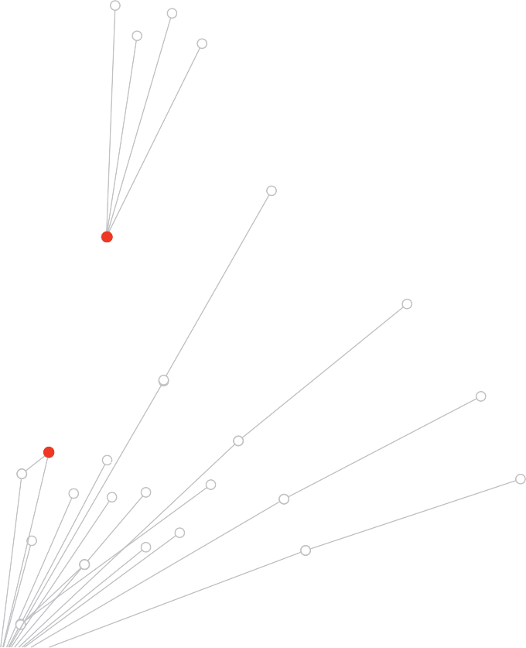
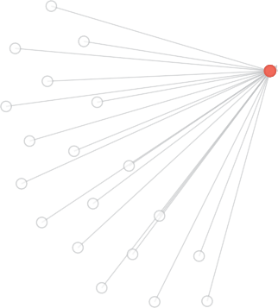
Monitoring particular elements of the end to end contact tracing process is important, as it can help identify where there are delays or bottlenecks in the system. The CDNA Australian National Disease Surveillance Plan for COVID-19 describes specific indicators for reporting on contact tracing processes. This surveillance plan and associated indicators are currently under revision.

References

- Coronavirus Diseases 2019 (COVID-19), CDNA National guidelines for public health units https://www1.health.gov.au/internet/main/ publishing.nsf/Content/cdna-song-novel-coronavirus.htm accessed 8 Nov 2020.

- AHPPC Statements on 21 August 2020. Australian Health Protection Principal Committee (AHPPC) updated statement on the role of asymptomatic testing. https://www.health.gov.au/news/australian-health-protection-principal-committee-ahppc-updated- statement-on-the-role-of-asymptomatic-testing accessed 8 Nov 2020.

- https://www.health.gov.au/sites/default/files/documents/2020/09/phln-statement-on-the-prioritisation-of-diagnostic-testing-for- covid-19.pdf accessed 8 Nov 2020.

- https://www.health.gov.au/sites/default/files/documents/2020/05/phln-statement-on-use-of-saliva-as-an-alternative-specimen- for-the-diagnosis-of-sars-cov-2.pdf accessed 8 Nov 2020.

- https://www.sahmri.org/m/uploads/2020/11/03/contact-tracing-covid-19-evidence-update-supplement-21-october-2020.pdf accessed 8 Nov 2020.
- https://www.sahmri.org/m/uploads/2020/11/03/contact-tracing-covid-19-evidence-update-supplement-21-october-2020.pdf accessed 8 Nov 2020.
- Endo, A., et al., Implication of backward contact tracing in the presence of over dispersed transmission in COVID-19 outbreak. MedRxiv, 2020: p. 2020.08.01.20166595. 10.1101/2020.08.01.20166595 accessed 8 Nov 2020.
- s23. Kojaku S, Hébert-Dufresne L, Ahn Y-Y. The effectiveness of backward contact tracing in networks. arXiv preprint arXiv:02362. 2020. accessed 8 Nov 2020.
- Coronavirus Diseases 2019 (COVID-19), CDNA National guidelines for public health units https://www1.health.gov.au/internet/main/ publishing.nsf/Content/cdna-song-novel-coronavirus.htm accessed 8 Nov 2020.

- Hui, B.B., et al., Modelling testing and response strategies for COVID-19 outbreaks in remote Australian Aboriginal communities. medRxiv, 2020: p. 2020.10.07.20208819. accessed 8 Nov 2020.
- Updated SAHMRI evidence summary https://www.sahmri.org/m/uploads/2020/11/03/contact-tracing-covid-19-evidence-update- supplement-21-october-2020.pdf accessed 8 Nov 2020.

- James, A., et al., Successful contact tracing systems for COVID-19 rely on effective quarantine and isolation. MedRxiv, 2020: p. 2020.06.10.20125013. 10.1101/2020.06.10.20125013 accessed 8 Nov 2020.
- National Review of Hotel Quarantine: https://www.health.gov.au/resources/publications/national-review-of-hotel-quarantine accessed 8 Nov 2020.
- Kretzschmar, ME. Et al. Impact of delays on effectiveness of contact tracing strategies for COVID-19: a modelling study. Lancet Public Health. 5:e452-59. July 2020. https://www.thelancet.com/journals/lanpub/article/PIIS2468-2667(20)30157-2/fulltext accessed 8 Nov 2020.
- Juneau, C.E., et al. Effective Contact Tracing for COVID-19: A Systematic Review. medRxiv, 2020:p.2020.07.23.20160234 accessed 8 Nov 2020.
- South Australian Health and Medical Research Institute. COVID-19 Evidence Update: Contact Tracing and COVID-19. https://www. sahmri.org/m/uploads/2020/09/02/covid-19-evidence-update-how-do-we-maximise-the-effectiveness-of-contact-tracing.pdf accessed 7 Nov 2020.

CHAPTER 3

OUTBREAK INVESTIGATION AND MANAGEMENT

Go hard, go early
An outbreak is generally defined as two or more confirmed cases, who do not reside in the same household, where illness is associated with a common source such as an event or within a community. For investigation purposes, all jurisdictions define an outbreak in a high-risk setting,
e.g. a residential aged care facility, as a single case.
Outbreak management is a sophisticated process. Preparation and public health expertise are key to keeping case numbers low and managing outbreaks. Some outbreaks are managed by multi- agency teams. As with contact tracing, outbreak investigation and management is assisted by local knowledge within the team, particularly in regional areas.

Through the extensive interview process with the cases, close contacts are identified and directed to quarantine. In simple cases, the contacts are family and friends.

In more complex cases, such as a venue having been visited by a confirmed case, incident management plans are developed for the venues to ensure that visitors are contacted directly or contacted via community messaging. This, plus thorough venue sanitisation and review of their COVID safety plans, makes it possible for the venues to be re-opened quickly and for the community to have confidence in the re-opening. In high risk settings, same day outbreak management mobilisation is essential, with an experienced team mobilised from the public health unit.
For most organisations – whether a school, a business or venue – there is benefit to a ‘rapid in, rapid out’ approach during an outbreak: early, fast and decisive action (rapid in) allows a quick exit (rapid out) by the authorities. This allows many normal operations to resume as soon as possible, minimising the negative impact on an organisation’s products or services. Of course, for some organisations such as hospitals, complete closure during an outbreak may not be an option.

Preparation by government, businesses and communities is vital. As in any crisis response, actions will be executed more swiftly and effectively when all parties are prepared: they know their roles, the required actions, and how to carry them out. Up front communication, dialogue and planning is a hallmark of effective preparation. Prevention and clear responsibilities for actions across different parties allows for more rapid and effective local responses.

Immediate case isolation, detailed case interviews, and quarantine of close contacts helps prevent further spread downstream from the case. However, to eliminate an outbreak or cluster, it is often necessary to trace and confirm the upstream source of infection of the current case. The source case or cases may have been asymptomatic and not previously identified. Once identified, further downstream contact tracing from that source can help to prevent further infection. The upstream contact tracing process may be repeated multiple times if generations of cases have not been identified.


CASE STUDY – NSW OUTBREAK AND CLUSTER INVESTIGATION

Within the NSW Health system, public health units with public health expertise and local knowledge conduct detailed case investigation and coordinate outbreak management.

Where there is a cluster or outbreak, an experienced public health team, pop-up testing clinics and local communications can be mobilised from the local health district within hours.

Linking the chains of transmission between cases and clusters may be difficult, often requiring detailed investigation of a case’s potential source of infection. This process is sometimes referred to as ‘upstream’ contact tracing and is routine practice in NSW when the source is not immediately identifiable.
To complement the epidemiological investigation, results from viral genome sequencing are available within 48 hours. These results are combined with information from serological antibody tests, which can be rapidly performed via a high throughput immunofluorescence assay.
This information is collated and expertly interpreted by epidemiologists to understand how and when the infection was transmitted.

Where a new case or cluster is identified within the community, NSW Health can swiftly target communications and increase local access to testing in specific geographical areas. All close and identified casual contacts are contacted and provided public health advice. All close contacts are asked to get tested immediately and to perform quarantine. People who work in or attend high risk settings and who are household contacts of a close contact are also quarantined for 24 to 48 hours until the close contact’s test results are known.

60 NATIONAL CONTACT TRACING REVIEW

Upstream contact tracing and analysing chains of transmission is difficult. It may require a combination of:
- Detailed interview with the current case or cases, conducted by qualified and experienced contact tracing personnel.
- Whole genome sequencing of viral genomes to identify linkages between cases, outbreaks and clusters.
- Antibody testing of upstream contacts to find the source of infection for the current case.
- Epidemiologists and public health personnel with a deep understanding of transmission dynamics to investigate and map the interconnections between cases.
- Local knowledge to help identify links between locations, community groups or events of interest.

To assist epidemiologists, the results from whole genome sequencing of the viral genome and antibody testing should ideally be available within 48 hours. This is common practice in NSW.

To date, the upstream contact tracing, outbreak and cluster investigation in most states and territories is conducted by highly trained epidemiologists, public health physicians or nurses. Software to provide advanced analytics and assist with linking cases is under development in Victoria.

COVID-Net: A national understanding of transmission
COVID-Net is a network of epidemiologists embedded in each jurisdictional health department. The National Incident Room at the Commonwealth Government Department of Health coordinates the network, and has made funding available for jurisdictions to employ an epidemiologist to participate in network activities. The purpose of COVID-Net is to understand SARS-CoV-2 transmission though investigation of clusters and outbreaks of COVID-19 and provide national surveillance information for public health action and policy development. The main objectives of COVID-Net are to conduct:
- Surveillance of clusters and outbreaks occurring in each jurisdiction reported weekly.
- National investigations into multi jurisdictional outbreaks of COVID-19.
- Nationally coordinated investigations into transmission of SARS-CoV-2 in high risk settings, e.g. on airplanes and in health care settings.

Genomic analysis and SARS-CoV-2
SARS-CoV-2 genomic analysis can enable enhanced disease control by permitting precise and accurate national and international pathogen characterisation and comparisons. Increasingly, SARS-CoV-2 genomics is being used to enhance surveillance and investigate COVID-19 clusters and transmission of the virus across Australia, resulting in better informed public health decision making.

NSW and Victoria are currently routinely using whole genome sequencing of viral genomes to track and confirm the source of infection, with Victoria aiming to perform sequencing for almost every identified case. These larger states also have the capacity to undertake genomic analysis for the smaller states and territories, though some jurisdictions are developing the capability to analyse genomic data in-house, in particular South Australia and Western Australia. Some states and territories are able to undertake viral genomic sequencing within 48–72 hours of sample collection. There is a longer turnaround time for whole genome sequencing of viral genomes in other states and territories; ideally these jurisdictions would also be able to complete the process within three to five days.


CASE STUDY – WESTERN AUSTRALIA VESSEL OUTBREAK RESPONSE

Western Australia has gained a wealth of experience in COVID-19 outbreaks on board vessels and, to date, has managed these vessel outbreaks successfully, demonstrating how this can be done nationally.

Each vessel outbreak has presented different challenges, from a cruise ship with large numbers of vulnerable people on board, to a bulk carrier that required outbreak management at anchorage. The various experiences have highlighted that vessel outbreak management needs to be individually tailored to the unique situation and circumstance of the vessel, its crew and the port.
Western Australia Health’s experience has shown the need for a proactive and strategic approach to the risk of COVID-19 on marine vessels, with continuous engagement with key stakeholders to ensure systems are in place to mitigate risk and respond to outbreaks.
Each port is considered individually, as the logistics of outbreak management vary greatly between ports. Robust governance structures, clear communication and active cooperation between the multiagency outbreak management team is required. Although successful to date, Western Australia are continually reviewing their protocols to ensure that a risk based approach is used to assess each situation and guide the management of vessel outbreaks.

62 NATIONAL CONTACT TRACING REVIEW

CHAPTER 4

DATA EXCHANGE
The development of a ‘Data Exchange’ would provide a new interoperability capability between existing state and territory based contact tracing systems and relevant government agency data systems in the near term. The Data Exchange will enhance Australia’s capability to rapidly trace contacts of cases across state and territory borders and provide more timely access to high value data sets for contact tracing.

The Data Exchange would allow contact tracing teams to search, request, share and transfer case and contact tracing data between states and territories. Contact tracing teams would also be able to quickly access airline and shipping passenger contact tracing information for international and domestic travel, registries of test results, and contact details from relevant government data systems. The Data Exchange would only transfer data relevant to contact tracing, such as phone numbers, addresses and test results.

Design assumptions
The Data Exchange would be predicated on a number of important design assumptions, including:
- Each state and territory will continue to operate its own contact tracing system.
- The Data Exchange will not hold contact data, modify contact data nor summarise contact data. It will act as a pipeline or a switchboard routing data between each jurisdiction’s contact tracing system and from government data sources.
- Each jurisdiction agrees to provide technical expertise to connect their contact tracing system (using an application programming interface, API) to the Data Exchange.
- Where it is not practical to implement automated requests in a state system, officials of a jurisdiction’s contact tracing system will be able to independently login to the Data Exchange using a centrally provided user interface.
- The Data Exchange itself will not support surge assistance. Instead the state, territory or Commonwealth staff providing assistance will be established as authorised users of the state or territory contact tracing system to which they are providing assistance.

Functional overview
The Data Exchange would be expected to be delivered using a modern Software-as-a-Service architecture using cloud based infrastructure. High level system components of the Data Exchange would include:
- The Data Exchange manages and logs requests and responses between jurisdiction based contact tracing systems and government data sources.
- Decentralised data storage model with no contact tracing data stored in the Data Exchange. Data are not synchronised between systems and data sources. Only the Data Exchange event data relating to request and response metadata are stored.
- APIs to control the query request and response connections between the Data Exchange, each contact tracing system and government agencies. The APIs will meet the Whole of Government National API design standards.
- Agreed syntax for API queries and a mapping of minimum core data between contact tracing systems.
- Loose coupling of data transfers using an asynchronous API messaging architecture to maintain contact tracing system and data store autonomy and flexibility.
- Notification of failure to receive responses within a specified time frame.



States and Territories
Australian Border Force
International flight manifests
Commonwealth
Web service API

Staging data (NIR)

Commonwealth data sources

Domestic flight manifests
Test and contact data

Jurisdiction A

Test and contact data
Web service API

System request and response

Data Exchange

Web service API

Jurisdiction B

Jurisdiction C
Portal User Interface

portal request and response

Key uses of the Data Exchange
The following use cases have been identified by the review team in consultation with the states and territories. They have been prioritised based on their utility to contact tracing teams and the importance of delivering the capability in a short time frame. Providing jurisdictions access to international and domestic travel information is the highest value use case. The quality of contact tracing details that can be accessed from airlines will be further enhanced through the newly implemented Australian Traveller Declaration by Australian Border Force.
It is expected that the implementation of the Data Exchange will follow a stage gate approach with the highest value and most achievable scenarios delivered first. Benefits of the Data Exchange will be evaluated before proceeding to the next phase.

Victoria, NSW and the ACT have indicated a willingness to be involved in implementing the Data Exchange. For efficiency, the initial implementation should be limited to a pilot involving Victoria, NSW, the ACT and the Commonwealth. Development of the pilot should be based on an indicative scope of technical work developed by these jurisdictions and other interested jurisdictions, and would only proceed through the stage-gate process following an evaluation of the pilot implementation.

64 NATIONAL CONTACT TRACING REVIEW

High priority uses for the Data Exchange

Use case | Utility | Immediacy | Priority
1. Enable faster contact tracing
1.1 Contact trace an international arrival accessing passenger manifest and contact details data | High | Medium term | Medium
1.2 Contact trace a domestic passenger accessing passenger manifest data | High | Near term | High
1.3 Confirm the international travel history of a domestic traveller | High | Medium term | Medium
1.4 Request contact details for a close contact from Commonwealth agency data sources | High | Near term | High
1.5 Request close contact data from another state or territory | High | Near term | High
1.6 Request close contact data from venue attendance registries | High | Near term | High
2. Coordination of contact tracing across states and territories
2.1 Request testing history for a close contact from another state | High | Medium term | Medium
2.2 Transfer a close contact to another state for ongoing contact tracing | High | Near term | High
2.3 Receive updates on a transferred close contact | Medium | Medium term | Medium
2.4 Notify the National Focal Point of a close contact who has departed Australia on an international flight | Low | Long term | Low

Legal and privacy
Given the design assumption that the Data Exchange service will not hold any data in the system, it is envisaged that privacy requirements can be met through the development of agreements with the state, territory and Commonwealth data owners. There will be no need to synchronise copies of data and risk, as a cyber attack target will be minimised.

Currently, under the National Health Security Act, Australia’s National Focal Point in the Commonwealth Department of Health oversees the sharing of personal data between states and territories, airlines, other Commonwealth agencies and other countries. A public health need, such as contact tracing for COVID-19, will be required to be demonstrated to share these personal data.

0 0
0 0 0 0
0
0
0
0

0
0

0
• •
•
0
•
0
0 0

•
/ .---1-a 0 • •
0 •
•
•
0

0
0
0
0
- 0
•
0
0
0 0
0 0 0 0
0 0 0 0
0 0 0 0
0
0 a-e 0
0 0 0 0 0
0
0 0 0 0

0 0
0 0 0
0
0 0 0
0
0 0 0
0 0 0
0 0 0 0
  - 0 0 0 0

0 0 0 0

66 NATIONAL CONTACT TRACING REVIEW

CHAPTER 5

TECHNOLOGY

Click and enter
Existing and emerging technologies have the capacity to significantly strengthen state and territory contact tracing and outbreak management capabilities by automating processes to manage large case numbers.
Technologies that complement the traditional contact tracing, surveillance and outbreak management capabilities can be classified into four broad categories:
- Testing technologies.
- Digital contact tracing tools.
- Advanced data analytics to support outbreak management.
- Digital technologies to support isolation and quarantine management.
The technologies described below complement the broader public health response, but should not be seen as a substitute for public health expertise.

Testing technologies
Detection of viral nucleic acid through the SARS-CoV-2 RT-PCR test remains the gold standard test for diagnosing COVID-19 infection. However, there are emerging supplementary and novel testing technologies for COVID-19. A PHLN working group, including CDNA members, is continuously monitoring these emerging technologies, and assessing their potential application in the Australian context.

Rapid antigen tests, genomic sequencing, and serological antibody testing are examples of other testing methods being utilised, or being given consideration, in the response to COVID-19.

Rapid antigen tests
Antigens are substances that stimulate an immune response in the body, such as proteins on the surface of a virus. For the SARS-CoV-2 virus, the antigen detected is the ‘spike’ protein that is required for the virus to enter into human cells.

Rapid point of care antigen tests have been developed for the early detection of SARS-CoV-2 virus in a specimen sample without the need for specialised and costly equipment. Rapid antigen tests offer turnaround of results within 15–30 minutes, are available at a lower cost compared to RT-PCR tests, and could be part of a surveillance strategy for high risk workforces and congregate settings. However, these tests are less sensitive than the RT-PCR test for COVID-19 diagnosis, with considerable variability between the rapid antigen tests on the market.
Moreover, the clinical performance of rapid antigen diagnostic tests largely depends on the circumstances in which they are used. These tests perform best when the patient is tested in the early stages of infection with SARS-CoV-2 when viral load is generally the highest. They may be useful as a screening test in high risk settings in which repeat testing could quickly identify someone with a SARS-CoV-2 infection to inform infection prevention and control measures.1 Adoption of rapid antigen testing in a broader testing framework will also require careful consideration of how to manage and confirm negative and positive results.

Rapid antigen tests require a nasopharyngeal swab taken by a health care professional. PHLN and CDNA’s Joint Statement on SARS-CoV-2 Rapid Antigen Tests has advised that rapid antigen tests should only be used with medical oversight under public health direction in specific settings.2 Analytical and epidemiological factors affect the test’s predictive value, leading to a high rate of false positive results, particularly when the prevalence of COVID-19 is low. For these reasons, PHLN and CDNA currently discourage the use of these tests in the general population. However, jurisdictions could consider forward planning for the potential use of rapid antigen tests in the event of further outbreaks and community transmission.

Genomic sequencing
Genomic sequencing is the highly accurate determination of the sequence of building blocks, known as nucleotides, from which the gene is constructed. In the context of this report, the genome being sequenced is the viral genome – not the human genome of the patient – and the type of genome is the viral RNA.

Whole genome sequencing of the approximately 30,000 RNA nucleotides that comprise the SARS-CoV-2 genome can be used to reveal the genetic makeup of the virus and discriminate between mutation patterns from different samples.

The SARS-CoV-2 RNA mutates frequently in ways that make very little difference to its infectivity but are sufficient to allow scientists to precisely distinguish various mutated strains. By tracking these mutations, viral genomics enables precise and powerful infectious disease surveillance.

By comparing SARS-CoV-2 genomes sequenced from multiple COVID-19 cases, clusters of COVID-19 and transmission of SARS-CoV-2 can be identified. The likely source of infection and routes of transmission can be monitored by the emergence of genetic variants over time and throughout communities. Whole genome sequencing can also be used to indicate whether the infection was acquired overseas, or locally from a known or unknown contact.3

Increasingly, SARS-CoV-2 genomic sequencing is being used to enhance surveillance and outbreak investigations across Australia. In the future, with sequencing results returned in two or three days, SARS-CoV-2 genomic sequencing may help identify genetic factors that impact susceptibility and disease severity, selecting effective targets for potential vaccines, and identifying drug resistant strains.

Serological antibody testing
Serological tests detect specific antibodies produced in the blood in response to an infection. For COVID-19, serological tests rely on the detection of anti-SARS-CoV-2 antibodies. Detection of these antibodies indicates previous exposure to the virus, and potential immunity.4,5

Serological tests rely on blood being drawn by a health care professional either from a vein or finger prick. All blood specimens should be regarded as potentially infectious.

Importantly, due to the time delay associated with the production of antibodies following infection by SARS-CoV-2 virus, serological testing should not be considered an alternative to RT-PCR for early detection and diagnosis.
Serological testing may be used for:
- Assistance with outbreak management, in situations where suspected cases return a negative COVID-19 RT-PCR test.
- Epidemiological investigation studies to define the degree of population infection, but not in low prevalence communities like Australia.
- Surveillance of frontline healthcare workers.
- Estimating the timing of infection to help define the likely infectious period of a patient.

68 NATIONAL CONTACT TRACING REVIEW

Digital contact tracing tools

Digital test trackers
The largely decentralised nature of specimen collection coupled with the centralised model for pathology services in most states and territories mean there are inherent delays between sampling, sending samples to labs, waiting for results, and follow up.

Currently, patient test records are a mix of paper pathology forms and digital records, with paper forms being digitised at the pathology labs, adding delays and introducing the potential for error. Digitally gathering patient information at the site of specimen collection allows much of the manual processing of testing to be automated, and has the potential to link with downstream digital contact and case management tools.

Digital case management
The use of technology to assist with contact tracing and case management is mixed across states and territories. However, all states and territories have been improving their systems and capabilities over recent months. In many jurisdictions, interviews are recorded on paper forms and subsequently entered into a database. In most states and territories, newly confirmed cases are manually assigned to contact tracing staff, with some daily monitoring activities also conducted manually. This model can quickly be overwhelmed during high case numbers, and can lead to situations where confirmed cases are not followed up, or instead are called multiple times by different interviewers for their initial contact tracing call.
To varying degrees, states and territories have digital data management and reporting in place based on third party database platforms configured to meet each system’s broad epidemiological event surveillance requirements. At the start of the pandemic, no jurisdiction had a system in place designed to respond efficiently to high case numbers.

Automation, where possible, of contact tracing and case management can significantly reduce workload, particularly during periods of high case numbers. When case numbers rise, the workload associated with daily monitoring activities (e.g. manually sending a text message or an email) rises rapidly. Automating this process can significantly reduce the elapsed time to notify close contacts and provide more efficient daily management of confirmed cases and close contacts in isolation and quarantine, respectively. Importantly, this automation will decrease the burden on the public health workforce which can then concentrate its efforts and expertise on outbreak management.

300
Number of daily new cases (vertical bars)
250
200
150
100
50
0
Automated daily monitoring saves time
Manual daily monitoring
Automated daily monitoring
1 7 14 21
Day of outbreak

5,000

4,000
Work hours (lines)

3,000

2,000

1,000

0

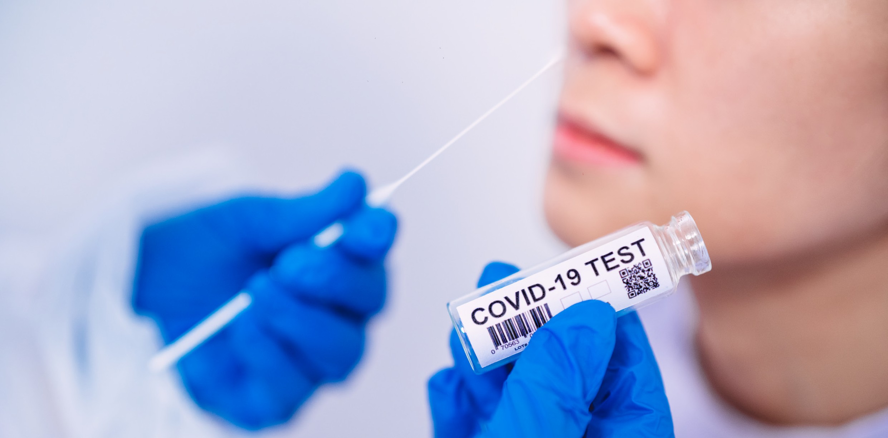
CASE STUDY – THE VICTORIAN TEST TRACKER
In the midst of the second outbreak, Victoria rolled out ‘Test Tracker’ to digitise information and data collected at the point of COVID-19 specimen collection to improve accuracy. Test Tracker is being used in all large volume pop up testing sites across Victoria.

The Test Tracker technology replaces the manual process of gathering key information from an individual when they present for a COVID-19 test, thereby reducing error caused delays and complications in contacting cases when handwritten forms are used.
When a person presents for testing they are provided a unique code (QR code) which is linked to their COVID-19 specimen and personal details collected on site. Once the specimen is tested the result is linked to the unique code and provided to the Department of Health and Human Services. If the sample is negative, the person receives an automated text message. If the sample tests positive for the presence of SARS-CoV-2, an official contacts the confirmed case to notify them to isolate, conducts a case interview and commences contact tracing.
Through this process, Test Tracker has saved valuable hours in notification of confirmed cases and contact tracing.
In addition to contact details, the digital form also collects data on language spoken at home, country of birth and occupation.
This additional data has proved important for the Department of Health and Human Services in conducting effective case interviews and contact tracing, enabling measures such as ensuring an interpreter is present before a case interview begins.
The digitisation of the data has also allowed Victoria to monitor testing levels in different cohorts, such as geographic location (based on home address), occupation, and industries and cultural groups. This has allowed Victoria to undertake targeted ‘call to testing’, through directed community engagement, working with community leaders and local health care services, as well as engaging with industry to bolster testing levels in underrepresented cohorts.
Test Tracker already plays an important part in Victoria’s end to end contact tracing system, with the aim of having 85% of COVID-19 tests in digital format by the end of the year. Test Tracker also provides future opportunities to extend beyond COVID-19 and create a practical legacy across pathology services.

70 NATIONAL CONTACT TRACING REVIEW

Most jurisdictions are in the process of implementing end to end case and contact management platforms. For example, South Australia, Victoria and Western Australia have each independently implemented a customer relationship management platform for their case and contact management process. In close development with local public health experts, these digital platforms are being used to better streamline the workflow through automation, where possible, and the use of digital surveys to help prioritise interviews with high risk cases and contacts.

Text messaging capabilities built into these platforms can be used to inform close contacts of their status and provide directions to quarantine, with follow up calls from health officers at the earliest practical time. This, and the use of text messages, web portals and smartphone apps for daily follow up during quarantine, can save hours of work for health officers per contact.

If case numbers surge to extreme levels, automated text messages can replace the usual practice of having a health officer call confirmed cases to notify them of their results, direct them to isolate and provide them with essential advice and support. If this capability were to be used, a health officer would follow up with a call as soon possible to the person, and the public should be well informed that text messages are being used for these notifications.

In addition, where case numbers are low and resources permit, a variety of daily monitoring options could be considered, based on the preferences of the case or contact. For example, in NSW, this can include web based video calling. In Western Australia, a smartphone app called G2G Now assists with daily monitoring. It is discussed further below.

Technology is not a substitute for public health expertise
Importantly, whilst a fully digital contact tracing system can dramatically improve the efficiency of contact tracing, it will never replace the need for well trained contact tracers and expert public health oversight. This is particularly relevant where there are critically important interpretive requirements such as difficult interviews, cluster analyses and outbreak responses.

Moreover, it is important to recognise there is likely to remain a proportion of the population, and regions of the country, where the use of technology will be limited.




CASE STUDY – ACT CHECK IN CBR
ACT Health has developed the CHECK IN CBR smartphone app – a contactless, secure and convenient way for customers to sign in at a Canberra venue.

In line with current ACT public health directions, non essential businesses and venues are required to ask all customers for their first name and phone number and record these details along with the date and time they attended the venue.

The CHECK IN CBR app enables venue operators to easily comply with these directions and the app enables individuals to check in to venues with ease. The data collected using the app is stored securely and directly with ACT Health for 28 days in the event contact tracing is needed due to a confirmed case of COVID-19 in the community.
The app allows contact tracers immediate access to information about who was in a
venue at a specific time. This greatly speeds up the contact tracing process, removing the need to contact venues for information, and bypassing traditional, error prone, paper based processes.

Importantly, the simplicity of the information requested, the security of data and the ability of the app to remember individuals’ details once entered is likely to lead to a higher adoption rate of the app and use at venues.

ACT Health has offered to share the app with other states and territories to support their contact tracing capabilities.

72 NATIONAL CONTACT TRACING REVIEW

Attendance apps
Contact tracing is greatly facilitated by attendees recording their presence at places that might become hotspots, such as cafes and restaurants, work, schools, universities, medical clinics, hospitals and sporting and entertainment venues.
Paper based recording of names and phone numbers is increasingly being replaced by innovative smartphone apps or web based portals that enable contactless registration of attendance at venues – places that allow routine and unmanaged public access. One jurisdiction is considering equipping staff at venues with an app for scanning attendees’ drivers licenses. The more common and actively used approach is for venue attendees to use apps, which generally scan a two dimensional pattern called a QR code posted at the venue entrance. The QR pattern encodes a globally unique number that identifies the specific venue.
A proliferation of third party attendance apps are being marketed to businesses across Australia. In addition to the disadvantage of not having a centralised database for contact tracers to interrogate the data, many of these apps are requesting unnecessary information from customers that adds significantly to the time taken to register, and is sometimes used for marketing purposes. Further, because of the multiplicity of applications, customers find themselves entering the same information repeatedly if they visit different venues. These repetitive and in some cases unnecessary burdens on customers are likely to result in lower overall compliance with attendance recording.
The utility of an attendance app in supporting state and territory contact tracing capabilities depends on wide adoption and use of the apps, accuracy of the information being obtained, and the availability of the attendance data to contact tracers. Important characteristics of attendance apps include:
- The information provided to the app is limited to the individual’s name and phone number or email address.
- During setup, the app verifies the phone number or email address to ensure accuracy of the information being obtained.
- The time and date, and the name and location of the venue are stored automatically.
- The app remembers an individual’s information so that any ‘check ins’ are as simple as clicking on the app and pointing the phone camera at the venue QR code.
- The data from the app is stored centrally and available for interrogation by contact tracing professionals, with little or no delay.

Within a jurisdiction, adoption of a simple, effective, and centralised app such as ACT Health’s CHECK IN CBR app will be important for realising the full potential of digital attendance recording in assisting contact tracing efforts across Australia.

Where non centralised check in apps are used, they should conform to the characteristics described above.


CASE STUDY – WESTERN AUSTRALIA G2G NOW

G2G Now is an initiative developed by the Western Australia Police Force to help police to support people subject to self quarantine directions.
This voluntary app allows people in self quarantine to prove their compliance quickly and easily by performing in app check ins rather than receiving physical checks by the police.
The G2G Now app uses facial recognition and phone location data to ensure people
in quarantine remain at their registered address throughout their mandated quarantine period. The app is directly linked to the G2G PASS.

Check in requests are sent to individuals’ phones at different times during their quarantine period. Individuals may receive no requests, or multiple requests on any given day.
Individuals are given five minutes to check in, and if they do not check in, a second request will be sent. If they fail to check in again they will receive a call from a police officer.

Each check in or health update checks their location against their registered quarantine address.

The G2G Now app also requires individuals to complete daily health questionnaires and register COVID-19 tests and their results.

74 NATIONAL CONTACT TRACING REVIEW

COVIDSafe proximity tracing app
The COVIDSafe app developed by the Commonwealth Government is an example of a proximity tracing app. An important distinction between proximity tracing apps and attendance apps is that COVIDSafe does not keep a record of a person’s location. Instead, COVIDSafe uses Bluetooth technology to look for other devices that have the app installed, and records contact when it occurs, through a digital handshake. It securely logs the other user’s encrypted reference code, the date and time, Bluetooth signal strength and proximity of the contact to the user’s phone. The COVIDSafe app stores these reference codes on the phone for 21 days, and automatically deletes contacts older than 21 days.

Aide-mémoire tools
Efficient contact tracing relies on the accurate memory recall of the confirmed case or close contact being interviewed by the contact tracers. In some cases, the smartphone that most people carry with them contains useful information that, like a diary, can prompt their memories.

For example, police in South Australia, with the consent of the case being interviewed, use a dedicated product called CARE to extract contact tracing information from interviewee smartphones. This information includes data such as GPS coordinates and time stamps of photos. Similar tools are used by the police in other jurisdictions, also with consent.

Advanced data analytics to support outbreak management
Some jurisdictions are exploring the use of advanced data analytics software to assist with outbreak management and predictive identification of locations of concern. Structured and unstructured data from many sources will be aggregated and analysed to identify patterns and relationships between confirmed cases, close contacts and places (e.g. workplaces, venues and postcodes).

Advanced analytics has the potential to increase productivity and efficiency by reducing the time spent on collating, processing, and linking cases. Already publicly available information such as internet search term frequencies, social media topics and Google and Apple map patterns could assist with predicting outbreak locations where people could then be offered increased access to testing.

Predictive analytics also has the potential to augment case and contact interviews – for example, by looking for features of cases and contacts that predict veracity and completeness of information. This function could in some cases flag a need to widen the net to secondary and tertiary contacts, and also provide information on where those nets should be cast such as homes, workplaces, and recreational facilities.

Digital technologies to support daily monitoring
The need to isolate confirmed cases and quarantine contacts presents a number of planning and implementation challenges, including the requirement for significant resources to monitor the health status and compliance of those in quarantine. Quarantining, whether at home or in a hotel, is undeniably taxing on individuals, and appropriate levels of welfare assistance and clinical care, along with mental health monitoring and supports are essential. In addition, compliance with quarantine requirements, usually through the support of local police, is resource intensive. The requirements for these specialised and finite resources will only increase as movement across state borders, and potentially incoming international arrivals, opens up. In most states and territories, health monitoring and quarantine compliance is monitored through a mixture of periodic telephone calls, facilitated with in home visits, with an increase in the number of in home visits based on assessment of risk.

Automated monitoring of quarantine compliance
Increasingly, technological solutions are being harnessed to dramatically improve the efficiency of the workforce and save many hours of manual processing, allowing valuable personnel to be deployed where most needed.

Automated quarantine compliance technologies, such as the G2G Now app developed by the Western Australia Police Force, provide a mechanism for people who are required to quarantine to prove their compliance with a quarantine direction. Importantly, these technologies are opt in systems, and people can still choose to be monitored through phone calls, and in person visits.
Daily health questionnaires can also be managed through the same app.

Clinical management in quarantine
Technologies can also be used to monitor the health and wellbeing of those people in quarantine. For example, in the Northern Territory, the National Critical Care and Trauma Response Centre is piloting the use of wearable devices for remote monitoring of people’s physiological parameters. The device is worn by individuals all day and night and allows health care teams located nearby in a telehealth control room to remotely monitor patient physiological measurements including blood pressure, heart rate and oxygen saturation. Face to face visits occur where needed, and patients still receive daily visits from a welfare support team, however remote real time physiological monitoring allows clinical care teams to provide care to a larger number of patients.

Digital travel exemptions
For tracking movement permits in special cases, such as entering vulnerable communities, or truck driver routes, digital solutions such as the G2G Pass can be very efficient by providing an electronic licensing system for COVID-19 travel restrictions.

These electronic passes can also be used so individuals can be fast tracked through border checks, saving time and improving efficiency. Relevant controls are in place to ensure data are only accessed by authorised officers within the relevant jurisdiction.

The Commonwealth Department of Home Affairs has replaced the paper based COVID-19 declaration card with the Australian Travel Declaration (ATD). The ATD is based on voluntary submission of contact details and information to support quarantine arrangements for international travellers. Work is underway to automate the flow of information from the ATD to states and territories.

References

- US Center of Disease Control Interim Guidance for Rapid Antigen Testing for SARS-CoV-2. https://www.cdc.gov/coronavirus/2019- ncov/lab/resources/antigen-tests-guidelines.html accessed 6 Nov 2020.

- Public Health Laboratory Network – Communicable Diseases Network Australia Joint Statement on SARS-CoV-2 Rapid Antigen Tests. https://www.health.gov.au/sites/default/files/documents/2020/10/phln-and-cdna-joint-statement-on-sars-cov-2-rapid- antigen-tests_0.pdf accessed 5 Nov 2020.

- PHLN guidance on laboratory testing for SARS-CoV-2 (the virus that causes COVID-19) version 1.14 https://www.health.gov.au/sites/ default/files/documents/2020/09/phln-guidance-on-laboratory-testing-for-sars-cov-2-the-virus-that-causes-covid-19.pdf, accessed 5 Nov 2020.
- Public Health Laboratory Network Guidance for serological testing in COVID-19. https://www.health.gov.au/sites/default/files/ documents/2020/09/phln-guidance-for-serological-testing-in-covid-19-phln-guidance-on-serological-testing-in-covid-19.pdf accessed 5 Nov 2020.
- Rapid Research Information Forum. The predictive value of serological testing during the COVID-19 pandemic. https://www.science. org.au/covid19/predictive-value-serological-testing accessed 8 Nov 2020.

CHAPTER 6

A CONVERSATION WITH COMMUNITIES
Efficient contact tracing and outbreak management are necessary but not sufficient to successfully live with COVID-19. Preventative measures such as attention to personal hygiene, social distancing, early testing at the first sign of symptoms, and voluntary quarantine when symptomatic will continue to be essential components of the first line of defence against COVID-19.

People have a right to know what is expected of them and how the pandemic and the response is unfolding. Therefore, a substantial commitment to a broad spectrum of public communication activities is required across government. This messaging may need to be strengthened in times of adjustment, particularly when restrictions are tightened. It is important to have communications and media experts integrated and embedded in health, emergency, police, customer service (NSW) and other relevant government agencies to ensure public health messages are consistent and pitched appropriately for Australia wide, state wide and local audiences.
Ongoing strong, consistent and culturally accessible and appropriate messaging through community engagement is vital to building and maintaining public awareness, trust, acceptance and confidence. Regular and proactive communication and engagement with the public, specifically with at risk populations, can also help alleviate confusion and avoid misunderstandings.

Education is needed to improve community understanding and health literacy, particularly with regards to infection prevention and control. The community must be encouraged to take personal responsibility and understand the impacts of their behaviour.

Consistency
It is important that as we move towards a COVID normal society the public remains vigilant. This is most likely if messages from the Commonwealth, state and territory public health and political leadership are consistent. Currently, there are inconsistencies in the messaging around getting tested between the jurisdictions. For example, the Commonwealth advice is “if you have cold or flu like symptoms you should seek medical advice about having a test for COVID-19”. However, in other jurisdictions the advice is that “anyone with mild COVID-19 symptoms should get tested”.
This inconsistency could create a barrier to some individuals getting tested, while also delaying the time it takes for an individual to get tested from symptom onset. Similarly, there is inconsistent advice about what people should do while awaiting test results and when they should resume usual activities.
There are also inconsistencies in key terms used by government and the media, including the use of the terms ‘community transmission’, ‘mystery cases’, ‘physical distancing’ and ‘social distancing’.

Where possible, states and territories should review their use of messaging around new cases, community transmission and mystery cases. There is currently not an agreed definition and these terms are being used differently in each state and territory. The review has adopted usage of terms to describe confirmed cases as ‘those identified in the community’ and ‘those identified in quarantine’. Further details can be found in Chapter 7 – Earning community confidence.

The term social distancing has become a commonly used term by governments and media and is used interchangeably with the term physical distancing. However, these terms can have different interpretations. Consistent use of ‘physical distancing of at least 1.5 meters’ would promote community understanding and practice.

When a person is notified of their COVID-19 test result, usually via a text message, it is important to clearly articulate the result to avoid confusion. Explicitly reporting detection of the virus, or no detection of the virus, in the test sample is preferred. The use of terms such as ‘positive’ and ‘negative’ can be misunderstood as a ‘good result’ or a ‘bad result’.

As part of contact tracing and case management, it is important consistent information and directions are given to all individuals in isolation and quarantine, including their immediate family and household. As part of an optimal end to end contact tracing and case management system this is optimised by allocating a single case manager to each household.

Consistency in messaging is vital across all community settings. During an outbreak clear, concise and consistent messages to affected settings such as workplaces, school and places of worship is important. This is optimised through ensuring communications and media experts are integrated and embedded in all government agencies, including health, emergency, police and, customer service (NSW), and ensuring all agencies are collaborating to present one voice.

In addition to consistency, it is important states and territories are checking to ensure public health messages are understood and not being misinterpreted. For example, South Australia has adapted their weekly state wide population health survey to include questions on understanding and adherence to COVID Safe messages. This includes questions on actions people are taking to protect against COVID-19 and reasons for not getting tested if symptomatic.

Working with community leaders
Australia has a diverse population, thus it is important that messaging is tailored for our various community groups, including people from culturally and linguistically diverse backgrounds.
Inclusion of community leaders in supporting and implementing public health measures is key to an effective response.

Working with community leaders has proved very important in states and territories with remote Aboriginal and Torres Strait Islander communities and also metropolitan areas with culturally and linguistically diverse communities. During the first wave, Aboriginal and Torres Strait Islander leaders called on governments to provide additional protection to remote communities, which was provided at a Commonwealth level through the Biosecurity Determination limiting travel to remote areas. States and territories with remote communities have invested extensive resources to assist communities and build trust and rapport to support them to protect and then reopen communities safely.
As an example, Queensland has committed to a co-ownership approach with local Aboriginal and Torres Strait Islander communities, drawing expertise from Aboriginal and Torres Strait Islander Community Controlled Health Organisations, the Queensland Department of Aboriginal and Torres Strait Islander Partnerships and the National Indigenous Australians Agency as well as working directly with mayors and CEOs of discrete and remote Aboriginal and Torres Strait Islander Communities. Through this approach, Queensland have provided support to communities, including targeted testing and targeted scenario planning for the unique circumstances of remote communities.
It is also important to engage with cultural and religious leaders in metropolitan areas, especially areas with large culturally and linguistically diverse populations. Community leaders in diverse cultural settings can help ensure key messages around physical distancing, hygiene, tightening restrictions and the importance of getting tested. In some communities there is stigma attached to contracting COVID-19 and getting tested. Cultural leaders can assist to break down these barriers. For example, in Melbourne cultural leaders helped to reduce stigma and bolster testing in underrepresented cultural groups.

Translation of key messages and resources
Ensuring all Australians can understand key messages around COVID-19 is vitally important in keeping the community safe by ensuring people adhere to public directions. With more than 300 different languages spoken in Australian homes, it is important that key messages are translated into appropriate languages and tailored to communities.

There are a number of translated materials on Commonwealth, state and territory designated COVID-19 webpages. The number and quality of these translated materials has improved greatly since March 2020, however it is an area that should undergo continued review and refinement.

It is imperative that translated messages are updated regularly to reflect any changes in the original English messages.

Further, the accuracy of the translations should be verified by reverse translation back into English to ensure the messages are concise and comprehensible.

As part of ongoing case management, most states are utilising automated daily text messages to monitor people in isolation and quarantine to remind about their obligations to remain in isolation or quarantine. Messages are generally sent in English, but contact tracing systems built on modern software applications can easily send these messages in preferred languages.

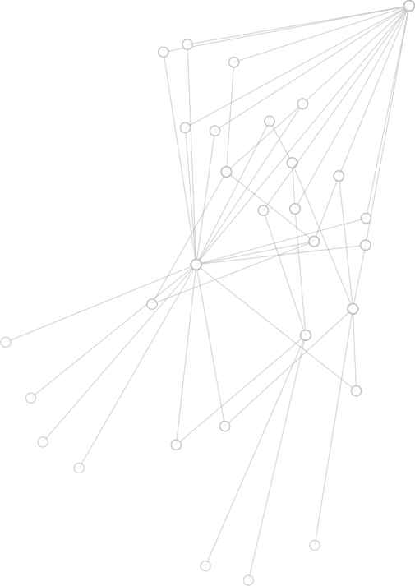


In addition, collecting information on language spoken at home alongside other contact details and symptom information at the point of COVID-19 specimen collection would enable the automated result notification to be sent in a person’s preferred language. This would help ensure people understand their test result, especially when COVID-19 virus is detected, to ensure the patient understands the need to isolate and await a case interview.

CASE STUDY – NORTHERN TERRITORY ENGAGEMENT WITH ABORIGINAL COMMUNITIES

Early in the pandemic the Northern Territory committed to inclusive engagement with Aboriginal communities.

The Northern Territory commenced regular meetings with a Regional Remote Taskforce with key stakeholders to ensure information sharing and a continued collaborative response to COVID-19 across the Northern Territory.







Weekly meetings were held by the Top End Primary Health Care Team with remote area communities and newsletters were distributed fortnightly to provide culturally sensitive information and key messages. Tailored training was delivered in communities on personal protective equipment use, outbreak management and ways to prevent transmission of COVID-19.

For more information
Public Health Unit 1800 008 002
coronavirus.nt.gov.au
Dry em kari
Ngulaka ngka
Barlkij marnda marnda
Marnda marnda kujada
Soap and nguku
Protect yunin nya family
Wash yininya marnda marnda
Coronavirus [COVID-19]
The Northern Territory has committed to a principles based approach to ensure all citizens have access to, and clearly understand, key messages regarding COVID-19. The key principles for Aboriginal communities include:
- Keep practising physical distancing – stay three steps away from people you don’t see very often.
- Wash your hands with soap and water regularly.
- Make sure you cough or sneeze into your elbow or a tissue.
- Try not to touch your eyes, mouth or nose.
- Monitor yourself for symptoms of coronavirus (COVID-19) and contact your health clinic if you start to feel sick.
Audio, video and printed files with health messages for COVID-19, focused on the key principles, were developed in Aboriginal languages and have been rolled out across the Northern Territory to cover the major language groups. These are easily located on the Northern Territory COVID-19 website.
A number of ‘no sound’ video resources have also been released to support the key principles and eliminate any possible language barriers. The videos are targeted at Aboriginal
people, and utilise Indigenous actors and localised familiar settings.

In addition, the Northern Territory has developed a specific disaster management plan for the Central and Top End services to handle COVID-19. This involved extensive training of remote health care workers, including Aboriginal Health Practitioners, to undertake contact tracing and case management on the ground.

Coronavirus - Wash Your Hands Protect Your Family - Mudburra

80 NATIONAL CONTACT TRACING REVIEW

CHAPTER 7

EARNING COMMUNITY CONFIDENCE
Reopening borders and keeping them open will depend on each state and territory being confident in the preventative and surveillance measures, outbreak management and contact tracing capabilities of all the other states and territories. However, we also need strong community confidence that all levels of government are doing everything required to both protect the community and ensure the economy can thrive.

Real time, simple, consistent and accessible reporting by all states and territories will assist in building this confidence.

Reporting confirmed cases
New confirmed cases of COVID-19 are reported daily by each state and territory and announced by the Premier, the Chief Minister, the Minister for Health or the Chief Health Officer (or equivalent) and published on the respective COVID-19 state and territory government websites. New confirmed cases generally include all cases, including those in the community and those already in home or hotel quarantine.

Grouping cases occurring in the community with those occurring in quarantine can send the wrong message to the community.

New confirmed cases identified in the community represent cases which may have been infectious until they were tested for COVID-19. These cases may be from an unknown source or linked to a known cluster and, either way, require close contacts to be identified. These cases are significant as they require extensive resources and can indicate an unidentified community outbreak.

New confirmed cases identified in quarantine represent cases which have already been directed to quarantine prior to becoming a confirmed case. This includes people who have returned from overseas and are in hotel quarantine and people who have been identified as a close contact and are also in home or hotel quarantine. With effective quarantine, these cases are not a risk to the community, especially if they were in quarantine prior to their onset of symptoms or infectious period. Confirmed cases in quarantine demonstrate a well managed testing and contact tracing system. Identification of a confirmed case in quarantine is the mark of a successfully operating system and should be celebrated rather than feared.
To improve public awareness and understanding of cases, these two categories should never be combined. It is recommended that states and territories, and the Commonwealth through consolidation, clearly distinguish the two categories in daily reporting. The review recommends the following reporting metrics:
- Number of new confirmed cases identified in the community, or if zero cases, the number of days since the last confirmed community case, and
- Number of new confirmed cases identified in quarantine.

Public Reporting (example)

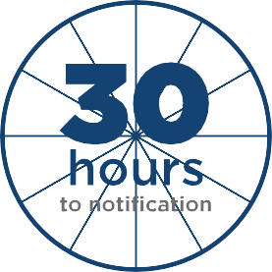

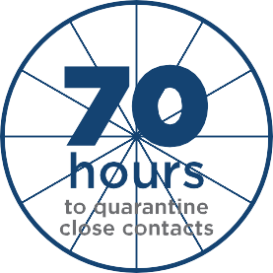
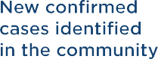
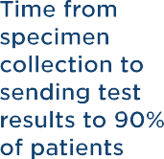
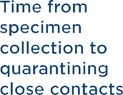
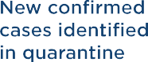



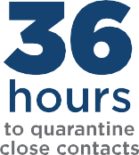

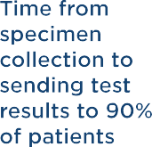
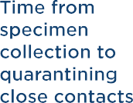



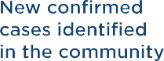
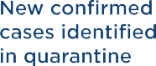

Reporting performance metrics
Real time, simple and accessible performance metrics are not being consistently reported across the country. To improve community awareness of the success, or otherwise, of the testing and contact tracing system, it is recommended that states and territories publish key testing performance metrics.
The Common Operating Picture (COP) is published weekly on the Commonwealth Department of Health website and provides a comparison of state and territory performance against a number of metrics, as agreed by National Cabinet. Even though publicly available, the COP has not been designed as an easily understood set of metrics for community engagement, but rather a detailed report to inform public health experts and government leadership.
As discussed earlier in this report, in order to minimise community transmission, states and territories should ensure all close contacts are quarantined within 48 hours, from the time of a case’s specimen collection. States and territories should publish these metrics regularly. This should include reporting on:
- The number of hours from specimen collection to notifying all people of their results, with the target being fewer than 24 hours at the 90th percentile.
- The number of hours from the patient’s specimen collection to notifying their close contacts that they must quarantine, with the target being fewer than 48 hours at the 90th percentile.

Achieving the first of the two metrics above is, important because if the time from testing to reporting results is too long, the second metric will be unachievable.

In addition, reporting results within 24 hours has a second, very important benefit. Symptomatic patients who have a test are required to self isolate until they receive their results. It is reasonable to expect patients to fulfil that requirement if they know they will get their results within 24 hours. However, it is less reasonable to expect patients to fulfil that requirement if it takes several days for patients to receive test results.

Targeting testing for the community
As Australia moves out of the second wave it is important the community does not become complacent. Maintaining high levels of testing will continue to be an important means of monitoring spread of the virus and identifying cases in the community. However, simply increasing the number of tests being undertaken will not be effective if testing is not targeted.

To optimise testing levels it is important states and territories have a targeted testing strategy. This includes identifying high risk populations and also under represented cohorts. Increasing community awareness, improving access to testing sites and removing barriers to testing can help motivate people to get tested. Many states are doing this already, and these measures are an integral part of their COVID-19 management plans.

For example, through collection of non-medical information at testing sites, Victoria is able to undertake targeted ‘call to testing’ programs, including community engagement, working with community leaders and local health care services, and engaging with industry to bolster testing levels in underrepresented cohorts.

Community awareness of the testing strategy in a state or territory including ongoing surveillance will help the public feel assured and have confidence in their state or territory’s ability to keep numbers low and stamp out transmission of the virus in the community.

Ongoing surveillance strategies such as the wastewater testing pilots being undertaken across Australia will also be an important part of assuring the public that governments are being vigilant and are prepared to respond early to detect and prevent potential second or third waves of the pandemic. They must be messaged carefully to avoid public complacency and reliance on these supporting strategies.

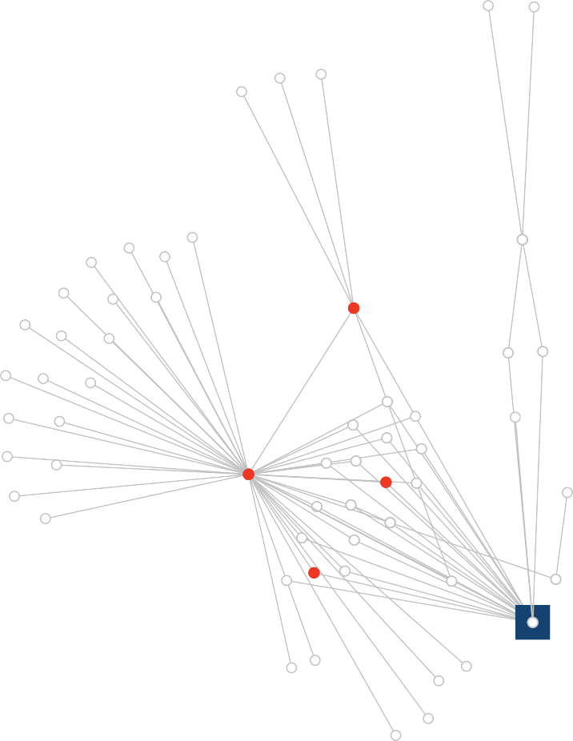
Open borders
The goal for Australia is to have an open society and a fully active economy supported by a rapid contact tracing and outbreak management system. A major step to achieve this goal is to open the internal borders within Australia by Christmas 2020 and keep them open.
At National Cabinet on 23 October 2020 the Commonwealth, states and territories, with the exception of Western Australia, agreed in principle to a new ‘Framework for National Reopening’. The framework sets a pathway for the removal of domestic border restrictions where it is safe to do so, and with free movement of people and freight consistent with National Cabinet’s strategy of suppression with a goal of no community transmission.
The framework identifies three steps to the future COVID normal:
Step 1 – Limiting group interactions and only allowing movement between areas of no community transmission.
Step 2 – Larger gatherings, more movement, the removal of domestic borders and movement allowed between areas of no community transmission.
Step 3 – COVID normal. Gatherings limited by physical distancing requirements, and free movement across Australia.

Many factors inform progress from Step 1 to Step 2 to Step 3. These include the preventative measures in place, the efficiency of the testing, contact tracing and outbreak management systems, the confidence of state and territory public health officials in the pandemic capabilities of the other states and territories, and the confidence of the public. Australia is doing well, and the measures recommended in this review should bolster confidence and achievement of the vision.

GLOSSARY
AHPPC: Australian Health Protection Principal Committee
The Australian Health Protection Principal Committee is the key decision making committee for health emergencies. It is comprised of all state and territory Chief Health Officers, is chaired by the Australian Chief Medical Officer and provides advice to National Cabinet.
CDNA: Communicable Diseases Network Australia
The Communicable Diseases Network Australia provides national public health co-ordination and leadership, and support for the prevention and control of communicable diseases. CDNA is a
sub-committee of the Australian Health Protection Principal Committee (AHPPC).
CDNA meets fortnightly to share and evaluate the latest information and developments in communicable diseases surveillance with a view to providing a high quality surveillance of communicable and notifiable diseases, including HIV, sexually transmissible infections, vaccine preventable diseases, arboviruses, zoonotic and enteric diseases.
Contact tracing
Contact tracing is the process of identifying assessing, and managing people who have been exposed to a disease to prevent onward transmission. When systematically applied, contact tracing will break the chains of transmission of COVID-19 and is an essential public health tool for controlling the virus.

Downstream contact tracing occurs when the contact tracing officer is trying to identify who has potentially been exposed to a confirmed case during their infectious period to ensure contacts immediately go into quarantine and do not spread the infection further.

Upstream contact tracing occurs when the contact tracing officer is trying to determine the source of a case. The use of whole genome sequencing, which can demonstrate links between cases, is effective in these scenarios. Serological antibody testing can be of value for upstream contacts of cases where there is no epidemiological link to identify the source of infection.
Contacts
A close contact is defined as a person who:
- Has face to face contact in any setting with a confirmed or probable case for 15 minutes or more. This is cumulative over the course of one week. It starts from 48 hours before the onset of symptoms in the confirmed or probable case, OR
- Has shared a closed space with a confirmed or probable case for a prolonged period (e.g. more than two hours). This is in the period extending from 48 hours before onset of symptoms in the confirmed or probable case.
A secondary contact is defined as a person who has had face to face contact for more than 15 minutes (cumulative over one week) with someone who is a close contact; or shared a closed space with a close contact for more than two hours (cumulative over one week). Both exposures will have occurred at least 48 hours after the close contact was exposed to the positive case. A secondary contact may also be determined by the Chief Health Officer when there is reasonable evidence of exposure to a possible human source or an exposure site.
A casual contact is defined as a person who has had exposure to an infectious confirmed case of COVID-19 where the exposure was face to face for a period of less than 15 minutes or in a closed space for a period of less than two hours.

COVID-19
Coronavirus disease 2019. The name of the disease caused by the virus SARS-CoV-2, as agreed by the World Health Organization, the World Organisation for Animal Health and the Food and Agriculture Organization of the United Nations.
COVID normal
As defined in the Framework for National Reopening, occurs when all indicators on the Common Operating Picture are green for 14 days, and the following activities occur:i
Work: People should return to the workplace, unless otherwise advised by public health advice.
Gatherings: People should maintain physical distancing of 1.5 metres and stay at home and get tested if unwell. Some density limits will remain for events and large venues.
Travel: Interstate travel is open and there are no domestic border restrictions in place. International travel partnerships and pilot programs are in place. Quarantine free international travel between New Zealand and other low risk international partners.
Confirmed COVID-19 case
A person who:
- Tests positive to a validated specific COVID-19 RT-PCR test; or
- The virus grows in cell culture from a swab, with RT-PCR confirmation using a validated method; or
- Has higher levels of COVID-19 neutralising or IgG antibodies detected in the blood after a second test.
Community and quarantine cases
New confirmed cases identified in the community represent cases which have been active in the community until they are tested for COVID-19. These cases are usually infected from unknown source or from a known cluster and require contact tracing of close contacts.
New confirmed cases identified in quarantine represent cases who have already been directed to quarantine prior to becoming a confirmed case. This includes people who have returned from overseas and people who have been identified as a close contact and are in home quarantine or hotel quarantine.
COVID-19 Safety plan
COVID-19 Safety Plans are usually checklists that provide clear directions on how businesses and organisations should fulfil their obligations to minimise risk of transmission of COVID-19 on their premises.

i https://www.health.gov.au/sites/default/files/documents/2020/10/framework-for-national-reopening-october-2020.pdf

COVID-19 test
Tests for COVID-19 aim to detect the causative virus, SARS-CoV-2, or an immune response to SARS-CoV-2.i
The three main types of COVID-19 tests are:
- Nucleic acid detection tests to detect viral RNA
- Rapid antigen tests – to detect antigen viral proteins on the surface of the virus
- Serology tests – to detect IgM or IgG antibodies against the virus
While rapid antigen tests can provide a result within 15–30 minutes, they are less sensitive than an RT-PCR test, which is still the gold standard in COVID-19 diagnosis.
Data Exchange
Provides a new interoperability capability between state and territory based contact tracing systems and relevant government data stores. This Data Exchange would allow contact tracing teams to search, request, share and transfer case and contact tracing data between states, and to request contact tracing data from government agencies.
Epidemiological link
Occurs when there is;
- Contact between two people involving a plausible mode of transmission at a time when one of them is likely to be infectious and the other has an illness that started within the incubation period after this contact, and
- At least one case in the chain of epidemiologically linked cases is laboratory confirmed.
Healthcare worker
Healthcare workers are people in contact with patients or the patient space – for example, doctors, nurses and cleaners who enter the patient’s room or cubicle as well as frontline administrative staff.
Isolation and quarantine
A person with COVID-19 or suspected to have it must enter mandatory isolation. A person enters quarantine when they are well but may have been in contact with someone with COVID-19. Either way, both are required to isolate from other people to prevent the spread of the virus. The period is usually 14 days from when they may have been in contact with the virus. Generally they:
- Must not leave home or the isolation location, except in an emergency or to get essential medical care
- Must not go into public places including work and shops
- Must not let any other person into the home unless the person
  - lives with them and cannot live somewhere else
  - is providing medical care for them
  - is entering for an emergency

i https://www.tga.gov.au/covid-19-testing-australia-information-health-professionals

NNDSS
The National Notifiable Disease Surveillance System supports Australia’s national case based reporting surveillance approach by integrating state and territory communicable disease data. This system is used to report nationally on all new diagnoses of COVID-19 infection and is supplemented by specialised reporting.
NINDSS
The National Interoperable Notifiable Disease Surveillance is a Commonwealth Department of Health project aimed to modernise and integrate Australia’s capability in communicable disease surveillance, outbreak management and interoperability. It is scheduled to begin in June 2021.
Physical distancing
Physical distancing in public means people:
- Keep 1.5 metres away from others wherever possible
- Avoid physical greetings such as handshaking, hugs and kisses
- Practise extra care if they are using public transport
- Avoid crowds
- Avoid large public gatherings
- Practise good hygiene
- Stay at home if they have any cold or flu symptoms, seek medical advice and get tested for COVID-19
SARS-CoV-2
Severe acute respiratory syndrome coronavirus 2. The formal name of the virus that causes COVID-19, as determined by the International Committee on Taxonomy of Viruses.
SoNG – Series of National Guidelines
The Series of National Guidelines have been developed in consultation for the Communicable Diseases Network Australia (CDNA) and endorsed by the Australian Health Protection Principal Committee (AHPPC). Their purpose is to provide nationally consistent advice and guidance to public health units in responding to notifiable disease events. These guidelines capture the knowledge of experienced professionals, built on past research efforts, and provide advice on best practices based upon the best available evidence at the time of guideline completion.

Specimen collection
Refers to the collection of samples from a patient to be tested for COVID-19, and includes; nasopharyngeal swab, throat swab and blood.
Surveillance
There are four main objectives of surveillance for COVID-19:
- To rapidly identify, isolate and manage cases.
- To identify, quarantine and provide information to contacts.
- To rapidly identify and manage clusters and outbreaks.
- To describe the epidemiology of COVID-19 in Australia including:
  - the progression of the epidemic in time, person and place,
  - transmission dynamics,
  - special risk groups.
Timeframes
For the purpose of this report, the following timeframes are defined below.
Near term: Until the end of 2020
Medium term: During 2021
Long term: 2022 and beyond

MEMBERS

National Contact Tracing Review Panel
Dr Alan Finkel (Chair)
Australia’s Chief Scientist

Leigh Jasper
Leigh cofounded and was the CEO of Aconex, the world’s most widely used cloud collaboration platform for managing construction projects. Leigh is the Chair of LaunchVic, the Victorian Government startup agency, and cofounder and Chair of Second Quarter Ventures. He is also a Director of SEEK Ltd, Buildxact, Salta Properties and the Burnet Institute.

Dr Tarun Weeramanthri
Dr Tarun Weeramanthri is an independent public health physician and newly elected President of the Public Health Association of Australia. He has served previously as Chief Health Officer in both Western Australia and the Northern Territory.

National Contact Tracing Review Taskforce
Dr Allison Jones (Taskforce lead)
Department of Health

Dr Kaori Ikeda
Office of the Chief Scientist

Emily Holt
Department of the Prime Minister and Cabinet

Joshua Montgomery
Department of Health

ACKNOWLEDGMENTS
The National Contact Tracing Review Panel would like to thank the following people who assisted in the development of the review.

Commonwealth representatives
- Dr Brendan Murphy, Professor Paul Kelly, Daniel Keys, Graeme Barden and Stephen Bouwhuis, Department of Health
- Phil Gaetjens and Alison Frame, Department of the Prime Minister and Cabinet
- Michael Pezzullo and Cath Patterson, Department of Home Affairs

State and Territory Health Department representatives
- Ms Kylie Jonasson, Director-General ACT Health
- Dr Kerryn Coleman, ACT Chief Health Officer
- Ms Elizabeth Koff, Secretary NSW Ministry of Health
- Dr Kerry Chant, NSW Chief Health Officer
- Professor Catherine Stoddart, Chief Executive Officer, Northern Territory Department of Health
- Dr Hugh Heggie, Northern Territory Chief Health Officer
- Dr John Wakefield, Director General, Queensland Health
- Dr Jeanette Young, Queensland Chief Health Officer
- Dr Chris McGowan, Chief Executive, South Australia Department of Health and Ageing
- Professor Nicola Spurrier, South Australia Chief Health Officer
- Ms Kathrine Morgan-Wicks, Secretary Tasmanian Department of Health and Human Services
- Dr Mark Veitch, Tasmanian Director of Public Health
- Ms Kym Peake, Secretary Victorian Department of Health and Human Services
- Professor Euan Wallace, Chief Executive Officer, Safer Care Victoria
- Dr David Russell-Weisz, Director General, Western Australia Department of Health
- Dr Andy Robertson, Western Australia Chief Health Officer

Individuals
We would like to thank Dr Sonya Bennett, Dr Paul Bertsch, Katina D’Onise, Alex Finkel, Victor Finkel, Lindsay Grayson, Dr Gary Lum, Professor Len Notaras, Charles Pain, Sandy Pitcher, Byron Scaf,
Ben Scalley, Paul Steel, Abigail Trewin and Professor Deborah Williamson for their advice during the consultations for this review.

Special thanks to
Sarah Brown, Amanda Caldwell, Paul Gunning, Kirsten Lawson, Brittany Locke, Emma McBeth.

