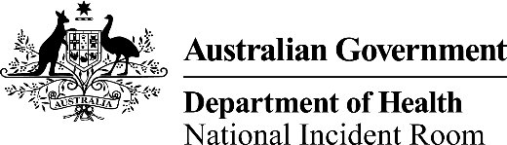

""

# New Zealand – Situation Update as at 29 October 2020

**Information presented in this assessment is based on data presented on the New Zealand Ministry of Health website.**

____________________

A/g Chief Medical Officer

Professor Paul Kelly

October 2020

| **Summary of Cases as at 1100h, 29 October 2020** | | |
| --- | --- | --- |
|  | **Total** | **Change in last 24 hours** |
| **Confirmed cases** | 1,593 | 6 |
| **Probable cases** | 356 | 0 |
| **Total (confirmed and probable)** | **1,949** | 6 |
| **Recovered cases** | 1,854 | 2 |
| **Deaths** | 25 | 0 |
| **Active cases** | 70 | 4 |
| **Current hospitalised** | 0 | 0 |

## New Zealand Quarantine-free travel Criteria

* New Zealand currently has no hotspots according to the definition: rolling 3-day average of daily new locally acquired cases is 3 or more by District Health Board.

## Summary of locally acquired cases

| Date | Locally acquired cases | Rolling 3-day average |
| --- | --- | --- |
| 23 October 2020 | 0 | 1 |
| 24 October 2020 | 0 | 0.33 |
| 25 October 2020 | 0 | 0 |
| 26 October 2020 | 0 | 0 |
| 27 October 2020 | 0 | 0 |
| 28 October 2020 | 0 | 0 |
| 29 October 2020 | 0 | 0 |

|  | Date | Number of days |
| --- | --- | --- |
| Last locally acquired case | 22/10/2020 | 7 days |
| Last locally acquired case of unknown source* | 21/08/2020 | 69 days |

| District Health Board | Past 3 days | Past 14 days | Past 28 days |
| --- | --- | --- | --- |
| Counties Manukau | 0 | 1* | 1* |
| Waitematā | 0 | 3 | 3 |

*\*In managed isolation at the time of testing*