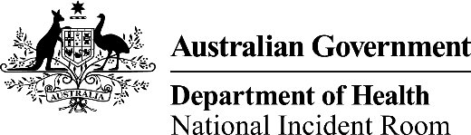

|  |
| --- |
| "" |

# signature New Zealand – Situation update as at 22 October 2020

| **Summary of cases as at 1100h, 22 October 2020**  ____________________  A/g Chief Medical Officer  Professor Paul Kelly  October 2020 | | |
| --- | --- | --- |
|  | Total | Change in last 24 hours |
| **Confirmed cases** | 1,558 | 2 |
| **Probable cases** | 356 | 0 |
| **Total (confirmed and probable)** | **1,914** | 2 |
| **Recovered cases** | 1,831 | 0 |
| **Deaths** | 25 | 0 |
| **Active cases** | 58 | 2 |
| **Current hospitalised** | 0 | 0 |

## New Zealand quarantine-free travel criteria

* New Zealand currently has no hotspots according to the definition: rolling 3-day average of daily new locally acquired cases is 3 or more by District Health Board.

## Summary of locally acquired cases

|  | Date | Number of days |
| --- | --- | --- |
| Last locally acquired case | 21/10/2020 | 1 day |
| Last locally acquired case of unknown source* | 21/10/2020 | 1 day |

| Date | Locally acquired cases | Rolling 3 days average |
| --- | --- | --- |
| 16 October 2020 | 0 | 0 |
| 17 October 2020 | 1 | 0.3 |
| 18 October 2020 | 0 | 0.3 |
| 19 October 2020 | 0 | 0.3 |
| 20 October 2020 | 0 | 0 |
| 21 October 2020 | 2 | 0.7 |
| 22 October 2020 | 0 | 0.7 |

* Note: The source of infection for the cases notified on 17 and 21 October 2020 are currently under investigation.

| District Health Board | Past 3 days | Past 14 days | Past 28 days |
| --- | --- | --- | --- |
| Counties Manukau | 1 | 1 | 1 |
| Waitematā | 1 | 2 | 3 |