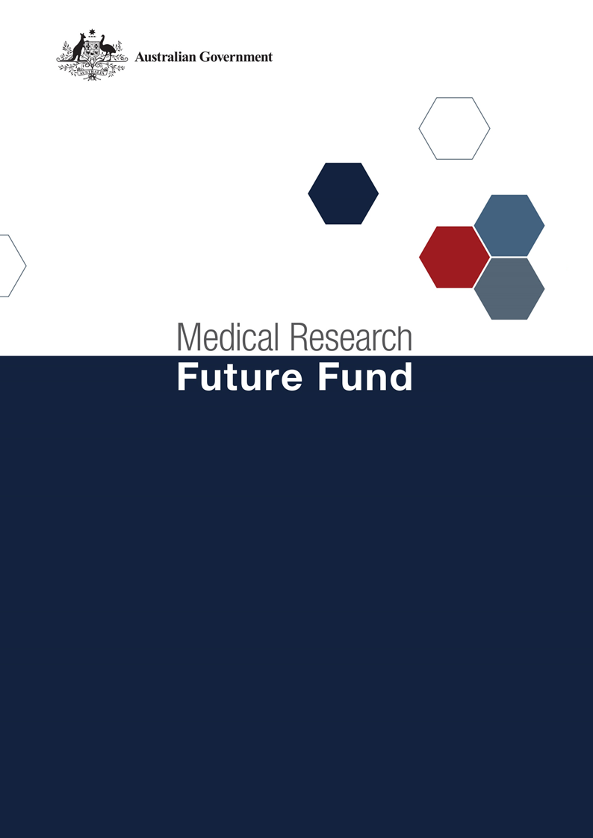

**Responses to Public Consultation Submissions   
Australian Medical Research and Innovation Priorities 2020-2022**

Table of Contents

Introduction 2

Responses to public consultation submissions 4

# Introduction

Consistent with the [*Medical Research Future Fund Act 2015*](https://www.legislation.gov.au/Details/C2020C00008) (the Act), the independent Australian Medical Research Advisory Board (AMRAB) has consulted with researchers, health service providers and consumers to develop the Medical Research Future Fund’s (MRFF) Australian Medical Research and Innovation Priorities 2020-22 (the Priorities).

Public consultation was conducted over the period 9 September 2020 to 7 October 2020, during which time public submissions were welcomed through the Department’s [consultation hub](https://consultations.health.gov.au/health-economics-and-research-division/medical-research-future-fund-consultation-to-infor/). AMRAB also held two public webinars, on 29 September and 7 October 2020.

As per the consultation guide, feedback was focussed on reflections on the current MRFF Priorities, the [*Australian Medical Research and Innovation Priorities 2018-2020*](https://www.health.gov.au/resources/publications/australian-medical-research-and-innovation-priorities-2018-2020), and their ongoing appropriateness to guide MRFF investments in health and medical research over the next 12 months operating under the current Australian Medical Research and Innovation Strategy 2016-21. The Strategy is due to expire in November 2021 with a process for revisiting the Strategy to occur in 2021. The Priorities will also necessarily be revisited as part of that process to ensure their alignment with the next Strategy which will be in effect from 2021-2026.

The following questions were provided on the consultation hub and also were the basis for the two webinars:

1. Do the current Priorities remain relevant in the contemporary environment for continuation for a further 12 months?
2. Should any of the Priorities be emphasised or de-emphasised for the next 12 month period?
3. Are there any un-addressed gaps in knowledge, capacity and effort across the healthcare continuum and research pipeline that would warrant changes to the Priorities?
4. Is there an opportunity to consolidate the Priorities for the remaining twelve months of the Strategy?

This report summaries public consultation comments. 245 submissions were received via the consultation hub, with 268 stakeholders attending the two public webinars. A diverse range of stakeholders provided submissions to the consultation. A breakdown is highlighted below in Figure 1 and Figure 2.

**Figure 1: Respondents organisation / affiliation**

**Please note no further details were provided on respondents who stated other or n/a for their affiliations**

**Figure 2: Respondents location**

**Please note no further details were available on respondents who stated an international location**

AMRAB considered all responses from the public consultation in October 2020 and, where necessary, revised the Priorities in accordance with the submissions. Summarised and themed feedback from the submissions and AMRAB’s responses are outlined in the following section.

# Responses to public consultation submissions

| **Strategic Platforms** | **2018-20 Priorities** | **Themes / Feedback** | **AMRAB Comments** |
| --- | --- | --- | --- |
| Strategic and International Horizons | One Health – Antimicrobial Resistance | * Focus on:   + new therapies, next generation of antimicrobial therapies, vaccines/immunotherapies   + new microbial threats such as Candida auris (fungal infection), drug resistant C. difficile and last-line antibiotic resistant gonorrhoea * Potential greater rise in AMR due to COVID-19 related secondary infections requiring increased use of antimicrobials | Updates made to the section to reflect the updated *National AMR Strategy-2020 and Beyond*.  Priority already has scope to focus on new therapies/ vaccines/ immunotherapies |
| Global Health and Health Security | * MRFF should increase investment in:   + emerging infectious diseases threats such as COVID-19;   + well-established pathogens that encroach national borders including tuberculosis and vector-borne diseases;   + endemic diseases that thrive in areas of disadvantage. * Australia’s health security is closely linked to the Indo-Pacific region and greater investment in the health issues impacting our region is critical. * Preparedness and response planning needs to contemplate both identified and emerging (unspecified) threats. * Consideration of second tier health impacts in future pandemic funding to ensure that as the pandemic comes under control there are mechanisms for managing the wider, secondary health impacts of the pandemic. * More funding to research the effects of bush fires, short term and long term, on general population and high risk groups health * Better preparedness for emerging diseases/pathogens as a public health priority * Clear gaps in emerging infectious diseases and streamlined pipelines to support rapid drug assessment, testing and approvals. * Limitations on the availability of primary health care due to the COVID-19 pandemic is a newly identified gap where the mental health of people living with rare disease and other vulnerable groups may feel a disproportionately large impact on mental health. * Priorities should, wherever relevant, consider themes of mental health. | Updates made to the section to reflect further emphasis on pandemic responses, noting the impacts on health and health systems such as mental health. |
| Aboriginal and Torres Strait Islander Health | * Address cultural safety and the engagement of Aboriginal and Torres Strait Islander people in models of care. * More opportunities should be made available to Aboriginal and Torres Strait Islander researchers and services to affect meaningful change. * Focus on Indigenous-led research / Indigenous leadership, agency and community empowerment, the promotion of health equity, elimination of discrimination and the strengthening of Indigenous research capacity. * Increasing equity of access to health care for Aboriginal and Torres Strait Islander people. | Updates to the section to reflect the need for continued investment to support Aboriginal and Torres Strait Islander health outcomes and also reflect the new National Agreement on Closing the Gap. |
| Ageing and Aged Care | * Focus on:   + frailty, end of life and optimising patient centred care in Aged Care Facilities.   + Optimal models of care, creation of new assisted living technologies and strategies to delay frailty and cognitive decline.   + Effective treatments and prevention strategies that will reduce dementia or its severity and therefore reduce nursing home admissions.   + quality of life including tackling cognitive decline and dementia including holistic aspects of care.   + residential care, particularly for people with dementia, must be a higher priority to enable response to recommendations of the Royal Commission into Aged Care Quality and Safety.   + processes of care including health services and workforce research.   + quality indicators for health and ageing care system   + palliative care research   + better identification, management and treatment of other sensory conditions, particularly vision loss | Updates to the section to reflect the need for continued investment to support improved ageing and aged care outcomes and to reflect the Royal Commission into Aged Care Quality and Safety’s Final Report, due in February 2021. |
| Data and Infrastructure | Digital Health Intelligence | * Investment to improve telehealth and data infrastructure will facilitate better coordination in patient care amongst all health practices, including older people in communities and residential aged care. * Digital technologies will transform healthcare, to shift from a system geared towards reactive and hospital-based treatment of acute conditions to one that is more community-based, with a preventative and anticipatory approach. * Evaluate the effectiveness of digital health tools and continue to improve their security, effectiveness and efficiency in the health system to provide optimal patient outcomes. * Address those people who cannot afford, cannot use or cannot access digital health solutions. * Incorporate not just Artificial Intelligence but also telehealth, big data analysis and more effective utilization of primary care data. * Funding should further develop the evidence-base for digital health (and related tech and trends such as AI, genomics and big data). * Increase the integration of routinely captured clinical and administrative data (e.g. primary care, aged care, emergency department, intensive care, and hospital admission data) with pre-hospital data, and results from imaging, pathology | Updates made to the section to reflect the important role innovative technologies are playing in transforming healthcare, including improving productivity and efficiency to improve health outcomes. |
| Health Services and Systems | Comparative Effectiveness Research | * Focus on:   + Clinical Quality Registries.   + evaluating effectiveness of healthcare delivery models (such as telehealth) used in the pandemic.   + scientific challenges of defining clear research questions, identifying corresponding research designs and developing appropriate analysis strategies that address the research questions, while recognising important sources of bias and uncertainty in conclusions.   + maximising health outcomes for individuals and populations e.g. Covid-19 pivotal to improve our understanding of pandemic’s impact on health systems, healthcare and healthcare attendance, and informing evidence-informed responses. | Updates to the section to reflect that continued investment is required to support Comparative Effectiveness Research, including a focus on patient benefit / cost effectiveness. |
| Primary Care Research | * A national practice-based clinical trial network in primary care would enable large-scale clinical trials, with the potential for evidence generated to be implemented into standard care. GPs also need support to participate in research for which there are good international models. * Practice-Based Research Networks (PBRNs) to advance primary health care research should be a high priority. PBRNs require both research and infrastructure funding to sustain necessary engagement between researchers and practitioners/community. * Meaningful research into innovative primary health models of care including precision medicine approaches. * Greater focus on remote, rural and regional health care and research. | Updates to the section to reflect that further approaches were required to ensure involvement of health services in research design and implementation to support translation. |
| Capacity and Collaboration | Clinical Researcher Capacity | * Equal access to fellowships across career stages is still lacking, particularly for early to mid-career researchers stages of their career. * MRFF funding should be expanded to support medical researchers across the research continuum. * Major gaps in supporting early-mid career researchers. There has been a shift towards supporting clinician researchers at the expense of those who conduct fundamental research. * Targeted MRFF funding could help address the issue of loss of early to mid-career researchers. * Clinical workforce gap in research translation. * Broaden the scope so that non-clinical researchers are included. * Greater prioritising and support for clinician researchers and clinician researcher teams to increase translation of research into routine patient care. | Updates to the section to reflect that overarching responsibility for capacity and capability should be within each individual MRFF program.  AMRAB noted the effect of COVID-19 and that continued support is required to enhance research capacity, including a focus on early and mid-career researchers. |
| Consumer-Driven Research | * There remains some way to go to build capacity, both in researcher interest, confidence and pathways to engage and involve consumers, as well as in having sufficient research-aware and interested consumers, willing, able and confident to engage with researchers. * Consumer driven research should be prioritised to ensure lived experience is included in the design of health and medical research. * Greater emphasis should be across all priorities with strong enabling processes to provide opportunities for consumers to meaningfully engage in research. * Evaluation of current models of consumer choice within health systems. * The ad-hoc engagement of consumers across all MRFF activities is a gap. | Updates to the section to reflect the importance of meaningful consumer involvement in the success of research translation into clinical practice in line with the 2016-21 Strategy.  AMRAB agreed consumer involvement should be embedded in MRFF programs and grant opportunities. |
| Trials and Translation | Drug Repurposing | * Drug repurposing can be a valuable tool to identify tractable targets that can then be progressed by rational drug design using medicinal chemistry to complement the field with novel technologies. * There is a knowledge gap in drug discovery principles and associated technology development - such as chemical reaction discovery towards bioactive molecules - skilled drug discovery and development scientists in public institutions struggle to gain access funding and the situation is worse for the underpinning reaction discovery area. * The MRFF should fund research to discover new drugs, as well as improve and modify existing drugs and should not solely focus on clinical trials of re-purposed or established drugs. * Research is required into structural changes and incentives in the regulation, registration and government subsidising of prescription medicines that could make our pharmaceutical industry more amenable to drug repurposing. | Updates to the section to reflect that continued investment is required to support Drug Repurposing, acknowledging the need to focus on supporting timely access to new therapies for patients. |
| Public Health Interventions | * Messaging about public health and vaccinations, that is consistent and underpinned by research, will be important in ensuring maximum uptake across the Australian community. * Prevention as a key approach to Public Health Interventions is currently under-emphasised and should be a far more prominent theme within the MRFF. * Strengthen the capacity of the research and health sector to respond to national (bushfires, air quality) and international (pandemics) threats. * Prevention of further communicable diseases and strategies to support infection control should be highlighted along approaches to reduce NCDs. * Prevention as a key approach to Public Health Interventions is currently under-emphasised and should be a far more prominent theme within the MRFF. * Evaluation, both in terms of cost and effect, of prevention strategies and early intervention research across the full care spectrum that aligns with Australia Health priorities * Environmental aspects of health and wellbeing offer an extraordinary opportunity for Australia to lead the world in research and systems development tackling the health challenge that will resonate over many decades, our changing climate. * Trans (including gender diverse and non-binary) healthcare is an under-researched area. The trans population have shocking rates of suicide/suicide ideation and significant mental health co-morbidities * Disability is an area of research that intersects with many other areas already identified as MRFF priorities, but knowledge generated in these fields does not readily transfer to the disability sector. * Prioritising rural health research, and translational rural health research in particular, will directly complement the existing priorities * Focus on the differential health experiences of CALD populations, and also a recognition of the social determinants of health including a focus on vulnerable populations. | Updates to reflect that continued investment is required to support Public Health Interventions, including the increasing role digital health can play in improving equity of access.  AMRAB also agreed a greater focus should be placed on vulnerable and at-risk groups. |
| Commercialisation | Translational Research Infrastructure | * Revisiting the concept of an infrastructure usage/access voucher system in collaboration with other funding portfolios is a way to ensure infrastructure investments are maximised and researchers are encouraged to collaborate. * Better integration between MRFF-funded missions and NCRIS-funded facilities will accelerate translation of Australia's biomedical assets. * TRI should be emphasized across all stages of the drug discovery pipeline – less support currently for capacity in both biology and medicinal chemistry * Emphasis should be broadened to support commercialising discoveries in a more comprehensive fashion. | Updates to the section to extend the focus towards building capacity and capability, including through a broader range of partners (e.g. philanthropy). |