

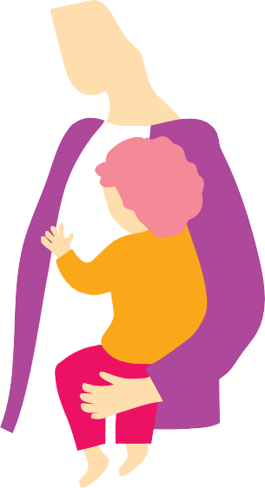

**Why does my child**

**need a flu shot?**

**Flu shots, called influenza vaccines, are recommended for babies and children every year from the time they are six months old to protect them from influenza. Influenza vaccines are free for all children aged six months to under five years.**

# **Isn’t the flu just a bad cold?**

Influenza (also called ‘the flu’) can be much worse than a bad cold. Some children who have influenza get so sick they can’t go to childcare or preschool for two weeks or more. Every year in Australia, hundreds of children get so unwell from influenza they need to be treated in hospital. Most of them are babies and children under five years.

# **Do influenza vaccines actually work?**

An influenza vaccine is the best way to protect your child from serious influenza. Influenza vaccines give better protection in some years than others. This is because the types of influenza viruses making people sick from year to year can change, and the vaccines may have to be updated. Before the influenza season, experts gather information from around the world to work out which influenza viruses are most likely to circulate. They often get it right, but sometimes it can be hard to predict. Influenza vaccines give your child good protection, even if they aren’t always perfect.

# **Could my child get influenza from the vaccine?**

Your child can’t get influenza from an influenza vaccine. Influenza vaccines contain pieces of influenza viruses, but these can’t make your child sick like the whole virus. Some vaccines in other countries have whole, weakened influenza viruses in them, but these vaccines are not used in Australia.

It’s normal for babies and children to be a bit unsettled or even feverish for a day or two after influenza vaccination. These side-effects are a sign that your child’s immune system is responding to the vaccine. Also, the vaccine starts to protect your child after about two weeks, so if your child caught the virus before they were vaccinated (but wasn’t feeling sick yet), or in the two weeks after they were vaccinated, it might seem like the vaccine made them sick.

# **I’ve heard influenza vaccines can have serious side effects. Is this true?**

Serious side effects are very rare. Less than two in every 100,000 children under two years have febrile convulsions (fever fits or seizures) in the days after vaccination.1 Febrile convulsions are caused by a sudden increase in body temperature. They can

be frightening, but are usually harmless. Children are much more likely to have febrile convulsions if they get sick from influenza. In one study, about four in 100 children who were treated in hospital for influenza had a febrile convulsion.2



About one child out of every million who get an influenza vaccine has a severe allergic reaction (anaphylaxis) to one of the ingredients. Any reactions usually occur before you leave the clinic, and the medical staff are trained to help children who have this reaction recover quickly. Anaphylaxis is frightening but extremely rare.

It’s safe for children with egg allergies to get influenza vaccines.3 This is because the amount of egg in influenza vaccines is tiny (usually less than one microgram of egg protein per dose, which is too small to trigger an allergic reaction). Many years ago, influenza vaccines used to contain more egg protein, but the way the vaccines are manufactured is much better now.

# **Does my child really need an influenza vaccine every year?**

Children six months or older need to get an influenza vaccine every year. This is because the types of influenza viruses circulating often change from year to year. Also, protection from an influenza vaccine generally lasts less than a year. The best time to get an influenza vaccine is in April or May, before the influenza season, which is usually June to September. Your child can get an influenza vaccine at the same time as other vaccines.

# **How can we be sure the vaccine is safe?**

Influenza vaccines must be assessed for safety by the Therapeutic Goods Administration (TGA) before they can be used in Australia. Although the types of influenza virus particles in vaccines may change each year, the way the vaccines are manufactured stays much the same, so they don’t need to be tested again each year. There are systems in place to detect any unexpected side-effects while a vaccine is being used. The TGA, along with other health authorities and experts, investigate any potential issues. In very rare circumstances, they may suspend use of a vaccine.

This is what happened in 2010, when one brand of influenza vaccine (Seqirus/ bioCSL Fluvax and Fluvax Junior) was found to have caused febrile convulsions in children under five years. We don’t give this specific vaccine to babies or children in Australia anymore.

**About us**

This information sheet was developed by Nina Chad PhD with Samantha Carlson PhD, Catherine King PhD and the National Centre for Immunisation Research and Surveillance, based on work from the SKAI Collaboration. The project is funded by the Australian Government Department of Health.

**Further reading**

talkingaboutimmunisation.org.au

**References**

1. Hambidge, S.J., et al., Safety of Trivalent Inactivated Influenza Vaccine in Children 6 to 23 Months Old. JAMA, 2006. 296(16): p. 1990-1997.
2. Dawood, F.S., et al., Complications and associated bacterial coinfections among children hospitalized with seasonal or pandemic influenza, United States, 2003-2010 (Report). Journal of Infectious Diseases, 2014. 209(5): p. 686.
3. National Centre for Immunisation Research and Surveillance. Influenza vaccines - Frequently Asked Questions (NCIRS Fact sheet). NCIRS: Sydney, Australia.