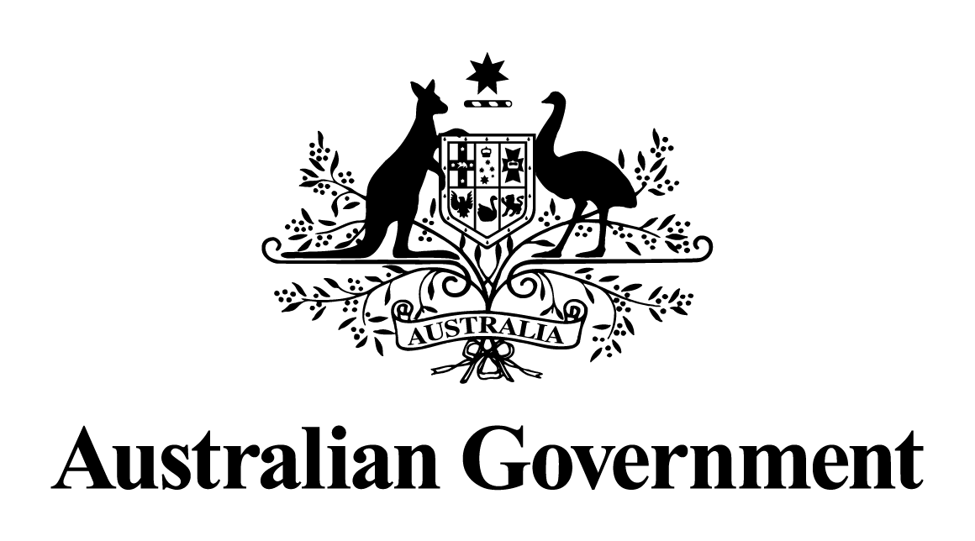

Australian Government response to the Senate Community Affairs References Committee report:

Support for Australia’s thalidomide survivors

October 2020

# Introduction

The Australian Government welcomes the Interim and Final Reports of the Senate Community Affairs References Committee Inquiry into *Support for Australia’s thalidomide survivors*.

The Government acknowledges the plight of Australia’s thalidomide survivors and their families, and understands they have suffered from circumstances outside of their control. The agony of thalidomide survivors has been a tragedy.

The Government would like to thank all of those involved in the Inquiry, in particular thalidomide survivors and their family members who bravely presented their personal accounts at the public hearings.

Thalidomide was available in Australia from 1960-1961, it was predominantly sold over the counter (rather than upon prescription) as a tranquilliser and pain killer that was effective for treating insomnia and headaches as well as nausea and morning sickness during pregnancy. At this time, the Commonwealth did not have a role in the evaluation of drug safety.

Prior to the thalidomide tragedy, the safety of medicines was not monitored in Australia. The Commonwealth legislation governing therapeutic substances at the time was the Therapeutic Substances Act 1953 (Cth), as amended by the Therapeutic Substances Act 1959 (Cth)(Therapeutic Substances Act). The Therapeutic Substances Act was concerned largely with labelling and manufacturing quality standards. It did not attempt to ensure that therapeutic substances proposed to be imported or sold in Australia were proven to be efficacious and had undergone clinical trials or other testing to ensure that they were safe to use.

As part of the Australian response to this tragedy an independent committee was established to monitor the safety of new medicines as well as medicines already available. The Australian Government established the Australian Drug Evaluation Committee (ADEC) in June 1963. Subsequently, the Australian Government established a Therapeutic Goods Branch within the Department of Health in 1967. The Therapeutic Goods Administration (TGA), as it now stands, was formed in 1989.

The TGA today carries out a range of assessment and monitoring activities to ensure therapeutic goods supplied in Australia are of the highest standards. It provides a national framework to ensure medicines and medical devices are safe, manufactured according to international quality standards and perform as intended.

The Final Report of the Senate Committee made 11 recommendations addressing a number of areas, including an apology from the Australian Government, the provision of financial support, and special consideration for access to health and disability services.

The Government notes the recommendations of the Interim Report and that the Final Report supersedes it. This response specifically addresses the recommendations identified in the Senate Committee’s Final Report, and has been coordinated and prepared by the Department of Health.

# Australian Government Response to Final Report

## Recommendation 1

*4.12 The committee recommends that the Australian Government apologise to Australian thalidomide survivors and their families.*

### Response:

The Australian Government **supports** this recommendation.

The Government has publicly stated that it would offer a national apology and would establish a public memorial as a site of recognition for Australia’s thalidomide survivors.

The Department of Health has had discussions with members of Thalidomide Group Australia regarding suitable options for a site of recognition. These discussions are ongoing.

The Government will work with the National Capital Authority and thalidomide survivors on selecting an agreed and appropriate site.

## Recommendation 2

*4.22 The committee recommends that the Australian Government provide all Australian thalidomide survivors who have been recognised by Diageo with a lump sum payment on a scale according to their level of disability that is exempt from income tax and the social security income test.*

### Response:

The Australian Government **supports** this recommendation.

The Government will make a lump sum payment, of between $75,000 and $500,000, on a scale according to their level of disability, to all Australian thalidomide survivors who have been recognised by Diageo.

The lump sum payment will be in addition to current Government support payments thalidomide survivors may receive, such as the Disability Support Pension and National Disability Insurance Scheme plan funding.

## Recommendation 3

*4.23 The committee recommends that the Australian Government provide any person who has not yet received financial compensation with a lump sum payment as soon as they are recognised as a thalidomide survivor on an equivalent basis with those thalidomide survivors already recognised with a similar level of impairment.*

### Response:

The Australian Government **supports** this recommendation.

The Government will establish an eligibility process to determine any Australians who may have been impacted by maternal thalidomide use, but have not previously received financial support from Diageo (that is, currently unrecognised survivors). This eligibility process will be modelled on similar international models.

The Government will make a lump sum payment of between $75,000 and $500,000 to all Australians recognised through this eligibility process, on a scale according to their level of disability.

The lump sum payment will be in addition to current Government support payments individuals may receive, such as the Disability Support Pension and National Disability Insurance Scheme plan funding.

## Recommendation 4

*4.29 The committee recommends that the Australian Government provide all Australian thalidomide survivors with an ongoing annual payment to provide them with flexibility to purchase the services they need. The committee considers that this annual payment should be increased over time to reflect thalidomide survivors' increasing health needs.*

### Response:

The Australian Government **supports** this recommendation.

To assist survivors with the costs associated with their increasing health care and daily living needs, the Government will establish:

* an annual pension payment scaled on level of disability;
* an Extraordinary Assistance Fund, administered by Services Australia, to support activities of daily living, including home and vehicle modifications; and
* a Health Care Assistance Fund, administered by Services Australia, to provide survivors with support for out of pocket health care expenses.

## Recommendation 5

*4.34 The committee considers that the Australian Government should establish a centre to disseminate information and coordinate services for thalidomide survivors and currently unrecognised survivors.*

### Response:

The Australian Government **supports** this recommendation.

The Government recognises the value of providing an identified point of contact for thalidomide survivors to facilitate the dissemination of information and the coordination of services.

The Government recommends providing funding to a suitable national disability support service to establish specific thalidomide support services, including undertaking a range of activities focused on disseminating information and coordinating services for both recognised and unrecognised thalidomide survivors.

The funded entity could facilitate the sharing of information regarding the health consequences associated with thalidomide; the availability of Australian Government health and disability services and programs; and other matters affecting thalidomide survivors. It could also promote networks, partnerships and cooperation between thalidomide survivors and health practitioners with relevant expertise and experience.

Relevant government agencies (for example, the Department of Health and Services Australia) will work collaboratively, as well as with representatives of Australia’s thalidomide survivors to establish a suitable point of contact for survivors, as well as to determine the necessary resources and assistance required by thalidomide survivors.

## Recommendation 6

*4.38 The committee considers that the National Disability Insurance Agency should implement a policy to refer matters relating to compensation payments and reduction amounts involving thalidomide survivors to the Chief Executive Officer, or their delegate, for consideration.*

### Response:

The Australian Government **supports** this recommendation.

Decisions concerning compensation recovery and application of a compensation reduction amount to a participant’s plan are currently decisions of the Chief Executive Officer (CEO), or their delegate.

On a case by case basis, in accordance with the National Disability Insurance Scheme Act 2013 and Compensation Rules, a delegate of the CEO in the NDIA’s Compensation Recoveries Division may apply special circumstances to his or her decision making such that there is no recovery or no compensation reduction amount applied to a participant’s plan. Participants, including thalidomide survivors, can also ask the CEO, or their delegate, for special circumstances to be applied to a recovery or compensation reduction amount. A case by case assessment is also required to ensure that duplicate funding does not occur.

## Recommendation 7

*4.41 The committee recommends that the Australian Government establish an Extraordinary Assistance Fund to aid thalidomide survivors to meet major expenses such as home and vehicle modifications.*

### Response:

The Australian Government **supports** this recommendation.

The Government will establish an Extraordinary Assistance Fund to assist thalidomide survivors with activities of daily living, such as major expenses associated with home and vehicle modifications.

Access to the Extraordinary Assistance Fund will be in addition to current Government supports thalidomide survivors may receive, such as access to services through the National Disability Insurance Scheme (NDIS). Survivors will not be eligible to receive support for the same item from the Government’s multiple financial support mechanisms.

The NDIS is an existing mechanism which provides funding for supports and services, such as those outlined in this recommendation, to Australians who have a permanent and significant disability.

The NDIS provides funding to eligible people based on their individual needs. The types of supports that the NDIS may fund for participants include home modification design and construction, mobility equipment, and vehicle modifications.

Age, residence and disability requirements must be met to access the NDIS. Thalidomide survivors are likely to meet disability requirements if they are able to provide evidence that demonstrates they cannot:

* participate in a variety of everyday activities within a life domain (that is, communication, learning, mobility, self-care or self-management);
* complete a variety of everyday activities effectively or completely without:
* Assistive Technology, home modifications or disability specific equipment (not commonly used items); or
* assistance from another person (including physical assistance, guidance, supervision or prompting).

## Recommendation 8

*4.44 The committee recommends that the Department of Social Services and the Department of Health consider developing a health care card that could provide access to a broader range of health services than are available under the Pensioner Concession Card that could be provided to people in circumstances where they require a higher level of care or in special circumstances.*

### Response:

The Australian Government **supports** providing a higher level of care where required by thalidomide survivors.

The Government will establish the Health Care Assistance Fund, administered by Services Australia, to support out of pocket expenses for health care services and goods to treat conditions arising directly as a consequence of thalidomide associated injuries. Out of pocket expenses are those still incurred by survivors, after the payment of any rebate available, such as through Medicare and/or the Pharmaceutical Benefits Scheme (PBS).

The Government will consolidate successful claims made by survivors under the Health Care Assistance Fund, and will seek reimbursement from the Grünenthal Foundation for these expenses.

*Medicare*

Medicare is a universal health system which provides Australian residents with affordable, accessible and high quality care. A component of Medicare is the Medicare Benefits Schedule (MBS), which the Government currently allocates more than $24 billion per year to subsidise a range of medical services, including medical consultations, pathology testing and diagnostic imaging, medical treatments and surgical interventions.

The Government pays Medicare benefits (rebates) for privately rendered services listed on the MBS and public patients can receive free hospital services in public hospitals. For MBS services provided in-hospital, Medicare pays 75% of the MBS schedule fee and for services provided out-of-hospital, Medicare pays 85% of the MBS schedule fee.

The Government is committed to providing further assistance to Australians with out‑of‑pocket expenses through a number of Medicare safety nets, such as the Extended Medicare Safety Net (EMSN). The EMSN provides an increase of benefits of up to 80% once the annual threshold has been reached. To assist Commonwealth Concession Card holders including those with a Pensioner Concession Card, a Health Care Card or a Commonwealth Seniors Card, people who are eligible for Family Tax Benefit Part A, and DSP recipients, a lower threshold of $692.20 applies compared to the general EMSN threshold of $2,169.20.

The Government appreciates thalidomide survivors may require access to a variety of allied health services to manage their injuries. The Government provides additional support to patients with chronic health conditions by funding MBS Chronic Disease Management (CDM) items. While CDM items are not specific to the requirements of thalidomide survivors, eligible thalidomide survivors can receive MBS rebates for a variety of allied health services to manage their injuries, such as physiotherapy, psychology and mental health services.

#### PBS Safety Net

Eligible Health Care Card holders can access PBS medicines at concessional prices. From 1 January 2020, concession card holders pay a co-payment of no more than $6.60 for each of their PBS medicines. The co-payment is the amount the patient pays towards the cost of their PBS prescription. The Australian Government pays the remaining cost.

The PBS Safety Net protects patients requiring a large number of PBS items. There are two Safety Net thresholds: one for general patients, and one for concession card holders. Patients who have access to a Health Care Card or a Pensioner Concession Card have access to the concessional PBS Safety Net threshold ($316.80 in 2020). When a patient’s or family's total applicable co‑payments in a calendar year reaches the stipulated threshold, they may apply for a Safety Net entitlement card and may receive pharmaceutical benefits free of charge (except for any applicable premium) for the rest of that calendar year.

#### Disability Support

There are also a range of government benefits which can be accessed by disabled persons. Of particular relevance to Australian thalidomide survivors are the Disability Support Pension (DSP) and the NDIS.

##### Disability Support Pension

DSP is designed to give people an adequate means of support if they are unable to work for at least 15 hours per week at or above the relevant minimum wage due to a permanent physical, intellectual or psychiatric impairment.

##### National Disability Insurance Scheme

The NDIS provides support for Australian citizens and permanent residents who seek access to the Scheme when under the age of 65 and who have a permanent and significant disability, including people with intellectual, physical, sensory and psycho-social disabilities. The NDIS provides support related to a person’s disability across a range of areas, such as education, employment, social participation, independence, living arrangements and health and wellbeing.

Thalidomide survivors have varying levels and types of disabilities. Access to the NDIS and DSP are dependent upon individual eligibility, however the nature of thalidomide survivors’ physical and permanent impairments are likely to meet the disability eligibility requirements for these initiatives.

## Recommendation 9

*4.47 The committee recommends that Diageo expedite the examination of its archives to determine if it retains copies of assessments of thalidomide survivors' disabilities and, if it finds relevant documents, offer to make copies of those documents available to the thalidomide survivors to whom they pertain at no cost.*

### Response:

The Australian Government **supports in-principle** this recommendation and has raised this matter in discussions with Diageo. The Government will continue to encourage Diageo to provide lifetime support, and to release all documentation to survivors.

## Recommendation 10

*4.50 The committee recommends that the Australian Government publish the Maddocks Lawyers' advice.*

## Response:

The Australian Government **notes** this recommendation.

## Recommendation 11

*4.52 The committee recommends that the Australian Government consider options to recover money from Grünenthal GmbH to support Australia's thalidomide survivors.*

### Response:

The Australian Government **supports** this recommendation.

Grünenthal has agreed to provide support for recognised Australian thalidomide survivors via the Grünenthal Foundation for Thalidomide Affected People. The Grünenthal Foundation engages in providing non-cash benefits and project financing, mainly in areas of concern which do not receive support from the national social security and health systems of the countries in which affected people reside.

The Australian Government and the Grünenthal Foundation will work together to streamline the processing of eligible claims from Australian thalidomide survivors, for financial assistance and in-kind support.

Recognised thalidomide survivors will be able to apply for financial assistance for the specific supports they require under either the Extraordinary Assistance Fund or the Health Care Assistance Fund. Successful applications will receive full and rapid payment from the Australian Government.

In addition, recognised thalidomide survivors will be able to apply for in-kind support as provided by the Grünenthal Foundation.