Stoma Appliance Scheme

Consultation Outcomes – February 2020

# Contents

Overview 3

Demography of consultation respondents 3

Consultation Feedback 5

Scheme access 5

Effective ostomate information, care and support 5

Scheme affordability 6

Scheme sustainability 6

Summary 6

Scheme demographics 7

## Overview

The Stoma Appliance Scheme (the Scheme) provides products to ostomates through 21 stoma associations across Australia. Approximately 45,000 people with stomas accessed products in   
2018-19.

Online consultation with stakeholders of the Scheme between 16 August 2019 and   
6 September 2019 provided 1,761 responses. At the request of the Australian Council of Stoma Associations (ACSA) consultation was extended until 20 September 2019 with a further 536 responses delivered.

There were 2,297 responses in total.

## Demography of consultation respondents

Around 92% of respondents identified as ostomates

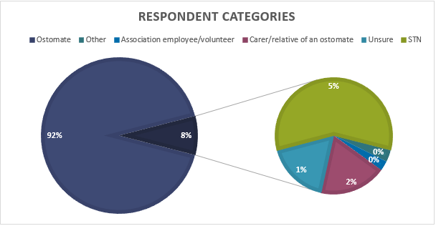

The distribution of responses across States and Territories varied. Around 53% of respondents were in NSW. Of the ostomates who responded, just over half identified as living in a capital city.

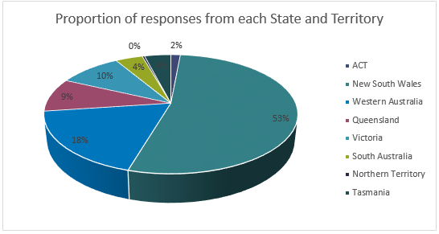

Ostomate respondents were also asked to identify how many stomas they had and if the stoma was permanent or temporary. Overall, 96% of respondents had a single stoma. Around 50% identified as having a permanent stoma.

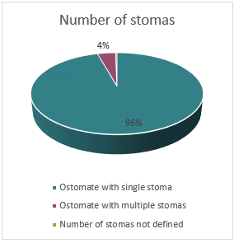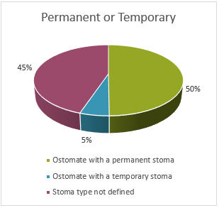

## Consultation Feedback

### Scheme access

The majority of respondents provided positive feedback in relation to their Stoma Association and the services offered. Respondents noted that some Associations also offer additional support such as monthly meetings with other ostomates, Stomal Therapy Nurse (STN) clinics and assistance over the phone during office hours.

Respondents acknowledged the good work of the volunteers within the Stoma Associations. Respondents also expressed that it was important that Associations are run by those with (or with an understanding of) lived experience of having a stoma. Respondents also stated that distribution of products needed to ensure personal privacy given the sensitive nature of stoma issues for individuals.

Highlighted areas for improvement in terms of product distribution were:

* association opening hours;
* ordering timeframes;
* the need for an on-line ordering system (and the ability to refer to previous orders);
* a need for online links to suppliers and better product information; and
* offering a choice for ostomates to collect orders from another outlet.

### Effective ostomate information, care and support

The majority of respondents agreed that the Scheme provided the products and support they needed.

Feedback indicated respondents were aware of the Scheme’s Schedule of listed products, however some found it long and difficult to navigate. Suggestions for improvement included clearer organisation, categorising and grouping of products differently and a need for an easier search capability (for example being able to search by product type or stoma type).

Respondents indicated that additional information about the Scheme would be helpful including:

* which products are available to them;
* which have restrictions;
* understanding maximum quantities; and
* general guidance and education around product suitability.

A number of respondents also indicated that the monthly limits on products can affect their stoma and life-style management.

Whilst ostomates were generally aware of the provisions for additional product quantities, respondents noted that access to these provisions is limited by reduced access to either an STN or health professional as well as the costs of obtaining the approval required under the Scheme.

Access was also noted as limited, especially in regional and remote areas. Some respondents advised they did not get the products and support they required with around half of these in a regional area.

Feedback from respondents identifying as STN’s indicated that ostomates should see an STN every 12 months and, in conjunction with the STN, select their products from the Scheme Schedule.

Some ostomates indicated they regularly saw their STN or General Practitioner (GP) in regard to their stoma. However, many indicated they had not seen an STN since their surgery, and others also indicated a concern that their GP is not fully aware of how to care for ostomates.

Ostomates responses broadly indicated that they would like to see an increase in access to STN’s with some suggesting a STN helpline would be beneficial, as this would also assist ostomates in regional areas. Respondents also suggested there may be a need for access to other allied healthcare professionals to support their care needs including:

* exercise physiotherapists (after surgery to assist with the risk of herniation);
* mental health support and/or counselling services; and
* targeted support groups and education for younger ostomates, children and their families.

### Scheme affordability

The impact of out-of-pocket costs (annual membership fees and monthly postage costs) were of concern to the majority of respondents.

### Scheme sustainability

A range of responses were received about how ostomates choose their products.

Most ostomates agreed they stayed with the products that offered them comfort and peace of mind as these were products that ‘fit their needs’. Many were also reluctant to change products in case the new product did not suit them (for example, causing leaks and skin irritations).

Many indicated they are guided by the advice of their STN, some choose to seek information and samples from suppliers directly to try new products, and some indicated they are still using the product they were originally supplied when discharged from hospital.

Respondents also noted that wastage and the management of over-use was a concern. Many noted that increased access to STNs and further product education could assist in managing this issue.

## Summary

Consultation responses indicate that the majority of respondents are generally satisfied with access to the Scheme and products they receive. Many responses noted the essential nature of the program, specifically that if the Scheme was not available they would not be able to afford the cost of the products.

Respondents noted the quality and variety of products available is excellent and gives them the opportunity to find the right fit for their body and lifestyle. Responses highlighted the needs of ostomates are individualised and can change over the course of their stoma treatment.

The consultation highlights a number of issues that are causing ostomates concern in managing their condition, through their interactions with the Scheme, and access to the products they need, potentially all affecting their health outcomes.

This consultation has highlighted several areas in the Scheme that may need closer examination. The Department will collaborate with stakeholders on areas for possible future improvements to better support ostomates using the Scheme in 2020.

## Attachment 1

### Scheme demographics

As of July 2019, an estimated 45,000 ostomates in Australia were members of the 21 approved Stoma Associations in Australia.

New South Wales and Victoria have the highest number of ostomates, followed by Queensland. The Northern Territory has the lowest number of ostomates.

