

**Report on the trial of the Australian National Aged Care Classification (AN-ACC)**

August 2020

# Report on the trial of the Australian National Aged Care Classification

## Overview

On 10 February 2019, the Prime Minister announced a $4.6 million trial of the Australian National Aged Care Classification (AN-ACC) assessment model.[1] The purpose of the trial was

1. Collect data to validate the expected distribution of care recipient classifications under the AN-ACC, as compared to the findings of the Resource Utilisation and Classification Study (RUCS).
2. Field test the performance of:

* the **AN-ACC assessment tool**, which when administered produces residential aged care recipient functional status data required to calculate AN-ACC classification levels for individuals;
* **an independent assessment workforce** trained to administer the tool; and
* the **training, clinical and IT supports** developed to equip assessors undertake assessments.

The trial was to be completed by 30 June 2020, and to involve the assessment of up to 12,000 residents of voluntarily participating residential aged care homes across all states and the mainland territories and all Modified Monash Model (MMM) categories (that is, from inner metropolitan to very remote locations).

The impact of the COVID-19 pandemic, which included restricting non-essential access to aged care homes, led to resident assessments ceasing in early April 2020, at which point **7387** AN-ACC assessments were completed (**7276** permanent residents, **111** respite residents), across **122** homes.

## Ethics approval

As the trial involved the assessment of aged care residents, and the collection of personal information, the Department of Health sought ethics approval for the project from the Australian Institute of Health and Welfare Ethics Committee. This ethics approval was granted on 18 September 2019.

## Procurement of assessment management organisations

An open tender process was conducted to procure a suitably qualified and experienced workforce of Registered Nurses, Occupational Therapists and Physiotherapists to undertake AN-ACC assessments.

Fourassessment management organisations were contracted:

* Access Care Network Australia;
* Aspire4Life;
* Care Tasmania; and
* HealthCare Australia.

Sixty assessors from these organisations were trained to undertake AN-ACC assessments including:

* 40 Registered Nurses;
* 11 Occupational Therapists; and
* 9 Physiotherapists.

## Assessor training

Assessors were required to undertake training in, and pass a mandatory test on, using the AN‑ACC tool prior to undertaking any assessments.

Training involved pre-reading (about the RUCS) and attendance at a two-day, face-to-face training session delivered by the Australian Health Services Research Institute and the Department.

During training all assessors received a hard copy reference manual for subsequent field use, containing guidance about how to apply each assessment instrument and basic IT ‘help’.

## Recruitment and profile of participating aged care homes

The Department was responsible for recruiting aged care homes to take part in the trial. In doing this the Department sought to achieve a mix broadly representative of the sector. Residential aged care providers representing approximately 70,000 of the 213,397 residential aged care places expressed interest to be involved with the trial.

Around 170 homes were selected and agreed to participate. Due to suspension of the trial due to the COVID-19 pandemic, assessments were completed in **122** homes. See tables 1 and 2 for a profile of these 122 homes.

**Table 1: Number of homes that participated in the trial by jurisdiction and ownership type**

|  |  |  |  |  |
| --- | --- | --- | --- | --- |
| **State** | **Private-for-profit** | **Not-for-profit** | **Government** | **Total** |
| **ACT** | 1 | 3 | 0 | **4** |
| **NSW** | 10 | 24 | 0 | **34** |
| **NT** | 0 | 1 | 0 | **1** |
| **QLD** | 6 | 7 | 2 | **15** |
| **SA** | 4 | 9 | 1 | **14** |
| **VIC** | 10 | 8 | 6 | **24** |
| **WA** | 7 | 13 | 0 | **20** |
| **TAS** | 2 | 8 | 0 | **10** |
| **Total** | **40** | **73** | **9** | **122** |

**Table 2: Number of homes that participated in the trial by MMM category and ownership type**

|  |  |  |  |  |
| --- | --- | --- | --- | --- |
| **Modified Monash Model category** | **Private for profit** | **Not for profit** | **Government** | **Total** |
| **1** | 33 | 46 | 3 | **82** |
| **2** | 4 | 8 | 1 | **13** |
| **3** | 1 | 8 | 1 | **10** |
| **4** | 1 | 3 | 1 | **5** |
| **5** | 1 | 7 | 0 | **8** |
| **6** | 0 | 1 | 3 | **4** |
| **7** | 0 | 0 | 0 | **0** |

Participating aged care homes were provided a profile of their residents across the 13 AN-ACC casemix classes following the completion of assessments at their facility.

## Summary of trial assessment data

**7387** AN-ACC assessments were completed, including:

* **7276** permanent residents; and
* **111** respite residents.

Chart 1 shows the distribution of residents assessed as part of the trial across the 13 AN-ACC classes[2], along with the distribution of residents assessed in Study Three in the RUCS.[3] No residents were assigned to class 1 in either the RUCS or the trial as this class is for residents who enter residential care for palliative care, and requires an assessment prior to entry, which was outside the scope of both the RUCS and the trial.

**Chart 1: Overall distribution of residents assessed in the trial and RUCS study 3**

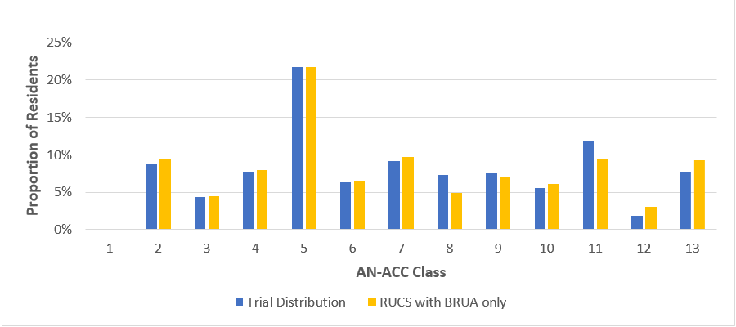

Chart 2 shows the casemix distribution of trial assessments by state and territory. In line with the results of the RUCS study, jurisdiction distributions were shown to differ, which is likely to be attributable to state based differences in population and resident characteristics such as remoteness, size and average population age.

**Chart 2: AN-ACC classes by jurisdiction**

This chart shows the distribution of AN-ACC trial assessments in the 13 AN-ACC classes by state and territory. 





Chart 3 shows variation in the distribution of residents across the AN-ACC classes by age category. As was found in the RUCS, younger aged care residents were more likely to fall into the two most complex classes (12 and 13), and also more likely to be independently mobile (classes 2 and 3).

**Chart 3: AN-ACC classes by age group**

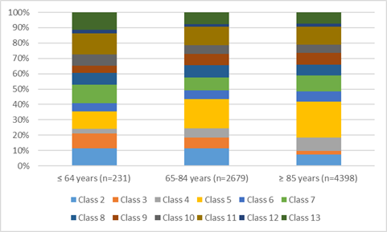

Chart 4 shows the distribution of residents across the AN-ACC classes by ownership type. Government-owned homes have a larger proportion of their residents falling into the most complex classes than the not-for-profit and private homes.

**Chart 4: AN-ACC classes by ownership type**

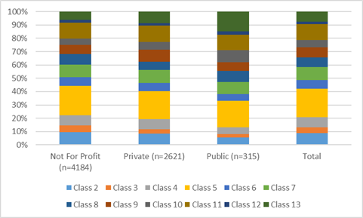

Chart 5 shows the distribution of residents across the AN-ACC classes by MMM region. Residents across metropolitan (MMM 1-2) and regional (MMM3-5) area relatively similar, but the distribution of the residents from remote areas is markedly different. The remote residents were much more likely to be independently mobile than residents from other areas, consistent with the results of the RUCS (although it should be noted that the sample size of residents in remote areas in the trial was small).

**Chart 5: AN-ACC classes by remoteness**

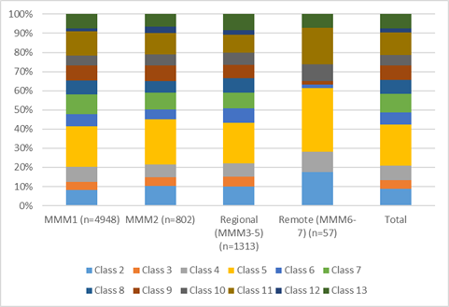

## Assessment Workforce Findings

The trial demonstrated that the AN-ACC assessment model is fit-for-purpose, nationally scalable and costs less on a per-assessment basis than was anticipated when the RUCS was completed.

Specific findings include:

* Consistent with findings of the RUCS, average time to complete an assessment is **one hour** (with variation around this average of +/- 20 minutes, related to degree of resident mobility), while an assessor can sustainably complete an average of **6 assessments per full working day** (allowing for performance of related non-assessment tasks).
* An appropriately qualified and experienced **independent** **assessment workforce**, employed through contracted assessment management organisations, is readily available to undertake AN-ACC assessments.
* The **training and clinical supports** developed to equip assessors undertake assessments were shown to be effective, however, areas of improvement were identified to optimise assessment consistency and accuracy for a potential national rollout of AN-ACC. These include increasing the length of training from two to three days, with additional time spent on providing training on assessing residents with complex cognitive variables and those from diverse linguistic and cultural backgrounds. Post-training assessor clinical support structures were also shown to be essential.

Appendix 1

The Australian National Aged Care Classification (AN-ACC) Variable Component Casemix Model

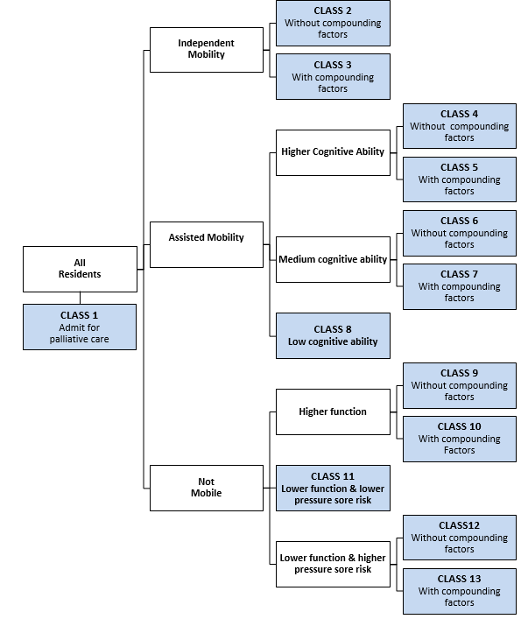

1. The AN-ACC assessment model was developed by the Australian Health Services Research Institute (AHSRI), at the University of Wollongong as part of the Resource Utilisation and Classification Study (RUCS). For RUCS reports and detail of the overall AN-ACC system, see: www.health.gov.au/resources/publications/resource-utilisation-and-classification-study-rucs-reports .
2. The AN-ACC classification structure can be found at Appendix 1.
3. The distribution of residents in Study One in the RUCS is not directly comparable as these residents were not assessed using the Behaviour Resource Utilisation Assessment (BRUA) assessment tool as part of their AN-ACC assessment.