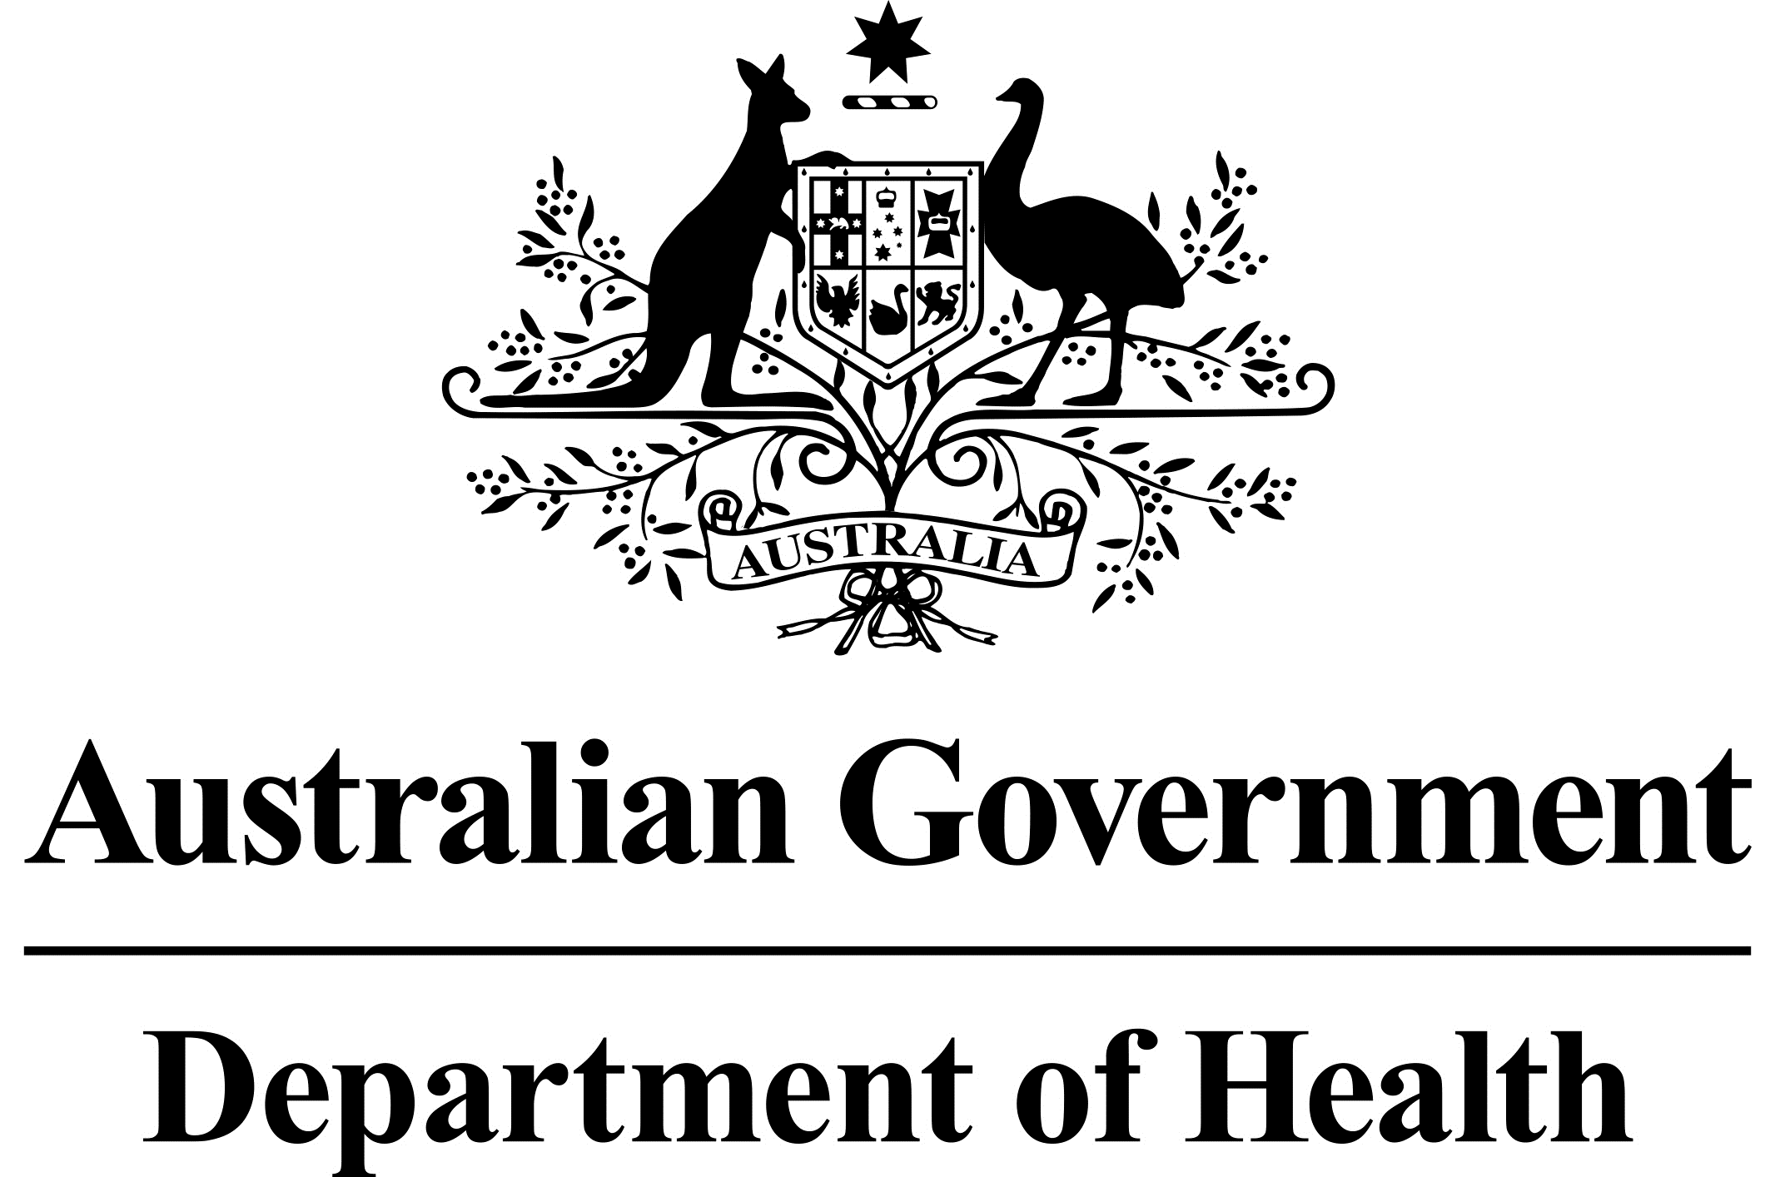

# Outcome of the application from Alexion Pharmaceuticals Australasia Pty Ltd to include Strensiq® (asfotase alfa) on the Life Saving Drugs Program for the treatment of peri-natal and infantile onset hypophosphatasia.

At their July 2017 meeting, the Pharmaceutical Benefits Advisory Committee (PBAC) considered, and rejected, a submission from Alexion Pharmaceuticals Australasia Pty Ltd requesting the listing of Strensiq® (asfotase alfa), on the Pharmaceutical Benefits Scheme (PBS) for the treatment of patients with paediatric-onset hypophosphatasia (HPP).

The PBAC noted the submission’s request that consideration be given to including Strensiq® on the Life Saving Drugs Program (LSDP) for paediatric-onset, and further noted that the Commonwealth CMO was responsible for advising the Minister on drugs proposed for inclusion on the LSDP.

The PBAC noted for the CMO that a number of outcomes from the PBAC’s review of Strensiq® might be relevant, including that any survival advantage associated with treatment with Strensiq® is limited to patients with perinatal- and infantile-onset HPP who are at high risk of premature death, and that, for a number of reasons, the PBS may be the most appropriate mechanism for subsidising treatments for juvenile onset HPP.

For further information refer to the Public Summary Document related to the PBAC’s consideration: <http://www.pbs.gov.au/industry/listing/elements/pbac-meetings/psd/2017-07/files/asfotase-alfa-rch-psd-july-2017.pdf>

Following the consideration by the PBAC, the sponsor applied for inclusion on the LSDP for patients with perinatal- and infantile-onset HPP.

The CMO subsequently recommended that Strensiq® be included on the LSDP for patients with perinatal- infantile-onset HPP. The CMO’s recommendations included a number of funding and access conditions.

The Department and Alexion have been unable to come to an agreement around the funding and access conditions for the listing of asfotase alfa on the LSDP, and as such the sponsor has notified the Department that the listing will not go ahead at this time.

## Sponsor’s Comment:

Strensiq is a proven transformative medication that addresses a significant unmet clinical need for a small number of patients with paediatric-onset HPP. Alexion will actively pursue a future listing for Strensiq when further data demonstrating its value is available from real-world sources.