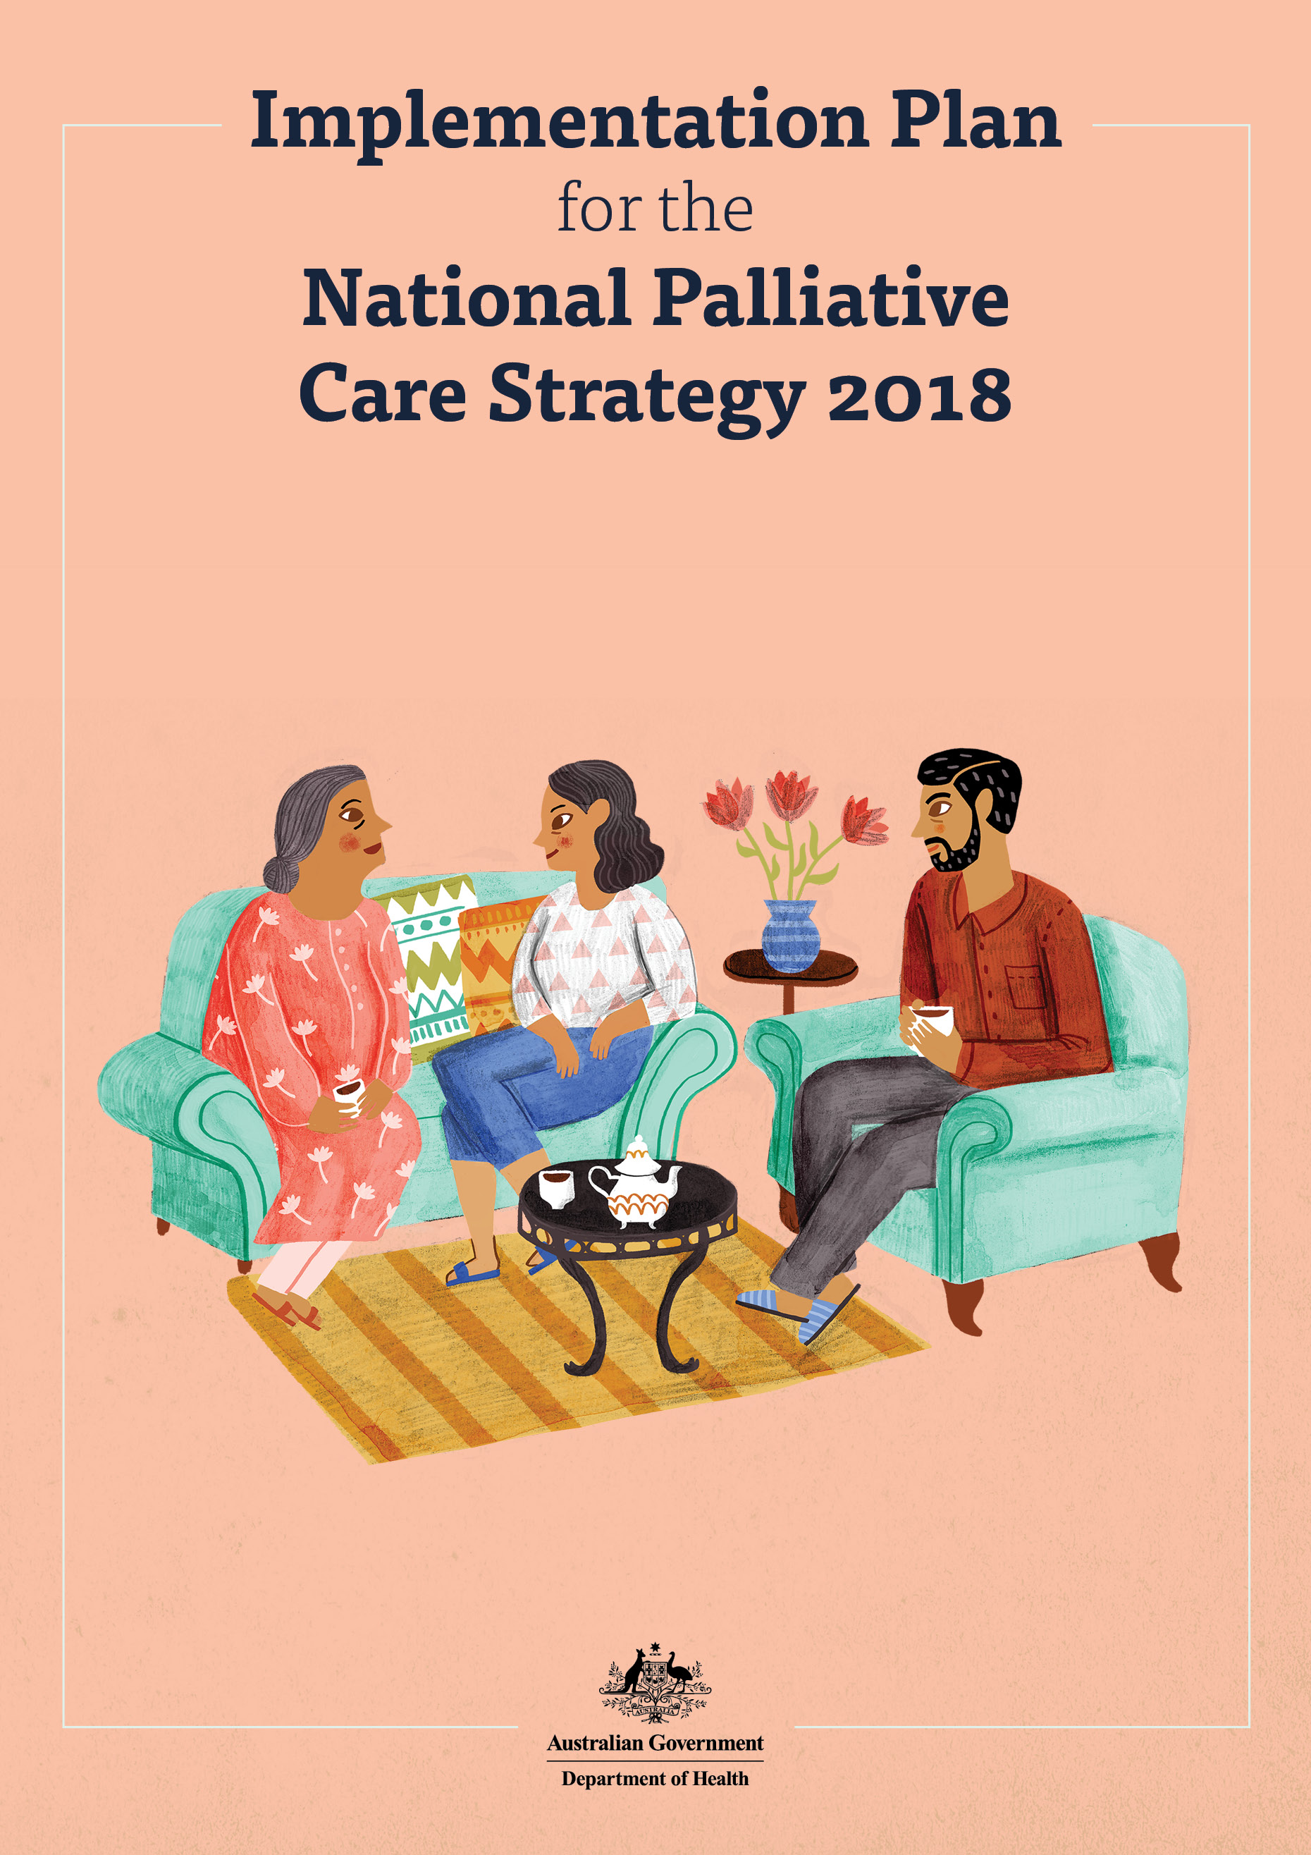

TABLE OF CONTENTS

The National Palliative Care Strategy 2018 1

How the Implementation Plan should be used 2

Action areas to address priorities within the National Strategy 3

Annual reporting 5

# The National Palliative Care Strategy 2018

The National Palliative Care Strategy 2018 (Strategy) articulates a cohesive national approach to the development and delivery of palliative care across Australia, guided by an overall vision and seven goals with supporting priorities. The Strategy was developed following extensive stakeholder consultation and was endorsed by all Australian governments.

**National Palliative Care Strategy 2018 Vision:**

“People affected by life-limiting illnesses get the care they need to live well”

**Guiding Principles:**

Palliative care is person-centred care

Death is a part of life

Carers are valued and receive the care they need

Care is accessible

Everyone has a role to play in palliative care

Care is high quality and evidence-based

**Goals:**

**1. Understanding** - People understand the benefits of palliative care, know where and how to access services, and are involved in decisions about their own care

**2. Capability** - Knowledge and practice of palliative care is embedded in all care settings

**3. Access and choice** - People affected by life-limiting illnesses receive care that matches their needs and preferences

**4. Collaboration** - Everyone works together to create a consistent experience of palliative care across care settings

**5. Investment** - A skilled workforce and systems are in place to deliver palliative care in any setting

**6. Data and evidence** - Robust national data and a strong research agenda strengthen and improve palliative care

**7. Accountability** - National governance of this Strategy drives action

The Strategy articulates a shared direction for the continual improvement of palliative care in Australia. It is the responsibility of state, territory and Commonwealth governments to implement the Strategy with the Commonwealth providing national leadership, policy direction and support for national research and other programs, and the state and territory governments providing quality palliative care and policy development within their jurisdictions.

## How the Implementation Plan should be used

The implementation of the Strategy primarily rests with the Commonwealth, state and territory governments and the Implementation Plan (Plan) provides the vital link between the higher-level vision and priorities in the Strategy and the palliative care activities funded or undertaken by Commonwealth and state and territory governments to realise the goals of the Strategy.

While the Strategy does not have a timeframe, this Plan identifies action areas to progress the goals and priorities in the Strategy over the next five years. The way in which action areas are implemented may differ across jurisdictions to reflect local needs and resources. Recognising that this is the first time a nationally-endorsed Plan has been undertaken, four national action areas have been identified that provide a starting point to progress the priorities of the National Strategy. Each action area does not attempt to address every priority in the Strategy, but rather provides direction for the collaborative efforts of governments over the next five years of the Strategy.

The Commonwealth and each jurisdiction will provide an annual update via the Palliative Care and End of Life Care Reference Group under the Health Services Principal Committee. This reporting will summarise the activity that is planned or underway to support each of the four action areas.

This annual reporting, along with the key data indicators being developed by the Palliative Care and End of Life Care Data Development Working group, will inform the monitoring and evaluation of the Strategy.

### Approach to developing the Implementation Plan

This Plan was developed in close consultation with key jurisdictional stakeholders.

Planned activities outlined in available state, territory and Commonwealth palliative care documents were mapped against the 37 priorities that underpin the seven goals in the Strategy. Outcomes from the mapping exercise were then discussed with state, territory and Commonwealth government stakeholders to inform the creation of a draft Plan which was then circulated to jurisdictions for feedback. Feedback on the draft Plan was synthesised and incorporated into the development of this final version for endorsement by all jurisdictions.

## Action areas to address priorities within the National Strategy

| **What the action area will look like** | **What state, territory or Commonwealth governments will do** | **How this contributes to the Strategy** |
| --- | --- | --- |
| **Action area 1**  **Access to palliative care is increased, particularly for underserved populations.**  This will require the following activities:   * Promoting consistent messaging to build understanding of the benefits and need for palliative care, including with care providers * Understanding the unmet need and gaps in service provision, including likely future demand for palliative care * Identifying workforce development initiatives such as staff attraction and retention strategies and ongoing education and training, including for palliative care specialists * Identifying and implementing service models that improve access to palliative care, including utilisation of technology * Implementing strategies for increasing access to palliative care for underserved populations * Increasing support for carers, including in bereavement * Including people affected by life-limiting illnesses in the planning, delivery and evaluation of services. | **Commonwealth Government:** will address access barriers in primary health and aged care settings; will invest in national research to inform evidence-based improvements in palliative care delivery. | Contributes to goals: 1,2,3,4,5,6,7  A focus on supporting access to palliative care will help people affected by life-limiting illnesses, and particularly groups that are currently underserved, to get care where and when it is needed. It will also build the understanding and capability of service providers. Ways of delivering palliative care will align with the needs of communities to ensure that people can access consistent, high quality care that is evidence-based. |
| **State and territory governments:** will address access barriers in community and acute service settings with a focus on those specific to local underserved populations. |
| **All governments:** will collaborate in the national research agenda to inform improvements to palliative care access and uptake, and to support workforce planning and service expansion. |
| **Action area 2**  **The collaboration and coordination of palliative care is improved.**  This will require the following activities:   * Building the capacity of service providers to provide care, with support from specialist palliative care services as needed * Identifying and implementing service models that improve collaboration and coordination of care * Improving the sharing of patient data in and across care settings * Addressing interface issues, including funding barriers that inhibit cross-sectoral collaboration * Actively participating in the national governance structure for the Strategy. | **Commonwealth Government:** will build the palliative care knowledge and improve the capacity of primary health and aged care providers to work with other service providers; will provide national leadership to develop and administer the national governance structure for the Strategy. | Contributes to goals: 1,2,3,4,5,6,7  Improving collaboration will help service providers clarify how they can work with others to ensure that a person affected by life-limiting illnesses gets the care they need. |
| **State and territory governments:** will support and facilitate collaboration across service settings including hospital, community and primary health care settings, including drawing on the expertise of specialist palliative care services and sharing patient data. |
| **All governments:** will work together to examine and resolve barriers to collaboration across service settings, particularly between palliative care services and primary health and aged care settings; and will collaborate to provide leadership for the governance of the Strategy. |
| **Action area 3**  **Advance care plans are being prepared by people affected by life-limiting illnesses and used to facilitate shared decision-making across care settings.**  This will require the following activities:   * Raising awareness of the need and mechanisms for advance care planning * Investing in training, resources and infrastructure to support the development and uptake of advance care planning tools and processes, with a focus on underserved populations * Developing and implementing mechanisms for recording, monitoring and reporting on the use of advance care plans. | **Commonwealth Government:** will promote the consistent preparation and use of advance care plans, particularly in primary health and aged care settings. | Contributes to goals: 1, 2, 3, 4  Continuing to support the development and use of advance care plans will help people affected by life-limiting illnesses to be involved in decisions about their own care and will support service providers to identify and meet the needs of people at the end of their life. It also supports the consistent delivery of person-centred care across different care settings. |
| **State and territory governments:** will promote the consistent preparation and use of advance care plans in all community and acute service settings. |
| **All governments:** will develop and disseminate information for the public, and training for clinicians, to increase the use and effectiveness of advance care plans; and take steps towards recognition of advance care planning documents between jurisdictions. Reporting on progress of these activities will provide an opportunity for shared learnings and provide a feedback loop for further improvement of uptake and use. |
| **Action area 4**  **Nationally consistent data collection mechanisms are implemented and national public reporting is underway.**  This will require the following activities:   * Scoping and agreeing on data collection mechanism * Consulting with appropriate national committees * Implementing and investing in data collection * Reporting collected data. | **Commonwealth Government:** will lead discussions and agreement regarding mechanisms, timeframe, investment and accountability; will ensure implementation of agreed nationally consistent data mechanisms in primary health and aged care settings. | Contributes to goals: 2, 3, 4, 5, 6, 7  Establishing this mechanism will improve the quality of the national evidence base regarding service delivery and effectiveness and support an evidence-based approach to service improvement. It will also inform a national research agenda by identifying gaps in evidence and data. This will also assist in workforce and service planning for the future. |
| **State and territory governments:** will work towards implementation of nationally consistent data mechanisms throughout community, specialist palliative care and acute service settings. |
| **All governments:** will collaborate in the development and implementation of data mechanisms, including consideration of a National Minimum Data Set for palliative care. The collected data will inform regular reporting to improve sharing of information and service improvement. |

## Annual reporting

Annual reporting on progress against the Plan, as required by the Strategy, will provide a summary of the activity that is being undertaken to support the action areas in the Plan. This reporting will be provided via the Palliative Care and End of Life Care Reference Group under the Health Services Principal Committee to the Australian Health Ministers’ Advisory Council (AHMAC).

The Palliative Care and End of Life Care Reference Group will make a summary of the reporting publicly available to facilitate information sharing regarding the activities being undertaken to support the National Palliative Care Strategy and to feed into the monitoring and evaluation of the Strategy. The annual reporting template below will be reviewed to reflect agreed data collection mechanisms throughout the life of this Plan.

### Annual reporting template

**Jurisdiction:**

**Reporting timeframe:**

**Summary:** <Brief overview of progress including update on any changes to the palliative care policy environment, and any particular achievements to be highlighted>

Summary of activities

| **Action areas** | **Update and outcomes** | **Timing** |
| --- | --- | --- |
| Action area 1 | | |
| Action(s) that address barriers to palliative care access | A short update on the action and any outcomes, with reference to possible data sources to demonstrate progress | Date completed or expected timing for completion of action |
| Action area 2 | | |
| Action(s) that address barriers to collaboration and coordination | A short update on the action and any outcomes, with reference to possible data sources to demonstrate progress | Date completed or expected timing for completion of action |
| Action area 3 | | |
| Action(s) that support advance care planning | A short update on the action and any outcomes, with reference to possible data sources to demonstrate progress | Date completed or expected timing for completion of action |
| Action area 4 |  |  |
| Action(s) that support the implementation of a nationally consistent data collection mechanism | A short update on the action and any outcomes, with reference to possible data sources to demonstrate progress | Date completed or expected timing for completion of action |

