NATIONAL FRAMEWORK FOR ALCOHOL, TOBACCO AND OTHER DRUG TREATMENT
2019–2029
December 2019


Contents

Preamble 3

Aims and purpose 5

The Australian alcohol, tobacco and other drug treatment service system 6

Principles for effective alcohol, tobacco and other drug treatment 11

Holistic and Coordinated 13

Principles for planning, purchasing and resourcing treatment 15

Principles for monitoring, evaluation and research 17

Partnerships 19

# Preamble

## Alcohol, tobacco and other drug use is common

Around 8 in 10 Australians consume alcohol each year and 12% of the Australian population smoke tobacco daily. About 1 in 8 Australians have used at least one illegal substance in the last year, the most common of which is cannabis (10.4%). The use of other illegal drugs, such as ecstasy, methamphetamine, and cocaine occurs in around 2% of the population, and the use of legal, prescribed medication not as intended occurs for around 5% of the Australian population.

## Not everyone who drinks alcohol or uses other substances will develop problems

Some people use substances without experiencing any significant short or long-term harm. However, there is a proportion of the population who require treatment, care and support to reduce harms from their alcohol, tobacco, prescribed medication, and illicit drug use.

## There are some groups in the community that are more at risk than others

Problems with alcohol, tobacco, prescription medication and illicit drugs can affect anybody. People who experience marginalisation and trauma are more at risk of developing problems, especially people who experience socio-economic disadvantage. Many generations of Aboriginal and Torres Strait Islander peoples have been impacted by government policy, societal values and exclusion from opportunities that have resulted in disconnection from culture, major disruption to families, unresolved trauma and poverty that has seen this population group become more vulnerable to harm from alcohol, tobacco and other drug use. Other marginalised groups that may experience disproportionate harm include people with co-occurring mental health conditions, young people, older people, people in contact with the criminal justice system, culturally and linguistically diverse populations, and people identifying as gay, lesbian, bisexual, transgender or intersex.

## Problems with substances are health problems

Problems with substances are health problems that can be treated, and treatment is generally more effective if initiated early. Historically, in Australia much alcohol, tobacco and other drug treatment was provided outside the healthcare system (largely by charitable organisations in institutions). Much of the treatment was focussed solely on abstinence, and notions of coordinated holistic or individualised care were absent. Now alcohol, tobacco and other drug treatment is seen as part of the healthcare system, the person receiving care drives the goals and outcomes to be attained, and there is a continuum between harm reduction and abstinence-based services.

## Treatment experiences vary depending on individual circumstance

For some people with alcohol, tobacco and other drug problems, treatment will be required over the course of their life (consistent with dependence being a chronic condition, like asthma or diabetes). In many cases ongoing support to achieve long-term change is crucial in helping people achieve a more enduring set of life changes. For other people, support and treatment early on will be sufficient to prevent alcohol, tobacco and other drug problems into the future; and for others they may access treatment intermittently as required. Some people will independently receive support through mutual aid services, such as Alcoholics Anonymous. And for others, the problems associated with substances will subside over time without the need for any formal intervention.

## Alcohol, tobacco and other drug treatment is only part of what a person might need

People who seek or receive alcohol, tobacco and other drug treatment may have social, psychological or other health care needs that they consider more, or as pressing, as their alcohol, tobacco or other drug problems. This may include social issues (e.g., housing, family and domestic violence, employment, welfare, child protection, legal problems), and other medical and health needs (e.g., co-occurring mental health conditions, liver disease, chronic obstructive pulmonary disease, blood borne viruses). Integration of care, addressing an individual’s needs, is the foundation for successful alcohol, tobacco and other drug treatment. Alcohol, tobacco and other drug treatment services need to collaborate and coordinate with other systems of care because attending to the overall health, wellbeing, cultural, and social needs of the person enables alcohol, tobacco and other drug treatment to be most effective. Improving the health, social and emotional wellbeing of people who are seeking or receiving alcohol, tobacco and other drug treatment not only relies on activities undertaken within the alcohol, tobacco and other drug treatment service system, but on actions across a wide range of social, economic, political, cultural and environmental determinants of health.

## Stigma and discrimination are barriers to seeking treatment

There is significant stigma and discrimination against people who experience problems because of their substance use. Stigma and discrimination against people exist in most settings: in the workplace, in healthcare services, in social welfare services, and in the broader community. It creates a serious barrier to seeking and receiving help.

# Aims and purpose

The overarching aim of the National Framework for Alcohol, Tobacco and other Drug Treatment is to ensure that:

All Australians seeking alcohol, tobacco and other drug treatment are able to access high quality treatment appropriate to their needs, when and where they need it.

Treatment is defined as:

**Structured health interventions delivered to individuals (by themselves, with their families, and/or in groups) to reduce the harms from alcohol, tobacco, prescribed medications or other drugs and improve health, social and emotional wellbeing.**

The National Framework for Alcohol, Tobacco and other Drug Treatment guides a national response, and focusses on treatment interventions, addressing how harms from alcohol, tobacco, prescribed medications or illicit drugs are reduced based on individual needs and goals. The Framework does not cover primary prevention, which focusses on preventing the commencement and delaying the uptake of alcohol, tobacco and/or other drugs.

The Framework aims to provide a nationally endorsed shared understanding, and common reference point for alcohol, tobacco and other drug treatment funders, treatment providers and practitioners, and people who use substances and their families, friends and significant others. The Framework facilitates strategic planning for the Australian treatment service system and provides the context for national and state treatment processes, programs and policies. It has been developed with extensive consultation and complements the National Drug Strategy (2017–2026). It should be read in conjunction with the National Quality Framework for Drug and Alcohol Treatment Services, and the other national and state/territory alcohol, tobacco and other drug strategy documents.

The implementation and monitoring of the National Framework for Alcohol, Tobacco and other Drug Treatment, along with all national strategies, is the responsibility of the Ministerial Drug and Alcohol Forum. The Ministerial Drug and Alcohol Forum reports directly to the Council of Australian Governments (COAG) and consists of the health and justice Ministers across Australia.

As a strategic framework, this document provides:

* An overview of the Australian treatment service system (section 3)
* Principles for effective treatment (section 4)
* Principles for effective treatment planning, purchasing and resourcing (section 5)
* Principles for effective monitoring, evaluation and research (section 6); and the
* Partnerships that are required for a successful alcohol, tobacco and other drug treatment service system (section 7).

# The Australian alcohol, tobacco and other drug treatment service system

Three types of interventions make up the Australian alcohol, tobacco and other drug treatment service system: interventions to reduce harm; interventions to screen, assess and co-ordinate care; and intensive interventions.

Figure 1 shows the key elements that make up the Australian alcohol, tobacco and other drug treatment system. Importantly, these are not mutually exclusive: someone may receive interventions to reduce harm, at the same time as coordinated care, while also receiving more intensive interventions.

**Interventions to reduce harm:** These treatment interventions aim to reduce immediate or short-term harms; engage and support people; and refer people into treatment.

There are many types of interventions to reduce harms (see examples in Figure 1), including providing a safe place when someone is severely intoxicated (sobering up shelters), providing information and support to family members, and delivering peer-based support services. Overdose prevention services, including the widespread availability of naloxone, and other harm reduction services such as needle and syringe programs are also fundamental to reduce harms. The focus is on reducing the immediate or short-term harms associated with alcohol or other drug consumption, and providing opportunities for improved physical and mental health, and social and emotional wellbeing.

These interventions are often the first point of contact with healthcare. They provide a way for someone to find out more about alcohol, tobacco and other drug-related harm, receive information, access peer-based support and receive further information about, and where appropriate referral to, treatment and support services.

**Interventions to screen, assess and co-ordinate:** These interventions are focussed on identifying and assessing harmful consumption patterns, facilitating referral to more intensive interventions when required, ensuring there is an appropriate match between the person’s needs and the interventions being offered, and providing coordinated care and case management services. These interventions may take place over several contacts, or occur on a single occasion, and should seek to reduce any real or perceived barriers to accessing further alcohol, tobacco and other drug treatment.

All health care providers have a responsibility to screen patients for harms associated with alcohol and other drug use. Screening and accompanying brief interventions, often delivered in primary care settings, form part of the Australian treatment system. These services ensure that people who may be experiencing harm from alcohol, tobacco, prescribed medicines or other drugs are provided with information, support and the opportunity to seek further assistance if appropriate. Consultation liaison services in hospitals provide hospital admitted patients with an opportunity to be assessed and for appropriate patient-centred care planning.

Early identification of pregnant women who use alcohol or other drugs is required in any setting in which the woman presents. Healthcare professionals may come into contact with a pregnant woman in any part of the health care system and it is important that the opportunity for support and assistance is not minimised or overlooked. It is good practice, in the care of pregnant women, to screen for use of alcohol, tobacco and other drugs to ensure effective antenatal and postnatal care of the mother and newborn.

Assessment services, especially for people who have been referred by the police or the courts, provide the opportunity for an assessment of their needs, and appropriate matching to support services. Assessment is an ongoing process, and the match between the person’s needs, goals and the treatment being provided is continually assessed.

Navigating the alcohol, tobacco and other drug treatment service system and accessing services and supports across other systems of care, such as housing, family and domestic violence, employment, welfare, child protection, and legal services, requires co-ordination. Care co-ordination and case management involves ongoing treatment planning, goal setting, review and facilitation for the client to achieve their goals including supported referral and system navigation support to other services, as required. It includes ensuring links are made with health or social welfare services, and that care is coordinated across care settings and systems. This may include shared care.

**Intensive interventions:** Intensive treatment interventions focus on changing behaviour, enhancing physical and mental health, and social and emotional wellbeing, and should be therapeutic and evidence-informed. There are four broad types of intensive interventions: withdrawal management (detoxification); psycho-social counselling; rehabilitation; and pharmacotherapy.

Intensive treatment interventions are the concentrated part of what will be a continuing relationship with the client, ensuring ongoing support and regular communication. In some cases, this will also entail formal transfer of care to another provider. In other cases it may involve ongoing contact and continuing support.

Withdrawal management (detoxification) refers to the safe discontinuation of the use of a substance of dependence. Withdrawal management services aid in the short-term cessation or reduction of heavy and/or prolonged alcohol or other drug use in a safe, supportive environment. Treatment is acute and provides short-term outcomes. Medications are sometimes used to help with symptoms of withdrawal. Supportive care is an essential component for successful withdrawal. Withdrawal alone does not produce lasting behaviour change and therefore planning for ongoing treatment, care and support is essential.

Psycho-social counselling refers to evidence-informed talking therapies, aimed at helping the person develop skills (whether that be psychological skills, and/or practical skills) to reduce alcohol or other drug consumption and/or harms,

in line with the person’s own goals. Examples of evidence-based psycho-social counselling include Cognitive-Behaviour Therapy, Contingency Management and Relapse Prevention. Psycho-social counselling can be delivered individually (one on one) or in groups, and may involve family members or be delivered to family members alone.

Rehabilitation is an intensive treatment program that integrates a range of services and therapeutic activities, including counselling, behavioural treatment approaches, social and community living skills, relapse prevention and recreational activities. Some rehabilitation programs are specially designed for women and/or for mothers with children. Other rehabilitation programs are dedicated to and governed by Aboriginal and Torres Strait Islander peoples. Rehabilitation can be provided on a non-residential basis (for example, day programs), in a residential setting, or in a therapeutic community.

There are several medications (pharmacotherapies) used to treat problems with alcohol, tobacco and other drugs. These pharmacotherapies can be prescribed for a short, medium or long-term duration, depending on the person’s goals. Pharmacotherapies work in different ways. Some work by reducing cravings, others by providing an aversive (negative) reaction when used in combination with a substance. Other types of pharmacotherapy prevent withdrawal, reduce cravings and block the reinforcing effects of additional drug use. Pharmacotherapies are prescribed by approved prescribers and dispensed either through a community pharmacy or a specialist clinic.

Figure 1: The Alcohol, Tobacco and Other Drug Treatment Service System

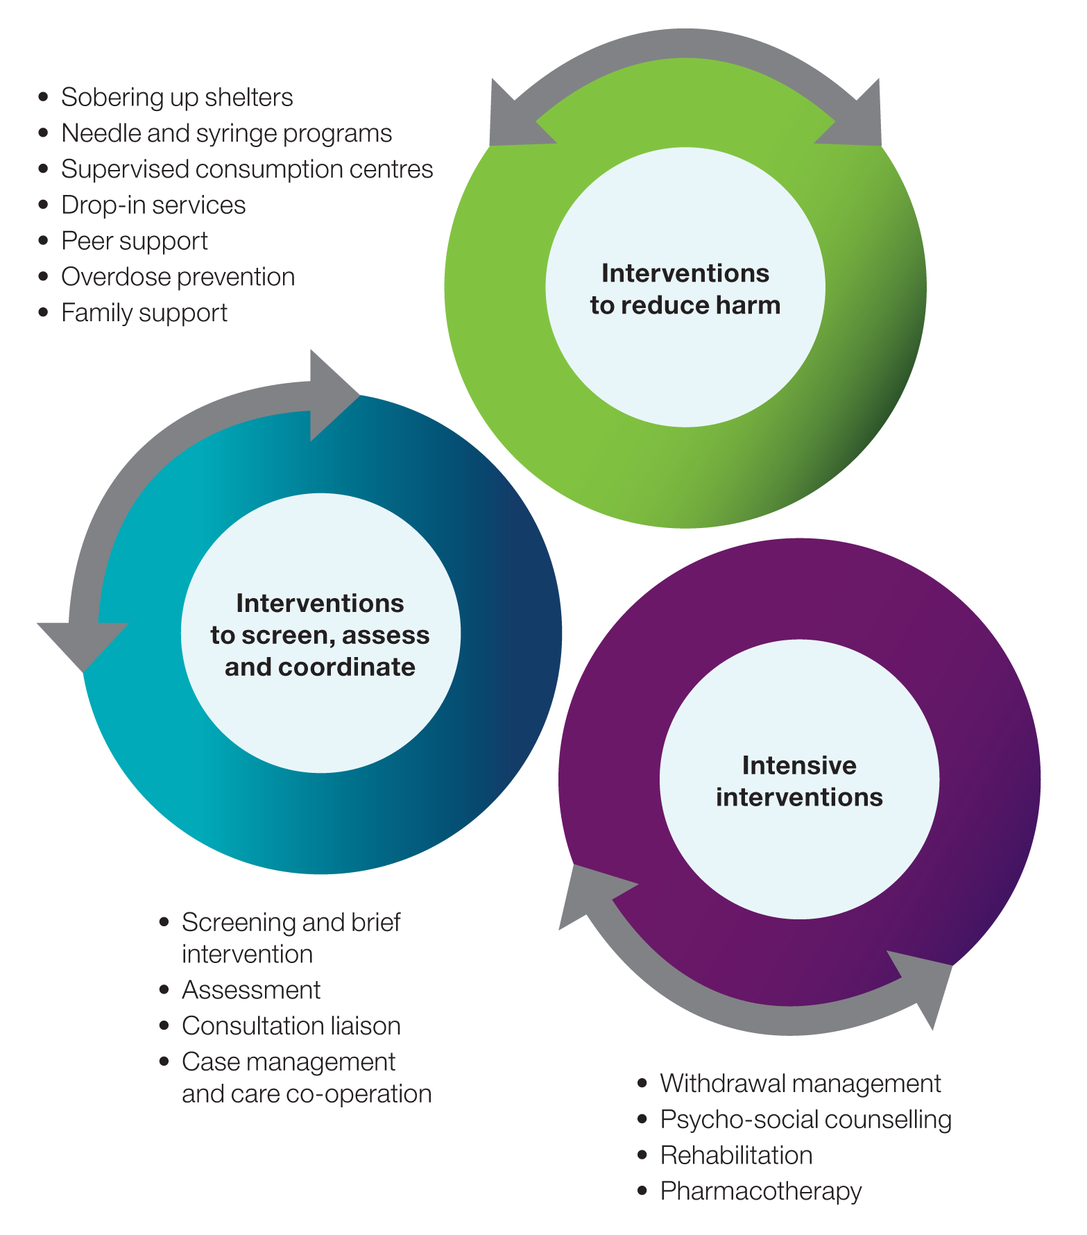

## Treatment settings

The three treatment system elements (interventions to reduce harm; screening, assessment and care coordination; and intensive interventions) are delivered across a variety of different settings.

Some settings are dedicated to alcohol, tobacco and other drug treatment, such as a drug residential rehabilitation centre or a pharmacotherapy maintenance clinic. Other settings also provide general healthcare, such as a GP practice or a hospital. Alcohol, tobacco and other drug treatment can also be provided in infectious disease services, perinatal units, sexual health services, maternity services, and youth services, to name a few.

Figure 2: Different alcohol, tobacco and other drug treatment settings 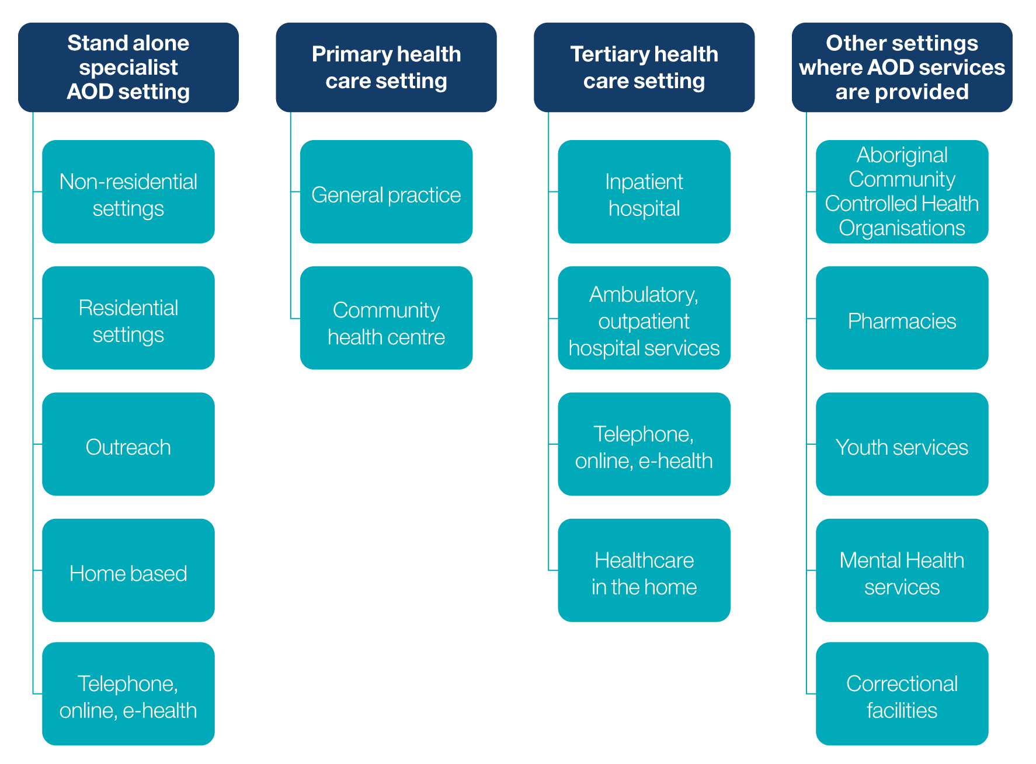

In some cases, integrated care is provided at a single setting providing the opportunity for holistic care across multiple areas of client need. Mental health services may offer integrated mental health and alcohol, tobacco and other drug treatment; homelessness services may offer alcohol, tobacco and other drug treatment; and Aboriginal Community Controlled Health Organisations may offer integrated social and cultural support, psychological therapies, and medical treatment.

The appropriate treatment setting is dependent on the person and their needs.

For many healthcare conditions, there is a match between the severity of the condition and the treatment settings, with lower severity conditions being treated in primary care settings and more severe presentations treated in tertiary facilities. This general principle should also largely apply to alcohol, tobacco and other drug treatment, but there are exceptions. For example, pharmacotherapy maintenance reserved for higher severity dependencies, is often best delivered in primary care settings.

## Workforce development

The provision of effective treatment across these three elements of our system requires a skilled, qualified, and fulfilled workforce. The alcohol, tobacco and other drug treatment workforce is diverse and includes, amongst others:

* Aboriginal Health Workers
* Addiction Medicine Specialists
* Alcohol and other drug workers
* Counsellors
* General Practitioners
* Nurses
* Nurse practitioners
* Peer workers
* Pharmacists
* Psychiatrists
* Psychologists
* Social workers
* Youth workers

Supporting and valuing the alcohol, tobacco and other drug treatment workforce is essential to provide high quality, responsive person-centred services and to meet client needs. Undertaking workforce planning initiatives and providing comprehensive workforce development and clinical supervision for existing professionals, peers and volunteers as well as new entrants is needed to ensure a sustainable workforce that is capable of meeting future challenges, innovation and reform. Effective strategies are particularly needed in rural and remote areas.

In recognition of the need for a national focus on workforce development activities for the alcohol, tobacco and other drug workforce, the “National Alcohol, Tobacco and other Drug Workforce Development Strategy” was developed to address these issues and to support the National Drug Strategy. The National Workforce Development Strategy identifies key strategic action areas to enhance the capacities of Australia’s alcohol, tobacco and other drug workforce. Responsibility for implementing the actions outlined in the National Workforce Development Strategy is shared by all governments, recognising that jurisdictions face different challenges and will undertake actions in line with their own priorities, timing and resources.

## Other important aspects of treatment

Reducing the harm from alcohol, tobacco and other drugs may include ceasing use, reducing use, or changing use such that it is less harmful (including reducing the severity of dependence). It should be noted that reducing harmful alcohol, tobacco and other drug consumption is a long-term process and that assessment taken at the end of an individual treatment episode will not reflect the impact of that treatment in the long-term. It is often the accumulation of many episodes of care over several years that contribute towards sustained reductions in alcohol or other drug harm, and improved physical and mental health, and social and emotional wellbeing.

There are many different motivating factors for someone entering treatment. Concern for their own wellbeing or that of others, pressure from significant others, and/or the need to change behaviour for employment or legal reasons can all motivate someone to enter treatment. Treatment can be provided as part of or as a result of a court-order. Involuntary treatment, through civil commitment, is rare.

Each client will have their own goals for treatment. It is important that the indicators of treatment outcomes are aligned with the individual’s treatment goals. Outcomes hoped and planned for from one type of treatment (e.g., withdrawal) may be different from the outcomes from another treatment type (e.g., residential rehabilitation).

Each person’s treatment journey is unique, and treatment should be stepped up (increased in intensity) or stepped down (decreased in intensity) based on client needs. This means that less intensive treatments (interventions to reduce harm, and screening, assessment and co-ordination) should be widely available, and used initially with progressively more intensive approaches offered as indicated to meet a person’s needs. Similarly, the less intensive settings (non-residential and primary care) should be employed in the first instance and treatment taken up in other settings (such as residential settings) where indicated based on client need.

# Principles for effective alcohol, tobacco and other drug treatment

Underpinning the below six treatment principles is respect for human rights; fundamental to supporting harm reduction and change processes for people experiencing problems with alcohol, tobacco and other drugs.

The following six principles should underpin all alcohol, tobacco and other drug treatment interventions in Australia (Figure 3).

Figure 3: Six treatment principles

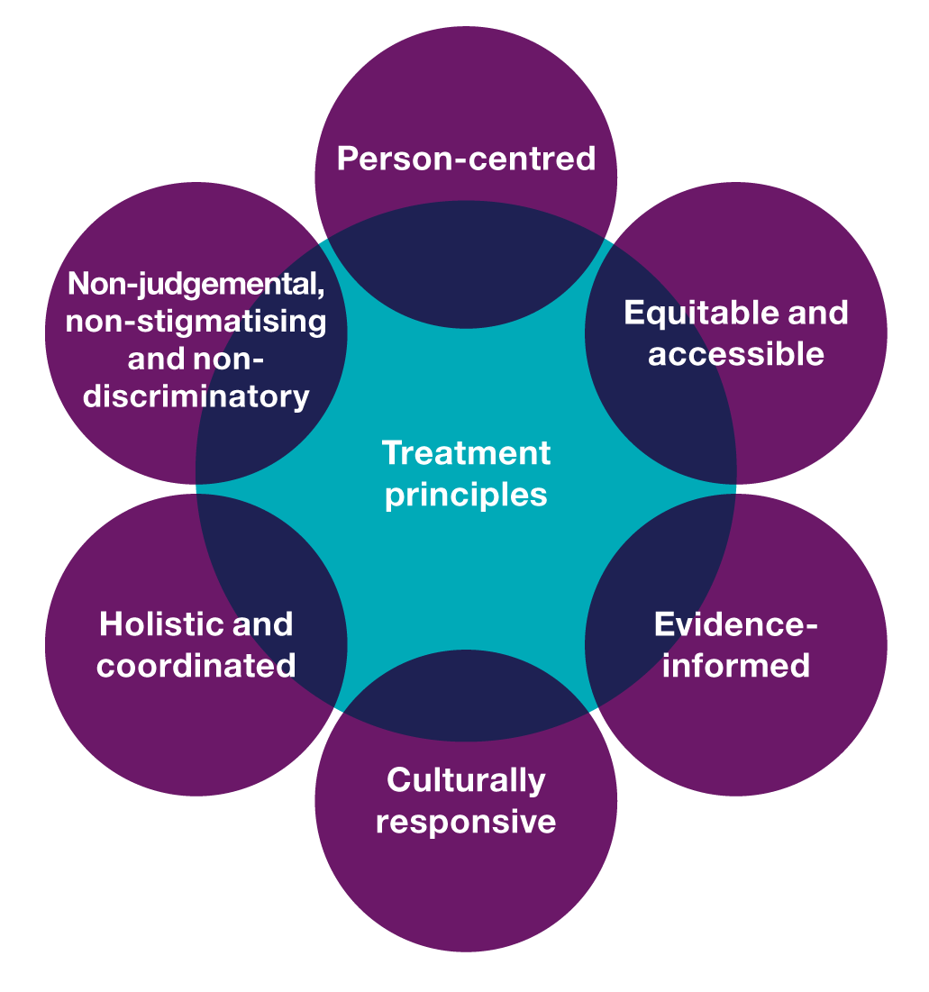

The principles should be implemented in all aspects of treatment including policies and procedures, practice approaches, models of care, treatment pathways, training and quality improvement activities. The principles are based on human rights, the right to healthcare, and the philosophy of harm minimisation.

## Person-Centred

Person-centred means that alcohol, tobacco and other drug treatment should be focussed on what the person needs and their rights, and it recognises individual preferences, diversity, and inclusion in decision making, treatment planning and goal setting. Treatment is about meeting the holistic needs of the person, not satisfying the requirements of health professionals, systems or institutions.

This means:

* Alcohol, tobacco and other drug treatment should be focussed on the person receiving treatment and their needs, protect their human rights, and should be responsive to their own unique situation, context and circumstances.
* Every person has the right to meaningful participation. The person receiving treatment should play a central role in all decision making in terms of treatment goals, the treatment received, and the choices within treatment.
* Alcohol, tobacco and other drug treatment should involve and provide support for the family, friends, children in their care, and other loved ones who are significant to the person receiving treatment, and who can help with meeting their treatment goals.
* The person’s Alcohol, alcohol, tobacco and other drug treatment should be responsive to their cultural, religious/spiritual, gender, sexual and gender identities, and age and developmental needs, and should be responsive to their changing needs.
* Every person has the right to be heard. Alcohol, tobacco and other drug treatment services and treatment policy should actively engage people who have experiences of treatment in service design and development, policy development and evaluation.

**Example:** A young person who has alcohol, tobacco and other drug use problems, who has a blood borne virus and is incarcerated: this person has the right to receive tailored treatment, care and support in prison and after their release, and treatment which is age and developmentally appropriate, as well as referral to and support accessing appropriate medical care and other services (e.g. housing support after their release).

## Equitable and Accessible

Every Australian should have an equal opportunity and right to seek and receive alcohol, tobacco and other drug treatment at a time, location, cost, and treatment type that suits their needs. The alcohol, tobacco and other drug treatment system should be understandable and easy to navigate.

This means:

* Alcohol, tobacco and other drug treatment services should be accessible, people should receive timely and affordable treatment, and should be able to remain in treatment for appropriate periods of time.
* Unfair and avoidable barriers to treatment that compromise health and wellbeing should be removed.
* Providers of alcohol, tobacco and other drug treatment should be flexible, open and responsive to the needs and rights of people receiving treatment.
* Alcohol, tobacco and other drug treatment in Australia should be appropriately planned and funded, such that it is equitable, readily available, and accessible. The treatment service system should support fair access, fair chances and fair resource distribution.

**Example:** Someone living in a rural or remote area may have different access needs to someone living in a capital city/urban environment including travel and accommodation; and may have related impacts including financial, family and employment. The alcohol, tobacco and other drug treatment services should be responsive to these needs.

## Evidence-Informed

Alcohol, tobacco and other drug treatments provided in Australia should be evidence-informed and have known effectiveness.

This means:

* The person has a right to receive high quality, safe and effective evidence-informed alcohol, tobacco and other drug treatment regardless of service setting or provider.
* Treatment should be delivered by a suitably qualified, skilled and experienced workforce.
* The alcohol, tobacco and other drug treatment service system should promote evidence-informed practice, innovation and ongoing evaluation.
* The Australian alcohol, tobacco and other drug treatment system should be adaptable and enabled to respond to new and emerging areas of concern and to flexibly accommodate new and different needs of the people requiring care and support.
* Alcohol, tobacco and other drug treatment services should engage in continuous improvement. People receiving care and their significant others should be involved in organisational governance and quality improvement processes.

**Example:** Alcohol, tobacco and other drug treatment providers should review their practices, ensure they are aligned with the current and emerging evidence-base, and have policies and procedures in place that ensure that clients of alcohol, tobacco and other drug treatment and their significant others have meaningful input into treatment services and quality improvement.

## Culturally Responsive

People seeking alcohol, tobacco and other drug treatment have the right to interventions that are culturally appropriate for them, and delivered in settings that are culturally competent, safe, secure, trauma-informed and respectful.

This means:

* Alcohol, tobacco and other drug treatment services should be culturally responsive and appropriate to the needs and rights of the person receiving care.
* Alcohol, tobacco and other drug treatment providers should be trained in and aware of culturally responsive practices, trauma-informed care principles and should attend to cultural needs by either providing or facilitating access to services that are culturally competent, safe, secure, trauma-informed and respectful.
* Australian alcohol, tobacco and other drug treatment services should work within a framework that recognises and respects the central importance of culture and identity to people receiving treatment, and work in ways that safeguard the importance of culture.

**Example:** For a person that identifies as Aboriginal and/or Torres Strait Islander this may mean receiving alcohol, tobacco and other drug treatment from an Aboriginal Community Controlled Health Organisation that provides connection to culture, family, land, and spirituality, and that supports the person’s capacity to strengthen the place of culture and identity in their lives. Alternatively, the person accesses a mainstream alcohol, tobacco and other drug treatment service that provides culturally competent care.

## Holistic and Coordinated

People seeking and receiving alcohol, tobacco and other drug treatment frequently experience co-occurring problems including mental health issues, physical health concerns (such as blood borne viruses), and social issues (including poverty and housing). Addressing these co-occurring problems is essential in order to reduce the harms associated with alcohol, tobacco and other drug use. Australian alcohol, tobacco and other drug treatment services should therefore work closely with general health, mental health, social welfare and other relevant services to provide a holistic approach to treatment. This may include integrated care within a single setting, close ongoing working relationships between systems of care and/or supported referral during and after treatment.

This means:

* The care the person receives should be coordinated and holistic, provide for continuity of care over time, and provide comprehensive responses to complex issues.
* Alcohol, tobacco and other drug treatment should be provided in collaboration with other service providers, for example, family and domestic violence services, housing workers, homelessness support, blood borne virus and other health care services, child protection, family services, debt/financial counselling, employment services, courts and justice services, Acquired Brain Injury support services and community health services, to support clients and to meet their individual needs.
* There should be coordination, collaboration, and communication across and between alcohol and other drug treatment providers, as well as other systems of care.
* Australian alcohol, tobacco and other drug treatment funders and treatment providers should work together to ensure that there is a comprehensive treatment and support system, gaps are minimised, and attention is paid to ongoing communications between all stakeholders.
* The alcohol, tobacco and other drug service system should support and invest in collaborative models of care and should be connected to broader health and social service systems.

**Example:** For an older person, with co-occurring problems, such as mental health, and ageing-related conditions, the alcohol, tobacco and other drug treatment for them and their significant others should recognise and identify the different needs, coordinate the care across mental health, aged care and alcohol, tobacco and other drug treatment such that there is seamless, coordinated and where appropriate integrated treatment.

## Non-Judgemental, Non-Stigmatising and Non-Discriminatory

Every person has the right to the same level and opportunity to access alcohol, tobacco and other drug treatment across Australia, without experiencing stigma, discrimination and judgement.

This means:

* Individuals seeking alcohol, tobacco and other drug treatment, and their families, partners, friends and other loved ones, should be treated with respect and dignity.
* The person has the right to receive alcohol, tobacco and other drug treatment in a safe, supportive, welcoming and non-discriminatory environment, and feels accepted and valued for who they are.
* The person seeking treatment, and their significant others, should be listened to and not discriminated against on any basis (including for co-occurring problems).
* Alcohol, tobacco and other drug treatment funders and treatment providers should work to reduce stigma and discrimination.

**Example:** Information given to a pregnant woman who uses legal or illegal substances is provided in a non-judgemental and supportive way, and alcohol, tobacco and other drug treatment choices are respected and supported.

# Principles for planning, purchasing and resourcing treatment

Siloed planning, purchasing and resourcing can result in treatment gaps and planning duplication. Coordination and collaboration in planning, purchasing and resourcing is a key principle for effective, accessible and equitable alcohol, tobacco and other drug treatment services in Australia.

Alcohol, tobacco and other drug treatment is primarily funded by state/territory governments and the federal government, either from within general healthcare budgets, new government directed special funding initiatives, or through grants made to dedicated NGO treatment providers. Responsibility for planning and coordinating the availability and accessibility of alcohol, tobacco and other drug treatment resides with both levels of government.

## Planning principles

Alcohol, tobacco and other drug treatment should be carefully planned to meet population needs, and occur in a coordinated and joined up way between, within and across funders and between government and non-government sectors, be undertaken in a timely and efficient manner, and engage treatment consumers in planning processes.

This means that alcohol, tobacco and other drug treatment planning should:

* Engage all funders of alcohol, tobacco and other drug treatment at all levels of government, as well as funders and planners of other systems of care that impact on alcohol, tobacco and other drug treatment.
* Engage all the other stakeholders beyond funders, including service providers, clients of treatment and their significant others, peak bodies, and community representatives.
* Be conducted in a coordinated and joined up fashion and be resourced to do this.
* Be informed by appropriate, tailored planning tools that enable the use of current evidence regarding population, demographics, prevalence of substance use problems and treatment effectiveness.
* Identify gaps, priority groups, and areas of emerging need, within the jurisdictional and regional context.
* Take into account the medium-term horizon but also the long-term horizon to ensure the right mix of treatment services and to facilitate a stable and strong alcohol, tobacco and other drug service system for the future.
* Take into account the capability and capacity of the workforces, the need for other services (health, social welfare, etc.) and consider treatment system continuity issues.
* Be undertaken efficiently, drawing on existing work, and making use of the latest research.
* Involve sharing data, resources, knowledge, and tools such that duplication of planning efforts are minimised.

## Purchasing principles

There are a variety of alcohol, tobacco and other drug treatment purchasing approaches, policies and procedures across Australia. Treatment purchasing should be efficient, effective, transparent and be designed for continuity and treatment system capacity.

This means that treatment purchasing processes should:

* Be transparent and equitable.
* Aim to ensure value for public money and support safe, high quality and equitable services.
* Be timely, effective, and efficient for the funder, and for the treatment providers.
* Ensure that funding contracts with service providers are of a length to enable continuity and certainty.
* Be designed and implemented to be proportional to the amount being invested.
* Involve funders and providers working together to reduce administrative and reporting burden.
* Use reporting systems that reflect accountability for what is being purchased.

## Resourcing principles

Funding for alcohol, tobacco and other drug treatment to meet the needs of Australians is fundamental to an effective treatment service system and to achieving health outcomes. Research has shown that alcohol, tobacco and other drug treatment is a sound investment. Treatment should be resourced at the level required for safe, high quality service delivery accessible to all who need it.

This means that alcohol, tobacco and other drug treatment resourcing should:

* Ensure that investment in alcohol, tobacco and other drug treatment in Australia is based on need.
* Be tailored to the local client/population need: for example, some services are more costly to provide in some settings (e.g., in rural or remote settings).
* Take into consideration the costs associated with delivering frontline services (for example, infrastructure, workforce, quality improvement) and these costs should be included within project proposals and budgets.
* Provide resources to support research and evaluation in order to increase the evidence base for alcohol, tobacco and other drug treatment and identified priorities.
* Provide resources for the meaningful engagement of clients and their significant others, alongside service providers, community organisations and advocates, in alcohol, tobacco and other drug treatment planning and purchasing.

# Principles for monitoring, evaluation and research

Monitoring, evaluation and research ensures that all those seeking alcohol, tobacco, and other drug treatment access high quality treatment, where and when they need it.

Measuring the impact of alcohol, tobacco and other drug treatment for clients, their significant others, and broader communities is important for many reasons:

* It provides for realistic as well as aspirational goals for clients;
* It gives hope to clients and their significant others, and improves communication with the general public;
* It enables the identification of ongoing system and service improvements; and
* It ensures accountability for public funds.

At a population level, alcohol, tobacco and other drug treatment can reduce the rates of injury, premature death, and improve the health and wellbeing of the population. Alcohol, tobacco and other drug treatment contributes to the headline indicators in the National Drug Strategy:

* Reduction of the recent use of drugs; and
* Reduction in the drug-related burden of disease, including mortality.

If the Australian system is working well, there will be:

* Reductions in alcohol or other drug harm;
* Improvements in health (physical and mental);
* Improvements in social and emotional well-being; and
* An increase in the number of people receiving treatment.

There will also be systems of care that are measurably:

* Person-centred
* Equitable and accessible
* Evidence-informed
* Culturally responsive
* Holistic and coordinated
* Non-judgemental, non-stigmatising and non-discriminatory

There are a number of principles which guide effective monitoring, evaluation and research.

## Accountability

There should be public accountability for alcohol, tobacco and other drug treatment. This means that:

* Routine administrative data should be collected at client, service, and service system level.
* Non-duplicative monitoring systems should be in place. This includes clarity about the respective roles and responsibilities of funding bodies and service providers for data collection and data management.
* There should be recognition that quantification (numbers) does not provide the full story and qualitative data, narratives, and case examples are required to gain a full sense of the experiences and outcomes from treatment.
* Periodic evaluations and new research should be supported, which seeks improvements in treatment and treatment systems as well as advancing the evidence-base of treatment.
* Once data are collected and appropriately de-identified, data should be widely accessible and available, including for use by service providers, funders, planners and policy makers, researchers, clients and their significant others, and community members.
* The findings from monitoring systems, evaluation and research should be translated into continuous improvements in the Australian alcohol, tobacco and other drug treatment service system.

## Meaningful engagement in data, monitoring, evaluation and research

There should be meaningful engagement of all the affected communities in monitoring, evaluation and research. This means:

* There should be significant input from various stakeholders including people receiving treatment and their significant others, treatment providers, funders and the community into the development of ongoing monitoring systems, service evaluation and any research studies.
* Active engagement of people who receive treatment, and their significant others, and the community is needed to drive research of relevance to affected populations.

## Ethical and best data practices are observed

All service monitoring, evaluation and research should follow ethical and best practice principles. This means that:

* All data being collected should have a clear purpose and documentation about its use, with consistency in terms, definitions and their application wherever possible.
* Privacy guidelines should always be observed.
* Datasets that collect information about alcohol, tobacco and other drug treatment in Australia should be aligned and articulate with each other.
* There should be a national consensus-based Minimum Data Set for client data, supplemented with state/territory (jurisdictional) data systems.
* The collection of all data, evaluation and research should be conducted under national standards and ethical guidelines. This includes quality assurance measures for research (such as ethics committee approvals), informed consent regarding all data collected, and established privacy policies for administrative data.
* People receiving treatment have the right to privacy and the right to not participate in research.

## Monitoring, evaluation and research is resourced

Investment in research capacity, research and evaluation is needed to drive innovation and service improvement. This means that:

* The collection of data (at the client, service, and system levels) should be explicitly funded.
* The costs associated with service evaluation to inform continuous service delivery should be recognised.
* New research should be funded.

The Australian alcohol, tobacco and other drug treatment service system should be a ‘learning system’, where there is continuous development, innovation, learning from each other, identification of parts of the system that are doing exceptional things, reflective practice, and ongoing interrogation of data to identify areas for improvements.

# Partnerships

Without partnerships, the principles documented in this Framework will not be able to be achieved.

The Australian alcohol, tobacco and other drug treatment service system and this National Framework need to be dynamic and responsive to ongoing evolutions in how we think about the harms associated with alcohol, tobacco and other drugs, prescribed medications and illicit drugs and the appropriate treatment responses; how to best plan, coordinate and fund treatment services, and how to meet the future needs of Australians seeking care and support.

Achieving the principles outlined in this framework requires a strong partnership approach between:

* The Federal government (including Health, Prime Minister and Cabinet);
* State/territory governments (including Health, Justice);
* Treatment providers (including government, non-government and private providers);
* Professional associations (including, for example the Australasian Professional Society on Alcohol, Tobacco and Other Drugs, the Royal Australian College of Physicians, the Drug and Alcohol Nurses Association);
* NGO Peak bodies (including each state/territory NGO peak body, the Australian Alcohol, Tobacco and Drug Council);
* Consumer groups (including, for example the Australian Injecting and Illicit Drug Users League, the Association of Participating Service Users, state/territory-based consumer groups);
* Peak bodies representing Aboriginal and Torres Strait Islander peoples, youth and other population groups;
* National research centres (including, for example the National Drug and Alcohol Research Centre, National Centre for Education and Training on Addictions, National Drug Research Institute); and
* Professionals organisations representing other systems of care (including, for example, Mental Health Council of Australia, Human Rights Law Centre, the Australian Association of Social Workers).

NATIONAL FRAMEWORK FOR ALCOHOL, TOBACCO AND OTHER DRUG TREATMENT

2019–2029

December 2019