  - AUSTRALIA’S COVID-19 VACCINE AND TREATMENT STRATEGY
Australia’s COVID-19 Vaccine and Treatment Strategy supports early access to, and delivery of, safe and effective COVID-19 vaccines and treatments, as soon as they become available.
It outlines how the Australian Government is investing in promising vaccines and treatments, and how they will be delivered to Australians, safely, fairly and rapidly.

Implementing the COVID-19 Vaccine and Treatment Strategy
The Government is working in five areas to deliver safe and effective COVID-19 vaccines and treatments:
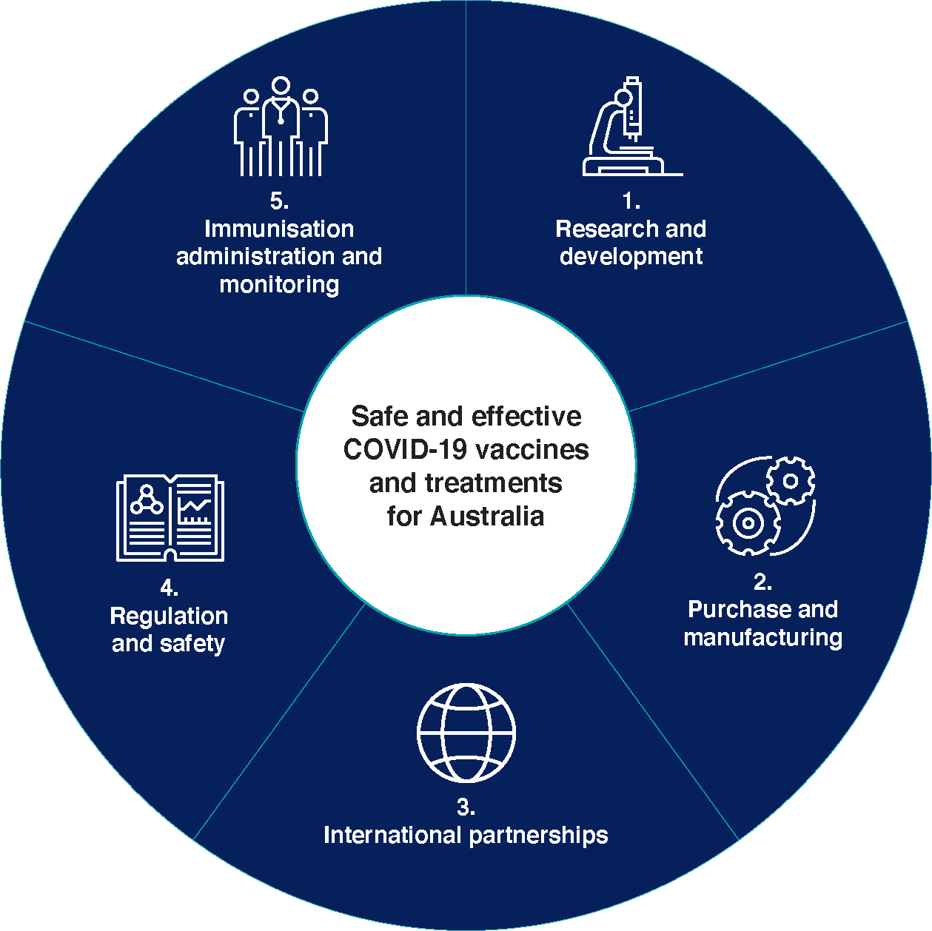

Research and development
Australia is identifying and supporting world-leading research to accelerate development and manufacture of promising COVID-19 vaccines and treatments.
The Australian Government has allocated $333 million to help develop COVID-19 vaccines, treatments, therapeutics and diagnostics, including $66 million from the Medical Research Future Fund (MRFF).
Funding from the MRFF targets Australia-based health and medical research:
- towards a vaccine for COVID-19
- towards antiviral therapies for COVID-19
- in clinical trials of potential treatments for COVID-19
- in improving the health system’s response to COVID-19 and future pandemics.
CSIRO’s Australian Centre for Disease Preparedness has had a $220 million upgrade, enabling COVID-19 research to be carried out safely.

Purchase and manufacturing
The Australian Government is building a diverse global portfolio of investments to secure early access to promising vaccines and treatments. Using and strengthening local manufacturing is a key aim of investment decisions.
Australians will have access to safe and effective vaccines, through direct procurement or manufacturing under license in Australia.
The Government is well progressed in purchasing and manufacturing through:
- advance purchase agreements to secure direct purchase of vaccine or treatment doses, once they’re available
- manufacturing agreements to use Australian manufacturers and expand their capability and capacity
- international and multilateral agreements to support and facilitate access for Australia and its region
- procurement contracts to buy the goods, materials and services needed to distribute and administer vaccines and treatments.
The Government is also collecting information on Australia’s COVID-19 vaccine and treatment manufacturing capability and capacity. This includes an audit identifying opportunities to expand, modify or repurpose local industry’s capability and capacity. This helps to maximise Australia’s role in the supply of COVID-19 vaccines and treatments.

International partnerships
Australia is working globally to accelerate development of safe and effective vaccines and treatments that are available and affordable to all. We are partnering with our Pacific and South East Asia neighbours, focusing on immunisation policy and coverage.
The global impact of COVID-19 requires a global response. The Australian Government has contributed to the Coalition for Epidemic Preparedness Innovations (CEPI), one of the international organisations that established the COVID-19 Vaccine Global Access (COVAX) Facility. The facility enables participating governments, including lower income countries, to access safe and effective vaccines for 20 per cent of their population.
The Government has also submitted an expression of interest to participate in the COVAX Facility, so we can participate in its design and implementation. The Government is considering further contributions to COVAX to support access to a vaccine by lower income countries.
Supporting our regional neighbours’ access will progress health outcomes, and help open up movement of people and goods, providing for economic recovery and longer-term resilience of the Pacific and South East Asia.
Partnering with like-minded countries improves our understanding of the vaccine and treatment landscape and may boost Australia’s purchasing power.

Regulation and safety
Australia will use Therapeutic Goods Administration (TGA) regulatory processes to enable early access to COVID-19 vaccines and treatments. To provide safe and fast approval for Australia and our region, the TGA will continue to work with its international counterparts, sharing information on vaccine clinical trials, manufacturing and safety.
Streamlined regulatory processes will ensure Australia takes quick and effective advantage of global vaccine and treatment developments. It will speed up product review and registration, while assuring safety and efficacy.
All manufacturers must comply with Good Manufacturing Processes (GMP), regardless of their location. The TGA is advising manufacturers on GMP and prioritising approvals, including through virtual inspections.
The TGA will continue to work with the International Coalition of Medicines Regulatory Authorities and the World Health Organization on international developments and assessment of vaccines for COVID-19.
Australia plays a key role in ensuring the safety of medicines across our region.
The TGA works with regulatory authorities across the Asia Pacific to support safe and quick regulation for new vaccines and therapeutics. It also works with 12 Pacific island countries to monitor the quality and storage of medicines.
These established relationships can be rapidly expanded to include COVID-19 treatments and vaccines.

Immunisation administration and monitoring
Australians will receive safe and effective vaccines under a targeted and responsive national COVID-19 vaccination policy and immunisation program. Policies and programs will be based on up-to-date health advice.
The Australian Technical Advisory Group on Immunisation (ATAGI) is preparing advice to support planning for the allocation and use of safe and effective vaccines. As vaccines are approved for Australian use, the national COVID-19 immunisation program will be updated regularly on the basis of ongoing ATAGI advice.
Australian Government agencies are working with states and territories on transportation, storage and distribution plans. This will ensure vaccines, syringes and needles can be moved and stored securely and distributed rapidly.
The Government will develop a comprehensive monitoring and surveillance plan so that any vaccine provided to Australians will be monitored to ensure ongoing safety.

