ASSAD 2017 Statistics & Trends

Trends in Substance Use among Australian Secondary School Students 1996-2017: Second Edition

Important note for readers

Since its original publication in May 2019, this report and the associated dataset has undergone a quality control review process. This process identified small errors in the calculation of population weights used during analyses of the 2017 data and inconsistencies compared to previous ASSAD survey years in the data cleaning protocols that were applied to a select group of variables for that survey year. Several transcription errors in the report were also identified. In rectifying these issues for the updated second edition of this report, it is important to note that some of the previously reported prevalence estimates have changed. However, these changes are generally minor (± 1%) and have not affected the key prevalence estimates of current (past week) and past month smoking and drinking among students aged 12-17 years, both overall and for male and female students separately.

July 2020, Centre for Behavioural Research in Cancer, Cancer Council Victoria

Report prepared by: Nicola Guerin and Victoria White

Prepared for Drug Strategy Branch, Australian Government Department of Health

Published by Cancer Council Victoria

Suggested citation:

Guerin, N. & White, V. (2020). ASSAD 2017 Statistics & Trends: Trends in Substance Use Among Australian Secondary Students 1996-2017. Second Edition. Cancer Council Victoria.

615 St Kilda Road  
Melbourne Victoria 3004  
Australia

For enquiries contact:

Centre for Behavioural Research in Cancer

T: +61 3 9514 6410

E: [cbrc@cancervic.org.au](mailto:cbrc@cancervic.org.au)

ASSAD 2017 Trends in Substance Use 1996-2017

The triennial Australian Secondary Students’ Alcohol and Drug Survey (ASSAD) is the largest national survey of adolescent substance use in Australia. This report presents information from ASSAD surveys between 1996 and 2017 on the use of tobacco, alcohol, and other licit and illicit substances among school students aged 12 to 17 in Australia. In measuring changes in substance use over time, this survey series provides a unique contribution to substance use research, policy, and prevention in this age group. This research tracks how changes in substance use relate to the characteristics and attitudes of the adolescents who use them, the social conditions of use, and the policy and legislative contexts of substance use. As a result, ASSAD findings have important implications for public policy. Our findings provide an evaluation of the effects of past substance use policies, and an indication of the current and future needs of adolescents in Australia. In this report, we analyse changes in substance use between 1996 and 2017[1] and examine these trends by sex and age.

In each survey year since 1996, 19,000-30,000 secondary students aged 12 to 17 have participated in the ASSAD survey. Teenagers who were not at school were not included in the school-based samples. Students answered questions about their current and lifetime use of tobacco, alcohol, analgesics, tranquilisers, and other substances, and their behaviour related to the use of these substances. Our measures include use in the lifetime, past year, past month, and past week (current use).

An overview of the survey’s history and methodology is available in our report of national findings from ASSAD 2017[2], which detailed the prevalence of substance use and related behaviour among secondary students in Australia in 2017.

Acknowledgements

The Centre for Behavioural Research in Cancer at Cancer Council Victoria gratefully acknowledges the cooperation and assistance of the people and organisations listed here in the running of this survey:

all students who participated in the survey

the staff of participating schools

state departments of education

state and diocese Catholic education offices

state associations of independent schools

The organisations listed below funded ASSAD data collection in states or territories during survey years between 1996 and 2017:

Australian Government Department of Health

Cancer Council Victoria

Department of Health and Human Services, Victorian Government

Centre for Epidemiology and Evidence, NSW Ministry of Health

Centre for Population Health, NSW Ministry of Health

Mental Health & Drug and Alcohol Office, NSW Ministry of Health

Cancer Institute, NSW

Cancer Council New South Wales

Cancer Council South Australia

Drug and Alcohol Services South Australia, SA Health

Tobacco Control Research and Evaluation, South Australian Health and Medical Research Institute (SAHMRI)

Chronic Disease Prevention Tobacco Policy Team, Health Department of Western Australia

Performance and Programs, Mental Health Commission, Government of Western Australia

Cancer Council Queensland

Queensland Health

ACT Health, Epidemiology Section, Health Improvement Branch, Population Health Division

Cancer Council Tasmania

Communities, Sport and Recreation, Department of Premier and Cabinet, Tasmania

Department of Education, Tasmania

Public Health Services, Department of Health and Human Services, Tasmania

Alcohol & Drug Services, Tasmanian Health Service

Northern Territory Government, Department of Health, Mental Health, Alcohol, and Other Drugs Branch

The people listed below coordinated the survey and/or organised data collection in their state or territory during 2017:

Tanya Plueckhahn, Gorjana Radisic, Kate Clarke-Palmer, Greg Sharplin, and Tony Daly, Cancer Council South Australia

Frances Gibson, Ann-Maree Hughes, Hai Phung, Sommer Sherwood, Epidemiology Section, Health Improvement Branch, Population Health Division, ACT Health

Tim Harrold, Jessica Gugusheff, Heather Baldwin, Suzanne Schindler, Health Behaviour Surveillance, Centre for Epidemiology and Evidence, NSW Ministry of Health

Chris Moon, Warren Que Noy, Northern Territory Government, Department of Health, Mental Health, Alcohol, and Other Drugs Branch

Amanda Harrison, Rebecca Hood, Su-Ann Drew, Russell Bridle, Performance and Programs, Mental Health Commission, Government of Western Australia

Mandy Gardener, Natalie Klein, Abby Smith, Cancer Council Tasmania

Nicola Guerin, Tahlia Williams, Maree Scully, Felicity Houewen, Cancer Council Victoria

Rebecca Perkins, Peter Anderson, Peter Baade, Upeksha Chandrasiri, Cancer Council Queensland

Ted White, Tendai Dawkins, Community Solutions, Queensland

Saskia Kirson, Angela Brooks, McNair Ingenuity Research, NSW

Catherine Manley, Sonja Porter, Miles Morgan Australia, Western Australia

Australian Council for Educational Research advised on all aspects of sampling in 2017 and earlier survey years.

Wai Yen Loh, Larissa Popowski, Alison Hopkins of Cancer Council Victoria, undertook and managed data cleaning and coding for ASSAD 2017.

We also thank the research teams that administered the survey to students throughout Australia 1996-2017.

Table of Contents

**Key findings and conclusions 6**

**Trends in smoking among Australian secondary students 1996-2017 10**

**Trends in drinking among Australian secondary students 1996-2017 17**

**Trends in over-the-counter drug use among Australian secondary students 1996-2017 22**

**Trends in illicit substance use among Australian secondary students 1996-2017 24**

**Tables 30**

List of tables 30

Trends in smoking among Australian secondary students 1996-2017 31

Trends in drinking among Australian secondary students 1996-2017 34

Trends in over-the-counter drug use among Australian secondary students 1996-2017 36

Trends in illicit substance use among Australian secondary students 1996-2017 40

**Summary of methods 50**

Key findings and conclusions

Substance use is a risky behaviour that has significant and serious health consequences among adolescents in Australia[3],[4]. After overall increases in the prevalence of substance use among secondary students during the 1990s, trends in substance use in ASSAD survey data collected between 2002 and 2017 show a substantial improvement in the prevalence of smoking, drinking (including drinking at risky levels), and cannabis use in this population. The use of other illicit substances was generally low overall. Similar trends have been observed in comparable high-income nations, including the US[5], UK[6],[7], Canada[8], and New Zealand[9],[10].

Causes and implications of changing trends in substance use

The timing of changes in substance use and their patterns across student ages and generations suggest that public health policies and legislation are likely to have played a key role in declining use, as has been found with adult populations[11]-[12][13][14]. Social, political, and economic effects have been cumulative, and ongoing research is needed to identify the policy and legislative initiatives that are likely to be most effective in further reducing adolescent smoking, drinking, and illicit substance use in the future.

Declines in smoking

Smoking prevention and cessation measures have been extremely effective in reducing the prevalence of tobacco use among adolescents in Australia[15],[16]. However, the continued decline of smoking in this age group is threatened by the proliferation and uptake of novel products[17] such as crushball cigarettes, smaller factory-made cigarette pack sizes, smaller roll-your-own tobacco pouch sizes, and e-cigarettes[18],[19].

Further standardising pack and pouch size to effectively prohibit the sale of smaller, cheaper products, and prohibiting the sale of novel products that attract adolescents, could be expected to lower smoking uptake and reduce the likelihood of teenagers becoming more regular smokers, and continuing to smoke in adulthood[20].

Declines in drinking

Alcohol consumption among secondary students in Australia has declined since the 2000s, most markedly among the younger age group (aged 12 to 15). We explore suggested reasons for these trends in a later section of this report (*Trends in drinking among secondary students in Australia 1996-2017*).

Despite these declines, the continued substantial prevalence of drinking among older adolescents (49% in the past month in 2017) is of particular concern, given strong associations between uptake in adolescence (especially early adolescence) and later unhealthy drinking behaviour and attitudes[21]-[22][23].

The net liberalisation of alcohol regulation over time, including extended opening hours and expanded locations of licensed premises[24], generally increased retail availability, and widescale alcohol sponsorship of major sporting teams and events, have created a social environment that normalises alcohol use and maintains adolescent exposure[25],[26].

Trends in illicit substance use

While the prevalence of other illicit substance use remains low among secondary students, increased prevalence of reported use of cannabis and ecstasy might be concerning and should continue to be monitored. Considered in the context of small fluctuations in any illicit substance use, and declining alcohol use, these increases might indicate changes in the relative popularity or availability of these substances, rather than increased substance use *per se*.

Associations between drinking and other substance use

Importantly, broader trends suggest changes in different kinds of substance use might be related[27], with alcohol use playing a pivotal role. While the association between alcohol use and smoking among adolescents has weakened with the very strong decline in smoking, students continue to identify smoking as a common negative consequence of consuming alcohol[28]. Exposure to alcohol is also likely to be a key factor in students’ other drug use. Drinking can initiate a cascade effect of lowered self-control, exposure to other substances, and increased substance use experimentation[29].

If alcohol is instrumental in further substance use, preventing or reducing alcohol would also be likely to reduce the prevalence of other substance use, including smoking. Longitudinal research is needed to establish causation in these observed associations between adolescents’ use of different substances.

Policy implications

In light of its association with other substance use, alcohol consumption, particularly among younger adolescents, should remain a priority target for policy initiatives and regulation. Interventions to counter adolescent alcohol consumption are likely to influence other risky substance use[30].

Tightening regulation of alcohol advertising is likely to be effective in reducing adolescent exposure to alcohol and its use by others, and to counter the normalisation of alcohol use across a widening range of social settings and events[31]. Lower levels of alcohol advertising in the mass media since 2005 have coincided with observed declines in adolescent drinking and are likely to have contributed to this lower drinking prevalence[32].

Product price can have an immediate impact on substance use patterns and prevalence. As such, price represents a prime target for policy that might reduce adolescent alcohol consumption, for example, through higher and increasing excise on all alcohol products[33] and product regulation.

The success of mass media campaigns highlighting the health effects of smoking[34] suggests that similar campaigns could effectively change drinking norms, especially if combined with more prominent and specific health warnings on alcoholic products to highlight the longer-term health effects of drinking. These measures are potentially effective routes to inform Australians of specific serious harms and contribute to reducing drinking prevalence and minimising the harms of excessive alcohol consumption over the lifetime[35].

Concerted government action continues to be critical for maintaining and strengthening the declines in adolescent smoking and drinking, and preventing adolescent uptake and use of other dangerous substances.

* 1. Key concepts for interpreting population trends in substance use prevalence

We report long-term trends in lifetime, past year, past month, and past week prevalence of use for tobacco, alcohol, and licit and illicit substances for three age groups: 12-15, 16-17, and 12-17.

Three main kinds of effect are evident in trends of substance use among Australian secondary students between 1996 and 2017:

* 1. *Age effects*

Age effects describe trends that can be seen over time for students at a specific age or in a specific age range, regardless of their cohort.

For example, substance use is generally lower among younger than older students.

Age and age group effects can be tracked over longer periods than cohort effects and indicate trends in substance use at a specific developmental stage.

* 1. **Cohor***t effects*

A cohort is the group of people born at around the same time and sharing common ages and experiences as they age.

A cohort effect is a trend that follows a cohort as it ages. For example, if there was an increase in alcohol use in a cohort when its members were aged 12-14, this same effect is likely to be observed three years later when that cohort of students is aged 15-17.

Cohort effects have a typical staggered pattern across trend lines.

A cohort effect can be caused by cohort-specific attitudes to substance use, changing peer norms, legislative change (e.g., greater restriction in drug availability or conditions of supply), and changes in the substance itself (e.g., addictiveness).

As ASSAD is triennial, cohort effects can be tracked only across the span of two consecutive surveys before a cohort moves out of the surveyed age range.

* 1. *History effects*

History effects are associated with key events experienced in common among all individuals at a population level at a specific time that had broad societal impact.

History effects show in patterns that are similar for all age groups in parallel, rather than in the more staggered pattern of a strong cohort effect.

The effect of legislation that affects substance availability might be observed as a history effect in trendlines, evident for all population sub-groups. For example, from 1996 to 2017, tobacco control policy events included point of sale tobacco advertising bans, graphic health warnings on tobacco packaging, tax increases, and the implementation of tobacco plain packaging. These measures affected all age groups similarly.

* 1. Types of trends evident in alcohol and illicit drug use 1996-2017

Age effects are evident, with use generally increasing with age.

Cohort effects are evident earliest at the lower age in a specific survey year and then also seen when this cohort is at the older age in the following survey year.

History effects are evident (i.e., increases or declines for all age groups in the same period), but their causes are not always clearly understood.

* 1. Types of trends evident in smoking 1996-2017

Age effects are evident, with use increasing with age.

Cohort effects can be observed but tend to be less marked for smoking than for other substances.

History effects are evident in parallel trend lines for age groups. Declining trends clearly show the impact of government action to reduce smoking prevalence on students of all ages in Australia.

Trends in smoking among Australian secondary students 1996-2017

Trends in smoking prevalence

In 2017, tobacco use across all surveyed ages (12-17) in all recency periods was at historic low levels, following a dramatic decline from the late 1990s.

Lifetime smoking declined from 1996 through to 2017 for both younger and older students. Trends largely show a pattern of history effects that are similar across all ages, but tobacco use was consistently higher among older than younger students.

The prevalence of past month smoking in 2017 was 4% among students aged 12-15, and 14% among students aged 16-17. The trend for past month smoking was similar for both younger (12-15) and older (16-17) students, but there were weak cohort effects in the timing of key points in the downturn in smoking prevalence. For example, the slowing of the decline in smoking during the late 2000s was seen from 2005 in the younger age group, and from 2008 in the older age group as this cohort aged. Following a plateau in prevalence between 2008 and 2011, further decline was evident across both age groups. This coincided with the implementation of plain tobacco packaging, larger graphic health warnings on cigarette packs, increasing restriction of tobacco advertising (e.g., at the point of sale), and annual increases in tax on tobacco products.

Largely parallel trends were also seen in past year, past week, and committed (smoked three or more days in the last week) smoking for all age groups. The prevalence of having smoked more than 100 cigarettes in the lifetime was below 2% from 2014 in the younger age group. However, slower declines in smoking at this level were evident from 2005 in the younger age group (and 2008 as this cohort aged) as the number of smokers decreased. Similarly, trend lines for the older age group showed slower declines in the proportion of students who had smoked more than 100 cigarettes over the past decade, from a plateau between 2008 and 2011.

Daily smoking among older students declined from around 4% in 2008 and 2011 to 2% in 2017. This followed a sharp drop in daily smoking prevalence between 2002 and 2005 for this older age group. Among younger students, daily smoking declined steadily from 5% in 1996 to 1% in 2008, where it has remained stable.

Trends in sources of cigarettes

Overall, the proportion of current smokers who bought cigarettes themselves has declined. Trends show cohort effects, with key declines evident earlier in students aged 12 to 15 than those aged 16 and 17.

Among younger students, fewer current smokers bought cigarettes from 1996 to 2002, following an earlier decade of decline. After a small increase was observed in 2005, this proportion again declined to 2017. The proportion of 12 to 15 year old current smokers (8%) who bought their last cigarette in 2017 was similar to 2008, 2011 and 2014.

In line with a cohort effect, a similar plateau was observed in the shrinking proportion of older current smokers who bought their own cigarettes. However, following further declines from 2008, there was a non-significant increase in the proportion of older students who had bought their own cigarettes from 2014 (18%) to 2017 (21%). The reasons for this recent upturn in self-bought cigarettes only among older students are not clear.

We also examined trends in the proportion of current smokers who asked someone else to buy cigarettes for them and found no cohort effects in earlier survey years, but a marked history effect that was similar for all ages. Among younger students, the proportion increased between 1996 and 2002 from 14% to 21%, and among older students from 7% to 18%, reflecting greater restrictions on cigarette sales to minors. After 2002, rates stayed between 15-19% for younger students. The proportion of older students getting someone else to buy cigarettes for them rose from 15% in 2005 to 23% in 2014. In 2017, however, the rate dropped to 13%. Corresponding to this drop, there have been small non-significant increases in the proportion of older students who were current smokers reporting getting cigarettes from friends (2014: 47%; 2017: 51%), as well as buying cigarettes themselves.

Summary of trends in smoking prevalence 1996-2017

Overall, trends in adolescent smoking from 1996 to 2017 follow a similar and largely parallel pattern across age groups, with key effects only weakly staggered by cohort. The prevalence of smoking increased through the 1990s for all age groups before rapidly declining from the late 1990s to the late 2000s. Since then, a continuing decline is apparent after a brief plateau. The generally parallel pattern for most outcomes is characteristic of history effects associated with events experienced similarly by people of all ages at that point of time. Here, trends in the prevalence of adolescent smoking reflect trends in adult smoking observed during the same period[36]. Smoking at all ages was greatly reduced in response to public health policy initiatives and legislation during this period[37].

Reasons for changes in prevalence over time

The observed increase in smoking during the 1990s coincided with decreased funding to tobacco control programs, along with reduced policy initiatives, and a drop in mass media anti-smoking campaign advertising[38]. The period also saw lower cigarette pricing, and sustained levels of incidental exposure of adolescents to smoking in mass media entertainment. These social, political, and economic events affected all ages similarly.

Reduced smoking prevalence from the late 1990s in all age groups coincided with multi-pronged anti-smoking action during this period[39]. The marked downturn in smoking among secondary students from this time is likely to have resulted from concerted public health advocacy and subsequent legislative and policy change in response to concerns about the general upsurge in smoking during the 1990s[40],[41]. Similar trends were observed internationally in comparable settings such as the US[42] and UK[43], where tobacco control policy and funding were also strengthened.

Specific developments that contributed to the decline in smoking among adolescents include increases in cigarette pricing (partly caused by increases in tobacco tax)[44], national and state-based anti-smoking advertising campaigns run by government and non-government organisations (e.g., Quit)[45],[46], the implementation of graphic health warnings on tobacco packaging[47], strong restrictions on advertising in the mass media and at point of sale[48], increased focus on preventing the sale of tobacco to people under the age of 18, the introduction and extension of smoke-free legislation[49], and implementation of plain packaging laws and larger graphic health warnings on tobacco packs in late 2012[50]-[51][52].

The trends observed in ASSAD survey data suggest multi-faceted policy responses to increases in smoking among adolescents were effective. Societal changes associated with this policy climate such as changed social norms around parenting and socialising might also have contributed to declining trends. The impact of rapid technological change (e.g., smart phone use) on how adolescents socialised and used recreation time has also been suggested as a potential contributor to reduced smoking prevalence in this age group. However, strong evidence has been found for the effects of policies such as bans on smoking in public places, anti-smoking advertising, tighter regulation of sales to minors, and tax increases.

Smoking prevalence plateaued between 2008 and 2011, from which time the implementation of plain tobacco packaging in December 2012 is likely to have played an important role in the further reductions observed in smoking between 2011 and 2017. While the absolute decline in smoking prevalence overall has been smaller over the last decade, this is substantially due to the shrinking proportion of students who have smoked. However, the most recent data indicate a slightly smaller decline from 2014 to 2017, so it remains important to continue to monitor prevalence.

Recent trends

The smaller decline in adolescent smoking from 2014 to the latest survey round in 2017 may be concerning. While the period from 2011 included the implementation of plain packaging and other policy measures, since 2014 there has been a reduction in government-funded national and state-based mass-media anti-smoking campaigns, and a greater identified need for support for quitters[53]. There has also been a proliferation of novel tobacco products and smaller pack sizes which are attractive and affordable for adolescents[54],[55]. These products designed to attract new smokers and retain existing smokers have gained substantial traction among adolescent smokers since their introduction following large tax increases from 2010, and since the advent of plain packaging[56],[57].

Implications

The implementation of plain packaging legislation, tax increases, and other public health efforts have effectively reduced smoking initiation and regular smoking among both adults and adolescents[58] since 2011. If the negative impact of smoking on individual and public health is to be further limited, more action is needed to consolidate public awareness of the specific dangers of smoking, reinforce the personal relevance of these dangers, and counter the marketing strategies of the tobacco industry.

Timeline of tobacco control in Australia[59],[60]

1973 Text health warning “Smoking is a health hazard” first mandated on all cigarette packs in Australia.

1976 Bans on all cigarette advertising on radio and television in Australia.

1983-1987 Introduction of TV-led Quit campaigns, starting in Western Australia.

1988 Introduction in all states of a rotating set of four of health warnings on the base of tobacco packaging.

1986-2006 Phased in bans on smoking in workplaces and public places.

1990 Bans on advertising of tobacco products in newspapers and magazines published in Australia.

1992 Increase in the tobacco excise.

1993 *Tobacco Advertising Prohibition Act 1992* prohibited broadcasting and publication of tobacco advertisements.

1994-2003 Bans on smoking in restaurants.

1995 Nationally consistent and enlarged text only health warnings required at the top of tobacco packaging.

1998-2006 Bans on point-of-sale tobacco advertising across Australia.

1997-2001 National tobacco mass media campaign.

1999-2000 Tobacco price increases due to new ‘per stick’ tobacco excise system (1999) and introduction of GST (2000).

2005-2010 Bans on smoking in pubs and clubs.

2006 Graphic health warnings required on packaging of most tobacco products.

2010 25% increase in the tobacco excise.

2011 First complete state or territory ban on point of sale tobacco product displays.

2012 Offence for any person to publish tobacco advertising on the internet or other electronic media.

2012 Introduction of tobacco plain packaging and updated and expanded graphic health warnings.

2012 Reduction in the duty free allowance from 250 cigarettes or 250 grams of cigars or tobacco products to 50 cigarettes or 50 grams of cigars or tobacco products.

2013 First 12.5% tobacco excise increase on 1 December.

2014 Change from bi-annual indexation based on the Consumer Price Index (CPI) to bi-annual indexation based on average weekly ordinary time earnings (AWOTE).

2014-2020 Annual 12.5% tobacco excise increase on 1 September each year.

2017 Reduction in duty free tobacco allowance, 25 grams of duty free tobacco (cigarette, loose leaf etc.), plus one open packet; equivalent to approximately 25 cigarettes.

2017 Harmonisation of the taxation of roll your own tobacco and other products such as cigars, with manufactured cigarettes.

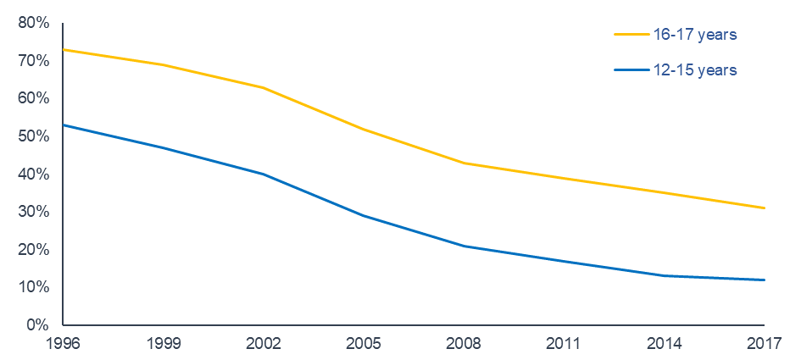

Figure 1: Percentage of Australian secondary school students who ever smoked, ASSAD **1996-2017**

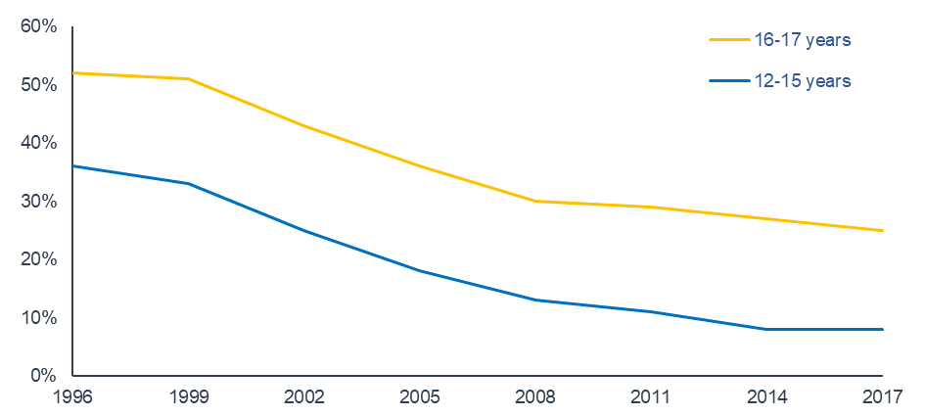

**Figure 2: Percentage of Australian secondary school students who smoked in the past year, ASSAD 1996-2017**

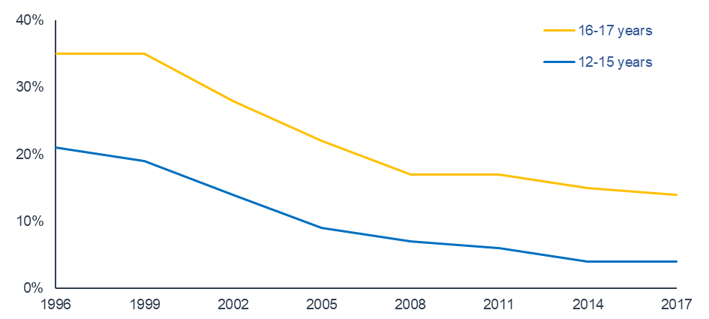

**Figure 3: Percentage of Australian secondary school students who smoked in the past month, ASSAD 1996-2017**

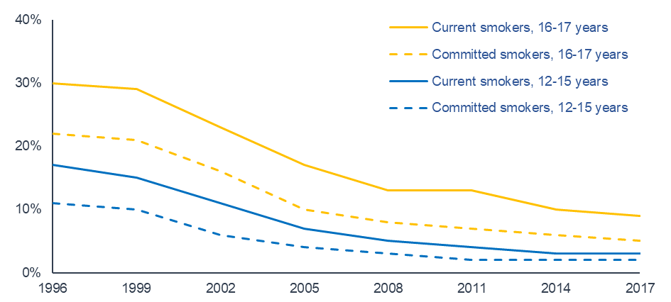

**Figure 4: Percentage of Australian secondary school students who were current or committed smokers, ASSAD 1996-2017**

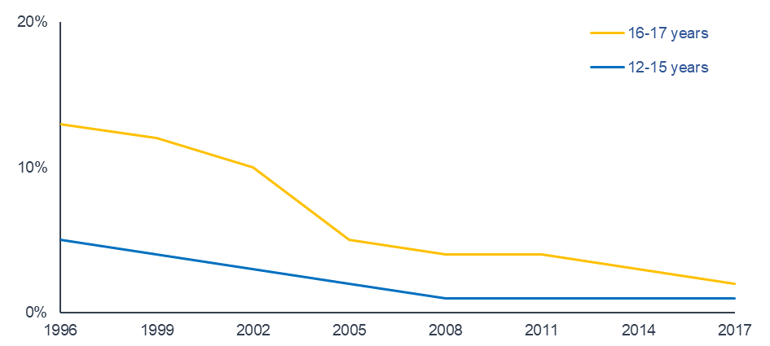

**Figure 5: Percentage of Australian secondary school students who smoked daily, ASSAD 1996-2017**

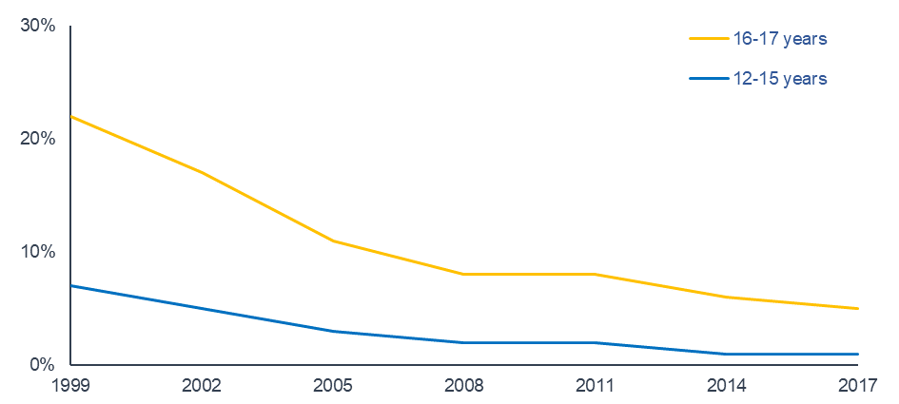

**Figure 6: Percentage of Australian secondary school students who had smoked more than 100 cigarettes in their lifetime, ASSAD 1999-2017**

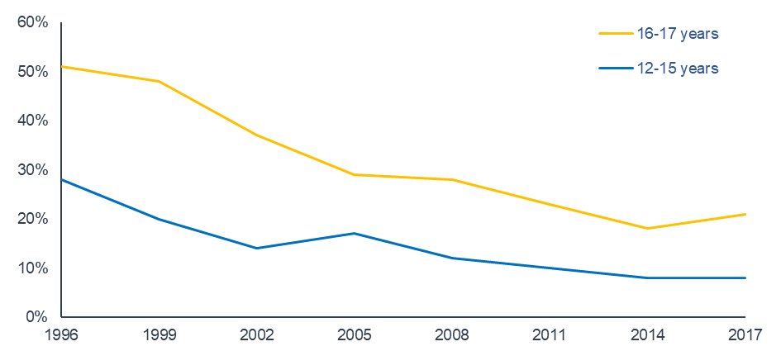

**Figure 7: Percentage of current smokers who had bought cigarettes themselves, ASSAD 1996-2017**

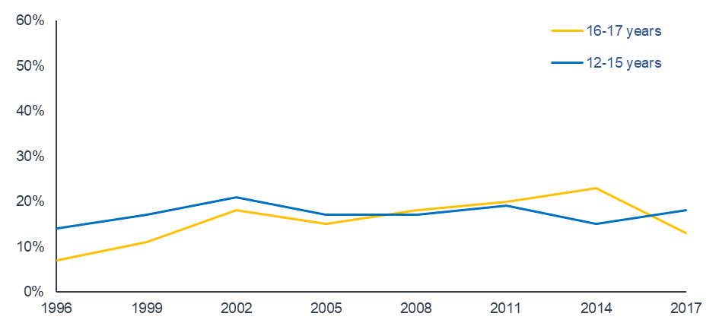

**Figure 8: Percentage of current smokers who had someone else buy cigarettes for them, ASSAD 1996-2017**

Trends in drinking among Australian secondary students 1996-2017

Trends in prevalence of alcohol use

Trends in the prevalence of adolescent alcohol consumption show age, cohort, and history effects. Similar to tobacco, drinking prevalence had declined in the late 1980s with some evidence of a cohort ‘lag’ effect of higher prevalence among older drinkers in 1987. However, drinking prevalence among secondary students increased from the early 1990s to the early 2000s. This pattern of trends was similar to those seen in the US[61] and UK[62], suggesting a strong history effect of shared social and policy climates and experiences.

From the early 2000s drinking prevalence declined among secondary students in Australia, following steadily declining rates of daily and weekly drinking among Australian adults in the same period, including young adults[63]. The rate of decline slowed after 2011. It is of some concern that past week drinking prevalence has not declined significantly among younger students since 2011. A significant decline between 2011 and 2017 across all ages was largely due to lower prevalence among older female students.

Prevalence rates for older students show evidence of a cohort effect, with the decline evident from 2005, rather than from 2002 as observed for younger students.

Trends in risky drinking

Trends in risky drinking (having five or more drinks on one occasion in the past week) show less variation than trends for lifetime drinking and other recency periods, but prevalence declined between 2002 and 2014 for younger students. Risky drinking was lower for older students in 2017 than in 2011, suggesting that while past week and past month drinking prevalence declined little from 2011, older students who did drink alcohol were drinking less.

Reasons for declines in the prevalence of adolescent drinking

Declining use of alcohol coincided with a period of diverse policy implementation aiming to reduce a range of adolescent substance use. In this period, harmful alcohol use became less acceptable among the broader Australian community[64]. However, there is continued debate over the factors that have contributed specifically to reduced drinking prevalence in this age group, in both Australia and comparable countries[65],[66].

In Australia, government-funded mass media campaigns included targeting of adolescent drinking[67], parental supply of alcohol[68], and parental modelling of drinking behaviours[69]. Mass media campaigns targeting alcohol-related harm garner high awareness, and effectively reduce the prevalence of specific consequences of harmful alcohol use in target populations[70],[71]. More generally, mass media campaigns that focused on the consequences of drink driving were likely to have had a similar effect on adolescents as they were shown to have in changing adult attitudes and behaviour[72],[73].

Governments also regulated the secondary supply of alcohol. In this period, there was growing awareness of the short- and longer-term risks of alcohol use, including risky levels of adolescent and adult drinking according to NHMRC guidelines[74].

As with smoking, it has been suggested that reduced alcohol use might be partially due to the impact of digital technologies including smart phone use on socialising and leisure activities.

Some researchers have also identified characteristics such as greater maturity, individuality, and responsibility among recent generations of young people, evident in less peer pressure to drink, and greater variation in the ways that adolescents socialise[75].

Reducing the prevalence of adolescent drinking

Drinking prevalence overall remains substantial, especially among older secondary students. Alcohol uptake in adolescence is related to increased later unhealthy drinking behaviour, attitudes, and health effects[76]-[77][78]. As current NHMRC guidelines recommend no drinking before the age of 18 years, further policy action may be needed to consolidate and strengthen recently observed declines in use.

While the implementation of selected policy measures and programs to reduce alcohol consumption among secondary students since the late 1990s seems to have had some impact on adolescents’ drinking behaviours[79], as these measures operate in an environment of increasing liberalisation of alcohol regulation, strengthening policy measures and reducing conflicting messages around alcohol may be needed to continue downward trends in adolescent drinking.

Current social environments of alcohol use are facilitated by extended opening hours of licensed premises, and a proliferation of sites where alcohol is available from licensed premises and retailers[80].

Alcohol sponsorship and advertising has a strong association with alcohol brand awareness, recognition, choice, and use[81],[82], with advertising of alcohol outlets playing an increasing role in advertising alcohol[83]. Adolescents are exposed to alcohol advertising in diverse media and locations, including television advertisements by retailers, and sponsorship of digital gaming and sports telecasts[84]. Exposure to alcohol advertising is likely to have a strong and ongoing effect on the initiation of alcohol use in adolescence, and continued alcohol consumption.

Restrictions on alcohol advertising during children’s television viewing time do not apply in major sports broadcasts, resulting in widescale alcohol sponsorship of major sporting teams and events that directly and substantially increases adolescents’ exposure[85].

Alcohol advertising is permitted in a range of other media and locations.

Excise taxes on alcohol have not been broadly increased for prevention and minimisation of alcohol-related harms in Australia[86].

In combination, these activities normalise alcohol use.

Implications

Alcohol price has been identified as a relatively immediate influence on substance use prevalence and a prime target for policy that might reduce adolescent alcohol consumption through higher and increasing excise[87] and product regulation.

Tightening regulation of alcohol advertising would reduce adolescent exposure to alcohol and its use by others and remove a contributing factor to the normalisation of alcohol use in adolescents’ social environments[88],[89].

Mass media campaigns provided at adequate scale and duration may help to counter the persuasive effects of alcohol advertising on alcohol consumption[90].

Industry-led alcohol harm minimisation advertising (e.g., DrinkWise[91]) may include less effective messaging than government-led campaigns[92].

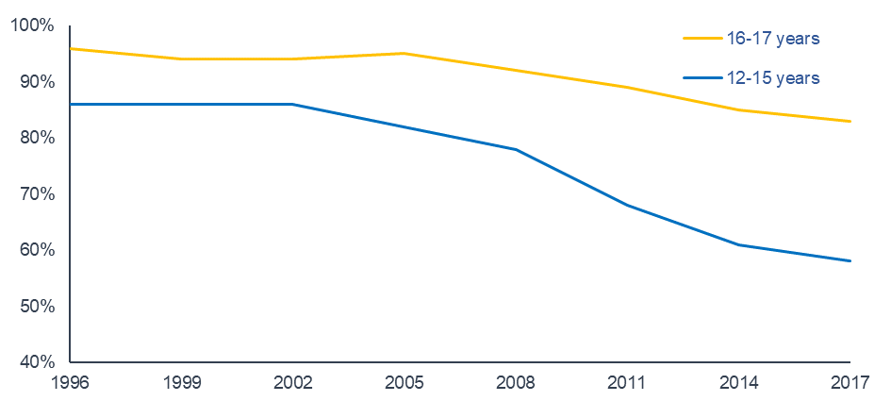

Figure 9: Percentage of Australian secondary school students who ever drank alcohol, ASSAD **1996-2017**

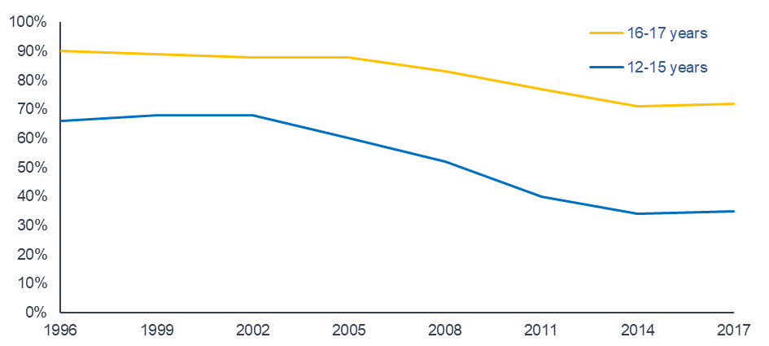

Figure 10: Percentage of Australian secondary school students who drank alcohol in the past year, ASSAD **1996-2017**

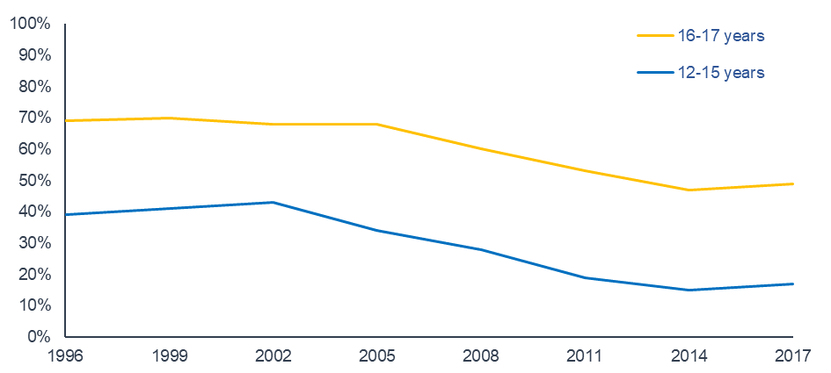

Figure 11: Percentage of Australian secondary school students who drank alcohol in the past month, ASSAD **1996-2017**

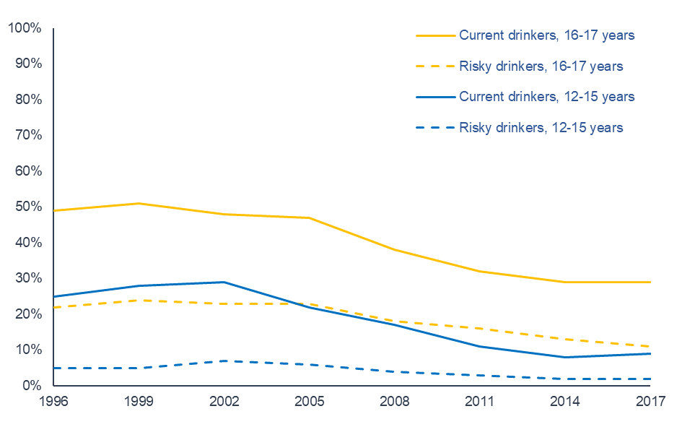

Figure 12: Percentage of Australian secondary school students who were current or risky drinkers, ASSAD **1996-2017[93]**

Trends in over-the-counter drug use among Australian secondary students 1996-2017

Trends in the prevalence of analgesic use

Use of painkillers or analgesics (e.g., Disprin, Panadol, or Nurofen) has been consistently common among secondary students over the past twenty years. In 2017, 95% of students had ever used an analgesic, and around two-thirds of students had used them in the past month.

Use increases with age and is higher among female than male students for lifetime, past year, past month, and past week. Prevalence of lifetime analgesic use was relatively similar across survey years, while past month use was slightly lower in 2017. This might correspond with increased use of other substances for pain relief.

Trends in reasons for analgesic use 2008-2017

Students’ reasons for use have been relatively stable over time, with analgesics most commonly used to ease headache. Other common reasons for use included easing cold or ‘flu symptoms, menstrual pain (females), or sports injury pain.

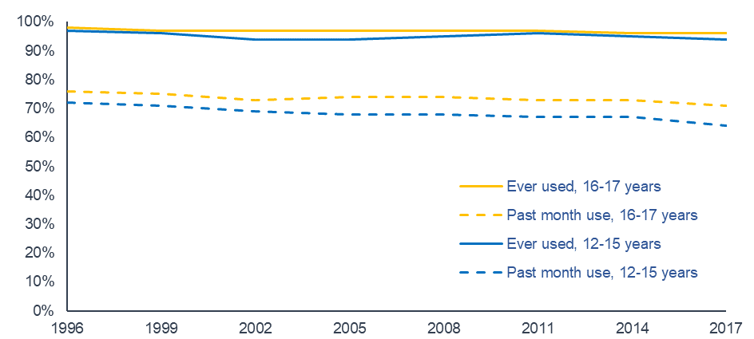

Figure 13: Percentage of Australian secondary school students who used analgesics, 1996-2017

Trends in prevalence of tranquiliser use

Overall, lifetime and past year tranquiliser use has increased slightly since 2005, while past month and past week use has been relatively stable. Past month and past week use increased slightly from 2011.

Trends in sources of tranquilisers 2011-2017

Parents were the most common source of tranquilisers for students who had used them for non-medicinal reasons in the past year. Reported use of prescribed tranquilisers for non-medicinal reasons might include incorrectly reported use for medical reasons.

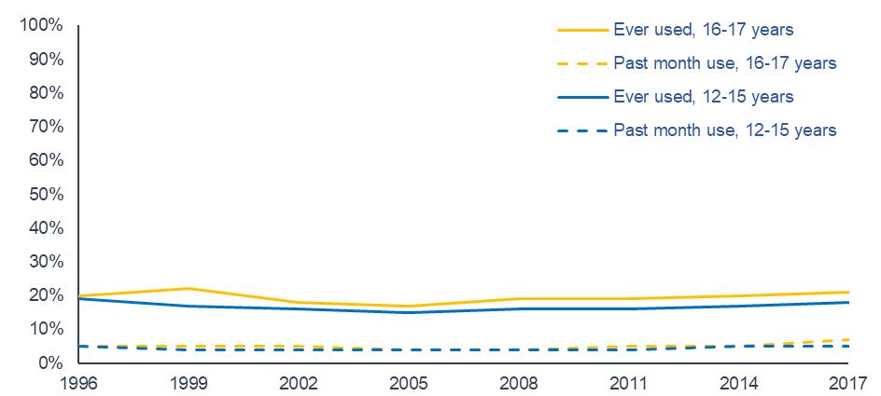

Figure 14: Percentage of Australian secondary school students who used tranquilisers, ASSAD **1996-2017**

Trends in illicit substance use among Australian secondary students 1996-2017

Trends in any illicit drug use

Any illicit drug use is a measure of the percentage of secondary students who used at least one type of illicit drug (cannabis, hallucinogens, amphetamines, cocaine, opiates or ecstasy) in their lifetime. Because cannabis is the illicit substance most commonly used by secondary students, with much higher prevalence than use of other illicit substances, we examine any illicit drug use both with and without any illicit cannabis use.

In 2017, students were asked different questions than in previous surveys about their use of amphetamines and opiates, with the use of dexamphetamine and methamphetamines measured separately, and the use of heroin and other opiates measured separately (whereas in previous survey years, a single question had measured amphetamine use overall, and a single question had measured opiate use overall). This difference might have affected the measure of use of any illicit drug. Specifically, students may have recorded use in both categories of a substance when only a single substance had been used, falsely elevating prevalence estimates. Thus, we only included methamphetamine use and heroin use in our measure of any illicit drug use when considering trends to 2017.

Trends from 1996 to 2017 generally indicate that use of any illicit drug is currently substantially lower than in past decades. When considered with the exclusion of cannabis use, the use of any illicit drug continues a trend of very low prevalence overall. While use generally declined from the late 1990s, past month use (including cannabis) increased slightly in the most recent survey period among older female students. For younger students, prevalence was similar to that reported in 2011 and 2014. Continued monitoring of trends will remain important as although use of many illicit substances is very low, recent increases in the prevalence of reported use of specific substances such as cannabis and ecstasy are of potential concern.

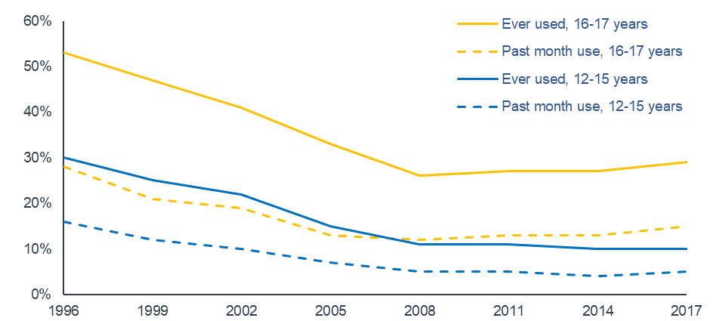

Figure 15: Percentage of Australian secondary school students who used any illicit substance (including cannabis), ASSAD **1996-2017**

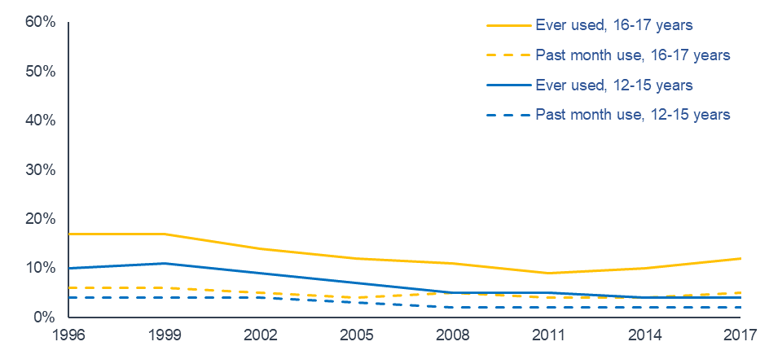

Figure 16: Percentage of Australian secondary school students who used any illicit substance (excluding cannabis), ASSAD **1996-2017**

Illicit substance use

Inhalants and cannabis were the most common illicit substances used between 1996 and 2017. However, while cannabis use increases with age, inhalant use follows a unique pattern of lower reported use with older age. Hallucinogens and ecstasy were the next most commonly used illicit substances, with their use also greater at older ages. Experiences with cocaine were rare at all ages between 1996 and 2017. Use of illicit substances in the past month was low at all ages.

Reasons for overall decline in the prevalence of illicit substance use 1996-2017

In general, similar patterns of declining use are evident for illicit drugs as for smoking and alcohol. These patterns suggest multi-faceted policy responses to increasing substance use among adolescents in the 1990s, and related changes in social norms, parenting and socialising, had a substantial effect.

Cannabis

Cannabis has long been the most commonly used illicit substance among secondary students. Use is more prevalent and more frequent in the older age group than among younger students, and typically higher among male than female students. Overall, the prevalence of cannabis use has declined since 1996 but there has been a slight resurgence in use among older students since 2008. Potential reasons for slightly increasing prevalence include more liberal social norms of cannabis use and acceptance, including the introduction of laws in other countries allowing the medical use of marijuana and deregulation of substances containing cannabinoids[94].

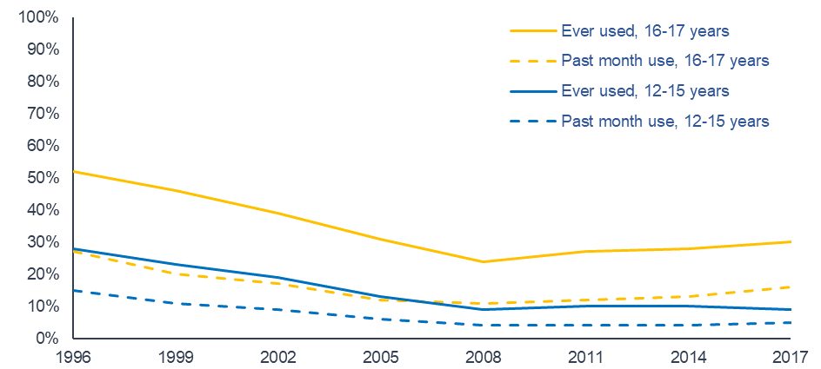

Figure 17: Percentage of Australian secondary school students who used cannabis, ASSAD **1996-2017**

Inhalants

Unlike other illicit substances used by students, inhalant use tends to be reported at a higher rate among younger than older students. Prevalence among older students has not differed markedly between survey years since 1996. Among younger students, prevalence generally declined over this period, with lifetime experience declining to 2005, before plateauing to 2017. Over all ages, past month experience was lower in 2017 than in 1996.

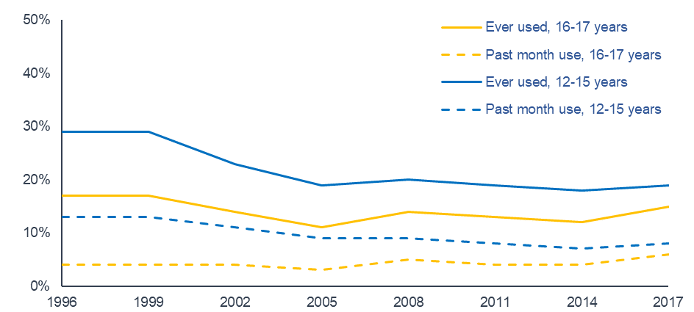

Figure 18: Percentage of Australian secondary school students who used inhalants, ASSAD **1996-2017**

Cocaine

Most secondary school students had never tried cocaine in any survey year. Only 1% of all students had used cocaine in the past month in any survey year. Lifetime cocaine use in 2017 among older students was slightly higher than in 2011. Among younger students, prevalence did not differ meaningfully from 2011 to 2017.

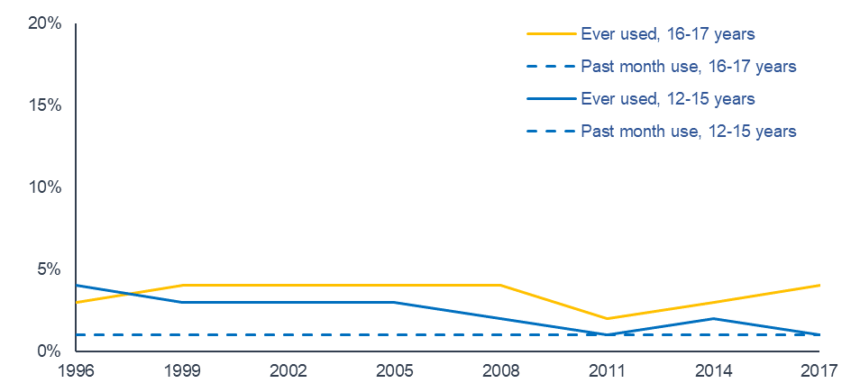

Figure 19: Percentage of Australian secondary school students who used cocaine, ASSAD **1996-2017**

Hallucinogens

Student use of hallucinogens such as LSD was extremely low in all survey years, with a substantial drop in lifetime experience evident between 1996 and 2002. Use was generally higher at older ages, but only 1% of all students reported use in the past month between 2005 and 2017. Male students were more likely to have tried hallucinogens than female students.

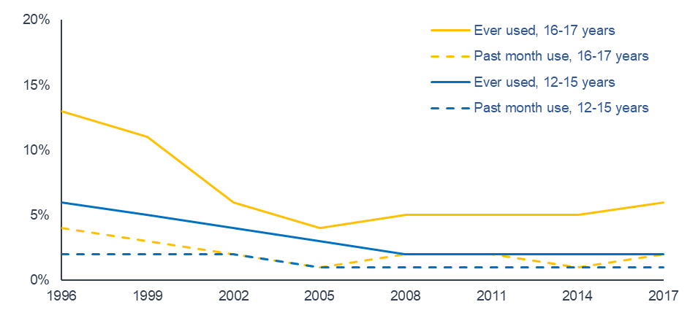

Figure 20: Percentage of Australian secondary school students who used hallucinogens, ASSAD **1996-2017**

Ecstasy

Most secondary school students in every survey year had never used ecstasy. Lifetime use increased with age. Male students were more likely than female students to have used ecstasy in each recency period across the survey series. The prevalence of lifetime ecstasy use has fluctuated within a narrow range since 1996, and in 2017 was slightly higher than in 2014. Past month prevalence was also slightly higher in 2017 than 2014. This increased use may reflect the onset of a change in the drug of choice among young people.

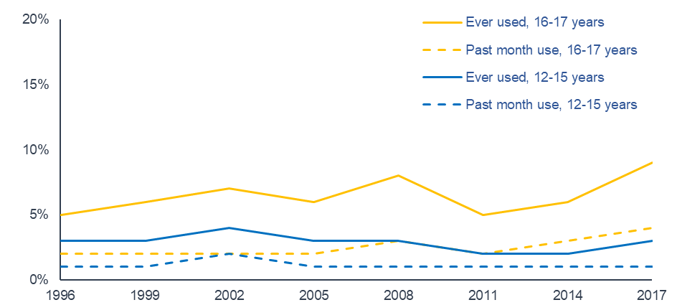

Figure 21: Percentage of Australian secondary school students who used ecstasy, ASSAD **1996-2017**

Amphetamines 1996-2014

Amphetamine use among adolescents other than for medical reasons has been low in all ASSAD survey years to 2014. Use decreased in the Australian adult population from the 2000s[95], and generally declining prevalence was observed in ASSAD data for adolescent use over this period.

Trends between 2002 and 2014 showed declining use across all ages, with lifetime prevalence around 2% and past month use around 1% in 2014.

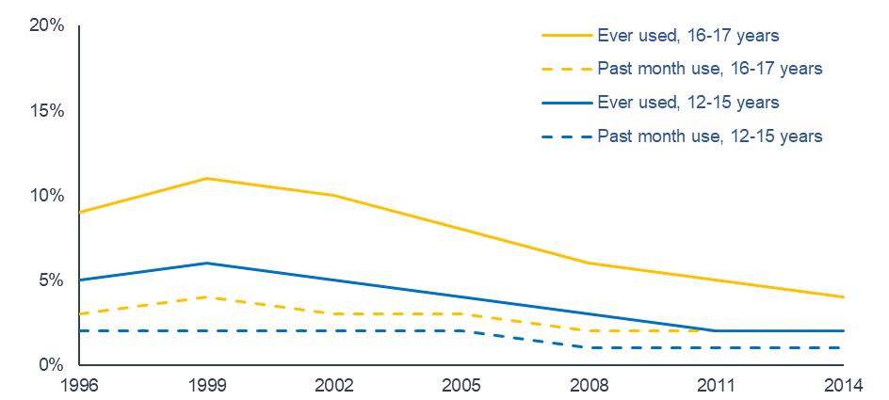

Figure 22: Percentage of Australian secondary school students who used amphetamines, ASSAD **1996-2014**

Opiates 1996-2014

Student use of heroin or other opiates (e.g., morphine, oxycodone, codeine) other than for medical reasons has been extremely low in all ASSAD survey years from 1996 to 2014. Past month prevalence was generally around 1% for both younger and older students.

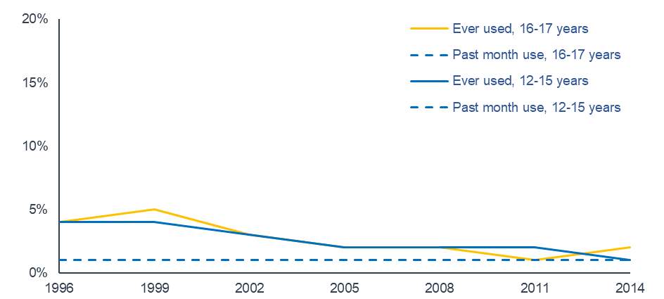

Figure 23: Percentage of Australian secondary school students who used opiates, ASSAD **1996-2014**

Tables

List of Tables

Table 1 Prevalence of tobacco use among secondary students aged 12-15 in Australia, ASSAD 1996-2017 31

Table 2 Prevalence of tobacco use among secondary students aged 16-17 in Australia, ASSAD 1996-2017 32

Table 3 Prevalence of tobacco use among secondary students aged 12-17 in Australia, ASSAD 1996-2017 33

Table 4 Prevalence of alcohol use among secondary students aged 12-15 & 16-17 in Australia, ASSAD 1996-2017 34

Table 5 Prevalence of alcohol use among secondary students aged 12-17 in Australia, ASSAD 1996-2017 35

Table 6 Prevalence of analgesic use among secondary students aged 12-15 & 16-17 in Australia, ASSAD 1996-2017 36

Table 7 Prevalence of analgesic use among secondary students aged 12-17 in Australia, ASSAD 1996-2017 37

Table 8 Prevalence of tranquiliser use among secondary students aged 12-15 & 16-17 in Australia, ASSAD 1996-2017 38

Table 9 Prevalence of tranquiliser use among secondary students aged 12-17 in Australia, ASSAD 1996-2017 39

Table 10 Prevalence of any illicit substance use# (including cannabis) among secondary students aged 12-15, 16-17, & 12-17 in Australia, ASSAD 1996-2017 40

Table 11 Prevalence of any illicit substance use# (excluding cannabis) among secondary students aged 12-15, 16-17, & 12-17 in Australia, ASSAD 1996-2017 41

Table 12 Prevalence of cannabis use among secondary students aged 12-15 & 16-17 in Australia, ASSAD 1996-2017 42

Table 13 Prevalence of cannabis use among secondary students aged 12-17 in Australia, ASSAD 1996-2017 43

Table 14 Prevalence of cocaine use among secondary students aged 12-15, 16-17, & 12-17 in Australia, ASSAD 1996-2017 44

Table 15 Prevalence of inhalant use among secondary students aged 12-15, 16-17, & 12-17 in Australia, ASSAD 1996-2017 45

Table 16 Prevalence of hallucinogen use among secondary students aged 12-15, 16-17, & 12-17 in Australia, ASSAD 1996-2017 46

Table 17 Prevalence of ecstasy use among secondary students aged 12-15, 16-17, & 12-17 in Australia, ASSAD 1996-2017 47

Table 18 Prevalence of amphetamine use among secondary students aged 12-15, 16-17, & 12-17 in Australia, ASSAD 1996-2014 48

Table 19 Prevalence of opiate use among secondary students aged 12-15, 16-17, & 12-17 in Australia, ASSAD 1996-2014 49

Table 20 Number of secondary school students aged 12 to 17 surveyed by sex and age, 1996-2017 53

Table 21 95% confidence intervals* for prevalence estimates for ASSAD 2017 sample sizes sex and age 54

Table 1 Prevalence of tobacco use among secondary students aged 12-15 in Australia, ASSAD 1996-2017

| Survey year |  | 1996  (%) | 1999  (%) | 2002  (%) | 2005  (%) | 2008  (%) | 2011  (%) | 2014  (%) | 2017  (%) |
| --- | --- | --- | --- | --- | --- | --- | --- | --- | --- |
| Recency | Sex |  |  |  |  |  |  |  |  |
| Lifetime | Male | 54* | 47*^ | 41*^ | 29*^ | 22*^ | 18*^ | 12^ | 12^ |
|  | Female | 51* | 47*^ | 40*^ | 28*^ | 20*^ | 16*^ | 13^ | 11^ |
|  | Total | 53* | 47*^ | 40*^ | 29*^ | 21*^ | 17*^ | 13^ | 12^ |
| Past year | Male | 36* | 31*^ | 24*^ | 17*^ | 12*^ | 11^ | 8^ | 8^ |
|  | Female | 36* | 35* | 27*^ | 19*^ | 14*^ | 11*^ | 9^ | 8^ |
|  | Total | 36* | 33*^ | 25*^ | 18*^ | 13*^ | 11*^ | 8^ | 8^ |
| Past month | Male | 21* | 18*^ | 13*^ | 9*^ | 7*^ | 6^ | 4^ | 5^ |
|  | Female | 22* | 20* | 16*^ | 10*^ | 8*^ | 6^ | 5^ | 4^ |
|  | Total | 21* | 19*^ | 14*^ | 9*^ | 7*^ | 6^ | 4^ | 4^ |
| Current | Male | 16* | 15* | 10*^ | 7*^ | 5*^ | 4^ | 3^ | 3^ |
|  | Female | 18* | 16*^ | 12*^ | 7*^ | 6*^ | 4*^ | 3^ | 3^ |
|  | Total | 17* | 15*^ | 11*^ | 7*^ | 5*^ | 4*^ | 3^ | 3^ |
| Committed | Male | 11* | 9* | 6*^ | 4*^ | 3*^ | 2^ | 2^ | 2^ |
|  | Female | 11* | 10* | 7*^ | 4*^ | 3*^ | 2*^ | 2^ | 1^ |
|  | Total | 11* | 10*^ | 6*^ | 4*^ | 3*^ | 2*^ | 2^ | 2^ |
| Daily | Male | 5* | 5* | 3*^ | 2*^ | 1^ | 1^ | 1^ | 1^ |
|  | Female | 5* | 4* | 3*^ | 2*^ | 1*^ | 1^ | <1^ | 1^ |
|  | Total | 5* | 4* | 3*^ | 2*^ | 1*^ | 1^ | 1^ | 1^ |
| > 100 cigs | Male | - | 8* | 5*# | 4*# | 2*# | 2# | 1# | 1# |
|  | Female | - | 7* | 5*# | 3*# | 2*# | 2*# | 1# | 1# |
|  | Total | - | 7* | 5*# | 3*# | 2*# | 2*# | 1# | 1# |

* Significantly different than 2017, p<.01; ^ Significantly different than 1996, p<.01; # Significantly different than 1999, p<.01.

Table 2 Prevalence of tobacco use among secondary students aged 16-17 in Australia, ASSAD 1996-2017

| Survey year |  | 1996  (%) | 1999  (%) | 2002  (%) | 2005  (%) | 2008  (%) | 2011  (%) | 2014  (%) | 2017  (%) |
| --- | --- | --- | --- | --- | --- | --- | --- | --- | --- |
| Recency | Sex |  |  |  |  |  |  |  |  |
| Lifetime | Male | 73* | 68*^ | 61*^ | 52*^ | 42*^ | 40*^ | 33^ | 31^ |
|  | Female | 73* | 70* | 65*^ | 53*^ | 44*^ | 39*^ | 37*^ | 32^ |
|  | Total | 73* | 69*^ | 63*^ | 52*^ | 43*^ | 39*^ | 35^ | 31^ |
| Past year | Male | 49* | 48* | 41*^ | 34*^ | 29^ | 30^ | 24^ | 25^ |
|  | Female | 54* | 53* | 45*^ | 37*^ | 31*^ | 29^ | 29^ | 25^ |
|  | Total | 52* | 51* | 43*^ | 36*^ | 30*^ | 29*^ | 27^ | 25^ |
| Past month | Male | 32* | 34* | 26*^ | 21*^ | 17^ | 18^ | 15^ | 15^ |
|  | Female | 37* | 36* | 30*^ | 23*^ | 17^ | 16^ | 14^ | 14^ |
|  | Total | 35* | 35* | 28*^ | 22*^ | 17^ | 17^ | 15^ | 14^ |
| Current | Male | 27* | 30* | 21*^ | 16*^ | 13^ | 13^ | 12^ | 10^ |
|  | Female | 32* | 29* | 25*^ | 17*^ | 13*^ | 12*^ | 9^ | 9^ |
|  | Total | 30* | 29* | 23*^ | 17*^ | 13*^ | 13*^ | 10^ | 9^ |
| Committed | Male | 21* | 21* | 14*^ | 10*^ | 8^ | 7^ | 7^ | 6^ |
|  | Female | 24* | 20* | 18*^ | 11*^ | 8*^ | 7*^ | 4^ | 4^ |
|  | Total | 22* | 21* | 16*^ | 10*^ | 8*^ | 7*^ | 6^ | 5^ |
| Daily | Male | 13* | 13* | 9*^ | 5*^ | 4^ | 4^ | 3^ | 2^ |
|  | Female | 14* | 11* | 12* | 6*^ | 4*^ | 3*^ | 2^ | 2^ |
|  | Total | 13* | 12* | 10*^ | 5*^ | 4*^ | 4*^ | 3^ | 2^ |
| > 100 cigs | Male | - | 23* | 15*# | 11*# | 9# | 9# | 8# | 7# |
|  | Female | - | 22* | 18* | 10*# | 7*# | 7*# | 5# | 4# |
|  | Total | - | 22* | 17*# | 11*# | 8*# | 8*# | 6# | 5# |

* Significantly different than 2017, p<.01; ^ Significantly different than 1996, p<.01; # Significantly different than 1999, p<.01.

Table 3 Prevalence of tobacco use among secondary students aged 12-17 in Australia, ASSAD 1996-2017

| Survey year |  | 1996  (%) | 1999  (%) | 2002  (%) | 2005  (%) | 2008  (%) | 2011  (%) | 2014  (%) | 2017  (%) |
| --- | --- | --- | --- | --- | --- | --- | --- | --- | --- |
| Recency | Sex |  |  |  |  |  |  |  |  |
| Lifetime | Male | 59* | 52*^ | 46*^ | 35*^ | 27*^ | 24*^ | 18^ | 18^ |
|  | Female | 57* | 53*^ | 47*^ | 35*^ | 27*^ | 23*^ | 20*^ | 17^ |
|  | Total | 58* | 53*^ | 47*^ | 35*^ | 27*^ | 23*^ | 19^ | 18^ |
| Past year | Male | 39* | 36*^ | 28*^ | 21*^ | 17*^ | 16*^ | 13^ | 13^ |
|  | Female | 41* | 40* | 32*^ | 24*^ | 19*^ | 16*^ | 15^ | 13^ |
|  | Total | 40* | 38*^ | 30*^ | 22*^ | 18*^ | 16*^ | 14^ | 13^ |
| Past month | Male | 24* | 22* | 16*^ | 12*^ | 10*^ | 9^ | 7^ | 8^ |
|  | Female | 26* | 24* | 19*^ | 13*^ | 11*^ | 9*^ | 8^ | 7^ |
|  | Total | 25* | 23* | 18*^ | 13*^ | 10*^ | 9*^ | 7^ | 7^ |
| Current | Male | 19* | 19* | 13*^ | 9*^ | 7*^ | 7*^ | 5^ | 5^ |
|  | Female | 22* | 20*^ | 16*^ | 10*^ | 8*^ | 6*^ | 5^ | 4^ |
|  | Total | 20* | 19* | 14*^ | 9*^ | 7*^ | 7*^ | 5^ | 5^ |
| Committed | Male | 13* | 12* | 8*^ | 6*^ | 4*^ | 4^ | 3^ | 3^ |
|  | Female | 15* | 13* | 10*^ | 6*^ | 5*^ | 4*^ | 2^ | 2^ |
|  | Total | 14* | 13* | 9*^ | 6*^ | 4*^ | 4*^ | 3^ | 3^ |
| Daily | Male | 7* | 7* | 5*^ | 3*^ | 2*^ | 2^ | 1^ | 1^ |
|  | Female | 7* | 6*^ | 5*^ | 3*^ | 2*^ | 2*^ | 1^ | 1^ |
|  | Total | 7* | 7* | 5*^ | 3*^ | 2*^ | 2*^ | 1^ | 1^ |
| > 100 cigs | Male | - | 12* | 8*# | 5*# | 4*# | 4# | 3# | 3# |
|  | Female | - | 11* | 8*# | 5*# | 4*# | 3*# | 2# | 2# |
|  | Total | - | 11* | 8*# | 5*# | 4*# | 3*# | 3# | 2# |

* Significantly different than 2017, p<.01; ^ Significantly different than 1996, p<.01; # Significantly different than 1999, p<.01.

Table 4 Prevalence of alcohol use among secondary students aged 12-15 & 16-17 in Australia, ASSAD 1996-2017

| Survey year |  | 1996  (%) | 1999  (%) | 2002  (%) | 2005  (%) | 2008  (%) | 2011  (%) | 2014  (%) | 2017  (%) |
| --- | --- | --- | --- | --- | --- | --- | --- | --- | --- |
| Aged 12-15 |  |  |  |  |  |  |  |  |  |
| Recency | **Sex** |  |  |  |  |  |  |  |  |
| Lifetime | Male | 88* | 88* | 88* | 83*^ | 79*^ | 70*^ | 62^ | 61^ |
|  | Female | 85* | 85* | 85* | 81*^ | 78*^ | 65*^ | 60^ | 55^ |
|  | Total | 86* | 86* | 86* | 82*^ | 78*^ | 68*^ | 61^ | 58^ |
| Past year | Male | 69* | 71* | 70* | 61*^ | 53*^ | 42*^ | 35^ | 36^ |
|  | Female | 63* | 66* | 65* | 58*^ | 51*^ | 38*^ | 33^ | 33^ |
|  | Total | 66* | 68* | 68* | 60*^ | 52*^ | 40*^ | 34^ | 35^ |
| Past month | Male | 41* | 45*^ | 46*^ | 36*^ | 29*^ | 21^ | 16^ | 18^ |
|  | Female | 36* | 38* | 39* | 33*^ | 27*^ | 18^ | 15^ | 16^ |
|  | Total | 39* | 41* | 43*^ | 34*^ | 28*^ | 19^ | 15^ | 17^ |
| Current | Male | 27* | 30*^ | 31*^ | 23*^ | 17*^ | 12^ | 9^ | 10^ |
|  | Female | 23* | 25* | 26* | 20*^ | 16*^ | 10^ | 8^ | 8^ |
|  | Total | 25* | 28*^ | 29*^ | 22*^ | 17*^ | 11^ | 8^ | 9^ |
| Risky | Male | 6* | 6* | 8*^ | 6* | 4*^ | 3^ | 2^ | 2^ |
|  | Female | 4* | 4* | 5*^ | 5* | 3* | 2^ | 1^ | 2^ |
|  | Total | 5* | 5* | 7*^ | 6* | 4*^ | 3^ | 2^ | 2^ |
| Aged 16-17 |  |  |  |  |  |  |  |  |  |
| Recency | **Sex** |  |  |  |  |  |  |  |  |
| Lifetime | Male | 96* | 95* | 94*^ | 95* | 91*^ | 88*^ | 84^ | 81^ |
|  | Female | 96* | 94* | 94* | 94* | 92*^ | 90*^ | 86^ | 85^ |
|  | Total | 96* | 94* | 94*^ | 95*^ | 92*^ | 89*^ | 85^ | 83^ |
| Past year | Male | 90* | 89* | 88* | 88* | 82*^ | 76*^ | 70^ | 69^ |
|  | Female | 89* | 89* | 88* | 87* | 83*^ | 79*^ | 72^ | 74^ |
|  | Total | 90* | 89* | 88* | 88* | 83*^ | 77*^ | 71^ | 72^ |
| Past month | Male | 70* | 70* | 70* | 70* | 62*^ | 52^ | 47^ | 48^ |
|  | Female | 68* | 70* | 66* | 66* | 59*^ | 53^ | 48^ | 49^ |
|  | Total | 69* | 70* | 68* | 68* | 60*^ | 53^ | 47^ | 49^ |
| Current | Male | 52* | 53* | 51* | 50* | 41*^ | 34^ | 30^ | 31^ |
|  | Female | 46* | 50* | 45* | 45* | 35*^ | 31^ | 29^ | 26^ |
|  | Total | 49* | 51* | 48* | 47* | 38*^ | 32^ | 29^ | 29^ |
| Risky | Male | 27* | 29* | 27* | 28* | 21*^ | 18^ | 15^ | 13^ |
|  | Female | 17* | 20* | 18* | 19* | 15* | 13*^ | 10^ | 8^ |
|  | Total | 22* | 24* | 23* | 23* | 18*^ | 16*^ | 13^ | 11^ |

* Significantly different than 2017, p<.01; ^ Significantly different than 1996, p<.01.

Table 5 Prevalence of alcohol use among secondary students aged 12-17 in Australia, ASSAD 1996-2017

| Survey year |  | 1996  (%) | 1999  (%) | 2002  (%) | 2005  (%) | 2008  (%) | 2011  (%) | 2014  (%) | 2017  (%) |
| --- | --- | --- | --- | --- | --- | --- | --- | --- | --- |
| Recency | Sex |  |  |  |  |  |  |  |  |
| Lifetime | Male | 90* | 90* | 89* | 86*^ | 82*^ | 75*^ | 68^ | 67^ |
|  | Female | 88* | 87* | 87* | 85*^ | 82*^ | 73*^ | 68^ | 64^ |
|  | Total | 89* | 89* | 88* | 86*^ | 82*^ | 74*^ | 68^ | 66^ |
| Past year | Male | 74* | 76* | 75* | 68*^ | 61*^ | 51*^ | 45^ | 46^ |
|  | Female | 70* | 72* | 72* | 66*^ | 60*^ | 50*^ | 45^ | 46^ |
|  | Total | 72* | 74* | 73* | 67*^ | 60*^ | 51*^ | 45^ | 46^ |
| Past month | Male | 49* | 51* | 52* | 45*^ | 38*^ | 30^ | 25^ | 27^ |
|  | Female | 45* | 47* | 47* | 42*^ | 36*^ | 29*^ | 25^ | 26^ |
|  | Total | 47* | 49* | 50* | 43*^ | 37*^ | 29*^ | 25^ | 27^ |
| Current | Male | 33* | 36* | 37* | 30*^ | 24*^ | 18^ | 15^ | 16^ |
|  | Female | 29* | 32* | 31* | 27*^ | 22*^ | 16*^ | 14^ | 14^ |
|  | Total | 31* | 34*^ | 34* | 29*^ | 23*^ | 17*^ | 15^ | 15^ |
| Risky | Male | 11* | 12* | 13* | 12* | 9*^ | 7^ | 6^ | 6^ |
|  | Female | 7* | 9* | 9* | 9* | 7* | 5*^ | 4^ | 4^ |
|  | Total | 9* | 10* | 11* | 10* | 8*^ | 6*^ | 5^ | 5^ |

* Significantly different than 2017, p<.01; ^ Significantly different than 1996, p<.01.

Table 6 Prevalence of analgesic use among secondary students aged 12-15 & 16-17 in Australia, ASSAD 1996-2017

| Survey year |  | 1996  (%) | 1999  (%) | 2002  (%) | 2005  (%) | 2008  (%) | 2011  (%) | 2014  (%) | 2017  (%) |
| --- | --- | --- | --- | --- | --- | --- | --- | --- | --- |
| Aged 12-15 |  |  |  |  |  |  |  |  |  |
| Recency | **Sex** |  |  |  |  |  |  |  |  |
| Lifetime | Male | 97* | 95*^ | 93^ | 92^ | 93^ | 95*^ | 93^ | 92^ |
|  | Female | 98* | 97^ | 95^ | 96^ | 97^ | 97^ | 97^ | 96^ |
|  | Total | 97* | 96*^ | 94^ | 94^ | 95^ | 96*^ | 95^ | 94^ |
| Past year | Male | 94* | 92*^ | 89^ | 89^ | 89^ | 91*^ | 89^ | 88^ |
|  | Female | 96* | 95^ | 93^ | 93^ | 94^ | 95^ | 95^ | 94^ |
|  | Total | 95* | 93*^ | 91^ | 91^ | 91^ | 93*^ | 92^ | 91^ |
| Past month | Male | 67* | 66* | 63*^ | 62*^ | 63*^ | 61*^ | 60*^ | 56^ |
|  | Female | 77* | 76* | 74^ | 74^ | 74^ | 74^ | 74^ | 72^ |
|  | Total | 72* | 71* | 69*^ | 68*^ | 68*^ | 67*^ | 67*^ | 64^ |
| Past week | Male | 36* | 37* | 36* | 35 | 35* | 32^ | 33^ | 31^ |
|  | Female | 45* | 46* | 43 | 44 | 45* | 42^ | 45* | 42^ |
|  | Total | 41* | 41* | 39* | 39* | 40* | 37^ | 39* | 36^ |
| Aged 16-17 |  |  |  |  |  |  |  |  |  |
| Recency | **Sex** |  |  |  |  |  |  |  |  |
| Lifetime | Male | 98* | 96 | 96^ | 96^ | 95^ | 96^ | 94^ | 95^ |
|  | Female | 99* | 99 | 98^ | 98^ | 98^ | 98^ | 98^ | 98^ |
|  | Total | 98* | 97^ | 97^ | 97^ | 97^ | 97^ | 96^ | 96^ |
| Past year | Male | 94* | 92 | 92^ | 91^ | 92^ | 92 | 90^ | 91^ |
|  | Female | 98* | 97 | 96^ | 97^ | 97^ | 97^ | 96^ | 96^ |
|  | Total | 96* | 95^ | 94^ | 94^ | 94^ | 95^ | 93^ | 94^ |
| Past month | Male | 67* | 67* | 63^ | 65 | 64 | 63 | 64 | 61^ |
|  | Female | 84* | 84 | 82 | 82 | 83 | 83 | 82 | 80^ |
|  | Total | 76* | 75* | 73^ | 74 | 74 | 73 | 73 | 71^ |
| Past week | Male | 35 | 37 | 34 | 34 | 34 | 34 | 35 | 35 |
|  | Female | 51 | 50 | 53 | 51 | 52 | 53 | 53 | 54 |
|  | Total | 43 | 44 | 44 | 43 | 43 | 44 | 44 | 45 |

* Significantly different than 2017, p<.01; ^ Significantly different than 1996, p<.01.

Table 7 Prevalence of analgesic use among secondary students aged 12-17 in Australia, ASSAD 1996-2017

| Survey year |  | 1996  (%) | 1999  (%) | 2002  (%) | 2005  (%) | 2008  (%) | 2011  (%) | 2014  (%) | 2017  (%) |
| --- | --- | --- | --- | --- | --- | --- | --- | --- | --- |
| Recency | Sex |  |  |  |  |  |  |  |  |
| Lifetime | Male | 97* | 95*^ | 94^ | 93^ | 94^ | 95*^ | 93^ | 93^ |
|  | Female | 98* | 98*^ | 96^ | 96^ | 97^ | 97^ | 97^ | 97^ |
|  | Total | 98* | 97*^ | 95^ | 95^ | 95^ | 96*^ | 95^ | 95^ |
| Past year | Male | 94* | 92*^ | 90^ | 90^ | 90^ | 91*^ | 89^ | 89^ |
|  | Female | 97* | 96^ | 94^ | 94^ | 95^ | 95^ | 95^ | 95^ |
|  | Total | 95* | 94*^ | 92^ | 92^ | 92^ | 93*^ | 92^ | 92^ |
| Past month | Male | 67* | 66* | 63*^ | 63*^ | 63*^ | 62*^ | 61*^ | 57^ |
|  | Female | 79* | 78* | 76^ | 76^ | 77*^ | 76^ | 77^ | 75^ |
|  | Total | 73* | 72* | 70*^ | 70*^ | 70*^ | 69*^ | 69*^ | 66^ |
| Past week | Male | 36* | 37* | 35* | 35 | 34 | 33^ | 34^ | 32^ |
|  | Female | 47 | 47 | 46 | 46 | 47 | 45 | 48 | 46 |
|  | Total | 41* | 42* | 41 | 40 | 41 | 39^ | 41 | 39^ |

* Significantly different than 2017, p<.01; ^ Significantly different than 1996, p<.01.

Table 8 Prevalence of tranquiliser use among secondary students aged 12-15 & 16-17 in Australia, ASSAD 1996-2017

| Survey year |  | 1996  (%) | 1999  (%) | 2002  (%) | 2005  (%) | 2008  (%) | 2011  (%) | 2014  (%) | 2017  (%) |
| --- | --- | --- | --- | --- | --- | --- | --- | --- | --- |
| Aged 12-15 |  |  |  |  |  |  |  |  |  |
| Recency | **Sex** |  |  |  |  |  |  |  |  |
| Lifetime | Male | 19 | 18 | 16^ | 14*^ | 15*^ | 16^ | 16^ | 19 |
|  | Female | 19 | 16^ | 15*^ | 15*^ | 17^ | 16^ | 19 | 17 |
|  | Total | 19 | 17^ | 16*^ | 15*^ | 16^ | 16^ | 17^ | 18 |
| Past year | Male | 11 | 10 | 8*^ | 9*^ | 8*^ | 10 | 10 | 12 |
|  | Female | 12 | 9*^ | 9*^ | 9*^ | 10^ | 11 | 12 | 11 |
|  | Total | 12 | 10*^ | 9*^ | 9*^ | 9*^ | 10^ | 11 | 11 |
| Past month | Male | 5 | 4 | 4 | 4 | 4 | 4 | 4 | 5 |
|  | Female | 5 | 4 | 4*^ | 4*^ | 4*^ | 4 | 5 | 5 |
|  | Total | 5 | 4*^ | 4*^ | 4 | 4*^ | 4 | 5 | 5 |
| Past week | Male | 3 | 2 | 2 | 2 | 3 | 2 | 2 | 3 |
|  | Female | 2 | 2* | 2 | 2* | 2* | 2 | 3 | 3 |
|  | Total | 3 | 2* | 2* | 2* | 2* | 2* | 3 | 3 |
| Aged 16-17 |  |  |  |  |  |  |  |  |  |
| Recency | **Sex** |  |  |  |  |  |  |  |  |
| Lifetime | Male | 19 | 21 | 17* | 16*^ | 18 | 19 | 20 | 22 |
|  | Female | 21 | 24 | 19 | 17*^ | 20 | 19 | 21 | 21 |
|  | Total | 20 | 22 | 18* | 17*^ | 19 | 19 | 20 | 21 |
| Past year | Male | 12* | 11* | 10* | 9*^ | 10* | 12 | 13 | 16^ |
|  | Female | 15 | 16 | 13 | 11*^ | 12 | 14 | 15 | 15 |
|  | Total | 13 | 14 | 11* | 10*^ | 11*^ | 13 | 14 | 15 |
| Past month | Male | 5* | 5 | 4* | 3*^ | 4* | 5 | 5 | 8^ |
|  | Female | 5 | 5 | 5 | 4* | 4* | 5 | 6 | 6 |
|  | Total | 5* | 5* | 5* | 4*^ | 4* | 5* | 5 | 7^ |
| Past week | Male | 3* | 3 | 3 | 2* | 3* | 3* | 3 | 5^ |
|  | Female | 2 | 2 | 3 | 2 | 2 | 3 | 3 | 3 |
|  | Total | 3* | 2* | 3 | 2* | 2* | 3* | 3 | 4^ |

* Significantly different than 2017, p<.01; ^ Significantly different than 1996, p<.01.

Table 9 Prevalence of tranquiliser use among secondary students aged 12-17 in Australia, ASSAD 1996-2017

| Survey year |  | 1996  (%) | 1999  (%) | 2002  (%) | 2005  (%) | 2008  (%) | 2011  (%) | 2014  (%) | 2017  (%) |
| --- | --- | --- | --- | --- | --- | --- | --- | --- | --- |
| Recency | Sex |  |  |  |  |  |  |  |  |
| Lifetime | Male | 19 | 19 | 16*^ | 15*^ | 16*^ | 17*^ | 17^ | 20 |
|  | Female | 20 | 18 | 16*^ | 15*^ | 18^ | 17^ | 19 | 18 |
|  | Total | 19 | 18 | 16*^ | 15*^ | 17*^ | 17*^ | 18 | 19 |
| Past year | Male | 11 | 10* | 9*^ | 9*^ | 9*^ | 11* | 11* | 13 |
|  | Female | 13 | 11 | 10*^ | 9*^ | 11*^ | 12^ | 13 | 12 |
|  | Total | 12 | 11*^ | 9*^ | 9*^ | 10*^ | 11*^ | 12 | 13 |
| Past month | Male | 5 | 4* | 4* | 4* | 4* | 4* | 5 | 6 |
|  | Female | 5 | 4* | 4* | 4*^ | 4*^ | 4 | 5 | 5 |
|  | Total | 5 | 4* | 4*^ | 4*^ | 4*^ | 4* | 5 | 5 |
| Past week | Male | 3 | 2* | 3* | 2* | 3* | 2* | 3 | 4 |
|  | Female | 2 | 2* | 2* | 2* | 2* | 2* | 3^ | 3 |
|  | Total | 3* | 2* | 2* | 2* | 2* | 2* | 3 | 3^ |

* Significantly different than 2017, p<.01; ^ Significantly different than 1996, p<.01.

Table 10 Prevalence of any illicit substance use# (including cannabis) among secondary students aged 12-15, 16-17, & 12-17 in Australia, ASSAD 1996-2017

| Survey year |  | 1996  (%) | 1999  (%) | 2002  (%) | 2005  (%) | 2008  (%) | 2011  (%) | 2014  (%) | 2017†  (%) |
| --- | --- | --- | --- | --- | --- | --- | --- | --- | --- |
| Aged 12-15 |  |  |  |  |  |  |  |  |  |
| Recency | **Sex** |  |  |  |  |  |  |  |  |
| Lifetime | Male | 33* | 28*^ | 24*^ | 17*^ | 12^ | 12^ | 10^ | 10^ |
|  | Female | 26* | 23*^ | 19*^ | 13*^ | 11^ | 10^ | 9^ | 9^ |
|  | Total | 30* | 25*^ | 22*^ | 15*^ | 11^ | 11^ | 10^ | 10^ |
| Past month | Male | 18* | 14*^ | 12*^ | 8*^ | 6^ | 6^ | 5^ | 5^ |
|  | Female | 14* | 11*^ | 9*^ | 5^ | 5^ | 5^ | 4^ | 4^ |
|  | Total | 16* | 12*^ | 10*^ | 7*^ | 5^ | 5^ | 4^ | 5^ |
| Aged 16-17 |  |  |  |  |  |  |  |  |  |
| Recency | **Sex** |  |  |  |  |  |  |  |  |
| Lifetime | Male | 55* | 50* | 44*^ | 35^ | 28^ | 30^ | 30^ | 31^ |
|  | Female | 50* | 44*^ | 38*^ | 31^ | 24^ | 24^ | 24^ | 27^ |
|  | Total | 53* | 47*^ | 41*^ | 33^ | 26^ | 27^ | 27^ | 29^ |
| Past month | Male | 32* | 24*^ | 21^ | 16^ | 15^ | 16^ | 16^ | 18^ |
|  | Female | 24* | 18*^ | 16^ | 10*^ | 10^ | 11^ | 9*^ | 13^ |
|  | Total | 28* | 21*^ | 19^ | 13^ | 12^ | 13^ | 13^ | 15^ |
| Aged 12-17 |  |  |  |  |  |  |  |  |  |
| Recency | **Sex** |  |  |  |  |  |  |  |  |
| Lifetime | Male | 38* | 34^* | 29*^ | 21*^ | 16^ | 17^ | 16^ | 16^ |
|  | Female | 33* | 29*^ | 25*^ | 18*^ | 14^ | 14^ | 14^ | 15^ |
|  | Total | 36* | 31*^ | 27*^ | 20*^ | 15^ | 16^ | 15^ | 16^ |
| Past month | Male | 21* | 17*^ | 14*^ | 10^ | 8^ | 9^ | 8^ | 9^ |
|  | Female | 16* | 13*^ | 11*^ | 7^ | 6^ | 6^ | 6^ | 7^ |
|  | Total | 19* | 15*^ | 12*^ | 8^ | 7^ | 8^ | 7^ | 8^ |

* Significantly different than 2017, p<.01; ^ Significantly different than 1996, p<.01.

# Illicit substances included cannabis, hallucinogens, amphetamines, cocaine, opiates and ecstasy.

† Excludes ‘dexamphetamines’ and ‘other opiates’ which were not surveyed in previous survey years.

Table 11 Prevalence of any illicit substance use# (excluding cannabis) among secondary students aged 12-15, 16-17, & 12-17 in Australia, ASSAD 1996-2017

| Survey year |  | 1996  (%) | 1999  (%) | 2002  (%) | 2005  (%) | 2008  (%) | 2011  (%) | 2014  (%) | 2017†  (%) |
| --- | --- | --- | --- | --- | --- | --- | --- | --- | --- |
| Aged 12-15 |  |  |  |  |  |  |  |  |  |
| Recency | **Sex** |  |  |  |  |  |  |  |  |
| Lifetime | Male | 12* | 11* | 10*^ | 8*^ | 6^ | 6^ | 4^ | 5^ |
|  | Female | 9* | 10* | 8* | 7*^ | 5*^ | 5^ | 3^ | 4^ |
|  | Total | 10* | 11* | 9*^ | 7*^ | 5*^ | 5^ | 4^ | 4^ |
| Past month | Male | 5* | 5* | 4* | 4* | 3^ | 3^ | 2^ | 2^ |
|  | Female | 3* | 3* | 3* | 3* | 2^ | 2^ | 1^ | 1^ |
|  | Total | 4* | 4* | 4* | 3* | 2^ | 2^ | 2^ | 2^ |
| Aged 16-17 |  |  |  |  |  |  |  |  |  |
| Recency | **Sex** |  |  |  |  |  |  |  |  |
| Lifetime | Male | 18* | 19* | 15 | 13^ | 12^ | 10^ | 12^ | 14^ |
|  | Female | 16* | 16* | 14* | 11^ | 10^ | 9^ | 7^ | 9^ |
|  | Total | 17* | 17* | 14 | 12^ | 11^ | 9^ | 10^ | 12^ |
| Past month | Male | 7 | 8 | 5 | 6 | 6 | 5 | 5 | 6 |
|  | Female | 5 | 4 | 5* | 3 | 4 | 3^ | 2^ | 3 |
|  | Total | 6 | 6 | 5 | 4^ | 5 | 4^ | 4^ | 5 |
| Aged 12-17 |  |  |  |  |  |  |  |  |  |
| Recency | **Sex** |  |  |  |  |  |  |  |  |
| Lifetime | Male | 13* | 13* | 11*^ | 9^ | 8^ | 7^ | 6^ | 7^ |
|  | Female | 10* | 11* | 10* | 8*^ | 7^ | 6^ | 5^ | 5^ |
|  | Total | 12* | 12* | 10*^ | 8*^ | 7^ | 6^ | 6^ | 6^ |
| Past month | Male | 5* | 6* | 5^ | 5 | 4^ | 3^ | 3^ | 3^ |
|  | Female | 3* | 3* | 3* | 3 | 3^ | 2^ | 2^ | 2^ |
|  | Total | 4* | 5* | 4* | 4*^ | 3^ | 3^ | 2^ | 3^ |

* Significantly different than 2017, p<.01; ^ Significantly different than 1996, p<.01.

# Illicit substances included cannabis, hallucinogens, amphetamines, cocaine, opiates and ecstasy.

† Excludes ‘dexamphetamines’ and ‘other opiates’ which were not surveyed in previous survey years.

Table 12 Prevalence of cannabis use among secondary students aged 12-15 & 16-17 in Australia, ASSAD 1996-2017

| Survey year |  | 1996  (%) | 1999  (%) | 2002  (%) | 2005  (%) | 2008  (%) | 2011  (%) | 2014  (%) | 2017  (%) |
| --- | --- | --- | --- | --- | --- | --- | --- | --- | --- |
| Aged 12-15 |  |  |  |  |  |  |  |  |  |
| Recency | **Sex** |  |  |  |  |  |  |  |  |
| Lifetime | Male | 32* | 26*^ | 22*^ | 15*^ | 10^ | 10^ | 11^ | 10^ |
|  | Female | 25* | 20*^ | 17*^ | 11^ | 9^ | 9^ | 9^ | 9^ |
|  | Total | 28* | 23*^ | 19*^ | 13*^ | 9^ | 10^ | 10^ | 9^ |
| Past year | Male | 28* | 21*^ | 18*^ | 11*^ | 8^ | 9^ | 9^ | 9^ |
|  | Female | 22* | 18*^ | 14*^ | 9^ | 7^ | 7^ | 8^ | 8^ |
|  | Total | 25* | 20*^ | 16*^ | 10^ | 8^ | 8^ | 8^ | 8^ |
| Past month | Male | 18* | 13*^ | 10*^ | 7^ | 5^ | 5^ | 5^ | 5^ |
|  | Female | 13* | 10*^ | 8*^ | 4^ | 4^ | 4^ | 4^ | 4^ |
|  | Total | 15* | 11*^ | 9*^ | 6^ | 4^ | 4^ | 4^ | 5^ |
| Past week | Male | 11* | 8*^ | 7*^ | 4^ | 3^ | 3^ | 3^ | 3^ |
|  | Female | 7* | 5*^ | 4*^ | 3^ | 2^ | 2^ | 2^ | 2^ |
|  | Total | 9* | 7*^ | 5*^ | 4^ | 3^ | 2^ | 3^ | 3^ |
| Aged 16-17 |  |  |  |  |  |  |  |  |  |
| Recency | **Sex** |  |  |  |  |  |  |  |  |
| Lifetime | Male | 55* | 50* | 42*^ | 33^ | 27^ | 30^ | 31^ | 33^ |
|  | Female | 50* | 43*^ | 36*^ | 29^ | 22*^ | 24^ | 26^ | 28^ |
|  | Total | 52* | 46*^ | 39*^ | 31^ | 24*^ | 27^ | 28^ | 30^ |
| Past year | Male | 49* | 41*^ | 35^ | 27^ | 23*^ | 26^ | 27^ | 30^ |
|  | Female | 44* | 35*^ | 30^ | 23^ | 19*^ | 21^ | 23^ | 26^ |
|  | Total | 46* | 38*^ | 32^ | 25^ | 21*^ | 23^ | 25^ | 28^ |
| Past month | Male | 31* | 23*^ | 20^ | 14^ | 13^ | 15^ | 16^ | 18^ |
|  | Female | 24* | 17^ | 15^ | 9*^ | 9*^ | 10*^ | 10*^ | 14^ |
|  | Total | 27* | 20*^ | 17^ | 12*^ | 11*^ | 12^ | 13^ | 16^ |
| Past week | Male | 21* | 15*^ | 12^ | 8^ | 8^ | 9^ | 9^ | 10^ |
|  | Female | 13* | 9^ | 8^ | 4*^ | 4*^ | 5^ | 5^ | 6^ |
|  | Total | 17* | 12*^ | 10^ | 6*^ | 6^ | 7^ | 7^ | 8^ |

* Significantly different than 2017, p<.01; ^ Significantly different than 1996, p<.01.

Table 13 Prevalence of cannabis use among secondary students aged 12-17 in Australia, ASSAD 1996-2017

| Survey year |  | 1996  (%) | 1999  (%) | 2002  (%) | 2005  (%) | 2008  (%) | 2011  (%) | 2014  (%) | 2017  (%) |
| --- | --- | --- | --- | --- | --- | --- | --- | --- | --- |
| Recency | Sex |  |  |  |  |  |  |  |  |
| Lifetime | Male | 38* | 32*^ | 27*^ | 19*^ | 14^ | 16^ | 17^ | 17^ |
|  | Female | 32* | 27*^ | 23*^ | 16^ | 13^ | 13^ | 14^ | 15^ |
|  | Total | 35* | 29*^ | 25*^ | 18*^ | 14^ | 15^ | 16^ | 16^ |
| Past year | Male | 33* | 27*^ | 23*^ | 16^ | 12*^ | 14^ | 14^ | 15^ |
|  | Female | 28* | 23*^ | 19*^ | 13^ | 11*^ | 12^ | 13^ | 14^ |
|  | Total | 31* | 25*^ | 21*^ | 14^ | 11*^ | 13^ | 14^ | 14^ |
| Past month | Male | 21* | 15*^ | 13*^ | 9^ | 7^ | 8^ | 8^ | 9^ |
|  | Female | 16* | 12*^ | 10*^ | 6*^ | 5*^ | 6*^ | 6*^ | 7^ |
|  | Total | 18* | 14*^ | 11*^ | 7^ | 6*^ | 7^ | 7^ | 8^ |
| Past week | Male | 14* | 10*^ | 8*^ | 5^ | 5^ | 4^ | 5^ | 5^ |
|  | Female | 9* | 6*^ | 5*^ | 3^ | 2*^ | 3^ | 3^ | 4^ |
|  | Total | 11* | 8*^ | 7*^ | 4^ | 4^ | 4^ | 4^ | 4^ |

* Significantly different than 2017, p<.01; ^ Significantly different than 1996, p<.01.

Table 14 Prevalence of cocaine use among secondary students aged 12-15, 16-17, & 12-17 in Australia, ASSAD 1996-2017

| Survey year |  | 1996  (%) | 1999  (%) | 2002  (%) | 2005  (%) | 2008  (%) | 2011  (%) | 2014  (%) | 2017  (%) |
| --- | --- | --- | --- | --- | --- | --- | --- | --- | --- |
| Aged 12-15 |  |  |  |  |  |  |  |  |  |
| Recency | **Sex** |  |  |  |  |  |  |  |  |
| Lifetime | Male | 5* | 4* | 4*^ | 3*^ | 2^ | 2^ | 2^ | 1^ |
|  | Female | 3* | 3* | 2* | 2* | 2^ | 1^ | 1^ | 1^ |
|  | Total | 4* | 3* | 3*^ | 3*^ | 2*^ | 1^ | 2^ | 1^ |
| Past year | Male | 3* | 3* | 3* | 3* | 2^ | 1^ | 1^ | 1^ |
|  | Female | 2* | 2* | 2* | 1* | 1 | 1^ | 1^ | 1^ |
|  | Total | 3* | 2* | 2* | 2* | 2*^ | 1^ | 1^ | 1^ |
| Past month | Male | 2* | 2 | 2* | 2* | 1^ | 1^ | 1^ | 1^ |
|  | Female | 1* | 1* | 1* | 1* | 1* | <1^ | 1 | <1^ |
|  | Total | 1* | 1* | 1* | 1* | 1^ | <1^ | 1^ | 1^ |
| Aged 16-17 |  |  |  |  |  |  |  |  |  |
| Recency | **Sex** |  |  |  |  |  |  |  |  |
| Lifetime | Male | 4 | 5 | 4 | 4 | 5 | 3* | 4 | 5 |
|  | Female | 2 | 3 | 3 | 3 | 3 | 2 | 2 | 3 |
|  | Total | 3 | 4 | 4 | 4 | 4 | 2*^ | 3 | 4 |
| Past year | Male | 3 | 3 | 3 | 3 | 4 | 2* | 3 | 4 |
|  | Female | 2 | 2 | 2 | 2 | 2 | 1 | 1 | 2 |
|  | Total | 2 | 3 | 2 | 3 | 3 | 2* | 2 | 3 |
| Past month | Male | 1 | 2 | 1 | 2 | 2 | 2 | 1 | 2 |
|  | Female | <1 | <1 | 1 | 1 | 1 | <1 | <1 | 1 |
|  | Total | 1 | 1 | 1 | 1 | 1 | 1 | 1 | 1 |
| Aged 12-17 |  |  |  |  |  |  |  |  |  |
| Recency | **Sex** |  |  |  |  |  |  |  |  |
| Lifetime | Male | 5* | 4* | 4*^ | 3^ | 3^ | 2^ | 2^ | 3^ |
|  | Female | 3 | 3 | 3 | 2 | 2 | 1^ | 1^ | 2 |
|  | Total | 4* | 4* | 3* | 3^ | 2^ | 2^ | 2^ | 2^ |
| Past year | Male | 3* | 3 | 3 | 3 | 2^ | 1^ | 2^ | 2^ |
|  | Female | 2* | 2* | 2 | 2 | 2 | 1^ | 1^ | 1^ |
|  | Total | 2* | 3* | 2* | 2* | 2^ | 1^ | 1^ | 2^ |
| Past month | Male | 2 | 2 | 2 | 2 | 1 | 1^ | 1^ | 1 |
|  | Female | 1 | 1* | 1* | 1* | 1* | <1^ | 1 | <1 |
|  | Total | 1* | 1* | 1* | 1* | 1 | 1^ | 1^ | 1^ |

* Significantly different than 2017, p<.01; ^ Significantly different than 1996, p<.01.

Table 15 Prevalence of inhalant use among secondary students aged 12-15, 16-17, & 12-17 in Australia, ASSAD 1996-2017

| Survey year |  | 1996  (%) | 1999  (%) | 2002  (%) | 2005  (%) | 2008  (%) | 2011  (%) | 2014  (%) | 2017  (%) |
| --- | --- | --- | --- | --- | --- | --- | --- | --- | --- |
| Aged 12-15 |  |  |  |  |  |  |  |  |  |
| Recency | **Sex** |  |  |  |  |  |  |  |  |
| Lifetime | Male | 29* | 28* | 23*^ | 19^ | 19^ | 17^ | 16^ | 18^ |
|  | Female | 30* | 30* | 24*^ | 19^ | 21^ | 21^ | 19^ | 20^ |
|  | Total | 29* | 29* | 23*^ | 19^ | 20^ | 19^ | 18^ | 19^ |
| Past year | Male | 22* | 21* | 17*^ | 15^ | 14^ | 13^ | 11^ | 13^ |
|  | Female | 23* | 24* | 18*^ | 15^ | 16^ | 16^ | 15^ | 15^ |
|  | Total | 23* | 22* | 17*^ | 15^ | 15^ | 14^ | 13^ | 14^ |
| Past month | Male | 13* | 13* | 11*^ | 9^ | 9^ | 7^ | 6^ | 7^ |
|  | Female | 13* | 14* | 11* | 9^ | 10^ | 10^ | 8^ | 9^ |
|  | Total | 13* | 13* | 11*^ | 9^ | 9^ | 8^ | 7^ | 8^ |
| Aged 16-17 |  |  |  |  |  |  |  |  |  |
| Recency | **Sex** |  |  |  |  |  |  |  |  |
| Lifetime | Male | 18 | 18 | 13^ | 11*^ | 15^ | 14^ | 12*^ | 16 |
|  | Female | 16 | 16 | 15 | 11*^ | 14 | 12*^ | 11*^ | 15 |
|  | Total | 17 | 17 | 14^ | 11*^ | 14^ | 13*^ | 12*^ | 15 |
| Past year | Male | 11 | 11 | 8*^ | 7*^ | 10 | 9 | 8*^ | 12 |
|  | Female | 9 | 10 | 9 | 8* | 9 | 8* | 7 | 10 |
|  | Total | 10 | 10 | 8* | 7*^ | 10 | 8* | 8*^ | 11 |
| Past month | Male | 5 | 5 | 4 | 4* | 5 | 4 | 4 | 6 |
|  | Female | 3* | 4* | 5^ | 3* | 4* | 4* | 4 | 6^ |
|  | Total | 4* | 4 | 4 | 3* | 5 | 4* | 4* | 6^ |
| Aged 12-17 |  |  |  |  |  |  |  |  |  |
| Recency | **Sex** |  |  |  |  |  |  |  |  |
| Lifetime | Male | 26* | 26* | 20^ | 17^ | 18^ | 16^ | 15*^ | 17^ |
|  | Female | 26* | 26* | 21*^ | 17^ | 19^ | 18^ | 17^ | 18^ |
|  | Total | 26* | 26* | 21*^ | 17^ | 19^ | 17^ | 16*^ | 18^ |
| Past year | Male | 19* | 19* | 14^ | 13^ | 13^ | 11^ | 10*^ | 13^ |
|  | Female | 19* | 20* | 16^ | 13^ | 14^ | 14^ | 12^ | 14^ |
|  | Total | 19* | 19* | 15^ | 13^ | 13^ | 13^ | 11*^ | 13^ |
| Past month | Male | 11* | 11* | 9*^ | 8^ | 8^ | 6^ | 5*^ | 7^ |
|  | Female | 10* | 11* | 10 | 7^ | 8^ | 8^ | 7^ | 8^ |
|  | Total | 11* | 11* | 9* | 7^ | 8^ | 7^ | 6*^ | 7^ |

* Significantly different than 2017, p<.01; ^ Significantly different than 1996, p<.01.

Table 16 Prevalence of hallucinogen use among secondary students aged 12-15, 16-17, & 12-17 in Australia, ASSAD 1996-2017

| Survey year |  | 1996  (%) | 1999  (%) | 2002  (%) | 2005  (%) | 2008  (%) | 2011  (%) | 2014  (%) | 2017  (%) |
| --- | --- | --- | --- | --- | --- | --- | --- | --- | --- |
| Aged 12-15 |  |  |  |  |  |  |  |  |  |
| Recency | **Sex** |  |  |  |  |  |  |  |  |
| Lifetime | Male | 7* | 5*^ | 4*^ | 4^ | 3^ | 2^ | 2^ | 3^ |
|  | Female | 5* | 5* | 3*^ | 2^ | 2^ | 2^ | 1^ | 2^ |
|  | Total | 6* | 5*^ | 4*^ | 3^ | 2^ | 2^ | 2^ | 2^ |
| Past year | Male | 6* | 4*^ | 3*^ | 3^ | 2^ | 2^ | 2^ | 2^ |
|  | Female | 4* | 3* | 2^ | 1^ | 1^ | 1^ | 1^ | 1^ |
|  | Total | 5* | 4*^ | 3*^ | 2^ | 2^ | 1^ | 1^ | 2^ |
| Past month | Male | 3* | 2^ | 2^ | 2^ | 1^ | 1^ | 1^ | 1^ |
|  | Female | 2* | 1* | 1*^ | 1^ | 1^ | <1^ | 1^ | <1^ |
|  | Total | 2* | 2*^ | 2*^ | 1^ | 1^ | 1^ | 1^ | 1^ |
| Aged 16-17 |  |  |  |  |  |  |  |  |  |
| Recency | **Sex** |  |  |  |  |  |  |  |  |
| Lifetime | Male | 14* | 13* | 7^ | 6^ | 6^ | 6^ | 7^ | 8^ |
|  | Female | 13* | 9*^ | 6^ | 3^ | 4^ | 5^ | 3^ | 4^ |
|  | Total | 13* | 11*^ | 6^ | 4^ | 5^ | 5^ | 5^ | 6^ |
| Past year | Male | 12* | 10* | 5^ | 4^ | 5^ | 5^ | 6^ | 7^ |
|  | Female | 10* | 7*^ | 4^ | 2^ | 3^ | 4^ | 3^ | 3^ |
|  | Total | 11* | 8*^ | 4^ | 3^ | 4^ | 4^ | 4^ | 5^ |
| Past month | Male | 5 | 4 | 2^ | 2^ | 3^ | 2^ | 2^ | 3 |
|  | Female | 3* | 1^ | 1^ | 1^ | 1^ | 1^ | 1^ | 1^ |
|  | Total | 4* | 3^ | 2^ | 1^ | 2^ | 2^ | 1^ | 2^ |
| Aged 12-17 |  |  |  |  |  |  |  |  |  |
| Recency | **Sex** |  |  |  |  |  |  |  |  |
| Lifetime | Male | 9* | 7*^ | 5^ | 4^ | 4^ | 4^ | 3^ | 4^ |
|  | Female | 7* | 6* | 4*^ | 2^ | 2^ | 3^ | 2^ | 2^ |
|  | Total | 8* | 7*^ | 4*^ | 3^ | 3^ | 3^ | 3^ | 3^ |
| Past year | Male | 7* | 5*^ | 4^ | 3^ | 3^ | 3^ | 3^ | 3^ |
|  | Female | 6* | 4*^ | 3^ | 2^ | 2^ | 2^ | 2^ | 2^ |
|  | Total | 6* | 5*^ | 3^ | 3^ | 2^ | 2^ | 2^ | 3^ |
| Past month | Male | 4* | 2^ | 2^ | 2^ | 2^ | 1^ | 1^ | 2^ |
|  | Female | 2* | 1*^ | 1*^ | 1^ | 1^ | 1^ | 1^ | 1^ |
|  | Total | 3* | 2*^ | 2^ | 1^ | 1^ | 1^ | 1^ | 1^ |

* Significantly different than 2017, p<.01; ^ Significantly different than 1996, p<.01.

Table 17 Prevalence of ecstasy use among secondary students aged 12-15, 16-17, & 12-17 in Australia, ASSAD 1996-2017

| Survey year |  | 1996  (%) | 1999  (%) | 2002  (%) | 2005  (%) | 2008  (%) | 2011  (%) | 2014  (%) | 2017  (%) |
| --- | --- | --- | --- | --- | --- | --- | --- | --- | --- |
| Aged 12-15 |  |  |  |  |  |  |  |  |  |
| Recency | **Sex** |  |  |  |  |  |  |  |  |
| Lifetime | Male | 4 | 4 | 4 | 4 | 3 | 2^ | 2*^ | 4 |
|  | Female | 2 | 3 | 3^ | 2 | 2 | 1*^ | 1*^ | 3 |
|  | Total | 3 | 3 | 4^ | 3 | 3 | 2*^ | 2*^ | 3 |
| Past year | Male | 3 | 3 | 3 | 3 | 2 | 1*^ | 1*^ | 3 |
|  | Female | 2 | 2 | 2 | 2 | 2 | 1*^ | 1* | 2 |
|  | Total | 2 | 2 | 3 | 3 | 2 | 1*^ | 1*^ | 2 |
| Past month | Male | 2 | 2 | 2 | 2 | 2 | 1*^ | 1*^ | 2 |
|  | Female | 1 | 1 | 1 | 1 | 1 | <1*^ | 1 | 1 |
|  | Total | 1 | 1 | 2 | 1 | 1 | 1*^ | 1*^ | 1 |
| Aged 16-17 |  |  |  |  |  |  |  |  |  |
| Recency | **Sex** |  |  |  |  |  |  |  |  |
| Lifetime | Male | 6* | 7* | 7* | 7* | 9^ | 5* | 8^ | 12^ |
|  | Female | 4* | 5 | 7^ | 5 | 7^ | 4* | 4* | 7^ |
|  | Total | 5* | 6* | 7*^ | 6* | 8^ | 5* | 6* | 9^ |
| Past year | Male | 5* | 6* | 5* | 6* | 8^ | 4* | 7^ | 9^ |
|  | Female | 3* | 4* | 5^ | 4* | 6^ | 3* | 4* | 6^ |
|  | Total | 4* | 5* | 5* | 5* | 7^ | 4* | 5^ | 8^ |
| Past month | Male | 2* | 3 | 3* | 3* | 4^ | 2* | 4^ | 5^ |
|  | Female | 1* | 2*^ | 2^ | 2*^ | 3^ | 1* | 2^ | 3^ |
|  | Total | 2* | 2*^ | 2*^ | 2* | 3^ | 2* | 3^ | 4^ |
| Aged 12-17 |  |  |  |  |  |  |  |  |  |
| Recency | **Sex** |  |  |  |  |  |  |  |  |
| Lifetime | Male | 4* | 5 | 5 | 4* | 4* | 3*^ | 4* | 6^ |
|  | Female | 3* | 3 | 4^ | 3 | 4^ | 2* | 2* | 4^ |
|  | Total | 3* | 4 | 4^ | 4* | 4 | 3*^ | 3* | 5^ |
| Past year | Male | 3* | 4 | 4 | 4 | 4 | 2*^ | 3* | 5^ |
|  | Female | 2* | 3^ | 3^ | 3 | 3^ | 2* | 2* | 3^ |
|  | Total | 3* | 3* | 3^ | 3 | 4^ | 2*^ | 3* | 4^ |
| Past month | Male | 2 | 2 | 2 | 2 | 2 | 1*^ | 2* | 3 |
|  | Female | 1* | 1^ | 1^ | 1^ | 1^ | 1* | 1* | 2^ |
|  | Total | 1* | 2^ | 2^ | 2^ | 2^ | 1*^ | 1* | 2^ |

* Significantly different than 2017, p<.01; ^ Significantly different than 1996, p<.01.

Table 18 Prevalence of amphetamine use among secondary students aged 12-15, 16-17, & 12-17 in Australia, ASSAD 1996-2014

| Survey year |  | 1996  (%) | 1999  (%) | 2002  (%) | 2005  (%) | 2008  (%) | 2011  (%) | 2014  (%) |
| --- | --- | --- | --- | --- | --- | --- | --- | --- |
| Aged 12-15 |  |  |  |  |  |  |  |  |
| Recency | **Sex** |  |  |  |  |  |  |  |
| Lifetime | Male | 6* | 6* | 6* | 5* | 3*^ | 2^ | 2^ |
|  | Female | 4* | 5*^ | 5* | 4* | 3*^ | 2^ | 2^ |
|  | Total | 5* | 6*^ | 5* | 4* | 3*^ | 2^ | 2^ |
| Past month | Male | 3* | 3* | 3* | 3* | 1^ | 1^ | 1^ |
|  | Female | 1 | 2*^ | 2* | 2* | 1 | 1^ | 1 |
|  | Total | 2* | 2*^ | 2* | 2* | 1^ | 1^ | 1^ |
| Aged 16-17 |  |  |  |  |  |  |  |  |
| Recency | **Sex** |  |  |  |  |  |  |  |
| Lifetime | Male | 9* | 12*^ | 10* | 8* | 7^ | 5^ | 5^ |
|  | Female | 8* | 10* | 11* | 7* | 6* | 4*^ | 2^ |
|  | Total | 9* | 11*^ | 10* | 8* | 6*^ | 5^ | 4^ |
| Past month | Male | 3 | 5* | 3 | 3 | 3 | 2 | 3 |
|  | Female | 2* | 3* | 3*^ | 2* | 2* | 1 | 1^ |
|  | Total | 3* | 4*^ | 3* | 3* | 2 | 2^ | 2^ |
| Aged 12-17 |  |  |  |  |  |  |  |  |
| Recency | **Sex** |  |  |  |  |  |  |  |
| Lifetime | Male | 7* | 8* | 7* | 6* | 4*^ | 3^ | 3^ |
|  | Female | 5* | 6*^ | 6*^ | 5* | 4*^ | 3^ | 2^ |
|  | Total | 6* | 7*^ | 7* | 5* | 4*^ | 3^ | 2^ |
| Past month | Male | 3* | 3* | 3* | 3* | 2^ | 1^ | 1^ |
|  | Female | 1* | 2*^ | 2*^ | 2* | 1* | 1^ | 1^ |
|  | Total | 2* | 3*^ | 3* | 2* | 2*^ | 1^ | 1^ |

* Significantly different than 2014, p<.01; ^ Significantly different than 1996, p<.01.

Table 19 Prevalence of opiate use among secondary students aged 12-15, 16-17, & 12-17 in Australia, ASSAD 1996-2014

| Survey year |  | 1996  (%) | 1999  (%) | 2002  (%) | 2005  (%) | 2008  (%) | 2011  (%) | 2014  (%) |
| --- | --- | --- | --- | --- | --- | --- | --- | --- |
| Aged 12-15 |  |  |  |  |  |  |  |  |
| Recency | **Sex** |  |  |  |  |  |  |  |
| Lifetime | Male | 4* | 4* | 3*^ | 3*^ | 2^ | 2^ | 1^ |
|  | Female | 3* | 3* | 2*^ | 2* | 2*^ | 1^ | 1^ |
|  | Total | 4* | 4* | 3*^ | 2*^ | 2*^ | 2^ | 1^ |
| Past month | Male | 2* | 1* | 2* | 1* | 1^ | 1 | 1^ |
|  | Female | 1 | 1* | 1 | 1 | 1 | <1^ | <1 |
|  | Total | 1* | 1* | 1* | 1* | 1^ | <1^ | 1^ |
| Aged 16-17 |  |  |  |  |  |  |  |  |
| Recency | **Sex** |  |  |  |  |  |  |  |
| Lifetime | Male | 5* | 6* | 3^ | 3^ | 3^ | 1*^ | 3^ |
|  | Female | 3* | 4* | 3* | 2 | 2 | 1^ | 1^ |
|  | Total | 4* | 5* | 3^ | 2^ | 2^ | 1^ | 2^ |
| Past month | Male | 2 | 2 | 1 | 1 | 1 | 1^ | 1 |
|  | Female | <1 | 1* | 1 | <1 | 1 | <1 | <1 |
|  | Total | 1 | 1* | 1 | 1 | 1 | 1 | 1 |
| Aged 12-17 |  |  |  |  |  |  |  |  |
| Recency | **Sex** |  |  |  |  |  |  |  |
| Lifetime | Male | 4* | 4* | 3*^ | 3*^ | 2^ | 2^ | 2^ |
|  | Female | 3* | 3* | 2* | 2* | 2*^ | 1^ | 1^ |
|  | Total | 4* | 4* | 3*^ | 2*^ | 2*^ | 2^ | 2^ |
| Past month | Male | 2* | 2* | 2* | 1* | 1^ | 1^ | 1^ |
|  | Female | 1 | 1* | 1 | 1 | 1 | <1^ | <1 |
|  | Total | 1* | 1* | 1* | 1* | 1*^ | 1^ | 1^ |

* Significantly different than 2014, p<.01; ^ Significantly different than 1996, p<.01.

Summary of methods

Sample size and final data set

During each ASSAD survey period between 1996 and 2017, around 19,000-30,000 students from years 7 to 12 were surveyed from schools across Australia (Table 20). Data collected during each survey were cleaned following an identical procedure, as reported elsewhere[96]. We excluded data from students who were not aged between 12 and 17 or who did not indicate their sex.

Measures of substance use

We asked students how many times they had used each substance within specified time periods. For all substances, the recency of use categories overlap and are not mutually exclusive. For example, a student who reported having used a substance in the past week was also included in the estimates of use for all other time periods (i.e., past month, past year, and lifetime use).

*Tobacco*

We use the terms ‘smoker’ and ‘tobacco use’ to refer to cigarette use. The prevalence of tobacco use is reported within recency periods by sex and age group.

*Alcohol*

Prevalence of alcohol use within recency periods is reported by sex and age group.

The 2009 NHMRC alcohol use guidelines advise abstinence as the safest option for people under 18[97]. Ever consuming alcohol indicates not adhering to this guideline. The guidelines also state that adults who consume five or more alcoholic drinks on any day are putting themselves at risk. We used this guideline for adults to estimate a risky level of alcohol consumption for teenagers and report the percentage of students who drank at this level that could result in short-term harm.

*Other substance use*

The prevalence of other illicit substance use is reported within recency periods by sex and age group.

Data analysis

*Population weights*

Analyses for students aged 12 to 17 were run with weighted data. Population weights align the sample with the distribution of 12 to 17 year old students in schools nation-wide. Weights address any possible bias in estimates of the prevalence of substance use that might result from disproportionate sampling of any state or territory, education sector, age, or sex. Enrolment details collected by the Australian Bureau of Statistics (ABS) in the survey year of students by sex, age group, and education sector, were used to calculate weights[98].

*Alpha levels*

As the sample is large, we interpreted and reported associations that were statistically significant at an alpha level of .01 (*p <* .01, or the 99% confidence interval did not include 0) as meaningful effects.

*Confidence intervals*

Prevalence estimates for the 2017 sample are provided for information. When the confidence interval is wide, we are less certain that the point estimate accurately reflects the population prevalence. For percentages or proportions, sampling error is indicated by the 95% confidence interval calculated for the number of students in the analysed group (e.g., 17 year old females) and the percentage reported (e.g., 20%). For smaller sample sizes and when the estimate is close to 50%, the confidence interval will be wide and should be interpreted with greater caution than when sample sizes are larger and estimates are more extreme. Interpretation of results should be made with reference to the confidence interval associated with the sample size for each age and sex group (Table 21).

*Limitations*

ASSAD data across survey years provides a series of cross-sectional ‘slices’ of patterns of population prevalence of substance use among secondary students in Australia. These patterns demonstrate associations over time between substance use and key social, political, and developmental factors that have an impact on adolescents’ lives. However, as these data are not longitudinal and do not track the development of individual students over time, it is more difficult to make definite conclusions about the causes of changes in the prevalence of substance use in this age group.

In addition, the self-report measures used in ASSAD surveys can reflect the social desirability of the reported behaviour, and trends might reflect changes in social acceptance over time. However, the survey methodology aims to minimise these effects and students participate anonymously and confidentially, with surveys administered by research staff, not teachers or other school staff.

Overall, ASSAD findings have been supported by other population surveys and studies of substance use among adolescents[99] as well as administrative data including the wider Australian population[100].

Substance definitions

The following substance categories, descriptions, and examples were used in the questionnaires.

Alcohol: Beer, wine, wine coolers, alcoholic energy drinks, spirits, premixed spirit drinks, liqueurs or alcoholic cider.

Amphetamines: Amphetamines or speed, uppers, goey, crystal meth, dex, dexies, dexamphetamine, ox blood, methamphetamine or ice, other than for medical reasons.

Analgesics: Painkillers/analgesics such as paracetamol (e.g., Panadol), ibuprofen (e.g., Nurofen), or aspirin/disprin.

Cannabis: Marijuana/cannabis (grass, hash, dope, weed, mull, yarndi, gunja, pot, a bong, a joint).

Cocaine: Cocaine.

Ecstasy: Ecstasy (E, MDMA, pingers, pills, bickies).

Hallucinogens: Hallucinogens (e.g., LSD, acid, trips, magic mushrooms, datura, angel’s trumpet).

Inhalants: Deliberately sniffed (inhaled) from spray cans or deliberately sniffed things like glue, paint, petrol, thinners, nangs or poppers in order to get high or for the way it makes you feel.

Opiates: Heroin, smack, horse, skag, hammer, H, or other opiates (narcotics) such as methadone, morphine, oxycodone or pethidine other than for medical reasons.

Tobacco: Cigarettes.

Tranquilisers: Sleeping tablets, tranquilisers, sedatives or benzodiazepines, such as Valium, alprazolam (Xanax), Mogadon, Diazepam, Temazepam (Mazzies, Vallies, Moggies, Jellies), Serepax (Serries) or Rohypnol (Rohies, Barbs), other than for medical reasons.

**Categories of students who had smoked cigarettes**

Never used: Never smoked. Did not have even a puff of a cigarette

Ever used: Ever smoked. Had smoked at least a few puffs of a cigarette in their lifetime

More than 100 cigarettes: Had smoked more than 100 cigarettes in their lifetime

Past-year: Past year smokers had smoked in the past 12 months

Past-month: Past month smokers had smoked in the past four weeks

Current, or past week: Current smokers had smoked on at least one of the seven days before the survey date (past week)

Committed smokers: Committed smokers had smoked on at least three days of the past week

Daily smokers: Daily smokers had smoked on every day of the week before the survey date

Categories of students who had consumed alcohol

Never used: Never drank alcohol. Did not have even a sip of an alcoholic drink in their lifetime

Ever used: Ever drank alcohol. Had consumed at least a few sips of an alcoholic drink in their lifetime

Past-year: Past year drinkers had consumed an alcoholic drink in the past 12 months

Past-month: Past month drinkers had consumed an alcoholic drink in the past four weeks

Current, or past week: Current drinkers had consumed an alcoholic drink on at least one of the seven days before the survey date (past week)

Single occasion risky drinkers: Had consumed five or more alcoholic drinks on any day in the past week (at risk of short-term harm, according to the 2009 NHMRC drinking guidelines for adults)

Categories of students who had used other substances

Never used: Never used the substance

Ever used: Had used the substance in their lifetime

Past-year: Had used the substance in the past year

Past-month: Had used the substance in the four weeks before the survey date

Current, or past week: Had used the substance in the seven days before the survey date

Regular use: Had used the substance 10 or more times in the past year

Table 20 Number of secondary school students aged 12 to 17 surveyed by sex and age, 1996-2017

| Age in years |  | 12 | 13 | 14 | 15 | 16 | 17 | Total |
| --- | --- | --- | --- | --- | --- | --- | --- | --- |
| Survey year | Sex |  |  |  |  |  |  |  |
| 1996 | Males | 1,905 | 2,769 | 2,764 | 2,772 | 2,514 | 1,845 | 14,569 |
|  | Females | 2,069 | 2,858 | 2,940 | 2,925 | 2,631 | 1,858 | 15,281 |
|  | Total | 3,974 | 5,627 | 5,704 | 5,697 | 5,145 | 3,703 | 29,850 |
| 1999 | Males | 1,708 | 2,459 | 2,351 | 2,266 | 2,263 | 1,497 | 12,544 |
|  | Females | 1,785 | 2,515 | 2,572 | 2,360 | 2,260 | 1,450 | 12,942 |
|  | Total | 3,493 | 4,974 | 4,923 | 4,626 | 4,523 | 2,947 | 25,486 |
| 2002 | Males | 1,401 | 2,317 | 2,390 | 2,375 | 1,819 | 1,344 | 11,646 |
|  | Females | 1,471 | 2,287 | 2,248 | 2,197 | 1,995 | 1,573 | 11,771 |
|  | Total | 2,872 | 4,604 | 4,638 | 4,572 | 3,814 | 2,917 | 23,417 |
| **2005** | Males | 1,230 | 2,031 | 1,917 | 1,848 | 1,829 | 1,307 | 10,162 |
|  | Females | 1,357 | 2,175 | 2,106 | 2,010 | 2,384 | 1,611 | 11,643 |
|  | Total | 2,587 | 4,206 | 4,023 | 3,858 | 4,213 | 2,918 | 21,805 |
| **2008** | Males | 1,141 | 2,153 | 2,216 | 2,241 | 2,318 | 1,422 | 11,491 |
|  | Females | 1,352 | 2,394 | 2,408 | 2,321 | 2,647 | 1,795 | 12,917 |
|  | Total | 2,493 | 4,547 | 4,624 | 4,562 | 4,965 | 3,217 | 24,408 |
| **2011** | Males | 887 | 2,157 | 2,418 | 2,130 | 2,345 | 1,804 | 11,741 |
|  | Females | 1,131 | 2,331 | 2,485 | 2,231 | 2,832 | 2,103 | 13,113 |
|  | Total | 2,018 | 4,488 | 4,903 | 4,361 | 5,177 | 3,907 | 24,854 |
| **2014** | Males | 956 | 2,181 | 2,354 | 2,142 | 1,930 | 1,431 | 10,994 |
|  | Females | 1,082 | 2,384 | 2,345 | 2,133 | 2,342 | 1,727 | 12,013 |
|  | Total | 2,038 | 4,565 | 4,699 | 4,275 | 4,272 | 3,158 | 23,007 |
| **2017** | Males | 832 | 1,818 | 1,590 | 1,610 | 1,774 | 1,267 | 8,891 |
|  | Females | 1,030 | 1,871 | 1,745 | 1,729 | 2,238 | 1,611 | 10,224 |
|  | Total | 1,862 | 3,689 | 3,335 | 3,339 | 4,012 | 2,878 | 19,115 |

Confidence intervals

Table 21 95% confidence intervals* for prevalence estimates for ASSAD 2017 sample sizes sex and age

| Prevalence (%) |  |  | 90 | 80 | 70 | 60 | 50 |
| --- | --- | --- | --- | --- | --- | --- | --- |
| Sex | Age in years | n |  |  |  |  |  |
| Male | 12 | 832 | ±2.04 | ±2.72 | ±3.11 | ±3.33 | ±3.40 |
|  | 13 | 1,818 | ±1.38 | ±1.84 | ±2.11 | ±2.25 | ±2.30 |
|  | 14 | 1,590 | ±1.47 | ±1.97 | ±2.25 | ±2.41 | ±2.46 |
|  | 15 | 1,610 | ±1.47 | ±1.95 | ±2.24 | ±2.39 | ±2.44 |
|  | 16 | 1,774 | ±1.40 | ±1.86 | ±2.13 | ±2.28 | ±2.33 |
|  | 17 | 1,267 | ±1.65 | ±2.20 | ±2.52 | ±2.70 | ±2.75 |
|  | 12-17 | 8,891 | ±0.62 | ±0.83 | ±0.95 | ±1.02 | ±1.04 |
| Female | 12 | 1,030 | ±1.83 | ±2.44 | ±2.80 | ±2.99 | ±3.05 |
|  | 13 | 1,871 | ±1.36 | ±1.81 | ±2.08 | ±2.22 | ±2.27 |
|  | 14 | 1,745 | ±1.41 | ±1.88 | ±2.15 | ±2.30 | ±2.35 |
|  | 15 | 1,729 | ±1.41 | ±1.89 | ±2.16 | ±2.31 | ±2.36 |
|  | 16 | 2,238 | ±1.24 | ±1.66 | ±1.90 | ±2.03 | ±2.07 |
|  | 17 | 1,611 | ±1.46 | ±1.95 | ±2.24 | ±2.39 | ±2.44 |
|  | 12-17 | 10,224 | ±0.58 | ±0.78 | ±0.89 | ±0.95 | ±0.97 |

* 95% Confidence intervals = ±Margin of Error (formula for confidence interval calculation). MOE = ± 1.96 multiplied by the square root of population standard deviation multiplied by 1 minus the population standard deviation and divided by the sample size.

1. The 2017 ASSAD survey was conducted during the academic school year of 2017. This was the twelfth survey in a series that began in 1984. Adolescents’ use of tobacco and alcohol has been measured across the entire survey series, while questions about the use of over-the-counter drugs (for non-medicinal purposes), and other substances have been included since 1996. Previous ASSAD surveys were conducted (tobacco and alcohol only) in 1984, 1987, 1990, and 1993, and (including other substances) in 1996, 1999, 2002, 2005, 2008, 2011, and 2014.
2. Guerin, N. & White, V. (2020). [ASSAD 2017 Statistics & Trends: Australian Secondary Students’ Use of Tobacco, Alcohol, Over-the-counter Drugs, and Illicit Substances](https://beta.health.gov.au/resources/publications/secondary-school-students-use-of-tobacco-alcohol-and-other-drugs-in-2017). Second Edition. Melbourne: Cancer Council Victoria.
3. World Health Organization. (2014). [*Health for the World’s Adolescents: A Second Chance in the Second Decade*](https://www.who.int/maternal_child_adolescent/documents/second-decade/en/). Geneva: WHO.
4. Hall, W. D., Patton, G., Stockings, E., et al. (2016). [Why young people's substance use matters for global health. *The Lancet Psychiatry*, 3, 265-279](https://www.sciencedirect.com/science/article/abs/pii/S2215036616000134).
5. Johnston, L. D., Mitch, R. A., O’Malley, P. M., et al. (2019). [*Monitoring the Future national survey results on drug use 1975-2018: Overview, key findings on adolescent drug use*](http://www.monitoringthefuture.org/pubs/monographs/mtf-overview2018.pdf). Ann Arbor: Institute for Social Research, University of Michigan.
6. NHS Digital. (2018). [*Statistics on Smoking*](https://digital.nhs.uk/data-and-information/publications/statistical/statistics-on-smoking)*.*
7. NHS Digital. (2019). [*Statistics on Alcohol*](https://digital.nhs.uk/data-and-information/publications/statistical/statistics-on-smoking)*.*
8. Blair, A., Siddiqi, A., & Frank, J. (2018). [Canadian report card on health equity across the life-course: Analysis of time trends and cross-national comparisons with the United Kingdom. *SSM-Population Health*, 6, 158-168](https://www.sciencedirect.com/science/article/pii/S2352827318301484).
9. Clark, T., Fleming, T., Bullen, P. et al. (2013). [Health and well-being of secondary school students in New Zealand: Trends between 2001, 2007 and 2012. *Journal of Paediatrics & Child Health*, 49, 925-934](https://onlinelibrary.wiley.com/doi/full/10.1111/jpc.12427).
10. Ball, J., Sim, D., & Edwards, R. (2018). [Why has adolescent smoking declined dramatically? Trend analysis using repeat cross-sectional data from New Zealand 2002–2015. *BMJ Open*, 8, e020320](https://bmjopen.bmj.com/content/8/10/e020320?int_source=trendmd&int_medium=trendmd&int_campaign=trendmd).
11. Wakefield, M.A., Durkin, S., Spittal, M.J., et al. (2008). [Impact of tobacco control policies and mass media campaigns on monthly adult smoking prevalence. *American Journal of Public Health*, 98, 1443-1450](https://ajph.aphapublications.org/doi/full/10.2105/AJPH.2007.128991).
12. Wakefield, M.A., Coomber, K., Durkin, S.J., et al. (2014). [Time series analysis of the impact of tobacco control policies on smoking prevalence among Australian adults, 2001–2011. *Bulletin of the World Health Organization*, 92, 413-422](https://www.scielosp.org/scielo.php?script=sci_arttext&pid=S0042-96862014000600413).
13. Wilkinson, C., Livingston, M., & Room, R. (2016). [Impacts of changes to trading hours of liquor licences on alcohol-related harm: a systematic review 2005–2015. *Public Health Research & Practice*, 26, e2641644](http://www.phrp.com.au/wp-content/uploads/2016/09/PHRP-Trading-26416441.pdf).
14. Hobday, M., Chikritzhs, T., Liang, W., et al. (2015). [The effect of alcohol outlets, sales and trading hours on alcohol‐related injuries presenting at emergency departments in Perth, Australia, from 2002 to 2010. *Addiction*, 110, 1901-1909.](https://academic.oup.com/ije/article/44/suppl_1/i13/2573638)
15. White, V.M., Durkin, S.J., Coomber, K., et al. (2015). [What is the role of tobacco control advertising intensity and duration in reducing adolescent smoking prevalence? Findings from 16 years of tobacco control mass media advertising in Australia. *Tobacco Control*, 24, 198–204](https://tobaccocontrol.bmj.com/content/24/2/198.short).
16. White, V.M., Warne, C.D., Spittal, M.J., et al. (2011). [What impact have tobacco control policies, cigarette price and tobacco control programme funding had on Australian adolescents' smoking? Findings over a 15-year period. *Addiction,* 106, 1493–1502](https://onlinelibrary.wiley.com/doi/abs/10.1111/j.1360-0443.2011.03429.x).
17. Scollo, M., Bayly, M., White, S., et al. (2018). [Tobacco product developments in the Australian market in the 4 years following plain packaging. *Tobacco Control*, 27, 580-584](https://tobaccocontrol.bmj.com/content/27/5/580?utm_campaign=tc&utm_content=consumer&utm_medium=cpc&utm_source=trendmd&utm_term=1-A).
18. White, V., & Williams, T. (2016). [Australian secondary school students’ use of tobacco, alcohol, and over-the-counter and illicit substances in 2014. Melbourne: Cancer Council Victoria.](http://www.nationaldrugstrategy.gov.au/internet/drugstrategy/publishing.nsf/Content/E9E2B337CF94143CCA25804B0005BEAA/$File/National-report_ASSAD_2014.pdf)
19. Guerin & White, 2020.
20. Pierce, J. P., White, V. M., & Emery, S. L. (2012). [What public health strategies are needed to reduce smoking initiation? *Tobacco Control*, 21, 258-264](https://tobaccocontrol.bmj.com/content/21/2/258?utm_source=trendmd&utm_campaign=tc&utm_content=consumer&utm_term=0-A).
21. Hagström, H., Hemmingsson, T., Discacciati, A., et al. (2018). [Alcohol consumption in late adolescence is associated with an increased risk of severe liver disease later in life. *Journal of Hepatology*, 68, 505-510](https://www.sciencedirect.com/science/article/abs/pii/S016882781732442X).
22. Waldron, J. S., Malone, S. M., McGue, M., et al. (2018). [A co-twin control study of the relationship between adolescent drinking and adult outcomes. *Journal of Studies on Alcohol and Drugs*, 79, 635-643](https://www.jsad.com/doi/abs/10.15288/jsad.2018.79.635).
23. Newton‐Howes, G., & Boden, J. M. (2016). [Relation between age of first drinking and mental health and alcohol and drug disorders in adulthood: evidence from a 35‐year cohort study. *Addiction*, 111, 637-644](https://onlinelibrary.wiley.com/doi/abs/10.1111/add.13230).
24. Azar, D., White, V., Coomber, K., et al. (2016). [The association between alcohol outlet density and alcohol use among urban and regional Australian adolescents. *Addiction*, 111, 65–72](https://onlinelibrary.wiley.com/doi/full/10.1111/add.13143).
25. Sartori, A., Stoneham, M., & Edmunds, M. (2018). [Unhealthy sponsorship in sport: a case study of the AFL. *Australian and New Zealand Journal of Public Health*, 42, 474-479](https://onlinelibrary.wiley.com/doi/full/10.1111/1753-6405.12820).
26. Anderson, P., De Bruijn, A., Angus, K., et al. (2009). [Impact of alcohol advertising and media exposure on adolescent alcohol use: a systematic review of longitudinal studies. *Alcohol and Alcoholism*, 44, 229-243](https://academic.oup.com/alcalc/article/44/3/229/178279).
27. Zuckermann, A. M., Williams, G., Battista, K., et al. (2019). [Trends of poly-substance use among Canadian youth. *Addictive Behaviors Reports*, 10, 100189](https://www.sciencedirect.com/science/article/pii/S2352853219300355).
28. Guerin & White, 2020.
29. Dodge, K. A., Malone, P. S., Lansford, J. E., et al. (2009). [A dynamic cascade model of the development of substance-use onset. *Monographs of the Society for Research in Child Development*, 74, vii-119](https://www.ncbi.nlm.nih.gov/pmc/articles/PMC3857111/).
30. Lewycka, S., Clark, T., Peiris-John, R., et al. (2018). [Downwards trends in adolescent risk-taking behaviours in New Zealand: Exploring driving forces for change. *Journal of Paediatrics and Child Health*, 54, 602-608.](https://ora.ox.ac.uk/objects/uuid:c3caa788-66d6-44e8-b638-40daf88dd924)
31. Anderson et al., 2009.
32. White, V., Azar, D., Faulkner, A., et al. (2017). [Adolescents’ exposure to paid alcohol advertising on television and their alcohol use: exploring associations during a 13‐year period. *Addiction*, 112, 1742-1751](https://onlinelibrary.wiley.com/doi/abs/10.1111/add.13873).
33. Chaloupka, F. J., Powell, L. M., & Warner, K. E. (2019). [The use of excise taxes to reduce tobacco, alcohol, and sugary beverage consumption. *Annual Review of Public Health*, 40](https://www.annualreviews.org/doi/full/10.1146/annurev-publhealth-040218-043816), 187-201.
34. Wakefield et al., 2008.
35. Catalano, R.F., Fagan, A.A., Gavin, L.E. et al. (2012). [Worldwide application of prevention science in adolescent health. *Lancet,* 379, 1653–1664](https://www.sciencedirect.com/science/article/pii/S0140673612602384).
36. Australian Institute of Health and Welfare (2017). National Drug Strategy Household Survey 2016: detailed findings. [*Drug Statistics series* no. 31. Cat. no. PHE 214](https://www.aihw.gov.au/getmedia/15db8c15-7062-4cde-bfa4-3c2079f30af3/21028a.pdf.aspx?inline=true). Canberra: AIHW.
37. Greenhalgh, E. M., & Bayly, M. (2017). 1.0 Trends in the prevalence of smoking. In Scollo, MM and Winstanley, MH [editors]. [*Tobacco in Australia: Facts & Issues*. Melbourne: Cancer Council Victoria](https://www.tobaccoinaustralia.org.au/chapter-1-prevalence).
38. Hill, D.H., White, V., & Scollo, M. (1998). [Smoking Behaviours of Australian Adults in 1995: Trends and Concerns. *The Medical Journal of Australia,* 168, 209-213](https://onlinelibrary.wiley.com/doi/abs/10.5694/j.1326-5377.1998.tb140132.x).
39. White et al., 2011
40. Wilkinson, A. L., Scollo, M., Durkin, S. J., et al. (2018). [Indexation of tobacco excise and customs duty and smoking prevalence among Australian adults, 2001–2010: A serial cross-sectional study. *Nicotine and Tobacco Research*, 21, 293-299](https://academic.oup.com/ntr/article-abstract/21/3/293/5125668).
41. Wood, L., Greenhalgh, E. M., & Hanley-Jones, S. (2019). 5.0 Introduction. In Scollo, MM and Winstanley, MH [editors]. [*Tobacco in Australia: Facts and issues*. Melbourne: Cancer Council Victoria](http://www.tobaccoinaustralia.org.au/chapter-5-uptake/5-0-introduction).
42. Johnston et al., 2019
43. NHS Digital, 2018.
44. White et al., 2011.
45. Wakefield et al., 2008.
46. Wakefield et al., 2014.
47. White, V. M., Williams, T., & Wakefield, M. (2015). [Has the introduction of plain packaging and larger graphic health warnings changed adolescents’ perceptions of cigarette packs and brands? *Tobacco Control*, 24(Suppl 2), ii42-ii49](https://tobaccocontrol.bmj.com/content/24/Suppl_2/ii42.short).
48. He, Y., Shang, C., Huang, J., et al. (2018[). Global evidence on the effect of point-of-sale display bans on smoking prevalence. *Tobacco Control*, 27, e98-e104](https://tobaccocontrol.bmj.com/content/27/e2/e98.abstract).
49. Wakefield et al., 2014.
50. Wilkinson et al., 2018.
51. Wood et al., 2019.
52. White, V., Guerin, N., Williams, T., et al. (2019). Long-term impact of plain packaging of cigarettes with larger graphic health warnings: findings from cross-sectional surveys of Australian adolescents between 2011 and 2017. *Tobacco Control*, 28, e77-e84.
53. Greenhalgh E. M., Stillman S., & Ford C. (2016). 7.7 Factors that predict success or failure in quit attempts. In Scollo, MM and Winstanley, MH [editors]. [*Tobacco in Australia: Facts and issues.* Melbourne: Cancer Council Victoria.](http://www.tobaccoinaustralia.org.au/7-7-personal-factors-associated-with-quitting)
54. Bayly, M., Scollo, M. M., & Wakefield, M. A. (2019). [Who uses rollies? Trends in product offerings, price and use of roll-your-own tobacco in Australia. *Tobacco Control*, *28*, 317-324](https://tobaccocontrol.bmj.com/content/28/3/317.abstract).
55. Wood, L., Greenhalgh, E. M., & Hanley-Jones, S. (2019). 5.0 Introduction. In Scollo, MM and Winstanley, MH [editors]. [*Tobacco in Australia: Facts and issues*. Melbourne: Cancer Council Victoria.](http://www.tobaccoinaustralia.org.au/chapter-5-uptake/5-0-introduction)
56. White & Williams, 2016.
57. Guerin & White, 2020.
58. Wood et al., 2019.
59. Based on Australian Government Department of Health (2018). Tobacco control timeline. [*Tobacco control key facts and figures*](https://www.health.gov.au/internet/publications/publishing.nsf/Content/tobacco-control-toc~timeline).
60. Additional information obtained from Scollo, M. M., & Winstanley, M. H. (2012). Introduction. In Scollo, MM and Winstanley, MH [Editors]. [*Tobacco in Australia: Facts and Issues*. Melbourne: Cancer Council Victoria.](https://www.health.gov.au/internet/publications/publishing.nsf/Content/tobacco-control-toc~timeline)
61. Johnston et al., 2019.
62. NHS Digital, 2019.
63. Australian Institute of Health and Welfare, 2017.
64. Azar, D., White, V., Bland, S., et al. (2013). [‘Something's brewing’: the changing trends in alcohol coverage in Australian newspapers 2000–2011. *Alcohol and Alcoholism*, 49, 336-342](https://academic.oup.com/alcalc/article/49/3/336/209275).
65. Törrönen, J., Roumeliotis, F., Samuelsson, E., et al. (2019). [Why are young people drinking less than earlier? Identifying and specifying social mechanisms with a pragmatist approach. *International Journal of Drug Policy*, 64, 13-20](https://www.sciencedirect.com/science/article/pii/S0955395918303025).
66. Oldham, M., Holmes, J., Whitaker, V., et al. (2018). [Youth drinking in decline. Report.](http://eprints.whiterose.ac.uk/136587/) Sheffield: University of Sheffield.
67. van Gemert, C., Dietze, P., Gold, J., et al. (2011). [The Australian national binge drinking campaign: campaign recognition among young people at a music festival who report risky drinking. *BMC Public Health*, *11*, 482](https://bmcpublichealth.biomedcentral.com/articles/10.1186/1471-2458-11-482).
68. Johnston, R. S., Stafford, J., Jongenelis, M. I., et al. (2018). [Evaluation of a public education campaign to support parents to reduce adolescent alcohol use. *Drug and Alcohol Review*, *37*, 588-598](https://onlinelibrary.wiley.com/doi/abs/10.1111/dar.12703).
69. Drug, Alcohol and Prevention Services Division, Mental Health Commission, WA government (2019). [alcohol think again](https://alcoholthinkagain.com.au/).
70. Young, B., Lewis, S., Katikireddi, S. V., et al. (2018). [Effectiveness of mass media campaigns to reduce alcohol consumption and harm: a systematic review. *Alcohol and Alcoholism*, *53*, 302-316](https://academic.oup.com/alcalc/article/53/3/302/4796878).
71. Elder, R. W., Shults, R. A., Sleet, D. A., et al. (2004). [Effectiveness of mass media campaigns for reducing drinking and driving and alcohol-involved crashes: a systematic review. *American Journal of Preventive Medicine*, 27, 57-65](https://www.sciencedirect.com/science/article/pii/S0749379704000467).
72. Pape, H., Rossow, I., & Brunborg, G. S. (2018). [Adolescents drink less: How, who and why? A review of the recent research literature. *Drug and Alcohol Review*, 37, S98-S114](https://onlinelibrary.wiley.com/doi/abs/10.1111/dar.12695).
73. Wakefield, M. A., Loken, B., & Hornik, R. C. (2010). [Use of mass media campaigns to change health behaviour. *The Lancet*, 376, 1261-1271](https://www.sciencedirect.com/science/article/pii/S0140673610608094).
74. Australian Government National Health and Medical Research Council. (2009). [Australian guidelines to reduce health risks from drinking alcohol. Canberra: Commonwealth of Australia.](https://www.nhmrc.gov.au/about-us/publications/australian-guidelines-reduce-health-risks-drinking-alcohol)
75. Törrönen et al., 2019.
76. Hagström et al., 2018.
77. Waldron et al., 2018.
78. Newton‐Howes & Boden, 2016.
79. White, V., Azar, D., Faulkner, A., et al. (2018). [Adolescents’ alcohol use and strength of policy relating to youth access, trading hours and driving under the influence: findings from Australia. *Addiction*, 113, 1030-1042](https://www.sciencedirect.com/science/article/pii/S0140673610608094).
80. Azar et al. 2016.
81. Faulkner, A., Azar, D., & White, V. (2017). [‘Unintended‘ audiences of alcohol advertising: exposure and drinking behaviors among Australian adolescents. *Journal of Substance Use*, 22, 108-112](https://www.tandfonline.com/doi/abs/10.3109/14659891.2016.1143047).
82. Brown, K. (2016). [Association between alcohol sports sponsorship and consumption: a systematic review. *Alcohol and Alcoholism*, 51, 747-755](https://academic.oup.com/alcalc/article/51/6/747/2374095).
83. White, V., Faulkner, A., Coomber, K., et al. (2015). [How has alcohol advertising in traditional and online media in Australia changed? Trends in advertising expenditure 1997–2011. *Drug and Alcohol Review*, 34, 521-530](https://onlinelibrary.wiley.com/doi/abs/10.1111/dar.12286).
84. Nuss, T., Scully, M., Wakefield, M., et al. (2019). Unhealthy sport sponsorship at the 2017 AFL Grand Final: a case study of its frequency, duration and nature. *Australian and New Zealand Journal of Public Health*, 43, 366-372*.*
85. Sartori, et al. 2018.
86. Vandenberg, B., Jiang, H., & Livingston, M. (2019). [Effects of changes to the taxation of beer on alcohol consumption and government revenue in Australia. *International Journal of Drug Policy*, 70, 1-7](https://www.sciencedirect.com/science/article/abs/pii/S095539591930115X).
87. Chaloupka et al., 2019.
88. Anderson et al., 2009.
89. White et al., 2017.
90. Kelly, S. J., Ireland, M., Mangan, J., et al. (2018). Can alcohol sponsorship be diluted by health messaging? *Sport in Society*, 21, 434-451.
91. DrinkWise (2019). [Get the Facts](https://drinkwise.org.au/).
92. Wakefield, M. A., Brennan, E., Dunstone, K., et al. (2018). [Immediate effects on adult drinkers of exposure to alcohol harm reduction advertisements with and without drinking guideline messages: experimental study. *Addiction*, 113, 1019-1029](https://onlinelibrary.wiley.com/doi/abs/10.1111/add.14147).
93. Students who drank alcohol at least once in the past week were defined as current drinkers. The 2009 NHMRC Australian drinking guidelines recommend no alcohol consumption as the safest option for people under 18. Therefore, drinking prevalence reflects the proportion of students who did not adhere to this guideline.

    Those that drank five or more drinks on one occasion were putting themselves at risk of short-term harm according to the 2009 NHMRC drinking guidelines for adults.
94. Wen, H., Hockenberry, J. M., & Cummings, J. R. (2015). [The effect of medical marijuana laws on adolescent and adult use of marijuana, alcohol, and other substances. *Journal of Health Economics*, 42, 64-80](https://www.sciencedirect.com/science/article/abs/pii/S0167629615000351).
95. Australian Institute of Health and Welfare, 2017.
96. Guerin & White, 2020.
97. Australian Government National Health and Medical Research Council, 2009.
98. Australian Bureau of Statistics. (2017). 4221.0 - [Schools, Australia, 2017](http://www.abs.gov.au/). NSSC Table 42b Number of Full-time and Part-time Students by Affiliation, Sex, Grade, Age and Indigenous Status, States and Territories, 2006-2017.
99. Australian Institute of Health and Welfare, 2017.
100. Mackie, R. S., Tscharke, B. J., O'Brien, J. W., et al. (2019). [Trends in nicotine consumption between 2010 and 2017 in an Australian city using the wastewater-based epidemiology approach. *Environment International*, 125, 184-190](https://www.sciencedirect.com/science/article/pii/S0160412018326163).