# **Modified Monash Model**

## The Modified Monash Model (MMM) 2019 has been updated to align with the latest available census data (2016).

The model was developed to better target health workforce programs to attract health professionals to more remote and smaller communities. The MMM classifies metropolitan, regional, rural and remote areas according to geographical remoteness, as defined by the Australian Bureau of Statistics (ABS), and town size.

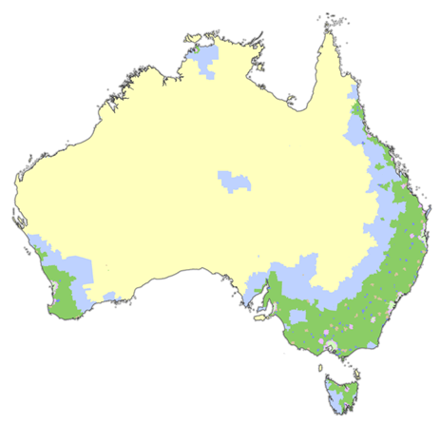Health programs will begin transitioning to the new MMM 2019 from 1 January 2020.

The MMM is used to determine eligibility for a range of health workforce programs, such as rural Bulk Billing Incentives, Workforce Incentive Program, Bonded Medical Program.

|  | MM1 | Metropolitan |
| --- | --- | --- |
| MM2 | Regional centres |
| MM3 | Large rural towns |
| MM4 | Medium rural towns |
| MM5 | Small rural towns |
| MM6 | Remote communities |
| MM7 | Very remote communities |
|  |  |

| Modified Monash  Category (MMM 2019) | Description (including the Australian Statistical Geography Standard –  Remoteness Area (2016) |
| --- | --- |
| MM 1 | **Metropolitan areas:** Major cities accounting for 70% of Australia’s population  All areas categorised ASGS-RA1. |
| MM 2 | **Regional centres:** Inner (ASGS-RA 2) and Outer Regional (ASGS-RA 3) areas that are in, or within a 20km drive of a town with over 50,000 residents.  For example: Ballarat, Mackay, Toowoomba, Kiama, Albury, Bunbury. |
| MM 3 | **Large rural towns:** Inner (ASGS-RA 2) and Outer Regional (ASGS-RA 3) areas that are not MM 2 and are in, or within a 15km drive of a town between 15,000 to 50,000 residents. For example: Dubbo, Lismore, Yeppoon, Busselton. |
| MM 4 | **Medium rural towns:** Inner (ASGS-RA 2) and Outer Regional (ASGS-RA 3) areas that are not MM 2 or MM 3, and are in, or within a 10km drive of a town with between 5,000 to 15,000 residents. For example: Port Augusta, Charters Towers, Moree. |
| MM 5 | **Small rural towns:** All remaining Inner (ASGS-RA 2) and Outer Regional  (ASGS-RA 3) areas. For example: Mount Buller, Moruya, Renmark, Condamine. |
| MM 6 | **Remote communities:** Remote mainland areas (ASGS-RA 4) AND remote islands less than 5kms offshore. For example: Cape Tribulation, Lightning Ridge, Alice Springs, Mallacoota, Port Hedland. Additionally, islands that have an MM 5 classification with a population of less than 1,000 without bridges to the mainland will now be classified as MM 6 for example: Bruny Island. |
| MM 7 | **Very remote communities:** Very remote areas (ASGS-RA 5). For example: Longreach, Coober Pedy, Thursday Island and all other remote island areas more than 5kms offshore. |

A map showing MMM 2019 can be viewed at [doctorconnect.gov.au](http://www.doctorconnect.gov.au/)