



**Home Care Provider Survey**

**Analysis of Data Collected**

***April 2020***

CONTENTS

1 Executive Summary 1

1.1 Background 1

1.2 Home Care Sector Profile 2

1.3 Summary of Outcomes 2

1.3.1 Package Utilisation and Unspent Funds 3

1.3.2 Amounts Charged to Care Recipient Packages 4

1.3.3 Hours of Service 4

1.3.4 Price of Services 5

1.3.5 Ownership of Provider 7

1.3.6 Location 8

1.3.7 Size of the Provider 8

1.3.8 Demographic Factors 9

2 Scope of and Methodology of the Survey Process 10

2.1 Abstract 10

2.2 Survey at Provider Level 11

2.3 Deep Dive Survey 13

3 Literature Review 15

3.1 The 2008 Community Care Census 15

3.2 Review of Pricing Transparency 17

4 Home Care Sector Profile 19

4.1 Ownership Structure 19

4.2 Growth in Package Numbers 21

4.3 Demographic Markers 22

5 Summary of Outcomes at Provider Level - FY 2018-19 31

5.1 Data Overview 31

5.2 Analysis Overview 32

5.3 Package Funding 33

5.4 Unspent Funds 35

5.5 Charges to Care Recipient Packages 40

5.6 Hours of Service 42

5.7 Price of Services 45

5.8 Other Items Provided to Clients 48

5.8.1 Capital Items 48

5.8.2 Allied Health Services 51

5.8.3 Consumables 52

5.8.4 Home Maintenance 53

5.8.5 Home Modifications 54

5.8.6 Meal Preparation 55

5.8.7 Sub‑contracting Services 56

5.9 Ownership 57

5.10 Location of Service as Determined by MMM 63

5.11 Size of the Provider 68

5.12 Average Age of Care Recipient 72

5.13 Average Age of First Entry into a Home Care Package 73

5.14 Other Demographic Factors 76

5.14.1 Gender Mix 76

5.14.2 Cultural Background 79

6 Summary of Outcomes at Provider Level - September 2019 Quarter 81

6.1 Data Overview 81

6.2 Context of the September 2019 Quarter 81

6.3 Amounts Charged to Care Recipient Packages 82

6.4 Hours of Service 86

6.5 Price of Services 90

6.6 Ownership 92

6.7 Location of Service as Determined by MMM 97

6.8 Size of Provider 99

7 Appendices 104

7.1 Appendix 1 - Detailed Data Tables for FY 2018-19 104

7.2 Appendix 2 - Detailed Data Tables for September 2019 Quarter 135

7.3 Appendix 3 - Explanation of MMM 155

7.4 Appendix 4 - Definitions Used in the Survey 156

# Executive Summary

## Background

A range of national information on the Home Care Packages Program is reported in the Quarterly Home Care Package Program Data Reports. However, the Department of Health (the Department) has limited data on the volume or cost to the consumer of specific services delivered under a Home Care Package, as this information is documented and agreed between the provider and the consumer. To rectify this limited data resource, a survey of home care providers has been conducted on a voluntary basis over two phases.

The first phase was to collect data about the aggregate number of hours of care and services delivered and the cost of those services to the individual’s package budget in the 2018-19 financial year (FY 2018-19) and the September 2019 quarter. This information was collected at the approved provider level.

The second phase was to collect data at a more granular level to enable further insights into the care and services delivered to particular client demographic groups by home care package level, across regions and by using other key demographic markers. This information was collected at the service delivery level of the approved provider.

There were 485 respondents to the survey, of which data was included for 416 providers for FY 2018-19. A decision was made to use the same sample of respondents that provided both financial data and data on hours of service. A number of other providers were excluded because, while they submitted a response, they provided no data at all, or did not have any packages. These 416 providers represented 45% of all approved home care providers at 30 June 2019 (or 51% of the providers with packages) and covered 51% of the packages that were operational at the time.

The response rate from the respondents in providing data for the September 2019 quarter was not as good and data from 98 respondents was used in the analysis (compared to data from 416 respondents in the FY 2018-19 data). This represented 12% of the providers in the sector and 16% of packages at 30 September 2019. The purpose of collecting the September 2019 quarter data was to ascertain whether there were any early signs of changes to prices, hours of service or provider behaviour as a result of the pricing transparency changes. The September data in fact largely confirmed the findings from the FY 2018‑19 data set and data from the pricing transparency table was used to make observations on what is likely to occur under the new transparency arrangements.

The analysis has four core aspects to it being:

* Total amount charged to a care recipient’s package for a particular service or fee type
* Total hours of service provided under the home care package
* Correlation between the amount charged and the hours of service provided (price)
* Funding received from subsidies and client contributions

Data has been examined from a number of key aspects being:

* Home care package levels
* Ownership structure
* Location of the packages
* The size of the provider

A number of demographic markers were also explored as part of the analysis:

* Average age of the care recipient
* Average age of first entry
* Gender
* Nationality and preferred language

## Home Care Sector Profile

The Home Care Packages Program Data Report for the period 1 July 2019 to 30 September 2019 reported that the total number of people in a home care package at 30 June 2019 was 106,707 and this had increased to 118,050 at 30 September 2019. This is an increase from 91,847 people in a home care package at 30 June 2018.

Since 31 March 2017, the number of home care providers providing home care services increased from 693 to 929 at 30 June 2019 before declining marginally to 926 at 30 September 2019. It should be noted that the number of providers who actually provided services at 30 June 2019 is less than the 929 providers that were approved to provide services. The number of providers that had packages at 30 June 2019 totalled 812.

Not-for-profit (NFP) providers continue to provide the largest share of the available packages, although that share has declined in the past two years from 82% to 72%. This is despite NFP providers only being 52% of the total number of providers, a reduction of 18%, from 70% since 2016.

Most care recipients are female (66%) and the average age of all care recipients is 82.4 years old. The average age of care recipients across all package levels in the sector does not vary significantly with the youngest bracket being in Level 1 packages with an average age of 81.1 years old. The average distribution of all persons in the community aged 80 to 84 years old is 56% female and 44% male. This is in contrast to the distribution of packages by gender of 66% female and 34% male.

The vast majority of care recipients (69%) in a home care package live in their own home or an independent living unit (retirement village) with a further 8% residing in a home owned by a relative. A total of 20% of care recipients are living in rental accommodation, or public or supported housing arrangements. For the moment at least, home ownership is still the dominant living arrangement.

Around 43% of care recipients live alone although this appears to decline slightly for those care recipients in a Level 4 package (37%). The remaining cohort live with a partner, family or friends. It is notable that there is a higher proportion of female care recipients living alone (48.6%) compared to male care recipients (31.2%).

Most persons receiving packaged care were born in Australia (62%) and listed English as their preferred language (84%).

## Summary of Outcomes

The following is a summary of the findings from the data analysis and general observations from the survey responses.

### Package Utilisation and Unspent Funds

Package utilisation across all package levels averages 81% with the best utilisation rate being 84% for Level 4 packages. Package utilisation is the value of services charged against a package as a proportion of the total funds available for consumers in care during FY 2018-19.

Unspent funds averaged $7,521 across all package levels for FY 2018-19 ranging from $2,098 for a Level 1 package and $15,182 for a Level 4 package.

In the deep dive, data was collected to stratify the distribution of the unspent funds balance. Across home care package levels, most consumers had unspent funds balances below the average.

As can be seen from the following table, the stratification of the individual unspent funds balances is different across the various package levels. This is likely to be caused by the length of time that someone has been in a package and the total amount of funding received for the package which can determine how quickly an unspent funds balance can be built up. For example, in the following table there are 2% of unspent funds balances in Level 4 packages exceeding $50,000, which represents at least one year’s subsidy for a Level 4 package at $50,287 per annum[1].

Unlike other package levels, the unspent funds balances are spread much more evenly for Level 4 packages, although the majority (69%) have balances that were below the average balance.

Table : Extract from Table 24 - Stratification of unspent funds report by respondents to the deep dive data collection process FY 2018-19

|  |  |  |  |  |  |
| --- | --- | --- | --- | --- | --- |
|  | **2018-19 Financial Year** | | | | |
|  | **Level 1** | **Level 2** | **Level 3** | **Level 4** | **All** |
| Total packages at period end | 472 | 3,108 | 1,038 | 1,874 | 6,492 |
| Total care recipients with unspent or available funds | 432 | 2,919 | 990 | 1,861 | 6,202 |
| Total unspent funds | $448,276 | $13,711,205 | $6,494,236 | $25,304,521 | $45,958,238 |
| Average unspent funds per package | $1,038 | $4,697 | $6,560 | $13,597 | $7,410 |
| Percentage of clients with unspent funds within each bracket below |  |  |  |  |  |
| $0 - $2,499 | 90% | 41% | 28% | 14% | 34% |
| $2,500 - $4,999 | 9% | 24% | 23% | 14% | 20% |
| $5,000 - $7,499 | 1% | 15% | 16% | 13% | 13% |
| $7,500 - $9,999 | 0% | 8% | 12% | 12% | 9% |
| $10,000 - $14,999 | 0% | 8% | 12% | 16% | 10% |
| $15,000 - $19,999 | 0% | 3% | 5% | 9% | 5% |
| $20,000 - $29,999 | 0% | 1% | 3% | 11% | 4% |
| $30,000 - $39,999 | 0% | 0% | 1% | 6% | 2% |
| $40,000 - $49,999 | 0% | 0% | 0% | 3% | 1% |
| Over $50,000 | 0% | 0% | 0% | 2% | 1% |
| **Total** | **100%** | **100%** | **100%** | **100%** | **100%** |

These figures need to be considered against the upcoming improvements to the payment arrangements for home care providers. The changes will mean that Government will hold the balance of unspent funds and providers will be reimbursed for their services after delivery, not in advance of the service being provided as is currently the case. Moving to payment in arrears based on an invoice for services delivered will align home care with other Government programs and is intended to reduce the prudential risk in home care over time.

### Amounts Charged to Care Recipient Packages

Care recipient package budgets are charged each month for care and services provided or for administrative costs. Across all package levels, care management and the administration charge average a total of 28% of the package receipts for FY 2018-19.

There is also a clear trend that as the package levels increase, and the care needs of the client increases, the type of services being provided does change, particularly between personal care services which increase as a proportion of the package in comparison with a service like cleaning which declines as the package level increases.

Chart : Top four services charged to client packages as a proportion of the package value receipted - changes across package levels for FY 2018-19

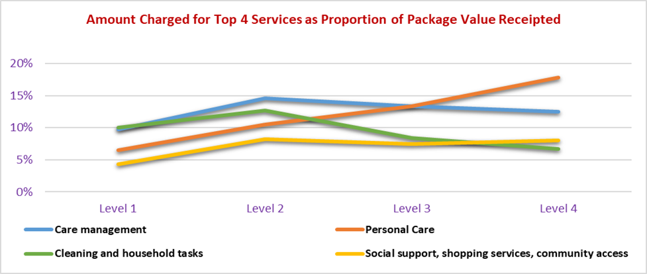

There is very little of the package used for nursing care services with less than 0.5% of charges for nursing care against a low care package (Level 1 or 2) and up to 2% for a Level 4 package.

### Hours of Service

The change in hours provided to clients as package levels change moves in a similar pattern to the amounts charged against a package. The hours of personal care services substantially increase across the home care package levels, from 30 minutes a fortnight under a Level 1 home care package (16% of hours), to just under 6 hours a fortnight under a Level 4 home care package (33% of hours).

While the number of hours charged may increase for some specialised services such as allied health services and nursing care, the overall proportion of the package funds utilised for those services remains negligible (2%) across all package levels.

Chart : Hours of service provided as proportion of total hours for top 4 services - trends between package levels for FY 2018-19

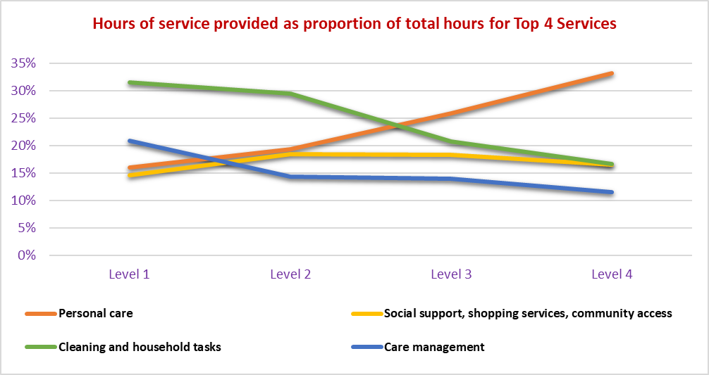

### Price of Services

The price of services is a derived amount for the purpose of this analysis. It was calculated by dividing the total amount charged against packages by the number of hours of service for each service. To provide a level of integrity to this method, the same sample of providers were used for both the hours of service data and dollars charged to client packages. This has meant that a number of providers that did provide some data, but did not provide data for both hours and dollars, have been excluded from the analysis.

There is a relative consistency in pricing for individual services across package levels, particularly for those most common services such as personal care; cleaning and household tasks; and social support, shopping services and community access. Variations occur with respect to care management which increases as package levels increase, as do the more specialised services such as nursing, and allied health services.

Table : Average price of services estimated using hours of service and amounts charged to care recipient packages for FY 2018‑19

|  |  |  |  |  |  |
| --- | --- | --- | --- | --- | --- |
| **Average cost per hour** | **Survey Average** | **Level 1** | **Level 2** | **Level 3** | **Level 4** |
| Care management | 109.85 | 65.39 | 103.68 | 104.98 | 120.19 |
| Nursing care - registered nurse | 76.10 | 57.35 | 72.50 | 77.29 | 76.84 |
| Nursing care - enrolled nurse or other licensed nurse | 123.40 | 64.64 | 96.14 | 113.57 | 131.80 |
| Personal care | 57.87 | 56.93 | 55.73 | 56.80 | 59.00 |
| Cleaning and household tasks | 44.18 | 44.65 | 44.14 | 44.52 | 44.02 |
| Social support, shopping services, community access | 49.17 | 41.30 | 45.79 | 45.10 | 53.60 |
| Light gardening | 76.81 | 57.80 | 70.08 | 68.93 | 92.14 |
| In-home respite (day-time) | 49.51 | 31.48 | 47.38 | 47.42 | 50.73 |
| In-home respite (overnight) | 43.85 | 55.90 | 31.32 | 43.96 | 45.90 |
| Transport services | 39.55 | 26.67 | 40.54 | 34.74 | 41.86 |
| Allied health professional (practitioner) | 177.28 | 143.06 | 157.44 | 165.62 | 192.89 |
| Other services provided to the home care recipient | 71.08 | 86.09 | 70.91 | 61.21 | 74.85 |
| **Average price per hour of service** | **61.96** | **52.43** | **58.95** | **59.72** | **65.08** |
| Average charged - total charge / hours of service (includes all charges) | 88.27 | 74.64 | 83.11 | 86.70 | 92.62 |

There were however small differences in prices for services for which similarly skilled staff would be undertaking the task. Taking a Level 2 package from the table above the following average prices are charged for the following service types which might be carried out by staff with a similar skill mix:

* Personal care - $55.73 per hour
* Cleaning and household tasks - $44.14 per hour
* Social support, shopping services, community access - $45.79
* In-home respite (day time) - $47.38

When analysing prices post 1 July 2019 as derived from the pricing transparency tables (as published on My Aged Care), there appeared to be more consistency in the prices for these services:

* Personal care - $57.96 per hour
* Cleaning and household tasks - $56.64 per hour
* In-home respite (day time) - $57.87

Based on the data collected from the September 2019 quarter, there has been a general increase in the amounts charged for package management in comparison to the charges for what was called administration costs in FY 2018-19. This is somewhat surprising given that if anything, package management would be expected to decline as a result of the pricing transparency system. However, this will take some time to filter through as clients are transitioned onto the new pricing arrangements from their old arrangements and the market adjusts to the increased transparency in pricing costs. Of note is that based on the pricing transparency data, the care management charges are likely to increase across all package levels as compared to the costs charged in FY 2018-19 and the September 2019 quarter.

Table : Comparison of prices for care management and package management/administration costs across survey periods and pricing transparency data

|  |  |  |  |  |  |
| --- | --- | --- | --- | --- | --- |
| **Total Amount Charged to Care Recipients per package per fortnight** | **Package Levels** | | | | |
| **All Average** | **Level 1** | **Level 2** | **Level 3** | **Level 4** |
| Total number of providers | 416 | na | na | na | 393 |
| Total number of packages | 54,823 | 3,222 | 27,234 | 9,973 | 14,394 |
| Total estimated number of subsidised days | 19,999,171 | 1,174,852 | 9,935,652 | 3,638,668 | 5,249,998 |
| **Survey for FY 2018-19** |  |  |  |  |  |
| Care management | $135.63 | $42.24 | $85.01 | $150.49 | $242.04 |
| Admin charge | $153.04 | $47.46 | $86.94 | $174.14 | $287.12 |
| **Survey for September 2019 Quarter** |  |  |  |  |  |
| Care management (Fully managed) | $134.97 | $40.50 | $86.05 | $156.47 | $237.69 |
| Package Management | $162.37 | $44.57 | $92.31 | $191.35 | $304.58 |
| **Pricing Transparency Data - Same sample of providers (FY 2018-19 Survey) - at 2 January 2020** |  |  |  |  |  |
| Care management (Fully managed) | $169.91 | $57.19 | $103.53 | $228.49 | $290.44 |
| Package Management | $131.72 | $35.36 | $71.60 | $151.29 | $268.63 |

### Ownership of Provider

The market is still dominated by the NFP providers when the market share of packages is measured (72%) although the NFP sector only comprises 52% of the total providers. Historically this sector has been dominated by the NFP providers and they are well established and many of them of large scale.

On the face of it the amounts charged to care recipient packages is, on average, weighted towards the NFP providers with an average charge to the package of $850.63 per client per fortnight compared to for-profit (FP) providers with $818.16 and Government providers an average of $655.35.

There are differences in behaviour and outcomes across ownership types in relation to receipts and revenue utilisation rates as well as unspent funds balances:

* ***Average receipts for Government providers are lower than the other providers*** and this is likely to be because their package mix is biased towards low care packages whereas the NFP and FP providers have a larger proportion of high care packages in their mix
* ***Government provider utilisation rates are lower than the FP and NFP providers*** resulting in relatively high unspent funds balances despite the package mix with more low care packages

One factor to be considered is that some of the FP home care providers will have entered the home care market with a background of providing private nursing or care services on a full fee for service basis where the practice was to include all underlying costs in the charge for the service to the client - no administration charge. Their pricing structure will have been based on cost recovery through the service price. This is likely to be carried over into the home care market. The average charged for administration cost by the FP providers was $113.84 compared to the NFP providers which had an average charge of $159.90 per fortnight and Government providers at $149.43 per fortnight.

### Location

The analysis of data by location is based on the Modified Monash Model (MMM). A large number of providers delivered packages across more than one location and as such the data was grouped based on which MMM classification the majority of packages were delivered to.

The overall charge to packages generally declines as remoteness increases from MMM1 to MMM5. There is then a big leap in the amount charged as remoteness increases further to MMM6 and MMM7 categories. This is also consistent with the numbers of hours charged per package per fortnight where there appears to be a greater level of service provision in the more remote areas (around double the national average) and package utilisation is higher than other regions. One reason for this may be that persons in remote areas rely more heavily on their package for services and support than in less remote areas. Persons in the city and less remote areas may have greater access to family and other community supports than those in the more remote areas.

### Size of the Provider

For the purpose of assessing whether there are any differences in behaviour or pricing depending on the size of the provider, data has been aggregated on the basis of how many packages are delivered by providers. This was based on the total package numbers at the end of FY 2018‑19.

There does appear to be a trend in that those with greater than 250 packages tend to charge a greater amount against a client per fortnight than those with fewer than 250 packages. One of the reasons for this is that the care management and administration charges for these larger providers are higher on average than many of the smaller providers.

Table : Care management and administration charge per package per fortnight based on size of provider as determined by the number of packages held for FY 2018-19

|  |  |  |  |  |  |  |  |  |
| --- | --- | --- | --- | --- | --- | --- | --- | --- |
| **Total Amount Charged to Care Recipients per package per fortnight** | **2018-19 Financial Year** | | | | | | | |
| **All Average** | **Under 25** | **25-50** | **50-100** | **100-150** | **150-250** | **250-500** | **Over 500** |
| Total number of providers | 416 | 170 | 65 | 65 | 35 | 32 | 27 | 22 |
| Total number of packages | 54,823 | 1,609 | 2,306 | 4,601 | 4,297 | 6,239 | 9,290 | 26,481 |
| Care management | $135.63 | $112.05 | $135.26 | $130.82 | $133.11 | $108.94 | $135.49 | $144.68 |
| Administration charge | $153.04 | $132.90 | $150.86 | $147.02 | $160.92 | $129.24 | $169.47 | $154.05 |
| **Total for care management and administration charge** | **$288.67** | **$244.95** | **$286.12** | **$277.84** | **$294.04** | **$238.18** | **$304.96** | **$298.73** |

There is little variance in the balance of unspent funds across the various sized providers. Package utilisation varies across the various sized providers but there is no consistent trend in that variance. This is more likely to be a result of the mix of packages held by providers in each group and their individual business models. Data at an individual provider level indicates that utilisation rates vary across providers within each size grouping.

Average hours of service clearly trends downwards as provider size increases. This is in line with the data on amounts charged to client packages and package utilisation rates. For those with less than 25 packages it would appear that most of the additional hours is in personal care and social support, shopping services and community access and this is also the case for those providers with between 25 and 50 packages. There is also additional time providing transport services.

### Demographic Factors

The average amount charged against a package trends upwards for people age 81 up to age 84 before declining again for those where the average age is 84 years and older. However, the average charged against the packages where the average age is under 80 years of $791.39 per fortnight is almost identical to that charged to persons over 84 years of $793.77 per fortnight.

There appears to be a trend that the earlier a person entered the system (year of entry), the higher the administration or package management charge. Those that have been in the system from an earlier age also have higher unspent funds balances on average and lower package utilisation rates. Both of these measures are indications of the length of time that a person has been in the system, and as such it is more likely that the longer a person has been in the system the higher the current package level (administration costs increase with package level) and the higher the unspent funds balance.

Persons who have entered the into a package at 79 years or younger have, on average less hours of service (8.03 hours per fortnight) provided to them and less charged against their package ($738.64 per fortnight) than those that first entered into a package at age 80 years or older (9.2 hours and $787.69 per fortnight).

Analysis shows that as the proportion of female clients increase, the average amount charged against a client package generally increases and package utilisation is higher. This analysis is undertaken at a provider level based on the proportion of female clients for which they provide packages. This is supported by the number of hours provided. The overall hours of services increases as the proportion of female clients increases. Most of the increase in hours of service are in the following categories:

* Personal Care
* Cleaning and household tasks
* Transport services

In relation to looking at cultural factors, where there are less than 50% of persons who were born in Australia, or less than 50% of persons who listed English as their preferred language:

* The total amounts charged against the packages were lower
* Unspent funds were lower
* Utilisation rate was higher

Based on the level of Government subsidies received by those providers with less than 50% of persons who were born in Australia, or less than 50% of persons who listed English as their preferred language, the average package level is lower than those providers with a higher proportion of persons born in Australia or having English as their preferred language. This would be one reason why the amounts charged to packages is lower on average, as well as a lower unspent funds balance. One exception is for cleaning and household services where there is a greater amount charged against a package where there are fewer than 50% of persons with English as their preferred language and a greater number of hours provided.

# Scope of and Methodology of the Survey Process

## Abstract

The Department has limited data on the volume or cost of specific services delivered under a home care package. As such, a survey and data collection exercise with home care providers has been undertaken. Where possible, data held as part of the StewartBrown Aged Care Financial Performance Survey has been utilised.

The survey collected data about the aggregate number of hours of care and services delivered across a wide range of service categories, and the cost to the individual care recipient’s package budget in FY 2018‑19. In developing those service categories for the purpose of the survey, a number of factors were considered including:

* Information available about home care package service delivery
* Categories used for the pricing transparency table as published on My Aged Care
* Previous surveys

Providers were also given the option of providing data for the September 2019 quarter. The main purpose of collecting the September quarter data was to ascertain whether there were any early signs of changes to prices, hours of service or provider behaviour as a result of the pricing transparency changes.

This survey was at provider level, asking for the total hours and amounts charged against all of the packages delivered during that period by package level. This was considered to be Phase 1 of the survey process.

The survey of home care providers was conducted on a voluntary basis.

The data collection process for Phase 1 took place from 25 November 2019 to 31 December 2019 with an extension provided to some providers until 14 January 2020. This initial data collection and collation process was undertaken by Forms Administration on behalf of the Department.

Providers also had an option to indicate if they would be willing to provide access to all of their service delivery data to enable further analysis on a de-identified basis. This would then enable a deeper data analysis for a small number of providers to enable further insights about the care and services delivered to specific client demographic groups, by home care package level, across regions, etc. (see Section 2.3 below).

## Survey at Provider Level

For the purpose of Phase 1, the collection of data at the provider level, the following information was requested in relation to hours of service:

Information was requested in relation to total hours of each service type delivered across each package level for the 2018-19 financial year. Total hours of all services delivered was also requested for each package level. 

The following information was requested in relation to the amounts charged to care recipients’ home care packages:

Information was requested in relation to amount charged for each service type delivered across each package level for the 2018-19 financial year. Total amount charged for all services delivered was also requested for each package level. 

Additional information was sought on the source of funding (Government subsidies or client contributions) and the level of unspent funds at period end.

Analysis of this data was carried out in the context of other information made available by the Department including the following characteristics of providers and their clients:

* Location of packages based on MMM scale of remoteness
* Age of care recipient at the time they entered a package
* Gender of the care recipient
* Country of birth of the care recipient
* The preferred language of the care recipient
* Ownership of the provider (FP, NFP or Government)
* Living arrangements of the care recipient
* The number of packages delivered by the provider at the end of each quarter
* Pricing information from the pricing transparency tables on My Aged Care

The aim of this analysis is to ascertain if there are patterns in service delivery or charging behaviour of providers based on one or more of these characteristics.

## Deep Dive Survey

As previously noted, providers had an option to indicate if they would be willing to provide access to additional service delivery data to enable further analysis on a confidential basis (Phase 2). This would facilitate a deeper data analysis for a small number of providers to enable further insights about the care and services delivered to particular client demographic groups, by home care package levels and across regions.

This deep dive survey was carried out at a service or outlet level with the aim of examining data on the same basis upon which a provider reports internally, particularly by service location. This would allow the data analysis to compare service hours and cost to consumer across different service areas within a provider as well as comparing similar service locations between providers. It was also to enable the analysis to look at specific characteristics of a provider and establish whether that had any effect on the level or cost to consumers of the services provided.

The data collection and analysis for the deep dive survey was carried out by StewartBrown.

Information was sought for FY 2018-19 and as was the case in Phase 1, a choice was given to provide data for the September 2019 quarter. The same information was sought in the same format for the hours of service provided and the amount charged against a client package. However, for this deep dive survey (Phase 2), the information was to be provided at the service level. Some additional information was also sought to provide greater insight into some of the information already provided.

Additional information sought in relation to unspent funds and receipts from the funding source was as follows:

Information was requested in relation to unspent funds assocaited with each package level for the 2018-19 financial year. This includes information on the total packages at the end of the period, total care recipients with unspent or available funds, the total amount of unspent funds, and the number of clients with unspent funds within a number of ranges.
Information was also requested on fees charged, including the basic daily fee, income tested care fee and the fee for service (top-up)

The main goal with this question was to ascertain whether the overall unspent funds balance was being affected by a few very large balances or whether there was a more even distribution of unspent funds balances.

With respect to the service types, the following additional information was sought:

* Proportion of each service type that was sub-contracted
* How many meals would be prepared where assistance was provided with meal preparation
* Most common type of consumables purchased on behalf of clients
* Frequency of home maintenance services
* Nature (type and cost) and number of any home modifications
* Average spend on capital purchases
* Most common type of capital purchase
* A granular analysis of allied health services (hours of service and cost to consumer) by these services into a range of sub-categories
* Allocation of other services into further sub-categories to be supplied by the respondent
* Whether or not the provider offers services to private clients, and if so – the amount charged, hours delivered and pricing information
* Travel expense policy
* Type of service delivery model used (itemised services, bundled services or a hybrid)

Several questions were also asked with respect to the clients being serviced including:

* Average age of the client
* Average age when entering the package
* Average length of stay in a package
* How the client was referred to them
* Living arrangements of the client (living alone, living with a carer)
* Whether a partner or carer is also receiving funded services
* Whether the care recipients live in a retirement village
* Whether the care recipients are receiving other funded services (CHSP, DVA etc.)

Additionally, information was sought on the type of system or software package that is being used by the provider to manage their home care clients and service delivery. Insufficient data was collected on this topic as well as services to private clients, the travel expense policy and the type of service delivery model to undertake detailed analysis.

# Literature Review

This project was to consider the previous data collected from home care providers, including the Community Care Census and information provided as part of the Home Care Pricing Transparency Project.

## The 2008 Community Care Census

The scope of the 2008 Census was both care recipients and their carers receiving assistance through the three Australian Government community care package programs:

* Community Aged Care Package (CACP);
* Extended Aged Care at Home (EACH); and
* Extended Aged Care at Home Dementia (EACHD)

and a survey of the National Respite for Carers Program (NRCP).

The 2008 Census was the second time information has been collected on CACP and EACH recipients as part of a Census of Community Care; it was the first time data of this nature was collected on the EACHD program. The previous census was conducted in 2002. In 2008, there were 39,552 operational CACP packages providing services to care recipients, significantly up from 26,403 operational places at the time of the 2002 census.

For the EACH program, the 2002 Census took place just after the completion of the EACH program pilot. At that time there were only 290 EACH packages available through about ten providers in five states. By 2008, the program was operating through about 300 outlets across Australia, reported to be providing services to care recipients through 4,244 operational EACH packages and 1,996 EACHD packages.

The 2008 Census included questions on the range of care recipients’ needs and how they were met through carer support and services delivered by providers. More information was also sought on the payment of fees, residential respite, sub-contracting of services and aspects of case management and care coordination.

The findings of the report included profiles of the age, gender and needs of care recipients and carers, and circumstances such as dementia and incontinence that may inhibit their capacity to continue living independently in the community.

The 2008 Census collected data from 1,242 outlets providing packaged care and/or respite services. Data was collected on 40,284 packaged care recipients, and 8,673 NRCP carers and care recipients.

Some key findings from this report included:

* 87.5% of care recipients were in a CACP (low care)
* 12.5% were in an EACH or EACHD package (high care)
* 70% of care recipients were female
* Average age of packaged care clients was 81 years
* Over 85% of care recipients lived in major cities and inner regional areas
* Around 67% of packaged care recipients were born in Australia
* English was the preferred language of 84% of care recipients
* 70% of care recipients lived in a home they owned or were purchasing
* 13% lived in some form of rental accommodation including community housing
* 8% lived in a retirement village
* 58% reported having a primary carer
* 59% reported living alone
* 39% lived with family
* 97% of CACP recipients were most likely to receive assistance with activities related to independent living such as housework and shopping - most common service was domestic assistance (81%) followed by personal care (39%) and social support (31%)
* EACH and EACHD recipients, as well as requiring assistance with those independent living tasks, were more likely to required personal care services as well - most common service was personal care (83% and 73% respectively) and domestic assistance (68% and 60% respectively). The next most common types were meal preparation/food services, transport and respite
* Case management/care coordination functions were undertaken for a large proportion of packaged care recipients (79 per cent of CACP recipients, 86 per cent of EACH recipients and 89 per cent of EACHD recipients)
* Nursing care was provided to 32 per cent of EACH recipients and 28 per cent of EACHD recipients
* When there were surplus funds from the package of one care recipient, providers could use those funds to supplement the care of another care recipient. Around one per cent of packaged care recipients in the 2008 Census period were funded through this mechanism
* The average hours of assistance provided under a CACP program was 6.5 hours per week including 5.4 hours of direct assistance and 1.4 hours of case management and care coordination
* The average hours of assistance provided under the EACH program was 16.2 hours per week; this included 14.1 hours of direct assistance and 2.3 hours of case management and care coordination.
* The average hours of assistance provided under the EACHD program was 17.5 hours per week; this included 15.2 hours of direct assistance and 2.6 hours of case management and client coordination

While some information is not directly comparable there are observations that can be made in relation to how the sector has shifted in both service delivery and scale since the 2008 Community Care Census. In this report, comparisons are made between a:

* Level 2 package and CACP, given both considered to be typical of low care packages and of similar subsidy levels
* Level 4 package and EACH, given both considered to be typical of high care packages and of similar subsidy levels

The methodology for calculating statistics was similar in both surveys whereby the total hours of assistance provided was divided by the number of clients assisted. However, these comparisons need to be read with the qualifier that the home care operating environment was different in 2008 compared to the current landscape.

This may be a reflection of several factors including that:

* Care recipients now have a greater say in how their package is utilised including the type, duration and frequency of services
* Care recipients are now choosing to save part of their package for a “rainy day” as is seen by the level of unspent funds
* There is no longer cross subsidisation between packages as had happened prior to the introduction of CDC in home care whereby the underutilised package of one care recipient may have been utilised for another care recipient - in effect the pooling of funds within a program
* There is a greater prevalence of capital purchases and purchases of contracted services which would not necessarily count towards the hours of direct service - a reflection of the consumer having greater control over who provides the service.

## Review of Pricing Transparency

In 2018, StewartBrown was requested to conduct a review of home care pricing behaviour to assist the Department to deliver on the third phase of the approach to improving pricing transparency and comparability in home care; to develop a standardised approach to publishing home care pricing information through a development of a table, to be included on the My Aged Care website.

The Review was focused on the pricing transparency mechanism however there were a number of outcomes that might be considered relevant to the current survey process.

There are a large range of services provided by home care providers and these are described and categorised in a variety of ways.

However, there are several services that might be described as “core services”. These are likely to be the most common services accessed by consumers and are also listed on the price lists of all providers, albeit the terminology can differ slightly.

These services were:

* Domestic assistance
* Personal care / nursing care (non-clinical)
* Registered nurses / nursing care (clinical)
* Allied health services
* Transport services
* Sleepover – overnight
* Sleepover – 24hr

There were also other practices that were very common across providers including:

* All providers charged for some form of case management
* Most providers charged a separate administration cost
* Exit amounts are noted on the price lists (either as nil or the amount of the maximum charge)
* While not commonly charged, the fact that an entry or set-up cost is not charged is commonly noted on the price lists

All providers have variations in price of one form or another in relation to providing services out-of-hours or on weekends and public holidays.

There were several types of variations noted between providers and these can be summarised as:

* Variation in methodology for charging consumers
* Variation in terminology
* Variation in how services are categorised
* Variation in service delivery models/business models

The outcomes and learnings from this survey and review were considered when developing the 2019 survey input forms including the categories of service (refer Appendix 4) and the format of the questions that would be asked of providers in the main survey and in the deep dive survey.

# Home Care Sector Profile

## Ownership Structure

The home care package sector, like much of the aged care sector has undergone a significant amount of reform in recent years including a move to a CDC model of service delivery, packages being allocated to the client instead of the provider and more recently a move to a greater level of pricing transparency.

These reforms, and in particular the allocation of packages to consumers rather than places to providers has seen underlying change in the structure of the sector. The number of home care providers providing home care services increased from 693 at 31 March 2017 to 926 at 30 September 2019.

Chart : Number of approved home care providers of home care with home care services since March 2017

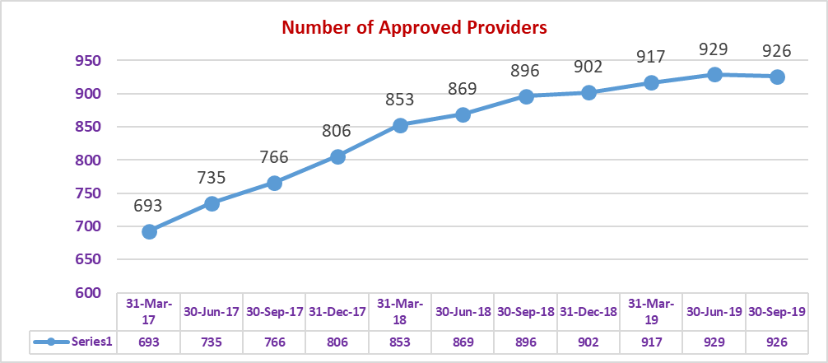

It should be noted that the number of providers that had packages at 30 June 2019 totalled 812. There are many providers that have been approved, but for one reason or another have not begun to provide services. Similarly, there will be providers who have provided services in the past and have now decided to exit the business and possibly revoke their approved provider status.

The overall increase in the number of providers has also resulted in a distinct change in the mix of ownership type. Prior to the change in the way packages were being allocated, the sector was clearly dominated by NFP providers whereby they comprised 70% of all providers of home care packages with the FP only accounting for 13% of providers and Government agencies making up the difference of 17%.

In the lead up to the changes in the way packages were allocated in February 2017 and subsequent to that, there has been a significant shift in the number of FP providers so that they now account for 36% of all providers, with the NFP sector accounting for 52% and the Government agencies 12%.

Chart : Distribution of approved providers of home care packages - proportion of total by ownership type

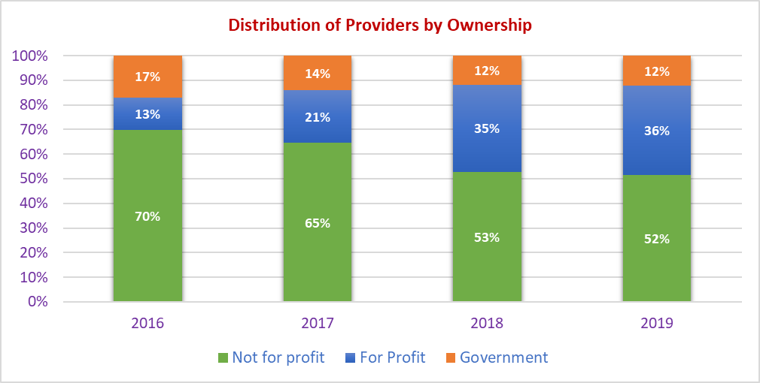

*Source: Aged care service lists at 30 June 2016 to 2019, Gen Data*

However, despite the rapid growth in the number of privately-owned home care providers, the NFP providers still have the largest share of the available packages. That share has declined in the past two years by 10%. It is clear that the dominance and scale of many of these established NFP providers has helped to protect their overall market share in terms of packages being serviced, despite there being a significant increase in overall competition.

Chart : Distribution of home of home care packages - proportion of total by ownership type

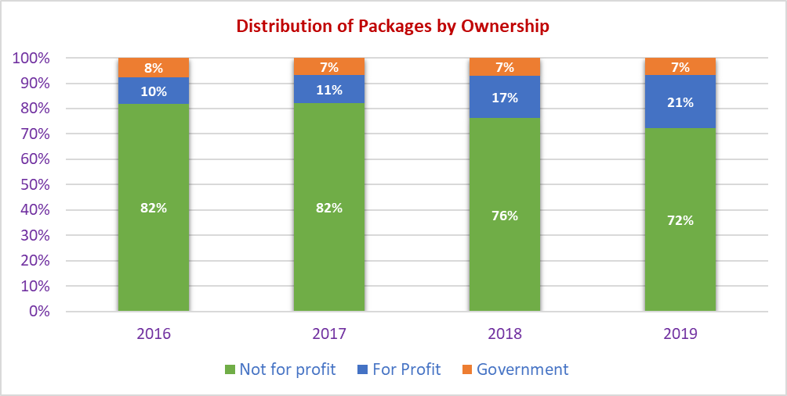

## Growth in Package Numbers

Over the past two years there has been an accelerated release of home care packages and this has seen the number of persons in a home care package increase from 64,096 at 30 June 2016 to 106,707 at 30 June 2019 and a further increase to 118,050 at 30 September 2019.

Chart : Number of persons in a home care package 30 June 2016 to 30 September 2019

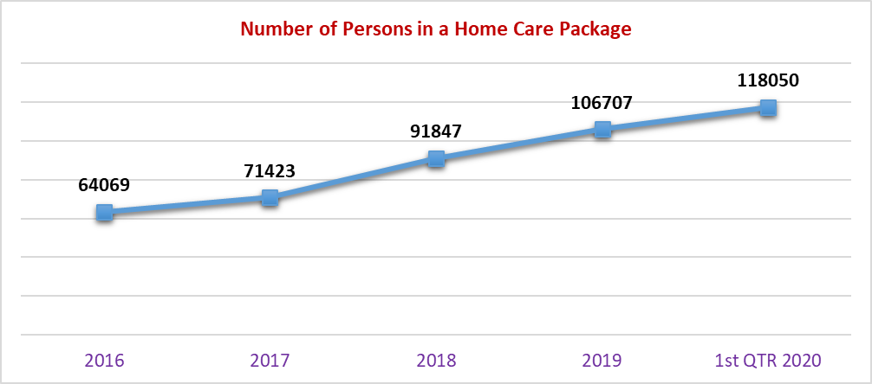

This represents a cumulative increase of 53,981 persons in a home care package since 2016, a cumulative increase of 84.3%.

Chart : Increase in numbers of person in a home care package - cumulative and year on year since 2016

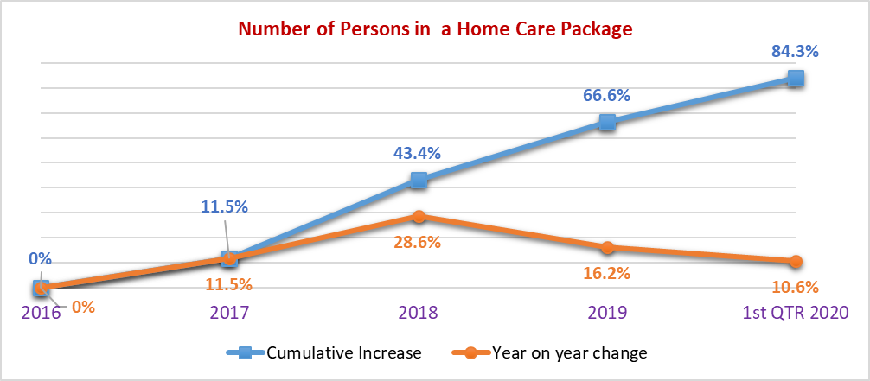

But as seen in the earlier charts, the increase in the number of persons in a package have been shared between existing providers and new entrants in the market, so it would be unusual to see growth in market share at a provider level that mirrored the overall growth rates of package numbers.

## Demographic Markers

As noted in the charts above, there were 929 home care providers and 106,707 persons in a home care package at 30 June 2019. The data analysis that follows is based on data provided by the Department and agencies.

There were 812 providers with packages at 30 June 2019 meaning that there were a further 117 approved providers of home care that had either stopped providing services or had not started providing services to care recipients.

Table : Summary of data by package level included in sector analysis

|  |  |  |  |  |  |
| --- | --- | --- | --- | --- | --- |
|  | **Sector Data Summary** | | | | |
|  | **LEVEL 1** | **LEVEL 2** | **LEVEL 3** | **LEVEL 4** | **Total** |
| **Provider data** |  |  |  |  |  |
| Number of providers |  |  |  |  | **812** |
| **Package data** |  |  |  |  |  |
| Number packages | 8,516 | 47,734 | 20,193 | 30,264 | **106,707** |
| **Proportion of total** | **8.0%** | **44.7%** | **18.9%** | **28.4%** | **100.0%** |

The analysis below provides a breakdown of the data using a variety of demographic markers relating to the persons in a home care package and across the four package levels.

Comparison to 2008 Community Care Census

The average age of persons in a package has not changed significantly despite the increase in high care packages but there are fewer female care recipients as a proportion of the total in 2019 (65.5%) than in 2008 (69.6%).

There are also far fewer persons living alone with only 43% living alone at June 2019 compared to 59% in 2008. The number of persons listing English as their preferred language is much the same as in 2008 although there are 5% fewer persons in a package that were born in Australia.

A comparison of outcomes across various demographic markers is in the table below.

Table : Comparison of outcomes for the home care sector, FY 2018-19 survey, 2019 sector data and 2008 Community Care Census

|  |  |  |  |
| --- | --- | --- | --- |
|  | **FY 2019 Survey** | **2019 Sector** | **2008 Census** |
| **Sector Profile** |  |  |  |
| Number of packages | 58,540 | 106,707 | 40,280 |
| % of persons in a Low Care package | 53.0% | 52.7% | 87.5% |
| % of persons in a High Care package | 47.0% | 47.3% | 12.5% |
| % of female care recipients | 65.9% | 65.8% | 70% |
| Average age of care recipient | 82.5 | 82.4 | 81 |
| % of persons with English as preferred language | 73.2% | 72.3% | 84% |
| % of care recipients born in Australia | 62.7% | 61.9% | 67% |
| % of care recipients living in their own home (purchased or purchasing) | 67.6% | 67.9% | 70% |
| % of persons living in rental accommodation (including social housing) | 19.6% | 19.8% | 13% |
| % of persons living in a retirement village | 9.4% | 9.2% | 8% |
| % of persons living alone | 43.2% | 42.6% | 59% |
| % of persons living with partner or family | 52.4% | 53.1% | 39% |

*Note: when comparing hours of service, a low care package compares a Level 2 package with CACP and a high care package compares a Level 4 package with an EACH package.*

Gender

Table : Summary of packages by package level by gender

|  |  |  |  |  |  |
| --- | --- | --- | --- | --- | --- |
|  | **Sector Data Summary** | | | | |
|  | **LEVEL 1** | **LEVEL 2** | **LEVEL 3** | **LEVEL 4** | **Total** |
| **Gender** |  |  |  |  |  |
| Female | 5,347 | 32,471 | 12,997 | 19,349 | 70,164 |
| Male | 3,169 | 15,246 | 7,190 | 10,898 | 36,503 |
| Unknown | 0 | 17 | 6 | 17 | 40 |
| **Total by Gender** | **8,516** | **47,734** | **20,193** | **30,264** | **106,707** |

|  |  |  |  |  |  |
| --- | --- | --- | --- | --- | --- |
|  | **Sector Data Summary** | | | | |
|  | **LEVEL 1** | **LEVEL 2** | **LEVEL 3** | **LEVEL 4** | **Total** |
| **Gender** |  |  |  |  |  |
| Female | 63% | 68% | 64% | 64% | 66% |
| Male | 37% | 32% | 36% | 36% | 34% |
| Unknown | 0% | 0% | 0% | 0% | 0% |
| **Total by Gender** | **100%** | **100%** | **100%** | **100%** | **100%** |

The mix of gender does not alter significantly across the package levels, with the exception of Level 2 packages where there is an even greater proportion of female care recipients than males compared to the other three package levels. In all package levels, there is a clear majority of females receiving care services compared to males at a ratio of close to 2:1.

The proportion of females in packages are generally greater than in the distribution of the over 75 year old population generally, as shown in the chart below.

Chart : Gender distribution of the population aged 75 and over with comparison to home care package average age

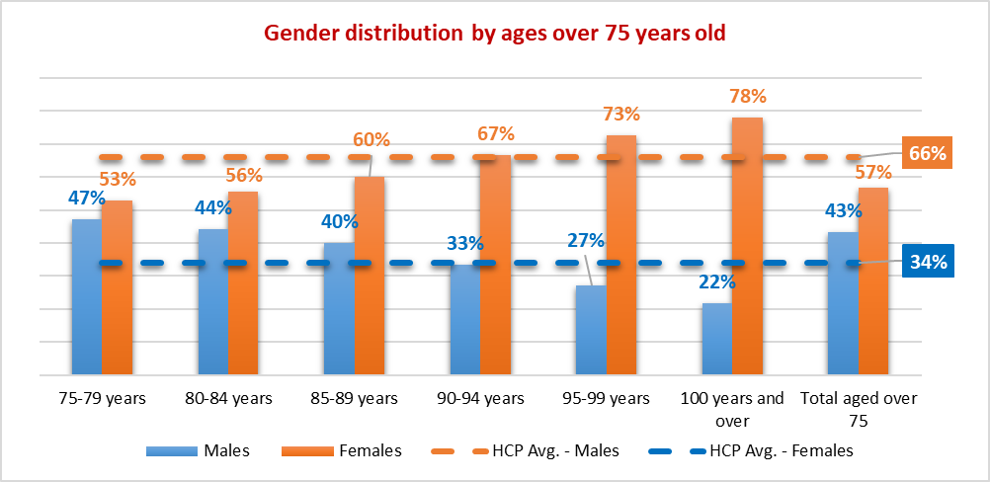

*Source: 2016 Census of Population and Housing - General Community Profile (Catalogue number 2001.0) Table G04 Age by sex*

Age of Care Recipient

The average age of care recipients across all package levels does not vary significantly with an average age of 82.4 years.

Table : Summary of packages by package level by age

|  |  |  |  |  |  |
| --- | --- | --- | --- | --- | --- |
|  | **Sector Data Summary** | | | | |
|  | **LEVEL 1** | **LEVEL 2** | **LEVEL 3** | **LEVEL 4** | **Total** |
| **Age** |  |  |  |  |  |
| Average age at Jun-19 | 81.1 | 82.8 | 82.4 | 82.0 | 82.4 |
| **Age at First Entry into HCP** |  |  |  |  |  |
| Average age of entry | 80.6 | 80.2 | 80.6 | 78.5 | 79.9 |

Of note is that the average age of entry for Level 4 packages, which is the package level that is considered to meet highest level of care needs, is lower than the other package levels. One of the reasons for this is that a total of 357 persons entered into a home care package when they were aged 50 years or younger. The average age of those 357 persons was 46.2 years. Of those persons under 50 years of age, 155 (43%) are currently allocated a Level 4 package. This only represents 0.5% of the total number of Level 4 packages but does have an influence on the statistic of age of entry. Of those entering a Level 4 package under the age of 50, 27% stated that they were Aboriginal and/or Torres Strait Islander and a further 19% did not state their Indigenous heritage.

Living Arrangements

The living arrangements of persons receiving services through a home care package can be influenced by two key factors; whether they live alone or with a carer/partner and to a lesser degree the type of accommodation they are living in. The first of those factors may influence the type and number of services a care recipient will require and the second factor may influence the ability to pay a contribution to their services either in the form of an income tested fee or basic daily fee (or both).

Table : Accommodation type by care recipients by package level across the home care sector

|  |  |  |  |  |  |
| --- | --- | --- | --- | --- | --- |
|  | **Sector Data Summary** | | | | |
|  | **LEVEL 1** | **LEVEL 2** | **LEVEL 3** | **LEVEL 4** | **Total** |
| **Accommodation Type** |  |  |  |  |  |
| Independent Living | 873 | 4,981 | 1,810 | 2,112 | 9,776 |
| PR Public Comm Housing | 813 | 4,863 | 1,940 | 2,933 | 10,549 |
| PR Client Owns/Purchasing | 5,114 | 27,957 | 12,391 | 18,141 | 63,603 |
| PR Relation Owns/Purchasing | 691 | 3,400 | 1,741 | 2,970 | 8,802 |
| PR Private/Rental | 868 | 4,007 | 1,822 | 2,501 | 9,198 |
| Not Stated/Inadequately Supp | 38 | 488 | 116 | 576 | 1,218 |
| Crisis Emergency Transition | 2 | 38 | 9 | 12 | 61 |
| Supported Accommodation | 57 | 361 | 110 | 211 | 739 |
| Hospital | 2 | 10 | 7 | 18 | 37 |
| Residential Aged Care | 10 | 68 | 46 | 89 | 213 |
| Other Community | 17 | 100 | 39 | 48 | 204 |
| Other Institutional | 1 | 12 | 4 | 3 | 20 |
| Boarding House | 10 | 71 | 23 | 33 | 137 |
| Indigenous Comm/Settlement | 9 | 282 | 62 | 92 | 445 |
| Public place/Temporary Shelter | 1 | 12 | 4 | 1 | 18 |
| Unknown | 10 | 1,084 | 69 | 524 | 1,687 |
| **Total by Accommodation Type** | **8,516** | **47,734** | **20,193** | **30,264** | **106,707** |

The vast majority of care recipients (69%) in a home care package live in their own home or an independent living unit (retirement village) with a further 8% residing in a home owned by a relative. A total of 20% of care recipients are living in rental accommodation, or public or supported housing arrangements. For the moment at least, home ownership is still the dominant living arrangement.

Table : Accommodation type inhabited by care recipients by package level across the home care sector

|  |  |  |  |  |  |
| --- | --- | --- | --- | --- | --- |
|  | **Sector Data Summary** | | | | |
|  | **LEVEL 1** | **LEVEL 2** | **LEVEL 3** | **LEVEL 4** | **Total** |
| **Accommodation Type** |  |  |  |  |  |
| Independent Living | 10% | 10% | 9% | 7% | 9% |
| PR Public Comm Housing | 10% | 10% | 10% | 10% | 10% |
| PR Client Owns/Purchasing | 60% | 59% | 61% | 60% | 60% |
| PR Relation Owns/Purchasing | 8% | 7% | 9% | 10% | 8% |
| PR Private/Rental | 10% | 8% | 9% | 8% | 9% |

*This is an extract of the full table to show the top five accommodation types*

There is no significant change in accommodation types across the package levels. However, there are some minor trends such as the decline in those in independent living units (retirement villages) as package levels increase. Many retirement villages are co‑located or located close to a residential aged care home. It is possible, that the residents in the retirement village may move into the aged care home earlier than someone living in their home in the general community.

This aligns with the data below regarding who the care recipient lives with.

Table : Living arrangements of care recipients by package level across the home care sector

|  |  |  |  |  |  |  |  |  |  |
| --- | --- | --- | --- | --- | --- | --- | --- | --- | --- |
|  | **Sector Data Summary** | | | | | | | | |
|  | **LEVEL 1** | **LEVEL 2** | | **LEVEL 3** | | **LEVEL 4** | | **Total** | |
| **Lives With** |  |  | |  | |  | |  | |
| Lives alone | 3,388 | 22,149 | | 8,678 | | 11,278 | | 45,493 | |
| With family | 1,020 | 10,688 | | 3,757 | | 10,098 | | 25,563 | |
| With partner | 3,905 | 12,612 | | 7,242 | | 7,343 | | 31,102 | |
| With friends | 69 | 227 | | 144 | | 157 | | 597 | |
| With others | 75 | 533 | | 179 | | 379 | | 1,166 | |
| Not Specified | 19 | 333 | | 61 | | 381 | | 794 | |
| Not applicable | 28 | 150 | | 59 | | 128 | | 365 | |
| Unknown | 12 | 1,042 | | 73 | | 500 | | 1,627 | |
| **Total by Lives With** | **8,516** | **47,734** | | **20,193** | | **30,264** | | **106,707** | |
| **Lives With** |  | |  | |  | |  | |  |
| Lives alone | 40% | | 46% | | 43% | | 37% | | 43% |
| With family | 12% | | 22% | | 19% | | 33% | | 24% |
| With partner | 46% | | 26% | | 36% | | 24% | | 29% |
| With friends | 1% | | 0% | | 1% | | 1% | | 1% |

The proportion of those living with family increases as the package levels increase in comparison with the other living arrangements. It would appear that, in many cases, the family takes the place of a partner as the package level, and presumably care needs of the person, increases.

It is also worth noting the differences in living arrangements between this survey and the 2008 Community Care Census. Below is the table from that Census and a similar summary of the FY 2018-19 data.

Table : Extract from the 2008 Community Care Census – living arrangements by gender

|  |  |  |  |  |  |  |
| --- | --- | --- | --- | --- | --- | --- |
| **All Packaged Care** | | | | | | |
| **Living Arrangement** | **Male** | | **Female** | | **Total** | |
|  | **(%)** | **(n)** | **(%)** | **(n)** | **(%)** | **(n)** |
| Lives alone | 49.9% | 6,119 | 62.7% | 17,572 | **58.8%** | 23,691 |
| With family | 46.9% | 5,748 | 35.0% | 9,808 | **38.6%** | 15,556 |
| With Others | 2.7% | 334 | 1.9% | 532 | **2.1%** | 866 |
| **Sub-total** | **99.6%** | **12,201** | **99.6%** | **27,912** | **99.6%** | **40,113** |
| *Unknown* | *0.4%* | *55* | *0.4%* | *116* | ***0.4%*** | ***171*** |
| ***Total*** | ***100.0%*** | ***12,256*** | ***100.0%*** | ***28,028*** | ***100.0%*** | ***40,284*** |

Table : Summary of living arrangements for those in a home care package at 30 June 2019

|  |  |  |  |  |  |  |  |  |  |
| --- | --- | --- | --- | --- | --- | --- | --- | --- | --- |
| **All Packaged Care** | | | | | | | | | |
| **Living Arrangement** | **Male** | | **Female** | | **Other** | | **Total** | | |
|  | **(%)** | **(n)** | **(%)** | **(n)** | **(%)** | **(n)** | **(%)** | **(n)** |
| Lives alone | 31.2% | 11,398 | 48.6% | 34,077 | 45.0% | 18 | **42.6%** | **45,493** |
| With family | 64.3% | 23,476 | 47.3% | 33,170 | 47.5% | 19 | **53.1%** | **56,665** |
| With Others | 2.1% | 756 | 1.4% | 1,006 | 2.5% | 1 | **1.7%** | **1,763** |
| **Sub-total** | **97.6%** | **35,630** | **97.3%** | **68,253** | **95.0%** | **38** | **97.4%** | **103,921** |
| *Unknown* | *2.4%* | *873* | *2.7%* | *1,911* | *5.0%* | *2* | ***2.6%*** | ***2,786*** |
| ***Total*** | ***100.0%*** | ***36,503*** | ***100.0%*** | ***70,164*** | ***100.0%*** | ***40*** | ***100.0%*** | ***106,707*** |

Based on the data available there are far fewer persons (as a proportion of the total persons in a package) living alone in 2019 (42.6%) than there were in 2008 (58.8%). Persons classified as living with family includes living with their partner.

Chart : Comparison of living arrangements of persons with a home care package based on data from the 2008 Community Care Census and data from the Department regarding persons in a home care package at 30 June 2019

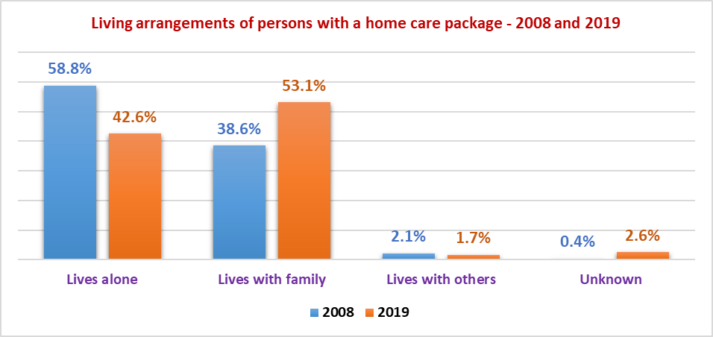

This would indicate that there are now more people who are in living arrangements where they have a part time or permanent carer, or their living partner may also be receiving some form of funded care. This may also go to the earlier point regarding persons in retirement villages. Often a person will move into a retirement village after they have lost a partner. This cohort may move into residential aged care at an earlier stage because they do not have a carer living with them.

This may have an impact on the level of services like respite that may be needed in the future to give a carer short term and longer-term relief should this trend continue. This may impact both community services such as day respite as well as providers of residential care in relation to long-stay respite.

Nationality and Preferred Language

Currently, the large majority of persons in a home care package are Australian born (62%) and English is their preferred language (84%). When taken as a proportion of the totals for each package level, there is little, if any change across the various package levels (refer Table 15).

Table : Birth country and language preference of persons in a home care package at 30 June 2019 by package level

|  |  |  |  |  |  |
| --- | --- | --- | --- | --- | --- |
|  | **Sector Data Summary** | | | | |
|  | **LEVEL 1** | **LEVEL 2** | **LEVEL 3** | **LEVEL 4** | **Total** |
| **Birth Country** |  |  |  |  |  |
| Australia | 5,211 | 29,859 | 12,572 | 18,373 | 66,015 |
| England | 628 | 3,562 | 1,712 | 2,487 | 8,389 |
| Italy | 317 | 2,217 | 831 | 1,521 | 4,886 |
| Greece | 234 | 1,255 | 503 | 815 | 2,807 |
| China (excludes SAR & Taiwan province) | 331 | 1,052 | 357 | 502 | 2,242 |
| Germany | 91 | 510 | 277 | 391 | 1,269 |
| Netherlands | 98 | 561 | 248 | 339 | 1,246 |
| New Zealand | 100 | 525 | 256 | 333 | 1,214 |
| Vietnam | 143 | 504 | 180 | 318 | 1,145 |
| India | 46 | 394 | 210 | 307 | 957 |
| Other | 1,317 | 7,295 | 3,047 | 4,878 | 16,537 |
| **Total by Birth Country** | **8,516** | **47,734** | **20,193** | **30,264** | **106,707** |
| **Preferred Language** |  |  |  |  |  |
| English Speaking | 6,045 | 34,578 | 14,877 | 21,681 | 77,181 |
| Non-English Speaking | 2,459 | 12,707 | 5,302 | 8,521 | 28,989 |
| Missing | 12 | 449 | 14 | 62 | 537 |
| **Total by Preferred Language** | **8,516** | **47,734** | **20,193** | **30,264** | **106,707** |

However, the fact that 27% of persons prefer a language other than English, has implications for workforce skills and training and also provides opportunities for providers who may specialise in services aimed at persons of a specific cultural background.

Table : Birth country and language preference of persons in a home care package at 30 June 2019 by package level (proportion of total)

|  |  |  |  |  |  |
| --- | --- | --- | --- | --- | --- |
|  | **Sector Data Summary** | | | | |
|  | **LEVEL 1** | **LEVEL 2** | **LEVEL 3** | **LEVEL 4** | **Total** |
| **Birth Country** |  |  |  |  |  |
| Australia | 61% | 63% | 62% | 61% | 62% |
| England | 7% | 7% | 8% | 8% | 8% |
| Italy | 4% | 5% | 4% | 5% | 5% |
| Greece | 3% | 3% | 2% | 3% | 3% |
| China (excludes SAR & Taiwan province) | 4% | 2% | 2% | 2% | 2% |
| Germany | 1% | 1% | 1% | 1% | 1% |
| Netherlands | 1% | 1% | 1% | 1% | 1% |
| New Zealand | 1% | 1% | 1% | 1% | 1% |
| Vietnam | 2% | 1% | 1% | 1% | 1% |
| India | 1% | 1% | 1% | 1% | 1% |
| Other | 15% | 15% | 15% | 16% | 15% |
| **Total by Birth Country** | **100%** | **100%** | **100%** | **100%** | **100%** |
| **Preferred Language** |  |  |  |  |  |
| English Speaking | 71% | 72% | 74% | 72% | 72% |
| Non-English Speaking | 29% | 27% | 26% | 28% | 27% |
| Missing | 0% | 1% | 0% | 0% | 1% |
| **Total by Preferred Language** | **100%** | **100%** | **100%** | **100%** | **100%** |

Indigenous Status

There are an average of 3% of persons in a home care package that state that they are Indigenous (Aboriginal and/or Torres Strait Islander). This is in line with the data from the 2016 Census where the proportion of the population that stated they were Indigenous was 2.7% of the total. It should be noted that the Indigenous status of the care recipient was unknown for 18.1% of packages.

Table : Indigenous status of person in a home care package at 30 June 2019

|  |  |  |  |  |  |
| --- | --- | --- | --- | --- | --- |
|  | **Sector Data Summary** | | | | |
|  | **LEVEL 1** | **LEVEL 2** | **LEVEL 3** | **LEVEL 4** | **Total** |
| **ATSI Status** |  |  |  |  |  |
| Aboriginal | 145 | 1,531 | 614 | 833 | 3,123 |
| Torres Strait Islander | 2 | 45 | 11 | 30 | 88 |
| Both | 6 | 32 | 12 | 19 | 69 |
| Neither | 6,394 | 36,021 | 17,212 | 24,478 | 84,105 |
| Unknown | 1,969 | 10,105 | 2,344 | 4,904 | 19,322 |
| **Total by ATSI Status** | **8,516** | **47,734** | **20,193** | **30,264** | **106,707** |
| **ATSI Status** |  |  |  |  |  |
| Aboriginal | 1.7% | 3.2% | 3.0% | 2.8% | 2.9% |
| Torres Strait Islander | 0.0% | 0.1% | 0.1% | 0.1% | 0.1% |
| Both | 0.1% | 0.1% | 0.1% | 0.1% | 0.1% |
| Neither | 75.1% | 75.5% | 85.2% | 80.9% | 78.8% |
| Unknown | 23.1% | 21.2% | 11.6% | 16.2% | 18.1% |
| **Total by ATSI Status** | **100.0%** | **100.0%** | **100.0%** | **100.0%** | **100.0%** |

Chart : Distribution of packages by Indigenous status at 30 June 2019

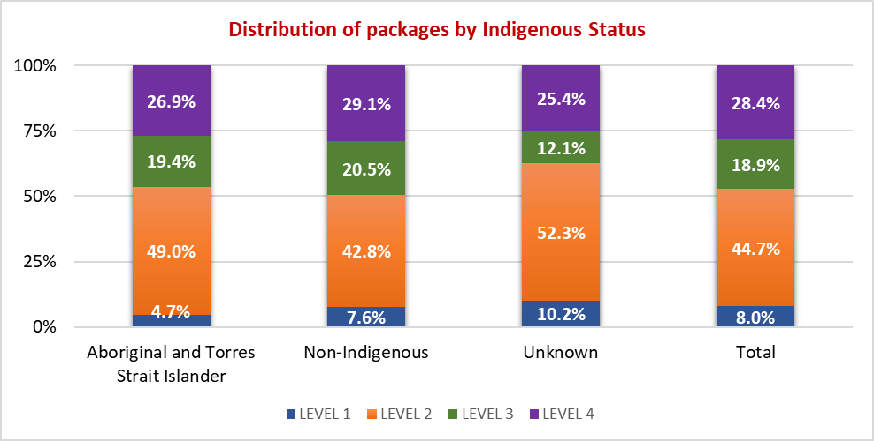

The distribution of packages by level overall does not vary greatly between Indigenous care recipients and non-indigenous care recipients.

# Summary of Outcomes at Provider Level - FY 2018-19

## Data Overview

There were a total of 485 respondents to the survey however a number of those responses were excluded from the overall data sets because of a variety of reasons including:

* Incomplete or unusable data
* No packages information provided
* No data included in the response
* Data not provided for both hours and amounts charged to clients

After these exclusions, for the purpose of the analysis conducted, data from 416 providers was used. Similarly, while there were 929 approved providers of home care, only 812 providers had packages at 30 June 2019. It is also noted that the previous analysis was based on the overall sector not on the information derived from this survey.

Table : Summary of survey data used for analysis purposes - financial data and hours data for FY 2018‑19

|  |  |  |  |  |  |  |
| --- | --- | --- | --- | --- | --- | --- |
|  | **Data include** | **Total data excluded** | ***Excluded due to no financial data*** | ***Exclude due to no package data*** | ***Exclude due to incomplete data*** | **Total data (include + exclude)** |
| No. of HC providers in the survey | 416 | 69 | 57 | 1 | 11 | 485 |
| No. of HC providers FY19 (Gen Data) | 812 | 117 | 0 | 117 | 0 | 929 |
| **HC providers % coverage** | **51%** | **na** | **na** | **na** | **na** | **52%** |
| No. of HC packages in the survey | 54,823 | 1,158 | 1,158 | 0 | 0 | 55,981 |
| No. of HC packages FY19 (Gen Data) | 106,707 | na | na | na | na | 106,707 |
| **HC packages % coverage** | **51%** | **na** | **na** | **na** | **na** | **52%** |

In both data sets, the exclusions saw very little decrease in the number of packages included in the analysis. This is because many of the exclusions related to providers that did not actually have any home care packages at 30 June 2019 or did not provide services under a home care package during the course of the year.

So while there was a decrease in the number of providers represented in the analysis to 45% of all providers at 30 June 2019 (or 51% of providers with a consumer in care), there was only a 1% reduction in the number of packages, to 51% of all packages at 30 June 2019.

The spread of data is also consistent across the various demographic markers so that there is a reasonable representation of the sector in the survey sample. Please refer to Appendix 1 for complete profile tables.

One exception to this is the number of respondents from the FP and Government run providers where the sample size is less than 50% but is still substantial.

Table : Profile of data sample by ownership type for FY 2018-19

|  |  |  |  |  |
| --- | --- | --- | --- | --- |
|  | **Not for Profit** | **For Profit** | **Government** | **Total** |
| No. of HC providers in the survey | 262 | 108 | 46 | 416 |
| No. of HC providers FY19 (Gen Data) | 479 | 335 | 115 | 929 |
| **HC providers % coverage** | **55%** | **32%** | **40%** | **45%** |
| No. of HC packages in the survey | 44,243 | 7,465 | 3,115 | 54,823 |
| No. of HC packages FY19 (Gen Data) | 77,156 | 22,317 | 7,234 | 106,707 |
| **HC packages % coverage** | **57%** | **33%** | **43%** | **51%** |

The coverage for the NFP providers is higher than the overall coverage in terms of providers and slightly higher in terms of packages (57% compared to an average of 51% representation).

There were 28 providers who participated in the deep data dive, from a total of 98 participants in the original survey that indicated their willingness to participate in the exercise.

## Analysis Overview

The analysis has four core aspects to it being:

* Total amount charged to a care recipient’s package for a particular service or fee type
* Total hours of service provided under the home care package
* Correlation between the amount charged and the hours of service provided (price)
* Funding received from subsidies and client contributions

Data has been collected at the provider level for this Phase 1 Survey with a deeper analysis to be provided in Phase 2 where data has been collected at the service level. Data outcomes are generally expressed in dollars per fortnight, hours per fortnight or average price per hour of service.

Due to the fact that data is collected at the provider level, the analysis is relatively high level although all analysis has been broken down into package levels where possible. Where data from the survey has been joined with other data provided by the Department, particularly in respect to the demographic markers, then the Department data has been aggregated and averaged to the provider level. This has made analysis of factors such as nation of birth and preferred language somewhat difficult. Where there have been other data limitations then these are explained in the relevant sections.

Data has been examined from a number of key aspects being:

* Ownership structure
* Location of the packages
* The size of the provider

Other avenues of analysis explored included:

* Average age of the care recipient
* Average age of first entry
* Gender
* Nationality and preferred language

## Package Funding

The following analysis is based on data collected for the 2018-19 financial year. The analysis of the data for the September 2019 quarter is assessed separately (see Chapter 6).

To put the total amounts charged per package per fortnight into context, it is informative to look at what is available under the current home care framework.

A care recipient is allocated a home care package based on their assessed needs. This package attracts a subsidy from the Government (which may be adjusted depending on the client’s ability to pay an income-tested care fee), and separately, the care recipient is liable to pay a basic daily fee, should the provider wish to charge it. There are also additional supplements that can be paid by Government (e.g. for dementia and cognition, veterans, viability, etc.), however these have not been included for the purposes of this analysis.

The combination of the subsidy amount and the basic daily fee represents the ***available package funding***. This available funding is shown in the table below per fortnight.

Table : Available package funding per fortnight as at 30 June 2019 (based on subsidy rates and basic daily fees published at 31 March 2019)

|  |  |  |  |  |
| --- | --- | --- | --- | --- |
| **Package funding available excluding supplements per fortnight (From March 2019)** | **Package Level** | | | |
| **Level 1** | **Level 2** | **Level 3** | **Level 4** |
| Government Supplements | $311.64 | $577.08 | $1,268.68 | $1,928.78 |
| Basic Daily Fee | $147.56 | $147.56 | $147.56 | $147.56 |
| **Total Available** | **$459.20** | **$724.64** | **$1,416.24** | **$2,076.34** |

Note that from 1 July 2019 the amount of basic daily fee paid by the care recipient for each package level changed, however the provider was to receive the same amount of funding as they would be reimbursed for any reduction in the fee amount. These new arrangements are shown in the table below.

Table : Summary of package funding available per fortnight from 1 July 2019 - excludes any supplements

|  |  |  |  |  |
| --- | --- | --- | --- | --- |
| **Package funding available excluding supplements per fortnight (From 1 July 2019)** | **Package Level** | | | |
| **Level 1** | **Level 2** | **Level 3** | **Level 4** |
| Government Supplements | $336.98 | $592.90 | $1,290.24 | $1,955.80 |
| Basic Daily Fee | $133.28 | $140.98 | $144.90 | $148.82 |
| **Total Available** | **$470.26** | **$733.88** | **$1,435.14** | **$2,104.62** |

In the analysis, data is provided on the amounts receipted from the two funding sources being the Government and the care recipient. That will often differ from the total available as described above.

This is because a number of providers do not charge the full amount of the basic daily fee and some do not charge the basic daily fee at all. This can be for a variety of reasons including that the care recipient is unable to pay due to financial hardship or chooses not to pay. Other providers may cease charging the fee if unspent funds accumulate to a certain level. Other providers use it as a marketing tool to encourage care recipients to use their services. In effect, the full value of the available package may not be “available” to the care recipient.

An analysis of the data from the pricing transparency table on My Aged Care (current at 2 January 2020) showed that the basic daily fee would be charged for only 34% of the 844 providers for which data had been provided. The other 66% of providers had zero or no amount entered for the basic daily fee charge.

Figure : Examples of pricing transparency table on My Aged Care for display of basic daily fee amount per fortnight

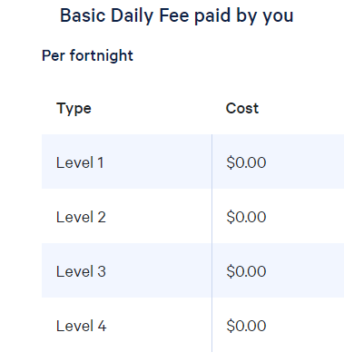 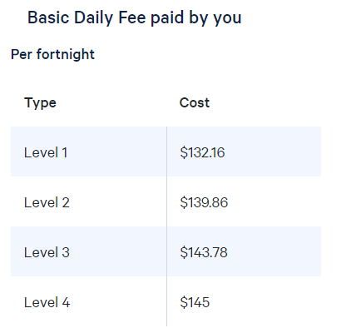

For those that are charging the basic daily fee, the average amount charged is shown below:

|  |  |  |  |  |
| --- | --- | --- | --- | --- |
| **Average price per fortnight** | **Level 1** | **Level 2** | **Level 3** | **Level 4** |
| BDF (for those that charge this) | 91.43 | 105.56 | 117.07 | 120.50 |

The combination of what has been received in Government subsidies and what has been actually been contributed by the care recipient in the form of a basic daily fee is described as the ***amount receipted*** from funding sources.

Table : Average amounts receipted by package level per fortnight and average amounts charged against a package budget based on data collected from providers for FY 2018-19

|  |  |  |  |  |
| --- | --- | --- | --- | --- |
| **Per fortnight (From March 2019)** | **Package Level** | | | |
| **Level 1** | **Level 2** | **Level 3** | **Level 4** |
| ***Average Receipted from funding sources (government and client)*** | $433.17 | $584.67 | $1,125.79 | $1,931.93 |
| Proportion of total available | 94.3% | 80.7% | 79.5% | 93.0% |
| Amount charged to client package as a proportion of amount receipted | 53.4% | 80.8% | 78.6% | 84.0% |

The ***amount charged to clients*** represents the costs charged against a client package for services rendered or for goods supplied either by the provider or a contracted third party as agreed with the care recipient while they were in care at that package level.

Based on the data, as displayed in Table 21, on average, across package Level 2 and 3, the amount of actual package available is up to 20% less than what could be available. In addition to that, the value of goods and services being charged against the available package funds is around 20% less again and in the case of Level 1 packages, almost half of the receipted funding. The difference between the amount receipted and the amount charged to the client package represents the ***unspent funds*** balance. The inverse of that unspent funds balance is the revenue or package ***utilisation rate***.

A further breakdown of these receipts from the Government and care recipient as well as the average package utilisation rate is shown in the table below. Average package utilisation is 81% when taken as a proportion of the receipted funds balance.

Table : Summary of receipts per fortnight and unspent funds at the end of the period based on data collected for FY 2018-19

|  |  |  |  |  |  |
| --- | --- | --- | --- | --- | --- |
| **Receipts and Unspent Funds** | **All Average** | **Level 1** | **Level 2** | **Level 3** | **Level 4** |
| **Receipts per fortnight from:** |  |  |  |  |  |
| Fees received from care recipients | $50.03 | $30.07 | $37.01 | $53.09 | $77.03 |
| Government subsidies received for the period | $977.86 | $403.10 | $547.66 | $1,072.70 | $1,854.90 |
| **Total receipts (Average per fortnight)** | **$1,027.89** | **$433.17** | **$584.67** | **$1,125.79** | **$1,931.93** |
| **Average Charged to care recipients per fortnight** | **$835.11** | **$231.24** | **$472.36** | **$884.69** | **$1,622.38** |
| Unutilised amount (per fortnight) | $192.78 | $201.93 | $112.31 | $241.10 | $309.55 |
| Utilisation rate | 81% | 53% | 81% | 79% | 84% |
| **Unspent funds/available balance at 30 June 2019** | $7,521 | $2,098 | $4,212 | $7,254 | $15,182 |

The highest utilisation rate is for Level 4 packages where utilisation is 84%. Despite this, unspent funds for Level 4 packages averaged $15,182 per package at June 2019. This would be due to a combination of people staying in these packages for a longer period on average and the higher level of available funds. It is also notable that the packages with the lowest utilisation rate are Level 1 packages which have the lowest level of funding available but care recipients are not utilising that funding. As this is a survey of providers rather than consumers, the reasons for this is not available as part of this survey. A question was asked in the deep dive analysis as to whether care recipients are receiving services under other funded arrangements such as the Commonwealth Home Support Programme (CHSP) however there was very little response so there is no analysis possible. The Department currently has a separate data analysis of the CHSP underway, which includes the interaction between CHSP and home care packages. This will provide a better understanding of the use and relationship between the two mainstream in‑home aged care programs.

## Unspent Funds

Unspent funds have been increasing over time and based on the data provided to this survey, if extrapolated over the total packages in the sector would account for over $800 million in unspent funds at 30 September 2019. Prior to the introduction of CDC, and the concept of tracking package funds by individual care recipients, unspent funds either helped to cross-subsidise other care recipients or contributed profits to the approved provider. Now, these funds must be returned to the Government or care recipient when they leave the system in the proportion that they contributed to the package over time.

The concern with unspent funds is such that in the 2019-20 Budget, the Government announced improvements to the payment arrangements for home care providers whereby the Government will hold the balance of unspent funds and providers will be reimbursed for their services when the service is provided, not in advance of the service being provided, as is currently the case. Moving to payment in arrears based on an invoice for services delivered will align home care with other Government programs and is intended to reduce the prudential risk in home care over time.

As noted earlier, unspent funds balances vary across package levels and is a function of the amount of funding received per fortnight for each package level and the length of time spent in the system. For example, based on the utilisation rate of the various package levels, the average length of time that has been taken to build to that level of unspent funds can be calculated as shown in the table below. Note that this is based on average funds receipted rather than on total available funds (*refer discussion above*).

Table : Estimation of average time to build the unspent funds balance for each package level FY 2018‑19

|  |  |  |  |  |  |
| --- | --- | --- | --- | --- | --- |
| **Receipts and Unspent Funds** | **All Average** | **Level 1** | **Level 2** | **Level 3** | **Level 4** |
| **Receipts per fortnight from:** |  |  |  |  |  |
| Fees received from care recipients | $50.03 | $30.07 | $37.01 | $53.09 | $77.03 |
| Government subsidies received for the period | $977.86 | $403.10 | $547.66 | $1,072.70 | $1,854.90 |
| **Total receipts (Average per fortnight)** | **$1,027.89** | **$433.17** | **$584.67** | **$1,125.79** | **$1,931.93** |
| **Average Charged to care recipients per fortnight** | **$835.11** | **$231.24** | **$472.36** | **$884.69** | **$1,622.38** |
| Unutilised amount (per fortnight) | $192.78 | $201.93 | $112.31 | $241.10 | $309.55 |
| Utilisation rate | 81% | 53% | 81% | 79% | 84% |
| **Unspent funds/available balance at 30 June 2019** | $7,521 | $2,098 | $4,212 | $7,254 | $15,182 |
| Average length of time to accumulate the unspent funds balance based on unutilised amount per fortnight | | | | | |
|  | **All Average** | **Level 1** | **Level 2** | **Level 3** | **Level 4** |
| - Days | 546 days | 146 days | 525 days | 421 days | 687 days |
| - Years | 1.5 years | 0.4 years | 1.4 years | 1.2 years | 1.9 years |

On average, based on the unutilised portion of a package per fortnight of $192.78, it would take 1.5 years to build to the average balance of unspent funds at 30 June 2019 of $7,521.

The deep dive survey also enabled the analysis to extend to the stratification of the average unspent funds balances of those providers who supplied the information.

Table : Stratification of unspent funds report by respondents to the deep dive data collection process for FY 2018‑19

|  |  |  |  |  |  |
| --- | --- | --- | --- | --- | --- |
|  | **2018-19 Financial Year** | | | | |
|  | **Level 1** | **Level 2** | **Level 3** | **Level 4** | **All** |
| Total packages at period end | 472 | 3,108 | 1,038 | 1,874 | 6,492 |
| Total care recipients with unspent or available funds | 432 | 2,919 | 990 | 1,861 | 6,202 |
| Total unspent funds | $448,276 | $13,711,205 | $6,494,236 | $25,304,521 | $45,958,238 |
| Average unspent funds per package | $1,038 | $4,697 | $6,560 | $13,597 | $7,410 |
| Number of clients with unspent funds within each bracket below |  |  |  |  |  |
| $0 - $2,499 | 389 | 1,197 | 279 | 252 | 2,117 |
| $2,500 - $4,999 | 37 | 703 | 230 | 267 | 1,237 |
| $5,000 - $7,499 | 4 | 435 | 155 | 233 | 827 |
| $7,500 - $9,999 | 1 | 230 | 119 | 215 | 565 |
| $10,000 - $14,999 | 1 | 224 | 123 | 295 | 643 |
| $15,000 - $19,999 | 0 | 94 | 47 | 171 | 312 |
| $20,000 - $29,999 | 0 | 34 | 29 | 214 | 277 |
| $30,000 - $39,999 | 0 | 2 | 8 | 109 | 119 |
| $40,000 - $49,999 | 0 | 0 | 0 | 61 | 61 |
| Over $50,000 | 0 | 0 | 0 | 44 | 44 |
| **Total** | **432** | **2,919** | **990** | **1,861** | **6,202** |
| Percentage of clients with unspent funds within each bracket below |  |  |  |  |  |
| $0 - $2,499 | 90% | 41% | 28% | 14% | 34% |
| $2,500 - $4,999 | 9% | 24% | 23% | 14% | 20% |
| $5,000 - $7,499 | 1% | 15% | 16% | 13% | 13% |
| $7,500 - $9,999 | 0% | 8% | 12% | 12% | 9% |
| $10,000 - $14,999 | 0% | 8% | 12% | 16% | 10% |
| $15,000 - $19,999 | 0% | 3% | 5% | 9% | 5% |
| $20,000 - $29,999 | 0% | 1% | 3% | 11% | 4% |
| $30,000 - $39,999 | 0% | 0% | 1% | 6% | 2% |
| $40,000 - $49,999 | 0% | 0% | 0% | 3% | 1% |
| Over $50,000 | 0% | 0% | 0% | 2% | 1% |
| **Total** | **100%** | **100%** | **100%** | **100%** | **100%** |

Given the distribution patterns of unspent funds for package Levels 2 through 4 it might be useful in future to speak about the median value of unspent funds as well as the overall average to get a better sense of where the range of balances lay. Providing the minimum and maximum values of unspent funds by package level would also help to inform the analysis. These measures would be useful in any future survey and analysis. Unfortunately, due to this information not being available as part of the deep dive or initial analysis, analysis of this type is not possible in this report.

Chart : Stratification of unspent funds for Level 1 packages based on the deep dive data collection process for FY 2018‑19

90% of unspent funds balances are less than $2,500.
9% of unspent fund balances were between $2,500 and $4,999, and 1% between $5,000 and $7,499.

For Level 1 packages, 90% of all unspent funds balances are less than $2,500 which aligns with the fact that the average unspent funds for the respondents was $1,038. It is also likely to be generally representative of the overall survey where the unspent funds balance averaged $2,098 for Level 1 packages.

Chart : Stratification of unspent funds for Level 2 packages based on the deep dive data collection process for FY 2018‑19

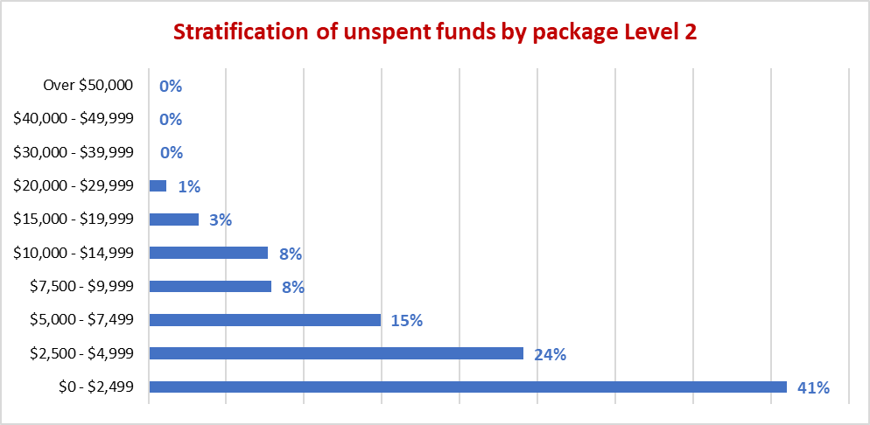

The average unspent funds balance for Level 2 packages in the respondents to the deep dive survey was $4,697 which was slightly higher than the average in the full survey of $4,212. However, 65% of the unspent funds balances were at or below the average with only 35% being above the average. Indeed, 41% of the balances were less than $2,500.

Chart : Stratification of unspent funds for Level 3 packages based on the deep dive data collection process for FY 2018‑19

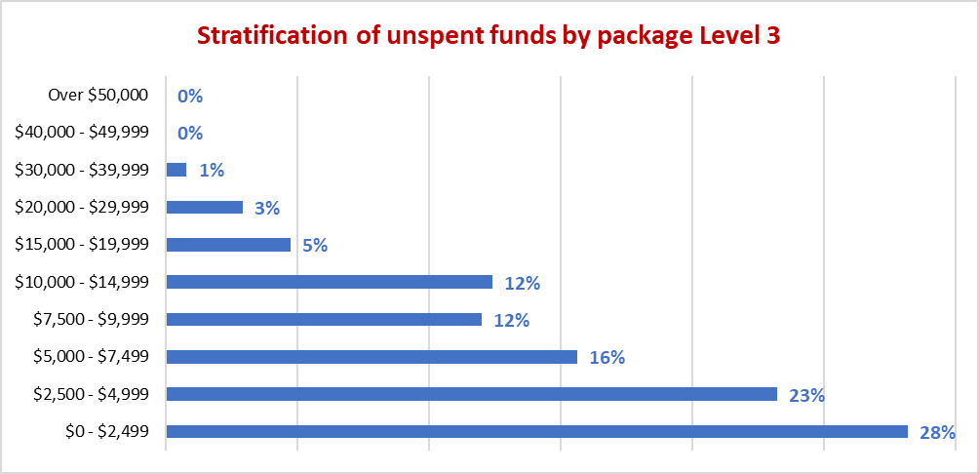

The average unspent funds balance for Level 3 packages in the respondents to the deep dive survey was $6,560 which was less than the average in the full survey of $7,254. However, 67% of the unspent funds balances were around or below the average with only 33% being above the average. Indeed, 51% of the balances were less than $5,000.

Chart : Stratification of unspent funds for Level 4 packages based on the deep dive data collection process for FY 2018‑19

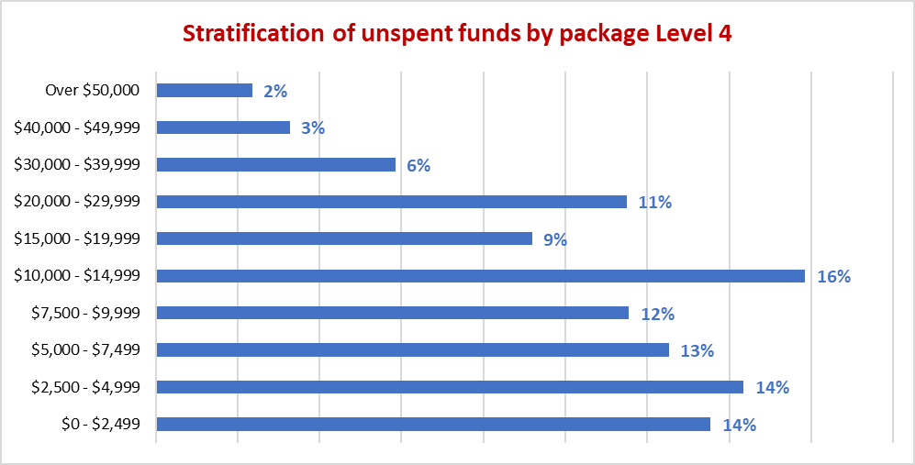

In contrast, there is a far greater spread but more even spread in the distribution of unspent funds in relation to the Level 4 packages data collected as part of the deep dive process.

The average unspent funds for Level 4 packages in this group of respondents was $13,597 which is less than the average of the general survey of $15,182. However, like the package levels 2 and 3, the majority (69%) of unspent funds balances fell at or below the average.

## Charges to Care Recipient Packages

***The following analysis relates to the charges against a care recipient’s package funds for services provided, goods supplied, for administration costs and other allowable charges.***

This analysis used data from 416 providers covering 54,823 packages representing 51% of all the packages operative at 30 June 2019. The data is for the 2018-19 financial year.

The following table provides a summary of the average amount charged per package per fortnight by package level for a variety of services and other items for which data was collected in this survey.

Table : Summary of average amount charged to client home care package budgets per fortnight for the listed items for FY 2018-19

|  |  |  |  |  |  |
| --- | --- | --- | --- | --- | --- |
| **Total Amount Charged to Care Recipients** | **2018-19 Financial Year** | | | | |
|  | **All Average** | **Level 1** | **Level 2** | **Level 3** | **Level 4** |
| Total number of packages | 54,823 | 3,222 | 27,234 | 9,973 | 14,394 |
| Total estimated number of subsidised days | 19,999,171 | 1,174,852 | 9,935,652 | 3,638,668 | 5,249,998 |
| Care management | $135.63 | $42.24 | $85.01 | $150.49 | $242.04 |
| Admin charge/(Package mgt - Sept. Qtr) | $153.04 | $47.46 | $86.94 | $174.14 | $287.12 |
| Nursing care - registered nurse | $8.52 | $1.08 | $2.45 | $10.46 | $20.34 |
| Nursing care - enrolled nurse or other licensed nurse | $3.87 | $0.43 | $0.71 | $3.66 | $10.78 |
| Personal care | $149.59 | $28.29 | $61.42 | $150.13 | $343.23 |
| Cleaning and household tasks | $90.23 | $43.54 | $73.86 | $94.66 | $128.57 |
| Meal preparation | $12.56 | $2.50 | $6.11 | $12.89 | $26.78 |
| Social support, shopping services, community access | $81.01 | $18.71 | $48.16 | $84.38 | $154.77 |
| Consumables | $19.23 | $4.64 | $9.96 | $20.52 | $39.14 |
| Light gardening | $14.21 | $6.85 | $10.66 | $15.20 | $21.88 |
| In-home respite (day-time) | $22.95 | $2.07 | $6.25 | $21.33 | $60.33 |
| In-home respite (overnight) | $2.45 | $0.16 | $0.45 | $1.62 | $7.33 |
| Transport services | $17.72 | $4.33 | $12.18 | $18.62 | $30.57 |
| Allied health professional (practitioner) | $22.30 | $4.18 | $10.52 | $23.42 | $47.87 |
| Capital purchases | $29.53 | $5.02 | $15.26 | $31.91 | $60.38 |
| Home modifications | $9.11 | $1.36 | $4.25 | $9.15 | $20.01 |
| Home maintenance | $9.19 | $3.23 | $5.67 | $9.41 | $17.02 |
| Travel expenses | $8.93 | $2.56 | $4.68 | $10.34 | $17.41 |
| Other services required to maintain the care recipient at home | $37.65 | $10.56 | $23.39 | $35.34 | $72.32 |
| Maximum exit amount | $1.61 | $0.97 | $1.37 | $1.58 | $2.22 |
| Processing charge on third party purchases/subcontracting | $5.79 | $1.06 | $3.07 | $5.44 | $12.27 |
| **Total Amount Charged to Clients** | **$835.11** | **$231.24** | **$472.37** | **$884.69** | **$1,622.38** |

As expected, the average amount charged against a package increases as the package level increases which is a function of both the increasing assessed needs of the care recipient and the increase in funding available under the package.

There are a number of observations in relation to the services being charged to care recipient packages:

* There is a significant proportion of the total amount charged allocated to care management and the administration charge
* There is very little charged for nursing care by specialist nursing staff (registered or enrolled) although the amount charged does increase as package levels increase
* There is very little charged for in-home respite services although the amount charged does increase as package levels increases
* The most predominant categories are personal care; cleaning and household tasks; and social support, shopping services, community access services
* Capital purchases plays very little role in a Level 1 package but increases for Level 2 packages onwards. If extrapolated over a year the amount of capital purchases increases from an average of $130 per annum for a Level 1 package to $1,570 per annum for a Level 4 package. Overall capital purchases average $768 per annum per package - this explored further below in Section 5.8

Table : Amounts charged to care recipient packages as a proportion of package funds receipted for FY 2018‑19

|  |  |  |  |  |  |  |
| --- | --- | --- | --- | --- | --- | --- |
| **Total Amount Charged to Care Recipients - Proportion of amount receipted** | **2018-19 Financial Year** | | | | |  |
| **All Average** | **Level 1** | **Level 2** | **Level 3** | **Level 4** |  |
| Care management | 13% | 10% | 15% | 13% | 13% |  |
| Admin charge/(Package mgt - Sept. Qtr) | 15% | 11% | 15% | 15% | 15% |  |
| Nursing care - registered nurse | 1% | 0% | 0% | 1% | 1% |  |
| Nursing care - enrolled nurse or other licensed nurse | 0% | 0% | 0% | 0% | 1% |  |
| Personal care | 15% | 7% | 11% | 13% | 18% |  |
| Cleaning and household tasks | 9% | 10% | 13% | 8% | 7% |  |
| Meal preparation | 1% | 1% | 1% | 1% | 1% |  |
| Social support, shopping services, community access | 8% | 4% | 8% | 7% | 8% |  |
| Consumables | 2% | 1% | 2% | 2% | 2% |  |
| Light gardening | 1% | 2% | 2% | 1% | 1% |  |
| In-home respite (day-time) | 2% | 0% | 1% | 2% | 3% |  |
| In-home respite (overnight) | 0% | 0% | 0% | 0% | 0% |  |
| Transport services | 2% | 1% | 2% | 2% | 2% |  |
| Allied health professional (practitioner) | 2% | 1% | 2% | 2% | 2% |  |
| Capital purchases | 3% | 1% | 3% | 3% | 3% |  |
| Home modifications | 1% | 0% | 1% | 1% | 1% |  |
| Home maintenance | 1% | 1% | 1% | 1% | 1% |  |
| Travel expenses | 1% | 1% | 1% | 1% | 1% |  |
| Other services required to maintain the care recipient at home | 4% | 2% | 4% | 3% | 4% |  |
| Maximum exit amount | 0% | 0% | 0% | 0% | 0% |  |
| Processing charge on third party purchases/subcontracting | 1% | 0% | 1% | 0% | 1% |  |
| **Package Utilisation** | **81%** | **53%** | **81%** | **79%** | **84%** |  |

|  |  |
| --- | --- |
| Increase in proportion of package |  |
| Decrease in proportion of package |  |
| Neutral |  |

Across all package levels, care management and the administration charge average a total of 28% of the package receipts for FY 2018-19. There is a clear trend that as the package levels increase, and the care needs of the client increases, the type of services being provided does change, particularly between personal care services and cleaning and household services.

Chart : Top four services charged to client packages as a proportion of the package value receipted - changes across package levels for FY 2018-19

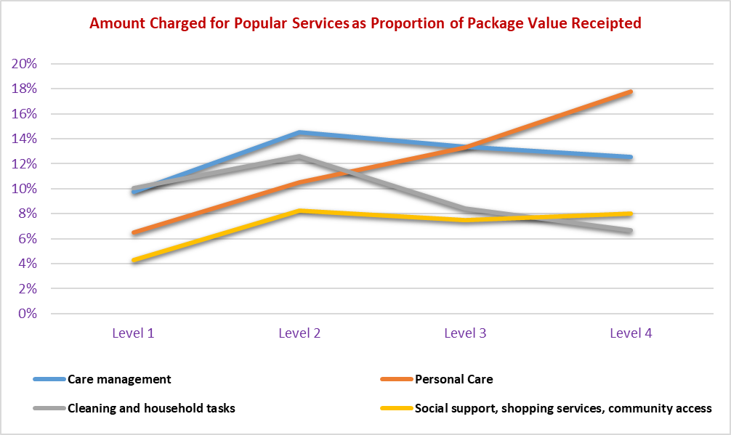

There is a clear trend towards more personal care services as the package levels increase and most of this comes from a decreasing proportion charged for the cleaning and household tasks as well as care management.

It is also notable that there is an increase in a number of services between a Level 1 package and the Level 2 packages and upwards. For some services there is an initial increase and then a decline as package levels increase beyond level 2 package. Given that the utilisation rates for Level 1 packages is close to 50% and that of a Level 2 package is just over 80%, this sort of jump in the level of services provided between a Level 1 and Level 2 package is expected.

## Hours of Service

***The following analysis relates to the hours of service provided to care recipients under a home care package.***

This analysis used data from the same 416 providers for which the preceding financial analysis used. The data is for the 2018-19 financial year.

The analysis of data at the provider, and other levels has used the same service categories as the analysis of the amounts charged against a package.

The following table provides a summary of the average hours provided for each service type by package level and across all the packages in the survey.

Table : Summary of average hours of service per package per fortnight by service type for FY 2018-19

|  |  |  |  |  |  |
| --- | --- | --- | --- | --- | --- |
|  | **2018-19 Financial Year** | | | | |
|  | **All Average** | **Level 1** | **Level 2** | **Level 3** | **Level 4** |
| Total number of packages | 54,823 | 3,222 | 27,234 | 9,973 | 14,394 |
| Total number of subsidised days | 19,999,171 | 1,174,852 | 9,935,652 | 3,638,668 | 5,249,998 |
| Care management | 1.23 | 0.65 | 0.82 | 1.43 | 2.01 |
| Nursing care - registered nurse | 0.11 | 0.02 | 0.03 | 0.14 | 0.26 |
| Nursing care - enrolled nurse or other licensed nurse | 0.03 | 0.01 | 0.01 | 0.03 | 0.08 |
| Personal care | 2.58 | 0.50 | 1.10 | 2.64 | 5.82 |
| Cleaning and household tasks | 2.04 | 0.98 | 1.67 | 2.13 | 2.92 |
| Social support, shopping services, community access | 1.65 | 0.45 | 1.05 | 1.87 | 2.89 |
| Light gardening | 0.18 | 0.12 | 0.15 | 0.22 | 0.24 |
| In-home respite (day-time) | 0.46 | 0.07 | 0.13 | 0.45 | 1.19 |
| In-home respite (overnight) | 0.06 | 0.00 | 0.01 | 0.04 | 0.16 |
| Transport services | 0.45 | 0.16 | 0.30 | 0.54 | 0.73 |
| Allied health professional (practitioner) | 0.13 | 0.03 | 0.07 | 0.14 | 0.25 |
| Other services provided to the home care recipient | 0.53 | 0.12 | 0.33 | 0.58 | 0.97 |
| **Total Hours of Service Provision** | **9.46** | **3.10** | **5.68** | **10.20** | **17.52** |

*For clarity in relation to the measurements in the tables relating to hours -* ***9.46 hrs*** *is equivalent to* ***9 hours 28 minutes***

There is a similar pattern in the number of hours of service provided as there was with the charges against the package, as package levels change. There is a general increase in the hours of service for most service types as package levels increase.

One service where the increase in service provision was not clear from the data on amounts charged to packages, is the growth in the level of in-home day respite provided as package levels increase. With respect to the amount charged to a package the proportion increases from 0% to 3% but with respect to the hours of service delivered the proportion increases from 2% of the total hours of service for a Level 1 package to 7% of a Level 4 package.

Table : Summary of average hours of service per package per fortnight by service type as a proportion of total hours provided for FY 2018-19

|  |  |  |  |  |  |  |
| --- | --- | --- | --- | --- | --- | --- |
|  | **2018-19 Financial Year** | | | | |  |
|  | **All Average** | **Level 1** | **Level 2** | **Level 3** | **Level 4** |  |
| Care management | 13% | 21% | 14% | 14% | 11% |  |
| Nursing care - registered nurse | 1% | 1% | 1% | 1% | 2% |  |
| Nursing care - enrolled nurse or other licensed nurse | 0% | 0% | 0% | 0% | 0% |  |
| Personal care | 27% | 16% | 19% | 26% | 33% |  |
| Cleaning and household tasks | 22% | 31% | 29% | 21% | 17% |  |
| Social support, shopping services, community access | 17% | 15% | 19% | 18% | 16% |  |
| Light gardening | 2% | 4% | 3% | 2% | 1% |  |
| In-home respite (day-time) | 5% | 2% | 2% | 4% | 7% |  |
| In-home respite (overnight) | 1% | 0% | 0% | 0% | 1% |  |
| Transport services | 5% | 5% | 5% | 5% | 4% |  |
| Allied health professional (practitioner) | 1% | 1% | 1% | 1% | 1% |  |
| Other services provided to the home care recipient | 6% | 4% | 6% | 6% | 6% |  |
| **Total Hours of Service Provision** | **100%** | **100%** | **100%** | **100%** | **100%** |  |

Chart : Hours of service provided as proportion of total hours for top 4 services - trends between package levels for FY 2018-19

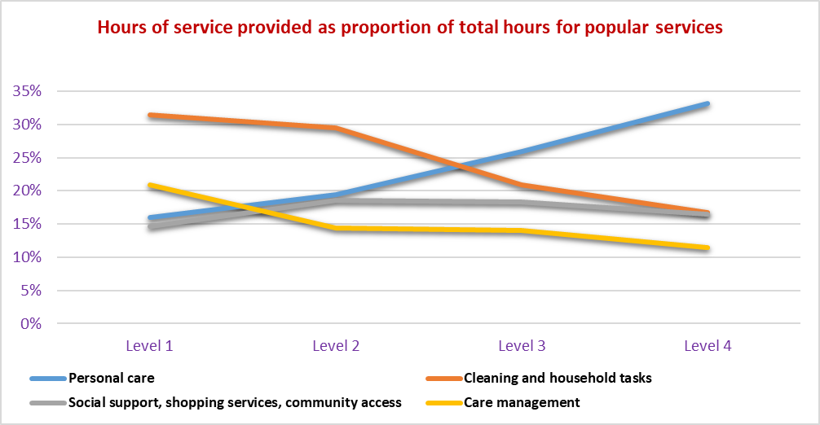

As package levels and assessed needs of the care recipients increase, the biggest increase in hours is in respect of personal care with declines in cleaning and household tasks.

Noting the above qualifications about comparisons, these top service types were similar to the 2008 Community Care Census. Personal care, social support and domestic assistance have remained the most common. However, there are differences in the total number of hours delivered in 2019 as compared to the 2008 Community Care Census. According to the 2019 survey, the average hours of direct care provided to a low care package was 2.4 hours per week compared to 5.4 hours per week in 2008. For a high care package there was 7.8 hours of service provided on average to a high care package compared to 14.1 hours per week in 2008.

Table : Comparison of outcomes for FY 2018-19 survey and 2008 Community Care Census

|  |  |  |  |
| --- | --- | --- | --- |
|  | **FY 2019 Survey** | **2019 Sector** | **2008 Census** |
| **Sector Profile** |  |  |  |
| Number of packages | 58,540 | 106,707 | 40,280 |
| % of persons in a Low Care package | 53.0% | 52.7% | 87.5% |
| % of persons in a High Care package | 47.0% | 47.3% | 12.5% |
| **Hours of Service (per week)** |  |  |  |
| Average hours of direct service |  |  |  |
| Low Care Package | 2.4 |  | 5.4 |
| High Care Package | 7.8 |  | 14.1 |
| Average hours of Care Management |  |  |  |
| Low Care Package | 0.4 |  | 1.4 |
| High Care Package | 1.0 |  | 2.3 |

*Note: when comparing hours of service, a low care package compares a Level 2 package with CACP and a high care package compares a Level 4 package with an EACH package.*

## Price of Services

The relationship between the hours of service and the amount charged to a client package should be directly attributable to the price of services.

Table : Average price of services estimated using hours of service and amounts charged to care recipient packages for FY 2018‑19

|  |  |  |  |  |  |
| --- | --- | --- | --- | --- | --- |
| **Average cost per hour** | **Survey Average** | **Level 1** | **Level 2** | **Level 3** | **Level 4** |
| Care management | 109.85 | 65.39 | 103.68 | 104.98 | 120.19 |
| Nursing care - registered nurse | 76.10 | 57.35 | 72.50 | 77.29 | 76.84 |
| Nursing care - enrolled nurse or other licensed nurse | 123.40 | 64.64 | 96.14 | 113.57 | 131.80 |
| Personal care | 57.87 | 56.93 | 55.73 | 56.80 | 59.00 |
| Cleaning and household tasks | 44.18 | 44.65 | 44.14 | 44.52 | 44.02 |
| Social support, shopping services, community access | 49.17 | 41.30 | 45.79 | 45.10 | 53.60 |
| Light gardening | 76.81 | 57.80 | 70.08 | 68.93 | 92.14 |
| In-home respite (day-time) | 49.51 | 31.48 | 47.38 | 47.42 | 50.73 |
| In-home respite (overnight) | 43.85 | 55.90 | 31.32 | 43.96 | 45.90 |
| Transport services | 39.55 | 26.67 | 40.54 | 34.74 | 41.86 |
| Allied health professional (practitioner) | 177.28 | 143.06 | 157.44 | 165.62 | 192.89 |
| Other services provided to the home care recipient | 71.08 | 86.09 | 70.91 | 61.21 | 74.85 |
| **Average price per hour of service** | **61.96** | **52.43** | **58.95** | **59.72** | **65.08** |
| Average charged - total charge / hours of service (includes all charges) | 88.27 | 74.64 | 83.11 | 86.70 | 92.62 |

The data above is an estimate of price and is formulated using average hours of service and average amounts charged at a provider level. It does not take into account variances relating to location, service delivery model and other variables. However, with some exceptions, there is a relative consistency in pricing for individual services across package levels. The exceptions are largely those specialist areas such as nursing care and allied health services. Some of the variances that are observed may include the type or range of service being provided to the care recipient and having it included under a broader heading. Nursing care and allied health services may be examples where the type of person delivering the service, and the type of service may vary within those broad headings.

However, there are inconsistencies across services where similarly skilled staff might be used to carry out the task and for a number of providers, they would provide multiple services in a single visit using the same staff member. Taking a Level 2 package from the table above the following average prices are charged for the following service types which might be carried out by staff with a similar skill mix:

* Personal care - $55.73 per hour
* Cleaning and household tasks - $44.14 per hour
* Social support, shopping services, community access - $45.79
* In-home respite (day time) - $47.38

To assist with understanding provider behaviour with respect to the pricing of services, as well as to gain a sense on where the pricing of services might be heading in the future, a data set from the pricing transparency tables on My Aged Care have been analysed. Based on the analysis of that data we can observe that the charges for some of these core services are far more consistent as shown in the chart below.

Chart : Comparison of prices under new pricing transparency arrangements against FY 2018-19 estimated prices for core services

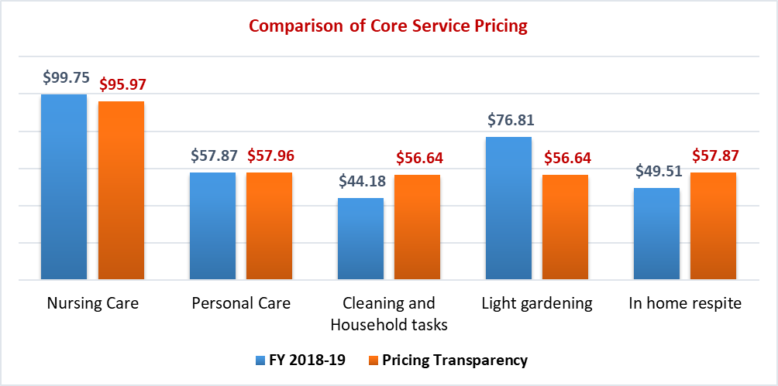

The ***care management*** charge is interesting in that both hourly rate and the number of hours provided vary as package levels change so that the total amount charged to the persons package is a function of both an increasing number of hours and an increasing hourly rate.

Table : Summary of average charge to a package and average hours of service provided for care management by package level for FY 2018-19

|  |  |  |  |  |  |
| --- | --- | --- | --- | --- | --- |
| ***Care Management*** | **2018-19 Financial Year** | | | | |
| **Total** | **Level 1** | **Level 2** | **Level 3** | **Level 4** |
| Charge against package ($ per fortnight) | $135.63 | $42.24 | $85.01 | $150.49 | $242.04 |
| Hours of service provided (per fortnight) | 1.23 | 0.65 | 0.82 | 1.43 | 2.01 |
| **Average hourly rate** | **$109.85** | **$65.39** | **$103.68** | **$104.98** | **$120.19** |

Comparisons to Pricing Transparency Data

While the new pricing transparency arrangements did not commence until 1 July 2019 it is still informative and provides some further insights into the pricing strategies for care management services. The pattern of behaviour that has been established in the FY 2018-19 remains in place post 1 July 2019 based on analysis of the data provided by the Department from the pricing transparency tables on My Aged Care.

Table : Summary of prices for care management sourced from the pricing transparency tables on My Aged Care - prices applicable at January 2020 and for the same 416 providers included in the survey

|  |  |  |  |  |
| --- | --- | --- | --- | --- |
| **Average price per fortnight** | **Level 1** | **Level 2** | **Level 3** | **Level 4** |
| Care management - fully managed | $57.19 | $103.53 | $228.49 | $290.44 |
| Care management - self managed | $49.82 | $71.14 | $121.59 | $161.64 |
| Care management hours - fully managed | 1.19 | 1.94 | 3.27 | 4.55 |
| Care management hours - self managed | 1.15 | 1.37 | 1.94 | 2.81 |
| **Care management average hourly rate - fully managed** | **$48.18** | **$53.25** | **$69.81** | **$63.78** |
| **Care management average hourly rate - self managed** | **$43.50** | **$52.04** | **$62.54** | **$57.62** |

Pricing levels on an hourly basis change as package levels change. Interestingly, for this sample of providers the average hourly rate for care management for a Level 4 package is less than for a Level 3 package.

The other observation is that the average cost per hour for care management, and the amount charged against a client package is likely to be less in the survey findings than from 1 July 2020 once the new pricing structures are transitioned to all existing clients (see also Section 6.3).

Table : Summary of prices for care management sourced from the pricing transparency tables on My Aged Care - prices applicable at January 2020 and for all providers with data

|  |  |  |  |  |
| --- | --- | --- | --- | --- |
| **Average price per fortnight** | **Level 1** | **Level 2** | **Level 3** | **Level 4** |
| Care management - fully managed | $57.83 | $104.69 | $223.73 | $303.75 |
| Care management - self managed | $45.17 | $66.90 | $120.78 | $165.16 |
| Care management hours - fully managed | 1.89 | 2.87 | 4.69 | 6.35 |
| Care management hours - self managed | 2.30 | 2.53 | 2.90 | 3.78 |
| **Care management average hourly rate - fully managed** | **$30.64** | **$36.50** | **$47.67** | **$47.80** |
| **Care management average hourly rate - self managed** | **$19.64** | **$26.49** | **$41.60** | **$43.68** |

Of note when comparing the pricing data for the sample of 416 providers to those in the sector generally, there is not a significant difference in the fortnightly charge for care management costs but there is a difference in the estimated hours of service. This results in a lower average hourly rate when examining all providers.

It also needs to be understood that the hours used for this calculation is an estimate of the number of hours of care management that will be provided to a care recipient. The charge itself is not charged at an hourly rate, rather a fixed rate per fortnight with an estimate in how many hours that will provide. This means that it is not a pure calculation but an estimate.

It would be expected that the number of hours of care management will increase as package levels increase due to the complexity and level of the care recipient’s needs. However, the staff providing the service would generally do so for a portfolio of packages which would normally cover the range of package levels and so the change in the effective rate per hour would not be reflective of the changes in the skill set of the person carrying out the care management tasks.

Instead, this would be part of the overall business model of providers to be able to recover the overall cost of care management across the various package levels. The actual cost of providing care management to a Level 1 client may not be fully recovered with the charge to them and the cost would be fully met by charges to other package levels.

## Other Items Provided to Clients

### Capital Items

As previously noted, capital purchases do not play a significant role in the amounts charged against a package for Level 1 packages but become more significant in Level 2 packages onwards (3% of overall amounts charged in FY 2018-19). Anecdotally, providers have said that a number of care recipients are choosing providers based on whether or not a provider will include a particular type of capital purchase in the package. To address these issues, further guidance and information has recently been provided to providers and consumers on the appropriate use of home care package funds. This includes the release of an inclusion and exclusion framework as part of the Home Care Provider and Consumer Manuals in March 2020.

Providers also note that care recipients, will often set aside package funds that might otherwise be used for direct services, to purchase a capital item in the future. This is often given as a reason for the build-up of unspent fund balances.

Capital purchases was one of the areas that was explored in greater detail as part of the deep dive survey.

The following questions were asked in relation to both the number of purchases and the total spend on capital purchases:

* What was the total number of capital purchases by package level?
* What was the total spend on capital purchases by package level?
* What were the top 5 capital items by volume purchased by clients?

A total of 14 respondents provided information on the average capital spend by package level. Three providers, covering a total of 610 packages, provided more detail on the type of items purchased. The results of those responses are shown below.

Table : Average spend per capital item purchased by package level for FY 2018‑19

|  |  |  |  |  |
| --- | --- | --- | --- | --- |
| **Package Level** | **Level 1** | **Level 2** | **Level 3** | **Level 4** |
| Average spend per capital item purchased | $380 | $1,036 | $1,865 | $1,710 |

Chart : Capital purchases by volume

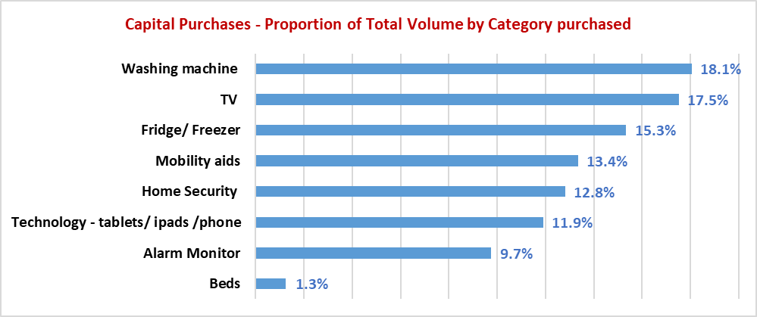

*Based on detailed responses from three providers covering 554 items purchased*

Overall, the most popular item purchased by volume was a washing machine closely followed by a TV. Assistive beds were very low on the list. Of note is the purchases of handheld devices (11.9%) because there are a number of providers that are now providing a tablet or other handheld device as part of the package with an App installed that allows the client to manage their package, contact support and so forth.

Mobility aids comes in half-way down the list and the level of 13.4% of the overall volume is similar across package Levels 2 through 4.

The only capital purchase provided for a Level 1 package (not shown in the chart below but included in the average above) was for a handheld device (iPad or tablet).

The full list of items purchased as part of a care recipients’ package is as follows:

* Mobility Aids
* Alarm Monitor
* Beds
* Hearing Aid
* Technology - Tablets/ iPads /Phone
* Fridge/ Freezer
* Bathroom and Toilet
* Household
* TV
* Washing Machine
* Home Security
* Compression Socks
* Oxygen Concentrator
* Hoist
* Personal Aids
* Furniture
* Safety
* Social Medium

Chart : Summary of capital purchases by proportion of total volume purchased by package level for FY 2018-19

*Based on detailed responses from three providers covering 554 items purchased*

For Level 2 packages, the most popular item purchased is some form of monitor or call system. For the higher package levels, home security systems appear to become a higher priority.

This is a very different landscape to that which was operating when the 2008 Community Care Census was taken. At that stage equipment was generally either purchased by the care recipient or hired from the provider. The most common items provided to CACP recipients were walking aids (48%), shower chairs (40%), commodes/bed pan/toilet equipment modification (23%). Most equipment was either provided by the service provider (34% of all equipment) or purchased by the care recipient not using package funds (45%). Walking aids were the item most likely to be purchased by the care recipient (57% of all walking aids available to CACP recipients). Key safe/locks were the item most likely to be supplied by the service provider (65% of all key safe/locks available to CACP recipients).

With respect to EACH packages the most common item was shower chairs (68% of all EACH recipients), followed by continence aids and appliances (57%), and commodes/bed pan/toilet equipment modification (56%). Nearly two-thirds (64%) of all equipment was provided by the service providers, which is nearly double that for the CACP program. The higher proportion of items provided by the service provider is not just for highly specialised equipment but also for the type of equipment used by CACP recipients. Electric wheelchairs were the item most likely to be purchased by the care recipient (53% of all electric wheelchairs available to EACH recipients).

Since 2008, it seems that the types of capital purchases or their proportion of commonality has changed. However, a key consideration is that the data from 2019 only reflects the capital purchases that the package funds are being used to buy, and no data is available on the equipment being purchased by the care recipient separately, obtained via other community or aged care programs or hired for them by the approved provider.

### Allied Health Services

Allied health services is one those areas that cover a broad range of services and specialties which are often aggregated under a single banner. As part of the deep dive survey, providers were asked to provide a more granular analysis of the types of services provided based on the number of hours and the amounts charged to packages. Based on that data the following were the most popular services in order:

1. Physiotherapy
2. Occupational therapy
3. Podiatry
4. Massage therapy
5. Dietician
6. Exercise physiologist
7. Speech therapy

There were some other categories listed by providers but very little commonality across those that did provide these additional items with the exception of dental. The list of additional items are as follows:

* Psychology
* Optometry
* Dental
* Personal trainer
* Radiology

The average cost per hour for those key services are as follows along with a comparison to the average price of allied health services based on the data for FY 2018-19 is displayed in the graph below:

Chart : Comparison of allied health service prices between the average of the FY 2018-19 survey and the deep dive analysis

The average price of allied health services in FY2018-19 is $177.28
Deep Dive data in this chart shows Speech Therapy with the highest price of $251.24, followed by Exercise Physiologist ($185.85), Occupational Therapy (138.91), Physiotherapy ($117.71), Podiatry ($108.73), Massage Therapy ($89.18) and Dietician ($56.71).

What we see is a wide range of pricing of services based on the range of skills required to provide the service.

### Consumables

Consumables account for around 2% of the charges against a home care package across package Levels 2 to 4 and 1% for a Level 1 package. The average amount charged against a package for these items does increase as package levels increase from $4.64 per fortnight for a Level 1 package to $39.14 per fortnight for a Level 4 package.

The deep dive survey explored this in further detail to ascertain what type of items are being purchased for care recipients and the volume of those purchases. Of the 28 providers who submitted some data to the deep dive survey, seven provided data relating to consumables and these seven providers represented a total of 1,299 packages. So while it is a relatively small sample, it does provide some insight into the types of consumables being purchased.

Table : Type and quantity of consumables purchased by package level based on information received in the deep dive survey for the FY 2018-19

|  |  |  |  |  |  |
| --- | --- | --- | --- | --- | --- |
| **Quantity of Consumables Purchased** | **Level 1** | **Level 2** | **Level 3** | **Level 4** | **Total** |
| Bandage | 400 | 640 | 280 | 330 | **1,650** |
| Care Alarm / GPS Tracker | 1 | 3 | 3 | 3 | **10** |
| Dressing | 0 | 18 | 20 | 290 | **328** |
| Household | 0 | 0 | 8 | 13 | **21** |
| Incontinence Aids | 335 | 2,533 | 940 | 2,297 | **6,105** |
| Medication | 80 | 169 | 74 | 308 | **631** |
| Mobility & Small Equipment Aids | 0 | 2 | 3 | 3 | **8** |
| Nutrition Supplements | 531 | 928 | 538 | 1,100 | **3,097** |
| Wound Care Products | 0 | 17 | 59 | 193 | **269** |
| **Total** | **1,347** | **4,310** | **1,925** | **4,537** | **12,119** |

Table : Proportion of total consumables purchased by package level based on information received in the deep dive survey for the FY 2018-19

|  |  |  |  |  |
| --- | --- | --- | --- | --- |
| **Proportion of total purchases** | **Level 1** | **Level 2** | **Level 3** | **Level 4** |
| Bandage | 30% | 15% | 15% | 7% |
| Care Alarm / GPS Tracker | 0% | 0% | 0% | 0% |
| Dressing | 0% | 0% | 1% | 6% |
| Household | 0% | 0% | 0% | 0% |
| Incontinence Aids | 25% | 59% | 49% | 51% |
| Medication | 6% | 4% | 4% | 7% |
| Mobility & Small Equipment Aids | 0% | 0% | 0% | 0% |
| Nutrition Supplements | 39% | 22% | 28% | 24% |
| Wound Care Products | 0% | 0% | 3% | 4% |
| **Total** | **100%** | **100%** | **100%** | **100%** |

Clearly the two most common items in order of commonality are incontinence aids and nutritional supplements. Dressings and bandages (if combined into a single item) would account for 13% of the consumables purchased and be ranked third in popularity. Interestingly, while incontinence aids increase as a proportion of the overall volume of consumables purchased as package levels increase, nutritional supplements and bandages decrease.

### Home Maintenance

Based on the FY 2018-19 data, home maintenance services account for an average of 1% of the total charges against package levels and this is consistent across all package levels. An average of $9.19 per fortnight is spent on home maintenance ranging from $3.23 per fortnight for a Level 1 package to $17.02 per fortnight for a Level 4 package.

The deep dive survey asked the following questions:

How many care recipients received a single service during the period?
How many care recipients received recurrent home maintenance services during the period?

Of the 28 respondents to the deep dive survey, 12 provided data for this question and they represented a total of 4,312 packages.

In FY 2018-19 there were a total of 2,003 home maintenance services provided across those 4,312 packages of which 1,058 services were listed as recurrent services. This means that up to 25% of the packages covered by these providers could be receiving a recurrent home maintenance service. The other 945 services were one-off or single services.

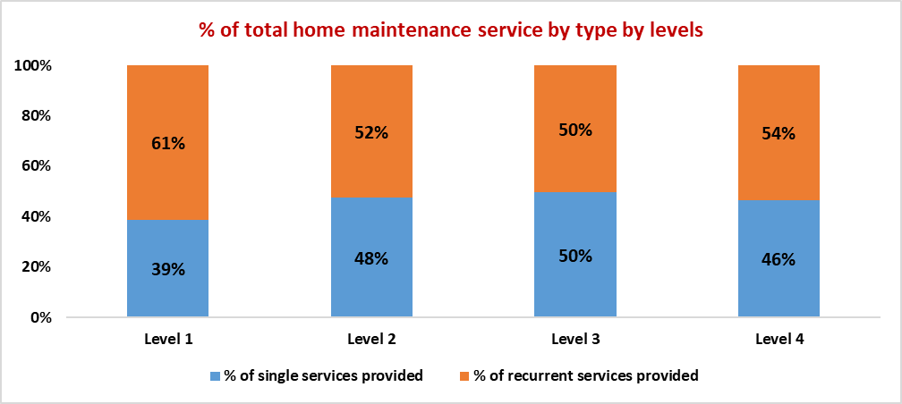

As a proportion of the total services at a package level, the Level 1 packages received a greater proportion of recurrent services than single services than the other package levels. The distribution of service types across the other package levels are generally similar.

In any future survey, it would be informative to gather information on the type of services being provided.

### Home Modifications

Based on the FY 2018-19 data, home modifications account for an average of 1% of the total charges against package Levels 2 through 4. An average of $236 per annum is spent on home modifications ranging from just $35 per annum for a Level 1 package to $520 per annum for a Level 4 package. It should be understood that most of these modifications will be a one-off service and is unlikely to occur every year for every package so those measures can be quite misleading with respect to the average cost of a single home modification.

To learn more about this service the deep dive survey sought information regarding the type, quantity and average cost of each type of home modification. Of the 28 providers that participated in the deep dive survey, 10 providers representing 1,627 packages responded with data.

There were a total of 642 home modifications across those packages of the following types:

Table : Number and type of home modifications based on information provided by providers in the deep dive survey for FY 2018-19

|  |  |  |  |  |  |
| --- | --- | --- | --- | --- | --- |
| **Number of Home Modifications** | **Level 1** | **Level 2** | **Level 3** | **Level 4** | **Total** |
| Kitchen Modifications | 2 | 14 | 3 | 13 | **32** |
| Bathroom Modifications | 3 | 37 | 33 | 71 | **144** |
| External Modifications (steps, access to house, garden/grounds) | 10 | 87 | 121 | 245 | **463** |
| Air Conditioning | 0 | 0 | 1 | 1 | **2** |
| Garage Door Opener (electric) | 0 | 0 | 1 | 0 | **1** |
| **Total** | **15** | **138** | **159** | **330** | **642** |

The most common type of home modification was on the external part of the home to provide easier access for care recipients in getting into and out of their home and around their garden. The second most common type of modification was to the bathroom followed by the kitchen.

Table : Proportion of home modifications by type based on information provided by providers in the deep dive survey for FY 2018-19

|  |  |  |  |  |
| --- | --- | --- | --- | --- |
| **% of Home Modifications** | **Level 1** | **Level 2** | **Level 3** | **Level 4** |
| Kitchen Modifications | 13% | 10% | 2% | 4% |
| Bathroom Modifications | 20% | 27% | 21% | 22% |
| External Modifications (steps, access to house, garden/grounds) | 67% | 63% | 76% | 74% |
| Air Conditioning | 0% | 0% | 1% | 0% |
| Garage Door Opener (electric) | 0% | 0% | 1% | 0% |
| **Total** | **100%** | **100%** | **100%** | **100%** |

Table : Average cost and type of home modifications based on information provided by providers in the deep dive survey for FY 2018-19

|  |  |  |  |  |  |  |
| --- | --- | --- | --- | --- | --- | --- |
| **Average cost of Home Modifications** | **Level 1** | **Level 2** | **Level 3** | **Level 4** | **Total** | **Average** |
| Kitchen Modifications | $82 | $491 | $222 | $1,804 | **$2,599** | $839 |
| Bathroom Modifications | $324 | $811 | $2,505 | $2,644 | **$6,283** | $1,987 |
| External Modifications (steps, access to house, garden/grounds) | $30 | $1,066 | $1,427 | $1,744 | **$4,267** | $1,412 |
| Air Conditioning | - | - | $2,645 | $3,601 | **$6,246** | $3,123 |
| Garage Door Opener (electric) | - | - | $684 | - | **$684** | $684 |
| **Average cost of Home Modifications** | **$145** | **$789** | **$1,497** | **$2,448** | **$4,016** | $1,609 |

While there were only two modifications that involved installing air-conditioning to a home, individually these were the most expensive type of modification based on the data provided. Bathroom modifications were the next most expensive followed by the external modifications to improve access to the home. The highest average cost across more than one modification in the one category was $15,000 for bathroom modifications and $10,000 for kitchen modifications.

### Meal Preparation

Based on the FY 2018-19 data, assistance with meal preparation accounted for an average of 1% of the total charges against packages across all package levels. An average of $12.56 per fortnight was spent on meal preparation ranging from just $2.50 per fortnight for a Level 1 package to $26.78 per fortnight for a Level 4 package.

To learn more about this service the deep dive survey sought information on where meal preparation is included, how many meals would be prepared as part of the service. Of the 28 providers that participated in the deep dive survey, 11 providers representing 2,014 packages responded with data.

Chart : Number of meals provided by package level based on information received in the deep dive survey for 2,014 packages - FY 2018-19

Level 1: 543 meals prepared
Level 2: 4,283 meals prepared
Level 3: 2,854 meals prepared
Level 4: 5,521 meals prepared

The most meals prepared was for level 4, followed by level 2, then level 3 and level 1 having the lowest number of meals prepared.

Cross referencing this information against the financial data that was provided in the deep dive survey, a meal cost was able to be established along with the cost of preparing that meal on an hourly basis. That information is provided in the following table.

Table : Average cost per meal prepared and average cost per hour of meal preparation based on data provided in the deep dive survey for FY 2018-19

|  |  |  |
| --- | --- | --- |
|  | **Cost per meal** | **Cost per meal per hour** |
| Level 1 | $18.6 | $56.34 |
| Level 2 | $18.2 | $25.58 |
| Level 3 | $33.2 | $50.93 |
| Level 4 | $23.8 | $42.21 |
| **Average** | **$23.5** | **$43.76** |

While there are some variances in the cost of meals, that is somewhat attributable to the moderate sample size. However, the average cost of a meal generally ranges between $18 and $24 per meal (although the average price for Level 3 packages is higher) and the cost per hour averages $43.76 per hour.

### Sub‑contracting Services

Increasingly providers make use of sub‑contractors to undertake tasks as a matter of choice, as well as through necessity either as a result of a care recipient choosing a particular service provider to provide a service or the provider does not have sufficient workforce of their own to undertake the work.

As part of the deep dive survey, providers were asked to nominate the proportion of each service carried out by sub-contractors during FY 2018-19 with the following results.

Table : Proportion of services provided by sub‑contractors by package level for FY 2018-19 based on data received in deep dive survey

|  |  |  |  |  |
| --- | --- | --- | --- | --- |
|  | **2018-19 Financial Year** | | | |
|  | **Level 1** | **Level 2** | **Level 3** | **Level 4** |
| Nursing care - registered nurse | 13% | 36% | 29% | 47% |
| Nursing care - enrolled nurse or other licensed nurse | 10% | 13% | 10% | 23% |
| Personal care | 0% | 3% | 4% | 5% |
| Cleaning and household tasks | 8% | 6% | 7% | 7% |
| Meal preparation | 13% | 21% | 15% | 10% |
| Social support, shopping services, community access | 4% | 4% | 5% | 10% |
| Consumables | 52% | 64% | 57% | 62% |
| Light gardening | 59% | 59% | 58% | 59% |
| In-home respite (day-time) | 0% | 2% | 5% | 4% |
| In-home respite (overnight) | 3% | 10% | 7% | 16% |
| Transport services | 12% | 14% | 13% | 12% |
| Allied health professional (practitioner) | 54% | 82% | 76% | 85% |
| Capital purchases | 58% | 75% | 75% | 77% |
| Home modifications | 39% | 49% | 52% | 58% |
| Home maintenance | 52% | 48% | 50% | 49% |
| Other services required to maintain the home care recipient at home | 24% | 38% | 33% | 37% |

What might be called core services being personal care, cleaning and household tasks and social support, shopping services, community access that account for an average of 59% of the charges against a package after excluding care and package management charges are predominantly not services where sub‑contractors play a significant role. In-home respite services are also not commonly sub‑contracted.

Sub‑contracted services play a much greater role where services are more specialised or skill sets might be higher (such as nursing, allied health or capital purchases) or where the instances of the service being provided are fewer (such as home maintenance and home modifications).

This provides opportunities for providers of these services to form partnerships or commercial alliances with approved providers to utilise their skill sets to the benefit of all parties concerned, including the consumer.

## Ownership

Introduction

As is the case within the sector overall, the majority of home care providers are NFP organisations. While there has been a significant growth in the number of FP providers, their overall market share remains in the minority.

Table : Profile of data sample by ownership type for FY 2018‑19

|  |  |  |  |  |
| --- | --- | --- | --- | --- |
|  | **Not for Profit** | **For Profit** | **Government** | **Total** |
| No. of HC providers in the survey | 262 | 108 | 46 | 416 |
| No. of HC providers FY19 (Gen Data) | 479 | 335 | 115 | 929 |
| **HC providers % coverage** | **55%** | **32%** | **40%** | **45%** |
| No. of HC packages in the survey | 44,243 | 7,465 | 3,115 | 54,823 |
| No. of HC packages FY19 (Gen Data) | 77,156 | 22,317 | 7,234 | 106,707 |
| **HC packages % coverage** | **57%** | **33%** | **43%** | **51%** |

The data used in this survey covers 45% of the providers in the sector overall, and if the providers without packages were taken into consideration then that would increase to 51% of the providers in the sector, the same level of coverage in respect of packages.

With respect to how the ownership of providers are distributed across the sector there is some differences in the distribution in the survey and in the sector generally. The representation of NFP providers is over‑represented in the survey compared to the sector generally, as is the representation of NFPs when assessing the distribution of packages by ownership. The Government representation in the survey is similar to that of the sector.

Chart : Distribution of providers and package by ownership - sector compared to 2019 survey

Graph depicts difference in distribution of providers by ownership between the survey respondents and the sector in 2019.
The survey has a greater proportion of not for profit providers than the sector, with a smaller proportion of for profit. Government providers have a similar proportion in the survey and sector in 2019.  Graph depicts difference in distribution of packages by ownership between the survey respondents and the sector in 2019.
The survey has a greater proportion of packages under a not for profit providers than the sector, with a smaller proportion of packages with a for profit provider. Packages with government providers have a similar proportion in the survey and sector in 2019. 

However, given that there is good representation from each of the sectors in the survey overall being greater than 30% for each ownership type (refer Table 42), and the distribution of providers is similar to that of the sector overall - the patterns emerging from the analysis and any observations made should be based on a reasonable body of data.

Amounts Charged to Care Recipient Packages

On the face of it the amounts charged to care recipient packages is, on average weighted towards the NFP providers with an average charge to the package of $850.63 per client per fortnight compared to FP providers with $818.16 and Government providers and average of $655.35.

Table : Summary of amounts charged to clients aggregated at the provider level - average across all package levels per client per fortnight - FY 2018-19

|  |  |  |  |  |
| --- | --- | --- | --- | --- |
| **Total Amount Charged to Care Recipients** | **2018-19 Financial Year** | | | |
|  | **All Average** | **Not for Profit** | **For Profit** | **Government** |
| Total number of providers | 416 | 262 | 108 | 46 |
| Total number of packages | 54,823 | 44,243 | 7,465 | 3,115 |
| Total number of subsidised days | 19,999,171 | 16,139,903 | 2,722,512 | 1,136,755 |
| Care management | $135.63 | $141.57 | $95.64 | $147.15 |
| Admin charge/(Package mgt - Sept. Qtr) | $153.04 | $159.90 | $113.84 | $149.43 |
| Nursing care - registered nurse | $8.52 | $8.12 | $11.33 | $7.60 |
| Nursing care - enrolled nurse or other licensed nurse | $3.87 | $4.21 | $2.28 | $2.83 |
| Personal care | $149.59 | $141.50 | $222.03 | $90.95 |
| Cleaning and household tasks | $90.23 | $90.50 | $98.44 | $66.66 |
| Meal preparation | $12.56 | $12.17 | $12.49 | $18.25 |
| Social support, shopping services, community access | $81.01 | $82.24 | $90.56 | $40.59 |
| Consumables | $19.23 | $20.92 | $11.24 | $14.27 |
| Light gardening | $14.21 | $14.73 | $12.15 | $11.72 |
| In-home respite (day-time) | $22.95 | $22.49 | $29.84 | $12.89 |
| In-home respite (overnight) | $2.45 | $2.70 | $1.76 | $0.53 |
| Transport services | $17.72 | $17.15 | $19.20 | $22.24 |
| Allied health professional (practitioner) | $22.30 | $24.23 | $16.69 | $8.41 |
| Capital purchases | $29.53 | $31.58 | $20.04 | $23.23 |
| Home modifications | $9.11 | $9.40 | $7.29 | $9.35 |
| Home maintenance | $9.19 | $9.81 | $5.60 | $8.93 |
| Travel expenses | $8.93 | $9.85 | $5.80 | $3.26 |
| Other services required to maintain the home care recipient at home | $37.65 | $39.88 | $34.87 | $12.80 |
| Maximum exit amount | $1.61 | $1.76 | $0.45 | $2.14 |
| Processing charge on third party purchases/subcontracting | $5.79 | $5.91 | $6.62 | $2.13 |
| **Total Amount Charged to Clients** | **$835.11** | **$850.63** | **$818.16** | **$655.35** |

However, there are some significant differences in the individual line items. For example, the average care management charge and package management charge is higher for the NFP providers and Government providers compared to FP providers whereas the charges for most of the individual services are higher for the FP providers.

When assessing the data at this high level, the mix of packages being serviced by providers will have an influence on the overall average amount charged per client.

Table : Mix of packages held at June 2019 by ownership type

|  |  |  |  |
| --- | --- | --- | --- |
|  | **Not For Profit** | **For Profit** | **Government** |
| Level 1 | 6% | 7% | 5% |
| Level 2 | 50% | 43% | 57% |
| Level 3 | 18% | 20% | 16% |
| Level 4 | 26% | 29% | 22% |
| **Total** | **100%** | **100%** | **100%** |

The other factor that should be considered is that some of the FP home care providers will have entered the home care market with a background of providing private nursing or care services on a full fee for service basis where the practice was to include all underlying costs in the charge for the service to the client - no separate administration charge. Their pricing structure will have been based on cost recovery through the service price.

Table : Summary of receipts and unspent funds aggregated at the provider level - average across all package levels per client per fortnight - FY 2018-19

|  |  |  |  |  |
| --- | --- | --- | --- | --- |
| **Receipts and Unspent Funds** | **2018-19 Financial Year** | | | |
|  | **All Average** | **Not for Profit** | **For Profit** | **Government** |
| **Receipts from:** |  |  |  |  |
| Fees received from care recipients | $50.03 | $52.53 | $44.64 | $27.56 |
| Government subsidies received for the period | $977.86 | $981.66 | $1,010.03 | $846.89 |
| **Total receipts** | **$1,027.89** | **$1,034.18** | **$1,054.67** | **$874.45** |
| Unutilised amount | $192.78 | $183.55 | $236.51 | $219.10 |
| Utilisation rate | 81% | 82% | 78% | 75% |
| Unspent funds per package | $7,521 | $7,668 | $6,802 | $7,159 |

There are differences in behaviour and outcomes across ownership types in relation to receipts and revenue utilisation rates as well as unspent funds balances:

* ***Average receipts for Government providers are lower than the other providers*** and this is likely to be because their package mix is biased towards low care packages whereas the NFP and FP providers have a larger proportion of high care packages in their mix
* ***Government provider utilisation rates are lower than the FP and NFP providers*** resulting in relatively high unspent funds balances despite the package mix with more low care packages

Hours of service

The amounts charged to the client is a product of the price of the service and the hours of service. The summary level data above shows that the average amounts charged per client per fortnight is higher on average for FP providers than for NFP providers. It also shows that this can vary depending on the type of service being provided.

The following table shows that the total hours of service delivered by FP and NFP providers is not significantly different, but the Government providers deliver far fewer hours on average. These variances are likely to be a function of the package mix as much as they might be to do with service delivery models.

FP providers charged clients for an average of 10.17 hours of service per fortnight compared to NFP providers who charged an average of 9.43 hours of service per fortnight which equates to an overall difference equivalent to 44 minutes per fortnight.

Table : Summary of hours of service provided to clients aggregated at the provider level - average across all package levels per client per fortnight - FY 2018-19

|  |  |  |  |  |
| --- | --- | --- | --- | --- |
|  | **2018-19 Financial Year** | | | |
| **Total Hours of Service Provision** | **All Average** | **Not for Profit** | **For Profit** | **Government** |
| Total number of providers | 416 | 262 | 108 | 46 |
| Total number of packages | 54,823 | 44,243 | 7,465 | 3,115 |
| Total number of subsidised days | 19,992,539 | 16,135,604 | 2,720,981 | 1,135,954 |
| Care management | 1.24 | 1.32 | 0.60 | 1.53 |
| Nursing care - registered nurse | 0.11 | 0.11 | 0.13 | 0.10 |
| Nursing care - enrolled nurse or other licensed nurse | 0.03 | 0.03 | 0.03 | 0.08 |
| Personal care | 2.59 | 2.44 | 3.80 | 1.81 |
| Cleaning and household tasks | 2.04 | 2.10 | 1.94 | 1.41 |
| Social support, shopping services, community access | 1.65 | 1.66 | 1.66 | 1.37 |
| Light gardening | 0.19 | 0.18 | 0.21 | 0.23 |
| In-home respite (day-time) | 0.46 | 0.47 | 0.52 | 0.26 |
| In-home respite (overnight) | 0.06 | 0.06 | 0.05 | 0.02 |
| Transport services | 0.45 | 0.41 | 0.56 | 0.75 |
| Allied health professional (practitioner) | 0.13 | 0.13 | 0.08 | 0.10 |
| Other services provided to the home care recipient | 0.53 | 0.52 | 0.58 | 0.53 |
| **Total Hours of Service Provision** | **9.46** | **9.43** | **10.17** | **8.20** |

Where there were large variances in the charge to clients between FP and NFP providers such as in personal care hours where FP providers charged an average of $222.03 per fortnight compared to NFP providers who charged an average $141.50 per fortnight (refer Table 43), it appears that the predominant factor is hours of service delivered contributing to that difference in total amount charged. On average, a total of 3.8 hours of personal care services are provided by FP home care providers whereas an average of 2.44 hours are provided by the NFP cohort.

To examine this in a little more detail it helps to look at an example - personal care services for a Level 4 package.

Table : Example to demonstrate the contributing factors in the amount charged to a Level 4 package for personal care services based on ownership

|  |  |  |  |  |
| --- | --- | --- | --- | --- |
| ***Example of contribution to difference in amount charged to package for Personal Care services*** | **Level 4 Average** | **Not for Profit** | **For Profit** | **Government** |
| Average hours of service (per fortnight) | 5.82 | 5.49 | 7.98 | 4.53 |
| Average price per hour | $59.00 | $59.58 | $58.19 | $51.50 |
| Average fortnightly charge | $343.23 | $327.13 | $464.28 | $233.16 |

In this case, there is very little difference in the effective hourly rate of the service between the FP and NFP providers and in fact the NFP hourly rate is marginally higher than the FP rate. The Government providers do display some price differential being $7.50 per hour lower than the overall average. The major contributing factor to the difference between the amount charged to a package for personal service by NFP and FP providers is the hours of service provided. For Government providers it is a mixture of price and hours.

For other services, price is the primary factor, for example social support, shopping services and community access for a Level 2 package.

Table : Example to demonstrate the contributing factors in the amount charged to a Level 2 package for social support, shopping services and community access based on ownership

|  |  |  |  |  |
| --- | --- | --- | --- | --- |
| ***Example of contribution to difference in amount charged to package*** | **Level 2 Average** | **Not for Profit** | **For Profit** | **Government** |
| Average hours of service (per fortnight) | 1.05 | 1.05 | 1.09 | 1.02 |
| Average price per hour | $45.79 | $45.70 | $56.33 | $26.59 |
| Average fortnightly charge | $48.16 | $47.91 | $61.43 | $27.23 |

Here the hours of service are very similar across all provider types, but the price charged per hour by FP providers in the survey is significantly higher than either NFP or Government providers. As a result the average amount charged to the packages of FP providers is higher than that of the NFP and Government providers.

It is important to remember that the amount charged to a package for a particular service is a function of both the hours of service provided as well as the price of that service.

Table : Average price by type of service and by ownership aggregated at the provider level - average for Level 2 packages per client per fortnight - FY 2018-19

|  |  |  |  |  |
| --- | --- | --- | --- | --- |
| **Average cost per hour** | **Level 2 Average** | **Not for Profit** | **For Profit** | **Government** |
| Care management | 103.68 | 100.87 | 152.27 | 97.64 |
| Nursing care - registered nurse | 72.50 | 73.68 | 82.88 | 41.91 |
| Nursing care - enrolled nurse or other licensed nurse | 96.14 | 108.59 | 58.15 | 75.80 |
| Personal care | 55.73 | 55.60 | 60.07 | 43.29 |
| Cleaning and household tasks | 44.14 | 42.78 | 52.80 | 47.71 |
| Social support, shopping services, community access | 45.79 | 45.70 | 56.33 | 26.59 |
| Light gardening | 70.08 | 74.00 | 61.66 | 48.92 |
| In-home respite (day-time) | 47.38 | 44.87 | 68.23 | 38.70 |
| In-home respite (overnight) | 31.32 | 28.19 | 44.43 | 264.34 |
| Transport services | 40.54 | 41.66 | 49.11 | 26.85 |
| Allied health professional (practitioner) | 157.44 | 160.89 | 181.44 | 78.48 |
| Other services provided to the home care recipient | 70.91 | 79.83 | 71.01 | 14.10 |
| **Average price per hour of service** | **58.95** | **59.03** | **65.34** | **45.98** |
| Average charged - total charge / hours of service (includes all charges) | 83.11 | 83.77 | 84.12 | 73.01 |

In the majority of cases, the price charged per hour by FP providers is slightly higher than that charged by NFP providers. This may be for a number of reasons, one being that the amount charged per fortnight by FP providers for administration of the package was less than NFP providers so they would need to recover those administration costs through the amounts charged for services.

With respect to hours charged, the pattern is relatively similar across package levels for some services, but for others there are some minor changes in behaviour.

Table : Extract of hours of service per client per fortnight by ownership type and package level for FY 2018‑19

|  |  |  |  |  |
| --- | --- | --- | --- | --- |
| **Hours per fortnight** | **Level 1** | **Level 2** | **Level 3** | **Level 4** |
| **Personal Care** |  |  |  |  |
| Not for profit | 0.39 | 1.04 | 2.53 | 5.49 |
| For profit | 1.08 | 1.63 | 3.48 | 7.98 |
| Government | 0.17 | 0.90 | 1.86 | 4.53 |
| **Cleaning and household tasks** |  |  |  |  |
| Not for profit | 0.96 | 1.72 | 2.19 | 3.02 |
| For profit | 1.13 | 1.60 | 3.48 | 2.62 |
| Government | 0.68 | 1.17 | 1.86 | 2.11 |
| **Social support, shopping services, community access** |  |  |  |  |
| Not for profit | 0.43 | 1.05 | 1.89 | 2.96 |
| For profit | 0.59 | 1.09 | 1.88 | 2.64 |
| Government | 0.31 | 1.02 | 1.57 | 2.38 |
| **Total Hours** |  |  |  |  |
| Not for profit | 2.97 | 5.66 | 10.25 | 17.52 |
| For profit | 3.84 | 5.83 | 10.31 | 18.18 |
| Government | 2.53 | 5.66 | 9.22 | 15.42 |

For personal care services, there is a continuity in the FP providers having more hours of service than NFP providers. This is also the case for cleaning and household tasks and social support, shopping services and community access for the low care package Levels 1 and 2, but as the package levels increase, the NFP providers deliver a greater number of service hours for these services. However, in total, the average numbers of hours of service provided by the FP providers is greater than the hours of service from the NFP providers across each of the package levels. This is mainly because the increases in the non-personal care services does not offset the differences in hours provided for that service type.

## Location of Service as Determined by MMM

The analysis of data by MMM at provider level is difficult because the majority of providers in the survey provide services across locations that span different MMM categories. An explanation of MMM categorisation of remoteness is attached as Appendix 3.

Of the 416 providers in the data set, 283 providers provided services across different MMM categories and a further 105 providers only provided services in MMM1 locations. There were only 28 providers who provided services to a single MMM category MMM2 through MMM7. This limits the integrity of the data to a significant degree because of the small sample sizes in some of most of the MMM categories.

Table : Summary of amounts charged to clients per fortnight by remoteness as determined by MMM - aggregated at provider level for FY 2018-19

|  |  |  |  |  |  |  |  |  |  |
| --- | --- | --- | --- | --- | --- | --- | --- | --- | --- |
| **Total Amount Charged to Care Recipients** | **2018-19 Financial Year** | | | | | | | | |
|  | **All Average** | **MMM 1** | **MMM 2** | **MMM 3** | **MMM 4** | **MMM 5** | **MMM 6** | **MMM 7** | **Mixed MMM** |
| Total number of providers | 416 | 105 | 7 | 2 | 2 | 7 | 5 | 5 | 283 |
| Total number of packages | 54,823 | 3,333 | 96 | 8 | 7 | 94 | 73 | 54 | 51,158 |
| Total number of subsidised days | 19,999,171 | 1,215,599 | 34,949 | 2,910 | 2,489 | 34,146 | 26,617 | 19,818 | 18,662,642 |
| Care management | $135.63 | $124.63 | $172.68 | - | - | $165.54 | $184.27 | $149.62 | $136.18 |
| Admin charge/(Package mgt - Sept. Qtr) | $153.04 | $140.85 | $361.66 | $682.28 | $250.54 | $160.87 | $177.04 | $295.98 | $153.14 |
| Nursing care - registered nurse | $8.52 | $7.41 | $1.47 | $12.01 | $22.70 | $18.97 | $17.32 | $0.96 | $8.58 |
| Nursing care - enrolled nurse or other licensed nurse | $3.87 | $1.93 | $3.59 | - | - | - | $8.65 | - | $4.01 |
| Personal care | $149.59 | $145.51 | $671.78 | $2,410.15 | $269.82 | $142.67 | $115.08 | $88.58 | $148.64 |
| Cleaning and household tasks | $90.23 | $127.13 | $4.65 | $151.07 | $77.19 | $100.20 | $99.08 | $223.82 | $87.80 |
| Meal preparation | $12.56 | $17.94 | $5.33 | $142.31 | - | $25.27 | $22.78 | $164.30 | $12.01 |
| Social support, shopping services, community access | $81.01 | $70.28 | $6.42 | $75.59 | $15.46 | $70.12 | $67.69 | $118.32 | $81.86 |
| Consumables | $19.23 | $26.08 | $2.17 | $43.80 | $ 21.34 | $27.73 | $1.97 | $49.49 | $18.79 |
| Light gardening | $14.21 | $11.08 | $28.91 | $16.60 | $4.02 | $23.61 | $13.27 | $18.78 | $14.36 |
| In-home respite (day-time) | $22.95 | $19.62 | - | - | $83.58 | $8.29 | $1.84 | $0.61 | $23.28 |
| In-home respite (overnight) | $2.45 | $7.17 | - | - | - | - | - | - | $2.16 |
| Transport services | $17.72 | $21.11 | $3.04 | $74.59 | $22.27 | $12.97 | $15.41 | $84.05 | $17.46 |
| Allied health professional (practitioner) | $22.30 | $23.40 | $1.43 | $11.58 | $4.13 | $6.85 | $17.61 | - | $22.33 |
| Capital purchases | $29.53 | $13.78 | $0.30 | - | $40.96 | $34.90 | $68.79 | $16.23 | $30.56 |
| Home modifications | $9.11 | $6.18 | $0.64 | - | - | $2.23 | $5.47 | - | $9.35 |
| Home maintenance | $9.19 | $4.39 | - | - | $13.41 | $4.91 | $5.20 | - | $9.54 |
| Travel expenses | $8.93 | $5.16 | $0.09 | $2.36 | $14.83 | $27.05 | $1.14 | $0.25 | $9.18 |
| Other services required to maintain the home care recipient at home | $37.65 | $16.56 | $0.50 | - | $7.53 | $3.71 | $35.22 | $10.13 | $39.20 |
| Maximum exit amount | $1.61 | $2.18 | $0.78 | - | $12.66 | $0.80 | $0.32 | $0.11 | $1.57 |
| Processing charge on third party purchases/subcontracting | $5.79 | $22.02 | - | $148.10 | - | - | - | - | $4.75 |
| **Total Amount Charged to Clients** | **$835.11** | **$814.43** | **$1,265.45** | **$3,770.43** | **$860.45** | **$836.70** | **$858.15** | **$1,221.23** | **$834.74** |

To overcome this issue, the data has been sorted based on where a provider has the majority of packages with the results on the following pages.

This realignment of data by MMM gives a better level of distribution of packages by MMM category which in turn should provide for greater integrity of the data. There remains an issue with a small number of providers operating predominantly in the more remote areas.

Table : Summary of amounts charged to clients per fortnight and unspent funds at the end of the period by remoteness as determined by MMM - aggregated at provider level for FY 2018-19

|  |  |  |  |  |  |  |  |  |
| --- | --- | --- | --- | --- | --- | --- | --- | --- |
| **Total Amount Charged to Care Recipients** | **2018-19 Financial Year** | | | | | | | |
|  | **All Average** | **MMM 1** | **MMM 2** | **MMM 3** | **MMM 4** | **MMM 5** | **MMM 6** | **MMM 7** |
| Total number of providers | 416 | 253 | 33 | 45 | 22 | 39 | 8 | 16 |
| Total number of packages | 54,823 | 46,465 | 1,993 | 3,404 | 820 | 1,761 | 158 | 224 |
| Total number of subsidised days | 19,999,171 | 16,950,047 | 726,885 | 1,241,382 | 298,914 | 642,829 | 57,482 | 81,632 |
| Care management | $135.63 | $137.38 | $101.99 | $113.24 | $123.73 | $164.36 | $136.00 | $230.44 |
| Admin charge/(Package mgt - Sept. Qtr) | $153.04 | $152.45 | $159.87 | $167.32 | $132.02 | $108.96 | $304.63 | $313.97 |
| Nursing care - registered nurse | $8.52 | $8.53 | $8.03 | $8.66 | $5.70 | $9.44 | $18.48 | $5.69 |
| Nursing care - enrolled nurse or other licensed nurse | $3.87 | $4.10 | $1.91 | $1.95 | $5.95 | $2.91 | $8.54 | $0.34 |
| Personal care | $149.59 | $155.24 | $168.92 | $119.67 | $76.48 | $83.33 | $159.68 | $41.46 |
| Cleaning and household tasks | $90.23 | $89.00 | $78.66 | $122.89 | $89.60 | $67.46 | $123.45 | $108.41 |
| Meal preparation | $12.56 | $12.45 | $6.46 | $10.63 | $7.93 | $10.67 | $27.27 | $141.20 |
| Social support, shopping services, community access | $81.01 | $82.25 | $73.98 | $73.37 | $87.81 | $51.54 | $227.28 | $104.98 |
| Consumables | $19.23 | $19.66 | $6.30 | $17.91 | $34.58 | $11.12 | $30.32 | $63.80 |
| Light gardening | $14.21 | $13.47 | $21.53 | $18.56 | $17.86 | $16.11 | $14.48 | $6.96 |
| In-home respite (day-time) | $22.95 | $24.37 | $9.33 | $21.23 | $13.86 | $11.22 | $17.55 | $3.41 |
| In-home respite (overnight) | $2.45 | $2.48 | $3.17 | $1.50 | $2.81 | $3.07 | $0.53 | $0.13 |
| Transport services | $17.72 | $18.36 | $8.99 | $14.03 | $9.76 | $16.34 | $34.27 | $47.02 |
| Allied health professional (practitioner) | $22.30 | $24.28 | $12.15 | $12.42 | $5.73 | $10.56 | $26.78 | $1.33 |
| Capital purchases | $29.53 | $30.04 | $35.26 | $25.49 | $22.15 | $19.22 | $53.71 | $24.89 |
| Home modifications | $9.11 | $9.11 | $4.56 | $11.13 | $11.22 | $10.58 | $9.43 | $0.23 |
| Home maintenance | $9.19 | $9.58 | $5.46 | $8.51 | $8.56 | $6.07 | $2.83 | $1.92 |
| Travel expenses | $8.93 | $9.15 | $5.95 | $7.99 | $10.56 | $7.51 | $0.53 | $13.83 |
| Other services required to maintain the home care recipient at home | $37.65 | $40.50 | $15.39 | $28.56 | $7.96 | $14.42 | $124.44 | $14.95 |
| Maximum exit amount | $1.61 | $1.66 | $0.72 | $1.31 | $2.27 | $1.35 | $2.83 | $1.23 |
| Processing charge on third party purchases/subcontracting | $5.79 | $5.80 | $8.73 | $6.84 | $6.77 | $1.05 | - | $1.21 |
| **Total Amount Charged to Clients** | **$835.11** | **$849.87** | **$737.37** | **$793.19** | **$683.32** | **$627.26** | **$1,323.01** | **$1,127.38** |

Table : Summary of receipts per fortnight and unspent funds at the end of the period by remoteness as determined by MMM - aggregated at provider level for FY 2018-19

|  |  |  |  |  |  |  |  |  |
| --- | --- | --- | --- | --- | --- | --- | --- | --- |
| **Receipts and Unspent Funds** | **2018-19 Financial Year** | | | | | | | |
|  | **All Average** | **MMM 1** | **MMM 2** | **MMM 3** | **MMM 4** | **MMM 5** | **MMM 6** | **MMM 7** |
| **Receipts from:** |  |  |  |  |  |  |  |  |
| Fees received from care recipients | $50.03 | $50.11 | $45.11 | $60.72 | $25.72 | $36.42 | $138.13 | $49.74 |
| Government subsidies received for the period | $977.86 | $991.69 | $951.90 | $857.26 | $881.03 | $836.93 | $1,605.26 | $1,193.69 |
| **Total receipts** | **$1,027.89** | **$1,041.80** | **$997.00** | **$917.98** | **$906.76** | **$873.34** | **$1,743.40** | **$1,243.42** |
| Unutilised amount | $192.78 | $191.93 | $259.63 | $124.79 | $223.44 | $246.08 | $420.39 | $116.04 |
| Utilisation rate | 81% | 82% | 74% | 86% | 75% | 72% | 76% | 91% |
| Unspent funds per package | $7,521 | $7,465 | $7,825 | $8,062 | $8,529 | $6,827 | $13,208 | $6,115 |

Table : Extract of average prices for some core services for a Level 4 package aggregated at provider level and sorted by MMM location for FY 2018-19

|  |  |  |  |  |  |  |  |  |
| --- | --- | --- | --- | --- | --- | --- | --- | --- |
| **Average cost per hour** | **Level 4 Average** | **MMM 1** | **MMM 2** | **MMM 3** | **MMM 4** | **MMM 5** | **MMM 6** | **MMM 7** |
| Personal care | $59.00 | $60.14 | $50.10 | $55.30 | $56.95 | $43.32 | $41.87 | $29.06 |
| Cleaning and household tasks | $44.02 | $42.86 | $35.66 | $66.14 | $45.80 | $46.71 | $43.14 | $48.34 |
| Social support, shopping services, community access | $53.60 | $56.08 | $45.74 | $37.75 | $50.88 | $39.22 | $16.56 | $30.95 |
| Light gardening | $92.14 | $99.91 | $63.16 | $68.87 | $87.42 | $52.69 | $41.69 | $96.96 |
| Transport services | $41.86 | $47.82 | $6.91 | $39.88 | $12.37 | $65.18 | $37.14 | $15.44 |
| Allied health professional (practitioner) | $192.89 | $198.04 | $116.48 | $223.69 | $161.19 | $110.45 | $88.75 | $63.25 |
| **Average price per hour of service** | **$65.08** | **$67.25** | **$47.13** | **$57.86** | **$55.44** | **$51.36** | **$34.27** | **$36.93** |

It is interesting that the overall charge to packages generally declines as remoteness increases from MMM1 to MMM5. There is then a big leap in the amount charged as remoteness increases further to MMM6 and MMM7 categories. Unspent funds are relatively consistent across most locations with the exception of MMM6 where there is a large increase in unspent funds but this is due to there being little data in this group compared to most of the others.

Chart : Trend in average amounts charged to clients per fortnight based on location as determined by MMM category - FY 2018-19

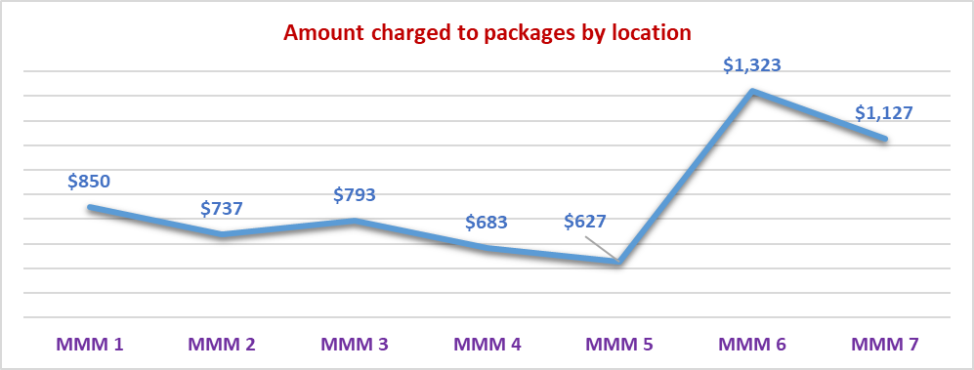

This is also consistent with the numbers of hours charged per package per fortnight where there appears to be a greater level of service provision in the more remote areas.

Table : Summary of hours of service delivered to clients per fortnight by remoteness as determined by MMM - aggregated at provider level for FY 2018-19

|  |  |  |  |  |  |  |  |  |  |
| --- | --- | --- | --- | --- | --- | --- | --- | --- | --- |
| **Total Hours of Service Provision** | **2018-19 Financial Year** | | | | | | | | |
|  | **All Average** | **MMM 1** | **MMM 2** | **MMM 3** | **MMM 4** | **MMM 5** | **MMM 6** | **MMM 7** |
| Total number of providers | 416 | 253 | 33 | 45 | 22 | 39 | 8 | 16 |
| Total number of packages | 54,823 | 46,465 | 1,993 | 3,404 | 820 | 1,761 | 158 | 224 |
| Total number of subsidised days | 19,992,539 | 16,944,290 | 726,739 | 1,241,237 | 298,695 | 642,610 | 57,408 | 81,559 |
| Care management | 1.24 | 1.12 | 1.22 | 1.76 | 1.55 | 2.75 | 2.54 | 2.91 |
| Nursing care - registered nurse | 0.11 | 0.12 | 0.11 | 0.08 | 0.10 | 0.09 | 0.25 | 0.07 |
| Nursing care - enrolled nurse or other licensed nurse | 0.03 | 0.03 | 0.02 | 0.03 | 0.07 | 0.12 | 0.15 | 0.05 |
| Personal care | 2.59 | 2.63 | 3.41 | 2.18 | 1.52 | 1.82 | 3.06 | 0.88 |
| Cleaning and household tasks | 2.04 | 2.07 | 1.93 | 1.96 | 1.96 | 1.50 | 2.61 | 2.72 |
| Social support, shopping services, community access | 1.65 | 1.59 | 1.71 | 2.08 | 2.39 | 1.24 | 5.96 | 4.73 |
| Light gardening | 0.19 | 0.16 | 0.36 | 0.36 | 0.25 | 0.31 | 0.25 | 0.15 |
| In-home respite (day-time) | 0.46 | 0.48 | 0.22 | 0.49 | 0.44 | 0.27 | 0.34 | 0.08 |
| In-home respite (overnight) | 0.06 | 0.06 | 0.02 | 0.04 | 0.09 | 0.08 | 0.01 | - |
| Transport services | 0.45 | 0.42 | 0.92 | 0.35 | 1.20 | 0.27 | 0.80 | 2.97 |
| Allied health professional (practitioner) | 0.13 | 0.13 | 0.10 | 0.06 | 0.04 | 0.10 | 0.24 | 0.01 |
| Other services provided to the home care recipient | 0.53 | 0.53 | 0.40 | 0.33 | 0.77 | 0.17 | 1.30 | 5.16 |
| **Total Hours of Service Provision** | **9.46** | **9.34** | **10.42** | **9.73** | **10.38** | **8.72** | **17.52** | **19.72** |

Chart : Trend in average hours of service provided to clients per fortnight based on location as determined by MMM category - FY 2018-19

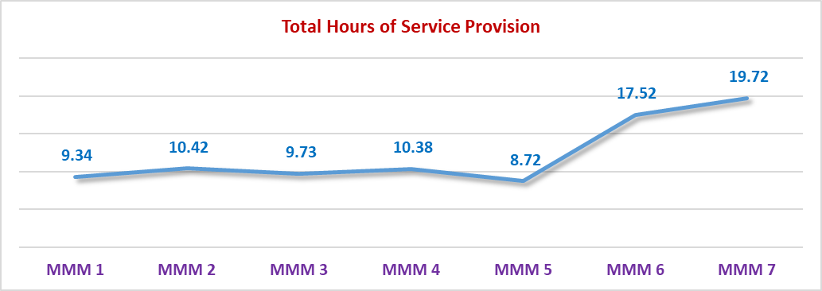

The trend line follows a similar pattern to the previous graph displaying the trend for the total amount charged per package. This indicates that, to a large degree the variations in the amounts charged against packages in more remote areas are related to the hours of service provision to a higher degree than caused by price variations. Table 54 shows that for some of the core services, price tends to decline as remoteness increases.

## Size of the Provider

For the purpose of assessing whether there are any differences in behaviour or pricing depending on the size of the provider, data has been aggregated on the basis of how many packages are delivered by providers. This was based on the total package numbers at the end of the financial year.

Table : Average amount charged to a client package per fortnight for FY 2018-19 by size of provider based on number of packages serviced

|  |  |  |  |  |  |  |  |  |
| --- | --- | --- | --- | --- | --- | --- | --- | --- |
| **Total Amount Charged to Care Recipients** | **2018-19 Financial Year** | | | | | | | |
|  | **All Average** | **Under 25** | **25-50** | **50-100** | **100-150** | **150-250** | **250-500** | **Over 500** |
| Total number of providers | 416 | 170 | 65 | 65 | 35 | 32 | 27 | 22 |
| Total number of packages | 54,823 | 1,609 | 2,306 | 4,601 | 4,297 | 6,239 | 9,290 | 26,481 |
| Total number of subsidised days | 19,999,171 | 586,669 | 841,100 | 1,678,175 | 1,566,980 | 2,276,211 | 3,388,839 | 9,661,196 |
| Care management | $135.63 | $112.05 | $135.26 | $130.82 | $133.11 | $108.94 | $135.49 | $144.68 |
| Admin charge/(Package mgt - Sept. Qtr) | $153.04 | $132.90 | $150.86 | $147.02 | $160.92 | $129.24 | $169.47 | $154.05 |
| Nursing care - registered nurse | $8.52 | $8.48 | $9.00 | $8.67 | $8.93 | $3.95 | $11.23 | $8.53 |
| Nursing care - enrolled nurse or other licensed nurse | $3.87 | $2.94 | $6.53 | $1.92 | $1.51 | $2.85 | $2.49 | $5.15 |
| Personal care | $149.59 | $170.02 | $133.79 | $130.21 | $166.59 | $131.90 | $154.37 | $152.83 |
| Cleaning and household tasks | $90.23 | $93.02 | $101.00 | $94.53 | $88.81 | $107.59 | $87.73 | $85.38 |
| Meal preparation | $12.56 | $35.51 | $17.58 | $12.26 | $12.73 | $6.23 | $16.18 | $10.97 |
| Social support, shopping services, community access | $81.01 | $85.91 | $88.45 | $72.51 | $69.01 | $78.34 | $86.15 | $82.31 |
| Consumables | $19.23 | $17.86 | $15.02 | $20.55 | $10.76 | $14.91 | $30.17 | $18.00 |
| Light gardening | $14.21 | $12.27 | $13.44 | $14.56 | $20.64 | $14.58 | $13.11 | $13.58 |
| In-home respite (day-time) | $22.95 | $23.63 | $19.84 | $25.07 | $14.09 | $17.36 | $20.38 | $26.46 |
| In-home respite (overnight) | $2.45 | $3.14 | $3.60 | $6.52 | $0.56 | $1.27 | $1.87 | $2.39 |
| Transport services | $17.72 | $21.82 | $21.09 | $21.04 | $19.39 | $19.02 | $16.11 | $16.58 |
| Allied health professional (practitioner) | $22.30 | $12.89 | $14.71 | $22.10 | $26.49 | $11.91 | $22.57 | $25.24 |
| Capital purchases | $29.53 | $27.24 | $20.01 | $27.17 | $32.70 | $33.92 | $27.10 | $30.22 |
| Home modifications | $9.11 | $7.01 | $7.13 | $10.49 | $12.17 | $8.17 | $13.20 | $7.46 |
| Home maintenance | $9.19 | $6.75 | $5.26 | $8.53 | $7.91 | $9.88 | $14.44 | $7.99 |
| Travel expenses | $8.93 | $9.53 | $7.90 | $10.12 | $8.49 | $6.10 | $6.08 | $10.51 |
| Other services required to maintain the home care recipient at home | $37.65 | $14.30 | $47.42 | $26.97 | $12.43 | $46.32 | $29.33 | $45.05 |
| Maximum exit amount | $1.61 | $1.45 | $2.39 | $1.64 | $1.32 | $0.61 | $2.29 | $1.58 |
| Processing charge on third party purchases/subcontracting | $5.79 | $6.76 | $9.03 | $22.23 | $5.37 | $9.67 | $3.61 | $2.52 |
| **Total Amount Charged to Clients** | **$835.11** | **$805.46** | **$829.28** | **$814.92** | **$813.95** | **$762.77** | **$863.36** | **$851.49** |

Chart : Average total amount charged to a client package per fortnight for FY 2018-19 by size of provider based on number of packages serviced

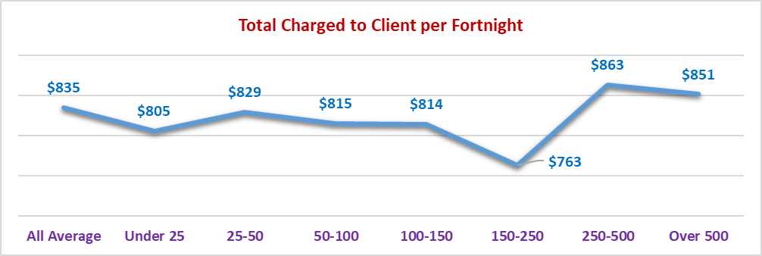

There does appear to be a trend in that those with greater than 250 packages tend to charge a greater amount against a client per fortnight than those with fewer than 250 packages.

Table : Average receipts per fortnight and unspent funds at the end of the period for FY 2018-19 by size of provider based on number of packages serviced

|  |  |  |  |  |  |  |  |  |
| --- | --- | --- | --- | --- | --- | --- | --- | --- |
| **Receipts and Unspent Funds** | **2018-19 Financial Year** | | | | | | | |
|  | **All Average** | **Under 25** | **25-50** | **50-100** | **100-150** | **150-250** | **250-500** | **Over 500** |
| **Receipts from:** |  |  |  |  |  |  |  |  |
| Fees received from care recipients | $50.03 | $70.77 | $54.15 | $42.80 | $55.91 | $48.18 | $50.80 | $48.89 |
| Government subsidies received for the period | $977.86 | $908.60 | $1,010.15 | $977.04 | $915.55 | $875.36 | $955.85 | $1,021.37 |
| **Total receipts** | **$1,027.89** | **$979.37** | **$1,064.30** | **$1,019.84** | **$971.46** | **$923.54** | **$1,006.65** | **$1,070.26** |
| Unutilised amount | $192.78 | $173.91 | $235.02 | $204.93 | $157.52 | $160.77 | $143.29 | $218.77 |
| Utilisation rate | 81% | 82% | 78% | 80% | 84% | 83% | 86% | 80% |
| Unspent funds per package | $7,521 | $6,292 | $7,618 | $6,699 | $7,444 | $7,482 | $7,963 | $7,597 |

There is little variance in the balance of unspent funds across the various sized providers. However, package utilisation rates tend to improve as the size of the provider increases although there is a decline again once the number of packages exceed 500.

Chart : Trend of package utilisation based on size of provider as measured by the number of packages held at 30 June 2019

Generally, as provider size increases, the package utilisation rate increases (from 78% for 25-50 packages, to 86% for 250-500 packages). 
Exceptions include for providers with less than 25 packages where the utilisation rate is 82%. Utilisation rate for providers with over 500 packages, is less than most other sizes with 80% utilisation. 

Table : Average hours of service provided to a client package per fortnight for FY 2018-19 by size of provider based on number of packages serviced

|  |  |  |  |  |  |  |  |  |
| --- | --- | --- | --- | --- | --- | --- | --- | --- |
| **Total Hours of Service Provision** | **2018-19 Financial Year** | | | | | | | |
|  | **All Average** | **Under 25** | **25-50** | **50-100** | **100-150** | **150-250** | **250-500** | **Over 500** |
| Total number of providers | 416 | 170 | 65 | 65 | 35 | 32 | 27 | 22 |
| Total number of packages | 54,823 | 1,609 | 2,306 | 4,601 | 4,297 | 6,239 | 9,290 | 26,481 |
| Total number of subsidised days | 19,992,539 | 586,669 | 840,662 | 1,677,884 | 1,566,762 | 2,274,899 | 3,388,113 | 9,657,550 |
| Care management | 1.24 | 2.06 | 2.25 | 2.49 | 1.52 | 1.35 | 1.01 | 0.88 |
| Nursing care - registered nurse | 0.11 | 0.10 | 0.11 | 0.14 | 0.12 | 0.04 | 0.10 | 0.13 |
| Nursing care - enrolled nurse or other licensed nurse | 0.03 | 0.05 | 0.11 | 0.05 | 0.02 | 0.04 | 0.03 | 0.02 |
| Personal care | 2.59 | 3.23 | 2.60 | 2.82 | 3.11 | 2.45 | 2.77 | 2.39 |
| Cleaning and household tasks | 2.04 | 2.29 | 2.05 | 3.91 | 1.70 | 2.02 | 1.85 | 1.83 |
| Social support, shopping services, community access | 1.65 | 2.49 | 2.08 | 1.79 | 1.46 | 1.85 | 1.53 | 1.56 |
| Light gardening | 0.19 | 0.24 | 0.24 | 0.25 | 0.37 | 0.22 | 0.16 | 0.14 |
| In-home respite (day-time) | 0.46 | 0.61 | 0.46 | 0.49 | 0.25 | 0.33 | 0.37 | 0.55 |
| In-home respite (overnight) | 0.06 | 0.12 | 0.04 | 0.08 | 0.02 | 0.02 | 0.02 | 0.08 |
| Transport services | 0.45 | 0.75 | 1.34 | 1.18 | 1.04 | 0.36 | 0.30 | 0.20 |
| Allied health professional (practitioner) | 0.13 | 0.09 | 0.17 | 0.19 | 0.15 | 0.08 | 0.13 | 0.12 |
| Other services provided to the home care recipient | 0.53 | 1.09 | 0.53 | 0.68 | 0.52 | 0.97 | 0.45 | 0.40 |
| **Total Hours of Service Provision** | **9.46** | **13.12** | **11.96** | **14.06** | **10.27** | **9.73** | **8.73** | **8.29** |

Average hours of service clearly trend downwards as provider size increases. This is in line with the data on amounts charged to client packages and package utilisation rates in the previous two tables. For those with less than 25 packages or between 25 to 50 packages, it would appear that most of the additional hours is in personal care, social support and transport services.

Chart : Average total amount of services delivered to a client package per fortnight for FY 2018-19 by size of provider based on number of packages serviced

On average, as the provider size increases, the hours of service delivery decrease from 13.1 hours for providers with less than 25 packages, to 8.3 hours for providers with over 500 packages.  Providers with 50 to 100 packages deliver 14.1 hours per fortnight deliver the highest number of all size groups, and do not follow the trend.
The average hours for all provider sizes is 9.5 hours. 

This is in contrast to the amount charged per client per fortnight where the larger providers are charging a greater amount against a client package.

This means that on average the larger providers are charging a higher amount against client packages but delivering fewer hours of service than smaller providers.

Chart : Average prices per fortnight for core services in a Level 2 package for FY 2018-19 by size of provider based on number of packages serviced

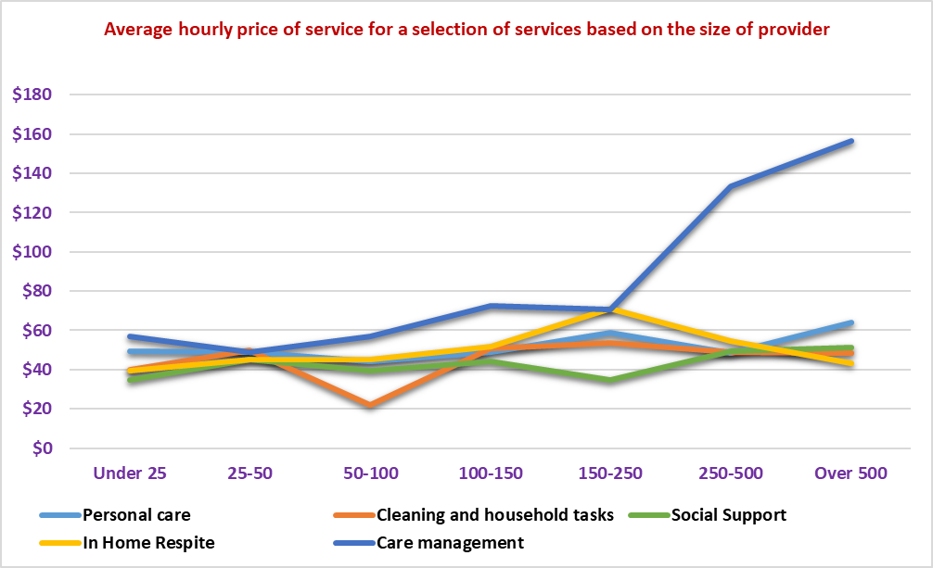

For most of the core services, prices tend to trend upwards as the provider size increases. This is particularly notable for care management.

## Average Age of Care Recipient

The following analysis is based on the average age of the clients being serviced by a provider and as a result of this aggregation level, it is difficult to obtain a true picture of the services required by persons at a different age at an individual level.

It is clear that the span of ages being considered is very narrow with the clear majority of persons being over 80 years of age.

The average amount charged against a package does trend upwards from age 81 up to age 84 before declining again for those where the average age is 84 years and older on average. The higher amount charged against packages for those under 80 years goes to a point raised earlier in this report where there were 357 persons aged under 50 entering the system and 43% of those were in a Level 4 package.

Unspent funds vary very little as well. There are some variances in the services provided and the only clear trend is an increase in the amounts charged for personal care as age increases.

Chart : Trend of average amount charged to a client package per fortnight for FY 2018-19 by average age of client at the provider level

Overall, as the average age of the client increases, so does the average amount charged against the package. For over 84 years old, the average amount charged ($794) declines slightly from the average age of 84 ($863). 
For the average age of 0 to 80, the amount charged is significantly higher than the ages of 81 or 82, with an amount charged of $791.

Table : Average amount charged to a client package and receipted per fortnight, and unspent funds at the end of the period for FY 2018-19 by average age of client at the provider level

|  |  |  |  |  |  |  |  |  |  |  |  |
| --- | --- | --- | --- | --- | --- | --- | --- | --- | --- | --- | --- |
| **Total Amount Charged to Care Recipients** | **2018-19 Financial Year** | | | | | | | | | | |
|  | **All Average** | **0-80** | | **81** | | **82** | **83** | **84** | | | **84+** |
| Total number of providers | 410 | 84 | | 29 | | 53 | 65 | 75 | | | 104 |
| Total number of packages | 58,540 | 4,654 | | 3,351 | | 8,057 | 16,819 | 15,229 | | | 10,430 |
| Total number of subsidised days | 21,367,100 | 1,698,710 | | 1,223,115 | | 2,940,805 | 6,138,935 | 5,558,585 | | | 3,806,950 |
| Care management | $126.94 | $150.91 | | $69.81 | | $110.98 | $142.60 | $138.65 | | | $104.58 |
| Admin charge/(Package mgt - Sept. Qtr) | $143.13 | $176.39 | | $129.92 | | $112.60 | $137.39 | $151.38 | | | $153.32 |
| Nursing care - registered nurse | $7.97 | $5.15 | | $2.84 | | $7.19 | $8.36 | $8.28 | | | $10.40 |
| Nursing care - enrolled nurse or other licensed nurse | $3.63 | $3.11 | | $0.73 | | $1.53 | $5.80 | $3.18 | | | $3.55 |
| Personal care | $139.54 | $96.06 | | $93.62 | | $111.39 | $126.29 | $177.57 | | | $161.27 |
| Cleaning and household tasks | $84.39 | $77.98 | | $64.41 | | $54.04 | $83.90 | $98.66 | | | $97.08 |
| Meal preparation | $11.73 | $19.75 | | $5.43 | | $7.95 | $15.22 | $10.08 | | | $9.90 |
| Social support, shopping services, community access | $75.77 | $75.96 | | $38.04 | | $43.01 | $103.09 | $80.54 | | | $62.12 |
| Consumables | $17.99 | $29.44 | | $15.13 | | $31.57 | $8.27 | $16.48 | | | $21.17 |
| Light gardening | $13.29 | $11.21 | | $6.43 | | $12.34 | $14.36 | $14.41 | | | $13.79 |
| In-home respite (day-time) | $21.48 | $28.12 | | $4.02 | | $15.87 | $23.69 | $29.07 | | | $13.79 |
| In-home respite (overnight) | $2.29 | $1.47 | | $1.19 | | $3.61 | $3.33 | $1.10 | | | $2.07 |
| Transport services | $16.56 | $19.79 | | $11.13 | | $12.89 | $19.42 | $15.46 | | | $16.70 |
| Allied health professional (practitioner) | $20.86 | $13.66 | | $9.36 | | $8.17 | $24.47 | $21.52 | | | $30.78 |
| Capital purchases | $27.63 | $31.44 | | $14.20 | | $23.66 | $23.19 | $40.70 | | | $21.39 |
| Home modifications | $8.52 | $4.00 | | $4.04 | | $8.76 | $11.82 | $7.41 | | | $8.12 |
| Home maintenance | $8.60 | $17.64 | | $3.40 | | $6.19 | $7.26 | $11.21 | | | $6.44 |
| Travel expenses | $8.36 | $7.17 | | $4.84 | | $14.27 | $4.18 | $6.89 | | | $14.32 |
| Other services required to maintain the home care recipient at home | $35.24 | $17.15 | | $9.38 | | $10.23 | $70.43 | $19.46 | | | $37.23 |
| Maximum exit amount | $1.50 | $2.00 | | $1.88 | | $1.43 | $1.37 | $1.26 | | | $1.79 |
| Processing charge on third party purchases/subcontracting | $5.40 | $3.01 | | $4.68 | | $3.32 | $3.84 | $10.12 | | | $3.94 |
| **Total Amount Charged to Clients** | **$780.82** | **$791.39** | | **$494.47** | | **$601.00** | **$838.29** | **$863.41** | | | **$793.77** |
| **Receipts and Unspent Funds** | **2018-19 Financial Year** | | | | | | | | | | |
|  | **All Average** | | **0-80** | | **81** | **82** | **83** | | **84** | **84+** | |
| **Receipts from:** |  | |  | |  |  |  | |  |  | |
| Fees received from care recipients | $46.81 | | $38.22 | | $19.61 | $38.57 | $43.99 | | $46.38 | $70.90 | |
| Government subsidies received for the period | $914.48 | | $958.33 | | $830.51 | $828.61 | $954.22 | | $942.94 | $882.59 | |
| **Total receipts** | **$961.29** | | **$996.55** | | **$850.13** | **$867.18** | **$998.21** | | **$989.32** | **$953.49** | |
| Unutilised amount | $180.46 | | $205.16 | | $355.66 | $266.18 | $159.92 | | $125.91 | $159.73 | |
| Utilisation rate | 81% | | 79% | | 58% | 69% | 84% | | 87% | 83% | |
| Unspent funds per package | $7,040 | | $7,341 | | $6,027 | $6,851 | $7,459 | | $6,986 | $6,783 | |

## Average Age of First Entry into a Home Care Package

The data below has been sorted based on the average age of clients when they first entered into a package and it is aggregated by provider level so again it is difficult to get a true picture at an individual level.

Table 60: Average amount charged to a client package and receipted per fortnight and unspent funds at the end of the period for FY 2018-19 by average age of client at first entry into a home care package at the provider level

|  |  |  |  |  |  |  |  |  |
| --- | --- | --- | --- | --- | --- | --- | --- | --- |
| **Total Amount Charged to Care Recipients** | **2018-19 Financial Year** | | | | | | | |
|  | **All Average** | **0-77** | **78** | **79** | **80** | **81** | **82** | **82+** |
| Total number of providers | 410 | 72 | 17 | 34 | 51 | 74 | 68 | 94 |
| Total number of packages | 58,540 | 5,677 | 912 | 7,059 | 9,752 | 17,451 | 12,933 | 4,756 |
| Total number of subsidised days | 21,367,100 | 2,072,105 | 332,880 | 2,576,535 | 3,559,480 | 6,369,615 | 4,720,545 | 1,735,940 |
| Care management | $126.94 | $138.98 | $100.23 | $164.75 | $137.72 | $116.99 | $111.69 | $117.44 |
| Admin charge/(Package mgt - Sept. Qtr) | $143.13 | $181.40 | $220.90 | $59.64 | $169.38 | $157.79 | $137.07 | $115.29 |
| Nursing care - registered nurse | $7.97 | $3.83 | $8.49 | $4.99 | $7.20 | $8.62 | $10.37 | $9.91 |
| Nursing care - enrolled nurse or other licensed nurse | $3.63 | $2.33 | $0.41 | $9.62 | $1.47 | $2.31 | $4.90 | $2.66 |
| Personal care | $139.54 | $75.89 | $142.88 | $111.99 | $118.98 | $163.17 | $171.98 | $123.02 |
| Cleaning and household tasks | $84.39 | $60.63 | $143.93 | $80.79 | $67.47 | $88.51 | $102.82 | $76.15 |
| Meal preparation | $11.73 | $16.33 | $8.85 | $17.42 | $8.38 | $10.26 | $11.57 | $11.06 |
| Social support, shopping services, community access | $75.77 | $62.42 | $24.68 | $92.07 | $88.98 | $73.19 | $75.35 | $60.84 |
| Consumables | $17.99 | $23.52 | $16.46 | $16.84 | $23.15 | $10.97 | $24.06 | $12.07 |
| Light gardening | $13.29 | $8.50 | $26.08 | $17.72 | $15.06 | $10.41 | $15.43 | $11.14 |
| In-home respite (day-time) | $21.48 | $19.50 | $8.98 | $11.45 | $21.12 | $29.24 | $20.89 | $14.96 |
| In-home respite (overnight) | $2.29 | $5.22 | $1.68 | $7.55 | $0.31 | $1.02 | $0.85 | $3.77 |
| Transport services | $16.56 | $17.47 | $10.23 | $18.73 | $21.93 | $14.72 | $14.66 | $14.35 |
| Allied health professional (practitioner) | $20.86 | $9.22 | $18.21 | $22.59 | $15.96 | $18.91 | $29.89 | $25.32 |
| Capital purchases | $27.63 | $22.93 | $29.08 | $28.20 | $26.67 | $30.61 | $31.13 | $13.66 |
| Home modifications | $8.52 | $3.21 | $22.19 | $7.24 | $13.59 | $8.65 | $6.35 | $9.21 |
| Home maintenance | $8.60 | $13.94 | $4.09 | $9.25 | $7.77 | $8.26 | $7.92 | $6.89 |
| Travel expenses | $8.36 | $6.32 | $8.28 | $4.53 | $11.58 | $5.89 | $13.33 | $5.39 |
| Other services required to maintain the home care recipient at home | $35.24 | $14.70 | $8.04 | $16.78 | $66.80 | $38.31 | $21.80 | $52.88 |
| Maximum exit amount | $1.50 | $2.47 | $0.57 | $0.82 | $2.29 | $1.19 | $1.53 | $1.01 |
| Processing charge on third party purchases/subcontracting | $5.40 | $2.28 | $15.56 | $1.99 | $9.44 | $5.82 | $4.10 | $5.96 |
| **Total Amount Charged to Clients** | **$780.82** | **$691.12** | **$819.82** | **$704.97** | **$835.26** | **$804.85** | **$817.69** | **$692.98** |
| **Receipts and Unspent Funds** | **2018-19 Financial Year** | | | | | | | |
|  | **All Average** | **0-77** | **78** | **79** | **80** | **81** | **82** | **82+** |
| **Receipts from:** |  |  |  |  |  |  |  |  |
| Fees received from care recipients | $46.81 | $35.43 | $23.20 | $47.78 | $48.27 | $38.55 | $54.16 | $70.76 |
| Government subsidies received for the period | $914.48 | $969.39 | $942.47 | $899.99 | $900.72 | $949.63 | $897.29 | $811.05 |
| **Total receipts** | **$961.29** | **$1,004.82** | **$965.67** | **$947.77** | **$948.99** | **$988.19** | **$951.46** | **$881.81** |
| Unutilised amount | $180.46 | $313.70 | $145.85 | $242.80 | $113.73 | $183.33 | $133.77 | $188.83 |
| Utilisation rate | 81% | 69% | 85% | 74% | 88% | 81% | 86% | 79% |
| Unspent funds per package | $7,040 | $7,417 | $6,351 | $7,117 | $6,976 | $7,174 | $7,108 | $6,068 |

However, in simple terms, it appears that persons who have entered the into a package at 79 years or younger have, on average less hours of service (8.03 hours per fortnight) provided to them and less charged against their package ($738.64 per fortnight) than those that first entered into a package at age 80 years or older (9.2 hours and $787.69 per fortnight).

Table : Average hours of service provided to a client package per fortnight for FY 2018-19 by average age of client at first entry into a package at the provider level

|  |  |  |  |  |  |  |  |  |
| --- | --- | --- | --- | --- | --- | --- | --- | --- |
| **Total Hours of Service Provision** | **2018-19 Financial Year** | | | | | | | |
|  | **All Average** | **0 - 77** | **78** | **79** | **80** | **81** | **82** | **82+** |
| Total number of providers | 410 | 71 | 14 | 37 | 48 | 75 | 67 | 98 |
| Total number of packages | 58,540 | 5,675 | 899 | 7,055 | 9,646 | 17,541 | 12,922 | 4,802 |
| Total number of subsidised days | 21,367,100 | 2,071,375 | 328,135 | 2,575,075 | 3,520,790 | 6,402,465 | 4,716,530 | 1,752,730 |
| Care management | 1.16 | 1.76 | 1.73 | 0.44 | 1.31 | 0.88 | 1.43 | 1.32 |
| Nursing care - registered nurse | 0.10 | 0.06 | 0.04 | 0.16 | 0.07 | 0.10 | 0.13 | 0.13 |
| Nursing care - enrolled nurse or other licensed nurse | 0.03 | 0.02 | 0.00 | 0.01 | 0.02 | 0.02 | 0.06 | 0.04 |
| Personal care | 2.41 | 1.16 | 2.69 | 2.05 | 2.45 | 2.67 | 2.79 | 2.33 |
| Cleaning and household tasks | 1.91 | 1.29 | 1.10 | 2.02 | 2.33 | 1.82 | 2.18 | 1.40 |
| Social support, shopping services, community access | 1.54 | 1.47 | 2.34 | 1.70 | 1.30 | 1.55 | 1.66 | 1.39 |
| Light gardening | 0.17 | 0.08 | 0.43 | 0.10 | 0.23 | 0.14 | 0.24 | 0.17 |
| In-home respite (day-time) | 0.43 | 0.37 | 0.17 | 0.47 | 0.39 | 0.54 | 0.41 | 0.29 |
| In-home respite (overnight) | 0.05 | 0.04 | 0.00 | 0.25 | 0.00 | 0.03 | 0.02 | 0.04 |
| Transport services | 0.42 | 0.75 | 0.09 | 0.33 | 0.39 | 0.20 | 0.51 | 0.84 |
| Allied health professional (practitioner) | 0.12 | 0.04 | 0.05 | 0.03 | 0.13 | 0.14 | 0.15 | 0.16 |
| Other services provided to the home care recipient | 0.50 | 0.50 | 0.03 | 0.29 | 0.69 | 0.45 | 0.35 | 1.04 |
| **Total Hours of Service Provision** | **8.84** | **7.54** | **8.69** | **7.85** | **9.31** | **8.53** | **9.93** | **9.14** |

There appears to be a general relationship between the overall movement in amounts charged to clients based on their age of entry and the numbers of hours of service provided as demonstrated in the graph below.

Chart : Relationship between amounts charged to a client package and hours of service delivered per fortnight for FY 2018-19 based on average age of client when entering a package and aggregated at provider level

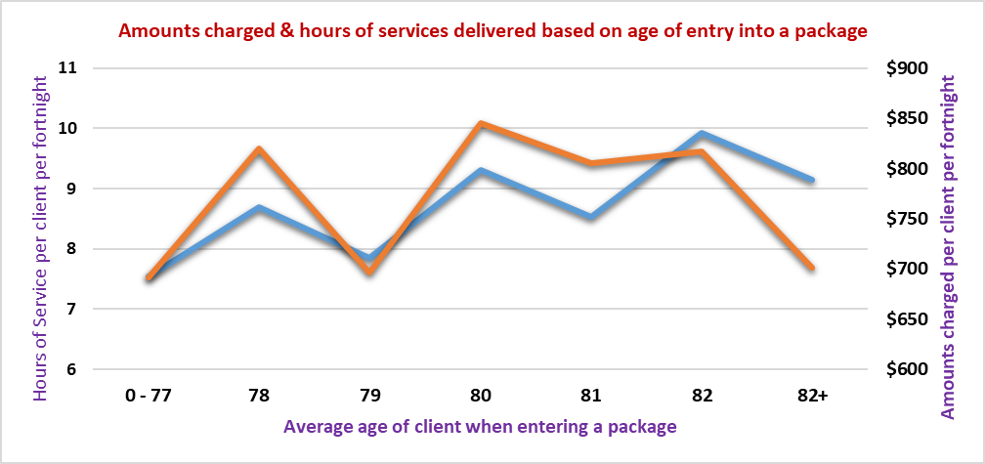

The level of care management provided (function of price and hours) also has an influence over the total amount charged against a package. Interestingly, it follows a contrasting trend to the overall charges against a package. This means that the primary cause for the trends in the amounts charged will be hours of service and the prices of those services.

Chart : Amounts charged per fortnight to a client package for care management in FY 2018‑19 based on average age of client when entering a package and aggregated at provider level

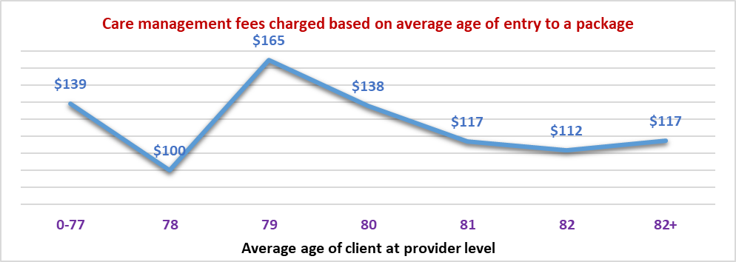

## Other Demographic Factors

### Gender Mix

To establish whether there are any major differences related to the predominant gender mix of clients at a provider level, data was grouped in bands based on the proportion of female clients. The largest group is where female clients made up greater than 70% of the client base. In fact 70% of providers have greater than 60% of their clients being female.

Table : Amounts charged per fortnight to client packages based on proportion of females in provider client mix - aggregated at provider level for FY 2018-19

|  |  |  |  |  |  |
| --- | --- | --- | --- | --- | --- |
| **Total Amount Charged to Care Recipients** | **2018-19 Financial Year** | | | | |
|  | **All Average** | **0-60%** | **61%-65%** | **66%-70%** | **71%-100%** |
| Total number of providers | 410 | 106 | 87 | 105 | 112 |
| Total number of packages | 58,540 | 4,114 | 15,943 | 31,604 | 6,879 |
| Total number of subsidised days | 21,367,100 | 1,501,610 | 5,819,195 | 11,535,460 | 2,510,835 |
| Care management | $126.94 | $124.89 | $112.19 | $134.97 | $125.47 |
| Admin charge/(Package mgt - Sept. Qtr) | $143.13 | $128.79 | $136.70 | $151.09 | $130.03 |
| Nursing care - registered nurse | $7.97 | $10.53 | $9.12 | $7.08 | $7.90 |
| Nursing care - enrolled nurse or other licensed nurse | $3.63 | $3.11 | $1.98 | $4.78 | $2.41 |
| Personal care | $139.54 | $129.03 | $146.67 | $127.38 | $185.17 |
| Cleaning and household tasks | $84.39 | $60.70 | $64.07 | $99.27 | $77.27 |
| Meal preparation | $11.73 | $16.22 | $11.53 | $11.51 | $10.53 |
| Social support, shopping services, community access | $75.77 | $59.68 | $86.24 | $72.99 | $73.94 |
| Consumables | $17.99 | $14.63 | $24.36 | $16.47 | $12.21 |
| Light gardening | $13.29 | $10.02 | $13.73 | $13.66 | $12.54 |
| In-home respite (day-time) | $21.48 | $24.36 | $21.99 | $22.17 | $15.36 |
| In-home respite (overnight) | $2.29 | $2.23 | $0.62 | $2.68 | $4.42 |
| Transport services | $16.56 | $14.83 | $14.24 | $17.49 | $18.68 |
| Allied health professional (practitioner) | $20.86 | $15.01 | $22.49 | $21.56 | $17.35 |
| Capital purchases | $27.63 | $19.00 | $24.58 | $31.02 | $24.30 |
| Home modifications | $8.52 | $7.88 | $14.14 | $5.31 | $10.67 |
| Home maintenance | $8.60 | $6.88 | $10.01 | $8.60 | $6.33 |
| Travel expenses | $8.36 | $6.01 | $8.67 | $8.89 | $6.58 |
| Other services required to maintain the home care recipient at home | $35.24 | $25.06 | $28.96 | $40.89 | $29.91 |
| Maximum exit amount | $1.50 | $1.47 | $1.25 | $1.73 | $1.05 |
| Processing charge on third party purchases/subcontracting | $5.40 | $6.41 | $9.29 | $2.22 | $10.43 |
| **Total Amount Charged to Clients** | **$780.82** | **$686.73** | **$762.83** | **$801.77** | **$782.54** |

Table : Amounts receipted per fortnight and unspent funds balance at the end of the year for client packages based on proportion of females in provider client mix - aggregated at provider level for FY 2018-19

|  |  |  |  |  |  |
| --- | --- | --- | --- | --- | --- |
| **Receipts and Unspent Funds** | **2018-19 Financial Year** | | | | |
|  | **All Average** | **0-60%** | **61%-65%** | **66%-70%** | **71%-100%** |
| **Receipts from:** |  |  |  |  |  |
| Fees received from care recipients | $46.81 | $36.22 | $43.51 | $46.74 | $61.10 |
| Government subsidies received for the period | $914.48 | $914.34 | $902.93 | $936.82 | $838.72 |
| **Total receipts** | **$961.29** | **$950.56** | **$946.44** | **$983.55** | **$899.82** |
| Unutilised amount | $180.46 | $263.83 | $183.60 | $181.78 | $117.28 |
| Utilisation rate | 81% | 72% | 81% | 82% | 87% |
| Unspent funds per package | $7,040 | $6,938 | $7,348 | $7,015 | $6,505 |

The predominant trend is that as the proportion of female clients increase, the average amount charged against a client package increases. This is supported by an increase in the package utilisation rate.

Chart : Trend of average amount charged to a client package per fortnight based on proportion of females in provider client mix - aggregated at provider level for FY 2018-19

As the proportion of female care recipients in a provider client mix increases, the average amount charged also increases.  For providers with females accounting for over 71% of care recipients in their care, the amount charged declines slightly compared to the 66-70%.
The lowest amount charged is for 0-60% female proportion at $687 per fortnight, with the highest for 66-70% females with $802 per fortnight.

Table : Average hours of service per fortnight provided to client packages based on proportion of females in provider client mix - aggregated at provider level for FY 2018-19

|  |  |  |  |  |  |  |
| --- | --- | --- | --- | --- | --- | --- |
| **Total Hours of Service Provision** | **2018-19 Financial Year** | | | | | |
|  | **All average** | **0-60%** | **61%-65%** | **66%-70%** | **71%-100%** |
| Total number of providers | 410 | 106 | 87 | 105 | 112 |
| Total number of packages | 58,540 | 4,114 | 15,943 | 31,604 | 6,879 |
| Total number of subsidised days | 21,367,100 | 1,501,610 | 5,819,195 | 11,535,460 | 2,510,835 |
| Care management | 1.16 | 1.08 | 1.29 | 1.05 | 1.36 |
| Nursing care - registered nurse | 0.10 | 0.14 | 0.11 | 0.10 | 0.08 |
| Nursing care - enrolled nurse or other licensed nurse | 0.03 | 0.05 | 0.02 | 0.03 | 0.03 |
| Personal care | 2.41 | 2.36 | 2.54 | 2.15 | 3.32 |
| Cleaning and household tasks | 1.91 | 1.35 | 1.51 | 1.92 | 3.15 |
| Social support, shopping services, community access | 1.54 | 1.45 | 1.60 | 1.51 | 1.60 |
| Light gardening | 0.17 | 0.17 | 0.21 | 0.16 | 0.15 |
| In-home respite (day-time) | 0.43 | 0.51 | 0.47 | 0.43 | 0.30 |
| In-home respite (overnight) | 0.05 | 0.06 | 0.01 | 0.07 | 0.04 |
| Transport services | 0.42 | 0.26 | 0.41 | 0.39 | 0.64 |
| Allied health professional (practitioner) | 0.12 | 0.12 | 0.14 | 0.11 | 0.10 |
| Other services provided to the home care recipient | 0.50 | 0.52 | 0.61 | 0.41 | 0.60 |
| **Total Hours of Service Provision** | **8.84** | **8.08** | **8.93** | **8.35** | **11.37** |

The trend in the hours of service also supports the amounts charged to client packages. The overall hours of services increases as the proportion of female clients increases particularly in the last bracket - those providers with greater than 70% female care recipients.

Most of the increase in hours of service are in the following categories all of which are at the lower price range for individual service types:

* Personal care
* Cleaning and household tasks
* Transport services

The fact that the types of services that increase are the less specialised and less expensive types of services, may help to explain why the overall charge to clients decline somewhat in the 71-100% bracket, yet the hours of service for that bracket increases.

### Cultural Background

The question of whether a person’s cultural background impacts on the type or level of service has been explored by looking at the proportion of clients at a provider level who were born in Australia or have listed English as their preferred language. This data has been aggregated and analysed at a provider level so the data or findings will be at a high level.

Table : Amounts charged to client packages per fortnight based on proportion of persons where their birth place is Australia or English is their preferred language in provider client mix - aggregated at provider level for FY 2018-19

|  |  |  |  |  |  |  |
| --- | --- | --- | --- | --- | --- | --- |
|  | **% of clients that birth country is Australia (per provider average)** | | | **% of clients Preferred Language is English (per provider average)** | | |
| **Total Amount Charged to Care Recipients** | **2018-19 Financial Year** | | | **2018-19 Financial Year** | | |
|  | **All Average** | **0%-50%** | **51%-100%** | **All Average** | **0%-50%** | **51%-100%** |
| Total number of providers | 410 | 118 | 292 | 410 | 91 | 319 |
| Total number of packages | 58,540 | 8,899 | 49,641 | 58,540 | 5,610 | 52,930 |
| Total number of subsidised days | 21,367,100 | 3,248,135 | 18,118,965 | 21,367,100 | 2,047,650 | 19,319,450 |
| Care management | $126.94 | $130.52 | $126.30 | $126.94 | $118.99 | $127.78 |
| Admin charge/(Package mgt - Sept. Qtr) | $143.13 | $136.70 | $144.28 | $143.13 | $135.96 | $143.89 |
| Nursing care - registered nurse | $7.97 | $8.13 | $7.94 | $7.97 | $5.30 | $8.25 |
| Nursing care - enrolled nurse or other licensed nurse | $3.63 | $1.61 | $3.99 | $3.63 | $0.42 | $3.97 |
| Personal care | $139.54 | $110.29 | $144.78 | $139.54 | $96.75 | $144.08 |
| Cleaning and household tasks | $84.39 | $82.21 | $84.78 | $84.39 | $99.03 | $82.84 |
| Meal preparation | $11.73 | $11.63 | $11.75 | $11.73 | $11.76 | $11.73 |
| Social support, shopping services, community access | $75.77 | $59.66 | $78.66 | $75.77 | $72.34 | $76.14 |
| Consumables | $17.99 | $19.06 | $17.80 | $17.99 | $19.16 | $17.86 |
| Light gardening | $13.29 | $12.22 | $13.48 | $13.29 | $12.04 | $13.43 |
| In-home respite (day-time) | $21.48 | $28.00 | $20.31 | $21.48 | $19.70 | $21.66 |
| In-home respite (overnight) | $2.29 | $4.15 | $1.96 | $2.29 | $4.47 | $2.06 |
| Transport services | $16.56 | $25.05 | $15.04 | $16.56 | $29.05 | $15.23 |
| Allied health professional (practitioner) | $20.86 | $26.03 | $19.93 | $20.86 | $20.78 | $20.87 |
| Capital purchases | $27.63 | $28.38 | $27.50 | $27.63 | $23.02 | $28.12 |
| Home modifications | $8.52 | $8.17 | $8.59 | $8.52 | $6.57 | $8.73 |
| Home maintenance | $8.60 | $10.16 | $8.32 | $8.60 | $7.51 | $8.71 |
| Travel expenses | $8.36 | $4.81 | $8.99 | $8.36 | $7.14 | $8.48 |
| Other services required to maintain the home care recipient at home | $35.24 | $39.97 | $34.39 | $35.24 | $17.25 | $37.14 |
| Maximum exit amount | $1.50 | $2.19 | $1.38 | $1.50 | $1.62 | $1.49 |
| Processing charge on third party purchases/subcontracting | $5.40 | $11.44 | $4.32 | $5.40 | $13.43 | $4.55 |
| **Total Amount Charged to Clients** | **$780.82** | **$760.39** | **$784.49** | **$780.82** | **$722.27** | **$787.03** |

Table : Amounts receipted per fortnight and unspent funds at the end of the period for client packages based on proportion of persons where their birth place is Australia or English is their preferred language in provider client mix - aggregated at provider level for FY 2018-19

|  |  |  |  |  |  |  |
| --- | --- | --- | --- | --- | --- | --- |
| **Receipts and Unspent Funds** | **2018-19 Financial Year** | | | **2018-19 Financial Year** | | |
|  | **All Average** | **0%-50%** | **51%-100%** | **All Average** | **0%-50%** | **51%-100%** |
| **Receipts from:** |  |  |  |  |  |  |
| Fees received from care recipients | $46.81 | $28.62 | $50.07 | $46.81 | $19.54 | $49.70 |
| Government subsidies received for the period | $914.48 | $827.10 | $930.15 | $914.48 | $796.17 | $927.02 |
| **Total receipts** | **$961.29** | **$855.72** | **$980.21** | **$961.29** | **$815.71** | **$976.72** |
| Unutilised amount | $180.46 | $95.34 | $195.73 | $180.46 | $93.44 | $189.69 |
| Utilisation rate | 81% | 89% | 80% | 81% | 89% | 81% |
| Unspent funds per package | $7,040 | $5,711 | $7,279 | $7,040 | $5,802 | $7,172 |

The pattern for both measures is relatively similar. Where there are less than 50% of persons who were born in Australia, or less than 50% of persons who listed English as their preferred language:

* The total amounts charged against the packages were lower
* Unspent funds were lower
* Utilisation rate was higher

Table : Average amount of hours delivered to client packages per fortnight based on proportion of persons where their birth place is Australia or English is their preferred language in provider client mix - aggregated at provider level for FY 2018-19

|  |  |  |  |  |  |  |
| --- | --- | --- | --- | --- | --- | --- |
|  | **% of clients that birth country is Australia (per provider average)** | | | **% of clients that preferred language is English (per provider average)** | | |
| **Total Hours of Service Provision** | **2018-19 Financial Year** | | | **2018-19 Financial Year** | | |
|  | **All Average** | **0%-50%** | **51%-100%** | **All Average** | **0%-50%** | **51%-100%** |
| Total number of providers | 410 | 108 | 302 | 410 | 84 | 326 |
| Total number of packages | 58,540 | 8,737 | 49,803 | 58,540 | 5,566 | 52,974 |
| Total number of subsidised days | 21,367,100 | 3,189,005 | 18,178,095 | 21,367,100 | 2,031,590 | 19,335,510 |
| Care management | 1.16 | 1.64 | 1.07 | 1.16 | 1.76 | 1.09 |
| Nursing care - registered nurse | 0.10 | 0.12 | 0.10 | 0.10 | 0.08 | 0.11 |
| Nursing care - enrolled nurse or other licensed nurse | 0.03 | 0.01 | 0.03 | 0.03 | 0.01 | 0.03 |
| Personal care | 2.41 | 2.06 | 2.47 | 2.41 | 2.10 | 2.44 |
| Cleaning and household tasks | 1.91 | 2.97 | 1.72 | 1.91 | 3.77 | 1.72 |
| Social support, shopping services, community access | 1.54 | 1.32 | 1.58 | 1.54 | 1.63 | 1.53 |
| Light gardening | 0.17 | 0.19 | 0.17 | 0.17 | 0.18 | 0.17 |
| In-home respite (day-time) | 0.43 | 0.59 | 0.41 | 0.43 | 0.42 | 0.44 |
| In-home respite (overnight) | 0.05 | 0.03 | 0.06 | 0.05 | 0.03 | 0.05 |
| Transport services | 0.42 | 0.58 | 0.39 | 0.42 | 0.79 | 0.38 |
| Allied health professional (practitioner) | 0.12 | 0.18 | 0.11 | 0.12 | 0.16 | 0.11 |
| Other services provided to the home care recipient | 0.50 | 0.96 | 0.41 | 0.50 | 0.70 | 0.47 |
| **Total Hours of Service Provision** | **8.84** | **10.66** | **8.53** | **8.84** | **11.63** | **8.55** |

The hours of service provided supports the higher utilisation rates and lower unspent funds in that there are more hours of service provided to persons who were not born in Australia or did not list English as their preferred language. Most of these additional hours are in the categories of cleaning and household tasks, care management and transport services.

# Summary of Outcomes at Provider Level - September 2019 Quarter

## Data Overview

Of the 485 original respondents to the survey, there were a total of 117 that also supplied September 2019 quarter data. However for a variety of reasons, mainly due to there being incomplete or un-usable data, there were 98 providers whose data for the September 2019 quarter could be used. These 98 providers supplied usable data for both the hours of service and amounts charged to client packages and this is summarised below.

Table : Summary of survey data used for analysis purposes - September 2019 quarter

|  |  |  |  |  |  |  |
| --- | --- | --- | --- | --- | --- | --- |
|  | **Data include** | **Data exclude** | ***Exclude due to no data*** | ***Exclude due to no package data*** | ***Exclude due to incomplete data*** | **Total data (include + exclude)** |
| No. of HC providers in the survey | 98 | 387 | 365 | 1 | 21 | 485 |
| No. of HC providers Sept-19 (Gen Data) | 926 | na | na | na | na | 926 |
| **HC providers % coverage** | **11%** | **na** | **na** | **na** | **na** | **52%** |
| No. of HC packages in the survey | 19,356 | 45,389 | 45,389 | 0 | 0 | 64,745 |
| No. of HC packages Sept-19 (Gen Data) | 118,050 | na | na | na | na | 118,050 |
| **HC packages % coverage** | **16%** | **na** | **na** | **na** | **na** | **55%** |

## Context of the September 2019 Quarter

On 1 July 2019, the new pricing transparency arrangements were implemented whereby all providers were required to publish prices for a range of core services as well as for other items such as care management and package management on the My Aged Care website. Providers must charge their clients the published prices, unless otherwise agreed and documented. Changes were also made to administration costs. In particular, providers can no longer charge separately for business‑related administration costs such as office rent, insurance, and marketing. Instead these charges must be included in the unit price for services, and all administration costs, including package management charges must be kept to a reasonable amount.

Leading up to the implementation of these new arrangements, many providers reassessed their prices and went through a process of better understanding their costs of delivering services so that prices could be reasonably set.

The new pricing arrangements affect new clients entering a package after 1 July 2019. The prices and other arrangements for existing clients would remain the same until their care agreements could be revised and renegotiated over the year to 30 June 2020.

The main reason for collecting the September 2019 quarter data was to assess whether there were any discernible changes in behaviour of clients or providers as a result of these new arrangements. However, it is noted that any change has to be viewed in the context that most of the existing clients will not have been transitioned to the new prices by the end of the September quarter. Further analysis would need to be taken after all existing clients transition to the new arrangements to evaluate the impact of pricing transparency. A secondary reason to collect the data at this stage was to confirm the results from the FY 2018-19 survey.

## Amounts Charged to Care Recipient Packages

There is not a significant difference in the amounts charged overall by providers for the September 2019 quarter with an average of $850.09 per package per fortnight being charged across all package levels compared to $835.11 per package per fortnight for the FY 2018-19.

Chart : Comparison of average amount charged at provider level per fortnight for services to clients for FY 2018-19 and September 2019 quarter

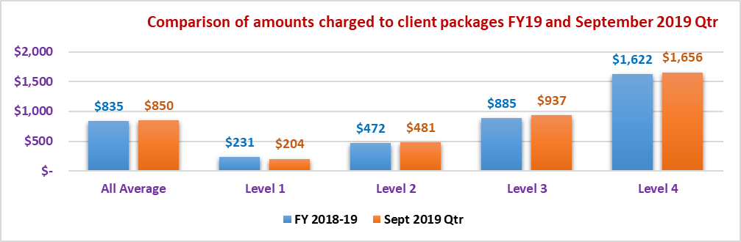

Table : Average amount charged to a client package per fortnight for the September 2019 quarter

|  |  |  |  |  |  |
| --- | --- | --- | --- | --- | --- |
| **Total Amount Charged to Care Recipients** | **September 2019 Quarter** | | | | |
|  | **All Average** | **Level 1** | **Level 2** | **Level 3** | **Level 4** | |
| Total number of providers | 98 | na | na | na | na | |
| Total number of packages | 19,356 | 1,809 | 8,756 | 3,740 | 5,052 | |
| Total number of subsidised days | 1,771,976 | 165,677 | 801,497 | 342,463 | 462,339 | |
| Care management | $134.97 | $40.50 | $86.05 | $156.47 | $237.69 | |
| Admin charge/(Package mgt - Sept. Qtr) | $162.37 | $44.57 | $92.31 | $191.35 | $304.58 | |
| Nursing care - registered nurse | $8.10 | $0.77 | $1.96 | $11.58 | $18.80 | |
| Nursing care - enrolled nurse or other licensed nurse | $2.82 | $0.23 | $0.62 | $3.86 | $6.78 | |
| Personal care | $136.34 | $17.99 | $55.39 | $131.16 | $322.92 | |
| Cleaning and household tasks | $87.95 | $39.09 | $69.07 | $98.86 | $130.10 | |
| Meal preparation | $7.90 | $1.11 | $4.82 | $8.80 | $15.01 | |
| Social support, shopping services, community access | $83.10 | $17.66 | $47.49 | $92.81 | $161.10 | |
| Consumables | $28.37 | $3.73 | $16.52 | $30.28 | $56.34 | |
| Light gardening | $12.67 | $5.83 | $8.11 | $14.48 | $21.69 | |
| In-home respite (day-time) | $23.33 | $2.12 | $6.65 | $19.56 | $62.65 | |
| In-home respite (overnight) | $1.41 | $0.00 | $0.33 | $0.20 | $4.69 | |
| Transport services | $17.98 | $3.91 | $11.09 | $19.87 | $33.56 | |
| Allied health professional (practitioner) | $21.10 | $4.03 | $10.41 | $25.14 | $42.75 | |
| Capital purchases | $22.89 | $4.42 | $11.55 | $29.12 | $44.54 | |
| Home modifications | $8.50 | $1.51 | $3.65 | $9.56 | $18.62 | |
| Home maintenance | $9.08 | $3.02 | $6.22 | $9.93 | $15.57 | |
| Travel expenses | $8.43 | $2.24 | $4.25 | $9.57 | $17.04 | |
| Other services required to maintain the home care recipient at home | $67.37 | $9.68 | $41.85 | $68.92 | $131.12 | |
| Maximum exit amount | $1.52 | $0.76 | $1.25 | $1.76 | $2.07 | |
| Processing charge on third party purchases/subcontracting | $3.91 | $1.19 | $1.84 | $4.01 | $8.39 | |
| **Total Amount Charged to Clients** | **$850.09** | **$204.33** | **$481.43** | **$937.28** | **$1,656.01** | |

While there are minor differences between the amounts charged, this is more likely to be a result of the two data sets having different providers with the September data a sub-set of the providers included in the FY 2018‑19 data set. It is unlikely that the differences in prices is as a result of the new pricing transparency arrangements, given the above reasons re timing of impacts for existing clients.

Chart : Comparison of average amount charged at provider level for a range of core services provided to clients for FY 2018-19 and September 2019 quarter

Chart displays the amount charged for personal care, cleaning and household tasks, social support and shopping, and other services across FY2018-19 and the September 2019 Quarter. 
Amounts charged for cleaning and household tasks, and social support and shopping are similar between the periods.  Peronal care decreased from $150 to $136 from FY2018-19 to the September quarter, while other services increased in amount charged from $38 to $67.

One area where there is a higher charge in the September 2019 quarter is in relation to “other services required to maintain the home care recipient”. This has increased from an average of $37.65 per package per fortnight to $67.37 per package per fortnight.

What we have learned through the limited data collected in the deep dive is that many of these “other services” actually relate to various allied health services but have been categorised as other services based on the provider’s reporting system and business model. We understand that many providers were essentially running “two systems” during the period of transitioning legacy clients onto the new pricing structures so this is possibly an allocation issue from legacy systems.

The other area which was expected to show some level of change was in relation to package management and care management services. While there are some minor reduction in care management costs in the September 2019 quarter, there has been a general increase in the amounts charged for package management in comparison to the administration charges in FY 2018-19.

Chart : Comparison of historical charges for fortnightly administration costs and the charges for package management under pricing transparency

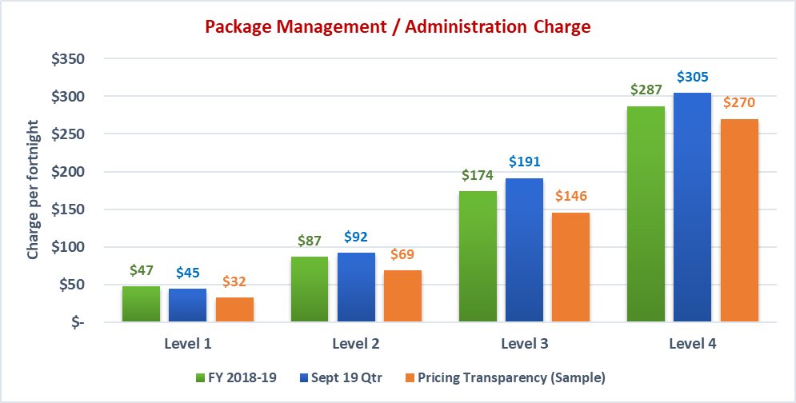

In fact, based on the pricing transparency data for the providers in the survey (sample) the package administration costs should be lower under the new pricing structures published on My Aged Care under the pricing transparency table. This will take some time to filter through as clients are transitioned onto the new pricing arrangements from their old arrangements and the market adjusts to the increased transparency in pricing costs. Note that the results for the sample are representative of the results for the overall sector in respect to the pricing transparency table.

Chart : Comparison of average amount charged per fortnight at provider level for care management services to clients for FY 2018-19 and September 2019 quarter

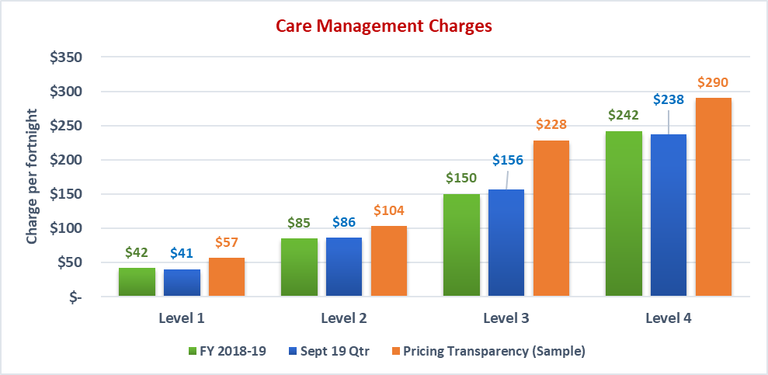

There is very little noticeable change in care management costs from the FY 2018-19 data to the September quarter data. However, based on the pricing transparency data, the care management charges are likely to increase across all package levels from where they have been historically when comparing the charges for fully managed packages. A mix of fully managed and self‑managed packages may see the average price come back to where it has been historically from that shown in the chart above.

Table : Summary of receipts per fortnight and unspent funds based on data collected for September 2019 quarter

|  |  |  |  |  |  |
| --- | --- | --- | --- | --- | --- |
| **Receipts and Unspent Funds** | **September 2019 Quarter** | | | | |
|  | **All Average** | **Level 1** | **Level 2** | **Level 3** | **Level 4** | |
| **Receipts from:** |  |  |  |  |  | |
| Fees received from care recipients | $26.96 | $9.13 | $22.77 | $26.66 | $40.83 | |
| Government subsidies received for the period | $1,061.91 | $293.30 | $583.19 | $1,278.94 | $2,006.48 | |
| **Total receipts** | **$1,088.87** | **$302.43** | **$605.95** | **$1,305.60** | **$2,047.32** | |
| Unutilised amount | $238.78 | $98.10 | $124.53 | $368.33 | $391.30 | |
| Utilisation rate | 78% | 68% | 79% | 72% | 81% | |
| Unspent funds per package | $6,751 | $1,031 | $4,141 | $6,587 | $13,443 | |

The total receipts per package are lower than what was reported for the FY 2018-19. This could be for a number of reasons. Providers may have returned funds in the September quarter that were more than the average across the previous year. In addition, some providers have made the decision not to charge a client contribution. An analysis of the data from the pricing transparency table on My Aged Care current at 2 January 2020 showed that 34% of the 844 providers had entered data for the amount of basic daily fee that would be charged (refer Section 5.3 for average basic daily fee amount charged). The other 66% of providers had zero or no amount entered for the basic daily fee charge. This is also evident in the average client contribution for the September quarter being $26.96 per client per fortnight compared to $50.03 per fortnight in FY 2018-19. We are also aware of some providers who cease collecting the means tested fee from clients should their unspent funds reach certain levels.

Chart : Comparison of average unspent funds by package level at period end of FY 2018-19 and September 2019 quarter

Across most package levels, the September 2019 Quarter records lower average unspent funds than in FY2018-19. Average unspent funds increases as package level increases.  Level 2 packages have a similar average amount of unspent funds across FY2018-19 and the September 2019 quarter.
The average unspent funds for FY2018-19 is $7,521 and for September 2019 quarter, $6,751.

Average unspent funds have generally declined based on this September quarter data-set which is in contrast to the StewartBrown Aged Care Financial Performance survey however the differences are not material. Similarly, the FY 2018-19 data set had an average unspent funds balance that was higher than the StewartBrown survey for the same period, and again the differences are not considered to be material.

## Hours of Service

The analysis of data at the provider, and other levels has been mirrored for the hours delivered to a package.

Table : Summary of average hours of service per package per fortnight by service type for September 2019 quarter

|  |  |  |  |  |  |
| --- | --- | --- | --- | --- | --- |
|  | **September 2019 Quarter** | | | | |
|  | **All Average** | **Level 1** | **Level 2** | **Level 3** | **Level 4** |
| Total number of packages | 19,356 | 1,809 | 8,756 | 3,740 | 5,052 |
| Total number of subsidised days | 1,771,976 | 165,677 | 801,497 | 342,463 | 462,339 |
| Care management | 1.22 | 0.54 | 0.97 | 1.31 | 1.84 |
| Nursing care - registered nurse | 0.47 | 0.03 | 0.19 | 0.57 | 1.05 |
| Nursing care - enrolled nurse or other licensed nurse | 0.01 | 0.00 | 0.00 | 0.01 | 0.03 |
| Personal care | 2.40 | 0.31 | 1.13 | 2.26 | 5.45 |
| Cleaning and household tasks | 1.70 | 0.82 | 1.35 | 1.87 | 2.47 |
| Social support, shopping services, community access | 1.48 | 0.40 | 0.97 | 1.63 | 2.66 |
| Light gardening | 0.15 | 0.11 | 0.12 | 0.18 | 0.19 |
| In-home respite (day-time) | 0.40 | 0.08 | 0.18 | 0.41 | 0.88 |
| In-home respite (overnight) | 0.02 | - | 0.00 | 0.01 | 0.07 |
| Transport services | 0.51 | 0.20 | 0.35 | 0.52 | 0.90 |
| Allied health professional (practitioner) | 0.91 | 0.15 | 0.49 | 1.36 | 1.59 |
| Other services provided to the home care recipient | 0.62 | 0.23 | 0.48 | 0.61 | 1.01 |
| **Total Hours of Service Provision** | **9.90** | **2.87** | **6.25** | **10.74** | **18.14** |

There has been a small shift in the proportion of services of the total package from the core services of personal care, cleaning and household tasks and social support to other services and allied health services. It should be noted that the deep dive suggested that some of these other services were in fact a variety of allied health services so the shift in the overall proportion of the package towards more allied health services is significant as the package levels increase. There has also been an increase in the proportion of hours that relate to nursing services.

Table : Summary of average hours of service per package per fortnight by service type as a proportion of total hours provided for September 2019 quarter

|  |  |  |  |  |  |
| --- | --- | --- | --- | --- | --- |
|  | **2018-19 Financial Year** | | | | |
|  | **All Average** | **Level 1** | **Level 2** | **Level 3** | **Level 4** |
| Care management | 12% | 19% | 16% | 12% | 10% |
| Nursing care - registered nurse | 5% | 1% | 3% | 5% | 6% |
| Nursing care - enrolled nurse or other licensed nurse | 0% | 0% | 0% | 0% | 0% |
| Personal care | 24% | 11% | 18% | 21% | 30% |
| Cleaning and household tasks | 17% | 29% | 22% | 17% | 14% |
| Social support, shopping services, community access | 15% | 14% | 16% | 15% | 15% |
| Light gardening | 2% | 4% | 2% | 2% | 1% |
| In-home respite (day-time) | 4% | 3% | 3% | 4% | 5% |
| In-home respite (overnight) | 0% | 0% | 0% | 0% | 0% |
| Transport services | 5% | 7% | 6% | 5% | 5% |
| Allied health professional (practitioner) | 9% | 5% | 8% | 13% | 9% |
| Other services provided to the home care recipient | 6% | 8% | 8% | 6% | 6% |
| **Total Hours of Service Provision** | **100%** | **100%** | **100%** | **100%** | **100%** |

Chart : Comparison of proportion of total service hours for personal care services per package level for FY 2018-19 and September 2019 quarter

Graph shows that across all package levels, FY2018-19 has a greater proportion of service hours for personal care services compared to the September 2019 Quarter. The difference in proportions is greatest for level 1 and level 3 where the difference is 5%.
In both FY2018-19 and the September quarter, the proportion of hours for personal care increases as package level increases.

Chart : Comparison of proportion of total service hours for cleaning and household tasks per package level for FY 2018-19 and September 2019 quarter

Graph shows that across all package levels, FY2018-19 has a greater proportion of service hours for cleaning and household tasks compared to the September 2019 Quarter. The difference in proportions is greatest for level 2 where the difference is 7%.
In both FY2018-19 and the September quarter, the proportion of hours for cleaning and household tasks declines as package level increases.

Chart : Comparison of proportion of total service hours for social support, shopping services, and community access per package level for FY 2018-19 and September 2019 quarter

Graph shows that across all package levels, FY2018-19 has a greater proportion of service hours for social support compared to the September 2019 Quarter. The difference in proportions is greatest for level 2 and 3 where the difference is 3%.
In both FY2018-19 and the September quarter, the proportion of hours for social support is fairly consistent as package level increases.

Chart : Comparison of proportion of total service hours for other services per package level for FY 2018‑19 and September 2019 quarter

Graph shows that across level 1 and 2 packages, FY2018-19 has a lower proportion of service hours for other services compared to the September 2019 Quarter. This is greatest for Level 1, where FY2018-19 has a proportion of 4%, and September Quarter has 8%.
For Level 3 and 4 packages, FY2018-19 and the September Quarter have the same proportions of service hours for other services of 6%.


Chart : Comparison of proportion of total service hours for nursing care services per package level for FY 2018-19 and September 2019 quarter

Graph shows that across all package levels, FY2018-19 has a lower proportion of service hours for nursing care compared to the September 2019 Quarter. FY2018-19 has between 1% and 2% proportions of service hours for nursing care across all package levels. 
In the September quarter, the proportion of hours for nursing care increases as package level increases, from 1% under level 1 to 6% under level 4.

Chart : Comparison of proportion of total service hours for allied health services per package level for FY 2018-19 and September 2019 quarter

Graph shows that across all package levels, FY2018-19 has a lower proportion of service hours for allied health services compared to the September 2019 Quarter. FY2018-19 has a proportions of service hours for allied health services of 1% across all package levels. 
In the September quarter, the proportion of hours for nursing care increases as package level increases, from 5% under level 1 to 13% under level 3, with exception of level 4 which has a proportion of 9%.

The pattern of service use between those basic services to assist with everyday living tasks trends downwards and the more one-on-one care services such as personal care, nursing care and allied health increases as package levels increase. This largely follows the same pattern for the data collected for FY 2018-19.

Chart : Hours of service provided as proportion of total hours for top 4 services - trends between package levels for September 2019 quarter

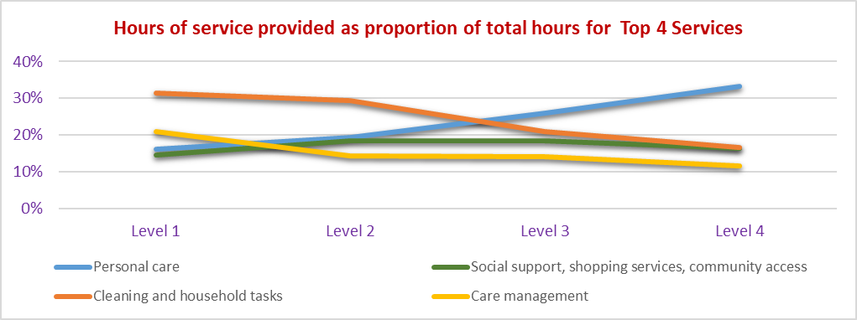

## Price of Services

The data below is an estimate of price and is formulated using average hours of service and average amounts charged at a provider level. It takes into account variances relating to location, service delivery model and other variables.

Table : Average price of services estimated using hours of service and amounts charged to care recipient packages for September 2019 quarter

|  |  |  |  |  |  |
| --- | --- | --- | --- | --- | --- |
| **Average cost per hour** | **Survey Average** | **Level 1** | **Level 2** | **Level 3** | **Level 4** |
| Care management | 110.42 | 75.35 | 88.62 | 119.82 | 129.07 |
| Nursing care - registered nurse | 17.14 | 22.67 | 10.23 | 20.35 | 17.98 |
| Nursing care - enrolled nurse or other licensed nurse | 261.73 | 156.88 | 153.46 | 368.89 | 261.11 |
| Personal care | 56.84 | 57.12 | 49.07 | 58.04 | 59.26 |
| Cleaning and household tasks | 51.88 | 47.79 | 51.04 | 52.78 | 52.66 |
| Social support, shopping services, community access | 55.96 | 44.51 | 49.02 | 56.99 | 60.48 |
| Light gardening | 84.10 | 52.03 | 65.40 | 81.15 | 114.10 |
| In-home respite (day-time) | 58.58 | 28.20 | 36.41 | 47.97 | 71.12 |
| In-home respite (overnight) | 72.09 | na | 106.73 | 36.04 | 71.50 |
| Transport services | 35.06 | 20.04 | 31.73 | 38.01 | 37.19 |
| Allied health professional (practitioner) | 23.10 | 26.53 | 21.37 | 18.42 | 26.88 |
| Other services provided to the home care recipient | 108.49 | 42.18 | 86.85 | 112.97 | 129.77 |
| **Average price per hour of service** | **60.32** | **49.48** | **54.28** | **59.89** | **64.72** |
| Average charged - total charge / hours of service (includes all charges) | 85.87 | 71.30 | 77.09 | 87.31 | 91.31 |

The differences between these prices and those averages for FY 2018-19 (refer Table 30) are marginal as shown in the extract below. This is likely because the majority of clients will still be on grandfathered arrangements during much of the September quarter.

|  |  |  |  |  |  |
| --- | --- | --- | --- | --- | --- |
| **Average price per hour of service** | **61.96** | **52.43** | **58.95** | **59.72** | **65.08** |
| Average charged - total charge / hours of service (includes all charges) | 88.27 | 74.64 | 83.11 | 86.70 | 92.62 |

Comparison to Pricing Transparency

With the requirement to publish prices and other changes commencing on 1 July 2019 as part of the move to pricing transparency, it is informative to make some comparisons of prices in place for FY 2018‑19, September 2019 quarter and the published prices. It is unlikely that many of these pricing changes will have been reflected in the September 2019 quarter data as most of the existing clients will not have been transitioned to the new prices, but it will provide a window into what the pricing of services will look like moving forward.

Table : Summary of average price for services listed on the pricing transparency table at January 2020 for respondents to the survey

|  |  |
| --- | --- |
| **Average price per hour** | **Sample Average** |
| Nursing | 95.97 |
| Non standard hours | 111.53 |
| Saturday (Per hour) | 132.28 |
| Sunday (Per hour) | 158.27 |
| Public Holiday (Per hour) | 216.16 |
| Personal care | 57.96 |
| Non standard hours | 67.09 |
| Saturday (Per hour) | 79.30 |
| Sunday (Per hour) | 96.52 |
| Public Holiday (Per hour) | 130.72 |
| Cleaning and household tasks - standard hours | 56.64 |
| Non standard hours | 65.31 |
| Saturday (Per hour) | 77.37 |
| Sunday (Per hour) | 94.54 |
| Public Holiday (Per hour) | 128.67 |
| Light gardening | 57.43 |
| Non standard hours | 69.92 |
| Saturday (Per hour) | 84.64 |
| Sunday (Per hour) | 105.43 |
| Public Holiday (Per hour) | 138.43 |
| In-home respite (day-time) - standard hours | 57.87 |
| Non standard hours | 66.95 |
| Saturday (Per hour) | 79.15 |
| Sunday (Per hour) | 96.34 |
| Public Holiday (Per hour) | 130.66 |
| Transport Services ($ per km) | 0.58 |

Chart : Comparison of hourly standard hours prices under new pricing transparency arrangements against FY 2018-19 estimated prices for core services

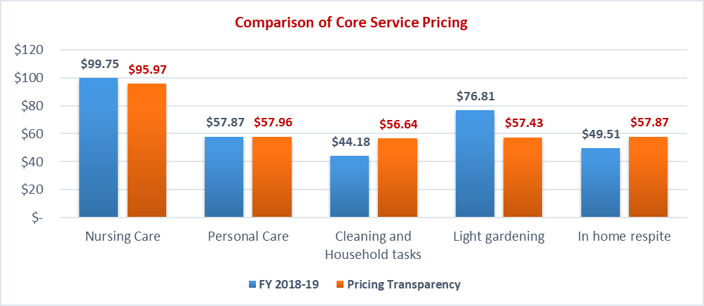

*Note. The FY 2018-19 price for nursing is a merge of the registered nurse cost and enrolled nurse cost as under the pricing transparency table there is only one category for registered nursing. Based on the data collected, many providers also did not make a clear distinction between the two categories. The similarity in average price also confirms the legitimacy of this comparison.*

While there are some differences in pricing they are somewhat marginal. Under the new pricing transparency, the prices for most standard services are roughly the same with higher prices for more specialised services. This would indicate that providers have been making a reasonable undertaking of publishing reasonable and accurate prices.

## Ownership

Overview

It is noted that the number of providers that provided data for the September data set is considerably less than that of the FY 2018-19 data set where there was data from 416 providers included representing a coverage of 45% of the overall sector compared to 98 providers in September 2019 quarter representing just 11% of the sector.

The overall distribution of providers is reasonable in the September data, but the distribution of packages is heavily biased towards the NFP provider types with very few packages from the FP or Government sectors in the survey September data as a proportion of the total.

Table : Profile of data sample by ownership type for September 2019 quarter

|  |  |  |  |  |
| --- | --- | --- | --- | --- |
|  | **Not for Profit** | **For Profit** | **Government** | **Total** |
| No. of HC providers in the survey | 62 | 26 | 10 | 98 |
| No. of HC providers FY19 (Gen Data) | 479 | 335 | 115 | 929 |
| **HC providers % coverage** | **13%** | **8%** | **9%** | **11%** |
| No. of HC packages in the survey | 17,565 | 1,440 | 351 | 19,356 |
| No. of HC packages FY19 (Gen Data) | 77,156 | 22,317 | 7,234 | 106,707 |
| **HC packages % coverage** | **23%** | **6%** | **5%** | **18%** |

Chart : Distribution of providers and packages in the survey by ownership type - September 2019 quarter

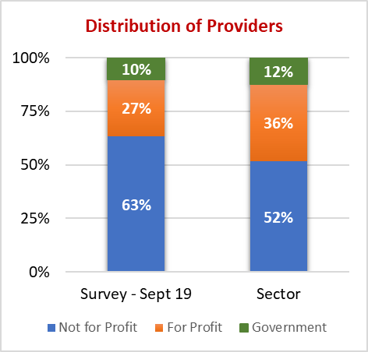 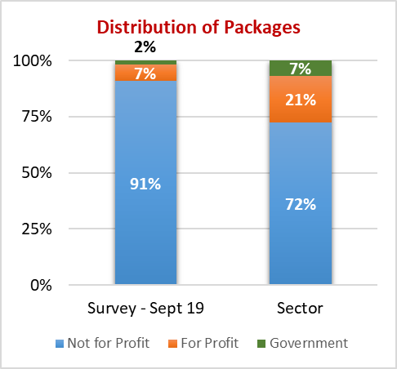

Amounts Charged to Care Recipient Packages

Table : Summary of amounts charged to clients aggregated at the provider level - average across all package levels per client per fortnight - September 2019 quarter

|  |  |  |  |  |
| --- | --- | --- | --- | --- |
| **Total Amount Charged to Care Recipients** | **September 2019 Quarter** | | | |
|  | **All Average** | **Not for Profit** | **For Profit** | **Government** | |
| Total number of providers | 98 | 62 | 26 | 10 | |
| Total number of packages | 19,356 | 17,565 | 1,440 | 351 | |
| Total number of subsidised days | 1,771,976 | 1,608,001 | 131,893 | 32,082 | |
| Care management | $134.97 | $137.15 | $100.31 | $168.17 | |
| Admin charge/(Package mgt - Sept. Qtr) | $162.37 | $165.36 | $135.90 | $121.59 | |
| Nursing care - registered nurse | $8.10 | $8.23 | $7.51 | $4.23 | |
| Nursing care - enrolled nurse or other licensed nurse | $2.82 | $2.86 | $2.94 | $0.01 | |
| Personal care | $136.34 | $132.11 | $207.87 | $54.40 | |
| Cleaning and household tasks | $87.95 | $84.76 | $135.05 | $54.11 | |
| Meal preparation | $7.90 | $7.14 | $6.72 | $50.93 | |
| Social support, shopping services, community access | $83.10 | $84.00 | $71.70 | $85.08 | |
| Consumables | $28.37 | $29.98 | $14.85 | $3.50 | |
| Light gardening | $12.67 | $12.35 | $18.31 | $5.73 | |
| In-home respite (day-time) | $23.33 | $23.82 | $22.72 | $1.38 | |
| In-home respite (overnight) | $1.41 | $0.83 | $8.34 | $2.02 | |
| Transport services | $17.98 | $18.55 | $9.24 | $25.50 | |
| Allied health professional (practitioner) | $21.10 | $20.98 | $25.12 | $10.11 | |
| Capital purchases | $22.89 | $21.67 | $38.23 | $20.90 | |
| Home modifications | $8.50 | $8.46 | $9.66 | $5.71 | |
| Home maintenance | $9.08 | $8.91 | $8.87 | $18.34 | |
| Travel expenses | $8.43 | $9.01 | $2.96 | $1.72 | |
| Other services required to maintain the home care recipient at home | $67.37 | $72.72 | $14.76 | $15.38 | |
| Maximum exit amount | $1.52 | $1.52 | $0.44 | $5.93 | |
| Processing charge on third party purchases/subcontracting | $3.91 | $3.49 | $4.21 | $23.89 | |
| **Total Amount Charged to Clients** | **$850.09** | **$853.87** | **$845.70** | **$678.62** | |

Chart : Comparison of average fortnightly charge per package for services by ownership type for FY 2018‑19 and September 2019 quarter

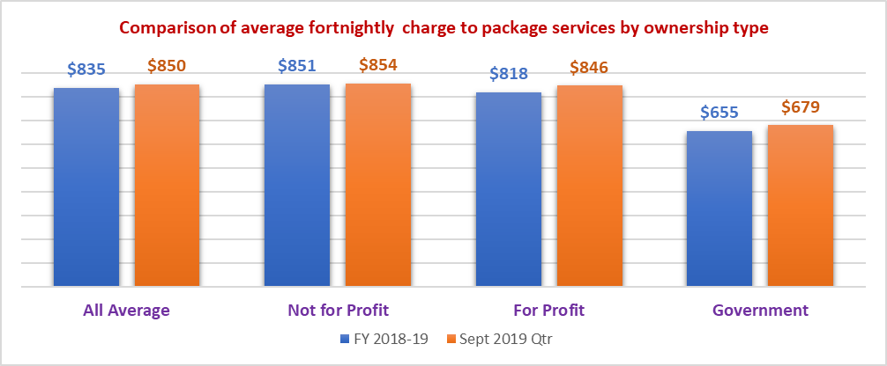

There are very few differences in the overall charges to clients from FY 2018-19 to the September 2019 quarter although the FP providers in the sample have increased the amount charged against the package to now be very similar to the NFP providers. Government providers continue to charge considerably less against their packages than the other providers.

Chart : Comparison of average fortnightly charge per package for personal care services by ownership type for FY 2018-19 and September 2019 quarter

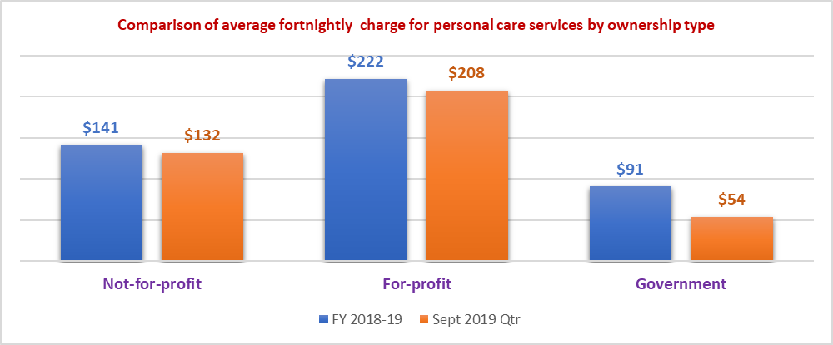

There are minimal reductions in the charges for personal care in the NFP and FP providers with larger differences in the Government providers. This is not likely to reflect the full effect of pricing transparency changes.

Chart : Comparison of average fortnightly charge per package for cleaning and household tasks by ownership type for FY 2018-19 and September 2019 quarter

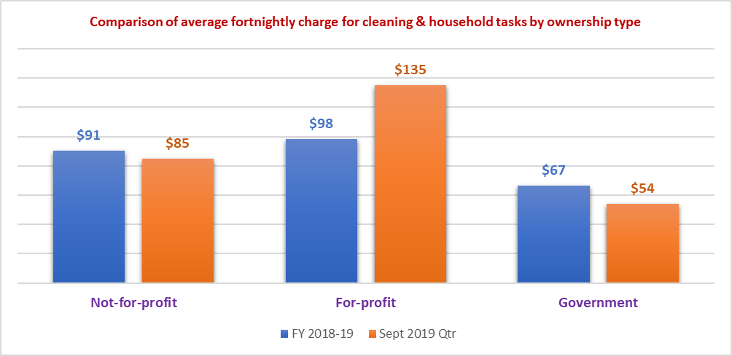

There are differences in the amount charged for other service types as shown in the charts above and below.

Chart : Comparison of average fortnightly charge per package for social support, shopping services and community access by ownership type for FY 2018-19 and September 2019 quarter

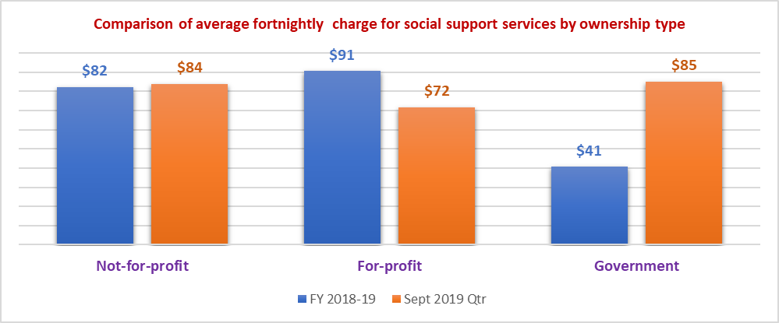

Table : Hours delivered per fortnight to client packages for September 2019 quarter by ownership type

|  |  |  |  |  |
| --- | --- | --- | --- | --- |
|  | **September 2019 Quarter** | | | |
|  | **All Average** | **Not for Profit** | **For Profit** | **Government** |
| Total number of providers | 98 | 62 | 26 | 10 |
| Total number of packages | 19,356 | 17,565 | 1,440 | 351 |
| Total number of subsidised days | 1,771,976 | 1,608,001 | 131,893 | 32,082 |
| Care management | 1.22 | 1.23 | 0.32 | 4.43 |
| Nursing care - registered nurse | 0.47 | 0.51 | 0.08 | 0.15 |
| Nursing care - enrolled nurse or other licensed nurse | 0.01 | 0.01 | 0.04 | 0.01 |
| Personal care | 2.40 | 2.25 | 4.58 | 0.90 |
| Cleaning and household tasks | 1.70 | 1.61 | 2.86 | 1.29 |
| Social support, shopping services, community access | 1.48 | 1.43 | 1.62 | 3.62 |
| Light gardening | 0.15 | 0.15 | 0.18 | 0.19 |
| In-home respite (day-time) | 0.40 | 0.40 | 0.42 | 0.13 |
| In-home respite (overnight) | 0.02 | 0.01 | 0.13 | 0.07 |
| Transport services | 0.51 | 0.34 | 2.40 | 1.27 |
| Allied health professional (practitioner) | 0.91 | 1.00 | 0.11 | 0.08 |
| Other services provided to the home care recipient | 0.62 | 0.66 | 0.09 | 0.82 |
| **Total Hours of Service Provision** | **9.90** | **9.60** | **12.84** | **12.97** |

There remains the same pattern in that the hours of service delivered by the FP providers is higher on average than that of the NFP providers. The increase in the number of hours for Government providers is likely to be attributed to the smaller sample size.

Chart : Comparison of average hours delivered to home care packages for FY 2018-19 and September 2019 quarter by ownership type

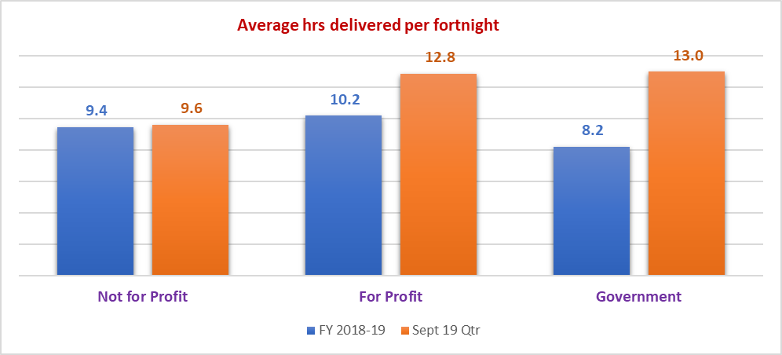

The change in hours delivered shows the same patterns as the amounts charged to client packages.

Chart : Average prices charged per hour for selected services based on information drawn from the pricing transparency table and grouped by ownership type

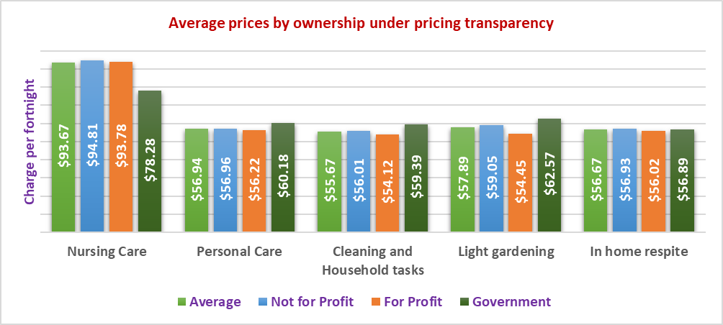

Under pricing transparency, there appears to be very little difference in pricing between the FP and NFP providers. In the non-specialised areas, the Government providers have a higher pricing structure than the other providers.

## Location of Service as Determined by MMM

The analysis of data by MMM at provider level is difficult because the majority of providers in the survey provide services across locations that span different MMM categories. An explanation of MMM categorisation of remoteness is attached as Appendix 3.

Of the 98 providers analysed for the September 2019 quarter survey, 63 operated across multiple areas as defined by the MMM classification. A further 25 providers only operated in MMM1 areas so that there were very few providers operating in more remote areas only. These providers have been reallocated to the MMM category in which the majority of their packages are delivered.

The more remote areas did incur a higher average charge against their packages which is similar to the outcome in the FY 2018-19 analysis (refer Section 5.7).

Table : Summary of amounts charged to clients per fortnight by remoteness as determined by MMM - aggregated at provider level for September 2019 quarter

|  |  |  |  |  |  |  |  |
| --- | --- | --- | --- | --- | --- | --- | --- |
| **Total Amount Charged to Care Recipients** | **September 2019 Quarter** | | | | | | |
|  | **All Average** | **MMM 1** | **MMM 2** | **MMM 3** | **MMM 4** | **MMM 5** | **MMM 7** |
| Total number of providers | 98 | 61 | 12 | 10 | 5 | 5 | 5 |
| Total number of packages | 19,356 | 16,866 | 1,176 | 890 | 150 | 179 | 97 |
| Total number of subsidised days | 1,771,976 | 1,544,003 | 107,634 | 81,432 | 13,735 | 16,347 | 8,826 |
| Care management | $134.97 | $135.62 | $109.79 | $141.18 | $136.21 | $140.92 | $256.83 |
| Admin charge/(Package mgt - Sept. Qtr) | $162.37 | $164.76 | $125.77 | $189.34 | $58.00 | $101.37 | $218.41 |
| Nursing care - registered nurse | $8.10 | $7.96 | $6.35 | $14.94 | $5.25 | $3.89 | $2.75 |
| Nursing care - enrolled nurse or other licensed nurse | $2.82 | $3.05 | $0.39 | $2.91 | - | $0.02 | - |
| Personal care | $136.34 | $137.80 | $115.92 | $172.50 | $44.02 | $29.82 | $136.82 |
| Cleaning and household tasks | $87.95 | $89.04 | $69.76 | $106.42 | $61.52 | $41.10 | $76.49 |
| Meal preparation | $7.90 | $6.38 | $8.53 | $15.20 | $1.82 | $6.08 | $212.12 |
| Social support, shopping services, community access | $83.10 | $80.10 | $105.73 | $108.23 | $82.93 | $13.67 | $228.91 |
| Consumables | $28.37 | $30.11 | $2.49 | $41.72 | - | $4.55 | $4.61 |
| Light gardening | $12.67 | $13.52 | $5.69 | $8.31 | $1.44 | $15.76 | $1.02 |
| In-home respite (day-time) | $23.33 | $24.89 | $8.78 | $23.51 | $0.18 | $2.54 | $0.77 |
| In-home respite (overnight) | $1.41 | $1.00 | $6.36 | $1.30 | - | $10.13 | - |
| Transport services | $17.98 | $18.91 | $11.30 | $6.26 | $4.88 | $5.68 | $87.88 |
| Allied health professional (practitioner) | $21.10 | $22.60 | $8.79 | $13.55 | $7.69 | $10.07 | $18.60 |
| Capital purchases | $22.89 | $23.35 | $14.50 | $27.68 | $1.22 | $32.39 | $15.97 |
| Home modifications | $8.50 | $9.09 | $3.53 | $5.71 | $12.26 | $0.91 | - |
| Home maintenance | $9.08 | $8.94 | $8.43 | $7.39 | $36.45 | $16.52 | - |
| Travel expenses | $8.43 | $9.10 | $1.98 | $7.21 | $1.04 | $4.15 | $0.12 |
| Other services required to maintain the home care recipient at home | $67.37 | $69.27 | $85.64 | $32.43 | $0.97 | $5.04 | $53.54 |
| Maximum exit amount | $1.52 | $1.56 | $0.21 | $0.76 | $6.04 | $2.14 | $8.17 |
| Processing charge on third party purchases/subcontracting | $3.91 | $2.89 | $5.80 | $13.21 | $55.79 | - | - |
| **Total Amount Charged to Clients** | **$850.09** | **$859.95** | **$705.76** | **$939.75** | **$517.71** | **$446.74** | **$1,323.00** |

Table : Receipts per fortnight and unspent funds at the end of the period aggregated at provider level across MMM categories for September 2019 quarter

|  |  |  |  |  |  |  |  |  |
| --- | --- | --- | --- | --- | --- | --- | --- | --- |
| **Receipts and Unspent Funds** | **September 2019 Quarter** | | | | | | | |
|  | **All Average** | **MMM 1** | **MMM 2** | **MMM 3** | **MMM 4** | **MMM 5** | **MMM 7** |
| **Receipts from:** |  |  |  |  |  |  |  |
| Fees received from care recipients | $26.96 | $24.78 | $39.60 | $52.21 | $7.46 | $17.94 | $67.14 |
| Government subsidies received for the period | $1,061.91 | $1,068.78 | $1,003.64 | $1,078.19 | $829.37 | $884.47 | $1,110.90 |
| **Total receipts** | **$1,088.87** | **$1,093.57** | **$1,043.23** | **$1,130.40** | **$836.84** | **$902.41** | **$1,178.04** |
| Unutilised amount | $238.78 | $233.62 | $337.48 | $190.64 | $319.12 | $455.67 | -$144.96 |
| Utilisation rate | 78% | 79% | 68% | 83% | 62% | 50% | 112% |
| Unspent funds per package | $6,751 | $6,587 | $8,442 | $8,211 | $6,985 | $5,967 | $2,452 |

Due to the higher amounts charged, the unspent funds in more remote areas are slightly less than the overall average. Recepts from Government are higher in the remote areas (MMM7) and contributions from clients generally lower. It is also noted that the utilisation rate in the MMM7 category is greater than 100%, meaning that for the September quarter, two of the five providers in this category were utilising unspent funds balances in addition to the receipts for the quarter pushing the average over 100%.

Table : Summary of hours of service delivered to clients per fortnight by remoteness as determined by MMM - aggregated at provider level for September 2019 quarter

|  |  |  |  |  |  |  |  |
| --- | --- | --- | --- | --- | --- | --- | --- |
|  | **September 2019 Quarter** | | | | | | |
|  | **All Average** | **MMM 1** | **MMM 2** | **MMM 3** | **MMM 4** | **MMM 5** | **MMM 7** |
| Total number of providers | 98 | 61 | 12 | 10 | 5 | 5 | 5 |
| Total number of packages | 19,356 | 16,866 | 1,176 | 890 | 150 | 179 | 97 |
| Total number of subsidised days | 1,771,976 | 1,544,003 | 107,634 | 81,432 | 13,735 | 16,347 | 8,826 |
| Care management | 1.22 | 0.98 | 3.36 | 1.82 | 7.14 | 1.95 | 2.14 |
| Nursing care - registered nurse | 0.47 | 0.52 | 0.07 | 0.21 | 0.22 | 0.10 | 0.03 |
| Nursing care - enrolled nurse or other licensed nurse | 0.01 | 0.01 | 0.01 | 0.04 | - | 0.02 | - |
| Personal care | 2.40 | 2.42 | 2.20 | 2.98 | 0.77 | 0.80 | 1.85 |
| Cleaning and household tasks | 1.70 | 1.67 | 1.81 | 2.11 | 1.24 | 1.61 | 1.14 |
| Social support, shopping services, community access | 1.48 | 1.26 | 3.54 | 2.16 | 3.53 | 0.57 | 8.07 |
| Light gardening | 0.15 | 0.15 | 0.23 | 0.12 | 0.06 | 0.35 | 0.02 |
| In-home respite (day-time) | 0.40 | 0.42 | 0.18 | 0.46 | 0.00 | 0.25 | 0.03 |
| In-home respite (overnight) | 0.02 | 0.02 | 0.02 | 0.03 | - | 0.36 | - |
| Transport services | 0.51 | 0.53 | 0.20 | 0.24 | 0.99 | 0.26 | 4.25 |
| Allied health professional (practitioner) | 0.91 | 1.04 | 0.06 | 0.11 | 0.12 | 0.06 | 0.01 |
| Other services provided to the home care recipient | 0.62 | 0.46 | 2.75 | 0.64 | 1.82 | 0.06 | 1.39 |
| **Total Hours of Service Provision** | **9.90** | **9.46** | **14.44** | **10.91** | **15.88** | **6.39** | **18.93** |

## Size of Provider

Unlike the FY 2018-19 data, the smaller providers do not appear to be charging client packages more than the larger providers.

Table : Average amount charged to a client package per fortnight for September 2019 quarter by size of provider based on number of packages serviced

|  |  |  |  |  |  |  |  |  |
| --- | --- | --- | --- | --- | --- | --- | --- | --- |
| **Total Amount Charged to Care Recipients** | **September 2019 Quarter** | | | | | | | |
|  | **All Average** | **Under 25** | **25-50** | **50-100** | **100-150** | **150-250** | **250-500** | **Over 500** |
| Total number of providers | 98 | 32 | 11 | 19 | 8 | 12 | 7 | 9 |
| Total number of packages | 19,356 | 360 | 412 | 1,330 | 958 | 2,412 | 2,602 | 11,284 |
| Total number of subsidised days | 1,771,976 | 32,937 | 37,679 | 121,730 | 87,717 | 220,833 | 238,179 | 1,032,903 |
| Care management | $134.97 | $104.50 | $154.36 | $145.56 | $120.55 | $123.27 | $111.11 | $143.20 |
| Admin charge/(Package mgt - Sept. Qtr) | $162.37 | $110.01 | $83.71 | $119.57 | $183.59 | $129.27 | $118.15 | $187.43 |
| Nursing care - registered nurse | $8.10 | $2.71 | $9.08 | $13.46 | $13.97 | $2.66 | $10.94 | $7.62 |
| Nursing care - enrolled nurse or other licensed nurse | $2.82 | $3.02 | $0.01 | $2.41 | $1.98 | $3.24 | $0.84 | $3.40 |
| Personal care | $136.34 | $115.68 | $189.10 | $135.24 | $146.82 | $134.37 | $89.18 | $145.61 |
| Cleaning and household tasks | $87.95 | $86.84 | $40.84 | $89.34 | $76.41 | $94.37 | $78.39 | $91.35 |
| Meal preparation | $7.90 | $34.90 | $2.79 | $22.57 | $12.98 | $9.34 | $6.40 | $5.11 |
| Social support, shopping services, community access | $83.10 | $99.89 | $18.56 | $116.80 | $78.17 | $83.45 | $40.65 | $91.08 |
| Consumables | $28.37 | $19.13 | $4.44 | $40.28 | $8.57 | $12.69 | $31.95 | $32.35 |
| Light gardening | $12.67 | $9.74 | $9.72 | $15.89 | $17.84 | $10.45 | $8.84 | $13.42 |
| In-home respite (day-time) | $23.33 | $13.87 | $1.10 | $35.71 | $14.45 | $6.17 | $7.63 | $31.03 |
| In-home respite (overnight) | $1.41 | $0.99 | $4.76 | $10.23 | $1.18 | $3.11 | $0.48 | $0.13 |
| Transport services | $17.98 | $25.14 | $11.54 | $11.09 | $12.23 | $14.02 | $6.95 | $22.68 |
| Allied health professional (practitioner) | $21.10 | $12.60 | $11.96 | $18.41 | $26.02 | $22.42 | $24.77 | $20.47 |
| Capital purchases | $22.89 | $23.54 | $20.90 | $25.57 | $33.79 | $28.98 | $22.71 | $20.43 |
| Home modifications | $8.50 | $11.44 | $0.65 | $9.11 | $5.85 | $8.37 | $7.18 | $9.18 |
| Home maintenance | $9.08 | $7.63 | $8.29 | $8.09 | $9.47 | $10.08 | $12.48 | $8.24 |
| Travel expenses | $8.43 | $4.73 | $9.73 | $6.56 | $10.68 | $3.57 | $5.15 | $10.32 |
| Other services required to maintain the home care recipient at home | $67.37 | $4.09 | $70.41 | $18.47 | $5.26 | $90.41 | $86.10 | $71.07 |
| Maximum exit amount | $1.52 | $1.28 | $3.12 | $1.83 | $0.70 | $0.63 | $0.39 | $1.95 |
| Processing charge on third party purchases/subcontracting | $3.91 | $5.96 | $12.21 | $15.91 | $3.98 | $2.11 | $9.25 | $1.27 |
| **Total Amount Charged to Clients** | **$850.09** | **$697.69** | **$667.29** | **$862.10** | **$784.49** | **$792.96** | **$679.55** | **$917.31** |

Chart : Total amount charged to care recipient packages per fortnight based on size of the provider as determined by the number of packages delivered for September 2019 quarter

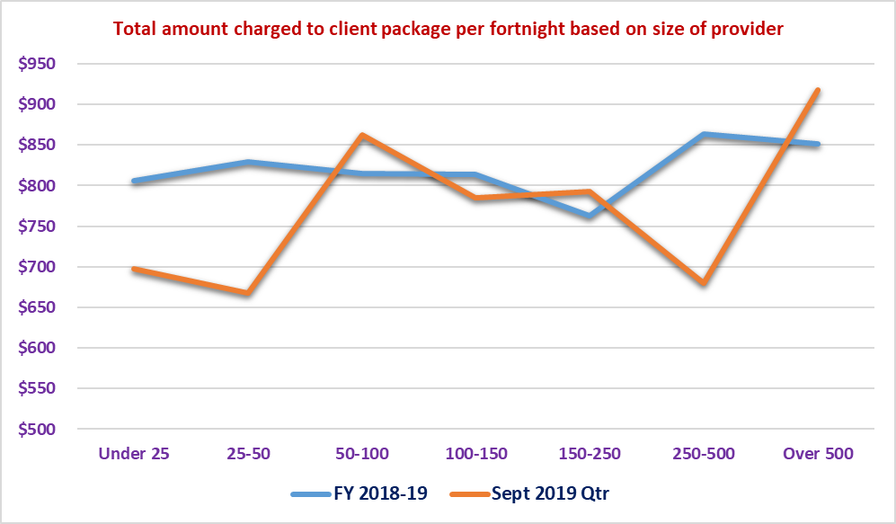

There are differences in amounts charged for those providers with between 50 and 250 packages but there are no consistent trends. What is consistent with FY 2018-19 is that the providers with greater than 500 packages charge more against the packages than all other providers.

Table : Average hours of service provided to a client package per fortnight for September 2019 quarter by size of provider based on number of packages serviced

|  |  |  |  |  |  |  |  |  |
| --- | --- | --- | --- | --- | --- | --- | --- | --- |
|  | **September 2019 Quarter** | | | | | | | |
|  | **All Average** | **Under 25** | **25-50** | **50-100** | **100-150** | **150-250** | **250-500** | **Over 500** |
| Total number of providers | 98 | 32 | 11 | 19 | 8 | 12 | 7 | 9 |
| Total number of packages | 19,356 | 360 | 412 | 1,330 | 958 | 2,412 | 2,602 | 11,284 |
| Total number of subsidised days | 1,771,976 | 32,937 | 37,679 | 121,730 | 87,717 | 220,833 | 238,179 | 1,032,903 |
| Care management | 1.22 | 1.58 | 1.46 | 1.78 | 1.44 | 2.42 | 0.47 | 1.04 |
| Nursing care - registered nurse | 0.47 | 0.14 | 0.16 | 0.16 | 0.18 | 0.03 | 0.13 | 0.73 |
| Nursing care - enrolled nurse or other licensed nurse | 0.01 | 0.08 | 0.01 | 0.03 | 0.02 | 0.03 | 0.01 | 0.00 |
| Personal care | 2.40 | 2.55 | 3.64 | 2.87 | 2.51 | 2.40 | 2.90 | 2.17 |
| Cleaning and household tasks | 1.70 | 2.10 | 1.19 | 1.74 | 1.57 | 2.00 | 1.63 | 1.66 |
| Social support, shopping services, community access | 1.48 | 3.03 | 0.38 | 2.94 | 1.71 | 2.24 | 0.98 | 1.24 |
| Light gardening | 0.15 | 0.16 | 0.18 | 0.19 | 0.25 | 0.18 | 0.07 | 0.15 |
| In-home respite (day-time) | 0.40 | 0.24 | 0.11 | 0.69 | 0.24 | 0.12 | 0.13 | 0.51 |
| In-home respite (overnight) | 0.02 | 0.04 | 0.16 | 0.12 | 0.04 | 0.04 | 0.00 | 0.00 |
| Transport services | 0.51 | 1.07 | 3.40 | 0.71 | 0.24 | 1.61 | 0.08 | 0.25 |
| Allied health professional (practitioner) | 0.91 | 0.12 | 0.05 | 0.14 | 0.23 | 0.04 | 0.13 | 1.49 |
| Other services provided to the home care recipient | 0.62 | 0.44 | 1.15 | 0.67 | 0.28 | 2.39 | 1.44 | 0.06 |
| **Total Hours of Service Provision** | **9.90** | **11.55** | **11.89** | **12.05** | **8.72** | **13.48** | **7.98** | **9.30** |

Chart : Total hours of service provided to care recipients per fortnight based on size of the provider as determined by the number of packages delivered for September 2019 quarter

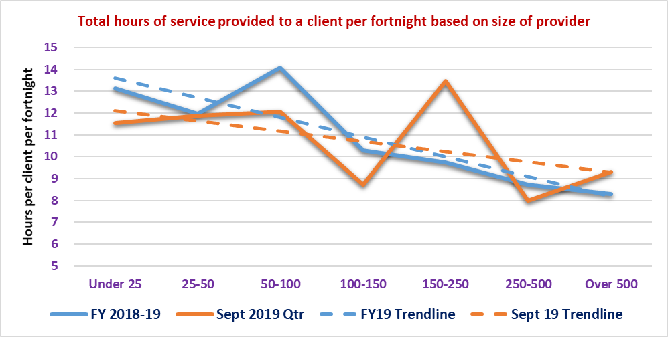

There are differences in the hours of service provision and there is a consistent trend downwards for both FY 2018-19 and the September 2019 quarter. With the total charged to a client package increasing for those providers over 500 packages, and the hours decreasing for that same group of providers, it indicates that either:

* Price is the dominant reason for the increase in the overall charge to the package being high, or
* The package management / administration cost is higher as it does not have an hour of service component attached to it, or
* Care management costs are higher, given we have observed the effective price increasing across package levels

Chart : Total amount charged to care recipient packages per fortnight based on size of the provider as determined by the number of packages delivered for September 2019 quarter

These two charges do follow similar trends to the overall amounts charged to the care recipient’s package. It would appear that the September 2019 quarter and FY 2018-19 data sets show that the providers with greater than 500 packages tend to charge a higher package management and care management cost than most other providers.

It should also be noted that during the data collection process, a number of providers indicated that they had made significant system changes as part of the move to a new pricing structure and in some cases a new business model. These system changes and the way in which data is collected, may be having an impact on both the quality of data and the way it has been collated or allocated against different income streams. For example, revenue streams may now be reflecting the new pricing arrangements but the data on hours may still be under older classifications.

Under the pricing transparency prices there are only marginal differences in pricing based on the size of the organisation as determined by the number of packages being delivered. There is still a trend for the larger providers to charge a slightly higher price than the smaller providers.

Table : Average standard hourly price of services as listed on the pricing transparency table based on size of the provider determined by the number of packages managed

|  |  |  |  |  |  |  |  |  |
| --- | --- | --- | --- | --- | --- | --- | --- | --- |
|  | **Average** | **Under 25** | **25-50** | **50-100** | **100-150** | **150-250** | **250-500** | **Over 500** |
| Nursing | $95.97 | $81.23 | $95.76 | $81.06 | $91.94 | $99.48 | $97.28 | $100.78 |
| Personal care | $57.96 | $55.14 | $56.94 | $55.09 | $58.06 | $55.46 | $56.27 | $60.00 |
| Cleaning and household tasks | $56.64 | $53.68 | $57.71 | $53.19 | $57.24 | $54.93 | $55.18 | $58.22 |
| Light gardening | $57.43 | $60.02 | $58.03 | $60.30 | $62.33 | $59.67 | $51.13 | $57.44 |
| In-home respite | $57.87 | $53.49 | $57.92 | $55.09 | $58.36 | $55.46 | $56.27 | $59.92 |

Chart : Average standard hourly price of services as listed on the pricing transparency table based on size of the provider determined by the number of packages managed for personal care and nursing care

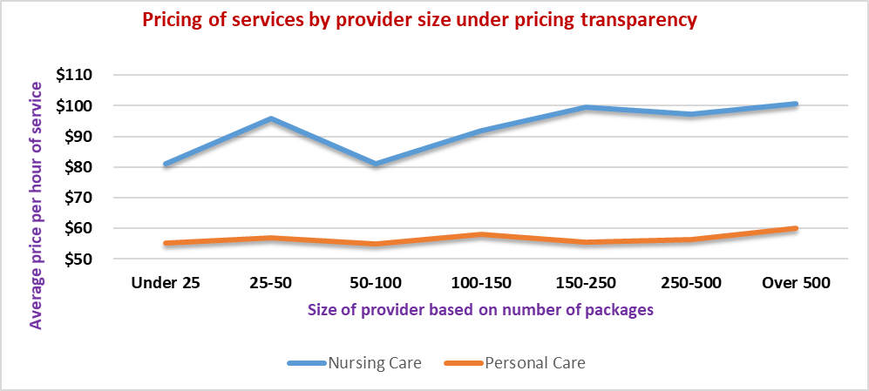

# Appendices

## Appendix 1 - Detailed Data Tables for FY 2018-19

Table : Data profile relating to demographic markers - comparison of sector data and survey data set FY 2018-19

|  |  |  |  |  |  |  |  |  |  |  |  |  |  |  |  |
| --- | --- | --- | --- | --- | --- | --- | --- | --- | --- | --- | --- | --- | --- | --- | --- |
|  | **ALL** | | | | | **DATA INCLUDED FOR ANALYSIS** | | | | |  |  |  |  |  |
|  | **LEVEL 1** | **LEVEL 2** | **LEVEL 3** | **LEVEL 4** | **Total** | **LEVEL 1** | **LEVEL 2** | **LEVEL 3** | **LEVEL 4** | **Total** | **LEVEL 1** | **LEVEL 2** | **LEVEL 3** | **LEVEL 4** | **Total** |
| **Provider data** |  |  |  |  |  |  |  |  |  |  |  |  |  |  |  |
| No. of providers | na | na | na | na | 812 | na | na | na | na | 410 | na | na | na | na | 50% |
|  |  |  |  |  |  |  |  |  |  |  |  |  |  |  |  |
| **Package data** |  |  |  |  |  |  |  |  |  |  |  |  |  |  |  |
| No. packages | 8,516 | 47,734 | 20,193 | 30,264 | 106,707 | 4,536 | 26,502 | 11,001 | 16,501 | 58,540 | 53% | 56% | 54% | 55% | 55% |
|  |  |  |  |  |  |  |  |  |  |  |  |  |  |  |  |
| **Gender** |  |  |  |  |  |  |  |  |  |  |  |  |  |  |  |
| Female | 5,347 | 32,471 | 12,997 | 19,349 | 70,164 | 2,856 | 18,117 | 7,075 | 10,540 | 38,588 | 53% | 56% | 54% | 54% | 55% |
| Male | 3,169 | 15,246 | 7,190 | 10,898 | 36,503 | 1,680 | 8,377 | 3,921 | 5,950 | 19,928 | 53% | 55% | 55% | 55% | 55% |
| Unspecified | 0 | 17 | 6 | 17 | 40 | 0 | 8 | 5 | 11 | 24 | na | 47% | 83% | 65% | 60% |
| **Total by Gender** | **8,516** | **47,734** | **20,193** | **30,264** | **106,707** | **4,536** | **26,502** | **11,001** | **16,501** | **58,540** | **53%** | **56%** | **54%** | **55%** | **55%** |
|  |  |  |  |  |  |  |  |  |  |  |  |  |  |  |  |
| **Age** |  |  |  |  |  |  |  |  |  |  |  |  |  |  |  |
| Average age at Jun-19 | 81.07 | 82.82 | 82.37 | 82.02 | 82.37 | 81.1 | 82.9 | 82.4 | 82.1 | 82.5 | na | na | na | na | na |
|  |  |  |  |  |  |  |  |  |  |  |  |  |  |  |  |
| **Age at First Entry into HCP** |  |  |  |  |  |  |  |  |  |  |  |  |  |  |  |
| Average age of entry | 80.65 | 80.21 | 80.63 | 78.54 | 79.85 | 80.67 | 80.26 | 80.54 | 78.55 | 79.86 | na | na | na | na | na |

Table : Data profile relating to demographic markers - comparison of sector data and survey data set FY 2018-19 (continued)

|  |  |  |  |  |  |  |  |  |  |  |  |  |  |  |  |
| --- | --- | --- | --- | --- | --- | --- | --- | --- | --- | --- | --- | --- | --- | --- | --- |
|  | **ALL** | | | | | **DATA INCLUDED FOR ANALYSIS** | | | | |  |  |  |  |  |
|  | **LEVEL 1** | **LEVEL 2** | **LEVEL 3** | **LEVEL 4** | **Total** | **LEVEL 1** | **LEVEL 2** | **LEVEL 3** | **LEVEL 4** | **Total** | **LEVEL 1** | **LEVEL 2** | **LEVEL 3** | **LEVEL 4** | **Total** |
| **Accommodation Type** |  |  |  |  |  |  |  |  |  |  |  |  |  |  |  |
| Independent Living | 873 | 4,981 | 1,810 | 2,112 | 9,776 | 470 | 2,845 | 974 | 1,194 | 5,483 | 54% | 57% | 54% | 57% | 56% |
| PR Public Comm Housing | 813 | 4,863 | 1,940 | 2,933 | 10,549 | 425 | 2,736 | 1,135 | 1,626 | 5,922 | 52% | 56% | 59% | 55% | 56% |
| PR Client Owns/Purchasing | 5,114 | 27,957 | 12,391 | 18,141 | 63,603 | 2,730 | 15,460 | 6,752 | 9,866 | 34,808 | 53% | 55% | 54% | 54% | 55% |
| PR Relation Owns/Purchasing | 691 | 3,400 | 1,741 | 2,970 | 8,802 | 376 | 1,889 | 926 | 1,600 | 4,791 | 54% | 56% | 53% | 54% | 54% |
| PR Private/Rental | 868 | 4,007 | 1,822 | 2,501 | 9,198 | 449 | 2,176 | 955 | 1,336 | 4,916 | 52% | 54% | 52% | 53% | 53% |
| Not Stated/Inadequately Supp | 38 | 488 | 116 | 576 | 1,218 | 17 | 273 | 63 | 330 | 683 | 45% | 56% | 54% | 57% | 56% |
| Crisis Emergency Transition | 2 | 38 | 9 | 12 | 61 | 0 | 22 | 5 | 9 | 36 | 0% | 58% | 56% | 75% | 59% |
| Supported Accom | 57 | 361 | 110 | 211 | 739 | 34 | 183 | 55 | 107 | 379 | 60% | 51% | 50% | 51% | 51% |
| Hospital | 2 | 10 | 7 | 18 | 37 | 1 | 5 | 1 | 10 | 17 | 50% | 50% | 14% | 56% | 46% |
| Residential Aged Care | 10 | 68 | 46 | 89 | 213 | 9 | 40 | 26 | 47 | 122 | 90% | 59% | 57% | 53% | 57% |
| Other Community | 17 | 100 | 39 | 48 | 204 | 14 | 65 | 19 | 23 | 121 | 82% | 65% | 49% | 48% | 59% |
| Other Institutional | 1 | 12 | 4 | 3 | 20 | 0 | 9 | 1 | 3 | 13 | 0% | 75% | 25% | 100% | 65% |
| Boarding House | 10 | 71 | 23 | 33 | 137 | 5 | 38 | 13 | 19 | 75 | 50% | 54% | 57% | 58% | 55% |
| Indigenous Comm/Settlement | 9 | 282 | 62 | 92 | 445 | 3 | 108 | 37 | 47 | 195 | 33% | 38% | 60% | 51% | 44% |
| Public place/Temporary Shelter | 1 | 12 | 4 | 1 | 18 | 0 | 8 | 2 | 1 | 11 | 0% | 67% | 50% | 100% | 61% |
| Unknown | 10 | 1,084 | 69 | 524 | 1,687 | 3 | 645 | 37 | 283 | 968 | 30% | 60% | 54% | 54% | 57% |
| **Total by Accommodation Type** | **8,516** | **47,734** | **20,193** | **30,264** | **106,707** | **4,536** | **26,502** | **11,001** | **16,501** | **58,540** | **53%** | **56%** | **54%** | **55%** | **55%** |
| **Lives With** |  |  |  |  |  |  |  |  |  |  |  |  |  |  |  |
| Lives alone | 3,388 | 22,149 | 8,678 | 11,278 | 45,493 | 1,823 | 12,438 | 4,827 | 6,215 | 25,303 | 54% | 56% | 56% | 55% | 56% |
| With family | 1,020 | 10,688 | 3,757 | 10,098 | 25,563 | 536 | 5,841 | 2,010 | 5,447 | 13,834 | 53% | 55% | 54% | 54% | 54% |
| With partner | 3,905 | 12,612 | 7,242 | 7,343 | 31,102 | 2,061 | 6,907 | 3,899 | 3,992 | 16,859 | 53% | 55% | 54% | 54% | 54% |
| With friends | 69 | 227 | 144 | 157 | 597 | 39 | 124 | 68 | 79 | 310 | 57% | 55% | 47% | 50% | 52% |
| With others | 75 | 533 | 179 | 379 | 1,166 | 42 | 305 | 96 | 214 | 657 | 56% | 57% | 54% | 56% | 56% |
| Not Specified | 19 | 333 | 61 | 381 | 794 | 8 | 182 | 31 | 220 | 441 | 42% | 55% | 51% | 58% | 56% |
| Not applicable | 28 | 150 | 59 | 128 | 365 | 24 | 90 | 30 | 64 | 208 | 86% | 60% | 51% | 50% | 57% |
| Unknown | 12 | 1,042 | 73 | 500 | 1,627 | 3 | 615 | 40 | 270 | 928 | 25% | 59% | 55% | 54% | 57% |
| **Total by Lives With** | **8,516** | **47,734** | **20,193** | **30,264** | **106,707** | **4,536** | **26,502** | **11,001** | **16,501** | **58,540** | **53%** | **56%** | **54%** | **55%** | **55%** |
| **Marital Status** |  |  |  |  |  |  |  |  |  |  |  |  |  |  |  |
| Widowed | 2,635 | 17,839 | 7,456 | 10,603 | 38,533 | 1,433 | 9,875 | 4,074 | 5,754 | 21,136 | 54% | 55% | 55% | 54% | 55% |
| Divorced | 779 | 4,645 | 2,056 | 2,922 | 10,402 | 391 | 2,607 | 1,163 | 1,646 | 5,807 | 50% | 56% | 57% | 56% | 56% |
| Married (registered/de facto) | 4,357 | 19,565 | 8,714 | 13,055 | 45,691 | 2,301 | 10,709 | 4,700 | 7,058 | 24,768 | 53% | 55% | 54% | 54% | 54% |
| Separated | 198 | 1,606 | 580 | 1,071 | 3,455 | 116 | 894 | 293 | 567 | 1,870 | 59% | 56% | 51% | 53% | 54% |
| Never married | 397 | 2,554 | 1,041 | 1,630 | 5,622 | 225 | 1,521 | 579 | 923 | 3,248 | 57% | 60% | 56% | 57% | 58% |
| Unable to determine | 133 | 769 | 266 | 583 | 1,751 | 65 | 459 | 147 | 346 | 1,017 | 49% | 60% | 55% | 59% | 58% |
| Unknown | 17 | 756 | 80 | 400 | 1,253 | 5 | 437 | 45 | 207 | 694 | 29% | 58% | 56% | 52% | 55% |
| **Total by Marital Status** | **8,516** | **47,734** | **20,193** | **30,264** | **106,707** | **4,536** | **26,502** | **11,001** | **16,501** | **58,540** | **53%** | **56%** | **54%** | **55%** | **55%** |

Table : Data profile relating to demographic markers - comparison of sector data and survey data set FY 2018-19 (continued)

|  |  |  |  |  |  |  |  |  |  |  |  |  |  |  |  |
| --- | --- | --- | --- | --- | --- | --- | --- | --- | --- | --- | --- | --- | --- | --- | --- |
|  | **ALL** | | | | | **DATA INCLUDED FOR ANALYSIS** | | | | |  |  |  |  |  |
|  | **LEVEL 1** | **LEVEL 2** | **LEVEL 3** | **LEVEL 4** | **Total** | **LEVEL 1** | **LEVEL 2** | **LEVEL 3** | **LEVEL 4** | **Total** | **LEVEL 1** | **LEVEL 2** | **LEVEL 3** | **LEVEL 4** | **Total** |
| **Birth Country** |  |  |  |  |  |  |  |  |  |  |  |  |  |  |  |
| Australia | 5,211 | 29,859 | 12,572 | 18,373 | 66,015 | 2,801 | 16,828 | 6,939 | 10,137 | 36,705 | 54% | 56% | 55% | 55% | 56% |
| England | 628 | 3,562 | 1,712 | 2,487 | 8,389 | 342 | 2,005 | 929 | 1,381 | 4,657 | 54% | 56% | 54% | 56% | 56% |
| Italy | 317 | 2,217 | 831 | 1,521 | 4,886 | 155 | 1,033 | 419 | 757 | 2,364 | 49% | 47% | 50% | 50% | 48% |
| Greece | 234 | 1,255 | 503 | 815 | 2,807 | 93 | 475 | 192 | 333 | 1,093 | 40% | 38% | 38% | 41% | 39% |
| China (excludes SAR & Taiwan province) | 331 | 1,052 | 357 | 502 | 2,242 | 193 | 638 | 206 | 314 | 1,351 | 58% | 61% | 58% | 63% | 60% |
| Germany | 91 | 510 | 277 | 391 | 1,269 | 50 | 314 | 159 | 217 | 740 | 55% | 62% | 57% | 55% | 58% |
| Netherlands | 98 | 561 | 248 | 339 | 1,246 | 48 | 357 | 141 | 196 | 742 | 49% | 64% | 57% | 58% | 60% |
| New Zealand | 100 | 525 | 256 | 333 | 1,214 | 58 | 300 | 126 | 156 | 640 | 58% | 57% | 49% | 47% | 53% |
| Vietnam | 143 | 504 | 180 | 318 | 1,145 | 61 | 392 | 122 | 192 | 767 | 43% | 78% | 68% | 60% | 67% |
| India | 46 | 394 | 210 | 307 | 957 | 26 | 216 | 119 | 171 | 532 | 57% | 55% | 57% | 56% | 56% |
| Other | 1,317 | 7,295 | 3,047 | 4,878 | 16,537 | 709 | 3,944 | 1,649 | 2,647 | 8,949 | 54% | 54% | 54% | 54% | 54% |
| **Total by Birth Country** | **8,516** | **47,734** | **20,193** | **30,264** | **106,707** | **4,536** | **26,502** | **11,001** | **16,501** | **58,540** | **53%** | **56%** | **54%** | **55%** | **55%** |
|  |  |  |  |  |  |  |  |  |  |  |  |  |  |  |  |
| **Preferred Language** |  |  |  |  |  |  |  |  |  |  |  |  |  |  |  |
| English Speaking | 6,045 | 34,578 | 14,877 | 21,681 | 77,181 | 3,252 | 19,483 | 8,183 | 11,938 | 42,856 | 54% | 56% | 55% | 55% | 56% |
| Non-English Speaking | 2,459 | 12,707 | 5,302 | 8,521 | 28,989 | 1,278 | 6,759 | 2,812 | 4,536 | 15,385 | 52% | 53% | 53% | 53% | 53% |
| Missing | 12 | 449 | 14 | 62 | 537 | 6 | 260 | 6 | 27 | 299 | 50% | 58% | 43% | 44% | 56% |
| **Total by Preferred Language** | **8,516** | **47,734** | **20,193** | **30,264** | **106,707** | **4,536** | **26,502** | **11,001** | **16,501** | **58,540** | **53%** | **56%** | **54%** | **55%** | **55%** |
|  |  |  |  |  |  |  |  |  |  |  |  |  |  |  |  |
| **ATSI Status** |  |  |  |  |  |  |  |  |  |  |  |  |  |  |  |
| Aboriginal | 145 | 1,531 | 614 | 833 | 3,123 | 76 | 716 | 311 | 451 | 1,554 | 52% | 47% | 51% | 54% | 50% |
| Torres Strait Islander | 2 | 45 | 11 | 30 | 88 | 1 | 14 | 5 | 14 | 34 | 50% | 31% | 45% | 47% | 39% |
| Both | 6 | 32 | 12 | 19 | 69 | 3 | 10 | 4 | 9 | 26 | 50% | 31% | 33% | 47% | 38% |
| Neither | 6,394 | 36,021 | 17,212 | 24,478 | 84,105 | 3,398 | 19,938 | 9,395 | 13,279 | 46,010 | 53% | 55% | 55% | 54% | 55% |
| Unknown | 1,969 | 10,105 | 2,344 | 4,904 | 19,322 | 1,058 | 5,824 | 1,286 | 2,748 | 10,916 | 54% | 58% | 55% | 56% | 56% |
| **Total by ATSI Status** | **8,516** | **47,734** | **20,193** | **30,264** | **106,707** | **4,536** | **26,502** | **11,001** | **16,501** | **58,540** | **53%** | **56%** | **54%** | **55%** | **55%** |

Table : Amounts charged and receipts per forntight and unspent funds at the end of the period by ownership type for package Levels 1 and 2 for FY 2018‑19

|  |  |  |  |  |  |  |  |  |
| --- | --- | --- | --- | --- | --- | --- | --- | --- |
| **Total Amount Charged to Care Recipients** | **2018-19 Financial Year** | | | | **2018-19 Financial Year** | | | |
|  | **Level 1 Average** | **Not for Profit** | **For Profit** | **Government** | **Level 2 Average** | **Not for Profit** | **For Profit** | **Government** |
| Total number of packages | 3,222 | 2,518 | 550 | 154 | 27,234 | 22,211 | 3,242 | 1,782 |
| Total estimated number of subsidised days | 1,174,852 | 918,308 | 200,467 | 56,078 | 9,935,652 | 8,103,137 | 1,182,293 | 650,222 |
| Care management | $42.24 | $43.94 | $36.54 | $34.76 | $85.01 | $87.82 | $62.21 | $91.43 |
| Admin charge/(Package mgt - Sept. Qtr) | $47.46 | $49.09 | $40.42 | $45.83 | $86.94 | $88.96 | $71.64 | $89.63 |
| Nursing care - registered nurse | $1.08 | $0.90 | $1.73 | $1.70 | $2.45 | $2.30 | $3.85 | $1.83 |
| Nursing care - enrolled nurse or other licensed nurse | $0.43 | $0.45 | $0.34 | $0.34 | $0.71 | $0.71 | $0.72 | $0.63 |
| Personal care | $28.29 | $22.89 | $58.75 | $7.93 | $61.42 | $57.91 | $97.74 | $39.06 |
| Cleaning and household tasks | $43.54 | $41.04 | $59.15 | $28.65 | $73.86 | $73.77 | $84.25 | $56.05 |
| Meal preparation | $2.50 | $2.56 | $2.32 | $2.24 | $6.11 | $5.03 | $6.78 | $18.38 |
| Social support, shopping services, community access | $18.71 | $16.72 | $30.90 | $7.67 | $48.16 | $47.91 | $61.43 | $27.23 |
| Consumables | $4.64 | $4.42 | $6.75 | $0.72 | $9.96 | $10.86 | $5.39 | $7.06 |
| Light gardening | $6.85 | $6.68 | $7.63 | $6.87 | $10.66 | $10.72 | $10.37 | $10.39 |
| In-home respite (day-time) | $2.07 | $2.30 | $1.42 | $0.78 | $6.25 | $6.08 | $9.00 | $3.31 |
| In-home respite (overnight) | $0.16 | $0.07 | $0.63 | - | $0.45 | $0.43 | $0.65 | $0.28 |
| Transport services | $4.33 | $3.85 | $5.86 | $6.75 | $12.18 | $11.48 | $14.55 | $16.58 |
| Allied health professional (practitioner) | $4.18 | $4.38 | $4.26 | $0.58 | $10.52 | $11.30 | $8.26 | $4.98 |
| Capital purchases | $5.02 | $5.16 | $4.98 | $2.90 | $15.26 | $15.65 | $11.63 | $17.05 |
| Home modifications | $1.36 | $1.45 | $0.81 | $1.75 | $4.25 | $4.12 | $4.04 | $6.32 |
| Home maintenance | $3.23 | $3.26 | $3.48 | $1.83 | $5.67 | $5.67 | $3.86 | $9.01 |
| Travel expenses | $2.56 | $2.73 | $2.36 | $0.48 | $4.68 | $5.14 | $2.85 | $2.33 |
| Other services required to maintain the care recipient at home | $10.56 | $11.46 | $8.48 | $3.16 | $23.39 | $23.90 | $28.23 | $8.27 |
| Maximum exit amount | $0.97 | $1.08 | $0.32 | $1.51 | $1.37 | $1.52 | $0.49 | $1.08 |
| Processing charge on third party purchases/subcontracting | $1.06 | $1.17 | $0.68 | $0.69 | $3.07 | $3.18 | $2.87 | $2.01 |
| **Total Amount Charged to Clients** | **$231.24** | **$225.60** | **$277.81** | **$157.14** | **$472.36** | **$474.45** | **$490.79** | **$412.93** |
|  |  |  |  |  |  |  |  |  |
| **Receipts and Unspent Funds** | **Level 1 Average** | **Not for Profit** | **For Profit** | **Government** | **Level 2 Average** | **Not for Profit** | **For Profit** | **Government** |
| **Receipts per fortnight from:** |  |  |  |  |  |  |  |  |
| Fees received from care recipients | $30.07 | $34.55 | $15.08 | $10.38 | $37.01 | $38.42 | $35.14 | $22.83 |
| Government subsidies received for the period | $403.10 | $414.60 | $379.54 | $298.89 | $547.66 | $540.94 | $628.71 | $484.03 |
| **Total receipts** | **$433.17** | **$449.15** | **$394.62** | **$309.27** | **$584.67** | **$579.37** | **$663.85** | **$506.86** |
| Unutilised amount | $201.93 | $223.55 | $116.82 | $152.13 | $112.31 | $104.92 | $173.06 | $93.93 |
| Utilisation rate | 53% | 50% | 70% | 51% | 81% | 82% | 74% | 81% |
| Unspent funds per package | $2,098 | $2,217 | $1,723 | $1,496 | $4,212 | $4,259 | $3,875 | $4,245 |

Table : Amounts charged and receipts per fortnight and unspent funds at the end of the period by ownership type for package Levels 3 and 4 for FY 2018‑19

|  |  |  |  |  |  |  |  |  |
| --- | --- | --- | --- | --- | --- | --- | --- | --- |
| **Total Amount Charged to Care Recipients** | **2018-19 Financial Year** | | | | **2018-19 Financial Year** | | | |
|  | **Level 3 Average** | **Not for Profit** | **For Profit** | **Government** | **Level 4 Average** | **Not for Profit** | **For Profit** | **Government** |
| Total number of packages | 9,973 | 7,947 | 1,521 | 505 | 14,394 | 11,567 | 2,152 | 674 |
| Total estimated number of subsidised days | 3,638,668 | 2,899,420 | 554,895 | 184,353 | 5,249,998 | 4,219,038 | 784,858 | 246,103 |
| Care management | $150.49 | $157.27 | $106.51 | $176.14 | $242.04 | $255.24 | $153.41 | $298.25 |
| Admin charge/(Package mgt - Sept. Qtr) | $174.14 | $183.35 | $122.10 | $185.87 | $287.12 | $304.16 | $190.33 | $303.71 |
| Nursing care - registered nurse | $10.46 | $10.14 | $12.38 | $9.76 | $20.34 | $19.47 | $24.31 | $22.59 |
| Nursing care - enrolled nurse or other licensed nurse | $3.66 | $3.84 | $2.23 | $5.16 | $10.78 | $12.01 | $5.18 | $7.48 |
| Personal care | $150.13 | $142.56 | $203.20 | $109.35 | $343.23 | $327.13 | $464.28 | $233.16 |
| Cleaning and household tasks | $94.66 | $94.97 | $100.97 | $70.95 | $128.57 | $130.33 | $128.05 | $100.12 |
| Meal preparation | $12.89 | $12.49 | $14.34 | $14.87 | $26.78 | $27.75 | $22.39 | $24.10 |
| Social support, shopping services, community access | $84.38 | $83.25 | $102.69 | $46.89 | $154.77 | $161.76 | $141.09 | $78.67 |
| Consumables | $20.52 | $22.30 | $11.85 | $18.60 | $39.14 | $42.90 | $20.77 | $33.17 |
| Light gardening | $15.20 | $15.53 | $14.89 | $10.97 | $21.88 | $23.63 | $14.04 | $16.89 |
| In-home respite (day-time) | $21.33 | $21.32 | $24.68 | $11.45 | $60.33 | $59.21 | $72.13 | $42.04 |
| In-home respite (overnight) | $1.62 | $1.60 | $1.74 | $1.50 | $7.33 | $8.39 | $3.76 | $0.57 |
| Transport services | $18.62 | $17.80 | $19.68 | $28.48 | $30.57 | $30.49 | $29.29 | $36.06 |
| Allied health professional (practitioner) | $23.42 | $25.39 | $18.32 | $7.81 | $47.87 | $52.58 | $31.41 | $19.71 |
| Capital purchases | $31.91 | $34.39 | $23.48 | $18.24 | $60.38 | $65.99 | $34.14 | $47.91 |
| Home modifications | $9.15 | $9.60 | $6.74 | $9.35 | $20.01 | $21.14 | $14.22 | $19.10 |
| Home maintenance | $9.41 | $10.06 | $6.48 | $7.97 | $17.02 | $19.02 | $8.15 | $11.03 |
| Travel expenses | $10.34 | $11.39 | $7.02 | $3.82 | $17.41 | $19.41 | $10.27 | $5.92 |
| Other services required to maintain the care recipient at home | $35.34 | $36.42 | $36.44 | $15.12 | $72.32 | $79.12 | $50.49 | $25.21 |
| Maximum exit amount | $1.58 | $1.77 | $0.49 | $1.90 | $2.22 | $2.38 | $0.40 | $5.24 |
| Processing charge on third party purchases/subcontracting | $5.44 | $5.47 | $6.34 | $2.30 | $12.27 | $12.51 | $13.96 | $2.64 |
| **Total Amount Charged to Clients** | **$884.69** | **$900.90** | **$842.55** | **$756.52** | **$1,622.38** | **$1,674.63** | **$1,432.08** | **$1,333.56** |
|  |  |  |  |  |  |  |  |  |
| **Receipts and Unspent Funds** | **Level 3 Average** | **Not for Profit** | **For Profit** | **Government** | **Level 4 Average** | **Not for Profit** | **For Profit** | **Government** |
| **Receipts per fortnight from:** |  |  |  |  |  |  |  |  |
| Fees received from care recipients | $53.09 | $55.76 | $45.56 | $33.71 | $77.03 | $81.30 | $65.85 | $39.38 |
| Government subsidies received for the period | $1,072.70 | $1,080.29 | $1,063.46 | $981.13 | $1,854.90 | $1,883.74 | $1,707.72 | $1,829.89 |
| **Total receipts** | **$1,125.79** | **$1,136.05** | **$1,109.02** | **$1,014.84** | **$1,931.93** | **$1,965.04** | **$1,773.57** | **$1,869.27** |
| Unutilised amount | $241.10 | $235.15 | $266.47 | $258.32 | $309.55 | $290.41 | $341.49 | $535.71 |
| Utilisation rate | 79% | 79% | 76% | 75% | 84% | 85% | 81% | 71% |
| Unspent funds per package | $7,254 | $7,439 | $6,298 | $7,229 | $15,182 | $15,560 | $12,863 | $16,097 |

Table : Amounts charged and receipts per fortnight and unspent funds at the end of the period by MMM category for package Level 1 for FY 2018-19

|  |  |  |  |  |  |  |  |  |
| --- | --- | --- | --- | --- | --- | --- | --- | --- |
| **Total Amount Charged to Care Recipients** | **2018-19 Financial Year** | | | | | | | |
|  | **Level 1 Average** | **MMM 1** | **MMM 2** | **MMM 3** | **MMM 4** | **MMM 5** | **MMM 6** | **MMM 7** |
| Total number of packages | 3,222 | 2,690 | 95 | 216 | 77 | 127 | 12 | 5 |
| Total estimated number of subsidised days | 1,174,852 | 980,714 | 34,804 | 78,755 | 28,172 | 46,496 | 4,234 | 1,678 |
| Care management | $42.24 | $41.97 | $35.39 | $43.41 | $44.74 | $41.92 | $132.62 | $25.98 |
| Admin charge/(Package mgt - Sept. Qtr) | $47.46 | $48.39 | $40.27 | $44.32 | $29.94 | $27.36 | $294.65 | $23.96 |
| Nursing care - registered nurse | $1.08 | $1.12 | $0.40 | $0.47 | $0.10 | $2.38 | $2.13 | - |
| Nursing care - enrolled nurse or other licensed nurse | $0.43 | $0.48 | $0.01 | $0.12 | - | $0.10 | $1.61 | $4.91 |
| Personal care | $28.29 | $28.13 | $24.26 | $32.90 | $4.34 | $12.35 | $354.67 | $10.23 |
| Cleaning and household tasks | $43.54 | $41.16 | $41.53 | $85.48 | $27.86 | $33.94 | $18.17 | $98.28 |
| Meal preparation | $2.50 | $2.19 | - | $4.48 | $0.96 | $8.23 | $5.22 | $5.26 |
| Social support, shopping services, community access | $18.71 | $18.98 | $15.31 | $24.02 | $11.85 | $11.30 | $15.64 | $10.67 |
| Consumables | $4.64 | $4.88 | $1.51 | $3.31 | $8.60 | $2.19 | $3.30 | - |
| Light gardening | $6.85 | $6.10 | $12.84 | $14.32 | $6.56 | $6.27 | $3.48 | $0.89 |
| In-home respite (day-time) | $2.07 | $2.21 | $1.46 | $1.62 | $0.89 | $0.60 | $7.05 | $3.57 |
| In-home respite (overnight) | $0.16 | $0.19 | - | $0.04 | - | - | - | - |
| Transport services | $4.33 | $4.61 | $1.19 | $2.76 | $2.11 | $2.45 | $28.35 | $10.08 |
| Allied health professional (practitioner) | $4.18 | $4.66 | $1.83 | $2.79 | $0.11 | $0.79 | $0.86 | $2.24 |
| Capital purchases | $5.02 | $5.22 | $3.46 | $6.92 | $1.72 | $1.44 | - | - |
| Home modifications | $1.36 | $1.22 | $0.48 | $3.22 | $1.35 | $1.98 | - | - |
| Home maintenance | $3.23 | $3.33 | $0.93 | $4.57 | $1.44 | $1.99 | $0.96 | $2.23 |
| Travel expenses | $2.56 | $2.64 | $4.85 | $1.66 | $2.09 | $1.18 | - | - |
| Other services required to maintain the care recipient at home | $10.56 | $11.73 | $4.96 | $6.15 | $1.87 | $3.77 | $3.05 | - |
| Maximum exit amount | $0.97 | $0.91 | $0.91 | $1.46 | $1.37 | $1.22 | - | $4.17 |
| Processing charge on third party purchases/subcontracting | $1.06 | $1.07 | $1.53 | $1.29 | $1.31 | $0.12 | - | - |
| **Total Amount Charged to Clients** | **$231.24** | **$231.20** | **$193.11** | **$285.31** | **$149.22** | **$161.57** | **$871.76** | **$202.47** |
|  |  |  |  |  |  |  |  |  |
| **Receipts and Unspent Funds** | **Level 1 Average** | **MMM 1** | **MMM 2** | **MMM 3** | **MMM 4** | **MMM 5** | **MMM 6** | **MMM 7** |
| **Receipts per fortnight from:** |  |  |  |  |  |  |  |  |
| Fees received from care recipients | $30.07 | $30.86 | $11.81 | $17.87 | $5.57 | $6.47 | $639.80 | $47.84 |
| Government subsidies received for the period | $403.10 | $419.16 | $302.28 | $314.21 | $265.41 | $233.53 | $828.38 | $3,214.21 |
| **Total receipts** | **$433.17** | **$450.02** | **$314.09** | **$332.08** | **$270.97** | **$240.00** | **$1,468.17** | **$3,262.05** |
| Unutilised amount | $201.93 | $218.82 | $120.98 | $46.77 | $121.76 | $78.43 | $596.42 | $3,059.58 |
| Utilisation rate | 53% | 51% | 61% | 86% | 55% | 67% | 59% | 6% |
| Unspent funds per package | $2,098 | $2,048 | $2,064 | $3,157 | $1,930 | $1,424 | $3,122 | $1,002 |

Table : Amounts charged and receipts per fortnight and unspent funds at the end of the period by MMM category for package Level 2 for FY 2018-19

|  |  |  |  |  |  |  |  |  |
| --- | --- | --- | --- | --- | --- | --- | --- | --- |
| **Total Amount Charged to Care Recipients** | **2018-19 Financial Year** | | | | | | | |
|  | **Level 2 Average** | **MMM 1** | **MMM 2** | **MMM 3** | **MMM 4** | **MMM 5** | **MMM 6** | **MMM 7** |
| Total number of packages | 27,234 | 22,819 | 1,067 | 1,762 | 439 | 931 | 78 | 139 |
| Total estimated number of subsidised days | 9,935,652 | 8,324,701 | 389,141 | 642,640 | 159,989 | 340,108 | 28,308 | 50,765 |
| Care management | $85.01 | $85.84 | $58.02 | $73.17 | $88.60 | $99.86 | $164.63 | $150.70 |
| Admin charge/(Package mgt - Sept. Qtr) | $86.94 | $85.09 | $95.99 | $104.33 | $85.09 | $62.39 | $249.88 | $180.77 |
| Nursing care - registered nurse | $2.45 | $2.29 | $3.23 | $3.33 | $2.57 | $2.08 | $17.56 | $5.80 |
| Nursing care - enrolled nurse or other licensed nurse | $0.71 | $0.67 | $1.01 | $0.78 | $1.36 | $0.78 | $3.72 | $0.39 |
| Personal care | $61.42 | $62.39 | $78.64 | $55.73 | $35.69 | $37.30 | $149.91 | $35.01 |
| Cleaning and household tasks | $73.86 | $72.68 | $64.75 | $101.31 | $75.75 | $54.03 | $141.64 | $79.81 |
| Meal preparation | $6.11 | $5.16 | $2.60 | $6.61 | $4.88 | $7.73 | $28.68 | $164.16 |
| Social support, shopping services, community access | $48.16 | $47.63 | $43.96 | $44.28 | $64.76 | $32.62 | $390.24 | $77.91 |
| Consumables | $9.96 | $9.97 | $3.82 | $11.75 | $20.77 | $5.35 | $14.50 | $27.65 |
| Light gardening | $10.66 | $9.74 | $17.88 | $15.28 | $15.05 | $14.54 | $16.92 | $3.82 |
| In-home respite (day-time) | $6.25 | $6.55 | $2.58 | $6.25 | $4.04 | $2.62 | $32.31 | $1.25 |
| In-home respite (overnight) | $0.45 | $0.40 | $0.63 | $0.73 | $1.42 | $0.42 | $0.77 | $0.20 |
| Transport services | $12.18 | $12.61 | $6.02 | $8.98 | $7.62 | $10.93 | $30.47 | $41.34 |
| Allied health professional (practitioner) | $10.52 | $11.48 | $5.25 | $5.61 | $3.67 | $4.19 | $44.04 | $1.52 |
| Capital purchases | $15.26 | $15.06 | $18.68 | $15.22 | $14.32 | $9.98 | $78.56 | $26.09 |
| Home modifications | $4.25 | $4.18 | $2.47 | $5.82 | $6.72 | $3.76 | $13.42 | $0.17 |
| Home maintenance | $5.67 | $5.68 | $3.82 | $7.03 | $9.26 | $4.27 | $3.12 | $1.18 |
| Travel expenses | $4.68 | $4.78 | $3.64 | $3.93 | $6.27 | $3.50 | $0.53 | $11.99 |
| Other services required to maintain the care recipient at home | $23.39 | $25.42 | $10.52 | $11.16 | $5.19 | $6.83 | $217.63 | $4.81 |
| Maximum exit amount | $1.37 | $1.44 | $0.52 | $0.96 | $1.77 | $1.05 | $3.42 | $0.73 |
| Processing charge on third party purchases/subcontracting | $3.07 | $2.94 | $5.37 | $3.66 | $6.94 | $0.98 | - | $1.76 |
| **Total Amount Charged to Clients** | **$472.36** | **$471.96** | **$429.43** | **$485.93** | **$461.74** | **$365.19** | **$1,601.97** | **$817.07** |
|  |  |  |  |  |  |  |  |  |
| **Receipts and Unspent Funds** | **Level 2 Average** | **MMM 1** | **MMM 2** | **MMM 3** | **MMM 4** | **MMM 5** | **MMM 6** | **MMM 7** |
| **Receipts per fortnight from:** |  |  |  |  |  |  |  |  |
| Fees received from care recipients | $37.01 | $35.50 | $38.51 | $59.17 | $20.28 | $30.34 | $104.97 | $52.39 |
| Government subsidies received for the period | $547.66 | $547.41 | $537.07 | $521.46 | $553.48 | $467.37 | $1,927.93 | $751.49 |
| **Total receipts** | **$584.67** | **$582.91** | **$575.59** | **$580.62** | **$573.76** | **$497.72** | **$2,032.90** | **$803.88** |
| Unutilised amount | $112.31 | $110.95 | $146.16 | $94.69 | $112.01 | $132.53 | $430.93 | -$13.19 |
| Utilisation rate | 81% | 81% | 75% | 84% | 80% | 73% | 79% | 102% |
| Unspent funds per package | $4,212 | $4,085 | $4,521 | $5,058 | $5,750 | $3,713 | $15,174 | $4,417 |

Table : Amounts charged and receipts per fortnight and unspent funds at the end of the period by MMM category for package Level 3 for FY 2018-19

|  |  |  |  |  |  |  |  |  |
| --- | --- | --- | --- | --- | --- | --- | --- | --- |
| **Total Amount Charged to Care Recipients** | **2018-19 Financial Year** | | | | | | | |
|  | **Level 3 Average** | **MMM 1** | **MMM 2** | **MMM 3** | **MMM 4** | **MMM 5** | **MMM 6** | **MMM 7** |
| Total number of packages | 9,973 | 8,472 | 358 | 631 | 129 | 313 | 33 | 38 |
| Total estimated number of subsidised days | 3,638,668 | 3,091,095 | 130,697 | 229,934 | 46,984 | 114,205 | 11,882 | 13,871 |
| Care management | $150.49 | $150.59 | $126.04 | $137.88 | $144.90 | $191.29 | $76.53 | $313.34 |
| Admin charge/(Package mgt - Sept. Qtr) | $174.14 | $173.27 | $196.50 | $184.28 | $155.09 | $119.41 | $278.32 | $414.45 |
| Nursing care - registered nurse | $10.46 | $10.30 | $12.10 | $12.97 | $5.28 | $11.29 | $6.45 | $2.56 |
| Nursing care - enrolled nurse or other licensed nurse | $3.66 | $3.68 | $2.14 | $1.49 | $12.28 | $5.16 | $12.69 | - |
| Personal care | $150.13 | $153.65 | $185.65 | $133.51 | $84.85 | $92.68 | $92.96 | $49.68 |
| Cleaning and household tasks | $94.66 | $93.72 | $103.41 | $117.60 | $108.27 | $61.54 | $91.91 | $70.56 |
| Meal preparation | $12.89 | $12.60 | $12.85 | $12.91 | $7.10 | $11.15 | $37.43 | $90.86 |
| Social support, shopping services, community access | $84.38 | $84.58 | $89.55 | $90.44 | $97.08 | $53.12 | $74.27 | $112.45 |
| Consumables | $20.52 | $20.62 | $5.93 | $23.17 | $35.35 | $13.20 | $29.19 | $92.60 |
| Light gardening | $15.20 | $14.22 | $24.30 | $24.05 | $18.07 | $13.32 | $12.03 | $9.37 |
| In-home respite (day-time) | $21.33 | $22.09 | $12.75 | $21.68 | $25.01 | $12.72 | $1.66 | $2.66 |
| In-home respite (overnight) | $1.62 | $1.55 | $0.53 | $1.35 | $8.47 | $2.76 | $0.74 | - |
| Transport services | $18.62 | $19.34 | $9.53 | $14.84 | $14.01 | $14.39 | $36.91 | $41.39 |
| Allied health professional (practitioner) | $23.42 | $25.44 | $8.61 | $16.83 | $4.72 | $9.96 | $18.45 | $0.19 |
| Capital purchases | $31.91 | $31.86 | $46.42 | $32.25 | $26.99 | $20.67 | $32.68 | $8.93 |
| Home modifications | $9.15 | $9.14 | $4.50 | $11.61 | $5.90 | $13.25 | $0.93 | $0.40 |
| Home maintenance | $9.41 | $9.38 | $6.80 | $11.05 | $11.40 | $10.14 | $3.99 | $3.90 |
| Travel expenses | $10.34 | $10.78 | $6.30 | $6.05 | $14.52 | $10.12 | $1.06 | $16.18 |
| Other services required to maintain the care recipient at home | $35.34 | $37.39 | $14.93 | $34.23 | $9.78 | $23.26 | $4.11 | $2.33 |
| Maximum exit amount | $1.58 | $1.56 | $1.12 | $1.79 | $3.86 | $1.23 | $3.30 | $1.01 |
| Processing charge on third party purchases/subcontracting | $5.44 | $5.19 | $10.91 | $8.04 | $8.25 | $0.78 | - | - |
| **Total Amount Charged to Clients** | **$884.69** | **$890.97** | **$880.89** | **$898.00** | **$801.18** | **$691.41** | **$815.62** | **$1,232.86** |
|  |  |  |  |  |  |  |  |  |
| **Receipts and Unspent Funds** | **Level 3 Average** | **MMM 1** | **MMM 2** | **MMM 3** | **MMM 4** | **MMM 5** | **MMM 6** | **MMM 7** |
| **Receipts per fortnight from:** |  |  |  |  |  |  |  |  |
| Fees received from care recipients | $53.09 | $53.94 | $56.77 | $48.92 | $35.02 | $40.82 | $80.07 | $35.89 |
| Government subsidies received for the period | $1,072.70 | $1,078.26 | $1,167.40 | $1,007.77 | $1,038.59 | $936.02 | $1,035.48 | $1,290.88 |
| **Total receipts** | **$1,125.79** | **$1,132.20** | **$1,224.18** | **$1,056.69** | **$1,073.61** | **$976.84** | **$1,115.56** | **$1,326.77** |
| Unutilised amount | $241.10 | $241.23 | $343.28 | $158.68 | $272.43 | $285.43 | $299.94 | $93.91 |
| Utilisation rate | 79% | 79% | 72% | 85% | 75% | 71% | 73% | 93% |
| Unspent funds per package | $7,254 | $7,039 | $9,864 | $8,760 | $7,667 | $6,757 | $9,430 | $6,319 |

Table : Amounts charged and receipts per fortnight and unspent funds at the end of the period by MMM category for package Level 4 for FY 2018-19

|  |  |  |  |  |  |  |  |  |
| --- | --- | --- | --- | --- | --- | --- | --- | --- |
| **Total Amount Charged to Care Recipients** | **2018-19 Financial Year** | | | | | | | |
|  | **Level 4 Average** | **MMM 1** | **MMM 2** | **MMM 3** | **MMM 4** | **MMM 5** | **MMM 6** | **MMM 7** |
| Total number of packages | 14,394 | 12,484 | 472 | 795 | 175 | 389 | 36 | 42 |
| Total estimated number of subsidised days | 5,249,998 | 4,553,537 | 172,244 | 290,054 | 63,770 | 142,020 | 13,058 | 15,318 |
| Care management | $242.04 | $243.18 | $196.53 | $201.44 | $231.16 | $337.23 | $129.14 | $442.07 |
| Admin charge/(Package mgt - Sept. Qtr) | $287.12 | $283.88 | $300.55 | $326.81 | $277.84 | $238.80 | $450.51 | $696.18 |
| Nursing care - registered nurse | $20.34 | $20.34 | $17.33 | $19.29 | $16.37 | $27.88 | $36.72 | $8.76 |
| Nursing care - enrolled nurse or other licensed nurse | $10.78 | $11.44 | $4.14 | $5.43 | $15.44 | $7.10 | $17.47 | - |
| Personal care | $343.23 | $353.45 | $389.43 | $273.93 | $204.50 | $209.29 | $178.35 | $58.80 |
| Cleaning and household tasks | $128.57 | $125.96 | $98.81 | $185.05 | $137.85 | $115.36 | $146.82 | $238.58 |
| Meal preparation | $26.78 | $27.88 | $11.65 | $19.38 | $19.28 | $18.15 | $22.13 | $125.60 |
| Social support, shopping services, community access | $154.77 | $157.60 | $141.85 | $137.68 | $172.35 | $108.78 | $81.86 | $198.25 |
| Consumables | $39.14 | $39.93 | $13.13 | $31.35 | $80.13 | $26.17 | $74.40 | $164.53 |
| Light gardening | $21.88 | $21.37 | $29.43 | $22.61 | $29.75 | $25.33 | $14.98 | $15.86 |
| In-home respite (day-time) | $60.33 | $63.27 | $23.57 | $59.40 | $36.00 | $34.07 | $3.39 | $11.19 |
| In-home respite (overnight) | $7.33 | $7.40 | $11.57 | $3.70 | $3.38 | $10.70 | - | - |
| Transport services | $30.57 | $31.15 | $16.88 | $27.65 | $15.37 | $35.43 | $42.01 | $75.00 |
| Allied health professional (practitioner) | $47.87 | $51.13 | $32.50 | $26.65 | $14.16 | $29.50 | $5.33 | $1.62 |
| Capital purchases | $60.38 | $61.56 | $70.67 | $47.93 | $47.23 | $46.01 | $36.38 | $38.11 |
| Home modifications | $20.01 | $19.79 | $10.14 | $24.63 | $30.81 | $27.55 | $11.57 | $0.27 |
| Home maintenance | $17.02 | $18.21 | $9.05 | $10.83 | $7.87 | $8.43 | $1.73 | $2.53 |
| Travel expenses | $17.41 | $17.46 | $11.13 | $20.26 | $22.16 | $17.10 | $0.19 | $19.31 |
| Other services required to maintain the care recipient at home | $72.32 | $76.37 | $28.86 | $68.68 | $16.27 | $28.97 | $71.28 | $61.64 |
| Maximum exit amount | $2.22 | $2.30 | $0.83 | $1.67 | $2.74 | $2.20 | $2.04 | $2.74 |
| Processing charge on third party purchases/subcontracting | $12.27 | $12.45 | $16.11 | $14.43 | $7.65 | $1.72 | - | $0.61 |
| **Total Amount Charged to Clients** | **$1,622.38** | **$1,646.09** | **$1,434.16** | **$1,528.77** | **$1,388.32** | **$1,355.77** | **$1,326.28** | **$2,161.66** |
|  |  |  |  |  |  |  |  |  |
| **Receipts and Unspent Funds** | **Level 4 Average** | **MMM 1** | **MMM 2** | **MMM 3** | **MMM 4** | **MMM 5** | **MMM 6** | **MMM 7** |
| **Receipts per fortnight from:** |  |  |  |  |  |  |  |  |
| Fees received from care recipients | $77.03 | $78.36 | $57.87 | $85.15 | $41.43 | $57.23 | $100.19 | $53.69 |
| Government subsidies received for the period | $1,854.90 | $1,868.45 | $1,856.82 | $1,629.41 | $1,858.71 | $1,839.79 | $1,676.14 | $2,349.80 |
| **Total receipts** | **$1,931.93** | **$1,946.82** | **$1,914.69** | **$1,714.56** | **$1,900.14** | **$1,897.02** | **$1,776.32** | **$2,403.49** |
| Unutilised amount | $309.55 | $300.73 | $480.54 | $185.79 | $511.82 | $541.25 | $450.04 | $241.83 |
| Utilisation rate | 84% | 85% | 75% | 89% | 73% | 71% | 75% | 90% |
| Unspent funds per package | $15,182 | $15,098 | $14,908 | $15,495 | $19,056 | $16,108 | $15,655 | $12,116 |

Table : Amounts charged and receipts per fortnight and unspent funds at the end of the period by size of provider for package Level 1 for FY 2018-19

|  |  |  |  |  |  |  |  |  |
| --- | --- | --- | --- | --- | --- | --- | --- | --- |
| **Total Amount Charged to Care Recipients** | **2018-19 Financial Year** | | | | | | | |
|  | **Level 1 Average** | **Under 25** | **25-50** | **50-100** | **100-150** | **150-250** | **250-500** | **Over 500** |
| Total number of packages | 3,222 | 158 | 141 | 372 | 231 | 387 | 491 | 1,442 |
| Total estimated number of subsidised days | 1,174,852 | 57,693 | 51,320 | 135,522 | 84,333 | 141,117 | 178,941 | 525,926 |
| Care management | $42.24 | $41.46 | $34.80 | $36.27 | $42.86 | $40.20 | $45.48 | $43.94 |
| Admin charge/(Package mgt - Sept. Qtr) | $47.46 | $43.50 | $42.27 | $35.88 | $48.32 | $35.05 | $56.02 | $51.65 |
| Nursing care - registered nurse | $1.08 | $1.74 | $0.90 | $0.77 | $1.75 | $0.19 | $2.23 | $0.85 |
| Nursing care - enrolled nurse or other licensed nurse | $0.43 | $0.31 | $0.73 | $0.12 | $0.10 | $0.00 | $0.46 | $0.65 |
| Personal care | $28.29 | $49.48 | $12.04 | $16.98 | $49.58 | $21.76 | $50.13 | $21.38 |
| Cleaning and household tasks | $43.54 | $36.35 | $29.69 | $50.56 | $40.55 | $56.92 | $47.45 | $39.43 |
| Meal preparation | $2.50 | $6.02 | $4.55 | $3.54 | $1.47 | $1.61 | $4.67 | $1.32 |
| Social support, shopping services, community access | $18.71 | $27.05 | $16.68 | $10.27 | $18.09 | $19.30 | $27.20 | $17.21 |
| Consumables | $4.64 | $2.47 | $4.02 | $3.59 | $1.85 | $2.42 | $14.45 | $2.93 |
| Light gardening | $6.85 | $5.16 | $7.46 | $7.08 | $11.60 | $9.89 | $6.52 | $5.46 |
| In-home respite (day-time) | $2.07 | $0.92 | $1.47 | $2.45 | $4.16 | $1.16 | $2.13 | $2.05 |
| In-home respite (overnight) | $0.16 | $0.06 | $0.31 | - | - | $0.32 | $0.49 | $0.07 |
| Transport services | $4.33 | $6.11 | $6.49 | $3.50 | $4.47 | $5.02 | $4.29 | $3.94 |
| Allied health professional (practitioner) | $4.18 | $2.98 | $2.53 | $2.48 | $5.41 | $3.04 | $6.90 | $4.09 |
| Capital purchases | $5.02 | $1.08 | $3.30 | $3.39 | $10.67 | $7.10 | $7.76 | $3.65 |
| Home modifications | $1.36 | $0.33 | $0.82 | $1.60 | $1.51 | $2.07 | $1.24 | $1.29 |
| Home maintenance | $3.23 | $2.64 | $2.05 | $3.01 | $6.38 | $2.17 | $6.80 | $2.03 |
| Travel expenses | $2.56 | $0.91 | $2.63 | $2.78 | $1.38 | $1.70 | $3.49 | $2.77 |
| Other services required to maintain the care recipient at home | $10.56 | $2.00 | $23.49 | $6.81 | $5.03 | $6.28 | $6.64 | $14.56 |
| Maximum exit amount | $0.97 | $1.83 | $1.25 | $1.07 | $1.34 | $0.74 | $1.00 | $0.82 |
| Processing charge on third party purchases/subcontracting | $1.06 | $2.35 | $2.23 | $1.27 | $2.56 | $1.41 | $0.36 | $0.65 |
| **Total Amount Charged to Clients** | **$231.24** | **$234.74** | **$199.69** | **$193.41** | **$259.08** | **$218.35** | **$295.73** | **$220.74** |
|  |  |  |  |  |  |  |  |  |
| **Receipts and Unspent Funds** | **Level 1 Average** | **Under 25** | **25-50** | **50-100** | **100-150** | **150-250** | **250-500** | **Over 500** |
| **Receipts per fortnight from:** |  |  |  |  |  |  |  |  |
| Fees received from care recipients | $30.07 | $57.13 | $7.64 | $8.78 | $24.35 | $18.99 | $79.75 | $21.77 |
| Government subsidies received for the period | $403.10 | $351.94 | $320.42 | $286.69 | $372.10 | $268.18 | $944.11 | $303.87 |
| **Total receipts** | **$433.17** | **$409.07** | **$328.07** | **$295.47** | **$396.45** | **$287.17** | **$1,023.86** | **$325.64** |
| Unutilised amount | $201.93 | $174.33 | $128.38 | $102.06 | $137.37 | $68.82 | $728.13 | $104.90 |
| Utilisation rate | 53% | 57% | 61% | 65% | 65% | 76% | 29% | 68% |
| Unspent funds per package | $2,098 | $1,495 | $4,131 | $1,620 | $1,326 | $1,383 | $5,388 | $1,223 |

Table : Amounts charged and receipts per fortnight and unspent funds at the end of the period by size of provider for package Level 2 for FY 2018-19

|  |  |  |  |  |  |  |  |  |
| --- | --- | --- | --- | --- | --- | --- | --- | --- |
| **Total Amount Charged to Care Recipients** | **2018-19 Financial Year** | | | | | | | |
|  | **Level 2 Average** | **Under 25** | **25-50** | **50-100** | **100-150** | **150-250** | **250-500** | **Over 500** |
| Total number of packages | 27,234 | 791 | 1,153 | 2,307 | 2,280 | 3,099 | 4,651 | 12,953 |
| Total estimated number of subsidised days | 9,935,652 | 288,464 | 420,639 | 841,641 | 831,548 | 1,130,844 | 1,696,549 | 4,725,968 |
| Care management | $85.01 | $75.68 | $80.90 | $77.61 | $89.56 | $63.62 | $96.34 | $87.51 |
| Admin charge/(Package mgt - Sept. Qtr) | $86.94 | $83.96 | $92.89 | $85.92 | $102.70 | $76.85 | $96.93 | $82.83 |
| Nursing care - registered nurse | $2.45 | $4.29 | $2.57 | $2.74 | $2.90 | $1.21 | $3.45 | $2.13 |
| Nursing care - enrolled nurse or other licensed nurse | $0.71 | $0.75 | $1.90 | $0.44 | $0.28 | $0.50 | $0.71 | $0.77 |
| Personal care | $61.42 | $88.75 | $59.25 | $54.93 | $67.64 | $62.61 | $57.89 | $60.98 |
| Cleaning and household tasks | $73.86 | $77.38 | $81.02 | $80.15 | $72.06 | $89.24 | $68.68 | $70.39 |
| Meal preparation | $6.11 | $39.06 | $8.20 | $6.17 | $6.62 | $3.16 | $9.98 | $3.14 |
| Social support, shopping services, community access | $48.16 | $59.43 | $70.69 | $49.11 | $42.33 | $44.93 | $45.32 | $48.13 |
| Consumables | $9.96 | $7.96 | $5.15 | $13.26 | $5.79 | $8.38 | $18.16 | $8.09 |
| Light gardening | $10.66 | $10.70 | $13.22 | $10.21 | $15.80 | $11.61 | $10.66 | $9.37 |
| In-home respite (day-time) | $6.25 | $5.12 | $5.32 | $9.35 | $4.79 | $5.76 | $5.96 | $6.33 |
| In-home respite (overnight) | $0.45 | $0.25 | $0.88 | $0.48 | $0.27 | $0.21 | $0.79 | $0.38 |
| Transport services | $12.18 | $19.06 | $13.15 | $13.43 | $15.49 | $14.30 | $12.00 | $10.42 |
| Allied health professional (practitioner) | $10.52 | $4.60 | $8.80 | $10.67 | $14.86 | $5.74 | $10.51 | $11.40 |
| Capital purchases | $15.26 | $18.63 | $12.92 | $12.35 | $19.19 | $18.34 | $14.47 | $14.64 |
| Home modifications | $4.25 | $3.96 | $2.74 | $5.21 | $6.96 | $5.21 | $5.20 | $3.19 |
| Home maintenance | $5.67 | $5.18 | $3.29 | $6.66 | $6.11 | $6.86 | $8.45 | $4.37 |
| Travel expenses | $4.68 | $4.49 | $4.26 | $6.91 | $4.77 | $3.74 | $2.85 | $5.20 |
| Other services required to maintain the care recipient at home | $23.39 | $5.64 | $37.10 | $15.41 | $6.64 | $29.40 | $16.38 | $28.70 |
| Maximum exit amount | $1.37 | $1.04 | $1.37 | $1.30 | $0.89 | $0.44 | $1.76 | $1.57 |
| Processing charge on third party purchases/subcontracting | $3.07 | $4.29 | $4.06 | $11.80 | $3.57 | $5.38 | $2.24 | $1.00 |
| **Total Amount Charged to Clients** | **$472.36** | **$520.23** | **$509.67** | **$474.11** | **$489.23** | **$457.48** | **$488.72** | **$460.53** |
|  |  |  |  |  |  |  |  |  |
| **Receipts and Unspent Funds** | **Level 2 Average** | **Under 25** | **25-50** | **50-100** | **100-150** | **150-250** | **250-500** | **Over 500** |
| **Receipts per fortnight from:** |  |  |  |  |  |  |  |  |
| Fees received from care recipients | $37.01 | $54.02 | $44.35 | $30.77 | $51.17 | $38.94 | $32.68 | $35.04 |
| Government subsidies received for the period | $547.66 | $531.32 | $609.19 | $559.77 | $516.41 | $499.39 | $517.94 | $568.74 |
| **Total receipts** | **$584.67** | **$585.33** | **$653.54** | **$590.54** | **$567.58** | **$538.34** | **$550.62** | **$603.78** |
| Unutilised amount | $112.31 | $65.10 | $143.87 | $116.43 | $78.35 | $80.85 | $61.90 | $143.25 |
| Utilisation rate | 81% | 89% | 78% | 80% | 86% | 85% | 89% | 76% |
| Unspent funds per package | $4,212 | $3,804 | $4,703 | $3,942 | $4,894 | $4,098 | $4,398 | $4,082 |

Table : Amounts charged and receipts per fortnight and unspent funds at the end of the period by size of provider for package Level 3 for FY 2018-19

|  |  |  |  |  |  |  |  |  |
| --- | --- | --- | --- | --- | --- | --- | --- | --- |
| **Total Amount Charged to Care Recipients** | **2018-19 Financial Year** | | | | | | | |
|  | **Level 3 Average** | **Under 25** | **25-50** | **50-100** | **100-150** | **150-250** | **250-500** | **Over 500** |
| Total number of packages | 9,973 | 306 | 450 | 850 | 731 | 1,216 | 1,597 | 4,823 |
| Total estimated number of subsidised days | 3,638,668 | 111,414 | 164,212 | 310,140 | 266,646 | 443,772 | 582,468 | 1,760,014 |
| Care management | $150.49 | $123.59 | $144.49 | $163.07 | $151.30 | $129.02 | $150.91 | $155.68 |
| Admin charge/(Package mgt - Sept. Qtr) | $174.14 | $154.62 | $149.76 | $178.70 | $176.46 | $142.12 | $184.87 | $181.01 |
| Nursing care - registered nurse | $10.46 | $7.41 | $9.24 | $10.81 | $11.71 | $4.86 | $14.07 | $10.74 |
| Nursing care - enrolled nurse or other licensed nurse | $3.66 | $3.02 | $9.74 | $2.53 | $1.50 | $2.95 | $3.02 | $4.05 |
| Personal care | $150.13 | $172.40 | $120.58 | $145.84 | $187.88 | $136.06 | $156.90 | $147.82 |
| Cleaning and household tasks | $94.66 | $94.90 | $96.29 | $106.99 | $103.22 | $112.96 | $88.70 | $88.39 |
| Meal preparation | $12.89 | $29.62 | $16.10 | $15.82 | $15.78 | $8.09 | $18.90 | $9.80 |
| Social support, shopping services, community access | $84.38 | $102.27 | $94.62 | $76.23 | $84.09 | $75.41 | $85.59 | $85.63 |
| Consumables | $20.52 | $15.50 | $16.61 | $24.38 | $12.21 | $13.45 | $30.05 | $20.40 |
| Light gardening | $15.20 | $13.38 | $14.74 | $15.82 | $25.32 | $17.33 | $14.07 | $13.56 |
| In-home respite (day-time) | $21.33 | $23.75 | $10.99 | $21.93 | $15.04 | $17.25 | $19.58 | $24.60 |
| In-home respite (overnight) | $1.62 | $3.12 | $1.45 | $5.25 | $0.83 | $0.06 | $2.09 | $1.25 |
| Transport services | $18.62 | $21.02 | $25.28 | $20.31 | $17.06 | $22.50 | $14.64 | $18.13 |
| Allied health professional (practitioner) | $23.42 | $17.43 | $10.99 | $22.26 | $32.32 | $11.21 | $22.48 | $27.20 |
| Capital purchases | $31.91 | $27.79 | $18.99 | $27.60 | $40.49 | $40.16 | $27.43 | $32.23 |
| Home modifications | $9.15 | $5.12 | $5.76 | $10.50 | $9.21 | $7.84 | $12.91 | $8.57 |
| Home maintenance | $9.41 | $8.09 | $4.66 | $10.57 | $8.63 | $10.74 | $14.11 | $7.95 |
| Travel expenses | $10.34 | $11.60 | $9.29 | $10.62 | $8.45 | $6.90 | $6.67 | $12.67 |
| Other services required to maintain the care recipient at home | $35.34 | $14.38 | $43.33 | $31.47 | $12.05 | $53.58 | $32.40 | $36.51 |
| Maximum exit amount | $1.58 | $1.78 | $1.89 | $1.99 | $1.56 | $0.66 | $2.14 | $1.52 |
| Processing charge on third party purchases/subcontracting | $5.44 | $7.73 | $10.17 | $23.60 | $7.26 | $5.25 | $2.55 | $2.38 |
| **Total Amount Charged to Clients** | **$884.69** | **$858.53** | **$814.97** | **$926.30** | **$922.39** | **$818.41** | **$904.07** | **$890.10** |
|  |  |  |  |  |  |  |  |  |
| **Receipts and Unspent Funds** | **Level 3 Average** | **Under 25** | **25-50** | **50-100** | **100-150** | **150-250** | **250-500** | **Over 500** |
| **Receipts per fortnight from:** |  |  |  |  |  |  |  |  |
| Fees received from care recipients | $53.09 | $73.34 | $47.20 | $46.50 | $53.18 | $50.99 | $56.22 | $52.99 |
| Government subsidies received for the period | $1,072.70 | $996.94 | $1,013.74 | $1,173.71 | $1,045.63 | $971.06 | $1,025.17 | $1,110.65 |
| **Total receipts** | **$1,125.79** | **$1,070.28** | **$1,060.94** | **$1,220.21** | **$1,098.81** | **$1,022.05** | **$1,081.40** | **$1,163.64** |
| Unutilised amount | $241.10 | $211.75 | $245.97 | $293.91 | $176.42 | $203.64 | $177.33 | $273.54 |
| Utilisation rate | 79% | 80% | 77% | 76% | 84% | 80% | 84% | 76% |
| Unspent funds per package | $7,254 | $6,708 | $6,767 | $7,496 | $7,282 | $7,891 | $7,497 | $7,046 |

Table : Amounts charged and receipts per fortnight and unspent funds at the end of the period by size of provider for package Level 4 for FY 2018-19

|  |  |  |  |  |  |  |  |  |
| --- | --- | --- | --- | --- | --- | --- | --- | --- |
| **Total Amount Charged to Care Recipients** | **2018-19 Financial Year** | | | | | | | |
|  | **Level 4 Average** | **Under 25** | **25-50** | **50-100** | **100-150** | **150-250** | **250-500** | **Over 500** |
| Total number of packages | 14,394 | 354 | 562 | 1,072 | 1,054 | 1,537 | 2,552 | 7,263 |
| Total estimated number of subsidised days | 5,249,998 | 129,099 | 204,929 | 390,872 | 384,452 | 560,478 | 930,881 | 2,649,287 |
| Care management | $242.04 | $214.91 | $264.59 | $252.60 | $234.49 | $201.80 | $214.51 | $259.33 |
| Admin charge/(Package mgt - Sept. Qtr) | $287.12 | $263.46 | $297.92 | $291.98 | $300.79 | $248.46 | $313.85 | $283.53 |
| Nursing care - registered nurse | $20.34 | $21.76 | $24.03 | $22.47 | $21.64 | $9.70 | $25.35 | $19.98 |
| Nursing care - enrolled nurse or other licensed nurse | $10.78 | $8.94 | $14.92 | $5.24 | $4.50 | $8.24 | $5.79 | $14.57 |
| Personal care | $343.23 | $403.41 | $327.85 | $319.14 | $391.53 | $296.15 | $348.65 | $346.09 |
| Cleaning and household tasks | $128.57 | $151.67 | $163.66 | $130.85 | $125.64 | $153.12 | $129.60 | $119.26 |
| Meal preparation | $26.78 | $45.85 | $41.28 | $25.55 | $26.32 | $12.14 | $27.99 | $27.64 |
| Social support, shopping services, community access | $154.77 | $157.24 | $137.91 | $141.54 | $127.42 | $162.94 | $172.25 | $154.01 |
| Consumables | $39.14 | $48.88 | $36.78 | $39.07 | $22.46 | $32.36 | $55.15 | $37.08 |
| Light gardening | $21.88 | $18.01 | $14.33 | $25.55 | $29.83 | $19.59 | $18.24 | $22.72 |
| In-home respite (day-time) | $60.33 | $75.04 | $61.34 | $69.24 | $35.74 | $44.93 | $50.69 | $68.44 |
| In-home respite (overnight) | $7.33 | $11.00 | $11.71 | $22.81 | $1.11 | $4.58 | $3.96 | $7.20 |
| Transport services | $30.57 | $35.69 | $37.70 | $44.07 | $32.73 | $29.31 | $26.78 | $29.06 |
| Allied health professional (practitioner) | $47.87 | $31.91 | $32.85 | $53.37 | $52.23 | $27.17 | $47.63 | $52.83 |
| Capital purchases | $60.38 | $57.69 | $39.54 | $66.98 | $61.33 | $67.18 | $53.63 | $61.95 |
| Home modifications | $20.01 | $18.41 | $18.81 | $24.93 | $27.80 | $15.93 | $30.25 | $15.59 |
| Home maintenance | $17.02 | $10.92 | $10.59 | $12.84 | $11.65 | $17.23 | $27.02 | $15.66 |
| Travel expenses | $17.41 | $22.84 | $15.56 | $19.19 | $18.11 | $11.33 | $12.09 | $20.09 |
| Other services required to maintain the care recipient at home | $72.32 | $39.05 | $77.87 | $55.30 | $26.84 | $84.80 | $55.39 | $85.92 |
| Maximum exit amount | $2.22 | $1.91 | $5.19 | $2.28 | $2.08 | $0.90 | $3.58 | $1.81 |
| Processing charge on third party purchases/subcontracting | $12.27 | $13.44 | $20.03 | $50.86 | $8.56 | $23.90 | $7.39 | $5.70 |
| **Total Amount Charged to Clients** | **$1,622.38** | **$1,652.04** | **$1,654.46** | **$1,675.87** | **$1,562.79** | **$1,471.77** | **$1,629.79** | **$1,648.47** |
|  |  |  |  |  |  |  |  |  |
| **Receipts and Unspent Funds** | **Level 4 Average** | **Under 25** | **25-50** | **50-100** | **100-150** | **150-250** | **250-500** | **Over 500** |
| **Receipts per fortnight from:** |  |  |  |  |  |  |  |  |
| Fees received from care recipients | $77.03 | $112.11 | $91.50 | $77.58 | $75.00 | $71.92 | $74.88 | $76.25 |
| Government subsidies received for the period | $1,854.90 | $1,924.13 | $2,003.00 | $1,958.83 | $1,807.85 | $1,711.04 | $1,712.81 | $1,911.92 |
| **Total receipts** | **$1,931.93** | **$2,036.23** | **$2,094.50** | **$2,036.41** | **$1,882.84** | **$1,782.97** | **$1,787.69** | **$1,988.17** |
| Unutilised amount | $309.55 | $384.19 | $440.04 | $360.54 | $320.05 | $311.20 | $157.90 | $339.70 |
| Utilisation rate | 84% | 81% | 79% | 82% | 83% | 83% | 91% | 83% |
| Unspent funds per package | $15,182 | $13,636 | $15,156 | $13,766 | $14,358 | $15,520 | $15,231 | $15,499 |

Table : Average hours of service by ownership type for FY 2018-19 for Level 1 and Level 2 packages

|  |  |  |  |  |  |  |  |  |  |
| --- | --- | --- | --- | --- | --- | --- | --- | --- | --- |
|  | **2018-19 Financial Year** | | | | **2018-19 Financial Year** | | | | |
|  | **Level 1 Average** | **Not for Profit** | **For Profit** | **Government** | **Level 2 Average** | **Not for Profit** | **For Profit** | **Government** |
| Total number of packages | 3,222 | 2,518 | 550 | 154 | 27,234 | 22,211 | 3,242 | 1,782 |
| Total number of subsidised days | 1,174,852 | 918,308 | 200,467 | 56,078 | 9,935,652 | 8,103,137 | 1,182,293 | 650,222 |
| Care management | 0.65 | 0.69 | 0.39 | 0.83 | 0.82 | 0.87 | 0.41 | 0.94 |
| Nursing care - registered nurse | 0.02 | 0.02 | 0.02 | 0.03 | 0.03 | 0.03 | 0.05 | 0.04 |
| Nursing care - enrolled nurse or other licensed nurse | 0.01 | 0.00 | 0.01 | 0.06 | 0.01 | 0.01 | 0.01 | 0.01 |
| Personal care | 0.50 | 0.39 | 1.08 | 0.17 | 1.10 | 1.04 | 1.63 | 0.90 |
| Cleaning and household tasks | 0.98 | 0.96 | 1.13 | 0.68 | 1.67 | 1.72 | 1.60 | 1.17 |
| Social support, shopping services, community access | 0.45 | 0.43 | 0.59 | 0.31 | 1.05 | 1.05 | 1.09 | 1.02 |
| Light gardening | 0.12 | 0.11 | 0.13 | 0.15 | 0.15 | 0.14 | 0.17 | 0.21 |
| In-home respite (day-time) | 0.07 | 0.08 | 0.02 | 0.02 | 0.13 | 0.14 | 0.13 | 0.09 |
| In-home respite (overnight) | 0.00 | 0.00 | 0.01 | - | 0.01 | 0.02 | 0.01 | 0.00 |
| Transport services | 0.16 | 0.12 | 0.34 | 0.19 | 0.30 | 0.28 | 0.30 | 0.62 |
| Allied health professional (practitioner) | 0.03 | 0.03 | 0.02 | 0.02 | 0.07 | 0.07 | 0.05 | 0.06 |
| Other services provided to the home care recipient | 0.12 | 0.13 | 0.09 | 0.07 | 0.33 | 0.30 | 0.40 | 0.59 |
| **Total Hours of Service Provision** | **3.10** | **2.97** | **3.84** | **2.53** | **5.68** | **5.66** | **5.83** | **5.66** |

Table : Average hours of service by ownership type for FY 2018-19 for Level 3 and Level 4 packages

|  |  |  |  |  |  |  |  |  |
| --- | --- | --- | --- | --- | --- | --- | --- | --- |
|  | **2018-19 Financial Year** | | | | **2018-19 Financial Year** | | | |
|  | **Level 3 Average** | **Not for Profit** | **For Profit** | **Government** | **Level 4 Average** | **Not for Profit** | **For Profit** | **Government** |
| Total number of packages | 9,973 | 7,947 | 1,521 | 505 | 14,394 | 11,567 | 2,152 | 674 |
| Total number of subsidised days | 3,638,668 | 2,899,420 | 554,895 | 184,353 | 5,249,998 | 4,219,038 | 784,858 | 246,103 |
| Care management | 1.43 | 1.56 | 0.65 | 1.87 | 2.01 | 2.16 | 0.91 | 3.01 |
| Nursing care - registered nurse | 0.14 | 0.13 | 0.15 | 0.15 | 0.26 | 0.26 | 0.28 | 0.22 |
| Nursing care - enrolled nurse or other licensed nurse | 0.03 | 0.03 | 0.03 | 0.06 | 0.08 | 0.07 | 0.06 | 0.30 |
| Personal care | 2.64 | 2.53 | 3.48 | 1.86 | 5.82 | 5.49 | 7.98 | 4.53 |
| Cleaning and household tasks | 2.13 | 2.19 | 2.00 | 1.53 | 2.92 | 3.02 | 2.62 | 2.11 |
| Social support, shopping services, community access | 1.87 | 1.89 | 1.88 | 1.57 | 2.89 | 2.96 | 2.64 | 2.38 |
| Light gardening | 0.22 | 0.20 | 0.32 | 0.25 | 0.24 | 0.24 | 0.20 | 0.26 |
| In-home respite (day-time) | 0.45 | 0.47 | 0.43 | 0.26 | 1.19 | 1.19 | 1.29 | 0.80 |
| In-home respite (overnight) | 0.04 | 0.04 | 0.04 | 0.01 | 0.16 | 0.18 | 0.10 | 0.06 |
| Transport services | 0.54 | 0.49 | 0.63 | 1.05 | 0.73 | 0.67 | 0.97 | 0.98 |
| Allied health professional (practitioner) | 0.14 | 0.15 | 0.10 | 0.13 | 0.25 | 0.27 | 0.15 | 0.21 |
| Other services provided to the home care recipient | 0.58 | 0.58 | 0.59 | 0.46 | 0.97 | 0.99 | 0.98 | 0.55 |
| **Total Hours of Service Provision** | **10.20** | **10.25** | **10.31** | **9.22** | **17.52** | **17.52** | **18.18** | **15.42** |

Table : Average hours of service by MMM category for Level 1 packages for FY 2018-19

|  |  |  |  |  |  |  |  |  |
| --- | --- | --- | --- | --- | --- | --- | --- | --- |
|  | **2018-19 Financial Year** | | | | | | | |
|  | **Level 1 Average** | **MMM 1** | **MMM 2** | **MMM 3** | **MMM 4** | **MMM 5** | **MMM 6** | **MMM 7** |
| Total number of packages | 3,222 | 2,690 | 95 | 216 | 77 | 127 | 12 | 5 |
| Total number of subsidised days | 1,174,852 | 980,714 | 34,804 | 78,755 | 28,172 | 46,496 | 4,234 | 1,678 |
| Care management | 0.65 | 0.58 | 0.80 | 1.01 | 0.70 | 1.23 | 1.21 | 3.19 |
| Nursing care - registered nurse | 0.02 | 0.02 | 0.01 | 0.02 | 0.01 | 0.01 | 0.19 | - |
| Nursing care - enrolled nurse or other licensed nurse | 0.01 | 0.00 | 0.00 | 0.00 | - | 0.01 | 0.03 | 2.04 |
| Personal care | 0.50 | 0.50 | 0.48 | 0.58 | 0.11 | 0.20 | 3.39 | 1.59 |
| Cleaning and household tasks | 0.98 | 0.95 | 0.68 | 1.53 | 0.64 | 0.83 | 1.52 | 5.08 |
| Social support, shopping services, community access | 0.45 | 0.43 | 0.26 | 0.72 | 0.39 | 0.28 | 3.86 | 0.15 |
| Light gardening | 0.12 | 0.10 | 0.21 | 0.27 | 0.17 | 0.10 | 0.10 | 0.73 |
| In-home respite (day-time) | 0.07 | 0.07 | 0.05 | 0.03 | 0.02 | 0.01 | 0.65 | - |
| In-home respite (overnight) | 0.00 | 0.00 | - | 0.00 | - | - | - | - |
| Transport services | 0.16 | 0.18 | 0.03 | 0.06 | 0.09 | 0.06 | 0.89 | 1.07 |
| Allied health professional (practitioner) | 0.03 | 0.03 | 0.01 | 0.03 | - | 0.01 | 0.01 | 0.06 |
| Other services provided to the home care recipient | 0.12 | 0.13 | 0.03 | 0.08 | 0.17 | 0.05 | 0.08 | 0.15 |
| **Total Hours of Service Provision** | **3.10** | **3.00** | **2.54** | **4.34** | **2.29** | **2.78** | **11.93** | **14.06** |

Table : Average hours of service by MMM category for Level 2 packages for FY 2018-19

|  |  |  |  |  |  |  |  |  |
| --- | --- | --- | --- | --- | --- | --- | --- | --- |
|  | **2018-19 Financial Year** | | | | | | | |
|  | **Level 2 Average** | **MMM 1** | **MMM 2** | **MMM 3** | **MMM 4** | **MMM 5** | **MMM 6** | **MMM 7** |
| Total number of packages | 27,234 | 22,819 | 1,067 | 1,762 | 439 | 931 | 78 | 139 |
| Total number of subsidised days | 9,935,652 | 8,324,701 | 389,141 | 642,640 | 159,989 | 340,108 | 28,308 | 50,765 |
| Care management | 0.82 | 0.73 | 0.59 | 1.44 | 1.32 | 1.63 | 1.67 | 1.54 |
| Nursing care - registered nurse | 0.03 | 0.03 | 0.07 | 0.02 | 0.07 | 0.02 | 0.20 | 0.05 |
| Nursing care - enrolled nurse or other licensed nurse | 0.01 | 0.01 | 0.01 | 0.01 | 0.01 | 0.02 | 0.07 | 0.01 |
| Personal care | 1.10 | 1.10 | 1.62 | 1.06 | 0.77 | 0.83 | 2.79 | 0.61 |
| Cleaning and household tasks | 1.67 | 1.70 | 1.46 | 1.67 | 1.60 | 1.20 | 2.62 | 2.14 |
| Social support, shopping services, community access | 1.05 | 0.98 | 1.09 | 1.38 | 2.16 | 0.72 | 7.70 | 3.21 |
| Light gardening | 0.15 | 0.12 | 0.31 | 0.36 | 0.22 | 0.29 | 0.26 | 0.12 |
| In-home respite (day-time) | 0.13 | 0.14 | 0.07 | 0.15 | 0.14 | 0.06 | 0.59 | 0.03 |
| In-home respite (overnight) | 0.01 | 0.02 | 0.01 | 0.00 | 0.04 | 0.01 | 0.02 | - |
| Transport services | 0.30 | 0.27 | 0.47 | 0.25 | 1.13 | 0.18 | 0.61 | 2.41 |
| Allied health professional (practitioner) | 0.07 | 0.07 | 0.04 | 0.04 | 0.03 | 0.05 | 0.39 | 0.01 |
| Other services provided to the home care recipient | 0.33 | 0.31 | 0.33 | 0.13 | 0.69 | 0.08 | 1.71 | 6.10 |
| **Total Hours of Service Provision** | **5.68** | **5.47** | **6.06** | **6.52** | **8.19** | **5.09** | **18.61** | **16.24** |

Table : Average hours of service by MMM category for Level 3 packages for FY 2018-19

|  |  |  |  |  |  |  |  |  |
| --- | --- | --- | --- | --- | --- | --- | --- | --- |
|  | **2018-19 Financial Year** | | | | | | | |
|  | **Level 3 Average** | **MMM 1** | **MMM 2** | **MMM 3** | **MMM 4** | **MMM 5** | **MMM 6** | **MMM 7** |
| Total number of packages | 9,973 | 8,472 | 358 | 631 | 129 | 313 | 33 | 38 |
| Total number of subsidised days | 3,638,668 | 3,091,095 | 130,697 | 229,934 | 46,984 | 114,205 | 11,882 | 13,871 |
| Care management | 1.43 | 1.32 | 1.29 | 1.82 | 1.86 | 3.32 | 2.36 | 3.28 |
| Nursing care - registered nurse | 0.14 | 0.14 | 0.14 | 0.11 | 0.10 | 0.12 | 0.12 | 0.03 |
| Nursing care - enrolled nurse or other licensed nurse | 0.03 | 0.03 | 0.03 | 0.02 | 0.13 | 0.07 | 0.22 | - |
| Personal care | 2.64 | 2.67 | 3.79 | 2.37 | 2.07 | 1.69 | 2.25 | 0.50 |
| Cleaning and household tasks | 2.13 | 2.15 | 2.53 | 1.85 | 2.59 | 1.44 | 2.12 | 2.07 |
| Social support, shopping services, community access | 1.87 | 1.78 | 2.10 | 2.55 | 2.98 | 1.27 | 3.63 | 8.99 |
| Light gardening | 0.22 | 0.20 | 0.41 | 0.40 | 0.29 | 0.26 | 0.18 | 0.18 |
| In-home respite (day-time) | 0.45 | 0.44 | 0.31 | 0.48 | 1.29 | 0.41 | 0.03 | 0.07 |
| In-home respite (overnight) | 0.04 | 0.04 | 0.01 | 0.01 | 0.28 | 0.05 | 0.02 | - |
| Transport services | 0.54 | 0.53 | 0.49 | 0.31 | 2.04 | 0.29 | 0.85 | 3.15 |
| Allied health professional (practitioner) | 0.14 | 0.15 | 0.06 | 0.08 | 0.03 | 0.09 | 0.17 | 0.00 |
| Other services provided to the home care recipient | 0.58 | 0.59 | 0.35 | 0.31 | 1.21 | 0.31 | 0.79 | 3.33 |
| **Total Hours of Service Provision** | **10.20** | **10.04** | **11.52** | **10.31** | **14.90** | **9.32** | **12.75** | **21.58** |

Table : Average hours of service by MMM category for Level 4 packages for FY 2018-19

|  |  |  |  |  |  |  |  |  |
| --- | --- | --- | --- | --- | --- | --- | --- | --- |
|  | **2018-19 Financial Year** | | | | | | | |
|  | **Level 4 Average** | **MMM 1** | **MMM 2** | **MMM 3** | **MMM 4** | **MMM 5** | **MMM 6** | **MMM 7** |
| Total number of packages | 14,394 | 12,484 | 472 | 795 | 175 | 389 | 36 | 42 |
| Total number of subsidised days | 5,249,998 | 4,553,537 | 172,244 | 290,054 | 63,770 | 142,020 | 13,058 | 15,318 |
| Care management | 2.01 | 1.81 | 2.66 | 2.63 | 2.27 | 5.46 | 5.02 | 7.06 |
| Nursing care - registered nurse | 0.26 | 0.27 | 0.21 | 0.19 | 0.23 | 0.25 | 0.49 | 0.18 |
| Nursing care - enrolled nurse or other licensed nurse | 0.08 | 0.07 | 0.05 | 0.08 | 0.19 | 0.45 | 0.29 | - |
| Personal care | 5.82 | 5.88 | 7.77 | 4.95 | 3.59 | 4.83 | 4.26 | 2.02 |
| Cleaning and household tasks | 2.92 | 2.94 | 2.77 | 2.80 | 3.01 | 2.47 | 3.40 | 4.94 |
| Social support, shopping services, community access | 2.89 | 2.81 | 3.10 | 3.65 | 3.39 | 2.77 | 4.94 | 6.41 |
| Light gardening | 0.24 | 0.21 | 0.47 | 0.33 | 0.34 | 0.48 | 0.36 | 0.16 |
| In-home respite (day-time) | 1.19 | 1.23 | 0.52 | 1.37 | 0.75 | 0.74 | 0.01 | 0.26 |
| In-home respite (overnight) | 0.16 | 0.16 | 0.08 | 0.15 | 0.11 | 0.28 | - | - |
| Transport services | 0.73 | 0.65 | 2.44 | 0.69 | 1.24 | 0.54 | 1.13 | 4.86 |
| Allied health professional (practitioner) | 0.25 | 0.26 | 0.28 | 0.12 | 0.09 | 0.27 | 0.06 | 0.03 |
| Other services provided to the home care recipient | 0.97 | 0.99 | 0.68 | 0.86 | 0.90 | 0.33 | 1.25 | 4.20 |
| **Total Hours of Service Provision** | **17.52** | **17.29** | **21.02** | **17.83** | **16.10** | **18.88** | **21.22** | **30.10** |

Table : Average hours of service by provider size for FY 2018-19 for Level 1 and Level 2 packages

|  |  |  |  |  |  |  |  |  |  |  |  |  |  |  |  |  |
| --- | --- | --- | --- | --- | --- | --- | --- | --- | --- | --- | --- | --- | --- | --- | --- | --- |
|  | **2018-19 Financial Year** | | | | | | | | **2018-19 Financial Year** | | | | | | | |
|  | **All Average Level 1** | **Under 25** | **25-50** | **50-100** | **100-150** | **150-250** | **250-500** | **Over 500** | **All Average Level 2** | **Under 25** | **25-50** | **50-100** | **100-150** | **150-250** | **250-500** | **Over 500** |
| Total number of packages | 3,222 | 158 | 141 | 372 | 231 | 387 | 491 | 1,442 | 27,234 | 791 | 1,153 | 2,307 | 2,280 | 3,099 | 4,651 | 12,953 |
| Total number of subsidised days | 1,174,852 | 57,693 | 51,320 | 135,522 | 84,333 | 141,117 | 178,941 | 525,926 | 9,935,652 | 288,464 | 420,639 | 841,641 | 831,548 | 1,130,844 | 1,696,549 | 4,725,968 |
| Care management | 0.65 | 1.37 | 0.77 | 1.31 | 0.75 | 0.75 | 0.58 | 0.36 | 0.82 | 1.33 | 1.65 | 1.37 | 1.23 | 0.90 | 0.72 | 0.56 |
| Nursing care - registered nurse | 0.02 | 0.03 | 0.01 | 0.02 | 0.03 | 0.00 | 0.04 | 0.01 | 0.03 | 0.04 | 0.03 | 0.06 | 0.05 | 0.01 | 0.03 | 0.03 |
| Nursing care - enrolled nurse or other licensed nurse | 0.01 | 0.06 | 0.02 | 0.00 | 0.00 | 0.00 | 0.00 | 0.00 | 0.01 | 0.03 | 0.03 | 0.01 | 0.00 | 0.01 | 0.01 | 0.00 |
| Personal care | 0.50 | 0.68 | 0.24 | 0.52 | 0.96 | 0.42 | 0.87 | 0.32 | 1.10 | 1.79 | 1.21 | 1.25 | 1.38 | 1.07 | 1.19 | 0.95 |
| Cleaning and household tasks | 0.98 | 1.06 | 0.69 | 1.30 | 0.71 | 1.02 | 1.00 | 0.93 | 1.67 | 1.93 | 1.63 | 3.66 | 1.42 | 1.66 | 1.40 | 1.45 |
| Social support, shopping services, community access | 0.45 | 0.92 | 0.47 | 0.35 | 0.39 | 0.50 | 0.60 | 0.37 | 1.05 | 1.72 | 1.57 | 1.24 | 0.96 | 1.30 | 0.92 | 0.94 |
| Light gardening | 0.12 | 0.16 | 0.17 | 0.13 | 0.22 | 0.14 | 0.07 | 0.10 | 0.15 | 0.19 | 0.21 | 0.17 | 0.29 | 0.22 | 0.15 | 0.10 |
| In-home respite (day-time) | 0.07 | 0.05 | 0.03 | 0.11 | 0.09 | 0.02 | 0.04 | 0.08 | 0.13 | 0.13 | 0.12 | 0.21 | 0.09 | 0.08 | 0.11 | 0.15 |
| In-home respite (overnight) | 0.00 | 0.00 | 0.01 | - | - | 0.00 | 0.02 | - | 0.01 | 0.01 | 0.01 | 0.01 | 0.01 | 0.01 | 0.01 | 0.02 |
| Transport services | 0.16 | 0.19 | 0.14 | 0.50 | 0.68 | 0.08 | 0.07 | 0.04 | 0.30 | 0.63 | 0.93 | 0.77 | 0.61 | 0.28 | 0.22 | 0.12 |
| Allied health professional (practitioner) | 0.03 | 0.03 | 0.01 | 0.04 | 0.04 | 0.02 | 0.02 | 0.03 | 0.07 | 0.03 | 0.06 | 0.12 | 0.09 | 0.04 | 0.06 | 0.06 |
| Other services provided to the home care recipient | 0.12 | 0.11 | 0.37 | 0.33 | 0.19 | 0.14 | 0.07 | 0.05 | 0.33 | 1.44 | 0.36 | 0.44 | 0.31 | 0.64 | 0.25 | 0.20 |
| **Total Hours of Service Provision** | **3.10** | **4.66** | **2.94** | **4.60** | **4.07** | **3.10** | **3.38** | **2.30** | **5.68** | **9.27** | **7.82** | **9.29** | **6.44** | **6.21** | **5.07** | **4.59** |

Table : Average hours of service by provider size for FY 2018-19 for Level 3 and Level 4 packages

|  |  |  |  |  |  |  |  |  |  |  |  |  |  |  |  |  |
| --- | --- | --- | --- | --- | --- | --- | --- | --- | --- | --- | --- | --- | --- | --- | --- | --- |
|  | **2018-19 Financial Year** | | | | | | | | **2018-19 Financial Year** | | | | | | | |
|  | **All Average Level 3** | **Under 25** | **25-50** | **50-100** | **100-150** | **150-250** | **250-500** | **Over 500** | **All Average Level 4** | **Under 25** | **25-50** | **50-100** | **100-150** | **150-250** | **250-500** | **Over 500** |
| Total number of packages | 9,973 | 306 | 450 | 850 | 731 | 1,216 | 1,597 | 4,823 | 14,394 | 354 | 562 | 1,072 | 1,054 | 1,537 | 2,552 | 7,263 |
| Total number of subsidised days | 3,638,668 | 111,414 | 164,212 | 310,140 | 266,646 | 443,772 | 582,468 | 1,760,014 | 5,249,998 | 129,099 | 204,929 | 390,872 | 384,452 | 560,478 | 930,881 | 2,649,287 |
| Care management | 1.43 | 2.02 | 2.37 | 3.46 | 1.68 | 1.47 | 1.14 | 1.00 | 2.01 | 4.03 | 3.76 | 4.56 | 2.19 | 2.32 | 1.55 | 1.48 |
| Nursing care - registered nurse | 0.14 | 0.11 | 0.14 | 0.16 | 0.16 | 0.05 | 0.13 | 0.15 | 0.26 | 0.27 | 0.27 | 0.34 | 0.27 | 0.10 | 0.22 | 0.30 |
| Nursing care - enrolled nurse or other licensed nurse | 0.03 | 0.04 | 0.14 | 0.03 | 0.02 | 0.04 | 0.04 | 0.02 | 0.08 | 0.12 | 0.26 | 0.19 | 0.06 | 0.13 | 0.07 | 0.05 |
| Personal care | 2.64 | 2.98 | 2.35 | 3.78 | 3.36 | 2.63 | 2.69 | 2.33 | 5.82 | 7.80 | 6.23 | 6.22 | 7.16 | 5.60 | 6.06 | 5.39 |
| Cleaning and household tasks | 2.13 | 2.32 | 1.93 | 4.03 | 2.03 | 2.09 | 1.94 | 1.88 | 2.92 | 3.62 | 3.36 | 5.24 | 2.28 | 2.94 | 2.79 | 2.65 |
| Social support, shopping services, community access | 1.87 | 3.10 | 2.33 | 2.03 | 1.81 | 1.84 | 1.99 | 1.70 | 2.89 | 4.37 | 3.30 | 3.28 | 2.54 | 3.31 | 2.53 | 2.81 |
| Light gardening | 0.22 | 0.29 | 0.23 | 0.30 | 0.61 | 0.21 | 0.17 | 0.16 | 0.24 | 0.32 | 0.31 | 0.41 | 0.42 | 0.23 | 0.19 | 0.19 |
| In-home respite (day-time) | 0.45 | 0.86 | 0.29 | 0.53 | 0.30 | 0.32 | 0.38 | 0.50 | 1.19 | 1.74 | 1.39 | 1.21 | 0.61 | 0.92 | 0.92 | 1.38 |
| In-home respite (overnight) | 0.04 | 0.05 | 0.03 | 0.08 | 0.02 | 0.00 | 0.02 | 0.04 | 0.16 | 0.48 | 0.10 | 0.25 | 0.04 | 0.07 | 0.05 | 0.21 |
| Transport services | 0.54 | 0.90 | 1.06 | 1.69 | 1.30 | 0.39 | 0.30 | 0.26 | 0.73 | 1.13 | 2.70 | 1.89 | 1.85 | 0.58 | 0.48 | 0.34 |
| Allied health professional (practitioner) | 0.14 | 0.11 | 0.11 | 0.22 | 0.16 | 0.08 | 0.13 | 0.15 | 0.25 | 0.21 | 0.46 | 0.39 | 0.30 | 0.16 | 0.28 | 0.21 |
| Other services provided to the home care recipient | 0.58 | 0.89 | 0.38 | 0.74 | 0.62 | 1.04 | 0.51 | 0.45 | 0.97 | 0.91 | 1.03 | 1.25 | 0.97 | 1.79 | 0.86 | 0.78 |
| **Total Hours of Service Provision** | **10.20** | **13.69** | **11.37** | **17.06** | **12.05** | **10.18** | **9.43** | **8.65** | **17.52** | **25.00** | **23.15** | **25.23** | **18.69** | **18.15** | **15.99** | **15.81** |

Table : Average cost per hour of service for Level 1 and Level 2 packages for FY 2018-19

|  |  |  |  |  |  |  |  |  |
| --- | --- | --- | --- | --- | --- | --- | --- | --- |
| **Average cost per hour** | **Level 1 Average** | **Not for Profit** | **For Profit** | **Government** | **Level 2 Average** | **Not for Profit** | **For Profit** | **Government** |
| Care management | 65.39 | 63.68 | 93.39 | 41.67 | 103.68 | 100.87 | 152.27 | 97.64 |
| Nursing care - registered nurse | 57.35 | 52.34 | 76.02 | 54.02 | 72.50 | 73.68 | 82.88 | 41.91 |
| Nursing care - enrolled nurse or other licensed nurse | 64.64 | 137.36 | 57.58 | 5.39 | 96.14 | 108.59 | 58.15 | 75.80 |
| Personal care | 56.93 | 58.85 | 54.24 | 46.42 | 55.73 | 55.60 | 60.07 | 43.29 |
| Cleaning and household tasks | 44.65 | 42.81 | 52.20 | 42.16 | 44.14 | 42.78 | 52.80 | 47.71 |
| Social support, shopping services, community access | 41.30 | 38.70 | 52.44 | 24.87 | 45.79 | 45.70 | 56.33 | 26.59 |
| Light gardening | 57.80 | 58.94 | 57.36 | 45.24 | 70.08 | 74.00 | 61.66 | 48.92 |
| In-home respite (day-time) | 31.48 | 29.49 | 57.22 | 46.04 | 47.38 | 44.87 | 68.23 | 38.70 |
| In-home respite (overnight) | 55.90 | 89.00 | 46.93 | na | 31.32 | 28.19 | 44.43 | 264.34 |
| Transport services | 26.67 | 31.48 | 17.27 | 36.19 | 40.54 | 41.66 | 49.11 | 26.85 |
| Allied health professional (practitioner) | 143.06 | 138.04 | 205.85 | 31.68 | 157.44 | 160.89 | 181.44 | 78.48 |
| Other services provided to the home care recipient | 86.09 | 85.73 | 96.50 | 48.18 | 70.91 | 79.83 | 71.01 | 14.10 |
| **Average price per hour of service** | **52.43** | **52.08** | **56.10** | **39.25** | **58.95** | **59.03** | **65.34** | **45.98** |
| Average charged - total charge / hours of service (includes all charges) | 74.64 | 75.97 | 72.26 | 62.18 | 83.11 | 83.77 | 84.12 | 73.01 |

Table : Average cost per hour of service for Level 3 and Level 4 packages for FY 2018-19

|  |  |  |  |  |  |  |  |  |
| --- | --- | --- | --- | --- | --- | --- | --- | --- |
| **Average cost per hour** | **Level 3 Average** | **Not for Profit** | **For Profit** | **Government** | **Level 4 Average** | **Not for Profit** | **For Profit** | **Government** |
| Care management | 104.98 | 101.13 | 162.88 | 94.36 | 120.19 | 118.09 | 168.87 | 99.12 |
| Nursing care - registered nurse | 77.29 | 77.02 | 83.48 | 63.12 | 76.84 | 73.78 | 86.34 | 100.61 |
| Nursing care - enrolled nurse or other licensed nurse | 113.57 | 128.09 | 66.02 | 81.69 | 131.80 | 164.14 | 86.97 | 24.92 |
| Personal care | 56.80 | 56.30 | 58.34 | 58.75 | 59.00 | 59.58 | 58.19 | 51.50 |
| Cleaning and household tasks | 44.52 | 43.40 | 50.49 | 46.27 | 44.02 | 43.09 | 48.96 | 47.36 |
| Social support, shopping services, community access | 45.10 | 44.10 | 54.58 | 29.78 | 53.60 | 54.60 | 53.35 | 33.01 |
| Light gardening | 68.93 | 77.70 | 46.74 | 43.87 | 92.14 | 97.52 | 68.57 | 65.37 |
| In-home respite (day-time) | 47.42 | 45.80 | 57.12 | 44.57 | 50.73 | 49.62 | 55.93 | 52.53 |
| In-home respite (overnight) | 43.96 | 42.72 | 41.03 | 166.11 | 45.90 | 47.73 | 36.19 | 9.12 |
| Transport services | 34.74 | 36.60 | 31.47 | 27.04 | 41.86 | 45.38 | 30.33 | 36.73 |
| Allied health professional (practitioner) | 165.62 | 168.95 | 184.25 | 60.91 | 192.89 | 195.22 | 212.97 | 95.31 |
| Other services provided to the home care recipient | 61.21 | 62.59 | 61.60 | 32.55 | 74.85 | 80.16 | 51.38 | 45.43 |
| **Average price per hour of service** | **59.72** | **59.54** | **62.44** | **53.56** | **65.08** | **66.19** | **61.46** | **57.11** |
| Average charged - total charge / hours of service (includes all charges) | 86.70 | 87.93 | 81.72 | 82.09 | 92.62 | 95.61 | 78.76 | 86.47 |

Table : Average cost per hour of service for Level 1 packages by MMM category for FY 2018-19

|  |  |  |  |  |  |  |  |  |
| --- | --- | --- | --- | --- | --- | --- | --- | --- |
| **Average cost per hour** | **Level 1 Average** | **MMM 1** | **MMM 2** | **MMM 3** | **MMM 4** | **MMM 5** | **MMM 6** | **MMM 7** |
| Care management | 65.39 | 72.97 | 44.21 | 42.90 | 64.04 | 34.16 | 109.60 | 8.15 |
| Nursing care - registered nurse | 57.35 | 57.35 | 70.71 | 30.88 | 7.77 | 239.18 | 11.30 | na |
| Nursing care - enrolled nurse or other licensed nurse | 64.64 | 132.70 | 24.00 | 74.89 | na | 8.58 | 54.11 | 2.41 |
| Personal care | 56.93 | 56.08 | 50.98 | 56.26 | 38.45 | 62.83 | 104.76 | 6.42 |
| Cleaning and household tasks | 44.65 | 43.42 | 60.91 | 55.74 | 43.87 | 41.08 | 11.92 | 19.35 |
| Social support, shopping services, community access | 41.30 | 43.70 | 59.39 | 33.46 | 30.68 | 39.70 | 4.05 | 71.06 |
| Light gardening | 57.80 | 60.01 | 62.46 | 53.29 | 38.36 | 60.76 | 36.31 | 1.22 |
| In-home respite (day-time) | 31.48 | 31.29 | 32.08 | 49.38 | 48.38 | 42.38 | 10.87 | na |
| In-home respite (overnight) | 55.90 | 62.06 | na | 8.39 | na | na | na | na |
| Transport services | 26.67 | 25.87 | 36.41 | 49.74 | 24.44 | 44.14 | 31.76 | 9.44 |
| Allied health professional (practitioner) | 143.06 | 148.33 | 142.47 | 89.03 | na | 97.15 | 65.00 | 38.43 |
| Other services provided to the home care recipient | 86.09 | 88.88 | 192.58 | 78.41 | 10.97 | 81.75 | 36.92 | - |
| **Average price per hour of service** | **52.43** | **53.80** | **54.70** | **49.36** | **43.82** | **41.63** | **47.57** | **11.87** |
| Average charged - total charge / hours of service (includes all charges) | 74.64 | 77.08 | 75.90 | 65.79 | 65.10 | 58.06 | 73.06 | 14.41 |

Table : Average cost per hour of service for Level 2 packages by MMM category for FY 2018-19

|  |  |  |  |  |  |  |  |  |
| --- | --- | --- | --- | --- | --- | --- | --- | --- |
| **Average cost per hour** | **Level 2 Average** | **MMM 1** | **MMM 2** | **MMM 3** | **MMM 4** | **MMM 5** | **MMM 6** | **MMM 7** |
| Care management | 103.68 | 117.16 | 97.66 | 50.84 | 67.01 | 61.23 | 98.71 | 98.00 |
| Nursing care - registered nurse | 72.50 | 71.13 | 46.32 | 151.04 | 38.53 | 86.08 | 89.09 | 124.49 |
| Nursing care - enrolled nurse or other licensed nurse | 96.14 | 113.17 | 79.62 | 70.15 | 102.20 | 35.37 | 53.67 | 31.13 |
| Personal care | 55.73 | 56.92 | 48.63 | 52.63 | 46.12 | 45.02 | 53.80 | 57.39 |
| Cleaning and household tasks | 44.14 | 42.80 | 44.29 | 60.66 | 47.49 | 44.99 | 54.15 | 37.28 |
| Social support, shopping services, community access | 45.79 | 48.56 | 40.31 | 32.09 | 29.94 | 45.07 | 50.71 | 24.25 |
| Light gardening | 70.08 | 80.14 | 58.56 | 41.93 | 69.51 | 50.46 | 66.34 | 31.08 |
| In-home respite (day-time) | 47.38 | 48.50 | 38.35 | 40.49 | 28.61 | 45.83 | 55.00 | 42.08 |
| In-home respite (overnight) | 31.32 | 26.20 | 75.77 | 465.72 | 32.04 | 48.20 | 36.90 | na |
| Transport services | 40.54 | 46.45 | 12.90 | 35.50 | 6.75 | 62.19 | 49.80 | 17.14 |
| Allied health professional (practitioner) | 157.44 | 160.93 | 144.00 | 158.45 | 106.57 | 87.60 | 112.28 | 184.00 |
| Other services provided to the home care recipient | 70.91 | 82.30 | 31.78 | 88.96 | 7.52 | 82.06 | 127.08 | 0.79 |
| **Average price per hour of service** | **58.95** | **61.74** | **48.26** | **50.13** | **37.33** | **52.29** | **65.00** | **24.79** |
| Average charged - total charge / hours of service (includes all charges) | 83.11 | 86.29 | 70.85 | 74.58 | 56.38 | 71.73 | 86.07 | 50.32 |

Table : Average cost per hour of service for Level 3 packages by MMM category for FY 2018-19

|  |  |  |  |  |  |  |  |  |
| --- | --- | --- | --- | --- | --- | --- | --- | --- |
| **Average cost per hour** | **Level 3 Average** | **MMM 1** | **MMM 2** | **MMM 3** | **MMM 4** | **MMM 5** | **MMM 6** | **MMM 7** |
| Care management | 104.98 | 113.83 | 97.55 | 75.84 | 77.72 | 57.69 | 32.38 | 95.64 |
| Nursing care - registered nurse | 77.29 | 74.38 | 85.47 | 115.02 | 52.24 | 97.23 | 54.18 | 97.58 |
| Nursing care - enrolled nurse or other licensed nurse | 113.57 | 123.61 | 72.75 | 74.41 | 91.97 | 75.15 | 56.70 | na |
| Personal care | 56.80 | 57.54 | 49.05 | 56.27 | 40.93 | 54.89 | 41.24 | 100.26 |
| Cleaning and household tasks | 44.52 | 43.63 | 40.79 | 63.67 | 41.73 | 42.72 | 43.46 | 34.15 |
| Social support, shopping services, community access | 45.10 | 47.59 | 42.65 | 35.48 | 32.56 | 41.70 | 20.44 | 12.51 |
| Light gardening | 68.93 | 72.31 | 59.21 | 59.76 | 62.66 | 50.78 | 65.47 | 51.28 |
| In-home respite (day-time) | 47.42 | 49.64 | 40.77 | 44.96 | 19.32 | 30.71 | 64.18 | 40.00 |
| In-home respite (overnight) | 43.96 | 42.53 | 64.74 | 207.97 | 29.85 | 59.62 | 36.88 | na |
| Transport services | 34.74 | 36.62 | 19.34 | 48.30 | 6.85 | 49.55 | 43.63 | 13.16 |
| Allied health professional (practitioner) | 165.62 | 165.80 | 154.30 | 203.35 | 153.68 | 109.61 | 106.50 | 184.00 |
| Other services provided to the home care recipient | 61.21 | 63.00 | 42.28 | 109.21 | 8.05 | 74.90 | 5.22 | 0.70 |
| **Average price per hour of service** | **59.72** | **61.41** | **51.20** | **58.84** | **35.74** | **52.75** | **33.63** | **28.02** |
| Average charged - total charge / hours of service (includes all charges) | 86.70 | 88.74 | 76.50 | 87.06 | 53.76 | 74.21 | 63.99 | 57.14 |

Table : Average cost per hour of service for Level 4 packages by MMM category for FY 2018-19

|  |  |  |  |  |  |  |  |  |
| --- | --- | --- | --- | --- | --- | --- | --- | --- |
| **Average cost per hour** | **Level 4 Average** | **MMM 1** | **MMM 2** | **MMM 3** | **MMM 4** | **MMM 5** | **MMM 6** | **MMM 7** |
| Care management | 120.19 | 134.10 | 74.01 | 76.55 | 102.05 | 61.72 | 25.71 | 62.64 |
| Nursing care - registered nurse | 76.84 | 74.70 | 83.94 | 99.61 | 71.63 | 113.77 | 75.10 | 49.92 |
| Nursing care - enrolled nurse or other licensed nurse | 131.80 | 164.39 | 80.98 | 65.16 | 82.73 | 15.78 | 59.90 | na |
| Personal care | 59.00 | 60.14 | 50.10 | 55.30 | 56.95 | 43.32 | 41.87 | 29.06 |
| Cleaning and household tasks | 44.02 | 42.86 | 35.66 | 66.14 | 45.80 | 46.71 | 43.14 | 48.34 |
| Social support, shopping services, community access | 53.60 | 56.08 | 45.74 | 37.75 | 50.88 | 39.22 | 16.56 | 30.95 |
| Light gardening | 92.14 | 99.91 | 63.16 | 68.87 | 87.42 | 52.69 | 41.69 | 96.96 |
| In-home respite (day-time) | 50.73 | 51.44 | 45.47 | 43.43 | 48.32 | 45.76 | 451.14 | 42.51 |
| In-home respite (overnight) | 45.90 | 45.90 | 150.27 | 24.60 | 29.84 | 37.67 | na | na |
| Transport services | 41.86 | 47.82 | 6.91 | 39.88 | 12.37 | 65.18 | 37.14 | 15.44 |
| Allied health professional (practitioner) | 192.89 | 198.04 | 116.48 | 223.69 | 161.19 | 110.45 | 88.75 | 63.25 |
| Other services provided to the home care recipient | 74.85 | 76.92 | 42.37 | 79.80 | 18.01 | 88.80 | 56.87 | 14.69 |
| **Average price per hour of service** | **65.08** | **67.25** | **47.13** | **57.86** | **55.44** | **51.36** | **34.27** | **36.93** |
| Average charged - total charge / hours of service (includes all charges) | 92.62 | 95.21 | 68.22 | 85.76 | 86.23 | 71.81 | 62.50 | 71.81 |

Table : Average cost per hour of service for Level 1 packages by size of provider for FY 2018-19

|  |  |  |  |  |  |  |  |  |
| --- | --- | --- | --- | --- | --- | --- | --- | --- |
| **Average cost per hour** | **Level 1 Average** | **Under 25** | **25-50** | **50-100** | **100-150** | **150-250** | **250-500** | **Over 500** |
| Care management | 65.39 | 30.17 | 45.36 | 27.60 | 57.19 | 53.55 | 78.23 | 122.30 |
| Nursing care - registered nurse | 57.35 | 54.19 | 106.16 | 32.22 | 57.73 | 86.09 | 61.77 | 61.11 |
| Nursing care - enrolled nurse or other licensed nurse | 64.64 | 4.81 | 29.67 | 128.44 | 68.78 | 5.60 | 93.84 | 212.92 |
| Personal care | 56.93 | 73.12 | 49.88 | 32.52 | 51.43 | 51.71 | 57.91 | 67.70 |
| Cleaning and household tasks | 44.65 | 34.28 | 43.10 | 38.83 | 56.79 | 55.66 | 47.33 | 42.43 |
| Social support, shopping services, community access | 41.30 | 29.25 | 35.46 | 29.72 | 46.65 | 38.32 | 45.57 | 45.90 |
| Light gardening | 57.80 | 33.04 | 44.57 | 53.56 | 51.98 | 73.05 | 99.43 | 53.05 |
| In-home respite (day-time) | 31.48 | 18.77 | 42.74 | 23.29 | 46.43 | 62.51 | 48.50 | 26.66 |
| In-home respite (overnight) | 55.90 | 29.38 | 47.50 | na | na | 159.60 | 32.91 | na |
| Transport services | 26.67 | 32.14 | 45.07 | 7.06 | 6.55 | 60.84 | 59.80 | 90.01 |
| Allied health professional (practitioner) | 143.06 | 107.72 | 205.91 | 69.89 | 142.26 | 156.24 | 376.85 | 119.14 |
| Other services provided to the home care recipient | 86.09 | 18.84 | 62.89 | 20.83 | 26.31 | 45.12 | 91.13 | 298.32 |
| **Average price per hour of service** | **52.43** | **37.23** | **46.47** | **29.81** | **45.09** | **52.97** | **59.24** | **66.71** |
| Average charged - total charge / hours of service (includes all charges) | 74.64 | 50.33 | 67.95 | 42.00 | 63.63 | 70.49 | 87.62 | 95.85 |

Table : Average cost per hour of service for Level 2 packages by size of provider for FY 2018-19

|  |  |  |  |  |  |  |  |  |
| --- | --- | --- | --- | --- | --- | --- | --- | --- |
| **Average cost per hour** | **Level 2 Average** | **Under 25** | **25-50** | **50-100** | **100-150** | **150-250** | **250-500** | **Over 500** |
| Care management | 103.68 | 56.69 | 49.01 | 56.81 | 72.56 | 70.48 | 133.17 | 156.49 |
| Nursing care - registered nurse | 72.50 | 104.90 | 79.83 | 49.41 | 62.42 | 100.60 | 102.54 | 65.31 |
| Nursing care - enrolled nurse or other licensed nurse | 96.14 | 27.95 | 56.84 | 77.64 | 69.39 | 76.43 | 72.72 | 188.21 |
| Personal care | 55.73 | 49.58 | 49.07 | 43.98 | 49.08 | 58.77 | 48.62 | 63.98 |
| Cleaning and household tasks | 44.14 | 40.08 | 49.77 | 21.90 | 50.68 | 53.82 | 49.08 | 48.40 |
| Social support, shopping services, community access | 45.79 | 34.53 | 44.90 | 39.67 | 44.06 | 34.63 | 49.24 | 51.44 |
| Light gardening | 70.08 | 55.43 | 61.65 | 60.86 | 55.04 | 53.04 | 72.00 | 91.08 |
| In-home respite (day-time) | 47.38 | 39.46 | 44.95 | 45.10 | 51.59 | 71.30 | 54.49 | 43.05 |
| In-home respite (overnight) | 31.32 | 49.24 | 68.14 | 39.53 | 43.55 | 30.15 | 127.19 | 17.73 |
| Transport services | 40.54 | 30.14 | 14.20 | 17.40 | 25.35 | 51.36 | 54.12 | 87.38 |
| Allied health professional (practitioner) | 157.44 | 133.97 | 141.75 | 90.01 | 172.92 | 140.96 | 161.98 | 179.12 |
| Other services provided to the home care recipient | 70.91 | 3.93 | 103.00 | 35.20 | 21.21 | 46.06 | 66.38 | 143.90 |
| **Average price per hour of service** | **58.95** | **37.92** | **47.93** | **34.94** | **51.64** | **53.03** | **64.78** | **73.28** |
| Average charged - total charge / hours of service (includes all charges) | 83.11 | 56.09 | 65.18 | 51.04 | 75.95 | 73.72 | 96.32 | 100.28 |

Table : Average cost per hour of service for Level 3 packages by size of provider for FY 2018-19

|  |  |  |  |  |  |  |  |  |
| --- | --- | --- | --- | --- | --- | --- | --- | --- |
| **Average cost per hour** | **Level 3 Average** | **Under 25** | **25-50** | **50-100** | **100-150** | **150-250** | **250-500** | **Over 500** |
| Care management | 104.98 | 61.20 | 60.91 | 47.12 | 89.92 | 87.60 | 132.07 | 155.65 |
| Nursing care - registered nurse | 77.29 | 66.40 | 67.72 | 66.03 | 73.96 | 90.33 | 104.37 | 72.05 |
| Nursing care - enrolled nurse or other licensed nurse | 113.57 | 67.83 | 69.86 | 75.47 | 65.74 | 69.88 | 83.07 | 215.88 |
| Personal care | 56.80 | 57.80 | 51.28 | 38.60 | 56.00 | 51.73 | 58.43 | 63.43 |
| Cleaning and household tasks | 44.52 | 40.82 | 49.92 | 26.52 | 50.93 | 54.17 | 45.72 | 46.94 |
| Social support, shopping services, community access | 45.10 | 33.00 | 40.58 | 37.60 | 46.56 | 41.04 | 43.03 | 50.32 |
| Light gardening | 68.93 | 45.57 | 62.76 | 52.54 | 41.73 | 81.69 | 84.96 | 83.60 |
| In-home respite (day-time) | 47.42 | 27.76 | 37.98 | 41.56 | 50.31 | 53.84 | 51.64 | 48.79 |
| In-home respite (overnight) | 43.96 | 57.50 | 46.24 | 63.02 | 49.93 | 22.39 | 84.63 | 28.70 |
| Transport services | 34.74 | 23.41 | 23.89 | 12.05 | 13.09 | 56.99 | 49.50 | 69.49 |
| Allied health professional (practitioner) | 165.62 | 152.59 | 98.35 | 102.28 | 199.77 | 134.37 | 177.27 | 182.81 |
| Other services provided to the home care recipient | 61.21 | 16.09 | 113.70 | 42.27 | 19.59 | 51.38 | 63.94 | 81.77 |
| **Average price per hour of service** | **59.72** | **43.58** | **51.18** | **36.49** | **53.29** | **57.30** | **64.12** | **70.94** |
| Average charged - total charge / hours of service (includes all charges) | 86.70 | 62.70 | 71.70 | 54.30 | 76.52 | 80.41 | 95.91 | 102.91 |

Table : Average cost per hour of service for Level 4 packages by size of provider for FY 2018-19

|  |  |  |  |  |  |  |  |  |
| --- | --- | --- | --- | --- | --- | --- | --- | --- |
| **Average cost per hour** | **Level 4 Average** | **Under 25** | **25-50** | **50-100** | **100-150** | **150-250** | **250-500** | **Over 500** |
| Care management | 120.19 | 53.34 | 70.43 | 55.40 | 107.26 | 87.17 | 138.64 | 175.19 |
| Nursing care - registered nurse | 76.84 | 80.37 | 90.32 | 67.03 | 79.85 | 101.03 | 115.93 | 65.53 |
| Nursing care - enrolled nurse or other licensed nurse | 131.80 | 73.06 | 58.39 | 27.79 | 69.78 | 63.68 | 81.78 | 310.51 |
| Personal care | 59.00 | 51.72 | 52.64 | 51.29 | 54.69 | 52.84 | 57.55 | 64.15 |
| Cleaning and household tasks | 44.02 | 41.94 | 48.65 | 24.96 | 55.18 | 52.15 | 46.41 | 45.08 |
| Social support, shopping services, community access | 53.60 | 35.96 | 41.82 | 43.17 | 50.23 | 49.17 | 68.18 | 54.73 |
| Light gardening | 92.14 | 55.67 | 46.70 | 62.43 | 70.76 | 85.41 | 96.68 | 116.71 |
| In-home respite (day-time) | 50.73 | 43.21 | 44.29 | 57.38 | 58.72 | 49.08 | 55.14 | 49.52 |
| In-home respite (overnight) | 45.90 | 22.99 | 115.13 | 90.36 | 28.86 | 66.85 | 84.49 | 34.04 |
| Transport services | 41.86 | 31.71 | 13.96 | 23.28 | 17.67 | 50.45 | 55.30 | 84.93 |
| Allied health professional (practitioner) | 192.89 | 155.12 | 71.88 | 136.71 | 174.86 | 165.73 | 168.70 | 249.68 |
| Other services provided to the home care recipient | 74.85 | 42.71 | 75.29 | 44.07 | 27.57 | 47.31 | 64.64 | 109.69 |
| **Average price per hour of service** | **65.08** | **46.75** | **50.48** | **45.26** | **57.99** | **57.44** | **68.71** | **74.59** |
| Average charged - total charge / hours of service (includes all charges) | 92.62 | 66.09 | 71.46 | 66.41 | 83.63 | 81.11 | 101.92 | 104.25 |

## Appendix 2 - Detailed Data Tables for September 2019 Quarter

Table : Data profile relating to demographic markers - comparison of sector data and survey data set for September 2019 quarter

|  |  |  |  |  |  |  |  |  |  |  |  |  |  |  |  |
| --- | --- | --- | --- | --- | --- | --- | --- | --- | --- | --- | --- | --- | --- | --- | --- |
|  | **ALL** | | | | | **DATA INCLUDED FOR ANALYSIS** | | | | | **% COVERAGE - AMOUNT CHARGED DATA** | | | | |
|  | **LEVEL 1** | **LEVEL 2** | **LEVEL 3** | **LEVEL 4** | **Total** | **LEVEL 1** | **LEVEL 2** | **LEVEL 3** | **LEVEL 4** | **Total** | **LEVEL 1** | **LEVEL 2** | **LEVEL 3** | **LEVEL 4** | **Total** |
| **Provider data** |  |  |  |  |  |  |  |  |  |  |  |  |  |  |  |
| No. of providers | na | na | na | na | 809 | na | na | na | na | 88 | na | na | na | na | 11% |
|  |  |  |  |  |  |  |  |  |  |  |  |  |  |  |  |
| **Package data** |  |  |  |  |  |  |  |  |  |  |  |  |  |  |  |
| No. packages | 8,210 | 44,337 | 19,953 | 28,637 | 101,137 | 1,923 | 10,369 | 4,418 | 6,259 | 22,969 | 23% | 23% | 22% | 22% | 23% |
|  |  |  |  |  |  |  |  |  |  |  |  |  |  |  |  |
| **Gender** |  |  |  |  |  |  |  |  |  |  |  |  |  |  |  |
| Female | 5,141 | 30,073 | 12,787 | 18,229 | 66,230 | 1,233 | 7,042 | 2,816 | 3,896 | 14,987 | 24% | 23% | 22% | 21% | 23% |
| Male | 3,069 | 14,237 | 7,162 | 10,371 | 34,839 | 690 | 3,321 | 1,602 | 2,355 | 7,968 | 22% | 23% | 22% | 23% | 23% |
| Not Specified | 0 | 24 | 3 | 35 | 62 | 0 | 6 | 0 | 8 | 14 | na | 25% | 0% | 23% | 23% |
| Indeterminate/intersex/unspec | 0 | 3 | 1 | 2 | 6 | 0 | 0 | 0 | 0 | 0 | na | 0% | 0% | 0% | 0% |
| **Total by Gender** | **8,210** | **44,337** | **19,953** | **28,637** | **101,137** | **1,923** | **10,369** | **4,418** | **6,259** | **22,969** | **23%** | **23%** | **22%** | **22%** | **23%** |
|  |  |  |  |  |  |  |  |  |  |  |  |  |  |  |  |
| **Age** |  |  |  |  |  |  |  |  |  |  |  |  |  |  |  |
| Average age at Jun-19 | 81.26 | 82.81 | 82.50 | 82.09 | 82.42 | 81.3 | 83.0 | 83.0 | 82.5 | 82.7 | na | na | na | na | na |
|  |  |  |  |  |  |  |  |  |  |  |  |  |  |  |  |
| **Days Elapsed Since First Entry to HCP** |  |  |  |  |  |  |  |  |  |  |  |  |  |  |  |
| Average time | 147 | 958 | 620 | 1,259 | 911 | 143 | 913 | 605 | 1,282 | 890 | na | na | na | na | na |
|  |  |  |  |  |  |  |  |  |  |  |  |  |  |  |  |
| **Age at First Entry into HCP** |  |  |  |  |  |  |  |  |  |  |  |  |  |  |  |
| Average age of entry | 80.86 | 80.19 | 80.80 | 78.65 | 79.93 | 80.92 | 80.47 | 81.31 | 78.96 | 80.26 | na | na | na | na | na |
|  |  |  |  |  |  |  |  |  |  |  |  |  |  |  |  |

Table : Data profile relating to demographic markers - comparison of sector data and survey data set for September 2019 quarter

|  |  |  |  |  |  |  |  |  |  |  |  |  |  |  |  |
| --- | --- | --- | --- | --- | --- | --- | --- | --- | --- | --- | --- | --- | --- | --- | --- |
|  | **ALL** | | | | | **DATA INCLUDED FOR ANALYSIS** | | | | | **% COVERAGE - AMOUNT CHARGED DATA** | | | | |
|  | **LEVEL 1** | **LEVEL 2** | **LEVEL 3** | **LEVEL 4** | **Total** | **LEVEL 1** | **LEVEL 2** | **LEVEL 3** | **LEVEL 4** | **Total** | **LEVEL 1** | **LEVEL 2** | **LEVEL 3** | **LEVEL 4** | **Total** |
| **Accommodation Type** |  |  |  |  |  |  |  |  |  |  |  |  |  |  |  |
| Independent Living | 917 | 4,948 | 1,871 | 2,185 | 9,921 | 242 | 1,181 | 361 | 500 | 2,284 | 26% | 24% | 19% | 23% | 23% |
| PR Public Comm Housing | 746 | 4,545 | 1,859 | 2,747 | 9,897 | 167 | 1,061 | 396 | 551 | 2,175 | 22% | 23% | 21% | 20% | 22% |
| PR Client Owns/Purchasing | 4,881 | 26,196 | 12,282 | 17,410 | 60,769 | 1,121 | 6,074 | 2,825 | 3,841 | 13,861 | 23% | 23% | 23% | 22% | 23% |
| PR Relation Owns/Purchasing | 659 | 3,018 | 1,701 | 2,710 | 8,088 | 160 | 714 | 360 | 583 | 1,817 | 24% | 24% | 21% | 22% | 22% |
| PR Private/Rental | 845 | 3,846 | 1,826 | 2,373 | 8,890 | 199 | 927 | 397 | 517 | 2,040 | 24% | 24% | 22% | 22% | 23% |
| Not Stated/Inadequately Supp | 37 | 456 | 117 | 553 | 1,163 | 5 | 112 | 20 | 127 | 264 | 14% | 25% | 17% | 23% | 23% |
| Crisis Emergency Transition | 2 | 30 | 11 | 15 | 58 | 0 | 0 | 3 | 4 | 7 | 0% | 0% | 27% | 27% | 12% |
| Supported Accom | 66 | 363 | 117 | 227 | 773 | 13 | 72 | 15 | 39 | 139 | 20% | 20% | 13% | 17% | 18% |
| Hospital | 2 | 10 | 7 | 17 | 36 | 0 | 3 | 1 | 1 | 5 | 0% | 30% | 14% | 6% | 14% |
| Residential Aged Care | 10 | 47 | 37 | 74 | 168 | 4 | 13 | 11 | 12 | 40 | 40% | 28% | 30% | 16% | 24% |
| Other Community | 20 | 111 | 42 | 54 | 227 | 6 | 35 | 12 | 12 | 65 | 30% | 32% | 29% | 22% | 29% |
| Other Institutional | 2 | 9 | 3 | 3 | 17 | 0 | 5 | 1 | 2 | 8 | 0% | 56% | 33% | 67% | 47% |
| Boarding House | 12 | 74 | 21 | 29 | 136 | 5 | 11 | 4 | 10 | 30 | 42% | 15% | 19% | 34% | 22% |
| Indigenous Comm/Settlement | 8 | 249 | 50 | 72 | 379 | 1 | 56 | 11 | 19 | 87 | 13% | 22% | 22% | 26% | 23% |
| Public place/Temporary Shelter | 1 | 11 | 4 | 1 | 17 | 0 | 1 | 0 | 1 | 2 | 0% | 9% | 0% | 100% | 12% |
| - | 2 | 424 | 5 | 167 | 598 | 0 | 104 | 1 | 40 | 145 | 0% | 25% | 20% | 24% | 24% |
| **Total by Accommodation Type** | **8,210** | **44,337** | **19,953** | **28,637** | **101,137** | **1,923** | **10,369** | **4,418** | **6,259** | **22,969** | **23%** | **23%** | **22%** | **22%** | **23%** |
|  |  |  |  |  |  |  |  |  |  |  |  |  |  |  |  |
| **Lives With** |  |  |  |  |  |  |  |  |  |  |  |  |  |  |  |
| Lives alone | 3,243 | 20,935 | 8,711 | 11,009 | 43,898 | 760 | 4,779 | 1,969 | 2,419 | 9,927 | 23% | 23% | 23% | 22% | 23% |
| With family | 935 | 9,828 | 3,633 | 9,265 | 23,661 | 205 | 2,300 | 773 | 1,944 | 5,222 | 22% | 23% | 21% | 21% | 22% |
| With partner | 3,832 | 12,015 | 7,190 | 7,266 | 30,303 | 893 | 2,922 | 1,589 | 1,665 | 7,069 | 23% | 24% | 22% | 23% | 23% |
| With friends | 62 | 221 | 134 | 159 | 576 | 19 | 52 | 20 | 39 | 130 | 31% | 24% | 15% | 25% | 23% |
| With others | 87 | 544 | 167 | 318 | 1,116 | 33 | 121 | 43 | 59 | 256 | 38% | 22% | 26% | 19% | 23% |
| Not Specified | 16 | 288 | 57 | 363 | 724 | 3 | 67 | 8 | 81 | 159 | 19% | 23% | 14% | 22% | 22% |
| Not applicable | 33 | 129 | 50 | 117 | 329 | 10 | 36 | 12 | 18 | 76 | 30% | 28% | 24% | 15% | 23% |
| - | 2 | 377 | 11 | 140 | 530 | 0 | 92 | 4 | 34 | 130 | 0% | 24% | 36% | 24% | 25% |
| **Total by Lives With** | **8,210** | **44,337** | **19,953** | **28,637** | **101,137** | **1,923** | **10,369** | **4,418** | **6,259** | **22,969** | **23%** | **23%** | **22%** | **22%** | **23%** |
|  |  |  |  |  |  |  |  |  |  |  |  |  |  |  |  |
| **Marital Status** |  |  |  |  |  |  |  |  |  |  |  |  |  |  |  |
| Widowed | 2,524 | 16,525 | 7,397 | 10,152 | 36,598 | 600 | 3,785 | 1,675 | 2,248 | 8,308 | 24% | 23% | 23% | 22% | 23% |
| Divorced | 720 | 4,373 | 2,070 | 2,807 | 9,970 | 152 | 1,000 | 479 | 586 | 2,217 | 21% | 23% | 23% | 21% | 22% |
| Married (registered/de facto) | 4,238 | 18,511 | 8,615 | 12,497 | 43,861 | 971 | 4,445 | 1,914 | 2,787 | 10,117 | 23% | 24% | 22% | 22% | 23% |
| Separated | 187 | 1,570 | 565 | 999 | 3,321 | 45 | 323 | 126 | 179 | 673 | 24% | 21% | 22% | 18% | 20% |
| Never married | 390 | 2,551 | 1,049 | 1,579 | 5,569 | 113 | 643 | 175 | 339 | 1,270 | 29% | 25% | 17% | 21% | 23% |
| Unable to determine | 143 | 762 | 247 | 580 | 1,732 | 38 | 168 | 47 | 116 | 369 | 27% | 22% | 19% | 20% | 21% |
| - | 8 | 45 | 10 | 23 | 86 | 4 | 5 | 2 | 4 | 15 | 50% | 11% | 20% | 17% | 17% |
| **Total by Marital Status** | **8,210** | **44,337** | **19,953** | **28,637** | **101,137** | **1,923** | **10,369** | **4,418** | **6,259** | **22,969** | **23%** | **23%** | **22%** | **22%** | **23%** |

Table : Data profile relating to demographic markers - comparison of sector data and survey data set for September 2019 quarter

|  |  |  |  |  |  |  |  |  |  |  |  |  |  |  |  |  |
| --- | --- | --- | --- | --- | --- | --- | --- | --- | --- | --- | --- | --- | --- | --- | --- | --- |
|  | **ALL** | | | | | **DATA INCLUDED FOR ANALYSIS** | | | | | | **% COVERAGE - AMOUNT CHARGED DATA** | | | | |
|  | **LEVEL 1** | **LEVEL 2** | **LEVEL 3** | **LEVEL 4** | **Total** | | **LEVEL 1** | **LEVEL 2** | **LEVEL 3** | **LEVEL 4** | **Total** | **LEVEL 1** | **LEVEL 2** | **LEVEL 3** | **LEVEL 4** | **Total** |
| **Birth Country** |  |  |  |  |  | |  |  |  |  |  |  |  |  |  |  |
| Australia | 5,056 | 28,310 | 12,579 | 17,787 | 63,732 | | 1,137 | 6,298 | 2,675 | 3,789 | 13,899 | 22% | 22% | 21% | 21% | 22% |
| England | 535 | 3,057 | 1,458 | 2,149 | 7,199 | | 108 | 668 | 318 | 434 | 1,528 | 20% | 22% | 22% | 20% | 21% |
| Italy | 324 | 2,138 | 904 | 1,444 | 4,810 | | 93 | 580 | 274 | 386 | 1,333 | 29% | 27% | 30% | 27% | 28% |
| Greece | 204 | 1,056 | 493 | 684 | 2,437 | | 57 | 225 | 124 | 156 | 562 | 28% | 21% | 25% | 23% | 23% |
| China | 302 | 870 | 282 | 400 | 1,854 | | 95 | 432 | 95 | 160 | 782 | 31% | 50% | 34% | 40% | 42% |
| Germany | 99 | 517 | 271 | 384 | 1,271 | | 31 | 108 | 65 | 74 | 278 | 31% | 21% | 24% | 19% | 22% |
| Netherlands | 101 | 626 | 254 | 338 | 1,319 | | 28 | 219 | 55 | 104 | 406 | 28% | 35% | 22% | 31% | 31% |
| New Zealand | 116 | 526 | 278 | 330 | 1,250 | | 34 | 119 | 67 | 60 | 280 | 29% | 23% | 24% | 18% | 22% |
| Vietnam | 99 | 263 | 117 | 205 | 684 | | 9 | 75 | 27 | 38 | 149 | 9% | 29% | 23% | 19% | 22% |
| Scotland | 93 | 424 | 244 | 253 | 1,014 | | 28 | 85 | 45 | 48 | 206 | 30% | 20% | 18% | 19% | 20% |
| Other | 1,281 | 6,550 | 3,073 | 4,663 | 15,567 | | 303 | 1,560 | 673 | 1,010 | 3,546 | 24% | 24% | 22% | 22% | 23% |
| **Total by Birth Country** | **8,210** | **44,337** | **19,953** | **28,637** | **101,137** | | **1,923** | **10,369** | **4,418** | **6,259** | **22,969** | **23%** | **23%** | **22%** | **22%** | **23%** |
|  |  |  |  |  |  | |  |  |  |  |  |  |  |  |  |  |
| **Preferred Language** |  |  |  |  |  | |  |  |  |  |  |  |  |  |  |  |
| English | 6,841 | 38,054 | 17,463 | 24,223 | 86,581 | | 1,578 | 8,599 | 3,790 | 5,203 | 19,170 | 23% | 23% | 22% | 21% | 22% |
| Italian | 198 | 1,310 | 547 | 948 | 3,003 | | 59 | 346 | 151 | 279 | 835 | 30% | 26% | 28% | 29% | 28% |
| Greek | 176 | 902 | 432 | 595 | 2,105 | | 55 | 194 | 118 | 131 | 498 | 31% | 22% | 27% | 22% | 24% |
| Mandarin | 218 | 472 | 153 | 222 | 1,065 | | 48 | 232 | 39 | 94 | 413 | 22% | 49% | 25% | 42% | 39% |
| Cantonese | 122 | 472 | 142 | 226 | 962 | | 61 | 265 | 74 | 91 | 491 | 50% | 56% | 52% | 40% | 51% |
| Korean | 82 | 184 | 71 | 90 | 427 | | 41 | 132 | 49 | 54 | 276 | 50% | 72% | 69% | 60% | 65% |
| Arabic | 103 | 323 | 156 | 324 | 906 | | 9 | 58 | 23 | 57 | 147 | 9% | 18% | 15% | 18% | 16% |
| Spanish | 31 | 202 | 99 | 143 | 475 | | 6 | 38 | 29 | 22 | 95 | 19% | 19% | 29% | 15% | 20% |
| Vietnamese | 81 | 201 | 92 | 167 | 541 | | 5 | 43 | 18 | 32 | 98 | 6% | 21% | 20% | 19% | 18% |
| Russian | 29 | 224 | 75 | 99 | 427 | | 6 | 31 | 5 | 11 | 53 | 21% | 14% | 7% | 11% | 12% |
| Other | 329 | 1,993 | 723 | 1,600 | 4,645 | | 55 | 431 | 122 | 285 | 893 | 17% | 22% | 17% | 18% | 19% |
| **Total by Preferred Language** | **8,210** | **44,337** | **19,953** | **28,637** | **101,137** | | **1,923** | **10,369** | **4,418** | **6,259** | **22,969** | **23%** | **23%** | **22%** | **22%** | **23%** |
|  |  |  |  |  |  | |  |  |  |  |  |  |  |  |  |  |
| **ATSI Status** |  |  |  |  |  | |  |  |  |  |  |  |  |  |  |  |
| No - Neither | 8,040 | 40,353 | 19,237 | 26,190 | 93,820 | | 1,893 | 9,525 | 4,293 | 5,754 | 21,465 | 24% | 24% | 22% | 22% | 23% |
| Yes - Aboriginal | 142 | 1,497 | 531 | 786 | 2,956 | | 23 | 245 | 87 | 156 | 511 | 16% | 16% | 16% | 20% | 17% |
| Not stated/inadequately desc | 18 | 2,344 | 153 | 1,545 | 4,060 | | 4 | 561 | 27 | 325 | 917 | 22% | 24% | 18% | 21% | 23% |
| Yes - Torres Strait Islander | 2 | 42 | 13 | 35 | 92 | | 0 | 12 | 1 | 10 | 23 | 0% | 29% | 8% | 29% | 25% |
| Yes - Both | 8 | 27 | 17 | 25 | 77 | | 3 | 6 | 10 | 5 | 24 | 38% | 22% | 59% | 20% | 31% |
| - | 0 | 74 | 2 | 56 | 132 | | 0 | 20 | 0 | 9 | 29 | na | 27% | 0% | 16% | 22% |
| **Total by ATSI Status** | **8,210** | **44,337** | **19,953** | **28,637** | **101,137** | | **1,923** | **10,369** | **4,418** | **6,259** | **22,969** | **23%** | **23%** | **22%** | **22%** | **23%** |

Table : Amounts charged and receipts per fortnight and unspent funds at the end of the period by ownership type for package Levels 1 and 2 for September 2019 quarter

|  |  |  |  |  |  |  |  |  |
| --- | --- | --- | --- | --- | --- | --- | --- | --- |
| **Total Amount Charged to Care Recipients** | **September 2019 Quarter** | | | | **September 2019 Quarter** | | | |
|  | **Level 1 Average** | **Not for Profit** | **For Profit** | **Government** | **Level 2 Average** | **Not for Profit** | **For Profit** | **Government** |
| Total number of packages | 1,809 | 1,585 | 193 | 31 | 8,756 | 8,040 | 514 | 202 |
| Total number of subsidised days | 165,677 | 145,194 | 17,643 | 2,841 | 801,497 | 735,977 | 47,079 | 18,441 |
| Care management | $40.50 | $41.45 | $30.48 | $54.13 | $86.05 | $86.70 | $60.43 | $125.51 |
| Admin charge/(Package mgt - Sept. Qtr) | $44.57 | $45.41 | $40.57 | $26.02 | $92.31 | $93.71 | $74.79 | $81.16 |
| Nursing care - registered nurse | $0.77 | $0.86 | $0.10 | - | $1.96 | $2.02 | $1.47 | $0.80 |
| Nursing care - enrolled nurse or other licensed nurse | $0.23 | $0.26 | $0.01 | - | $0.62 | $0.55 | $2.03 | $0.00 |
| Personal care | $17.99 | $17.92 | $21.45 | - | $55.39 | $55.05 | $69.13 | $33.60 |
| Cleaning and household tasks | $39.09 | $38.44 | $47.98 | $17.02 | $69.07 | $67.68 | $94.19 | $60.41 |
| Meal preparation | $1.11 | $0.88 | $3.09 | $0.52 | $4.82 | $3.59 | $4.17 | $55.68 |
| Social support, shopping services, community access | $17.66 | $17.80 | $16.24 | $19.03 | $47.49 | $47.16 | $39.76 | $80.36 |
| Consumables | $3.73 | $4.15 | $0.91 | - | $16.52 | $17.59 | $5.04 | $3.02 |
| Light gardening | $5.83 | $5.25 | $10.93 | $3.95 | $8.11 | $7.80 | $14.43 | $4.36 |
| In-home respite (day-time) | $2.12 | $1.96 | $3.72 | - | $6.65 | $6.88 | $5.63 | $0.14 |
| In-home respite (overnight) | $0.00 | $0.00 | - | - | $0.33 | $0.22 | $1.59 | $1.63 |
| Transport services | $3.91 | $4.03 | $3.28 | $1.61 | $11.09 | $11.05 | $5.48 | $26.97 |
| Allied health professional (practitioner) | $4.03 | $3.91 | $4.98 | $3.89 | $10.41 | $10.58 | $8.82 | $7.58 |
| Capital purchases | $4.42 | $4.35 | $5.13 | $3.13 | $11.55 | $11.29 | $12.58 | $19.22 |
| Home modifications | $1.51 | $1.66 | $0.52 | - | $3.65 | $3.66 | $1.45 | $9.13 |
| Home maintenance | $3.02 | $2.75 | $3.36 | $14.47 | $6.22 | $5.86 | $6.86 | $18.75 |
| Travel expenses | $2.24 | $2.30 | $1.32 | $4.90 | $4.25 | $4.53 | $1.03 | $1.47 |
| Other services required to maintain the home care recipient at home | $9.68 | $10.83 | $1.75 | - | $41.85 | $45.02 | $7.52 | $3.10 |
| Maximum exit amount | $0.76 | $0.78 | - | $4.53 | $1.25 | $1.20 | $0.43 | $5.18 |
| Processing charge on third party purchases/subcontracting | $1.19 | $1.22 | $0.56 | $3.31 | $1.84 | $1.50 | $1.34 | $16.92 |
| **Total Amount Charged to Clients** | **$204.33** | **$206.23** | **$196.38** | **$156.52** | **$481.43** | **$483.63** | **$418.18** | **$554.99** |
|  |  | | | |  | | | |
| **Receipts and Unspent Funds** | **September 2019 Quarter** | | | | **September 2019 Quarter** | | | |
|  | **Level 1 Average** | **Not for Profit** | **For Profit** | **Government** | **Level 2 Average** | **Not for Profit** | **For Profit** | **Government** |
| **Receipts from:** |  |  |  |  |  |  |  |  |
| Fees received from care recipients | $9.13 | $9.38 | $7.34 | $7.59 | $22.77 | $22.66 | $23.46 | $25.21 |
| Government subsidies received for the period | $293.30 | $297.90 | $267.69 | $217.17 | $583.19 | $582.89 | $567.71 | $634.51 |
| **Total receipts** | **$302.43** | **$307.28** | **$275.03** | **$224.76** | **$605.95** | **$605.55** | **$591.17** | **$659.73** |
| Unutilised amount | $98.10 | $101.05 | $78.65 | $68.24 | $124.53 | $121.92 | $173.00 | $104.74 |
| Utilisation rate | 68% | 67% | 71% | 70% | 79% | 80% | 71% | 84% |
| Unspent funds per package | $1,031 | $1,072 | $729 | $802 | $4,141 | $4,248 | $2,518 | $4,052 |

Table : Amounts charged and receipts per fortnight and unspent funds at the end of the period by ownership type for package Levels 3 and 4 for September 2019 quarter

|  |  |  |  |  |  |  |  |  |
| --- | --- | --- | --- | --- | --- | --- | --- | --- |
| **Total Amount Charged to Care Recipients** | **September 2019 Quarter** | | | | **September 2019 Quarter** | | | |
|  | **Level 3 Average** | **Not for Profit** | **For Profit** | **Government** | **Level 4 Average** | **Not for Profit** | **For Profit** | **Government** |
| Total number of packages | 3,740 | 3,353 | 335 | 53 | 5,052 | 4,588 | 399 | 66 |
| Total number of subsidised days | 342,463 | 306,967 | 30,689 | 4,807 | 462,339 | 419,864 | 36,482 | 5,994 |
| Care management | $156.47 | $158.08 | $132.51 | $206.30 | $237.69 | $243.36 | $158.44 | $322.87 |
| Admin charge/(Package mgt - Sept. Qtr) | $191.35 | $195.61 | $156.08 | $145.02 | $304.58 | $310.31 | $243.91 | $272.46 |
| Nursing care - registered nurse | $11.58 | $12.08 | $6.83 | $9.82 | $18.80 | $18.83 | $19.47 | $12.29 |
| Nursing care - enrolled nurse or other licensed nurse | $3.86 | $4.14 | $1.71 | $0.03 | $6.78 | $6.89 | $6.57 | $0.01 |
| Personal care | $131.16 | $128.27 | $167.02 | $87.42 | $322.92 | $309.47 | $511.43 | $117.70 |
| Cleaning and household tasks | $98.86 | $93.82 | $155.96 | $55.85 | $130.10 | $124.09 | $212.29 | $50.93 |
| Meal preparation | $8.80 | $8.55 | $5.51 | $45.46 | $15.01 | $14.50 | $12.78 | $64.61 |
| Social support, shopping services, community access | $92.81 | $93.68 | $88.23 | $66.50 | $161.10 | $164.38 | $125.83 | $145.82 |
| Consumables | $30.28 | $31.90 | $17.66 | $7.27 | $56.34 | $59.22 | $31.87 | $3.60 |
| Light gardening | $14.48 | $14.53 | $14.54 | $10.92 | $21.69 | $21.18 | $30.05 | $6.65 |
| In-home respite (day-time) | $19.56 | $20.19 | $16.26 | $0.14 | $62.65 | $63.73 | $59.39 | $6.88 |
| In-home respite (overnight) | $0.20 | $0.13 | $0.88 | - | $4.69 | $2.70 | $27.37 | $5.78 |
| Transport services | $19.87 | $20.63 | $11.13 | $26.87 | $33.56 | $35.18 | $15.39 | $31.21 |
| Allied health professional (practitioner) | $25.14 | $24.91 | $30.67 | $4.43 | $42.75 | $42.26 | $51.23 | $25.37 |
| Capital purchases | $29.12 | $27.24 | $44.31 | $52.18 | $44.54 | $41.77 | $82.22 | $9.39 |
| Home modifications | $9.56 | $9.70 | $9.30 | $2.21 | $18.62 | $18.32 | $24.99 | $0.70 |
| Home maintenance | $9.93 | $9.81 | $9.56 | $20.45 | $15.57 | $15.73 | $13.54 | $17.22 |
| Travel expenses | $9.57 | $10.22 | $4.44 | $0.57 | $17.04 | $18.30 | $5.00 | $1.89 |
| Other services required to maintain the home care recipient at home | $68.92 | $74.82 | $19.38 | $8.77 | $131.12 | $141.14 | $26.51 | $65.74 |
| Maximum exit amount | $1.76 | $1.86 | $0.52 | $2.68 | $2.07 | $2.06 | $0.59 | $11.49 |
| Processing charge on third party purchases/subcontracting | $4.01 | $3.83 | $2.81 | $23.39 | $8.39 | $7.50 | $10.85 | $55.47 |
| **Total Amount Charged to Clients** | **$937.28** | **$943.99** | **$895.30** | **$776.28** | **$1,656.01** | **$1,660.93** | **$1,669.71** | **$1,228.09** |
|  |  | | | | | | |  |
| **Receipts and Unspent Funds** | **September 2019 Quarter** | | | | **September 2019 Quarter** | | | |
|  | **Level 3 Average** | **Not for Profit** | **For Profit** | **Government** | **Level 4 Average** | **Not for Profit** | **For Profit** | **Government** |
| **Receipts from:** |  |  |  |  |  |  |  |  |
| Fees received from care recipients | $26.66 | $26.21 | $31.39 | $24.97 | $40.83 | $37.73 | $77.90 | $32.53 |
| Government subsidies received for the period | $1,278.94 | $1,275.58 | $1,327.66 | $1,182.61 | $2,006.48 | $1,985.38 | $2,251.80 | $1,991.60 |
| **Total receipts** | **$1,305.60** | **$1,301.79** | **$1,359.05** | **$1,207.58** | **$2,047.32** | **$2,023.11** | **$2,329.70** | **$2,024.13** |
| Unutilised amount | $368.33 | $357.80 | $463.75 | $431.29 | $391.30 | $362.18 | $659.99 | $796.04 |
| Utilisation rate | 72% | 73% | 66% | 64% | 81% | 82% | 72% | 61% |
| Unspent funds per package | $6,587 | $6,705 | $5,493 | $6,061 | $13,443 | $13,641 | $11,296 | $12,611 |

Table : Amounts charged and receipts per fortnight and unspent funds at the end of the period by MMM category for package Level 1 for September 2019 quarter

|  |  |  |  |  |  |  |  |  |
| --- | --- | --- | --- | --- | --- | --- | --- | --- |
| **Total Amount Charged to Care Recipients** | **September 2019 Quarter** | | | | | | | |
|  | **Level 1 Average** | **MMM 1** | **MMM 2** | **MMM 3** | **MMM 4** | **MMM 5** | **MMM 6** | **MMM 7** |
| Total number of packages | 1,809 | 1,576 | 94 | 97 | 17 | 24 | 0 | 2 |
| Total number of subsidised days | 165,677 | 144,328 | 8,568 | 8,886 | 1,513 | 2,200 | 0 | 184 |
| Care management | $40.50 | $40.22 | $28.53 | $47.13 | $81.82 | $41.79 | No data | $147.17 |
| Admin charge/(Package mgt - Sept. Qtr) | $44.57 | $43.67 | $59.71 | $51.64 | $28.42 | $30.45 | No data | $4.12 |
| Nursing care - registered nurse | $0.77 | $0.83 | $0.48 | $0.33 | - | - | No data | - |
| Nursing care - enrolled nurse or other licensed nurse | $0.23 | $0.22 | - | $0.61 | - | - | No data | - |
| Personal care | $17.99 | $18.24 | $16.93 | $21.96 | $0.44 | - | No data | $35.32 |
| Cleaning and household tasks | $39.09 | $38.85 | $24.92 | $62.63 | $44.02 | $10.70 | No data | $50.35 |
| Meal preparation | $1.11 | $0.69 | - | $7.82 | $0.97 | - | No data | $66.76 |
| Social support, shopping services, community access | $17.66 | $17.71 | $24.89 | $10.24 | $29.59 | $4.84 | No data | $56.69 |
| Consumables | $3.73 | $3.97 | $0.54 | $4.63 | - | - | No data | - |
| Light gardening | $5.83 | $5.87 | $4.93 | $5.78 | $7.09 | $6.79 | No data | - |
| In-home respite (day-time) | $2.12 | $2.03 | $0.32 | $5.92 | $1.63 | - | No data | - |
| In-home respite (overnight) | $0.00 | $0.00 | - | - | - | - | No data | - |
| Transport services | $3.91 | $3.84 | $4.98 | $2.96 | $1.06 | $4.16 | No data | $74.77 |
| Allied health professional (practitioner) | $4.03 | $4.36 | $1.42 | $0.96 | $0.32 | $7.27 | No data | - |
| Capital purchases | $4.42 | $4.76 | $0.08 | $2.39 | $9.30 | $4.04 | No data | - |
| Home modifications | $1.51 | $1.63 | $0.29 | $1.29 | - | - | No data | - |
| Home maintenance | $3.02 | $2.87 | $2.55 | $1.63 | $19.72 | $8.79 | No data | - |
| Travel expenses | $2.24 | $2.31 | $0.31 | $1.01 | $0.04 | $11.94 | No data | - |
| Other services required to maintain the home care recipient at home | $9.68 | $9.01 | $28.74 | $6.03 | - | $1.43 | No data | - |
| Maximum exit amount | $0.76 | $0.75 | $0.57 | - | $3.89 | $3.18 | No data | - |
| Processing charge on third party purchases/subcontracting | $1.19 | $1.05 | $0.36 | $3.69 | $6.22 | - | No data | - |
| **Total Amount Charged to Clients** | **$204.33** | **$202.89** | **$200.54** | **$238.63** | **$234.53** | **$135.39** | **No data** | **$435.18** |
|  |  |  |  |  |  |  |  |  |
| **Receipts and Unspent Funds** | **September 2019 Quarter** | | | | | | | |
|  | **Level 1 Average** | **MMM 1** | **MMM 2** | **MMM 3** | **MMM 4** | **MMM 5** | **MMM 6** | **MMM 7** |
| **Receipts from:** |  |  |  |  |  |  |  |  |
| Fees received from care recipients | $9.13 | $7.91 | $6.90 | $31.97 | $0.83 | $9.28 | No data | $35.10 |
| Government subsidies received for the period | $293.30 | $294.74 | $287.64 | $299.25 | $199.91 | $237.36 | No data | $575.41 |
| **Total receipts** | **$302.43** | **$302.65** | **$294.54** | **$331.22** | **$200.74** | **$246.64** | **No data** | **$610.51** |
| Unutilised amount | $98.10 | $99.77 | $94.00 | $92.58 | -$33.79 | $111.25 | No data | $175.32 |
| Utilisation rate | 68% | 67% | 68% | 72% | 117% | 55% | No data | 71% |
| Unspent funds per package | $1,031 | $1,000 | $1,162 | $1,529 | $563 | $856 | No data | $776 |

Table : Amounts charged and receipts per fortnight and unspent funds at the end of the period by MMM category for package Level 2 for September 2019 quarter

|  |  |  |  |  |  |  |  |  |
| --- | --- | --- | --- | --- | --- | --- | --- | --- |
| **Total Amount Charged to Care Recipients** | **September 2019 Quarter** | | | | | | | |
|  | **Level 2 Average** | **MMM 1** | **MMM 2** | **MMM 3** | **MMM 4** | **MMM 5** | **MMM 6** | **MMM 7** |
| Total number of packages | 8,756 | 7,612 | 530 | 368 | 86 | 96 | 0 | 66 |
| Total number of subsidised days | 801,497 | 696,766 | 48,481 | 33,688 | 7,827 | 8,746 | 0 | 5,990 |
| Care management | $86.05 | $86.20 | $63.33 | $90.78 | $97.71 | $99.36 | No data | $190.35 |
| Admin charge/(Package mgt - Sept. Qtr) | $92.31 | $92.84 | $74.92 | $118.19 | $28.15 | $63.80 | No data | $151.39 |
| Nursing care - registered nurse | $1.96 | $1.79 | $1.46 | $6.37 | $0.14 | $1.56 | No data | $4.05 |
| Nursing care - enrolled nurse or other licensed nurse | $0.62 | $0.65 | $0.18 | $1.00 | - | $0.01 | No data | - |
| Personal care | $55.39 | $55.92 | $43.82 | $73.94 | $18.38 | $8.93 | No data | $98.96 |
| Cleaning and household tasks | $69.07 | $68.88 | $50.41 | $103.27 | $63.96 | $47.30 | No data | $87.97 |
| Meal preparation | $4.82 | $3.07 | $3.83 | $5.57 | $0.96 | $6.00 | No data | $215.72 |
| Social support, shopping services, community access | $47.49 | $44.09 | $63.12 | $71.65 | $82.47 | $9.54 | No data | $189.65 |
| Consumables | $16.52 | $17.62 | $1.34 | $24.99 | - | $4.04 | No data | $3.38 |
| Light gardening | $8.11 | $8.60 | $3.69 | $6.64 | $0.62 | $11.96 | No data | $0.23 |
| In-home respite (day-time) | $6.65 | $6.80 | $3.31 | $12.53 | - | $0.48 | No data | $0.36 |
| In-home respite (overnight) | $0.33 | $0.21 | $0.53 | $1.81 | - | $3.44 | No data | - |
| Transport services | $11.09 | $11.18 | $7.30 | $4.77 | $6.49 | $5.38 | No data | $80.78 |
| Allied health professional (practitioner) | $10.41 | $10.98 | $3.64 | $10.13 | $8.06 | $6.30 | No data | $9.28 |
| Capital purchases | $11.55 | $11.51 | $6.56 | $16.60 | $0.34 | $40.53 | No data | - |
| Home modifications | $3.65 | $3.73 | $1.95 | $1.97 | $21.52 | - | No data | - |
| Home maintenance | $6.22 | $5.90 | $4.65 | $7.20 | $39.72 | $10.68 | No data | - |
| Travel expenses | $4.25 | $4.56 | $0.79 | $4.95 | $0.34 | $2.84 | No data | $0.18 |
| Other services required to maintain the home care recipient at home | $41.85 | $42.18 | $72.03 | $17.28 | $1.40 | $3.15 | No data | $7.30 |
| Maximum exit amount | $1.25 | $1.25 | $0.16 | $0.73 | $5.67 | $0.80 | No data | $7.36 |
| Processing charge on third party purchases/subcontracting | $1.84 | $1.18 | $2.94 | $5.91 | $39.86 | - | No data | - |
| **Total Amount Charged to Clients** | **$481.43** | **$479.16** | **$409.96** | **$586.28** | **$415.78** | **$326.10** | **No data** | **$1,046.98** |
|  |  |  |  |  |  |  |  |  |
| **Receipts and Unspent Funds** | **September 2019 Quarter** | | | | | | | |
|  | **Level 2 Average** | **MMM 1** | **MMM 2** | **MMM 3** | **MMM 4** | **MMM 5** | **MMM 6** | **MMM 7** |
| **Receipts from:** |  |  |  |  |  |  |  |  |
| Fees received from care recipients | $22.77 | $20.08 | $39.87 | $50.45 | $8.95 | $13.39 | No data | $72.70 |
| Government subsidies received for the period | $583.19 | $582.86 | $532.73 | $630.31 | $543.07 | $561.63 | No data | $848.32 |
| **Total receipts** | **$605.95** | **$602.94** | **$572.59** | **$680.77** | **$552.02** | **$575.01** | **-** | **$921.02** |
| Unutilised amount | $124.53 | $123.79 | $162.63 | $94.48 | $136.25 | $248.91 | No data | -$125.96 |
| Utilisation rate | 79% | 79% | 72% | 86% | 75% | 57% | No data | 114% |
| Unspent funds per package | $4,141 | $4,041 | $4,725 | $5,486 | $4,734 | $4,516 | No data | $2,202 |

Table : Amounts charged and receipts per fortnight and unspent funds at the end of the period by MMM category for package Level 3 for September 2019 quarter

|  |  |  |  |  |  |  |  |  |
| --- | --- | --- | --- | --- | --- | --- | --- | --- |
| **Total Amount Charged to Care Recipients** | **September 2019 Quarter** | | | | | | | |
|  | **Level 3 Average** | **MMM 1** | **MMM 2** | **MMM 3** | **MMM 4** | **MMM 5** | **MMM 6** | **MMM 7** |
| Total number of packages | 3,740 | 3,243 | 257 | 182 | 22 | 29 | 0 | 9 |
| Total number of subsidised days | 342,463 | 296,905 | 23,536 | 16,665 | 1,970 | 2,609 | 0 | 779 |
| Care management | $156.47 | $157.17 | $127.17 | $166.41 | $150.18 | $210.55 | No data | $396.39 |
| Admin charge/(Package mgt - Sept. Qtr) | $191.35 | $194.28 | $150.35 | $212.69 | $65.30 | $139.80 | No data | $348.28 |
| Nursing care - registered nurse | $11.58 | $10.90 | $11.83 | $24.15 | $15.14 | $6.67 | No data | - |
| Nursing care - enrolled nurse or other licensed nurse | $3.86 | $4.27 | $0.38 | $2.66 | - | $0.05 | No data | - |
| Personal care | $131.16 | $130.50 | $109.38 | $186.35 | $50.23 | $45.72 | No data | $352.74 |
| Cleaning and household tasks | $98.86 | $100.40 | $81.81 | $109.97 | $53.30 | $38.51 | No data | $104.82 |
| Meal preparation | $8.80 | $7.51 | $13.90 | $14.29 | $1.36 | $2.59 | No data | $268.54 |
| Social support, shopping services, community access | $92.81 | $90.77 | $109.15 | $115.60 | $69.37 | $12.87 | No data | $213.55 |
| Consumables | $30.28 | $30.61 | $1.70 | $72.34 | - | $10.20 | No data | $10.72 |
| Light gardening | $14.48 | $15.24 | $9.19 | $8.96 | $2.13 | $22.63 | No data | $5.39 |
| In-home respite (day-time) | $19.56 | $20.63 | $4.72 | $27.65 | - | $0.25 | No data | - |
| In-home respite (overnight) | $0.20 | $0.12 | $0.43 | - | - | $8.05 | No data | - |
| Transport services | $19.87 | $20.87 | $14.26 | $8.21 | $5.35 | $8.75 | No data | $129.66 |
| Allied health professional (practitioner) | $25.14 | $26.97 | $12.72 | $16.16 | $3.75 | $10.79 | No data | - |
| Capital purchases | $29.12 | $28.81 | $25.67 | $33.84 | - | $51.73 | No data | $148.90 |
| Home modifications | $9.56 | $10.12 | $7.40 | $5.11 | - | $4.07 | No data | - |
| Home maintenance | $9.93 | $9.61 | $11.09 | $10.04 | $36.49 | $19.07 | No data | - |
| Travel expenses | $9.57 | $10.42 | $3.27 | $5.69 | $0.10 | $3.91 | No data | - |
| Other services required to maintain the home care recipient at home | $68.92 | $69.14 | $114.65 | $19.44 | - | $4.38 | No data | $53.23 |
| Maximum exit amount | $1.76 | $1.89 | $0.21 | $1.26 | $2.99 | $2.68 | No data | - |
| Processing charge on third party purchases/subcontracting | $4.01 | $3.32 | $3.01 | $12.27 | $57.09 | - | No data | - |
| **Total Amount Charged to Clients** | **$937.28** | **$943.56** | **$812.30** | **$1,053.10** | **$512.78** | **$603.30** | **No data** | **$2,032.24** |
|  |  |  |  |  |  |  |  |  |
| **Receipts and Unspent Funds** | **September 2019 Quarter** | | | | | | | |
|  | **Level 3 Average** | **MMM 1** | **MMM 2** | **MMM 3** | **MMM 4** | **MMM 5** | **MMM 6** | **MMM 7** |
| **Receipts from:** |  |  |  |  |  |  |  |  |
| Fees received from care recipients | $26.66 | $24.40 | $40.62 | $48.64 | $7.14 | $17.53 | No data | $77.36 |
| Government subsidies received for the period | $1,278.94 | $1,277.37 | $1,297.00 | $1,311.68 | $1,001.81 | $1,156.27 | No data | $1,745.84 |
| **Total receipts** | **$1,305.60** | **$1,301.76** | **$1,337.62** | **$1,360.32** | **$1,008.95** | **$1,173.79** | **No data** | **$1,823.20** |
| Unutilised amount | $368.33 | $358.20 | $525.32 | $307.22 | $496.17 | $570.50 | No data | -$209.04 |
| Utilisation rate | 72% | 72% | 61% | 77% | 51% | 51% | no data | 111% |
| Unspent funds per package | $6,587 | $6,207 | $10,080 | $8,488 | $5,266 | $7,962 | No data | $3,894 |

Table : Amounts charged and receipts per fortnight and unspent funds at the end of the period by MMM category for package Level 4 for September 2019 quarter

|  |  |  |  |  |  |  |  |  |
| --- | --- | --- | --- | --- | --- | --- | --- | --- |
| **Total Amount Charged to Care Recipients** | **September 2019 Quarter** | | | | | | | |
|  | **Level 4 Average** | **MMM 1** | **MMM 2** | **MMM 3** | **MMM 4** | **MMM 5** | **MMM 6** | **MMM 7** |
| Total number of packages | 5,052 | 4,436 | 296 | 243 | 27 | 31 | 0 | 21 |
| Total number of subsidised days | 462,339 | 406,005 | 27,049 | 22,194 | 2,426 | 2,792 | 0 | 1,875 |
| Care management | $237.69 | $238.59 | $203.69 | $236.37 | $283.03 | $284.16 | No data | $422.03 |
| Admin charge/(Package mgt - Sept. Qtr) | $304.58 | $309.63 | $216.45 | $334.94 | $166.85 | $239.04 | No data | $399.56 |
| Nursing care - registered nurse | $18.80 | $18.95 | $12.19 | $26.88 | $16.97 | $11.63 | No data | - |
| Nursing care - enrolled nurse or other licensed nurse | $6;.78 | $7.28 | $0.90 | $6.93 | - | $0.03 | No data | - |
| Personal care | $322.92 | $326.16 | $282.18 | $371.98 | $148.89 | $103.90 | No data | $178.06 |
| Cleaning and household tasks | $130.10 | $133.16 | $108.14 | $126.06 | $71.22 | $48.07 | No data | $30.59 |
| Meal preparation | $15.01 | $13.25 | $14.97 | $33.47 | $5.52 | $14.41 | No data | $191.44 |
| Social support, shopping services, community access | $161.10 | $156.27 | $204.72 | $197.45 | $128.68 | $34.31 | No data | $377.57 |
| Consumables | $56.34 | $60.49 | $5.85 | $58.98 | - | $4.44 | No data | $6.47 |
| Light gardening | $21.69 | $23.44 | $6.48 | $11.37 | - | $28.31 | No data | $1.79 |
| In-home respite (day-time) | $62.65 | $67.18 | $24.81 | $44.11 | - | $13.12 | No data | $2.46 |
| In-home respite (overnight) | $4.69 | $3.35 | $24.01 | $2.01 | - | $40.99 | No data | - |
| Transport services | $33.56 | $36.09 | $17.91 | $8.37 | $1.70 | $4.92 | No data | $94.48 |
| Allied health professional (practitioner) | $42.75 | $45.84 | $16.93 | $21.81 | $14.32 | $23.38 | No data | $57.91 |
| Capital purchases | $44.54 | $46.28 | $23.59 | $50.00 | - | $11.19 | No data | $13.37 |
| Home modifications | $18.62 | $20.18 | $4.03 | $13.63 | - | $1.50 | No data | - |
| Home maintenance | $15.57 | $15.83 | $14.77 | $8.00 | $36.29 | $38.54 | No data | - |
| Travel expenses | $17.04 | $18.34 | $3.52 | $14.27 | $4.68 | $2.33 | No data | - |
| Other services required to maintain the home care recipient at home | $131.12 | $137.26 | $102.83 | $75.75 | $0.96 | $14.42 | No data | $206.65 |
| Maximum exit amount | $2.07 | $2.14 | $0.18 | $0.73 | $11.08 | $5.01 | No data | $14.94 |
| Processing charge on third party purchases/subcontracting | $8.39 | $6.15 | $15.09 | $28.80 | $137.07 | - | No data | - |
| **Total Amount Charged to Clients** | **$1,656.01** | **$1,685.86** | **$1,303.24** | **$1,671.89** | **$1,027.26** | **$923.69** | **No data** | **$1,997.32** |
|  |  |  |  |  |  |  |  |  |
| **Receipts and Unspent Funds** | **September 2019 Quarter** | | | | | | | |
|  | **Level 4 Average** | **MMM 1** | **MMM 2** | **MMM 3** | **MMM 4** | **MMM 5** | **MMM 6** | **MMM 7** |
| **Receipts from:** |  |  |  |  |  |  |  |  |
| Fees received from care recipients | $40.83 | $39.13 | $48.59 | $65.67 | $7.06 | $39.42 | No data | $48.25 |
| Government subsidies received for the period | $2,006.48 | $2,025.32 | $1,819.18 | $1,894.56 | $2,005.77 | $2,151.74 | No data | $1,738.63 |
| **Total receipts** | **$2,047.32** | **$2,064.46** | **$1,867.77** | **$1,960.23** | **$2,012.84** | **$2,191.17** | **No data** | **$1,786.88** |
| Unutilised amount | $391.30 | $378.59 | $564.53 | $288.34 | $985.58 | $1,267.47 | No data | -$210.44 |
| Utilisation rate | 81% | 82% | 70% | 85% | 51% | 42% | No data | 112% |
| Unspent funds per package | $13,443 | $13,216 | $15,983 | $14,810 | $19,640 | $12,671 | No data | $2,817 |

Table : Amounts charged and reciepted per fortnight, and unspent funds at the end of the period by size of provider for package Level 1 for September 2019 quarter

|  |  |  |  |  |  |  |  |  |
| --- | --- | --- | --- | --- | --- | --- | --- | --- |
| **Total Amount Charged to Care Recipients** | **September 2019 Quarter** | | | | | | | |
|  | **Level 1 Average** | **Under 25** | **25-50** | **50-100** | **100-150** | **150-250** | **250-500** | **Over 500** |
| Total number of packages | 1,809 | 67 | 51 | 138 | 75 | 267 | 281 | 932 |
| Total number of subsidised days | 165,677 | 6,097 | 4,628 | 12,599 | 6,875 | 24,459 | 25,698 | 85,324 |
| Care management | $40.50 | $32.25 | $39.16 | $38.29 | $29.69 | $41.80 | $34.05 | $43.94 |
| Admin charge/(Package mgt - Sept. Qtr) | $44.57 | $50.97 | $22.39 | $30.32 | $36.09 | $45.37 | $29.88 | $52.29 |
| Nursing care - registered nurse | $0.77 | - | $1.77 | $2.05 | $0.81 | $0.05 | $0.71 | $0.80 |
| Nursing care - enrolled nurse or other licensed nurse | $0.23 | - | - | $0.76 | $0.02 | $0.02 | - | $0.32 |
| Personal care | $17.99 | $16.23 | $24.23 | $10.06 | $7.39 | $17.59 | $18.29 | $19.83 |
| Cleaning and household tasks | $39.09 | $43.66 | $14.10 | $40.88 | $31.65 | $46.87 | $30.20 | $40.90 |
| Meal preparation | $1.11 | $8.40 | - | $1.91 | $0.50 | $1.92 | $0.80 | $0.43 |
| Social support, shopping services, community access | $17.66 | $9.29 | $11.23 | $26.72 | $12.40 | $15.59 | $5.58 | $21.92 |
| Consumables | $3.73 | $0.08 | $0.53 | $4.28 | - | $1.20 | $5.50 | $4.58 |
| Light gardening | $5.83 | $2.99 | $3.23 | $10.08 | $8.87 | $5.11 | $5.74 | $5.54 |
| In-home respite (day-time) | $2.12 | $0.59 | - | $6.42 | $1.60 | $0.69 | $1.37 | $2.38 |
| In-home respite (overnight) | $0.00 | - | - | - | - | - | - | $0.00 |
| Transport services | $3.91 | $6.19 | $4.95 | $1.08 | $1.42 | $6.87 | $1.81 | $4.10 |
| Allied health professional (practitioner) | $4.03 | $2.01 | $4.90 | $1.02 | $2.98 | $3.54 | $6.65 | $4.00 |
| Capital purchases | $4.42 | $3.94 | $1.92 | $5.00 | $6.05 | $2.51 | $7.46 | $4.00 |
| Home modifications | $1.51 | - | - | $0.73 | $0.24 | $1.75 | $2.73 | $1.47 |
| Home maintenance | $3.02 | - | $5.48 | $3.16 | $2.04 | $3.33 | $4.36 | $2.66 |
| Travel expenses | $2.24 | $0.00 | $6.12 | $1.64 | $0.99 | $0.72 | $3.25 | $2.51 |
| Other services required to maintain the home care recipient at home | $9.68 | - | $3.32 | $4.15 | $0.12 | $16.03 | $12.70 | $9.57 |
| Maximum exit amount | $0.76 | - | $2.78 | $0.72 | $1.61 | $0.23 | $0.68 | $0.83 |
| Processing charge on third party purchases/subcontracting | $1.19 | $0.49 | $0.76 | $3.35 | $5.95 | $0.39 | $2.50 | $0.39 |
| **Total Amount Charged to Clients** | **$204.33** | **$177.09** | **$146.88** | **$192.62** | **$150.42** | **$211.62** | **$174.28** | **$222.43** |
|  |  |  |  |  |  |  |  |  |
| **Receipts and Unspent Funds** | **September 2019 Quarter** | | | | | | | |
|  | **Level 1 Average** | **Under 25** | **25-50** | **50-100** | **100-150** | **150-250** | **250-500** | **Over 500** |
| **Receipts from:** |  |  |  |  |  |  |  |  |
| Fees received from care recipients | $9.13 | $6.89 | $12.51 | $14.91 | $12.57 | $13.24 | $2.78 | $8.71 |
| Government subsidies received for the period | $293.30 | $258.60 | $219.40 | $285.12 | $282.72 | $273.25 | $266.87 | $315.56 |
| **Total receipts** | **$302.43** | **$265.49** | **$231.91** | **$300.02** | **$295.29** | **$286.50** | **$269.65** | **$324.27** |
| Unutilised amount | $98.10 | $88.39 | $85.03 | $107.40 | $144.87 | $74.88 | $95.37 | $101.84 |
| Utilisation rate | 68% | 67% | 63% | 64% | 51% | 74% | 65% | 69% |
| Unspent funds per package | $1,031 | $504 | $854 | $1,153 | $821 | $1,001 | $952 | $1,109 |

Table : Amounts charged and reciepted per fortnight, and unspent funds at the end of the period by size of provider for package Level 2 for September 2019 quarter

|  |  |  |  |  |  |  |  |  |
| --- | --- | --- | --- | --- | --- | --- | --- | --- |
| **Total Amount Charged to Care Recipients** | **September 2019 Quarter** | | | | | | | |
|  | **Level 2 Average** | **Under 25** | **25-50** | **50-100** | **100-150** | **150-250** | **250-500** | **Over 500** |
| Total number of packages | 8,756 | 163 | 191 | 526 | 447 | 1,097 | 1,220 | 5,112 |
| Total number of subsidised days | 801,497 | 14,930 | 17,491 | 48,152 | 40,926 | 100,430 | 111,641 | 467,930 |
| Care management | $86.05 | $84.30 | $95.42 | $88.64 | $80.79 | $80.24 | $80.22 | $88.58 |
| Admin charge/(Package mgt - Sept. Qtr) | $92.31 | $82.49 | $49.75 | $72.14 | $91.53 | $81.79 | $81.01 | $101.31 |
| Nursing care - registered nurse | $1.96 | $1.67 | $1.09 | $4.43 | $4.05 | $0.48 | $1.87 | $1.91 |
| Nursing care - enrolled nurse or other licensed nurse | $0.62 | $3.62 | $0.00 | $0.80 | $0.76 | $0.31 | $0.03 | $0.73 |
| Personal care | $55.39 | $53.44 | $41.22 | $52.71 | $66.48 | $47.30 | $51.80 | $57.87 |
| Cleaning and household tasks | $69.07 | $73.58 | $47.17 | $77.11 | $54.52 | $89.35 | $38.40 | $73.15 |
| Meal preparation | $4.82 | $39.53 | $3.32 | $24.05 | $11.93 | $3.32 | $3.19 | $1.89 |
| Social support, shopping services, community access | $47.49 | $79.55 | $10.06 | $86.14 | $36.42 | $55.38 | $22.57 | $49.10 |
| Consumables | $16.52 | $17.85 | $4.95 | $24.10 | $3.05 | $4.09 | $33.02 | $16.04 |
| Light gardening | $8.11 | $8.93 | $9.39 | $9.84 | $12.01 | $6.70 | $5.64 | $8.41 |
| In-home respite (day-time) | $6.65 | $4.82 | $0.24 | $12.41 | $5.55 | $2.00 | $3.36 | $8.23 |
| In-home respite (overnight) | $0.33 | - | $2.06 | $1.74 | $0.24 | $0.24 | $0.77 | $0.05 |
| Transport services | $11.09 | $22.49 | $5.35 | $12.35 | $6.75 | $7.42 | $6.03 | $13.18 |
| Allied health professional (practitioner) | $10.41 | $3.31 | $8.57 | $10.17 | $8.91 | $14.11 | $12.87 | $9.48 |
| Capital purchases | $11.55 | $7.58 | $23.43 | $11.72 | $17.50 | $13.80 | $15.32 | $9.31 |
| Home modifications | $3.65 | - | - | $6.66 | $3.03 | $1.97 | $2.58 | $4.27 |
| Home maintenance | $6.22 | $3.88 | $5.76 | $9.13 | $5.31 | $9.34 | $9.93 | $4.53 |
| Travel expenses | $4.25 | $1.61 | $7.81 | $4.27 | $4.61 | $2.27 | $2.51 | $5.01 |
| Other services required to maintain the home care recipient at home | $41.85 | $3.96 | $80.65 | $7.80 | $2.31 | $57.14 | $41.99 | $45.26 |
| Maximum exit amount | $1.25 | $1.17 | $3.08 | $2.48 | $0.38 | $0.47 | $0.29 | $1.52 |
| Processing charge on third party purchases/subcontracting | $1.84 | $0.20 | $3.34 | $10.80 | $2.23 | $1.33 | $3.60 | $0.58 |
| **Total Amount Charged to Clients** | **$481.43** | **$493.97** | **$402.64** | **$529.49** | **$418.35** | **$479.03** | **$416.99** | **$500.43** |
|  |  |  |  |  |  |  |  |  |
| **Receipts and Unspent Funds** | **September 2019 Quarter** | | | | | | | |
|  | **Level 2 Average** | **Under 25** | **25-50** | **50-100** | **100-150** | **150-250** | **250-500** | **Over 500** |
| **Receipts from:** |  |  |  |  |  |  |  |  |
| Fees received from care recipients | $22.77 | $31.18 | $34.78 | $32.66 | $42.80 | $38.24 | $17.51 | $17.22 |
| Government subsidies received for the period | $583.19 | $573.95 | $559.77 | $680.37 | $737.33 | $541.48 | $567.00 | $573.69 |
| **Total receipts** | **$605.95** | **$605.12** | **$594.55** | **$713.03** | **$780.13** | **$579.72** | **$584.51** | **$590.90** |
| Unutilised amount | $124.53 | $111.16 | $191.91 | $183.54 | $361.78 | $100.69 | $167.52 | $90.47 |
| Utilisation rate | 79% | 82% | 68% | 74% | 54% | 83% | 71% | 85% |
| Unspent funds per package | $4,141 | $2,419 | $4,064 | $3,802 | $3,821 | $4,202 | $3,669 | $4,362 |

Table : Amounts charged and reciepted per fortnight, and unspent funds at the end of the period by size of provider for package Level 3 for September 2019 quarter

|  |  |  |  |  |  |  |  |  |
| --- | --- | --- | --- | --- | --- | --- | --- | --- |
| **Total Amount Charged to Care Recipients** | **September 2019 Quarter** | | | | | | | |
|  | **Level 3 Average** | **Under 25** | **25-50** | **50-100** | **100-150** | **150-250** | **250-500** | **Over 500** |
| Total number of packages | 3,740 | 53 | 75 | 303 | 205 | 447 | 495 | 2,163 |
| Total number of subsidised days | 342,463 | 4,814 | 6,865 | 27,748 | 18,773 | 40,943 | 45,281 | 198,040 |
| Care management | $156.47 | $158.05 | $190.42 | $165.76 | $125.24 | $156.10 | $116.16 | $166.21 |
| Admin charge/(Package mgt - Sept. Qtr) | $191.35 | $177.55 | $101.83 | $121.08 | $209.14 | $150.99 | $133.89 | $224.44 |
| Nursing care - registered nurse | $11.58 | $7.07 | $11.39 | $18.29 | $18.74 | $3.40 | $14.80 | $11.03 |
| Nursing care - enrolled nurse or other licensed nurse | $3.86 | $6.00 | $0.02 | $3.73 | $1.23 | $5.89 | $1.00 | $4.44 |
| Personal care | $131.16 | $170.92 | $178.76 | $124.88 | $125.77 | $151.45 | $81.77 | $137.04 |
| Cleaning and household tasks | $98.86 | $131.84 | $51.20 | $93.30 | $82.42 | $90.50 | $102.89 | $102.85 |
| Meal preparation | $8.80 | $28.41 | $0.98 | $18.28 | $14.14 | $10.57 | $12.44 | $5.56 |
| Social support, shopping services, community access | $92.81 | $114.47 | $16.20 | $124.96 | $72.77 | $86.59 | $47.98 | $103.86 |
| Consumables | $30.28 | $20.41 | $5.98 | $54.41 | $6.69 | $16.16 | $18.40 | $35.85 |
| Light gardening | $14.48 | $22.79 | $13.45 | $14.36 | $17.08 | $14.35 | $9.51 | $15.24 |
| In-home respite (day-time) | $19.56 | $2.92 | $0.10 | $26.09 | $13.15 | $5.00 | $6.72 | $26.28 |
| In-home respite (overnight) | $0.20 | - | $3.06 | - | $0.86 | $0.27 | - | $0.10 |
| Transport services | $19.87 | $24.53 | $20.84 | $8.81 | $12.25 | $17.19 | $9.15 | $24.99 |
| Allied health professional (practitioner) | $25.14 | $30.25 | $12.34 | $12.03 | $29.71 | $20.94 | $31.64 | $26.25 |
| Capital purchases | $29.12 | $70.69 | $34.10 | $23.85 | $47.92 | $39.98 | $31.53 | $24.10 |
| Home modifications | $9.56 | $21.01 | $1.87 | $3.42 | $7.81 | $5.78 | $5.15 | $12.37 |
| Home maintenance | $9.93 | $16.66 | $11.46 | $8.50 | $13.95 | $11.33 | $11.51 | $8.89 |
| Travel expenses | $9.57 | $9.68 | $13.51 | $6.76 | $9.65 | $2.38 | $6.44 | $12.01 |
| Other services required to maintain the home care recipient at home | $68.92 | $3.54 | $16.35 | $9.65 | $6.34 | $127.06 | $100.70 | $67.28 |
| Maximum exit amount | $1.76 | $1.89 | $2.69 | $0.71 | $0.92 | $1.13 | $0.40 | $2.39 |
| Processing charge on third party purchases/subcontracting | $4.01 | $0.65 | $5.30 | $12.31 | $3.45 | $2.43 | $11.98 | $1.44 |
| **Total Amount Charged to Clients** | **$937.28** | **$1,019.32** | **$691.83** | **$851.17** | **$819.20** | **$919.48** | **$754.06** | **$1,012.62** |
|  |  |  |  |  |  |  |  |  |
| **Receipts and Unspent Funds** | **September 2019 Quarter** | | | | | | | |
|  | **Level 3 Average** | **Under 25** | **25-50** | **50-100** | **100-150** | **150-250** | **250-500** | **Over 500** |
| **Receipts from:** |  |  |  |  |  |  |  |  |
| Fees received from care recipients | $26.66 | $22.52 | $33.07 | $29.28 | $44.05 | $40.56 | $17.85 | $23.66 |
| Government subsidies received for the period | $1,278.94 | $1,294.46 | $1,030.34 | $1,327.92 | $1,722.07 | $1,238.10 | $1,169.09 | $1,271.88 |
| **Total receipts** | **$1,305.60** | **$1,316.98** | **$1,063.42** | **$1,357.20** | **$1,766.12** | **$1,278.66** | **$1,186.93** | **$1,295.54** |
| Unutilised amount | $368.33 | $297.66 | $371.59 | $506.04 | $946.92 | $359.18 | $432.88 | $282.92 |
| Utilisation rate | 72% | 77% | 65% | 63% | 46% | 72% | 64% | 78% |
| Unspent funds per package | $6,587 | $3,427 | $7,014 | $6,601 | $7,674 | $7,682 | $5,557 | $6,553 |

Table : Amounts charged and reciepted per fortnight, and unspent funds at the end of the period by size of provider for package Level 4 for September 2019 quarter

|  |  |  |  |  |  |  |  |  |
| --- | --- | --- | --- | --- | --- | --- | --- | --- |
| **Total Amount Charged to Care Recipients** | **September 2019 Quarter** | | | | | | | |
|  | **Level 4 Average** | **Under 25** | **25-50** | **50-100** | **100-150** | **150-250** | **250-500** | **Over 500** |
| Total number of packages | 5,052 | 78 | 95 | 363 | 231 | 601 | 607 | 3,077 |
| Total number of subsidised days | 462,339 | 7,096 | 8,696 | 33,232 | 21,144 | 55,003 | 55,560 | 281,610 |
| Care management | $237.69 | $172.75 | $305.73 | $251.85 | $222.90 | $213.63 | $204.72 | $247.87 |
| Admin charge/(Package mgt - Sept. Qtr) | $304.58 | $172.81 | $170.35 | $220.87 | $387.05 | $237.12 | $220.76 | $345.45 |
| Nursing care - registered nurse | $18.80 | $4.29 | $27.23 | $26.83 | $33.19 | $7.27 | $30.76 | $16.77 |
| Nursing care - enrolled nurse or other licensed nurse | $6.78 | $2.33 | $0.01 | $4.29 | $5.63 | $8.05 | $2.72 | $8.03 |
| Personal care | $322.92 | $294.61 | $582.45 | $310.93 | $366.38 | $332.58 | $203.14 | $335.51 |
| Cleaning and household tasks | $130.10 | $121.33 | $34.18 | $122.13 | $128.01 | $127.53 | $161.04 | $128.78 |
| Meal preparation | $15.01 | $52.31 | $4.63 | $31.84 | $18.03 | $22.74 | $10.50 | $11.56 |
| Social support, shopping services, community access | $161.10 | $210.66 | $41.43 | $188.55 | $185.19 | $162.54 | $87.24 | $172.79 |
| Consumables | $56.34 | $37.30 | $4.27 | $65.57 | $23.72 | $30.93 | $53.07 | $65.40 |
| Light gardening | $21.69 | $8.38 | $10.91 | $28.14 | $32.71 | $16.74 | $16.17 | $22.83 |
| In-home respite (day-time) | $62.65 | $51.76 | $4.21 | $88.59 | $37.00 | $17.12 | $19.86 | $80.93 |
| In-home respite (overnight) | $4.69 | $4.59 | $14.08 | $34.95 | $3.68 | $11.85 | $0.50 | $0.34 |
| Transport services | $33.56 | $47.40 | $20.15 | $14.96 | $26.31 | $26.88 | $9.39 | $42.44 |
| Allied health professional (practitioner) | $42.75 | $29.28 | $22.25 | $42.26 | $63.36 | $47.07 | $51.49 | $39.66 |
| Capital purchases | $44.54 | $42.00 | $15.51 | $54.87 | $61.78 | $60.27 | $37.44 | $41.32 |
| Home modifications | $18.62 | $38.86 | $1.32 | $20.57 | $11.39 | $24.92 | $20.14 | $17.43 |
| Home maintenance | $15.57 | $15.94 | $12.37 | $8.12 | $15.96 | $13.49 | $22.15 | $15.62 |
| Travel expenses | $17.04 | $11.97 | $12.53 | $11.59 | $26.49 | $8.09 | $10.27 | $20.32 |
| Other services required to maintain the home care recipient at home | $131.12 | $8.25 | $128.21 | $46.73 | $11.69 | $156.93 | $196.79 | $135.24 |
| Maximum exit amount | $2.07 | $2.17 | $3.74 | $2.23 | $0.84 | $0.71 | $0.45 | $2.67 |
| Processing charge on third party purchases/subcontracting | $8.39 | $26.41 | $41.61 | $31.10 | $7.22 | $4.04 | $21.47 | $2.58 |
| **Total Amount Charged to Clients** | **$1,656.01** | **$1,355.41** | **$1,457.17** | **$1,606.98** | **$1,668.53** | **$1,530.51** | **$1,380.09** | **$1,753.53** |
|  |  |  |  |  |  |  |  |  |
| **Receipts and Unspent Funds** | **September 2019 Quarter** | | | | | | | |
|  | **Level 4 Average** | **Under 25** | **25-50** | **50-100** | **100-150** | **150-250** | **250-500** | **Over 500** |
| **Receipts from:** |  |  |  |  |  |  |  |  |
| Fees received from care recipients | $40.83 | $52.23 | $61.63 | $53.30 | $73.65 | $44.88 | $40.32 | $35.28 |
| Government subsidies received for the period | $2,006.48 | $1,575.42 | $2,033.41 | $2,036.46 | $3,004.81 | $1,887.80 | $1,940.56 | $1,974.21 |
| **Total receipts** | **$2,047.32** | **$1,627.65** | **$2,095.03** | **$2,089.76** | **$3,078.46** | **$1,932.68** | **$1,980.88** | **$2,009.49** |
| Unutilised amount | $391.30 | $272.23 | $637.87 | $482.78 | $1,409.93 | $402.17 | $600.79 | $255.96 |
| Utilisation rate | 81% | 83% | 70% | 77% | 54% | 79% | 70% | 87% |
| Unspent funds per package | $13,443 | $7,126 | $13,303 | $11,358 | $16,091 | $14,161 | $12,448 | $13,709 |

Table : Average hours of service per fortnight by ownership type for September 2019 quarter for Level 1 and Level 2 packages

|  |  |  |  |  |  |  |  |  |
| --- | --- | --- | --- | --- | --- | --- | --- | --- |
|  | **September 2019 Quarter** | | | | **September 2019 Quarter** | | | |
|  | **Level 1 Average** | **Not for Profit** | **For Profit** | **Government** | **Level 2 Average** | **Not for Profit** | **For Profit** | **Government** |
| Total number of packages | 1,809 | 1,585 | 193 | 31 | 8,756 | 8,040 | 514 | 202 |
| Total number of subsidised days | 165,677 | 145,194 | 17,643 | 2,841 | 801,497 | 735,977 | 47,079 | 18,441 |
| Care management | 0.54 | 0.56 | 0.12 | 2.03 | 0.97 | 0.94 | 0.17 | 4.19 |
| Nursing care - registered nurse | 0.03 | 0.04 | 0.00 | - | 0.19 | 0.21 | 0.02 | 0.02 |
| Nursing care - enrolled nurse or other licensed nurse | 0.00 | 0.00 | - | - | 0.00 | 0.00 | 0.05 | 0.00 |
| Personal care | 0.31 | 0.28 | 0.65 | - | 1.13 | 1.03 | 2.87 | 0.51 |
| Cleaning and household tasks | 0.82 | 0.79 | 1.10 | 0.28 | 1.35 | 1.32 | 1.77 | 1.43 |
| Social support, shopping services, community access | 0.40 | 0.38 | 0.43 | 0.96 | 0.97 | 0.90 | 0.94 | 3.66 |
| Light gardening | 0.11 | 0.11 | 0.14 | 0.07 | 0.12 | 0.12 | 0.15 | 0.14 |
| In-home respite (day-time) | 0.08 | 0.08 | 0.07 | - | 0.18 | 0.19 | 0.11 | 0.02 |
| In-home respite (overnight) | - | - | - | - | 0.00 | 0.00 | 0.02 | 0.03 |
| Transport services | 0.20 | 0.08 | 1.19 | 0.07 | 0.35 | 0.29 | 1.10 | 0.84 |
| Allied health professional (practitioner) | 0.15 | 0.16 | 0.06 | 0.13 | 0.49 | 0.53 | 0.05 | 0.08 |
| Other services provided to the home care recipient | 0.23 | 0.25 | 0.01 | 0.33 | 0.48 | 0.50 | 0.02 | 0.78 |
| **Total Hours of Service Provision** | **2.87** | **2.74** | **3.78** | **3.86** | **6.25** | **6.04** | **7.28** | **11.71** |

Table : Average hours of service per fortnight by ownership type for September 2019 quarter for Level 3 and Level 4 packages

|  |  |  |  |  |  |  |  |  |
| --- | --- | --- | --- | --- | --- | --- | --- | --- |
|  | **September 2019 Quarter** | | | | **September 2019 Quarter** | | | |
|  | **Level 3 Average** | **Not for Profit** | **For Profit** | **Government** | **Level 4 Average** | **Not for Profit** | **For Profit** | **Government** |
| Total number of packages | 3,740 | 3,353 | 335 | 53 | 5,052 | 4,588 | 399 | 66 |
| Total number of subsidised days | 342,463 | 306,967 | 30,689 | 4,807 | 462,339 | 419,864 | 36,482 | 5,994 |
| Care management | 1.31 | 1.34 | 0.38 | 5.10 | 1.84 | 1.90 | 0.55 | 5.76 |
| Nursing care - registered nurse | 0.57 | 0.62 | 0.08 | 0.33 | 1.05 | 1.13 | 0.19 | 0.44 |
| Nursing care - enrolled nurse or other licensed nurse | 0.01 | 0.01 | 0.02 | 0.03 | 0.03 | 0.02 | 0.08 | 0.01 |
| Personal care | 2.26 | 2.17 | 3.29 | 1.28 | 5.45 | 5.12 | 9.77 | 2.21 |
| Cleaning and household tasks | 1.87 | 1.74 | 3.30 | 1.18 | 2.47 | 2.29 | 4.76 | 1.45 |
| Social support, shopping services, community access | 1.63 | 1.57 | 1.99 | 2.84 | 2.66 | 2.62 | 2.77 | 5.38 |
| Light gardening | 0.18 | 0.18 | 0.18 | 0.29 | 0.19 | 0.18 | 0.25 | 0.33 |
| In-home respite (day-time) | 0.41 | 0.42 | 0.32 | 0.14 | 0.88 | 0.87 | 1.06 | 0.54 |
| In-home respite (overnight) | 0.01 | 0.00 | 0.03 | - | 0.07 | 0.03 | 0.44 | 0.28 |
| Transport services | 0.52 | 0.32 | 2.26 | 2.41 | 0.90 | 0.55 | 4.78 | 2.25 |
| Allied health professional (practitioner) | 1.36 | 1.51 | 0.16 | 0.08 | 1.59 | 1.73 | 0.17 | 0.09 |
| Other services provided to the home care recipient | 0.61 | 0.66 | 0.08 | 0.54 | 1.01 | 1.07 | 0.24 | 1.40 |
| **Total Hours of Service Provision** | **10.74** | **10.55** | **12.08** | **14.23** | **18.14** | **17.51** | **25.05** | **20.14** |

Table : Average hours of service per fortnight by MMM category for Level 1 and Level 2 packages for September 2019 quarter

|  |  |  |  |  |  |  |  |  |  |  |  |  |  |  |  |  |
| --- | --- | --- | --- | --- | --- | --- | --- | --- | --- | --- | --- | --- | --- | --- | --- | --- |
|  | **September 2019 Quarter** | | | | | | | | **September 2019 Quarter** | | | | | | | |
|  | **Level 1 Average** | **MMM 1** | **MMM 2** | **MMM 3** | **MMM 4** | **MMM 5** | **MMM 6** | **MMM 7** | **Level 2 Average** | **MMM 1** | **MMM 2** | **MMM 3** | **MMM 4** | **MMM 5** | **MMM 6** | **MMM 7** |
| Total number of packages | 1,809 | 1,576 | 94 | 97 | 17 | 24 | 0 | 2 | 8,756 | 7,612 | 530 | 368 | 86 | 96 | 0 | 66 |
| Total number of subsidised days | 165,677 | 144,328 | 8,568 | 8,886 | 1,513 | 2,200 | 0 | 184 | 801,497 | 696,766 | 48,481 | 33,688 | 7,827 | 8,746 | 0 | 5,990 |
| Care management | 0.54 | 0.35 | 2.69 | 0.78 | 5.12 | 0.30 | No data | 1.30 | 0.97 | 0.69 | 3.62 | 1.16 | 7.34 | 1.42 | No data | 1.73 |
| Nursing care - registered nurse | 0.03 | 0.04 | 0.00 | 0.04 | - | - | No data | - | 0.19 | 0.21 | 0.02 | 0.10 | 0.01 | 0.04 | No data | 0.04 |
| Nursing care - enrolled nurse or other licensed nurse | 0.00 | 0.00 | - | 0.01 | - | - | No data | - | 0.00 | 0.00 | 0.00 | 0.01 | - | 0.01 | No data | - |
| Personal care | 0.31 | 0.31 | 0.35 | 0.41 | - | - | No data | 1.45 | 1.13 | 1.15 | 0.87 | 1.35 | 0.38 | 0.21 | No data | 1.52 |
| Cleaning and household tasks | 0.82 | 0.80 | 0.69 | 1.29 | 0.93 | 0.21 | No data | 1.68 | 1.35 | 1.32 | 1.32 | 1.99 | 1.31 | 1.96 | No data | 1.24 |
| Social support, shopping services, community access | 0.40 | 0.36 | 1.11 | 0.21 | 1.63 | 0.13 | No data | 1.30 | 0.97 | 0.76 | 2.54 | 1.46 | 3.91 | 0.49 | No data | 6.76 |
| Light gardening | 0.11 | 0.11 | 0.13 | 0.11 | 0.17 | 0.10 | No data | - | 0.12 | 0.12 | 0.19 | 0.09 | 0.05 | 0.25 | No data | 0.01 |
| In-home respite (day-time) | 0.08 | 0.08 | 0.01 | 0.12 | 0.04 | - | No data | - | 0.18 | 0.19 | 0.07 | 0.25 | - | 0.05 | No data | 0.02 |
| In-home respite (overnight) | - | - | - | - | - | - | No data | - | 0.00 | 0.00 | 0.00 | 0.02 | - | 0.07 | No data | - |
| Transport services | 0.20 | 0.21 | 0.08 | 0.08 | 0.08 | 0.10 | No data | 3.74 | 0.35 | 0.34 | 0.20 | 0.18 | 1.28 | 0.23 | No data | 2.44 |
| Allied health professional (practitioner) | 0.15 | 0.17 | 0.01 | 0.08 | 0.02 | 0.17 | No data | - | 0.49 | 0.55 | 0.04 | 0.08 | 0.12 | 0.04 | No data | 0.02 |
| Other services provided to the home care recipient | 0.23 | 0.10 | 2.43 | 0.12 | 0.61 | - | No data | 1.91 | 0.48 | 0.28 | 3.26 | 0.33 | 1.74 | 0.02 | No data | 1.80 |
| **Total Hours of Service Provision** | **2.87** | **2.52** | **7.52** | **3.26** | **8.60** | **0.99** | **No data** | **11.37** | **6.25** | **5.63** | **12.12** | **7.03** | **16.15** | **4.79** | **No data** | **15.57** |

Table : Average hours of service per fortnight by MMM category for Level 3 and Level 4 packages for September 2019 quarter

|  |  |  |  |  |  |  |  |  |  |  |  |  |  |  |  |  |
| --- | --- | --- | --- | --- | --- | --- | --- | --- | --- | --- | --- | --- | --- | --- | --- | --- |
|  | **September 2019 Quarter** | | | | | | | | **September 2019 Quarter** | | | | | | | |
|  | **Level 3 Average** | **MMM 1** | **MMM 2** | **MMM 3** | **MMM 4** | **MMM 5** | **MMM 6** | **MMM 7** | **Level 4 Average** | **MMM 1** | **MMM 2** | **MMM 3** | **MMM 4** | **MMM 5** | **MMM 6** | **MMM 7** |
| Total number of packages | 3,740 | 3,243 | 257 | 182 | 22 | 29 | 0 | 9 | 5,052 | 4,436 | 296 | 243 | 27 | 31 | 0 | 21 |
| Total number of subsidised days | 342,463 | 296,905 | 23,536 | 16,665 | 1,970 | 2,609 | 0 | 779 | 462,339 | 406,005 | 27,049 | 22,194 | 2,426 | 2,792 | 0 | 1,875 |
| Care management | 1.31 | 1.08 | 2.84 | 2.04 | 7.26 | 2.90 | No data | 3.85 | 1.84 | 1.61 | 3.58 | 3.06 | 7.62 | 4.04 | No data | 2.84 |
| Nursing care - registered nurse | 0.57 | 0.62 | 0.13 | 0.32 | 0.60 | 0.16 | No data | - | 1.05 | 1.16 | 0.14 | 0.37 | 0.75 | 0.29 | No data | - |
| Nursing care - enrolled nurse or other licensed nurse | 0.01 | 0.01 | 0.01 | 0.03 | - | 0.05 | No data | - | 0.03 | 0.02 | 0.02 | 0.11 | - | 0.03 | No data | - |
| Personal care | 2.26 | 2.23 | 2.12 | 3.29 | 0.88 | 1.19 | No data | 3.54 | 5.45 | 5.47 | 5.25 | 6.23 | 2.42 | 2.93 | No data | 2.22 |
| Cleaning and household tasks | 1.87 | 1.86 | 1.99 | 2.23 | 1.23 | 1.17 | No data | 1.13 | 2.47 | 2.46 | 2.89 | 2.54 | 1.19 | 2.02 | No data | 0.76 |
| Social support, shopping services, community access | 1.63 | 1.43 | 3.38 | 2.38 | 3.28 | 0.24 | No data | 8.85 | 2.66 | 2.32 | 6.26 | 3.83 | 3.69 | 1.47 | No data | 12.61 |
| Light gardening | 0.18 | 0.17 | 0.31 | 0.15 | 0.04 | 0.51 | No data | 0.09 | 0.19 | 0.18 | 0.28 | 0.16 | - | 0.69 | No data | 0.03 |
| In-home respite (day-time) | 0.41 | 0.43 | 0.09 | 0.56 | - | 0.25 | No data | - | 0.88 | 0.91 | 0.53 | 0.85 | - | 1.08 | No data | 0.11 |
| In-home respite (overnight) | 0.01 | 0.00 | 0.04 | - | - | 0.28 | No data | - | 0.07 | 0.06 | 0.03 | 0.06 | - | 1.60 | No data | - |
| Transport services | 0.52 | 0.53 | 0.20 | 0.19 | 1.19 | 0.31 | No data | 12.48 | 0.90 | 0.95 | 0.25 | 0.42 | 0.45 | 0.40 | No data | 6.68 |
| Allied health professional (practitioner) | 1.36 | 1.56 | 0.07 | 0.12 | 0.09 | 0.08 | No data | - | 1.59 | 1.79 | 0.12 | 0.16 | 0.18 | 0.04 | No data | - |
| Other services provided to the home care recipient | 0.61 | 0.51 | 2.09 | 0.38 | 1.28 | 0.01 | No data | 0.09 | 1.01 | 0.88 | 2.49 | 1.51 | 3.25 | 0.31 | No data | 0.56 |
| **Total Hours of Service Provision** | **10.74** | **10.43** | **13.25** | **11.70** | **15.84** | **7.17** | **No data** | **30.03** | **18.14** | **17.81** | **21.83** | **19.29** | **19.56** | **14.90** | **No data** | **25.82** |

Table : Average hours of service per fortnight by provider size for September 2019 quarter for Level 1 and Level 2 packages

|  |  |  |  |  |  |  |  |  |  |  |  |  |  |  |  |  |
| --- | --- | --- | --- | --- | --- | --- | --- | --- | --- | --- | --- | --- | --- | --- | --- | --- |
|  | **September 2019 Quarter** | | | | | | | | **September 2019 Quarter** | | | | | | | |
|  | **All Average Level 1** | **Under 25** | **25-50** | **50-100** | **100-150** | **150-250** | **250-500** | **Over 500** | **All Average Level 2** | **Under 25** | **25-50** | **50-100** | **100-150** | **150-250** | **250-500** | **Over 500** |
| Total number of packages | 1,809 | 67 | 51 | 138 | 75 | 267 | 281 | 932 | 8,756 | 163 | 191 | 526 | 447 | 1,097 | 1,220 | 5,112 |
| Total number of subsidised days | 165,677 | 6,097 | 4,628 | 12,599 | 6,875 | 24,459 | 25,698 | 85,324 | 801,497 | 14,930 | 17,491 | 48,152 | 40,926 | 100,430 | 111,641 | 467,930 |
| Care management | 0.54 | 0.93 | 0.37 | 0.70 | 0.26 | 1.39 | 0.16 | 0.38 | 0.97 | 1.47 | 1.09 | 1.83 | 0.94 | 2.30 | 0.42 | 0.71 |
| Nursing care - registered nurse | 0.03 | 0.06 | 0.03 | 0.03 | 0.01 | 0.00 | 0.01 | 0.05 | 0.19 | 0.09 | 0.03 | 0.05 | 0.06 | 0.01 | 0.03 | 0.31 |
| Nursing care - enrolled nurse or other licensed nurse | 0.00 | - | - | 0.02 | - | 0.00 | - | - | 0.00 | 0.12 | 0.00 | 0.01 | 0.01 | 0.00 | 0.00 | 0.00 |
| Personal care | 0.31 | 0.99 | 0.52 | 0.20 | 0.08 | 0.31 | 0.39 | 0.27 | 1.13 | 1.30 | 0.83 | 2.36 | 1.00 | 0.85 | 1.78 | 0.92 |
| Cleaning and household tasks | 0.82 | 1.67 | 0.28 | 0.77 | 0.56 | 0.92 | 0.58 | 0.85 | 1.35 | 1.83 | 1.48 | 1.40 | 1.23 | 1.84 | 0.70 | 1.39 |
| Social support, shopping services, community access | 0.40 | 0.54 | 0.23 | 0.65 | 0.25 | 0.52 | 0.25 | 0.38 | 0.97 | 2.29 | 0.26 | 2.55 | 0.96 | 1.68 | 0.53 | 0.74 |
| Light gardening | 0.11 | 0.07 | 0.05 | 0.23 | 0.11 | 0.08 | 0.05 | 0.13 | 0.12 | 0.15 | 0.14 | 0.11 | 0.17 | 0.13 | 0.06 | 0.13 |
| In-home respite (day-time) | 0.08 | 0.01 | - | 0.12 | 0.02 | 0.01 | 0.03 | 0.11 | 0.18 | 0.09 | 0.02 | 0.24 | 0.11 | 0.03 | 0.06 | 0.25 |
| In-home respite (overnight) | - | - | - | - | - | - | - | - | 0.00 | - | 0.04 | 0.02 | 0.01 | - | 0.00 | 0.00 |
| Transport services | 0.20 | 0.19 | 0.08 | 0.23 | 0.04 | 0.92 | 0.02 | 0.05 | 0.35 | 1.25 | 4.60 | 0.41 | 0.17 | 0.74 | 0.08 | 0.15 |
| Allied health professional (practitioner) | 0.15 | 0.04 | 0.08 | 0.06 | 0.04 | 0.01 | 0.01 | 0.27 | 0.49 | 0.02 | 0.03 | 0.09 | 0.12 | 0.03 | 0.08 | 0.79 |
| Other services provided to the home care recipient | 0.23 | 0.06 | 0.04 | 0.19 | 0.02 | 1.06 | 0.17 | 0.06 | 0.48 | 0.86 | 1.26 | 0.46 | 0.17 | 2.34 | 0.71 | 0.02 |
| **Total Hours of Service Provision** | **2.87** | **4.55** | **1.67** | **3.22** | **1.39** | **5.22** | **1.69** | **2.56** | **6.25** | **9.46** | **9.79** | **9.52** | **4.93** | **9.95** | **4.44** | **5.42** |

Table : Average hours of service per fortnight by provider size for September 2019 quarter for Level 3 and Level 4 packages

|  |  |  |  |  |  |  |  |  |  |  |  |  |  |  |  |  |
| --- | --- | --- | --- | --- | --- | --- | --- | --- | --- | --- | --- | --- | --- | --- | --- | --- |
|  | **September 2019 Quarter** | | | | | | | | **September 2019 Quarter** | | | | | | | |
|  | **All Average Level 3** | **Under 25** | **25-50** | **50-100** | **100-150** | **150-250** | **250-500** | **Over 500** | **All Average Level 4** | **Under 25** | **25-50** | **50-100** | **100-150** | **150-250** | **250-500** | **Over 500** |
| Total number of packages | 3,740 | 53 | 75 | 303 | 205 | 447 | 495 | 2,163 | 5,052 | 78 | 95 | 363 | 231 | 601 | 607 | 3,077 |
| Total number of subsidised days | 342,463 | 4,814 | 6,865 | 27,748 | 18,773 | 40,943 | 45,281 | 198,040 | 462,339 | 7,096 | 8,696 | 33,232 | 21,144 | 55,003 | 55,560 | 281,610 |
| Care management | 1.31 | 2.09 | 1.84 | 1.61 | 1.30 | 2.58 | 0.39 | 1.17 | 1.84 | 2.03 | 2.49 | 2.27 | 2.93 | 2.97 | 0.79 | 1.67 |
| Nursing care - registered nurse | 0.57 | 0.33 | 0.28 | 0.21 | 0.23 | 0.03 | 0.18 | 0.87 | 1.05 | 0.21 | 0.40 | 0.34 | 0.42 | 0.07 | 0.36 | 1.54 |
| Nursing care - enrolled nurse or other licensed nurse | 0.01 | 0.10 | 0.02 | 0.04 | 0.02 | 0.02 | 0.01 | 0.00 | 0.03 | 0.04 | 0.01 | 0.07 | 0.06 | 0.09 | 0.03 | 0.01 |
| Personal care | 2.26 | 3.06 | 3.60 | 2.08 | 2.10 | 2.83 | 2.15 | 2.14 | 5.45 | 6.17 | 10.99 | 5.27 | 6.59 | 5.82 | 6.92 | 4.83 |
| Cleaning and household tasks | 1.87 | 3.35 | 1.23 | 1.83 | 1.79 | 1.89 | 2.10 | 1.82 | 2.47 | 2.19 | 1.05 | 2.53 | 2.36 | 2.83 | 3.60 | 2.23 |
| Social support, shopping services, community access | 1.63 | 2.72 | 0.23 | 3.02 | 1.70 | 2.30 | 1.21 | 1.41 | 2.66 | 6.93 | 0.82 | 4.31 | 3.65 | 3.99 | 2.02 | 2.21 |
| Light gardening | 0.18 | 0.44 | 0.25 | 0.22 | 0.26 | 0.20 | 0.07 | 0.18 | 0.19 | 0.06 | 0.29 | 0.27 | 0.43 | 0.28 | 0.12 | 0.16 |
| In-home respite (day-time) | 0.41 | 0.05 | 0.10 | 0.52 | 0.24 | 0.10 | 0.12 | 0.56 | 0.88 | 0.88 | 0.35 | 1.70 | 0.58 | 0.35 | 0.34 | 1.03 |
| In-home respite (overnight) | 0.01 | - | 0.11 | - | 0.05 | 0.00 | - | 0.00 | 0.07 | 0.19 | 0.54 | 0.41 | 0.10 | 0.14 | 0.00 | 0.00 |
| Transport services | 0.52 | 1.36 | 1.00 | 0.69 | 0.30 | 1.87 | 0.13 | 0.30 | 0.90 | 1.25 | 4.65 | 1.35 | 0.41 | 3.31 | 0.08 | 0.45 |
| Allied health professional (practitioner) | 1.36 | 0.35 | 0.05 | 0.10 | 0.29 | 0.04 | 0.16 | 2.27 | 1.59 | 0.27 | 0.07 | 0.27 | 0.46 | 0.08 | 0.27 | 2.47 |
| Other services provided to the home care recipient | 0.61 | 0.04 | 0.32 | 0.70 | 0.38 | 2.27 | 1.65 | 0.06 | 1.01 | 0.17 | 2.16 | 1.14 | 0.51 | 3.17 | 3.32 | 0.14 |
| **Total Hours of Service Provision** | **10.74** | **13.88** | **9.02** | **11.02** | **8.65** | **14.13** | **8.15** | **10.77** | **18.14** | **20.39** | **23.81** | **19.94** | **18.50** | **23.10** | **17.85** | **16.75** |

Table : Average cost per hour of service for Level 1 and Level 2 packages for September 2019 quarter

|  |  |  |  |  |  |  |  |  |
| --- | --- | --- | --- | --- | --- | --- | --- | --- |
| **Average cost per hour** | **Level 1 Average** | **Not for Profit** | **For Profit** | **Government** | **Level 2 Average** | **Not for Profit** | **For Profit** | **Government** |
| Care management | 75.35 | 74.21 | 244.68 | 26.72 | 88.62 | 92.07 | 355.91 | 29.97 |
| Nursing care - registered nurse | 22.67 | 22.40 | 130.00 | na | 10.23 | 9.77 | 78.57 | 34.03 |
| Nursing care - enrolled nurse or other licensed nurse | 156.88 | 156.29 | na | na | 153.46 | 456.65 | 41.63 | 1.00 |
| Personal care | 57.12 | 63.80 | 33.21 | na | 49.07 | 53.32 | 24.04 | 66.16 |
| Cleaning and household tasks | 47.79 | 48.43 | 43.47 | 61.68 | 51.04 | 51.09 | 53.22 | 42.21 |
| Social support, shopping services, community access | 44.51 | 46.70 | 37.36 | 19.90 | 49.02 | 52.21 | 42.37 | 21.96 |
| Light gardening | 52.03 | 47.91 | 78.67 | 53.40 | 65.40 | 64.11 | 93.29 | 31.36 |
| In-home respite (day-time) | 28.20 | 25.41 | 53.94 | na | 36.41 | 36.02 | 49.09 | 5.59 |
| In-home respite (overnight) | na | na | na | na | 106.73 | 192.95 | 70.47 | 51.21 |
| Transport services | 20.04 | 52.63 | 2.75 | 21.73 | 31.73 | 38.22 | 4.99 | 31.98 |
| Allied health professional (practitioner) | 26.53 | 24.03 | 78.38 | 29.26 | 21.37 | 20.14 | 176.56 | 98.85 |
| Other services provided to the home care recipient | 42.18 | 42.56 | 220.20 | - | 86.85 | 89.34 | 395.19 | 3.96 |
| **Average price per hour of service** | **49.48** | **52.18** | **37.28** | **25.78** | **54.28** | **56.39** | **42.65** | **29.41** |
| Average charged - total charge / hours of service (includes all charges) | 71.30 | 75.39 | 51.96 | 40.51 | 77.09 | 80.04 | 57.44 | 47.38 |

Table : Average cost per hour of service for Level 3 and Level 4 packages for September 2019 quarter

|  |  |  |  |  |  |  |  |  |
| --- | --- | --- | --- | --- | --- | --- | --- | --- |
| **Average cost per hour** | **Level 3 Average** | **Not for Profit** | **For Profit** | **Government** | **Level 4 Average** | **Not for Profit** | **For Profit** | **Government** |
| Care management | 119.82 | 118.07 | 347.46 | 40.43 | 129.07 | 128.21 | 289.73 | 56.05 |
| Nursing care - registered nurse | 20.35 | 19.44 | 87.05 | 29.59 | 17.98 | 16.68 | 103.94 | 27.98 |
| Nursing care - enrolled nurse or other licensed nurse | 368.89 | 455.70 | 79.64 | 1.00 | 261.11 | 315.02 | 87.33 | 1.00 |
| Personal care | 58.04 | 59.04 | 50.82 | 68.22 | 59.26 | 60.45 | 52.33 | 53.26 |
| Cleaning and household tasks | 52.78 | 53.87 | 47.28 | 47.24 | 52.66 | 54.27 | 44.60 | 35.22 |
| Social support, shopping services, community access | 56.99 | 59.53 | 44.43 | 23.42 | 60.48 | 62.86 | 45.35 | 27.11 |
| Light gardening | 81.15 | 82.32 | 80.71 | 37.49 | 114.10 | 115.53 | 122.53 | 20.18 |
| In-home respite (day-time) | 47.97 | 48.00 | 50.78 | 1.00 | 71.12 | 73.22 | 56.10 | 12.81 |
| In-home respite (overnight) | 36.04 | 38.06 | 33.36 | na | 71.50 | 88.90 | 62.89 | 20.63 |
| Transport services | 38.01 | 64.53 | 4.93 | 11.13 | 37.19 | 64.44 | 3.22 | 13.85 |
| Allied health professional (practitioner) | 18.42 | 16.55 | 189.93 | 56.30 | 26.88 | 24.36 | 295.36 | 278.54 |
| Other services provided to the home care recipient | 112.97 | 112.66 | 241.39 | 16.18 | 129.77 | 131.68 | 110.87 | 46.99 |
| **Average price per hour of service** | **59.89** | **61.18** | **53.42** | **33.52** | **64.72** | **67.01** | **49.66** | **39.29** |
| Average charged - total charge / hours of service (includes all charges) | 87.31 | 89.51 | 74.13 | 54.55 | 91.31 | 94.87 | 66.65 | 60.99 |

Table : Average cost per hour of service for Level 1 packages by MMM category for September 2019 quarter

|  |  |  |  |  |  |  |  |  |
| --- | --- | --- | --- | --- | --- | --- | --- | --- |
| **Average cost per hour** | **Level 1 Average** | **MMM 1** | **MMM 2** | **MMM 3** | **MMM 4** | **MMM 5** | **MMM 6** | **MMM 7** |
| Care management | 75.35 | 115.23 | 10.60 | 60.07 | 15.98 | 139.72 | na | 113.47 |
| Nursing care - registered nurse | 22.67 | 23.16 | 97.67 | 7.67 | na | na | na | na |
| Nursing care - enrolled nurse or other licensed nurse | 156.88 | 228.20 | na | 55.00 | na | na | na | na |
| Personal care | 57.12 | 58.10 | 48.63 | 54.03 | na | na | na | 24.37 |
| Cleaning and household tasks | 47.79 | 48.35 | 35.96 | 48.71 | 47.09 | 50.97 | na | 30.00 |
| Social support, shopping services, community access | 44.51 | 49.78 | 22.33 | 48.86 | 18.16 | 38.00 | na | 43.71 |
| Light gardening | 52.03 | 53.00 | 36.77 | 52.43 | 42.56 | 71.13 | na | na |
| In-home respite (day-time) | 28.20 | 26.01 | 49.00 | 49.41 | 44.00 | na | na | na |
| In-home respite (overnight) | na | na | na | na | na | na | na | na |
| Transport services | 20.04 | 18.56 | 58.62 | 37.60 | 12.78 | 43.60 | na | 20.00 |
| Allied health professional (practitioner) | 26.53 | 26.34 | 123.86 | 11.45 | 17.50 | 43.92 | na | na |
| Other services provided to the home care recipient | 42.18 | 87.96 | 11.81 | 48.46 | - | na | na | - |
| **Average price per hour of service** | **49.48** | **55.96** | **18.09** | **50.53** | **19.30** | **77.54** | **na** | **32.05** |
| Average charged - total charge / hours of service (includes all charges) | 71.30 | 80.41 | 26.66 | 73.28 | 27.27 | 136.38 | na | 38.28 |

Table : Average cost per hour of service for Level 2 packages by MMM category for September 2019 quarter

|  |  |  |  |  |  |  |  |  |
| --- | --- | --- | --- | --- | --- | --- | --- | --- |
| **Average cost per hour** | **Level 2 Average** | **MMM 1** | **MMM 2** | **MMM 3** | **MMM 4** | **MMM 5** | **MMM 6** | **MMM 7** |
| Care management | 88.62 | 124.22 | 17.51 | 78.32 | 13.31 | 69.82 | na | 110.20 |
| Nursing care - registered nurse | 10.23 | 8.38 | 97.52 | 64.41 | 16.00 | 37.50 | na | 96.22 |
| Nursing care - enrolled nurse or other licensed nurse | 153.46 | 178.96 | 69.44 | 66.69 | na | 1.00 | na | na |
| Personal care | 49.07 | 48.51 | 50.58 | 54.75 | 48.24 | 42.89 | na | 64.94 |
| Cleaning and household tasks | 51.04 | 52.26 | 38.13 | 51.77 | 48.65 | 24.12 | na | 70.88 |
| Social support, shopping services, community access | 49.02 | 58.08 | 24.87 | 49.23 | 21.10 | 19.35 | na | 28.08 |
| Light gardening | 65.40 | 70.69 | 19.72 | 75.41 | 11.63 | 47.57 | na | 33.33 |
| In-home respite (day-time) | 36.41 | 35.36 | 47.21 | 50.26 | na | 9.68 | na | 22.00 |
| In-home respite (overnight) | 106.73 | 162.63 | 182.20 | 72.45 | na | 51.21 | na | na |
| Transport services | 31.73 | 32.83 | 35.84 | 26.15 | 5.06 | 23.03 | na | 33.10 |
| Allied health professional (practitioner) | 21.37 | 19.90 | 90.14 | 128.98 | 66.26 | 157.48 | na | 496.13 |
| Other services provided to the home care recipient | 86.85 | 152.61 | 22.10 | 52.31 | 0.80 | 197.00 | na | 4.06 |
| **Average price per hour of service** | **54.28** | **60.00** | **25.80** | **56.95** | **17.29** | **41.19** | **na** | **42.96** |
| Average charged - total charge / hours of service (includes all charges) | 77.09 | 85.18 | 33.81 | 83.43 | 25.74 | 68.04 | na | 67.25 |

Table : Average cost per hour of service for Level 3 packages by MMM category for September 2019 quarter

|  |  |  |  |  |  |  |  |  |
| --- | --- | --- | --- | --- | --- | --- | --- | --- |
| **Average cost per hour** | **Level 3 Average** | **MMM 1** | **MMM 2** | **MMM 3** | **MMM 4** | **MMM 5** | **MMM 6** | **MMM 7** |
| Care management | 119.82 | 145.15 | 44.76 | 81.55 | 20.69 | 72.65 | na | 103.00 |
| Nursing care - registered nurse | 20.35 | 17.50 | 93.83 | 75.65 | 25.36 | 41.43 | na | na |
| Nursing care - enrolled nurse or other licensed nurse | 368.89 | 455.41 | 57.73 | 87.94 | na | 1.00 | na | na |
| Personal care | 58.04 | 58.56 | 51.70 | 56.63 | 56.98 | 38.37 | na | 99.57 |
| Cleaning and household tasks | 52.78 | 54.08 | 41.16 | 49.40 | 43.34 | 32.91 | na | 92.52 |
| Social support, shopping services, community access | 56.99 | 63.50 | 32.30 | 48.52 | 21.12 | 53.29 | na | 24.14 |
| Light gardening | 81.15 | 90.94 | 29.67 | 58.27 | 50.00 | 44.38 | na | 60.00 |
| In-home respite (day-time) | 47.97 | 48.05 | 52.24 | 49.28 | na | 1.00 | na | na |
| In-home respite (overnight) | 36.04 | 120.27 | 12.00 | na | na | 28.30 | na | na |
| Transport services | 38.01 | 39.14 | 72.43 | 42.87 | 4.50 | 28.12 | na | 10.39 |
| Allied health professional (practitioner) | 18.42 | 17.28 | 171.10 | 134.54 | 43.92 | 134.07 | na | na |
| Other services provided to the home care recipient | 112.97 | 136.15 | 54.84 | 51.19 | - | 408.50 | na | 592.00 |
| **Average price per hour of service** | **59.89** | **62.04** | **44.94** | **58.62** | **22.05** | **51.53** | **na** | **41.81** |
| Average charged - total charge / hours of service (includes all charges) | 87.31 | 90.48 | 61.28 | 90.04 | 32.36 | 84.20 | na | 67.67 |

Table : Average cost per hour of service for Level 4 packages by MMM category for September 2019 quarter

|  |  |  |  |  |  |  |  |  |
| --- | --- | --- | --- | --- | --- | --- | --- | --- |
| **Average cost per hour** | **Level 4 Average** | **MMM 1** | **MMM 2** | **MMM 3** | **MMM 4** | **MMM 5** | **MMM 6** | **MMM 7** |
| Care management | 129.07 | 148.63 | 56.91 | 77.34 | 37.12 | 70.40 | na | 148.70 |
| Nursing care - registered nurse | 17.98 | 16.40 | 89.87 | 72.84 | 22.62 | 40.00 | na | na |
| Nursing care - enrolled nurse or other licensed nurse | 261.11 | 327.71 | 57.70 | 61.75 | na | 1.00 | na | na |
| Personal care | 59.26 | 59.63 | 53.72 | 59.67 | 61.42 | 35.42 | na | 80.27 |
| Cleaning and household tasks | 52.66 | 54.17 | 37.45 | 49.69 | 59.61 | 23.79 | na | 40.16 |
| Social support, shopping services, community access | 60.48 | 67.47 | 32.71 | 51.51 | 34.89 | 23.35 | na | 29.93 |
| Light gardening | 114.10 | 127.25 | 23.01 | 72.07 | na | 41.20 | na | 60.00 |
| In-home respite (day-time) | 71.12 | 73.52 | 47.18 | 51.95 | na | 12.17 | na | 22.00 |
| In-home respite (overnight) | 71.50 | 57.60 | 724.78 | 33.23 | na | 25.55 | na | na |
| Transport services | 37.19 | 37.90 | 72.84 | 20.04 | 3.77 | 12.28 | na | 14.13 |
| Allied health professional (practitioner) | 26.88 | 25.57 | 146.72 | 135.58 | 80.03 | 582.75 | na | na |
| Other services provided to the home care recipient | 129.77 | 156.36 | 41.22 | 50.27 | 0.30 | 46.37 | na | 368.92 |
| **Average price per hour of service** | **64.72** | **67.03** | **46.04** | **58.52** | **34.03** | **40.76** | **na** | **53.12** |
| Average charged - total charge / hours of service (includes all charges) | 91.31 | 94.68 | 59.71 | 86.65 | 52.51 | 62.00 | na | 77.36 |

## Appendix 3 - Explanation of MMM

**Modified Monash Model**

The Modified Monash Model (MMM) 2019 has been updated to align with the latest available census data (2016).

The model was developed to better target health workforce programs to attract health professionals to more remote and smaller communities. The MMM classifies metropolitan, regional, rural and remote areas according to geographical remoteness, as defined by the Australian Bureau of Statistics (ABS), and town size.

Health programs will begin transitioning to the new MMM 2019 from 1 January 2020.

| MM1 | Metropolitan |
| --- | --- |
| MM2 | Regional centres |
| MM3 | Large rural towns |
| MM4 | Medium rural towns |
| MM5 | Small rural towns |
| MM6 | Remote communities |
| MM7 | Very remote communities |

| Modified Monash  Category (MMM 2019) | Description (including the Australian Standard Geographical Classification –  Remoteness Area (2016) |
| --- | --- |
| MM 1 | **Metropolitan areas:** Major cities accounting for 70% of Australia’s population  All areas categorised ASGS-RA1. |
| MM 2 | **Regional centres:** Inner (ASGS-RA 2) and Outer Regional (ASGS-RA 3) areas that are in, or within a 20km drive of a town with over 50,000 residents.  For example: Ballarat, Mackay, Toowoomba, Kiama, Albury, Bunbury. |
| MM 3 | **Large rural towns:** Inner (ASGS-RA 2) and Outer Regional (ASGS-RA 3) areas that are not MM 2 and are in, or within a 15km drive of a town between 15,000 to 50,000 residents. For example: Dubbo, Lismore, Yeppoon, Busselton. |
| MM 4 | **Medium rural towns:** Inner (ASGS-RA 2) and Outer Regional (ASGS-RA 3) areas that are not MM 2 or MM 3, and are in, or within a 10km drive of a town with between 5,000 to 15,000 residents. For example: Port Augusta, Charters Towers, Moree. |
| MM 5 | **Small rural towns:** All remaining Inner (ASGS-RA 2) and Outer Regional  (ASGS-RA 3) areas. For example: Mount Buller, Moruya, Renmark, Condamine. |
| MM 6 | **Remote communities:** Remote mainland areas (ASGS-RA 4) AND remote islands less than 5kms offshore. For example: Cape Tribulation, Lightning Ridge, Alice Springs, Mallacoota, Port Hedland. Additionally, islands that have an MM 5 classification with a population of less than 1,000 without bridges to the mainland will now be classified as MM 6 for example: Bruny Island. |
| MM 7 | **Very remote communities:** Very remote areas (ASGS-RA 5). For example: Longreach, Coober Pedy, Thursday Island and all other remote island areas more than 5kms offshore. |

The MMM is used to determine eligibility for a range of health workforce programs, such as rural Bulk Billing Incentives, Workforce Incentive Program, Bonded Medical Program.

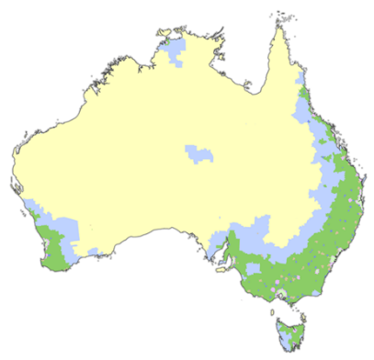

A map showing MMM 2019 can be viewed at [doctorconnect.gov.au](http://www.doctorconnect.gov.au/)

## Appendix 4 - Definitions Used in the Survey

| **Survey category** | **Definition** |
| --- | --- |
| **Care management** | Care management is an essential key component of every Home Care Package. It ensures clients receive the appropriate level of support in a way that meets their current and future care needs. It should ensure there is no overlap, over-servicing or mismanagement of services.  Care management may include: reviewing the Home Care Agreement and Care Plan; coordination and scheduling of services; ensuring care is aligned with other supports; providing a point-of-contact for client's or their support network; ensuring the care received is respectful of the client's culture; and identifying and addressing risks to client safety. |
| **Package management** | Package management is the ongoing administration and organisational activities associated with ensuring the smooth delivery and management of a client's Home Care Package. It may include the costs for: preparing monthly statements; managing package funds; and compliance and quality assurance activities required for Home Care Packages. |
| **Administration charge** | Administration and overhead costs charged to a home care package. |
| **Nursing care - registered nurse** | Nursing services may include: wound care and management; medication administration such as assisting client's to take medication; general health and other assessments; certain medical tests including blood pressure; and support with dementia. The costs shown are for nursing services delivered by a Registered Nurse.  Note: charges for goods such as bandages, dressings and continence aids should be listed under "Consumables". |
| **Nursing care - enrolled nurse or other licensed nurse** | Nursing services may include: wound care and management; medication administration such as assisting client's to take medication; general health and other assessments; certain medical tests including blood pressure; and support with dementia. The costs shown are for nursing services delivered by other levels of nurses (e.g. an Enrolled Nurse or specialist nurse).  Note: charges for goods such as bandages, dressings and continence aids should be listed under "Consumables". |
| **Personal care** | Personal care services may include help with: bathing; showering; toileting; dressing/undressing; getting in and out of bed; washing and drying hair; shaving; and reminding client's to take their medication. |
| **Cleaning and household tasks** | Cleaning and household tasks may include: help with making beds; ironing; laundry; dusting; vacuuming; and mopping. |
| **Meal preparation** | Assistance with preparing meals or delivery of a ready-made meal. It does not include the cost of food which client's must pay for. |
| **Social support, shopping services, community access** | Individual and group/centre-based social support which may include arranging social or cultural activities, taking a client shopping or to events, and other out-of-home services that help prevent social isolation. May also include advocacy services to help protect the person’s interests or emotional support and support services to maintain personal affairs. |
| **Consumables** | This includes the price for goods such as bandages, dressings and continence aids where supplied to the client. |
| **Light gardening** | Light gardening may include help with light weeding; watering; light pruning; lawn mowing; or minor garden maintenance.  Any large gardening job (e.g. quote based) should be captured under "Home maintenance". |
| **In-home respite (day‑time)** | A care worker supporting client's in their home for a short period of time, for example when their carer is away or unavailable. |
| **In-home respite (overnight)** | A care worker supporting client's in their home overnight, for example when their carer is away or unavailable. May also be called a 'sleepover'. |
| **Transport services** | Accompanied or unaccompanied transport to help the person shop, visit a health practitioner or attend social activities. |
| **Allied health professional (practitioner)** | Allied health and therapy services provided by a qualified practitioner including services such as Physiotherapists, Occupational Therapists, Podiatrists, Speech Therapists, Exercise Physiologists, Dietitians, Diversional Therapists etc. |
| **Capital purchases** | Include items such as mobility aids and equipment, or assistive technology. |
| **Home modifications** | Modifications to the home, if required, such as easy access taps, shower hose or bath rails or other modifications to allow the consumer to remain at home. Approved providers will assist the consumer and homeowner, if the home owner is not the consumer, in accessing further technical advice on more comprehensive home modifications. |
| **Home maintenance** | Home maintenance, reasonably required to maintain the home and garden in a condition of functional safety and provide an adequate level of security. Will include the cost of any large/quote based gardening job. |
| **Travel expenses** | Amount charged to the Home Care Package for the home care worker to travel to the client to provide the service. |
| **Maximum Exit Amount** | This is the maximum amount that can be deducted from funds that are left in a package when the care recipient leaves your care (either when they change providers or leave home care). The amount covers administration costs associated with leaving. |
| **Processing charge on third party purchases / sub‑contracting** | A charge for services that you coordinate for the care recipient but is not delivered directly by you. It may also include any handling amount charged for arranging equipment or other purchases. |
| **Other Services** | This is a general category that captures agreed other services required to support the client to live at home. May include telehealth or a range of other services required. |
| **Fees received from care recipients** | This includes all fees received from care recipients such as: basic daily fees, income tested care fees and other fees (i.e. top-up fees for home care services purchased in addition to those funded with package funding). |
| **Government subsidies received for the period** | The aggregate amount of the subsidies and supplements approved providers have claimed/received from the Department of Human Services (DHS). |
| **Unspent funds / available balance at period end** | The aggregate amount of unspent package funds that will be carried over into the next financial year. It is the liability that the approved provider must repay to the Commonwealth Government and/or care recipients if the care recipient leaves the service. |

1. Based on daily subsidy of $137.77 effective at 30 June 2019