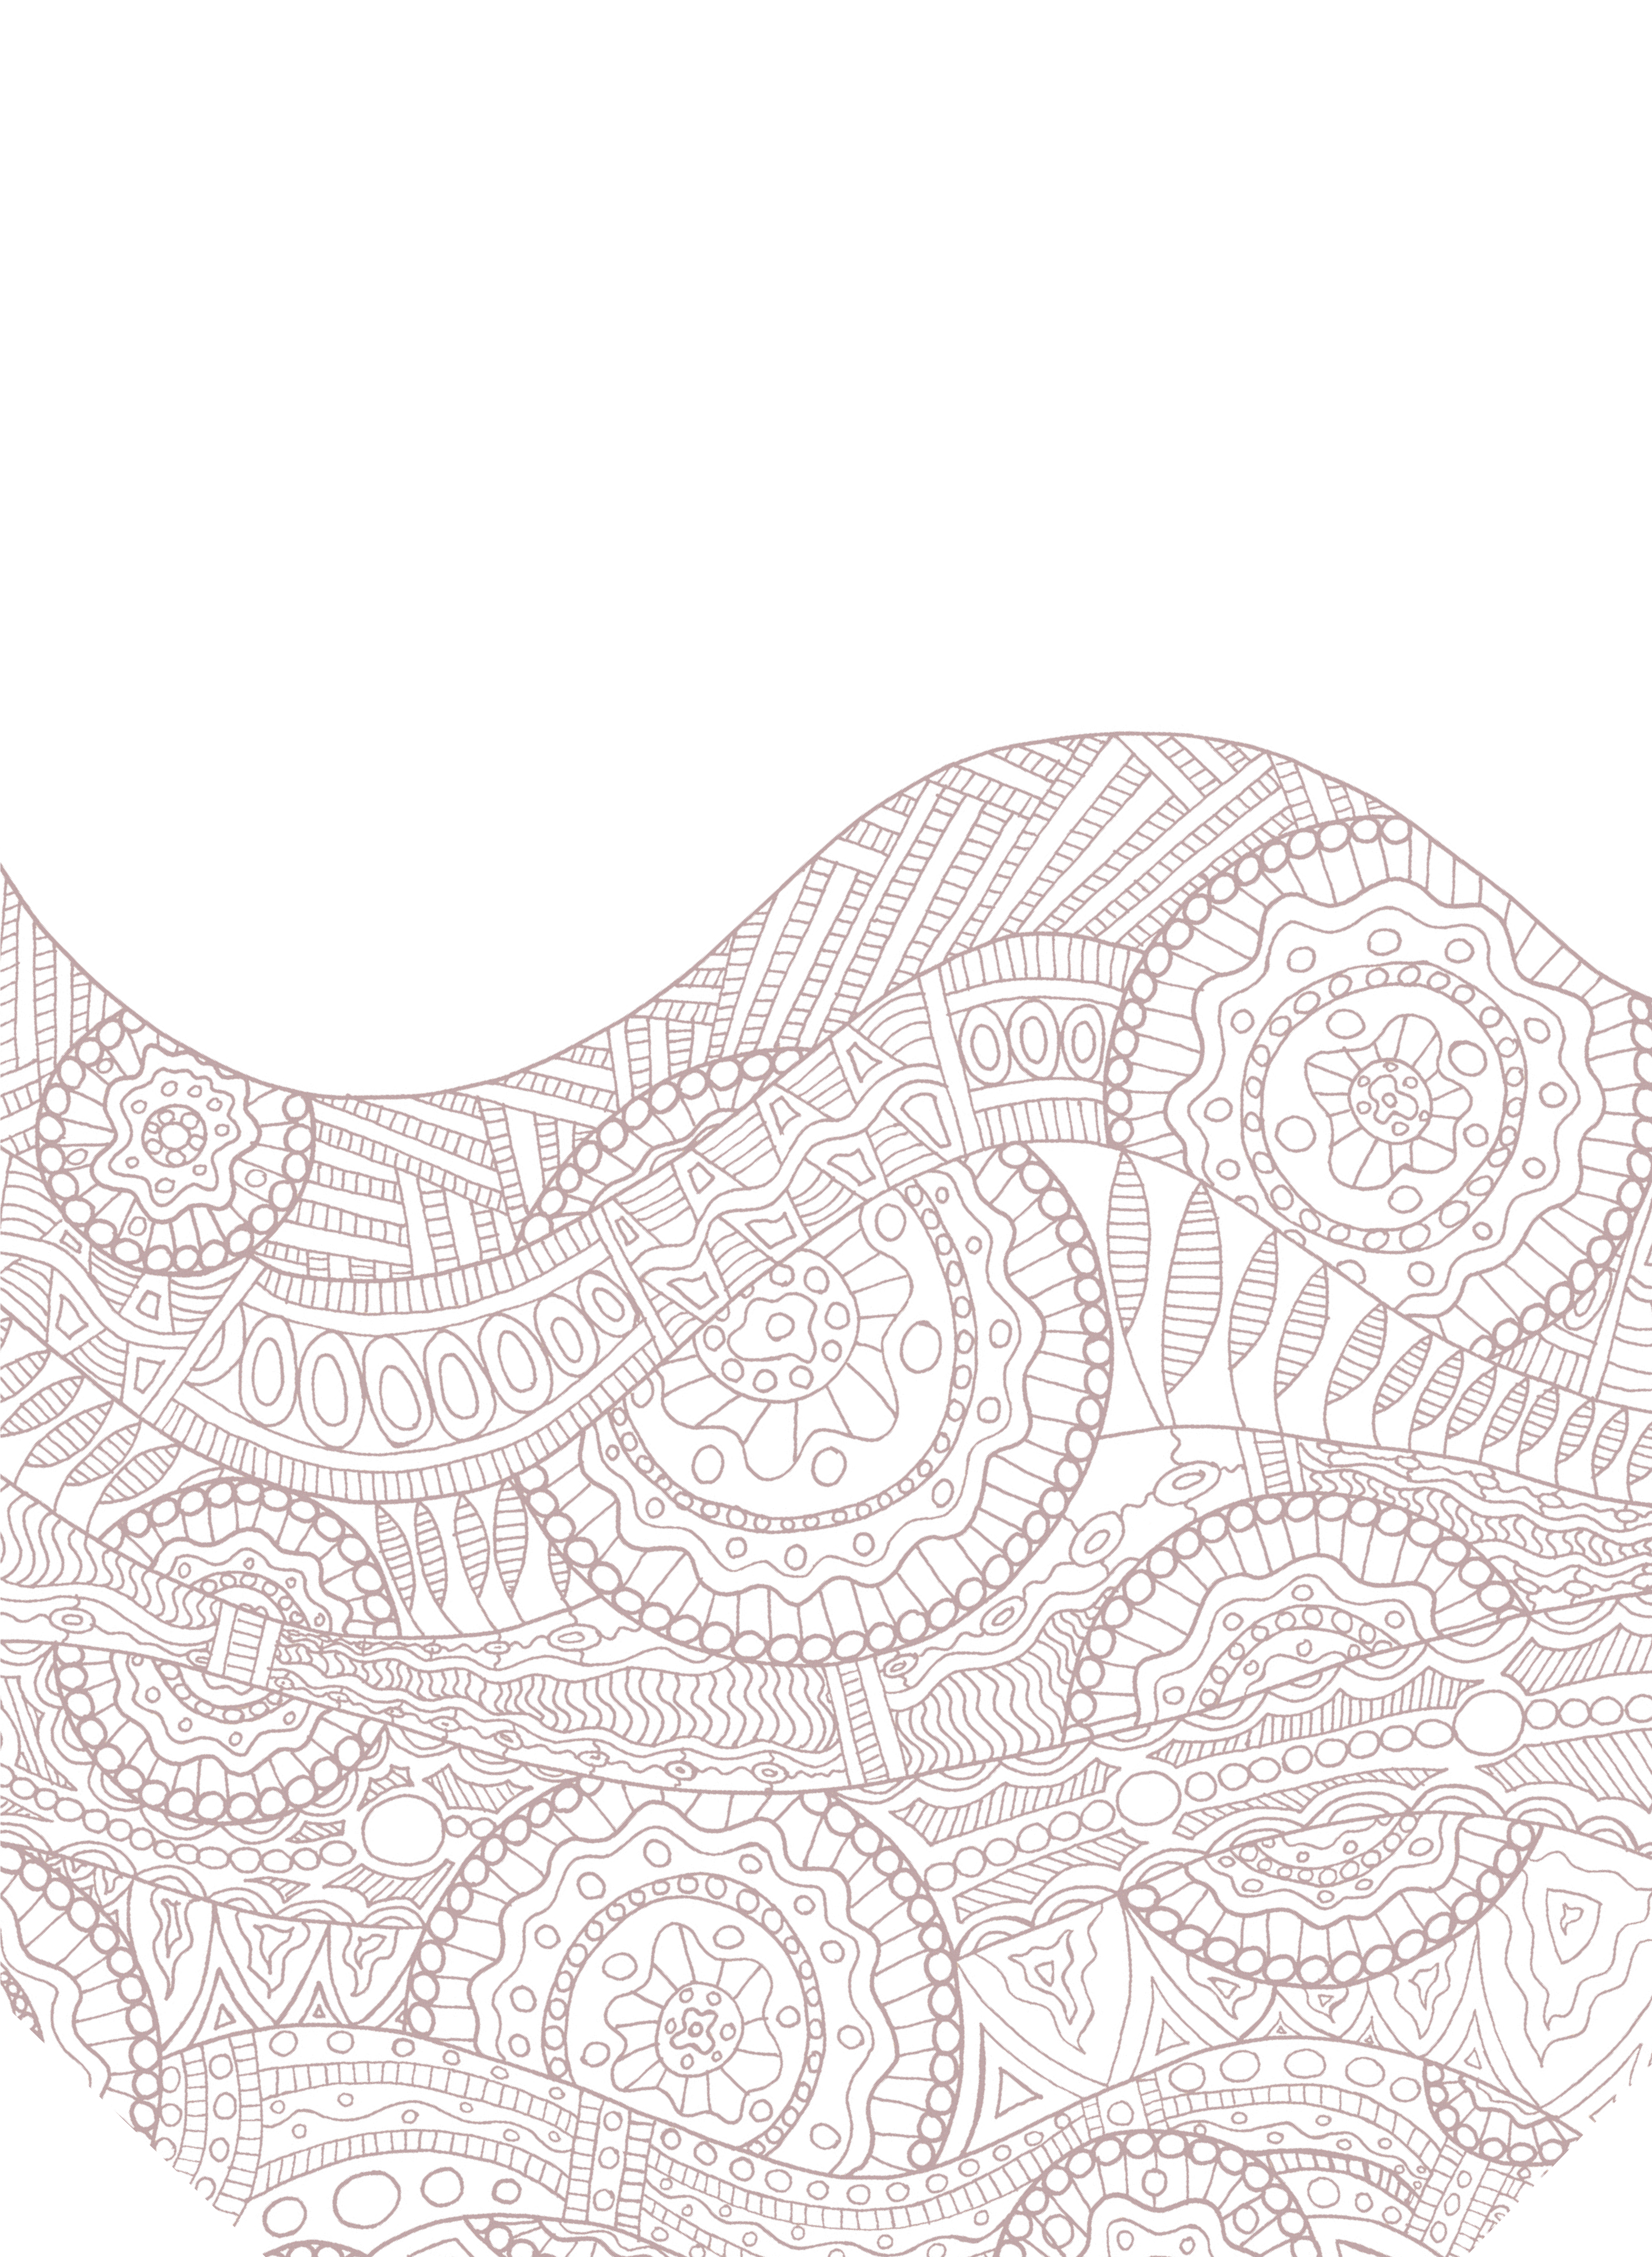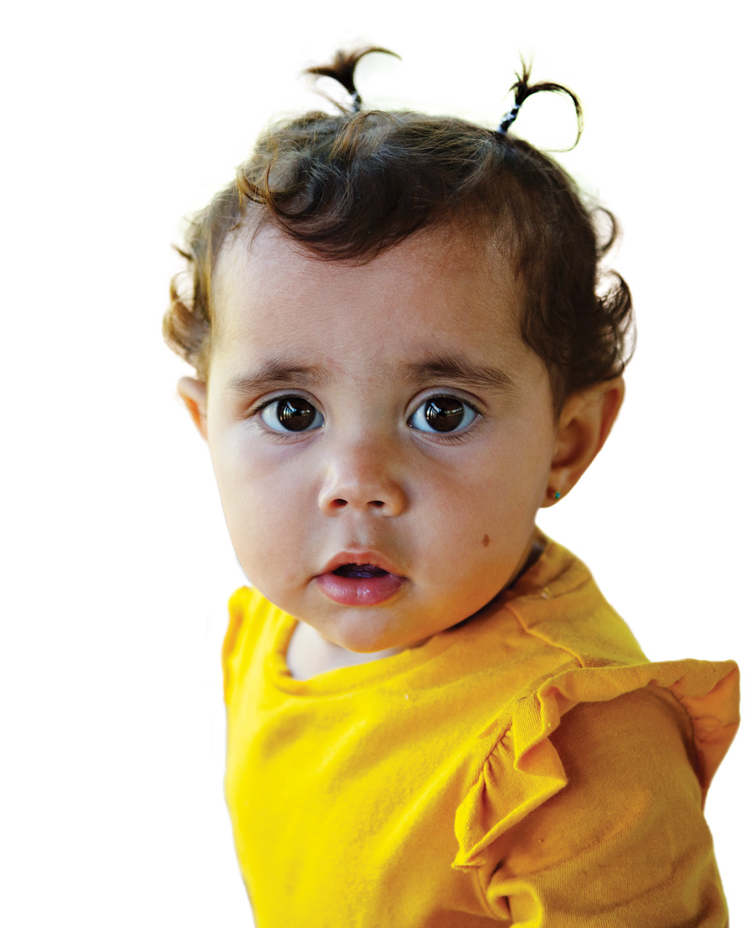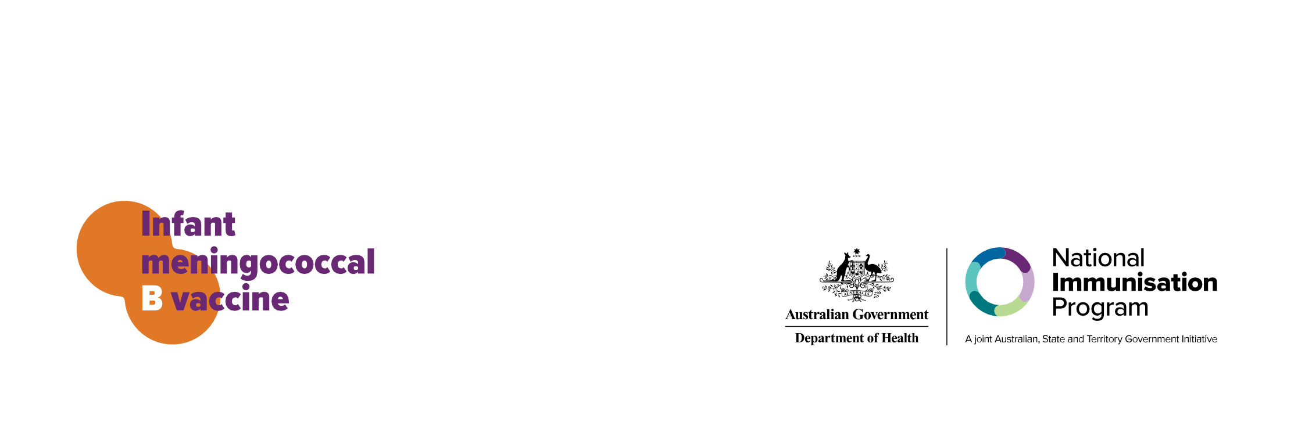FREE
Meningococcal B vaccine
For all Aboriginal and Torres Strait Islander kids under 2 years of age.
Talk to your Aboriginal Health Practitioner or Worker, GP or nurse about the vaccine.

For more information visit:
health.gov.au/immunisation

