Aged Care Financing Authority

Eighth report on the Funding and Financing of the Aged Care Industry

May 2020

Contents

Foreword 1

Executive Summary 4

1. This report 2

1.1 Aged care in Australia 2

1.2 About the Aged Care Financing Authority 2

1.3 The Annual Report on the Funding and Financing of the Aged Care Industry 3

1.3.1 Methodology 3

1.3.2 Navigating the 2020 annual report 5

2. Aged care in Australia 6

2.1 Overview 6

2.2 Current aged care 9

2.3 Australian Government expenditure on aged care 11

2.4 Consumer contributions 12

2.5 Aged care providers 13

2.6 Aged care workforce 15

2.6.1 Aged Care Workforce Strategy 16

2.7 Ongoing aged care reforms and changes 17

2.8 Royal Commission into Aged Care Quality and Safety 18

3. Access to aged care 20

3.1 Supply of subsidised aged care 20

3.2 Aged Care Approvals Round 23

3.3 Access to aged care 23

3.4 Access to home care 24

3.4.1 Release of home care packages 25

3.4.2 Demand for home care packages 25

3.4.3 Length of stay in home care 26

3.5 Access to residential care 27

3.5.1 Occupancy in residential care 27

3.5.2 Admissions to residential care 29

3.5.3 Length of stay in residential care 31

3.6 Residential respite care 33

3.6.1 Length and frequency of stay in residential respite care 33

3.6.2 High and low residential respite care 35

3.7 Supported residents 35

3.8 Age profile across care types 37

3.9 Access by Culturally and Linguistically Diverse and Indigenous Australians 38

3.9.1 Culturally and Linguistically Diverse Australians 38

3.9.2 Indigenous Australians 39

4. Home support 40

4.1 Introduction 40

4.2 Commonwealth Home Support Programme 40

4.3 Home and Community Care — Western Australia 43

4.4 Sector overview 43

4.4.1 Providers of home support 43

4.5 Funding for Home Support 44

4.5.1 Consumer contributions 46

4.6 Looking forward 46

5. Home care 48

5.1 Overview of the sector 48

5.1.1 The Home Care Packages Program 48

5.1.2 Providers of home care 49

5.2 Operational performance 52

5.2.1 Methodology 52

5.2.2 Analysis of 2018-19 financial performance of home care providers 53

5.2.3 Revenue 54

5.2.4 Expenditure 57

5.2.5 Profit 59

5.2.6 Unspent funds 64

5.3 Feedback from consultations and developments in 2019-20 66

6. Residential care 68

6.1 Overview of the sector 69

6.1.1 Supply of residential care 69

6.1.2 Residential care providers 70

6.1.3 Ownership type 71

6.1.4 Provider scale 71

6.1.5 Provider location 72

6.1.6 Residential care facility size and room configuration 73

6.1.7 Provisionally allocated places 74

6.1.8 Extra service 76

6.1.9 Additional services 77

6.2 Residential care funding sources 77

6.2.1 Operational funding 77

6.2.2 Commonwealth operational funding 78

6.2.3 Basic care subsidies 79

6.2.4 Residential care supplements 82

6.2.5 Payments for residential respite care 83

6.2.6 Resident operational funding 84

6.3 Operational performance in 2018-19 84

6.3.1 Revenue 84

6.3.2 Expenses 89

6.3.3 Financial results 93

6.3.4 Feedback from consultations and developments in 2019-20 102

7. Residential care: capital investment 104

7.1 Capital financing 104

7.1.1 Residents as a source capital 105

7.1.2 Commonwealth as a source of capital 105

7.1.3 Other sources of capital finance 105

7.2 Accommodation deposits 105

7.2.1 Accommodation deposit prices 110

7.3 Financing status - balance sheet 111

7.3.1 Balance sheet analysis by ownership type 113

7.3.2 Balance sheet performance ratios 116

7.3.3 Recent trends in building and investment in the residential care sector 122

8. Future demand for aged care 124

8.1 Future demand for aged care services 124

8.1.1 Determinants of demand 124

8.1.2 An ageing population – older people demand more aged care 125

8.1.3 Consumer preference 126

8.1.4 Availability of alternative care types 126

8.1.5 Economic factors 127

8.2 Current demand for aged care 128

8.2.1 Residential care 128

8.2.2 Home care 129

8.3 Projecting future demand 129

8.3.1 Substitution of residential care and home care 129

8.3.2 Updated projections 131

8.3.3 Planning for the supply of aged care 132

8.4 Investment requirements for residential care 133

8.5 The investment environment 135

8.5.1 Access to capital 135

9. Challenges facing the aged care industry – uncertainty, transformation, transition 137

9.1 The aged care industry faces many challenges and uncertainties. 137

9.2 Setting a future direction 138

Appendix A: ACFA Membership 147

Appendix B: Recent work completed by ACFA 148

Appendix C: ACFA’s stakeholder engagement 149

Appendix D: Aged care workforce 151

Appendix E: Means testing arrangements 153

Appendix F: Financial ratios by provider ownership type 155

Appendix G: Residential aged care subsidies and supplements 159

Appendix H: Residential care subsidy and supplements rates 160

Appendix I: Residential care financing structures and balance sheets 163

Appendix J: Home care revenue and expenditure 164

Appendix K: Home care subsidies and supplements 166

Appendix L: Residential care and home care financial data 169

Appendix M: References 170

Glossary 172

Charts, tables & figures Index 182

# Foreword

I am pleased to present the Aged Care Financing Authority’s (ACFA) 2020 Report on Funding and Financing in the Aged Care Industry. This is ACFA’s eighth annual report.

It comes at a particularly challenging time for the Australian community as it grapples with the consequences of the COVID-19 pandemic. COVID-19 has resulted in an unprecedented dislocation to the lives of all Australians and to the Australian and global economies. It is impacting on the financial position of aged care providers and, depending on the spread of the virus, has the potential to cause major financial problems for the aged care industry. In particular, it could significantly disrupt the financial position of residential care providers who are responsible for some of the most vulnerable Australians to coronavirus.

This report was compiled before the impact of COVID-19 started to become more evident. It includes analysis of the financial data supplied by aged care providers in their 2018-19 Aged Care Financial Reports, supplemented by more recent data sources where available and feedback from consultations with stakeholders.

While the data collected from the Aged Care Financial Reports represent the most comprehensive data set available on financial issues in the Australian aged care industry, in most cases it is nearly a year old at the time of publication of ACFA’s annual report. To gain a more updated impression of the financial issues and pressures confronting providers, ACFA consulted with a wide cross section of stakeholders in preparing its 2020 Annual Report. However events have overtaken those consultations which largely took place in January, February and early March 2020. While COVID-19 was acknowledged as a risk at that time, the magnitude of the disruption and costs of seeking to contain coronavirus were not evident.

Consequently, this report essentially outlines the funding and financing issues confronting the aged care industry prior to the onset of COVID-19. As such, it provides an insight into the financial position of aged care providers before they were confronted with the costs, challenges and uncertainties of COVID-19.

The overall financial performance of residential aged care providers declined in 2017-18. A major factor influencing this outcome was the changes to the Aged Care Financing Instrument (ACFI) that took effect in 2016 and 2017. Overall, the ACFI changes constrained growth in providers’ revenue below growth in their costs, particularly staff costs.

The financial performance of residential care providers broadly stabilised in 2018-19. The Average Earnings Before Interest, Tax, and Depreciation (EBITDA) per resident for residential care providers was $8,523 in 2019-18, down slightly from $8,746 in 2017-18. This followed the 24 per cent decrease from 2016-17. The 2018-19 financial results incorporate the one-off $320 million increase in revenue resulting from the Government’s 9.5 per cent increase in ACFI that applied between 20 March and 30 June 2019. In the absence of this one-off increase in revenue, the overall financial performance of residential care providers in 2018-19 would have declined considerably to around $7,000 or a 20 per cent decrease on 2017-18. Although this estimate does not add back any extra expense the providers may have incurred as a result of utilising the additional funding.

Home care providers continue to adjust to the introduction in February 2017 of home care consumers having choice of the services they receive through their packages as well as choice of the provider who delivers these services. Adjusting to this change increased costs for providers, while the significant increase in competition constrained revenue growth. Average EBITDA per consumer fell significantly in 2017-18, although it was relatively stable in 2018-19.

The feedback from consultations with providers suggests that the financial pressure residential care providers experienced in 2017-18 and 2018-19 (discounting for the Government’s one-off increase in ACFI funding in 2018-19) has continued in 2019-20. Nearly all residential providers consulted said that their financial results had deteriorated in 2019-20. This is confirmed in the *StewartBrown Aged Care Financial Performance Surveys* undertaken in 2019-20.

While a number of home care providers said that they had benefited from the increase in the number of home care packages in 2019-20, competitive pressures continued to constrain margins. However, some home care providers reported they had significantly overhauled their businesses with the aim of improving efficiency as well as to be more responsive to consumers. These providers reported seeing the benefits of these changes reflected in their financial results.

Uncertainty was a major theme raised in the consultations that took place with providers in early 2020. A major focus of uncertainty at that time was the future direction of the aged care industry and reforms that will be recommended by the Royal Commission into Aged Care Quality and Safety (the Royal Commission), the nature and timing of the Government’s response and uncertainty regarding the timing and impact of the new funding model to replace ACFI. Financial pressure combined with uncertainty contributed to a reduction in new investment in the residential care sector.

It is to be expected that the paramount issue confronting aged care providers in the second half of 2019-20 and into 2020-21 are the costs and uncertainties associated with COVID-19. Containing the spread of the virus has increased the costs for providers, and in March and May 2020 the Government announced three temporary funding packages to support aged care providers in responding to COVID-19, with specific mechanisms to reinforce the aged care workforce. The further spread of COVID-19 and continuation of social isolation and distancing measures would have a very significant financial impact on residential care providers, including difficulties in maintaining staffing, a reduction in occupancy rates and cash-outflows in refunding Refundable Accommodation Deposits (RADs).

In addition to the financial pressures the aged care industry was facing before COVID-19, along with the potentially major financial implications of coronavirus, the industry faces the prospect of major reforms arising from the Royal Commission. As Commissioners noted in their Interim Report, ‘It is clear that a fundamental overhaul of the design, objectives, regulation and funding of aged care in Australia is required[1].’

ACFA made a submission to the Royal Commission in April 2019. The submission outlined the impact of policy changes on the financial performance of aged care providers and issues surrounding the outlook for the aged care industry. In October 2019 ACFA provided the Government with a report on *the Attributes for Sustainable Aged Care- a Funding and Financing Perspective*. This report expanded on some preliminary comments on this issue which were raised in ACFA’s submission to the Royal Commission into Aged Care Quality and Safety.

There is likely to be a significant period of transformation within the industry, with potentially different models of care across home care, residential care and independent retirement living in the future. Against the background of the underlying pressures facing the industry, including the potential impact of the Royal Commission, Chapter 9 of this report has some broad observations on some of the issues to be considered in order to place the aged care industry on a sustainable path.

In response to a request from the Minister for Aged Care and Senior Australians, ACFA submitted to the Government in December 2019 a report on the potential financial impact on home care providers of the Government’s 2019-20 Budget measure to change the way providers are paid Government subsidies.

ACFA will continue to assess the range of factors impacting on the aged care industry and advise the Government on the likely implications of developments on the sustainability and viability of the industry. A particular focus in the immediate period ahead will be the implications of COVID-19 ACFA will seek to provide analysis and commentary to inform the medium and longer term effects this is likely to have on the industry. ACFA will continue to perform its role through its annual report, along with updates on the funding and financing issues confronting the industry, as well as projects it is commissioned to undertake by the Minister for Aged Care and Senior Australians. In this regard, the Minister has requested that ACFA undertake analysis of the future role of Refundable Accommodation Deposits and the Basic Daily Fee. These projects will be completed in 2020 or early 2021.

ACFA would like to acknowledge and thank the aged care providers, peak bodies, consumer representatives, financial institutions and other parties it has consulted for their input and for their submissions to the reports ACFA has prepared. As part of its outreach activities, in 2019 ACFA held roundtables with stakeholders in Sydney, Melbourne and Adelaide. ACFA members continued to participate in a wide range of industry forums and conferences as well as the proceedings of the Royal Commission.

There are currently many challenges confronting the Australian community and the aged care industry. It is an uncertain outlook for all Australians. In this environment, ACFA will seek to enhance its role in advising the Government and informing stakeholders on funding and financing issues confronting the aged care industry.



**Mike Callaghan AM PSM**  
Chairman  
Aged Care Financing Authority

# Executive Summary

Overview of developments in 2018-19

This report was compiled before the magnitude of the disruption and costs of seeking to contain COVID-19 were evident. It covers the financial data supplied by aged care providers in their 2018‑19 Aged Care Financial Reports, supplemented by feedback from consultations with stakeholders in early 2020. As such it provides an insight into the financial position of aged care providers before they were confronted with the costs, challenges and uncertainties of COVID-19, an environment that will likely last for the remainder of 2020. As noted in the Foreword, ACFA will seek to undertake analysis on the longer term impacts of the COVID-19 crisis on the aged care industry, particularly residential care.

Following a significant decline in the financial performance of both residential and home care providers in 2017‑18, their financial results appeared to stabilise in 2018‑19. However the underlying financial pressures confronting providers, particularly residential care providers, remain and feedback from consultations suggest that these pressures have continued in 2019-20. The effort to contain COVID-19 will have added to the costs of aged providers in 2020 and in turn resulted in additional downward pressure on their financial performance. The Government announced two funding packages in March 2020 and an additional funding increase in May 2020 to assist the industry respond to the pressures of COVID-19, however the financial impact of the virus on providers may intensify over the course of 2020.

The average Earnings Before Interest, Tax and Depreciation (EBITDA) per resident for residential care providers fell by 24 per cent in 2017-18 and decreased slightly by a further 2.5 per cent in 2018-19. The number of residential providers reporting a loss in 2018-19 was 42 per cent. The 2018-19 financial results of residential care providers were supported by the Government’s one-off $320 million increase in the Aged Care Financing Instrument (ACFI) in the final quarter of that year. In the absence of this one-off funding increase, the overall financial performance of residential care providers would have deteriorated more significantly in 2018-19 to an EBITDA of about $7,000, or a 20 per cent decrease on 2017-18, although this estimate does not add back any extra expense the providers may have incurred as a result of utilising the additional funding.

Feedback from consultations with providers in early 2020, along with other data sources such as StewartBrown’s Aged Care Financial Performance Survey, indicate that the financial performance of residential care providers continued to deteriorate in 2019-20. The important influence on the decline in the financial performance of residential aged care providers in 2017-18 was the Government’s change in ACFI arrangements in 2016 and 2017 and the pause in ACFI indexation in 2017-18. While the Government forecast daily average growth in ACFI expenditure in 2017-18 of 2.4 per cent, there was no growth.

Providers indicate that the margin squeeze they have been experiencing since 2017-18 has continued, with growth in ACFI, which represents the bulk of their revenue, significantly below the growth in their costs. The Government’s forecast for average daily ACFI expenditure for 2018-19 was 1.5 per cent while the actual growth was 0.8 per cent. Most providers consulted said that they were experiencing little or no growth in their ACFI revenue in 2019-20. As of December 2019, the growth was 0.2 per cent compared with forecast annual average growth of 1.0 per cent. In contrast to the slow growth in revenue, residential care providers said costs continue to rise, particularly staff costs. They also note that the introduction of the new quality standards and the stepped-up compliance activities of the Aged Care Quality and Safety Commission had significantly increased their costs. This feedback came before the impact of responding to COVID-19 had intensified. Dealing with COVID-19 will have significantly added to the costs for providers.

There was also a significant deterioration in the financial performance of home care providers in 2017-18. After several years of stable returns, EBITDA per consumer for home care providers fell by over 60 per cent in 2017-18. This was influenced by the introduction in 2017 of home care packages following consumers rather than being allocated to providers. This reform allows consumers to direct their care package to the provider of their choice as well as to change providers, which resulted in a large increase in the number of approved providers and greater competition between providers. Adapting to the new arrangements increased costs for providers and the more competitive market put downward pressure on prices.

Although relative stability returned in 2018‑19, feedback from most providers suggest that there is little improvement in their financial results in 2019-20, despite the increase in the number of home care packages being released. Some providers did indicate that they were seeing a lift in their financial results following a significant restructuring of their business models, targeted advertising and recruiting new staff, in order to ensure that they were more efficient and responsive to consumer needs. Most providers, however, said trading conditions remained difficult notwithstanding the increase in the number of packages being released, and financial returns remained flat. As with residential providers, COVID-19 will have posed additional challenges for home care providers and added to their costs.

There continues to be a steady overall decline in occupancy rates in residential care facilities. The average occupancy rate in 2018-19 was 89.4 per cent, down from 90.3 per cent in 2017-18 and 91.8 per cent in 2016-17. For several years prior to 2016-17 the occupancy rate had been steady at around 92 per cent, but was as high as 97.1 per cent in 2003‑04. A small decline in occupancy rates can have a significant impact on the financial results of providers, especially smaller facilities. A number of providers consulted said they were experiencing further declines in occupancy, while others said their occupancy was holding up. Providers with falling occupancy rates attributed the decline to the increase in home care packages and the concerns raised during the Royal Commission over the quality of care being provided in residential care facilities. Some providers said there was an excess supply of residential beds in some areas. Older facilities were experiencing the biggest falls in occupancy, reflecting they have less appeal to consumers when compared with newer or refurbished facilities. A major risk facing residential aged care providers is that the spread of COVID-19 in a facility may lead to a sizeable decline in occupancy if departures are not matched by new admissions. This could have a major impact on the financial performance of the facility and provider liquidity.

Feedback from consultations suggests there is a growing number of smaller residential care providers, particularly in regional and remote areas, facing significant financial stress and seeking to leave the industry. The impact of the restrictions and additional costs as a result of COVID-19 may have particularly disadvantaged smaller providers in regional and remote areas given they do not have the same flexibility of larger providers to adjust to changes and absorb additional costs. Part of the Government’s package of support for aged care providers to deal with COVID-19 was a 30 per cent increase to the Viability and Homeless Supplements in residential care and a $205 million payment announced in May involving a higher rate of payment for regional, rural and remote providers. Prior to COVID‑19, many providers reported having received approaches to takeover a struggling provider. The appetite for such acquisitions was low, with the providers being approached saying that they are under financial pressure and the effort to turnaround an underperforming provider would be a major distraction in management time and resources. It also appears that many of the providers seeking to leave have older facilities targeting lower care residents unsuited to the rising acuity of resident profiles. Given the additional costs and uncertainties associated with COVID-19, there may be little or no appetite to take over a provider in financial difficulties.

Prior to the uncertainties arising from COVID-19, there was a general expectation that there would be an ongoing process of rationalisation and consolidation within the residential care sector, a process that might accelerate if the Government confirms its in-principle support to transition the allocation of subsidised residential places to consumers and cease the current Aged Care Approvals Round process. The reforms following the Royal Commission may also play a further role. In this context, a number of providers welcomed the announcement of the Government Business Improvement Fund for residential care which provides assistance to providers at greatest risk of service failure, and where the impacts on residents would be highest. The impact of COVID-19 may accelerate the process of consolidation within the sector and result in increased demands on the Government’s Business Improvement Fund.

Prior to the additional demands placed on aged care workers as a result of COVID-19, most residential care providers reported that they continue to face difficulty in attracting and retaining skilled staff. They indicated that contributing to this challenge are negative community perceptions regarding residential aged care as a consequence of the Royal Commission. In addition, a combination of ongoing financial pressure, rising expectations by residents and their families, and the enhanced activities of the Aged Care Quality and Safety Commission, have increased workloads and pressure on staff. Many providers said that in this environment it was particularly challenging to attract and retain registered nurses and managerial positions. In response to the pressures resulting from COVID-19, the Government announced in March 2020, funding of $235 million for the payment of a retention bonus for direct care workers in residential care and home care. Additional funding has also been provided to upskill training in infection control and to hire additional nurses and aged care workers and related costs in the event of a COVID-19 outbreak in a home. In May an additional $205 million was announced to support providers meet increased costs arising from COVID-19. At this stage, it is not possible to determine whether these allocations will be sufficient to cover the additional costs of preparing for and managing the spread of COVID-19.

In 2018-19 there continued to be a shift, albeit small, in the proportion of people choosing to pay their residential accommodation by a Daily Accommodation Payment/Contribution (DAP/DAC) rather than a Refundable Accommodation Deposit (RAD/RAC). However, this trend away from RAD/RACs and towards DAP/DACs has been occurring for a number of years. For example, the proportion of people choosing DAP/DACs has risen from 33 per cent in 2014-15 to 41 per cent in 2018-19. A sustained move away from RAD/RACs will have significant financial implications for many residential care providers, depending on how they have structured their business. However a significant potential risk for providers is a sizeable and quick cash outflow in repaying RADs in response to the spread of COVID-19 in a facility. In such a situation, new residents may not be replacing departing residents. In addition, a downturn in the housing market as a consequence of COVID-19 would flow through to lower use and lower value of RADs.

The Minister for Aged Care and Senior Australians has requested ACFA to undertake an analysis on the future role of RADs in the aged care market. This report is scheduled to be completed in 2020 or early 2021.

The number of residential care providers reporting that they planned to rebuild or upgrade their facilities remained low in 2018-19, after first falling in 2017-18. Feedback from consultations indicates that many providers are putting their investment plans on hold, influenced by the squeeze on margins and uncertainty as to future funding arrangements, particularly the unknown outcome of the Royal Commission, the timing and nature of the Government’s response and uncertainty about the timing and impact of the new funding model to replace the ACFI. Analysts advise that potential new investors in the aged care industry are also deferring any decisions given the extent of uncertainty that currently exists. The significant uncertainty associated with COVID-19 and the pressure on the financial position of providers would further deter new investment in the industry.

While there is no data on additional services offered by residential aged care providers, the feedback from consultations indicates that there continues to be strong interest by providers in introducing additional service fees. This is one of the limited measures available to providers to lift their revenue. It appears that many providers adopt the ‘package’ approach, where a fee is charged for a package of additional services. In contrast, however, a few providers said they were moving away from the package approach and introducing a ‘menu’ of additional services for a fee. It appears that in many facilities that are charging for additional services, the same service was provided to all residents but only those assessed as being able to afford the fee are being charged. A number of other providers said that while they were actively considering introducing additional service fees, they had not done so because of regulatory uncertainty over which additional services could attract a fee. A number also said that given the socio economic area where some of their facilities were located, there was little capacity for residents to pay additional fees.

The spread of COVID-19 would significantly disrupt the aged care industry and have a major adverse impact on the financial position of aged care providers, particularly residential care providers. There would be difficulties in maintaining staffing, occupancy rates would likely fall with consequential large cash outflows in refunding RADs. Some providers are in a better financial position than others to deal with the immediate cash flow consequences of RAD outflows, although, from a consumer perspective, all RADs are guaranteed by the Government. Providers commissioning new services would be particularly affected. Home care providers may also be significantly affected with some home care consumers choosing to put their services on hold due to COVID-19.

2020 will be a challenging year for the Australian community and the Australian economy, and will be a particularly challenging year for the aged care industry.

Aged care in Australia

In 2018-19, Government subsidised aged care services were provided to around 1.3 million people. The majority of these (1.2 million) received services through the three major programs discussed in this report: The Commonwealth Home Support Programme (CHSP), the Home Care Packages Program and residential care. It is estimated that by 2022-23 around 1.5 million people will be accessing subsidised aged care services. Many older Australians continue to purchase support services on the open market and/or receive assistance from volunteers and charitable organisations.

Australian Government expenditure on aged care in 2018-19 was $19.9 billion, up from $18.1 billion in 2017-18. This is projected to increase to over $25 billion by 2022-23. The aged care industry makes a significant contribution to the Australian economy, representing more than 1 per cent of Gross Domestic Product (GDP).

In 2018-19, subsidised aged care services were provided by:

* 1,458 CHSP providers. In 2017-18 there were 1,456 CHSP providers and 91 Western Australian HACC providers[2];
* 928 home care providers (873 in 2017-18); and
* 873 residential care providers (886 in 2017-18).

Consumer expenditure on aged care was around $5.1 billion in 2018-19 (excluding refundable accommodation deposits), compared with $4.9 billion in 2017-18. Fees for everyday living expenses in residential care (the basic daily fee) represents two-thirds of consumer expenditure.

There are over 366,000 paid workers in aged care with a further 68,000 volunteers[3].

Access to aged care

In 2018‑19 there was a significant increase in the number of home care consumers, up to 133,439 from 116,843 in 2017‑18, an increase of 14 per cent. This followed a similar increase from 97,516 in 2016‑17. The number of consumers of residential care increased marginally from 241,723 in 2017‑18 to 242,612 in 2018‑19, an increase of 0.5 per cent. The number of CHSP consumers in 2018‑19 was 840,984, the first year that the CHSP operated as a fully national program. In 2017-18, when Western Australian HACC operated separately, there were 64,491 older Australians who received Western Australian HACC services and 783,043 recipients of CHSP services.

The overall aged care provision target ratio is being adjusted to progressively increase from the target of 113 operational places per 1,000 people aged 70 and over that applied prior to 2012 to 125 by 2021-22. Over the same period the target for home care packages is increasing from 27 to 45, while the residential care target will reduce from 86 to 78. The remaining two places are for the Short Term Restorative Care Programme (STRC).

The proportion of people using home care and residential care at age 85 and over is more than three times that of people aged 70 and over, as has been the case in recent years.

During 2018-19, across all residential care, access to services for supported residents (excluding residents receiving extra services) was stable, as has been the case in previous years.

In residential care, average occupancy continues to fall, down to 89.4 per cent in 2018-19 from 90.3 per cent in 2017-18 and 91.8 per cent in 2016-17. The spread of COVID-19 will likely significantly impact occupancy rates.

Commonwealth Home Support Programme

In 2018-19 the CHSP provided services to 840,984 older Australians. Total Australian Government expenditure on the CHSP in 2018‑19 was $2.6 billion, with $2.5 billion being for service delivery.

In November 2019 the Government, as part of its response to the Royal Commission into Aged Care Quality and Safety Interim Report, re-affirmed an intention first announced in the 2015-16 Budget to establish a single unified system for care of older people at home. The unified system would replace the existing Commonwealth Home Support Programme (CHSP) and the Home Care Packages Program (HCPP). Final decisions by Government about a unified system will be made following final recommendations of the Royal Commission. The Government therefore announced as part of the 2019-20 Budget that CHSP contracts are being extended to June 2022.

The Western Australian HACC program transitioned into the CHSP on 1 July 2018, making the CHSP a national program.

Home care

Australian Government expenditure on home care packages in 2018‑19 was $2.5 billion, up from $2.0 billion in 2017‑18. Services were provided to 133,439 consumers, up from 116,843.

Consumers of home care contributed $107 million toward the cost of their care through the basic daily fee and income tested fees.

Not-for-profit providers continue to be the largest provider group in the home care sector, with 52 per cent from this group, stable from 53 per cent in 2017-18, while 72 per cent of consumers had their home care package with a not‑for‑profit provider at 30 June 2019.

Sixty-nine per cent of home care providers achieved a net profit in 2018-19, stable from 70 per cent in 2017-18. Across the sector, providers achieved an average EBITDA of $1,211 per consumer, relatively stable from $1,217 in 2017-18, which followed the significant decline from around $3,000 per consumer over the previous three years.

The for‑profit providers, after being the strongest performing provider group up to 2016‑17, reported by far the worst results for the second year in a row. The for‑profit providers recorded average EBITDA per consumer of $728 compared with $1,320 reported by the not-for-profit providers.

Unspent funds continue to increase significantly with home care providers holding $751 million at 30 June 2019, an increase of 39 per cent from $539 million at 30 June 2018. Based on the current rate at which unspent funds are increasing, unspent funds could be around $1 billion by 30 June 2020, although may be even higher due to some consumers putting their services on hold due to COVID-19. The Government had announced that commencing in June 2020 home care providers would begin to be paid the subsidy and supplements in arrears rather than in advance, and then at a later date phase two would mean providers would only be paid for services provided. This change will eventually lead to the Commonwealth holding the unspent funds rather than the provider. Implementation of this change has been postponed due to the COVID-19 pandemic.

Residential care

Australian Government expenditure on residential care in 2018-19 was $13.0 billion, up from $12.2 billion in 2017-18. Services were provided to 242,612 residents (an increase of 0.5 per cent). At 30 June 2019 there were 213,397 operational places, up from 207,142 at 30 June 2018 (an increase of 3 per cent).

In 2018-19, residents contributed $4.8 billion toward their living expenses ($3.4 billion), care ($0.6 billion) and accommodation ($0.8 billion) (excluding refundable lump sum accommodation deposits). Fees for everyday living expenses made up 71 per cent of resident contributions.

As at 30 June 2019, there were 873 residential care providers, down from 886 in 2017-18, continuing the consolidation of recent years, with the number of residential care places increasing while the number of providers gradually decreases. Not-for-profit providers continue to represent the largest proportion of ownership type in residential care, with 56 per cent of providers and 55 per cent of places.

Residential care providers generated total revenue of $19.3 billion in 2018-19, up from $18.1 billion in 2017-18, an increase of 6.8 per cent, equating to revenue of $283.54 per resident per day, an increase of 4.2 per cent from $272.16 in 2017-18.

Total expenses were $19.0 billion, up from $17.6 billion in 2017-18, an increase of 8 per cent, equating to $279.65 per resident per day, compared with $265.62, an increase of 5.3 per cent. The increase in costs continues to outstrip the increase in revenue.

Total profit was $264 million in 2018-19, down from $435 million in 2017-18. Average EBITDA per resident was $8,523 in 2018-19, down from $8,746 in 2017-18, a 2.5 per cent decrease, which follows a 24 per cent decrease from 2016-17 when average EBITDA was $11,481.

ACFA notes the additional $320 million paid to providers through the one-off 9.5 per cent increase in the basic care subsidy (ACFI) between March and June 2019. This increase positively impacted on the financial results of residential aged care providers in 2018-19. Analysis from the Department shows that without this one-off injection, the number of residential care providers reporting a loss would have been 48 per cent instead of 42 per cent, and average EBITDA would have declined to about $7,000, or a 20 per cent decline on 2017-18. Although this estimate does not add back any extra expense the providers may have incurred as a result of utilising the additional funding.

Residential care: capital investment

At 30 June 2019, the residential care sector held total assets of $52.6 billion and total liabilities of $39.0 billion. Total liabilities included $30.2 billion of refundable accommodation deposits (77 per cent of liabilities), up from $27.5 billion at 30 June 2018.

Residential care providers recorded an average return on equity of 11.8 per cent in 2018-19, down from 13.4 per cent in 2017-18. The average return on assets was 3.0 per cent in 2018-19, down from 3.3 per cent in 2017-18.

As at 30 June 2019, $5.3 billion of building works were either completed or in-progress compared with $4.9 billion at 30 June 2018. However, planned building activity remained significantly lower for the second year in a row compared with the previous years. The uncertainty associated with COVID-19 is likely to further depress investment intentions.

Future demand for aged care

While the COVID-19 crisis may pose sizeable dislocations to both the demand and supply of subsidised aged care services in 2020, in the longer term the demand for all aged care services and support required by older Australians, including subsidised services, will continue to expand with the ageing of the population. However it is not currently possible to accurately measure demand or to reliably establish consumer preference for residential and home care, due to existing supply constraints. Better evidence about unmet need and consumer preference is, however, being revealed through the introduction of the national prioritisation system for home care packages. Similarly, should the allocation of residential aged care places be transitioned to consumers without a cap on supply, demand would be better understood (although would continue to be distorted by the ongoing cap on the supply of home care packages).

The structural ageing of the Australian population over the next 20 years will see the size of the 70 years and over cohort increase by over 1 million people each decade; this is on a base of 2.8 million people in 2020. Underneath this, the older age groups will more than double over this period; for example, the 85 years and over cohort will increase from around 500,000 people in 2020 to over 1 million people by 2040.

At the same time that population ageing is putting pressure on the demand for aged care, the relative supply of informal carers is diminishing.

*The Legislated Review of Aged Care 2017* (Tune Review) recommended changes to the aged care target planning ratio. The current ratio denominator (70+ population) is not aligned to the older cohort of the population who are most likely to use aged care services. This is expected to result in a short-term oversupply of places (as places are created but not required as people enter their 70s), and a long-term undersupply (as the people using aged care start to comprise a larger proportion of the 70+ population).

ACFA recommends, while ever the supply of residential places remain capped, that the change in the denominator be accompanied by a change in the target provision ratio formula so that it is based on the number of consumers and not the number of operational places. This will allow comparable reporting and monitoring of the supply of residential and home care places, and overall supply against the provision targets, and help inform unmet demand and consumer preference.

**Royal Commission into Aged Care Quality and Safety**

The Royal Commission into Aged Care Quality and Safety was established in October 2018, with broad terms of reference to examine the aged care system in Australia, and to consider how to meet the challenges and the opportunities of delivering aged care services now and into the future.

The Royal Commission released its Interim Report on 31 October 2019. Commissioners identified three areas for urgent attention: providing more home care packages to reduce the waiting time for higher level care; reducing the over-reliance on chemical restraints in aged care; and taking stronger action to reduce the number of younger people living in residential aged care.

On 25 November 2019, the Government announced a funding package totalling $537 million in response to the Royal Commission’s Interim Report. This included:

* $496.3 million for an additional 10,000 home care packages;
* $25.5 million to improve medication management programs to reduce the use of medication as a chemical restraint on aged care residents and at home, and new restrictions and education for prescribers on the use of medication as a chemical restraint;
* $10 million for additional dementia training and support for aged care workers and providers, including to reduce the use of chemical restraint; and
* $4.7 million to help meet new targets to remove younger people with disabilities from residential aged care.

In March 2020, the Royal Commission announced that it was suspending all hearings and workshops until further notice, due to COVID-19. The closing date for public submissions to the Royal Commission has also been extended until at least 30 June 2020. The final report is now required to be provided no later than 12 November 2020, rather than 30 April 2020.

Challenges facing the aged care indistry – uncertainty, transformation, transition

Against the background of the COVID-19 pandemic, underlying financial pressures on providers and the prospect that the industry may undergo major transformation following the Royal Commission, ACFA provides some observations on issues to be considered to ensure that Australia transitions to a sustainable aged care industry.

While COVID-19 has placed added financial pressure on providers, it comes on the top of a three year steady deterioration in the financial position of residential care providers. This is not a sustainable position if the aged care industry is to meet the needs of an ageing society. There is uncertainty among providers as to when this trend will be arrested. This uncertainty is deterring new investment in the industry. Providers also appear to be apprehensive of the direction and cost of reforms that may be recommended by the Royal Commission, along with the timing and nature of the Government’s response.

While recognising the challenges associated with COVID-19, priority must be given to dealing with the underlying financial pressures and need for reform in the aged care industry. The delay in the Royal Commissions hearings is another source of uncertainty. When the Royal Commission does finalise its report, it will be important that its recommendations are evidence-based, clear, precise, readily implementable and affordable.

The Government cannot respond to the Royal Commission’s recommendations until they are finalised. But a prompt response is required. In the interim, and given the uncertainty that prevails, the Government could reassure both consumers and providers that the COVID-19 crisis has not diminished the Government’s resolve to advance long-term reforms in the industry, including reforms to funding arrangements.

Some of the preliminary proposals by Counsel Assisting the Royal Commission involve changes that would significantly increase the funding requirements in aged care, including uncapping the supply of aged care services. Some factors for Government to consider in this regard are:

* When considering the long-term funding requirements of the aged care industry, the Government cannot ignore fiscal realities. Prior to the impact of COVID-19, a focus of the Government was on ensuring that its expenditure on aged care was balanced against other spending priorities and was consistent with the sustainability of the Government’s overall fiscal position. That balancing task will remain after the COVID-19 crisis, albeit in more difficult circumstances.
* The conditions for the Government uncapping the supply of aged care services as outlined in the Legislated Review of the Aged Care Act (2017) remains, namely: the Government needs an accurate understanding of underlying demand, consumers must make equitable and sufficient contributions to the cost of care; there must be a robust system for assessing eligibility for Government funded aged care and the Government needs to ensure the equitable supply of services across population groups.
* Establishing an ‘efficient’ price for aged care services is essential. The Government has to set an appropriate overall price for the services it subsidises that avoids over generous support for inefficient providers while allowing a sufficient return for efficient providers such that they will invest in the industry.

The Aged Care Financing Authority and the 2020 Annual Industry Report

# This report

## Aged care in Australia

The aged care industry in Australia provides services to over 1.3 million Australians and generates annual revenues totalling over $24.4 billion. The industry makes a significant contribution to the Australian economy, representing 1 per cent of Gross Domestic Product (GDP).

The industry is heavily reliant on taxpayer funding, receiving $19.9 billion in Commonwealth funding in 2018-19, an increase of 10 per cent from 2017-18. Almost 66 per cent of total funding ($13.0 billion) was for residential care. Given the amount of taxpayer funding, objective and thorough analysis of the funding and financing of the industry is of central importance to the Government, aged care consumers and providers.

## About the Aged Care Financing Authority

The Aged Care Financing Authority (ACFA), established in 2012, is a statutory committee whose role is to provide independent, transparent advice to the Australian Government on funding and financing issues in the aged care industry. ACFA considers issues in the context of maintaining a viable and sustainable aged care industry and accessible services that balance the needs of consumers, providers, the workforce, taxpayers, investors and financiers.

ACFA is led by an independent Chairman (Mike Callaghan) and Deputy Chair (Nicolas Mersiades) complemented by seven members with aged care or finance industry expertise. Figure 1.1 shows the ACFA membership and structure. Further details about each member are provided in Appendix A. There are three non-voting Australian Government representatives on ACFA.

Figure 1.1: ACFA Membership

|  |  |  |  |  |  |  |  |  |  |  |  |  |  |
| --- | --- | --- | --- | --- | --- | --- | --- | --- | --- | --- | --- | --- | --- |
|  |  |  |  |  | **Mike Callaghan** | |  |  |  |  |  |  |  |
|  |  |  |  |  | Chairman | |  |  |  |  |  |  |  |
|  |  |  |  |  |  |  |  |  |  |  |  |  |  |
|  |  |  |  |  | **Nicolas Mersiades** | |  |  |  |  |  |  |  |
|  |  |  |  |  | Deputy Chair | |  |  |  |  |  |  |  |
|  |  |  |  |  |  |  |  |  |  |  |  |  |  |
|  |  |  |  |  |  |  |  |  |  |  |  |  |  |
| **Louise Biti** | | **Mike Woods** | | **Gary Barnier** | | **Mike Rungie** | | **Natalie Smith** | | **Ian Yates** | | **Susan Emerson** | |
| Member | | Member | | Member | | Member | | Member | | Member | | Member | |
|  | **Victoria Wooley** | |  |  | **Jaye Smith** | |  |  |  |  | **John Dicer** | |  |
|  | Representative Treasury | |  |  | Representative Department of Health | |  |  |  |  | Aged Care Pricing Commissioner | |  |

## The Annual Report on the Funding and Financing of the Aged Care Industry

Each year ACFA provides the Minister responsible for aged care with a report on the funding and financing of the aged care industry.

Over time, each annual report builds upon the last, producing a substantial body of in-time as well as trend data on the funding and financing of the aged care industry. This is the eighth annual report published.[4]

### Methodology

The 2020 annual report mainly presents and analyses 2018-19 data provided by aged care providers and data held by the Department of Health, although this is supplemented by more recent data sources where available along with consultations with industry participants.

The principal data sources are financial and administrative data collected by the Department of Health:

* From Commonwealth Home Support Programme (CHSP) providers (Home and Community Care providers in WA prior to 2018-19):
  + CHSP Data Exchange; and
  + HACC Minimum Data Set (WA) prior to 2018-19.
* From home care providers:
  + Aged Care Financial Reports (ACFR).
* From residential care providers:
  + Aged Care Financial Reports (ACFR);
  + General Purpose Financial Reports (GPFR) prior to 2016-17;
  + Annual Survey of Aged Care Homes (SACH); and
  + Published aged care accommodation prices (My Aged Care website).
* Other general data:
  + The 2018-19 Report on the Operation of the Aged Care Act 1997 (ROACA), and previous editions;
  + Quarterly home care data reports;
  + The 2016 National Aged Care Workforce Census and Survey; and
  + Relevant supplementary information from industry analysts, including StewartBrown.

In addition to these listed data sources, ACFA regularly consults with the industry, relevant financiers and other key stakeholders. The 2020 report, as was the case in 2019, is supplemented by feedback from substantial consultations ACFA has conducted with a cross section of stakeholders to gain an insight into current factors impacting on the industry. The increased consultation for the 2019 and 2020 annual reports follows the approach undertaken in the preparation of ACFA’s Update on funding and financing issues in the residential aged care sector that was published in November 2018.

When discussing the financial performance of providers in this report, Earnings Before Interest, Tax, Depreciation and Amortisation (EBITDA) is the main measure used to analyse profitability. This is because EBITDA excludes items such as interest (both income and expense) and tax expenditures, which can vary depending on the financing decisions of an organisation; and non‑cash expenses, such as depreciation and amortisation which can vary greatly based on the size and age of facilities and other assets, and on ownership type and depreciation methods.

EBITDA therefore can be used to compare organisations with each other and against industry averages and is a good measure of core profit trends because it eliminates some of the extraneous factors mentioned above. This is particularly important when analysing aged care given the diversity of ownership and capital structures. EBITDA helps to smooth out these factors.

This report also refers to Net Profit Before Tax (NPBT) which also assists in making comparison between organisations subject to different tax treatments.

Financial information reported in this chapter has been collected through the Aged Care Financial Report (ACFR). *The Accountability Principles 2014*, made under Section 96-1 of the *Aged Care Act 1997*, require approved providers to submit a financial report in a form approved by the Secretary of the Department of Health. For providers of residential care, the ACFR must be accompanied by an audited General Purpose Financial Report and accompanying audit opinion. The ACFR submitted by home care providers is not required to be audited and should not be considered a General Purpose Financial Report.

The financial analysis and commentary in this report does not include National Aboriginal and Torres Strait Islander Flexible Care Program providers, providers operating Multi-Purpose Services or providers under the Short Term Restorative Care Programme.

As discussed in previous annual reports, it is important to be mindful of the industry composition and the varying objectives of providers when interpreting the data. The industry continues to be dominated by not‑for‑profit providers. Traditional profit-based measures are not always consistent with the mission and objectives of not-for-profit providers.

#### Considerations and limitations

As reforms in aged care continue, some forms of service delivery, and therefore data collection, are changing. For this reason, analysis is not always directly comparable with analysis contained in previous reports. Where this is the case, it is noted.

Since 2016-17, the Aged Care Financial Reports (ACFR) were used by home care and residential care providers to report financial data to the Department of Health. Providers previously reported their financial information using different methodologies meaning comparisons with 2015-16 and earlier years are not always possible.

The vast majority of financial data available to ACFA regarding home and residential care is at the approved provider level. Because many providers have services in multiple locations, ACFA is constrained in its ability to analyse performance at facility or service level or the impact of locational factors on funding, financing and financial performance of services.

### Navigating the 2020 annual report

The 2020 annual report is structured as follows:

* Chapter 2 Aged care in Australia**:** Provides an overview of the aged care industry in Australia.
* Chapter 3 Access to aged care**:** Discusses the supply of, and access to, subsidised aged care in Australia.
* Chapter 4 Home support**:** Provides an overview of home support through the Commonwealth Home Support Programme.
* Chapter 5 Home care**:** Provides an overview of the Home Care Packages Program and a summary of financial performance of home care providers in 2018-19.
* Chapter 6 Residential care**:** Provides an overview of residential aged care and a summary of financial performance of residential care providers in 2018-19.
* Chapter 7 Residential care: capital investment**:** Provides discussion and analysis of residential care provider balance sheets and capital investments, as well as building trends in the sector.
* Chapter 8 Future demand for aged care**:** Discusses the future demand for aged care in the short, medium and long-term.
* Chapter 9 Challenges facing the aged care industry – uncertainty, transformation, transition: Discusses the challenges facing the aged care industry, now and in the future.

Analysis of providers in this report is generally presented in four ways:

* Whole of sector (refers to all providers operating a particular type of care);
* Ownership type (not-for-profit, for-profit or government owned);
* Location (metropolitan, regional[5] or a mix of metropolitan and regional); and
* Scale (number of services[6] operated by a home care provider or number of facilities operated by a residential care provider).

When referring to facility ‘size’ the report is referring to the number of beds operated by a single residential care facility.

When referring to ‘government owned’, the report is referring to services owned and operated by state, territory and local governments. The Australian Government does not own or operate aged care facilities or services.

# Aged care in Australia

|  |
| --- |
| **This chapter discusses:**   * Types of subsidised aged care in Australia; * providers of aged care; * the regulation of the supply of subsidised aged care services; * Commonwealth and consumer expenditure on aged care; and * the aged care workforce.   **This chapter reports that:**   * Australian Government total expenditure on aged care was $19.9 billion in 2018-19, up from $18.1 billion in 2017-18; * total expenditure is expected to be $21.7 billion in 2019-20, and increase to $25.4 billion by 2022‑23; * services were provided to around 1.3 million[7] people in 2018‑19; and is estimated to increase to 1.5 million by 2020-21; * services were provided by:   + 1,458 Commonwealth Home Support Programme providers. In 2017-18 there were 1,456 CHSP providers and 91 Western Australian HACC providers[8];   + 928 home care providers (873 in 2017‑18); and   + 873 residential care providers (886 in 2016-17). |

## Overview

The aged care system is continuing to undergo reform so that it more effectively and efficiently supports older people to live in their homes and communities for as long as possible, and enable people to make informed decisions about their care, while remaining sustainable for taxpayers and service providers. Further reform is expected to follow Government consideration of the Royal Commission’s Final Report.

Older Australians can access a spectrum of aged care, ranging from home-based support through to 24 hour care provided in residential settings. A major factor impacting on the aged care system in 2020 is the COVID-19 pandemic.

Many aged care services are subsidised and regulated by the Australian Government. Figure 2.1 illustrates the Commonwealth subsidised Australian aged care system.

My Aged Care, administered by the Department of Health, is responsible for arranging an assessment of a person’s eligibility for Commonwealth subsidised aged care services. The assessment determines the level of care and support for which the individual may be eligible.

Means testing conducted by the Services Australia (formerly the Department of Human Services) determines whether an individual is required to make a contribution towards the cost of their care and accommodation, and the amount of the contribution.

Figure 2.1: Australian aged care system – guide to Australian Government subsidised aged care services

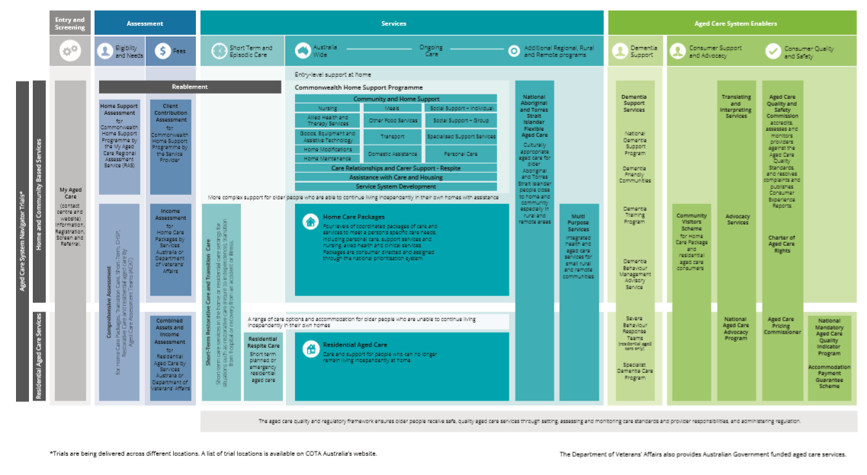

1. Current as at April 2020.
2. The Department of Veterans’ Affairs also provides Australian Government subsidised aged care services.

## Current aged care

In this report, as was the case with previous ACFA annual reports, the aged care industry is discussed in terms of the three main programs:

* **Commonwealth Home Support Programme (CHSP):** Provides services for those who require basic services to assist with remaining in their own homes. On 1 July 2015, the CHSP was implemented, combining the previous Commonwealth HACC program[9], the National Respite for Carers Program, Day Therapy Centres and Assistance with Care and Housing for the Aged. On 1 July 2016, the HACC Program in Victoria transitioned to the CHSP and on 1 July 2018 HACC services in Western Australia were also incorporated into the CHSP. All states and territories now operate under the CHSP.
* **Home Care Packages Program:** Provides services for those who have greater care needs and wish to remain living at home. Care and support is provided through a package of home care services.
* **Residential care:** Providesaccommodation and 24 hour care for those who have greater care needs and choose, or need to be cared for, in an aged care facility. Care can be provided on either a temporary (respite) or permanent basis.

Table 2.1 shows the number of providers, services, places and consumers as well as Commonwealth and consumer funding for each of the three care types for the five years to 2018‑19.

In addition there are care types about which, due to a lack of financial data, ACFA does not provide analysis or commentary. These include:

* **Flexible care:** Services in either a residential or home care setting that, due to difficulties in delivering services in some communities, are delivered using different care approaches than are provided through mainstream residential and home care. Examples of flexible care include Multi-Purpose Services in rural and remote locations and Aboriginal and Torres Strait Islander flexible care.
* **Transition and Restorative care:** Services that focus on enhancing the physical and cognitive function of people who have lost or are at risk of losing condition and independence. The Short-Term Restorative Care (STRC) Programme, which commenced in February 2017, aims to reverse and/or slow ‘functional decline’ in older people and improve their wellbeing through the delivery of a time-limited, goal-oriented, multi-disciplinary and co-ordinated range of services. The Transition Care Programme seeks to optimise the functioning and independence of older people after a hospital stay, enabling them to return home rather than enter residential care. Unlike the STRC, the Transition Care Programme is a joint Commonwealth-State funded program.
* **Innovative pool:** The Innovative Care Programme supports the development and testing of flexible models of service delivery in areas where mainstream aged care services may not appropriately meet the needs of a location or target group.

Table 2.1: Aged care in Australia 2014-15 to 2018-19

|  | 2014-15 | | | 2015-16 | | | 2016-17 | | | 2017-18 | | | 2018-19 | | |
| --- | --- | --- | --- | --- | --- | --- | --- | --- | --- | --- | --- | --- | --- | --- | --- |
|  | Home support | Home care | Residential care | Home support | Home care | Residential care | Home support | Home care | Residential care | Home support | Home care | Residential care | Home support | Home care | Residential care |
| Number of providers | 1,628 | 504 | 972 | 1,686 | 496 | 949 | 1,621 | 702 | 902 | 1,547 | 873 | 886 | 1,458 | 928 | 873 |
| Numbers of services/facilities | N/A | 2,292 | 2,681 | N/A | 2,099 | 2,669 | N/A | 2,367 | 2,672 | N/A | 2,599 | 2,695 | N/A | 2,691 | 2,717 |
| Number of operational places | N/A | 72,702 | 192,370 | N/A | 78,956 | 195,825 | N/A | N/A[10] | 200,689 | N/A | N/A | 207,142 | N/A | N/A | 213,397 |
| Number of consumers | 812,384 | 83,838 | 231,255 | 925,432 | 88,875 | 234,931 | 784,927 | 97,516 | 239,379 | 847,534 | 116,843 | 241,723 | 840,984 | 133,439 | 242,612 |
| Commonwealth funding | $1.9b | $1.3b | $10.6b | $2.2b | $1.5b | $11.4b | $2.4b | $1.6b | $11.9b | $2.4b | $2.0b | $12.2b | $2.6b | $2.5b | $13.0b |
| Consumer contribution | N/A | $136m | $4.2b | N/A | $127m | $4.5b | $204m | $128m | $4.5b | $219m | $122m | $4.5b | $252m | $107m | $4.8b |

**Notes:**

1. This table only shows data for the three main types of Government funded aged care: CHSP (and Vic/WA HACC), home care and residential care. Therefore total consumers of aged care does not match the over 1.3 million stated at the beginning of this chapter as that figure includes all other types of Government funded aged care.
2. Home support for 2014-15 comprises Commonwealth HACC as well as Vic and WA HACC, in 2015-16 comprises CHSP as well as VIC and WA HACC and in 2016-17 and 2017-18 comprises CHSP as well as WA HACC.
3. Commonwealth funding for home support in 2015‑16, 2016‑17 and 2018-19 includes funding for My Aged Care and Regional Assessment Service (RAS) to support the CHSP ($148 million in 2015-16, $123 million in 2016-17 and $128 million in 2018-19).
4. The number of consumers of home support in 2015-16 (925,432) includes 285,432 for Vic and WA HACC and an estimate of over 640,000 in the CHSP as accurate data was not available. Due to the lack of accurate data and differences in counting methods the CHSP consumers for 2015‑16 are likely overstated.

## Australian Government expenditure on aged care

The Australian Government spent $19.9 billion on aged care in 2018-19, up from $18.1 billion in 2017-18. In 2019‑20, Australian Government funding is expected to be $21.7 billion with $25.4 billion budgeted for 2022‑23. Chart 2.1 shows Commonwealth funding in aged care since 2015-16 and budgeted expenditure to 2022-23.

More than two-thirds of the 10.2 per cent increase in Australian Government funding during 2018‑19 ($1.26billion) is attributable to increases in residential and home care expenditure, $810 million and $437 million respectively. The balance is spread across a mix of programs such as CHSP and flexible aged care programs.

The growth in residential care expenditure can be attributed to a 1.9 per cent increase in the number of days of care provided during the year due to an increase in the number of residents ($231 million), and a 4.7 per cent increase in average care subsidy and supplement payments ($569 million), the latter resulting primarily from the one-off increase to care subsidies that applied between March 2019 and June 2019. There is also a small interaction effect ($11 million) due to the combined effect of growth in volume and price.

The increase in home care expenditure in 2018-19 is mainly due to a 19.5 per cent increase in the number of days of care provided during the year (due to the increase in the number of packages).

Chart 2.1: Australian Government total aged care expenditure, 2015‑16 to 2018‑19 and total budgeted aged care expenditure, 2019‑20 to 2022-23

Funding for residential care is by far the largest proportion of the Commonwealth expenditure at 66 per cent. The proportions of Commonwealth expenditure in 2018‑19 across the industry are illustrated in Chart 2.2.

Chart 2.2: Australian Government total aged care expenditure, by major program, 2018‑19

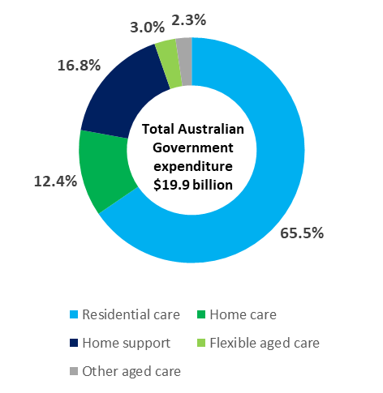

Australian Government expenditure on aged care is projected to nearly double as a share of the economy, from 1 per cent currently to around 1.7 per cent of GDP by 2055[11], noting that this projection is based on aged care funding policies that were current in 2015. Costs of care will continue to rise on account of growth in input costs (e.g. wages) and the increasing complexity of chronic health conditions in ageing populations.

ACFA has previously noted that the shift in the balance of care in favour of home care over residential care was expected to improve affordability for taxpayers over the long term. This is because the costs of subsidising accommodation associated with residential care are not incurred with home care, and because, on average, higher care subsidies apply in residential care where 24 hour care is provided. As noted in recent ACFA annual reports, there are many home care consumers with higher care needs who are in receipt of a lower level package until a package suitable to their needs becomes available, as well as people with assessed needs who are waiting to be offered a package.

## Consumer contributions

Most aged care consumers contribute to their aged care costs. The level of contribution is subject to an assessment of affordability.

In residential care, consumers contribute 85 per cent of the single age pension towards their living expenses (through the Basic Daily Fee) and, subject to means testing, may be required to contribute towards their accommodation and care costs. In 2018-19, residents contributed $3.4 billion towards their living expenses, $822 million towards accommodation costs by those who chose to pay through a Daily Accommodation Payment (which excludes those choosing to pay through a refundable lump sum deposit) and $513 million towards care costs. Overall, contributions from residents (excluding lump sum deposits) represent 24.6 per cent of total residential care provider revenue (down from 26.6 per cent in 2017-18).

Consumers of home care packages contributed around $107 million (representing 4.2 per cent of home care provider’s revenue (down from 5.9 per cent in 2017-18) to their care costs in 2018-19, while Commonwealth Home Support Programme consumers contributed $252 million, which represents 9.9 per cent of total expenditure on home support.

Table 2.2 shows the total Government and consumer contribution across service types since 2014‑15.

Table 2.2: Australian Government expenditure and consumer contribution, by service type, 2014-15 to 2018-19

|  |  | 2014-15 | 2015-16 | 2016-17 | 2017-18 | 2018-19 |
| --- | --- | --- | --- | --- | --- | --- |
| Home care | Government | $1.3b | $1.5b | $1.6b | $2.0b | $2.5b |
| Consumer | $136m | $127m | $126m | $122m | $107m |
| Residential care | Government | $10.6b | $11.4b | $11.9b | $12.2b | $13.0b |
| Consumer | $4.2b | $4.5b | $4.5b | $4.5b | $4.8b |
| Home support | Government | $1.9b | $2.2b | $2.4b | $2.4b | $2.5b |
| Consumer | N/A | N/A | $204m | $219m | $252m |

Note: Consumer contributions for home support were not available until 2016-17.

Consumers may also choose to pay additional amounts to a provider to access additional levels of care or services (e.g. to ‘top-up’ funding available under a home care package, or to purchase services in residential care that are additional to those required to be provided under the *Aged Care Act 1997.*

## Aged care providers

In this report, as with previous annual reports, providers of the three main types of Government subsidised aged care in Australia are discussed. These are CHSP, home care and residential care.

There are over 3,000 providers who provide these services to older Australians. Table 2.3 shows the number of providers over the last six years. The number of home care providers was stable until 2015‑16 but has since increased dramatically. By contrast, the number of residential care providers and home support providers have been declining over the six years. The changing number of home care and residential care providers is discussed in Chapter 3.

Table 2.3: Number of aged care providers, by service type, 2013-14 to 2018-19

|  | Home support | Home care | Residential care |
| --- | --- | --- | --- |
| 2013-14 | 1,676 | 504 | 1,016 |
| 2014-15 | 1,628 | 504 | 972 |
| 2015-16 | 1,686 | 496 | 949 |
| 2016-17 | 1,621 | 702 | 902 |
| 2017-18 | 1,547 | 873 | 886 |
| 2018-19 | 1,458 | 928 | 873 |

While the majority of providers operate only one type of aged care service, some operate two or all three of the major types. Chart 2.3 shows the number of providers providing only one type, two types and all three types of services in 2018-19.[12]

Chart 2.3: Proportion of aged care providers providing more than one type of aged care service, 2018-19

CHSP

905

Home care

347

Residential care

524

167

309

105

77

As shown, and as has been the case in previous years, there appears to be a high degree of specialisation in terms of service types offered by providers, partly reflecting the fact that the three care types are separately funded programs. However the proportion of providers who have diversified into more than one type of care is continuing to increase, albeit very slowly, as shown in Table 2.4. Of the 167 organisations who provide all three major types of care, only four are for‑profit providers.

Table 2.4: Proportion of aged care providers providing more than one type of service, 2013‑14 to 2018-19

|  | One type only | Two types | All three types |
| --- | --- | --- | --- |
| 2013-14 | 85% | 13% | 2% |
| 2014-15 | 84% | 14% | 2% |
| 2015-16 | 78% | 16% | 6% |
| 2016-17 | 76% | 17% | 7% |
| 2017-18 | 74% | 19% | 7% |
| 2018-19 | 73% | 20% | 7% |

There may be more occurrences of providers providing more than one type of service than reported here, however as noted in recent annual reports, separate provider registration in the three different sub-sectors means this is not always apparent, as providers often have different ABNs and different trading names.

## Aged care workforce

The aged care workforce is a shared responsibility between the Australian Government and the aged care industry, with many of the levers to influence the workforce resting with employers/providers. The Australian Government supports the industry through setting policy with appropriate funding that aims to foster flexibility, responsiveness and innovation, and supporting competitive labour markets. It also supports the industry through funding and regulating the higher education and the vocational education and training systems. In response to the pressures resulting from COVID-19, the Government announced in March 2020, funding of $235 million for a COVID-19 retention bonus for direct care workers in residential aged care and home care. Additional funding was also provided to upskill aged care workers in infection control, enable residential and home aged care providers to hire extra nurses and aged care workers, and increase aged care staff and training to facilities during an outbreak.

The National Aged Care Workforce Census and Survey[13] is conducted approximately every four years. In its 2017 annual report, ACFA provided a summary of the findings of the 2016 Survey. The 2016 census reported the number of paid workers in the aged care industry was around 366,000, with an additional 68,000 volunteers.

Total paid workers in residential care in 2016 was estimated at 235,764, of whom 153,854 were direct care workers. Total paid workers in home support and home care were estimated at 130,263, of whom 86,463 were in direct care roles.

Of the reported 434,443 people working in aged care in 2016, 60 per cent were in residential care. The remainder of the workforce were in home support and home care. Chart 2.4 shows the composition of the aged care workforce as reported in 2016.

Chart 2.4: Aged care workforce composition, 2016

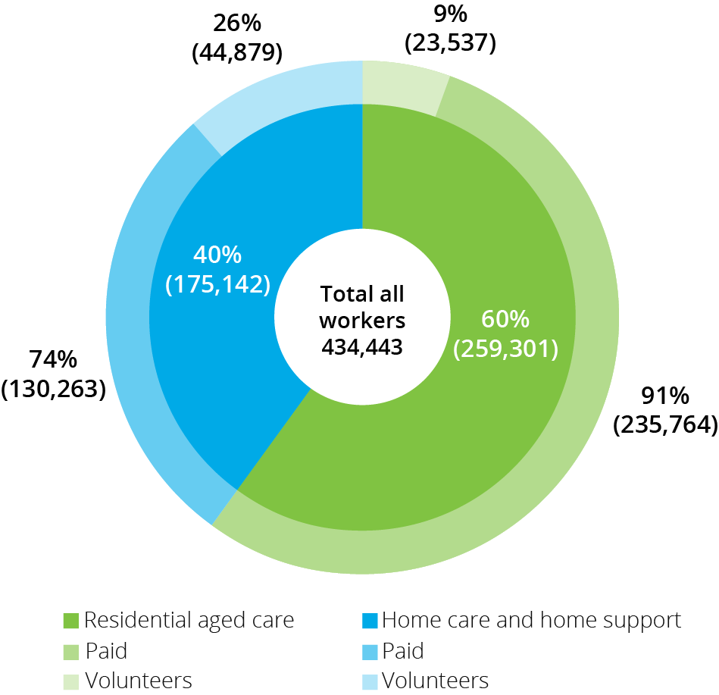

The average age of the residential direct care workforce decreased from 48 to 46 between 2012 and 2016. In contrast, the average age of the direct care workforce in home support and home care increased from 50 in 2012 to 52 in 2016.

Overseas born workers make up a very significant proportion of the aged care workforce. In 2016, the proportion in residential direct care was highest with 32 per cent of workers born overseas, while in home support and home care the proportion was 23 per cent. This compares with 35 per cent in residential care and 28 per cent in home support and home care in 2012.

Although aged care remains a female dominated industry, the proportion of males in the workforce is continuing to grow, albeit slowly and from a small base. In residential care, 13 per cent of direct care workers were male (compared with 11 per cent in 2012). In the home support and home care sectors, men represented 11 per cent of all direct care workers (10 per cent in 2012).

More detailed information from the 2016 National Census and Survey is provided in Appendix D. The next census is planned to commence in late 2020 or early 2021.

### Aged Care Workforce Strategy

As announced in the 2017–18 Budget, the Australian Government established an industry-led Aged Care Workforce Strategy Taskforce to develop an Aged Care Workforce Strategy. The Taskforce delivered its Strategy to the Minister on 29 June 2018.

In September 2018, the Strategy – *A Matter of Care: Australia’s Aged Care Workforce Strategy* - was released and the Government announced support for industry-led implementation. The Strategy includes 14 actions[14] to grow the professional workforce and attract, train and retain skilled and talented staff to work in aged care services in a variety of settings. A new Aged Care Workforce Industry Council, established in May 2019, will steward the Strategy and is developing an implementation plan.

An Aged Services Industry Reference Committee (IRC) has also been established to respond to relevant recommendations in the [Strategy](https://agedcare.health.gov.au/aged-care-workforce-taskforce-strategy-report) and to ensure that the national education and training system is able to deliver an agile workforce that can provide safe and quality care in a variety of settings. This includes addressing the current and future competencies and skill requirements for new workers entering the industry and existing staff needing to upskill in both the vocational education and training (VET) and higher education sectors.

In addition, the Aged Services IRC has established a number of ‘specific interest’ advisory committees to provide high-level strategic and policy advice to support the work of the IRC.

## Ongoing aged care reforms and changes

As ACFA noted last year the aged care industry has undergone, and continues to undergo substantial change in recent years with a view to improving the sustainability of aged care services and increasing consumer choice and control. This change includes a suite of reforms that have had a phased implementation as part of a ten-year transition strategy announced in April 2012 and further changes announced in subsequent years.

The changes since 2012 are summarised below according to the care type they relate to, that is, CHSP, home care, residential care or cross-program.

Commonwealth Home Support Programme (CHSP)

* From 1 July 2015, the CHSP commenced by combining the former Commonwealth-State Home and Community Care (HACC) programs in all states and territories except Victoria and Western Australia, and the Commonwealth National Respite for Carers, Day Therapy Centres and Assistance with Care and Housing for the Aged programs;
* Regional Assessment Services established in 2015 to assess eligibility for CHSP services; and
* Victoria transitioned their HACC services to the CHSP on 1 July 2016 and Western Australia transitioned to the CHSP on 1 July 2018.

Home care

* New home care packages (levels 1-4) commenced from 1 August 2013;
* income testing with subsidy reduction, including annual and lifetime caps, commenced on 1 July 2014;
* all packages required to be consumer directed care (CDC), with individualised budgets, from 1 July 2015;
* from 27 February 2017:
  + creation of a consistent National Prioritisation System to assign home care packages; and
  + home care packages assigned to the consumer rather than allocated to the provider;
* home care providers required to publish their current pricing information on the My Aged Care Service Finder, from 30 November 2018;
* 6,000 additional higher level home care packages in 2017-18 announced in the 2017-18 MYEFO;
* 14,000 additional higher level home care packages announced in the 2018-19 Budget;
* 10,000 higher level home care packages in 2018-19 announced in the 2018‑19 MYEFO;
* 10,000 home care packages across all levels in 2019‑20 announced as part of the 2019-20 Budget;
* home care providers required to publish their pricing information in a new standardised schedule from 1 July 2019;
* Reduction of the level of basic daily fee to be proportionate to the level of home care package from 1 July 2019; and
* 10,000 home care packages across levels 2, 3, and 4 in 2019-20 and 2020-21 announced in the 2019-20 MYEFO.

Residential care

* New means testing (combining income and assets test), including annual and lifetime caps, commenced on 1 July 2014;
* new accommodation payment arrangements from 1 July 2014 which allow market-based accommodation prices for all non-supported residents, accompanied by consumer choice to pay by lump sum, daily payment or a combination of both;
* requirements for providers to publish the maximum price they charge for accommodation and extra services, from 1 July 2014;
* higher accommodation supplement payable for supported residents in residential care facilities that were newly built or significantly refurbished since 20 April 2012;
* creation of an Aged Care Pricing Commissioner position in October 2013; and
* rental income from the former home became assessable for all residents who enter care from 1 July 2016 (formerly exempt for residents who made a daily payment for their accommodation).

Cross-program

* Overall target provision ratio for Government subsidised aged care places to increase from 113 places for every 1,000 people aged 70+ to 125 places over the period 2012-13 to 2021-22;
* creation of a single budget item for home care packages and residential care places from 1 July 2018 that allows flexibility for the Government to direct available funding to home care or residential care in response to consumer preferences;
* establishing the Aged Care Quality and Safety Commission from January 2019 and the commencement of a single set of quality standards across all aged care from 1 July 2019;
* from 1 July 2019, all Commonwealth subsidised residential care facilities required to collect and provide clinical quality indicator data to the Department of Health through the National Aged Care Quality Indicator Program. The program had initially started in 2016 as a voluntary program;
* from 1 July 2019, a new Charter of Aged Care Rights provides the same rights to all consumers, regardless of the type of Commonwealth subsided care and services they receive; and
* further improvements to My Aged Care in 2018-19 and 2019-20.

## Royal Commission into Aged Care Quality and Safety

The Royal Commission into Aged Care Quality and Safety was established in October 2018, with broad terms of reference to examine the aged care system in Australia, and to consider how to meet the challenges and the opportunities of delivering aged care services now and into the future.

The Royal Commission continued to conduct its inquiry during 2018‑19, with hearings across a range of topics. The Royal Commission released its Interim Report on 31 October 2019. Commissioners identified three areas for urgent attention: providing more home care packages to reduce the waiting time for higher level care; reducing the over-reliance on chemical restraints in aged care; and taking stronger action to reduce the number of younger people living in residential aged care.

On 25 November 2019, the Government announced a funding package totalling $537 million in response to the Royal Commission’s Interim Report. This included:

* $496.3 million for an additional 10,000 home care packages;
* $25.5 million to improve medication management programs to reduce the use of medication as a chemical restraint on aged care residents and at home, and new restrictions and education for prescribers on the use of medication as a chemical restraint;
* $10 million for additional dementia training and support for aged care workers and providers, including to reduce the use of chemical restraint; and
* $4.7 million to help meet new targets to remove younger people with disabilities from residential aged care.

In the Interim Report, Commissioners also made the following statements about the focus of the Final Report:

*It is clear that a fundamental overhaul of the design, objectives, regulation and funding of aged care in Australia is required. This will be the central purpose of the Final Report. [Interim Report, Vol.1, page 10]*

*We will recommend comprehensive reform and major transformation of the aged care system in Australia. [Interim Report, Vol.1, page 12]*

*The scope and complexity of this task are great.*  *[Interim Report, Vol.1, page 12]*

*[The Final] Report will set the framework for a complete overhaul of the aged care system - from system philosophy and design, to interactions with health and disability services, to workforce, funding and regulation. [Royal Commission Media Release, 31 October 2019]*

The Royal Commission indicated it intended to hold hearings on a range of matters in 2020, including funding and financing issues. In March 2020, the Royal Commission announced that it was suspending all hearings and workshops until further notice, due to COVID-19. The closing date for public submissions to the Royal Commission has also been extended until at least 30 June 2020. The final report is now required to be provided no later than 12 November 2020, rather than 30 April 2020.

# Access to aged care

|  |
| --- |
| **This chapter discusses:**   * Access to subsidised aged care for older Australians; * the supply of subsidised aged care; and * usage of aged care and impacts of a changing population.   **This chapter reports that:**   * The number of consumers of home care increased from 116,843 in 2017‑18 to 133,439 in 2018‑19; * the number of consumers of residential care increased from 241,723 in 2017‑18 to 242,612 in 2018‑19; * average occupancy in residential care continues to fall; 89.4 per cent in 2018‑19, down from 90.3 per cent in 2017-18, 91.8 per cent in 2016-17 and 92.4 per cent in 2015-16; * the proportion of people using home care and residential care at age 85 and over is more than three times that of people aged 70 and over; and * the average age of people in permanent residential care in 2018-19 was 84.8 compared with 82.4 in home care and 80 in the CHSP. |

## Supply of subsidised aged care

Ensuring access to appropriate quality care remains a fundamental policy objective for the Australian Government in the funding and financing of aged care. However, as ACFA has previously discussed, access to care services needs to be balanced with affordability for both consumers and taxpayers.

The Government regulates the supply of services offered through the Commonwealth Home Support Programme (CHSP) through a capped funding amount that is indexed annually. This is discussed in Chapter 4.

The Australian Government regulates the supply of home care packages and residential aged care places it funds by specifying targets. These targets, known as the aged care target provision ratios, are based on the number of people aged 70 and over.

The overall aged care target provision ratio was first set in 1985 at 100 operational residential care places per 1,000 people aged 70 and over. The overall provision ratio was increased to 108 in 2004, further increased to 113 in 2007, and in 2012 was adjusted to increase progressively to 125 operational places by 2022. Home care packages were first introduced into the ratio in the early 1990s and since then successive Governments have gradually increased home care as a proportion of the overall target provision ratio.

This population-based target provision formula is designed to allow the overall supply of services to increase in line with the ageing of the population, while also defining the total number of places/packages and, thereby, helping control the Commonwealth’s expenditure on aged care.

As set in 2012, within the current overall target provision ratio of 125, the mix of home care and residential care is being significantly rebalanced in favour of home care. Over the period 2012 to 2022 the target for home care is increasing from 27 to 45 operational places, while the residential care target is reducing from 86 to 78. The remaining two places are for the Short Term Restorative Care Programme (STRC).

Chart 3.1 shows the changes in the target ratios since 1985 and the planned increase through to 2022.

Chart 3.1: Increase in target provision ratios, 1985-2022

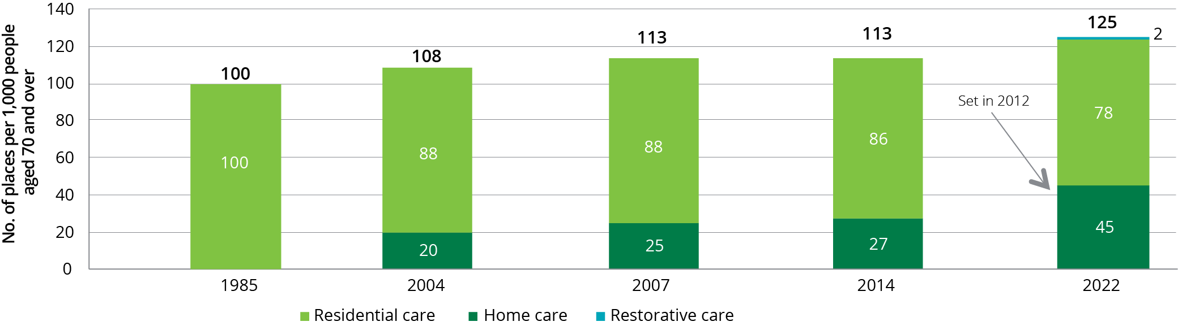

Implementation of the current target provision ratio will continue to see an overall increase in the supply of home care packages and residential care places. However, the changes result in the number of home care packages increasing at a faster rate than residential care places, which reflects the Government’s response to the increasing number of consumers wishing to remain in their own homes.

Up until 2015-16, the Department published achieved ratios for the overall provision target and for both home care and residential care in a consistent and comparable way, based on the number of operational places (operational places included allocated places that are vacant). The calculation of this ratio on this basis is still possible in residential care, but is no longer possible for home care since February 2017 when packages were directly assigned to consumers. As a result, the 2018 ACFA report did not include achieved ratios for either the overall target provision ratio or the home care target ratio.

The Department has however since calculated and published achieved ratios for home care, for 2016-17 and beyond, based on the number of consumers in a package, plus the number of consumers who have been offered a package but who have not yet accepted the offer and whose offer still remains open (i.e. within 56 days of offer). The latter effectively substitutes for formerly vacant packages. While not directly comparable to previous years, it can be used to broadly monitor progress towards the achievement of the overall provision target ratio and home care ratio.

Chart 3.2 shows the achieved overall provision ratio and the achieved home care and residential care ratios for the seven years to 30 June 2019. The chart also shows the target of 45 for home care and 78 for residential care to be reached by 2021-22.

Chart 3.2: Home care and residential care achieved ratios, 2012-13 to 2018-19, and target ratios 2022

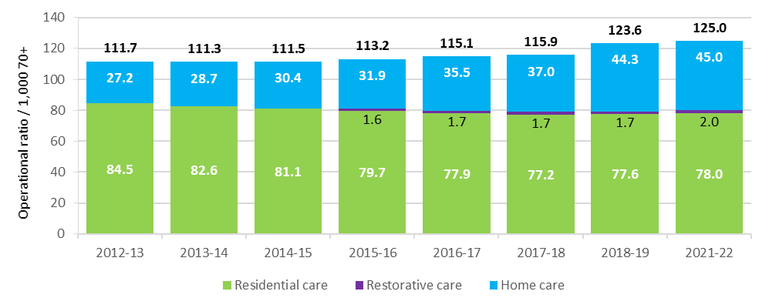

Chart 3.3 shows the number of consumers with a home care package as at 30 June for each of the previous seven years, as well as the target number of packages to 2023-24. While the historical and forward estimates numbers are not directly comparable, the chart gives some indication of the increase in home care packages that has occurred and the increase that is planned to be released.

Chart 3.3: Home care consumers, 2012-13 to 2018-19 and published target packages to be released, 2019-20 to 2023-24

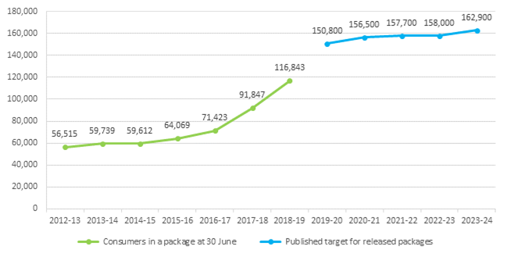

Source: Department of Health

The target ratio approach applied to home care packages and residential care places does not apply to the supply of care through the CHSP. Instead, CHSP funding is subject to an annual capped funding allocation, and CHSP providers are grant funded to provide contracted home support services. Consumers who are assessed as eligible through their Regional Assessment Service (RAS) to receive CHSP services can then access those services through a provider who delivers the services for which they have been assessed.

## Aged Care Approvals Round

Unlike home care packages, new residential care places are still currently allocated to providers through a competitive Aged Care Approvals Round (ACAR). In the 2018‑19 Budget, the Government announced in-principle support to potentially move to allocating residential care places to consumers, pending a detailed impact analysis to investigate options and implications for stakeholders. This was in response to recommendations in the *Legislated Review of Aged Care 2017* to discontinue the ACAR for residential care and instead assign places directly to consumers. The impact analysis was led by Professor Michael Woods. The independent final report of the impact analysis was provided to Government in early 2020. No decisions have been made about any changes to the place allocation approach for residential care.

The next ACAR was to commence in early 2020, but has been postponed due to the COVID-19 pandemic.

The results of the 2018-19 ACAR[15] were announced by the Government in March 2019. Through this ACAR, 13,500 new residential care places were allocated which represented an increase of 36 per cent on the 9,911 ACAR places allocated in 2016–17. It was planned that the 2020 ACAR would release at least 10,000 residential aged care places, 750 short-term restorative care places and up to $60 million in capital grants for residential care.

In terms of provider ownership, a trend evident for the last four ACARs is that the for‑profit providers have been successful in gaining around two thirds of allocated residential care places, as shown in Table 3.1.

Table 3.1: Aged Care Approval Rounds, proportion of allocated places, by ownership, 2012‑13 to 2018‑19

| Allocated places | 2012-13 | 2014 | 2015 | 2016-17 | 2018-19 |
| --- | --- | --- | --- | --- | --- |
| For-profits | 57% | 68% | 70% | 64% | 67% |
| Not-for-profits | 42% | 31% | 30% | 35% | 32% |

## Access to aged care

In 2018-19 around 1.3 million older Australians accessed some form of Government subsidised aged care. Table 3.2 shows the number of consumers of the three types of aged care that this report mainly discusses (CHSP, home care and residential care) since 2014-15.

Table 3.2: Aged care in Australia, number of consumers, 2014-15 to 2018-19

|  | 2014-15 | 2015-16 | 2016-17 | 2017-18 | 2018-19 |
| --- | --- | --- | --- | --- | --- |
| Home support | 812,384 | 925,432 | 784,927 | 847,534 | 840,984 |
| Home care | 83,838 | 88,875 | 97,516 | 116,843 | 133,439 |
| Residential care | 231,255 | 234,931 | 239,379 | 241,723 | 242,612 |

CHSP client numbers for 2018-19 are not perfectly comparable with home support client numbers reported for previous years, which combine CHSP client counts with the HACC programs that operated in Victoria and Western Australia. These HACC programs have now ceased providing aged care. The methods used to collect data and measure client numbers are different across programs, and any comparisons over time should be treated with caution.

Home support consumers for 2015-16 were likely overstated.

## Access to home care

The number of older Australians who received subsidised home care during 2018‑19 was 133,439, an increase of 14 per cent from 116,843 in 2017‑18. As at 30 June 2019 there were 106,707 consumers in a package, up from 91,847 as at 30 June 2018. Chart 3.4 shows the significant increase in overall home care consumer numbers, particularly since 2017-18. Chart 3.5 shows the number of consumers, by package levels, since 2014‑15.

Chart 3.4: Number of home care consumers in a package, 30 June 2013 to 30 June 2019

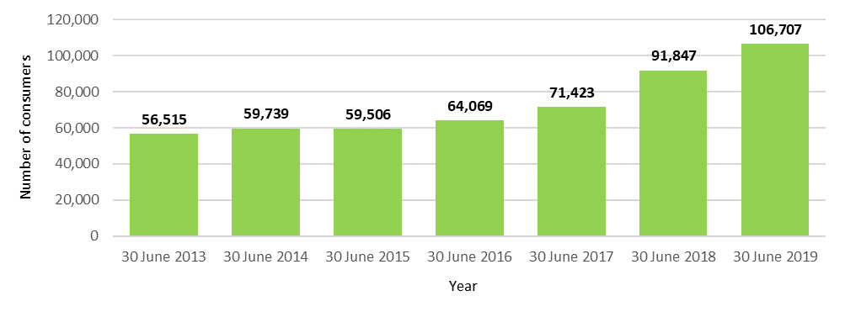

Chart 3.5: Number of home care consumers, by package level, 2014-15 to 2018-19

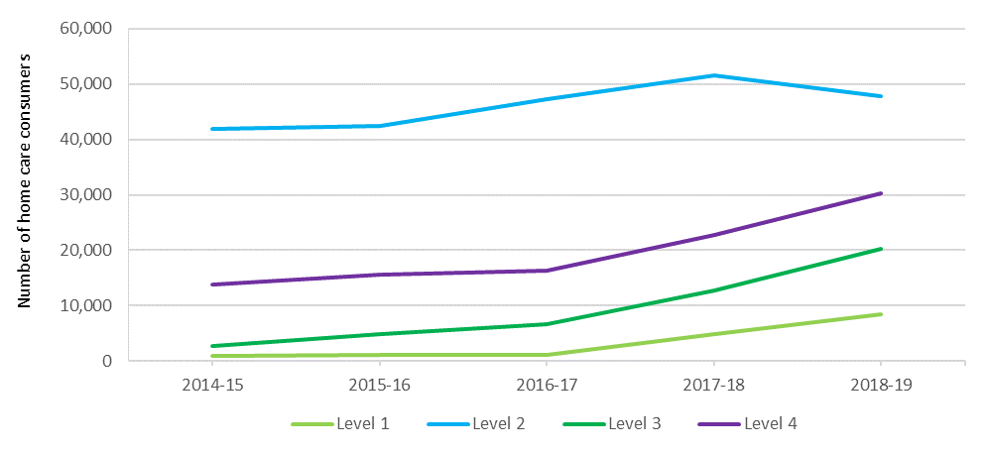

### Release of home care packages

Since February 2017, home care packages have been assigned directly to consumers rather than allocated to providers. This allows consumers to direct their package to the provider of their choice as well as to change providers.

Older Australians assessed as requiring home care are placed on the National Prioritisation System based on how long they have been waiting for care and their individual needs and circumstances, regardless of where they live. Packages are periodically released and assigned directly to consumers by the Department of Health within My Aged Care. Packages are assigned to consumers according to when they were approved for home care and urgency of need.

The number of packages released at each level takes into account the number of new packages that are available (having regard to the phased increase in the target home care provision ratio), the number of packages that consumers have exited or not accepted in previous weeks, as well as the amount of unspent Commonwealth funds that have been returned when consumers leave home care. While the total number of packages will increase each year, the number of packages at each funding level will continue to be capped in line with the aged care target provision ratio and the available budget.

### Demand for home care packages

ACFA has previously noted that unmet demand for home care was not able to be quantified until implementation of the National Prioritisation System for assigning packages directly to consumers.

Data from the Department of Health shows that as at 31 December 2019 there was a total of 104,473 people waiting for a package. This is a decrease of 7,764 in the three months since 30 September 2019. There were 28,110 approvals for home care in the three months to 31 December 2019, of which 55 per cent were for higher level (3 and 4) packages.  Around 66.8 per cent of the 104,473 people waiting for a package also had approval for permanent residential care. One of the factors influencing declining occupancy rates in residential care is the preference of older people for home-based aged care services.

At 31 December 2019, there were 45,537 people who were waiting for a home care package at their approved level, who had been offered a lower level package in the interim. Of these people, 28,206 had taken up that package and were receiving care, 8,515 were deciding on whether to take up a package and 9,320 had not taken up the offer(s) of a lower level package.

At 31 December 2019, there were 58,936 people waiting on a home care package at their approved level, who had not yet been offered any level package. Of these people, 96 per cent (56,777) had been provided with an approval to access support through the Commonwealth Home Support Program (CHSP), although data regarding how many have actually accessed CHSP services is not available.

Information from the Department of Health indicates that waiting times for people to access a package vary depending on package level. People approved for a level 4 package are waiting in excess of 12 months to be assigned a package at any level. People approved for a level 3 package can wait up to six months for an interim package at level 1, but still wait more than 12 months for their assigned package level.

### Length of stay in home care

Length of stay in home care differs between package levels.

For people who entered care in 2015‑16, around half the recipients of level 2 packages stayed at their package level for about 17 months. By contrast the length of stay was 21 months at level 2 in 2016-17. However, for people who entered home care in 2017-18, length of stay data was not available for more than half the recipients of level 2 packages (Table 3.3).

The length of stay for people entering a level 4 package was 15 months in 2015-16, rising to 18 months in 2016-17 and 22 months in 2017-18.

The three year trend indicates that length of stay in home care is slightly increasing in recent years in all levels of care.

In this report, length of stay is reported as the period between entry and exit at a single level of care minus any gaps between entry and exit, for care recipients who had multiple entry and exit dates for the same care level.

Table 3.3: Median length of stay (months) in home care, by package entry level cohort, 2015‑16 to 2017‑18

|  | 2015-16 | 2016-17 | 2017-18 |
| --- | --- | --- | --- |
| Level 1 | 16 | 18 | N/A |
| Level 2 | 17 | 21 | N/A |
| Level 3 | 13 | 14 | 18 |
| Level 4 | 15 | 18 | 22 |

Note: The proportion of people in level 1 and 2 packages (2017-18) who have left care, and all levels (2018-19) who

have left care, are too low to calculate a median length of stay.

## Access to residential care

The number of older Australians who received permanent residential care during 2018-19 was 242,612, up from 241,723, in 2017-18. At 30 June 2019 there were 182,705 permanent residents in care.

As has been the case in recent years, the number of people accessing residential respite care is increasing proportionally faster than those accessing permanent residential care. The number of people who accessed respite care in 2018-19 was 65,523, an increase of 5.7 per cent from 61,993 in 2017-18. Residential respite care usage is discussed later in this chapter.

### Occupancy in residential care

Occupancy is measured as the total number of days an allocated place is occupied by a resident, divided by the total number of days an allocated place was available to be occupied. Occupancy rates reflect both demand and the number of places available. In 2018-19, the average occupancy rate across all residential care places was 89.4 per cent, down from 90.3 per cent in 2017-18 and 91.8 per cent in 2016-17. This continues the decline in recent years following relative stability for several years at above 92 per cent.

The overall average occupancy rate in residential care peaked at 97.1 per cent in 2003‑04.

A major immediate risk facing residential care providers is the spread of COVID-19 in a facility which has the potential to cause a sizeable decline in occupancy through both departures and delays in new admissions. This could have a major impact on the financial position of the facility.

The occupancy rate is comprised of both a numerator and a denominator. The numerator is the number of care days provided and the denominator is the number of bed days that providers had available (based on operational places).

The 0.9 percentage point decline in the occupancy rate in 2018-19 was contributed to by the growth in the number of bed days available (2.9 per cent) which grew at 1.5 times the rate of the growth in care days provided (1.9 per cent). Both the for-profit and not-for-profit sectors had faster growth in the available bed days compared with days of care provided (Table 3.4).

Table 3.4: Growth in residential care claims and growth in available beds between 2017-18 and 2018-19

| Provider type | Claim day growth | Bed day growth |
| --- | --- | --- |
| Not-for-profit | 1.6% | 2.2% |
| For-profit | 2.8% | 4.4% |
| Government | -2.3% | -2.4% |
| All providers | 1.9% | 2.9% |

In terms of ownership type, not-for-profit providers continue to have the highest occupancy at an average of 91.5 in 2018‑19, although their occupancy fell from 92.1 per cent in 2017-18. For‑profit providers once again recorded the biggest drop in occupancy, falling to 86.5 per cent in 2018‑19 from 87.9 per cent in 2017-18 (Table 3.5).

Table 3.5: Occupancy rates, by organisation type, 2014-15 to 2018-19

| Provider type | 2014-15 | 2015-16 | 2016-17 | 2017-18 | 2018-19 |
| --- | --- | --- | --- | --- | --- |
| Not-for-profit | 94.0% | 94.0% | 93.0% | 92.1% | 91.5% |
| For-profit | 91.0% | 91.0% | 90.0% | 87.9% | 86.5% |
| Government | 89.0% | 90.0% | 90.0% | 90.3% | 90.4% |
| **All providers** | **92.5%** | **92.4%** | **91.8%** | **90.3%** | **89.4%** |

There are some variations in occupancy by state and territory, as has been the case in previous years. The Northern Territory continues to have the highest occupancy with 94.3 per cent (94.4 per cent in 2017-18) while Queensland again reported the lowest with 88.3 (89.1 in 2017-18). Table 3.6 shows occupancy by state and territory for the last five years.

Table 3.6: Occupancy in residential care, by state and territory, 2014-15 to 2018-19

| State/territory | 2014-15 | 2015-16 | 2016-17 | 2017-18 | 2018-19 |
| --- | --- | --- | --- | --- | --- |
| New South Wales | 92.5% | 92.3% | 91.1% | 89.5% | 89.2% |
| Victoria | 91.6% | 91.7% | 91.1% | 90.2% | 89.0% |
| Queensland | 92.7% | 92.2% | 92.3% | 89.1% | 88.3% |
| Western Australia | 94.4% | 94.5% | 93.8% | 93.2% | 90.3% |
| South Australia | 92.3% | 93.7% | 93.5% | 93.4% | 92.8% |
| Tasmania | 90.6% | 91.0% | 91.2% | 90.2% | 89.9% |
| Australian Capital Territory | 94.5% | 88.6% | 90.1% | 91.0% | 89.6% |
| Northern Territory | 92.8% | 95.0% | 95.4% | 94.4% | 94.3% |
| **Australia** | **92.5%** | **92.4%** | **91.8%** | **90.3%** | **89.4%** |

There also remains variation in occupancy rates by remoteness location. In 2018-19 the occupancy in very remote areas was significantly less than in all other locations, as was the case in previous years. The occupancy in remote areas is also between 1-3 per cent lower than in the cities and regional areas.

Table 3.7 shows occupancy in residential care by location over the last five years.

Table 3.7: Occupancy in residential care, by location, 2014-15 to 2018-19

| Provider location | 2014-15 | 2015-16 | 2016-17 | 2017-18 | 2018-19 |
| --- | --- | --- | --- | --- | --- |
| Major cities | 92.6% | 92.4% | 91.4% | 90.0% | 88.9% |
| Inner regional | 92.4% | 92.5% | 92.7% | 91.4% | 91.1% |
| Outer regional | 92.1% | 92.0% | 92.2% | 90.8% | 90.0% |
| Remote | 86.5% | 89.7% | 91.7% | 88.4% | 87.6% |
| Very remote | 84.8% | 80.0% | 77.4% | 77.1% | 71.9% |
| **Australia** | **92.5%** | **92.4%** | **91.8%** | **90.3%** | **89.4%** |

In last year’s annual report, ACFA noted that some providers had expressed concern that falling occupancy rates would put pressure on the viability of some residential aged care facilities. The continued fall in occupancy during 2018-19 indicates this issue continues to grow. As noted previously, an immediate risk for occupancy rates and the financial position of a facility is the spread of COVID-19 in the residential care sector.

As discussed earlier in the report, an independent impact analysis was undertaken to examine the potential options and implications for stakeholders of moving away from allocating residential care places to providers. One of the options examined was a move to a model, similar to home care, where the consumer is assigned a residential care place. ACFA considers that this would create greater competition for consumer custom, potentially putting further pressure on occupancy rates for some providers. The possible impact of increased competition on occupancy rates was considered as part of the impact analysis.

### Admissions to residential care

Elapsed time between when a resident is assessed as eligible for residential care and entering permanent care has been increasing steadily in recent years and continued to increase in 2018‑19 as shown in Chart 3.6. This trend has been evident since 2011‑12, however has been more obvious since 2013‑14. In 2018‑19:

* 7 per cent of people entering care did so within one week of being assessed by an ACAT (18 per cent in 2011-12);
* 21 per cent did so within one month (44 per cent in 2011-12); and
* 59 per cent did so within nine months (89 per cent in 2011-12).

However, as ACFA has previously noted, the delay between an assessment of eligibility and a person entering care could be due to consumer choice and not necessarily delays in the system.

Also, the increasing availability of and preference for home care and the increased usage of residential respite care could be contributing to the longer time between assessment and entering permanent care.

Chart 3.6: Elapsed time between assessment and entering permanent residential care, 2011-12 to 2018‑19 (%)

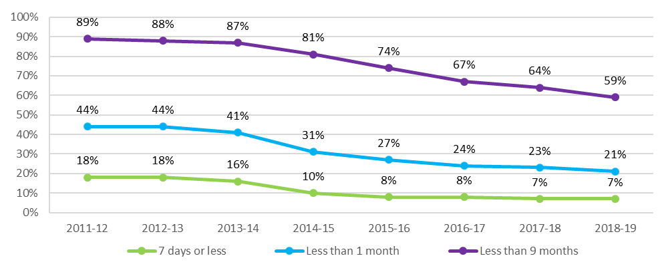

#### Consumers transitioning from home care to residential care

Chart 3.7 shows the proportion of consumers who enter permanent residential care after leaving home care. The proportion entering residential care was relatively stable at around 60 per cent for the years leading up to the introduction of the Aged Care Funding Instrument (ACFI) in 2008, when it increased to around 63 per cent. Since the start of the major reforms in 2014, the proportion has been dropping consistently and saw a further significant drop to 53 per cent in 2018-19.

This is likely partly explained by the significant increase in higher level home care packages in recent years, and the number of home care packages overall, which would impact on the proportion of package holders transferring to residential care.

Chart 3.7: Proportion of consumers entering permanent residential care after leaving home care, 2008-09 to 2018‑19

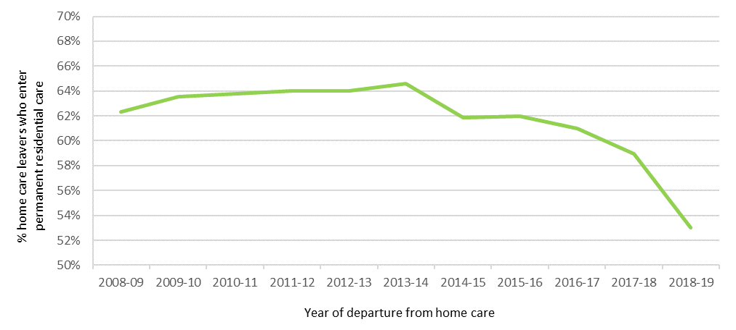

### Length of stay in residential care

The average length of time between first admission into permanent residential care and final discharge was decreasing gradually from around 3.3 years in 2003 to just below 3 years in 2012. Since then it has stabilized and in 2019 the average length of stay (LOS) of those leaving residential care was 2.96 years. There remains a very significant difference between males and females, with females staying in care, on average, 10 months longer than males (Chart 3.8).

Chart 3.8: Average length of stay in residential care, by gender and year of entry, 2003 to 2019

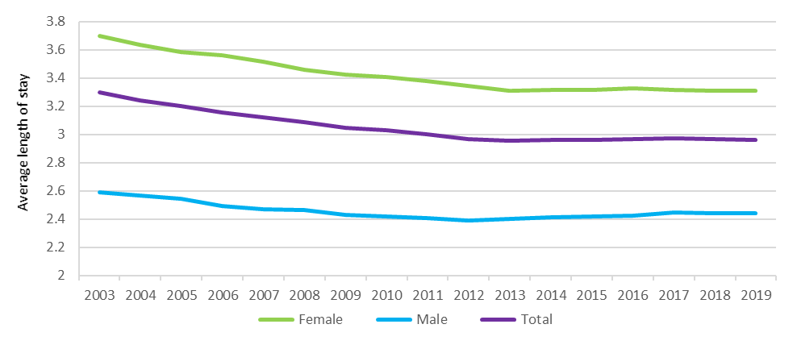

Two drivers of this decrease in LOS have been an increasing average age of entry (both male and female) and an increasing proportion of male residents. Older residents and male residents have shorter average LOS, so increasing proportions of these residents result in a shorter average LOS. Chart 3.9 shows both of these indicators, with the proportion of male entrants increasing from 36 per cent in 2003 to just over 41 per cent in 2019, and the average age of entry increasing from 82.7 to 84.4 over the same period.

Chart 3.9: Changes in age and gender distribution, 2003 to 2019

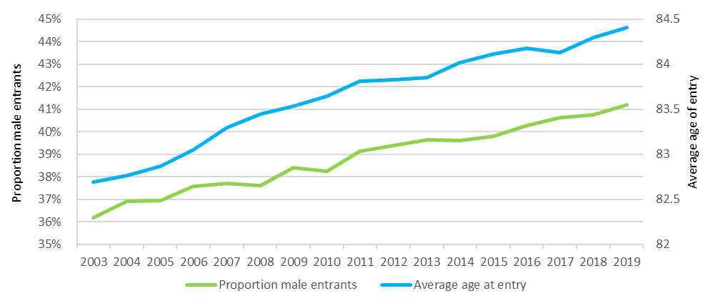

The proportion of permanent residents that leave within three, six or 12 months of first entry increased from 2004-05 to 2013‑14 (Chart 3.10), which is in line with a decreasing average LOS. However, since 1 July 2014, this proportion has tended to decrease, which will likely have an upwards impact on average LOS.

Chart 3.10: Proportion of permanent residents that leave within 3, 6 or 12 months of first entry, 2004-05 to 2018-19

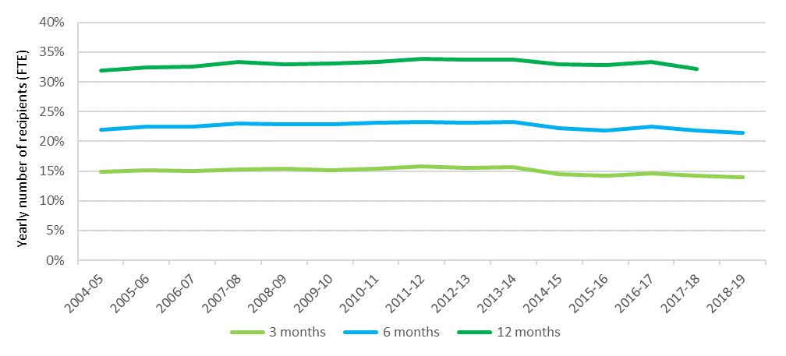

#### Dementia

Since 2008-09, the proportion of people entering residential care with a diagnosis of dementia has been consistently between around 43 per cent and 45 per cent of all permanent residents entering care. The average age at admission for people with dementia was around six months older than for those without a diagnosis of dementia.

Chart 3.11 shows the proportion of people still in care over time by dementia status (diagnosis of dementia recorded within first 28 days of admission). It shows that half of the people entering without a dementia diagnosis died or left care within 22 months; compared with around 25 months for people entering care with an initial diagnosis of dementia. People with dementia are less likely to die or leave care in the initial period after entry, however in the longer-term, proportionally fewer people with dementia have longer lengths of stays when compared with those that do not.

Chart 3.11: Proportion of residents in care over time, with and without dementia

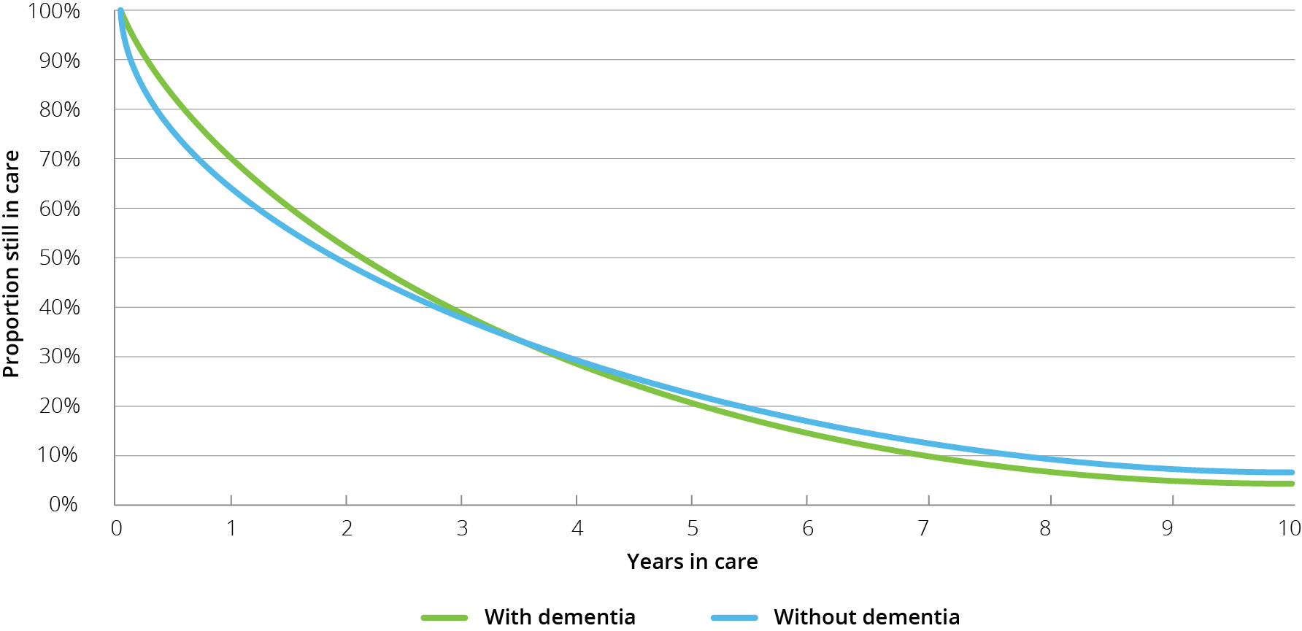

## Residential respite care

Residential respite care is short-term care delivered within an aged care facility[16] on either a planned or emergency basis. People are assessed for eligibility by an Aged Care Assessment Team (ACAT), who will approve someone for low care respite or high care respite. The distinction between high and low care was not removed from respite care when it was removed from permanent residential care on 1 July 2014. A consumer can access residential respite for up to 63 days per financial year, with extensions possible when an ACAT considers it necessary. As a result of COVID-19 pandemic, there may be increased demand for respite care, although some consumers may prefer to stay at home rather than risk using residential respite care.

As noted previously, a significant difference in respite care compared with permanent residential care is that respite residents do not make any means-tested accommodation or care contributions. They can however be asked to pay the basic daily fee for living expenses, which is at the same rate as permanent residents. Respite residents can also purchase additional services, in the same manner as a permanent resident.

Residential care providers have a proportion of their allocated residential care places which may be used for the provision of respite care, and it is up to each provider what mix of permanent and respite care that they provide. Providers can vary this proportion, however currently they have to contact the Department of Health to seek approval.

Access to respite services will depend on a person’s need/choice to access this type of care and on an approved provider’s willingness and ability to provide respite care.

### Length and frequency of stay in residential respite care

During 2018-19, 65,523 people received residential respite care. Of these, on average, each person had 1.3 respite stays[17], down from 1.4 in recent years. On average, each stay was 25.8 days, up slightly from 25.6 in 2017-18. Until 2014-15 the average stay had been stable at just below 24 days however it has since risen to be between 25 and 26 days, as shown in Chart 3.12.For home care package consumers who access residential respite care, the average length of stay is considerably shorter, at around 21 days and has remained relatively stable since 2014‑15.

Chart 3.12: Average length of stay (days) in residential respite care, 2012-13 to 2018‑19

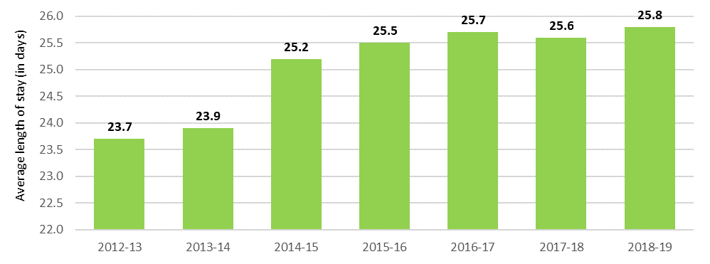

As has been the case in previous years, a clear pattern of respite care usage in recent years, and again evident in 2018-19, was that it was usually for stays of whole weeks at a time (Chart 3.13). Two weeks is by far the most common residential respite care length of stay. One, three and four weeks are the next most common lengths of stay. Around 4 per cent used the maximum of 63 days in one stay. These usage trends have been stable in recent years.

Chart 3.13: Frequency of length of respite care stays, 2018-19

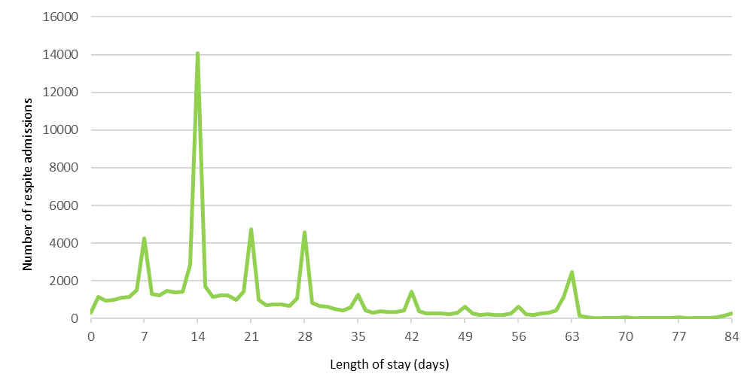

ACFA noted in its 2018 report on respite care that, in general, this pattern of respite use is provider driven, primarily due to the relatively high cost of the admission process in residential care. Feedback through consultation was that for many providers offering respite care, providing less than two weeks of residential respite is financially unviable. The feedback from consultation with consumers, however, suggested they would prefer access to shorter periods of respite care.

### High and low residential respite care

A trend that has been occurring since 2014‑15 is the number of respite consumers accessing high level respite care is increasing while the number accessing low level respite care is decreasing. This trend continued in 2018-19 as shown in Chart 3.14. This was also discussed in ACFA’s report on respite care, with ACFA noting the significant difference in funding for providers between high and low care was potentially serving as a disincentive to providers taking respite consumers who had only been approved for low level care. As can be seen, the number of days of high and low level respite care provided was almost the same in 2013‑14, whereas in 2018-19, 75 per cent of respite days were for high care respite residents.

Chart 3.14: Number of residential respite care days, by level, 2013-14 to 2018-19

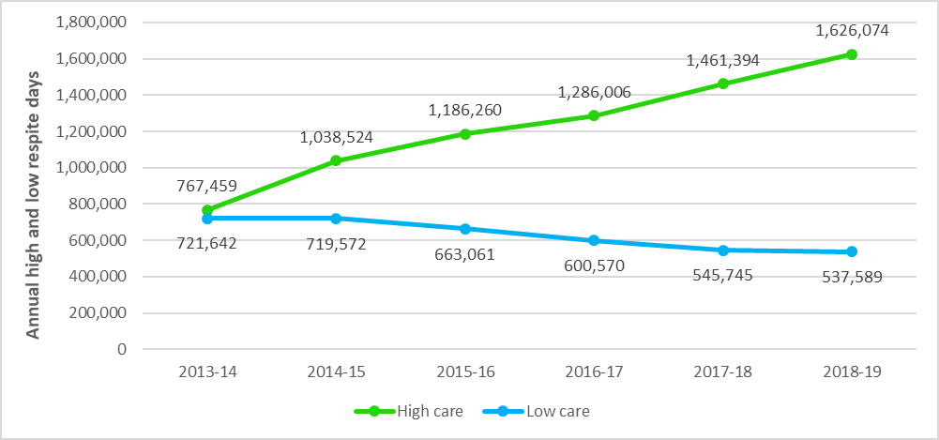

One of the recommendations from ACFA’s 2018 Respite care report was that funding for respite care should be neutral between respite care and permanent residential care and also neutral between high and low care respite consumers, so that providers did not face a financial disincentive to provide respite care.

## Supported residents

The Australian Government supports access to permanent residential care by consumers who are assessed as not being able to meet all or part of their own accommodation costs by paying providers an accommodation supplement on their behalf. These residents are known as supported (or low-means) residents.

Since the aged care reforms of 1 July 2014, eligibility for a full or partial accommodation supplement is determined by a combined assessment of an individual’s income and assets (the means test).

The amount of accommodation supplement received by a provider on behalf of a supported resident depends on:

* the outcome of the resident’s means test assessment;
* whether the residential care facility has been built or significantly refurbished since 20 April 2012; and
* whether the facility provides more than 40 per cent of its care days to supported residents.

Providers have discretion to determine the proportion of supported residents in their facilities. However providers with 40 per cent or fewer supported residents in a facility (excluding those residents receiving extra services) have the accommodation supplement they receive for all supported residents in that facility reduced by 25 per cent.

As shown in Table 3.8 and Table 3.9 the proportion of supported residents has been relatively stable in recent years. The trend evident in recent years of a higher proportion of supported residents in regional and remote locations compared with metropolitan areas has continued in 2018-19. Also not-for-profit providers continue to have a higher proportion of supported residents compared with for-profit providers.

The analysis used in Table 3.8 and Table 3.9 is based on claims submitted by providers on behalf of their residents[18].

Table 3.8: Proportion of claims for supported residents, by location, 2014-15 to 2018-19

| Location | 2014-15 | 2015-16 | 2016-17 | 2017-18 | 2018-19 |
| --- | --- | --- | --- | --- | --- |
| Metropolitan | 49.1% | 50.1% | 48.7% | 47.9% | 47.1% |
| Regional | 53.2% | 54.0% | 52.8% | 51.8% | 50.9% |
| Remote | 66.0% | 68.1% | 67.9% | 65.9% | 63.6% |
| **Australia** | **50.5%** | **51.5%** | **50.2%** | **49.3%** | **48.4%** |

Table 3.9: Proportion of claims for supported residents, by ownership type, 2014-15 to 2018‑19

| Ownership type | 2014-15 | 2015-16 | 2016-17 |  | 2017-18 | 2018-19 |
| --- | --- | --- | --- | --- | --- | --- |
| Not-for-profit | 52.4% | 53.1% | 51.9% |  | 50.7% | 49.9% |
| For-profit | 46.3% | 47.7% | 46.6% |  | 46.2% | 45.4% |
| Government | 56.5% | 57.8% | 55.9% |  | 54.6% | 53.8% |
| **All providers** | **50.5%** | **51.5%** | **50.2%** |  | **49.3%** | **48.4%** |

The relative stability in recent years in the number of supported residents in care seems to indicate that the incentive of the higher accommodation supplement for having a resident profile with more than 40 per cent supported residents, along with the higher accommodation supplement payment for facilities newly built or significantly refurbished, are combining to ensure access to care continues for this cohort of older Australians. This is consistent with ACFA’s conclusions in its 2018 report on supported residents.

## Age profile across care types

As consumers of aged care get older, the types of care they access changes. Chart 3.15 shows the proportion of older Australians using home support, home care and residential care in 2018-19. As has been the case previously, the proportion using home care and residential care increases around three-fold in the 85 and over bracket compared with those aged 70 and over.

Chart 3.15: Proportion of the population 70+ and 85+ accessing aged care, at 30 June 2019

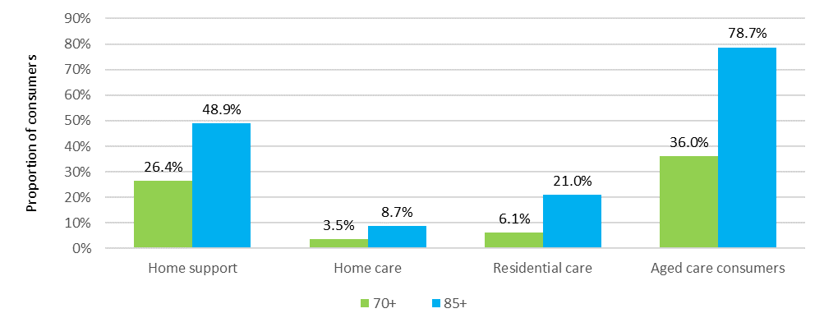

Chart 3.16 shows the age profile for consumers of home care over the five years to 30 June 2019. The proportion of those aged 65-74 and those aged 95 and over have been steady in recent years. The proportion of those aged 75-84 has steadily increased in the last 3 years and the proportion of those aged 85-94 was stable.

Chart 3.16: Age profile of people in home care, 30 June 2015 to 30 June 2019

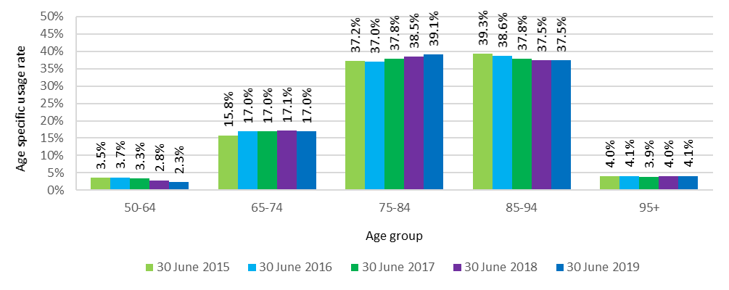

In residential care, the trends of recent years generally continued in 2018-19 (Chart 3.17). The proportion of people aged 65-74 in residential care has slowly increased over the five years while the proportions of those aged 75-84 have been steady. The proportion of those aged 85-94 has been falling. The proportion of those aged 95 and over has steadily increased every year over the five years.

Chart 3.17: Age profile of people in residential care, 30 June 2015 to 30 June 2019

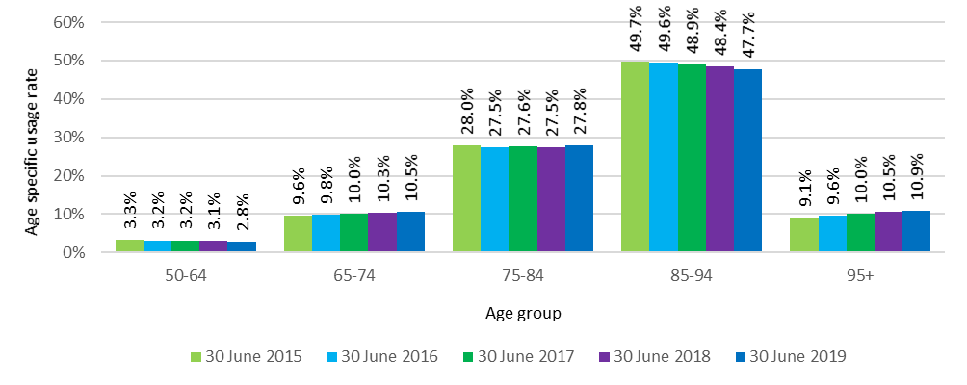

Detailed data regarding the age of consumers in CHSP is not readily available for the same level of analysis as it is for home and residential care. However the overall average age of consumers in CHSP in 2018-19 was 80.0 compared with 79.6 in 2017-18 and 79.5 in 2016-17. The average age of people in home care and residential care as at 30 June 2019 was 82.4 and 84.8 respectively.

## Access by Culturally and Linguistically Diverse and Indigenous Australians

### Culturally and Linguistically Diverse Australians

There is significant cultural diversity among Australians and many people from culturally and linguistically diverse (CALD)[19] backgrounds are seeking culturally appropriate aged care. This is an area where aged care is changing and will continue to change as providers respond to the cultural needs of consumers.

To assist this, the Australian Government provides aged care website information for people who do not speak English, or for whom English is a second language. The My Aged Care website provides translated material in 26 languages. In 2018-19, there were 25,223 visits to the translation pages.

Chart 3.18 shows the number of CALD home care and residential care consumers over the last five years as well as the number of CALD consumers of the CHSP for the last three years (as previous years data was not available).

There were 27,427 older Australians from CALD backgrounds in a home care package as at 30 June 2019, up from 22,525 at 30 June 2018. This represents around 26 per cent of total home care consumers which is stable from recent years. In residential care, as at 30 June 2019, there were 36,344 older Australians from CALD backgrounds in permanent or respite care, which represents around 20 per cent of all residents. As with home care, this proportion has been stable in recent years. In 2018-19, 166,755 consumers from a CALD background accessed home support (20 per cent of all consumers), up from 155,905 in 2017-18.

Chart 3.18: CALD consumers in aged care, 2014-15 to 2018-19

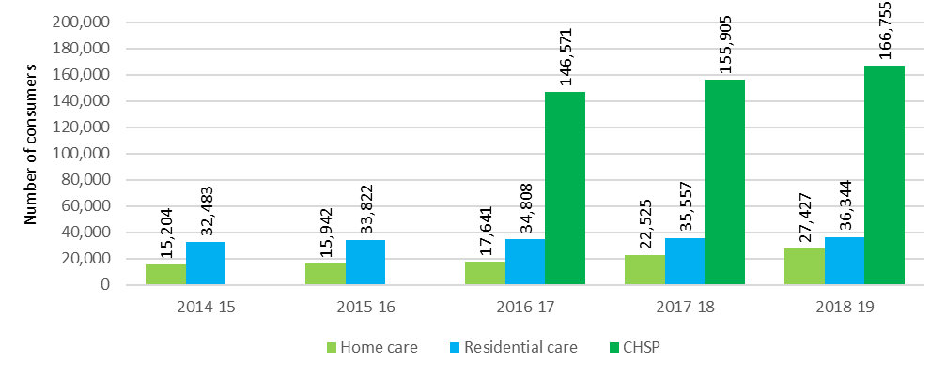

### Indigenous Australians

Chart 3.19 shows the number of Indigenous Australians accessing home care and residential care over the last five years, and the number accessing home support over the last three years (as previous years are not available).

The number of Indigenous Australians accessing home care continued to increase to 3,280 at 30 June 2019, up from 2,866. The number of Indigenous Australians accessing the CHSP also increased from 21,443 to 22,148.

Chart 3.19: Indigenous Australians in aged care, 2014-15 to 2018-19

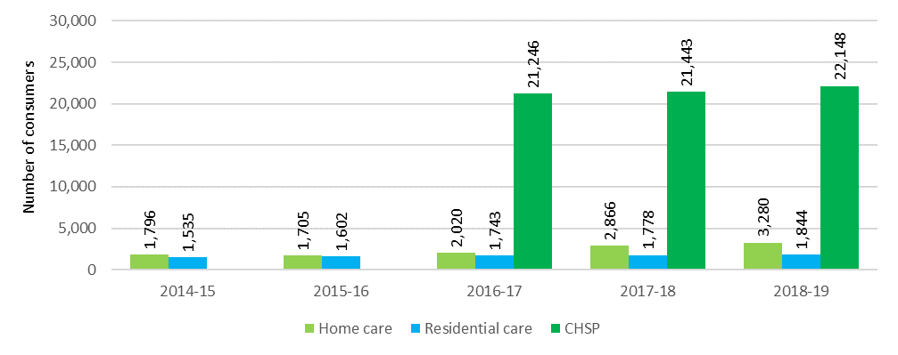

# Home support

|  |
| --- |
| **This chapter discusses:**   * The operation of the CHSP[20]; * the supply and usage of CHSP; and * the funding of the CHSP.   **This chapter reports that in 2018-19:**   * The Commonwealth funded 1,458 providers to deliver CHSP. In 2017‑18 there were 1,456 CHSP providers and 91 HACC providers in WA[21]. * the CHSP provided services to 840,984 older Australians nationally. In 2017‑18 there were 783,043 consumers of CHSP and 64,491 older Australians received services through the Western Australian HACC.   **The Australian Government contributed $2.6 billion to home support in 2018-19:**   * $2.5 billion for service delivery in the CHSP plus $128 million to support the Regional Assessment Service. |

## Introduction

The Commonwealth Home Support Programme generally provides small amounts of services (entry-level services) designed to help older Australians continue living in their own homes for as long as they can and wish to do so, and delay the need for higher level care, including home care packages and residential care, through early intervention.

## Commonwealth Home Support Programme

The Commonwealth Home Support Programme (CHSP) provides entry-level support services for frail, older people aged 65 years and older (or 50 years and older for Aboriginal and Torres Strait Islander people) who need assistance to keep living independently at home and in their community. CHSP entry level support is underpinned by a ‘wellness approach’, which is about building on older people’s strengths, capacity and goals to help them remain independent and to live safely at home.

The CHSP also supports homeless people, or people at risk of homelessness, to access care and housing. To be eligible for assistance with care and housing services through the CHSP, a person must be: prematurely aged; 50 years and over (45 years and over for Aboriginal and Torres Strait Islander people); on a low income; and be homeless or at risk of homelessness as a result of experiencing housing stress or not having secure accommodation.

My Aged Care is the Australian Government’s single entry point for aged care services. Access to CHSP services is coordinated through My Aged Care and Regional Assessment Services.

Table 4.1 sets out the types of services that may be accessed through the CHSP. Around 53 per cent of CHSP consumers receive one type of service, 41 per cent receive between two and four types of service and the remainder access five or more types of services. On average, CHSP consumers received services to the value of $2,949 per annum in 2018-19, however as noted previously, there can be significant variation in funding between consumers. Accurate data regarding the range of funding provided for individual consumers through the CHSP is not currently available.

Table 4.1: CHSP services: by sub-program and service type

| Sub-program | Community and home support | Care relationships and carer support | Assistance with care and housing | Service system development |
| --- | --- | --- | --- | --- |
| Objective | To provide entry-level support services to assist frail, older people to live independently at home and in the community. | To support and maintain care relationships between carers and consumers, through providing good quality respite care for frail, older people so that regular carers can take a break. | To support those who are homeless or at risk of homelessness, to access appropriate and sustainable housing as well as community care and other support services, specifically targeted at avoiding homelessness or reducing the impact of homelessness. | To support the development of the community aged care service system in a way that meets the aims of the CHSP and broader aged care system. |
| Service types funded | * Meals * Other food services * Transport * Domestic assistance * Personal care * Home maintenance * Home modifications * Social support-individual * Social support-group (formerly centre-based day care) * Nursing * Allied health and therapy services * Goods, equipment and assistive technology * Specialised support services | * Flexible respite: * In-home day respite * In-home overnight respite * Community access - individual respite * Host family day respite * Host family overnight respite * Mobile respite * Other planned respite * Centre-based respite: * Centre based day respite * Residential day respite * Community access-group respite * Cottage respite (overnight community) | Assistance with care and housing (a person must be: prematurely aged; 50 years and over (45 years and over for Aboriginal and Torres Strait Islander people); on a low income; and be homeless or at risk of homelessness as a result of experiencing housing stress or not having secure accommodation). | Sector support and development activities. |

CHSP expenditure in 2018-19 on each of the major service types is detailed in Table 4.2.

Table 4.2: CHSP expenditure by service type 2018-19

| Service | $m |
| --- | --- |
| Social support | 519.4 |
| Domestic assistance | 492.2 |
| Nursing | 271 |
| Respite | 267.9 |
| Allied health and therapy services | 237.3 |
| Personal care | 195.9 |
| Transport | 184.3 |
| Home modifications and maintenance | 161.3 |
| Meals and other food services | 85.2 |
| Sector support and development | 52.6 |
| Assistance with Care and Housing | 12.8 |
| **Total** | **2,479.9** |

## Home and Community Care — Western Australia

Up until 1 July 2018 the HACC program in Western Australia provided similar services for older people to those provided under the CHSP, but also provided support for younger people with a disability.

From 1 July 2018 the Western Australian HACC services for older people aged 65 years and over (and 50 years and over for Aboriginal and Torres Strait Islander people) transitioned to the CHSP, which means that from 1 July 2018 the CHSP became a national program.

## Sector overview

### Providers of home support

In 2018-19, the first year that the CHSP operated as a fully national program, there were 1,458 CHSP providers. In 2017-18 when the Western Australian HACC was still operating separately, there were 1,456 CHSP providers and 91 Western Australian HACC providers. While some of the HACC providers in Western Australia in 2017‑18 would have subsequently become part of the CHSP in 2018-19, others would have already been captured in the 2017-18 CHSP provider count as they may have provided services in other states also. Therefore a direct comparison between years is not possible.

CHSP services are predominately provided by not-for-profit organisations (69 per cent), as shown in Chart 4.1. For-profit providers make up only 7 per cent of all providers with government providers representing almost one-quarter. This has been the case since the inception of the CHSP in 2015-16, and was the case for the former programs that combined to create the CHSP.

Chart 4.1: CHSP providers by ownership type, 2018-19

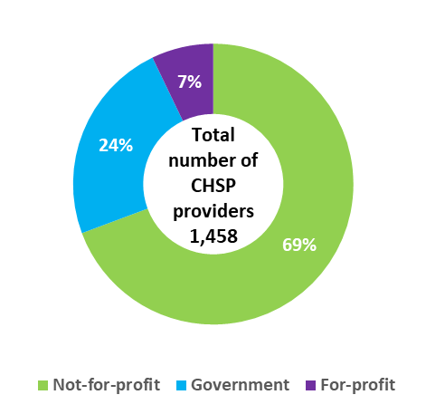

## Funding for Home Support

In 2018-19, the Commonwealth contributed $2.5 billion to service delivery in the CHSP (as well as providing $128 million in assessment and other support activities).

Chart 4.2 shows total expenditure on home support service delivery since 2016‑17, along with budgeted expenditure to 2023‑24.

Chart 4.2: Government expenditure and budgeted expenditure of CHSP[22] and Western Australian HACC program[23], 2016‑17 to 2023‑24

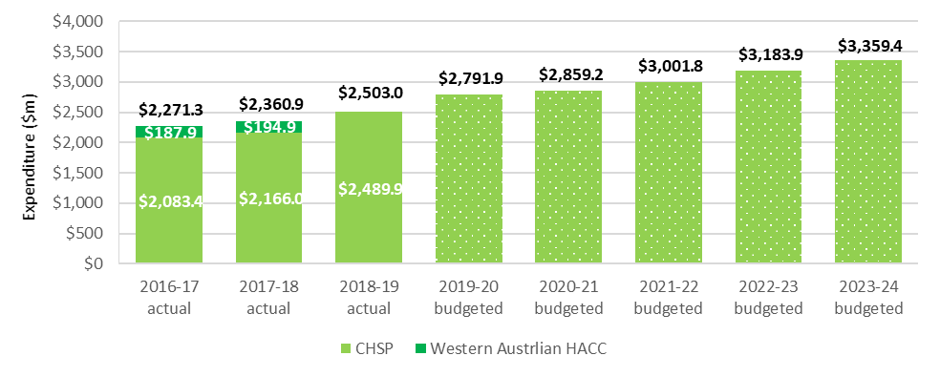

Chart 4.3 shows Commonwealth expenditure for service delivery in the CHSP in 2018-19, by state and territory.

Chart 4.3: Commonwealth expenditure on CHSP services, by state and territory, 2018-19 ($m)

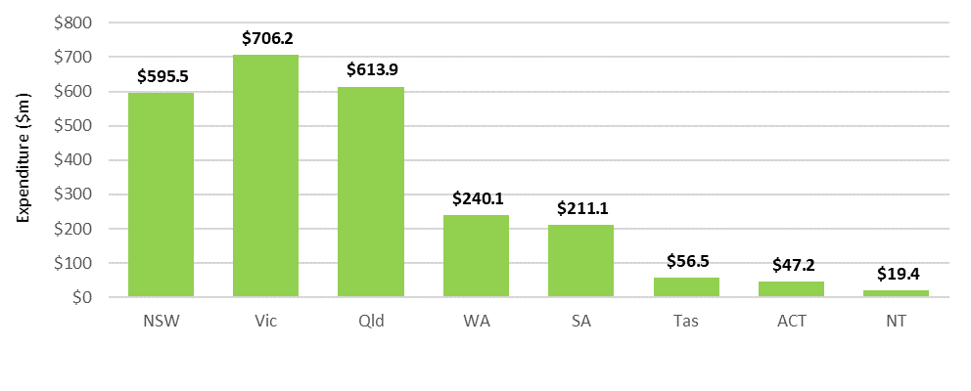

As part of the 2014‑15 Budget, the Australian Government announced a reduction in the annual real rate of growth for the CHSP from 6 per cent to 2.8 per cent in 2015‑16, 1.5 per cent in 2016‑17 and 2.4 per cent in 2017‑18. In 2018‑19 the annual growth rate was 3.5 per cent, which broadly aligns with the annual growth in the population aged 65 and over. Real growth is in addition to annual indexation. Growth funding enables the CHSP to respond to the changing needs of CHSP consumers and to align with the growth in Australia’s aged population. Grants under the CHSP are indexed each year by WCI-3[24] (1.3 per cent in 2018-19).

Table 4.2 shows a breakdown of the size of grants provided through the CHSP in 2018-19 by organisation type. Results from 2018-19 are similar to previous years. The majority (72 per cent) of providers receive less than $1 million and of those, 77 per cent receive less than $500,000.

Table 4.3: CHSP grants, by size of grant and provider ownership, 2018-19

| Grant size | Not-for-profit | For-profit | Government | Total |
| --- | --- | --- | --- | --- |
| Less than $500,000 | 623 | 60 | 118 | 801 |
| $500,000 - $1 million | 140 | 16 | 83 | 239 |
| $1-10 million | 222 | 24 | 131 | 377 |
| $10-50 million | 15 | 2 | 9 | 26 |
| Over $50 million | 4 | 1 | 1 | 6 |

### Consumer contributions

The Client Contribution Framework and the National Guide to the CHSP Client Contribution Framework set out principles to guide CHSP providers in setting and implementing their own consumer contribution policy.

The principles are designed to introduce fairness and consistency, with a view to ensuring that those who can afford to contribute do so, whilst protecting the most vulnerable.

Recommendation 16 of the Legislated Review of Aged Care 2017 recommended that mandatory consumer contributions based on an individual’s financial capacity be introduced for services under the CHSP. This would bring the CHSP fees policy more in line with those under other aged care programs. The Government has not yet responded to this recommendation.

In 2018-19, consumer contributions totalled around $252 million, which represents around 10 per cent of total CHSP funding. This is stable from 2017-18.

## Looking forward

In the 2019‑20 Budget, the Australian Government extended funding agreements with CHSP providers by a further two years, after a similar two year extension in the 2017‑18 Budget. This means the CHSP and Home Care Packages Program will continue to operate as separate programs until at least mid‑2022.

In the 2015-16 Budget, the Australian Government had announced an intention to integrate CHSP and home care into a single home care and support program by July 2018.

In November 2019, the Government re-announced its intention to establish the single unified system for care of older people at home as part of the response to the Interim Report of the Royal Commission into Aged Care Quality and Safety. No decisions have been made about the scope, model or funding of the future program and significant consultation will be required on any option to be considered. Any final decisions by Government about a unified system will be made following the Royal Commission.

Following the establishment of the CHSP as a program with full national coverage in 2018, the Department of Health issued a new Program Manual that sets out service providers’ responsibilities, including a new emphasis on wellness and reablement. CHSP providers are now required to submit an annual report outlining service level information regarding the implementation of a wellness approach within their organisation. These reports will be used to measure overall progress towards embedding wellness and reablement in CHSP service delivery.

The Department of Health is also conducting pilots to further embed wellness and reablement practices within the CHSP. The Department is also considering options for simplifying consumer access to home-based care by combining the current RASs and ACATs into a single assessment and referral process across CHSP and home care.

In addition, the 2018-19 Budget provided $29.2 million over two years to 30 June 2020 to trial reablement-based assessment for the CHSP. The assessment model being trialled provides a time-limited reablement period, usually between ten to twelve weeks, prior to being referred for ongoing services.

# Home care

|  |
| --- |
| **This chapter discusses:**   * The operation of the Home Care Packages Program; * the funding of the sector; and * the financial performance of home care providers in 2018-19.   **The chapter reports that:**   * There were 928 home care providers as at 30 June 2019, up from 873 at 30 June 2018. This continues the trend of increasing numbers of home care providers since 2017 (702 providers as at 30 June 2017); * the sector continues to be predominately not-for-profit with 52 per cent of providers and 72 per cent of consumers; and * home care services were provided to 133,439 consumers, up from 116,843 in 2017-18.   **Key findings on financial performance in 2018-19:**   * Home care providers received an estimated $2.53 billion in revenue, paid $2.43 billion in expenses and generated $90 million in profit; * 69 per cent of home care package providers achieved a net profit, down slightly from 70 per cent in 2017-18; * average EBITDA was $1,211 per consumer, steady from $1,217 in 2017-18 following a significant decline from $2,989 in 2016-17; * EBITDA margin was 4.5 per cent, down slightly from 4.6 per cent in 2017-18; and * as at 30 June 2019 home care providers held $751 million in unspent funds, up from $539 million at 30 June 2018. |

## Overview of the sector

### The Home Care Packages Program

The Home Care Packages Program commenced on 1 August 2013, replacing the former home care programs – Community Aged Care Packages (CACPs), Extended Aged Care at Home (EACH) packages and Extended Aged Care at Home Dementia (EACH-D) packages.

Home care packages allow consumers to purchase a range of services and equipment which assist them living in their own home. Packages are delivered on a Consumer Directed Care (CDC) basis with consumers having an individualised budget which allows them to decide what type of care and services they purchase and who delivers the services.

In February 2017, an important change occurred in home care in that packages began being assigned directly to the consumer, rather than allocated to the provider. This meant that consumers have the choice of provider to deliver their services and can opt to change providers.

Home care consumers may use their package funds to purchase the following:

* **Personal services.** Examples include help with showering or bathing, dressing and mobility;
* **Support services.** Examples include help with washing and ironing, house cleaning, gardening, basic home maintenance, home modifications related to care needs, transport to help with shopping, doctor visits or attending social activities;
* **Care related service.** Examples include nursing and other health support including physiotherapy (exercise, mobility, strength and balance), services of a dietitian (nutrition assessment, food and nutrition advice, dietary changes) and hearing and vision services; and
* **Care management.** Coordinating care and services that will help consumers achieve the goals identified in their care plan.

In addition, providers may charge consumers a package management fee, which covers regulatory-related costs such as issuing monthly financial statements and managing unspent package funds on behalf of consumers.

For many consumers, home care packages offer an opportunity to remain living at home instead of entering residential care. Packages are categorised into four levels with level 1 being for people with lower care needs through to level 4 which supports people with higher care needs.

To obtain access to a home care package, individuals are first assessed by an Aged Care Assessment Team (ACAT) which determines eligibility for a home care package. Many people assessed as eligible to receive a package are also assessed as eligible for residential care. Once assessed as eligible for home care, an individual is placed on the National Prioritisation System and is offered a package when one becomes available. The National Prioritisation System is discussed later in this chapter.

### Providers of home care

Chart 5.1 shows overall home care provider numbers, as well as the proportion by ownership, over the six years to June 2019. As noted last year, there has been a significant increase in home care providers since the February 2017 changes that assigned home care packages directly to consumers rather than to providers. Many new providers have entered the market seeking to compete for consumers.

Chart 5.1: Number of home care providers, by proportion of ownership type, 30 June 2014 to 30 June 2019

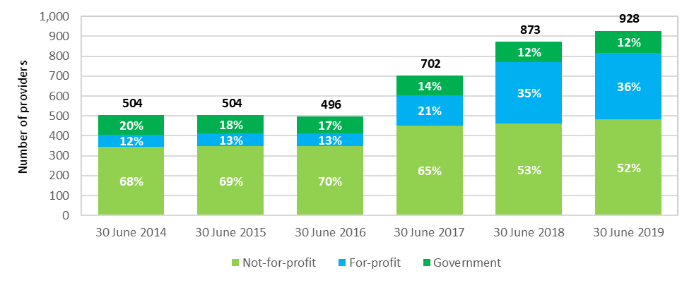

Table 5.1 presents a breakdown of home care providers by ownership type, location and scale in 2018-19.

Table 5.1: Provider numbers, number of services and number of consumers, at 30 June 2019

|  |  | | Ownership type | | | Location | | | Scale | | |
| --- | --- | --- | --- | --- | --- | --- | --- | --- | --- | --- | --- |
|  | 30 June 2018 | 30 June 2019 | Not-for-profit | For-profit | Government | Metropolitan | Regional | Metropolitan & regional | Single service | Two to six services | Seven or more services |
| Number of providers | 873 | 928 | 479  52% | 335  36% | 114  12% | 518  56% | 331  36% | 79  9% | 671  72% | 176  19% | 81  9% |
| Numbers of services | 2,599 | 2,691 | 1,898  71% | 584  22% | 209  8% | 1,647  61% | 1,044  39% | n/a  n/a | 671  25% | 538  20% | 1,482  55% |
| Number of consumers | 91,847 | 106,707 | 77,156  72% | 22,317  21% | 7,234  7% | 72,903  68% | 33,804  32% | n/a  n/a | 23,663  22% | 23,222  22% | 59,822  56% |

As shown in Chart 5.1 and Table 5.2, the mix of provider ownership was stable in 2018-19 compared with 2017-18, although the overall number of providers did continue to increase (928 compared with 873 in 2017-18). The not‑for‑profits represent 52 per cent of the sector while the for‑profits make up 36 per cent. The February 2017 reforms resulted in a significant initial increase in the proportion of for-profit providers, from 13 per cent to 35 per cent by 30 June 2018, but the proportions have stabilised since.

Table 5.2: Change in number of providers and ownership, 30 June 2017 to 30 June 2019

|  | 30 June 2017 | Proportion of total | 30 June 2018 | Proportion of total | 30 June 2019 | Proportion of total |
| --- | --- | --- | --- | --- | --- | --- |
| Not-for-profit | 407 | 65% | 461 | 53% | 479 | 52% |
| For-profit | 200 | 21% | 309 | 35% | 335 | 36% |
| Government | 95 | 14% | 103 | 12% | 114 | 12% |
| **Total** | **702** | **100%** | **873** | **100%** | **928** | **100%** |

At 30 June 2019 there were 106,707 consumers in home care, compared with 91,847 at 30 June 2018.

During 2018-19, 133,439 older Australians were in receipt of a home care package at some time (up from 116,843 in 2017-18).

As at 30 June 2019, 53 per cent of packages were levels 1 or 2 while 47 per cent were levels 3 or 4 (Table 5.3), compared with 68 per cent and 32 per cent respectively in 2016-17. This rebalancing of package level proportions reflects recent Government policy to increase the proportion of higher level packages in response to older Australians’ preference to stay living in their homes longer.

Table 5.3: Home care consumers, by package level and proportion of total, 2016-17 to 2018-19

|  | 2016-17 | % of total | 2017-18 | % of total | 2018-19 | % of total |
| --- | --- | --- | --- | --- | --- | --- |
| Level 1 | 1,168 | 1.6% | 4,841 | 5.3% | 8,516 | 8.0% |
| Level 2 | 47,268 | 66.2% | 51,496 | 56.1% | 47,734 | 44.7% |
| Level 3 | 6,750 | 9.5% | 12,693 | 13.8% | 20,193 | 18.9% |
| Level 4 | 16,237 | 22.7% | 22,817 | 24.8% | 30,264 | 28.4% |
| **Total** | **71,423** | **100.0** | 91,847 | **100.0** | **106,707** | **100.0** |

As shown in Chart 5.2, the proportion of home care consumers receiving services from for-profit providers has increased slightly in 2018-19, up to 21 per cent from 17 per cent in 2017-18 and 11 per cent in 2016-17. There was a commensurate decline in the proportion of consumers receiving services from not-for-profit providers. This continues the trend of for-profit providers increasing their share of the market, albeit from a relatively small base, since the changes of February 2017. The proportion of for‑profit providers, however, is increasing faster than their share of consumers, increasing to 36 per cent in 2018‑19 from 21 per cent in 2017‑18.

Chart 5.2: Home care consumers, by ownership type, 30 June 2015 to 30 June 2019

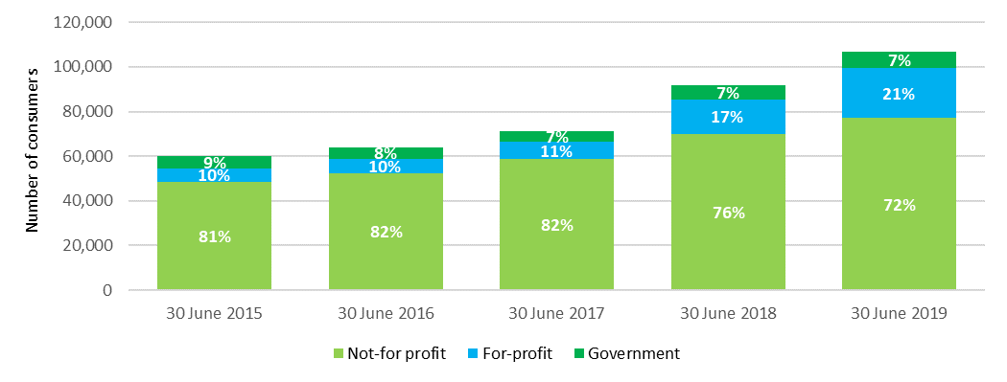

Across Australia, around 68 per cent of home care consumers are in major cities, around 25 per cent are in inner regional locations, around 6 per cent are in outer regional locations, and the remaining 1 per cent are in remote and very remote areas. These proportions have been steady in recent years.

## Operational performance

### Methodology

The discussion of financial performance in this chapter predominantly relates to Earnings Before Interest, Tax, Depreciation and Amortisation (EBITDA). EBITDA is the commonly used metric for analysis and comparison of the profitability of providers and the sector. Net Profit Before Tax (NPBT), which takes interest, depreciation and amortisation into the calculation, is also used on occasion.

Financial information reported in this chapter has been collected through the Aged Care Financial Report (ACFR). The Accountability Principles 2014, made under Section 96-1 of the Aged Care Act 1997, require each home care provider to submit a financial report in a form approved by the Secretary of the Department of Health. The ACFR submitted by home care providers is not required to be audited and should not be considered a General Purpose Financial Report.

Until the 2018 ACFA report, financial performance of home care providers was largely summarised on a ‘per package’ basis as the packages were previously allocated to providers after a competitive tender through an ACAR. Analysis on this basis included the provider’s packages that were not fully utilised for whatever reason in a financial year. The reform changes of February 2017 have resulted in packages being assigned to consumers and as a result, the analysis is now calculated on a ‘per consumer’ basis. EBITDA calculated on a ‘per consumer’ basis is generally higher when compared with EBITDA calculated on a ‘per package’ basis as unutilised packages are excluded. When trend data is analysed, previous years have been re‑calculated on the ‘per‑consumer’ basis to allow for direct comparison between years.

### Analysis of 2018-19 financial performance of home care providers

2018-19 saw a further slight decline in the overall financial performance of home care providers following the significant decline in 2017-18 compared with recent years. Average EBITDA per consumer across the sector was $1,211 in 2018-19, down from $1,217 in 2017-18. This followed the average over the previous three years at around $3,000.

Chart 5.3 shows the whole of sector average EBITDA per consumer of all home care providers since 2014‑15.

Chart 5.3: Home care providers average EBITDA per consumer per year, 2014-15 to 2018-19

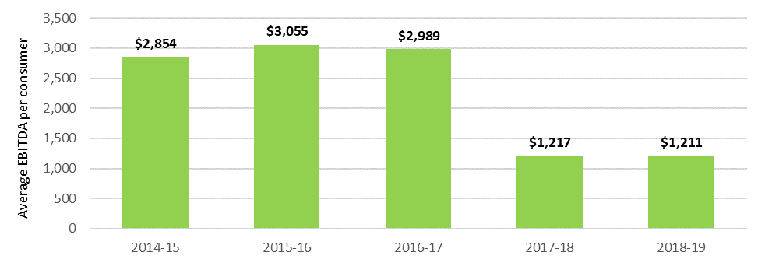

Table 5.4 provides an overview of the 2018-19 financial performance of home care providers, including a breakdown by ownership type, location and scale.

Table 5.4: Summary of financial performance of home care providers, 2018-19

|  | All providers | Not-for-profit | For-profit | Government | Metropolitan | Regional | Metropolitan & regional | Single service | Two to six services | Seven or more services |
| --- | --- | --- | --- | --- | --- | --- | --- | --- | --- | --- |
| Total revenue ($m) | $2,525.3 | $1,844.2 | $529.4 | $151.7 | $1,421.6 | $427.8 | $675.5 | $571.1 | $552.4 | $1,401.8 |
| Total expenses ($m) | $2,429.1 | $1,763.5 | $527.3 | $140.6 | $1,361.0 | $415.1 | $654.6 | $539.5 | $517.8 | $1,374.2 |
| Profit ($m) | $90.14 | $80.64 | $2.08 | $11.09 | $60.62 | $12.68 | $20.91 | $31.58 | $34.60 | $27.63 |
| EBITDA ($m) | $113.81 | $93.16 | $12.83 | $11.47 | $75.95 | $17.12 | $24.79 | $36.14 | $39.07 | $42.26 |
| Average EBITDA per consumer | $1,211 | $1,321 | $728 | $1,976 | $1,470 | $974 | $1,003 | $1,866 | $1,928 | $778 |
| Average NPBT per consumer | $959 | $1,143 | $118 | $1,910 | $1,173 | $721 | $846 | $1,631 | $1,707 | $508 |
| EBITDA margin | 4.5% | 5.1% | 2.4% | 7.6% | 5.3% | 4.0% | 3.7% | 6.3% | 7.1% | 3.0% |
| NPBT margin | 3.6% | 4.4% | 0.4% | 7.3% | 4.3% | 3.0% | 3.1% | 5.5% | 6.3% | 2.0% |

### Revenue

Home care revenue consists of Commonwealth contributions in the form of subsidies and supplements, and a lessor contribution from consumers (the basic daily fee and income tested fees). Total revenue can also include other revenue sources (such as consumer contributions for non-home care related services, interest income and state and territory government payments).

In 2018-19, total Commonwealth expenditure on home care subsidies and supplements was $2.5 billion, up from $2.0 billion in 2017-18.

The basic subsidy for home care is indexed annually based on Wage Cost Index 9 (WCI‑9), the same index as applies for the care subsidy in residential care. WCI-9 is a composite index constructed by the Department of Finance that comprises a wage cost component (weighted at 75 per cent) and a non-wage cost component (weighted at 25 per cent). For all Wage Cost Indices, the value of the wage cost component is based on the dollar increase in the national minimum wage (as determined annually by the Fair Work Commission) expressed as a percentage of the latest available estimate of average weekly ordinary time earnings (AWOTE) published by the Australian Bureau of Statistics as at November of each year. The value of the non‑wage cost component of WCI-9 is based on changes in the Consumer Price Index (CPI) between March quarters each year.

Some home care supplements are also indexed by WCI-9, including the dementia and cognition and Veterans’ supplements, while the remainder, such as the oxygen and enteral feeding supplements, are indexed annually using the Consumer Price Index (CPI).

#### Commonwealth funding (subsidies and supplements)

Commonwealth funding is determined per consumer based on the level of package accessed. It is calculated on a daily basis and is currently paid to the provider monthly in advance[25]. Each package level has a fixed maximum amount of annual funding set by the Commonwealth (Table 5.5). Supplements can also be paid in circumstances where the consumer requires additional care and/or services.

Table 5.5: Maximum home care basic subsidy payments per annum, 2019-20

| Package level | annualised subsidy |
| --- | --- |
| Level 1 | $8,810 |
| Level 2 | $15,500 |
| Level 3 | $33,731 |
| Level 4 | $51,130 |

Supplements in home care are paid in addition to the amount of basic subsidy applicable at each package level. Supplements are paid if a consumer is eligible due to a specific care need or circumstance. The supplements that apply to home care are at Appendix K. All supplements payable are included in the consumer’s individualised budget.

#### Consumer contributions

Consumers may be asked to pay a basic daily fee up to 17.5 per cent of the single basic age pension ($10.63 a day/$3,890 per annum as at 20 September 2019[26]). The basic daily fee is not subject to an income or asset test and all consumers can be asked to pay unless they prove financial hardship, in which case the Commonwealth pays the provider on their behalf. The basic daily fee, when charged by the service provider, must be included in the individualised budget for the consumer.

Additionally, consumers may be asked to make a contribution towards the cost of their care through an income tested fee. The package amount paid by the Commonwealth on behalf of a consumer is reduced by the amount of the income tested fee regardless of whether the fee is collected by the provider or not.

Consumer contributions in 2018-19 reported by providers totalled around $107 million, compared with $122 million for 2017-18. This contribution is made up of $66 million from the basic daily fee ($78 million in 2017-18) and $42 million in income-tested care fees ($44 million in 2017-18).

As noted last year, feedback from providers suggest many are foregoing charging their consumers, many of whom are pensioners, the basic daily fee, or are reducing that fee, likely due to the recent increase in competition in the home care market. The amount reported in 2018-19 by home care providers for the income tested fees suggests this may also be the case for these fees. ACFA notes this practice seems to be increasing among home care providers.

#### Unspent funds

Prior to the changes that occurred in February 2017, when home care consumers moved between home care providers or exited care (often to enter residential care), unspent package funds could be retained by their former provider. As part of the changes introduced in February 2017, unspent package funds now follow the consumer to their new provider or are returned to the Commonwealth and the consumer (based on their respective proportions paid) when the consumer leaves home care.

The unspent home care amount is the total amount of each consumer’s individual budget (comprising home care subsidy, supplements and home care fees) that has not been spent or committed for the consumer’s care, less any agreed exit amount. Unspent package funds will not generally, and should not, be recognised as income by the provider until the funds have been spent or are committed for the consumer’s care.

Unspent funds are discussed in more detail at 5.2.6.

#### Total revenue

In 2018-19, total sector revenue for all home care providers was $2.53 billion, up from $2.07 billion in 2017-18, an increase of 22 per cent. Commonwealth contributions represent more than 90 per cent of the total revenue received by home care providers. Unspent funds held by providers ($751 million at 30 June 2019) are not treated as revenue. The average income per consumer per day in 2018-19 was $73.62 ($26,871 per annum), a 2 per cent increase from $72.04 ($26,295 per annum) in 2017-18.

Table 5.6 shows provider income per consumer per day since 2016-17, split by the major types of income. As shown, there is a significant amount charged for management and administration costs, similar to recent years. In 2018-19, management and administration charges are almost 30 per cent of provider income. Some providers have indicated that this relatively high proportion of income derived from management and administration reflects the costs for providers delivering care on a CDC basis, including regulatory-related costs such as providers being required to provide consumers with full transparency regarding their packages, negotiating an individualised budget, providing monthly itemised expenditure statements, and having to administer unspent funds in a prudentially appropriate way.

Under the comparative pricing schedule that has been required to be published on My Aged Care since July 2019, providers distinguish between care management fees and package management fees. Normal business overheads are required to be included in the fees set for services.

Table 5.6: Home care provider income per consumer per day, 2016-17 to 2018-19

| Income type | 2016-17 | % of total | 2017-18 | % of total | 2018-19 | % of total |
| --- | --- | --- | --- | --- | --- | --- |
| Provision of care / service charged to consumers | $44.71 | 61.5 | $47.94 | 66.5 | $49.57 | 67.3 |
| Management fees charged to consumers | $10.27 | 14.1 | $9.72 | 13.5 | $10.35 | 14.1 |
| Administration of packages charged to consumers | $12.88 | 17.7 | $12.10 | 16.8 | $11.49 | 15.6 |
| Unspent funds and exit amounts deducted | $2.98 | 4.1 | $0.16 | 0.2 | $0.15 | 0.2 |
| Other revenue | $1.87 | 2.6 | $2.11 | 2.9 | $2.07 | 2.8 |
| **Total** | **$72.71** | **100** | **$72.03** | **100** | **$73.62** | **100** |

1. Provision of care/services charged to consumers includes income recognised from consumers' packages and private home care consumers. This amount will include Government subsidies and supplements, consumer contributions in the form of the basic daily fee, income tested care fees, top-ups and private contributions.
2. Management fees charged to consumers is the amount of income recognised for on-going management and coordination of the consumers’ packages and care requirements.
3. Administration fees charged to consumers is the amount of income recognised for on-going administration of consumers’ packages.
4. Income derived from unspent package funds reflects income remaining from a consumer’s care package when a consumer left the home care service (prior to the February 2017 changes). No income can be derived from unspent funds since the change. Exit amounts deducted by the provider when ceasing to provide home care to a consumer may be charged after this date.
5. Other revenue includes other sources of income generated from running the home care services such as state and territory payments, consumer payments for non-home care services, trust distribution, donations and bequests, interest earned on investments, insurance and gains from the sale of assets.

### Expenditure

Total sector expenditure in 2018-19 was $2.43 billion, up from $1.99 billion in 2017-18. The average expenditure per consumer per day in 2018-19 was $70.89 ($25,875 per annum), an increase of 2.1 per cent from $69.45 in 2017-18 (Table 5.7). The main driver of the increase in expenses was a $1.07 (2.3 per cent) increase in total care costs.

Table 5.7: Home care expenditure per consumer per day, 2015-16 to 2018-19

| Expenses | 2015-16 | 2016-17 | 2017-18 | 2018-19 |
| --- | --- | --- | --- | --- |
| **Care costs** |  |  |  |  |
| Wages and salaries - care staff | $31.98 | $28.78 | $29.99 | $28.83 |
| Subcontracted or brokered customer services | $9.44 | $10.30 | $10.32 | $11.47 |
| Care related expenses | $5.01 | $5.64 | $6.94 | $8.01 |
| **Total care costs** | **$46.43** | **$44.72** | **$47.25** | **$48.32** |
| **Administration costs** |  |  |  |  |
| Wages and salaries - administration staff | $8.77 | $8.00 | $9.26 | $9.58 |
| Administration costs and management fees | $10.55 | $10.18 | $10.26 | $10.28 |
| Depreciation and interest costs | $0.55 | $0.42 | $0.74 | $0.69 |
| Other expenses | $2.57 | $1.62 | $1.94 | $2.03 |
| **Total administration costs** | **$22.44** | **$20.22** | **$22.20** | **$22.57** |
| **Total costs** | **$68.87** | **$64.94** | **$69.45** | **$70.89** |

Care related expenses represent 68 per cent of total expenses per consumer per day, while administration costs represent 32 per cent of total costs, which is significant. This is consistent with 2017-18.

Table 5.8 provides a breakdown of expenditure according to ownership type, location and scale for the last two years.

In terms of ownership, not‑for‑profit providers ($68.49 per day) continue to incur significantly lower expenses per consumer than the for‑profit providers ($81.98 per day), although the latter did record a significant decrease in expenses down from $94.97 in 2017-18 per consumer per day. The main drivers behind this difference are the care related salaries and the other expenses and non-direct costs categories where the not‑for‑profit providers reported $6.77 and $10.90 less respectively per consumer per day reduction. The significant reduction in total expenses for the for‑profit providers reflects an almost $30 per day reduction in their care related salaries, although this was partially offset by a $15 per day increase in their other expenses and non-direct costs, presumably due in part to some contracting out of services rather than using direct employees.

As was the case in 2017‑18, on average, regional providers reported less expense per consumer per day ($64.69) than their metropolitan counterparts ($72.19). Both metropolitan and regional providers reported significant reductions in their care related salaries ($11.81 and $11.06 respectively). However both reported commensurate increases in their other expenses and non-direct costs.

In terms of scale, single service providers once again recorded the highest expenses per consumer per day with $76.31. Providers with 7 or more services recorded by far the lowest expenses at $55.44, while those operating 2–6 services reported $69.99.

Table 5.8: Home care expenditure per consumer per day, by ownership type, location and scale, 2017-18 to 2018-19

|  |  | Care related salaries | Admin and Mgmt fees | Other care related expenses | Other expenses and non-direct costs | Total |
| --- | --- | --- | --- | --- | --- | --- |
| **Ownership** | **Year** |  |  |  |  |  |
| Not-for-profit | 2017-18 | $35.98 | $10.43 | $17.47 | $2.16 | $66.03 |
|  | 2018-19 | $28.03 | $10.05 | $19.40 | $11.00 | $68.49 |
| For-profit | 2017-18 | $64.29 | $10.90 | $13.72 | $6.06 | $94.97 |
|  | 2018-19 | $34.83 | $8.37 | $16.89 | $21.90 | $81.98 |
| Government | 2017-18 | $24.51 | $6.97 | $22.32 | $1.54 | $55.33 |
|  | 2018-19 | $20.44 | $7.44 | $28.35 | $10.12 | $66.35 |
| **Location** |  |  |  |  |  |  |
| Metropolitan | 2017-18 | $40.45 | $10.72 | $19.13 | $2.74 | $73.04 |
|  | 2018-19 | $28.64 | $8.69 | $21.34 | $13.51 | $72.19 |
| Regional | 2017-18 | $35.78 | $7.53 | $14.73 | $3.55 | $61.59 |
|  | 2018-19 | $24.72 | $9.75 | $15.91 | $14.31 | $64.69 |
| Metropolitan & regional | 2017-18 | $38.92 | $11.08 | $14.84 | $1.96 | $66.79 |
|  | 2018-19 | $32.16 | $11.30 | $18.14 | $10.97 | $72.57 |
| **Scale** |  |  |  |  |  |  |
| Single service | 2017-18 | $60.50 | $11.45 | $14.69 | $5.64 | $92.28 |
|  | 2018-19 | $34.92 | $8.24 | $17.39 | $15.76 | $76.31 |
| Two to six services | 2017-18 | $38.01 | $8.27 | $15.43 | $3.04 | $64.76 |
|  | 2018-19 | $29.25 | $8.02 | $20.48 | $12.24 | $69.99 |
| Seven or more services | 2017-18 | $36.47 | $10.68 | $18.18 | $2.13 | $67.46 |
|  | 2018-19 | $21.21 | $8.51 | $15.89 | $9.83 | $55.44 |
| **Total sector** | **2017-18** | **$39.25** | **$10.26** | **$17.26** | **$2.68** | **$69.45** |
| **Total sector** | **2018-19** | **$28.83** | **$9.58** | **$19.48** | **$12.99** | **$70.89** |

### Profit

In 2018-19, home care providers generated $90 million in total profit, up from $74 million in 2017‑18. In terms of profit per consumer (Table 5.9), the average EBITDA decreased slightly to $1,211 from $1,217 in 2017-18 while the average NPBT increased to $959 from $947 in 2017-18.

Prior to 2017-18, the average EBITDA per annum per consumer had been around $3,000 for the previous three years.

Table 5.9: Summary of financial performance of home care providers, per consumer per year, 2014‑15 to 2018-19

|  | 2014-15 | 2015-16 | 2016-17 | 2017-18 | 2018-19 |
| --- | --- | --- | --- | --- | --- |
| Average EBITDA per consumer | $2,854 | $3,055 | $2,989 | $1,217 | $1,211 |
| Average NPBT per consumer | $2,657 | $2,854 | $2,832 | $947 | $959 |

Approximately 69 per cent of home care providers achieved a profit in 2018-19, compared with 70 per cent in 2017-18.

Chart 5.4 shows average EBITDA per consumer by quartile. As has been the case previously, EBITDA varies considerably across the sector with the top quartile of providers (although still reporting a decline from 2017-18) performing substantially better than the rest of the home care sector. The average EBITDA per consumer per year for the top quartile was $6,654 compared with the next top quartile returning $2,109.

Chart 5.4: Home care average EBITDA per consumer, by quartile (number of providers in parentheses), 2015-16 to 2018-19

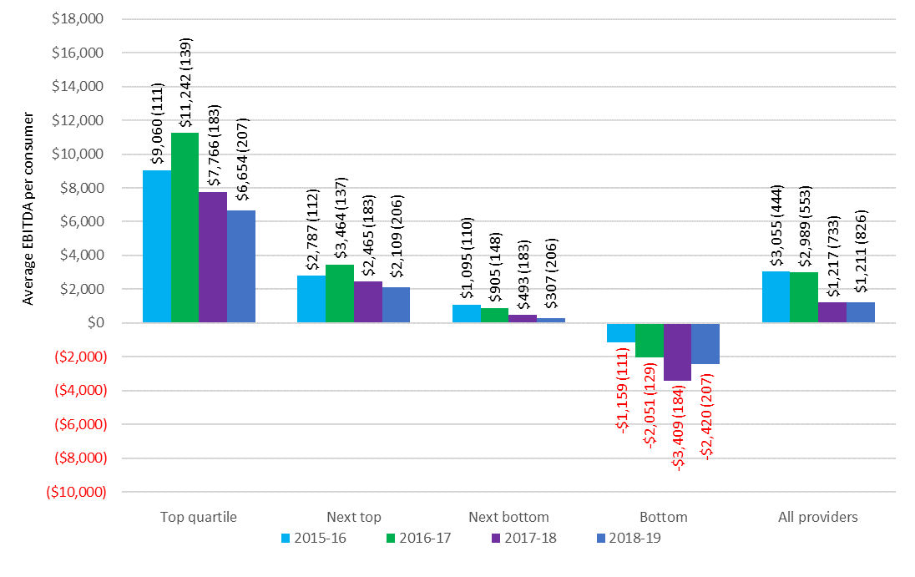

Chart 5.5 shows the quartile analysis of the average EBITDA per consumer for home care providers by ownership in 2018‑19, while Chart 5.6 shows the overall average EBITDA per consumer by ownership over the last five years.

After significantly outperforming the not‑for‑profits and government providers up to 2016‑17, the for‑profits reported by far the worst results in 2017‑18 and 2018-19 (Chart 5.6). In 2018-19 the for‑profit providers recorded average EBITDA per consumer of $728 compared with $1,321 reported by the not-for-profit providers. The 2018-19 for-profit result is, however, a noticeable improvement on reported average EBITDA per consumer of $169 in 2017-18.

Despite the overall poor results of for‑profit providers, the 86 for‑profit providers (30 per cent) in the top quartile recorded average EBITDA of $9,482 (Chart 5.5) which was well above that of the 96 not‑for‑profit providers in the top quartile ($8,187). However, as noted last year, the overall significant decline in the profitability of for‑profit providers likely reflects that the influx of new providers was largely for-profit providers and it could be expected that new entrants into a market may make a loss as they seek to establish market presence.

Chart 5.5: Home care average EBITDA per consumer per year, by quartile and ownership type, 2018-19 (number of providers in parentheses)

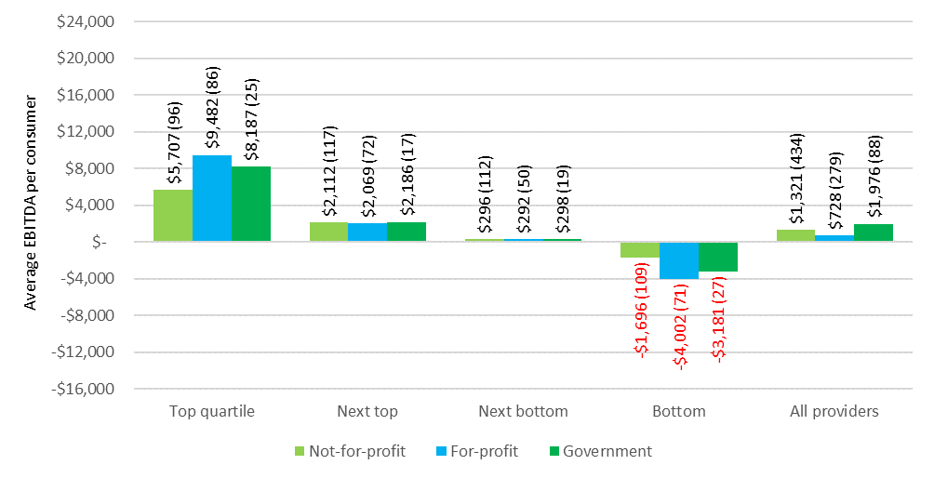

Chart 5.6: Home care average EBITDA per consumer per year, by ownership type, 2014-15 to 2018-19

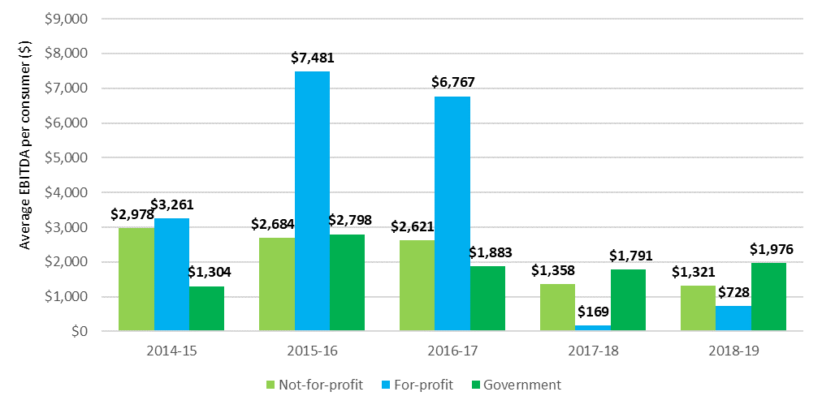

When performance is considered by location, providers in regional areas continued to decline, reporting an average EBITDA of $974 in 2018-19, down from $1,555 in 2017-18, and $2,960 in 2016-17 (Chart 5.8). In contrast, the metropolitan providers were the strongest performers in 2018‑19, reporting an average EBITDA of $1,470, up from $1,202 in 2017-18. However this was after a very significant decline from $3,431in 2016-17.

In terms of quartile analysis (Chart 5.7), regional providers in the top quartile outperformed the metropolitan providers and, as was the case last year, metropolitan providers were the worst performers in the bottom quartile.

Chart 5.7: Home care average EBITDA per consumer per year, by quartile and provider location, 2018-19 (number of providers in parentheses)

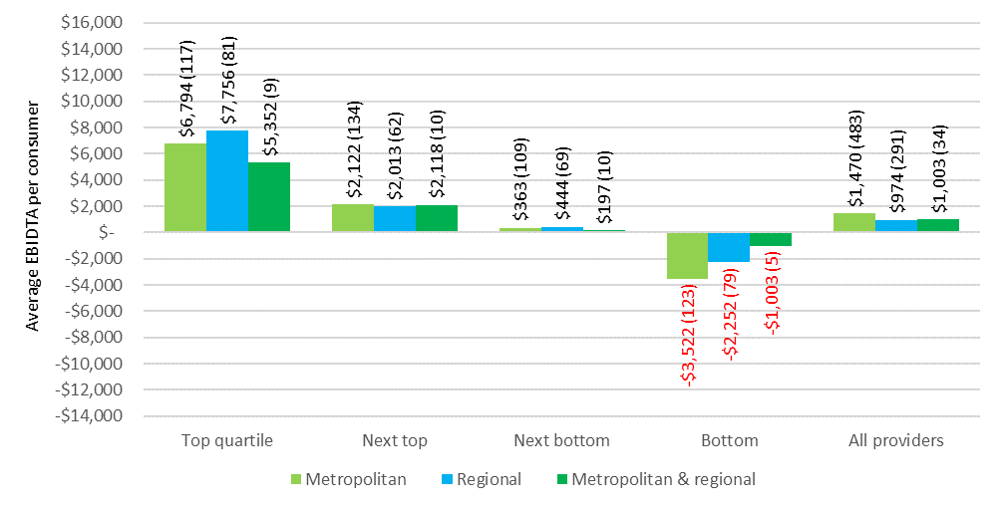

Chart 5.8: Home care average EBITDA per consumer, by provider location, 2014-15 to 2018-19

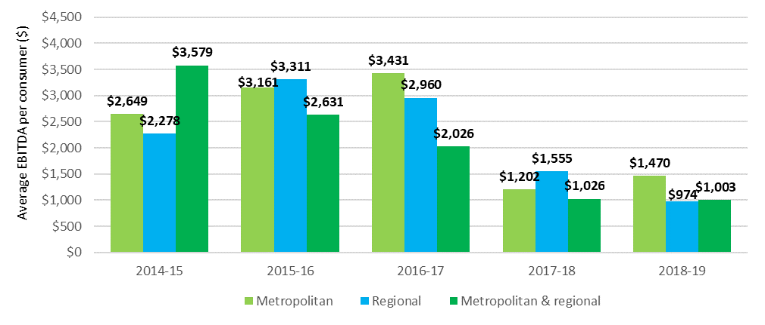

When performance is considered by scale, providers who operate seven or more services were once again by far the worst performers when compared with providers operating two to six services and single service providers - average EBITDA per consumer of $778 in 2018‑19 compared with $1,866 for single service providers and $1,928 for providers with two to six services.

Chart 5.9: Home care average EBITDA per consumer per annum, 2018-19, by quartile and provider scale (number of providers in parentheses)

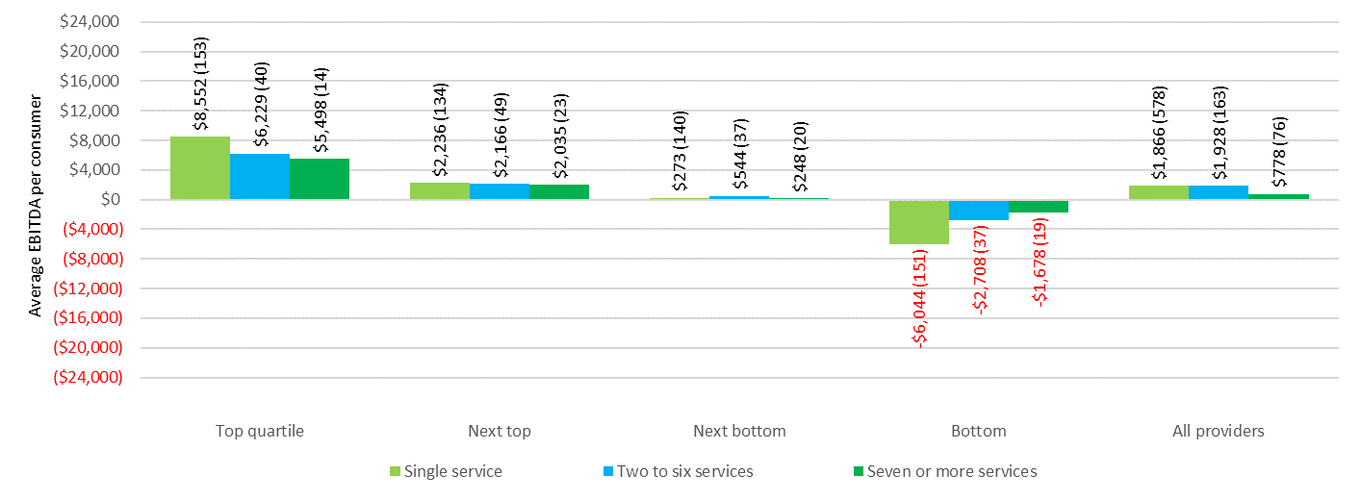

Chart 5.10: Home care average EBITDA per consumer per annum, by provider scale, 2014-15 to 2018-19

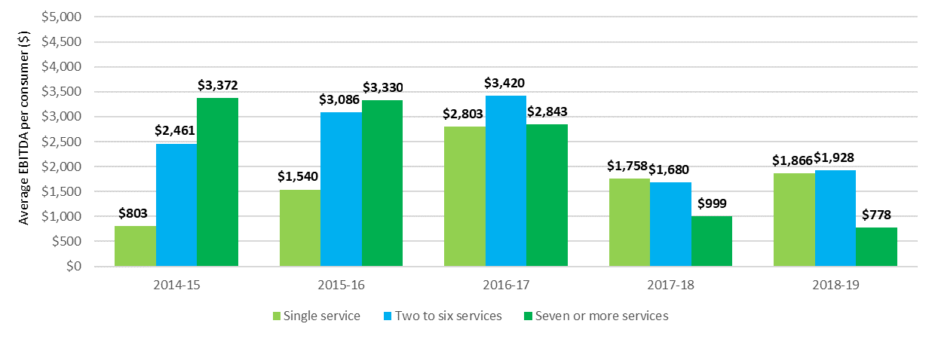

### Unspent funds

In the last two annual reports, ACFA noted the significant amount of unspent package funds held by providers on behalf of consumers. The amount held has been increasing at a significant rate over the last three years. At 30 June 2019, home care providers reported holding unspent funds of $751 million. This is up from $539 million at 30 June 2018. The level of unspent funds being held at 30 June 2019 equates to holding average unspent funds per consumer of around $7,100, up from $5,900 at 30 June 2018 and $4,600 as at 30 June 2017. Based on the current rate of growth of unspent funds, this amount could reach around $1 billion by 30 June 2020, especially with the potential for some consumers to defer or reduce the amount of services they seek during the COVID-19 pandemic.

Unspent funds may accumulate for a variety of reasons, including that consumers wish to save a proportion of their budget for future events; the services that the consumer wants are not available; the consumer is reluctant to allow people into their home; misconceptions that the money not spent under the package belongs to the consumer; or because the consumer does not require all the funds allocated to them. ACFA commented previously that if the consumer does not need all the funds they have been allocated, these funds could be used more effectively elsewhere, including meeting unmet demand. Unspent package funds also raises prudential issues since these funds held by providers need to be available should the consumer leave their care (either transferring to another provider or leaving home care).

The Department of Health does take into account unspent Commonwealth funds that are returned when a consumer leaves home care as an input in determining the number of new home care packages to be released.

In the 2019-20 Budget, the Government announced that payment arrangements in home care are to be changed from payment in-advance to payment upon delivery of service. One of the intentions of this change was to avoid Commonwealth subsidies and supplements funding being held as unspent funds by providers. Consumers would still be able to access any unspent funds from the Commonwealth.

In October 2019 the Minister for Aged Care and Senior Australian’s asked ACFA to examine the potential financial impact on home care providers of the Government’s 2019-20 Budget measure to change the way providers are paid Government subsidies and to advise on any significant impact of the new arrangements. ACFA provided a report to the Minister in November 2019. [27] In preparing this report, ACFA consulted with a cross section of provider, departments and software firms. It assessed the potential financial impact on providers of each of the proposed phases of the implementation of the new arrangements, along with how consumers may be affected. ACFA made a number of recommendations to limit the potential impacts and risk of each phase. Below is a summary of ACFA’s recommendations.

|  |
| --- |
| **Phase 1 recommendations**  **Recommendation 1**: Providers who consider they would be financially vulnerable as a result of the change in payment arrangements should be encouraged to apply to the Business Advisory Service.  **Recommendation 2:** Transitional financial support should be available for providers in thin and difficult markets, such as regional and remote areas, or those providing specialised services to vulnerable consumers. Providers seeking transitional financial support should first utilise the Business Advisory Service.  **Recommendation 3:** All phases should commence at the start of a financial year for consistent reporting within a financial year and to minimise impacts on providers’ end of year financial reporting requirements.  **Phase 2 recommendations**  **Recommendation 4:** All aspects of how the new payment arrangements will operate need to be settled as quickly as possible to determine the system changes required by both DHS (now Services Australia) and providers. In settling this detail, the focus should be on minimising the costs to providers and avoiding any reduction in the flexibility of the current system in providing goods and services to consumers as they need them.  **Recommendation 5:** Once the details of the new arrangements are settled, there need to be consultations between DHS (now Services Australia), providers and software developers to determine an appropriate time frame to ensure a smooth change to the new funding scheme, and also what can be done to minimise the administrative burden on providers. There should be a reasonable trial period of the new systems before full implementation. The current time frame for the introduction of Phase 2 (April 2021) should be reviewed following these consultations between DHS (now Services Australia), providers and software developers.  **Recommendation 6:** Consideration should be given to providing financial support to providers operating in thin and difficult markets who may find it particularly challenging to adjust their systems to deal with the requirements of the new payment arrangements.  **Phase 3 recommendation**  **Recommendation 7:** Do not proceed with the proposed proportional return of existing unspent funds under Phase 3. Instead providers should have a choice to either:   * 1. return the unspent funds of all existing consumers immediately when Phase 3 commences; or   2. retain the unspent funds of existing consumers and allow those funds to be drawn down by the recipient or returned to the Government when the recipient leaves home care. Consideration should be given to setting a maximum period that providers can retain existing unspent funds. |

The first stage of the changes, involving home care subsidies for consumers being paid to providers after the month (in arrears) rather than at the start of the month (in advance), was due to commence on 1 June 2020. Timing of the second phase, involving providers only being paid the subsidy for the goods and services actually provided to the consumer, and a proposed third stage involving the repayment of unspent funds still held by the providers, had not yet been announced by Government. However the implementation has been placed on hold due to the outbreak of COVID-19. The Government has announced that the timing for the recommencement will be determined in consultation with the sector.

## Feedback from consultations and developments in 2019-20

Home care providers are continuing to adjust to the changes introduced in February 2017 which assigned home care packages directly to consumers, with consumers having a choice of provider and the ability to change providers. In response to this change there has been a substantial increase in the number of providers, along with greater competition. The number of home care providers rose again in 2018-19 to 928 as at June 2019, compared with 496 as at June 2016.

After several years of relatively stable overall financial performance among home care providers, the changes in February 2017 contributed to a significant decline in their financial performance in 2017-18. The EBITDA for home care providers fell by over 60 per cent in 2017-18. Their overall financial performance in 2018-19 was broadly flat, notwithstanding the increase in the number of home care packages released over the course of 2018-19, from 91,847 as at end June 2018 to 106,707 as at end June 2019. Profit margins have been well below the returns being achieved before the changes introduced in February 2017. Consistent with the feedback from providers outlined in ACFA’s 2019 report, the changes continue to put upward pressure on their costs, and the greater competition puts downward pressure on their revenue.

The consultations with home care providers took place in early 2020, before the full impact of seeking to contain COVID-19 was apparent. Responding to COVID-19 will have increased costs for home care providers, including the provision of personal protective equipment and increased cleaning and sanitisation costs. It will also impact on the availability of home care workers, for example, if they have to self-isolate, resulting in back-filling costs. The Government has provided additional funding to seek to ensure continuity of aged care workers.

While dealing with COVID-19 is the immediate priority of aged care providers, a number of home care providers consulted earlier in the year observed that over the past 12 months or so they had significantly restructured their business model and recruited new staff in order to be more responsive to consumers’ needs. Many also report that the introduction of greater price transparency has resulted in a re-think of aspects of their operations. Some providers said that they were being more strategic in marketing their services and they believed they were gaining market share and that their financial performance was picking up over the course of 2019-20. This was not a uniform view. Many providers said competitive pressure remained intense and at best they were breaking even. While the number of home care providers increased in 2018-19, some of the providers consulted pointed to signs that some recent entrants have dropped out of the market. Some of the long established providers felt that their reputation and proven record of delivering quality and consistent services would translate into an improvement in market share as the sector adjusted to the impact of the February 2017 changes.

Notwithstanding the competitive trading conditions in home care, a few residential care providers who did not offer home care services indicated that they were considering entering home care. This appeared to be related to increased interest among a number of residential care providers in investing in independent retirement living and the preference of consumers that home care services be readily available if they moved to retirement accommodation. Providers consulted also suggested that the likely direction of the aged care industry flowing from the Royal Commission into Aged Care Quality and Safety would be an increased emphasis on the provision of home care services.

As noted in Section 5.2.6, ACFA consulted widely with home care providers in the context of the report it prepared for the Government on the potential financial impact of the Government’s 2019‑20 Budget measure to change the payment arrangements for home care subsidies. During the course of the consultations, providers noted that while the measure may change who holds the unspent funds of consumers, the focus should be on addressing the reasons for the growth in unspent funds, which continued to rise in 2018-19. While the growth of an individual’s unspent funds balance will largely be related to how long they are in care, providers reported that their unspent funds were concentrated on a small number of consumers with very large balances. A number of suggestions were offered on how to reduce the growth in unspent funds, predominantly involving changes to the assessment process to avoid over assessment and to enable downgrading of package levels if a consumer’s needs reduce.

# Residential care

|  |
| --- |
| **This chapter discusses:**   * The operation of residential care; * the ownership, locational and scale characteristics of residential care providers; * the funding arrangements in residential care; and * the financial performance of residential care providers in 2018-19.   **This chapter reports that:**   * At 30 June 2019 there were 213,397 operational places, up from 207,142 at 30 June 2018; * during 2018-19 residential care was provided to 242,612 older Australians, up from 241,723 in 2017-18; * at 30 June 2019 there were 873 providers, down from 886 in 2017-18, continuing the gradual consolidation of providers in recent years; and * not-for-profit providers continue to represent the largest proportion of ownership type in residential care, with 56 per cent of providers and 55 per cent of places.   **Key findings on financial performance in 2018-19 compared with 2017-18:**   * Total revenue of $19.3 billion, up from $18.1 billion, an increase of 6.8 per cent, equating to revenue of $283.54 per resident per day, an increase of 4.2 per cent from $272.16; * total expenses of $19.0 billion, up from $17.6 billion, an increase of 8 per cent, equating to $279.65 per resident per day, compared with $265.62, an increase of 5.3 per cent; * average EBITDA per resident per annum of $8,523 compared with $8,746, a decrease of 2.5 per cent, although ACFA notes without the one-off additional $320m paid in increased subsidies at the end of 2018‑19 the average EBITDA would have been around $7,000 or a 20 per cent decrease on 2017‑18; * total profit of $264 million compared with $435 million, a decrease of 39 per cent; and * 58 per cent of providers achieved a net profit, compared with 56 per cent in 2017-18. |

## Overview of the sector

### Supply of residential care

The Australian Government uses a population based planning ratio (target provision ratio) to determine the number of subsidised operational residential care places. This is outlined in Chapter 3.

Table 6.1 shows the number of providers, facilities[28], places and residents since 30 June 2015. The number of providers continues to decrease each year through consolidation, while the number of places and residents continues to increase. The number of facilities has increased gradually.

Table 6.1 also shows the achieved provision ratio in residential care, as well as provisionally allocated places and respite residents.

Table 6.1: Number of residential care providers, facilities, places and residents, 30 June 2015 to 30 June 2019

|  | 30 June 2015 | 30 June 2016 | 30 June 2017 | 30 June 2018 | 30 June 2019 |
| --- | --- | --- | --- | --- | --- |
| Providers | 972 | 949 | 902 | 886 | 873 |
| Facilities | 2,681 | 2,669 | 2,672 | 2,695 | 2,717 |
| Allocated places | 228,024 | 238,843 | 247,907 | 246,536 | 258,934 |
| Operational places | 192,370 | 195,825 | 200,689 | 207,142 | 213,397 |
| Achieved residential care ratio | 81.1 | 79.7 | 77.9 | 77.2 | 79.6 |
| Provisionally allocated places | 28,000 | 35,124 | 39,294 | 31,603 | 36,905 |
| Provisionally allocated places as proportion of allocated places | 12.4% | 14.7% | 15.9% | 12.8% | 14.3% |
| Occupancy | 92.5% | 92.4% | 91.8% | 90.3% | 89.4% |
| Total residents | 177,820 | 181,048 | 184,077 | 186,597 | 188,773 |
| - Permanent residents | 172,828 | 175,989 | 178,713 | 180,923 | 182,705 |
| - Respite residents | 4,992 | 5,059 | 5,364 | 5,674 | 6,068 |

1. This table excludes flexible care places.
2. The number of allocated residential care places was less at 30 June 2018 (246,536) than it was at 30 June 2017 (247,907), while the number of operational places increased by 6,453 as provisional allocations and offline places came online. The overall reduction in allocated places was due to no new places being allocated during 2017-18 (as there was no ACAR) and 1,371 provisionally allocated places were either surrendered by providers or revoked by the Department.

Table 6.2 shows a breakdown of residential care providers as at 30 June 2019, presented by ownership type, location and scale.

Table 6.2: Number of providers, facilities, places and residents in residential care, by ownership, location and scale, 2018-19

|  |  |  | Ownership type | | | Location | | | Scale | | | |
| --- | --- | --- | --- | --- | --- | --- | --- | --- | --- | --- | --- | --- |
|  |  | Total sector 2018-19 | Not-for-profit | For-profit | Government | Metropolitan | Regional | Metropolitan & regional | Single facilities | Two to six facilities | Seven to 19 facilities | 20 or more facilities |
| Providers |  | 873 | 488 | 288 | 97 | 441 | 341 | 91 | 547 | 244 | 61 | 21 |
| Facilities |  | 2,717 | 1,558 | 922 | 237 | 1,697 | 1,020 | N/A | 547 | 681 | 666 | 823 |
| Operational places |  | 213,397 | 117,500 | 87,425 | 8,472 | 150,014 | 63,383 | N/A | 42,179 | 47,975 | 53,833 | 69,410 |
| Occupancy |  | 89.4% | 91.5% | 86.5% | 90.4% | 88.9% | 89.7% | N/A | 88.7% | 88.8% | 90.2% | 89.8% |
| Total residents |  | 188,773 | 106,532 | 74,646 | 7,595 | 132,386 | 56,387 | N/A | 37,229 | 42,356 | 47,662 | 61,526 |
| -Permanent residents |  | 182,705 | 103,658 | 71,658 | 7,389 | 128,268 | 54,437 | N/A | 35,756 | 40,942 | 46,387 | 59,620 |
| - Respite residents |  | 6,068 | 2,874 | 2,988 | 206 | 4,118 | 1,950 | N/A | 1,473 | 1,414 | 1,275 | 1,906 |

### Residential care providers

At 30 June 2019, there were 873 residential care providers operating 213,397 residential care places in Australia. This compares with 886 providers operating 207,142 places at 30 June 2018. As has been the case in recent years, some providers are continuing to expand the scale of their businesses. As a result there has been a consolidation of residential care providers over a number of years. Chart 6.1 and Chart 6.2 show the decreasing provider numbers but increasing operational places since 2010‑11.

Chart 6.1: Number of residential care providers, 2010‑11 to 2018‑19

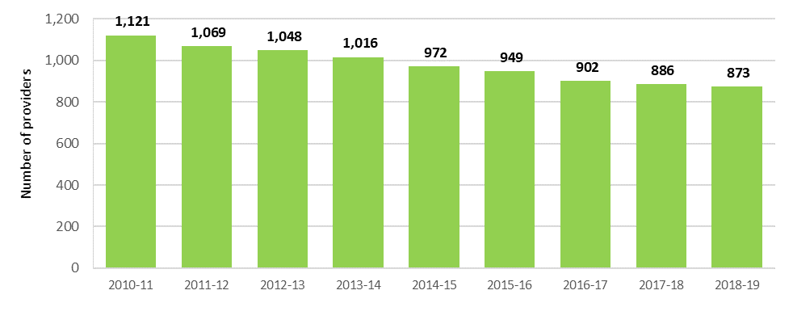

Chart 6.2: Number of operational residential care places, 2010-11 to 2018-19

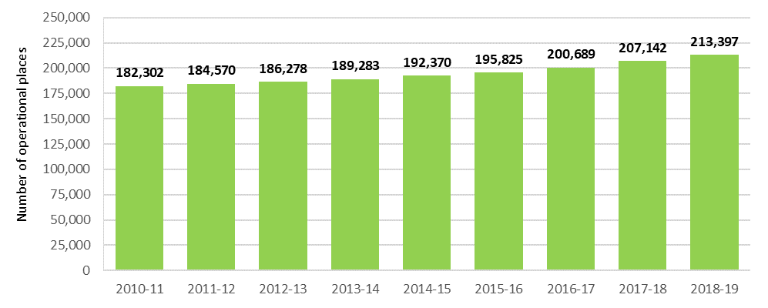

### Ownership type

As shown in Chart 6.3, the largest provider group remains the not-for-profit group (religious, charitable and community-based organisations). They represent 56 per cent of providers and operate 55 per cent of all residential aged care places. For-profit providers account for 33 per cent of providers and 41 per cent of places. The remaining providers and places are state and territory and local government-owned providers. This distribution has been very stable in recent years.

Not-for-profit providers continue to operate proportionally more of the residential care places in rural and regional areas compared with the for‑profits. As at 30 June 2019, not‑for‑profits (55 per cent of all places) were operating 66 per cent of all regional places. Conversely, and also similar to previous years, for-profit providers operated 41 per cent of all places and only 23 per cent of regional places. Government providers operated the remaining regional places.

Chart 6.3: Residential care provider and operational places by ownership type, 2016-17 to 2018-19

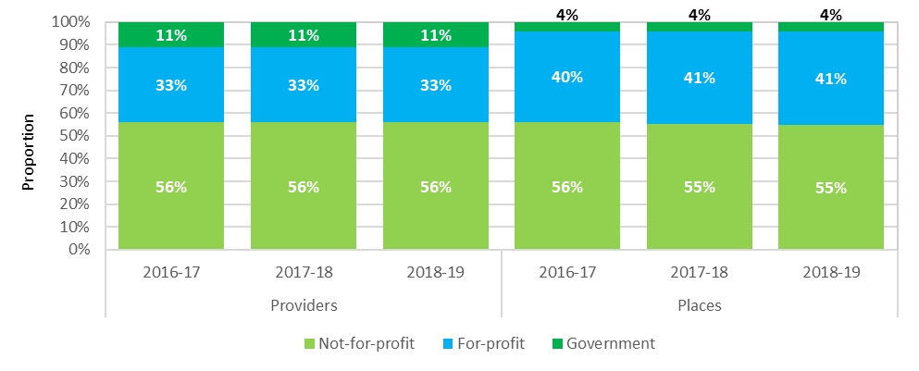

### Provider scale

The majority of residential care providers (63 per cent) operate only one residential care facility (Chart 6.4). These single aged care facility providers account for 20 per cent of all operational residential care places. However this proportion is very gradually declining (23 per cent in 2015-16). Conversely, 2 per cent (21 providers in total) operate more than 20 facilities, but they account for 33 per cent of operational places. This proportion is gradually increasing (27 per cent in 2015-16).

Chart 6.4: Residential care provider and operational places by provider scale, 2015-16 to 2018-19

As shown in Table 6.3, for-profit and not-for-profit providers have, on average, just over three facilities per provider. However within those facilities, for-profit providers, on average, operate 95 residential care places per facility, compared with not‑for‑profit providers who operate 75 places per facility. This likely reflects both some for‑profit providers expanding their facilities and also reflecting the not‑for‑profit’s bigger presence in regional locations where facility size is usually smaller.

Table 6.3: Number of residential care facilities per provider, by ownership type, 30 June 2019

| Organisation type | Number of providers | Number of facilities | Average facilities per provider | Total operational places | Average places per provider | Average places per facility |
| --- | --- | --- | --- | --- | --- | --- |
| Not-for-profit | 488 | 1,558 | 3.19 | 117,500 | 241 | 75 |
| For-profit | 288 | 922 | 3.20 | 87,425 | 304 | 95 |
| Government | 97 | 237 | 2.44 | 8,472 | 87 | 36 |

### Provider location

ACFA generally categorises residential care providers as those operating only in metropolitan areas, those operating only in regional[29] areas, and those who have facilities in both metropolitan and regional areas. A provider is categorised as being regional if more than 70 per cent of their residents are in facilities in regional areas.

Chart 6.5 shows that 51 per cent of providers operate only in metropolitan areas and 39 per cent operate only in regional areas. This has been steady for the last five years.

Chart 6.5: Residential care providers, by location, 2014-15 to 2018-19

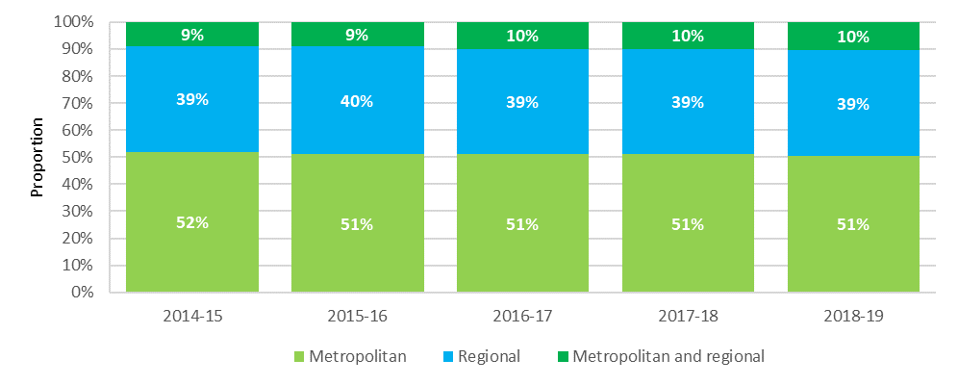

### Residential care facility size and room configuration

The average size of residential care facilities has been increasing over the last 10 years. In 2008, 39 per cent of facilities had over 60 places. This has increased to 60 per cent in 2019. By contrast, the proportion of facilities with 40 places or less has decreased from 32 per cent in 2008 to 20 per cent 2019. This trend seems particularly evident in the for‑profit sector, as discussed in Section 6.1.3, with for‑profit providers having, on average, 20 more places per facility than the not‑for‑profits.

Table 6.4: Size of residential care facilities, 2008 to 2019

| Number of places | June 2008 | June 2009 | June 2010 | June 2011 | June 2012 | June 2013 | June 2014 | June 2015 | June 2016 | June 2017 | June 2018 | June 2019 |
| --- | --- | --- | --- | --- | --- | --- | --- | --- | --- | --- | --- | --- |
| Proportion of facilities (%) | | | | | | | | | | | |  |
| 1–20 places | 7.0 | 6.6 | 6.5 | 6.2 | 6.2 | 6.0 | 5.5 | 5.4 | 5.4 | 5.3 | 5.0 | 4.7 |
| 21–40 places | 24.6 | 22.5 | 21.1 | 20.4 | 19.5 | 19.4 | 18.6 | 18.0 | 17.2 | 16.5 | 16.1 | 15.6 |
| 41–60 places | 29.9 | 29.5 | 28.7 | 28.2 | 27.0 | 26.3 | 25.0 | 24.4 | 23.5 | 22.5 | 21.2 | 19.9 |
| 61+ places | 38.5 | 41.4 | 43.7 | 45.1 | 47.3 | 48.4 | 50.9 | 52.2 | 54.0 | 55.7 | 57.7 | 59.7 |

The increasing trend for room configuration for residential care facilities is a single-bed room with an ensuite. In 2018-19, around 82 per cent (80 per cent in 2017-18 and 77 per cent in 2016-17) of rooms are single-bed rooms with an ensuite. Conversely, 10 per cent of residential care rooms could be considered ‘ward style’ which are shared and have a common shared bathroom, down from 14 per cent in 2017-18 and 18 per cent in 2016-17.

### Provisionally allocated places

Under current arrangements, the Commonwealth releases residential care places through the ACAR. After a place is allocated to an approved provider, there is usually a period during which the place is considered ‘provisional’ while the provider constructs the facility or extends the current facility. Once the place is available to be occupied by a resident, it becomes ‘operational’. The average time it takes providers to bring places online is around four years.

At 30 June 2019, there were 36,905 provisional residential care places reflecting the carryover of allocated places from previous ACARs which are yet to become operational. This represents around 14 per cent of all allocated places, which compares with 13 per cent at 30 June 2018 and 16 per cent at 30 June 2017. The provisional allocations are held by around 18 per cent of all facilities.

As was the case last year, Western Australia has the highest proportion of provisionally allocated places with 27 per cent. The ACT has the next highest with 23 per cent. South Australia and Tasmania have once again the lowest proportion of provisionally allocated places with around 5 per cent (Table 6.5).

Not-for-profit providers, who have 55 per cent of operational places, have only 35 per cent of provisionally allocated places, whereas the for-profit providers, who have 41 per cent of operational places, have 65 per cent of the provisionally allocated places. This is similar to previous years.

In addition, there were also 8,632 formerly operational places that were offline[30] at 30 June 2019 pending refurbishment or redevelopment, or pending sale to another provider.

Table 6.5: Provisionally allocated residential care places, by state and territory, at 30 June 2019

| State/territory | Provisionally allocated places | All allocated places | Proportion |
| --- | --- | --- | --- |
| New South Wales | 10,702 | 85,512 | 12.5% |
| Victoria | 7,594 | 66,795 | 11.4% |
| Queensland | 9,675 | 52,245 | 18.5% |
| Western Australia | 6,842 | 25,131 | 27.2% |
| South Australia | 868 | 19,423 | 4.5% |
| Tasmania | 297 | 5,518 | 5.4% |
| Australian Capital Territory | 812 | 3,590 | 22.6% |
| Northern Territory | 115 | 720 | 16.0% |
| **Australia** | **36,905** | **258,934** | **14.3%** |

Changes introduced in 2016 were designed to encourage providers to operationalise their provisional places in a timely manner. The changes limit the provisional allocation period to four years (noting that up to two extensions of 12 months each may be granted by the Department of Health, and further extensions in exceptional circumstances). At the end of this time, the provisional allocations lapse and the places return to the Department for redistribution in a future ACAR.

In 2018-19, 657 (1,371 in 2017-18) provisionally allocated places were either surrendered by providers or revoked by the Department. The majority (612) of these provisionally allocated places were surrendered by providers or lapsed as the six years expired and the provider did not apply for an extension.

Table 6.6 and Table 6.7 show the distribution of the age of provisionally allocated places by location and state and territory.

Table 6.6: Provisionally allocated residential care places by location and year of distribution, at 30 June 2019

|  | <1 year old | 1-2 years old | 2-4 years old | 4-6 years old | 6-8 years old | 8-10 years old | 10+ years | Total |
| --- | --- | --- | --- | --- | --- | --- | --- | --- |
| Metropolitan | 7,554 | 60 | 12,414 | 5,120 | 467 | 587 | 372 | 26,574 |
| Inner regional | 4,602 | 0 | 3,383 | 649 | 0 | 24 | 52 | 8,710 |
| Outer regional | 602 | 0 | 718 | 233 | 12 | 0 | 0 | 1,565 |
| Remote | 26 | 0 | 30 | 0 | 0 | 0 | 0 | 56 |
| **Total** | **12,784** | **60** | **16,545** | **6,002** | **479** | **611** | **424** | **36,905** |

Table 6.7: Provisionally allocated residential care places by state and territory and year of distribution, at 30 June 2019

|  | <1 year old | 1-2 years old | 2-4 years old | 4-6 years old | 6-8 years old | 8-10 years old | 10+ years | Total |
| --- | --- | --- | --- | --- | --- | --- | --- | --- |
| NSW | 3,408 | 0 | 4,630 | 1,905 | 317 | 300 | 142 | 10,702 |
| VIC | 1,404 | 0 | 4,546 | 1,540 | 15 | 89 |  | 7,594 |
| QLD | 4,117 | 60 | 4,050 | 1,294 |  | 114 | 40 | 9,675 |
| WA | 2,973 | 0 | 2,413 | 1,090 | 32 | 108 | 226 | 6,842 |
| SA | 484 | 0 | 377 | 7 | 0 | 0 | 0 | 868 |
| TAS | 146 | 0 | 135 | 16 | 0 | 0 | 0 | 297 |
| ACT | 202 |  | 329 | 150 | 115 | 0 | 16 | 812 |
| NT | 50 | 0 | 65 | 0 | 0 | 0 | 0 | 115 |
| **Total** | **12,784** | **60** | **16,545** | **6,002** | **479** | **611** | **424** | **36,905** |

#### Transferring residential care places

Residential aged care places (both provisionally allocated and operational) may be transferred between providers. A transfer of places commonly occurs as the result of a business transaction between two approved providers where a decision has been made by the transferor to sell all or some of their residential care places. Transfers of places need to be approved by the Department of Health.

As a general rule, when places transfer between providers, the planning region in respect of which the places are allocated does not change. This rule, and the need for approval by the Department of Health, are designed to discourage attempts to subvert the competitive allocation process and to maintain care delivery in the region where the places were originally allocated.

Data from the Department of Health shows that in 2018-19 around 5,800 operational places and 800 provisionally allocated places were transferred between providers (through around 110 transactions). This compares with 4,400 operational and 1,400 provisional places transferred in 2017-18 (through around 100 transactions).

### Extra service

Providers with extra service status are able to charge an extra service fee for residents occupying an extra service place for the duration of their stay. Extra service status involves the provision of a higher than average standard of services, including accommodation, range and quality of food, and non-care services such as recreational and personal interest activities.

Providers that have been granted extra service status apply to the Aged Care Pricing Commissioner for approval of their proposed extra service fees, including proposed increases to current extra service fees.

For extra service status places that are occupied by a resident who was in care prior to 1 July 2014 and who is covered under the pre-reform fee arrangements, the care subsidy is reduced by 25 per cent of the approved extra service fee for that place. This is known as the Extra Service Subsidy Reduction. The provider can charge a continuing care recipient an amount equal to the extra service fee plus the extra service reduction for receiving extra service. Extra service subsidy reduction does not apply to residents entering care on or after 1 July 2014.

There was a significant decrease in 2014-15 and 2015‑16 in the number of places with extra service status (Chart 6.6). This was likely because changes made to accommodation pricing on 1 July 2014 reduced the need and motivation for providers to have extra service status, partly because:

* lump sum accommodation payments can now be made for all care types – previously they were restricted to low care or high care with extra service;
* market-based prices determined by the provider apply for all new non-supported residents; and
* providers can offer additional care and services for additional fees outside the extra service framework.

Providers who had relinquished their Extra Service places began offering residents ‘fee for additional service’ arrangements instead. However ACFA notes that due to the ongoing uncertainty about the regulation of additional services fees, some providers have reconsidered letting their Extra Service places lapse in recent years, which has resulted in the number of active Extra Service places stabilising since 2015-16, though a further small decline was evident in 2018-19. ACFA also notes that there are currently no plans for new Extra Service places to be released through future ACAR’s.

Chart 6.6: Number of operational extra service residential care places, 30 June 2014 to 30 June 2019

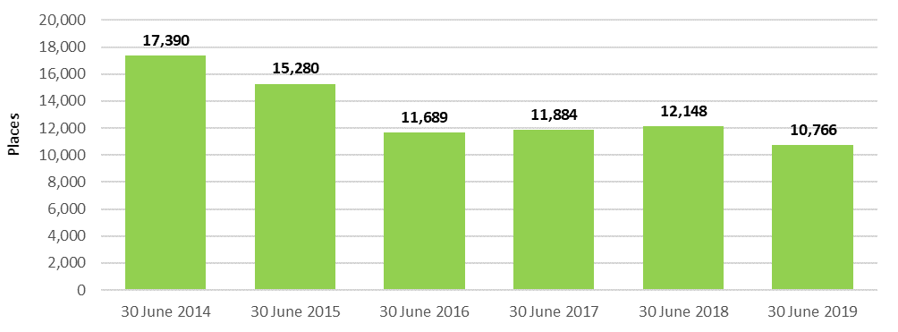

### Additional services

Additional services are care and services that aged care providers can make available to consumers above those that they are legislatively required to provide under the Schedule of Specified Care and Services[31] for residential care services. Additional services vary greatly but may include items such as the provision of pay TV, hairdressing, additional beverage offerings (e.g. wine and beer) and access to a gym. Additional services may be offered individually or as part of a bundle of services. These services attract an additional fee for consumers.

An additional service fee can only be charged for services that have been agreed to by the resident, that are over and above those paid for by the Commonwealth under the Schedule of Specified Care and Services, and from which aged care residents receive a direct and tangible benefit.

As noted previously there remains very limited data available on additional services. However this is an area that is receiving increasing attention from providers. The Department of Health is working with the sector to provide additional clarity and transparency for both providers and residents on the operation of additional services. It is hoped that additional data will be available in future years to enable analysis.

## Residential care funding sources

### Operational funding

Funding for residential care is made up of operational funding and capital financing.

Operational funding supports day-to-day services such as nursing and personal care, living expenses and accommodation expenses. Capital financing supports the construction of new residential care facilities and the refurbishment of existing facilities. Capital financing is discussed in Chapter 7.

A combination of Australian Government and resident contributions provides the operational funding for residential care. Figure 6.1 shows the different funding types from the Commonwealth and residents for operational funding.

Figure 6.1: Residential care services

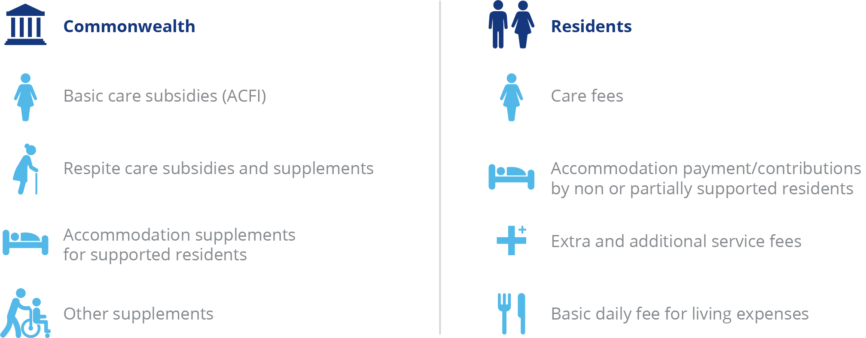

The Commonwealth determines its contributions on behalf of permanent residents in residential care by setting:

* A basic care subsidy for personal and nursing care;
* the rates of supplements paid to support aspects of residential care that incur higher costs to deliver; and
* the maximum rate of accommodation supplement.

With regard to respite care, the Commonwealth sets the basic respite care subsidy at two levels (low or high) depending on the level of respite care the consumer is approved for by the Aged Care Assessment Team (ACAT).

The Commonwealth also sets the maximum levels for contributions made by residents for the following:

* the maximum rate of the basic daily fee for living expenses (permanent and respite); and
* the maximum means tested care fee that may be charged by providers (permanent only).

### Commonwealth operational funding

Commonwealth payments for residential care can be classified as:

* basic care subsidies
* respite care subsidies and supplements
* accommodation supplements
* viability supplements
* other supplements

A full list of subsidies and supplements is at Appendix G.

Commonwealth subsidies and supplements are generally indexed either biannually (accommodation related) or annually (care related).

The indexation applied to the basic subsidy for residential care is the Wage Cost Index 9 (WCI‑9), which is a composite index constructed by the Department of Finance that comprises a wage cost component (weighted at 75 per cent) and a non-wage cost component (weighted at 25 per cent). For all Wage Cost Indices the value of the wage cost component is based on the dollar increase in the national minimum wage (as determined annually by the Fair Work Commission) expressed as a percentage of the latest available estimate of average weekly ordinary time earnings (AWOTE) published by the Australian Bureau of Statistics as at November of each year. The value of the non-wage cost component of WCI-9 is based on changes in the Consumer Price Index between the March quarters each year.

Accommodation related supplements are indexed using the Consumer Price Index (CPI) and are indexed twice a year in line with the aged pension.

### Basic care subsidies

* **The basic care subsidy** is a payment to support the costs of providing personal and nursing services for permanent residents. It is calculated based on the assessed need of each permanent resident as determined by the provider by applying the Aged Care Funding Instrument (ACFI).The Commonwealth determines the level of payments on behalf of residents by setting the prices and rules for claiming ACFI care subsidies.
* **The residential respite subsidy** is a payment to support the costs of providing personal and nursing services for respite consumers. Respite consumers are assessed by an ACAT as requiring either low or high level respite care, with payment amounts for each set by the Commonwealth.

#### The Aged Care Funding Instrument (ACFI)

The ACFI is the funding allocation tool currently used to determine the amount of funding paid to a provider on behalf of a resident for their care. It assesses the care needs of permanent residents as a basis for allocating care funding by focusing the funding allocation around the main areas that differentiate relative care needs and costs among residents.

The ACFI consists of 12 questions about assessed care needs, each having four ratings (A, B, C or D) and two diagnostic sections. ACFI is self-assessed by providers, but is subject to audits by the Department of Health.

As discussed in recent reports, during 2015-16, real growth of expenditure per resident per day through the ACFI was 5.2 per cent, compared with a Government budgeted real growth of 3.2 per cent. This resulted in an increase to the Government’s forecast expenditure over four years of $3.8 billion. The Government responded by announcing changes to the ACFI and indexation which took effect on 1 July 2016 and 1 January 2017. The changes to ACFI included a new matrix reducing the rating categories for medication under Question 11 of the Complex Health Care domain and changes to the scoring and eligibility requirements for certain Complex Health Care procedures. The changes were complemented by an indexation pause on all ACFI domains in 2017‑18 and a partial indexation pause in 2018‑19.

Annual growth in the daily average ACFI expenditure for 2017-18 was forecast to be around 2.4 per cent but the actual growth for the year was around 0 per cent. For 2018-19 the annual growth in the daily average ACFI expenditure was forecast to be around 1.5 per cent and the actual growth for the year was 0.8 per cent. For 2019-20, annual real growth in ACFI is forecast to be 1.2 per cent. Real growth up to December 2019 was 0.2 per cent.

Real growth refers to growth in the average ACFI above that which can be attributed to the indexation applied annually. Separate to the annual indexation increases, the Government announced two measures that impacted average subsidies paid to providers in 2018-19. These are the additional $50 million in ACFI funding from September 2018 to end June 2019 to assist providers in transitioning to the new Quality Standards, and the $320 million one-off increase in ACFI funding from March to end June 2019. These increases were for the 2018-19 year only.

The Department of Health produces monthly reports regarding actual ACFI expenditure compared with Budget estimates. These reports can be found at <https://agedcare.health.gov.au/tools-and-resources/aged-care-funding-instrument-acfi-reports>. Chart 6.7 shows the average ACFI payment per resident per day that applied in each month since January 2016. This is shown in real and nominal terms and also shows the impact of the one-off $320 million increase as discussed above.

Chart 6.7: Average monthly ACFI payments (real and nominal), January 2016 to July 2019

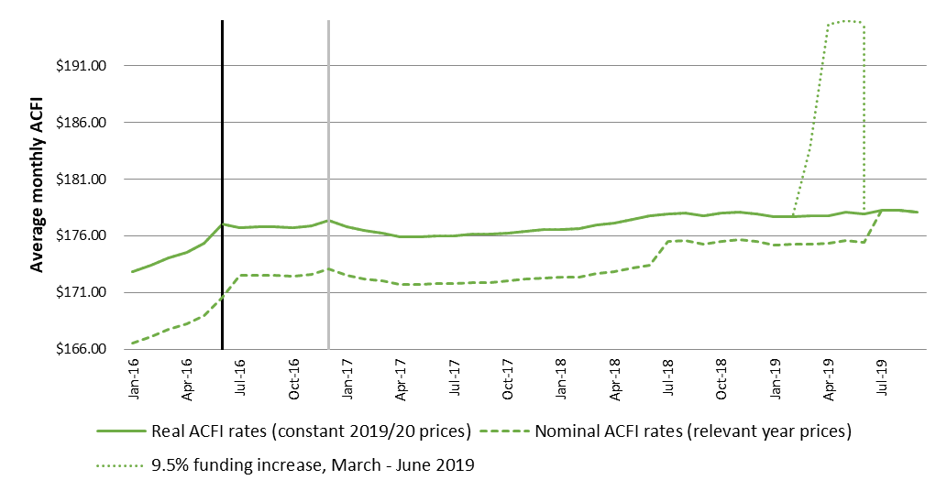

The average ACFI claim per resident per day can vary across facilities, reflecting variations in resident profile and the claiming behaviour of providers. ACFA noted last year that during its consultations with providers, a number indicated that they were ‘under claiming’ ACFI relative to the care needs of residents and were seeking to improve their ACFI claims process. Chart 6.8 shows the range of claims for 2018-19 with some facilities averaging less than $70 per day while a number average over $210 per day.

Chart 6.8: Number of residential care facilities in each range of ACFI claims per resident per day, 2018-19

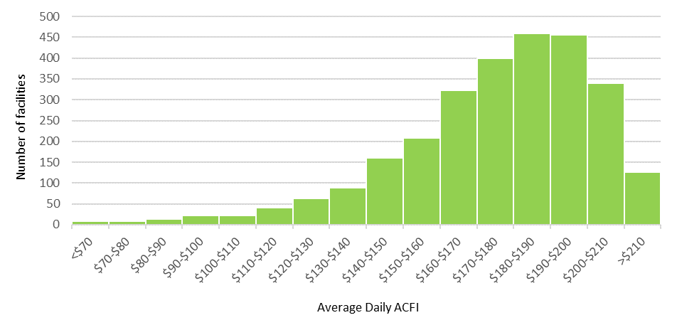

As noted last year, the Government commissioned a study on the relative costs of providing care for residents with differing care needs and has been consulting with the sector on long-term reform options for residential aged care funding. Reports from the Resource Utilisation and Classification Study (RUCS) were released in March 2019 and included evidence on the drivers of costs of care in residential care facilities as well as a proposed new funding model to replace the ACFI. The Government began consulting with the sector on the recommendations in the reports.

The RUCS suggested that the ACFI does not adequately distinguish between the fixed costs of providing residential aged care and the variable costs per resident based on individual care needs. As part of the RUCS, a new assessment and funding model was proposed, known as the Australian National Aged Care Classification (AN-ACC) system.

A trial of the AN-ACC assessment system commenced in November 2019, involving over 150 facilities. Over 7,000 assessments (out of a planned total of 10,000) had been completed before the trial was suspended due to the COVID-19 pandemic.

The Government has also appointed a Residential Aged Care Funding Reform Working Group to discuss the practicalities of implementing the AN-ACC and strategies to support sector readiness.

While consultation is important, and the delay due to COVID-19 is understandable, ACFA notes the delay in responding to the RUCS reports is creating considerable uncertainty in the sector and may be adversely affecting investment decisions.

The ACFI does not apply for residential respite care. Instead, respite care funding is paid at either a low or high rate depending on the level of care for which the consumer is approved by the ACAT. Additionally, providers who use 70 per cent or more of their respite allocation over a 12‑month period receive a higher payment[32].

ACFA considers that future funding for residential respite should be incorporated within the proposed AN-ACC assessment and funding model.

### Residential care supplements

Residential care supplements are payments in addition to the basic daily subsidy (ACFI). There are two types of supplements:

* primary supplements, which provide additional funds to meet specific care needs. These include the oxygen supplement and enteral feeding supplement; and
* other supplements, which are accommodation-based and assist providers with costs related to the operation of a residential care facility. Other supplements include accommodation supplements, the viability supplement and homeless supplement.

The types and amounts of supplements that a residential care facility will receive depends on the provider and/or residents meeting the eligibility requirements for those supplements.

The major supplements are summarised below and a full list of supplements, including rates and expenditure over the last 3 years are included at Appendices G and H.

#### Accommodation supplements

Accommodation supplements are paid by the Commonwealth to assist with the accommodation costs of permanent residents who do not have the means to meet all of that cost themselves (supported residents). These supplements include both the current accommodation supplement and grand-parented supplements under previous policies. Accommodation supplements (or accommodation payments) do not apply for consumers accessing residential respite care.

The Commonwealth determines the amount of accommodation supplement payable by setting the maximum rate of accommodation supplement and determining the share paid by residents based on a means test.

Two significant reforms from 1 July 2014 affected accommodation payments. A new means test that combined the formerly separate income and assets tests was introduced for residents entering residential care after 1 July 2014, and the accommodation supplement paid by the Commonwealth to a provider on behalf of supported residents living in aged care facilities that have been built or significantly refurbished since 20 April 2012 was significantly increased.

#### Viability supplement

The viability supplement aims to improve the financial position of smaller, rural and remote residential care facilities that incur additional costs due to their location and are constrained in their ability to realise economies of scale due to smaller numbers of beds. In addition, the viability supplement also supports providers who specialise in aged care services for Indigenous people, or people who are homeless or who are at risk of becoming homeless, in recognition of the often higher costs associated with providing these services.

The supplement is available to residential care facilities, home care services, Multi-Purpose Services and Aboriginal and Torres Strait Islander Flexible services. In 2018-19, on average, the viability supplement provided around $10,800 per resident per annum for residential care facilities in remote and very remote areas, directly improving their financial results.

Over the last decade the amount paid per resident per day for the viability supplement has increased by over 100 per cent. The increases or expansions to the viability supplement include:

* A 40 per cent increase from 2009-10;
* An expansion of the supplement from 2011-12 to provide additional support to facilities in remote to moderately accessible locations that target low care residents or who provide specialist care to Indigenous Australians or people with a history of (or who may be at severe risk of) homelessness;
* A 20 per cent increase from 2014-15;
* A flat rate increase of $2.12 per resident per day from 2017-18;
* A 30 per cent increase from March 2019; and
* A temporary 30 per cent increase for 6 months from March 2020 as part of the COVID-19 response.

#### Homeless supplement

A homeless supplement is paid to providers for each resident of an eligible aged care facility. Eligibility for the supplement is based on the facility having more than 50 per cent of its residents with complex behavioural needs who are identified as being homeless, or at risk of becoming homeless.

The supplement is in addition to the funding provided under the viability supplement.

In 2018-19, 40 residential services received the homeless supplement on behalf of more than 1,900 residents. During 2018‑19 $9.8 million in homeless supplement was paid to providers.

A 30 per cent increase to the rate of the homeless supplement took effect from March 2019. As part of the response to COVID-19, the Government temporarily increased the Homeless supplement by an additional 30 per cent for six months from 1 March 2020.

### Payments for residential respite care

The Australian Government pays the provider a residential respite subsidy and a respite supplement for each eligible respite resident.

The subsidy and supplement are paid at either a low or high rate depending on the level of respite care the consumer is approved for by the ACAT. Additionally, facilities that use 70 per cent or more of their respite allocation over a 12 month period receive a higher daily respite supplement rate per eligible high care recipient. Respite subsidies are indexed on 1 July each year. Respite supplements are indexed on 20 March and 20 September each year in line with pension indexation. Table 6.8 shows the residential care respite rates applicable as at 20 March 2020[33].

Table 6.8: Residential respite care subsidies and supplement rates, at 20 March 2020

|  | Daily subsidy | Daily supplement | Total paid per day |
| --- | --- | --- | --- |
| Low level respite care | $47.39 | $39.87 | $87.26 |
| High level respite care | $132.88 | $55.88 | $188.76 |
| High level respite care when a facility uses 70% or more of respite allocation | $132.88 | $95.08 | $227.96 |

In addition, residential respite consumers can be eligible for other supplements, such as oxygen supplement, where there is a need.

Chart 6.9 shows total Commonwealth payments for residential respite care since 2012-13. Respite care is also discussed in Chapter 3.

Chart 6.9: Total residential respite care expenditure, 2012-13 to 2018-19 ($m)

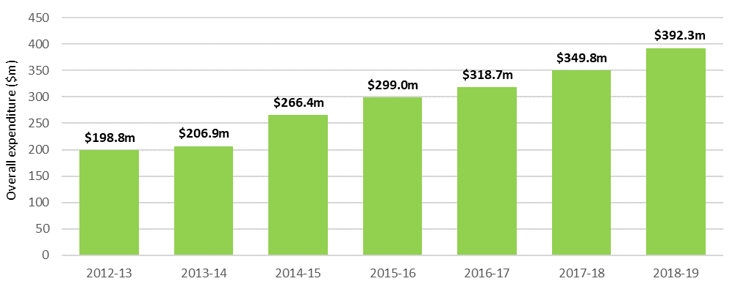

### Resident operational funding

Contributions by permanent residents for operational funding are made up of:

* **A basic daily fee,** which is a contribution towards living expenses such as meals, laundry services, utilities and toiletries. The price is set by the Commonwealth, and is set at a maximum of 85 per cent of the single basic age pension.
* **A means tested care fee,** which is a contribution some residents make towards their care costs (personal and nursing) based on their assessable income and assets. Annual and lifetime caps on care contributions apply as a consumer protection. As at 20 September 2019, the annual cap for a means tested care fee was $27,754.52, with a lifetime cap of $66,610.90 also applying.
* **Accommodation payments,** which are daily payments for accommodation in an aged care facility. Lump sum accommodation deposits are not treated as revenue, but as capital financing, discussed in Chapter 7.
* **Extra service fees,** which residents in aged care facilities with extra service status may be asked to pay for significantly higher standards of accommodation, food and non-care services. These vary from facility to facility.
* **Additional services fees,** which are for care and services in non-extra service facilities that are over and above those that providers are required to deliver under the Specified Care and Services Schedule of the Aged Care Act 1997, and must be agreed between the resident and provider. These vary from facility to facility, and are not payable at all facilities.

## Operational performance in 2018-19

### Revenue

ACFA broadly describes revenue for residential care providers in four categories: care related, living expenses, accommodation and other. Table 6.9 provides a breakdown of the revenue reported by residential care providers in 2018-19 compared with the previous two years.

**Table 6.9: Revenue sources for residential care providers, by care, accommodation, living and ‘other’, 2016-17 to 2018-19 ($m)**

| Revenue sources | 2016-17 ($million) | 2017-18 ($million) | Change ($million) | 2018-19 ($million) | Change ($million) |
| --- | --- | --- | --- | --- | --- |
| **Care Related** |  |  |  |  |  |
| Basic care subsidy (ACFI) | $10,741.7 | $10,812.3 | $70.60 | $11,286.2 | $473.9 |
| Respite subsidy & supplements | $301.4 | $346.9 | $45.50 | $383.0 | $36.1 |
| Other supplements | $89.3 | $84.5 | -$4.80 | $106.5 | $22.0 |
| Resident means tested fee | $468.9 | $504.0 | $35.10 | $586.0 | $82.0 |
| Resident other care fees | $61.2 | $48.7 | -$12.50 | $79.2 | $30.5 |
| **Total care revenue** | **$11,662.5** | **$11,796.4** | **$133.90** | **$12,440.8** | **$644.5** |
| **Living Related** |  |  |  |  |  |
| Resident basic daily fee | $3,186.7 | $3,253.4 | $66.70 | $3,425.8 | $172.4 |
| Extra service fee | $157.5 | $119.3 | -$38.20 | $118.4 | -$0.9 |
| Additional services fees | N/A | $96.7 | $96.70 | $122.2 | $25.5 |
| Total living related revenue | **$3,344.2** | **$3,469.4** | **$125.20** | **$3,666.4** | **$197.0** |
| **Accommodation related** |  |  |  |  |  |
| Accommodation supplement | $929.7 | $1,008.1 | $78.40 | $1,158.6 | $150.5 |
| Accommodation payments from residents | $778.4 | $781.0 | $2.60 | $828.7 | $47.7 |
| Capital Grants | $61.7 | $56.5 | -$5.20 | $70.0 | $13.6 |
| **Total Accommodation related revenue** | **$1,769.8** | **$1,845.5** | **$75.70** | **$2,057.3** | **$211.8** |
| **Other income** |  |  |  |  |  |
| Interest | $313.8 | $326.2 | $12.40 | $334.6 | $8.4 |
| Donations and fundraising | $32.3 | $29.0 | -$3.30 | $24.2 | -$4.8 |
| Gain on sale of assets | $29.1 | $23.2 | -$5.90 | $54.8 | $31.6 |
| Revaluation of assets | $130.4 | $37.9 | -$92.50 | $108.3 | $70.5 |
| Other | $474.4 | $538.6 | $64.20 | $615.1 | $76.5 |
| **Total other revenue** | **$980.0** | **$954.9** | -$25.10 | **$1,137.1** | $182.2 |
| **Total residential provider revenue** | **$17,756.5** | **$18,066.2** | **$309.70** | **$19,301.6** | **$1,235.4** |

1. ‘Resident other care fees’ are fees and charges received from a resident in respect of occasional care services like consultation, medication, treatment or procedures provided in addition to services required to be delivered under Schedule 1 of the Aged Care Act 1997.
2. The inclusion of a line item for additional services fees since 2017-18 has resulted in a decrease in extra services fees, resident other care fees, and comparative decrease in accommodation payments from residents.

In 2018-19, care related revenue ($12.4 billion) formed the majority (64.5 per cent) of total revenueearned by residential care providers ($12.8 billion), which has been the case in previous years. Livingrelated revenue received from residents, which includes the basic daily fee, extra services fees and additional service fees, accounted for 19.0 per cent ($3.7 billion) of total revenue, again similar to previous years.

Accommodation payments, consisting of accommodation supplements paid by the Government and daily accommodation payments paid by residents, accounted for 10.7 per cent ($2.1 billion) of total provider revenue.

Other income of $1.1 billion made up the remaining 5.9 per cent of total residential care provider revenue in 2018-19. Interest revenue, which makes up a third of total ‘other’ income may include interest earned on lump sum deposits less any interest payments made on borrowings (providers may show these separately in their balance sheets or may combine them as ‘net’).

Chart 6.10 shows the proportions of all revenue sources for residential care providers in 2018-19.

Chart 6.10: Proportions of total residential care provider revenue, 2018-19 ($m)

~~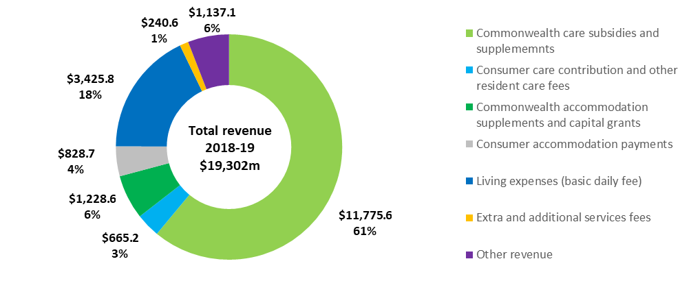~~

ACFA also analyses revenue sources in terms of those sources provided by the Commonwealth compared with those provided by residents. Table 6.10 shows provider revenue sources for 2018‑19 compared with the previous two years.

Table 6.10: Revenue sources for residential care providers, Commonwealth, resident and ‘other’, 2016-17 to 2018-19 ($m)

| Revenue sources | 2016-17 ($million) | 2017-18 ($million) | Change ($million) | 2018-19 ($million) | Change ($million) |
| --- | --- | --- | --- | --- | --- |
| **Commonwealth** |  |  |  |  |  |
| Basic care subsidy (ACFI) | $10,741.7 | $10,812.3 | $70.60 | $11,286.2 | $473.9 |
| Respite subsidy & supplements | $301.4 | $346.9 | $45.50 | $383.0 | $36.1 |
| Other supplements | $89.3 | $84.5 | -$4.80 | $106.5 | $22.0 |
| Accommodation supplement | $929.7 | $1,008.1 | $78.40 | $1,158.6 | $150.5 |
| Capital Grants | $61.7 | $56.5 | -$5.20 | $70.0 | $13.6 |
| **Commonwealth funding sources** | **$12,123.8** | **$12,308.2** | **$184.40** | **$13,004.3** | **$696.1** |
| **Resident** |  |  |  |  |  |
| Resident basic daily fee | $3,186.7 | $3,253.4 | $66.70 | $3,425.8 | $172.4 |
| Resident means tested fee | $468.9 | $504.0 | $35.10 | $586.0 | $82.0 |
| Resident other care fees | $61.2 | $48.7 | -$12.50 | $79.2 | $30.5 |
| Accommodation payments from residents | $778.4 | $781.0 | $2.60 | $828.7 | $47.7 |
| Extra service fee | $157.5 | $119.3 | -$38.20 | $118.4 | -$0.9 |
| Additional services fees | N/A | $96.7 | $96.70 | $122.2 | $25.5 |
| **Resident funding sources** | **$4,652.7** | **$4,803.1** | **$150.40** | **$5,160.3** | **$357.2** |
| **Other income** |  |  |  |  |  |
| Interest | $313.8 | $326.2 | $12.40 | $334.6 | $8.4 |
| Donations and fundraising | $32.3 | $29.0 | -$3.30 | $24.2 | -$4.8 |
| Gain on sale of assets | $29.1 | $23.2 | -$5.90 | $54.8 | $31.6 |
| Revaluation of assets | $130.4 | $37.9 | -$92.50 | $108.3 | $70.5 |
| Other | $474.4 | $538.6 | $64.20 | $615.1 | $76.5 |
| Other funding sources | **$980.0** | **$954.9** | -$25.10 | **$1,137.1** | **$182.2** |
| **Total revenue** | **$17,756.5** | **$18,066.2** | **$309.70** | **$19,301.6** | **$1,235.4** |

1. Extra service subsidy reduction does not apply to new residents entering care from 1 July 2014, however it still applies to residents in ESS places who were in care prior to 1 July 2014.
2. Additional services fees were not reported for 2016‑17 so no comparison between 2016‑17 and 2017‑18 is possible.

Overall in 2018-19, the Commonwealth contributed 67.4 per cent of total provider funding ($13.0 billion) and residents contributed 26.7 per cent ($5.2 billion). This is comparable with 2017‑18 when the Commonwealth’s share was 68.1 per cent and residents contributed 26.6 per cent.

Chart 6.11 shows the proportion of revenue that residential care providers received in 2018-19 from the Commonwealth. Basic subsidies (ACFI) comprised by far the greatest share at 87 per cent.

Chart 6.11: Proportions of provider revenue from the Commonwealth, 2018-19 ($m)



Chart 6.12 shows the proportion of total revenue that residential care providers receive from residents. The basic daily fee forms the greatest share (67 per cent). Accommodation payments formed a further 16 per cent of the revenue received and means tested care fees represented 11 per cent.

Chart 6.12: Proportions of residential care provider revenue from residents, 2018-19 ($m)



Table 6.11 shows total revenue per resident per day in 2018-19 compared with the previous two years. Total revenue per resident per day was $283.54, an increase of 4.2 per cent from 2017-18 ($272.16).

Table 6.11: Residential care provider revenue sources per resident per day, 2016-17 to 2018-19

|  | 2016-17 | 2017-18 | Change ($) | 2018-19 | Change ($) |
| --- | --- | --- | --- | --- | --- |
| **Commonwealth** |  |  |  |  |  |
| Basic care subsidy (ACFI) | $163.07 | $162.88 | -$0.19 | $165.79 | $2.91 |
| Respite subsidy & supplements | $4.58 | $5.23 | $0.65 | $5.63 | $0.40 |
| Other supplements | $1.36 | $1.27 | -$0.09 | $1.56 | $0.29 |
| Accommodation supplement | $14.11 | $15.19 | $1.08 | $17.02 | $1.83 |
| Capital Grants | $0.94 | $0.85 | -$0.09 | $1.03 | $0.18 |
| **Commonwealth funding sources** | **$184.06** | **$185.42** | **$1.36** | **$191.03** | **$5.61** |
| **Resident** |  |  |  |  |  |
| Resident basic daily fee | $48.38 | $49.01 | $0.63 | $50.32 | $1.31 |
| Resident means tested fee | $7.12 | $7.59 | $0.47 | $8.61 | $1.02 |
| Resident other care fees | $0.93 | $0.73 | -$0.20 | $1.16 | $0.43 |
| Accommodation payments from residents | $11.82 | $11.77 | -$0.05 | $12.17 | $0.40 |
| Extra service fee | $2.39 | $1.8 | -$0.59 | $1.74 | -$0.06 |
| Additional services fees | $0 | $1.46 | $1.46 | $1.80 | $0.34 |
| **Resident funding sources** | **$70.64** | **$72.36** | **$1.72** | **$75.80** | **$3.44** |
| **Other** |  |  |  |  |  |
| Other income | $14.88 | 14.38 | -$0.50 | $16.70 | $2.32 |
| **Total revenue** | **$269.58** | **$272.16** | **$2.58** | **$283.54** | **$11.37** |

1. Extra service subsidy reduction does not apply to new residents entering care from 1 July 2014, however it still applies to residents in ESS places who were in care prior to 1 July 2014.

### Expenses

Total expenditure in 2018-19 for residential care providers was $19.0 billion, up 8 per cent from $17.6 billion in 2017-18. Chart 6.13 shows total expenses for the seven years to 2018-19.

Chart 6.13: Total expenses, residential care providers, 2012-13 to 2018-19 ($b)

~~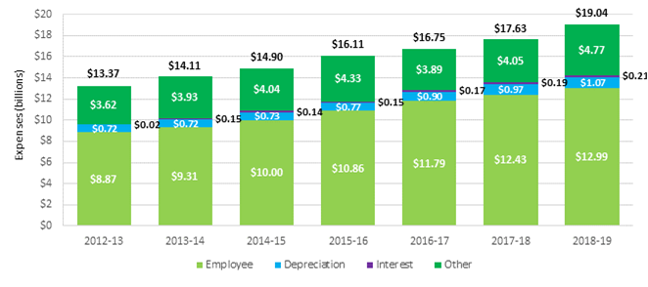~~

Table 6.12 shows the expenses for residential care providers in 2018-19 compared with the previous two years. Chart 6.14 presents the expenses for 2018-19 as a proportion of total expenses.

Table 6.12: Summary of expenses, residential care providers, 2016‑17 to 2018-19 ($m)

| Expenses |  | 2016‑17 ($m) | 2017-18 ($m) | 2018-19 ($m) | Change ($m) | Change (%) |
| --- | --- | --- | --- | --- | --- | --- |
| Employee |  | $11,792.1 | $12,426.7 | $12,994.2 | $567.5 | 4.6% |
| Depreciation |  | $895.3 | $968.9 | $1,067.0 | $98.1 | 10.1% |
| Interest |  | $171.1 | $186.7 | $205.7 | $19.0 | 10.2% |
| Other expenses |  | $3,892.3 | $4,048.8 | $4,770.4 | $721.5 | 17.8% |
| **Total expenses** |  | **$16,750.8** | **$17,631.1** | **$19,037.3** | **$1,406.2** | **8.0%** |

Employee costs represent 68 per cent of the total expenses incurred by providers, an increase of 4.6 per cent over 2017-18, following a similar increase over 2016-17.

‘Other’ expenses represented 25 per cent of total costs, up slightly from 2017-18 when it was 23 per cent. ‘Other’ expenses include building repairs and maintenance expenses, rent, utilities and costs associated with employment support activities, cleaning and administration. Depreciation and interest costs account for the remaining 6 per cent and 1 per cent respectively, similar to 2017-18.

Chart 6.14: Proportion of residential care provider total expenses, 2018-19 ($m)



Table 6.13 shows the major expense types for providers, per resident per day, for the six years to 2018-19. Total expenses per resident per day have generally increased each year by between 4‑6 per cent.

Table 6.13: Summary of residential care provider expenses, per resident per day, 2013-14 to 2018-19

| Expenses | 2013-14 | 2014-15 | 2015-16 | 2016-17 | 2017-18 | 2018-19 |
| --- | --- | --- | --- | --- | --- | --- |
| Employee | $148.81 | $157.68 | $166.84 | $179.01 | $187.21 | $190.88 |
| Depreciation | $11.56 | $11.49 | $11.87 | $13.59 | $14.60 | $15.67 |
| Interest | $2.34 | $2.21 | $2.3 | $2.6 | $2.81 | $3.02 |
| Other | 6$2.81 | $63.67 | $66.57 | $59.09 | $61.00 | $70.08 |
| **Total expenses** | **$225.52** | **$235.05** | **$247.58** | **$254.29** | **$265.61** | **$279.65** |

As noted previously, since 2016‑17, a new breakdown of expenditure data was collected through the introduction of the ACFR. This has enabled the collection of more detailed expenditure information. Table 6.14 shows provider expenditure in 2018-19, compared with the previous two years, using the new categories collected through the ACFR.

Table 6.14: Breakdown of residential care provider expenses, 2016-17 to 2018-19 ($m)

|  |  |  |  |  |  |  |  |  |  |  |  |  |  |  |  |  |  |  |  |  |  |  |  |  |  |  |  |  |  |  |  |  |  |  |  |  |  |  |  |  |  |  |  |  |  |  |  |  |  |  |  |  |  |  |  |  |  |  |  |  |  |  |  |  |  |  |  |  |  |  |  |  |  |  |  |  |  |  |  |  |  |  |  |  |  |  |  |  |  |  |  |  |  |  |  |  |  |  |  |  |  |  |  |  |  |  |  |  |  |  |  |  |  |  |  |  |  |  |  |  |  |  |  |  |  |  |  |  |  |  |  |  |  |  |  |  |  |  |  |  |  |  |  |  |  |  |  |  |  |  |  |  |  |  |  |  |  |  |  |  |  |  |  |  |  |  |  |  |  |  |  |  |  |  |  |  |  |  |  |  |  |  |  |  |  |  |  |  |  |  |  |  |  |  |  |  |  |  |  |  |  |  |  |  |  |  |  |  |  |  |  |  |  |  |  |  |  |  |  |  |  |  |  |  |  |  |  |  |  |  |  |  |  |  |  |  |  |
| --- | --- | --- | --- | --- | --- | --- | --- | --- | --- | --- | --- | --- | --- | --- | --- | --- | --- | --- | --- | --- | --- | --- | --- | --- | --- | --- | --- | --- | --- | --- | --- | --- | --- | --- | --- | --- | --- | --- | --- | --- | --- | --- | --- | --- | --- | --- | --- | --- | --- | --- | --- | --- | --- | --- | --- | --- | --- | --- | --- | --- | --- | --- | --- | --- | --- | --- | --- | --- | --- | --- | --- | --- | --- | --- | --- | --- | --- | --- | --- | --- | --- | --- | --- | --- | --- | --- | --- | --- | --- | --- | --- | --- | --- | --- | --- | --- | --- | --- | --- | --- | --- | --- | --- | --- | --- | --- | --- | --- | --- | --- | --- | --- | --- | --- | --- | --- | --- | --- | --- | --- | --- | --- | --- | --- | --- | --- | --- | --- | --- | --- | --- | --- | --- | --- | --- | --- | --- | --- | --- | --- | --- | --- | --- | --- | --- | --- | --- | --- | --- | --- | --- | --- | --- | --- | --- | --- | --- | --- | --- | --- | --- | --- | --- | --- | --- | --- | --- | --- | --- | --- | --- | --- | --- | --- | --- | --- | --- | --- | --- | --- | --- | --- | --- | --- | --- | --- | --- | --- | --- | --- | --- | --- | --- | --- | --- | --- | --- | --- | --- | --- | --- | --- | --- | --- | --- | --- | --- | --- | --- | --- | --- | --- | --- | --- | --- | --- | --- | --- | --- | --- | --- | --- | --- | --- | --- | --- | --- | --- | --- | --- | --- | --- | --- | --- | --- | --- | --- |
| |  | 2016-17 ($m) | 2017-18 ($m) | 2018-19 ($m) | Change ($m) | Change (%) | % of total expenses | | --- | --- | --- | --- | --- | --- | --- | | **Care** |  |  |  |  |  |  | | Employee expenses | $8,549.9 | $8,968.7 | $9,449.6 | $480.9 | 5.4% | 49.6% | | Contracted services | $0.0 | $0.0 | $278.0 | $278.0 | 100.0% | 1.5% | | Other | $536.1 | $588.4 | $594.0 | $5.6 | 0.9% | 3.1% | | **Total care expenses** | **$9,086.0** | **$9,557.0** | **$10,321.6** | **$764.5** | **8.0%** | **54.2%** | | **Accommodation** |  |  |  |  |  |  | | Employee expenses | $364.1 | $283.7 | $315.1 | $31.3 | 11.0% | 1.7% | | Repairs & maintenance | $470.3 | $477.6 | $450.8 | -$26.8 | -5.6% | 2.4% | | Rent | $342.1 | $357.0 | $423.5 | $66.5 | 18.6% | 2.2% | | Other | $455.4 | $497.8 | $530.8 | $33.0 | 6.6% | 2.8% | | **Total accommodation expenses** | **$1,631.9** | **$1,616.2** | **$1,720.2** | **$104.1** | **6.4%** | **9.0%** | | **Hotel** |  |  |  |  |  |  | | Employee expenses | $1,463.0 | $1,600.4 | $1,691.7 | $91.3 | 5.7% | 8.9% | | Contracted services | $445.9 | $495.9 | $533.4 | $37.5 | 7.6% | 2.8% | | Other | $712.1 | $722.4 | $764.9 | $42.4 | 5.9% | 4.0% | | **Total hotel expenses** | **$2,621.0** | **$2,818.7** | **$2,990.0** | **$171.3** | **6.1%** | **15.7%** | | **Administration** |  |  |  |  |  |  | | Employee expenses | $922.6 | $970.4 | $967.3 | -$3.0 | -0.3% | 5.1% | | Management fees | $492.5 | $603.5 | $570.4 | -$33.0 | -5.5% | 3.0% | | Other | $594.0 | $662.4 | $713.2 | $50.9 | 7.7% | 3.7% | | **Total administration expenses** | **$2,009.1** | **$2,236.2** | **$2,251.0** | **$14.8** | **0.7%** | **11.8%** | | **Financing** |  |  |  |  |  |  | | Depreciation | $874.5 | $942.9 | $1,067.0 | $124.1 | 13.2% | 5.6% | | Amortisation | $20.8 | $26.0 | $52.6 | $26.6 | 102.2% | 0.3% | | Interest | $171.2 | $186.7 | $205.7 | $19.0 | 10.2% | 1.1% | | **Total financing expenses** | **$1,066.5** | **$1,155.6** | **$1,325.3** | **$169.7** | **14.7%** | **7.0%** | | **Other** |  |  |  |  |  |  | | Revaluation of assets (decrease) | $32.2 | $38.7 | $48.3 | $9.6 | 24.7% | 0.3% | | Loss on sale of assets | $9.5 | $9.4 | $18.8 | $9.4 | 99.6% | 0.1% | | Other | $294.9 | $199.3 | $362.2 | $162.9 | 81.8% | 1.9% | | **Total other expenses** | **$336.6** | **$247.4** | $429.2 | $181.9 | 73.5% | 2.3% | | **Total expenses** | **$16,751.1** | **$17,631.1** | **$19,037.3** | **$1,406.2** | **8.0%** | **100%** | |  |  |  |  |  |  |
| Note: Management fees are expenses that are paid to another person/organisation to govern and manage operations of the facility on behalf of the provider (includes management fees paid to both related and non-related parties). |  |  |  |  |  |  |

Care expenditure relates to the direct costs incurred in providing care for residents within residential care facilities. Care related employee expenses make up 92 per cent of total care expenses, and 50 per cent of total expenditure, making it the largest single expense for providers. Employee expenses include payments made to doctors, nursing, therapists, nutritionists, case managers, health assistants and support staff.

Other care expenses include items such as resident medication, oxygen and related equipment, treatments and procedures, incontinence aids, items that assist mobility, recreation and social activities, rehabilitation support, personal grooming and specific cultural and social events.

Accommodation expenditure, which represents 9 per cent of total expenses, relates to the costs incurred in providing accommodation to residents. This includes accommodation employee expenses, repairs and maintenance and rent.

Hotel expenditure (which represents 16 per cent of total expenses) relates to the costs incurred in the provision of everyday living expenses to residents, including employees, contracted services and other. Contracted services are payments made to external providers or internal divisions for the provision of catering, cleaning or laundry. Other expenses consist of expenses such as meals, refreshments, other food consumables, bedding materials, toiletry and sanitary goods, cleaning items and laundry items.

Financing expenditure relates to depreciation incurred on property, plant and equipment, amortisation of intangible assets, and interest paid on borrowing used to fund the capital requirements of facilities. Financing accounted for 7 per cent of total expenditure in 2018-19.

Other expenses relate to expenditure not covered in any of the above categories.

### Financial results

The financial performance of residential care providers is affected by variations in both revenue and expenditure. It can also vary depending on the location in which care is delivered.

Chart 6.15 shows the average EBITDA and average NPBT per resident per annum for all residential care providers since 2010‑11. Overall, residential care providers performed slightly worse in 2018‑19 compared with 2017-18. The average EBITDA per resident decreased to $8,523 (a 2.5 per cent decrease) in 2018‑19 after it had dropped by 24 per cent from $11,481 in 2016‑17 to $8,746 in 2017‑18. Providers continue to face increased financial pressure as discussed further in this chapter and in Chapter 9.

Chart 6.15: Residential care provider average EBITDA and average NPBT per resident per annum, 2010-11 to 2018-19

~~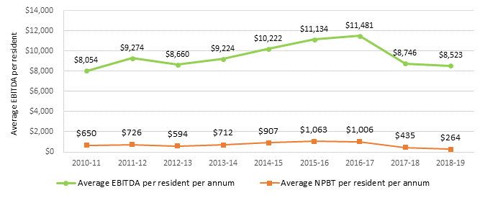~~

Table 6.15 provides a summary of the overall financial performance of residential care providers since 2013-14. The overall profit of the sector was $264 million, down from $435 million in 2017‑18. The average EBITDA per resident declined slightly from $8,746 in 2017‑18 to $8,523.

Table 6.15: Summary of financial performance of residential care providers, 2013-14 to 2018-19

|  | 2013-14 | 2014-15 | 2015-16 | 2016-17 | 2017-18 | 2018-19 |
| --- | --- | --- | --- | --- | --- | --- |
| Revenue ($m) | $14,826 | $15,810 | $17,172 | $17,757 | $18,066 | $19,302 |
| Expenses ($m) | $14,115 | $14,903 | $16,109 | $16,751 | $17,631 | $19,037 |
| NPBT ($m) | $712 | $907 | $1,063 | $1,006 | $435 | $264 |
| NPBT margin | 4.8% | 5.7% | 6.2% | 5.7% | 2.4% | 1.4% |
| EBITDA ($m) | $1,582 | $1,776 | $1,985 | $2,072 | $1,591 | $1,590 |
| Average EBITDA per resident per annum | $9,224 | $10,222 | $11,134 | $11,481 | $8,746 | $8,523 |
| EBITDA margin | 10.7% | 11.2% | 11.6% | 11.7% | 8.8% | 8.2% |

Table 6.16 shows the financial performance of providers in 2018-19 by ownership type, location and scale. In general terms, for‑profit providers outperformed not‑for‑profit providers and metropolitan providers outperformed regional and rural providers. This is similar to 2017-18. More detailed discussion of performance based on ownership, location and scale is included later in this section.

Table 6.16: Summary of financial performance of residential care providers, by ownership, location and scale, 2018-19

|  |  |  | Ownership type | | | | | Location | | | | | | Scale | | | | | | | |
| --- | --- | --- | --- | --- | --- | --- | --- | --- | --- | --- | --- | --- | --- | --- | --- | --- | --- | --- | --- | --- | --- |
|  |  | Total sector 2018-19 | Not-for-profit | | For-profit | Government | | Metropolitan | | Regional | | Metropolitan & regional | | Single facility | | Two to six facilities | | Seven to 19 facilities | | 20 or more facilities | |
| Revenue ($m) |  | $19,302 | $10,585 | $7,755 | | | $962 | | $12,668 | | $2,898 | | $3,736 | | $4,329 | | $4,108 | | $4,498 | | $6,367 | |
| Expenses ($m) |  | $19,037 | $10,463 | $7,547 | | | $1,027 | | $12,370 | | $2,943 | | $3,724 | | $4,224 | | $4,107 | | $4,468 | | $6,238 | |
| Profit ($m) |  | $264 | $122 | $208 | | | -$66 | | $297 | | -$45 | | $12 | | $105 | | $1 | | $30 | | $129 | |
| EBITDA ($m) |  | $1,590 | $900 | $698 | | | -$8 | | $1,180 | | $136 | | $273 | | $378 | | $282 | | $371 | | $558 | |
| EBITDA p.r.p.a ($m) |  | $8,523 | $8,520 | $9,528 | | | -$1,036 | | $9,790 | | $4,916 | | $7,146 | | $8,907 | | $7,212 | | $8,852 | | $8,861 | |
| EBITDA margin |  | 8.2% | 8.5% | 9.0% | | | -0.8% | | 9.3% | | 4.7% | | 7.3% | | 8.7% | | 6.9% | | 8.2% | | 8.8% | |
| NPBT margin |  | 1.4% | 1.1% | 2.7% | | | -6.8% | | 2.3% | | -1.6% | | 0.3% | | 2.4% | | 0.0% | | 0.7% | | 2.0% | |

As noted, the financial performance of the residential care sector overall declined very slightly in 2018-19 after reporting a very significant decline in 2017‑18 compared with 2016-17. In 2018-19 providers reported an average EBITDA per resident of $8,523 down from $8,746 in 2017-18. These two years of poorer financial performance follow five years of improving financial performance since 2012‑13. Fifty-eight per cent of residential care providers reported a net profit in 2018-19, up slightly from 56 per cent in 2017-18. This follows the decline from 68 per cent in 2016‑17 and 69 per cent in 2015-16.

The EBITDA margin was 8.2 per cent, down slightly from 8.8 per cent in 2017‑18. The NPBT margin continued to decline to 1.4 per cent in 2018-19, after dropping significantly to 2.4 per cent from 5.7 per cent in 2017-18.

Chart 6.16 presents the EBITDA per resident for 2016-17 to 2018-19 by provider performance quartiles. As shown, the average EBITDA per resident improved slightly in all but the bottom quartile.

Chart 6.16: Residential care provider comparative EBITDA per resident per annum, 2016-17 to 2018-19

~~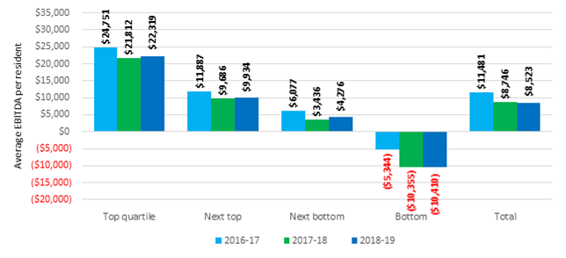~~

Operating performance has traditionally varied across provider ownership type, location and scale. The following commentary provides analysis across the segments of providers.

#### By provider ownership type

Chart 6.17 shows the performance ratios for the last three years by ownership type, and Chart 6.18 shows the average EBITDA per resident per annum for the last four years, by ownership type.

Not‑for‑profit providers reported a slight improvement in performance in 2018‑19, up to an EBITDA per resident of $8,571 from $7,916 in 2017‑18. This was after a very significant decline from $11,408 in 2016‑17. The for‑profit providers recorded a significant decline in 2018‑19, down to $9,528 from $11,634 in 2017‑18. The trend of for‑profit providers outperforming not‑for‑profit providers, which has been evident for some time, continued in 2018‑19.

However, this measure needs to be considered carefully because providers in the not-for-profit and government sectors often have different business motives, business models and funding sources and often operate in areas affected by the impacts of remoteness and facility size.

Commentary from the not-for-profit sector indicates that the generally lower operating financial results may be consistent with their community or religious missions. They may fulfil their charters in a range of ways that might be difficult or inappropriate in a more commercial environment where investors are seeking returns.

Specifically, not-for-profit providers may choose to invest in or expend funds on amenities and services for which they are not funded through regulated sources. Not‑for‑profit providers may be assisted to do this through a range of funding pathways and tax benefits, including payroll tax relief, income tax exemptions and tax deductible donations. However, where these costs are not covered by such incremental revenue, the comparatively lower EBITDA for many not‑for‑profit providers may be the product of the delivery of additional “community benefits” or “social impacts” or returns which are not recognised in the annual financial accounts.

Chart 6.17: Residential care provider operating performance ratios, by ownership type, 2016-17 to 2018‑19

~~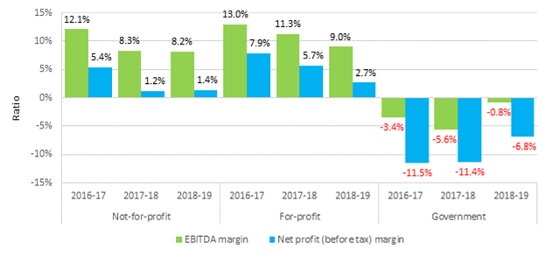~~

Chart 6.18 shows the average EBITDA for the four years to 2018-19 by ownership type. The for‑profit providers reported a decrease in EBITDA per resident, down to $9,528 from $11,634 in 2017-18. The not-for-profits on the other hand reported a 7.6 per cent increase, up to $8,520 from $7,916 in 2017-18.

Chart 6.18: EBITDA per resident, by ownership type, 2015-16 to 2018-19

~~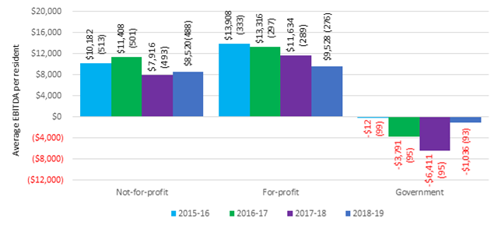~~

As has been the case in recent years, a higher proportion (31 per cent) of for-profit providers were present in the top quartile of EBITDA performance per resident (Chart 6.19 and Chart 6.20), compared with not‑for‑profit providers (22 per cent).

As has been the case with all previous years, there is some representation of all ownership types in each quartile.

Chart 6.19: Residential care provider average EBITDA per resident per annum, by quartile (number of providers in parentheses) – by ownership type, 2018-19

~~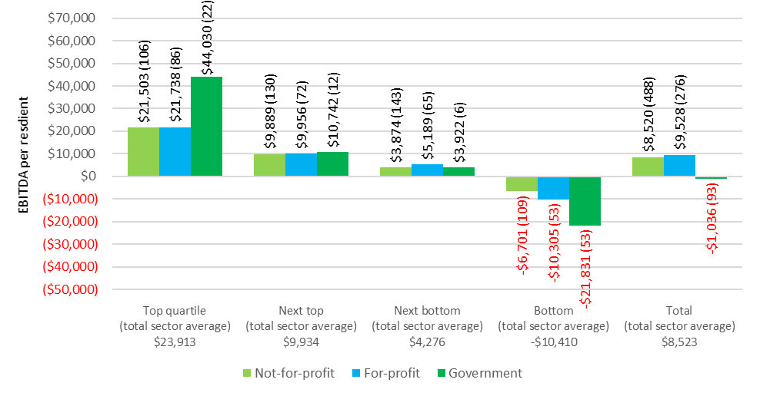~~

Chart 6.20: Residential care provider distribution between quartile of average EBITDA per resident per annum – by provider ownership type, 2018-19

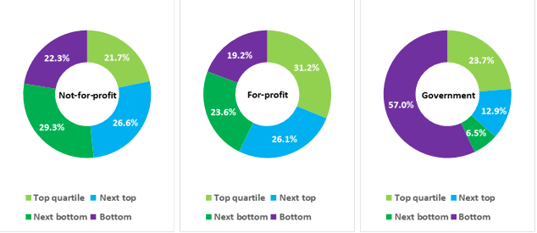

#### By provider location

As shown in Chart 6.21, metropolitan providers significantly outperformed regional providers with an EBITDA per resident per annum of $9,790 compared with $4,916. This is consistent with recent years although regional providers did record an improvement after reporting $2,702 for 2017‑18.

Chart 6.21: Residential care provider EBITDA per resident, by provider location, 2015-16 to 2018-19

~~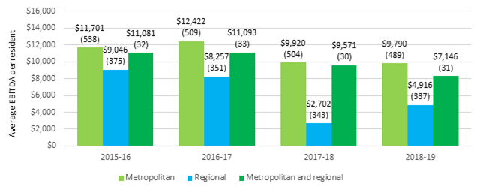~~

As with previous years, a higher proportion (30 per cent) of metropolitan providers are present in the top quartile of ranking by EBITDA per resident compared with regional providers (20 per cent), as shown in Chart 6.22 and Chart 6.23. Conversely, and consistent with recent years, a significantly higher proportion of regional providers (33 per cent) were represented in the bottom quartile compared with 20 per cent of metropolitan providers.

As was the case with analysis based on ownership type, providers from all locations are present in each quartile.

Chart 6.22: Residential care provider average EBITDA per resident per annum, by quartile (number of providers in parentheses) – by location, 2018-19

~~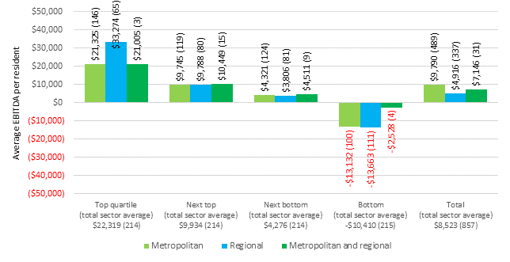~~

Chart 6.23: Residential care provider distribution between quartile of average EBITDA per resident per annum – by location, 2018-19

~~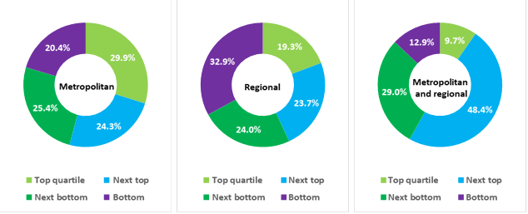~~

#### By provider scale

In 2018-19, single facility providers were the best performing providers, reporting an average EBITDA of $8,907, up from $7,110 in 2017‑18. Providers with 20 or more facilities were the next best with EBITDA per resident of $8,861, but this was well down from $10,622 in 2017-18.

Providers with between 2 and 6 facilities were the worst performers for the third year in a row, recording an average EBITDA per resident of $7,212, although this was an improvement from $6,340 in 2017-18.

Chart 6.24: Residential care provider EBITDA per resident per day, by provider scale, 2015-16 to 2018-19

~~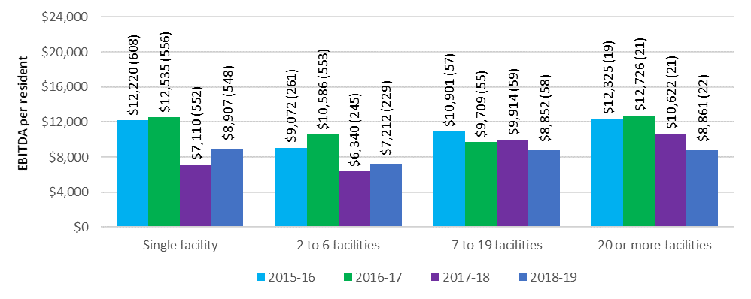~~

In 2018-19, more than 60 per cent of providers with between 7 and 19 facilities were in the top two quartiles (Chart 6.25 and Chart 6.26). Thirteen of the 22 providers (64 per cent) who own more than 20 facilities were also in the top two quartiles of ranking by EBITDA per resident per annum, although is noticeably down from 17 of these providers who were in the top quartile in 2017-18. Also noticeable is that the average EBITDA per resident per annum for the 20+ facility providers in the top quartile was $15,406 compared with the top quartile providers from all other scales whose average EBITDA was over $20,000.

Providers with between 2 and 6 facilities have the largest representation in the bottom quartile, at almost 30 per cent.

As was the case in previous years, providers from all the scale classifications are represented in all four quartiles.

Chart 6.25: Residential care provider average EBITDA per resident per annum, by quartile (number of providers in parentheses), by provider scale, 2018-19

~~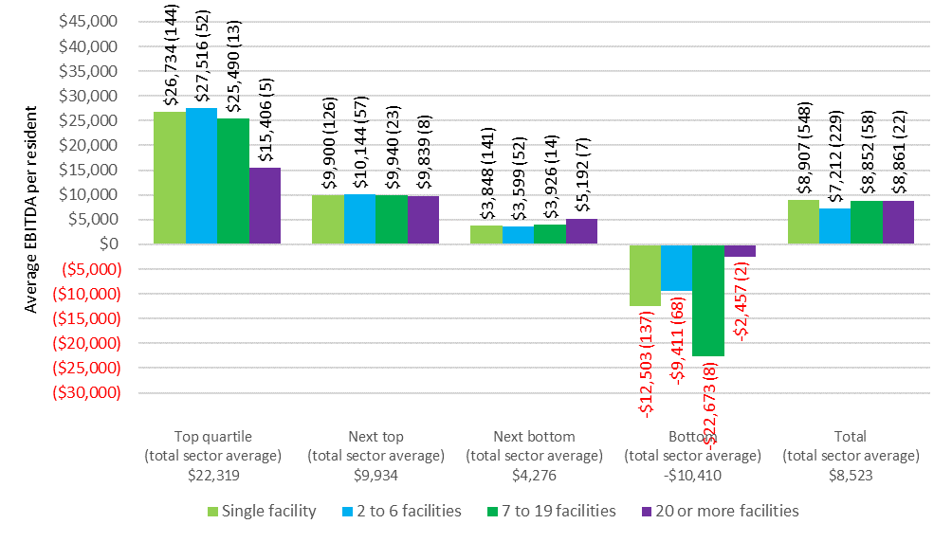~~

Chart 6.26: Residential care provider distribution between quartile of average EBITDA per resident per annum – by provider scale, 2018-19

~~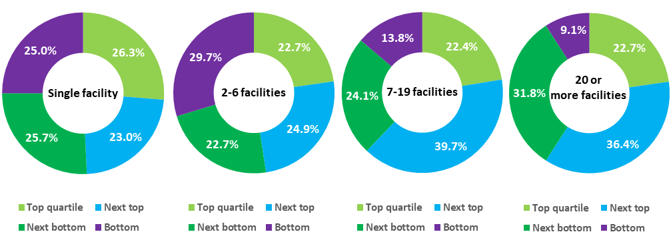~~

### Feedback from consultations and developments in 2019-20

The immediate focus of residential providers is dealing with the challenges posed by COVID-19, which is impacting on their financial performance and has the potential to pose significant financial difficulties for providers. The discussion with residential providers as part of the preparation of this report took place in early 2020, before the full impact of the COVID-19 was apparent.

The COVID-19 related financial pressures come on top of a continuation of the financial pressures experienced in 2017-18 and 2018-19 into 2019-20, albeit temporarily relieved somewhat by a one-off $320 million subsidy increase in 2018-19. In the absence of this one-off increase in ACFI, the overall financial position of providers would have fallen further, which follows the significant decline in their results in 2017-18.

While providers welcomed the $320 million increase in ACFI funding, they noted in consultations that it did not address the significant underlying margin pressure they are experiencing which is continuing in 2019-20. The COVID-19 pandemic will have added to these pressures. In the consultations that took place in early 2020, most providers said that their financial position was continuing to deteriorate. Many providers said that there was little or no growth in ACFI revenue while their expenses, particularly staff costs, continued to rise. A few providers said that they had devoted additional resources to reviewing their ACFI claiming procedures, believing they may be under-claiming ACFI, while others saw little upside to their existing ACFI revenue. As noted, COVID‑19 will have added to these financial pressures.

As discussed earlier, ACFA notes the delay in responding to the RUCS reports and the uncertainty of the future of the funding arrangements is adding to uncertainty in the sector and may be adversely affecting investment decisions.

ACFA observes that the Counsel Assisting the Royal Commission into Aged Care Quality and Safety has effectively endorsed a funding model along the lines of AN-ACC by indicating that implementation of an appropriate case-mix base funding classification for residential aged care, with resident classification derived from independent assessment, be a consideration for the future state of residential aged care in Australia.

Most providers said they were making every effort to restrain costs, with some pointing to sizeable reductions in administrative staff and others investing in technology in order to improve the efficiency of their operations and reduce ongoing operating expenses. However, the overwhelming comment was that there was little scope for further reductions in costs. All providers noted that the enhanced activities of the Quality and Safety Commission, along with the new quality standards, had increased their compliance costs. A number of the larger providers also referred to costs associated with the Royal Commission into Aged Care Quality and Safety. Responding to COVID-19 will have increased costs for providers and posed additional demands in managing facilities. In March and May 2020, the Government has announced a number of temporary funding packages to help providers with the additional costs due to COVID, maintain continuity of staff, deliver additional training, and if needed hire additional nurses and aged care workers. If COVID-19 continues to spread to more residential facilities, the financial position of more providers will come under significant pressure.

Many of the providers consulted said that the drop in occupancy rates was one of their major concerns and was having a significant adverse impact on their financial results. They believed the increase in home care packages and adverse publicity regarding residential aged care coming from the hearings of the Royal Commission were contributing to the decline in occupancy rates. In addition, some providers felt that there was excess capacity in some areas, and older facilities were experiencing the biggest falls in occupancy. As noted earlier there is also a potential that COVID-19 may result in a further decline in occupancy.

A number of providers said that they had introduced additional services fees in an effort to increase revenue, and some said that these fees were the main reason they were not making a loss. Some providers said that while they were considering introducing additional service fees, they were concerned about the regulatory uncertainty as to what would be considered to be an additional service. Most of the providers who had additional service fees supplied the same service to supported and non-supported residents, but only charged those residents who they assessed could afford to pay. A few providers said that because of pressure to lift occupancy, the additional service fee was often reduced in an effort to attract residents.

Nearly all providers consulted said that they had delayed or deferred new investment in the residential care sector given pressure on margins and the uncertainty around the future direction of reforms, particularly following the completion of the Royal Commission. However both not‑for‑profit and for-profit providers said that they were increasingly looking to invest in independent retirement living with the provision of home care services. They believed that this would be an important aspect of the future direction of aged care. The uncertainties associated with COVID-19 are likely to further depress investment plans.

Many providers suggested that there was an increasing number of smaller providers, particularly in regional areas, in financial difficulty and seeking to leave the sector. There was a widespread view that one of the consequences from the outcome of the Royal Commission would be an accelerated rationalisation of the residential care sector. In the current environment of margin pressure and significant uncertainty, there is significant reluctance for providers to take over a provider facing major financial problems. Moreover, a provider under financial pressures often has problems meeting quality standards. The impact of COVID-19 is likely to have further depressed the appetite to acquire an underperforming residential facility.

A number of providers welcomed the announcement of the Government’s Business Advisory Services (BAS) program for residential care and home care providers, which provides access to independent advice services at no cost to the provider. This program has been designed to help providers review their operations and identify strategies to support their financial improvement. The BAS program is available to residential and home care providers until June 2021 and is complemented by the recent announcement of a Business Improvement Fund (BIF) for residential providers, which is directed at struggling residential providers, particularly those in regional and remote areas. As at 30 April 2020, 210 applications for assistance had been received under the Business Advisory Services program. Of these, 30 per cent were residential care providers, 20 per cent were home care providers and 50 per cent were from providers who offered both residential and home care.

The BIF will support improvements in the provider’s operations where the benefit can be linked to improving the provider’s ongoing viability. The BIF is also aimed at structural adjustment in the industry by providing funding for providers seeking to transition or leave the sector. Funding can support the transition of a facility to another provider through a procurement arrangement, or the safe transition of residents to alternative facilities where no other option exists to improve ongoing viability. Providers can access both programs on a voluntary basis. The fallout from COVID-19 may see a significant increase in assistance for providers whose ongoing viability is at risk.

It was evident in the consultations with providers that there was significant uncertainty as to when the pressure on margins would be eased and the overall future direction of the aged care industry, particularly following the completion of the Royal Commission. COVID-19 will have added to providers’ concerns as to the uncertainty over the financial outlook for the industry.

# Residential care: capital investment

|  |
| --- |
| **This chapter discusses:**   * The sources of capital financing for the residential care sector, including the role of Refundable Accommodation Deposits[34]; * key balance sheet metrics for residential care providers for 2018-19; and * building and investment trends in the residential care sector.   **On 30 June 2019, compared with 30 June 2018, the residential care sector had:**   * Total assets of $52.6 billion, up from $48.4 billion, which includes: * $14.4 billion of current assets, an increase of $300 million; and * $38.2 billion of non-current assets, up from $34.3 billion. * total liabilities of $39.0 billion, up from $36.6 billion. This includes $30.2 billion of accommodation deposits held by the sector, up from $27.5 billion; * net assets of $13.5 billion, an increase of $1.7 billion; * average return on equity was 11.8 per cent, down from 13.4 per cent; * average return on assets was 3.0 per cent, down from 3.3 per cent; and * cash held as percentage of accommodation deposit balances was 20.8 per cent, down from 22.1 per cent   **Recent building trends:**   * $5.3 billion of building works were either completed or in-progress as at 30 June 2019 compared with $4.9 billion at 30 June 2018; and * planned building activity remains subdued. |
|  |

## Capital financing

Capital for residential care providers is comprised of:

* equity, including retained earnings;
* loans from financial or other institutions;
* interest free loans from residents in the form of lump sum Refundable Accommodation Deposits (bonds pre 1 July 2014);
* capital investment support from Government by way of capital grants for eligible projects; and
* capital endowments.

### Residents as a source capital

Lump sum accommodation payments by residents is a significant source of funding for capital investment in residential care. Refundable Accommodation Deposits (RADs) act as an interest free loan to providers, paid by residents. At 30 June 2019, a total of $30.2 billion of accommodation deposits was held by providers. The investment of accommodation deposits held by providers is a source of interest income that is included in the other income reported by providers in their operating statement.

As an alternative to RADs, residents can choose to a pay a Daily Accommodation Payment (DAP) or a combination of a RAD and DAP.

Partially supported residents contribute towards accommodation as a Refundable Accommodation Contribution (RAC) or Daily Accommodation Contribution (DAC). In this report, references to RADs also include RACs and references to DAPs include DACs.

### Commonwealth as a source of capital

The Australian Government makes capital grants available through the ACAR (via the Rural, Regional and Other Special Needs Building Fund) for services that target communities and geographic areas where there may be insufficient access to capital from other sources.

The 2018-19 ACAR allocated $60 million in capital grants under the Fund to successful approved providers, following a competitive application process. In addition to the ACAR, through a separate announcement in the 2018‑19 Budget, one-off funding of $40 million was allocated for infrastructure investment and distributed on a competitive application process.

Additionally, the higher accommodation supplement, payable where a facility has been built or significantly refurbished since 20 April 2012, is encouraging investment in residential care. Although not strictly a form of capital for providers, it provides an increased rate of return on the capital invested.

The higher accommodation supplement is $58.19 per eligible resident per day compared with $37.93 for the standard accommodation supplement (20 March 2020 rates). As at 31 December 2019, 1,622 facilities (1,395 at 31 December 2018) or 60 per cent of all facilities qualified for the higher accommodation supplement. Of these, 1,432 were significantly refurbished and 190 were newly built facilities.

### Other sources of capital finance

Residential care providers also obtain capital finance from investors, loans from financial and other institutions and donations/endowments. ACFA does not have data across the sector on debt and equity financing, other than that reported in the aggregated balance sheets, which are discussed in this chapter.

## Accommodation deposits

At 30 June 2019, refundable accommodation deposits (including bonds) held by residential care providers totalled $30.2 billion, and comprised 57 per cent of total assets ($52.6 billion) and 74 per cent of liabilities ($39.0 billion).

At 30 June 2019, there were 94,870 refundable accommodation deposits held by providers (90,899 at 30 June 2018), with an average value of $318,000 ($303,000 in 2017‑18). As shown in Table 7.1 the average value of accommodation deposits has steadily increased over the last six years.

Table 7.1: Average value of refundable accommodation deposits held by providers, 2013-14 to 2018-19

| 2013-14 | 2014-15 | 2015-16 | 2016-17 | 2017-18 | 2018-19 |
| --- | --- | --- | --- | --- | --- |
| $229,000 | $248,000 | $267,000 | $283,000 | $303,000 | $318,000 |

Residents who are assessed as having low financial capacity are eligible for Commonwealth assistance with their accommodation costs as either a partially supported or fully supported resident. Partially supported residents may be asked to contribute towards the cost of accommodation, depending on their means. They can choose to pay their accommodation contribution by a lump sum refundable accommodation contribution (RAC), a daily accommodation contribution (DAC), or a combination of the two. Fully supported residents cannot be asked to make a contribution and have their accommodation costs met in full by Government. In 2018-19, 48 per cent of all residents were supported, either fully or partially.

Residents who are not eligible for Commonwealth assistance with their accommodation costs pay the accommodation price they agree with their provider before they enter care and can choose (within 28 days of admission) to pay by a lump sum refundable accommodation deposit (RAD), a daily accommodation payment (DAP) or a combination of the two. The maximum permissible interest rate (MPIR) is used to maintain equivalence between daily payments and lump sums[35].

Chart 7.1 shows the total pool of accommodation deposits held by providers since 2012‑13.

Chart 7.1: Total pool of accommodation deposits held, 2012-13 to 2018-19

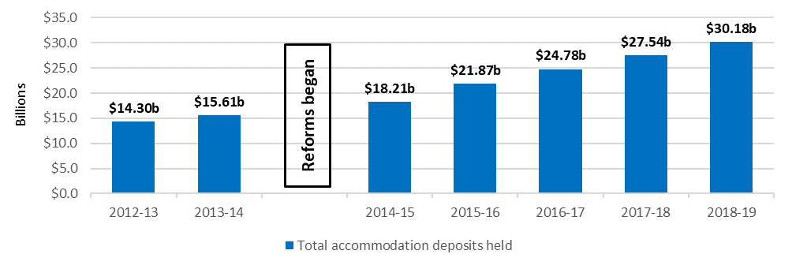

While the pool of accommodation deposits continues to grow, ACFA noted in last year’s report that there is a trend emerging of a move away from RADs in favour of DAPs. Chart 7.2 shows that this trend continued in 2018-19. The proportion of people choosing RAD/RACs has dropped every year, albeit slightly, since 2014‑15. The proportion of residents choosing DAP/DACs has gradually increased over the four years from 33 per cent in 2014–15 to 41 per cent in 2018-19. This trend has not been caused by a change in the number of non-supported residents as that has been stable at around 50-52 per cent since 2014-15.

While the overall shift away from RADs is modest, feedback from consultations for the preparation of the 2020 ACFA annual report suggested that this is a concern for some providers, (including the cash flow implications of a shift away from RADs). Providers noted, however, the use of RADs was directly related to the state of the housing market and the recent improvement in the housing market in Sydney in Melbourne up until the emergence of COVID corresponded with a rise in RAD inflows. Nevertheless, some providers said they welcomed a move towards DAPs because DAPs were included in their profit results. A sustained shift away from RADs to DAPs would significantly impact the business model of some providers who have relied significantly on continuing growth in RADs. The COVID‑19 pandemic has the potential to significantly disrupt the position of providers’ RAD balances. The spread of the virus in a facility could result in large cash outflows as RADs are repaid, but there may not be a corresponding inflow of RADs from new residents.

In February 2020, the Minister for Aged Care tasked ACFA with reviewing the role of RADs in residential aged care. ACFA will deliver its report in late 2020.

Chart 7.2: Resident method of accommodation payment, 2014-15 to 2018-19

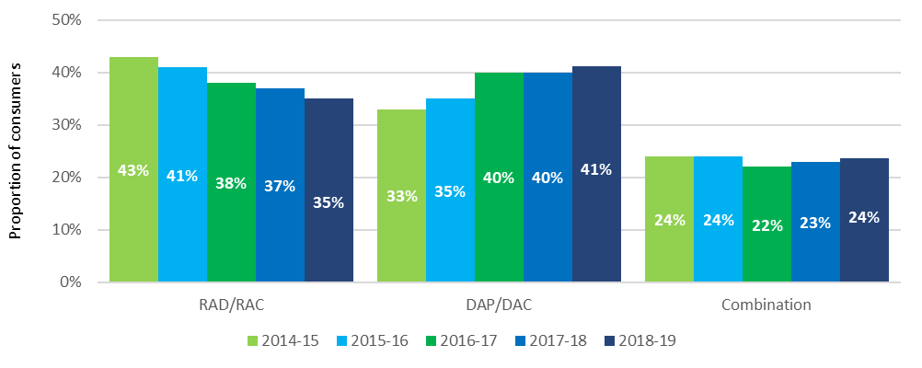

ACFA has previously noted there are several factors that a consumer might take into consideration when determining how to pay the accommodation payment, including in its report Understanding how consumers plan and finance aged care[36]. These include; the rate of the MPIR, (if interest rates fall, equivalent daily payments will fall and vice versa), expected length of stay (if shorter, then more likely to pay by daily payment), personal financial circumstances and the length of time it takes to sell the family home.

ACFA also notes that an expected fall in property prices since the emergence of COVID and a likely reluctance of residents to sell their house in a declining market may also result in a further decline in RADs.

Feedback from providers suggest that the movement in house prices and conditions in the housing market are important factors in influencing the choice between RADs or DAPs.

In terms of the MPIR influencing decisions on accommodation payments in aged care, there is the potential for movement from lump sums to daily payments if the equivalence rate is set too low. The current record low interest rates has seen the equivalent daily accommodation payment for a $550,000 RAD fall from $100.89 in July 2014, when the equivalence formula was introduced, to $63.89 currently. Of course, a rise in interest rates would see a reversal of this situation.

If all other things are equal, and consumers can achieve a better return, they may be inclined to invest the lump sum and pay the daily payment out of investment earnings. On the other hand, some residents see daily payments as interest charged on the outstanding lump sum. From this perspective, residents see the MPIR as a punitively high rate of interest.

As noted last year, part of the reduction in the proportion of residents paying by lump sum could also be transitional and may reflect a greater understanding by consumers of their ability to choose how to pay for their accommodation, as was intended by the reforms implemented in 2014.

The decrease in the proportion of RAD/RACs has been most noticeable in the not‑for-profit providers, where the proportion has dropped steadily from 42 per cent in 2014-15 to 30 per cent in 2018-19 (Chart 7.3). For for‑profit providers, the proportion of residents choosing RAD/RACs was slightly higher (44 per cent) in 2018-19 compared with 43 per cent in 2017-18 after declining in the previous two years.

Chart 7.3: Resident choice of payment method, by ownership, 2014-15 to 2018-19

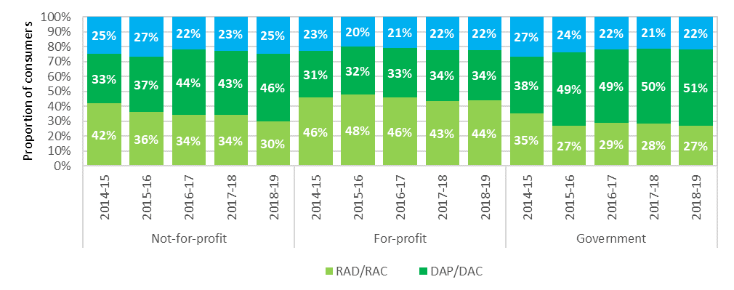

When analysed in terms of location, lump sum payments continued to drop in metropolitan areas to 37 per cent in 2018-19, dropping from 45 per cent over the last four years (Chart 7.4). In regional and remote areas, there was also a drop in the number of residents choosing RADs. In regional areas, 32 per cent chose to pay by a RAD, down from 35 per cent in 2017-18. In remote areas, 25 per cent chose to pay by a RAD, down from 29 per cent.

Chart 7.4: Resident choice of payment method, by location, 2015-16 to 2018-19

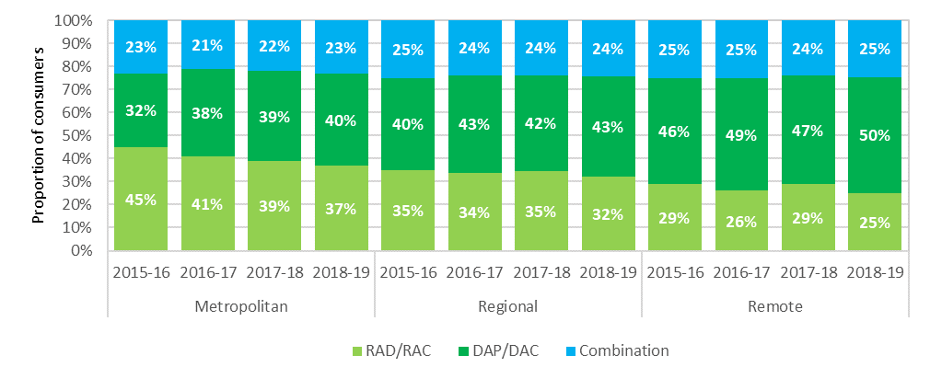

As noted in ACFA’s 2019 report, feedback from providers indicated that a decline in the housing market in 2018-19 was contributing to a shift away from RADs to DAPs, particularly where the individual entering residential care is very frail and the expected stay is short. The feedback was that many families were not prepared to sell a house when prices are falling. However a number of providers noted that the recent pick up in the housing market up until the emergence of COVID, particularly in Sydney and Melbourne, was contributing to greater interest in RADs. Should the fallout from the COVID-19 pandemic result in a decline in the housing market, this will likely impact on inflow of RADs.

There continues to be a very significant difference in choice of payment between non-supported residents and partially supported residents, as shown in Chart 7.5. Forty-three per cent of non-supported residents chose to pay their accommodation payment by a RAD whereas only 7 per cent of partially supported residents chose this option, although the proportion of non‑supported residents paying a RAD has also been decreasing steadily over the four years since, from 51 per cent in 2015-16 to 43 per cent in 2018-19. The proportion of residents paying by lump sum may include residents who had commenced to pay full or partial daily payments, and then paid a lump sum during the year. Similarly, residents paying a daily payment may subsequently pay a lump sum (e.g. once their house is sold).

Chart 7.5: Resident choice of payment method, by partially supported and non-supported residents, 2015-16 to 2018-19

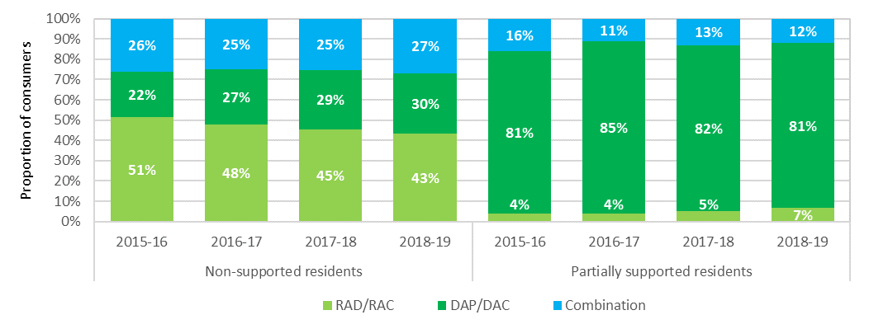

### Accommodation deposit prices

On 1 July 2014, new accommodation pricing arrangements came into effect. The changes were:

* Lump sum accommodation payments became known as Refundable Accommodation Deposits (RADs) instead of Accommodation Bonds;
* providers were able to charge a RAD to any eligible resident whereas they had previously only been able to charge an Accommodation Bond for low care residents, or a high care resident in Extra Service facilities;
* providers were no longer able to deduct a retention amount from the RAD;
* residents became able to, at their discretion, choose to pay a RAD, a Daily Accommodation payment (DAP) or any combination of RAD and DAP; and
* providers were required to publish the maximum price for their rooms, or part of a room, in their aged care facilities. Residents may negotiate a lower price (known as the agreed price) but cannot be asked to pay more than the published price.

Charts 7.6 and 7.7 show the average published and agreed accommodation prices since 1 July 2014, presented by provider ownership type and location. This data includes RADs, DAPs and combination payments and covers the price of a residential care room, not the method of payment.

In terms of provider ownership (Chart 7.6), the for‑profit providers have average published prices around $40-50,000 higher than the not‑for‑profit providers. Since 2014‑15 the average published price by for‑profit providers has increased faster than those of the not‑for‑profit providers.

As shown, agreed prices for both the for‑profit and the not‑for‑providers are consistently higher than the published prices and the gap is getting bigger. In 2018‑19 the overall average agreed price for the sector was around $50,000 less than the average published price. The average agreed price is less than the average published price because residents may, and often do, negotiate a lower price.

Chart 7.6: Average agreed and published accommodation prices (lump sum equivalent), by ownership, 2014‑15 to 2018-19

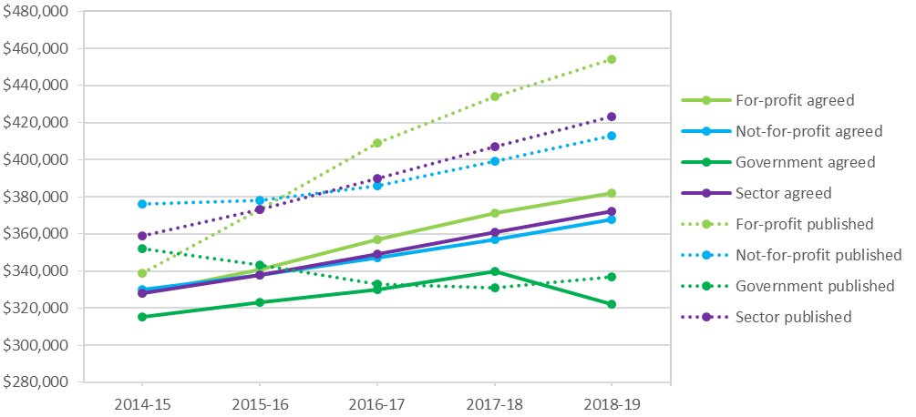

In terms of location (Chart 7.7), as has been the case in previous years, the average published and agreed price in metropolitan areas was significantly higher than in regional and remote areas. This is to be expected given the difference in house prices across these areas.

Chart 7.7: Average agreed and published accommodation prices (lump sum equivalent), by location, 2014-15 to 2018-19

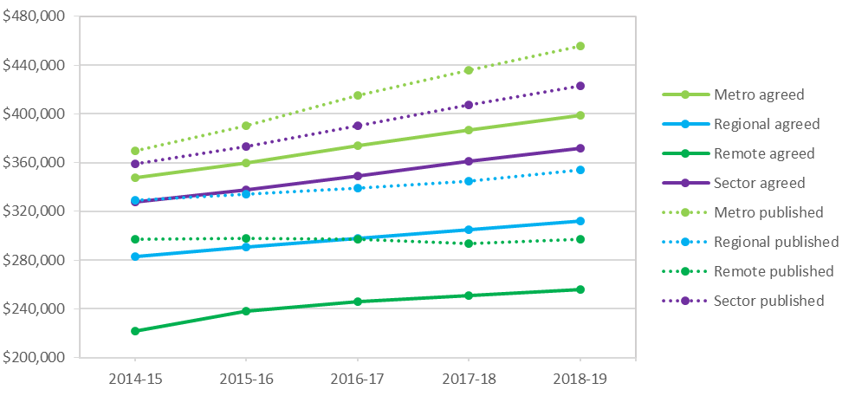

## Financing status - balance sheet

This section focuses on the balance sheet of the residential care sector, showing the liabilities, assets and net assets.

In 2016‑17 the Department of Health began collecting financial data from providers via the Aged Care Financial Report (ACFR). This allows greater disaggregation of the total assets and liabilities compared with earlier years. Therefore the majority of analysis in this section is restricted to 2016‑17 to 2018-19. Some longer term trends are presented at the higher aggregate level.

Table 7.2: Balance sheet of residential care providers, 2016-17 to 2018-19

| Assets/Liabilities | 2016-17 ($m) | 2017-18  ($m) | Change (%) | 2018-19  ($m) | Change  (%) |
| --- | --- | --- | --- | --- | --- |
| Current assets | $13,138 | $14,101 | 7.33% | $14,367 | 1.89% |
| Fixed assets | $22,963 | $24,061 | 4.78% | $27,997 | 16.36% |
| Other non-current assets | $8,916 | $10,238 | 14.83% | $10,203 | -0.34% |
| **Total assets** | **$45,017** | **$48,400** | **7.52%** | **$52,568** | **8.61%** |
| Accommodation deposits | $24,710 | $27,523 | 11.39% | $30,183 | 9.67% |
| Other liabilities | $8,981 | $9,050 | 0.76% | $8,866 | -2.03% |
| **Total liabilities** | **$33,691** | **$36,573** | **8.55%** | **$39,049** | **6.77%** |
| **Net worth/equity** | **$11,326** | **$11,827** | **4.42%** | **$13,519** | **14.30%** |

At 30 June 2019, the sector as a whole had total assets of $52.6 billion (an increase of $4.2 billion since 30 June 2018). Current assets increased by 1.9 per cent, fixed assets increased by 16.4 per cent and accommodation deposits increased by 9.7 per cent.

Total liabilities were $39.0 billion (compared with $36.6 billion in 2017-18). This includes the $30.2 billion of accommodation deposits held by the sector. Since 2013-14 and up until 2017-18, growth in liabilities had exceeded the growth in assets. In 2018-19, liabilities grew by 6.8 per cent compared with an 8.6 per cent increase in total assets. Liabilities as a proportion of total assets is a measure that indicates an organisation’s leverage and shows the proportion of total assets financed through borrowings.

Overall, net worth/total equity in the sector was $13.5 billion in 2018-19, up from $11.8 billion in 2017-18.

As shown in Chart 7.8, accommodation deposits as a proportion of total assets has been increasing gradually over the last five years from 49.8 per cent in 2014-15 to 57.4 per cent in 2018-19, increasing the rate of leveraging.

Other liabilities, which include secured bank and related party lenders, creditors and provisions, dropped to 17 per cent in 2018-19 after being relatively stable at around 20 per cent for the previous four years.

Net worth/total equity as a proportion of assets increased slightly from 24 per cent in 2017-18 to 25 per cent in 2018-19. This is a measure of the share of an organisation which is contributed by and held beneficially by the owners/shareholders. Previous to 2018-19 there had been a gradual decline from 33 per cent in 2013‑14.

Table 7.3: Balance sheet of residential care providers 2014-15 to 2018-19 ($m)

| Assets/liabilities | 2014-15 ($m) | 2015-16 ($m) | 2016-17 ($m) | 2017-18 ($m) | 2018-19 ($m) |
| --- | --- | --- | --- | --- | --- |
| Financial assets | $5,170 | $5,611 | $8,199 | $9,047 | $9,248 |
| Fixed assets | $10,674 | $11,455 | $22,963 | $24,061 | $27,997 |
| Other assets | $20,742 | $23,629 | $13,855 | $15,292 | $15,323 |
| **Total assets** | **$36,586** | **$40,695** | **$45,017** | **$48,400** | **$52,568** |
| Refundable accommodation deposits | $18,213 | $21,872 | $24,710 | $27,523 | $30,183 |
| Other liabilities | $7,472 | $7,878 | $8,981 | $9,050 | $8,866 |
| **Total liabilities** | **$25,685** | **$29,750** | **$33,691** | **$36,573** | **$39,049** |
| **Net worth/equity** | **$10,901** | **$10,945** | **$11,326** | **$11,827** | **$13,519** |

Chart 7.8: Residential care provider liability types as a proportion of total assets, 2014-15 to 2018-19

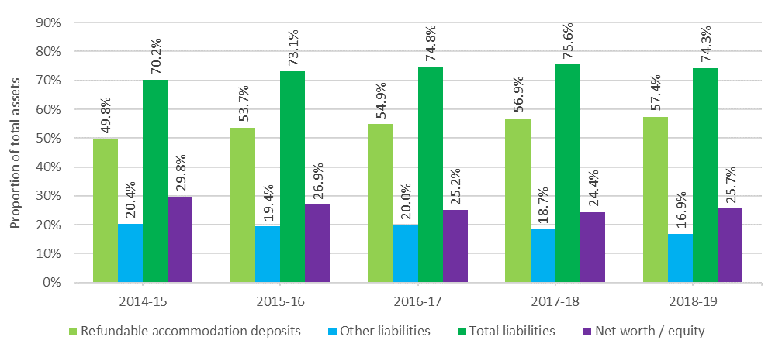

### Balance sheet analysis by ownership type

Assets and liabilities have been analysed by ownership type in order to identify differences between not-for-profit, for-profit and government providers. Table 7.4 shows liabilities and net worth/equity as a proportion of total assets by ownership type, while Chart 7.9 shows the proportions for the past three years.

At 30 June 2019, for the not-for-profit providers, refundable accommodation deposits (RAD) funded 55 per cent of their total assets of $28.2 billion. This compares with the for‑profit providers whose RADs funded 62 per cent of their total assets of $22.4 billion.

As has been the case in previous years, the for-profit sector has a significantly higher proportion of liabilities, with their total liabilities being 88 per cent (91 per cent in 2017‑18) of their total assets, compared with the not‑for‑profit providers with 65 per cent (66 per cent in 2017‑18). This significant difference is representative of the way the for-profits operate in terms of higher leveraging.

Table 7.4: Balance sheet, by ownership type, at 30 June 2019 ($m)

|  | Not-for-profit ($m) | For-profit ($m) | Government ($m) | Total sector ($m) |
| --- | --- | --- | --- | --- |
| **Total assets funded by:** | **$28,174** | **$22,416** | **$1,979** | **$52,568** |
| Refundable accommodation deposits | $15,490 | $14,003 | $690 | $30,183 |
| Other liabilities | $2,895 | $5,698 | $272 | $8,866 |
| **Total liabilities** | **$18,385** | **$19,701** | **$962** | **$39,049** |
| **Net worth/equity** | **$9,788** | **$2,714** | **$1,016** | **$13,519** |
| **As a % of total assets** |  |  |  |  |
| Refundable accommodation deposits | 55.0% | 62.5% | 34.9% | 57.4% |
| Other liabilities | 10.3% | 25.4% | 13.8% | 16.9% |
| **Total liabilities** | **65.3%** | **87.9%** | **48.6%** | **74.3%** |
| **Net worth/equity** | **34.7%** | **12.1%** | **51.4%** | **25.7%** |

Chart 7.9: Liabilities and net worth as a proportion of total assets, by provider ownership type, 2016-17 to 2018-19

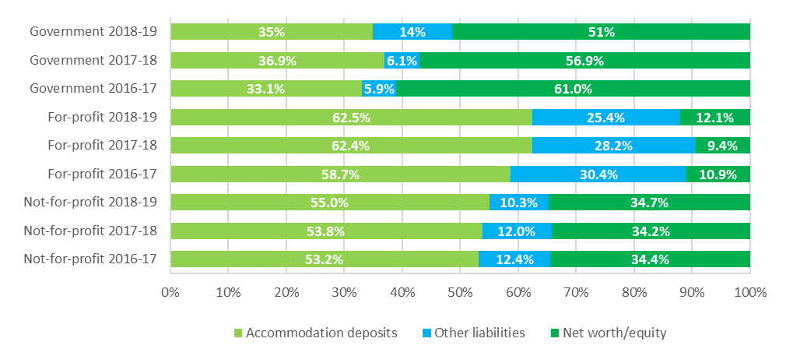

Table 7.5 presents the consolidated balance sheet at segment and organisation level for 2018-19.

Table 7.5: Disaggregated balance sheet by provider ownership type, at 30 June 2019 ($m)

|  | Not-for-profit ($m) | For-profit ($m) | Government ($m) | All providers ($m) |
| --- | --- | --- | --- | --- |
| **Assets** |  |  |  |  |
| **Current assets** |  |  |  |  |
| Cash | $4,181 | $1,808 | $287 | $6,276 |
| Financial assets | $2,242 | $112 | $122 | $2,476 |
| Trade receivables | $459 | $227 | $33 | $719 |
| RADs & RACs receivable | $627 | $350 | $33 | $1,010 |
| Related party loans | $230 | $2,445 | $0 | $2,675 |
| Work in progress | $39 | $1 | $2 | $42 |
| Other current assets | $583 | $437 | $149 | $1,169 |
| **Total currents** | **$8,362** | **$5,380** | **$625** | **$14,367** |
| **Non-current assets** |  |  |  |  |
| Financial assets | $380 | $108 | $7 | $495 |
| Related party loans | $131 | $2,770 | $0 | $2,901 |
| Work in progress | $210 | $326 | $6 | $542 |
| Intangibles - bed licences | $1,056 | $2,317 | $10 | $3,383 |
| Intangibles - other | $400 | $1,813 | $1 | $2,214 |
| Fixed assets | $17,521 | $9,168 | $1,308 | $27,997 |
| Other non-current assets | $113 | $532 | $22 | $668 |
| **Total non-current assets** | **$19,812** | **$17,035** | **$1,354** | **$38,201** |
| **Total assets** | **$28,174** | **$22,416** | **$1,979** | **$52,568** |
| **Liabilities** |  |  |  |  |
| **Current liabilities** |  |  |  |  |
| Accommodation deposits (incl. bonds) | $15,490 | $14,003 | $690 | $30,183 |
| Bank borrowings | $151 | $495 | $1 | $647 |
| Related party loans | $174 | $1,042 | $0 | $1,216 |
| Employee provisions | $856 | $494 | $102 | $1,451 |
| Other current liabilities | $875 | $926 | $53 | $1,854 |
| **Total current liabilities** | **$17,545** | **$16,960** | **$846** | **$35,351** |
| **Non-current liabilities** |  |  |  |  |
| Bank borrowings | $391 | $1,042 | $63 | $1,496 |
| Related party loans | $78 | $1,036 | $0 | $1,114 |
| Employee provisions | $153 | $99 | $27 | $279 |
| Other non-current liabilities | $218 | $564 | $27 | $809 |
| **Total non-current liabilities** | **$840** | **$2,741** | **$117** | **$3,698** |
| **Total liabilities** | **$18,385** | **$19,701** | **$962** | **$39,049** |
| **Net assets** | **$9,788** | **$2,714** | **$1,016** | **$13,519** |

As shown in Table 7.5, fixed assets – predominantly residential aged care facilities - are the single largest asset category held by providers ($28 billion or 53 per cent of total assets). This is up from 48 per cent in 2017-18. It is also the largest asset category based on ownership type, although for not‑for‑profit providers, fixed assets represent 62 per cent of total assets whereas for the for-profit providers it represents 41 per cent. The significant difference is likely explained in part by providers in the for-profit sector being more likely to rent the facilities in which they provide residential services, often under arrangements where the facilities are rented from related party entities.

Cash ($6.3 billion) and financial assets ($2.5 billion) represent $8.8 billion (16.6 per cent) of total assets. Not-for-profit providers hold 77 per cent, or $6.4 billion of current assets in cash and financial assets, while for-profit providers hold 36 per cent, or $1.9 billion. For‑profit providers are more active in placing their funds in other categories of assets, including related parties entities.

Intangible assets make up 11 per cent, or $5.6 billion of total sector assets (same as in 2017-18). Of the $5.6 billion, bed licences make up 60 per cent, or $3.4 billion, and other intangibles of $2.2 billion, consisting mostly of goodwill held by the for-profit sector, make up the remainder. For‑profit providers hold 77 per cent ($4.1 billion) of the intangibles balance for the sector.

Fifty-two per cent of for-profit providers (58 per cent in 2017-18) have recognised the value of bed licences. In contrast, only 28 per cent of not-for-profit providers (stable from 2017-18) have recognised the value of their bed licences.

As noted previously, an independent impact analysis has examined the potential implications of moving away from allocating residential care places to providers. This included consideration of the implications for bed licences and intangible assets. ACFA notes that if there are changes to the ACAR then this may have some bearing on the valuations currently attributed to bed licences (intangible) in the future.

### Balance sheet performance ratios

Balance sheet ratios provide a guide as to the financial health of providers through an analysis of their profitability, liquidity and efficiency as well as their net worth.

#### Balance sheet performance ratios – definitions

##### Current Ratio

Current ratio is a measure of an organisation’s ability to meet its short term obligations (current liabilities) from its current assets. The current ratio measures an organisation’s liquidity and provides an indication of risk that the organisation may not be able to meet its short term obligations as and when they fall due. It is calculated by dividing current assets of an organisation by its current liabilities.

Generally, a current ratio of at least 1.0, shows that an organisation has sufficient current assets to meet its short term obligations. However the requirement to categorise accommodation deposits as current liabilities[37] on the balance sheet of providers means that the current ratio needs to be treated with some caution and considered in conjunction with other financial indicators of liquidity for aged care organisations. For example, although refundable accommodation deposits (RADs) are required to be repaid when a resident leaves care, they are more often than not, repaid after a stay of longer than one year. The average length of stay for residents is currently just over three years.

##### Cash as a proportion of accommodation deposits

Cash and cash equivalents in the form of financial assets, as a proportion of refundable accommodation deposit balances provides an indication of an organisation’s capacity to repay the accommodation deposit balances with liquid resources.

##### Net Assets Value

The net assets value provides an indication of the value of an organisation. The net assets value is determined by taking the total assets of an organisation and subtracting total liabilities. A low net assets value or a decrease in the value over time indicates higher levels of financial risk for lenders and consumers.

##### Debt Ratio

The debt ratio is calculated by dividing an organisation’s total liabilities by its total assets and provides an indication of the degree of financing of an organisation. Within the aged care sector, total liabilities will consist of an organisation’s refundable accommodation deposits as well as other secured and unsecured debt balances. An organisation’s total assets will include cash and asset balances to which the refundable accommodation deposits may have been applied. As total liabilities increase as a proportion of total assets, the higher levels of debt could reflect the use of additional borrowings used to fund an organisation’s improvements and expansions.

##### EBITDA to total assets ratio

The EBITDA to total assets ratio measures the operating return generated from an organisation’s total assets. The ratio is a measure of financial performance and is calculated by taking the earnings, before interest, tax, depreciation and amortisation (EBITDA) and dividing this by the organisation’s total assets. Generally, the higher the EBITDA to total assets ratio, the better the level of return generated from the organisation’s total assets.

##### Equity to total assets ratio

Net worth/total equity as a proportion of total assets provides an indication of solvency. For the for-profit providers, it shows the proportion of an organisation’s assets which have been contributed by the owners/shareholders. For the not-for-profit and government providers, equity typically consists of retained earnings and revaluation reserves. The lower the ratio suggests that an organisation has used more debt to fund its asset balances.

As shown in Chart 7.10 the current ratio for the whole sector continued to gradually decrease in 2018‑19, down to 0.41 from 0.42 in 2017-18. The decrease indicates a slight increase in the risk that organisations may not be able to meet their current liabilities from the current asset balances.

In terms of ownership type, in 2018-19, the current ratio for not‑for‑profit providers decreased to 0.48 compared with 0.49 in 2017-18. As has been the case for the last five years, the current ratio for the not-for-profits was higher than the current ratio achieved by the for-profit providers which decreased again to 0.32 from 0.34 in 2017-18.

A current ratio of less than 1.0 ordinarily indicates an organisation has insufficient assets to meet their obligations when they become due and payable. However, although refundable accommodation deposits can become repayable at any time and are classified as current liabilities, in practice, the repayment period for accommodation deposit balances will vary in line with each resident’s tenure. This means that the current ratio result should be used with some caution and considered with other financial indicators in the residential aged care sector.

Chart 7.10: Current ratio, by provider ownership, 2012-13 to 2018-19

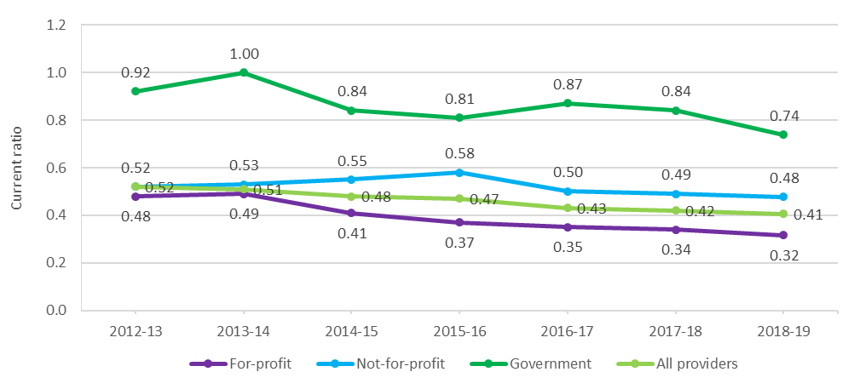

As shown in Chart 7.11 the EBITDA to total assets has been trending downwards in recent years. This continued in 2018-19 with a decline to 3.0 per cent from 3.3 per cent in 2017-18. In terms of ownership, the for‑profit providers continued to decline, as they have over the previous four years, down to 3.11 per cent from 3.99 per cent in 2017-18. The not‑for‑profit providers were relatively steady at 3.19 per cent compared with 3.13 per cent in 2017-18. The EBITDA to total assets ratio measures the operating return generated from an organisation’s total assets.

Chart 7.11: EBITDA to total assets, by provider ownership, 2014-15 to 2018-19

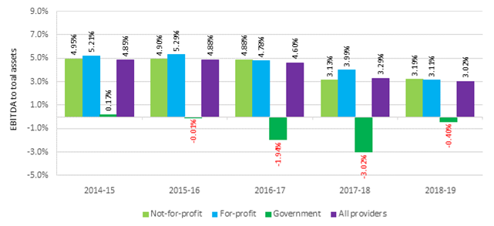

There continues to be a significant difference between provider types when looking at the results for the equity to total assets ratio, as shown in Chart 7.12. Not-for-profit providers were relatively steady at 35 per cent whereas the for-profit providers reported 12 per cent in 2018-19, although this was an increase from 9 per cent in 2017-18. The results for all provider types had been gradually decreasing over a number of years, suggesting a preference for debt to fund the growth in assets, however in 2018-19 increased to 26 per cent from 24 per cent in 2017-18.

Chart 7.12: Equity to total assets, by provider ownership, 2013-14 to 2018-19

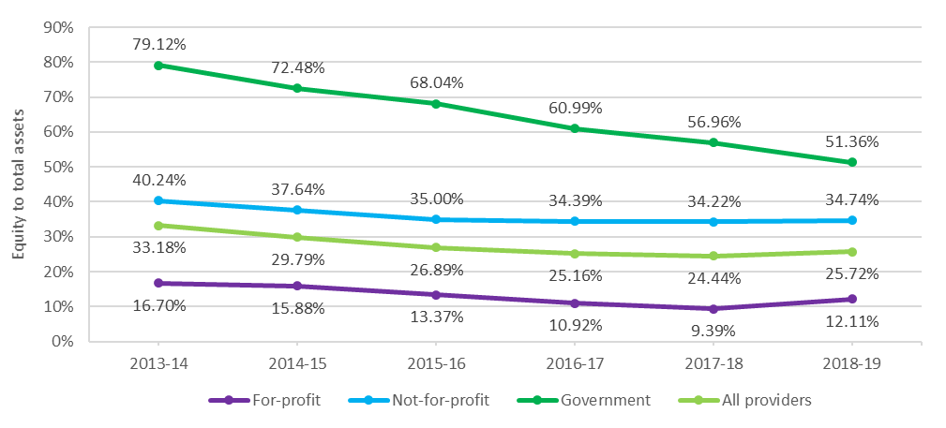

The average debt ratio across the sector decreased slightly from 0.76 in 2017-18 to 0.74 in 2018‑19. This follows a trend increase in each of the previous five years (Chart 7.13). Both the for‑profit and not‑for‑profit providers reported a decrease. The average debt ratio shows the proportion of organisational assets that are financed through debt. A ratio of more than 1.0 indicates that an organisation has a higher debt level than the value of its assets.

Chart 7.13: Average debt ratio, by provider ownership, 2013-14 to 2018-19

|  |  |  |  |  |  |  |  |
| --- | --- | --- | --- | --- | --- | --- | --- |
|  |  |  |  |  |  |  |  |
| |  | | --- | |  | | | | | | | | |
|  |  |  |  |  |  |  |  |
|  |  |  |  |  |  |  |  |
|  |  |  |  |  |  |  |  |
|  |  |  |  |  |  |  |  |
|  |  |  |  |  |  |  |  |
|  |  |  |  |  |  |  |  |
|  |  |  |  |  |  |  |  |
|  |  |  |  |  |  |  |  |
|  |  |  |  |  |  |  |  |
|  |  |  |  |  |  |  |  |
|  |  |  |  |  |  |  |  |
|  |  |  |  |  |  |  |  |
|  |  |  |  |  |  |  |  |
|  |  |  |  |  |  |  |  |
|  |  |  |  |  |  |  |  |

The net asset position increased for the sector from $11.8 billion in 2017-18 to $13.5 billion in 2018-19 (Chart 7.14). For‑profit providers increased from $1.9 billion to $2.7 billion and not‑for‑profit providers increased from $9.0 billion to $9.8 billion. The net asset position of the sector as a whole has been increasing since 2014-15.

Chart 7.14: Net assets, by provider ownership, 2013-14 to 2018-19

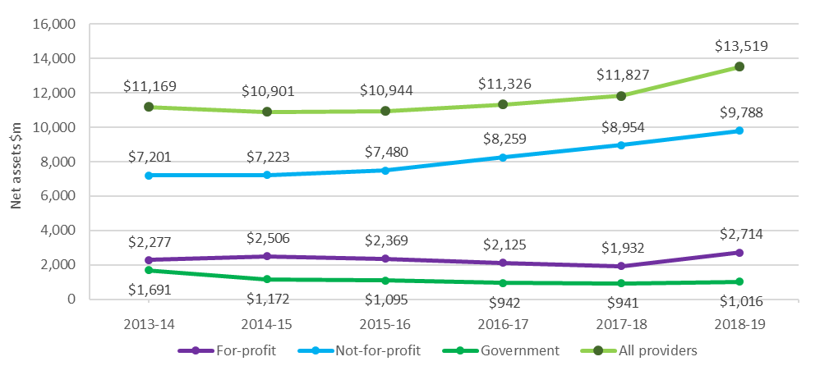

Cash held as a percentage of accommodation balances provides an indication of an organisation’s capacity to repay the accommodation deposit balances from liquid resources (Chart 7.15). The levels of cash and cash equivalents held by the for‑profit providers is around half that of the not‑for‑profit providers and decreased slightly to 12.9 per cent in 2018-19 from 14.3 per cent. The not‑for–profit providers also reported a decrease from 29.3 per cent in 2017‑18 to 27 per cent in 2018‑19.

Chart 7.15: Cash held as percentage of accommodation deposit balances, by provider ownership, 2017-18 and 2018-19

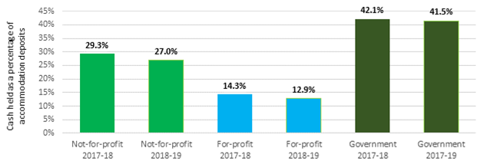

Chart 7.16 shows total assets, net worth/equity and average accommodation deposit value per resident, by ownership type in 2018-19, compared with 2017-18. For the whole sector, average accommodation deposits held increased to $318,283 per resident from $303,107 in 2017-18, an increase of 5 per cent. This metric measures the average value of all bonds (pre 1 July 2014) and accommodation deposits (post 1 July 2014) that providers hold. The average value of bonds/RADs has been steadily increasing in recent years.

In terms of net worth/equity, for‑profit providers recorded a significant increase, up to $37,159 from $27,357 in 2017-18. This follows two years of decline. The not-for-profits recorded an increase for the third year in a row, increasing to $94,600 from $87,262 in 2017-18. The value of total assets per resident for both the for‑profit and not‑for‑profit providers increased in 2018-19 compared with 2017-18 by 5.3 and 5.5 per cent respectively.

Chart 7.16 total assets, net worth/equity and average accommodation deposit value per resident, by ownership type, 2017-18 and 2018-19

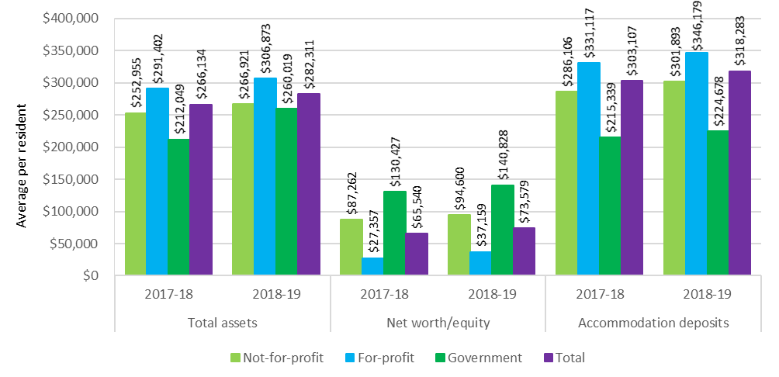

### Recent trends in building and investment in the residential care sector

In 2018-19 the total completed or in-progress work was $5.3 billion, compared with $4.9 billion in 2017-18 (Chart 7.17).

However, there remains a significantly lower proportion of providers reporting their intention to rebuild or upgrade compared with 2016-17 and the years preceding. In 2018-19, there was a further slight decline in providers reporting they were planning to rebuild, and the proportion reporting they intended to upgrade their facilities was stable (Chart 7.18). In 2015‑16 the proportion of facilities planning to rebuild or upgrade was at its strongest, with 5 per cent and 14 per cent respectively. In 2018-19, following a third year of declining intentions, only 1 per cent of facilities are reporting they are planning rebuilding works and 5 per cent planning to upgrade.

As noted in ACFA’s 2019 Report, feedback from consultations with providers indicated that many had curtailed or delayed investment plans in the residential care sector, citing depressed returns and policy and regulatory uncertainty along with the potential impact of increased home care packages. In the consultations undertaken for this year’s report, providers indicate that the same factors are curtailing their investment plans. The degree of uncertainty over the future direction of aged care following the completion of the Royal Commission into Aged Care Quality and Safety was often cited as a major factor influencing future investment decisions.

Consistent with the feedback reported in last year’s report, many providers, both for-profit and not-for-profit, say their immediate plans would be directed to retirement living rather than residential care. Factors cited in influencing this decision included: the considerable policy and regulatory uncertainty in the aged care sector; the desirability of diversifying income streams given the volatility in residential aged care; and the advantages of establishing an integrated aged care operation that involved retirement living, home care and residential aged care.

For-profit providers continue to emphasise that the current return on capital employed in aged care was below the cost of capital and, in the absence of any change, this would curtail additional investment in the sector. The uncertainty associated with COVID-19 is likely to cause further delayed investment plans in the residential aged care sector.

Chart 7.17: Residential care building activity (completed or in-progress), 2013-14 to 2018-19

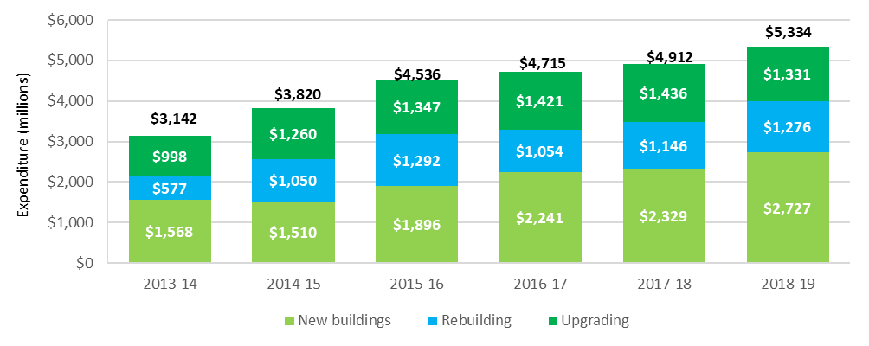

Chart 7.18: Proportion of facilities planning to either upgrade or rebuild, 2013-14 to 2018-19

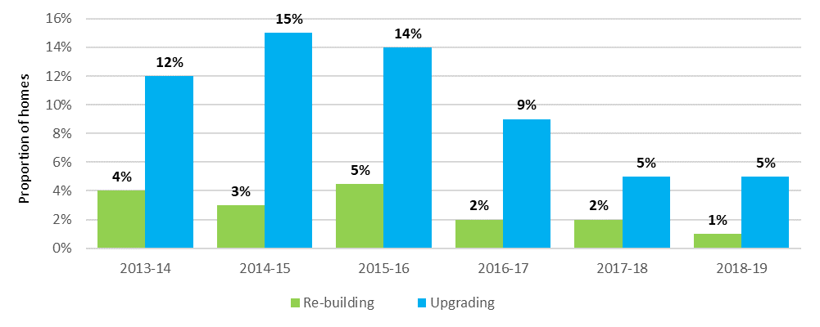

The decline in planned building activity discussed above is also evident, albeit less significantly, in data regarding aged care building approvals from the Australian Bureau of Statistics. There were 351 and 336 building approvals for aged care facilities in 2017‑18 and 2018‑19 respectively after the previous two years had seen over 400 approvals (Chart 7.19).

Chart 7.19: Number of building approvals, by value of building work, 2013-14 to 2018-19

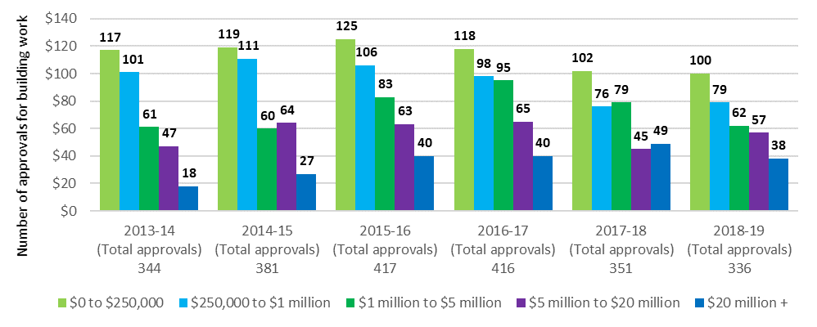

# Future demand for aged care

|  |
| --- |
| **This chapter discusses:**   * The factors that affect demand for aged care; * demand for the different types of subsidised aged care; * changing population of older Australians requiring aged care; and * changing preferences of consumers seeking aged care. |

## Future demand for aged care services

The demand for aged care services will expand with the ageing of the population. This chapter discusses the factors that affect demand for the relevant aged care types, how this is likely to look in the future, and the investment that is needed to ensure the aged care system can adequately cater for the expected future requirements of an ageing population.

An investigation into demand and supply of aged care services was undertaken by David Tune AO PSM in the Legislated Review of Aged Care 2017. The Review concluded that there was insufficient data available and that “robust measures of demand and unmet demand in aged care are a significant way off”. The Review also noted however that there is no doubt that demographic factors will lead to significant growth in service provision and expenditure requirements.

It is also currently not possible to accurately determine consumer preference for residential and home care, due to existing supply constraints. However some better evidence about unmet need and consumer preference is being revealed since the creation of the National Prioritisation System for home care packages and the decline in average residential care occupancy despite a large proportion of older people on the home care queue also being approved for permanent residential care, but choosing to remain living at home. The introduction of flexibility to switch funding across care types in response to consumer demand will also help to inform consumer preferences. The other variable is how providers might respond to increased consumer choice, such as innovation in accommodation options for older people and innovation in service delivery models.

The analysis in this chapter focuses on projections based on current use of aged care and population growth, and should not be treated as forecasts of what is likely to happen in terms of future demand for types of aged care.

### Determinants of demand

Demand for aged care services is complex and dependent on a range of demographic, service need, and economic factors. The Productivity Commission noted in its 2011 report, Caring for Older Australians, that “The demand for aged care services depends on the number of older people needing care and support. However, care needs are not homogenous and the nature and location of aged care services demanded will depend on the physical and mental health of older people, their capacity and willingness to pay, their preferences, and the availability of informal carers.”

Figure 8.1: Factors affecting the extent and type of aged care service demand

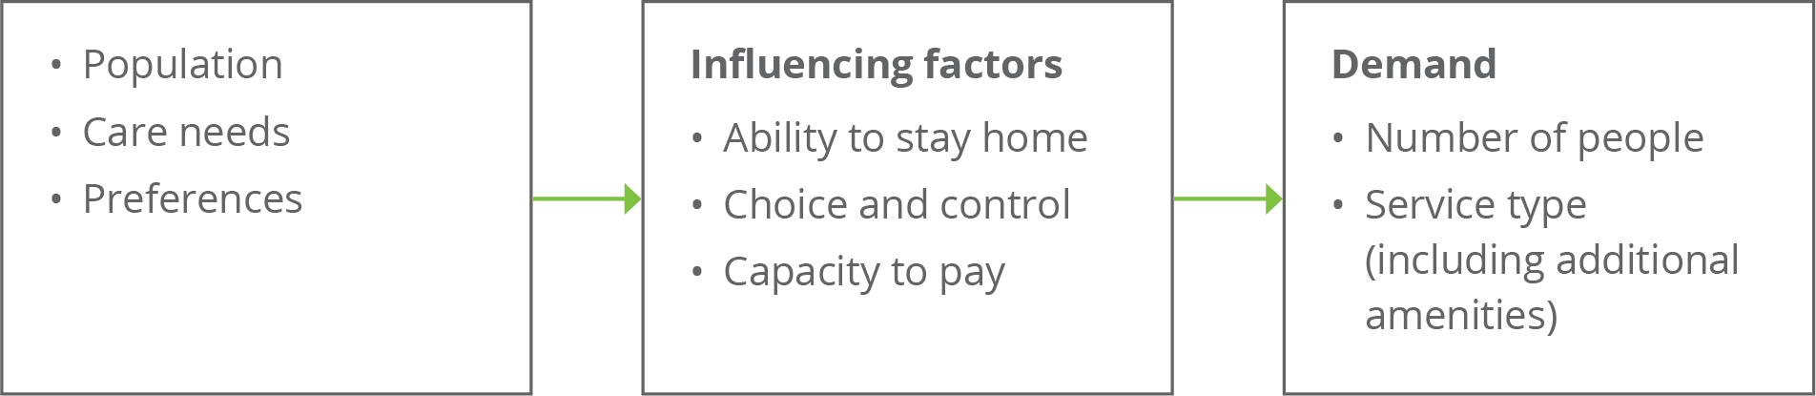

Source: adapted from Caring for older Australians (Productivity Commission, 2011)

### An ageing population – older people demand more aged care

The structural ageing of the Australian population over the next 20 years will see the size of the 70 years and over cohort increase by around 1 million people each decade; this is on a base of 2.9 million people in 2020. Underneath this, the older age groups will more than double over this period; for example, the 85 years and over cohort will increase from just over 500,000 people in 2020 to just over 1 million people by 2040.

Chart 8.1: Number of people aged 70 years and over, by 5 year age cohort, 2020 to 2040

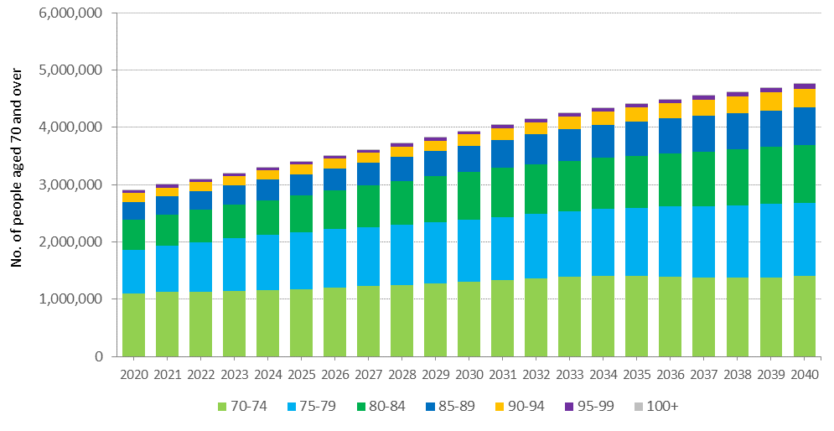

Because the baby boomers are such a large group compared with the pre-war generation, the proportion of the 70 and over population who are aged 85 and over will actually reduce over the next decade before subsequently increasing, as shown in Chart 8.2. This implies that the challenge of ensuring there is sufficient aged care supply to meet demand arising from the baby boomer generation is likely to be most strongly felt in 10–15 years (from the late 2020s) rather than over the next decade.

Chart 8.2: Proportion of 70 years and over age group who are aged 85 and over, 2020 to 2040

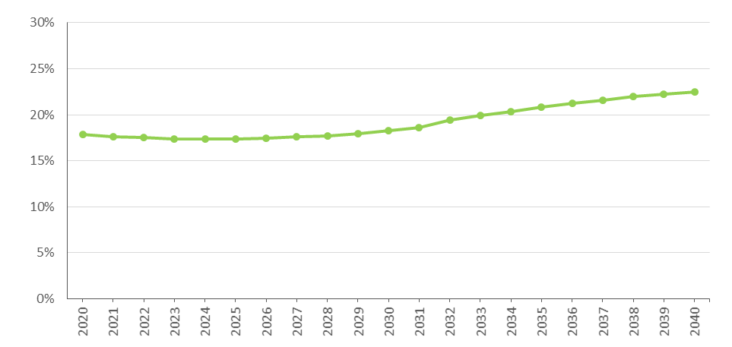

### Consumer preference

A key characteristic of the baby boomer generation is that they are wealthier than previous generations[38]. The bulk of the people likely to be demanding care in the next two decades have benefitted from high growth in property prices while paying down their mortgage, and are the first generation to have compulsory superannuation. It is reasonable to assume that they will both expect and be able to afford higher standards of residential accommodation, lifestyle amenities and quality of life than previous generations have been willing to accept. Like the current generation, however, baby boomers can be expected to prefer to remain living in their own home for as long as possible as they age.

The consequences of these trends are that while the demand for aged care will grow with the ageing of the population, consumers may be more demanding in the range and quality of aged care services they are seeking, along with having a greater capacity to pay for these services. Nevertheless, with the Age Pension being the main source of income for current retirees and those entering aged care over coming decades, maintaining equity in access to aged care services will continue to be important and a robust safety net will continue to be necessary.

ACFA noted last year that to compete in this environment providers will need to be more responsive in meeting consumer needs and expectations, including in particular the desire to stay at home for as long as possible. This may require the introduction of new business models and changes in the interaction between retirement living, home care and residential care. The aged care regulatory system will also need to adapt to enable providers greater flexibility to pursue new business models and innovation.

### Availability of alternative care types

According to the 2015 Survey of Disability, Ageing, and Carers[39], around 1 in 9 Australians, or 2.7 million people, were informal carers. Almost all carers cared for a family member. The assistance provided by informal carers can avoid or delay entry into residential care, including with the support of home-based care, and is also an important source of support for those in residential care.

At the same time that ageing population structures (discussed earlier) are putting pressure on the demand for care, the relative supply of informal carers will be diminishing. This is due to increased participation of women in the workforce, and changing family structures with fewer children being born per family (1.7 babies per woman in 2017 compared with nearly 3 in 1970[40]), generational differences in marriage and divorce rates, and more people living alone.

All else equal, this will increase the demand for formal aged care for older people.

In terms of demand for specific types of aged care, the relative availability of places within each care type under current regulated supply arrangements will also affect the rates at which people access them and to the extent they are not available, redirect demand across care types. As previously outlined in this report, the Government is gradually changing the mix of residential and home care over time through adjustments to the provisional target ratios, and has implemented mechanisms whereby funding for unused residential care places can be redirected into home care where, at least over the short term, demand is expected to be more acute.

In addition, a key objective of the Legislated Review of Aged Care 2017 was “to trigger changes that are prerequisites for a fully consumer-driven system”, and outlined recommendations that were “intended as the next steps on the road to consumer-driven care”. Most of the Legislated Review’s recommendations in this regard have not been acted upon.

The unknown, therefore, is the extent to which the modes of delivering care may develop in the future in response to consumer preferences, such as further relaxation or removal of supply constraints, the availability of more higher level home care packages and closer integration between retirement living and home care. New ways of service delivery and innovation may widen the scope of aged care services available, which in turn may result in significant shifts in demand for different types of services. The direction of aged care policy following the completion of the Royal Commission into Aged Care Quality and Safety will be an important influence in this regard.

### Economic factors

The demand for different types of care, and the way consumers distinguish between services in the same type of care, is affected by the price they can be asked to pay and the perceived value of that contribution. Demand may also reflect the relative subsidies that apply for different care types.

Consumers of residential and home care are currently required to make a co-contribution to the cost of their care (and residential accommodation) if they can afford to do so. However the amount and proportion of contribution required to be made by a consumer varies between residential care and home care, including in relation to capacity to pay. Such anomalies have the potential to distort the demand for types of care or additional services.

Nevertheless a challenge remains for Government to establish funding policies that ensure access to aged care services for all older Australians needing aged care and support at a level that meet the community’s quality of life expectations, irrespective of their means and social and cultural circumstances. Incentives in funding arrangements are also important in influencing the type of care supplied, for example if funding arrangements have no incentive for reablement services and a provider loses funding if there is an improvement in the level of acuity of a consumer, then there will likely be limited supply of services promoting reablement.

## Current demand for aged care

An understanding of the current profile of aged care usage is helpful for undertaking projections of future demand.

As shown in Chart 8.3, the proportion of each age group who use residential and home care package services increases dramatically with age. By age 80, the proportion of people using either permanent residential care or a home care package is around 7 per cent; this doubles by aged 85; and more than doubles again by age 90.

Chart 8.3: Proportion of people of each age using residential care and home care, by gender and age, 30 June 2019

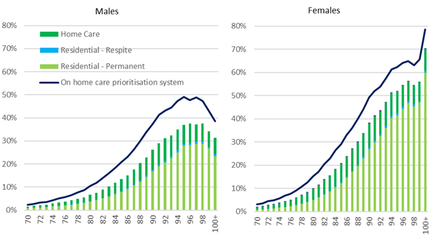

Note: Home care consumers receiving care in an interim level package are counted as using home care. People counted as waiting for a home care package are only those consumers who do not have a package at any level.

This projection is based on current usage, which may well not reflect the extent to which consumers are having their needs and preferences met by current regulated supply. True demand is much harder to measure given the current highly regulated supply system.

### Residential care

There are indicators which suggest that the overall demand for residential care is currently being met. The occupancy rate in 2018‑19 was 89.4 per cent, down from 90.3 per cent in 2017‑18, 91.8 per cent in 2016-17 and 92.4 per cent in 2015-16. The average occupancy rate in residential care peaked at 97.1 per cent in 2003-04. There may, nevertheless, be pockets or regions of the country where people are waiting to access residential care. The Tune Review asked stakeholders about the level of unmet demand and received little feedback to suggest that there is significant unmet demand.

Residential care usage may, however, be artificially high as result of people entering residential care prematurely as an alternative to waiting on the allocation of a home care package, notwithstanding that a large number of people on the home care queue also have a residential care approval which they are choosing not to exercise. Current usage also does not reflect the potential for residential care services in a more competitive and flexible system to offer a more attractive service that includes more opportunities for higher quality and meaningful life delivered in a secure environment.

### Home care

There is evidence of unmet demand for home care. As noted in section 3.4.2, as at 31 December 2019 there was a total of 104,473 people waiting for their approved level home care package (including those already receiving lower level home care) through the National Prioritisation System.

## Projecting future demand

Previous ACFA reports contained a projection of demand for residential care over the next 20 years based on current age-specific use and the current residential aged care target provision ratio which is based on the number of people aged 70 years and over.

A projection on this basis suggests that the projected number of operational places is likely to exceed demand for residential care to 2027. This is because places are linked to growth in the 70+ population, which due to baby boomers entering their 70s, is growing at a faster rate than people who currently are using residential care, who are the 80 plus cohort of the population. Following 2027, as the baby boomers enter their 80s, demand for care is expected to rise faster than the release of places in line with the provision target ratio.

Care is needed in interpreting such projections because they are limited to residential care and do not take into account changes in consumer preferences and changes in modes of delivery of aged care. In particular, no account is taken for substitution of residential care for home care as the number of home care packages continue to expand.

### Substitution of residential care and home care

One of the key factors that has to be taken into account in projecting demand for aged care is the potential substitutability of service types. The introduction of the National Prioritisation System indicates there is significant unmet demand for home care services. It is also possible that some people have entered residential care because a home care place at a suitable level was not available.

The proportion of people in each age group (age-specific use) who are in either residential care or home care has remained stable (Chart 8.4, first column) over a long period of time. However, the amount of home care packages available has increased significantly as a share of these two care types (Chart 8.4, second column). As the amount of home care has expanded, there has been a reduction in the age-specific use of residential care (Chart 8.4, third column and Chart 8.5 which gives a cross-section of Chart 8.4). This would indicate that home care is substituting for residential care.

It is not known what the level of home care availability is that would be needed before all people who wish to remain in their home with a home care package can do so, and do not have to enter residential care. In addition, the substitutability between residential and home care will also change if, for example, the government were to introduce a new higher level package as recommended by The Tune Review (Recommendation 7). It is possible that the introduction of higher level home care packages could see the age-specific use of residential care potentially reduce. Similarly, other possible policy changes, such as consumer contribution policies and support available for informal carers (such as improved respite services), could influence value for money and consumer choice.

Chart 8.4: Utilisation of residential care and home care, 2000 to 2019

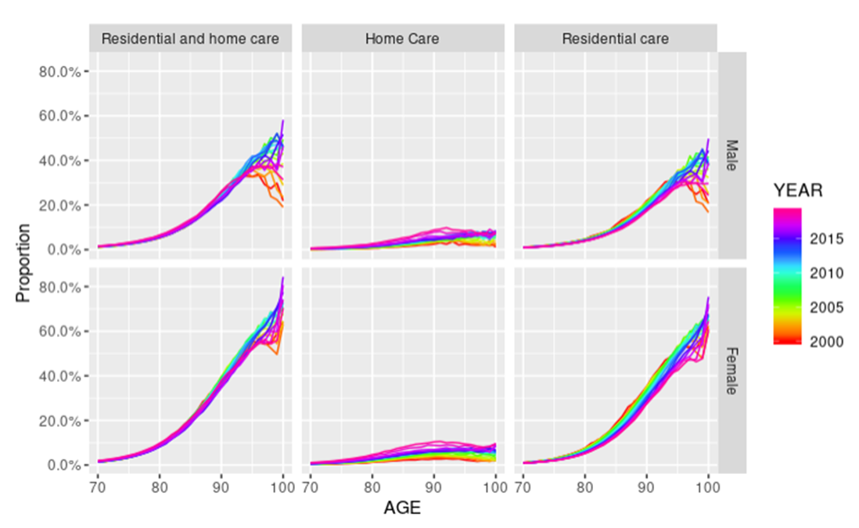

Chart 8.5: Utilisation of residential care and home care for 85-89 year olds, 2000 to 2019

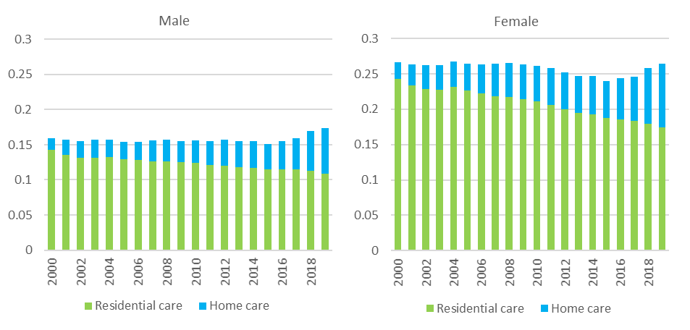

The expansion of home care is likely to not only divert people from entering residential care for longer or at all, but it will also have an impact on people receiving care from informal carers and through other programs such as the Commonwealth Home Support Program (CHSP). It is estimated that 94.3 per cent of people waiting for a home care package as at September 2019 had been provided with approval to access support through CHSP.

### Updated projections

The projected demand from the current age-sex specific usage of residential care is one approach to projecting future demand for residential aged care. However, with the expansion of the home care program and the concomitant fall in the usage of residential care in all age groups (Chart 8.4 and Chart 8.5), such projections may over estimate demand for residential care. Chart 8.6 shows the number of people using residential care proportional to growth in the population (using ABS single-year-age and sex population projections).

It is evident from Chart 8.6 that, if the growth in the number of residential care places grows in line with the current target provision ratio (purple line) and is not impacted by any other factors, occupancy rates will continue to fall over the 2020s, before rising in the 2030s.

Chart 8.6: Projected demand for and supply of residential care places, 2019 to 2040

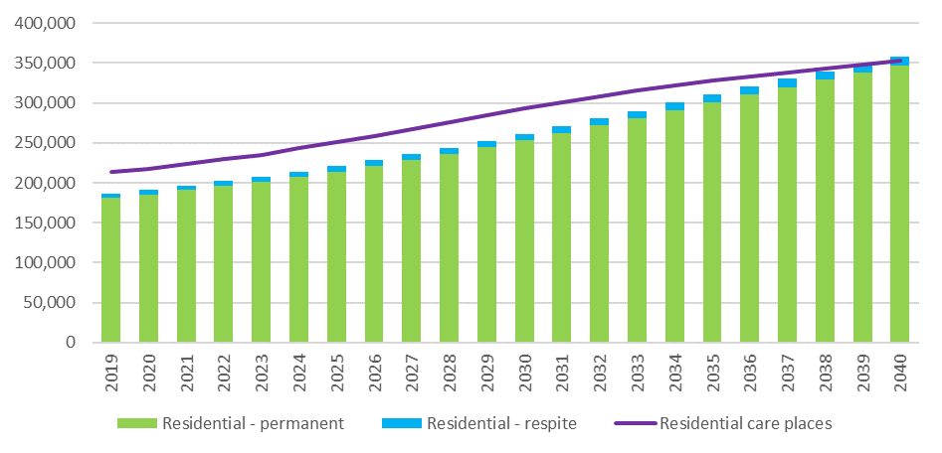

There remains excess demand for home care. Consequently, projections based on the current usage of home care, which is constrained by current supply, are not going to give a meaningful guide as to future demand. In addition, the current profile of assessment for home care could be influenced by the number of people waiting for home care through the National Prioritisation System and prospect of long wait times.

With this in mind, Chart 8.7 shows the number of people in the home care system at 30 June 2019 - with a package (blue series) or waiting for a package to be offered (orange series) – proportional to growth in the population using the ABS single-year-age and sex population projections. These series have been broken down into sub-components:

* the ‘with a package’ series (blue) is further sub-divided into those receiving a package at their assessed level, those receiving an interim package and those who have been offered a package and are in the process of deciding whether to take up the offered package; and
* the ‘waiting for package to be offered’ series (orange) is further sub-divided into those who have not been offered any package and those who have been offered an interim package but have not taken this up.

It is evident from this chart that the growth in the number of packages (black line) as the provision target of 45 by 2020 is achieved will, in the short-term, significantly reduce the number of people waiting for home care through the National Prioritisation System who have not yet been offered a package. However, there will still be a significant number of people without a package and over time the number of people waiting will grow again. It needs to be kept in mind that those people who have declined the offer of an interim package have indicated they are actively seeking care and are awaiting an offer of a higher level package.

Chart 8.7: Projected demand for and supply of home care packages, 2019 to 2040

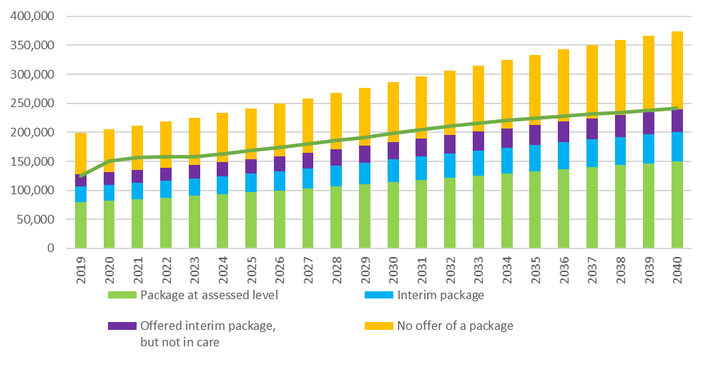

### Planning for the supply of aged care

As noted previously, if residential care places increased in line with the current target provision ratio and current age-specific use rates continued, there would be an excess supply of residential care over most of the 2020s. As the baby boomers start to enter their 80s in the 2030s, this demand could start to put pressure on the sector and its ability to ensure there is adequate supply of residential care. This has been flagged in previous ACFA reports and in the Tune Review.

There is excess demand for home care, and this is likely to remain the pressure point in the supply of aged care over the projection period. At least part of this undersupply can be met through a reduction in residential care places as currently provided for in the target provision ratio.

The Tune Review report recommended changes to the target planning ratio. The current ratio denominator of the 70+ population is not aligned to the cohort of the population more likely to use aged care services, and results in the observed periods of relative oversupply and undersupply. ACFA supports the Tune Review recommendation to change the denominator in the ratio to the 75+ cohort of the population following the achievement of the 125 ratio in 2021-22.

ACFA also recommends that the change in the denominator be accompanied by a change in the target provision ratio formula so that it is based on the number of consumers and not the number of operational places. This will allow comparable reporting and monitoring of the supply of residential and home care places against the provision targets, and help inform unmet demand and consumer preference.

The following analysis shows the supply of aged care places under the 70+ population and 80+ population. The equivalent rates (converted as at 30 June 2023) are 194 per 1,000 people aged 75+ and 351 per 1,000 people aged 80+. As can be seen in Chart 8.8 the expected growth in the number of consumers (blue line) more closely follows the 75+ population growth over the medium term to the mid 2030’s.

Chart 8.8: Cumulative growth in aged care places, 2023 to 2040

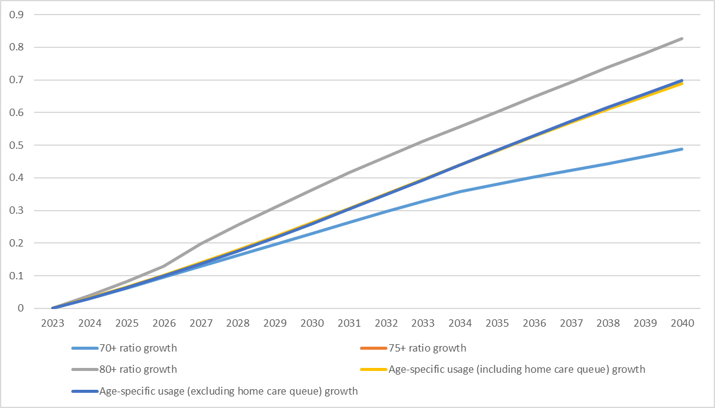

## Investment requirements for residential care

As noted above, there are many variables that will influence the future demand for residential aged care. Nevertheless, it is evident given the ageing of the population, along with increasing consumer expectations, that there will need to be significant future investment in the residential sector to both build new facilities and to refurbish existing facilities.

Using only the current target provision ratio to project the future supply of residential aged care, and not taking into account the impact of increased home care on the demand for residential care, the sector would need to build over 80,000 places over the next decade. At the same time, the sector would need to rebuild or refurbish a substantial proportion of the current stock of aged care facilities. It is assumed that over the next decade around a quarter of the existing stock of buildings, covering around 56,000 places, would need to be rebuilt or refurbished (at an even rate over the period).

Chart 8.9: Number of operational residential aged care places required 2018-19 to 2028-29

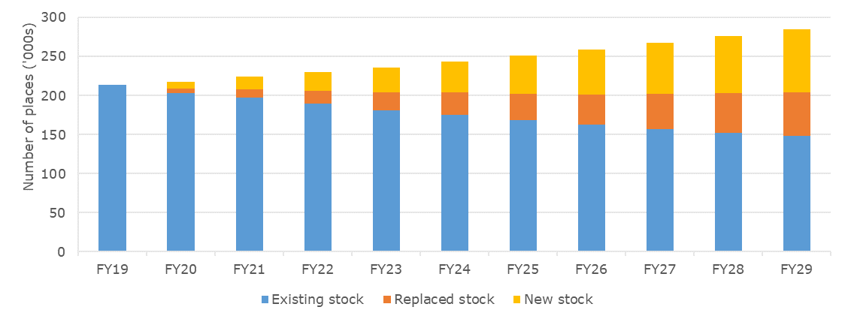

On the basis of the above assumptions, the combined total investment for new and rebuilt places over the next decade would be around $56 billion. The net present value of this estimate is approximately $51 billion. This compares with an estimate of around $19 billion (in present value) in building and upgrade work completed between 2010 and 2019. As previously noted, however, these projections are based on particular assumptions and should be treated with care.

While the total number of residential care places increased from 179,749 to 213,397 over the last 10 years, the number of mainstream facilities decreased from 2,772 to 2,717. This means that, on average, the investment in new places was primarily through expansion of existing facilities. There is a limit to how big existing facilities can expand and future investment to increase the supply of residential care places may have to be increasingly through greenfield projects.

Chart 8.10: Future annual investment requirement, 2019-20 to 2028-29

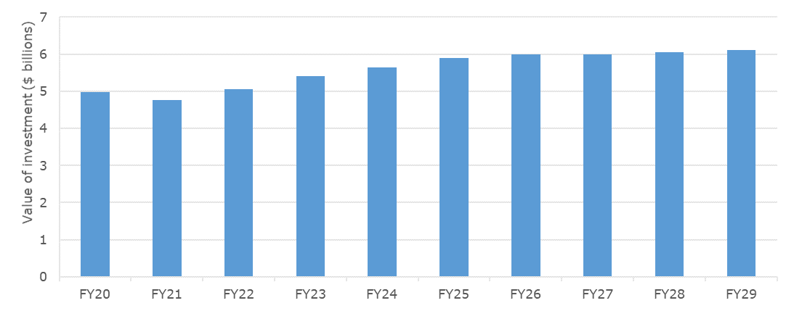

|  |
| --- |
| The model used to determine the investment requirements was developed for the Department in 2018 by Deloitte Access Economics. The assumptions behind the analysis are:   * Total place requirements (i.e. the total of all new and rebuilt stock) that is estimated to be operational at each point in the future is based on the Department’s projections which take into account the current stock of provisionally allocated places; the historical rate of building; and the expected number of flexible residential care places that also contribute to the overall residential care target. * The share of places that are rebuilt each year is estimated using a flat rate assumption of 2.5 per cent of the stock in that year, i.e. a 40 year average building lifetime. * The cost of construction differs by region. The base construction costs in 2018-19 of $260,700 per new place, $221,200 per rebuild, and $27,700 per upgrade (from the Survey of Aged Care Homes) have been adjusted by using indices that scale up costs in regional areas relative to the nearest capital city. * The cost of construction is indexed over time using a 10 year average of Rawlinson’s Building Cost Index for each state’s metropolitan and regional areas (averaging out at 2.4 per cent per annum nationally). * The cost of land is sourced from ABS land price data for each state’s metropolitan areas and again adjusted using the relevant regional index for that state. * The cost of land is indexed over time using a flat rate of 4.4 per cent per annum for all areas based on ABS residential property price data. |

The value of building work completed and in progress during 2018-19, and other indicators of construction and investment in the sector is discussed in Chapter 7.

## The investment environment

The significant capital investment needed to meet the future demand for aged care services will largely come from the non-government sector, both for-profit and not-for-profit sectors. As noted in Chapter 9, one of the challenges facing the Government is to ensure that the funding and regulatory arrangements in the aged industry sector are such that it provides the ongoing environment that facilitates the needed investment. A key requirement in this regard is that the non-government sector has confidence in the direction and stability of Government policies and those providers receive a return such that it will attract the necessary capital and labour resources. The funding arrangements will also need to be flexible so that providers can respond and adapt to changes in consumers’ preferences for aged care services as well as innovate and embrace new technologies.

### Access to capital

Capital investment in the residential aged care industry is required to expand and refurbish existing facilities, as well as building to meet future capacity. To attract investment the industry needs to generate consistent rates of return that are appropriate for the risk involved and are competitive with returns in other sectors that have similar attributes.

Viable and well-run providers are best placed to attract the financial capital, experienced management and quality staff required to deliver long term industry sustainability and growth. Key ingredients of well-run providers include the exercise of good governance that oversees the implementation of strategic investment plans and the ability to successfully monitor their operational performance against those plans.

To be viable, a provider, whether not-for-profit, for-profit or government owned, must have access to sufficient funds to repair and replace their capital stock, be able to maintain working capital to support their operations, and use capital efficiently relative to the other purposes to which it could be deployed. These outcomes are underpinned by sound financial management that effectively manages costs and sets appropriate pricing strategies to derive the revenue stream to support sustainable capital returns.

Investment activity requires equity investor and debt provider confidence in the capacity of providers to deliver sustainable returns on capital and of the sector overall. The amount of (and change in) invested capital is one key metric of sustainability.

Capital investment in the residential sector can include: equity injections or retained earnings; loans from financial institutions or investors which require sufficient profits to be generated to meet the interest costs and repayment amounts; and interest-free loans from residents in the form of lump sum accommodation payments. Where providers are unable to meet the whole cost of essential capital works, limited capital grant funding is available from the Government-funded Rural, Regional and Other Special Needs Building Fund.

# Challenges facing the aged care industry – uncertainty, transformation, transition

|  |
| --- |
| **This chapter discusses**  some of the issues that need to be considered in ensuring the sustainability of the aged care industry against the background of COVID-19, existing and continuing underlying financial pressures on providers and the prospect that the industry may undergo major transformation following the Royal Commission into Aged Care Quality and Safety. |

## The aged care industry faces many challenges and uncertainties.

The immediate challenge facing the aged care industry is combatting the spread of COVID-19. It is imposing additional costs on providers and has the potential to cause significant financial disruption as well as bring into question the viability of a number of providers. The Government has provided some temporary funding increases to help the sector respond to the demands from the coronavirus pandemic. However the pressures, challenges and uncertainties posed by COVID‑19 are impacting on an aged care industry that was already facing a period of transformation. The direction, shape and timing of the transformation was and remains uncertain.

The underlying difficulties confronting the aged care industry have not diminished as a result of COVID-19, rather they have intensified. And these underlying difficulties still need to be addressed.

There is significant variation in the financial performance of aged care providers, however the overall trend, particularly in the residential care sector, is not sustainable. Since 2017‑18, the non-accommodation revenue of residential providers, which primarily reflects ACFI payments from the Government and the basic daily fee paid by consumers, has been growing substantially slower than the growth in expenses which are primarily employee costs. The result has been a significant deterioration in the financial performance of residential care providers. This deterioration is expected to continue, if not accelerate in 2019-20 with the onset of the COVID-19 pandemic. Aged care providers in regional and remote areas face particularly pronounced financial pressures. An increasing number of residential care providers are making a loss, and it appears that a growing number of smaller providers are facing significant financial difficulties and are seeking to leave the industry. The COVID-19 impact is likely to accelerate this trend.

The financial performance of home care providers fell significantly in 2017-18 following the reforms in February 2017 that saw home care packages being assigned to consumers rather than allocated to providers, and consumers being able to direct their care package to the provider of their choice as well as to change providers. These factors have led to a significant increase in competition and choice in the home care market, and also has contributed to the fall in financial performance. The financial performance of providers stabilised in 2018-19 as they continue to adjust to the new arrangements.

In residential aged care, investment is needed to continue to meet demand given the ageing population. However, volatility, margin pressure and uncertainty have resulted in many residential aged care providers putting their investment plans on hold while they assess the future direction of aged care policy. Some are instead investing outside the aged care industry where they can obtain higher returns as well as diversify income streams in order to reduce their exposure to volatility in aged care. Potential new investors in aged care are also holding off investing given the uncertain environment. The COVID‑19 pandemic would have further contributed to a delay in new investment in the industry.

As noted in ACFA’s report on *Attributes for Sustainable Aged Care,* a legacy of a highly regulated system, funding pressures, low community status and at times esteem, incentives that do not reward innovation, together with elements of ageism in society, have combined with the result that the aged care industry has struggled to attract management and leadership skills compared with better resourced and more dynamic industries. The coronavirus crisis has added to staff costs and to the pressure aged care workers are under. The Government has provided additional funding to assist aged care workers and providers deal with these pressures, although the funding is temporary and is in response to the immediate impact of COVID-19, rather than dealing with underlying issues.

## Setting a future direction

Abstracting from the immediate pressures caused by COVID19, which may remain and intensify over the course of 2020, the position of the aged care industry was not sustainable and was not consistent with an industry that is capable of meeting the future demand for aged care services. The Australian population is ageing and there will be a commensurate increase in demand for aged care services. The aged care regulatory system and funding arrangements need to transform so that the industry attracts the capital to finance increased investment along with an expansion in a dedicated and skilled workforce to meet the rising demand for quality aged care.

Prior to the impact of COVID-19, providers indicated that they were looking for a ‘circuit breaker’ that would see an improvement in their funding, reverse the current trend decline in their financial performance, and provide more certainty on the future direction of aged care policy.

Feedback from consultations suggest some providers were looking for the Royal Commission to be the circuit breaker, while others were concerned that the Royal Commission process may delay a much needed increase in aged care funding.

Both camps appeared to be disappointed when the Royal Commission noted in its Interim Report:

*‘ Since the Royal Commission began its work, there have been calls from several quarters for government funding to aged care to be significantly increased , without waiting for our Final Report and recommendations. These interventions are essentially variations on a theme which has haunted this area of government policy for far too long: short-term solutions which will at best temporarily stave off the worst problems and, at worst, produce another set of unintended outcomes requiring further inquiries and reviews and further injections*

Council Assisting the Royal Commission have made a number of submissions to the Commissioners suggesting their thinking in terms of the future direction of aged care. The Commission has foreshadowed the need for significant additional funding, but is yet to examine in detail issues related to the funding and financing of aged care. In March 2020, the Royal Commission announced that it was suspending all hearings and workshops until further notice, due to COVID‑19. The closing date for public submissions to the Royal Commission has also been extended until at least 30 June 2020. The final report is now required to be provided no later than 12 November 2020, rather than 30 April 2020.

Many providers appear to be apprehensive as to the direction of the reforms that the Royal Commission may recommend. They also expressed concern about how long it may take for the Government to respond to the Royal Commission’s recommendations. There is also a concern among some providers that the Royal Commission’s recommendations may raise expectations regarding the level and quality of aged care services, but this may not be matched with the increase in funding necessary to meet the cost of delivering those raised expectations.

As noted, the immediate focus of aged care providers and the Government is dealing with COVID‑19. However the underlying financial pressures in the aged care industry need to be addressed and there is the prospect that aged care may undergo a major transformation following the completion of the Royal Commission. Against this background, ACFA offers some observations on the considerations that need to be taken into account to ensure the sustainability of the industry as it transitions and adapts to changing circumstances. These observations draw on ACFA’s report on the *Attributes of Sustainable Aged Care – a funding and financing perspective.*

**Reducing uncertainty must be a priority**

Not only is the trend deterioration in the financial performance of residential care providers not sustainable, but there is also considerable uncertainty as to when this deterioration will be arrested and what will be the future direction of Government policy. COVID-19 will be contributing to this uncertainty, although all aspects of Australian society remain uncertain as to the impact of the virus.

Even before the impact of COVID-19, uncertainty was delaying and deterring investment in the residential care sector. If the margin pressure remains, the overall financial position of providers will continue to deteriorate and the viability of an increasing number of providers will come into question. This trend could be accelerated if COVID-19 takes hold in more aged care residential facilities, as has occurred in some other countries.

The viability of providers is varied. Some rationalisation in the industry is needed, and while poorly performing providers should exit, disruptive and disorderly closure of services needs to be avoided. The recently announced Government Funded Business Improvement Fund for residential aged care provides grants to facilitate struggling providers to improve their viability and, if that is not possible, to facilitate the transition of services to a new provider or the closure of the business in a safe and orderly fashion. This is a welcome initiative, however, if the financial performance of residential care continues to deteriorate, which may accelerate with the spread of COVID-19, the size of the Fund will need to be significantly increased. More importantly, unless the uncertainty over the outlook for the industry is not reduced, providers will be increasingly reluctant to take over a provider experiencing significant financial difficulties regardless of any financial incentive offered by the Government.

The temporary funding increases provided by the Government to the aged care industry to deal with COVID-19 would be welcomed by the community as an appropriate response. However, given the issues and concerns raised in the proceedings of the Royal Commission, the public would likely expect that any ongoing additional funding to the aged care industry would be linked to an improvement in the aged care system, particularly to enhance the quality and safety of care, and to improve access to and choice of care. The nature of the reforms being contemplated by the Royal Commission is still being developed, although consultation papers from the Royal Commission and submissions from Counsel Assisting indicate the Commission’s preliminary thinking on some matters and possible recommendations. They also acknowledge that the significant reforms will be expensive and take time to implement, and in some areas further analysis will be required, along with impact studies.

Of course, the Royal Commission only makes recommendations. It will be up to the Government to decide which recommendations will be implemented and their timing. While this process will take time, the Royal Commission, and the Government, must give a priority to reducing the uncertainty that currently prevails in the aged care industry. The impact of COVID-19 has added to the uncertainty confronting the industry and the delay in the proceedings of the Royal Commission may have increased concerns over when the fundamental issues facing the industry will be addressed. When the Royal Commission does finalise its report, to reduce uncertainty, it will be important that its recommendations are based on sound evidence, clear and precise and most importantly, are readily implementable and affordable.

In addition, any transition arrangements need to be carefully considered and clearly specified.

The COVID-19 pandemic significantly adds to the uncertainty confronting the aged care industry. The unprecedented nature of the pandemic makes it impossible to know when it will be resolved and the uncertainty removed. However another source of uncertainty impacting on the industry is the Royal Commission, and perhaps more importantly, the Government’s response. The Government cannot respond to the Royal Commission’s recommendations until they are finalised, and given the delay in the Royal Commission’s processes, it is difficult for the Government to give any indication as to the timing of its response. But in order to give some guidance to the industry against this background of uncertainty, the Government could reassure both consumers and providers that COVID-19 has not diminished its commitment to advancing the long-term reforms in aged care. In providing such reassurance, it could acknowledge that there will be permanent additional funding for aged care services, both Government and consumer contributions (discussed further below), and this increase in funding will be accompanied by significant improvements in safety and quality of care, access to care and overall accountability and efficiency of the industry.

**Establishing an environment that supports investment in aged care**

One of the reasons for emphasising the priority for reducing uncertainty over the future direction of aged care reforms is the necessity to improve the environment for investment in the industry.

While the Government is the main source of funding for aged care, the services are primarily delivered by the non-government sector, both for-profit and not-for-profit providers. These providers will not invest in the aged care industry, nor will they be able to attract and retain the required management teams and staff, unless they have confidence in the direction and stability of policy settings, particularly regulatory and funding structures. As noted previously, this needs to be a key consideration of the Royal Commission in approaching its recommendations, and for the Government in considering the timing and nature of its response to the Commission’s recommendations. In this regard, it will be important that providers understand the rationale for changes and have the opportunity to inject their perspective on the implications of the proposed changes.

**Promoting innovation and technology**

The need for social distancing, isolation and visit restrictions are some of the outcomes from the COVID-19 crisis that are forcing aged care providers to innovate processes and access technology to create solutions. Some of these ideas may be developed internally, others by external service providers.

The sector was already making changes and will continue to do so. Changes seen so far include: use of technology to deliver services and connect people; combining service offerings; new forms of engagement of families and volunteering; different delivery arrangements in home care; use of generic services; joint venturing between service providers and product providers; take up of new products by consumers and families; product providers changing their service offering; new procurement networks; and, older people making their own priority decisions. Providers are also starting to reconsider residential care design that would better support frail residents in future pandemics. The aged care industry likely continue to embrace many of these changes. Stewardship, incentives, funding and regulation will all need to support these new practices.

This process could be facilitated through aged care incubator programs that bring together aged care entrepreneurs and start-ups with mentors, investors and support networks to fast-track ideas into the market. Such programs may also encourage aged care providers tap in to additional revenue streams through the commercialisation of new technology solutions.

**The Government’s fiscal constraints cannot be ignored**

In preliminary submissions on program re-design, Counsel Assisting the Royal Commission has proposed a future system where there is a needs-based entitlement to aged care, where funding levels are linked to actual costs, and where the supply of aged care is not capped or rationed. Counsel Assisting’s submissions also propose mandatory minimum staffing levels in residential aged care, along with enhanced training, skills and qualifications, and improved remuneration for workers. If these proposals are agreed and implemented this would require a very large increase in the funding for aged care providers, particularly Government funding.

The Government’s response to the COVID-19 crisis has already led to a very large increase in the Budget deficit and the level of Australian Government debt. This was essential given the potential magnitude of the economic downturn as a consequence of the steps taken to contain the spread of the virus. The Government has emphasised, however, that the measures are temporary and that there has not been a structural increase in Government spending.

When considering the long-term funding requirements of the aged care industry, the Government cannot ignore fiscal realities. In fact, once the crisis has passed there may be a strong focus on containing Government expenditure in order to restore fiscal sustainability. Should the Royal Commission recommend changes that involve a very substantial increase in Government outlays on aged care, there needs to be an assessment as to whether this can be accommodated within the Government’s fiscal settings. Prior to the impact of COVID-19, a focus of the Government was on ensuring that its expenditure on aged care was balanced against other spending priorities and consistent with the sustainability of the Government’s overall fiscal position. That balancing task will remain once the coronavirus crisis has passed. A recommendation from the Royal Commission for an ‘aspirational’ aged care system that is not anchored in fiscal realities will not provide the certainty that the industry needs.

The *Legislated Review of Aged Care 2017* (the Tune Review), noted that there are four key conditions that must be met before removing regulatory controls to uncap supply of aged care. These are:

* Government needs an accurate understanding for the underlying demand for aged care services.
* Consumers must make equitable and sufficient contributions to the costs of their care, without those contributions being so high that they create a barrier to accessing care.
* There must be a robust system for assessing eligibility for Government funded aged care services.
* Government policy needs to ensure equitable supply of services across different population groups, and in settings where there is limited choice or competition, such as remote locations.

It will be important that these conditions are met before the Government uncaps the supply of aged care services as recommended by the Counsel Assisting the Royal Commission.

Counsel Assisting acknowledged that a reliable understanding of demand for aged care services is needed for budgeting and planning and an understanding of the supply side to avoid bottlenecks. Counsel also said that pre-conditions should include robust quality assurances and arrangements for ensuring accountability for expenditure on care.

With an ageing population, expenditure on aged care, along with age pensions and age-related health costs, will be an increasingly important component of the Federal Budget. The Government will need to have an accurate understanding of future demand for Government subsidised aged care services in order to prepare its Budget and set fiscal policy. The Productivity Commission’s 2011 report *Caring for Older Australians* and the *Legislated Review of Aged Care* 2017 both observed that estimating demand for aged care services is complex, there are data limitations and accurate assessments of demand are yet to be developed. They are important because no government wants an unexpected ‘blow out’ in its budget. Before fully uncapping supply, the Government will have to have confidence in its ability to estimate the future demand for aged care services.

Another of the conditions for uncapping supply set by the Tune Reviewwas that there must be a robust system for assessing eligibility for government funded aged care services. It will also be important to ensure that Government funding is accurately reflective of the actual cost of care, and that the care is delivered in the most efficient and cost effective manner. It is important that the Government has confidence that its care assessment arrangements and its tool for allocating funding is robust. If there is an increase in Government expenditure beyond what is forecast in the Budget, the Government has to be confident that this reflects growth in the underlying need for aged care services and is not driven by deficiencies in the assessment process or the funding tool. The recent ad hoc changes in policy and ACFI funding are examples of the ongoing cycle of policy changes and uncertainty.

**Setting the ‘price’ for aged care services**

The preliminary submission from Counsel Assisting the Royal Commission envisaged a redesigned aged care program where aged care funding reflects the actual cost of providing necessary care, which would be set by an independent authority on the basis of efficient standardised costs ascertained at regular intervals. It is important that the funding arrangements are stable, for this is fundamental to ensuring overall confidence in the aged care industry. The funding arrangements also have to be consistent with achieving ongoing equity of access for all consumers that does not incentivise outmoded or inefficient care practices and use of resources.

Government subsidies for aged care have to support the delivery of quality aged care services, but they should not support inefficient and poorly managed services. Nor should the overall arrangements provide higher than necessary funding. However a key aspect of ensuring the overall funding pool is appropriate is to ensure that it not only adequately covers the actual cost of care but also allows providers to achieve an adequate rate of return. As noted, the preliminary submission by Counsel Assisting the Royal Commission is envisaging that the ‘cost’ of care would be set by an independent authority. In its 2011 report on *Caring for Older Australians,* the Productivity Commission recommended that an independent Australian Aged Care Commission set the ‘price’ for aged care services as well as recommending the level of consumer co-contribution. The Aged Care Roadmap refers to establishing a ‘market informed price that the Government is prepared to pay’ for subsidising the delivery of aged care services.

It is not a simple matter, however, for the Government to set an appropriate overall price for aged care services that avoids over generous support for inefficient providers and does not provide a rate of return greater than that necessary for providers to maintain their involvement in the aged care industry. The industry is very diverse and the financial results of providers vary greatly depending on business structures, business acumen, location, financing arrangements, and motivations, including those who are mission based. Nevertheless, while a difficult task, establishing the efficient ‘price’ for aged care is fundamental to ensuring the sustainability of the industry. Towards reducing uncertainty in the industry, priority has to be given to establishing, in consultations with providers, arrangements for determining the ‘price’ for aged care services.

**Equitable contributions by consumers for the costs of their aged care**

One of the key considerations before uncapping supply for aged care services, as noted by the *Legislated Review of Aged Care 2017,* is consumers making equitable and sufficient contribution to the cost of their care. The Royal Commission’s Consultation Paper 1 released in December 2019 noted the Australian Government’s financial support for health needs of older people relies on several principles, including; the cost of care should be affordable to individuals, underwriting some of the cost of essential care for all people, and supplying additional assistance where individuals are unable to afford the cost of their care; and individuals should be given a sense of personal and social responsibility through, for example, the use of co-payments.

As outlined in ACFA’s report on *Attributes for Sustainable Aged Care,* the Government has to clarify its role, and the role of the consumer, in funding aged care. The Government has to clarify whether its role is to provide subsidised aged care to all Australians, with a limited contribution from consumers who can afford to do so, or whether the Government’s primary role is to provide a safety net for those Australians who cannot meet some or all of their aged care costs, while those with means taking greater responsibility for their care costs.

The current system is closer to the former situation. While those who can afford to make a contribution to their care costs do so, this contribution is minimal and capped by annual and lifetime limits. . Also, while a resident’s principal home is included in the means test to determine a resident’s contribution to their accommodation and care costs, if it is unoccupied by a protected person, the cap is set at a low level ($170,000). At such a low level, the cap is regressive, representing a significant proportion of the value of a resident’s home in a regional area, but a fraction of the value of a home in metropolitan areas. Residents with a greater proportion of their wealth in a home will contribute relatively less to the cost of care than a person with wealth in other areas. Moreover, regardless of the resident’s financial circumstances, the basic daily fee is set at 85 per cent of the single person’s pension. Such a situation is inequitable and regressive.

The Royal Commission process has highlighted that the Australian community is expecting a higher level and quality of aged care than currently available. The cost of funding these services will be substantially higher than current funding levels. Sustainable aged care funding arrangements will require that consumers who can afford to do so make a greater contribution towards the cost of the services they receive in aged care (complemented by a greater choice of higher quality services). This would involve stronger means testing arrangements for care fees. This should include increasing the cap on the value of the home in the residential care means test and/or introducing a threshold beyond which the home value becomes assessable. In addition, attention should be directed towards accessing the value of the home, such as through equity release arrangements along the lines of the Government’s Pension Loans Scheme, which will allow residents to pay for aged care services without having to sell their home. The *Legislated Review of Aged Care 2017* recommended including the full value of the home in the means test for residential care when there is no protected person in that home. The *Review* also recommended removing the annual and lifetime caps on means-tested care fees.

A further step would be to uncap the basic daily fee for residential care for consumers who can afford to pay. This would boost the revenue of residential care providers and allow older people increased choice of everyday living conditions. The Government should also implement the recommendation of the Legislated Review of Aged Care 2017 and require providers to charge the basic daily fee and income-tested care fee in home care. As noted previously, signalling such changes would help improve confidence in the aged care industry.

Much of the current focus in the aged care program has been on achieving viability and sustainability within the current service models. However changes to service models could reduce the demand for aged care services and increase consumer’s preparedness to pay. The implications of the development of new service models will need to be carefully monitored.

**Better engagement of consumers in the role they play**

As noted above, consumers who have the capacity to contribute to the cost of their aged care services should do so, for this to be achieved, it will require greater consumer acceptance of their need and ability to contribute higher fees. The core to achieving this acceptance is to improve consumers’ access to information.

While information sources such as MyAgedCare help in identifying what fees are payable, most people come into aged care decisions in a period of high stress with limited time to make decisions. There is a pressing need to help consumers make more informed decisions.

There is currently no clear pathway for consumers to readily access unbiased advice. ACFA’s report Understanding How Consumers Plan and Finance Aged Care highlighted that consumers consult a variety of sources including aged care providers, friends and family, financial planners, accountants, placement agencies, Centrelink Financial Information Services officers and websites.

Further research is needed to unpack and understand the consumer decision process and the role that advice plays. Many of the sources from which consumers currently seek advice do not have adequate skills or modelling tools to consider not only consumers immediate needs but also the impact of future changes throughout the person’s life. Aged care advice should be better defined by government and regulators to clarify its connection to advice requirements under the Corporations Act. This could be facilitated by considering the classification of a refundable accommodation deposit (RAD) and its payment option of a daily accommodation payment (DAP) - as well as the low-means resident equivalents – as a financial product.

Consideration and research may also include understanding how to reposition government messages to highlight that aged care is an individual and community problem, and the role of government is to ensure everyone has access at a level that is affordable rather than to be the core funder. In the minds of consumers and their families, this may help to shift the focus of Government subsidies to be a concession they can access, rather than the fees they contribute being a penalty. This may also help to refocus that the consumer is the client for aged care services rather than the government.

**A challenging year ahead**

As a result of COVID-19, 2020 is proving to be a difficult and challenging year for all aspects of Australian society, and this includes the aged care industry. The consequences and uncertainties associated with COVID-19 can be overwhelming and all consuming. Yet as noted in this report, the need for a sustainable aged care industry remains. Among the challenges facing providers, consumers and the Government is to continue to advance the reforms needed to ensure that Australia has an efficient, equitable and sustainable aged care industry which delivers safe, quality care.

Appendices

1. ACFA Membership

Members

| ACFA position | Name | Organisation |
| --- | --- | --- |
| Chairman | Mr Mike Callaghan AM PSM | Economic consultant |
| Deputy chair | Mr Nicolas Mersiades | Director Aged Care, Catholic Health Australia |
| Member | Mr Ian Yates AM | Chief Executive, COTA Australia |
| Member | Mr Gary Barnier | Partner, Cooperage Capital |
| Member | Mrs Natalie Smith | Head of Business Execution, Business and Private Bank, ANZ |
| Member | Prof Michael Woods | Professor, Centre for Health Economics Research and Evaluation, UTS Business School |
| Member | Dr Mike Rungie | Global Centre for Modern Ageing |
| Member | Ms Susan Emerson | General Manager Equip for living and Leef Independent Living Solutions SA/NT |
| Member | Ms Louise Biti | Director, Aged Care Steps |

Government representatives

| ACFA position | Name | Organisation |
| --- | --- | --- |
| Representative | Mr Jaye Smith | First Assistant Secretary, Ageing and Aged Care Group, Department of Health |
| Representative | Mr John Dicer | Aged Care Pricing Commissioner |
| Representative | Ms Victoria Wooley | Manager, Health and Disability Social Policy Division, Department of the Treasury |

1. Recent work completed by ACFA[41]

| Work | Date of completion |
| --- | --- |
| ‘Consideration of the financial impact on home care providers as a result of changes in payment arrangements’ report | Published 8 January 2020. |
| ‘Attributes for sustainable aged care’ report | Published 22 November 2019. |
| 2019 Annual Report on Funding and Financing of the Aged Care Industry | Published 5 July 2019. |
| ACFA provided its Submission to the Royal Commission into Aged Care Quality and Safety | 29 April 2019. |
| ACFA’s report on understanding how consumers plan and finance aged care | Published 24 December 2018. |
| ACFA’s report on respite for aged care recipients | Published 28 November 2018. |
| ACFA’s Update on Funding and Financing issues in residential aged care industry | Published 5 November 2018. |
| 2018 ACFA Annual Report on Funding and Financing of the Aged Care Sector | Published 28 August 2018. |
| 2017 Annual Report on Funding and Financing of the Aged Care Sector | Published in August 2017. |
| Application of the Base Interest Rate | Published in June 2017. |
| Bond Guarantee Scheme | Published in May 2017. |
| Report to Inform the 2016-17 Review of Amendments to the Aged Care Act 1997 | Published in June 2017. |
| Access to Residential Care by Supported residents | Published in February 2017. |
| 2016 Annual Report on Funding and Financing of the Aged Care Sector | Published in August 2016. |
| Report on Issues Affecting the Financial Performance of Rural and Remote Providers, Residential and Home Care | Published in February 2016. |
| 2015 Annual Report on Funding and Financing of the Aged Care Sector | Published in August 2016. |

1. ACFA’s stakeholder engagement

ACFA holds meetings and forums with representatives from the investment and financing industries, providers and consumers. This engagement is critical to ACFA’s understanding of the key issues, developments and challenges facing the industry. Since July 2018, ACFA’s consultations with industry have increased significantly as noted in Chapter 1.

In preparation for its 2020 annual report, ACFA has once again consulted heavily with consultations held in January, February and early March 2020. Consultations included a wide range of aged care providers (residential and home care), financial institutions and analysts and included providers in metropolitan and regional areas. This additional consultation allows ACFA to present an updated view of both the home care and residential care sectors in 2019-20.

ACFA Roundtables

In August and September 2019, ACFA held Roundtables in Sydney, and Melbourne and Adelaide with aged care providers and members of the investment and financing community to share the findings of its 2019 annual report and to hear their views on key issues facing the industry. These roundtables were also used as consultations for ACFA’s ‘*Attributes for Sustainable Aged Care*’ report, provided to Government in October 2019.

More than 50 representatives from various organisations participated in the roundtables and a diverse range of issues and views were discussed regarding the current financial situation in the aged care Industry, current and future investment challenges and workforce issues.

Presentations

Since its last annual report, ACFA has presented at the various forums:

* Criterion Conference on Financial Transformation in Aged Care on 29 April 2020.
* ACFA Chair consultations on funding and financing issues January to March 2020
* Aged Care Guild Board Meeting January 2020
* StewartBrown workshops in Sydney, Melbourne and Brisbane ‘Funding and Financing Challenges in Aged Care’ in October 2019
* Criterion Conference on ‘Funding and Financing Challenges in Aged Care’ in September 2019
* ACFA Roundtables in Sydney, Melbourne and Adelaide in August and September 2019

1. Aged care workforce

Table D.1: Full-time equivalent (FTE) direct care employees in the residential aged care workforce, by occupation: 2003, 2007, 2012 and 2016 (estimated FTE and per cent)

| Occupation | 2003 | 2007 | 2012 | 2016 |
| --- | --- | --- | --- | --- |
| Nurse practitioner | n/a | n/a | 190 | 293 |
| Registered nurse | 16,265 | 13,247 | 13,939 | 14,564 |
| Enrolled nurse | 10,945 | 9,856 | 10,999 | 9,126 |
| Personal care attendant | 42,943 | 50,542 | 64,669 | 69,983 |
| Allied health professional | 5,776 | 5,204 | 1,612 | 1,092 |
| Allied health assistant | 3,414 | 2,862 |
| **Total number of employees (FTE)** | **75,929** | **78,849** | **94,823** | **97,920** |
| **As a % of total employees** |  |  |  |  |
| Nurse practitioner | n/a | n/a | 0.2% | 0.3% |
| Registered nurse | 21.4% | 16.8% | 14.7% | 14.9% |
| Enrolled nurse | 14.4% | 12.5% | 11.6% | 9.3% |
| Personal care attendant | 56.5% | 64.1% | 68.2% | 71.5% |
| Allied health professional | 7.6% | 6.6% | 1.7% | 1.1% |
| Allied health assistant | 3.6% | 2.9% |

Table D.2: Size of the home support and home care workforce, all PAYG employees and direct care employees: 2007, 2012 and 2016

| Occupation | 2007 | 2012 | 2016 |
| --- | --- | --- | --- |
| All PAYG employees | 87,478 | 149,801 | 130,263 |
| Direct care employees | 74,067 | 93,359 | 86,463 |

Table D.3: Direct care employees in the home support and home care workforce, by occupation: 2007, 2012 and 2016 (estimated FTE and per cent)

| Occupation | 2007 | 2012 | 2016 |
| --- | --- | --- | --- |
| Nurse practitioner | n/a | 55 | 41 |
| Registered nurse | 6,079 | 6,544 | 4,651 |
| Enrolled nurse | 1,197 | 2,345 | 1,143 |
| Community care worker | 35,832 | 41,394 | 34,712 |
| Allied health professional | 2,948 | 2,618 | 2,785 |
| Allied health assistant | 1,581 | 755 |
| **Total number of employees (FTE)** | **46,056** | **54,537** | **44,087** |
| **As a % of total employees** |  |  |  |
| Nurse practitioner | n/a | 0.1% | 0.1% |
| Registered nurse | 13.2% | 12.0% | 10.5% |
| Enrolled nurse | 2.6% | 4.3% | 2.6% |
| Community care worker | 77.8% | 75.9% | 78.7% |
| Allied health professional | 6.4% | 4.8% | 6.3% |
| Allied health assistant | 2.9% | 1.7% |

1. Means testing arrangements

Home care

In addition to the basic daily fee, an income-tested care fee was introduced in home care from 1 July 2014. Unlike the arrangements for the basic daily fee, the Commonwealth payment received by the provider is reduced by the amount of the income-tested care fee. Accordingly, to receive an amount equivalent to the full subsidy the provider needs to charge the appropriate income-tested care fee.

Annual income-tested care fees in home care are currently capped at $5,617.47 for part-pensioners and $11,234.96 for non-pensioners (March 2020 rate). A lifetime cap of $67,409.85 per consumer currently applies for care contributions across home care and residential care (March 2020 rate). Full pensioners are not required to contribute to their care costs and may only be required to pay the basic daily fee.

Figure E.1: Current income testing for home care (post 1 July 2014)

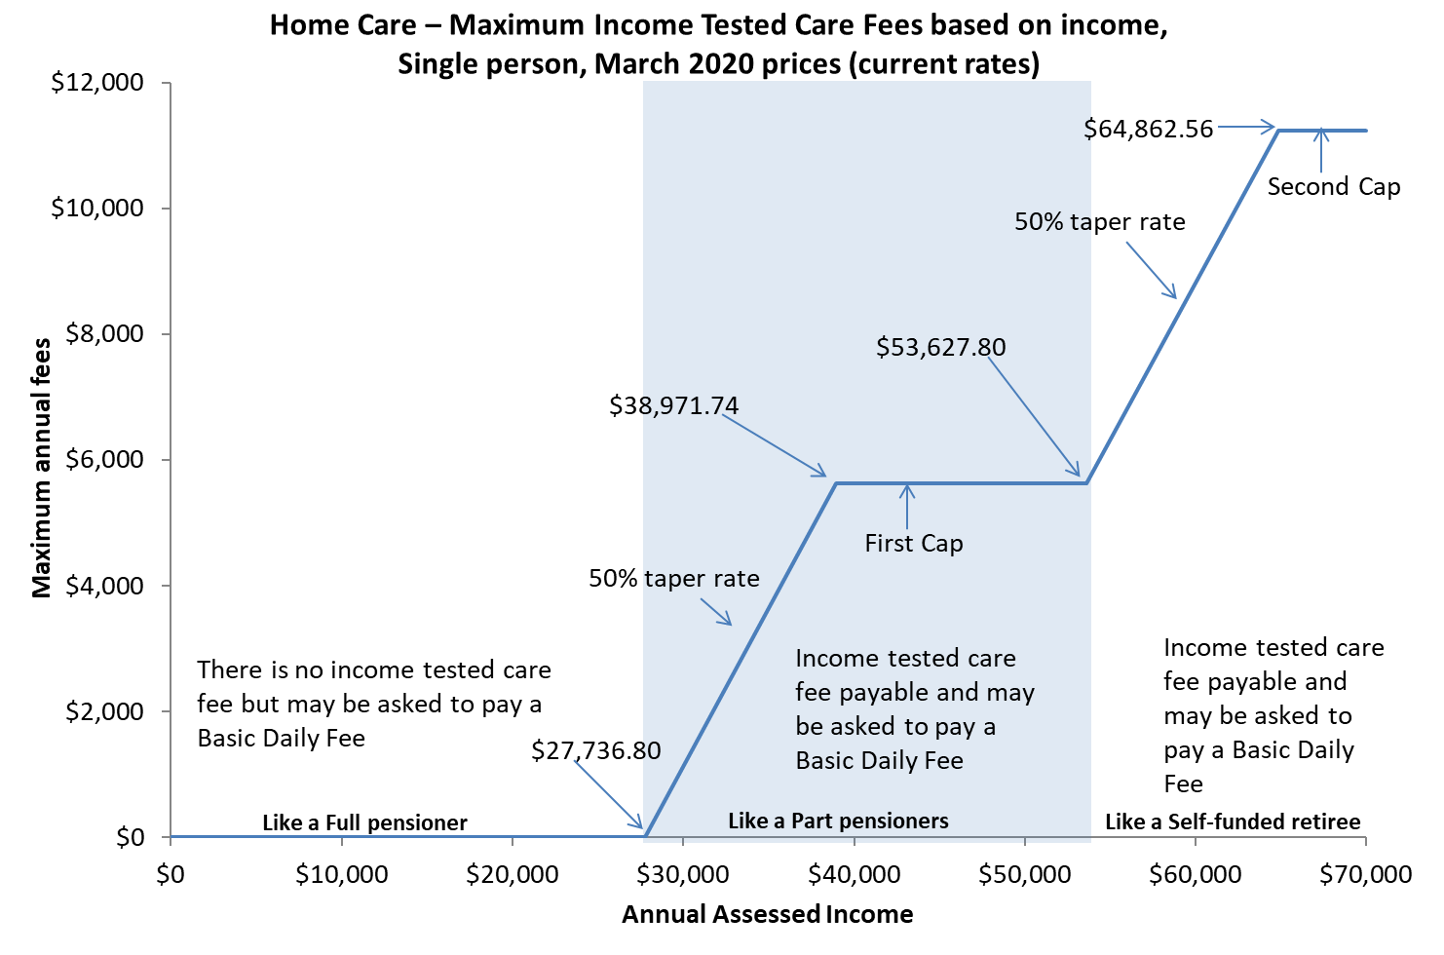

Residential care

Changes to residential care from 1 July 2014 introduced more comprehensive means testing arrangements by way of a combined assets and income assessment and a new fees structure.

Annual and lifetime caps were also introduced, with an annual cap of $28,087.41 applying to the means‑tested care fee and a lifetime cap of $67,409.85 for care contributions (March 2020 rate).

Figure E.2 demonstrates how the means testing arrangements created three tiers of consumer contributions in residential care:

* consumers with low means, who are required to pay only the basic daily fee (85 per cent of the single basic age pension) as a contribution towards their daily living expenses, while their accommodation and care costs are funded by the Australian Government;
* consumers with moderate means, who in addition to contributing towards their daily living expenses by paying the basic daily fee, also make a capped contribution towards their accommodation costs; and
* consumers with greater means, who in addition to contributing towards their daily living expenses, also pay the basic daily fee for their accommodation costs in full and make a capped contribution towards their care costs.

Figure E.2: Current means testing for residential care (post 1 July 2014)

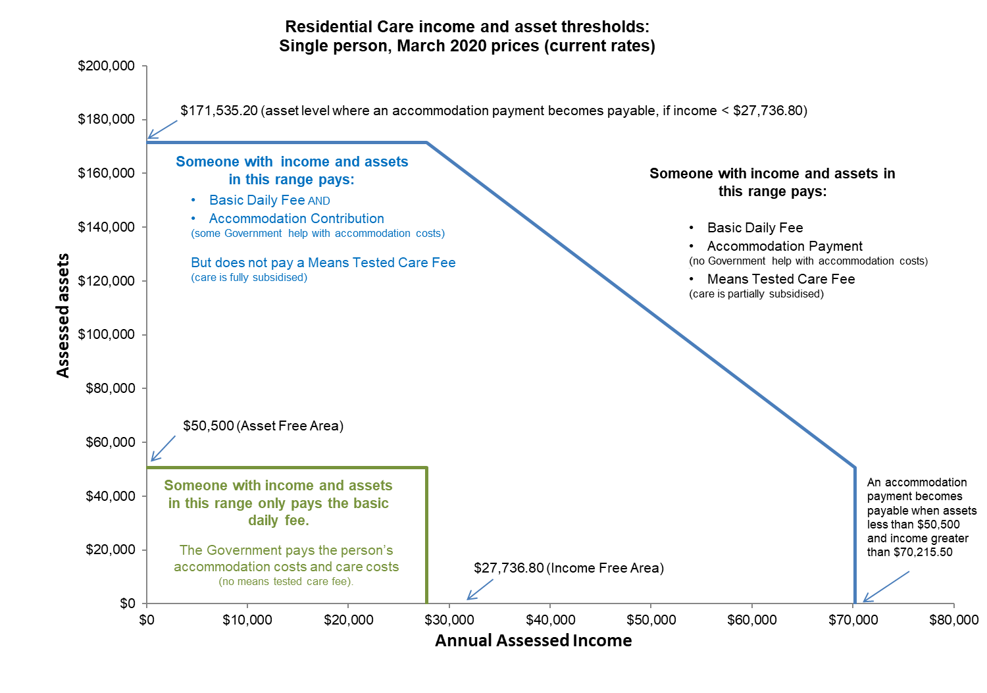

1. Financial ratios by provider ownership type

Table F.1: Financial ratios of total sector by provider type, 2018-19

|  | Not-for-profit | For-profit | Government | Total sector |
| --- | --- | --- | --- | --- |
| Total RADs ($m) | $15,490 | $14,003 | $690 | $30,183 |
| No. of providers | 488 | 276 | 93 | 857 |
| EBITDA p.r.p.a | $8,520 | $9,528 | -$1,036 | $8,523 |
| **Capital structure** |  |  |  |  |
| Assets p.r.p.a | $265,812 | $304,923 | $259,862 | $280,920 |
| No. of RADs | 51,345 | 40,453 | 3,072 | 94,870 |
| Avg RAD per resident | $301,683 | $346,156 | $224,678 | $280,920 |
| Net worth p.r.p.a | $90,520 | $27,832 | $147,326 | $68,244 |
| Working capital p.r.p.a | -$89,963 | -$160,540 | -$15,013 | -$114,592 |
| Non-current liabilities as % of total assets | 2.7% | 12.2% | 5.9% | 6.8% |
| RADs as % of total assets | 55.2% | 62.7% | 34.7% | 57.6% |
| Net worth as % total assets | 34.1% | 9.1% | 56.7% | 24.3% |
| Viability |  |  |  |  |
| **Current ratio** | 0.47 | 0.33 | 0.85 | 0.41 |
| Interest coverage | 13.7 times | 5.0 times | -7.4 times | 7.7 times |
| NPBT margin | 1.1% | 2.7% | -6.8% | 1.4% |
| Occupancy | 91.6% | 86.8% | 90.4% | 89.6% |
| % EBITDA to total assets | 3.2% | 3.1% | -0.4% | 3.0% |
| % EBITDA to net worth | 9.4% | 34.2% | -0.7% | 12.5% |
| RADs asset cover (T.A.) | 1.8 times | 1.6 times | 2.9 times | 1.7 times |

Table F.2: Financial ratios for not-for-profit providers, 2018-19

|  | Top | Next top | Next bottom | Bottom | Total |
| --- | --- | --- | --- | --- | --- |
| No. of providers | 106 | 130 | 143 | 109 | 488 |
| EBITDA p.r.p.a | $21,503 | $9,889 | $3,874 | -$6,701 | $8,520 |
| **Capital structure** |  |  |  |  |  |
| T. Assets p.r.p.a | $296,782 | $244,470 | $259,391 | $293,568 | $265,812 |
| No. of RADs | 11,091 | 18,376 | 15,572 | 6,306 | 51,345 |
| Avg RAD per resident | $312,047 | $287,020 | $310,900 | $303,423 | $301,683 |
| Net Worth p.r.p.a | $109,419 | $83,868 | $77,985 | $109,437 | $90,520 |
| Working Capital p.r.p.a | -$92,819 | -$76,332 | -$108,474 | -$80,558 | -$89,963 |
| Non.Curr Liab as % of T.Asts. | 2.2% | 2.8% | 2.5% | 3.4% | 2.7% |
| RADs as % of T. Asts | 52.7% | 55.3% | 58.7% | 51.4% | 55.2% |
| Net Worth as % T.Asts | 36.9% | 34.3% | 30.1% | 37.3% | 34.1% |
| **Viability** |  |  |  |  |  |
| Current ratio | 0.49 | 0.50 | 0.38 | 0.54 | 0.47 |
| Interest coverage | 45.8 times | 16.5 times | 5.4 times | -9.5 times | 13.7 times |
| NPBT margin | 12.0% | 2.6% | -2.8% | -14.7% | 1.1% |
| Occupancy | 93.6% | 92.3% | 90.9% | 87.9% | 91.6% |
| %EBITDA to T. Assets | 7.2% | 4.0% | 1.5% | -2.3% | 3.2% |
| %EBITDA to Net Worth | 19.7% | 11.8% | 5.0% | -6.1% | 9.4% |
| RADs Asset Cover (T.A.) | 1.9 times | 1.8 times | 1.7 times | 1.9 times | 1.8 times |

Table F.3: Financial ratios of government providers, 2018-19

|  | Top | Next Top | Next Bottom | Bottom | Total |
| --- | --- | --- | --- | --- | --- |
| No. of providers | 22 | 12 | 6 | 53 | 93 |
| EBITDA p.r.p.a | $44,030 | $10,742 | $3,922 | -$21,831 | -$1,036 |
| **Capital structure** |  |  |  |  |  |
| T. Assets p.r.p.a | $280,874 | $236,590 | $319,000 | $256,480 | $259,862 |
| No. of RADs | 739 | 483 | 116 | 1,734 | 3,072 |
| Avg RAD per resident | $206,671 | $196,512 | $226,444 | $240,079 | $224,678 |
| Net Worth p.r.p.a | $142,065 | $172,387 | $218,935 | $134,240 | $147,326 |
| Working Capital p.r.p.a | -$31,998 | $1,840 | -$6,150 | -$15,970 | -$15,013 |
| Non.Curr Liab as % of T.Asts. | 5.8% | 1.8% | 1.7% | 7.7% | 5.9% |
| RADs as % of T. Asts | 36.1% | 25.3% | 24.9% | 38.3% | 34.7% |
| Net Worth as % T.Asts | 50.6% | 72.9% | 68.6% | 52.3% | 56.7% |
| **Viability** |  |  |  |  |  |
| Current ratio | 0.74 | 1.03 | 0.93 | 0.84 | 0.85 |
| Interest coverage | 309.5 times | 248.3 times | 18.2 times | -129.8 times | -7.4 times |
| NPBT margin | 22.0% | 2.2% | -4.4% | -26.3% | -6.8% |
| Occupancy | 92.1% | 90.7% | 91.6% | 89.6% | 90.4% |
| %EBITDA to T. Assets | 15.7% | 4.5% | 1.2% | -8.5% | -0.4% |
| %EBITDA to Net Worth | 31.0% | 6.2% | 1.8% | -16.3% | -0.7% |
| RADs Asset Cover (T.A.) | 2.8 times | 3.9 times | 4.0 times | 2.6 times | 2.9 times |

Table F.4: Financial ratios of for-profit providers, 2018-19

|  | Top | Next Top | Next Bottom | Bottom | Total |
| --- | --- | --- | --- | --- | --- |
| No. of providers | 86 | 72 | 65 | 53 | 276 |
| EBITDA p.r.p.a | $21,738 | $9,956 | $5,189 | -$10,305 | $9,528 |
| **Capital structure** |  |  |  |  |  |
| T. Assets p.r.p.a | $328,318 | $287,018 | $224,989 | $376,612 | $304,923 |
| No. of RADs | 14,412 | 11,176 | 7,083 | 7,782 | 40,453 |
| Avg RAD per resident | $371,270 | $307,943 | $326,536 | $372,384 | $346,156 |
| Net Worth p.r.p.a | $28,988 | $37,286 | $15,393 | $23,697 | $27,832 |
| Working Capital p.r.p.a | -$175,389 | -$189,547 | -$92,497 | -$158,612 | -$160,540 |
| Non.Curr Liab as % of T.Asts. | 9.8% | 8.8% | 7.7% | 23.5% | 12.2% |
| RADs as % of T. Asts | 64.9% | 56.7% | 72.8% | 60.0% | 62.7% |
| Net Worth as % T.Asts | 8.8% | 13.0% | 6.8% | 6.3% | 9.1% |
| **Viability** |  |  |  |  |  |
| Current ratio | 0.34 | 0.16 | 0.52 | 0.40 | 0.33 |
| Interest coverage | 10.9 times | 6.7 times | 4.6 times | -3.2 times | 5.0 times |
| NPBT margin | 12.8% | 2.7% | 1.8% | -18.1% | 2.7% |
| Occupancy | 87.8% | 88.8% | 86.2% | 82.7% | 86.8% |
| %EBITDA to T. Assets | 6.6% | 3.5% | 2.3% | -2.7% | 3.1% |
| %EBITDA to Net Worth | 75.0% | 26.7% | 33.7% | Note 1 | 34.2% |
| RADs Asset Cover (T.A.) | 1.5 times | 1.8 times | 1.4 times | 1.7 times | 1.6 times |

Note 1 - The bottom quartile of the for-profit sector has been distorted by a number of providers who have significant deficits in their net assets, which has resulted in the total net assets of that quartile being negative. The %EBITDA to Net Worth calculation does not return a useful amount, and therefore has not been published.

1. Residential aged care subsidies and supplements

Table G.1: Total expenditure for subsidies and supplements in residential care, 2016-17 to 2018-19

|  | 2016-17 $m | 2017-18 $m | 2018-19 $m |
| --- | --- | --- | --- |
| **Basic Care subsidies** |  |  |  |
| Permanent | 11,024.2 | 11,163.5 | 11,947.4 |
| Respite | 280.6 | 312.3 | 348.8 |
| **Primary care supplements** |  |  |  |
| Oxygen | 17.5 | 18.3 | 18.3 |
| Enteral feeding | 5.9 | 5.9 | 5.2 |
| Respite incentive | 30.1 | 34.6 | 40.6 |
| **Hardship** |  |  |  |
| Hardship | 4.9 | 4.0 | 3.9 |
| **Accommodation supplements** |  |  |  |
| Accommodation supplement | 907.5 | 1,029.6 | 1,134.2 |
| Hardship accommodation | 2.9 | 2.6 | 2.5 |
| Transitional accommodation Supplement | 15.5 | 10.7 | 7.6 |
| Concessional | 55.6 | 51.3 | 46.5 |
| Accommodation charge top-up | 1.4 | 1.0 | 0.7 |
| Pensioner supplement | 27.2 | 20.7 | 16.3 |
| **Viability Supplement** |  |  |  |
| Viability | 43.2 | 55.8 | 62.0 |
| **Supplements relating to grand parenting** |  |  |  |
| Transitional | 4.8 | 3.8 | 3.2 |
| Charge exempt | 2.0 | 1.8 | 1.7 |
| Basic daily fee | 0.4 | 0.3 | 0.2 |
| **Other supplements** |  |  |  |
| Veterans’ | 1.1 | 1.6 | 1.7 |
| Homeless | 8.3 | 8.6 | 9.8 |
| **Reductions** |  |  |  |
| Means testing reduction | -560.8 | -564.0 | -627.2 |
| Other | 31.5 | 42.0 | -9.1 |
| **TOTAL** | **11,903.8** | **12,204.4** | **13,014.3** |

1. Residential care subsidy and supplements rates

Table H.1: ACFI rates ($ per day), 2017-18 to 2019-20

| ACFI | 2017-18 | 2018-19 | 2019-20 |
| --- | --- | --- | --- |
| **Activities of daily living (ADL)** |  |  |  |
| Low | $36.65 | $37.16 | $37.68 |
| Medium | $79.80 | $80.92 | $82.05 |
| High | $110.55 | $112.10 | $113.67 |
| **Behaviour (BEH)** |  |  |  |
| Low | $8.37 | $8.49 | $8.61 |
| Medium | $17.36 | $17.60 | $17.85 |
| High | $36.19 | $36.70 | $37.21 |
| **Complex Health Care (CHC)** |  |  |  |
| Low | $16.37 | $16.48 | $16.71 |
| Medium | $46.62 | $46.95 | $47.61 |
| High | $67.32 | $67.79 | $68.74 |
| Interim rate for new residents pending ACFI assessment | $56.22 | $57.01 | $57.81 |

| Daily residential respite subsidy rates | 2017-18 | 2018-19 | 2019-20 |
| --- | --- | --- | --- |
| Low | $46.09 | $46.74 | $47.39 |
| High | $129.24 | $131.05 | $132.88 |

Table H.2: Residential care supplements table, 2017-18 to 2019-20

| Residential care | 2017-18 | 2018-19 | 2019-20 |
| --- | --- | --- | --- |
| Oxygen supplement* | $11.35 | $11.57 | $11.72 |
| Enteral Feeding supplement – Bolus* | $17.99 | $18.33 | $18.57 |
| Enteral Feeding supplement – Non-bolus* | $20.21 | $20.59 | $20.86 |
| Adjusted Subsidy Reduction | $13.03 | $13.21 | $13.39 |
| Veterans’ supplement | $6.98 | $7.08 | $7.18 |
| Homeless supplement | $15.94 | $21.01 | $21.30 |

*These supplements are payable in respect of eligible residential respite care recipients.

Table H.3: Residential care supplements (accommodation and hotel related)

| Residential care | 20/03/19 | 20/09/19 | 20/03/20 |
| --- | --- | --- | --- |
| Higher accommodation supplement - newly built or significantly refurbished facilities | $57.14 | $57.49 | $58.19 |
| Accommodation supplement - facilities that are not newly built or significantly refurbished but do meet set building requirements | $37.24 | $37.47 | $37.93 |
| Accommodation supplement – facilities that are not newly built or significantly refurbished and don’t meet set building requirements | $31.29 | $31.48 | $31.86 |
| Concessional resident supplement (concessional and assisted residents) - newly built or significantly refurbished facilities | $57.14 | $57.49 | $58.19 |
| Concessional resident supplement (concessional residents) – facilities that are not newly built or refurbished | $22.77 | $22.91 | $23.19 |
| Concessional resident supplement (assisted residents) - facilities that are not newly built or significantly refurbished | $9.36 | $9.42 | $9.53 |
| After 19 March 2008 and before 20 September 2010 | $8.52 | $8.57 | $8.67 |
| After 19 September 2010 and before 20 March 2011 | $5.68 | $5.71 | $5.78 |
| After 19 March 2011 and before 20 September 2011 | $2.84 | $2.86 | $2.89 |
| Transitional supplement | $22.77 | $22.91 | $23.19 |
| Basic Daily Fee supplement | $0.60 | $0.60 | $0.61 |
| Respite supplement – high level is equal to or greater than 70% of the specified proportion of respite care for the approved provider | $93.36 | $93.94 | $95.08 |
| Respite supplement – high level is less than 70% of the specified proportion of respite care for the approved provider | $54.87 | $55.21 | $55.88 |
| Respite supplement – low level | $39.15 | $39.39 | $39.87 |

Table H.4: Residential aged care viability supplement

| Residential care viability supplement | 2017-18 | 2018-19 | 2019-20 |
| --- | --- | --- | --- |
| **2017 Scheme Services (Modified Monash Model)** |  |  |  |
| Eligibility score of 100 | $56.09 | $73.94 | $74.98 |
| Eligibility score of 95 | $49.95 | $65.85 | $66.77 |
| Eligibility score of 90 | $45.06 | $59.40 | $60.23 |
| Eligibility score of 85 | $38.94 | $51.34 | $52.06 |
| Eligibility score of 80 | $32.76 | $43.19 | $43.79 |
| Eligibility score of 75 | $25.47 | $33.58 | $34.05 |
| Eligibility score of 70 | $19.09 | $25.17 | $25.52 |
| Eligibility score of 65 | $13.75 | $18.12 | $18.37 |
| Eligibility score of 60 | $11.63 | $15.33 | $15.54 |
| Eligibility score of 55 | $8.48 | $11.18 | $11.34 |
| Eligibility score of 50 | $6.36 | $8.39 | $8.51 |
| Eligibility score of 45 # | $0.00 | $0.00 | $0.00 |
| Eligibility score of 40 # | $0.00 | $0.00 | $0.00 |
| Less than a score of 40 | $0.00 | $0.00 | $0.00 |

Note: the Modified Monash Model classification scale was implemented on 1 January 2017

1. Residential care financing structures and balance sheets

Table I.1: Distribution of average lump sum accommodation deposits by ownership and quartile of EBITDA, 2018‑19

|  | Top | Next top | Next bottom | Bottom | Total |
| --- | --- | --- | --- | --- | --- |
| **Not-for-profit** |  |  |  |  |  |
| No. of providers | 106 | 130 | 143 | 109 | 488 |
| No. of providers that held RADs | 102 | 129 | 141 | 105 | 477 |
| Proportion of residents that paid RADs in facilities, where RADs were held | 49.6% | 46.9% | 48.3% | 51.0% | 48.4% |
| Average RAD per resident | $312,047 | $287,020 | $310,900 | $303,423 | $301,683 |
| **For-profit** |  |  |  |  |  |
| No. of providers | 86 | 72 | 65 | 53 | 276 |
| No. of providers that held RADs | 85 | 72 | 64 | 53 | 274 |
| Proportion of permanent residents that paid RADs in facilities, where RADs were held | 56.2% | 50.0% | 49.2% | 60.3% | 53.8% |
| Average RAD per resident | $371,270 | $307,943 | $326,536 | $372,384 | $346,156 |
| **Government** |  |  |  |  |  |
| No. of providers | 22 | 12 | 6 | 53 | 93 |
| No. of providers that held RADs | 21 | 12 | 5 | 51 | 89 |
| Proportion of permanent residents that paid RADs in facilities, where RADs were held | 49.6% | 30.6% | 41.1% | 41.5% | 40.8% |
| Average RAD per resident | $206,671 | $196,512 | $226,444 | $240,079 | $224,678 |
| **Total** |  |  |  |  |  |
| No. of providers | 214 | 214 | 214 | 215 | 857 |
| No. of providers that held RADs | 208 | 213 | 210 | 209 | 840 |
| Proportion of permanent residents that paid RADs in facilities, where RADs were held | 53.1% | 47.6% | 48.5% | 53.7% | 50.2% |
| Average RAD per resident | $341,605 | $293,350 | $315,333 | $330,399 | $318,153 |

1. Home care revenue and expenditure

Table J.1: Financial performance results of home care providers per consumer per day, by ownership type, by quartile, 2018‑19

|  | Top quartile | Next top | Next bottom | Bottom | Total |
| --- | --- | --- | --- | --- | --- |
| **Not-for-profit** |  |  |  |  |  |
| Number of providers | 96 | 117 | 125 | 109 | 447 |
| Provision of care/services charged | $54.72 | $43.38 | $46.51 | $47.77 | $47.04 |
| Client/case management fees charged | $8.60 | $10.97 | $13.41 | $10.03 | $11.03 |
| Admin and management of packages | $15.32 | $12.86 | $9.76 | $9.85 | $11.73 |
| Exit amounts deducted | $0.16 | $0.19 | $0.14 | $0.25 | $0.19 |
| Other income | $1.27 | $0.81 | $1.92 | $2.75 | $1.63 |
| Total expenses | $65.00 | $63.02 | $71.16 | $75.90 | $68.49 |
| Net Profit Before Tax | $15.08 | $5.21 | $0.58 | -$5.24 | $3.13 |
| **For-profit** |  |  |  |  |  |
| Number of providers | 86 | 72 | 56 | 71 | 285 |
| Provision of care/services charged | $115.79 | $59.27 | $50.12 | $42.87 | $61.35 |
| Client/case management fees charged | $9.17 | $5.01 | $5.34 | $8.39 | $7.09 |
| Admin and management of packages | $12.40 | $9.31 | $8.70 | $9.24 | $9.73 |
| Exit amounts deducted | $0.15 | $0.08 | -$0.48 | $0.01 | -$0.01 |
| Other income | $12.38 | $4.10 | $3.82 | $0.65 | $4.15 |
| Total expenses | $125.75 | $72.82 | $67.08 | $74.91 | $81.98 |
| Net Profit Before Tax | $24.14 | $4.95 | $0.42 | -$13.75 | $0.32 |
| **Government** |  |  |  |  |  |
| Number of providers | 25 | 17 | 25 | 27 | 94 |
| Provision of care/services charged | $60.05 | $41.76 | $39.63 | $37.68 | $44.52 |
| Client/case management fees charged | $20.69 | $6.38 | $11.77 | $10.49 | $11.89 |
| Admin and management of packages | $17.00 | $16.30 | $11.17 | $10.29 | $13.88 |
| Exit amounts deducted | $0.38 | $0.19 | $0.22 | $0.28 | $0.26 |
| Other income | $1.05 | $1.47 | $0.38 | $1.25 | $1.03 |
| Total expenses | $76.99 | $60.25 | $62.50 | $68.95 | $66.35 |
| Net Profit Before Tax | $22.18 | $5.86 | $0.68 | -$8.96 | $5.23 |
| **Total** |  |  |  |  |  |
| Number of providers | 207 | 206 | 206 | 207 | 826 |
| Provision of care/services charged | $67.11 | $45.93 | $46.43 | $45.91 | $49.57 |
| Client/case management fees charged | $9.73 | $9.72 | $12.41 | $9.58 | $10.35 |
| Admin and management of packages | $14.89 | $12.47 | $9.74 | $9.70 | $11.49 |
| Exit amounts deducted | $0.18 | $0.17 | $0.08 | $0.19 | $0.15 |
| Other income | $3.42 | $1.40 | $2.02 | $2.09 | $2.07 |
| Total expenses | $77.89 | $64.49 | $70.12 | $75.29 | $70.89 |
| Net Profit Before Tax | $17.45 | $5.20 | $0.57 | -$7.83 | $2.73 |

Table J.2: Financial package results for home care providers per consumer per day, by ownership type, by quartile, 2018‑19

|  | Top quartile | Next top | Next bottom | Bottom | Total |
| --- | --- | --- | --- | --- | --- |
| **Not-for-profit** |  |  |  |  |  |
| Number of providers | 96 | 117 | 125 | 109 | 447 |
| Total revenue per consumer | $29,228 | $24,902 | $26,184 | $25,789 | $26,141 |
| Total expenses per consumer | $23,725 | $23,001 | $25,973 | $27,702 | $24,998 |
| NPBT per consumer | $5,503 | $4,069 | $356 | -$2,759 | $7,169 |
| **For-profit** |  |  |  |  |  |
| Number of providers | 86 | 72 | 56 | 71 | 285 |
| Total revenue per consumer | $54,710 | $28,385 | $24,638 | $22,323 | $30,042 |
| Total expenses per consumer | $45,899 | $26,579 | $24,484 | $27,342 | $29,924 |
| NPBT per consumer | $8,811 | $1,806 | $153 | -$5,019 | $118 |
| **Government** |  |  |  |  |  |
| Number of providers | 25 | 17 | 25 | 27 | 94 |
| Total revenue per consumer | $36,197 | $4,029 | $28,273 | -$2,513 | $4,826 |
| Total expenses per consumer | $28,102 | $3,672 | $27,968 | -$2,888 | $4,474 |
| NPBT per consumer | $8,095 | $357 | $305 | $375 | $353 |
| **Total** |  |  |  |  |  |
| Number of providers | 207 | 206 | 206 | 207 | 826 |
| Total revenue per consumer | $34,797 | $25,437 | $25,801 | $24,623 | $26,872 |
| Total expenses per consumer | $28,429 | $23,539 | $25,593 | $27,481 | $25,873 |
| NPBT per consumer | $6,368 | $1,898 | $207 | -$2,858 | $998 |

1. Home care subsidies and supplements

Table K.1: Home care subsidies per day, 2017-18 to 2019-20

| Package level | 2017-18 | Annual | 2018-19 | Annual | 2019‑20 | Annual |
| --- | --- | --- | --- | --- | --- | --- |
| Level 1 | $22.35 | $8,157.75 | $22.66 | $8,270.90 | $24.07 | $8,809.62 |
| Level 2 | $40.65 | $14,837.25 | $41.22 | $15,045.30 | $42.35 | $15,500.10 |
| Level 3 | $89.37 | $32,620.05 | $90.62 | $33,076.30 | $92.16 | $33,730.56 |
| Level 4 | $135.87 | $49,592.55 | $137.77 | $50,286.05 | $139.70 | $51,130.20 |

Table K.2: Home care supplement amounts per day, 2017-18 to 2019-20

| Home care supplements | 2017-18 | 2018-19 | 2019‑20 |
| --- | --- | --- | --- |
| **Dementia and Cognition and Veterans’ supplement (11.5% of basic care subsidy)** |  |  |  |
| Level 1 | $2.24 | $2.67 | $2.77 |
| Level 2 | $4.07 | $4.12 | $4.87 |
| Level 3 | $8.94 | $9.06 | $10.60 |
| Level 4 | $13.59 | $13.78 | $16.07 |
| **Other** |  |  |  |
| Note: the rate of both the Dementia and Cognition supplement and the Veterans’ supplement in home care were increased from 10% of the basic subsidy to 11.5% from 20 March 2019 |  |  |  |
| EACH-D Top Up supplement | $2.69 | $2.73 | $2.77 |
| Oxygen Supplement | $11.35 | $11.57 | $11.72 |
| Enteral Feeding supplement – Bolus | $17.99 | $18.33 | $18.57 |
| Enteral Feeding supplement – Non–bolus | $20.21 | $20.59 | $20.86 |
| **Home Care Viability supplement – Modified Monash Model classification** |  |  |  |
| MMM 1,2,3 | $0.00 | $0.00 | $0.00 |
| MMM 4 | $1.04 | $1.05 | $1.06 |
| MMM 5 | $2.29 | $2.32 | $2.35 |
| MMM 6 | $15.16 | $15.37 | $15.59 |
| MMM 7 | $18.20 | $18.45 | $18.71 |

Note: the MMM classification scale was implement on 1 January 2017

| Home Care Viability supplement – ARIA value viability supplement amount | 2017-18 | 2018-19 | 2019‑20 |
| --- | --- | --- | --- |
| ARIA Score 0 to 3.51 inclusive | $0.00 | $0.00 | $0.00 |
| ARIA Score 3.52 to 4.66 inclusive | $5.37 | $5.45 | $5.53 |
| ARIA Score 4.67 to 5.80 inclusive | $6.45 | $6.54 | $6.63 |
| ARIA Score 5.81 to 7.44 inclusive | $9.02 | $9.15 | $9.28 |
| ARIA Score 7.45 to 9.08 inclusive | $10.84 | $10.99 | $11.14 |
| ARIA Score 9.09 to 10.54 inclusive | $15.16 | $15.37 | $15.59 |
| ARIA Score 10.55 to 12.00 inclusive | $18.20 | $18.45 | $18.71 |

Note: the MMM classification scale was implement on 1 January 2017

Table K.3: Summary of Australian Government payments of subsidies and supplements of home care, 2016‑17 to 2018‑19

| Supplement | 2016-17 | 2017-18 | 2018‑19 |
| --- | --- | --- | --- |
| Dementia and cognition supplement | $24.7m | $29.3m | $36.2m |
| Veterans’ supplement | $0.2m | $0.3m | $0.4m |
| Oxygen supplement | $2.4m | $3.1m | $3.7m |
| Enteral feeding supplement | $0.7m | $0.9m | $0.9m |
| Viability supplement | $11.4m | $16.0m | $18.1m |
| Hardship supplement | $0.2m | $0.3m | $0.2m |

Supplements in home care:

**Dementia and cognition supplement:** provides additional funding in recognition of the extra costs of caring for people with cognitive impairment associated with dementia and other conditions. This supplement is available across all levels of home care packages. The supplement is payable at a rate of 11.5 per cent[42] of the basic subsidy payable for the level of home care package.

**Veterans’ supplement:** provides additional funding for veterans with a mental health condition accepted by the Department of Veterans’ Affairs (DVA) as related to their service. This supplement is available across all levels of home care packages. The supplement is payable at a rate of 11.5 per cent of the basic subsidy payable for the level of home care package.

**Oxygen supplement:** provides additional funding for consumers who have a specified medical need for the continual administration of oxygen.

**Enteral Feeding supplement:** provides additional funding for care recipients with a specified medical need for enteral feeding.

**Viability supplement:** is paid in recognition of the higher costs of providing services in rural and remote areas.

**Hardship supplement:** is available to home care consumers who are having difficulty paying their aged care fees for reasons beyond their control.

1. Residential care and home care financial data

* Residential care and home care providers’ financial data is obtained from Aged Care Financial Reports (ACFRs) required to be prepared and submitted by providers of residential aged care under the Accountability Principles 2014 (Section 35, 35A, 36, 37 and 37A) made under Section 96-1 of the Aged Care Act 1997.
* Residential and home care financial data and analysis given in this report includes financial information for only those services that were operational from 1 July 2018 to 30 June 2019 and whose financial information is received by the Department of Health.
* Approximately 99 per cent of residential aged care providers and 97 per cent of home care providers submitted their ACFRs.
* Financial information contained in ACFRs varies from provider to provider. Accounting standards are subject to interpretation and it is possible that interpretations may differ between providers. The Department has not verified providers’ interpretation and application of the accounting standards.
* The information in the ACFR is not audited. It is however tested for reasonableness to the Approved Provider’s audited General Purpose Financial Report which is also submitted annually. Whilst some verification of data is undertaken by the Department, a significant portion of data submitted through the ACFR has not been independently verified.
* Analysis of financial data may be affected by incomplete, aggregated data provided in ACFRs. As a result, averages stated in the report may not fully represent the sector.
* Discrepancies occur in the ACFR home care income statement which can impact the overall average results of the sector. For example, there are instances where the details of the expenses are aggregated to other expenses or total expenses. There are also instances where income and expenditure through brokered services are not disclosed in their entirety thus understating revenue and expenditure. These instances result in inconsistency and limitations in deriving various metrics and measurements.
* The ACFR home care income and expenses are aggregated for Commonwealth Government funded package consumers and private consumers. Therefore, the analysis used in this report is not interpretable for any particular group of clients who are receiving/paying any particular funding type.
* Assets and liabilities reported in the residential aged care balance sheet contain, where not already fully verifiable, some proportional allocations based on the historical and sector trends from other sources within provider ACFRs and GPFRs. These allocations have not been verified.

1. References

Aged Care Financing Authority – Report on attributes for sustainable aged care, available at <https://agedcare.health.gov.au/acfas-report-on-attributes-of-sustainable-aged-care>

Aged Care Financing Authority - Submission to the Royal Commission into Aged Care Quality and Safety, available at <https://agedcare.health.gov.au/reform/acfas-submission-to-the-royal-commission-into-aged-care-quality-and-safety>

Aged Care Financing Authority- Consideration of the financial impact on home care providers as a result of changes in payment arrangements’ report, available at <https://www.health.gov.au/resources/publications/consideration-of-the-financial-impact-on-home-care-providers-as-a-result-of-changes-in-payment-arrangements>

Aged Care Financing Authority- Report on the Funding and Financing of the Aged Care Industry - Various editions, available at <https://agedcare.health.gov.au/aged-care-reform/aged-care-financing-authority>

Aged Care Financing Authority (2016), Report on Issues Affecting the Financial Performance of Rural and Remote Providers, both Residential and Home Care Providers, available at <https://agedcare.health.gov.au/aged-care-reform/aged-care-financing-authority>

Aged Care Financing Authority (2016), Report to inform the 2016-17 review of amendments to the Aged Care Act 1997, available at <https://agedcare.health.gov.au/reform/report-to-inform-the-2016-17-review-of-amendments-to-the-aged-care-act-1997>

Aged Care financing Authority (2018) Report on respite for aged care recipients, available at <https://agedcare.health.gov.au/acfas-report-on-respite-for-aged-care-recipients>

Aged Care financing Authority (2018) ACFA Update on funding and financing issues in the residential aged care industry, available at <https://agedcare.health.gov.au/reform/acfa-update-on-funding-and-financing-issues-in-the-residential-aged-care-industry>

Australian Accounting Standards Board, Accounting Standard AASB 101 Presentation of Financial Statements, Commonwealth of Australia, Melbourne, available at: [AASB](http://www.aasb.gov.au/Pronouncements/Current-standards.aspx)

Australian Bureau of Statistics (ABS), Australian Demographic Statistics, Jun 2016 Cat No. 3101.0 Commonwealth of Australia, available at [the ABS website](http://www.abs.gov.au/)

Australian Bureau of Statistics (ABS), Building Activity, Cat No. 8762.0 Commonwealth of Australia, Canberra, available at: [www.abs.gov.au](http://www.abs.gov.au/)

Australian Bureau of Statistics (ABS), Building Approvals, Cat No. 8731.0 Commonwealth of Australia, Canberra, available at: [www.abs.gov.au](http://www.abs.gov.au/)

The National Aged Care Workforce Census and Survey – The Aged Care Workforce, 2016 Final Report, Commonwealth of Australia, Canberra

David Tune, Legislated Review of Aged Care 2017, available at <https://agedcare.health.gov.au/legislated-review-of-aged-care-2017-report>

Department of Health (Australia), 2018‑19 Report on the Operation of the Aged Care Act 1997 (ROACA), Commonwealth of Australia Canberra (and earlier editions)

Department of the Treasury (Australia), 2015 Intergenerational Report: Australia in 2055. Department of the Treasury (Australia)

StewartBrown, Aged Care Financial Performance Surveys: Home Care Report – various editions

StewartBrown, Aged Care Financial Performance Survey: Residential Aged Care Report – various editions

The Intergenerational Report 2015– Australia to 2050, Commonwealth of Australia, Canberra, available at: <http://archive.treasury.gov.au/igr/igr2010/default.asp>

# Glossary

| **Term** | **Definition** |
| --- | --- |
| **Accommodation supplement** | The accommodation supplement is payable on behalf of residents receiving permanent residential aged care who do not have the capacity to contribute to all or part of the cost of their accommodation. |
| **Aged and Community Services Australia (ACSA)** | A national peak body for not-for-profit providers of aged and community care in Australia. |
| Aged Care Act 1997 **(the Act)** | The primary legislation governing the provision of aged care services. |
| **Aged Care Approvals Round (ACAR)** | A competitive application process that enables prospective and existing approved providers of residential aged care to apply for a range of new Australian Government funded aged care places and financial assistance in the form of a capital grant. |
| **Aged Care Assessment Team (ACAT)** | ACATs are teams of medical and allied health professionals who assess the physical, psychological, medical, restorative, cultural and social needs of frail older people and help them and their carers to access appropriate levels of support. |
| **Aged Care Financial Report (ACFR)** | A reporting template introduced for the 2016-17 reporting year that consolidates prudential and financial reporting information that was previously separately reported. The ACFR consolidates information previously reported through the Annual Prudential Compliance Statement, the Survey of Aged Care Homes, the Home Care Financial Report and the Short Term Restorative Care Financial Report. |
| **Aged Care Financing Authority (ACFA)** | ACFA is a statutory committee that provides independent advice to the Australian Government on funding and financing issues, informed by consultation with consumers, and the aged care and finance sectors. |
| **Aged Care Funding Instrument (ACFI)** | The classification instrument used to calculate subsidies to residential aged care facilities. |
| **Aged Care Pricing Commissioner** | The Aged Care Pricing Commissioner is an independent, statutory office holder appointed under the Aged Care Act 1997 and reports to the Minister for Aged Care. |
| **Aged Care Sector Committee**  **(ACSC)** | The ACSC is a representative committee of the aged care sector appointed by the Minister for Aged Care that provides advice to Government on aged care policy development and implementation and helps to guide future reform of the aged care system. |
| **Agreed accommodation price** | Accommodation prices agreed between providers and prospective residents prior to entry, as reported by providers through the Aged Care Entry Record. |
| **Approved provider** | An approved provider of aged care is an organisation that has been approved by the Secretary of the Department of Health to provide residential care, home care or flexible care under the Aged Care Act 1997. |
| **Assistance with Care and Housing for the Aged (ACHA)** | ACHA is a program which provides a range of supports for eligible clients, who are at risk of becoming homeless or are homeless, to remain in the community through accessing appropriate, sustainable and affordable housing and linking them to community care. From 1 July 2015 the ACHA program was incorporated into the new Commonwealth Home Support Programme. |
| **Australian Bureau of Statistics (ABS)** | The Government agency responsible for the production and dissemination of statistics in a range of key areas. |
| **Bed days** | The number of days for which a residential care place was available to be occupied by care recipients. |
| **Bond Asset Cover** | Provides an indication of the extent to which the accommodation bond liability is covered by assets. It is calculated as Total Assets/Total Accommodation Bonds. |
| **Brownfield site** | Site where an extension to an existing aged care operation is possible. |
| **Care days** | The number of days for which care was actually provided to a care recipient in an aged care place. |
| **Commonwealth Home Support Programme (CHSP)** | This program provides entry-level support services designed to help frail older people stay in their homes. It was introduced on 1 July 2015, consolidating four former programs: Commonwealth Home and Community Care (HACC); the National Respite for Carers Program (NRCP); Day Therapy Centres (DTC); and Assistance with Care and Housing for the Aged (ACHA). |
| **Community Aged Care Package (CACP)** | A package of services provided to a person in their own home. This type of care was replaced on 1 August 2013 when the new home care package levels 1-4 were introduced. A CACP package is generally consistent with the level of care provided in a level 2 home care package. |
| **Consumer Directed Care (CDC)** | Consumer Directed Care in home care gives consumers greater choice over their own lives by allowing them to decide what types of care and services they access and how those services are delivered. |
| **Consumer Price Index (CPI)** | CPI measures the changes in the price of a fixed basket of goods and services, acquired by household consumers who are resident in the eight state and territory capital cities. |
| **Culturally and Linguistically Diverse (CALD)** | Consumers who have particular cultural or linguistic affiliations due to their:   * place of birth or ethnic origin; * main language other than English spoken at home; or * proficiency in spoken English. |
| **Current Ratio** | Represents the ability to meet short term debt through current assets. A current ratio of more than one indicates that an organisation’s current assets exceed its current liabilities. It is calculated as Current Assets/Current Liabilities. In the aged care context, current ratio needs to be interpreted with caution given all accommodation deposits (bonds pre 1 July 2014) held by providers are treated as current liabilities. |
| **Daily Accommodation Contribution (DAC)** | An amount paid by a partially supported resident as a contribution toward their accommodation costs in a residential aged care facility, calculated on a daily basis and paid periodically. |
| **Daily Accommodation Payment (DAP)** | An amount paid by a non-supported resident towards their accommodation costs in a residential aged care facility calculated on a daily basis and paid periodically. |
| **Day Therapy Centres Program (DTC)** | The DTC program provides a wide range of therapy and services to eligible frail, aged people living in the community and to residents in Commonwealth funded residential aged care facilities. It assists them to regain or maintain physical and cognitive abilities which support them to either maintain or recover a level of independence. As of 1 July 2015 the DTC program became part of the new Commonwealth Home Support Programme (CHSP). |
| **Department of Health** | The department that administers the Aged Care Act 1997 and regulates the aged care industry on behalf of the Commonwealth. |
| **Earnings Before Interest, Tax, Depreciation and Amortisation (EBITDA)** | Net profit after tax with interest, tax, depreciation, and amortisation added back to it, and can be used to analyse and compare profitability between companies and industries because it eliminates the effects of financing and accounting decisions. |
| **EBITDA margin** | EBITDA margin shows the average net profit after tax (with interest, taxes, depreciation and amortisation added back into it) generated for each $1 of revenue earned. It’s calculated as EBITDA/total revenue. |
| **Extended Aged Care at Home**  **(EACH)** | Services previously provided to a person in their own home, who required a high level of care. This type of care was replaced on 1 August 2013 when the new home care package levels 1-4 were introduced. An EACH package was generally consistent with the level of care provided in a level 4 home care package. |
| **Extended Aged Care at Home Dementia (EACH-D)** | Services previously provided to a person in their own home, with dementia, who required a high level of care. This type of care was replaced on 1 August 2013 when the new home care package levels 1-4 were introduced. An EACH-D package was generally consistent with the level of care provided in a level 4 home care package, with the additional Dementia and Cognition supplement also being paid. |
| **Facility** | A residential aged care facility, approved under the Aged Care Act 1997 to provide government subsidised accommodation and care. |
| **Financial Accountability Reports (FARs)** | FARs were non-audited financial statements submitted by home care providers up until 2014-15 when they were replaced by the new Home Care Packages financial reports. In 2016-17 the Home Care Packages financial reports were subsequently replaced by the Aged Care Financial Reports. |
| **Flexible care** | For those in either a residential or home care setting, that may require a different care approach than that provided through mainstream residential and home care. |
| **General Purpose Financial Report (GPFR)** | An audited financial report that is submitted by providers with their unaudited Aged Care Financial Report (ACFR). While the ACFR provides a greater level of detail the GPFR is the only audited report and is used to verify information provided. |
| **Government provider** | In the context of this report, the term references a provider that is owned by a local, state or territory government. |
| **Greenfield site** | Site where an aged care operation is built for the first time. |
| **Gross Domestic Product (GDP)** | GDP is the market value of all officially recognised final goods and services produced within a country in a year, or over a given period of time. |
| **High care facility** | A facility where over 80 per cent of residents were classified as ‘high care’. The distinction between high care and low care in permanent residential care was removed from 1 July 2014. |
| **Higher accommodation supplement** | A higher maximum accommodation supplement was introduced on 1 July 2014 for aged care facilities that have been built or significantly refurbished since 20 April 2012. |
| **Home and Community Care (HACC)** | A previous program that provided basic support and maintenance to people living at home to help avoid premature or inappropriate admission to long-term residential care (WA only in 2016‑17). The former Commonwealth HACC program was consolidated into the new CHSP from 1 July 2015. |
| **Home care** | Home based care provided through a home care package to help older Australians to remain in their own homes. Home care is provided through the Home Care Packages Program. |
| **Home care package** | A package of services, delivered though the Home Care Packages Program, tailored to meet the care needs of a person living at home. The package is coordinated by an approved home care provider, with funding provided by the Australian Government (with some contributions from the consumer). Home care packages range from level 1 to 4 depending on the care needs of the consumer. |
| **Home Care Packages Program** | An Australian Government funded program which has as its objectives to assist people to remain living at home and enable consumers to have choice and flexibility in the way that care and support is provided at home. The Home Care Packages Program commenced on 1 August 2013. |
| **Homeless supplement** | A supplement paid to better support residential aged care facilities that specialise in caring for people with a history of, or at risk of, homelessness. This funding is in addition to the funding provided under the viability supplement. |
| **Increasing choice in home care** | From 27 February 2017, funding for a home care package followed the consumer, replacing the former system where home care places were allocated to individual approved providers to deliver services in a particular location or region. |
| **Interest Coverage** | Shows the number of times that EBITDA will cover interest expense. Indicates an organisation’s ability to service the interest on its debt. It is calculated as EBITDA/Interest Expense. |
| **Leading Age Services Australia (LASA)** | LASA is a peak body for aged service providers. |
| **Location** | Indicates where a provider, service or consumer is located based on whether they are metropolitan or regional areas. Metropolitan is all major cities and regional is any area outside of a major city. A provider is classified as metropolitan if more than 70 per cent of its services are located in metropolitan areas and similarly classified as regional if more than 70 per cent of its services are located in regional areas. |
| **Low care facility** | A facility where over 80 per cent of residents were classified as ‘low care’. The distinction between high care and low care was removed from 1 July 2014. |
| **Maximum accommodation price** | Maximum accommodation prices are set by residential care providers for a room (or bed in a shared room) and published on My Aged Care. These are maximum prices (providers and residents may agree lower amounts), that apply to residents who are not eligible for Government support for their accommodation costs. |
| **Maximum Permissible Interest Rate (MPIR)** | The MPIR is the rate used to calculate the equivalent daily payment of a Refundable Accommodation Deposit (RAD). The RAD is multiplied by the MPIR and divided by 365 days. The MPIR is determined in accordance with Section 6 of the Fees and Payments Principles 2014 (No. 2).The MPIR is available on the Department of Health website and is updated every three months. |
| **My Aged Care** | The main entry point to the aged care system in Australia. My Aged Care aims to make it easier for older people, their families, and carers to access information on ageing and aged care, have their needs assessed and be supported to find and access services. |
| **National Disability Insurance Scheme (NDIS)** | The NDIS offers support for Australians who are under 65 years of age with a significant and permanent disability, their families and their carers. |
| **National Respite for Carers Program (NRCP)** | The NRCP aims to support caring relationships between carers and their dependent family members or friends by facilitating access to information, respite care and other support appropriate to their individual needs and circumstances and those of the people for whom they care. The NRCP was integrated into the CHSP from 1 July 2015. |
| **National Prioritisation System** | People who have been approved for home care and have indicated they are actively seeking services are placed in the National Prioritisation System, with each person’s place in the system based on the time and date of their approval for home care and their priority for service (medium or high). |
| **Net Profit Before Tax (NPBT)** | The NPBT is determined by revenue minus expenses for the period except for taxes. |
| **Net Profit (Before Tax) Margin** | Shows the average profitability generated on each $1 of total revenue. It is calculated as Net Profit Before Tax / total revenue. |
| **Non-supported residents** | Residents who have been assessed (based on a means test) as able to pay the full cost of their accommodation and contribute toward their care costs. Non-supported residents pay a basic daily fee, accommodation payment and means-tested care fee (may still receive some assistance with care costs). |
| **Offline residential care places** | Previously operational places that are currently not being used due to renovations or rebuilding of facilities or pending sale to other providers. Providers do not receive Australian Government subsidies while places are offline. |
| **Operational places** | Operational place refers to a residential care place that was allocated to a provider and has since become available for a person to receive care. |
| **Partially supported residents** | Residents who have been assessed (based on a means test) as eligible for full Government assistance with their care costs, but able to make a part contribution to their accommodation costs. Partially-supported residents pay a basic daily fee and accommodation contribution. |
| **Pay as you go (PAYG)** | Pay as you go (PAYG) instalments is a system for making regular payments towards an employee’s expected annual income tax liability. |
| **Per consumer per annum (pcpa)** | An annual average financial figure relating to home care consumers. |
| **Per consumer per day (pcpd)** | A daily average financial figure relating to home care consumers. |
| **Per resident per annum (prpa)** | An annual average financial figure relating to residential aged care residents that converts financial data to daily amount per resident. |
| **Per resident per day (prpd)** | A daily average financial figure relating to residential aged care residents. |
| **Provisionally allocated places** | Residential care places allocated through Aged Care Approval Rounds that are not yet operational. |
| **Refundable Accommodation Contribution (RAC )** | An amount paid as a lump sum by a partially supported resident as a contribution toward their accommodation costs in a residential aged care facility. |
| **Refundable Accommodation Deposit (RAD)** | An amount paid as a lump sum by a non-supported resident for their accommodation costs in a residential aged care facility. |
| **Regional** | Geographic region outside of a major city and classified by the Australian Bureau of Statistics as inner regional, outer regional, remote and very remote. |
| **Regional Assessment Services (RAS)** | RAS provides in home, face to face assessments of new and existing clients/carers to assess their eligibility to access CHSP services. |
| **Report on the Operations of the Aged Care Act 1997 (ROACA)** | A legal requirement under the Act, the ROACA is tabled in Parliament in November each year and presents an annual snapshot of facts and figures on Commonwealth funded aged care services in Australia. |
| **Resident Classification Scale (RCS)** | The basic tool for residential aged care funding prior to 20 March 2008, when it was replaced by the ACFI. A very small number of residents who entered care before 20 March 2008 are still classified using the RCS through grand-parenting arrangements. |
| **Residential aged care** | A program that provides a range of care options and accommodation for older people who choose not to continue living in their own homes. |
| **Restorative care** | Care focusing on enhancing the physical and cognitive function of people who have lost or are at risk of losing condition and independence. The Short-Term Restorative Care (STRC) Programme, which commenced in February 2017, is a flexible care program to provide restorative care to older people to improve their capacity to stay independent and living in their own homes. |
| **Retained earnings** | Refers to the percentage of net earnings not paid out as dividends, but retained by the company to be reinvested in its core business, or to pay debt. This is recorded under shareholders' equity on the balance sheet. |
| **Retention amounts** | An amount that an approved provider was allowed to deduct per month from an accommodation bond for up to five years. The maximum retention amount was set by the Australian Government. Retentions were no longer permitted for residents entering residential aged care after 1 July 2014. |
| **Return on Assets** | Indicates the productivity of assets employed in the organisation. It is calculated as EBITDA/total assets. |
| **Return on Equity/ Return on Net Worth** | Indicates the productivity of equity/net worth employed in the organisation. It is calculated as EBITDA/net worth. |
| **Scale (providers)** | Refers to the number of facilities operated by a residential care provider or the number of services operated by a home care provider. |
| **Services Australia** | Services Australia, formerly the Department of Human Services, is an Executive Agency of the Australian Government responsible for delivering a range of welfare, health, child support payments and other services to the people of Australia |
| **Size (providers)** | Refers to the number of beds operated by a specific residential aged care facility. |
| **Supported residents** | Residents who have been assessed (based on a means test) as eligible for full Government assistance with their care and accommodation costs. Supported residents only pay a basic daily fee. |
| **Survey of Aged Care Homes (SACH)** | Each year SACH seeks information on accommodation payments and planned and actual building activity during the previous financial year for each operating residential aged care service. |
| **Target provision ratio** | The Australian Government target of subsidised operational residential care places and allocated home care packages. These targets are based on the number of persons for every 1,000 people aged 70 years or over. The population-based provision formula ensures that the supply of services increases in line with the ageing of the population. |
| **Transition care** | For those requiring time-limited, goal-oriented and therapy-focused packages of services after a hospital stay. |
| **Viability supplement** | The viability supplement aims to improve the financial position of smaller, rural and remote aged care services that incur additional costs due to their location and are constrained in their ability to realise economies of scale due to smaller numbers of care recipients. The viability supplement also provides additional funding for residential care providers who specialise in services to Indigenous people, or people who are homeless or who are at risk of becoming homeless, in recognition of the often higher costs associated with providing care to these people. |
| **Working Capital** | Defined as current assets less current liabilities. |

# Charts, tables & figures Index

Charts

Chart 2.1: Australian Government total aged care expenditure, 2015‑16 to 2018‑19 and total budgeted aged care expenditure, 2019‑20 to 2022-23 11

Chart 2.2: Australian Government total aged care expenditure, by major program, 2018‑19 12

Chart 2.3: Proportion of aged care providers providing more than one type of aged care service, 2018-19 14

Chart 2.4: Aged care workforce composition, 2016 16

Chart 3.1: Increase in target provision ratios, 1985-2022 21

Chart 3.2: Home care and residential care achieved ratios, 2012-13 to 2018-19, and target ratios 2022 22

Chart 3.3: Home care consumers, 2012-13 to 2018-19 and published target packages to be released, 2019-20 to 2023-24 22

Chart 3.4: Number of home care consumers in a package, 30 June 2013 to 30 June 2019 24

Chart 3.5: Number of home care consumers, by package level, 2014-15 to 2018-19 25

Chart 3.6: Elapsed time between assessment and entering permanent residential care, 2011-12 to 2018‑19 (%) 30

Chart 3.7: Proportion of consumers entering permanent residential care after leaving home care, 2008-09 to 2018‑19 30

Chart 3.8: Average length of stay in residential care, by gender and year of entry, 2003 to 2019 31

Chart 3.9: Changes in age and gender distribution, 2003 to 2019 31

Chart 3.10: Proportion of permanent residents that leave within 3, 6 or 12 months of first entry, 2004-05 to 2018-19 32

Chart 3.11: Proportion of residents in care over time, with and without dementia 33

Chart 3.12: Average length of stay (days) in residential respite care, 2012-13 to 2018‑19 34

Chart 3.13: Frequency of length of respite care stays, 2018-19 34

Chart 3.14: Number of residential respite care days, by level, 2013-14 to 2018-19 35

Chart 3.15: Proportion of the population 70+ and 85+ accessing aged care, at 30 June 2019 37

Chart 3.16: Age profile of people in home care, 30 June 2015 to 30 June 2019 37

Chart 3.17: Age profile of people in residential care, 30 June 2015 to 30 June 2019 38

Chart 3.18: CALD consumers in aged care, 2014-15 to 2018-19 39

Chart 3.19: Indigenous Australians in aged care, 2014-15 to 2018-19 39

Chart 4.1: CHSP providers by ownership type, 2018-19 44

Chart 4.2: Government expenditure and budgeted expenditure of CHSP and Western Australian HACC program, 2016‑17 to 2023‑24 44

Chart 4.3: Commonwealth expenditure on CHSP services, by state and territory, 2018-19 ($m) 45

Chart 5.1: Number of home care providers, by proportion of ownership type, 30 June 2014 to 30 June 2019 49

Chart 5.2: Home care consumers, by ownership type, 30 June 2015 to 30 June 2019 51

Chart 5.3: Home care providers average EBITDA per consumer per year, 2014-15 to 2018-19 52

Chart 5.4: Home care average EBITDA per consumer, by quartile (number of providers in parentheses), 2015-16 to 2018-19 59

Chart 5.5: Home care average EBITDA per consumer per year, by quartile and ownership type, 2018-19 (number of providers in parentheses) 60

Chart 5.6: Home care average EBITDA per consumer per year, by ownership type, 2014-15 to 2018-19 61

Chart 5.7: Home care average EBITDA per consumer per year, by quartile and provider location, 2018-19 (number of providers in parentheses) 61

Chart 5.8: Home care average EBITDA per consumer, by provider location, 2014-15 to 2018-19 62

Chart 5.9: Home care average EBITDA per consumer per annum, 2018-19, by quartile and provider scale (number of providers in parentheses) 62

Chart 5.10: Home care average EBITDA per consumer per annum, by provider scale, 2014-15 to 2018-19 63

Chart 6.1: Number of residential care providers, 2010‑11 to 2018‑19 69

Chart 6.2: Number of operational residential care places, 2010-11 to 2018-19 70

Chart 6.3: Residential care provider and operational places by ownership type, 2016-17 to 2018-19 70

Chart 6.4: Residential care provider and operational places by provider scale, 2015-16 to 2018-19 71

Chart 6.5: Residential care providers, by location, 2014-15 to 2018-19 72

Chart 6.6: Number of operational extra service residential care places, 30 June 2014 to 30 June 2019 76

Chart 6.7: Average monthly ACFI payments (real and nominal), January 2016 to July 2019 79

Chart 6.8: Number of residential care facilities in each range of ACFI claims per resident per day, 2018-19 80

Chart 6.9: Total residential respite care expenditure, 2012-13 to 2018-19 ($m) 83

Chart 6.10: Proportions of total residential care provider revenue, 2018-19 ($m) 85

Chart 6.11: Proportions of provider revenue from the Commonwealth, 2018-19 ($m) 87

Chart 6.12: Proportions of residential care provider revenue from residents, 2018-19 ($m) 87

Chart 6.13: Total expenses, residential care providers, 2012-13 to 2018-19 ($b) 89

Chart 6.14: Proportion of residential care provider total expenses, 2018-19 ($m) 90

Chart 6.15: Residential care provider average EBITDA and average NPBT per resident per annum, 2010-11 to 2018-19 93

Chart 6.16: Residential care provider comparative EBITDA per resident per annum, 2016-17 to 2018-19 95

Chart 6.17: Residential care provider operating performance ratios, by ownership type, 2016-17 to 2018‑19 96

Chart 6.18: EBITDA per resident, by ownership type, 2015-16 to 2018-19 96

Chart 6.19: Residential care provider average EBITDA per resident per annum, by quartile (number of providers in parentheses) – by ownership type, 2018-19 97

Chart 6.20: Residential care provider distribution between quartile of average EBITDA per resident per annum – by provider ownership type, 2018-19 97

Chart 6.21: Residential care provider EBITDA per resident, by provider location, 2015-16 to 2018-19 98

Chart 6.22: Residential care provider average EBITDA per resident per annum, by quartile (number of providers in parentheses) – by location, 2018-19 98

Chart 6.23: Residential care provider distribution between quartile of average EBITDA per resident per annum – by location, 2018-19 99

Chart 6.24: Residential care provider EBITDA per resident per day, by provider scale, 2015-16 to 2018-19 99

Chart 6.25: Residential care provider average EBITDA per resident per annum, by quartile (number of providers in parentheses), by provider scale, 2018-19 100

Chart 6.26: Residential care provider distribution between quartile of average EBITDA per resident per annum – by provider scale, 2018-19 100

Chart 7.1: Total pool of accommodation deposits held, 2012-13 to 2018-19 105

Chart 7.2: Resident method of accommodation payment, 2014-15 to 2018-19 106

Chart 7.3: Resident choice of payment method, by ownership, 2014-15 to 2018-19 107

Chart 7.4: Resident choice of payment method, by location, 2015-16 to 2018-19 108

Chart 7.5: Resident choice of payment method, by partially supported and non-supported residents, 2015-16 to 2018-19 109

Chart 7.6: Average agreed and published accommodation prices (lump sum equivalent), by ownership, 2014‑15 to 2018-19 110

Chart 7.7: Average agreed and published accommodation prices (lump sum equivalent), by location, 2014-15 to 2018-19 110

Chart 7.8: Residential care provider liability types as a proportion of total assets, 2014-15 to 2018-19 112

Chart 7.9: Liabilities and net worth as a proportion of total assets, by provider ownership type, 2016-17 to 2018-19 113

Chart 7.10: Current ratio, by provider ownership, 2012-13 to 2018-19 117

Chart 7.11: EBITDA to total assets, by provider ownership, 2014-15 to 2018-19 117

Chart 7.12: Equity to total assets, by provider ownership, 2013-14 to 2018-19 118

Chart 7.13: Average debt ratio, by provider ownership, 2013-14 to 2018-19 118

Chart 7.14: Net assets, by provider ownership, 2013-14 to 2018-19 119

Chart 7.15: Cash held as percentage of accommodation deposit balances, by provider ownership, 2017-18 and 2018-19 120

Chart 7.16 total assets, net worth/equity and average accommodation deposit value per resident, by ownership type, 2017-18 and 2018-19 120

Chart 7.17: Residential care building activity (completed or in-progress), 2013-14 to 2018-19 121

Chart 7.18: Proportion of facilities planning to either upgrade or rebuild, 2013-14 to 2018-19 122

Chart 7.19: Number of building approvals, by value of building work, 2013-14 to 2018-19 122

Chart 8.1: Number of people aged 70 years and over, by 5 year age cohort, 2020 to 2040 124

Chart 8.2: Proportion of 70 years and over age group who are aged 85 and over, 2020 to 2040 125

Chart 8.3: Proportion of people of each age using residential care and home care, by gender and age, 30 June 2019 127

Chart 8.4: Utilisation of residential care and home care, 2000 to 2019 129

Chart 8.5: Utilisation of residential care and home care for 85-89 year olds, 2000 to 2019 129

Chart 8.6: Projected demand for and supply of residential care places, 2019 to 2040 130

Chart 8.7: Projected demand for and supply of home care packages, 2019 to 2040 131

Chart 8.8: Cumulative growth in aged care places, 2023 to 2040 132

Chart 8.9: Number of operational residential aged care places required 2018-19 to 2028-29 133

Chart 8.10: Future annual investment requirement, 2019-20 to 2028-29 133

Tables

Table 2.1: Aged care in Australia 2014-15 to 2018-19 10

Table 2.2: Australian Government expenditure and consumer contribution, by service type, 2014-15 to 2018-19 13

Table 2.3: Number of aged care providers, by service type, 2013-14 to 2018-19 13

Table 2.4: Proportion of aged care providers providing more than one type of service, 2013‑14 to 2018-19 15

Table 3.1: Aged Care Approval Rounds, proportion of allocated places, by ownership, 2012‑13 to 2018‑19 23

Table 4.1: CHSP services: by sub-program and service type 42

Table 4.2: CHSP expenditure by service type 2018-19 43

Table 4.3: CHSP grants, by size of grant and provider ownership, 2018-19 45

Table 5.1: Provider numbers, number of services and number of consumers, at 30 June 2019 49

Table 5.2: Change in number of providers and ownership, 30 June 2017 to 30 June 2019 50

Table 5.3: Home care consumers, by package level and proportion of total, 2016-17 to 2018-19 50

Table 5.4: Summary of financial performance of home care providers, 2018-19 52

Table 5.5: Maximum home care basic subsidy payments per annum, 2019-20 53

Table 5.6: Home care provider income per consumer per day, 2016-17 to 2018-19 56

Table 5.7: Home care expenditure per consumer per day, 2015-16 to 2018-19 56

Table 5.8: Home care expenditure per consumer per day, by ownership type, location and scale, 2017-18 to 2018-19 58

Table 5.9: Summary of financial performance of home care providers, per consumer per year, 2014‑15 to 2018-19 59

Table 6.1: Number of residential care providers, facilities, places and residents, 30 June 2015 to 30 June 2019 68

Table 6.2: Number of providers, facilities, places and residents in residential care, by ownership, location and scale, 2018-19 69

Table 6.3: Number of residential care facilities per provider, by ownership type, 30 June 2019 71

Table 6.4: Size of residential care facilities, 2008 to 2019 72

Table 6.5: Provisionally allocated residential care places, by state and territory, at 30 June 2019 73

Table 6.6: Provisionally allocated residential care places by location and year of distribution, at 30 June 2019 74

Table 6.7: Provisionally allocated residential care places by state and territory and year of distribution, at 30 June 2019 74

Table 6.8: Residential respite care subsidies and supplement rates, at 20 March 2020 82

**Table 6.9: Revenue sources for residential care providers, by care, accommodation, living and ‘other’, 2016-17 to 2018-19 ($m)** 84

Table 6.10: Revenue sources for residential care providers, Commonwealth, resident and ‘other’, 2016-17 to 2018-19 ($m) 86

Table 6.11: Residential care provider revenue sources per resident per day, 2016-17 to 2018-19 88

Table 6.12: Summary of expenses, residential care providers, 2016‑17 to 2018-19 ($m) 89

Table 6.13: Summary of residential care provider expenses, per resident per day, 2013-14 to 2018-19 90

Table 6.14: Breakdown of residential care provider expenses, 2016-17 to 2018-19 ($m) 91

Table 6.15: Summary of financial performance of residential care providers, 2013-14 to 2018-19 93

Table 6.16: Summary of financial performance of residential care providers, by ownership, location and scale, 2018-19 94

Table 7.1: Average value of refundable accommodation deposits held by providers, 2013-14 to 2018-19 105

Table 7.2: Balance sheet of residential care providers, 2016-17 to 2018-19 111

Table 7.3: Balance sheet of residential care providers 2014-15 to 2018-19 ($m) 112

Table 7.4: Balance sheet, by ownership type, at 30 June 2019 ($m) 113

Table 7.5: Disaggregated balance sheet by provider ownership type, at 30 June 2019 ($m) 114

Table D.1: Full-time equivalent (FTE) direct care employees in the residential aged care workforce, by occupation: 2003, 2007, 2012 and 2016 (estimated FTE and per cent) 150

Table D.2: Size of the home support and home care workforce, all PAYG employees and direct care employees: 2007, 2012 and 2016 150

Table D.3: Direct care employees in the home support and home care workforce, by occupation: 2007, 2012 and 2016 (estimated FTE and per cent) 151

Table F.1: Financial ratios of total sector by provider type, 2018-19 154

Table F.2: Financial ratios for not-for-profit providers, 2018-19 155

Table F.3: Financial ratios of government providers, 2018-19 156

Table F.4: Financial ratios of for-profit providers, 2018-19 157

Table G.1: Total expenditure for subsidies and supplements in residential care, 2016-17 to 2018-19 158

Table H.1: ACFI rates ($ per day), 2017-18 to 2019-20 159

Table H.2: Residential care supplements table, 2017-18 to 2019-20 160

Table H.3: Residential care supplements (accommodation and hotel related) 160

Table H.4: Residential aged care viability supplement 161

Table I.1: Distribution of average lump sum accommodation deposits by ownership and quartile of EBITDA, 2018‑19 162

Table J.1: Financial performance results of home care providers per consumer per day, by ownership type, by quartile, 2018‑19 163

Table J.2: Financial package results for home care providers per consumer per day, by ownership type, by quartile, 2018‑19 164

Table K.1: Home care subsidies per day, 2017-18 to 2019-20 165

Table K.2: Home care supplement amounts per day, 2017-18 to 2019-20 165

Table K.3: Summary of Australian Government payments of subsidies and supplements of home care, 2016‑17 to 2018‑19 166

Figures

Figure 1.1: ACFA Membership 2

Figure 2.1: Australian aged care system – guide to Australian Government subsidised aged care services 8

Figure 6.1: Residential care services 77

Figure 8.1: Factors affecting the extent and type of aged care service demand 124

Figure E.1: Current income testing for home care (post 1 July 2014) 152

Figure E.2: Current means testing for residential care (post 1 July 2014) 153

1. <https://agedcare.royalcommission.gov.au/publications/Documents/interim-report/interim-report-volume-1.pdf>
2. Due to differences in counting methodology and some providers being counted as a CHSP provider and a Western Australian HACC provider in 2017-18, direct comparison between 2017-18 and 2018-19 is not possible.
3. This is as of 2016 when the most recent Workforce Census was conducted.
4. Previous ACFA annual reports can be accessed at <https://agedcare.health.gov.au/aged-care-reform/aged-care-financing-authority>
5. ‘Regional’ refers to all areas outside of major cities.
6. A home care service is a location to which a consumer goes to interact with an approved home care provider regarding their package of services.
7. The figure of 1.3 million consumers includes all consumers of Government funded aged care. Much of this report discusses only home support, home care and residential care and therefore total consumers reported may not always match. Consumers of home support, home care and residential care total 1.2 million while consumers of other aged care programs total around 100,000.
8. Due to differences in counting methodology and some providers being counted as a CHSP provider and a Western Australian HACC provider in 2017-18, direct comparison between 2017-18 and 2018-19 is not possible.
9. The Commonwealth Home and Community Care program was created on 1 July 2012 following agreement to the transfer of all formerly joint Commonwealth-state/territory HACC programs, except Victoria and Western Australia. All states and territories have now joined the CHSP.
10. Since the changes in February 2017, packages are no longer allocated to providers. Instead packages are assigned to consumers who choose their preferred service provider.
11. Department of the Treasury *Intergenerational Report, 2015*.
12. Some aged care providers, particularly not-for-profit providers, also provide disability services and seniors’ housing.
13. <https://agedcare.health.gov.au/news-and-resources/publications/2016-national-aged-care-workforce-census-and-survey-the-aged-care-workforce-2016>
14. <https://agedcare.health.gov.au/sites/default/files/documents/09_2018/at_a_glance_-_the_fourteen_strategic_actions_of_the_australias_aged_care_taskforce_strategy.docx>
15. <https://agedcare.health.gov.au/funding/aged-care-approvals-round-acar/2018-19-aged-care-approvals-round/results>
16. Other types of respite care can be accessed through the CHSP or through a home care package.
17. A residential respite ‘stay’ refers to a single stay and is from when they enter to when they exit, no matter the duration.
18. Slight differences in data analysis methodology for calculating the supported resident ratios has resulted in some difference in figures published for 2014-15 to 2017-18 in previous years.
19. CALD status is derived from self-reported information provided by consumers.
20. In last year’s report, ACFA also provided commentary on the operation of the Western Australian HACC services. This program was incorporated into the CHSP on 1 July 2018 which means the CHSP operated as fully National program for the first time during 2018-19.
21. There may be instances of some providers being counted as a WA HACC provider and as a CHSP provider in 2017‑18.
22. CHSP expenditure shown here excludes the expenditure on RAS and My Aged Care support services of $123 million in 2016-17 and $128 million in 2018-19 as they were not for services to consumers.
23. The Victorian HACC services for older Australians became part of the CHSP on 1 July 2016 and the WA HACC services for older Australians became part of the CHSP on 1 July 2018.
24. WCI-3 is a composite index constructed by the Department of Finance that comprises a wage cost component (weighted at 60 per cent) and a non-wage cost component (weighted at 40 per cent).For all Wage Cost Indices the value of the wage cost component is based on the dollar increase in the national minimum wage (as determined annually by the Fair Work Commission) expressed as a percentage of the latest available estimate of average weekly ordinary time earnings (AWOTE) published by the Australian Bureau of Statistics as at November of each year. The value of the non‑wage cost component of WCI-3 is based on changes in the Consumer Price Index between March quarters each year.
25. In the 2019-20 Budget the Government announced it would move home care to a payment in arrears arrangement based on services delivered. The first phase of this, payment in arrears rather than advance, was due to be implemented on 1 July 2020 although is on hold due to the COVID-19 pandemic.
26. As of 1 July 2019 the basic daily fee was reduced for level one packages ($400 per annum), level two packages ($200 per annum) and level three packages ($100 per annum) with a commensurate increase in the basic subsidy paid by the Commonwealth.
27. <https://www.health.gov.au/resources/publications/consideration-of-the-financial-impact-on-home-care-providers-as-a-result-of-changes-in-payment-arrangements>
28. In residential care, a ‘facility’ also refers to an aged care home or service.
29. In the aged care context, ‘regional’ includes rural and remote aged care areas.
30. This accounts for places where a provider has advised the Department of Health the places are offline.
31. <https://www.legislation.gov.au/Details/F2014L00830>
32. An additional amount is paid to residential care providers if they use an average of 70 per cent or more of their respite care allocation during the 12 months up to and including the month providing respite care. If the 70 per cent target is met, a payment is made at the end of the month for each of the high care respite days provided during that month.
33. Note that in April 2020 the Government announced a temporary six month increase of 1.2 per cent to subsidies in residential care, including the respite subsidy. This increase is not reflected here as it is temporary and will cease in August 2020.
34. Includes bonds prior to 1 July 2014
35. The lump sum RAD amount, which is agreed between the provider and the resident, is multiplied by the MPIR and divided by 365 days to calculate the daily DAP. Conversely, a daily DAC amount, which is advised by the Department of Human Services, is divided by the MPIR and multiplied by 365 days to calculate the lump sum RAC. The MPIR is determined quarterly in accordance with Section 6 of the *Fees and Payments Principles 2014 (No. 2).* Current and historic rates of the MPIR are available on the Department of Health website.
36. <https://agedcare.health.gov.au/reform/acfas-report-on-understanding-how-consumers-plan-and-finance-aged-care>
37. The requirements for the presentation of financial statements is set out in AASB 101 and paragraph 69(d) relates to liabilities where there is no right to defer settlement of the liability for at least 12 months after the reporting period. The average length of stay of a resident is three years and as a result, the liability for repayment of an accommodation deposit can extend beyond 12 months after year end if the resident is still in care.
38. ABS, Household Income and Wealth 2017-18 (Cat no. 6253.0)
39. ABS, 2018 Survey of Disability, Ageing and Carers, Australia (Cat no. 4430.0)
40. ABS, *Births, Australia, 2018* (Cat no. 3301.0)
41. [Past ACFA Advice](https://webarchive.nla.gov.au/awa/20191107074933/https:/agedcare.health.gov.au/aged-care-reform/aged-care-financing-authority/aged-care-financing-authority-past-advice) 
42. the rate of both the dementia and cognition supplement and the veterans’ supplement in home care were increased from 10% of the basic subsidy to 11.5% from 20 March 2019.