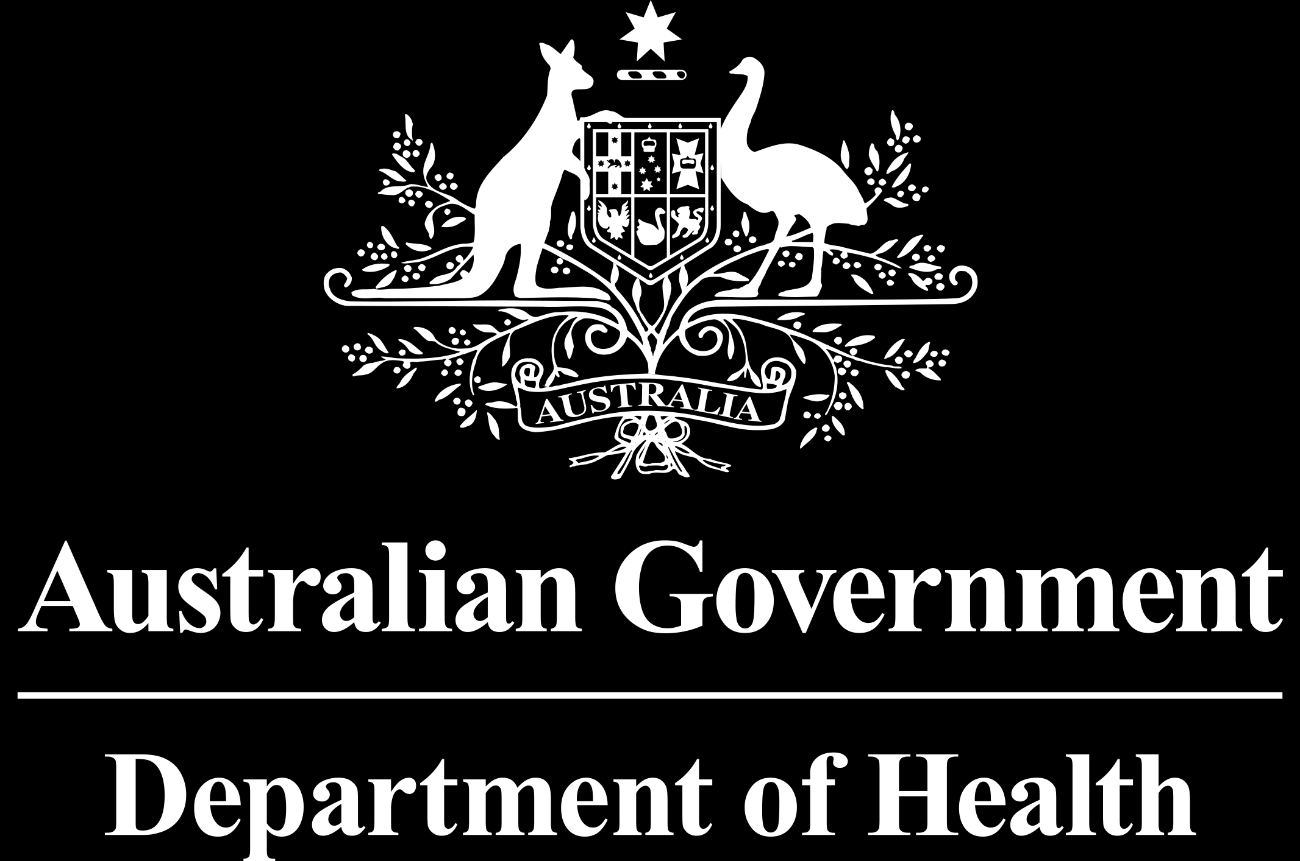 | AUSTRALIAN TECHNICAL ADVISORY GROUP ON IMMUNISATION (ATAGI) | CLINICAL ADVICE
 | Issue date: 1 July 2020

ATAGI CLINICAL ADVICE ON CHANGES TO RECOMMENDATIONS for the use and funding of meningococcal Vaccines from 1 july 2020
It is important to read this statement in conjunction with The Australian Immunisation Handbook available at immunisationhandbook.health.gov.au and other related ATAGI statements on NIP schedule changes from 1 July 2020

Key points
- From 1 July 2020, recommendations for meningococcal vaccines are changing to make meningococcal vaccines more readily available and give extra protection to people who are most at risk of invasive meningococcal disease.
- Recommendations for the use of meningococcal vaccines, including scheduling and dose requirements, remain unchanged. However, some of the recommended vaccine doses will now be funded under the National Immunisation Program (NIP).
- The recombinant multicomponent meningococcal serogroup B vaccine (MenB-MC), Bexsero®, is now available through the NIP for:
  - People of all ages with some specified medical conditions that increase their risk of invasive meningococcal disease (List 1). (Also refer to ATAGI clinical advice on changes to vaccine recommendations and funding for people with risk conditions from 1 July 2020)
  - Aboriginal and Torres Strait Islander infants from 2 months of age (refer to ATAGI clinical advice on changes to vaccine recommendations and funding for Aboriginal and Torres Strait Islander people from 1 July 2020).
List 1. Risk conditions for invasive meningococcal disease that are eligible for both MenACWY and MenB NIP-funded* vaccines
- Defects in, or deficiency of, complement components, including factor H, factor D or properdin deficiency
- Current or future treatment with eculizumab (a monoclonal antibody directed against complement component C5)
- Functional or anatomical asplenia, including sickle cell disease or other haemoglobinopathies, and congenital or acquired asplenia
* Please refer to The Australian Immunisation Handbook available at immunisationhandbook.health.gov.au for advice on persons who are strongly recommended to receive meningococcal vaccination but not eligible for NIP funded MenB and MenACWY vaccines

  - A nationally funded meningococcal B vaccination program for the above populations has been assessed as cost-effective.
  - Meningoccoccal serogroup B (MenB) vaccine continues to be strongly recommended also for non-Indigenous children aged <2 years, Aboriginal and Torres Strait Islander children aged 2–14 years, all adolescents aged 15–19 years, people living with HIV, recipients of haematopoietic stem cell transplant, young adults aged 20–24 years who are smokers or living in close quarters, and laboratory workers handling Neisseria meningitidis. However these populations are not eligible for NIP-funded doses, as cost-effectiveness thresholds for a nationally-funded population program have not been met to-date.
- The quadrivalent meningococcal serogroup ACWY (MenACWY) vaccine, Nimenrix® is now available through the NIP for
- People of all ages with some specified medical conditions that increase their risk of invasive meningococcal disease (List 1).
  - Those with ongoing increased risk of invasive meningococcal disease due to these medical conditions are also eligible for funded booster dose(s), as recommended by the Australian Immunisation Handbook.
- The meningococcal ACWY (MenACWY) vaccine will continue to be funded under the NIP with a single dose for:
  - All children at 12 months of age.
  - All adolescents at approximately 14 to <16 years of age, mostly administered through the school immunisation program, with catch-up available up to age 19 years.
- Children <2 years of age are recommended to receive prophylactic paracetamol with every dose of Bexsero®. This is because of the increased risk of fever associated with receiving Bexsero®.
  - Give first dose (15 mg/kg/dose) of paracetamol within 30 minutes before, or as soon as practicable after, receiving the vaccine, regardless of whether the child has a fever.
  - This can be followed by 2 more doses of paracetamol given 6 hours apart.
- Clinicians should ensure careful screening of all patients to determine if they have either; a) specified risk conditions for invasive meningococcal disease or b) identify as Aboriginal and Torres Strait Islander, as they may be eligible for funded doses of meningococcal vaccine(s), as described below.

Children and adults with conditions that increase the risk of invasive meningococcal disease
- MenB and MenACWY vaccines are now funded under the NIP for people of all ages with some specified medical conditions that increase their risk of invasive meningococcal disease (List 1). Also refer to ATAGI clinical advice on changes to vaccine recommendations and funding for people with risk conditions from 1 July 2020
  - Individuals with functional or anatomical asplenia are at increased risk of certain infections particularly from encapsulated bacteria such as meningococcus. Individuals with a complement deficiencies or receiving treatment with eculizumab are at a substantially greater risk of invasive meningococcal disease than the general population (1,000 to 10,000-fold increase)
  - National funding of meningococcal vaccinations for these populations has been assessed as cost-effective.
- People living with HIV, recipients of haematopoietic stem cell transplant, young adults aged 20–24 years who are smokers or living in close quarters, and laboratory workers handling Neisseria meningitidis are also recommended to receive both the MenB and MenACWY vaccines. However, they are not eligible for NIP-funded doses of these vaccines, as cost-effectiveness thresholds for a nationally-funded population program have not been met.

Aboriginal and Torres Strait Islander children
- Bexsero is now funded through the NIP for Aboriginal and Torres Strait Islander infants from 2 months of age, with catch-up available for Aboriginal and Torres Strait Islander children aged <2 years (i.e. up to 23 months) for the first 3 years of the program (i.e. until June 2023). (Note: some Aboriginal and Torres Strait Islander children in South Australia would have already received Bexsero® through the state-based program which commenced in October 2018.)
  - The incidence of IMD caused by serogroup B is highest in young children compared with other age groups and it is about 4 times higher in Aboriginal and Torres Strait Islander children <2 years than in non-Indigenous children.
  - The number of Bexsero doses required will depend on age and presence of any medical conditions which increase the risk of invasive meningococcal disease (Refer to Meningococcal disease chapter in the Australian Immunisation Handbook).

