NATIONAL DRUG STRATEGY

2017–2026

2018 ANNUAL REPORT

© Commonwealth of Australia as represented by the Department of Health 2020

National Drug Strategy 2017–2026 2018 ANNUAL REPORT  
Publications Number: 12728

Creative Commons Licence  
This publication is licensed under the Creative Commons Attribution 4.0 International Public License available from https://creativecommons.org/licenses/by/4.0/legalcode (“Licence”). You must read and understand the Licence before using any material from this publication.

Restrictions

The Licence may not give you all the permissions necessary for your intended use. For example, other rights (such as publicity, privacy and moral rights) may limit how you use the material found in this publication.

The Licence does not cover, and there is no permission given for, use of any of the following material found in this publication:

the Commonwealth Coat of Arms. (by way of information, the terms under which the Coat of Arms may be used can be found at www.itsanhonour.gov.au);

* any logos and trademarks;
* any photographs and images;
* any signatures; and
* any material belonging to third parties.

Attribution

Without limiting your obligations under the Licence, the Department of Health requests that you attribute this publication in your work. Any reasonable form of words may be used provided that you:

* include a reference to this publication and where, practicable, the relevant page numbers;
* make it clear that you have permission to use the material under the Creative Commons Attribution 4.0 International Public License;
* make it clear whether or not you have changed the material used from this publication;
* include a copyright notice in relation to the material used. In the case of no change to the material, the words “© Commonwealth of Australia (Department of Health) 2019” may be used. In the case where the material has been changed or adapted, the words: “Based on Commonwealth of Australia (Department of Health) material” may be used; and
* do not suggest that the Department of Health endorses you or your use of the material.

Enquiries

Enquiries regarding any other use of this publication should be addressed to the Branch Manager, Communication Branch, Department of Health, GPO Box 9848, Canberra ACT 2601, or via e-mail to corporatecomms@health.gov.au.

Contents

Introduction 5

Executive Summary 7

SECTION 1: Activities and Highlights 9

Commonwealth 9

Australian Capital Territory 9

New South Wales 9

Northern Territory 10

Queensland 10

South Australia 11

Tasmania 11

Victoria 12

Western Australia 12

Section 2: reporting against indicators 14

Indicator 1: Illicit drugs and precursors seized 14

Indicator 2: The availability of illegal drugs, as perceived by people who use illegal drugs 16

Indicator 3: The purity of illegal drugs 22

Indicator 4: Evaluation data from current policy interventions, programs and projects 24

Indicator 5: Hepatitis C virus (HCV) and HIV/AIDS incidence 26

Indicator 6: Opioid pharmacotherapy clients 27

Indicator 7: Drug treatment episodes 28

Indicator 8: Diversion of licit drugs e.g. pharmaceuticals 29

Indicator 9: Coronial data sources 30

Indicator 10: Wastewater Analysis 31

Indicator 11: The Illicit Drug Data Report 35

Indicator 12: Alcohol and other drug attributable hospital admissions and ambulance attendances 36

Section 3: NDS Sub-strategies 40

National Action Strategy 40

Priority Area 1: Empower Local Communities and Families 40

Priority Area 2: Prevention and Education 42

Action Area 3: Treatment and Workforce 43

Action Area 4: Strengthening Law Enforcement 45

Action Area 5: Better Research and Data 47

National Aboriginal and Torres Strait Islander Peoples Drug Strategy 49

National Alcohol and Other Drug Workforce Development Strategy 51

National Tobacco Strategy 53

National Alcohol Strategy 55

National Fetal Alcohol Spectrum Disorder Strategic Action Plan 56

Annexure 57

Attachment 59

Attachment A 2018 National Ice Action Strategy Quick Reference Progress Table 59

Introduction

The National Drug Strategy 2017–2026 (NDS), is the seventh iteration of the Strategy since its inception in 1985. This is the first time Australia has adopted a ten year Strategy and the first Annual Report for this current iteration of the NDS.

To measure the effectiveness of the Strategy, Annual Reports will be provided from the National Drug Strategy Committee (NDSC) to the Ministerial Drug and Alcohol Forum (MDAF) for noting by COAG. These Annual Reports will then be made publically available on the MDAF website.

The success of the Strategy relies on a coordinated national effort across Health and Law Enforcement/Justice from the Commonwealth and State and Territory Governments.

This Annual Report is consistent with the following Supplementary Indicators, identified in the National Drug Strategy 2017–2026:

* Supplementary Indicator 1: Illicit drugs and precursors seized;
* Supplementary Indicator 2: The availability of illegal drugs, as perceived by people who use illegal drugs;
* Supplementary Indicator 3: The purity of illegal drugs;
* Supplementary Indicator 4: Evaluation data from current policy interventions, programs and projects;
* Supplementary Indicator 5: Hepatitis C virus (HCV) and HIV/AIDS incidence;
* Supplementary Indicator 6: Opioid pharmacotherapy clients;
* Supplementary Indicator 7: Drug treatment episodes;
* Supplementary Indicator 8: Diversion of licit drugs e.g. pharmaceuticals;
* Supplementary Indicator 9: Coronial Data sources;
* Supplementary Indicator 10: Wastewater analysis;
* Supplementary Indicator 11: The Illicit Drug Data Report; and
* Supplementary Indicator 12: Alcohol and other drug attributable hospital admissions and ambulance attendances.

A more detailed report will be developed in 2018, 2021, 2024 and 2027, which includes the following Key Performance Indicators:

* Indicator 1: Increasing the average age of uptake of drugs, by drug type;
* Indicator 2: Reduction of the recent use of any drug, people living in households;
* Indicator 3: Reduction in arrestees’ illicit drug use in the month before committing an offence for which charged;
* Indicator 4: Reduction in the number of victims of drug-related incidents; and
* Indicator 5: Reduction in the drug-related burden of disease, including mortality.

This data is sourced from the findings from the National Drug Strategy Household Survey, undertaken by the Australian Institute of Health and Welfare, and compiled by the NDSC Research and Data Working Group.

This is the first Report that will include updates on the NDS sub-strategies, for the 2018 Annual Report these include:

* National Aboriginal and Torres Strait Islander Peoples Drug Strategy
* National Alcohol and other Drug Workforce Development Strategy
* National Alcohol Strategy
* National Fetal Alcohol Spectrum Disorder (FASD) Strategic Action Plan
* National Ice Action Strategy
* National Tobacco Strategy

Data is presented at a national level, excluding Supplementary Indicator 4 and the NDS sub-strategies.

Executive Summary

The National Drug Strategy 2017–2026 (the Strategy) continues the overarching approach of harm minimisation adopted in the first National Drug Strategy in 1985. All States and Territories have contributed to the 2018 National Drug Strategy Annual Report (the Report). The Report showcases the significant work being undertaken to address the harms associated with alcohol, tobacco and other drugs in each jurisdiction and nationally across both Health and Law Enforcement/Justice sectors.

Alcohol, tobacco and other drug use remain a significant issue in the broader community, contributing to the burden of disease in Australia and other social impacts. Tobacco use remains the highest contributor to the overall burden of disease, followed by alcohol and illicit drugs.

Governments have invested additional funding to significantly improve access to treatment services for alcohol and other drug use over the last ten years. Alcohol is the most common drug nominated by clients as the reason to seek treatment. For hospital admissions and ambulance attendances, where alcohol or other drug use was an attributable factor, alcohol is the predominant factor. Although opioids are the highest primary contributor in drug related deaths, alcohol has the highest overall prevalence in drug related deaths, as either a primary or secondary contributor.

Despite a decrease in the number of illicit drug seizures by law enforcement, there has been an increase in the weight of seizures. There has also been an increase in the number of illicit drug arrests.

The Report demonstrates:

* In 2018, the fourth and fifth National Wastewater Drug Monitoring Program reports were released. The reports capture the collection of approximately 55% of the Australian population in each report. These reports highlight that alcohol and nicotine remain the most consumed drugs monitored by the program, with methylamphetamine the most consumed illicit drug tested for.
* Tobacco use accounted for 9.3% of the total burden of disease in Australia in 2015, with alcohol use accounting for 4.5% of the total burden, and illicit drug use accounting for 2.7% of the total. Tobacco use represents the largest preventable risk factor when calculating the overall burden of disease in Australia.
* In 2015–16, the overall cost of tobacco to society was calculated as $136.9 billion, with $19.2 billion in tangible costs and $117.6 million in intangible costs. In addition to these costs, smokers and society incur costs in terms of ‘gap’ and over-the-counter payments to the Pharmaceutical Benefit Scheme.
* Alcohol accounted for 51% of all drug related hospital separations. The data indicates that there was a notable increase for methamphetamine as a drug related principle diagnosis from 1.6% in 2012–13 to 6.3% in 201617.
* The number of closed treatment episodes has increased by approximately 46% over the last 10 years. In 2017–18 nationally, clients seeking treatment received an average of 1.6 treatment episodes with alcohol being the most common drug clients seek treatment for.
* More opioid dependent people are seeking pharmacotherapy treatment for their dependence than in 2017, with the median age of those receiving treatment 43 years of age.
* In 2017, the number of notifications for the Hepatitis C virus (HCV) has decreased by 16% from 2008 to 2017. Notifications for HIV/AIDS has also decreased over time, with a 7% decline over the last five years, and a 5% decline between 2016 and 2017.
* The diversion of pharmaceuticals to the illicit market is difficult to measure. The data collected through the National Wastewater Drug Monitoring Program does not differentiate between licit and illicit use of these pharmaceuticals, such as fentanyl and oxycodone. Overall, the National Wastewater Drug Monitoring Program shows the use of these two drugs for licit and illicit purposes remains high, with regional Australia use approximately double than capital city average consumption.
* The Illicit Drug Data Report demonstrates that the number of illicit drug arrests have increased by 76.9% over the last decade, the number of illicit drug arrests decreased between 2016–17 to 2017–18, with cannabis accounting for the greatest proportion of these arrests.
* While there was a decrease in the number of national illicit drug seizures of 0.6% from 201617 to 2017–18, the weight of seizures has increased by 11.3%. Methylamphetamine remains the main drug produced in clandestine laboratories, the most effective and efficient way of limiting supply of illicit drugs is by preventing the diversion of precursors, reagents and solvents.

The 2018 National Drug Strategy Annual Report requires performance measurement of the Key Performance Indicators, provided in the Annexure. The measurement of three of these indicators is reliant on the latest findings of the National Drug Strategy Household Survey (NDSHS), the last NDSHS was published in 2016, with the data reflecting the baseline for future NDS Annual Reports. The next NDSHS findings are due to be released in 2020, the findings will inform the 2021 NDS Annual Report.

Of the remaining two Key Performance Indicators, the number of detainees consenting to a urine analysis shows 75% tested positive for any drug use, this is licit and illicit drug use. The Australian Burden of Disease Study 2015, determines an increase in illicit drugs on the total burden on disease to 2.7%, with a decrease for alcohol and tobacco 4.5% and 9.3% respectively.

SECTION 1:   
Activities and Highlights

Commonwealth

The Australian Government is investing approximately $1.1 billion over four years to support drug and alcohol treatment services, Indigenous specific services, as well as a number of prevention activities. The prevention activities are designed to raise awareness of the harms associated with alcohol, tobacco and other drug use and support decisions to prevent initial uptake of these substances.

In 2018, there were 92 local drug action teams established to provide health promotion and primary prevention activities in their local communities. This included information, education and mentoring programs.

On 1 May 2018, the Minister for Home Affairs announced the establishment of the Commonwealth Transnational, Serious and Organised Crime Coordinator and the appointment of Australian Federal Police Deputy Commissioner Karl Kent OAM to this role.

* The Coordinator has strengthened the national effort to combat transnational, serious and organised crime affecting Australia, including illicit drugs, taking a full spectrum approach addressing supply, demand and harm reduction.

In December 2018, the Council of Australian Governments agreed to the National Strategy to Fight Transnational, Serious and Organised Crime that provides a national framework to maximise opportunities for government agencies, international partners, industry and the broader community to work together on this issue.

* The framework ensures coordinated and agile response that match the complexity and sophistication of transnational, serious and organised crime threats, including illicit drugs.

Australian Capital Territory

The Australian Capital Territory launched its ACT Drug Strategy Action Plan 2018–2021, this document outlines the ACT actions and priorities across both Health and Law Enforcement/Justice to minimise harms from Alcohol, Tobacco and Other Drug Use in the Canberra community and aligns with the National Drug Strategy 2017–2026.

The Action Plan looks to expand on and explore further opportunities that build on the results of the pill testing trial which took place at the Groovin’ the Moo music festival in April 2018.

Further information is available on the Australian Capital Territory Government website [www.act.gov.au](http://www.act.gov.au).

New South Wales

In 2018, the New South Wales Government have undertaken a range of activities to reduce harms associated with alcohol, tobacco, licit and illicit drug use in its jurisdiction. Through the Methamphetamine Use and Related Harms in NSW Surveillance Report to December 2018, the NSW Government were able to determine that although overall methamphetamine use had decreased, an increasing proportion of use was high risk.

The New South Wales Governments’ focus on licit and illicit drug harm minimisation resulted in the: announcement of a Special Commission Inquiry into the Drug Ice, formation of an Expert Panel on Keeping People Safe at Music Festivals, implementation of a trial of Overdose Response and Take Home Naloxone, and release of the NSW Clinical Guidelines: Treatment of Opioid Dependence 2018.

The NSW State Coroner recently held an inquest into six opioid-related deaths and has conducted an inquest into six deaths at NSW music festivals between December 2017 and January 2019.

Further information on these initiatives and reports are available on the New South Wales Government website [www.nsw.gov.au](http://www.nsw.gov.au) and NSW Health website [www.health.nsw.gov.au](http://www.health.nsw.gov.au)

Northern Territory

The Northern Territory Government has implemented several key activities under its Alcohol Harm Minimisation Plan 2018–2019 and its Alcohol Action Initiatives to address alcohol related harms. Funding for youth initiatives included an additional budget allocation to enhance treatment services for youth and the Alcohol and Other Drugs Youth Grants.

A system-wide review of the frameworks around volatile substance abuse (VSA) was completed, led by the Department of Health in consultation with a VSA Advisory Group comprising professionals, clinicians, non-government services and the Aboriginal Controlled Community Health Service sector.

The Northern Territory Select Committee on a Northern Territory Harm Reduction Strategy for Addictive Behaviours was established.

Further information is available on the Northern Territory Government website [www.nt.gov.au](http://www.nt.gov.au)

Queensland

On 10 February 2018, Queensland released Action on ice: The Queensland Government’s plan to address use and harms caused by crystal methamphetamine and committed more than $105.5 million over five years to implement the initiatives aimed at reducing the supply, demand and harms from ice use across Queensland.

Under Connecting Care to Recovery 2016–2021—A plan for Queensland’s State-funded mental health alcohol and other drugs services, an additional $10 million from 2017–18 has been invested to establish more treatment services provided by the non-government sector including community-based counselling, residential and non-residential rehabilitation services, withdrawal management and support for families.

The re-established Queensland Drug and Alcohol Court (QDAC), led by the Department of Justice and Attorney-General, commenced operation within the Brisbane Magistrate’s Court on 29 January 2018. QDAC is a multi-agency service (including justice, corrections, police, health, housing and legal aid staff) providing an intensive and targeted response to adult offenders with severe drug and/or alcohol use directly associated with their offending.

Court Link, a bail-based court assessment, referral and support program that aims to address the underlying contributors to offending behaviour through targeted case management and judicial monitoring of defendants, has been established in Brisbane, Cairns, Ipswich and Southport.

Further information on these and other Queensland Government initiatives is available at [www.qld.gov.au](http://www.qld.gov.au)

South Australia

The South Australian Government introduced several legislative changes in 2018, this includes: the Statutes Amendment (Drug Offences) Act 2018; the Tobacco Products Regulation (E-cigarettes and Review) Amendment Bill 2018 and the Controlled Substances (Youth Treatment Orders) Amendment Bill 2018.

In 2018, the South Australian Government finalised the South Australian Specialist Alcohol and Other Drug Treatment Service Delivery Framework. The purpose of the Framework is to describe alcohol and other drug treatment service delivery in South Australia, with a focus on government and non-government specialist alcohol and other drug treatment services.

The South Australian Government’s smoking cessation social marketing campaign continued throughout 2018 as part of the State’s comprehensive tobacco control strategy to decrease smoking prevalence in the community. The campaign was led by television advertising with supporting advertising, including digital, playing a vital role. A further phase of the ‘Give up smokes for good’ Aboriginal smoking cessation campaign also ran as part of SA Health’s commitment to Closing the Gap.

Under the South Australian Ice Action Plan, the South Australian Government has increased access to treatment across South Australia through the provision of additional outpatient counselling appointments and 18 new residential rehabilitation beds in three regional locations.

South Australia Police continue to engage with the community to reduce harms associated with alcohol and other drug use through consultation and education.

Tasmania

In 2018, the Tasmanian Government provided additional funding for 30 additional residential rehabilitation beds including day programs and after-care services and 1 community-based non-medicated withdrawal management bed. In addition funding was also provided to enhance the Good Sports and Healthy Minds program and the Street Teams Programs.

Tasmanian Department of Health through Public Health Services (PHS) engaged in a collaborative project with The Australian Prevention Partnership Centre (TAPPC) Sax Institute of New South Wales to develop a simulation model of alcohol use in Tasmania. It serves as a ‘what if’ tool to test the likely impacts of a combination of policy and program interventions to reduce alcohol-related harms over the next 5–10 years. The modelling will be used to help inform development of a new Tasmanian Alcohol Action Framework in the future.

Further information on Tasmanian Government Alcohol, Tobacco and Other Drug interventions are available at [www.tas.gov.au](http://www.tas.gov.au)

Victoria

The Royal Commission into Victoria’s Mental Health System commenced in October 2018. The Royal Commission is looking at ways to best support Victorians living with mental illness, including those experiencing problematic alcohol and drug use.

In October 2018, the Victorian Government began a roll-out of the SafeScript program, which allows doctors, nurse practitioners and pharmacists to access information about their patient’s prescription history for certain high-risk medicines. This information helps clinicians make safer clinical decisions and reduces the incidence of harm, including death, from the use of pharmaceuticals.

The Victorian Government has undertaken a range of activities to enhance their forensic capabilities regarding drug profiling and intelligence to address local illicit drug manufacturing, and explore relationships between drug seizures/offences and community impacts or harm. Through the ongoing development of forensic drug information and reporting protocols Victoria Police are able to provide a differing view of drug networks and possible distribution patterns.

Through the Joint Organised Crime Taskforce (JOCTF) and the Clandestine Laboratory Squad, Victoria Police were successful in disrupting and reducing supply of illicit drugs in Victoria. For example, in July 2018 JOCTF commenced an intelligence supported operation. This led to the seizure by United States law enforcement agencies of 1.7 tonnes of methamphetamine, 25 kilograms of cocaine and 5 kilograms of heroin located in two containers destined for Melbourne.

The Victorian Government has provided additional funding for 10 new alcohol and drug vehicles and for Victoria Police to conduct 100,000 drug tests each year, and under the Victorian Government’s Community Safety Statement 2018/19 funding was received to increase the number of roadside drug tests to 150,000 tests per annum.

Further information is available on the Victorian Government website [www.vic.gov.au](http://www.vic.gov.au)

Western Australia

In 2018, the Western Australia Government ran several campaigns through the, Alcohol. Think Again and Drug Aware websites. Work commenced to increase access to Naloxone and decrease opioid related harms through several projects including: WA Peer Naloxone and Overdose Prevention and Management projects; Acacia Prison Peer Naloxone project; and a hospital emergency department and non-medical community-based take-home naloxone pilot.

The State Coroner conducted an inquest hearing into the deaths of thirteen children and young persons in the Kimberley Region of Western Australia. The Coroner’s findings (early 2019) identified the significant contribution of alcohol and drug use in the Kimberley and made several recommendations to reduce alcohol availability, reduce consumption and reduce harm.

Through the Western Australia Mental Health Commission, a procurement process was completed for 31 residential rehabilitation and 3 low medical withdrawal beds in the South West of the State. The Commission led the development of the draft Mental Health, Alcohol and Other Drug Workforce Strategic Framework 2019–2025.

The Western Australian Mental Health, Alcohol and Other Drug Services Plan 2015–2025 (the Plan) Update 2018 was developed. The Western Australia Minister for Mental Health released the Mental Health Promotion, Mental Illness, Alcohol and Other Drug Prevention Plan 20182025 and the Engagement Framework and Toolkit.

Under the Methamphetamine Action Plan 2017–2021, the Western Australia Police Force established the Meth Taskforce and increased its capacity to intercept illicit drugs being trafficked into Western Australia in regional areas, at state borders and deconstruct manufacturing laboratories within its borders. The Western Australian Government, through its Police Force, continue to target the profits and assets generated by the sale of illicit drugs with a total value of over $40 million of assets frozen (including cash, vehicles and property) in 2018.

Further information is available on the Western Australian Government website [www.wa.gov.au](http://www.wa.gov.au)

Section 2:   
reporting against indicators

Indicator 1: Illicit drugs and precursors seized

Lead Agency Name: ACIC

Number of national illicit drug seizures, 2008–09 to 2017–18

* The number of national illicit drug seizures has increased 67.0 per cent over the last decade, increasing from 67,559 in 2008–09 to 112,827 in 2017–18.
* The number of national illicit drug seizures remained relatively stable in 2017–18, with 112,827 seizures, the third highest number on record.

Number of national illicit drug seizures—comparison between 2016–17 and 2017–18[1]

|  |  |  |  |  |  |
| --- | --- | --- | --- | --- | --- |
| National | ATS | Cannabis | Heroin | Cocaine | Other and unknown drugs |
| Relatively stable  -0.6% | Relatively stable  -0.7% | Decrease  -1.4% | Increase 1.3% | Increase (highest on record) 11.6% | Decrease -1.4% |
| 113,533 to 112,827 | 37,351 to 37,093 | 60,006 to 59,139 | 1,951 to 1,977 | 4,567 to 5,096 | 9,658 to 9,522 |

* In 2017–18, cannabis accounted for the greatest proportion of the number of national illicit drug seizures (52.4 per cent), followed by ATS (amphetamine-type stimulants) (32.9 per cent), other and unknown drugs (8.2 per cent), cocaine (4.5 per cent) and heroin and other opioids (2.0 per cent).

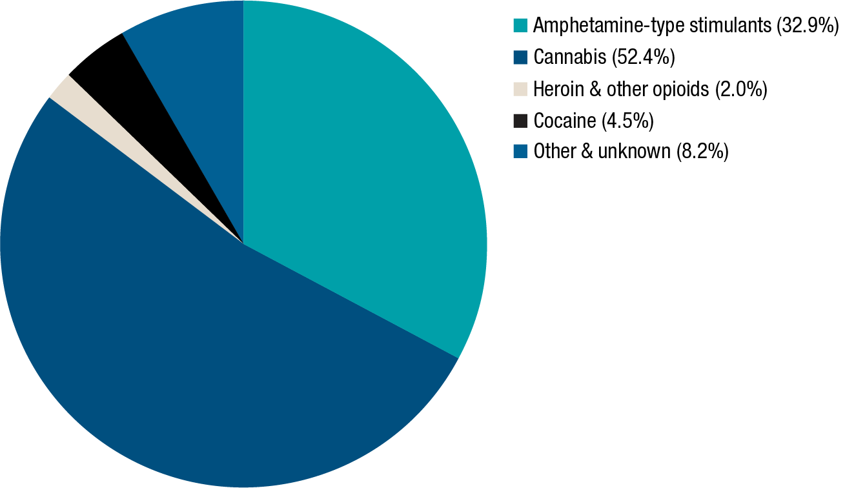

Weight of national illicit drug seizures, 2008–09 to 2017–18

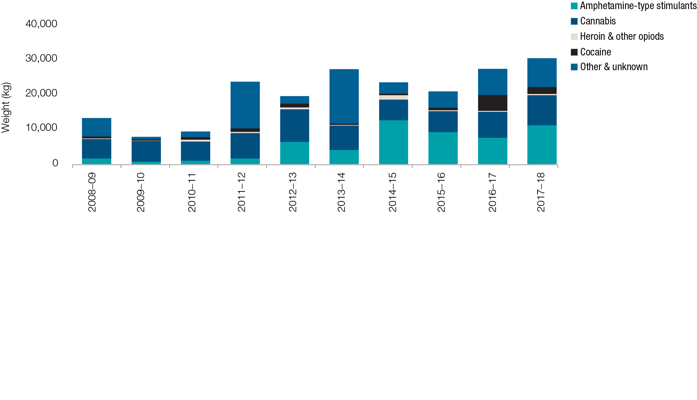

* The weight of illicit drugs seized nationally has increased 130.0 per cent over the last decade, from 13.3 tonnes in 2008–09 to a record 30.6 tonnes in 2017–18.
* The weight of illicit drugs seized nationally in 2017–18 further increased, from a record 27.4 tonnes in 2016–17 to a record 30.6 tonnes.

Weight of national illicit drug seizures–comparison between 2016–17 and 2017–18

|  |  |  |  |  |  |
| --- | --- | --- | --- | --- | --- |
| National | ATS | Cannabis | Heroin | Cocaine | Other and unknown drugs |
| Increase (highest on record) 11.3% | Increase  48.0% | Increase  14.7% | Increase  1.9% | Decrease -57.4% | Increase 13.5% |
| 27.4t  to 30.6t | 7,571kg to 11,205kg | 7,547kg to 8,655kg | 224kg  to 229kg | 4.623kg to 1,970kg | 7,524kg to 8,540kg |

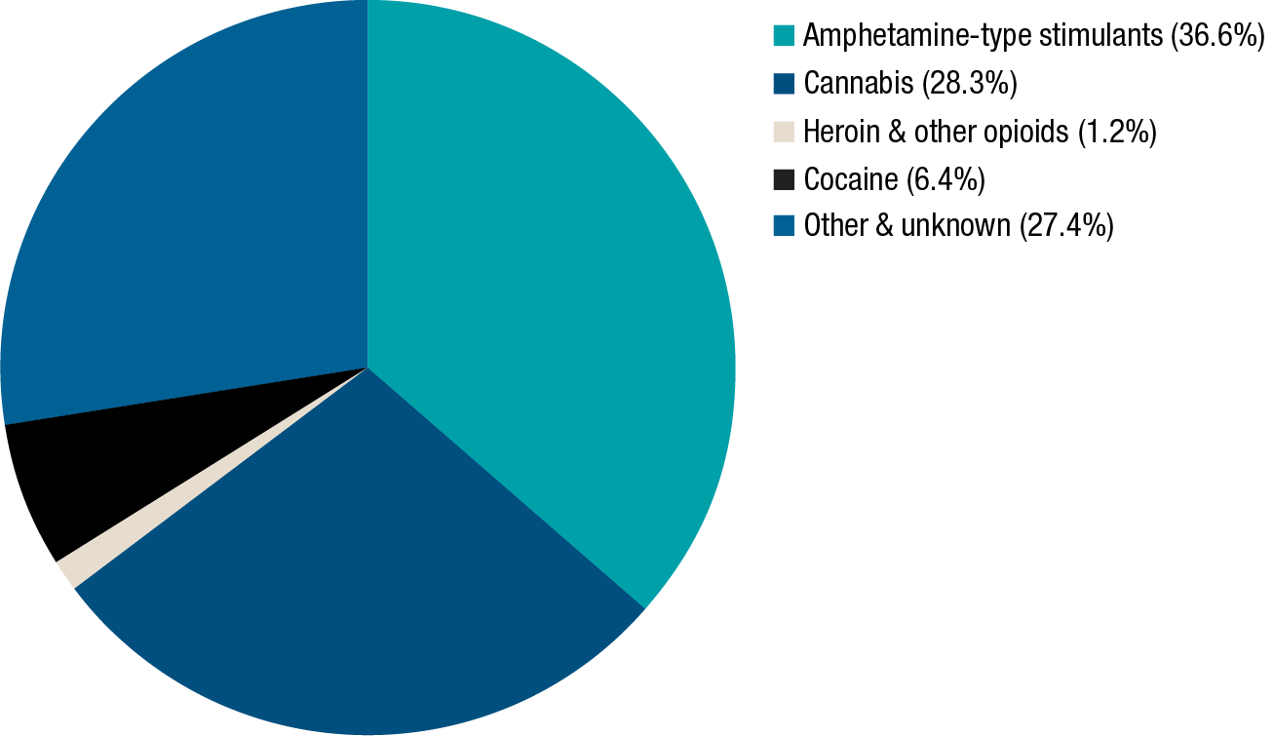

* In 2017–18, ATS accounted for the greatest proportion of the weight of illicit drugs seized nationally (36.6 per cent), followed by cannabis (28.3 per cent), other and unknown drugs (27.4 per cent), cocaine (6.4 per cent) and heroin and other opioids (1.2 per cent).
* Preventing the diversion of precursors, reagents and solvents for use in illicit drug manufacture is an effective and efficient way of limiting the supply of illicit drugs. As many of these substances have legitimate application within various branches of industry, controls must balance legitimate access with efforts to reduce diversion to the illicit market.
* Methylamphetamine remains the main drug produced in clandestine laboratories detected nationally.
* Drug profiling data of analysed border and domestic seizures indicate ephedrine and pseudoephedrine remain the predominant methylamphetamine precursors.
* The number of ATS (excluding MDMA) precursor detections at the Australian border decreased from 552 in 2016–17 to 332 in 2017–18, with the weight detected increasing from 1,584.0 kilograms in 2016–17 to a record 4,912.4 kilograms in 2017–18.
* The number of MDMA precursor detections at the Australian border decreased from 4 in 2016–17 to 1 in 2017–18, with the weight detected decreasing from 10.2 kilograms in 2016–17 to 5.0 grams in 2017–18.
* In addition to detections at the Australian border, precursors, reagents and solvents were also seized nationally in 2017–18, the majority of which relate to the manufacture of methylamphetamine.

Data Source: Illicit Drug Data Report (IDDR).

All data analysis should be undertaken from the original data source, provided in the link below, as this presentation is a snapshot from the report and does not necessarily represent the limitations involved in the collection or reporting of the data.

<https://www.acic.gov.au/publications/reports/illicit-drug-data-report-2017-18>

Indicator 2: The availability of illegal drugs, as perceived by people who use illegal drugs

Lead Agency Name: Commonwealth Department of Health

The [Ecstasy and Related Drugs Reporting System (EDRS)](https://ndarc.med.unsw.edu.au/project/ecstasy-and-related-drugs-reporting-system-edrs) and the [Illicit Drug Reporting System (IDRS)](https://ndarc.med.unsw.edu.au/project/illicit-drug-reporting-system-idrs), produced by the National Drug and Alcohol Research Centre (NDARC), include data on the perceived availability of specific illicit drugs, based on interviews with people who regularly use ecstasy and other related drugs (EDRS) and people who inject drugs (IDRS). The latest data is from 2018.

Amongst people interviewed who regularly use ecstasy and related drugs and people who inject drugs, participants perceived the availability of cocaine, bush cannabis, as easy or very easy to obtain. The perceived availability of methamphetamine (powder and crystal) amongst this group remained relatively unchanged from 2017. However, amongst injecting drug users 48% of participants perceived that it was very easy to obtain powder methamphetamine which was up from 33% in 2017 and 64% found it very easy to obtain crystal methamphetamine compared to 56% in 2017.

Results for ketamine and LSD remained relatively unchanged from 2017, however the majority of participants found it easy or very easy to obtain these substances. In 2018, of those who responded, over half (55%) perceived the current availability of heroin as ‘very easy’ and a third (34%) as ‘easy’ to obtain, reflecting similar results from 2017 (52% and 37%, respectively). Whilst the availability of ecstasy as perceived by the participants had decreased.

People interviewed who regularly use ecstasy and related drugs, perceived availability of particular illegal drugs was as follows:

Ecstasy

During 2016 to 2018, the reported difficulty of obtaining ecstasy has increased slightly, while the number of people who found ecstasy as ‘very easy’ to obtain has decreased universally.

|  | **2016** | **2017** | **2018** |
| --- | --- | --- | --- |
| **Current availability** |  |  |  |
| **% Pills (n)** | (n=472) | (n=576) | **(n=597)** |
| Very easy | 57 | 50 | **43** |
| Easy | 36 | 38 | **40** |
| Difficult | 7 | 10 | **16** |
| Very difficult | - | 1 | **2** |
| **% Powder (n)** | (n=31) | (n=122) | **(n=115)** |
| Very easy | 61 | 30 | **20** |
| Easy | 36 | 40 | **48** |
| Difficult | 3 | 27 | **30** |
| Very difficult | 0 | 3 | **2** |
| **% Capsules (n)** | (n=223) | (n=567) | **(n=588)** |
| Very easy | 49 | 43 | **38** |
| Easy | 44 | 43 | **47** |
| Difficult | 7 | 13 | **14** |
| Very difficult | 0 | 1 | **1** |
| **% Crystal (n)** | (n=353) | (n=433) | **(n=392)** |
| Very easy | 36 | 38 | **30** |
| Easy | 47 | 40 | **44** |
| Difficult | 16 | 20 | **23** |
| Very difficult | 1 | 2 | **4** |

Cocaine

In 2018, 62% of people perceived availability of cocaine as ‘easy’ or ‘very easy’, compared to 55% in 2017. 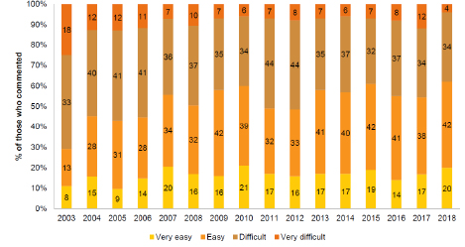

Methamphetamine

In 2018, 65% of people found it ‘easy’ or ‘very easy’ to obtain powder methamphetamine. This remained unchanged from 2017.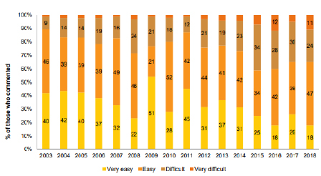

In 2018, 94% of people found it ‘easy’ or ‘very easy’ to buy crystal methamphetamine, compared to 90% in 2017.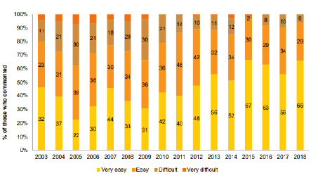

Cannabis

In 2018, 84% of people perceived that hydroponic cannabis was ‘easy’ or ‘very easy’ to obtain, compared to 94% in 2017.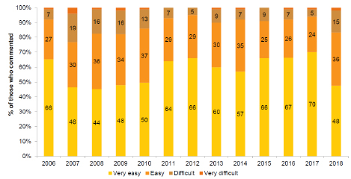

The perception of bush cannabis being ‘easy’ or ‘very easy’ to obtain remained relatively unchanged with 75% of people finding it ‘easy’ or ‘very easy’ to obtain in 2018 compared to 76% in 2017.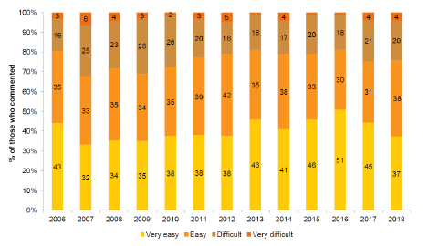

Cocaine

In 2018, of those who responded (n=69), the largest proportion of cocaine users reported it to be ‘easy’ to obtain in 2018 (42%), with a further 22% reporting it to be ‘very easy’ to obtain.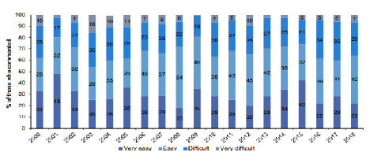

Cannabis

In 2018, of those who responded, a majority of hydroponic cannabis users reported it to be ‘very easy’ (49%) or ‘easy’ (40%) to obtain. Reports of bush cannabis availability also indicated that it tended to be ‘easy’ (40%) or ‘very easy’ (37%) to obtain, with 21% reporting it was ‘difficult’ to obtain.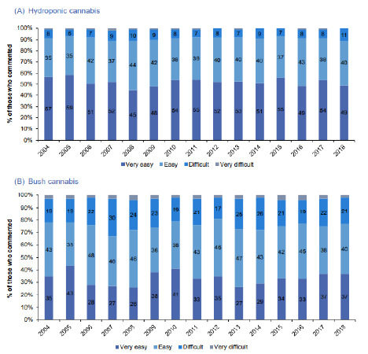

Data Source: Ecstasy and Related Drugs Reporting System (EDRS) National Report/ Illicit Drug Reporting System (IDRS) National Report

All data analysis should be undertaken from the original data source, provided in the link below, as this presentation is a snapshot from the report and does not necessarily represent the limitations involved in the collection or reporting of the data.

<https://ndarc.med.unsw.edu.au/resource/australian-drug-trends-2018-key-findings-national-ecstasy-and-related-drugs-reporting>

<https://ndarc.med.unsw.edu.au/resource/australian-drug-trends-2018-key-findings-national-illicit-drug-reporting-system-idrs>

Indicator 3: The purity of illegal drugs

Lead Agency Name: ACIC

Annual median purity of amphetamine samples, 2008–09 to 2017–18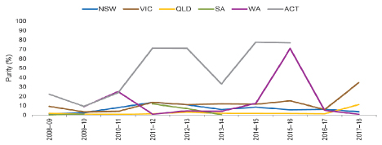

* Over the last decade the annual median purity of analysed amphetamine[2] samples has ranged between less than 1.0 per cent and 77.7 per cent.
* In 2017–18, the annual median purity ranged from 1.0 per cent in Western Australia to   
  34.7 per cent in Victoria.

Annual median purity of methylamphetamine samples, 2008–09 to 2017–18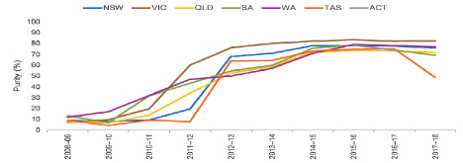

* Over the last decade the annual median purity of analysed methylamphetamine samples has ranged between 4.4 per cent and 83.4 per cent.
* There was a notable increase in the annual median purity of methylamphetamine in 2012–13, with the successive annual median purity remaining high and relatively stable across most states.
* In 2017–18, the annual median purity ranged from 48.6 per cent in Tasmania to 82.4 per cent in Victoria.

Annual median purity of cocaine samples, 2008–09 to 2017–18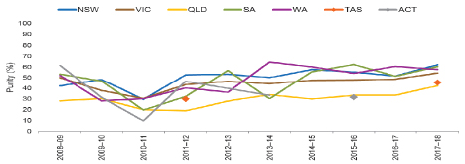

* Over the last decade the annual median purity of analysed cocaine samples has ranged between 9.5 per cent and 64.5 per cent.
* In 2017–18, the annual median purity ranged from 42.1 per cent in Queensland to 62.0 per cent in New South Wales.

Annual median purity of heroin samples, 2008–09 to 2017–18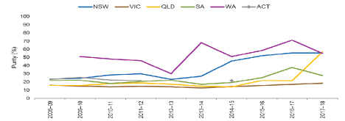

Over the last decade the annual median purity of heroin has ranged from 12.7 per cent to 71.0 per cent.

In 2017–18, the annual median purity of heroin ranged from 18.3 per cent in Victoria to 56.7 per cent in Queensland.

Data Source: Illicit Drug Data Report

All data analysis should be undertaken from the original data source, provided in the link below, as this presentation is a snapshot from the report and does not necessarily represent the limitations involved in the collection or reporting of the data.

<https://www.acic.gov.au/publications/reports/illicit-drug-data-report-2017-18>

Indicator 4: Evaluation data from current policy interventions, programs and projects

Several jurisdictions have provided evaluation data from current policy interventions, programs and projects, this includes:

New South Wales:

* Reports on alcohol, tobacco and methamphetamine are available online.
* Methamphetamine Surveillance Report <https://www.health.nsw.gov.au/methamphetamine/Pages/nsw-data.aspx>
* Alcohol Snapshot <https://www.health.nsw.gov.au/aod/Publications/alcohol-related-harm-snapshot-2018.pdf>
* Tobacco Snapshot <https://www.health.nsw.gov.au/tobacco/Publications/tobacco-snapshot.pdf>

Northern Territory:

* PriceWaterhouseCoopers Indigenous Consulting undertook a review of Sobering Up Shelters. The report was released in December 2018. The recommendations included mechanisms to plan and implement service improvements and enhance linkages with client support/treatment agencies.
* The Northern Territory Government has introduced a minimum unit price for alcohol, commonly referred to as the ‘minimum floor price’, to minimise the harms associated with high-alcohol, low-cost alcoholic beverages. Analysis of data to inform the effectiveness of the Minimum Floor Price initiative is ongoing with an evaluation yet to occur.

South Australia:

* Ongoing data collection by the South Australian Government, through the 2018 South Australian Population Health Survey shows a decrease in the proportion of daily smokers aged 15 years and older decreased from 17.2% in 2010 to 8.6% in 2018, the proportion of South Australians who are drinking at levels that puts them at risk of injury or disease at both single occasion and lifetime has steadily declined between 2012 to 2018, from 30% to 21% and 23% to 14% respectively.
* South Australia Police focused heavily on traffic operations known for being drug transit routes and a number of drug driver testing activities, particularly drug testing outside schools at drop-off and pick-up times.
* The proportion of the population aged 14 years and over drinking at levels that puts them at risk of injury or disease at both single occasion and lifetime has steadily declined between 2012 to 2018, from 30% to 21%. (Source: SA Population Health Survey and Health Omnibus Surveys).
* Data from the 2017 Australian Secondary Students Alcohol and Drugs Survey, released in December 2018 indicates:
  + The proportion of secondary students in South Australia who had ever drunk alcohol decreased from 91.9% in 2002 to 66.7% in 2017. There was also a significant decrease in reported alcohol consumption in the last week (from 15% in 2011 to 12.3% in 2017).
  + The majority (89.8%) of secondary school students in 2017 had never smoked, which was significantly higher than in 2014 (86.2%).
  + The proportion of secondary school students who had ever used at least one illicit drug (including cannabis, methamphetamine, ecstasy, cocaine, heroin and hallucinogens) decreased significantly since 1996. In 2017, 13.5% of students reported ever using at least one illicit drug; this remained stable since the last survey of secondary school students.

Tasmania:

* Additional funding has been provided to the Salvation Army Tasmania for an expanded Street Teams program in the Hobart and Launceston CBDs on Friday and Saturday nights, providing support and assistance to vulnerable people who may be at risk of harm or causing harm to others due to alcohol and/or other drugs use. The 2015–16 trial of the Street Teams approach saw reductions in the number of public place assaults of 52.9% in the Hobart waterfront district, compared to 24.5% in the general Hobart area.
* Tasmanian Good Sports accreditation have demonstrated steady increases each year, as demonstrated below.

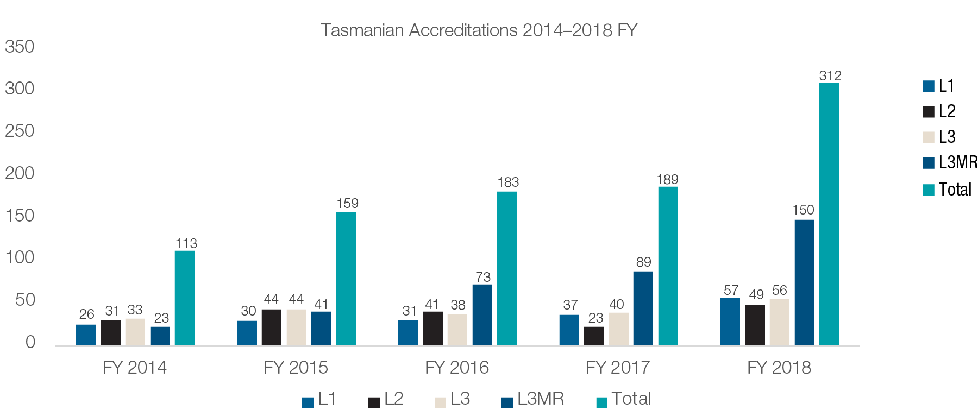

Western Australia:

* A record high of 72% of Western Australian parents (of 12 to 17 years old’s) surveyed say they have never provided alcohol to their child (up from 56% in 2013). This is consistent with increased parental belief it is inappropriate to provide alcohol to under 18’s (in 2018, 25% stated it was appropriate to provide alcohol to their own child, down from 37% in 2013).
* The Foundation for Alcohol Research and Education’s 2018 Annual Alcohol Poll showed that, while there is limited jurisdictional breakdown available from the polling results, the available data indicates Western Australian’s alcohol-related attitudes, knowledge and behaviour is faring above that of other jurisdictions and the national average. Jurisdictional comparison shows a significantly higher proportion of Western Australians are aware of the Guidelines (80%) and know drinking more than two standard drinks a day increases the risk of long-term harm (56%), compared to the national average.
* The trend for intent to use methamphetamine amongst 18 to 25 year-olds remains on the decline. Post campaign results from the ‘Meth Can Take Control’ campaign saw a decline from 14% (2016) to 12% (2018). The younger cohort of 18 to 21 years old’s intent to use in 2018 was 3%, compared to 17% in 2016.

Indicator 5: Hepatitis C virus (HCV) and HIV/AIDS incidence

Lead Agency Name: Commonwealth Department of Health

Hepatitis C

* A total of 10,537 hepatitis C notifications were reported in Australia in 2017.
* Between 2008 and 2017 there was a 16% decrease in the hepatitis C notification rate from 52.6 to 44.2 per 100 000. The notification rates declined by 16% between 2008 and 2012, and have been relatively stable since, with an increase in 2016. It is important to note that the increase in notification rate in 2016 may reflect increased testing in response to the availability of new direct‑acting antiviral treatments for hepatitis C.
* According to the Australian Needle and Syringe Program Survey (ANSPS), the prevalence of hepatitis C remains high among people who inject drugs, with 49% hepatitis C antibody prevalence in 2017. In 2015, the ANSPS commenced hepatitis C RNA testing, which determines current hepatitis C infection. The hepatitis C RNA prevalence was 42% in 2015, declining to 25% in 2017, which demonstrates the positive impact of the direct‑acting antiviral treatments.

HIV

There were 963 HIV notifications in Australia in 2017, the lowest number of notifications since 2010, with a 7% decline over the last five years, and a 5% decline between 2016 and 2017.

Male‑to‑male sex continues to be the major HIV risk exposure in Australia, reported for 607 (63%) HIV notifications in 2017, with heterosexual sex reported for 238 (25%) notifications, combined male‑to‑male sex and injecting drug use for 53 (5%) notifications and injecting drug use for 33 (3%) notifications.

Data Source: HIV, viral hepatitis and sexually transmissible infections in Australia Annual Surveillance Report 2018 (Kirby Institute)

All data analysis should be undertaken from the original data source, provided in the link below, as this presentation is a snapshot from the report and does not necessarily represent the limitations involved in the collection or reporting of the data.

<https://kirby.unsw.edu.au/report/hiv-viral-hepatitis-and-sexually-transmissible-infections-australia-annual-surveillance>

Indicator 6: Opioid pharmacotherapy clients

Lead Agency Name: Commonwealth Department of Health

* In 2018, there were 50,597 people in Australia on a course of pharmacotherapy treatment for their opioid dependence compared to 49,792 in 2017.
* Both the number of people (50,597) and the rate of people (20 clients per 10,000 people) receiving pharmacotherapy treatment have remained relatively stable since 2010, with most states recording small increases in client numbers during this time.
* In 2018, clients ranged in age from their late teens to 88 years. The median age across all pharmacotherapy types in 2018 was 43 years. This is an increase from 38 years in 2011, 39 years in 2012, 40 years in 2013, 2014 and 2015 and 42 years in 2016 and 2017.
* Almost two-thirds (65%) of clients in 2018 were aged 30–49 years. The proportion of clients aged under 30 has declined each year since 2006 (28% of clients in 2006 falling to 7% of clients in 2017 and 2018).
* The number of clients aged 60 years and over has continued to increase slowly, from 223 (1% of total clients) in 2008 to 3,635 in 2018 (7% of total clients).
* This continues the trend of an ageing cohort in opioid pharmacotherapy treatment and is consistent with the pattern observed in other drug treatment services (AIHW 2016). This may be due to:
  + methadone treatment being available in Australia for more than 40 years;
  + pharmacotherapy treatment reducing the risk of premature death, resulting in some clients remaining in treatment for decades; and/or
  + clients seeking treatment for the first time at an older age.
* Nationally in 2018, 37% of clients reported heroin as their opioid drug of dependence. Oxycodone (6%) was the next most commonly reported drug of dependence followed by codeine (5%), morphine, methadone and buprenorphine (all 4%).
* Just over two-thirds (62%) of clients were treated with methadone in 2018 and the remaining 38% were treated with buprenorphine, either alone or in combination with naloxone.
* From 2009 to 2018, treatment with:
  + Methadone fell (from 70% of clients to 62%)
  + buprenorphine rose slightly (from 14% of clients to 16%), and
  + buprenorphine-naloxone increased (from 16% of clients to 22%).

Data Source: National Opioid Pharmacotherapy Statistics Annual Data Collection (NOPSAD) 2018

All data analysis should be undertaken from the original data source, provided in the link below, as this presentation is a snapshot from the report and does not necessarily represent the limitations involved in the collection or reporting of the data.

<https://www.aihw.gov.au/reports/alcohol-other-drug-treatment-services/nopsad-2018/contents/introduction>

Indicator 7: Drug treatment episodes

Lead Agency Name: Commonwealth Department of Health

In 2017–18, 209,287 closed treatment episodes were provided to clients. The number of closed treatment episodes has increased by around 46% over the last 10 years, up from 143,672 in 2008–09. There was an increase in the number of reported treatment episodes, up from 200,751 in 2016–17. Nationally, clients seeking treatment received an average of 1.6 treatment episodes in 2017–18.

The four most common drugs that led clients to seek treatment were alcohol (34% of all treatment episodes), amphetamines (25%), cannabis (21%) and heroin (5%). Two-thirds (66%) of all clients receiving treatment were male and the median age of clients was 34 years.

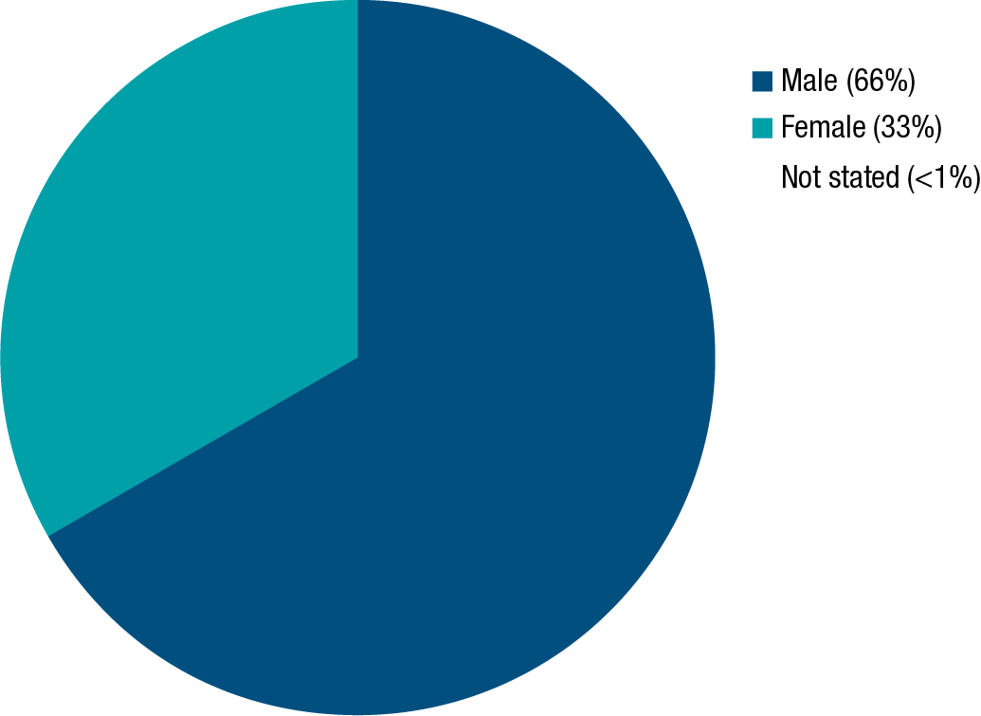

Data Source: Alcohol and other drug treatment services in Australia 2017–18

All data analysis should be undertaken from the original data source, provided in the link below, as this presentation is a snapshot from the report and does not necessarily represent the limitations involved in the collection or reporting of the data.

<https://www.aihw.gov.au/reports/alcohol-other-drug-treatment-services/aodts-2017-18-key-findings/contents/summary>

Indicator 8: Diversion of licit drugs e.g. pharmaceuticals

Lead Agency Name: ACIC

Fentanyl and oxycodone are opioid pharmaceuticals with therapeutic application, but are also diverted to the illicit market. Consumption of fentanyl and oxycodone in the NWDMP reflects both the licit and illicit use of these substances.

Fentanyl consumption levels remain high, particularly in regional areas, with regional average fentanyl consumption exceeding capital city average consumption.

The regional average consumption of fentanyl in December 2018 was around double capital city average consumption.

The population-weighted average of all sites for fentanyl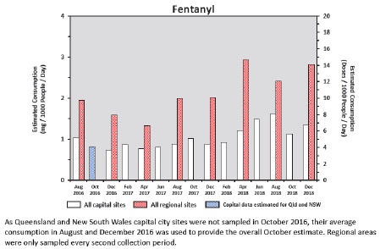

Oxycodone

* Oxycodone consumption levels remain high, particularly in regional areas, with regional average oxycodone consumption exceeding capital city average consumption.
* The regional average consumption of oxycodone in December 2018 was more than double capital city average consumption.

The population-weighted average of all sites for oxycodone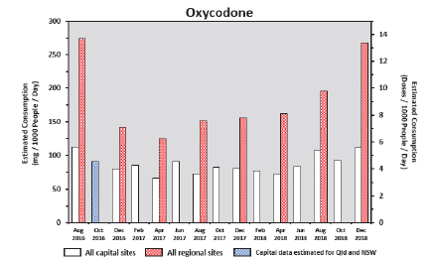

Data Source: National Wastewater Drug Monitoring Program (NWDMP).

All data analysis should be undertaken from the original data source, provided in the link below, as this presentation is a snapshot from the report and does not necessarily represent the limitations involved in the collection or reporting of the data.

<https://www.acic.gov.au/publications/reports/national-wastewater-drug-monitoring-program-reports>

Indicator 9: Coronial data sources

Lead Agency Name: Commonwealth Department of Health

* In 2016 there were 16,955 deaths reported to an Australian coroner. Of those deaths, 3,240, or nearly one fifth (19.1%), were classified as being drug-related. Drugs were found to have made a primary contribution to death in 54.1%* of instances (n=1,754).
* Queensland, the Northern Territory and Western Australia had the highest proportion of drug related deaths across all jurisdictions.
* Over two-thirds of drug-related deaths occurred in those aged between 25−54 years (68.7%), while more than half of drug-related deaths were unintentional in nature (56.1%).
* Opioids were the most frequently identified drug class involved in drug-related deaths (of the drug classes analysed in this report), both as a primary and overall contributor.
* Alcohol and benzodiazepines were the second and third most frequently identified drug classes involved in drug-related deaths. This is consistent with previous reports.
* Benzodiazepines were the second most frequent primary contributor to drug-related deaths after opioids.
* In 12.3% of deaths where opioids made a primary contribution to death, they were the sole contributor. Benzodiazepines were far less frequently found to be the sole drug class making a primary contribution to death (0.9% of deaths where benzodiazepines made a primary contribution to death).
* Alcohol had a high prevalence in terms of total involvement in drug-related deaths (n=1,239 cases), however in the majority of instances it was determined to be a secondary contributor to death (70.5%). This is consistent with the 2015 report (70.4%). In 19.9% of deaths in which alcohol made a primary contribution to death it was the sole contributor.

Frequency proportion and contribution status of drug-related deaths by drug class

| **Drug class** | **Indication of  drug-related death  (n=3,240)** | **Proportion of all drug-related deaths  (%)** | **Frequency of primary contribution  to death** | **Frequency of secondary contribution  to death** |
| --- | --- | --- | --- | --- |
| Opioids | 1,380 | 42.6 | 1,213 | 167 |
| Alcohol | 1,239 | 38.2 | 366 | 873 |
| Benzodiazepines | 1,150 | 35.5 | 907 | 243 |
| Amphetamines | 828 | 25.6 | 453 | 375 |
| Cocaine | 59 | 1.8 | 34 | 25 |

* As multiple drugs can contribute to a single death, the sum of each drug class will likely be higher than the total number of drug-related deaths.

Data Source: National Coroners Information System and ABS Causes of death data

All data analysis should be undertaken from the original data source, provided in the link below, as this presentation is a snapshot from the report and does not necessarily represent the limitations involved in the collection or reporting of the data.

<https://www.ncis.org.au/>

<https://www.abs.gov.au/ausstats/abs@.nsf/Lookup/by%20Subject/3303.0~2018~Main%20Features~Australia%27s%20leading%20causes%20of%20death,%202018~1>

Indicator 10: Wastewater Analysis

Lead Agency Name: ACIC

* The December 2015 Report of the National Ice Taskforce (NIT) recommended that a national program of wastewater analysis be added to existing sources of drug data in Australia, and this was incorporated into the National Ice Action Strategy (NIAS).
* In 2016, the ACIC received funding from the Proceeds of Crime Act 2002 to implement a national wastewater program. Funding has been allocated in the Budget to continue the existing program for a further four years once the current funding expires later in 2019.
* The ACIC has contracted the University of Queensland, and through it, the University of South Australia, to deliver the program.
* The ACIC’s National Wastewater Drug Monitoring Program (NWDMP) covers on average fifty sites nationally, and slightly more than half the Australian population. The program covers capital city and selected regional sites in every state and territory.
* The program currently measures the consumption of thirteen drugs (both licit and illicit)—amphetamine, methylamphetamine, cocaine, MDMA, MDA, heroin, cannabis, mephedrone, methylone, oxycodone, fentanyl, nicotine and alcohol.
* Of the drugs with available dose data, alcohol and nicotine remain the most consumed drugs monitored by the program, with methylamphetamine the most consumed illicit drug.

National average drug consumption of nicotine and alcohol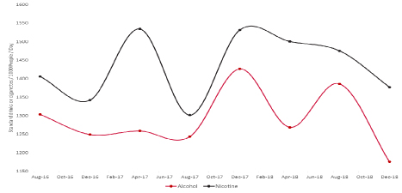

National average drug consumption of methylamphetamine, cocaine, MDMA, oxycodone, fentanyl and heroin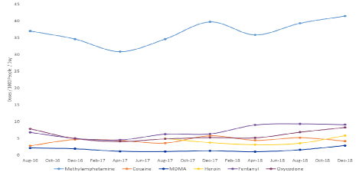

* There are a number of factors that influence drug consumption, including but not limited to different drug preferences and drug availability. This concept is illustrated in the SCORE[3] data and the notable differences in stimulant drug preferences.
* Noting that SCORE data in many cases relate to a single or small number of sites per participating country, consistent with previous SCORE findings, of the 25 countries with comparable reported data for MDMA, cocaine and methylamphetamine, Australia ranks second highest after the United States of America for total estimated stimulant consumption.
* Stimulant consumption in Australia continues to be primarily driven by methylamphetamine use. In comparing the individual stimulant drug components, of the countries with comparable consumption data Australia ranks second for methylamphetamine and MDMA and seventeenth for cocaine.
* The NWDMP has identified variation in patterns of drugs consumption, both over time and within and between states and territories. Wastewater data are also particularly useful for identifying levels of drug consumption in capital city and regional areas of Australia, as illustrated below.

Estimated average consumption of methylamphetamine by state/territory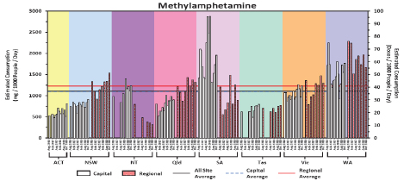

Estimated methylamphetamine consumption for December 2018 in mass consumed per day (left axis) and doses per day (right axis) per thousand people (the number of collection days varied from 5–7)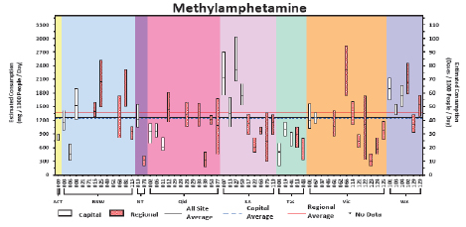

* A shared approach that targets supply, demand and harm reduction is critical to addressing drug use in Australia. Drug consumption estimates derived from wastewater data, when used in combination with other data—such as seizure, arrest, price, purity, health and self-report data—provide greater insight into the related markets and the potential impact of supply, demand and harm reduction strategies.
* Using wastewater data collected between August 2016 and August 2017 (Year 1) and August 2017 and August 2018 (Year 2) of the program, the ACIC has estimated the annual weight of methylamphetamine, MDMA, cocaine and heroin consumed in Australia.

| Drug | Estimated consumption kilograms per year (revised)  Year 1 of program | Estimated consumption kilograms  per year  Year 2 of program | % Change | Estimated street price for drugs consumed in  Year 2 $AUD* |
| --- | --- | --- | --- | --- |
| Methylamphetamine | 8,405 | 9,847 |  17.2 (increase) | 7.3 billion |
| Cocaine | 3,057 | 4,115 |  34.6 (increase) | 1.5 billion |
| MDMA | 1,251 | 1,162 |  -7.1 (decrease) | 114 million |
| Heroin | 830 | 750 |  -9.6 (decrease) | 375 million |

* The estimated weight of methylamphetamine and cocaine consumed annually has increased from Year 1 to Year 2, while the estimated weight of MDMA and heroin consumed annually has decreased.
* Consistent with estimates from the first year of the program, the total estimated combined weight of cocaine, MDMA and heroin consumed annually in the second year of the program equates to around 60 per cent of the estimated weight of methylamphetamine consumed annually.
* Using price data for the 2016–17 financial year, consumption estimates suggest for Year 2 of the program Australians spent more than $9.3 billion in methylamphetamine, cocaine, MDMA and heroin. More than 78 per cent of this was spent on methylamphetamine.

Data Source: National Wastewater Drug Monitoring Program Report

All data analysis should be undertaken from the original data source, provided in the link below, as this presentation is a snapshot from the report and does not necessarily represent the limitations involved in the collection or reporting of the data.

<https://www.acic.gov.au/publications/reports/national-wastewater-drug-monitoring-program-reports>

Indicator 11: The Illicit Drug Data Report

Lead Agency Name: ACIC

**Number of national illicit drug arrests[4], 2008–09 to 2017–18**

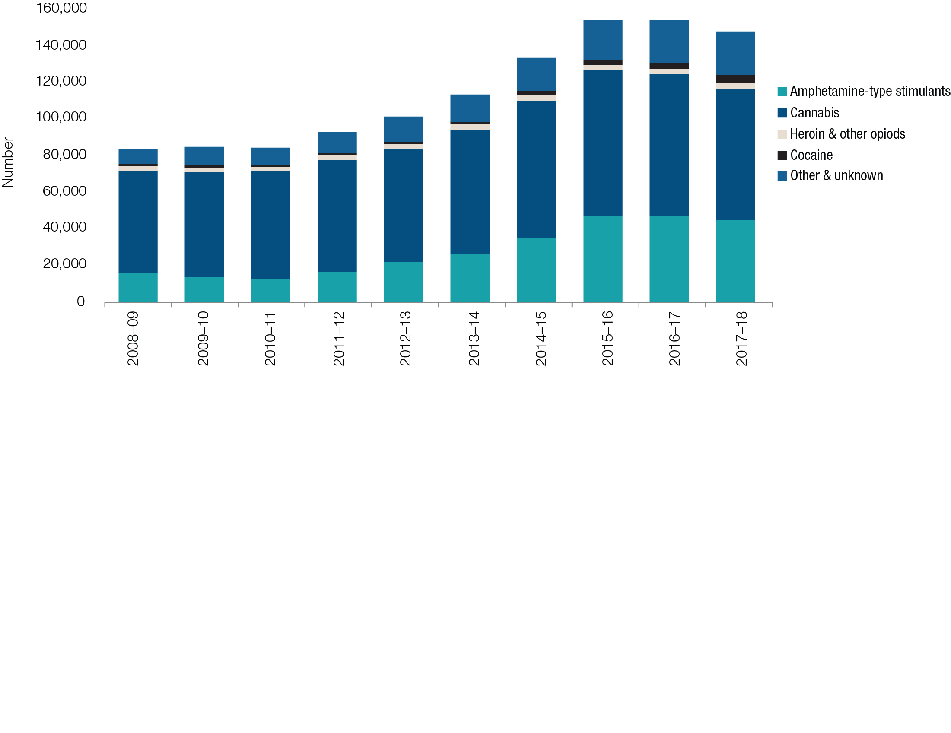

The number of national illicit drug arrests increased 76.9 per cent over the last decade, from 83,873 in 2008–09 to 148,363 in 2017–18.

The number of national illicit drug arrests decreased from a record 154,650 arrests in 2016–17, with the number of arrests reported in 2017–18 the third highest number on record.

**National illicit drug arrests—comparison between 2016–17 and 2017–18[5]**

|  |  |  |  |  |  |
| --- | --- | --- | --- | --- | --- |
| National | ATS | Cannabis | Heroin and other opioids | Cocaine | Other and unknown drugs |
| Decrease -4.1% | Decrease -5.6% | Decrease -6.7% | Increase 20% | Increase (highest on record) 28.5% | Increase (highest on record)  2.2% |
| 154,650 to 148,363t | 47,531 to 44,887 | 77,549 to 72,381 | 2,970 to 3,029 | 3,366  to 4,325 | 23,234 to 23,741 |

* In 2017–18, cannabis accounted for the greatest proportion of national illicit drug arrests (48.8 per cent), followed by ATS (30.3 per cent), other and unknown drugs (16.0 per cent), cocaine (2.9 per cent) and heroin and other opioids (2.0 per cent).
* In 2017–18, summons accounted for the greatest proportion of national drug arrests (43.8 per cent), followed by charge (31.6 per cent) and caution/diversion/infringement (24.5 per cent).
* These proportions vary between drug type, with charge accounting for the greatest proportion of national heroin and other opioid arrests (56.6 per cent), summons accounting for the greatest proportion of national steroid arrests (58.0 per cent) and caution/diversion/infringements accounting for the greatest proportion of national cannabis arrests (39.1 per cent).
* Males accounted for the majority of national arrests in 2017–18, with females accounting for less than one quarter of arrests.
* While there was some variation in the proportion of arrests involving males across drug types, males consistently accounted for the greatest proportion of arrests across all drug types this reporting period, ranging from 72.5 per cent of national other and unknown drug arrests to 86.4 per cent of national steroid arrests.
* While consumer arrests account for the greatest proportion of arrests across all drug types, the proportion attributed to them does vary, from 77.7 per cent of national cocaine arrests to 92.0 per cent of national cannabis arrests in 2017–18.

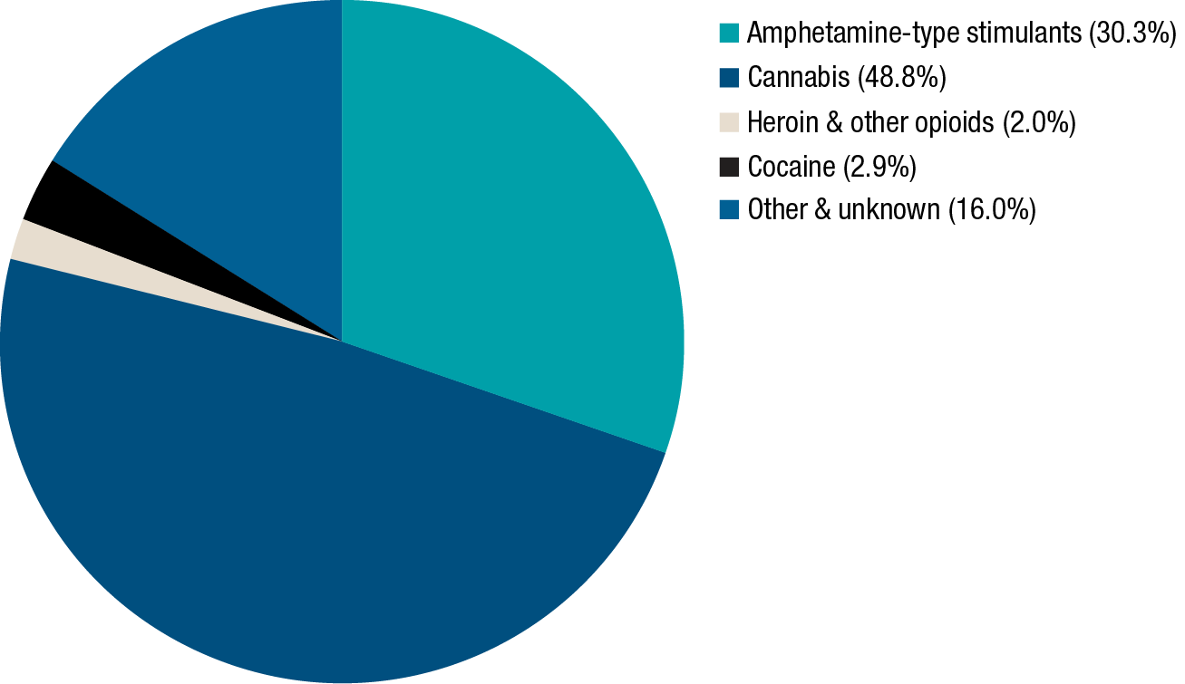

Data Source: Illicit Drug Data Report

All data analysis should be undertaken from the original data source, provided in the link below, as this presentation is a snapshot from the report and does not necessarily represent the limitations involved in the collection or reporting of the data.

<https://www.acic.gov.au/publications/reports/illicit-drug-data-report-2017-18>

Indicator 12: Alcohol and other drug attributable hospital admissions and ambulance attendances

Lead Agency Name: Commonwealth Department of Health

**Hospital admissions**

Number of drug-related separations in 2016–17:

* there were about 11.0 million separations (episodes of admitted patient care) in Australia’s public and private hospitals
* about 137,000 hospital separations with a drug-related principal diagnosis were reported in 2016–17, representing 1.2% of all hospital separations, a similar proportion to previous years
* sedatives and hypnotics continued to account for the highest proportion of hospital separations with a drug-related principal diagnosis (59% of all such separations), with alcohol making up 87% of separations for sedatives and hypnotics
* on its own, alcohol accounted for 51% of all drug-related hospital separations
* of all separations with a drug-related principal diagnosis, 13% were for analgesics, with opioids (heroin, opium, morphine and methadone) accounting for half of this group (6.3% of all drug-related separations)
* stimulants and hallucinogens, which includes cannabis, cocaine and methamphetamines, accounted for 16% of all separations where the principal diagnosis was drug-related
* overnight separations continued to be more common for drug-related treatment than same-day separations, accounting for 60% of all drug-related separations.

**Trends in drug-related hospital separations**

The total number of drug-related hospital separations has increased from 111,910 in 2012–13 to 137,203 in 2016–17, an increase of 23%. At the same time, total hospital separations have increased, with drug-related hospital separations consistently making up about 1% of all hospital separations across this 5-year period.

Alcohol was the drug-related principal diagnosis with the highest number of hospital separations across the 5-year period from 2012–13 to 2016–17, with the number of separations increasing from 62,359 to 70,011 in that time. Over the same period, there was a notable increase regarding methamphetamine drug-related principal diagnosis, rising from 1.6% of all drug-related principal diagnoses in 2012–13 to 6.3% of all drug-related principal diagnoses in 2016–17.

Hospital Separations by drug-related principal diagnosis, 2012–13 to 2016–17

| Drug of concern | 2012–13 | 2013–14 | 2014–15 | 2015–16 | 2016–17 |
| --- | --- | --- | --- | --- | --- |
| Analgesics | | | | | |
| Opioids | 7,438 | 8,153 | 8.365 | 8.904 | 8,615 |
| Non-opioid analgesics | 7,525 | 7,301 | 7,579 | 8,545 | 9,144 |
| Sedatives and hypnotics | | | | | |
| Alcohol | 62,359 | 64,248 | 65,701 | 68,239 | 70,011 |
| Other sedatives and hypnotics | 8,919 | 8,717 | 9,173 | 9,857 | 10,414 |
| Stimulants and hallucinogenics | | | | | |
| Cannabinoids | 4,314 | 4,991 | 5,550 | 6,021 | 6,302 |
| Hallucinogens | 215 | 214 | 241 | 263 | 339 |
| Cocaine | 444 | 523 | 827 | 776 | 818 |
| Tobacco and nicotine | 60 | 84 | 77 | 72 | 96 |
| Methamphetamines | 1,741 | 2,782 | 4,612 | 7,762 | 8,652 |
| Other amphetamines | 4,644 | 5,055 | 6,765 | 7,302 | 5,654 |
| Other stimulants | 400 | 434 | 377 | 413 | 391 |
| Antidepressants and antipsychotics | 7,924 | 7,827 | 8,264 | 9,104 | 9,290 |
| Volatile solvents | 805 | 884 | 901 | 818 | 875 |
| Other and unspecified drugs of concern | | | | | |
| Multiple drug use | 4,580 | 4,564 | 5,294 | 5,649 | 5,176 |
| Unspecified drug use and other drugs not elsewhere classified | 299 | 256 | 295 | 352 | 374 |
| Fetal and perinatal conditions | 27 | 27 | 26 | 5 | 12 |
| Total | 111,910 | 116,337 | 124,483 | 135,001 | 137,203 |

Data Source: Drug Related Hospitalisations, AIHW December 2018

All data analysis should be undertaken from the original data source, provided in the link below, as this presentation is a snapshot from the report and does not necessarily represent the limitations involved in the collection or reporting of the data.

<https://www.aihw.gov.au/reports/alcohol-other-drug-treatment-services/drug-related-hospitalisations/contents/content>

Ambulance data

In 2017–18 the substance most commonly associated with ambulance attendances is alcohol. Cannabis and amphetamines are the most common illicit substances, with benzodiazepines the most common prescription medication associated with ambulance attendances.

Data source: Turning Point Annual Review 2018

All data analysis should be undertaken from the original data source, provided in the link below, as this presentation is a snapshot from the report and does not necessarily represent the limitations involved in the collection or reporting of the data.

<https://www.easternhealth.org.au/about-us/publications/item/3-turning-point-annual-reports/837-turning-point-2018>

Section 3:   
NDS Sub-strategies

There are a number of sub-strategies that sit under the NDS. These sub-strategies provide a consistent and coordinated approach to addressing specific alcohol, tobacco and other drug problems.

* National Ice Action Strategy
* National Aboriginal Torres Strait Islander Peoples Drug Strategy
* National Alcohol and other Drug Workforce Development Strategy
* National Tobacco Strategy
* National Alcohol Strategy
* National Fetal Alcohol Spectrum Disorder Strategic Action Plan

National Action Strategy

The National Ice Action Strategy (NIAS) has historically been provided as its own report, from the 2018 NDS Annual report, the NIAS reporting has been incorporated and will no longer be provided as a separate report.

The quick reference guide on the NIAS progress is provided as an attachment to this document.

Priority Area 1: Empower Local Communities and Families

**The National Ice Action Strategy aims to help families and communities by providing the resources, information and support they need to respond to ice and develop solutions tailored to their local needs.**

The most significant investment in the Community and Families Priority by the Commonwealth is the establishment of Local Drug Action Teams (LDATs). The Alcohol and Drug Foundation (ADF) is being provided $19.2 million over four years from 1 July 2016 to establish up to 220 LDATs across Australia.

The LDAT program engages and supports community organisations to work together to develop and deliver local solutions to tackle drug and alcohol issues they might be facing.  This program is about investing in and building capacity to drive change at a local level.

LDATs are supported by the ADF to develop locally-focused and responsible action plans and implement evidence-based and appropriate prevention activities. This includes running programs with a focus on school education and retention, employment pathways, increased access to mental health services, support for young people and connection to community.

Application rounds for LDATs will be conducted periodically over the life of the NIAS. As of the end of 2018, three application rounds were completed, with 92 LDATs added to the program in 2018. A fourth round was conducted from 29 October 2018 to 8 December 2018, with outcomes announced in February 2019.

Other key progress made within the LDAT program in 2018 include the movement of LDATs onto a new contract and data management system and the continued development of the Community of Practice model for collaboration and learning.

LDATs have also achieved the following:

* In the ACT the University Drug and Alcohol Network was established. This education program is delivered by Alcohol, Tobacco and other Drug Association ACT in partnership with Australian National University, University of Canberra, and the Australian Catholic University.

Other work undertaken in this priority improves people’s access to evidence-base prevention resources and school based education programs, as well as support services:

* Parents, teachers, students and frontline service providers continue to use the ‘Positive Choices’ portal that has had more than 260,000 in 2018. NIAS funding has allowed culturally appropriate resources tailored for Indigenous people to be developed as well as the development of an integrated online program for students and their parents to prevent alcohol and cannabis use.
* On 12 October 2018, an Expert Advisory Group meeting for Positive Choices for Aboriginal and Torres Strait Islander young people, Strong and Deadly Futures was held in Sydney. This is the first computerized school-based alcohol and drug prevention program in Australia that is culturally inclusive for Aboriginal and Torres Strait Islander secondary students.

Activities from State and Territory Governments also contribute to this priority area, these activities include, but are not limited to:

* New South Wales Health continues to have information available to educate the community on the dangers of crystal methamphetamine use, including by providing information and materials on the harm and impact of methamphetamine use, and where to seek help. Information is available from the Your Room website [www.yourroom.health.nsw.gov.au](http://www.yourroom.health.nsw.gov.au) and the NSW Health website [www.health.nsw.gov.au/methamphetamine/Pages/treatment.aspx](http://www.health.nsw.gov.au/methamphetamine/Pages/treatment.aspx%20yourroom.health.nsw.gov.au)
* Establishment of the Alcohol and Other Drugs Youth Grants Program in the Northern Territory, providing 17 grants for community projects or initiatives aimed at preventing substance misuse by youths.
* The Queensland Government launched its Breakthrough for Families program, contributed funding for the Lives Lived Well Logan Family Recovery Units and collaborated with the Queensland Aboriginal and Islander Health Council, to support Indigenous communities to address ice. The Queensland Government, through its Police Services engages with communities to encourage reporting of criminal activity, which includes the Report a Drug Dealer portal.
* The South Australian Government is providing additional support for family support groups through its Ice Action Plan, with additional work underway to build peer education capacity. South Australia Health has expanded capacity of face to face support groups, training and phone support services for families experiencing alcohol and other drug problems. Additional funding enabled family support groups to be established in three new locations, doubling our investment in this area.
* The Tasmanian Government offered Cognitive Behaviour Therapy Masterclass to 40 staff from across the government and non-government AOD sector in Tasmania.
* In 2018–19, the Victorian Government awarded 14 grants to Community Ice Action Groups across Melbourne and regional Victoria to deliver targeted local action to help tackle the devastating effects of ice use and addiction. This bring the total number of Community Ice Action Grants to 52.
* The Western Australia Government is developing a whole of state government response to the Methamphetamine Action Plan Taskforce Report, which includes addressing the 57 recommendations in its response. Ongoing work continues with the Parent and Family Drug Support program.

Priority Area 2: Prevention and Education

The National Ice Action Strategy aims to ensure prevention messages are targeted at high-risk populations and accurate information about drugs and alcohol is more accessible.

Prevention is a broad strategy focused on reducing the demand for crystal methamphetamine through a suite of projects and programs that empower communities, families and individuals to become better informed on the harms associated with ice, and reduce the number of individuals engaging in illicit substance use.

The Commonwealth and jurisdictional actions in the Targeted Prevention Priority are broad and use a number of delivery mechanisms. These varied approaches reflect the diverse challenges faced in developing prevention initiatives that often require generational timeframes for population based behavioral impacts to be seen.

Some key achievements under the prevention priority:

* Additional evidence-based information regarding crystal methamphetamine can be found in the ‘Cracks in the Ice’ online resource that was launched in April 2017. Expansion of this work is already underway, with the development of a culturally appropriate online toolkit for Indigenous people, and development of an online intervention and support package for families and friends of people who use crystal methamphetamine. The Cracks in the Ice portal website had over 140,000 site views in 2018.
* The Good Sports Tackling Illegal Drugs program has increased efforts to reach more specific groups. $4.6 million is being provided to the Alcohol and Drug Foundation for this program that was launched in March 2017. Forums and workshops that seek cultural change in behaviour and attitudes to drug and alcohol use in sport have commenced. By its completion, the program will engage 1,200 sporting clubs across Australia, including remote Indigenous communities. In 2018, there were 42 Forums and workshops held, with over 340 clubs participating.

State and Territory prevention activity also aims to support specific high risk groups. Some examples include:

* The ACT Government has undertaken a range of activities for the prevention and education of ice, such as a pill testing trial, Impact Alcohol activities, Pregnant Pause campaign—swap the pub for your bub, Reduce Risky Drinking program, and a campaign to address the booming booze culture among ACT women.
* The NSW Government provides a range of drug and alcohol information resources to the community. These include the Family Drug Support Line, the Alcohol and Drug Information Service, Drug Information at Your Library, and ‘Breaking the Ice’ (Ice specific information on the Yourroom website ([yourroom.health.nsw.gov.au](https://yourroom.health.nsw.gov.au/Pages/home.aspx))).
* The Queensland Government launched the Ice Help campaign which featured personal stories of recovery (<https://campaigns.premiers.qld.gov.au/icehelp/>) and progressed several public education and awareness community based activities such as the District Crime Prevention Officers, and the School Based Police Officers program.
* The South Australian Government progressed activities under its South Australian Ice Action Plan. This includes supporting grassroots sporting associations by building capacity to respond appropriately to substance abuse issues. South Australia Health has undertaken targeted approaches to workplaces employing these groups of people, and increase the capacity of specific South Australian workplaces to provided evidence-based and best practice responses to identify and respond to methamphetamine or other substance use amongst their workforce.
* The Tasmanian Government launched its Drug Education Network website (<http://www.den.org.au/>) which provides best practice information, resources and training for the Tasmanian community.
* The Western Australia Minister for Mental Health released the Mental Health Promotion, Mental Illness, Alcohol and Other Drug Prevention Plan 20182025 (<https://www.mhc.wa.gov.au/about-us/strategic-direction/the-western-australian-mental-health-promotion-mental-illness-alcohol-and-other-drug-prevention-plan-2018-2025/> ). The Western Australia Government continued to deliver its Methamphetamine Prevention Education Program through its Drug Aware website (<https://drugaware.com.au/> ), which included the “Call the Meth Hotline”. Additional funding was provided to the Western Australia School Drug Education and Road Aware program to include a focus on methamphetamine initiatives for at-risk students.

Action Area 3: Treatment and Workforce

**The National Ice Action Strategy aims to improve access to treatment and ensure the workforce is supported to deliver effective and flexible treatment.**

Acknowledging the importance of providing adequate treatment support and building the workforce of the future, the Australian Government invested $241.5 million of the $298.2 million NIAS funding in the Treatment and Workforce Priority. This funding is being distributed through the 31 PHNs across Australia, to deliver additional alcohol and other drug treatment services based on local need. This includes $78.6 million which has been allocated for Indigenous specific services spanning three of the NIAS actions in this priority.

PHNs have made significant progress to achieve an effective balance between the requirements of the NIAS and meeting the needs of the local communities. They have worked closely with the drug and alcohol peak bodies and the community to overcome commissioning and service delivery delays experienced through recruitment issues, gaps within the workforce and organisational capacity difficulties to meet these needs.

Other NIAS actions within the Treatment and Workforce priority include a number of important pieces of work that will guide future strategic decisions, such as the National Treatment Framework and the National Quality Framework for Drug and Alcohol Treatment Services.

Specific services or treatments include:

* The Alcohol, Smoking and Substance Involvement Screening Test (ASSIST) Lite in the Emergency Department training resource was developed. Via three case studies, the 20-minute instructional video highlights how the ASSIST-Lite can be administered effectively in time critical areas. The launch and roll-out is on track for February 2019.

States and Territories continue to contribute to, and add to treatment options and workforce improvements. The following examples do not reflect the totality of jurisdictional efforts but do show the diversity of work being undertaken:

* In addition to the ongoing funding provided by the ACT Government for specialist alcohol, tobacco and other drug treatment and support which provides services such as the ACT Sobering Up Shelter, the ACT Government also provides funding to the Alcohol, Tobacco and Other Drug Association ACT to support the AOD sector. In 2018, the Canberra Alliance for Harm Minimisation and Advocacy Peer Treatment Support Framework was developed to provide treatment staff a specialist peer-based support and supported referrals for people who use drugs.
* The NSW Government extended services in Goulburn, Dubbo, Wellington, Wagga Wagga and Griffith under its program to Enhance the Role of Non-Government Organisation Sector to Address the Needs of Methamphetamine Users. In addition an Alcohol and Other Drugs Consumer Reference Committee has been established to support and facilitate meaningful engagement with consumers with a lived experience of alcohol and/or drug use and to enhance policy and service development activity.
* NSW Government continues to provide services under its NSW Drug Package initiative to improve the capacity of the NSW health system to respond to methamphetamine by providing services delivered by government and non-government organisations including: substance use in pregnancy and parenting services; rehabilitation programs for women/parents with children; youth treatment services; community based care for people with complex needs. The funding also supported early intervention and workforce development activities targeting young people at risk and families.
* The Northern Territory Government continues to work with service providers to increase the range of services and enhance access to support interventions for clients seeking support for their drug use.
* Queensland Police are also conducting workforce training to develop police skills in targeting methamphetamine. This includes the development of internal on-line resources and the provision of clandestine drug laboratory awareness training.
* Queensland Health has funded the establishment of a new residential rehabilitation and treatment services in Rockhampton and further treatment services provided by non-government organisations across 26 locations in Queensland. Training and education events were provided to AOD frontline health and related workforce participants and on-line methamphetamine training resources and a brief intervention toolkit developed ([www.insight.qld.edu.au](http://www.insight.qld.edu.au)).
* South Australia Health has increased access to treatment across South Australia through the provision of additional outpatient counselling appointments and 18 new residential rehabilitation beds in three regional locations—in Mount Gambier, Whyalla and the Riverland. South Australia Health launched its “Know your options” website ([www.knowyouroptions.sa.gov.au](http://www.knowyouroptions.sa.gov.au)) designed to provide individuals, family members, clinicians, community workers and the general community information on drugs and alcohol and treatment options and services.
* The Tasmanian Government has invested in an additional 30 residential rehabilitation beds, and is progressing its Reform Agenda for the Alcohol and Other Drugs Sector, with the release of its consultation draft in September 2018. Three additional Consultation Liaisons are providing specialist alcohol, tobacco and other drugs consultation and liaison services to the Tasmanian community. The Tasmanian Government are working towards an expansion of the Court Mandated Diversion Program, starting with legislative amendments.
* The Victorian Government commissioned an additional 100 residential rehabilitation beds across the Melbourne region and are providing funding to support the construction of residential rehabilitation centres in the Grampians, Gippsland, Hume and Barwon regions. The Victorian Government released its Alcohol and other Drugs Workforce Strategy 2018–2022 designed to sets the direction for workforce development and planning for Victoria’s alcohol and other drug treatment sector to 2022 (<https://www2.health.vic.gov.au/about/publications/researchandreports/victoria-alcohol-other-drugs-workforce-strategy-2018-2022>).
* Western Australia released its Working Together: Mental Health and Alcohol and Other Drug Engagement Framework and Toolkit 2018–2025 (<https://www.mhc.wa.gov.au/about-us/consumer-family-and-carer-participation/statewide-engagement-framework-and-toolkit> ) and continues to strengthen its workforce through frontline training, under the Western Australia Alcohol and Drug Interagency Strategy 2018–2022 (<https://www.mhc.wa.gov.au/about-us/news-and-media/news-and-updates/the-western-australian-alcohol-and-drug-interagency-strategy-2018-2022-release/>). The Western Australian Government continued its Clinical Liaison model in Joondalup and commenced its consultation to expand AOD services in the Kimberley region.

Action Area 4: Strengthening Law Enforcement

**The National Ice Action Strategy aims to enhance existing efforts to disrupt the supply of ice through better use of intelligence and international engagement, and through targeting organised crime groups involved in the ice trade.**

On 1 May 2018, the Minister for Home Affairs announced the establishment of the Commonwealth Transnational, Serious and Organised Crime Coordinator and the appointment of Australian Federal Police Deputy Commissioner Karl Kent OAM to this role.

* The Coordinator has strengthened the national effort to combat transnational, serious and organised crime affecting Australia, including illicit drugs, taking a full spectrum approach addressing supply, demand and harm reduction.

In December 2018, the Council of Australian Governments agreed to the National Strategy to Fight Transnational, Serious and Organised Crime that provides a national framework to maximise opportunities for government agencies, international partners, industry and the broader community to work together on this issue.

* The framework ensures coordinated and agile response that match the complexity and sophistication of transnational, serious and organised crime threats, including illicit drugs.

In December 2018, the Australian Government agreed to a package of measures to combat supply, demand and harm of illicit drugs in Australia, consistent with the National Drug Strategy and the National Strategy to Fight TSOC. This included the establishment of the Commonwealth Illicit Drug Joint Agency Taskforce.

* The Taskforce brings together the Home Affairs, Health, Social Services, Education and Foreign Affairs Portfolios and will ensure the Commonwealth is working collectively to target its illicit drug supply and demand reduction efforts where they are needed most, and achieve the best outcomes for Australian communities.

Many jurisdictions are participating in a number of the NIAS actions to enhance existing efforts to disrupt the supply of ice, a highlight of these activities include:

* The ACT Government undertook significant policy and planning work in 2018 to lay the foundations for the establishment of the ACT’s Drug and Alcohol Court (ACT DAC) including holding stakeholder workshops, liaising with drug courts in other jurisdictions and preparing legislation.
* The NSW Government, through the Police inter-jurisdictional working group are leading the business case for an End User Declaration Online (EUDO) system. EUDO will be a web-based system for the management of national End User Declarations. Additionally, the NSW Police Force has announced a trial of drug Criminal Infringement Notices (CINs) for minor possession offences at music festivals as part of a harm reduction approach and continued to increase the Mobile Drug Testing (MDT) capability of NSW Police to reduce road deaths and trauma.
* The Northern Territory Police continue to focus on disrupting organized crime locally as well as in the national and state border context. Methylamphetamine production and supply is a priority focus with all options, including reviewing legislative frameworks and working towards national systems to prevent methylamphetamine production.
* The Queensland Government through the Queensland Police Service continues to tackle alcohol-fuelled violence, organised crime and the drug ice across Queensland which has led to the seizure of illicit drugs and the restraining of assets through the proceeds of crime. Additional resources have been provided to expand the Roadside Drug Testing as part of the Queensland Action on Ice Package.
* The South Australian Government has undertaken five targeted campaigns, focusing on regional areas under the “Dob in a Dealer” campaign and continues to be actively involved in national and local initiatives aimed at addressing the issue of ice in the community.
* The Tasmanian Government through Tasmania Police introduced a suite of Tasmanian law enforcement legislative changes aimed at combatting organised crime through increased control over the presence and identification of organised criminal groups. An internal review of the Tasmanian Illicit Drug Diversion initiative was undertaken in 2018–19 and Tasmania Police continued to work with the Office of the Director of Public Prosecutions on matters of unexplained wealth, as part of efforts to disrupt organised criminal activity.
* The Western Australia Government is engaged in policy development to increase utilisation of its drug diversion program and is engaged in the EUDO development at a national level.

Action Area 5: Better Research and Data

**The National Ice Action Strategy aims to enhance our evidence base, deliver new guidelines and improve the quality of data and research on ice and other illicit drugs.**

The Commonwealth funded National Clinical Centre for Research of Emerging Drugs (NCCRED) which was established in April 2017 is a national entity to support clinical treatment and build clinical research capacity within the Australian alcohol and other drugs services sector with an emphasis on responses to users of methamphetamine and emerging drugs of concern. NCCRED supports clinical research into new treatment options for people with substance dependences and assist with training of health professionals and the evaluation of treatment effectiveness. NCCRED has undertaken its first round of Capacity Building and Seed Funding Grants to contribute to the implementation of new and innovative treatment interventions, as well as value-add to currently established clinical trials.

Work is ongoing to increase the quality and quantity of drug use data in Australia. The Commonwealth Department of Health has provided funding to the Australian Institute of Health and Welfare for the development of new Alcohol and Other Drug treatment data items, including treatment outcomes, and an annual compendium of published national Alcohol and Other Drug data. The Commonwealth Department of Health has also funded the expansion of the Victorian Ambulance Project. The National Surveillance System for Alcohol and Other Drug Misuse and Overdose is an acute monitoring system that records ambulance presentations for alcohol and other drug use and overdose, managed by the Turning Point Alcohol and Drug Centre at Monash University.

The Australian Criminal Intelligence Commission (ACIC) National Wastewater Drug Monitoring Program (NWDMP) provides a consistent, timely and sound measure of drug consumption and provides unique insights into drug consumption in regional areas of Australia. This provides the Australian Government the opportunity to use the data for operational and policy decision making, monitoring of the effectiveness of existing responses and for resource prioritisation.

Evidence base and data collection play an important role in state and territory policy development, for example:

* The ACT Government have implemented additional alcohol use questions in the ACT Midwives Data Collection Form and improved data gathering on alcohol and illicit drug use’s impact on ACT Hospitals’ emergency departments.
* The NSW Government, through its Methamphetamine Use and Related Harms in NSW Surveillance report to December 2018 identified overall methamphetamine use has decreased in NSW, however, an increasing proportion of use is high risk. (<https://www.health.nsw.gov.au/methamphetamine/Pages/nsw-data.aspx>).
* The South Australian Government continue to conduct its own metropolitan wastewater analysis every two months which contributes to its understanding of patterns of drug consumption over time. The purpose of this project is to determine population consumption levels of drugs in Adelaide, which informs policy development, service delivery, and monitoring of the impact of police operations.
* The Victorian Government provided its health workers with the evidence-based Practice Guidelines for the Treatment of Methamphetamine Use Disorder (<https://www2.health.vic.gov.au/about/publications/researchandreports/clinical-treatment-guidelines-for-methamphetamine-dependence-and-treatment-2007> ).

National Aboriginal and Torres Strait Islander Peoples Drug Strategy

Total investment under the Indigenous Advancement Strategy (IAS) for Indigenous alcohol and other drug (AOD) treatment services is around $70 million per year.

In 2018–19 this supported about 80 AOD treatment services across Australia.

In addition to funding for treatment services, in 2018–19 the Commonwealth invested over $13 million to reduce alcohol related harm in the Northern Territory (NT) through the National Partnership on Northern Territory Remote Aboriginal Investment (NP NTRAI).

In 2018–19 $10.3 million was provided to support the rollout of low aromatic fuel and a further $3 million to support other harm reduction measures.

In 2018–19 the Commonwealth funded researchers from the University of New South Wales, to work with the local network of six IAS-funded residential rehab facilities in NSW to develop practical ways to embed evidence-based practice in service delivery, through standardised data collection processes and continuous quality improvement. The project addresses an identified need for stronger evidence around the effectiveness of Indigenous AOD treatment and will help inform future policy and program development. Phase two is underway, which is an evaluation project that builds on the previous work with UNSW and the six services, to help embed evaluation capacity in the services, and then quantify the impact of follow-up care on the health impacts of clients.

Aboriginal and Torres Strait Islander Peoples Alcohol and Other Drug Knowledge Centre

The Australian Government provides funding to Edith Cowan University to establish, develop and maintain the Aboriginal and Torres Strait Islander Peoples Alcohol and Other Drug Knowledge Centre. The Knowledge Centre operates as a centralised hub that provides free online access to culturally appropriate alcohol and other drug materials for practitioners, community members, policy makers and other involved in reducing Indigenous substance use. The Knowledge Centre is recognised as a critical tool for providing evidence based approaches to tackling drug and alcohol issues for communities and frontline health and community workers.

Local Drug Action Teams

The Australian Government provides funding through the Alcohol and Drug Foundation for Local Drug Action Teams (LDAT’s), this program supports communities to work together to prevent and minimise harm caused by alcohol and other drugs, this includes 20 indigenous specific LDAT’s across Australia.

**Western Australia**

The Western Australian Government delivers the Strong Spirit Strong Mind (SSSM) Metro Project which provides culturally secure prevention, early intervention and community action initiatives to prevent AOD use and related problems, with a specific focus on Aboriginal young people (12 to 25 years) and their families. Activity includes delivery of AOD public education, art activation events, youth networks and capacity building for services and community members supporting young people.

In 2018, the WA Police Force Commissioner issued a formal apology to Aboriginal and Torres Strait Islander peoples for previous laws, practices and policies that deeply affected the lives of Aboriginal people and led to mistrust in law enforcement. The WA Police Force committed to working with Aboriginal people to improve relationships and foster meaningful change for future generations.

They announced the establishment of an Aboriginal Affairs Division, led by Indigenous officers, and the Aboriginal Cadet Program to assist the transition to becoming a sworn police officer.

National Alcohol and Other Drug Workforce Development Strategy

The Australian Government announced the Drug and Alcohol Addiction Training Program in the 2018–19 Budget as part of the Support for Drug and Alcohol Abuse Treatment measure. Funding of $20 million (over three years, from 2018–19 to 2020–21) has been allocated to the program to support professional development in primary care for the treatment and support for alcohol and drug addiction.

The program is being delivered by the two GP colleges with assistance from PHNs to promote training to GPs. Funding under this grant aims to improve support and increase resources available to GPs to treat drug and alcohol addiction.

Acknowledging the importance of providing adequate treatment support and building the workforce of the future, the Australian Government has provided funding in the Treatment and Workforce Priority. This funding is being distributed through the 31 PHNs across Australia, PHNs have made significant progress to achieve effective outcomes based on the community needs. They have worked closely with the drug and alcohol peak bodies and the community to overcome commissioning and service delivery delays experienced through recruitment issues, gaps within the workforce and organisational capacity difficulties to meet these needs.

Additional work has progressed that will guide future strategic decisions, such as the National Treatment Framework and the National Quality Framework for Drug and Alcohol Treatment Services.

**Western Australia**

The Western Australian Government reviewed its National Alcohol and Other Drug Workforce Development Strategy 2015–2018, this review has influenced the development of the draft Western Australian Mental Health, Alcohol and Other Drug Workforce Strategic Framework 2019–2025 (Workforce Strategic Framework).

The draft Workforce Strategic Framework aims to guide the growth and development of an appropriately qualified and skilled workforce that will provide individualised, high quality mental health and AOD services and programs for the Western Australian community. The draft Workforce Strategic Framework identifies five key priority areas and includes strategies and suggested actions, and is anticipated to be released by the end of 2019.

Existing AOD workforce training has shown that:

* 89% of participants reported that the training was useful in relation to their work ‘a lot’ to ‘extremely’
* 83% of participants reported that the training increased their knowledge ‘a lot’ to ‘extremely’
* 78% of participants reported that the training increased their competence ‘a lot’ to ‘extremely’
* 76% of participants reported that the training increased their competence ‘a lot’ to ‘extremely’

National Tobacco Strategy

The National Tobacco Strategy (NTS) 2012–2018 aims to improve the health of all Australians by reducing the prevalence of smoking and its associated health, social and economic costs, and the inequalities it causes.

Results from the Australian Bureau of Statistics (ABS) 2017–18 National Health Survey (NHS) were published in December 2018 and provide key insights regarding recent progress made under the NTS 2012–2018.[6] Encouragingly, results from the 2017–18 NHS showed that between 2014–15 and 2017–18, fewer young Australians took up smoking: in 2017–18, 75.3% of young adults aged 18–24 were reported to have never smoked, an increase from 69.5% in 2014–15. However, these survey results also showed that the overall daily smoking rate has remained relatively similar over this period: 14.5% (14.7% aged-standardised) of adults aged 18 years were daily smokers in 2014–15 compared to 13.8% (14% age-standardised) in 2017–18.[7],[8]

In 2018, the Commonwealth Department of Health commenced work in consultation with other jurisdictions to develop the next iteration of the NTS. To date, a range of evaluation activities have been undertaken to inform the development of the next NTS, including a public consultation process conducted in the second half of 2018.

Emerging priorities and issues of concern

In 2017–18, the MDAF noted a range of concerns regarding the marketing and use of e-cigarettes following statements and advice issued by a range of health authorities in Australia and overseas. In light of these concerns, the MDAF agreed to a set of national guiding principles for e-cigarettes. The guiding principles reflect Australia’s precautionary approach to e-cigarettes and affirm that the current national regulatory framework for these products remains appropriate.[9]

**New South Wales**

NSW Health has released a tobacco workplan 2019–2021 to support implementation of the NSW Tobacco Strategy 2012–2021. This includes: quit smoking support; compliance and enforcement of smoke-free and retailing laws; targeted programs for vulnerable groups; and education campaigns. Reducing smoking in pregnancy is a priority. NSW Health has been focussing on improving how smoking cessation is delivered as a part of routine clinical care. <https://www1.health.nsw.gov.au/pds/Pages/doc.aspx?dn=IB2019_018>

**Tasmania**

* The key achievements of the Tasmanian Tobacco Control Plan 2017–2021 the Tasmanian Government has regulated the sale, use and display of electronic cigarettes; increased penalties for tobacco supply to children; and introduced ‘fit and proper’ checks for tobacco seller licence holders. On 1 July 2018, an Antenatal Carbon Monoxide Monitoring Opt-out Referral pilot commenced which aims to increase cessation of smoking by pregnant women through improved screening, referral and counselling. To increase coverage of anti-tobacco campaigns the Tasmanian Government has partnered with the Cancer Council to achieve optimal exposure of television advertising of 700 Targeted Audience Rating Points per month

**South Australia**

* Under the South Australian Tobacco Control Strategy 2017–2020 South Australia achieved the lowest ever recorded daily smoking rate (8.6%) in 2018, as measured through the annual South Australian Population Health Survey. It is likely that a key contributor to this trend has been the strong investment in tobacco cessation mass media campaigns in South Australia over many years. In 2018, the campaign was refreshed with the development of the Be Smoke Free tagline, encouraging smokers to quit their ‘own way’. Additionally, a new SA Health smoking cessation website went live, serving as a portal for smokers to access a range of tools and services for quitting, such as the My QuitBuddy app and the Quitline. Development also commenced on locally made campaign advertisements which were filmed and produced locally. New e-cigarettes legislation was enacted in 2018, including a ban on the sale of e-cigarettes to children and e-cigarette advertising, as well as a ban on online sales. The legislative amendments also included the introduction of a range of administrative enhancements to the legislation, including increased penalty levels for offences. Additionally, the Bowden Town Square was declared a smoke-free area under the tobacco control legislation in early 2018.

National Alcohol Strategy

The Australian Government is currently developing the next iteration of the National Alcohol Strategy (2019–2026). Following the National Alcohol Strategy (NAS) Stakeholder Roundtable in July 2018, all jurisdictions of the Ministerial Drug and Alcohol Forum have undertaken cross-portfolio consultations. The NAS has been circulated for out-of-session endorsement by the Ministerial Drug and Alcohol Forum, and the finalisation of the NAS is currently a priority item for all Ministers.

The previous National Alcohol Strategy (2006–2009) and the consultation draft of the National Alcohol Strategy (2019–2026) both identify the provision of effective treatment options as a priority. The Guidelines for the Treatment of Alcohol Problems were published in June 2009, and are the current recommendations that provide guidance to health professionals on available treatments for people with alcohol problems. On 19 June 2018, the University of Sydney was awarded a grant by the Commonwealth Department of Health to review and revise the guidelines. The revised guidelines will be published by January 2020.

The National Health and Medical Research Council’s 2009 Australian guidelines to reduce the health risks from drinking alcohol (the alcohol guidelines) are currently under review. This is being informed by a comprehensive evaluation of current published scientific evidence, as well as technical modelling of the health risks associated with alcohol consumption. The alcohol guidelines are expected to be publicly released in 2020.

National Fetal Alcohol Spectrum Disorder Strategic Action Plan

The Australian Government launched the National Fetal Alcohol Spectrum Disorder (FASD) Strategic Action Plan 2018–2028 (Strategic Action Plan) on 21 November 2018. The Strategic Action Plan provides a clear pathway of priorities and opportunities to improve the prevention, diagnosis, support and management of FASD in Australia. The key aims of the Strategic Action Plan are to (1) reduce the prevalence of FASD, (2) reduce the associated impact of FASD, and (3) improve the quality of life for people living with FASD. Identified priorities and opportunities in the Strategic Action Plan will inform future approaches by governments, service providers, and communities over the next decade.

**Western Australia**

WA Police Force compiled a guide to assist officers with interviewing witnesses and suspects, especially those with vulnerabilities such as FASD. The guide is designed to ensure fairness and voluntariness when police are interviewing vulnerable people.

A FASD seminar was held for police officers where visiting experts from Alaska presented on the criminal law challenges being experienced in the US. Speakers included a superior court judge, doctor, midwife, psychologist from Alaska as well as the PATCHES Paediatrics team from Western Australia. The seminar remains available as a resource to police officers across WA on the WA Police Force training website.

Further training is provided in other government agencies addressing support and management of people with a FASD and other neurodevelopmental problems.

Annexure

Indicator 1: Increasing the average age of uptake of drugs, by drug type

There are no new data available to report against this indicator since the release of the strategy. The next data from the 2019 National Drug Strategy Household Survey are due to be released mid-2020.

Indicator 2: Reduction of the recent use of any drug, people living in households

There are no new data available to report against this indicator since the release of the strategy. The next data from the 2019 National Drug Strategy Household Survey are due to be released mid-2020.

Indicator 3: Reduction in arrestees’ illicit drug use in the month before committing an offence for which charged

The data item identified in the National Drug Strategy 2017–2026 for reporting against this indicator is the percentage of detainees who tested positive for any drug use, based on urinary analysis taken within 48 hours of being taken into police custody, from the Drug Use Monitoring in Australia project. The project collects data at four sites across Australia (Adelaide, Brisbane, Perth and Sydney) from police detainees who were recently arrested (typically for violent, property or breach-related offences). Most detainees are males, aged in their 30s, and have a prior criminal history. Detainees are more likely than the general community to have had recent contact with the illicit drug market.

The most recent statistic is from the report: Drug Use Monitoring in Australia: Drug Use Among Police Detainees 2017.

In 2017, a sample of 832 detainees consented to urinary analysis and 75% tested positive for any drug use.  At baseline (2013–14), a sample of 1551 detainees consented to urinary analysis and 73% tested positive for any drug use.

Caution is needed when interpreting this data item as it is merely a measure of recent drug use (and includes some medically prescribed pharmaceutical drugs). It may not reflect drug use in the month before committing a crime, and does not establish a causal link between drug use and offending.  Additionally, multiple factors can contribute to changes in the measure between reporting periods, such as changes in the prevalence of specific drugs and the profile of arrestees in detention.

Indicator 4: Reduction in the number of victims of drug-related incidents

There are no new data available to report against this indicator since the release of the strategy. The next data from the 2019 National Drug Strategy Household Survey are due to be released mid-2020.

Indicator 5: Reduction in the drug-related burden of disease, including mortality

The most recent data available are from the Australian Burden of Disease Study 2015.

These amounts reflect the amount of disease burden that could have been avoided if all people in Australia had not used the specified drug.

Illicit Drugs—2.7% of total disease burden (up from 2.5% at baseline 2011)

Alcohol—4.5% of total disease burden (down from 4.7% at baseline 2011)

Tobacco—9.3% of total disease burden (down from 9.8% at baseline 2011)

Changes in attributable burden over time may be influenced by multiple factors including changes in: exposure to the risk factor (estimated from the National Drug Strategy Household Survey and other data sources); and each of the fatal and non-fatal burden of the diseases or injuries that are linked to the risk factors (where such change may come from variation in exposure to other risk factors, treatment or health intervention).

Attachment

Attachment A  
2018 National Ice Action Strategy Quick Reference Progress Table

| **Action** | **NIAS Funding  2016–17 to 20–21** | **NIAS Status and Activity 2018** |  |  |
| --- | --- | --- | --- | --- |
| Community and Families | Establish up to 220 new Local Drug Action Teams across Australia. The teams will bring together community groups to reduce drug related harms at a local level. | $19.2m | • | There have been three Grant Rounds with 172 LDATs announced. The fourth Grant Round opened on 29 October and closed on 7 December and expected to be announced in early 2019. |
| Launch the ‘Positive Choices’ web portal to deliver up-to-date, accessible, and relevant information on ice to community organisations, parents, teachers and students. | $1.1m | •  • | The Positive Choices website went live in December 2015. NIAS funded expansion activities are in progress and include development of an integrated online program for children and parents and the development of culturally appropriate Indigenous resources. Positive choices is the first computerised school-based alcohol and drug prevention program in Australia that is culturally inclusive for Aboriginal and Torres Strait Islander secondary students. |
| Establish a national phone line that will serve as a single point of contact for individuals and families seeking to receive information, counselling and other support services for dealing with ice use and other drugs. |  | • | The National AOD Hotline became operational in July 2017 and links to existing landline numbers in each state and territory. The Commonwealth will provide quarterly reporting to jurisdictions. |
| Targeted Prevention | Deliver evidence-based targeted communication activities, including through social media and other innovative media. |  | • | The National Drug Research Institute is continuing to develop targeted intervention methods, and is presently developing an evidence base to inform future targeted campaigns and communication efforts. |
| Support more than 1,200 community sporting clubs to deliver prevention messages about ice, including sporting clubs in remote Indigenous communities. | $4.6m | •  • | The Good Sports Program includes a module “Tackling Illegal Drugs”, which was launched in March 2017. In 2018 42 Forums and workshops were held, with over 340 clubs participating. |
| Develop strategies to increase prevention and education about ice in high-risk industries such as mining, construction and transport. |  | • | The National Centre for Clinical Research on Emerging Drugs (NCCRED) is undertaking its third round of capacity building and seed funding grants. The outcomes of some of those research projects are expected to contribute to this action item. |
| Treatment and Workforce | Increase investment in the alcohol and other drug sector, including for Indigenous-specific drug and alcohol services. | $241.5m | •  • | Since 2016, PHNS have delivered an additional 470 drug and alcohol treatment projects based on the needs of their local communities under the NIAS. |
| Expand the Counselling Online program to provide a national online counselling service for people affected by substance misuse. |  | • | The expanded Counselling Online program was launched 28 October 2016. |
| Establish a new National Treatment Framework that clarifies government roles and improves planning across the sector, so that communities have the types of services they need. |  | • | The National Treatment Framework for the drug and alcohol treatment system will aim to improve planning and commissioning across the sector. It is expected that the National Treatment Framework will be endorsed by the National Drug Strategy Committee and the Ministerial Drug and Alcohol Forum in late 2019. |
| Increase the links that exist between Primary Health Networks (PHNs) and health care providers and community services to improve continuity of care. |  | •  • | This action is linked to the $254.7 over four years from 1 July 2019. PHNs continue to undertake Needs Assessments to ensure the services they commission are based on local needs of the community. |
| Support expanded training to promote the use of the Alcohol, Smoking and Substance Involvement Screening Test and Brief Intervention tool nationally to provide screening and brief interventions for ice and other drug problems. | $1.7m | • | ASSIST-Lite in the Emergency Department training resource was developed with the launch and roll-out is on track for February 2019. |
| Treatment and Workforce | Enhance the delivery of early intervention and post-treatment care through Health Networks. |  | •  • | This action is linked to the $254.7 PHN investment. PHNs are commissioning evidence based treatment based on local needs, which ranges from early intervention to post treatment support. |
| Implement a pilot quality framework to provide consistent and appropriate treatment in accordance with best practice. |  | • | It is expected that the National Treatment Framework will be endorsed by the National Drug Strategy Committee and the Ministerial Drug and Alcohol Forum in late 2019. |
| Add new items to the Medicare Benefits Schedule to increase the availability of care through Addiction Medicine Specialists. | $13m | • | Items were available from  1 November 2016. |
| Renew and disseminate a national suite of evidence-based guidelines to assist frontline workers to respond to ice in their workplace. |  | • |  |
| Renew and disseminate National Comorbidity Guidelines for alcohol and drug treatment services to assist with managing co-occurring alcohol, drug and mental health conditions. |  | • | Updated guidelines officially launched in September 2016. An online training program was released in August 2017. |
| Strengthened Law Enforcement | Strengthen international cooperation through developing a new international supply disruption strategy. |  |  | The Australian Federal Police led the development of the Commonwealth Law Enforcement International Engagement Methamphetamine Disruption Strategy to disrupt the supply of ice and its precursors from major source and transit countries. A finalised strategy was provided to the Secretaries Committee on National Security for endorsement in August 2017. Meetings between the Working Group and Steering Committee have taken place to determine Priority Actions and coordinate international engagement on methamphetamine disruption. |
| Strengthen the eligibility criteria of the Aviation Security Identification Card and Maritime Security Identification Card schemes to target serious and organised crime. |  |  |  |
| Achieve greater national consistency of controls on precursor chemicals and equipment used to manufacture ice. |  |  | The Commonwealth, states and territories continue to work together to implement key reforms to control precursor chemicals and equipment. |
| Strengthened Law Enforcement | Develop and implement a national electronic End User Declaration (eEUD) system |  |  |  |
| Develop a pilot infrastructure platform to inform the design and development of a National Criminal Intelligence System. |  |  |  |
| Run a national Dob in a Dealer campaign to encourage the public to report information on drug manufacture and distribution in their community. |  |  | A second ‘Dob in a Dealer campaign was launched in September 2018. The campaign involved Crime Stoppers Australia undertaking 81 localised engagement activities across Australia to encourage the public to report persons suspected of supplying and dealing in illicit drugs. All activities were successfully completed by March 2019. An assessment of the campaign impact is currently being undertaken. Preliminary findings provided by Crime Stoppers Australia indicate that the objective of increased reporting was achieved. |
| Develop a national cooperative scheme to target the unexplained wealth of people involved in serious and organised crime. |  |  | The national cooperative scheme on unexplained wealth came into force on 10 December 2018. Currently, the Commonwealth, New South Wales, the Northern Territory and the Australian Capital Territory are members of the scheme. The Commonwealth will continue to liaise with the remaining states to encourage participation. |
| Work through existing structures to disrupt the production and supply of ice in regional and remote areas. |  |  |  |
| The Northern Territory to pilot the Swift, Certain and Fair Sanctions model and share the results with other jurisdictions. |  |  |  |
| Conduct a national review of drug diversionary programs to inform best approaches and options for improving and expanding existing arrangements. |  |  |  |
| Better Research and Data | Establish a National Centre of Clinical Excellence in treatment, research and training for emerging drugs of concern, with an initial focus on ice. | $9.0m | • | National Clinical Centre for Research of Emerging Drugs (NCCRED) has undertaken its third round of Capacity Building and Seed Funding Grants to contribute to the implementation of new and innovative treatment interventions, as well as value-add to currently established clinical trials. These are expected to continue. |
| Invest in research into medication for ice addiction and also into methamphetamine use in Indigenous communities. |  | • | This work is linked to NCCRED. Some work is also undertaken by the National Drug Research Institute and the National Centre for Education and Training on Addiction. |
| Create a new Australian Crime and Justice Research Centre to provide a coordinated national law enforcement and justice research and intelligence picture on illicit drug markets like ice. |  | • | The Australian Institute of Criminology (AIC) and the Australian Criminal Intelligence Commission (ACIC) continue to work cooperatively to provide a coordinated national law enforcement and justice research and intelligence picture on illicit drug markets like ice. The Chief Executive Officer of the ACIC is also the Director of the AIC, and although an independent entity, AIC staff were transferred to the ACIC under a Machinery of Government process in 2015. These administrative arrangements support better informed and targeted research that is of great value to law enforcement and justice agencies, enabling evidence-based policy decisions and responses to criminal threats, including ice |
| Increase the quality and quantity of drug use data in Australia by:  • Increasing the frequency and quality of population prevalence data  • Enhancing national treatment data  • Continuing the Drug Use Monitoring in Australia (DUMA) program  • Continuing wastewater testing, and  • Expanding the Ambulance Project. | $8.1m | • | The National Drug Strategy Household Survey content, methodology and reporting outputs have been updated to increase the quality and useability of national prevalence data and to allow for shorter lag time between completion of fieldwork and release of results.  The first stage in the development of treatment outcomes data items in the Alcohol and other Drugs Treatment Services National Minimum Dataset has been completed by the Australian Institute of Health and Welfare.  The Ambulance Project has been expanded to include Victoria, New South Wales, Tasmania, the Australian Capital Territory, Queensland and the Northern Territory. |
| Governance and Reporting | Form a new Ministerial Drug and Alcohol Forum (MDAF) to oversee the development, implementation and monitoring of Australia’s national drug policy framework. |  | • | The inaugural MDAF was held on 16 December 2016. Consequent meetings of MDAF and the preceding NDSC have ensured visibility and monitoring of the NIAS and other drug and alcohol matters. |
|  | TOTAL | $298.2m |  |  |

KEY:

• Commissioning or Grant Round in Progress  
• Some Services Commenced or Work Underway  
• Services Commenced  
• Complete  
• Issues or Delays   
• Not Yet Commenced

1. = Decrease  = Relatively stable  = Increase  = Highest on record  = Highest in last decade
2. Amphetamine is a manufacturing by-product of some commonly used methods of methylamphetamine production. This can result in two separate purity figures for a single drug sample—one for methylamphetamine with considerable purity and another for amphetamine with low purity.
3. Sewage Core Group Europe (SCORE).
4. Arrest data in the IDDR incorporate recorded law enforcement action against a person for suspected unlawful involvement in illicit drugs. It includes action by way of arrest and charge, summons, diversion, infringement and caution. The action taken by law enforcement is influenced by a number of factors, including but not limited to which state or territory the incident occurs in, the drug type and quantity and related legislation/regulation.
5. = Decrease  = Relatively stable  = Increase  = Highest on record
6. A range of indicators have been developed to monitor progress under the NTS 2012–2018. Further information is available at: https://www.aihw.gov.au/reports/smoking/tobacco-indicators-measuring-midpoint-progress/contents/publication
7. ABS 2017–18 National Health Survey. Available at: <https://www.abs.gov.au/ausstats/abs@.nsf/Lookup/by%20Subject/4364.0.55.001~2017-18~Main%20Features~Key%20Findings~1>
8. This finding pertains to end-point progress against one of two COAG performance benchmarks for tobacco. Further information is available at: <https://performancedashboard.d61.io/healthcare>
9. Available at: www.health.gov.au/internet/main/publishing.nsf/Content/principles-underpin-current-policy-regulatory-approach-electroniccigarettes-eeCigarettes-australia