Healthdirect Australia

My Aged Care Evaluation: Wave 3

Summary Report

*Final Report*

Client Contact

Cliff Wise, Contact Centre Procurement & Contract Manager

Robyn Linkhorn, Service Director, Innovation & Gateway Services

Healthdirect Australia

Level 4, 477 Pitt Street

Sydney NSW 2000

Ph. 02 9263 9000

AMR Contacts

Chris Pyra

Catherine Lao

1 Kent St, Millers Point NSW 2000

Ph. 02 9020 6700

Date: 08 November 2019

Index of Tables iii

Index of Figures iv

1. Research Background and Objectives 6

1.1 Research Background 6

1.2 Research Scope 7

2. Guide to this document 10

2.1 Guide to this Report 10

2.1.1 Comparisons between segments 10

2.1.2 Top-2-Box ratings (T2Bs) 11

2.1.3 Sample sizes 11

2.1.4 Interpreting significance 11

2.1.5 Special Needs (subgroups) 12

2.1.6 Style conventions 13

3. Key Findings 14

4. Summary of Findings 18

4.1 Views on the Aged Care System 18

4.2 Awareness, Information and Contact 20

4.2.1 My Aged Care Contact Centre 21

4.2.2 My Aged Care Website 26

4.3 Inbound Referrals 33

4.3.1 Referral methods 33

4.3.2 Contact Centre referrals 35

4.3.3 Fax referrals 37

4.3.4 Online referrals 37

4.3.5 Referral outcomes 39

4.4 Screening 41

4.5 Assessment 44

4.5.1 Assessment type 44

4.5.2 Assessment process 47

4.5.3 Assessor training 52

4.5.4 Aspects of conducting assessments 55

4.6 Referral to Service and Service Provision 57

4.6.1 Referral to services 57

4.6.2 Provision of services 59

4.7 Home Care Packages Program 61

4.7.1 Accessing a Home Care Package 62

4.7.2 HCP service provision 65

4.8 Increasing Choice Reforms 68

4.8.1 Awareness of reforms 68

4.8.2 Changing providers 71

4.9 Consumer Outcomes 72

4.9.1 Consumer views on My Aged Care 72

4.9.2 Consumer outcomes 74

4.10 Special Needs Groups (Culturally and Linguistically Diverse, Aboriginal and Torres Strait Islander and Area subgroups) 80

# Index of Tables

Table 1: Consumer quantitative sample size summary 7

Table 2: Consumer qualitative sample size summary 8

Table 3: Health Professionals quantitative sample size summary 8

Table 4: Service Provider quantitative sample size summary 9

Table 5: Assessors quantitative sample size summary 9

Table 6: Example of statistical significance presentation 10

Table 7: Example Top-2-Box presentation 11

Table 8: Example Sample size presentation 11

Table 9: Example significance testing 11

Table 10: Example Special Needs Subgroups 12

Table 11: Care recipient satisfaction with My Aged Care, by demographics 19

Table 12: Carer satisfaction with My Aged Care, by demographics 19

Table 13: Satisfaction with service aspects, by demographics 59

Table 14: Summary Home Care Package sample size 61

Table 15: Care recipients: Frequency of HCP services, by demographics 65

Table 16: Rating of aspects of My Aged Care consumer outcomes (T2B), by profession 77

Table 17: Care recipient My Aged Care experience, by Special Needs group 80

Table 18: Carer satisfaction with My Aged Care, by Special Needs group 80

Table 19: Care recipient satisfaction with My Aged Care, by area 82

Table 20:Carer satisfaction with My Aged Care, by area 82

Table 21: Care recipient – Culturally And Linguistically Diverse, Aboriginal and Torres Strait Islander and Total Summary Contact Points 82

Table 22: Carer – Culturally And Linguistically Diverse, Aboriginal and Torres Strait Islander and Total Summary Contact Points 83

# Index of Figures

Figure 1: Care recipient satisfaction with the aged care system, by wave 18

Figure 2: Carer satisfaction with the aged care system, by wave 18

Figure 3: Participant satisfaction with Contact Centre information 21

Figure 4: Care recipient satisfaction with Contact Centre information, by wave 22

Figure 5: Carer satisfaction with Contact Centre information, by wave 22

Figure 6: GP satisfaction with Contact Centre information, by wave 23

Figure 7: Other Health Professional satisfaction with Contact Centre information, by wave 23

Figure 8: Service Provider satisfaction with Contact Centre information, by wave 24

Figure 9: RAS Assessor satisfaction with Contact Centre information, by wave 24

Figure 10: ACAT Assessor satisfaction with Contact Centre information 25

Figure 11: Participant satisfaction with website information 26

Figure 12: Care recipient satisfaction with website information, by wave 27

Figure 13: Carer satisfaction with website information, by wave 27

Figure 14: GP satisfaction with website information 28

Figure 15: Other Health Professional satisfaction with website information 28

Figure 16: RAS Assessor satisfaction with website information, by wave 29

Figure 17: ACAT Assessor satisfaction with website information 29

Figure 18: RAS assessor satisfaction with Portal activities, by wave 30

Figure 19: Service Provider satisfaction with website information, by wave 31

Figure 20: Service provider satisfaction with Portal activities, by wave 32

Figure 21: GPs vs Other Health Professionals rating of ease of referral methods (T2B) 33

Figure 22: GP rating of ease of referral methods (T2B), by wave 33

Figure 23: Other Health Professionals usage of referral methods, by wave 34

Figure 24: Participant agreement that they were satisfied with Contact Centre referral experience 35

Figure 25: Aspects of Contact Centre referrals – Health Professionals 35

Figure 26: Service Provider agreement with aspects of the Contact Centre referral process 36

Figure 27: Health Professionals agreement that they were satisfied with fax referral experience 37

Figure 28: Health Professionals agreement that they were satisfied with online form referral experience 37

Figure 29: GP rating of aspects of online referrals (T2B), by wave 38

Figure 30: Other Health Professionals rating of aspects of online referrals (T2B), by wave 38

Figure 31: GP overall rating of My Aged Care’s assistance in helping patients access services, by wave 39

Figure 32: Other Health Professionals overall rating of My Aged Care’s assistance in helping patients access services, by wave 40

Figure 33: Care recipient satisfaction with screening outcome, by wave 41

Figure 34: Carer satisfaction with screening outcome, by wave 41

Figure 35: Assessor satisfaction with My Aged Care handling of referrals 42

Figure 36: RAS Assessor satisfaction with My Aged Care referral to your assessment service 43

Figure 37: ACAT Assessor satisfaction with My Aged Care referral to your assessment service 43

Figure 38: Care recipient assessment type, by wave 44

Figure 39: Carers assessment type, by wave 45

Figure 40: Care recipient having a face-to-face assessment, by wave 46

Figure 41: Care recipients indicating a carer was present for the assessment 46

Figure 42: Care recipient satisfaction with assessment aspects, by wave 47

Figure 43: Carer satisfaction with assessment aspects, by wave 49

Figure 44: Consumer overall satisfaction with assessment 50

Figure 45: Care recipient overall satisfaction with assessment, by wave 51

Figure 46: Carer overall satisfaction with assessment, by wave 51

Figure 47: Undertaking official training within the My Aged Care system 52

Figure 48: Assessor satisfaction with assessment training 52

Figure 49: RAS assessor satisfaction with the training carried out within the My Aged Care system 53

Figure 50: ACAT assessor satisfaction with the training carried out within the My Aged Care system 53

Figure 51: RAS assessor satisfaction with navigating the My Aged Care Assessor Portal, by wave 55

Figure 52: ACAT assessor satisfaction with navigating the My Aged Care Assessor Portal 56

Figure 53: Care recipient satisfaction with referral aspects, by wave 57

Figure 54: Carer satisfaction with referral aspects, by wave 58

Figure 55: Service Provider satisfaction with the usefulness of the Support Plan in planning service for clients, by wave 58

Figure 56: Care recipient satisfaction with service aspects, by wave 59

Figure 57: Carer satisfaction with service aspects, by wave 60

Figure 58: Action taken following assessment 62

Figure 59: Usage of information and resources 63

Figure 60: Satisfaction with HCP set up information 64

Figure 61: HCP services received 65

Figure 62: Interim aged care services 66

Figure 63: Reasons for not starting HCP services 67

Figure 64: Awareness of reforms 68

Figure 65: Recipient attitudes towards HCP reforms 69

Figure 66: Carer attitudes towards HCP reforms 70

Figure 67: Reasons for not considering changing provider 71

Figure 68: Care recipient likelihood of recommending My Aged Care (NPS), by wave 72

Figure 69: Carer likelihood of recommending My Aged Care (NPS), by wave 72

Figure 70: Service Provider perceived ease for people navigating different aspects of the My Aged Care system 74

Figure 71: RAS Assessor ease of looking for aged care services 75

Figure 72: ACAT Assessor – consumer ease of looking for aged care services 76

Figure 73: Health Professionals rating of aspects of My Aged Care performance 77

Figure 74: GP rating of My Aged Care consumer outcomes 78

Figure 75: Other Health Professionals rating of My Aged Care consumer outcomes 78

Figure 76: Care Recipient satisfaction with the way the aged care system allows older Australians to access quality services, among CALD 80

Figure 77: Carers rating satisfaction with the way the aged care system allows older Australians to access quality services, among CALD 81

Figure 78: Care Recipient satisfaction with the way the aged care system allows older Australians to access quality services, among Aboriginal and Torres Strait Islander subgroup 81

Figure 79: Carers satisfaction with the way the aged care system allows older Australians to access quality services, among Aboriginal and Torres Strait Islander subgroup 82

# Research Background and Objectives

## Research Background

My Aged Care has been designed to provide older Australians with an entry point into the aged care system including access to information, assessment and services. My Aged Care was introduced on 1 July 2013, with increased services and functionality coming into effect on 1 July 2015. Since this time, significant improvements and enhancements have been made to both processes and systems.

On 27 February 2017, the Increasing Choice in Home Care reforms were introduced to the Home Care Package program. A key feature of the reforms is that home care packages are now assigned to individual consumers rather than allocated to approved providers under an allocation process. This change has given consumers the ability to choose a preferred provider that can best meet their needs and to direct the Government subsidy to that provider. This enables consumers to change their provider if they wish, including if they move to another area to live.

Prior to the July 2015 changes taking effect, AMR conducted baseline research in June and July 2015. This baseline involved collecting information on My Aged Care brand awareness and the experiences and perceptions of consumers and Service Providers with the aged care system.

Wave 1 of the tracking study was conducted between January and March 2016. This was established to monitor key metrics around views of the aged care system and the implementation of My Aged Care. Wave 1 research was required to measure levels of awareness of the My Aged Care brand, and to investigate experiences and perceptions of the aged care system among care recipients, carers, Assessors, Service Providers and Health Professionals working within My Aged Care.

Wave 2 of the My Aged Care Evaluation was conducted between October 2016 and early 2017. It was designed to continue monitoring the same key metrics with consumers, Service Providers, Assessors and Health Professionals regarding the aged care system and how well My Aged Care provided access to information, assessment and services.

Wave 3 of the My Aged Care Evaluation was conducted from March to late May 2019. This wave was designed to measure continuing wave-on-wave data for several aspects of the effectiveness of My Aged Care established in previous research. This wave of evaluation involved refinement of the requirements of the previous waves of research to better reflect the evolving role of My Aged Care as a service by:

* Monitoring ongoing performance of the various aspects of My Aged Care
* Focusing on consumer experience related to awareness and accessing aged care services
* Establishing a clear understanding of the referral system among Health Professionals and Service Providers
* Employing qualitative research with care recipients, carers, Assessors and Health Professionals, to explore and establish a comprehensive understanding of those groups’ experiences of My Aged Care
* Conducting further research, using a more accurate methodology to identify Home Care Package participants (either as care recipients or carers to higher-need parents or spouses), to assess the experiences of receiving Government-subsidised aged care services.

## Research Scope

The scope of the research included both qualitative and quantitative components, researching the attitudes and experiences of consumers, Service Providers, Assessors and Health Professionals.

### Consumers

The research for **consumers** comprised the following:

* A national survey of My Aged Care users across Australia aged 30+ (n=2,001 sample size), to encompass experience with how My Aged Care provides access to and delivery of services through awareness, registration, screening and assessment to the receipt of services. This survey was administered by Computer-Assisted Telephone Interviewing (CATI). These surveys were completed across a number of different targeted sample groups and subsections of the community, including care recipients and carers verified as having been assessed for a home care package and were achieved at an average duration of 20 minutes.

#### Table : Consumer quantitative sample size summary

| Sample size | Home Care Package  completes | Total completes |
| --- | --- | --- |
| Care recipients | 440 | 1,688 |
| Carers | 158 | 313 |
| Total Clients | **598** | **2,001** |

* In addition, qualitative information was captured through focus groups and in-depth phone and in-home interviews.

### Focus group and in-depth interview recruitment

* Care recipients and carers were recruited from the quantitative survey. At the end of the survey, interviewers mentioned the possibility of conducting a follow-up interview or participation in a focus group, and took the name and telephone number of interested participants, along with a preferred date and time for the interview/focus group participation.
* This qualitative sample was then contacted by AMR with participants selected to attain a spread of consumers across Australia.
* A range of in-depth interviews were achieved with care recipients and carers in New South Wales, Victoria, Queensland, South Australia and Western Australia.

The below tables provides a breakdown of the qualitative research method and participants:

#### Table : Consumer qualitative sample size summary

For Care Recipients:

| Participant category | Method | Completes |
| --- | --- | --- |
| HCP | Telephone | 12 |
| Non-HCP | Telephone | 12 |
| HCP | In-home | 16 |
| Sydney Focus Group | 6 participants | 11 total |
| Adelaide Focus Group | 5 participants | 11 total |
| ATSI | In-home | 10 |
| CALD | In-home | 10 |

For Carers:

| Participant category | Method | Completes |
| --- | --- | --- |
| HCP | Telephone | 8 |
| Non-HCP | Telephone | 8 |
| HCP | In-home | 2 |
| Sydney Focus Group | 7 participants | 14 total |
| Adelaide Focus Group | 7 participants | 14 total |
| ATSI | In-home | 5 |
| CALD | In-home | 5 |

### Health Professionals

The research for **Health Professionals** comprised the following:

* A national online and telephone survey of 325 Health Professionals with responsibility for making referrals into the aged care system through My Aged Care.

#### Table : Health Professionals quantitative sample size summary

| Health Professionals | Survey Completed by Professional |
| --- | --- |
| GPs | 104 |
| Nurse/Hospital worker | 62 |
| Allied Health Professional | 79 |
| Social worker | 80 |
| Total | 325 |

* Interviews with ten Health Professionals with responsibility for making referrals into the aged care system through My Aged Care; including five GPs and five Other Health Professionals, usually nurses, Occupational Therapists and Social Workers.

### Service Providers

The research for **Service Providers** comprised the following:

* A survey of 501 Service Providers with experience using the My Aged Care Provider Portal to receive referrals of new clients, and having personally accessed the provider portal.

#### Table : Service Provider quantitative sample size summary

| Size of Service Provider Organisation | Survey Completes |
| --- | --- |
| Fewer than 20 employees / Not sure | 149 |
| 20 – 99 employees | 181 |
| More than 100 employees | 171 |
| Total | 501 |

* Interviews with 16 Service Providers with experience accessing the provider portal.

### Assessors

The research for **Assessors** comprised the following:

* A survey of 555 Assessors who were personally responsible for conducting RAS and/or ACAT/ACAS assessments and who had accessed at least one of the Assessor Portal, the My Aged Care website, or the My Aged Care Contact Centre.

#### Table : Assessors quantitative sample size summary

| Assessor Type | Sample Size |
| --- | --- |
| ACAT | 249 |
| RAS | 305 |
| Both | 1 |

* Interviews with 13 Assessors with responsibility for conducting RAS and/or ACAT/ACAS assessments who were recruited from the quantitative survey.

# Guide to this document

## Guide to this Report

Several reporting and style conventions have been used throughout this document to maximise its readability and accessibility.

### Comparisons between segments

Comparisons have been made between different segments of the general public, Service Provider, Assessor, and Health Professional survey populations, using tests of statistical significance. Statistically significant differences in data between groups in the tables of results have been highlighted using the following coding:

|  |  |
| --- | --- |
| Higher result | Lower result |

In the example table below, the ‘yes’ results recorded for nurse/hospital workers and for Social Workers are significantly higher, while that for GPs is significantly lower.[1]

#### Table : Example of statistical significance presentation by profession and area

| **Result** | **Total (%)** | **GP (%)** | **Nurse/ Hospital worker (%)** | **Allied health prof. (%)** | **Social worker (%)** | **Area: MC (%)** | **Area:  IR (%)** | **Area: OR (%)** |
| --- | --- | --- | --- | --- | --- | --- | --- | --- |
| Yes | 59 | 22 | 81 | 65 | 85 | 61 | 52 | 57 |
| No | 39 | 77 | 16 | 33 | 15 | 37 | 46 | 43 |
| Not sure/Can't remember | 2 | 1 | 3 | 3 | 0 | 2 | 2 | 0 |
| *Sample size* | *325* | *104* | *62* | *79* | *80* | *231* | *50* | *42* |

A survey result is reported as being ‘significant’ if it is unlikely to have occurred as a result of chance due to only a portion of the population being sampled rather than the population as a whole. This significance is asserted at a given ‘confidence level’, with the convention in social research usually 95%. This means that if 100 different samples of the population were surveyed, one could be confident that the same conclusion would be achieved in at least 95 of these samples. This definition of ‘significance’ is beneficial when searching for noteworthy results to report, in particular when results for certain subsamples are significantly higher or lower than the overall sample average.[2]

### Top-2-Box ratings (T2Bs)

Scale questions in this report adhere to a five-point scale format (not including extra non-rating responses, i.e. ‘not sure’ or ‘not relevant’). The *top two* response options are considered the ‘top two box score’ for the question. For example, in the table below, 72% of respondents would be considered to be ‘satisfied’. This score can be calculated for different subgroups such as age groups, residents of different states, and so on, to compare these groups’ relative satisfaction.

#### Table : Example Top-2-Box presentation

| **% Very + fairly satisfied** | **Total** | **Male** | | **Female** | **Age  30-64** | **Age  65-74** | **Age  75+** |
| --- | --- | --- | --- | --- | --- | --- | --- |
| Satisfied with the aged care system | 72 | 78 | 74 | | 60 | 71 | 78 |
| *Sample size* | *1688* | *449* | *1173* | | *43* | *533* | *1045* |

### Sample sizes

When a subgroup contains less than n=30 respondents, the base size includes an *. This is considered a low base size and should be treated as indicative only.

#### Table : Example Sample size presentation

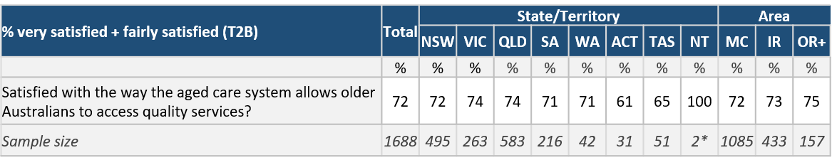

### Interpreting significance

Statistical significance is the likelihood that the difference in conversion rates between a given variation and the baseline is not due to random chance.

* Significance testing has been conducted at the 0.05 level. This means we can be 95% certain the observed results are real and not an error caused by variance in the data.
* Testing has not been conducted on groups containing less than 30 respondents (see row ‘*sample size*’), as this sample is not sufficient to generate reliable results.

#### Table 9: Example significance testing

Example indicating the coloured arrows up or down to show significantly higher or lower results

Demographic subgroups have been significance tested against the total

indicates this group is significantly lower than the total

indicates this group is significantly higher than the total

This example shows: Satisfaction with the way the aged care system allows older Australians to access quality service among care recipients aged 75+ is significantly higher than the Total.

Note: when differences are small but statistically significant, it is due to a very large sample size; in a sample of a smaller size, the differences would not be enough to be statistically significant as the margin for error is higher.

### Special Needs (subgroups)

Information is captured based on a combination of those who have indicated one or more of the following categories:

* Culturally and Linguistically Diverse background
* Aboriginal and/or Torres Strait Islander
* Living in Outer Regional (OR) OR Remote and Very Remote areas in Australia

#### Table 10: Example Special Needs Subgroups

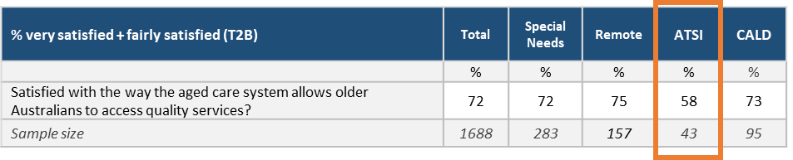

This example shows: 58% of ATSI (n=43) care recipients reported some degree of satisfaction with the way the aged care system allows older Australians to access quality services.

In this report, a number of approaches have been taken to analyse the data which result in specific modes of presentation throughout. This also affects the terminology used to refer to specific audience groups and subgroups, which is designed to be internally consistent within the report and other documents. The breakdown of sample groups for analysis have been developed in conjunction with Healthdirect Australia and the Department of Health.

With regards to the definition of top-level audience groups:

* Consumers were consulted via the same qualitative and quantitative guides and survey. However, their data is reported separately as that of **care recipients** and **carers**
* Aged Care Assessors were consulted via the same qualitative and quantitative guides and survey. However, their data is reported separately as that of **RAS Assessors** and **ACAT Assessors**
* Health Professionals were consulted via the same qualitative and quantitative guides and survey. However, their data is reported separately as that of **GPs** and **Other Health Professionals**
* **Service Providers’** results are presented at a total level. Differences between service provider types are noted where relevant.

### Style conventions

Several conventions are adhered to when presenting charts and tables.

* Specific abbreviations used throughout include:
* Abbreviation of the codes of the ABS Remoteness Index, including ‘MC’ = Major Cities of Australia, ‘IR’ = Inner Regional Australia, ‘OR’ = Outer Regional, and ‘OR+’ = Outer Regional, Remote, and Very Remote Australia
* ‘CALD’ = Culturally and Linguistically Diverse
* ‘ACAT’ is used as a national term for Aged Care Assessment Team and is not intended to exclude Victorian results (where these organisations are known as ACAS)
* Charts show the relevant overall sample size and the question wording used in this wave below. In the case of wave-on-wave comparisons, the relevant sample size for any previous waves is also included, but specific question wording is not, for readability
* Bar charts containing a ‘not sure / can’t remember’ or ‘none of the above’ option have those bars coloured differently. This is to allow clearer visual presentation of the selection of codes presented in the question
* Stacked bar charts are not always labelled with a value for every code presented – specifically in instances where page space is limited and a ‘not sure’ or other non-code response has received a small number of selections, or where a code has zero selections, this is done to reduce visual clutter
* Due to rounding, overall satisfaction/ease/agreement percentage figures given for previous waves of research may in some cases vary by 1% from the figure quoted in previous reporting document

# Key Findings

Overall, consumers had a positive view with the way My Aged Care allows older Australians to access quality aged care services, with almost three in four (72%) indicating some degree of satisfaction, and only 14% dissatisfied with My Aged Care in 2019.

1. ***Overall the majority of care recipients (72%) are satisfied with the way My Aged Care allows older Australians to access quality care.***

A relatively small proportion (14%) are dissatisfied with the system. Among carers, overall satisfaction is considerably lower (58%) compared to clients (72%), with the proportion of very satisfied carers down significantly on Wave 2 (26%, compared to 37%).

Satisfaction with My Aged Care was largely similar across demographic groups, differing only by age. Care recipients aged 65-74 years were significantly less satisfied (71%), and older recipients were significantly more satisfied (78%).

1. ***The most common means of consumers initially becoming aware of My Aged Care was through a GP or Other Health Professional.***

Health Professionals (GPs and Other Health Professionals) was by far the most common means of developing awareness of My Aged Care, with approximately one in three (33%) care recipients reported having first heard about My Aged Care through this source. Other means of awareness were through friends or neighbours (16%) or a family member (8%), and through an aged care service provider (13%).

More than one in three carers initially became aware of My Aged Care through a GP or other health professional (36%). Secondary sources for My Aged Care awareness were through an aged care service provider (13%), a family member (10%), or friends/neighbours (9%).

Qualitatively, Health Professionals often commented on the difficulty obtaining information from the website, with the system perceived as challenging for carers and those seeking aged care. This is likely as a result of lack of computer literacy and accessibility to the internet among the older demographic.

1. ***The majority of consumers rated their experience with the Contact Centre positively, with approximately three in four ascribing some degree of satisfaction with this source.***

Satisfaction with the quality of information provided by the Contact Centre rated strongly among care recipients and carers, with over three in four rating as ‘fairly satisfied’ or ‘very satisfied’ (78% and 73%). This has remained steady across evaluation since Wave 1 (2016). However, the proportion indicating ‘very satisfied’ scores were higher among care recipients.

Some groups did not display such positive views on the Contact Centre information they received. ACAT Assessors were less likely to be satisfied (32% reporting any level of satisfaction in 2019, and 37% in 2017), as were Other Health Professionals (27% compared with 24% in the last wave).

GPs surveyed displayed a stronger level of satisfaction, with more than half (52%) reporting satisfaction compared with 27% among Other Health Professionals as stated above.

1. ***Satisfaction with information obtained from the My Aged Care website continues to track at a high level among Consumers, GPs and Service Providers.***

Over two in three carers reported satisfaction with the information received on the website (note: data collection had been finalised by May 2019, ahead of the release of the new My Aged Care website in June 2019). The result in the current wave included over one in three (35%) ‘very satisfied’ with the resource. Dissatisfaction with the website remained low, with less than one in five (16%) care recipients indicating any degree of dissatisfaction.

Satisfaction with the website information saw 45% of Total Health Professionals satisfied. GPs were much more likely to be satisfied (67%) when compared with Other Health Professionals (38%).

Among service providers surveyed more than half (60%) reported some degree of satisfaction with the quality of information. The proportion of those nominating they were ‘very satisfied’ increased significantly from Wave 2 (14% to 20%).

Of those Service Providers who indicated they were dissatisfied with the website (11%), the majority found it hard to locate information (84%); some felt the information they sought was not available on the website (35%), while close to one in three (32%) cited dissatisfaction with the presentation of information on the My Aged Care Service Finder.

1. ***Other Health Professionals tended to refer clients using the online referral form (90%) and the ease of referring clients using the online referral form has improved markedly for GPs since Wave 2 – from 40% up to 59%.***

The vast majority of Other Health Professionals reported making inbound referrals via the online form (90%); 59% among GPs.

Other Health Professionals were significantly less likely to report sending a fax, with only one in ten (10%) reporting having used this method compared with 42% in Wave 2. Referrals via the Contact Centre have been growing steadily since Wave 1.

Other Health Professionals’ overall satisfaction with aspects of online referral remains broadly on par with previous waves of research except for the proportion of Other Health Professionals who believe My Aged Care acted on the information they gave them, which increased significantly since Wave 2 from 26% to 49%. No statistically significant shifts were recorded on *time taken to complete and submit the form* (64% in 2019 and 69% in 2017) and *referral being dealt with in a timely way* (37% in 2019 and 26% in 2017).

Among GPs consulted, overall experience and agreement that the time taken to complete and submit the online form was reasonable, both recorded an increase, reversing the declines observed in Wave 2. However, agreement that the referral was dealt with in a timely way has continued to decline with just over one in two (55%) reporting some agreement with this aspect compared to 60% and 63% observed in Wave 2 and Wave 1 respectively.

1. ***GPs’ overall rating of how My Aged Care assists their patients to access aged care services were generally positive, with 68% giving a positive response, noting a significant increase in those indicating ‘very satisfied’ compared to the previous wave (58%).***

Overall, GPs gave a positive response to how My Aged Care assists consumers with access to aged care services; 68% indicating a ‘very satisfied’ response compared to 58% for the previous wave.

Other Health Professionals recorded an improvement in overall satisfaction with My Aged Care’s ability to assist them in progressing patients through to aged care services, with 31% giving a positive response. In this wave, Other Health Professionals recorded an improvement in those satisfied with the system, from 18% to 27%.

1. ***When arranging Home Care Package services, care recipients were most satisfied with information received about setting up services and having a 56-day period to do so.***

When arranging Home Care Package services, care recipients were most satisfied with information received about setting up services (71% satisfied) and having a 56-day period to do so (67% satisfied).

Satisfaction among carers with information when arranging Home Care Package services was similar to that for care recipients. Satisfaction was highest for information received about setting up services (63% satisfied) and having a 56-day period to do so (59% satisfied). Around half of carers were also satisfied with what to do if more time was required (54%) and the ability to request a 28-day extension (48%).

1. ***While the majority of Home Care Package consumers report they have not taken any action since their assessment, among those who have sought to find out more, the majority used information supplied by a service provider to help them understand how to arrange aged care services.***

The majority (60%) of consumers have not done anything since being assessed for a Home Care Package (note: a large proportion of participants received interim services while they waited to be assigned a Home Care Package - 60% of care recipients and 54% of carers). Among those who have taken action, 18% have found out about different providers. Similarly, just over half (52%) of carers have not done anything since the person they care for was assessed, although over one quarter (27%) of carers have found out about the different providers that are available.

The majority (62%) of care recipients who have been assigned a Home Care Package have used information supplied by a service provider to help them understand how to arrange a service. Almost half (48%) have sought information from the contact centre and referenced printed brochures supplied by the assessor.

Among carers, utilisation of information and resources was similar. Two thirds (67%) referenced information given to them by the service provider, and just over half (52%) phoned the contact centre or read brochures supplied by the assessor.

1. ***Just over one in two care recipients had heard about the Increasing Choice reforms, with slightly higher awareness levels among carers (58% vs. 48% care recipients).***

Almost half (48%) of care recipients had not heard about the Increasing Choice reforms. Awareness of the reforms was higher among carers (58%), however a relatively high proportion of them (38%) had not heard anything.

The majority of recipients reported being happy with the services from their current provider (81%) and happy with the workers who deliver the services (78%). Results were very similar for carers; with 84% reporting they are happy with the current provider and 74% happy with the workers. However, carers were also slightly more pragmatic, with 35% indicating they think it would be too hard to move.

A relatively small proportion of recipients (14%) and carers (11%) reported changing provider after 27 February 2017. Among those who had changed provider, three quarters (75%) found this process ‘very easy’ (45%) or ‘quite easy’ (30%).

Qualitatively, those who had changed providers generally had an idea of which provider they wanted to switch to before making the change. The new provider tended to be one recommended by others.

1. ***The Net Promoter Score (NPS[3]) for carers rating service providers in 2019 (+13) was lower than for care recipients (+27). From a qualitative perspective, care recipients and carers shared that they would recommend for those seeking aged care services to act sooner rather than later in getting their care recipients registered.***

NPS for care recipients in 2019 (+27) was lower than in 2017 (+40), and more similar to 2016 (+33). The change in 2019 from 2017 was influenced by an increase in rating 0-6 on the advocacy scale (from 16% to 23% overall) and a decline in rating 9-10 (from 53% to 49% overall).

Some participants suggested that if they had their time again, they would seek advice and recommendations from others about service providers and the process overall, and enlist the support of the care recipients’ health professionals.

NPS for carers in 2019 (+13) was lower than in 2017 (+37) but maintained some improvement over 2016 (+1). The change in 2019 from 2017 was influenced by an increase in rating 0-6 on the advocacy scale (from 20% to 29% overall) and a decline in rating 9-10 (from 56% to 42% overall).

# Summary of Findings

## Views on the Aged Care System

#### Figure 1: Care recipient satisfaction with the aged care system, by wave

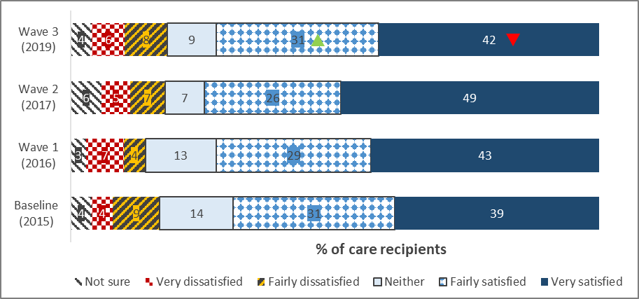

Overall, the findings from this wave showed care recipients had a positive view of the way the aged care system allows them to access quality aged care services, with almost three in four (72%) indicating some degree of satisfaction, and only 14% dissatisfied to any degree with the system at large in 2019.

#### Figure : Carer satisfaction with the aged care system, by wave

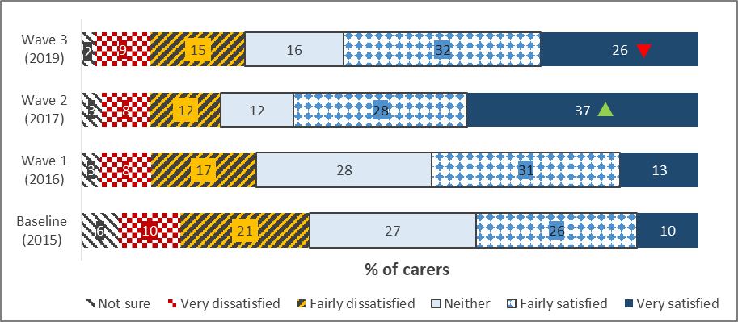

Q8. Overall, how satisfied or dissatisfied are you with the way the aged care system allows older Australians to access quality services?

Care recipients: N=1688, all care recipients; W2 n=908; W1 n=309: B n=148

Carers: N=313, all carers; W2 n=868; W1 n=410; B n=344

Satisfaction with the aged care system among carers remained strong, with close to three in five (58%) carers reporting some degree of satisfaction, and under one in four (24%) expressing any degree of dissatisfaction.

Following a significant increase in satisfaction among carers in Wave 2, the overall satisfaction with the aged care system declined significantly in 2019 among carers surveyed, with a greater than 10 percentage point decrease in those reporting being very satisfied (from 37% to 26%).

#### Table 11: Care recipient satisfaction with My Aged Care, by demographics

| **% Very + fairly satisfied** | **Total (%)** | **Male (%)** | | **Female (%)** | **Age  30-64 (%)** | **Age  65-74 (%)** | **Age  75+ (%)** |
| --- | --- | --- | --- | --- | --- | --- | --- |
| Satisfied with the aged care system | 72 | 78 | 74 | | 60 | 71 | 78 |
| *Sample size* | *1688* | *449* | *1173* | | *43* | *533* | *1045* |

Care recipients aged 65-74 years were significantly less satisfied (71%), and older recipients were significantly more satisfied (78%).

#### Table 12: Carer satisfaction with My Aged Care, by demographics

| **% Very + fairly satisfied** | **Total (%)** | **Male (%)** | | **Female (%)** | **Age  30-64 (%)** | **Age  65-74 (%)** | **Age  75+ (%)** |
| --- | --- | --- | --- | --- | --- | --- | --- |
| Satisfied with My Aged Care | 58 | 66 | 54 | | 50 | 56 | 68 |
| *Sample size* | *313* | *115* | *191* | | *100* | *89* | *116* |

Satisfaction with the aged care system was steady across carer demographics, although younger carers appeared to judge the system more harshly than older carers. Only half (50%) of carers below the age of 65 indicated satisfaction with the quality of aged care services compared to over two in three (68%) carers aged 75 and older.

## Awareness, Information and Contact

* The most common means of care recipients initially becoming aware of My Aged Care was through a GP or Other Health Professional, with approximately one in three (33%) care recipients reporting having first heard about My Aged Care through this source. Other means of awareness were through friends or neighbours (16%), an aged care service provider (13%) or a family member (8%).
* Less than one in ten (8%) recipients reported hearing about My Aged Care through other government service departments such as the Department of Human Services or the Department of Veterans’ Affairs.
* More than one in three carers had initially become aware of My Aged Care through a GP or other health professional (36%). Secondary sources for My Aged Care were through an aged care service provider (13%), a family member (10%), or friends/neighbours (9%).
* Less than one in four (18%) reported accessing the My Aged Care website prior to ever calling the My Aged Care Contact Centre, and just over one in ten (13%) had utilised the ‘Find the help you need with myagedcare’ brochure. Less than one in ten reported utilising the purple ‘Your guide to Home Care Package services’ or the red ‘Your guide to Commonwealth Home Support Programme services’ booklets (7% and 6% respectively).
* Similar to initial source of awareness, over one in three carers (38%) reported visiting the My Aged Care website to find out information before first calling the Contact Centre, compared with just 18% among care recipients.
* Among carers consulted, less than one in five (16%) cited that they had used other departmental resources (i.e. booklets and brochures).
* Approximately a third (33%) of carers surveyed reported not using any of the resources.

### My Aged Care Contact Centre

#### Figure : Participant satisfaction with Contact Centre information

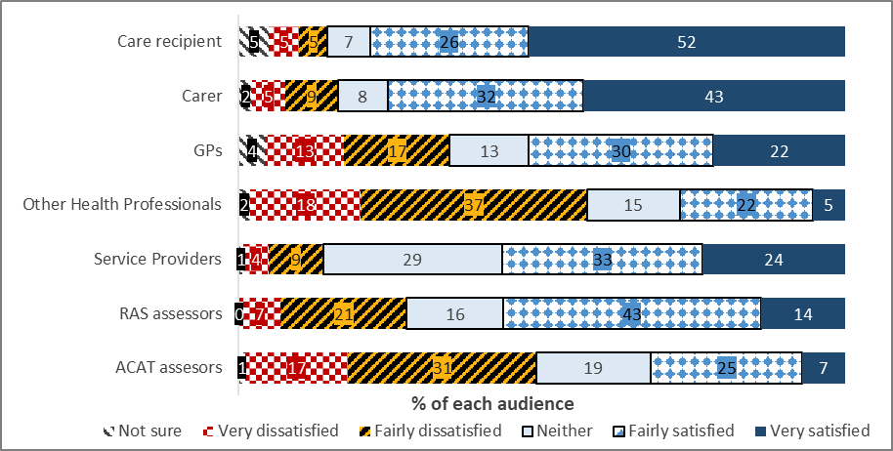

*Various question numbers: How satisfied or dissatisfied were you with the quality of information that you received from the My Aged Care Contact Centre? Various base sizes.*

* Satisfaction with the quality of information provided by the Contact Centre rated strongly among care recipients and carers, with over three in four rating their experience as ‘fairly satisfied’ or ‘very satisfied’ (78% and 73%). The proportion indicating ‘very satisfied’ were higher among care recipients than other groups (52%).
* Some groups did not display such positive views regarding the Contact Centre information they received. ACAT assessors were less likely to be satisfied (32% reporting any level of satisfaction), as were Other Health Professionals (27% compared with 24% in the last wave).
* GPs surveyed displayed a higher level of satisfaction, with more than half (52%) reporting satisfaction compared with 27% among Other Health Professionals.

*Consumers (care recipients and carers)*

#### Figure 4: Care recipient satisfaction with Contact Centre information, by wave

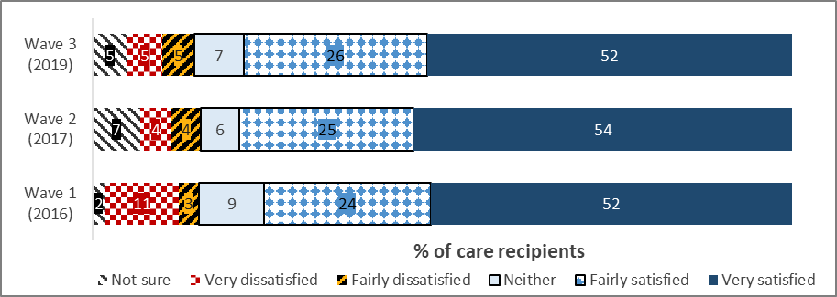

*Q11. Overall, how satisfied or dissatisfied have you been with the quality of the information you have received from the My Aged Care telephone contact centre?*

*N=1,688, all care recipients indicating Contact Centre usage; W2 n=908; W1 n=85*

Satisfaction with quality of information received from the Contact Centre among care recipients remained consistent across evaluation waves.

Qualitative findings highlight the positive experiences with the My Aged Care Contact Centre:

*“It was excellent, particularly the phone was answered by a real person and there was no waiting.”* **Care Recipient, Female, Sydney**

*“This guy was just wonderful, he was warm, he led me to believe that I would have my assessment really quickly and I did within two weeks and it was all positive. I left that phone call quite amazed.”* **Care Recipient, Female, Adelaide**

#### Figure 5: Carer satisfaction with Contact Centre information, by wave

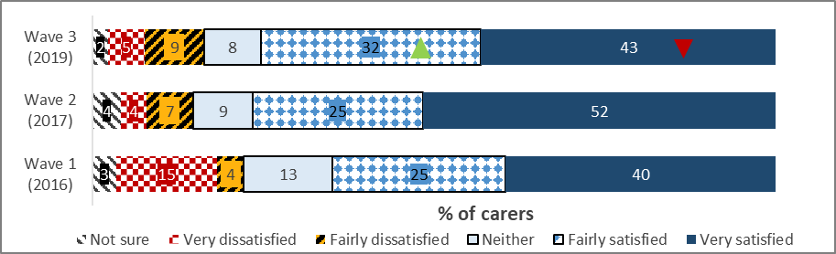

*Q11. Overall, how satisfied or dissatisfied have you been with the quality of the information you have received from the My Aged Care telephone contact centre?*

N=313, all care recipients indicating Contact Centre usage; W2 n=826; W1 n=66

Overall, carer satisfaction with the quality of information received from the Contact Centre remained high in 2019. However, there was a significant decrease in the proportion of carers who reported being very satisfied – 43%, down from 52% in Wave 2.

*Health Professionals*

#### Figure 6: GP satisfaction with Contact Centre information, by wave

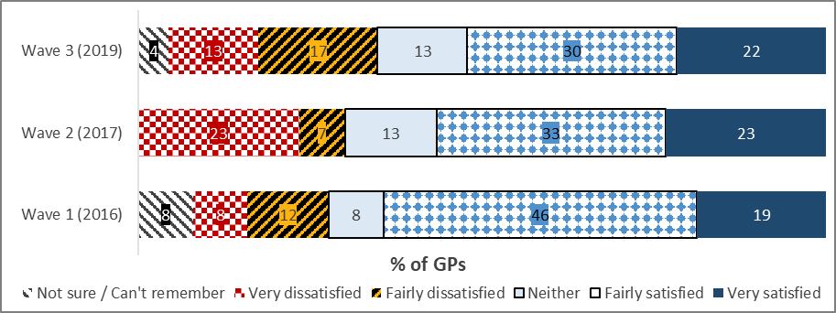

*Q7. How satisfied or dissatisfied were you with the quality of information that you received from the My Aged Care Contact Centre? Base*: GPs indicating Contact Centre usage (W3 n=23, W2 n=30, W1 n=26) *Low base sizes treat as indicative only*

The proportion of GPs who reported being very satisfied with the contact centre information remained fairly consistent across all three waves.

#### Figure 7: Other Health Professional satisfaction with Contact Centre information, by wave

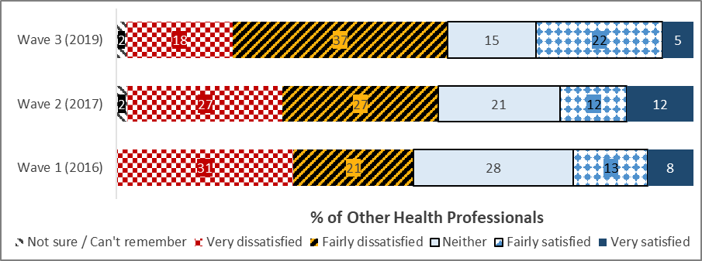

*Q7. How satisfied or dissatisfied were you with the quality of information that you received from the My Aged Care Contact Centre? Base: Other Health Professionals indicating Contact Centre usage (W3 n=169, W2 n=52, W1 n=39)*

Over the three waves, there is a downwards trend in the proportion of Other Health Professionals who reported being very dissatisfied with the information they received from the Contact Centre.

*Service Providers*

#### Figure 8: Service Provider satisfaction with Contact Centre information, by wave

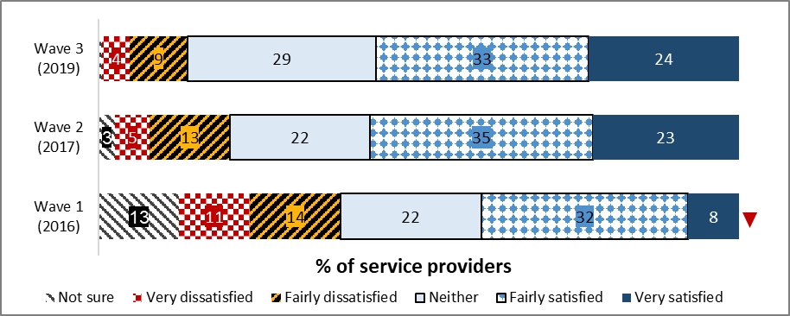

*Q15. How satisfied or dissatisfied have you been with the quality of information that you have received from the My Aged Care Contact Centre? N=302, all providers reporting Contact Centre usage; W2 n=224; W1 n=127*

Over half (57%) of Service Provider employees surveyed in Wave 3 were satisfied to some degree with the quality of information they received from the Contact Centre. Though not statistically significant, there has been a declining trend in Service Provider representatives reporting dissatisfaction (as seen in Figure 8).

*Assessors*

#### Figure 9: RAS Assessor satisfaction with Contact Centre information, by wave

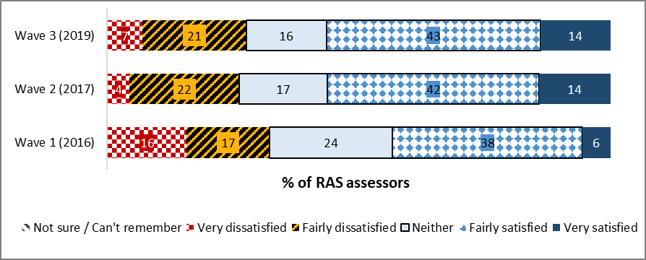

*Q7. How satisfied or dissatisfied have you been with the quality of information that you have received from the My Aged Care Contact Centre?*

*N=286, RAS Assessors indicating My Aged Care Contact Centre usage; W1 n=127; W2 n=248*

More than half (56%) of RAS Assessors using the Contact Centre indicated satisfaction with the quality of information received there - this result is consistent with Wave 2.

#### Figure 10: ACAT Assessor satisfaction with Contact Centre information

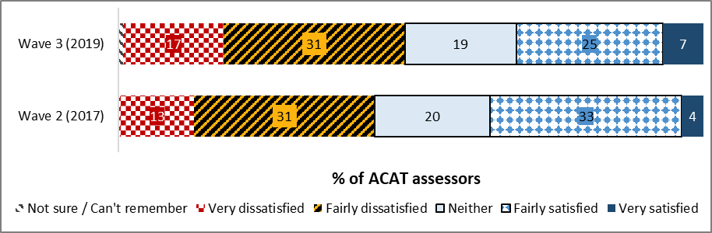

*Q7. How satisfied or dissatisfied have you been with the quality of information that you have received from the My Aged Care Contact Centre?*

*N=198, ACAT Assessors indicating Contact Centre usage; W2 n=269*

At 32%, ACAT assessors’ satisfaction is down slightly on Wave 2 (37%), however this is not a significant change.

My Aged Care Website

#### Figure : Participant satisfaction with website information

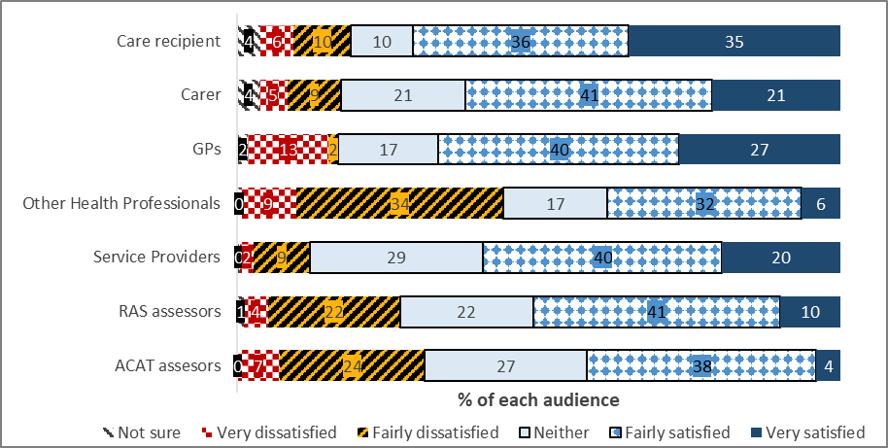

*Various question numbers: How satisfied or dissatisfied were you with the quality of information that you received from the My Aged Care website [at myagedcare.gov.au]? Various base sizes*

* Well over two in three carers reported satisfaction with the information received on the website. The result in the current wave included over one in three (35%) ‘very satisfied’ with the resource. Dissatisfaction with the website remained low, with less than one in five (16%) care recipients indicating any degree of dissatisfaction.
* Satisfaction with the website information saw 45% of Total Health Professionals satisfied. GPs were much more likely to be satisfied (67%) when compared with Other Health Professionals (38%).
* Among service providers surveyed more than half (60%) reported some degree of satisfaction with the quality of information from the website. The proportion of those nominating a high level of satisfaction increased significantly from Wave 2 (14% to 20%).

*“Personally, I find it [the website] reasonably easy, although I do find the My Aged Care site is better than it used to be, but I don't think it's overly friendly from a consumer's perspective and especially someone who is not comfortable or used to using computers”* **RAS Assessor, Female, NSW**

*“We tried looking at the website - and that can be quite unfriendly - it wasn’t a very good website, it was hard to find your way around. We probably found out more through our daughter-in-law than anything”* **HCP Carer, Morphett Vale, SA**

*“…because it’s all internet-based, it’s [the website] quite useful. The site is quite helpful in fact to get any information that we need.”* **GP, Davenport, TAS**

*Consumers (care recipients and carers)*

#### Figure 12: Care recipient satisfaction with website information, by wave

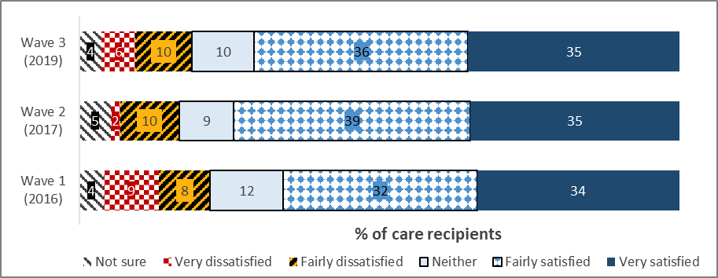

*Q14. Overall, how satisfied or dissatisfied have you been with the quality of the information you have received from the My Aged Care website?*

*N=398, all care recipients indicating website usage; W2 n=132; W1 n=39*

Care recipient satisfaction with quality of information received from the website remains consistent across waves.

*“It was understandable, it was clear, it wasn’t too much to take in … not as bad as Centrelink’s site. One thing leads to another when I looked at it.”* **Care Recipient, Male, Sydney**

#### Figure 13: Carer satisfaction with website information, by wave

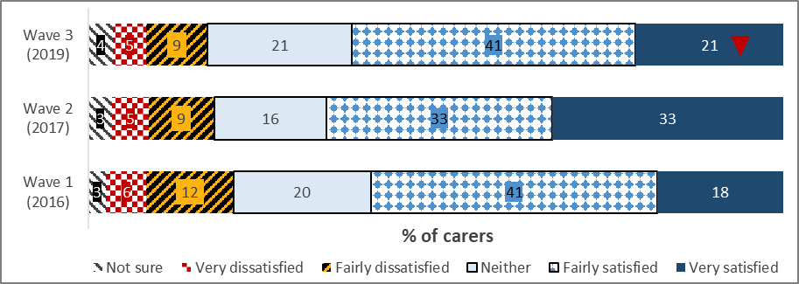

*Q14. Overall, how satisfied or dissatisfied have you been with the quality of the information you have received from the My Aged Care website?*

*N=169, all carers indicating website usage; W2 n=415; W1 n=81*

Carers’ satisfaction with the quality of information received from the website remained high in 2019 at 62%. However, the proportion of carers very satisfied with the information has decreased significantly on Wave 2 – 21%, down from 33%.

One carer pointed out the logical structure of the website layout:

*“**The website's pretty good…* *It's worked pretty well, to be honest. It's very logically structured, or the way I think anyway, because I'm very sort of accounting background, think very sequentially.”* **Carer, Buderim, Queensland**

*Health Professionals*

#### Figure 14: GP satisfaction with website information

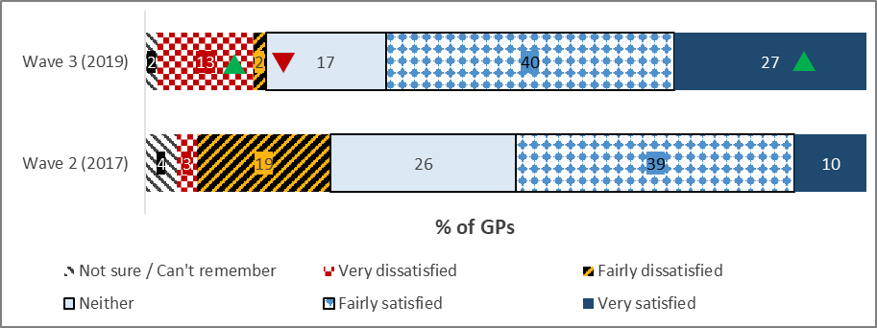

*Q9. How satisfied or dissatisfied were you with the quality of information that you received from the My Aged Care website? Base: GPs indicating website usage (Wave 3 n=60; Wave 2 n=70)*

Wave 3 has seen a significant increase in GPs who are very dissatisfied with the information received from the My Aged Care website - 13%, up from 3% in Wave 2. However, there has also been a significant positive shift in the proportion of GPs who are very satisfied with the information they received; 27%, up from 10% in Wave 2.

#### Figure 15: Other Health Professional satisfaction with website information

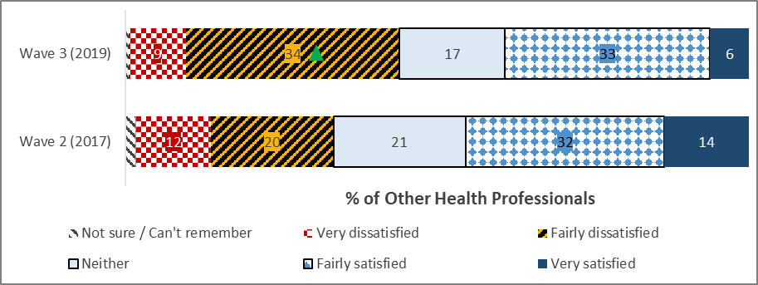

*Q9. How satisfied or dissatisfied were you with the quality of information that you received from the My Aged Care website? Base: Other Health Professionals indicating website usage (W3 n=207, W2 n=66)*

Over one third of Other Health Professionals (34%) indicated that they were fairly dissatisfied with the website information. This is a significant increase on Wave 2 (20%).

*Assessors*

#### Figure 16: RAS Assessor satisfaction with website information, by wave

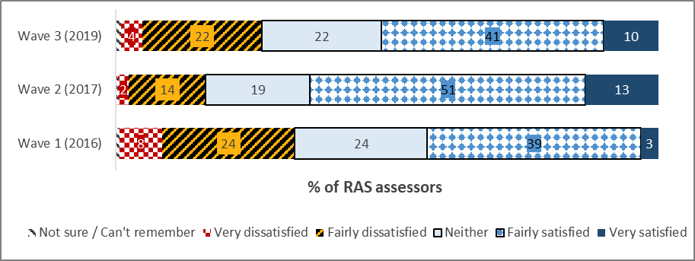

*Q9. How satisfied or dissatisfied have you been with the quality of information provided on the My Aged Care website?*

*N=297, RAS Assessors indicating website usage; W1 n=127; W2 n=240*

Just of over half (51%) of RAS assessors reported being satisfied with the information they received from the website, down slightly but not significantly on Wave 2 (64%).

#### Figure 17: ACAT Assessor satisfaction with website information

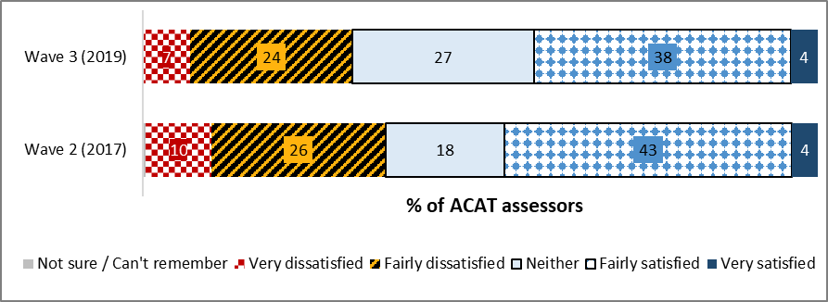

*Q9. How satisfied or dissatisfied have you been with the quality of information provided on the My Aged Care website?*

*N=241, ACAT Assessors indicating website usage; W2 n=267*

Forty-two (42%) percent of ACAT assessors reported being satisfied with the information they received from the My Aged Care website, down slightly on Wave 2 (47%).

ACAT Assessors also saw a decline from Wave 2 2017, with 42% satisfied with the quality of information provided on the My Aged Care website compared with 47% in 2017.

Four in ten (42%) ACAT assessors were satisfied with the quality of information on the website, though more than one in three (31%) were dissatisfied. This result was broadly similar to that seen in Wave 2.

#### Figure : RAS assessor satisfaction with Portal activities, by wave

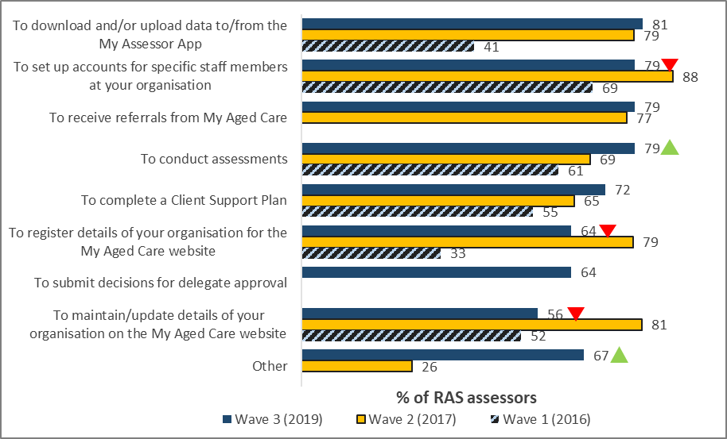

*Q11. How satisfied or dissatisfied have you been with how the Assessor Portal's functionality allows you to perform the following transaction?*

*N=6-298, assessors selecting each activity; W1 n=15-120; W2 n=7-235*

In this current wave, a significant increase in satisfaction is noted with the ability ‘to conduct assessments’ in the Assessor Portal compared with the last wave (69% in Wave 2 vs 79% in Wave 3).

There were some significant decreases in RAS assessors’ satisfaction with some Portal tasks compared to Wave 2; the ability to set up accounts (79% vs. 88%), registering details of assessors’ organisation (64% vs. 79%) and maintain and update details of your organisation on the My Aged Care website (56% vs. 81%). On the other hand, satisfaction with the Portal’s functionality in terms of conducting assessments had increased significantly, from 69% in Wave 2 to 79% in Wave 3.

The ability to maintain and update details of assessors’ organisations for the My Aged Care website (56%) was considered the least satisfactory Portal task.

Feedback from the Assessors on these aspects of using the Portal often highlighted the general improvement of the system from previous years.

*“Okay, well I use the portal for my assessment and delegation. I find it a really [user-friendly], when it's working and it's going beautifully, it is fantastic. It is a really good system. It is an improvement on what they had.”* **RAS assessor, Brisbane, Queensland**

*“They improved the usability, which I think has a flow on effect to making it easier to capture information. So whether it’s improved overall the quality of information collected, I’m not sure but from my perspective as an assessor it has made it easier to enter information.”* **RAS assessor, Kuring-Gai, New South Wales**

Some assessors pointed out issues with the reliability and user interface of the system.

*“They do have problems every now and then. It just either slows down and it crashes, and you can lose information that you've put in, which is one of my biggest frustrations.”* **RAS assessor, Brisbane, Queensland**

*Service Providers*

#### Figure 19: Service Provider satisfaction with website information, by wave

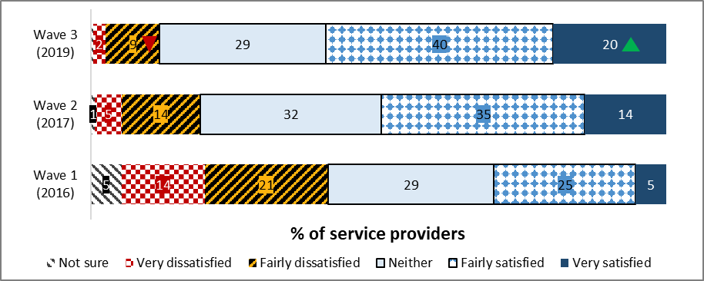

*Q12. How satisfied or dissatisfied have you been with the quality of information that you have received from the My Aged Care website?*

*N=493, all providers reporting website usage; W2 n=295; W1 n=187*

The majority (60%) of Service Providers reported some degree of satisfaction with the quality of information received from the website. Notably, the proportion of providers nominating a high degree of satisfaction has increased significantly on Wave 2 (14% to 20%).

#### Figure : Service provider satisfaction with Portal activities, by wave

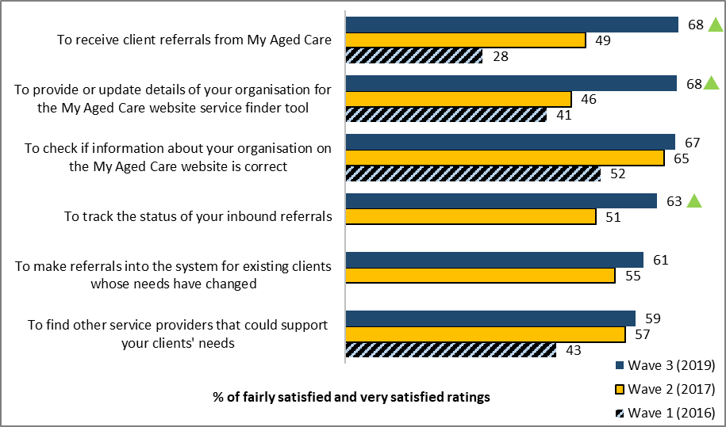

*Q17. And how satisfied or dissatisfied have you been with how the Provider Portal has enabled you to…?*

*N=98-436, providers selecting each activity; W1 n=44-126; W2 n=77-269*

Among Service Providers who have indicated any degree of dissatisfaction with the website (11%), the majority found it hard to locate information (84%), some felt the information they sought was not available on the website (35%) and almost one in three (32%) cited dissatisfaction with the presentation of information on the My Aged Care Service Finder. However, almost one in four (23%) service provider employees stated that inaccurate information on the website was the source of their dissatisfaction.

## Inbound Referrals

### Referral methods

*Health Professionals*

#### Figure 21: GPs vs Other Health Professionals rating of ease of referral methods (T2B)

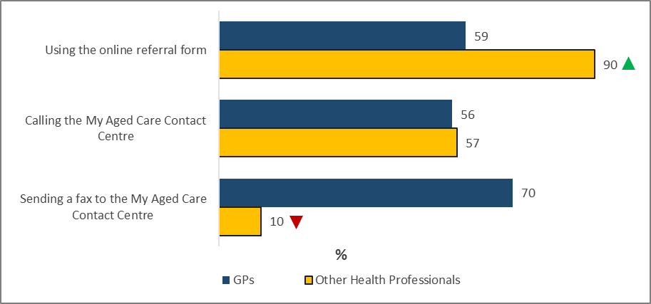

*Q10. Overall, how easy or difficult was the process of referring a patient…? Base: GPs using each method (W3 n=34-66) Other Health Professionals (W3 n=221)*

Other Health Professionals were significantly more likely than GPs to rate the online referral form with some degree of ease to process referrals (90% vs. 59% respectively). In contrast, Other Health Professionals were significantly less likely to report ease of referring a patient by sending a fax to the My Aged Care Contact Centre (10% vs. 70%).

*GPs*

#### Figure 22: GP rating of ease of referral methods (T2B), by wave

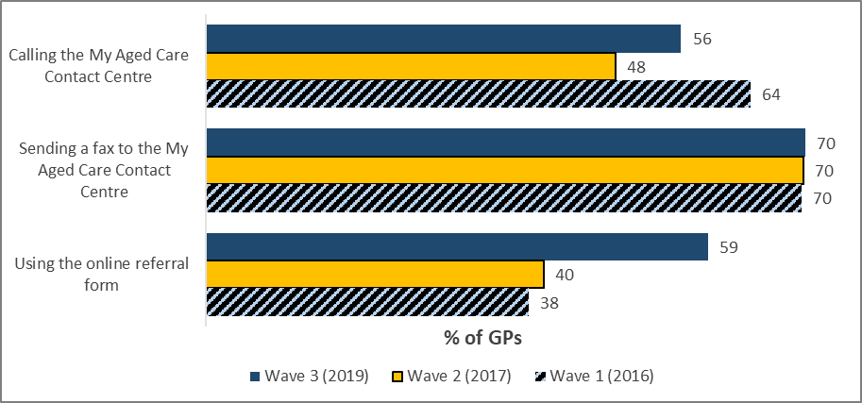

*Q10. Overall, how easy or difficult was the process of referring a patient…? Base: GPs using each method (W3 n=34-66, W2 n=56-74, W1 n=11-23)*

Among GPs consulted, the ease of referring clients using the online referral form has increased since Wave 2 – from 40% up to 59% (in 2017 and 2019).

Referring clients via fax remains the easiest referral method, remaining steady at 70% since Wave 1 for GPs.

Although some GPs do not personally process the referrals, they are aware of some issues with processing referrals online based on feedback from their patients, as the following quote from the qualitative research indicates:

“I think the staff at the hospital…start off through the online referral form, and they get families to do that as well. So, they try and go at it from multiple angles. The feedback from families is that they tried that or the system didn't work, or it crashed and then they've had to resubmit multiple times, so a lot of time is wasted.” **GP, Bellingen, New South Wales**

*Other Health Professionals*

#### Figure 23: Other Health Professionals usage of referral methods, by wave

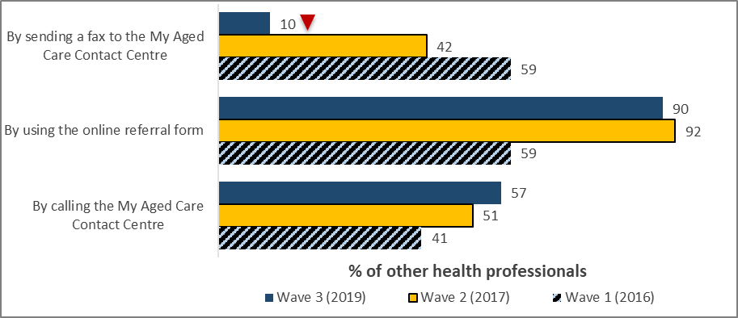

*Q5. Through which of the following means have you ever referred a patient into the My Aged Care system? Base: All Other Health Professionals (W3 n=221, W2 n=76, W1 n=39)*

The vast majority of Other Health Professionals reported making inbound referrals via the online form (90%), followed by calling the Contact Centre (57%) and sending a fax (10%).

Other Health Professionals were significantly less likely to report sending a fax, with only one in ten (10%) doing so compared with 42% in Wave 2.

Referrals via the Contact Centre have been growing steadily since Wave 1.

### Contact Centre referrals

#### Figure : Participant agreement that they were satisfied with Contact Centre referral experience

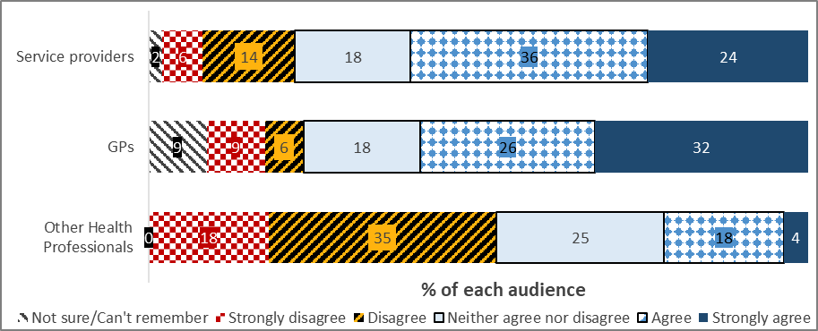

*Various question numbers: To what extent do you agree with the following statements about referring a client to the Contact Centre? ‘I was satisfied with the experience overall’*

*n=194 service providers; n=34 GPs; n=126 other health professionals*

Three in five (60%) were satisfied with the overall experience of referring a client to the Contact Centre.

*Health Professionals*

#### Figure 25: Aspects of Contact Centre referrals – Health Professionals

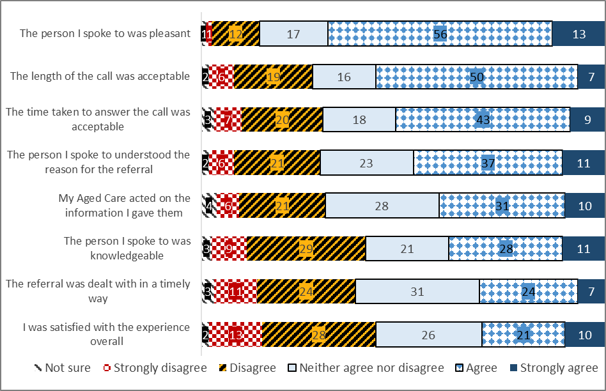

*Q11. To what extent do you agree or disagree with the following statements about referring a patient via the Contact Centre?  
Base: Have referred a patient via the Contact Centre n=160*

Health Professionals who had referred a patient via the Contact Centre, two out of three agreed that the person they spoke to was pleasant (69%), while over half stated length of call (57%) and time taken to answer (52%) was acceptable, as indicated in Figure 29. Qualitatively, Health Professionals highlighted their agreement with the timely management of the referral process:

*“I think they respond to the referral in a really good, quick manner.”* **Other Health Professional (Social Worker), Western Australia**

Other Health Professionals found the online system much more reliable for processing referrals, as the following quote from the qualitative research illustrates:

*“I always do it online. I've had two occasions where I've tried to do a phone referral with the patient with me, because I thought ‘well we can do this because I've got the patient with me and we bypass all that privacy stuff’. Now, we've had a time where I don't know the reasons why, but that referral was lost, so I had to do it online again. So once is enough for me, I now just do it all online.”* **Health Professional (Social Worker), Armadale, Western Australia**

Qualitative research among Other Health Professionals also highlight the ease of processing referrals online compared to the Contact Centre:

*“I probably make about five to ten [referrals] a week through the online referral pathway, maybe because it’s very challenging to refer over the phone.”* **Health Professional (Social Worker), South Port, Queensland**

*Service Providers*

#### Figure 26: Service Provider agreement with aspects of the Contact Centre referral process

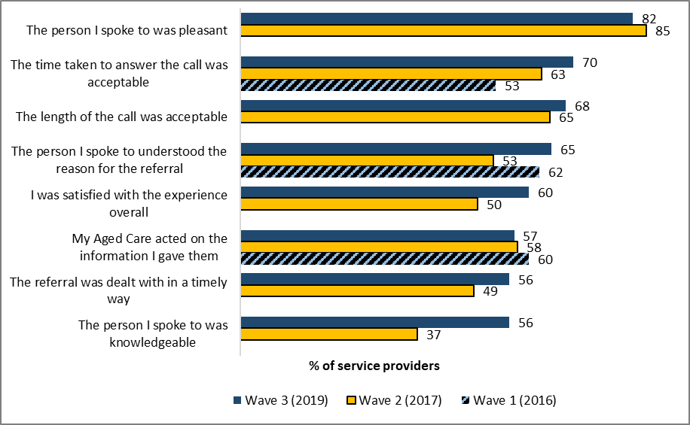

*Q26. To what extent do you agree with the following statements about referring a client to the Contact Centre?*

*n=194, service providers who have referred an existing client to My Aged Care via the Contact Centre; W2 n=119; W1 n=88*

Perceived knowledgeability of Contact Centre staff has increased significantly, up 19% on Wave 2. Also up significantly is agreement that the person spoken to understood the reason for referral (65%).

While not significant, overall satisfaction with the Contact Centre experience is up 10% to 60% for this wave. Perceived acceptability of the time taken to answer the call continues to increase wave-on-wave and is currently at 70%, up 17% on Wave 1.

### Fax referrals

#### Figure : Health Professionals agreement that they were satisfied with fax referral experience

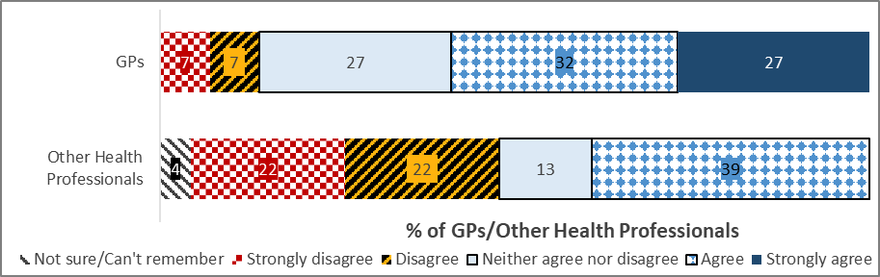

*Q12. To what extent do you agree or disagree with the following statements about referring a patient via fax?*

*N=74 GPs; N=32 hospital referrers*

Aspects of fax referrals were also surveyed. A little over half (59%) of GPs surveyed reported being satisfied with the fax referral experience.

Other Health Professionals were not typically satisfied with their experience of making fax referrals, with less than one in ten reporting a strong agreement on any aspect of conducting a referral via fax.

### Online referrals

#### Figure : Health Professionals agreement that they were satisfied with online form referral experience

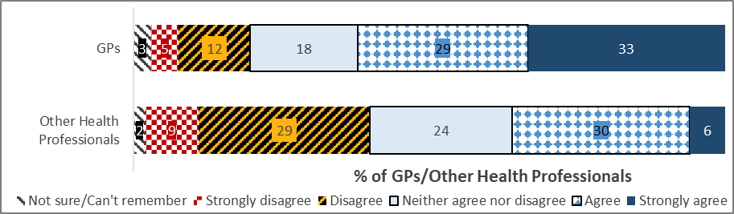

*Q12. To what extent do you agree or disagree with the following statements about referring a patient via fax?*

*N=73 GPs; N=70 hospital referrers*

Ratings of the online referral form were stronger among GPs, 62% of whom were satisfied overall with their experience of using it to make inbound referrals. Just over one in three (36%) Other Health Professionals surveyed reported a degree of satisfaction with the online referral process.

#### Figure 29: GP rating of aspects of online referrals (T2B), by wave

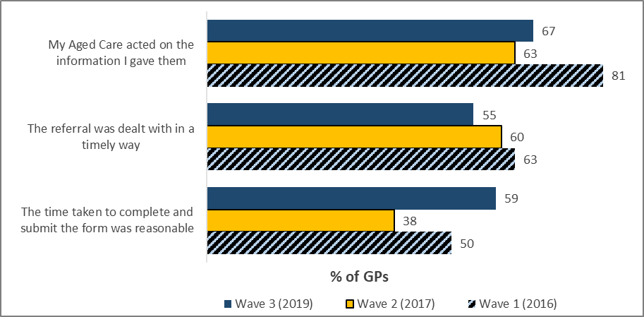

*Q13. To what extent do you agree or disagree with the following statements about referring a patient via the online referral form? GPs referring online (W3 n=66, W2=73, W1 n=16)*

Among GPs consulted, overall experience and agreement that the time taken to complete and submit the form was reasonable recorded an increase, reversing the declines observed in Wave 2. However, agreement that the referral was dealt with in a timely way has experienced further declines, with just over one in two (55%) reporting agreement with this aspect to some degree compared to 60% and 63% observed in Wave 2 and Wave 1 respectively.

#### Figure 30: Other Health Professionals rating of aspects of online referrals (T2B), by wave

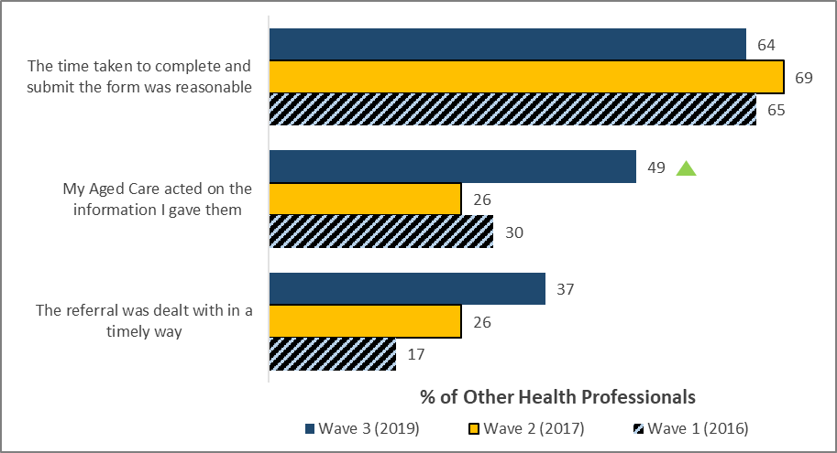

*Q13. To what extent do you agree or disagree with the following statements about referring a patient via the online referral form? Base: Other Health Professionals referring online (W3 n=83, W2 n=70, W1 n=23)*

Other Health Professionals’ overall satisfaction with aspects of online referral remains on par with previous waves of research, except for the proportion of Other Health Professionals who believe My Aged Care acted on the information they gave them, which increased significantly since Wave 2.

Some Health Professionals found the online system to be significantly more reliable than other methods of capturing information, as this quote from the qualitative research reveals:

*“If it's an actual referral I will always do it online because I find they're captured. I've never had an online referral that has been lost.”* **Other Health Professional (Allied Health Professional), Victoria**

### Referral outcomes

*Health Professionals*

#### Figure : GP overall rating of My Aged Care’s assistance in helping patients access services, by wave

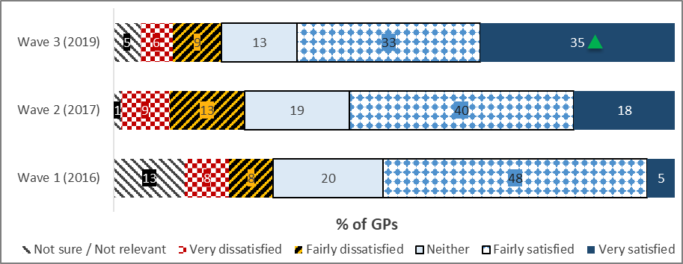

*Q20. How satisfied or dissatisfied are you with the way My Aged Care has helped you to assist patients in accessing aged care services? Base: All GPs (W3 n=104, W2 n=150, W1 n=40)*

GPs’ overall rating of how My Aged Care functions assist their patients to access aged care services was generally positive, with 68% giving a positive response and a significant increase in those indicating ‘very satisfied’ compared to the previous wave (58%).

Discussion with one regional GP in the qualitative research highlighted the timely acknowledgement and response to referrals:

*“Assessment is quite quick I would say. The services are prompt. Even being a rural area in Tasmania, I would say it's quite good. As soon as we do the referral, there's an acknowledgement and there's not too much wrong there.”* **GP , Devonport, Tasmania**

#### Figure : Other Health Professionals overall rating of My Aged Care’s assistance in helping patients access services, by wave

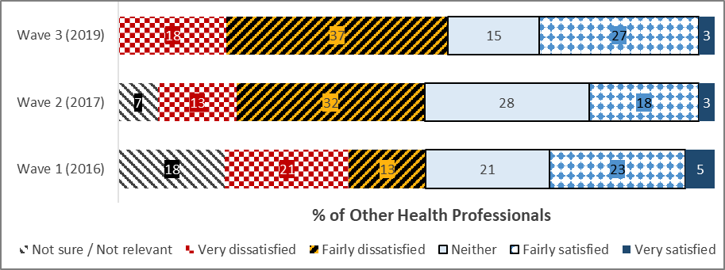

Q20. How satisfied or dissatisfied are you with the way My Aged Care has helped you to assist patients in accessing aged care services? Base: All Other Health Professionals (W3 n=221, W2 n=76, W1 n=39)

Other Health Professionals recorded an improvement in overall satisfaction with My Aged Care’s ability to assist them in progressing patients towards aged care services, with 31% giving a positive response.

In this wave, Other Health Professionals recorded an improvement in those rating the system satisfied, from 18% to 27%.

## Screening

*Consumer (care recipient and carer)*

#### Figure : Care recipient satisfaction with screening outcome, by wave

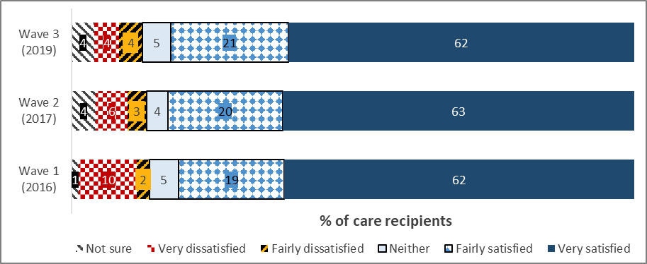

Figure : Carer satisfaction with screening outcome, by wave

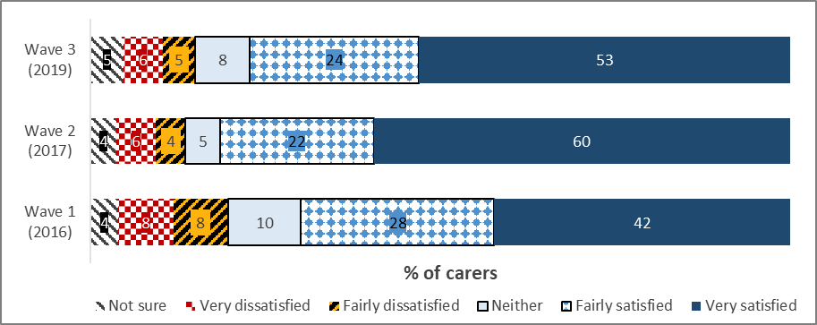

*Q18. How satisfied or dissatisfied were you with this outcome?*

*Wave 3 n=829 care recipients; n=194 carers*

*Wave 2: n=654 care recipients; n=677 carers*

*Wave 1: n=54 care recipients; n=46 carers*

Care recipients’ satisfaction with the screening outcome has been stable across 2016 to 2019, with around four in five (81-83%) satisfied overall. This result has included relatively high levels of being ‘very satisfied’ with the outcome in 2019 (53%). Around one in ten recipients, however, have reported being dissatisfied across the waves (9-13%).

Over three in four (77%) carers in 2019 were satisfied with the screening outcome, similar to the result for care recipients (82%). The result in 2019 was similar to 2017 (82%) and included over half of carers in both 2019 (53%) and 2017 (60%) being ‘very satisfied’. There was a trend for overall satisfaction to have improved from since 2016 (70%).

There was a corresponding trend for dissatisfaction to be marginally lower for carers in both 2019 (10%) and 2017 (10%) compared with 2016 (18%).

Findings in the qualitative research showed that after dealing with the Contact Centre, there was a clear understanding that the next expected step was an assessment.

*“It was a positive experience, I probably wouldn’t understand the system and they explained that someone would come out and do an assessment. My recollection would be it might be six weeks before someone came out.”* **Care Recipient, Male, Adelaide**

*Assessors*

#### Figure : Assessor satisfaction with My Aged Care handling of referrals

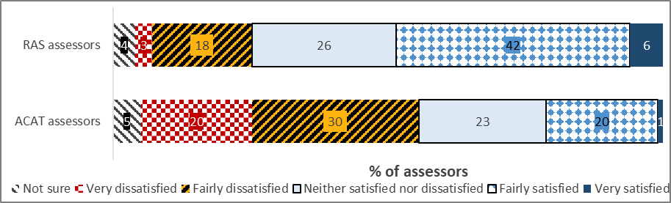

*Q27. Overall, how satisfied or dissatisfied are you with the way My Aged Care refers clients to your assessment service?*

*N=306 RAS; n=250 ACAT*

Nearly half of RAS assessors (49%) reported some degree of satisfaction with the way My Aged Care refers clients to their assessment service, while fewer than one in five (21%) were dissatisfied, results which are similar to Wave 2.

Less than one quarter of ACAT Assessors (21%) were satisfied with the way My Aged Care refers clients to their assessment service, while half of those (50%) were dissatisfied.

Qualitative research amongst ACAT Assessors revealed that while the referrals they receive are generally appropriate, there are aspects for further refinement.

*“so generally speaking, the assessments we get from the referral centre are appropriate to the assessment they've asked for. But that's the route that comes in through the portal. We are also getting a huge influx of input from the contact centre as support plan reviews and many of them should actually have come through the portal as a new assessment.”* **ACAT assessor, Adelaide, South Australia**

*“I don't have a problem with that. It's not 100 percent fluid, but the main problem with that aspect is the one I mentioned before, service providers who are on that system are not actually recording what services they provide. So you are then back to the old fashioned way of phoning up and saying look, you know, Joe Blow needs this, do you do it.”* **ACAT assessor, Alice Springs, Northern Territory**

#### Figure 36: RAS Assessor satisfaction with My Aged Care referral to your assessment service

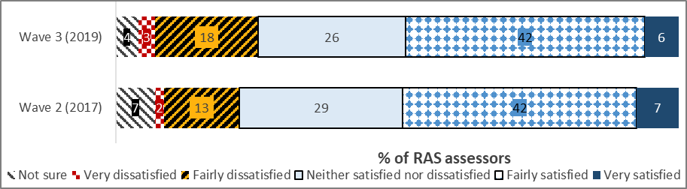

*Q27. Overall, how satisfied or dissatisfied are you with the way My Aged Care refers clients to your assessment services?*

*n=306, all RAS Assessors; W2 n=255*

RAS Assessor satisfaction with the way My Aged Care refers clients to their services remains consistent with Wave 2.

#### Figure 37: ACAT Assessor satisfaction with My Aged Care referral to your assessment service

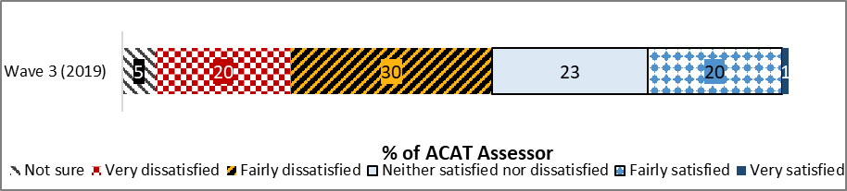

*Q27. Overall, how satisfied or dissatisfied are you with the way My Aged Care refers to clients to your assessment services?*

*n=250, all ACAT Assessors*

Less than one quarter of ACAT Assessors (22%) were satisfied with the way My Aged Care refers clients to their assessment service, while half of those (50%) were dissatisfied.

Qualitative research amongst ACAT Assessors revealed that while the referrals they receive are generally appropriate, there are aspects for further refinement.

## Assessment

### Assessment type

*Consumers (care recipients and carers)*

#### Figure 38: Care recipient assessment type, by wave

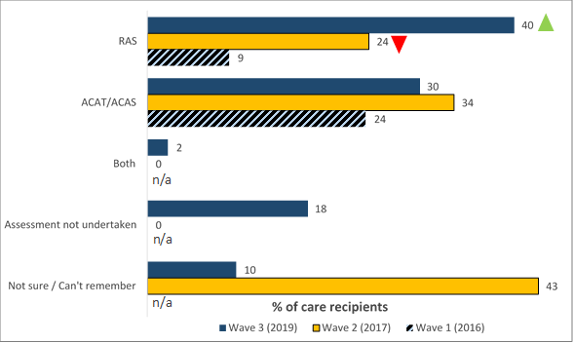

*Q19A. To the best of your knowledge, was the face-to-face assessment you arranged through My Aged Care a RAS or ACAT assessment?*

*N=1,688, all care recipients with assessment experience; W2 n=427; W1 n=405\**

***\* Please note: in Wave 1 consumers were categorised into a likely assessment type based on their responses to a series of questions. Not all were possible to confidently categorise, and so the Wave 1 figures do not total 100%.***

Care recipients reporting having had the Regional Assessment Service (RAS) assessment arranged through My Aged Care was significantly higher in 2019 (40%) compared with 2017 (24%). The next most common assessment type was through the Aged Care Assessment Team/Service (ACAT/ACAS), by around one in three in both years (2019 – 30%, 2017 – 34%).

The results in 2017 were impacted substantially by over two in five (43%) unable to specify the type, while the results in 2016 were limited by the assessment type being based on responses to a series of questions rather than one.

#### Figure 39: Carers assessment type, by wave

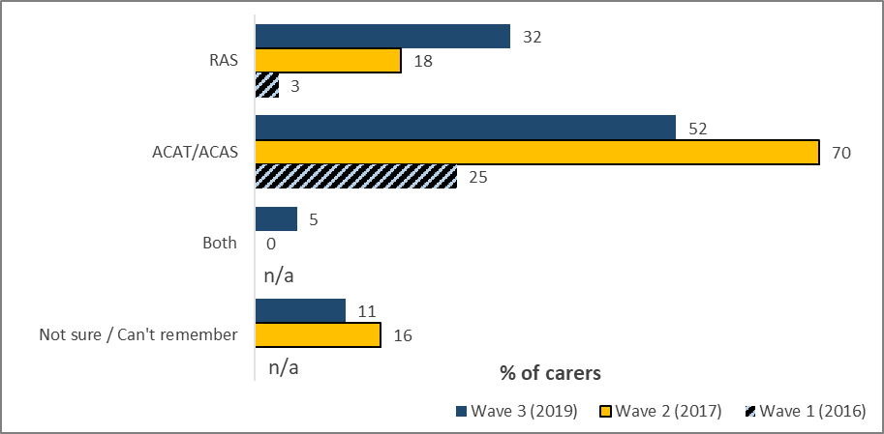

*Q19A. To the best of your knowledge, was the face-to-face assessment you arranged through My Aged Care a RAS or ACAT assessment?*

*N=313, all carers indicating their family member had assessment experience; W2 n=481; W1 n=551\**

***\* Please note: in Wave 1 consumers were categorised into a likely assessment type based on their responses to a series of questions. Not all were possible to confidently categorise, and so the Wave 1 figures do not total 100%.***

The targeted sample design in the 2019 wave aimed to capture consumers across the different stages of the My Aged Care process. The approach resulted in a higher proportion of those identified as ‘Assessment not undertaken’ being included. Around half (51%) of carers who participated reported that the person whom they cared for had not had an assessment.

Among those reporting the person they cared for having had an assessment, the profile of assessment type has shifted between 2017 and 2019. In 2017, over two thirds (70%) of carers reported an ACAT/ACAS type, with one in five (18%) a RAS type. There had been a shift in 2019 towards more RAS assessments (32%), with a corresponding decrease in ACAT/ACAS (52%) that were survey in Wave 3.

#### Figure 40: Care recipient having a face-to-face assessment, by wave

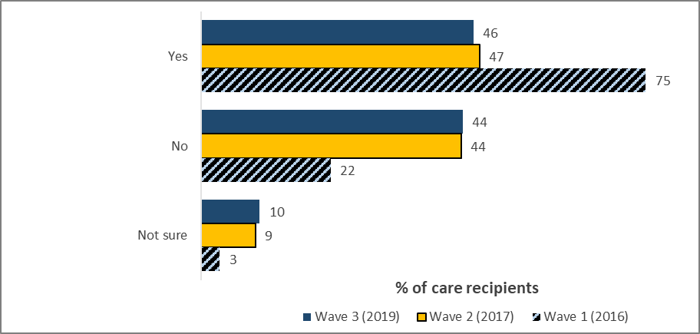

*Q19. Have you been through a face-to-face assessment of your aged care needs from an organisation that was not the service provider as a result of you contacting My Aged Care?*

*N=1,225 all care recipients using My Aged Care; W2 n=908; W1 (care recipients using My Aged Care) n=405*

Close to half (46%) of care recipients in 2019 indicated they had undergone an assessment (46%), similar to 2017 (47%). These results were lower than in 2016 (75%), when assessments were primarily arranged though the Contact Centre.

#### Figure 41: Care recipients indicating a carer was present for the assessment

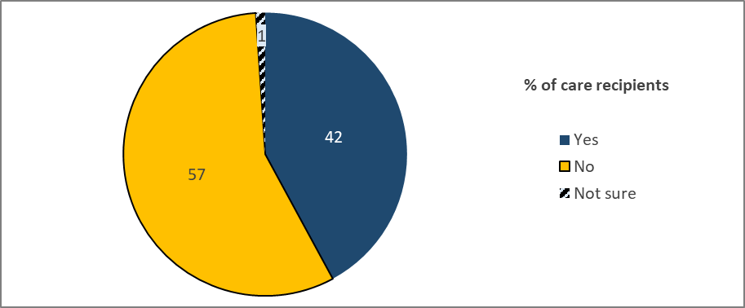

*Q21. Did you have a family member, spouse, friend or other carer present during your assessment?*

*N=563, all care recipients with assessment experience*

Only two in five (42%) care recipients reported being accompanied by a family member, spouse, friend or other carer during the assessment, with over half (57%) indicating they were not accompanied by anyone else.

### Assessment process

*Consumers (care recipients and carers)*

#### Figure : Care recipient satisfaction with assessment aspects, by wave

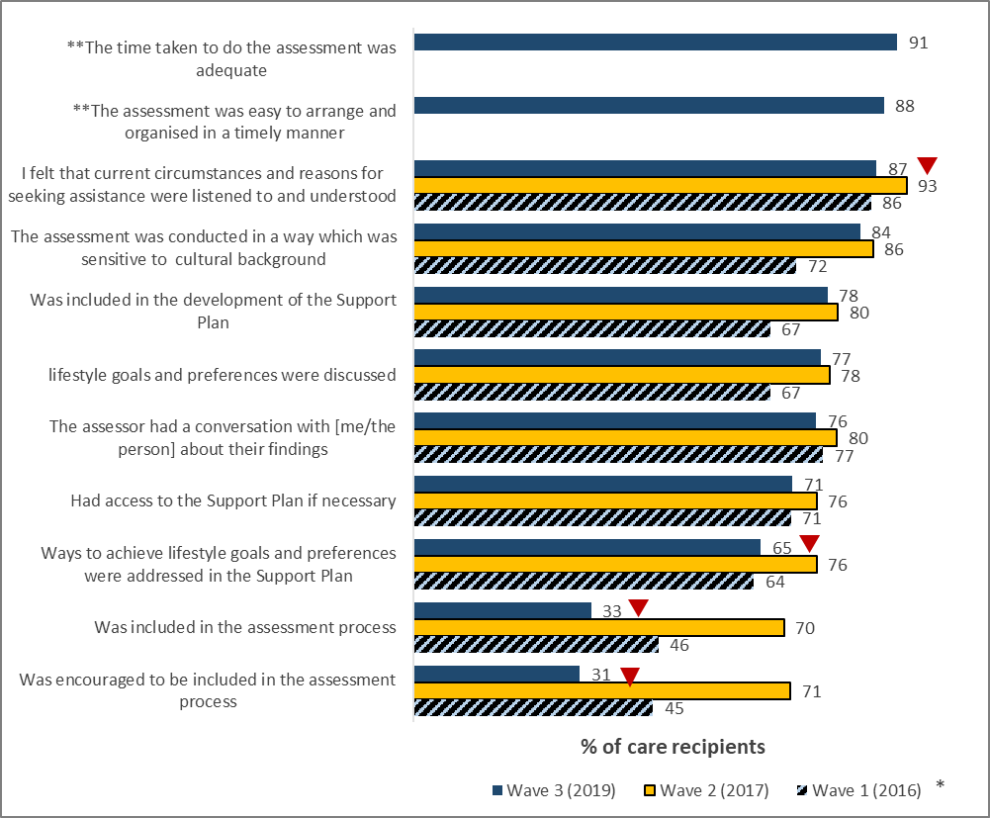

*Q23. To what extent do you agree or disagree with each of the following statements about the assessment?*

*N=563, care recipients with assessment experience; W2 n=427; W1 n=254*

*\*Please note: Wave 1 included a ‘not relevant’ option, which was selected by care recipients for the two codes above if they had no carer present. The score above is calculated omitting these responses because in this wave, the question was only asked if a carer was present.*

*\*\*Statement introduced in Wave 3 (2019)*

Recipients’ satisfaction with all but two of the prompted statements displayed some level of decline compared with the last wave, with significant declines in the endorsement that their circumstances and reasons for seeking assistance were listened to and understood (-6%), the support plan addressed their lifestyle goals and preferences (-10%), they were encouraged and included in the assessment process (-40% and -37% respectively).

Care recipients’ agreement with the statements presented regarding their assessment experience was generally very high, with the exception of ‘being encouraged to’ and ‘being included in’ the assessment process as discussed above. The remaining statements were agreed to by at least two in three recipients. This pattern suggests a positive assessment experience for most care recipients.

Agreement was highest for: that the time taken to do the assessment was adequate (91%), that it was easy to arrange (89%), that they had been listened to and understood (87%), that the assessment had been sensitive to their cultural background (84%), that they were included in the support plan (78%), and had discussed their lifegoals and preferences (77%).

In the qualitative phase, there were positive experiences reported in relation to the face-to-face assessments with participants commenting on how personable and friendly the assessors had been. Many reported feeling they had an opportunity to express their needs during the assessment:

*“It was great, it was like I meet a friend.”* Care Recipient, Female, Sydney

*“I was very happy also with the first visit. We talked I think for an hour and she explained what I could get. For me the main problem was cleaning the house and she told me that I will get that number and that it would be arranged. She also offered occupational therapy or something like that to come because my bathroom wasn’t appropriate for my hand, I cracked my hand. And organise another lady to come and organise people to come to fix those things.”* Care Recipient, Female, Adelaide

*“The lady that came to see me the same very warm and friendly I felt really good.”* Care Recipient, Female, Sydney

Participants felt the assessors were very knowledgeable, often explaining about additional services which could be accessed beyond those originally considered by the participant, which left the recipients feeling very informed. Some participants also reported being given very practical information about what to expect from services.

*“She gave me brochures of contacts for everything. That’s how I got onto Meals on Wheels, I got onto TLC, Tender Loving Cuisine. I got onto a multitude of shops where you can hire some walker type things … I even got three fire alarms put in and she said I could get it done for the whole house.”* **Care Recipient, Female, Sydney**

#### Figure 43: Carer satisfaction with assessment aspects, by wave

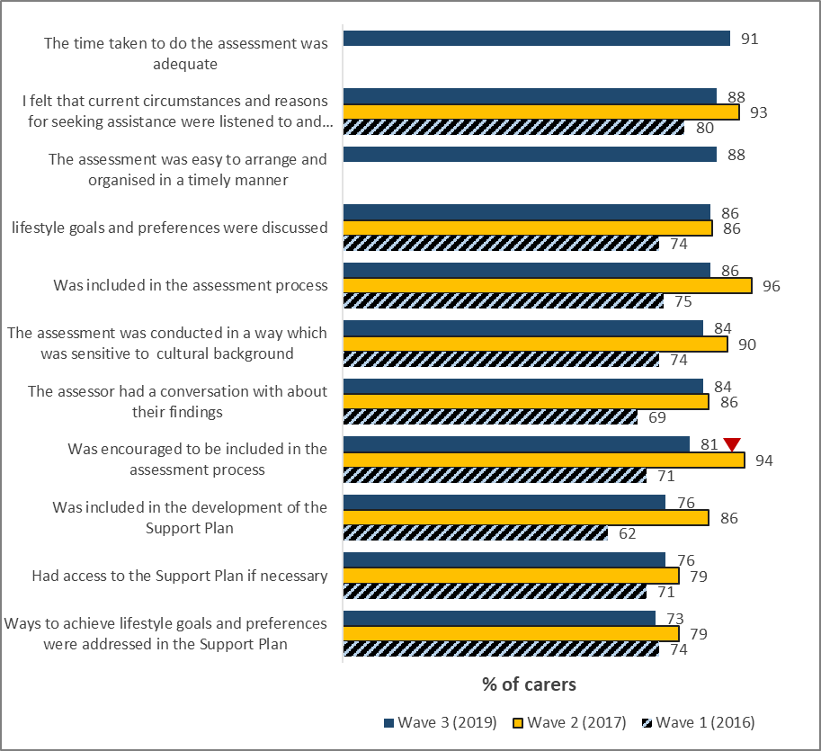

*Q23. To what extent do you agree or disagree with each of the following statements about the assessment?*

*N=71, carers with assessment experience; W2 n= 399; W1 n=264*

Carers’ agreement with aspects of the assessment were generally stable across 2016-2019. However, agreement that they were encouraged to be included in the assessment process declined significantly from 2017 (94%) to 2019 (81%).

Agreement with positive elements of the assessment was generally high, with three in four (all but one aspect rated 75% or higher) carers agreeing with the majority of statements.

There was greatest agreement that the time taken to do the assessment was adequate (91%) and that the reasons for seeking aged care assistance were listened to (88%).

Aspects of the assessment process were considered to be positive and thorough, especially those around the assessor’s ability to create a relaxed environment for the older person, and in their understanding of how to include the carer in the process.

Not all carers had wanted to or were able to attend the assessment. For those who were present, there were reports of a positive experience, with very punctual, knowledgeable, respectful and patient assessors. Many reported feeling they had an opportunity to express their needs during the assessment:

*“They were great. They were aware, they had information, the appropriate information. They just presented it in a very confident fashion.”* Carer, Female, Sydney, New South Wales

*“[The assessor] was very experienced at what she was doing and she had obviously been in a lot of situations very similar to ours and she knew how to control the meeting, she had an answer immediately to every question my sister and I had … she was very good at managing also my mother and taking away the anxiety so yes we were delighted with the assessment.”* Carer, Male, Adelaide

Other carers experienced difficulties booking a suitable appointment time for the assessment, given what appeared to be the busy schedules of assessors in the area and the inability to offer out-of-hours appointments, while others found scheduling easy. Carers working full-time could not secure after-hours appointments, while those with less firm time demands found scheduling their assessment easier.

*“They weren’t hard to get hold of, but it was slotting the time because they have so many people that they have to assess, there is obviously an ageing population in the eastern suburbs. It wasn’t hard but the time had to be juggled just because they were so busy.”* Carer, Female, Sydney

*“I was working, and I wasn’t there and I am the official carer and I couldn’t make it and they couldn’t change the date. I said to my sister when you book make sure it is after five … She asked and she got refused she said no we can’t make it after five it has to be between nine and four.”* Carer, Male, Sydney

#### Figure : Consumer overall satisfaction with assessment

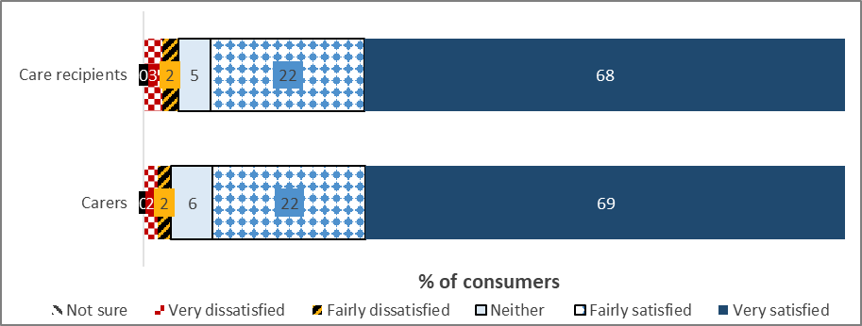

*Q24. Overall, how satisfied or dissatisfied were you with the face-to-face assessment process?*

*n=563 care recipients; n=71*

Overall satisfaction with the assessment experience was very high across 2016-2019 with around nine in ten (88-92%) indicating a degree of satisfaction. In 2019, this included two in three (68%) recipients being ‘very satisfied’.

In the qualitative research, many described the experience as being reassuring and mentioned the value of the face-to-face interaction for both themselves and their family member:

*“The woman [assessor] was good and professional and assessed that because mum is 95 but she showers herself and looks after herself and dresses herself and just a bit of shopping and taking her around so we all came to the consensus that it would be best to have her activated on the system for when she needs to access services.”* Carer, Male, Adelaide

#### Figure 45: Care recipient overall satisfaction with assessment, by wave

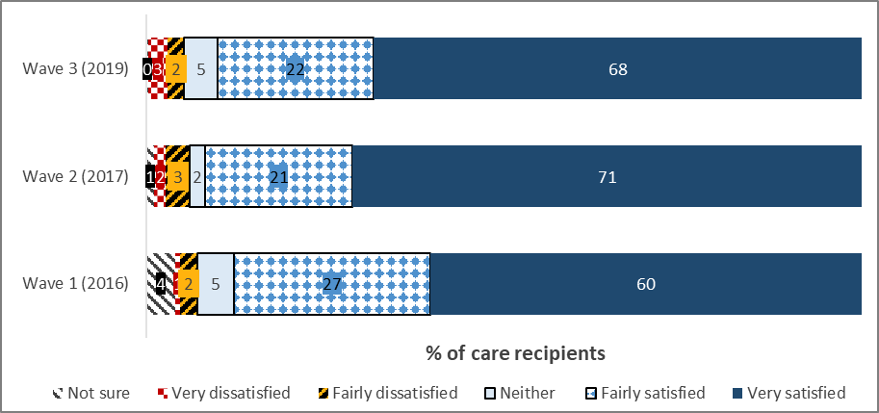

*Q24. Overall, how satisfied or dissatisfied were you with the face-to-face assessment process?*

*N=563, care recipients with assessment experience; W2 n=427; W1 n=254*

Overall satisfaction with the assessment experience has remained consistently high across waves.

*“She was good. Friendly and easy to understand, I’d give her a 10/10. Gave me a feeling of security for the future.”* HCP recipient, Male, Sydney, New South Wales

#### Figure 46: Carer overall satisfaction with assessment, by wave

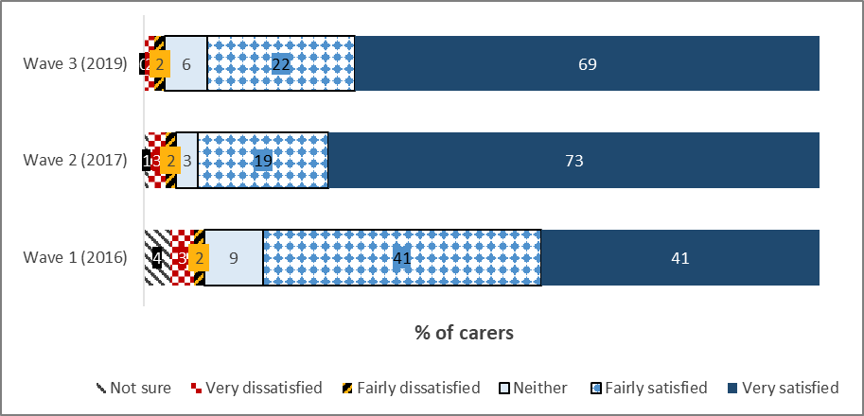

*Q24. Overall, how satisfied or dissatisfied were you with the face-to-face assessment process?*

*N=71, carers with assessment experience; W2 n=399; W1 n=264*

Overall satisfaction with the assessment experience among carers remains broadly consistent with Wave 2.

### Assessor training

#### Figure 47: Undertaking official training within the My Aged Care system

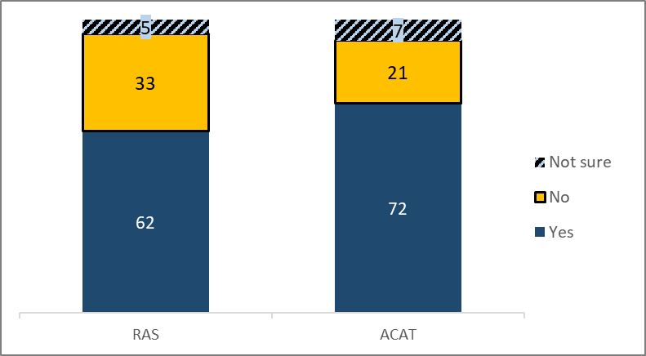

*Q17. Have you undertaken any official training on carrying out assessments within the My Aged Care system in the last two years?*

*RAS assessors N=306*

*ACAT assessors N=250*

Close to two in three RAS assessors (62%) reported having experienced official training on carrying out assessments within the My Aged Care system in the last two years, with 33% indicating they had not and 5% unsure.

Around seven in ten (72%) RAS assessors report having experienced training on carrying out assessments within the My Aged Care system, with 21% indicating they had not and 7% unsure.

#### Figure : Assessor satisfaction with assessment training

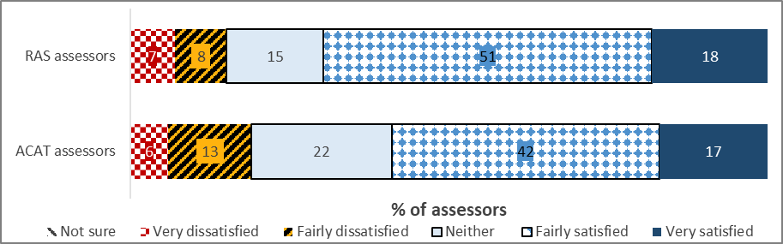

*Q15. How satisfied or dissatisfied were you that the training and information you received equipped you to carry out assessments effectively within the My Aged Care guidelines?*

*RAS n=190*

*ACAT n=179*

Satisfaction with assessment training is notably higher among RAS than ACAT assessors, with 69% and 59% (respectively) reporting some degree of satisfaction with the training and information received.

#### Figure 49: RAS assessor satisfaction with the training carried out within the My Aged Care system

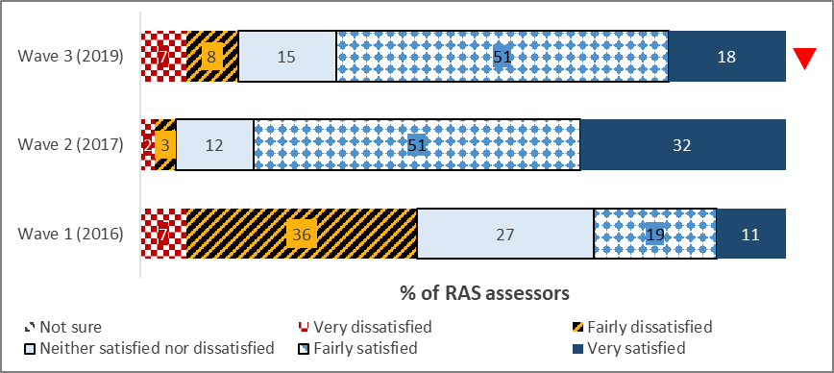

*Q18. How satisfied or dissatisfied were you that the training and information you received equipped you to carry out assessments effectively within the My Aged Care system in the last two years?*

*n=190, RAS assessors indicating received the training; W2 n=91; W1 n=84*

There was a significant decline in RAS Assessors indicating they were very satisfied with the training on conducting assessments, down from 32% in Wave 2 to 18% in Wave 3, contributing to an overall satisfaction decline from 83% to 69%.

There were some explanations offered in the qualitative research as to why satisfaction with the training carried out within the My Aged Care system has declined:

*“It was probably after I'd already been using it. I had already worked it out, so it wasn't anything new. You need to actually have it [training] and you need to know what they're talking about prior to doing the training, so you need to work with it as you go. It was just too repetitive and too over the top.”* RAS assessor, Melbourne, Victoria

#### Figure 50: ACAT assessor satisfaction with the training carried out within the My Aged Care system

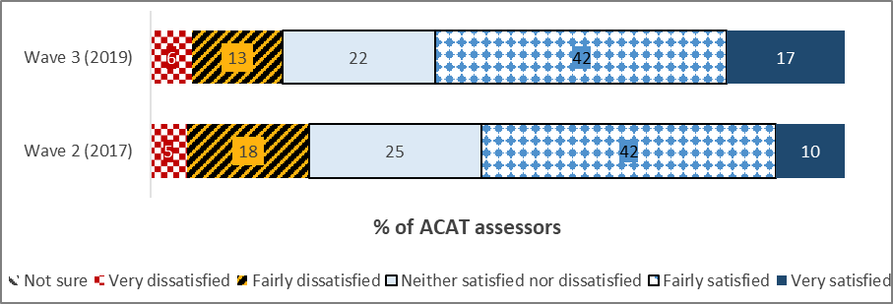

*Q18. How satisfied or dissatisfied were you that the training and information you received equipped you to carry out assessments effectively within the My Aged Care system in the last two years?*

*n=179, ACAT assessors indicating received the training; W2 n=170*

More than half of the ACAT assessor respondents (59%) who underwent training were satisfied that it equipped them to carry out assessments effectively within My Aged Care guidelines. Less than one in five (19%) were dissatisfied. These results are a small improvement on Wave 2.

*“Well yeah, the last reform on that had made the NSAF significantly simpler to complete and to navigate. The training we had about that at the time was quite useful. In particular, the feature on important parts of the NSAF into the assessment summary has been really useful, not only because it makes it easier for us, but also the ... It gives you a better idea of what the Commonwealth expects in the summary. I think we're getting more continuity and a more standardised summary coming out of that, because it's clearer what the expectations are. But using it itself, you know, certainly picked up at that point.”* ACAT assessor, Adelaide, South Australia

*“There is training, but subsequently I don't think there is a lot of training recently because with the offering of the national assessment form.”* ACAT Assessor, Manningham, Victoria

*“The timing of it, as with everything we've found with My Aged Care, is not great. Things are not fully in place at the point that they're being rolled out. There's a lot of finding as you go, and things that don't work as you expected them to work. So yeah there was some training and the user guides are good about that. So it was useful, but there is still room for improvement.”* ACAT Assessor, Houtman Abrolhos, Western Australia

### Aspects of conducting assessments

#### Figure 51: RAS assessor satisfaction with navigating the My Aged Care Assessor Portal, by wave

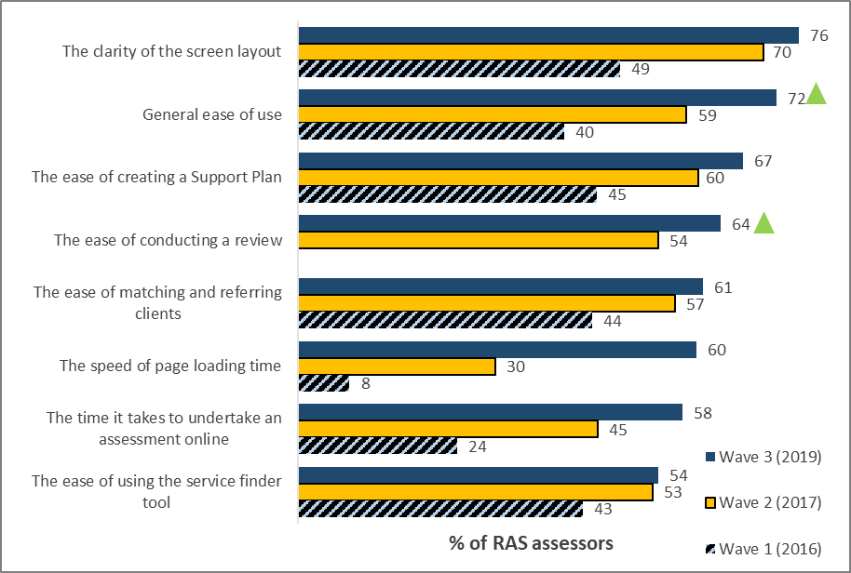

*Q22. How satisfied or dissatisfied were you with each of the following aspects of navigating the My Aged Care Assessor Portal platform during and after performing assessme*nts?   
Base: All RAS Assessor n=298, W1 n=142, W2 n=232

RAS assessors’ satisfaction with navigation of the Assessor Portal improved across all aspects in Wave 3 compared with Wave 2, with many of the improvements noted as significant including:

* the speed of page loading time (60% in Wave 3 vs 30% In Wave 2)
* general ease of use (72% in Wave 3 vs 59% in Wave 2)
* the ease of conducting a review (64% in Wave 3 vs 54% In Wave 2)
* the time it takes to conduct an assessment online (58% in Wave 3 vs 45% In Wave 2).

*“The portal is very useful. The first time was obviously when it was all set up in 2015 and it was a little bit confusing then, but with a bit of practice that was fine.”* **RAS Assessor, Queensland**

#### Figure 52: ACAT assessor satisfaction with navigating the My Aged Care Assessor Portal

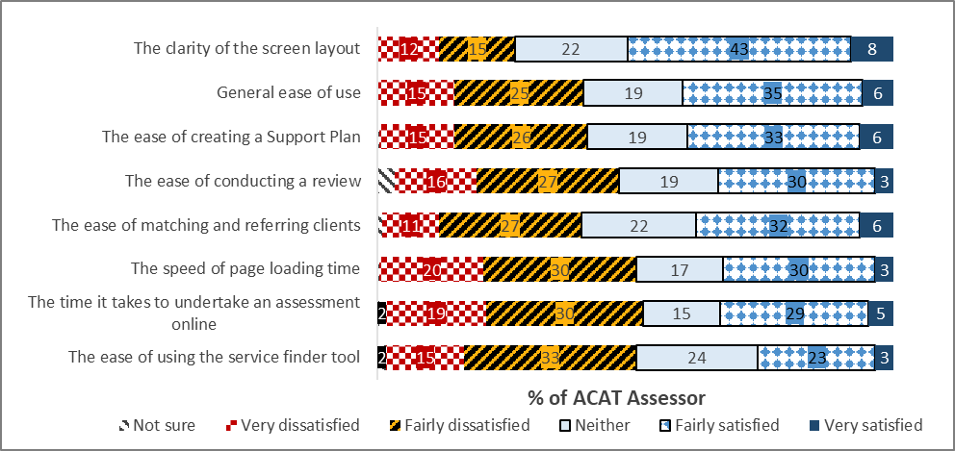

*Q22. How satisfied or dissatisfied were you with each of the following aspects of navigating the My Aged Care Assessor Portal platform during and after performing assessments?*

*Base: All ACAT Assessor n=233*

ACAT Assessors had mixed levels of satisfaction overall with navigating the My Aged Care Assessor Portal.

The highest level of satisfaction was for the clarity of screen layout (51%), however 27% were dissatisfied in this aspect.

The second highest level of satisfaction was with general ease of use (41%), however a similar proportion expressed dissatisfaction (40%). Areas such as ease of using the service finder tool (26% satisfied vs 48% dissatisfied) indicated that there were improvements required to drive satisfaction higher.

*“So, the system in itself that we see the referrals come through is quite clear. We are able to sort by the due dates of different things to help manage that, that works well.”* ACAT Assessor, WA

## Referral to Service and Service Provision

### Referral to services

*Care recipients*

#### Figure 53: Care recipient satisfaction with referral aspects, by wave

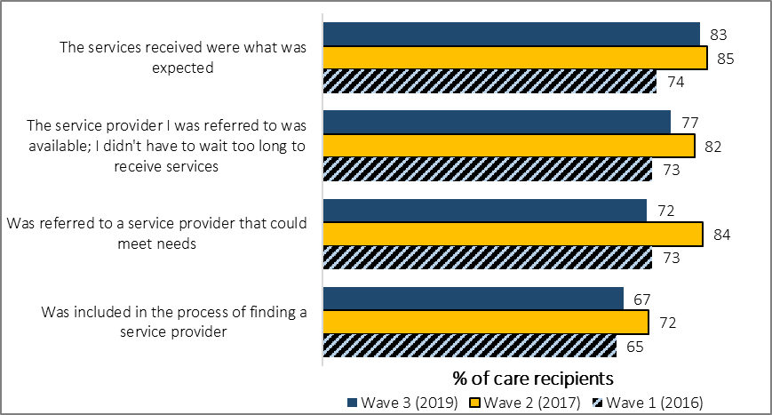

*Q28. To what extent do you agree or disagree with each of the following statements about the arrangement of aged care services through My Aged Care?*

*N=1,127, care recipients receiving services through My Aged Care; W2 n=537; W1 n=254*

At least two thirds (67%) of care recipients consulted indicated some level of agreement with each of the prompted aspects of the referral process through My Aged Care.

Three of the four statements’ agreement scores represented a significant decline from that recorded in the last wave of research. Most notably, agreement that:

* the service provider that they had been referred to was available/didn’t have to wait too long to receive services (77%)
* had been referred to a service provider that could meet their needs (72%)
* was included in the process of finding an aged care service provider (67%).

*Carers*

#### Figure 54: Carer satisfaction with referral aspects, by wave

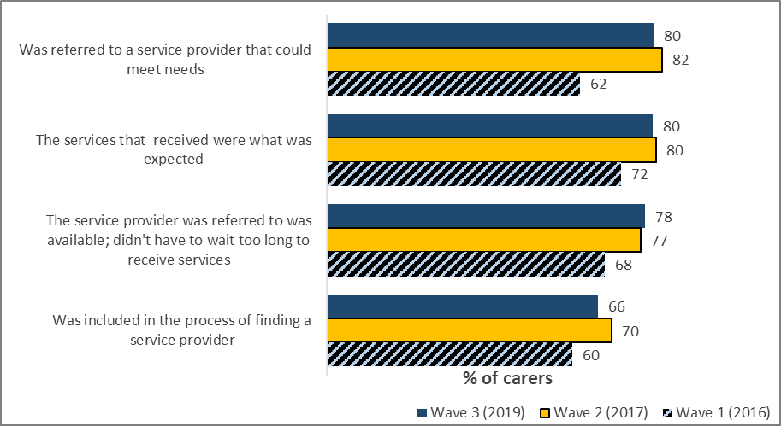

*Q28. To what extent do you agree or disagree with each of the following statements about the arrangement of aged care services through My Aged Care?*

*N=213, carers receiving services through My Aged Care; W2 n=543; W1 n=264*

All four of the surveyed statements were largely stable compared to the previous wave of research. The aspects receiving the highest satisfaction were “*referred to a service provider that could meet the care needs”* and “*the services received were what was expected”* – both at 80%.

*Service Providers*

#### Figure 55: Service Provider satisfaction with the usefulness of the Support Plan in planning service for clients, by wave

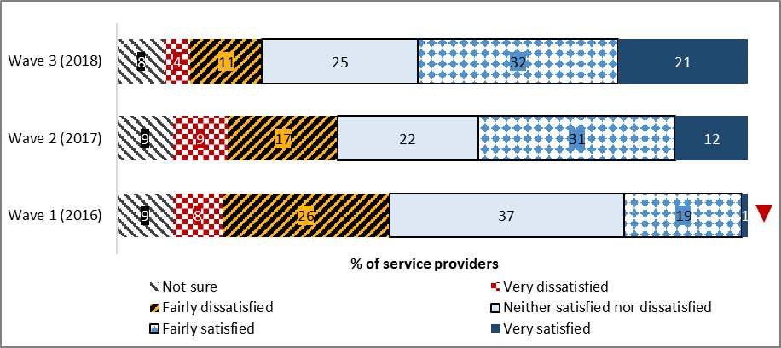

*Q22. Overall, how satisfied or dissatisfied are you with the usefulness of the Support Plan in planning services for clients?*

*n=501, all service providers; W2 n=300; W1 n=88*

Satisfaction with the usefulness of the Support Plan also continues to increase wave-on-wave, with 53% of Service Providers indicating some degree of satisfaction this wave. During the interviews, service providers commented that the support plans were useful in establishing the needs of clients and who in their staff is best placed to work with them.

Provision of services

*Care recipients*

#### Figure 56: Care recipient satisfaction with service aspects, by wave

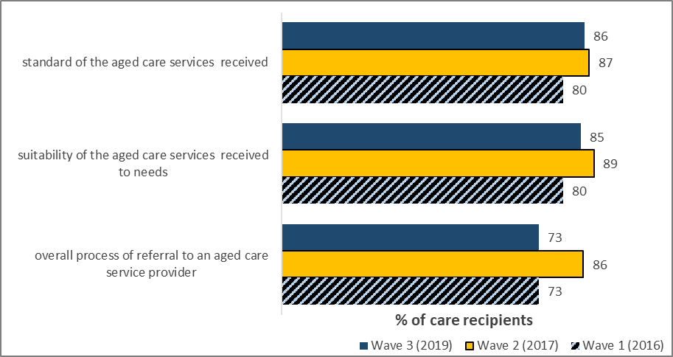

*Q29. And how satisfied or dissatisfied were you with each of the following?*

*N=1,127, care recipients receiving services through My Aged Care; W2 n=537; W1 n=254*

Satisfaction with the prompted aspects of the services they received remained stable from those last observed in Wave 2, with the highest endorsement seen for the standard of the service received (86%) and lowest for the overall process of referral to an aged care service provider (73%).

Qualitatively, care recipients spoke very positively about the provision of aged care services:

*“It was quite pleasant for me … She was a very personable lady … we had a good discussion and I told her exactly what I needed as far as cleaning was concerned and she said that would be fine. She offered me hydrotherapy which I certainly wasn’t expecting, and I was pleasantly surprised that it was.”* **Care Recipient, Female, Adelaide**

| ***% Fairly/Very satisfied*** | **Total (%)** | **Male (%)** | **Female (%)** | **Age**  **30-64 (%)** | **Age**  **65-74 (%)** | **Age**  **75+ (%)** |
| --- | --- | --- | --- | --- | --- | --- |
| The standard of the aged care services I received | 86 | 87 | 85 | 87 | 80 | 89 |
| The suitability of the aged care services I received to my needs | 85 | 85 | 84 | 74 | 80 | 87 |
| The overall process of referral to an aged care service provider | 79 | 76 | 71 | 61 | 71 | 74 |
| *Sample size* | *1127* | *307* | *820* | *31* | *374* | *722* |

#### Table 13: Satisfaction with service aspects, by demographics

Care recipients aged 65 to 74 were significantly less likely to be satisfied with the standard of the aged care they received (80%). In contrast, older care recipients were significantly more likely to report satisfaction with the standard and suitability of the service (89% and 87% respectively).

*Carers*

#### Figure 57: Carer satisfaction with service aspects, by wave

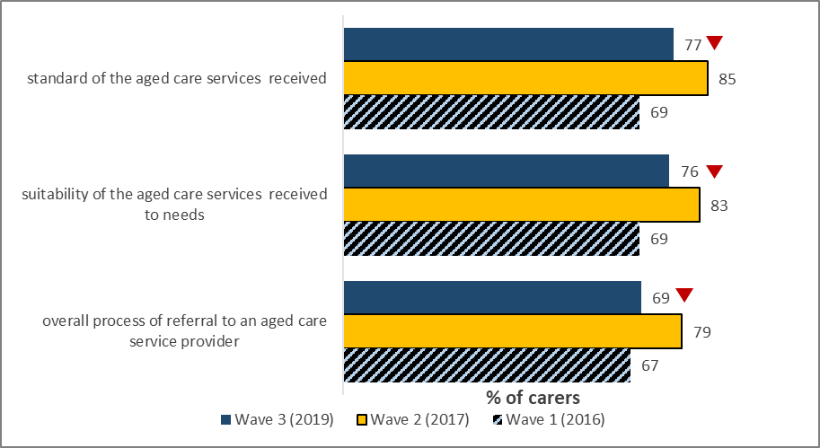

*Q29. And how satisfied or dissatisfied were you with each of the following?*

*N=213, carers receiving services through My Aged Care; W2 n=543; W1 n=264*

Among carers who participated in this wave, there has been a significant decline in satisfaction with all service aspects, noting a significant difference in the:

* standard of aged care service (from 85% to 77%)
* suitability of the services (83% to 76%)
* overall process of referral to an aged care provider (from 79% to 69%).

## Home Care Packages Program

As well as continuing to evaluate the My Aged Care reforms, this research also focussed on monitoring the implementation and effectiveness of the Increasing Choice in Home Care reforms and support continuous improvement.

As part of the research sampling for consumers, a pre-surveying matching process was undertaken to validate participants that have been approved for a Home Care Package and determine the status for receiving aged care services.

The total number of completed surveys by confirmed Home Care Package consumers are as follows:

#### Table : Summary Home Care Package sample size

| Type of Client | Home Care Package  completes |
| --- | --- |
| Care recipients | 440 |
| Carers | 158 |
| Total Clients | **598** |

Note: A proportion of participants were receiving interim services, including CHSP services, while they waited to be assigned a Home Care Package - 60% (n=43) of care recipients and 54% (n=11) of carers (n=43 and n=11 respectively).

Therefore, the total base for those **Not currently receiving a Home Care Package** is n=54.

### Accessing a Home Care Package

#### Figure : Action taken following assessment

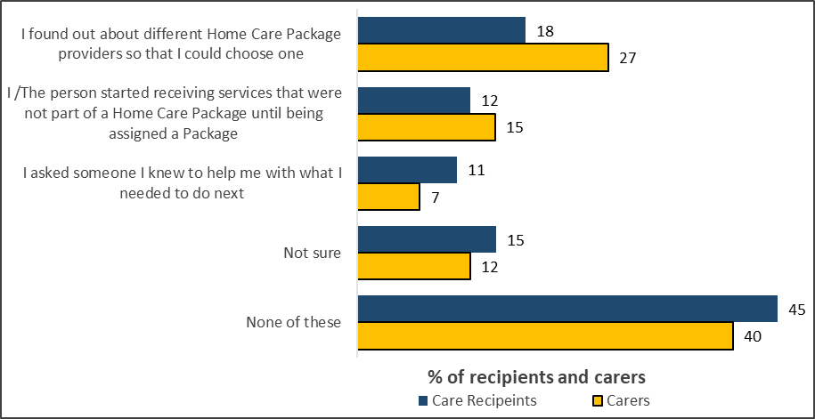

*Q38. Which of the following have you done since your assessment? Base: Recipients n=358, Carer n=75*

Just under one in five (18%) of care recipients and over one in four (27%) carers reported that they had searched for Home Care Package providers to help them make a choice.

A minority (11% care recipients and 7% carers) sought the advice of others to gain clarity on the steps proceeding the assessment.

Almost one in two (45% care recipients) reported that they have not taken any of the listed actions following their assessment. Among those who have taken action, 18% have found out about different providers and 11% had asked someone else for help with what to do next.

Similarly, just under half (40%) of carers have not taken any of the listed actions following the assessment of the person whom they care for, while over one quarter (27%) of carers have found out about the different providers that are available to deliver services to the person they care for.

#### Figure : Usage of information and resources

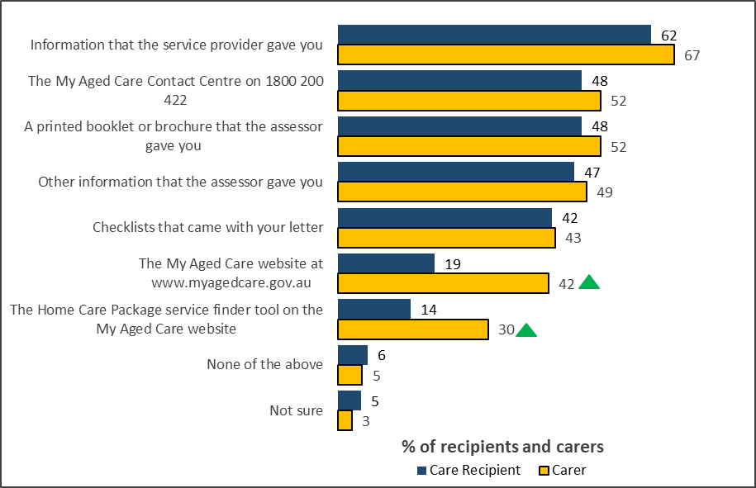

*Q46. Which of the following have you used to help you understand how to arrange services? Base: Eligible for a Home Care Package Care Recipients n=408, Carers n=144*

The majority (62%) of care recipients have used information supplied by a Service Provider to help them understand how to arrange a service. Almost half (48%) have sought information from the Contact Centre, and referenced printed brochures supplied by the assessor.

Among carers, utilisation of information and resources was similar. Two thirds (67%) referenced information given to them by the Service Provider, and just over half (52%) phoned the Contact Centre and read brochures supplied by the assessor.

Usage of the website and Home Care Package service finder tool is also significantly higher for carers than that for care recipients.

Qualitative findings highlight some of the positive aspects with using the website:

*“I think I went online [and there was] a list of services, the different type of services you can get so I became aware of a wide range of services.”* **Care Recipient, Male, Adelaide**

*“I look at the website and what is available so I rang up three and then they sent someone to come and talk to me and then they tell me about how much they charge and how much they charge per hour and what kind of service you can have so I find this quite helpful and quite easy.”* **Carer, Male, Adelaide**

#### Figure : Satisfaction with HCP set up information

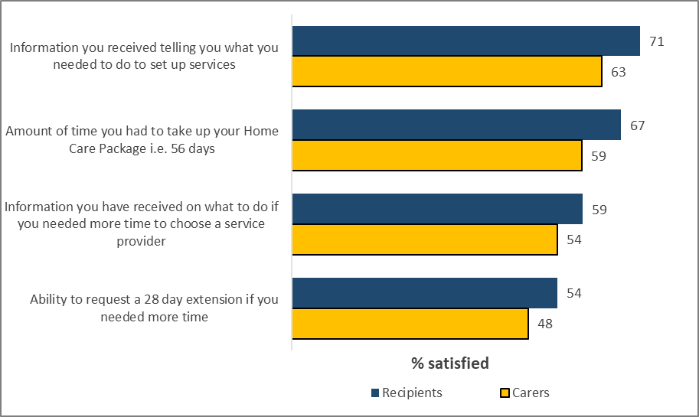

*Q45. When arranging your Home Care Package services, how satisfied have you been with each of the following? Base: Eligible for a Home Care Package – Recipients n=408, Carers n=144*

When arranging Home Care Package services, care recipients were most satisfied with information received about setting up services (71% satisfied) and having a 56-day period to do this (67% satisfied). Over half of carers were also satisfied with what to do if more time was required (59%) and ability to request a 28-day extension (54%).

Satisfaction among carers with information when arranging Home Care Package services was similar to that for care recipients. Satisfaction was highest for information received about setting up services (63% satisfied) and having a 56-day period to do so (59% satisfied). Around half of carers were also satisfied with what to do if more time was required (54%) and ability to request a 28-day extension (48%).

Qualitative findings reveal that some care recipients were well informed around the next steps and were provided with contacts to help set up services:

*“I think I went online [and there was] a list of services, the different type of services you can get so I became aware of a wide range of services.”* **Care Recipient, Male, Adelaide**

*“My Aged Care did send me an email with a couple of contacts which I didn’t do because I always went to the council ... I didn’t look into it but went straight to the council because of previous experience.”* **Care Recipient, Female, Adelaide**

### HCP service provision

| **Column %** | **Total** | **Male** | **Female** | **Age 30-64** | **Age 65-74** | **Age 75+** | **Income <$30k** | **Income $30k+** |
| --- | --- | --- | --- | --- | --- | --- | --- | --- |
| Daily | 6 | 6 | 6 | 7 | 10 | 4 | 8 | 4 |
| Four or more days per week | 7 | 14 | 5 | 13 | 9 | 6 | 5 | 16 |
| Two or three days per week | 17 | 23 | 15 | 27 | 21 | 15 | 16 | 16 |
| Weekly | 31 | 25 | 33 | 40 | 30 | 30 | 31 | 31 |
| Less frequently than once per week | 38 | 32 | 40 | 13 | 30 | 45 | 39 | 33 |
| Don't know / Can't remember | 0 | 0 | 0 | 0 | 0 | 1 | 0 | 0 |
| *Sample size* | *316* | *81* | *235* | *15\** | *112* | *189* | *190* | *45* |

#### Table 15: Care recipients: Frequency of HCP services, by demographics

The majority of recipients reported receiving Home Care Package services once a week (31%) or less than once a week (38%). Few (6%) reported receiving services daily. Frequency of services did not vary significantly by demographics or jurisdiction.

#### Figure : HCP services received

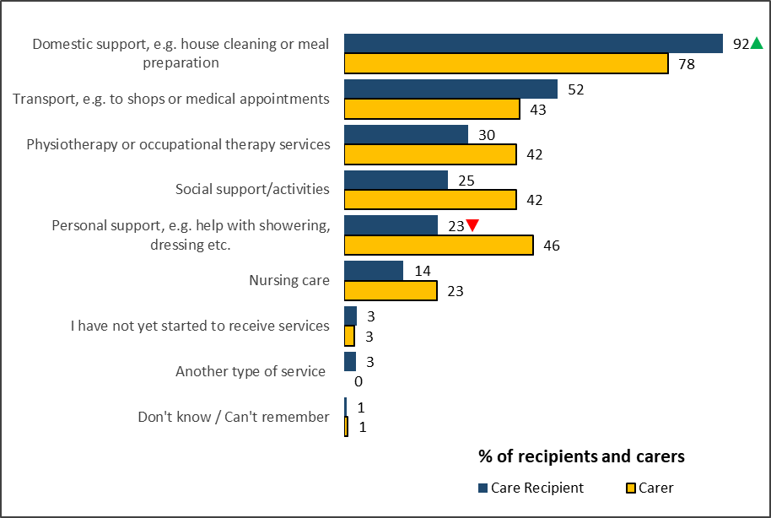

*Q30. Which of the following services do you receive as part of your Home Care Package?*

*Base: Recipients receiving a Home Care Package n=327, Carers receiving a home care package n=120*

Among care recipients receiving a Home Care Package, almost all (92%) are receiving domestic support, and over half (52%) are receiving transport assistance. One quarter reported receiving social support (25%) and personal support (23%).

Domestic support (78%) was also the most common service carers reported receiving. Carers were significantly more likely to report the person they are caring for is receiving personal support (46%), physio or occupational therapy services (42%), and social support (42%).

Among carers, the reported frequency of services received by the person they care for tended to be higher than reported by recipients. One quarter reported receiving services daily (11%) or four or more times per week (14%), while only 18% were receiving services less than once a week.

#### Figure : Interim aged care services

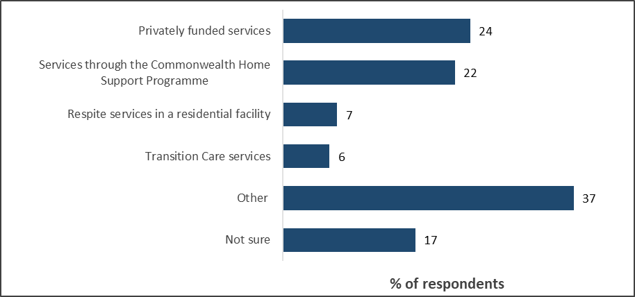

*Q39. Which of the following types of services have you received while waiting for HCP? Base: Not currently receiving a Home Care Package n=54*

The majority (83%) of those waiting for a Home Care Package (n=54) reported receiving interim services. These are fairly evenly divided between privately funded (24%) and CHSP (22%) services noting respondents were able to select more than one option.

While a relatively high proportion (37%) indicated receiving ‘other’ services, these responses were generally specific examples of the services they received (services that are likely arranged through CHSP) rather than how they were delivered, for example, podiatry, cleaning, physiotherapy, transport etc.

#### Figure : Reasons for not starting HCP services

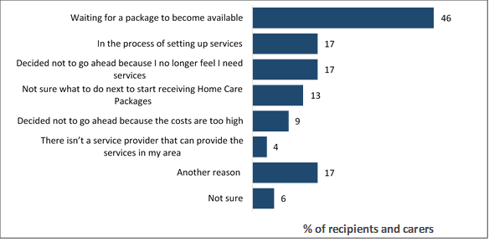

*Q40. Which of the following are reasons you have not started receiving Home Care Package services? Base: Not currently receiving a Home Care Package n=54*

Almost half (46%) of those who are not currently receiving a Home Care Package (n=54) are waiting for one to become available. Nearly one in five (17%) have decided they no longer need the service, while a similar proportion (17%) are currently setting up their service.

## Increasing Choice Reforms

### Awareness of reforms

On 27 February 2017, the Australian Government introduced the Increasing Choice in Home Care reforms. These were designed to improve the way home care services are delivered to senior Australians and support the move to a consumer-driven, market-based and less regulated system.

The key areas of change for consumers were:

* funding for a Home Care Package following the consumer providing more choice and flexibility for consumers to change providers
* a nationally consistent approach to Home Care Package assignment.

#### Figure 64: Awareness of reforms

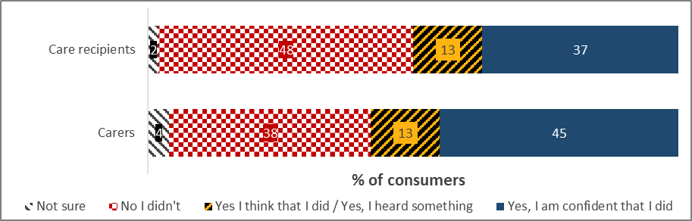

*Q35. Did you know about these changes before today?  
Base: Care recipients n=327, Carers n=120*

Almost half (48%) of care recipients had not heard about the Increasing Choice reforms. Awareness of the reforms was higher among carers (58%). However, a relatively high proportion (38%) had not heard anything.

#### Figure : Recipient attitudes towards HCP reforms

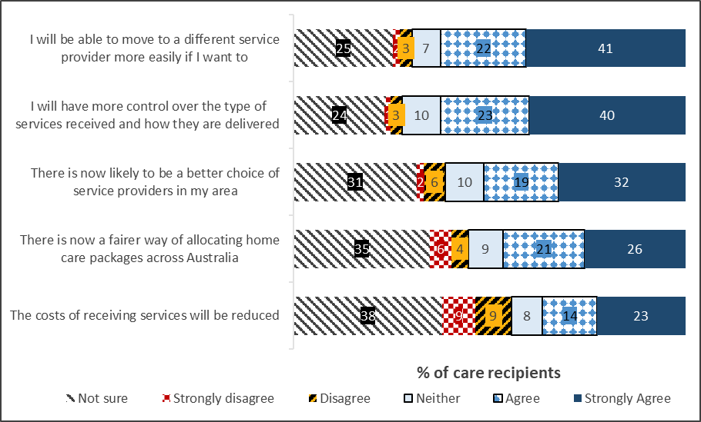

*Q37. To what extent do you agree or disagree with the following statements about the changes to the way home care packages are allocated? Base: Recipients n=327*

Attitudes of recipients towards the reforms were more positive around personal control and choice, including moving to a different service provider (62% agreeing) or selection of a provider in their area (51%), and control over accessing services (62% agreeing).

Close to half agreed with increasing fairness of allocation of packages (46%). However, there was less expectation that costs of services would be reduced (36% agreeing). Reduction in costs had the highest level of disagreement, by close to one in five (18%).   
It should be noted that a relatively high proportion were not sure what kind of impact the reforms would have on the way packages are allocated.

#### Figure : Carer attitudes towards HCP reforms

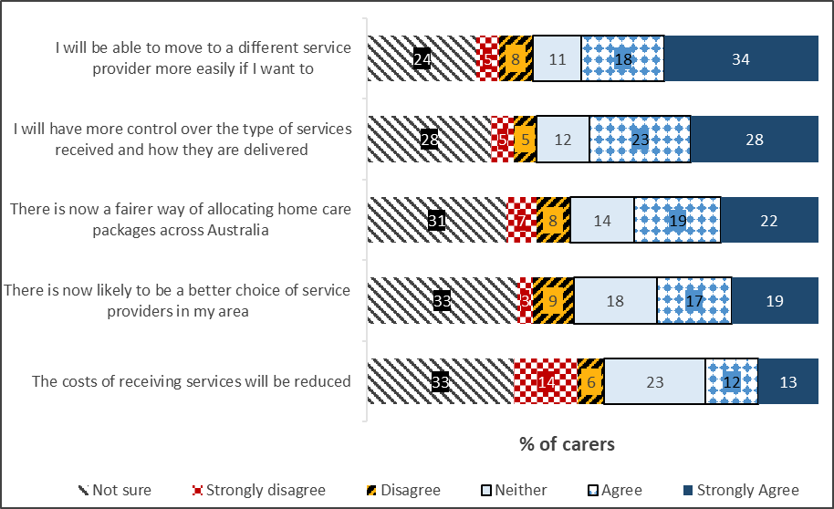

*Q37. To what extent do you agree or disagree with the following statements about the changes to the way home care packages are allocated? Base: Carers n=120*

Attitudes of carers tended to be less positive overall on each impact (around 10 percentage points lower in each case). As with recipients, carers were more positive around personal control and choice, including moving to a different service provider (53% agreeing) and control over accessing services (51% agreeing), and better choice of service provider in the area (41%).

Similar to recipients, a relatively high proportion of carers are also not sure of the impact the reforms would have on home care package allocation.

### Changing providers

#### Figure : Reasons for not considering changing provider

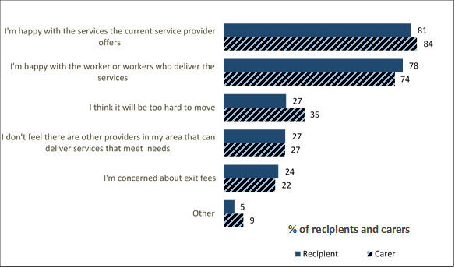

*Q43. Which of the following are reasons you would not consider changing providers? Base: Not considered changing provider – Recipients n=202, Carers n=94*

A relatively small proportion of recipients (14%) and carers (11%) reported changing provider after 27 February 2017. This was reflected in qualitative findings where recipients and carers appreciated having the option of change and felt this was important. However, most of those interviewed mentioned they would be unlikely to switch providers in the near future.

Among those who had changed provider, the three quarters (75%) found this process ‘very easy’ (45%) or ‘quite easy’ (30%). Qualitatively, those who had changed providers generally had an idea of which provider they wanted to switch to before making the change. The new provider tended to be one recommended by others.

Among recipients who have not considered changing provider, the majority reported being happy with the services of their current provider (81%) and happy with the workers who deliver the services (78%). Results were very similar for carers; with 84% reporting they are happy with the current provider and 74% happy with the workers. Although, carers were also slightly more pragmatic with 35% indicating they think it would be too hard to move.

## Consumer Outcomes

A Net Promoter Score (NPS) is calculated by asking respondents of their likelihood of recommending a product, service, or brand on a scale of 0 to 10, with an option for those who are unsure. Unsure responses are removed, and then the proportion of those offering an answer of 0 to 6 (Detractors) is subtracted from those offering a score of 9 or 10 (Promoters), while Passives (7-8) are omitted from the calculation. The resulting score can vary from -100 to +100 and is intended to provide a broad view of the net positivity or negativity towards the item measured.

### Consumer views on My Aged Care

NPS for care recipients in 2019 (+27) was lower than in 2017 (+40), and more similar to 2016 (+33). The change in 2019 from 2017 was influenced by an increase in rating 0-6 on the advocacy scale (from 16% to 23% overall) and a decline in rating 9-10 (from 53% to 49% overall).

Some participants suggested that if they had their time again, they would seek recommendations from others about service providers and the process overall and enlist the support of the care recipients’ health professionals.

*“Next time around I would know a lot more. Recommendations from other people, they tell you where to go, that makes a big difference.”* **Carer, Male, Sydney**

#### Figure 68: Care recipient likelihood of recommending My Aged Care (NPS), by wave

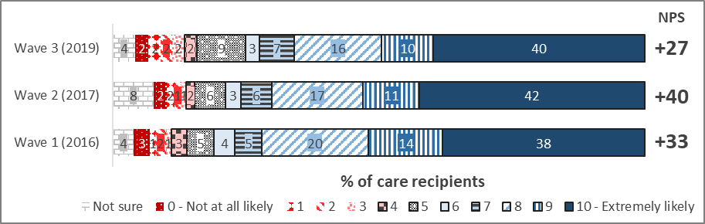

*Q50. How likely would you be to recommend My Aged Care for finding out information and accessing aged care services?*

*N=1,688, all care recipients; W2 n=841; W1 n=97*

#### Figure 69: Carer likelihood of recommending My Aged Care (NPS), by wave

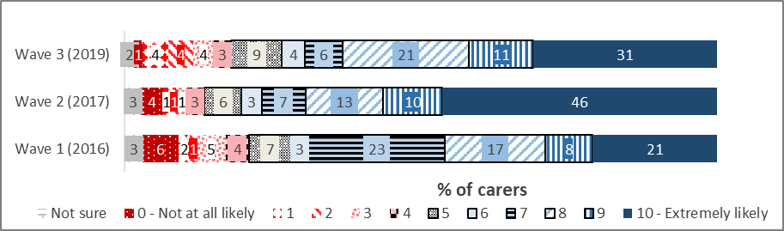

**+1**

**+13**

**NPS**

**+37**

Q50. How likely would you be to recommend My Aged Care for finding out information and accessing aged care services?

*N=313, all carers; W2 n=843*

NPS for carers in 2019 (+13) was lower than in 2017 (+37) but maintained some improvement over 2016 (+1). The change in 2019 from 2017 was influenced by an increase in rating 0-6 on the advocacy scale (from 20% to 29% overall) and a decline in rating 9-10 (from 56% to 42% overall).

NPS for carers in 2019 (+13) was lower than for care recipients (+27).

When asked what advice they would give others beginning their interactions with My Aged Care, some carers felt it was important to act sooner rather than later in getting their care recipients registered.

*“I have been asked at work and I have said to the person ‘don’t delay so the minute you think mum is getting on a bit or dad is getting on do it get onto it straight away before you actually really need the service’.”* **Carer, Female, Adelaide**

Having some experience of the system, participants would have liked a clearer idea at the onset about the different stages of the process involved and would suggest that others should research the process and what is involved before embarking on it.

*“Floundering with My Aged Care - we have had nobody at all that has led us through the system and the expectations and ok you have got an ACAT Level One what does it mean and how do you access it whereas with NDIS we were very carefully coached right through to the online portals, everything. First impressions were great and it is the aged care equivalent of NDIS but the assessment disappointed.”* **Carer, Male, Adelaide**

*Research as well the more research the better … [on the] internet, the GP, welfare services, support groups and clubs that they go to like bingo clubs and stuff maybe there should be information packages given out there that is where mum gets most of her information from.”* **Carer, Male, Adelaide**

### Consumer outcomes

*Service Provider*

#### Figure 70: Service Provider perceived ease for people navigating different aspects of the My Aged Care system

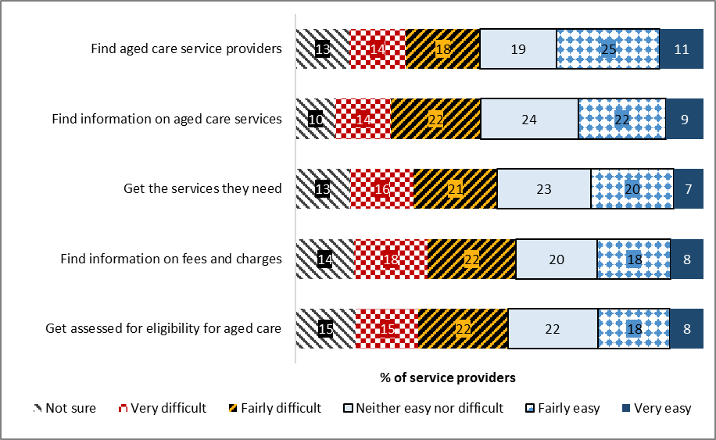

*Q45. How easy or difficult do you consider it is for people looking for aged care services to do each of the following through My Aged*

*Care? Base: n=501, all service providers*

Service Providers were also asked how easy they think it is for people to navigate the different aspects of the My Aged Care system. With the exception of finding aged care service providers, all areas received a higher proportion of ‘very difficult’ or ‘fairly difficult’ ratings than ‘very easy’ or ‘fairly easy’. Finding information on fees and charges (40%) was perceived to be the most difficult for people.

*Assessors*

#### Figure 71: RAS Assessor ease of looking for aged care services

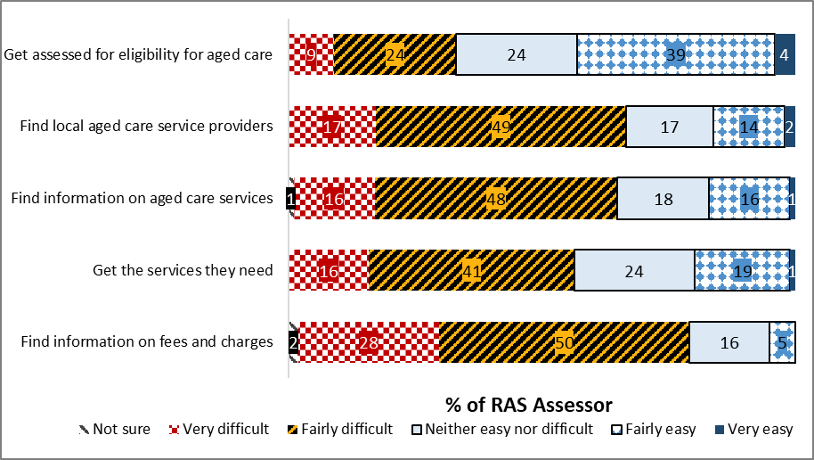

Q33. How easy or difficult do you consider it is for people looking for aged care services to do each of the following through My Aged Care?

*n=306, all RAS Assessors*

Aside from getting assessed for eligibility for aged care (43%), all other areas had very poor ease ratings, with most respondents indicating that looking for many aged care services is in fact fairly or very difficult. Finding information on fees and charges (78%) has the highest difficulty rating.

RAS assessors reported a lack of awareness about My Aged Care in general amongst consumers, which was noted in qualitative research.

*“A lady I saw just earlier this week, she didn't know about My Aged Care until she was at an information session at a local club. It's kind of one of those things that if you don't need it, you don't know about it, but then you don't know that you do need it. So yeah, I just think making information more available to people.”* **RAS Assessor, Kuring-Gai, New South Wales**

#### Figure 72: ACAT Assessor – consumer ease of looking for aged care services

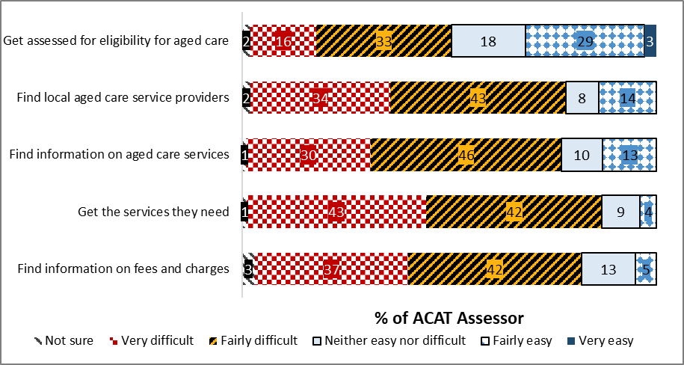

*Q33. How easy or difficult do you consider it is for people looking for aged care services to do each of the following through My Aged Care?*

*n=250, all ACAT Assessors*

There were high levels of consumer difficulty noted by ACAT Assessors across a range of consumer outcomes. 85% of ACAT Assessors claimed it was difficult for consumers to get the services they need, while results for being able to find information on fees and charges (79%), to find local aged care Service Providers (77%) and to find information on aged care services (76%) also indicated considerable difficulty.

*“I think that the system is not supporting them enough there that they should be able to go to a website and see, not only which providers are in their area, because you can find that on Find a Service, but also get some more details about the costings. That's what people want to know. They want to know how much percentage goes to admin and case management fees. They want to know the base costings that the workers are paid at because that will affect their hours. You know, they want to know that nitty-gritty detail about where to go and who's going to give them the best choice.”* **ACAT, Adelaide, South Australia**

*Health Professionals*

#### Figure 73: Health Professionals rating of aspects of My Aged Care performance

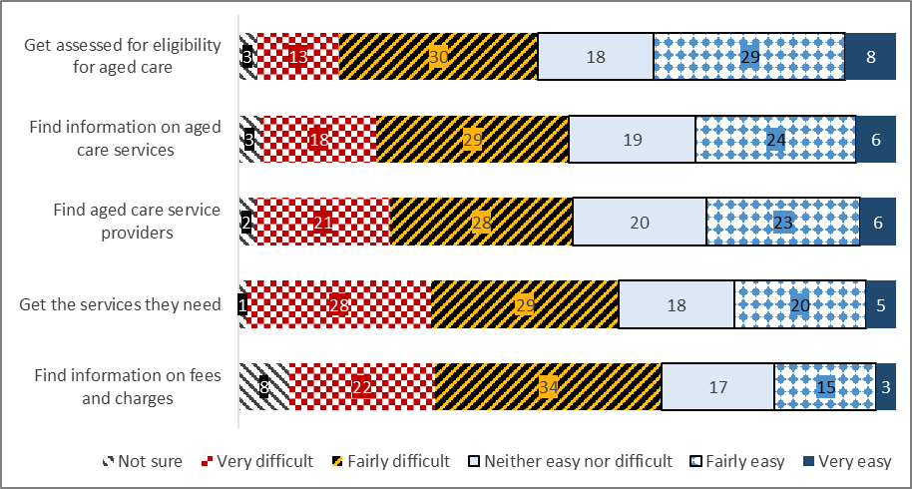

*Q22. How easy or difficult do you consider it is for people looking for aged care services to do each of the following through My Aged Care? Base: Total Health Professionals n=325*

Among Health Professionals surveyed, the best performing aspect of My Aged Care performance is the ease of getting assessed for eligibility for aged care, with 36% finding it easy to a degree. The poorest performing aspect was finding information on fees and charges (18%).

Notably, across all aspects, there is a greater proportion of responses indicating dissatisfaction rather than satisfaction.

#### Table 16: Rating of aspects of My Aged Care consumer outcomes (T2B), by profession

| **% Fairly/Very Easy** | **Total** | **GP** | **Nurse/**  **Hospital worker** | **Allied health prof.** | **Social worker** |
| --- | --- | --- | --- | --- | --- |
| Get assessed for eligibility for aged care | 37 | 56 | 19 | 34 | 29 |
| Find information on aged care services | 30 | 47 | 15 | 27 | 25 |
| Find aged care Service Providers | 29 | 47 | 18 | 24 | 19 |
| Get the services they need | 25 | 49 | 8 | 18 | 13 |
| Find information on fees and charges | 18 | 36 | 8 | 9 | 14 |
| *Sample size* | *325* | *104* | *62* | *79* | *80* |

Nurses and hospital workers were significantly less likely to indicate ease across assessment, information on aged care, and getting services aspects, while Social Workers were significantly less likely to indicate ease of getting the services they need (13% vs 25% average).

GPs were significantly more likely to find all aspects of My Aged Care consumer outcomes easy, as noted below in the qualitative research:

*“They're pretty knowledgeable. If you go through it and explain to them like, "These other things that are available," I would say definitely, I mean, be able to access, they're able to comprehend and understand and seek the correct help required. So I don't think that's a problem.”* **GP, Devonport, Tasmania**

#### Figure 74: GP rating of My Aged Care consumer outcomes

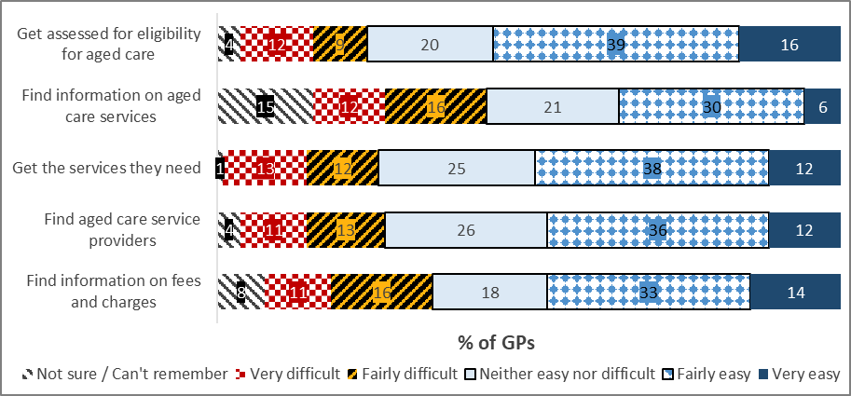

*Q22. How easy or difficult do you consider it is for people looking for aged care services to do each of the following through My Aged Care? Base: All GPs (W3 n=104)*

GPs believe that it was moderately easy for the older population to pursue aged care services through My Aged Care with at least one third indicating some degree of ease with the prompted aspects of the system, and strong levels of ease with the aged care eligibility assessment processes (55%).

#### Figure 75: Other Health Professionals rating of My Aged Care consumer outcomes

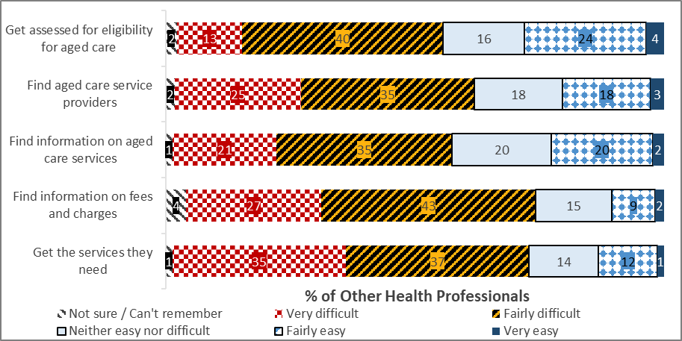

*Q22. How easy or difficult do you consider it is for people looking for aged care services to do each of the following through My Aged Care? Base: Other Health Professionals (W3 n=88)*

Other Health Professionals were on the whole sceptical about the ease of accessing aspects of My Aged Care for consumers, evident by difficulty ratings above 50% (53% to 71%) across all 5 aspects of the My Aged Care services. The highest rated aspect was the perceived ease to get assessed for eligibility for aged care services (28%), and the lowest rating for the patients’ ability to receive the services they need, with more than one in three (35%) Other Health Professionals rating this as ‘very difficult’.

## Special Needs Groups (Culturally and Linguistically Diverse, Aboriginal and Torres Strait Islander and Area subgroups)

#### Table : Care recipient My Aged Care experience, by Special Needs group

| **% very satisfied + fairly satisfied (T2B)** | **Total** | **Remote areas** | **ATSI** | **CALD** |
| --- | --- | --- | --- | --- |
|
| How satisfied or dissatisfied are you with the way the aged care system allows older Australians to access quality services? | 72 | 75 | 58 | 73 |
| *Sample size* | *1688* | *157* | *43* | *95* |

No significant differences were noted by remoteness or special needs groups compared to the total of all care recipients surveyed.

#### Table : Carer satisfaction with My Aged Care, by Special Needs group

| **% very satisfied + fairly satisfied (T2B)** | **Total** | **Rural and Remote areas** | **ATSI** | **CALD** |
| --- | --- | --- | --- | --- |
|
| How satisfied or dissatisfied are you with the way the aged care system allows older Australians to access quality services? | 58 | 74 | 33 | 44 |
| *Sample size* | *313* | *27\** | *12\** | *32* |

Low base size preclude meaningful analysis by those based in remote locations and Aboriginal and Torres Strait Islander subgroups.

#### Figure 76: Care Recipient satisfaction with the way the aged care system allows older Australians to access quality services, among CALD

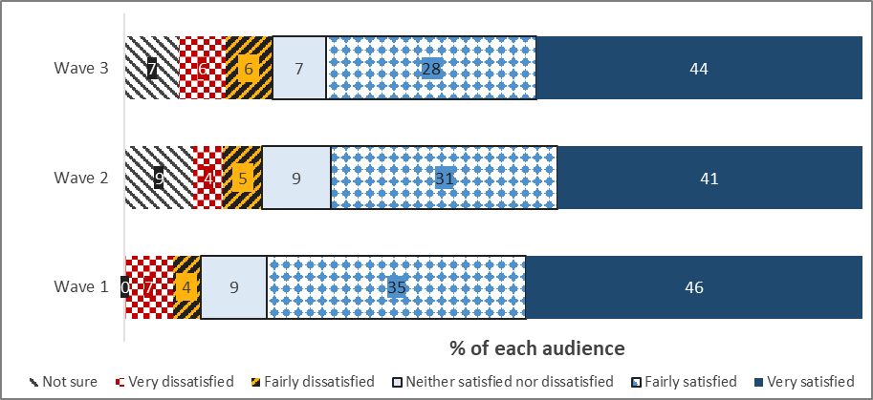

Q8. Overall, how satisfied or dissatisfied are you with the way the aged care system allows older Australians to access quality services?

Care recipients: Wave 3 n=95, Wave 2 n=75, Wave 1 n=58

Satisfaction with the way the aged care system allows older Australians access to quality services remains steady among the Culturally and Linguistically Diverse subgroup.

#### Figure 77: Carers rating satisfaction with the way the aged care system allows older Australians to access quality services, among CALD

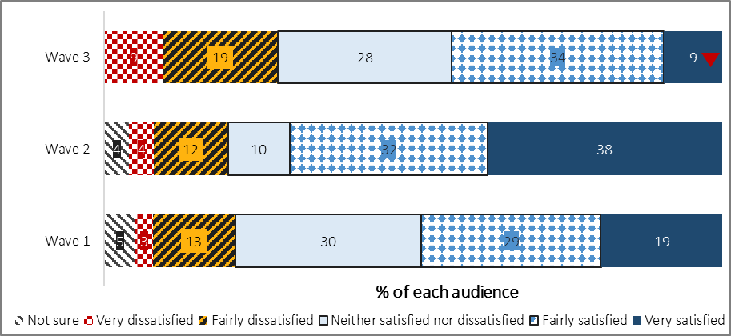

Q8. Overall, how satisfied or dissatisfied are you with the way the aged care system allows older Australians to access quality services?

Carer: Wave 3 n=32, Wave 2 n=50, Wave 1 n=108

There were some declines seen in those very satisfied with the way the aged care system allows older Australians to access quality services among CALD carers.

#### Figure 78: Care Recipient satisfaction with the way the aged care system allows older Australians to access quality services, among Aboriginal and Torres Strait Islander subgroup

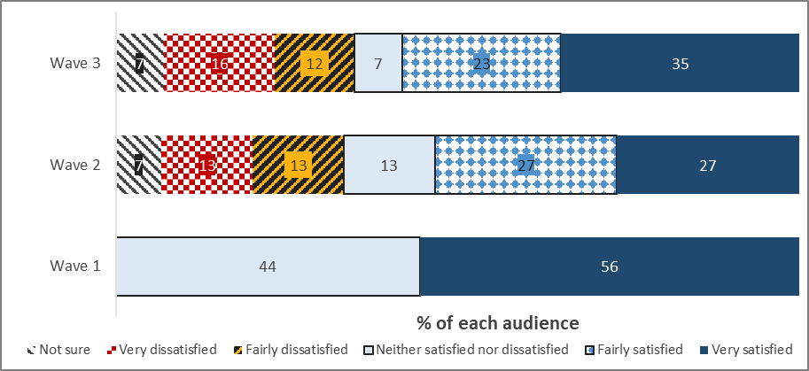

Q8. Overall, how satisfied or dissatisfied are you with the way the aged care system allows older Australians to access quality services?

Care recipients: Wave 3 n=43*, Wave 2 n=15*, Wave 1 n=11*

#### Figure 79: Carers satisfaction with the way the aged care system allows older Australians to access quality services, among Aboriginal and Torres Strait Islander subgroup

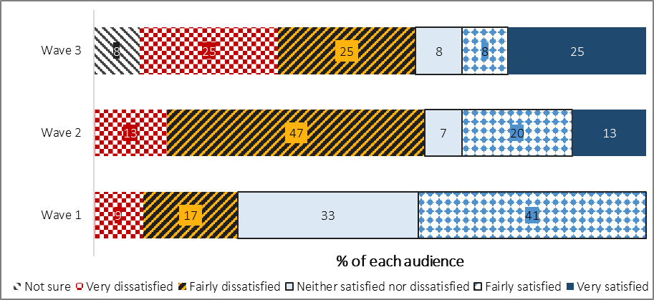

Q8. Overall, how satisfied or dissatisfied are you with the way the aged care system allows older Australians to access quality services?

Care recipients: Wave 3 n=12*, Wave 2 n=15*, Wave 1 n=10*

#### Table : Care recipient satisfaction with My Aged Care, by area

| **% very satisfied + fairly satisfied (T2B)** | **Total** | **Major City** | **Inner Regional** | **Outer/Very Regional** |
| --- | --- | --- | --- | --- |
| How satisfied or dissatisfied are you with the way the aged care system allows older Australians to access quality services? | 72 | 72 | 73 | 75 |
| *Sample size* | *1688* | *1085* | *433* | *157* |

#### Table :Carer satisfaction with My Aged Care, by area

| **% very satisfied + fairly satisfied (T2B)** | **Total** | **Major City** | **Inner Regional** | **Outer/Very Regional** |
| --- | --- | --- | --- | --- |
| How satisfied or dissatisfied are you with the way the aged care system allows older Australians to access quality services? | 58 | 54 | 60 | 74 |
| *Sample size* | *313* | *213* | *73* | *27\** |

Satisfaction with the aged care system was steady across carer subgroups with no significant differences by area.

#### Table 21: Care recipient – Culturally And Linguistically Diverse, Aboriginal and Torres Strait Islander and Total Summary Contact Points

|  | ***Sample size***  ***(n=)*** | **Website information** | **Contact Centre Information** | **Screening outcome** | **Assessment experience** | **Referral process** | **Aged Care System** |
| --- | --- | --- | --- | --- | --- | --- | --- |
| ATSI | *43* | 50%* | 74% | 83% | 78%* | 61% | 58% |
| CALD | *95* | 77% | 76% | 84% | 94% | 78% | 73% |
| Rural and Remote areas | *31* | 68% | 75% | 90% | 92% | 76% | 75% |
| Special Needs Total | *283* | 69% | 76% | 85% | 91% | 75% | 72% |
| Non-Special Needs | *1405* | 71% | 79% | 82% | 90% | 72% | 72% |

Satisfaction with key touch points across the My Aged Care System do not vary significantly for special needs recipients. While not significant, it should be noted that Aboriginal and Torres Strait Islander satisfaction with the aged care system as a whole remains somewhat lower than other groups.

#### Table 22: Carer – Culturally And Linguistically Diverse, Aboriginal and Torres Strait Islander and Total Summary Contact Points

|  | ***Sample size***  ***(n=)*** | **Website information** | **Contact Centre Information** | **Screening outcome** | **Referral** | **Aged Care System** |
| --- | --- | --- | --- | --- | --- | --- |
| ATSI* | *12\** | 67%* | 67%* | 67%* | 71%* | 33%* |
| CALD | *32* | 71%* | 66% | 59% | 55% | 44% |
| Rural and Remote areas | *14* | 79% | 81% | 67% | 84% | 74% |
| Special Needs Total | *69* | 72% | 71% | 62% | 67% | 54% |
| Non-Special Needs | *244* | 59% | 77% | 82% | 70% | 59% |

For the most part, special needs carers display satisfaction levels consistent with those of non-special needs carers, although special needs carers are significantly less satisfied with the screening outcome.

1. The specific test compares the result for a group with the rest of the population.
2. Technically this practice rests on the assumption that the survey was randomly sampled, which was not the case for this study, although random dialling of records was employed within the sample records possessed. Nevertheless, it is retained as a useful heuristic of noteworthy discrepancies between varying respondent subgroups, and one that takes relative sample sizes into consideration.
3. A Net Promoter Score (NPS) is calculated by asking respondents of their likelihood of recommending a product, service, or brand on a scale of 0 to 10, with an option for those who are unsure. Unsure responses are removed, and then the proportion of those offering an answer of 0 to 6 (Detractors) is subtracted from those offering a score of 9 or 10 (Promoters), while Passives (7-8) are omitted from the calculation. The resulting score can vary from -100 to +100 and is intended to provide a broad view of the net positivity or negativity towards the item measured.