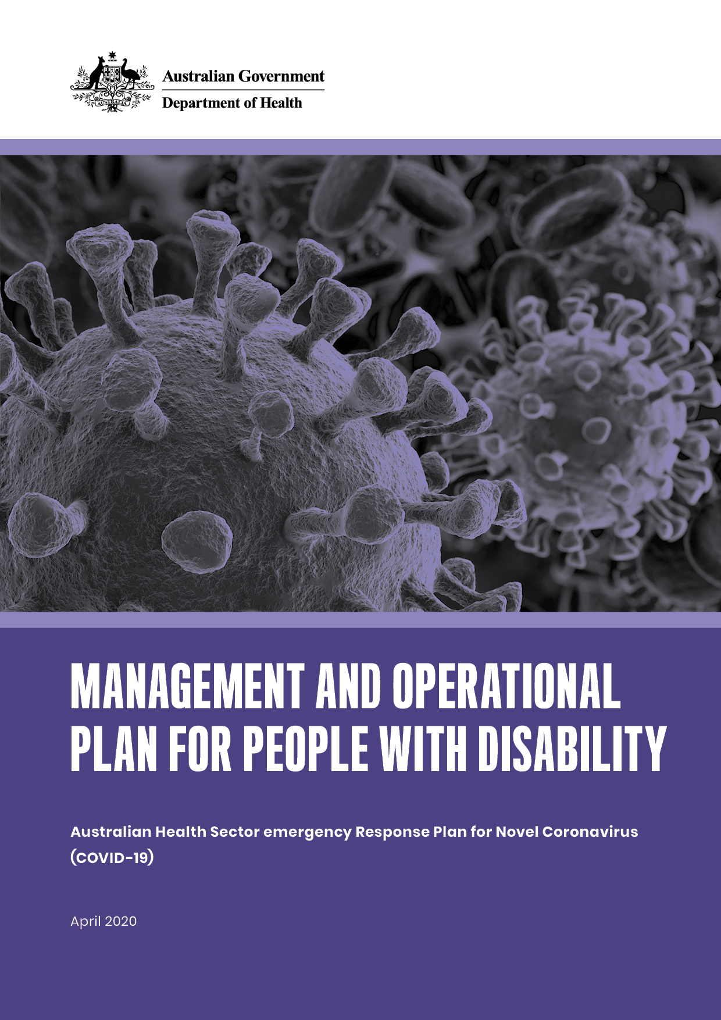
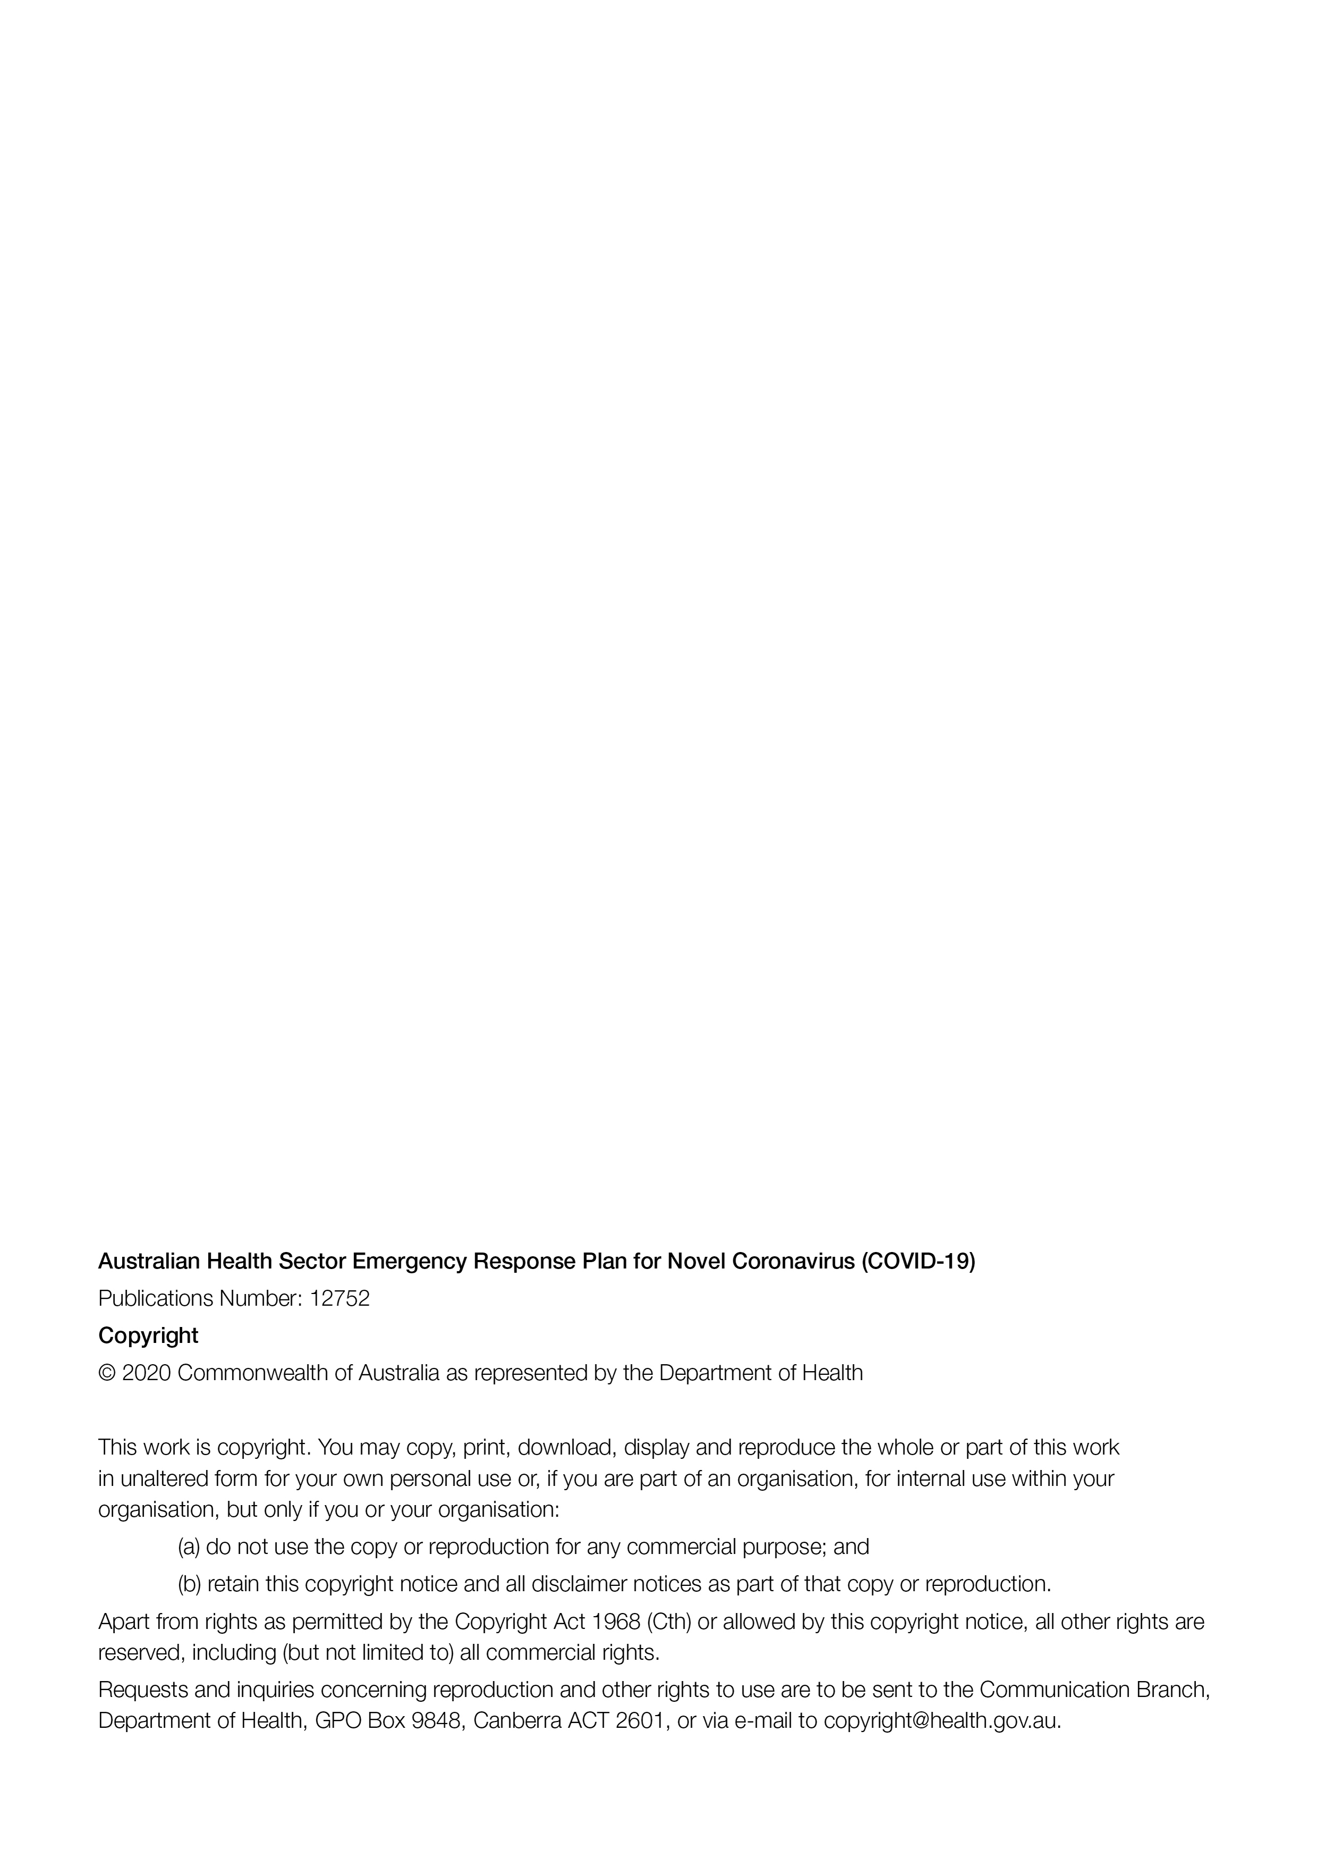

Contents
Contents 3
Introduction 4
PART 1 5
The Plan 5
Objectives 5
Principles 6
Rationale for the Plan 7
Roles and Responsibilities 8
Governance and Consultation 8
PART 2 9
Operational Plan as it relates to people with disability 9
Phase 1: Preparedness 9
Phase 2: Targeted action 10
Phase 3: Stand down and Evaluation 10

Introduction
On 11 March 2020, the World Health Organization (WHO) announced that novel coronavirus (COVID-19) was a worldwide health emergency. COVID-19 is a big risk to Australia. However, Australia is well prepared and has excellent health systems to deal with the virus.
The Australian Government wants to make sure that people with disability and their families have fair access to health care during the viral outbreak. This includes health and disability support advice that is easy to understand for all people with disability, and access to key supports and services. In this document, people with disability refers to people who have long-term physical, mental, intellectual, cognitive or sensory impairments.
COVID-19 will be difficult for many people with disability, including children and young people, the people who provide support to them, and the entire disability sector. Some people with disability are more likely to experience the effects associated with COVID-19.
The Management and Operational Plan for COVID-19 for People with Disability (the Plan) has been developed to provide a direct plan of action for the health care needed by people with disability, their families and support workers.
Developing the Plan also means that the Government is keeping its promise to uphold the United Nations Convention on the Rights of Persons with Disabilities (CRPD) and the National Disability Strategy 2010-2020. Both of these documents take a social model view of disability. The social model of disability recognises that disability happens because of the interaction between persons with impairments and attitudinal and environmental barriers that stop them from participating fully in society on an equal basis with others.
The CRPD emphasises the rights of people with disability to life and the same standard of health care as other people.
Additionally, under the Disability Discrimination Act (Cth) 1992 the Government is committed to removing discrimination against people with disability, and ensuring that the basic rights of people with disability are recognised on the same basis as the rest of the community. Implementation of the Plan will also uphold what the Government needs to do under the Carers Recognition Act (Cth) 2010.
For this document, the following definitions will be used:
Carer means: a person who provides unpaid care and support to people with disability who are family members or friends. In this summary document, the word families is used to include families who have carer roles.
Support worker means: a person who provides paid support to a person with disability.

PART 1

The Plan
The Plan has been developed for people of all ages with disability, their families, support workers and the disability and health care sectors. The Plan will take a risk-based approach, prioritising individuals whose disability, current health status and the setting in which they live, places them at a bigger risk of negative outcomes related to COVID-19.
The Plan will be updated and reviewed from time to time, in line with the Australian Health Sector Emergency Response Plan for Coronavirus. The Plan was developed, and its implementation will be overseen, by an Advisory Committee and it has been endorsed by the Australian Health Prevention Principal Committee and the National Cabinet.
Members of the Advisory Committee are experts from a range of backgrounds including people with disability, family members, Disabled Peoples Organisations, the disability service sector, the research sector, the health care sector including medical practitioners, allied health professionals and nurses, Australian Government officials, and state and territory government officials.

Objectives
The objectives of the Plan are to:
- minimise the spread of COVID-19, and illness and/or death caused by the virus for people with disability
- guide action across Australia to reduce the risk of people with disability catching COVID-19
- provide information to and empower all people with disability, their families, and support workers in relation to COVID-19
- identify the scientific nature of the virus, and determine how severe the disease is for people with disability
- support effective health care, including rehabilitation, for people with disability who contract COVID-19, and reduce additional challenges from COVID-19 for healthcare and disability support workers
- support people with disability in continuing to access vital health care for conditions that are not related toCOVID-19throughout the virus period.
Please note: decisions on the implementation of public health measures may vary across state and territory governments.

Principles
The following principles underpin the Plan and actions under it:
- EQUITY: The human rights of people with disability are maintained through a health care response that is fair, accessible for everyone, and specific to people with disability.
- PREVENTION: Preventing people with disability becoming infected is the main focus.
- INFORMED: People with disability, their families and support workers understand what to do during the virus outbreak and how to access support.
- TARGETED: Clear and targeted information and advice is communicated in a range of accessible ways.
- SUPPORT NETWORKS: Supporters of people with disability (families, support workers and others providing formal and informal supports) are important to the safety of people with disability, during the virus outbreak.
- PARTNERSHIPS: The health sector and the disability sector must work together to respond to the range of needs that people with disability, their families and support workers have.
- CULTURAL CONSIDERATION: Aboriginal and Torres Strait Islander people with disability need specific focus in this plan and associated plans, with underlying disadvantage, cultural considerations, remoteness and other issues making it challenging for this group to have fair and equal access to health care and other supports.
- WELLBEING: protect the mental health and wellbeing of people with disability and their families by involving them in making decisions and not disrupting their daily lives. Where appropriate, provide appropriate health care in non-hospital settings as much as possible, and provide the necessary support that people with disability need.

Rationale for the Plan
The COVID-19 pandemic presents a significant risk to the health and wellbeing of all Australians, but particularly people with disability. More than 4.4 million people in Australia have disability – this is equal to almost one in five Australians. The issues and risks with COVID-19 for people with disability may vary with the type of disability (e.g. intellectual disability, mobility impairments ) as well as factors such as age, gender, socio-economic status, family environment, where someone lives, whether they are Aboriginal or Torres Strait Islander, and whether they are from culturally and linguistically diverse backgrounds.
People with disability live and work in a range of places and they are active members of the community. Some people live at home by themselves, others live with family members, or in congregate disability accommodation services or group homes. Some work within organisations that provide job opportunities for people with disability. Some places may increase the risk of illness or death, including when an ageing person cares for a person with disability. These places need extra planning and support to prevent the spread of COVID-19.
Many people with disability experience more illness than other people including managing a range of complex health needs. They also experience higher rates of death.
Fifty per cent of people with disability in Australia live in households with a low income, compared with 24 per cent of other Australians.
Many people with disability also come from multiple ‘priority’ population groups and this can have a strong effect on their health needs and outcomes. For example, many people with disability from rural and remote areas also have a lower socioeconomic status, may identify as an Aboriginal or Torres Strait Islander, identify as LGBTI+ or are from a culturally and linguistically diverse background.
In addition, the following factors play a big role in increasing COVID-19 risk for people with disability:
- impaired health literacy, at times due to information that is not accessible for all people, may affect a person’s ability to stay safe and stick to the COVID-19-related prevention and management rules, which are often changing
- the reliance on other people including family members and support workers to provide support at close contact
- people with high and complex support needs (including behaviours of concern) may need extra support so that their needs are met, including communication or behavioural support. People in these situations may not be able to self-isolate in the same way as the rest of the community, as they rely on a large group of support people to help them with their daily needs.
The places where some people with disability live and work, combined with the public health rules to limit community movement may increase the chance of people with disability being hurt, neglected and/or mistreated. This includes domestic and supported living settings. The regulation of supports, such as through the National Disability Insurance Scheme (NDIS) Quality and Safeguards Commission, will continue unchanged through the COVID-19 outbreak.

Roles and Responsibilities
Everyone has a role to play in protecting the health of people with disability from being infected by COVID-19. This includes the health and disability agencies of the Australian and state and territory governments, people with disability, families, support workers, and the healthcare and disability sectors.
The Australian Government’s responsibilities include leading and coordinating the implementation of this plan.
State and territory governments will lead health service action in their jurisdictions.

PART 2

Operational Plan as it relates to people with disability

Phase 1: Preparedness

Minimise the spread of COVID-19 to people with disability

Reduce the risk of infection in people with disability and prepare the community to respond if people are infected: Create specific plans and communicate information to people who need it.
- Prepare and support the health workforce
- Prepare and support the disability sector and workforce
- Work out how much personal protective equipment (PPE) is required and how people can access it
- Maintain and prepare health care and public health management
- Make sure information is provided specifically to people with disability and is accessible
- Support planning and preparedness
- Understand the disease
- Establish leadership and decision making systems.

To read about the specific actions under each of the above dot points, please see the full version of the Plan at health.gov.au

Phase 2: Targeted action

Act on suspected or confirmed COVID-19 infection of people with disability

Optimise health and disability support responses to help recovery and minimise further spread of the disease.
- Review actions that have been carried out previously
- Triage patients and potential patients
- Early identification of people infected with COVID-19 and treatment of confirmed people
- Manage and support the health and disability workforce, including carers.

To read about the specific actions under each of the above dot points, please see the full version of the Plan at health.gov.au

Phase 3: Stand down and Evaluation
Guide action at the end of the pandemic.
- Share information between the health system and people with disability and others in the disability sector.
- Public communication about post pandemic changes and learnings
- Assess the levels of Personal Protective Equipment and medical equipment and restocking what is needed
- Monitor for new infection risks
- Review and learn from how we have addressed the pandemic

To read about the specific actions under each of the above dot points, please see the full version of the Plan at health.gov.au

