Home Australian Health Protection Principal Committee

# CORONAVIRUS (COVID-19) IN AUSTRALIA – PANDEMIC HEALTH INTELLIGENCE PLAN

# BACKGROUND

At National Cabinet on 16 April 2020, it was agreed that the national strategy would continue to be one of suppression, with potential to eliminate the virus in some areas of the country. Achieving success in reducing the health impacts of COVID-19 on the population has come at wider health, social and economic costs. These need to continue to be balanced in planning for the next phases of the response.

The Australian Health Protection Principal Committee (AHPPC) has established a set of precedent conditions necessary before it considers adjusting any of the public health measures currently implemented. Future actions should be guided by objective measures and indicators, and evaluated with pre-determined metrics. Appendix 1 provides a summary of the current status of each of these precedent conditions.

AHPPC needs a more comprehensive awareness of the current measures and their impact, and further development of a disease surveillance plan to guide future decision-making. This requires surveillance of disease incidence and spread; and monitoring of health system status, public health capabilities, stocks of material, and community acceptance and adherence to public health measures.

The Pandemic Health Intelligence Plan provides a framework for collecting the information required to support decision-making about COVID-19. Elements of this plan include an epidemiological disease surveillance plan, modelling inputs to planning, measures of public health capacity, measures of testing capacity and the impact of any alternative testing solutions and supply of consumables, measures of health system capacity including bed and workforce availability, measures of readiness to mount a surge response and indicators of assurance of necessary supply lines. Once the systems to collect the required information are in place, these metrics will support decision making to adjust measures. AHPPC strongly recommends that any adjustments to measures are gradual and stepped to allow the impact to be assessed before further adjustment.

# PANDEMIC INTELLIGENCE COLLECTION

Once containment of disease, physical distancing and other public health-related measures have reduced transmission, enhanced surveillance systems which are capable of confirming the residual level of transmission in the community are required. These systems must be able to detect and control early transmission resulting from reintroductions of disease into the community once measures begin to be relaxed. They must also enable a rapid response to achieve strong containment. A resurgence of community transmission cannot be rapidly detected by the current level of passive surveillance of symptomatic presentations. This is why enhanced testing and surveillance are required. The decision to adjust measures will require an understanding of a number of interdependent metrics. These are grouped into four broad intelligence inputs:

1. Epidemiological situation
2. Public health system capacity
3. Health care system capacity
4. Community acceptance and adherence

These intelligence inputs will be informed by the National Disease Surveillance Plan for COVID-19, and will be enabled by a COVID-19 testing framework.

## Epidemiological Disease Surveillance Measures

Disease surveillance measures create a picture of numbers of cases, their ages, their source of acquisition, where they are in the country and changes over time. Case detection is dependent on testing policy and practice. In the early phase of the pandemic, the focus was on encouraging people with relevant symptoms. It recognised exposure risk seeking healthcare, and a healthcare provider identifying that people may have the disease, and ordering the appropriate test. Testing has now been expanded to encourage all people with respiratory symptoms, irrespective of exposure risk, to present for testing at one of the many clinics that offer this service.

With the current low case numbers in Australia, and the need to identify any new infection in the community, we will continue to further expand testing, using increasingly more active forms of case finding. Active surveillance requires that health services no longer wait for people with symptoms to present for diagnosis. Rather, the detection is brought into the community by looking for the disease where it might not be recognised through current testing, by targeting testing to specific groups.

This approach has dual benefits:

1. People with COVID-19 who do not have symptoms, or who may have symptoms but have not sought testing, can be detected early to allow intervention to limit community transmission; and
2. If no cases are identified by these comprehensive strategies, this provides assurance that effective control is being achieved.

The expansion approach relies on targeted testing across specific settings to identify whether all cases are being detected. This testing needs to cover settings in such a way as to be representative of the community (i.e. it covers a wide geographic area, all age groups and populations, and captures people who are not presenting with illness). This ensures that the strategy is broad enough to demonstrate all cases are detected. This will place an increased demand on testing capacity (collection and laboratory) and consumables, including Personal Protective Equipment (PPE), while a substantially lower number of diagnosed cases of COVID-19 is expected. Figure 1 highlights the current yield of cases for the amount of testing that is conducted.

**Figure 1** - **Number of daily reported tests conducted and per cent of tests that are reported positive, Australia as at 3pm 28 April 2020***Data source: State and Territory daily reporting to the Department of Health*

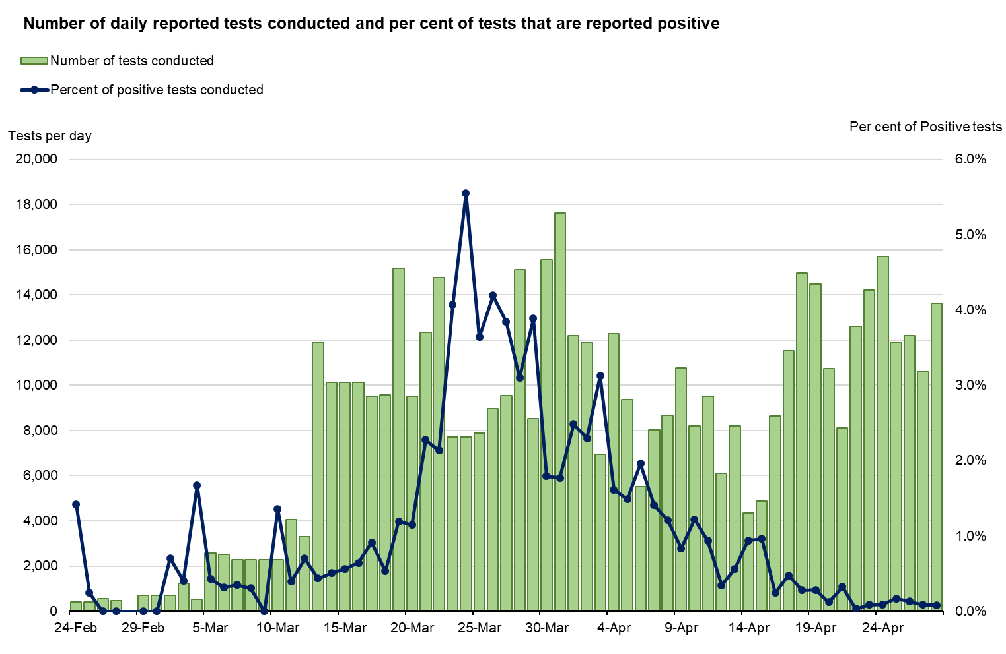

Expanding testing to asymptomatic people in the community does not effectively identify disease transmission at most levels of likely COVID-19 prevalence. Even with very high levels of testing, cases in the population would be missed, and the estimates of prevalence would still have a comparatively wide range of uncertainty around them. Further, at low prevalence of disease, the proportion of positive tests that are false-positives increases. Although intuitively attractive, ongoing active surveillance of asymptomatic people across the whole population is not supported. Instead, the preferred approach is targeted testing of specific groups or occupations selected on the basis of being either higher risk, or as a representative sample of the community.

The testing strategyprioritises testing of symptomatic people, followed by those groups that are more likely to reveal the presence of community transmission, in the following order:

1. All people presenting with fever or acute respiratory illness. Just over 30% of these people are currently tested. This represents the most important group in which to increase testing.
2. People at high risk of exposure who present with atypical symptoms, such as
   * Health care workers
   * Residential aged care facility workers
3. Contacts of cases, including
   * Upstream contacts (the index ‘fever or cough’ case), including people who are asymptomatic
   * Downstream contacts (contacts in the COVID-19 infectious period), including people who are asymptomatic
4. Vulnerable populations in which a single case is identified, such as
   * Residential care settings (test all residents and staff, including people who are asymptomatic)
   * Health care settings (test all patients and staff, including people who are asymptomatic)
   * Remote Aboriginal and Torres Strait Islander communities (test all contacts including people who are asymptomatic)
   * Workers in critical infrastructure

Medically supervised self-collection of testing samples may be used as a method to increase testing in people who have symptoms of acute respiratory illness (fever or cough) or influenza-like illness. Patients who present to their GP or a respiratory clinic will be provided with a swab and instructions on how to collect their own sample. This method of testing may be more acceptable to people and decreases the demand on PPE, as healthcare providers are removed from the process. It is a reliable method of testing with adequate sensitivity, and any potential reduction of performance in terms of increased false-negatives (when compared to clinician-collected samples) is outweighed by the increase in testing capacity and reduction of demand on PPE.

In addition, questions about the extent of community transmission can be addressed through well designed, time-limited surveys in specific settings. This type of targeted testing of population sub-groups can be beneficial in fostering confidence with the response. For some of these surveys, the population may have a higher risk of exposure (such as health and aged care workers). For others, there is not seen to be a higher risk of exposure, but community anxiety can be allayed by conducting representative surveys (e.g. elective surgery patients, healthcare workers). When well considered, such surveys can also provide information about community transmission.

Currently proposed surveys of groups include:

* Elective surgery patients (tranche 1 a survey is currently being developed)
* Residential aged care workers (tranche 2)
* Healthcare workers (tranche 3)

Additional surveillance tools such as serosurveillance surveys and wastewater sampling will be established to further inform management of the COVID-19 pandemic. Serosurveillance measures long lasting levels of antibodies in individuals, which can improve our understanding of the cumulative extent of transmission at a population level. Wastewater sampling could also be used to monitor high risk facilities, such as hospitals and aged care facilities, in order to identify early transmission in such settings where case numbers are low.

Epidemiological disease surveillance also provides data on disease severity and how this may change over time, and can monitor the occurrence of respiratory illnesses such as influenza. Vulnerable populations, such as the elderly and remote Aboriginal and Torres Strait Islander communities, are particularly susceptible to the impact of COVID-19. Focused surveillance in these populations and their surrounding communities will inform decisions to adapt any planned adjustment of measures to protect these groups.

The epidemiological measures will inform the timing and direction of adjusting measures. Testing measures need to demonstrate a stable and very low test positivity rate before measures can be relaxed. When disease levels are low and have been stable over a four week period (approximately equal to two reproduction cycles of viral transmission), consideration may be given to relaxing certain restrictions. Disease surveillance that indicates increasing numbers of cases without a known source of transmission or cases without an overseas link, would indicate the need for widespread tightening of restrictions. Where case numbers increase nationally in a specific population over a short period, but not across the wider population, this would indicate the need for local tightened restrictions.

## Public Health System Capacity Measures

Measures of public health system capacity will tell us how well we are able to detect and isolate cases, and trace and quarantine contacts to reduce transmission. The faster all contacts of a case can be traced, the sooner disease transmission can be halted. There will need to be certainty as to the surge capacity across states and territories to undertake additional contact tracing and the timeframe of scaling up resources to conduct it.

Time taken to contact trace is a function of case numbers, numbers of contacts, public health contact tracing workforce and technological support. During periods of strict physical distancing measures, the numbers of contacts per case is reduced but when these measures are relaxed the average number of contacts per case increases. Technological support, such as a contact tracing app, will augment traditional contact tracing practices and support the public health workforce.

Rapid contact tracing can provide reassurance that transmission is being controlled. A rapid increase in time taken to contact trace relative to the number of contacts for each case may indicate that disease control is slipping and measures may need to be adjusted and/or that further resources are needed.

## Health Care System Capacity Measures

Public health measures implemented to control the spread of COVID-19 have included reducing normal health system activity (ceasing all but Category 1 elective surgery), thus freeing up capacity to cope with potential demand of COVID-19 cases. Planning for surge capacity has accelerated with additional equipment and consumables being procured. Now, with lower case numbers and quieter hospitals, there is pressure to resume normal health care activities, at least in part. This will require careful monitoring of bed states, ICU bed utilisation, demand on ventilators, ECMO and renal dialysis, and overall, whether any portion of surge capacity is being utilised, to understand the burden of COVID-19 in hospitals. Sufficient surge capacity must exist to manage any large outbreak, including outbreaks in rural communities, and to ensure that normal health care can be provided safely.

Health system burden due to COVID-19 will need to be well within normal ranges and surge capacity will need to be ready with appropriate stores and workforce to allow restrictions to be relaxed. Creating surge capacity through scaling back specific health care activities needs to be balanced against the impacts of deferring such activities.

Increasing case numbers of COVID-19 that impact on usual health system capacity and cause surge capacity to be activated would indicate the need to consider tightened measures and/or reallocating resources from other parts of the health system if this burden is localised.

### Modelling

Modelling has proved invaluable as a planning tool for this pandemic. As we move into a phase with real-time data informing this modelling, these tools will provide forecasting of likely disease trajectories and the likely impact of different intervention strategies. This modelling looks back over the previous epidemic activity to predict forward and will provide an additional layer of evidence to inform decisions to adjust measures. Modelling for specific contexts, including for remote Aboriginal and Torres Strait Islander communities, can provide valuable information

Where modelling predicts an increase in case numbers and burden, this will indicate the need to consider tightening measures. Conversely, where modelling predicts an effective reproduction number (Reff) less than one and/or additional modelling assessments indicate control, measures could potentially be relaxed.

### Health system logistics – provision of PPE and consumables

***Personal Protective Equipment*.** Without sufficient stocks of PPE, identification and care of patients with COVID-19 cannot occur and prevention of disease transmission is impacted, particularly in health care settings. An assured supply of PPE is needed for the health system to confidently manage and control this disease. Modelling of *expected* health care PPE usage will inform ongoing needs and the size of any stockpile needed to support actions to control any large outbreak(s). Careful monitoring of international and national supply chains will be required to advise of any impending supply issues. Metrics to advise on current PPE supplies, guaranteed orders and stockpile adequacy will need to be monitored closely. This modelling will apply to other consumables needed to support usual health care and any surge capacity. Where there are likely shortages, the need for stockpile support will require monitoring.

Before measures can be adjusted, particularly relaxation of restrictions, there needs to be sufficient stores to allow current operations and surge capacity to deal with any outbreak(s). Relaxing any public health-related measures will require adequate and ongoing supplies of PPE to support confidence in the ability to provide usual health care while managing the risk of COVID-19 transmission. Supply line shortages that will impact on ability to manage COVID-19 patients will impact on case numbers and transmission, and will require consideration of tightening of measures.

***Testing and Laboratory Capacity*.** Case identification relies on adequate testing capacity to ensure no cases are missed and is required for comprehensive sentinel testing. Testing has been constrained by shortages of consumables. While active procurement strategies, diversification of testing platforms and innovative testing practices have improved capacity, careful monitoring of testing consumables supply and the impact on testing capacity will need to continue.

## Community Acceptance and Adherence Measures

Community attitudes and perceptions towards current measures and proposed adjustments to public health measures are very important. The effectiveness of measures depends on public acceptance and adherence to advice. If community acceptance of the measures decreases (e.g. if the community feels measures being implemented are disproportionate, or that there are inequalities across regions), community adherence is likely to reduce. We need to be able to be quickly identify any change to adherence. This will be achieved through monitoring community attitudes to government communications and measures, with tools that will assess how well the public is adhering to the guidance, including transport and traffic movements and movement data.

# DECISION POINTS FOR SPECIFIC MEASURES

Australia approached the COVID-19 outbreak in line with the Australian Health Sector Emergency Response Plan for Novel Coronavirus (COVID-19), with measures implemented in the ‘Initial Action’ and ‘Targeted Action’ phases of the health emergency response. The decision to adjust these measures will be informed by different metrics (or a combination of) at different stages of the pandemic. Measures may also differ depending on the national strategy being pursued at that time, whether it be to achieve suppression or elimination. Adjusting measures in Australia must be conducted in a stepped manner, with close monitoring of COVID-19 case numbers. The ability to quickly readjust measures in response to increasing cases must be maintained. Measures to protect vulnerable populations are of particular importance. The protection afforded by current measures must not be compromised.

The effectiveness of individual physical distancing measures is difficult to quantify. This is because primary evidence is limited and the seriousness of this pandemic necessitated the rapid introduction of community-level physical distancing measures that were almost simultaneously introduced. Evidence is not yet available on the impact of relaxing these measures to inform decision-making. However, lifting restrictions too soon or rapidly could result in subsequent waves of infection. In the absence of COVID-19-specific findings, evidence of the impact of physical distancing measures from previous pandemics and epidemics of respiratory disease can inform decision-making. However, findings should be extrapolated to COVID-19 with caution as differences in the characteristics of the virus and disease indicate that some measures that are effective for other viruses are not recommended for COVID-19 (e.g. school closures). The sharing of indoor spaces presents a significant risk with COVID-19, compared to outdoor environments. Retaining physical distancing measures in indoor venues such as shops and restaurants is important. Though limited, the research indicates that outdoor environments present a lower risk of SARS-CoV-2 transmission and outbreaks. Easing outdoor gathering restrictions and movements may therefore be considered in the earlier phase of a staged easing of physical distancing restrictions. In the case of outdoor exercise, distances of greater than 1.5 metres are recommended to prevent potential droplet transmission from one individual to a trailing walker or runner, although the risk of transmission of infection under these circumstances remains unclear. In allowing indoor gatherings and trading, consideration could be given to additional requirements beyond limits on indoor gathering size and density to reduce risk, e.g. ensuring adequate room ventilation in addition to proper and regular disinfection of surfaces.

International case studies may provide useful insights which will need to be interpreted for the Australian context. When looking to other countries’ experience in relaxing measures to aid decision-making, it is important to understand that many of these countries are relaxing restrictions from a state of lockdown, with much heavier restrictions than that which have been applied in Australia.

The University of Oxford has developed a tool – the Oxford COVID-19 Government Response Tracker – to track and compare government policy responses to the COVID-19 pandemic around the world. It uses a scoring system for the stringency of measures implemented in each country and aggregates these scores into a ‘Stringency Index’ to help decision makers monitor the international response. While it is too early to validate the scoring system, it is a useful tool for comparisons. Australia currently has a Stringency Index score of 71.43 (out of a possible 100). The important information that can be gleaned from international scores is that all countries currently considering, or implementing, a relaxation of measures (referred to as lockdown rollback) are relaxing from a higher Stringency Index score (Figure 2). This reinforces AHPPC’s position that Australia should not be too hasty to relax the most effective of measures that have been implemented.

Figure 2 – International Stringency Index Scores

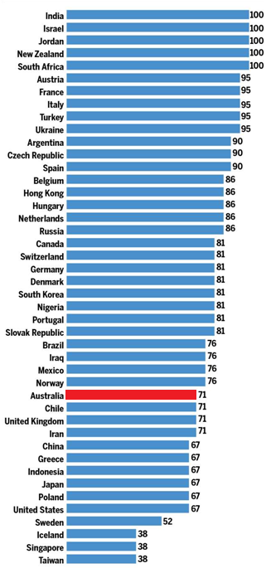

Note: Data from 20 March – 05 April 2020

Source: Oxford COVID-19 Government Response Tracker - https://covidtracker.bsg.ox.ac.uk/

The public health measures that are likely to continue to be implemented for an extended period, without any major adjustments, include sentinel testing and active surveillance; and individual measures such as physical distancing and personal hygiene practices (respiratory etiquette, and hand hygiene), as these are minimal social impact-high reward measures. While health care system measures may be necessary in varying degrees for the duration of the pandemic, the gradual easing of restrictions may be considered when health system capacity is able to meet the normal healthcare needs in addition to being able to surge if numbers increase, or outbreaks arise.

It is acknowledged that community-level physical distancing measures were almost simultaneously introduced, and, as such, it is difficult to measure the impact of individual measures. Gradually relaxing restrictions may be considered, with maintaining physical distancing and hygiene practices, and with enough time to adequately assess impact before adjusting further. Decisions to remove restrictions must be balanced with economic and societal impacts, and risks to vulnerable populations, with the knowledge these public health measures have health costs as well as benefits.

Travel restrictions are the final measure to adjust in the COVID-19 pandemic response. Some domestic travel restrictions may need to be continued due to specific local circumstances, such as local outbreaks or community transmission, or in order to limit community transmission to protect vulnerable populations ( e.g. remote Aboriginal communities). Decisions to reduce or withdraw current international border restrictions will be informed by the epidemiological situation and capacity to respond within Australia, in addition to the epidemiological situation in overseas destinations. International border restrictions could eventually be gradually reduced, to allow travel between Australia and countries with low transmission rates or who have successfully suppressed or eliminated the virus. However, this would depend on the reliability of data from that country and the risk of reintroducing case numbers into Australia.

# APPENDIX 1

# STATUS OF PRECEDENT CONDITIONS AS AT 1 MAY 2020

| **Precedent Conditions** | **Status** |
| --- | --- |
| **Situational awareness of current measures and their impact** | |
| Sophisticated surveillance of disease incidence and spread | Surveillance mechanisms are well established in jurisdictions, with planned expansion of disease surveillance and testing. Testing has already been expanded to include people with acute respiratory illness.  Serosurveillance is a longer term goal, and requires further development. |
| Community adherence to public health measures | Community adherence to public health measures is currently being assessed through modelling of mobility data available from public and other sources. There will be ongoing evaluation of this, which will be aligned with any adjustments of public health measures, to examine whether, and to what degree, the public is adhering to current advice. Public adherence will also be impacted by acceptability of public health measures. These will be monitored and assessed through market research (including surveys, polls, social media comments). |
| **Finalised surveillance plan** | |
| Must be wholly enabled with adequate resources | The Australian National Disease Surveillance Plan for COVID-19 has been developed and will continue to be updated. |
| **MODELLING** | |
| A better understanding of the implications of the modelling and a better understanding of the characteristics and transmission of the virus. | Regular modelling updates are provided. As more data is collected, the accuracy of models and our confidence in them increases. |
| **Complete maturation of public health capacity** | |
| Capacity to conduct testing more broadly | Jurisdictions have already expanded testing.  As per the COVID-19 Testing Framework there will be further testing increases. |
| Public health workforce | Sufficient public health personnel currently to contact trace quickly and extensively.  Surge capacity is available, however as case numbers are currently low, the workforce has been redistributed. Jurisdictions are confident that the workforce can be rapidly redeployed. |
| Contact tracing capacity | Contact tracing mechanisms are well established in jurisdictions, and the Australian National Disease Surveillance Plan for COVID-19, in conjunction with the Testing Framework detail expansion of disease surveillance and testing.  Of note is that testing has already been expanded to include people with acute respiratory illness. Further encouragement of people who have respiratory symptoms to seek testing is needed, and expansion of contact tracing and time limited epidemiological group studies are being developed.  Serosurveillance is a longer term goal to better understand the predicted immunity status of the Australian population, and requires further funding and consideration.  Jurisdictions currently have the ability to contact trace both quickly and thoroughly, with the ability of this workforce to surge already established through training and upskilling of additional personnel. |
| Technology for contact tracing, data collection and analysis | The COVIDSafe App was launched on 27 April 2020, with significant uptake within the first 24 hours (>2 million). |
| **Assurance of adequate health system capacity** | |
| Health system status | The health system is currently able to manage usual healthcare needs in addition to current levels of COVID-19-related illness. |
| Surge capacity | The health system currently has the ability to surge. |
| Hospital beds/ventilators | Jurisdictions provide daily updates on bed states, including ICU beds and patients requiring ventilation/ECMO. Current status: has capacity, and surge abilities. |
| Stocks of PPE – Masks | The National Medical Stockpile (NMS) details PPE stores in Australia.  NMS has capacity to meet 8 week mask demand for jurisdictions and Primary Health Network distributions, until end December 2020 (at current usage rates). Significant additional orders are still to come and local manufacturing capability is developing. |
| Stocks of PPE – Gowns and gloves | Status of all holdings of gowns and gloves in the jurisdictions requires confirmation.  Further modelling and an assessment on the security of supply lines are needed. |
| Stocks of healthcare consumables | Therapeutic Goods Administration monitors drug and Australian Register of Therapeutic Goods registered consumable shortages. There are currently no reported shortages. |
| Ongoing workforce training | Workforce training to upskill and expand employee training has already occurred. There are currently enough workforce personnel (with surge capabilities able to be used if required). Ongoing training for critical care nurses would be required if an ICU surge occurred. |