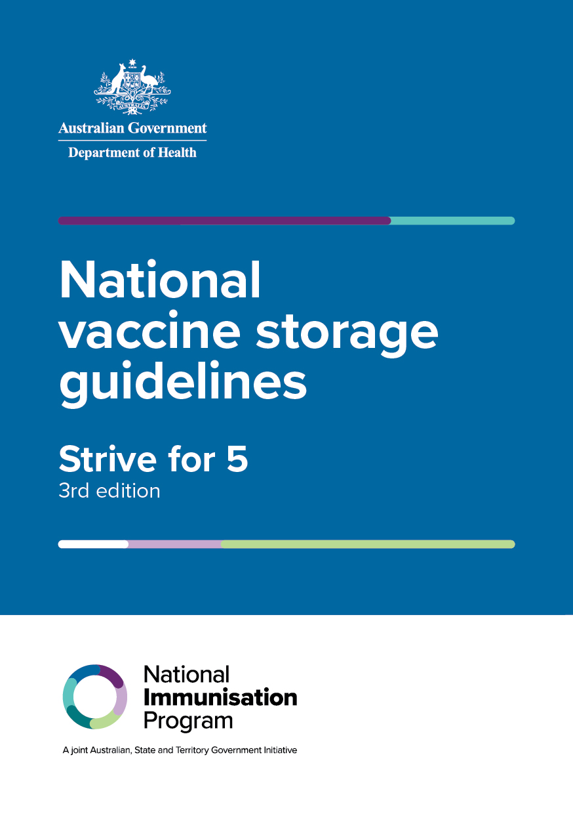

NATIONAL VACCINE STORAGE GUIDELINES

STRIVE FOR 5

3rd edition

Australian Government   
Department of Health

Title: National Vaccine Storage Guidelines – Strive for 5, 3rd edition

ISBN: 978-1-76007-396-1

Online ISBN: 978-1-76007-397-8

Publications Number: 12470

**Copyright**

© 2019 Commonwealth of Australia as represented by the Department of Health

This work is copyright. You may copy, print, download, display and reproduce the whole or part of this work in unaltered form for your own personal use or, if you are part of an organisation, for internal use within your organisation, but only if you or your organisation:

* do not use the copy or reproduction for any commercial purpose; and
* retain this copyright notice and all disclaimer notices as part of that copy or reproduction.

Apart from rights as permitted by the Copyright Act 1968 (Cth) or allowed by this copyright notice, all other rights are reserved, including (but not limited to) all commercial rights.

Requests and inquiries concerning reproduction and other rights to use are to be sent to the Communication Branch, Department of Health, GPO Box 9848, Canberra ACT 2601, or via email to [copyright@health.gov.au](mailto:copyright@health.gov.au).

Contents

Acknowledgments v

Glossary vi

1 Using these guidelines 1

2 Safe vaccine storage 2

2.1 What is the cold chain? 2

2.2 What is a cold chain breach? 2

2.3 How sensitive are vaccines to heat and cold? 2

2.4 Principles of safe vaccine storage management 3

2.5 Why is vaccine storage management important? 3

2.6 Why ‘strive for 5’? 4

3 Types of refrigerators for vaccine storage 5

3.1 Purpose-built vaccine refrigerators 5

3.2 Portable purpose-built vaccine refrigerators 5

4 Vaccine temperature-monitoring devices 6

4.1 Temperature chart recording systems 6

4.2 Data loggers 6

4.3 Thermometers 8

4.4 How to check the accuracy of a thermometer (‘slush test’) 9

4.5 Disposable cold chain monitors 9

4.6 Automated temperature-monitoring systems 10

4.7 Back-to-base alarm systems 10

5 Key recommendations for effective vaccine storage management 11

5.1 Vaccine management protocol 11

5.2 Positioning the vaccine refrigerator 13

5.3 Power source reliability 13

5.4 Stabilising the vaccine refrigerator temperature 14

5.5 Storage 15

5.6 Monitoring and recording refrigerator temperatures 17

5.7 Maintaining the vaccine refrigerator 18

5.8 Maintaining equipment 18

5.9 Self-audit 18

6 Considerations when choosing a purpose-built vaccine refrigerator 19

6.1 Clinical considerations 19

6.2 Technical suitability 20

6.3 Maintenance 20

6.4 Other considerations when purchasing a purpose-built vaccine refrigerator 21

6.5 Questions to ask 22

7 Caring for vaccines during immunisation clinics 23

7.1 Key issues 23

7.2 Mobile or outreach immunisation clinics 23

7.3 Community pharmacy–acquired vaccine 24

8 Managing a power failure 25

8.1 Back-up plans 25

8.2 Purpose-built vaccine refrigerators 25

8.3 When power goes off 26

8.4 When power is returned 26

9 Coolers 28

9.1 Tips for using coolers 28

9.2 Freezing and conditioning ice packs and gel packs 29

9.3 How to pack a cooler 30

9.4 Specialised vaccine coolers 34

APPENDIX 1 Vaccine management protocol 35

APPENDIX 2 Vaccine storage self-audit 38

APPENDIX 3 Cold chain breach protocol 40

APPENDIX 4 Frequently asked questions 42

APPENDIX 5 Minimum/maximum vaccine refrigerator temperature chart 45

APPENDIX 6 Quick reference poster 47

APPENDIX 7 Preparation for mobile or outreach immunisation clinics 48

APPENDIX 8 Checklist and temperature chart for mobile or outreach immunisation clinics, or emergency storage of vaccines 49

APPENDIX 9 Checklist for managing a power failure 52

APPENDIX 10 Considerations when choosing a purpose-built vaccine refrigerator 55

Additional reading 57

Useful contacts 57

State and territory health department contact details 58

Figures

Figure 1: Solid-door purpose-built vaccine refrigerator with map 16

Figure 2: Ice packs/gel packs placed in bottom of cooler to chill cooler 31

Figure 3: Insulating material placed in bottom of cooler 31

Figure 4: Vaccines packed in cooler 32

Figure 5: Minimum/maximum thermometer placed in centre of vaccine stock 32

Figure 6: Insulating material placed on top of vaccine stock followed by ice packs/gel packs 33

Figure 7: Minimum/maximum thermometer display placed outside cooler 33

# Acknowledgments

The Australian Government Department of Health gratefully acknowledges the work of the National Vaccine Storage Guidelines Jurisdictional Immunisation Committee Working Group who updated this third edition of the guidelines.

# Glossary

The list below gives the meanings of words as used in this document. Some of these words have different meanings elsewhere.

**Accuracy check** A method used to ascertain the accuracy of a thermometer. See Section 4.4.

**Adverse vaccine storage event** Exposure of vaccines to temperatures outside the recommended range of +2°C to +8°C. An adverse vaccine storage event may be referred to as a ‘cold chain breach’.

**Ambient temperature** Temperature of the surrounding environment in which the vaccine refrigerator is operating.

**Automated temperature-monitoring systems** Wireless temperature-monitoring systems that provide real-time temperature readings, and email or text message alerts when a temperature excursion outside the recommended +2°C to +8°C range occurs.

**Back-to-base system** A computer-based control system that alerts staff when a temperature excursion outside the recommended +2°C to +8°C range occurs.

**Cold chain** The system of transporting and storing vaccines within the safe temperature range of +2°C to +8°C.

**Cold chain breach** Exposure of vaccines to temperatures outside the recommended range of +2°C to +8°C. A cold chain breach may be referred to as an ‘adverse vaccine storage event’.

**Cold life** The maximum time that a vaccine can be stored between +2°C and +8°C in a cooler or specialised cooler.

**Cold mass** A non-technical term for materials (eg cooled bottles of water; frozen products should not be used) stored in a refrigerator to help maintain cold temperatures if, for example, the power fails or the door has been left opened.

**Conditioning of ice packs/gel packs** Leaving ice packs/gel packs at room temperature to allow the ice or gel at the surface of the pack to defrost and the ice core to move freely within the pack, surrounded by a melted layer. This minimises the risk of freezing the vaccines. See Section 9.2.

**Cooler** A generic term to describe portable solid-walled or vaccine-specific soft-walled insulated containers, also known by names such as Esky™, Willow™ or Coleman™.

**Cooling plate** Also known as the plate evaporator, load heat exchanger or cold plate. It is located inside the refrigerator, usually on the back wall.

**Data logger** A small electronic device that continuously measures temperatures and keeps a record of the results.

**Dual time–temperature indicator** A device that shows the accumulated time–temperature history of vaccine stock and signals when the vaccines have been exposed to temperatures outside the recommended range of +2°C to +8°C.

**Freezing** A situation in which vaccines experience temperatures at or below 0°C. Vaccines may not appear frozen but may have been damaged at these temperatures.

**Gel packs** Commercial coolant products, commercial gel packs and other non-ice coolants.

**Immunisation service providers** Includes medical practices, outreach providers, baby health centres, aged care facilities, large hospitals and clinics.

**Lagging** The process of using specific materials to reduce short-term fluctuations in the refrigerator temperature. Lagging provides a better indication of the actual temperature of vaccines and prevents the alarm going off unnecessarily.

**Mobile service** A service that spans a number of days, and involves travelling long distances and providing immunisation sessions in a number of different sites. A mobile service should not be confused with an ‘outreach clinic’.

**Outreach clinic** An immunisation session that is conducted away from the main or ‘home’ immunisation venue. This service normally lasts a number of hours, and staff then return to the ‘home’ venue before the end of the day. An outreach clinic should not be confused with a ‘mobile service’.

**Purpose-built vaccine refrigerator** A refrigerator that is designed and constructed specifically for vaccine storage at temperatures between +2°C and +8°C.

**Refrigeration** Withdrawal of heat from a chamber to achieve a temperature below ambient temperature.

**Temperature excursion** Any temperature reading outside the ranges recommended in the manufacturer’s product information.

**Thermostability** Capability of withstanding moderate heat without loss of characteristic properties.

**Thermostat** A device that adjusts the amount of heating and cooling produced and/or distributed by automatically responding to the temperature in the environment.

# 1 Using these guidelines

National Vaccine Storage Guidelines – Strive for 5*,* 3rd edition, provides information and advice for managing vaccine storage. The guidelines have been written to assist all Australian immunisation service providers, including medical practices, large hospitals, clinics, mobile services and outreach providers.

Correct vaccine storage and handling has been an important factor in preventing and eradicating many common vaccine-preventable diseases. Yet, each year, storage and handling errors result in revaccination of many clients and significant financial loss because of wasted vaccines. Failure to store and handle vaccines properly can reduce vaccine potency, resulting in inadequate immune responses in clients and poor protection against disease. Clients can lose confidence in vaccines and immunisation service providers if they have to be revaccinated after receiving vaccines that may have been compromised.

The publication’s title refers to **strive for 5 degrees Celsius (°C)** — this is the point midway between +2°C and +8°C, which is the temperature range recommended for vaccine storage. Many vaccines are damaged or destroyed at temperatures outside this range.

These guidelines:

describe the best approach to ensure that clients receive effective and potent vaccines

describe the ‘cold chain’ and provide advice on what should be done in the event of a cold chain breach

include resources such as checklists, charts, posters and stickers

apply to vaccines stored in purpose-built vaccine refrigerators.

Although these guidelines are copyright, they may be freely reproduced for non-profit purposes, provided the source is acknowledged.

# 2 Safe vaccine storage

## 2.1 What is the cold chain?

The ‘cold chain’ is the system of transporting and storing vaccines within the safe temperature range of +2°C to +8°C.

The cold chain begins from the time the vaccine is manufactured, continues through to state or territory vaccine distribution centres and immunisation service providers, and ends when the vaccine is administered.

## 2.2 What is a cold chain breach?

A ‘cold chain breach’ occurs when vaccine storage temperatures deviate outside the recommended range of +2°C to +8°C. The optimal storage temperature for vaccines is +5°C.

All vaccine temperatures recorded below +2°C or above +8°C must be reported to your state or territory health department. This does not include temperature deviations or excursions in which the temperature reaches a maximum of up to +12°C for 15 minutes or less. Any deviation below +2°C must be reported.

**In the event of a cold chain breach, follow the cold chain breach protocol described in Appendix 3.**

## 2.3 How sensitive are vaccines to heat and cold?

Vaccines are delicate biological substances that can become less effective or destroyed if they are:

frozen

allowed to get too warm

exposed to direct sunlight or ultraviolet (UV) light, including fluorescent light.

Vaccines have varying degrees of heat stability and sensitivity to freezing. Repeated exposure to temperatures outside the +2°C to +8°C range diminishes vaccine potency. This effect is cumulative and cannot be reversed. All instances in which vaccines are exposed to temperatures outside the recommended +2°C to +8°C range should be reported to your state or territory health department for advice on vaccine disposal.

**If we don’t protect our vaccines, they won’t protect our community!**

The technology for vaccine storage is evolving. When purchasing vaccine storage equipment, it is recommended that you thoroughly investigate the item first. The information in this document will help with such investigations. For further information, contact your state or territory health department. See contact details on the last page of these guidelines.

## 2.4 Principles of safe vaccine storage management

Immunisation service providers must:

* Store vaccines in a purpose-built vaccine refrigerator (see Section 5 ‘Key recommendations for effective vaccine storage management’).
* Educate all people responsible for handling vaccines so that they understand the importance of effective vaccine management.
* Nominate a staff member to be responsible for vaccine management, and a back-up staff member to take responsibility in their absence.
* Ensure that policies, procedures and protocols are in place for vaccine management in all facilities within the practice or organisation (see Appendix 1 ‘Vaccine management protocol’).
* Ensure that all people involved in vaccine transport, storage and administration are trained in vaccine management to ensure that the vaccines remain effective and potent.
* Perform vaccine storage self-audits at least every 12 months (see Appendix 2 ‘Vaccine storage self-audit’).
* Monitor the temperature of vaccine refrigerators twice daily, or more if required (see Section 4 ‘Vaccine temperature-monitoring devices’).
* Ensure that plans are in place for responses to cold chain breaches and power failures in all facilities within the practice or organisation (see Section 8 ‘Managing a power failure’).
* Report temperatures outside the +2°C to +8°C range to your state or territory health department. Do not use or discard vaccines until advice is received (see Appendix 3 ‘Cold chain breach protocol’).
* Follow the guidelines for using ice packs/gel packs and monitoring vaccines in coolers (see Section 9 ‘Coolers’).

A quick reference guide is available as a poster from the Australian Government Department of Health website: [www.health.gov.au/immunisation](http://www.health.gov.au/immunisation) (see Appendix 6).

## 2.5 Why is vaccine storage management important?

Health professionals have a responsibility to ensure that clients receive effective health products, including vaccines that have not been adversely affected by heat or cold.

Vaccines are expensive and can be in short supply. The total financial value of the vaccines contained within one vaccine refrigerator can be significant.

Good vaccine management precludes the need to revaccinate clients who may, under circumstances of poor vaccine management, receive an ineffective vaccine.

Cold chain breaches can occur as a result of technical malfunctions, even in well-designed and well-managed systems. When effective procedures are in place, problems will be detected and managed before an ineffective vaccine is used.

Efficient vaccine storage management is a good quality assurance measure of an immunisation service provider.

Exposure to heat or freezing temperatures has a cumulative effect on vaccine viability and may decrease efficacy.

## 2.6 Why ‘strive for 5’?

Vaccines must be stored and transported within the recommended temperature range of +2°C to +8°C at all times — aim to store vaccines at 5°C. Most vaccines are destroyed by freezing, and some vaccines are also particularly sensitive to heat.

# 3 Types of refrigerators for vaccine storage

Purpose-built vaccine refrigerators are the only suitable option for vaccine storage.

## 3.1 Purpose-built vaccine refrigerators

Purpose-built vaccine refrigerators are specifically designed to store vaccines and should be used for all vaccine storage. See also Section 6 ‘Considerations when choosing a purpose-built vaccine refrigerator’.

Purpose-built vaccine refrigerators have the following advantages:

a stable, uniform and controlled cabinet temperature between +2°C and +8°C

standard alarm and safety features that alert to and/or prevent irregular temperature fluctuations in the cabinet

inbuilt digital temperature monitoring (inbuilt data logger) and/or digital temperature indicators (minimum and maximum temperature displays)

effective temperature recovery after the refrigerator door has been opened

potential for most of the internal space to be used for vaccine storage; ask the manufacturer how to pack the refrigerator to accommodate the maximum quantity of vaccine.

**Note:**

An additional refrigerator with a freezer section will be required for storing ice packs and gel packs — purpose-built vaccine refrigerators do not have freezer compartments.

Domestic refrigerators (including bar fridges) are not built or designed to store vaccines and must not be used for vaccine storage. Refer to your state or territory health department for further advice.

Blood refrigerators are specifically designed to store blood products at a controlled temperature between +2°C and +6°C. This means that, if necessary, it is acceptable to store vaccines and blood products in the same refrigerator. Temperature monitoring will still be required (see Section 4 ‘Vaccine temperature-monitoring devices’).

## 3.2 Portable purpose-built vaccine refrigerators

Portable purpose-built vaccine refrigerators are also available on the market. An online search will provide details.

Portable refrigerators that are not purpose-built for vaccine storage have a propensity to freeze vaccines and should not be used for vaccine storage.

If transporting vaccines for 3 days or more, use a specialised vaccine cooler (see Section 9.4).

# 4 Vaccine temperature-monitoring devices

To ensure that vaccines have been stored within the recommended temperature range of +2°C to +8°C, the temperatures to which vaccines are exposed must be monitored, recorded and reported throughout the cold chain. These procedures help to ensure that:

vaccine quality is maintained throughout the vaccine cold chain

temperature excursions and any potential impact on the potency of the vaccines are identified early, and corrective action is taken

clients receive potent and effective vaccines.

Several vaccine temperature-monitoring devices can be used to monitor the cold chain. These include temperature chart recording systems, data loggers, thermometers, disposable cold chain monitors, automated temperature-monitoring systems and back-to-base systems. At a minimum, all vaccine refrigerators must have a basic data logger and thermometer to continuously monitor refrigerator temperatures.

## 4.1 Temperature chart recording systems

Temperature chart recording systems can record temperatures over long periods, and provide visual and audio alarms. They can be set to record air and/or product temperature. These systems can be installed in refrigerator units, but check with the manufacturer because doing so may void the warranty.

## 4.2 Data loggers

### What is a data logger?

Temperature data loggers are small electronic devices that measure temperatures at preset time intervals and record the results over a period of time. Data loggers should be set to record temperatures at 5-minute intervals.

Each logger is a self-contained miniature computer. Data loggers come in a range of shapes and sizes. Once programmed using a computer, loggers are disconnected from the computer and placed in the vaccine refrigerator near the temperature probe or vaccines. The logger then operates independently on its own battery until the recording is downloaded to the computer.

Some purpose-built vaccine refrigerators have an inbuilt data logger. Information from the data logger should be downloaded at least weekly (or more frequently if recommended by the manufacturer), reviewed and digitally stored.

Advances in technology are producing more features in data loggers; the information in this section refers to basic models.

### What information do data loggers provide?

Data loggers provide an accurate indication of vaccine refrigerator temperatures and can be used to map ‘cold spots’ or investigate problems. Loggers use a similar measuring principle to chart recorders; however, they record the data electronically. The data can be stored by the monitoring system and can also be downloaded to a computer.

The objective of data logging is to build up a ‘temperature map’ for the refrigerator (see Section 5.4 ‘Stabilising the vaccine refrigerator temperature’), to identify which areas are safe for vaccine storage. In particular, it is important to identify areas where vaccines could freeze.

**Twice-daily minimum and maximum temperatures must still be manually recorded as a timely alert to any breach in the cold chain.** If a data logger is used for routine temperature monitoring (instead of a minimum/maximum thermometer), it must have a visual display of minimum/maximum temperatures to allow twice-daily real-time readings to be viewed and manually recorded.

Many data loggers can be programmed to alarm when a temperature outside the +2°C to +8°C range is recorded.

### Using a data logger

The data logger and the minimum/maximum thermometer should be co-located in the refrigerator; otherwise, different recordings can occur. If the data logger and probe have a fixed position in the refrigerator and cannot be moved, the vaccines should be stored as close as practicable to the probe.

The results from the data logger can be printed in graph and numerical formats, including times that the temperature was recorded outside the +2°C to +8°C range, and the minimum and maximum temperatures.

All staff should be trained in how to operate and manage the data logger and interpret its readings. Data logging will help immunisation service providers to get to know their refrigerator (see Section 5.4 ‘Stabilising the vaccine refrigerator temperature’). Any actions taken in response to data logging should be documented and retained according to state or territory health department policy or medico-legal requirements.

### Continuous logging

All vaccine refrigerators should have a permanent data logger in place to continuously measure the refrigerator temperature at preset 5-minute intervals. The data should be downloaded at least weekly, in addition to twice-daily minimum/maximum recordings. The data logger can be a portable digital data logger or may be built into the refrigerator.

### Benefits of continuous temperature monitoring

Continuous temperature monitoring:

provides information on the duration of a cold chain breach and supplements a cold chain audit

confirms that the cold chain has been maintained and provides accurate knowledge of the vaccine refrigerator temperature

identifies times when there is a risk of vaccines freezing (0°C or below) — for example, overnight, long weekends and when the refrigerator is not in use

assists staff to understand the functioning of the refrigerator

identifies temperature fluctuations between the refrigerator shelves and the location of any cold spots on each shelf

supports accreditation documentation and audits

helps to assess the refrigerator thermometer’s accuracy.

### Points to consider when purchasing a data logger

Find out:

whether the data logger will allow preset 5-minute temperature recordings

whether the data logger is easy to set up and use, particularly for recording and downloading data

whether the data logger has alert capabilities

the accuracy of the data logger (is it ±1°C or, more usually, ±0.1°C?)

whether the accuracy of the data logger can be checked by the user or requires a technician

the battery life of the data logger (this depends on the frequency of temperature recording, downloading and resetting)

whether there is a display on the set-up screen of remaining battery life

* whether the data logger will be used as a permanent method of monitoring temperatures
* does it have a visual minimum/maximum temperature display?

is the current temperature visible?

Checklist for data loggers

* Place the data logger where it is easily seen and in the middle of the vaccines.
* Measure the current, minimum and maximum temperatures twice daily, and record them.
* Set the alarm system to alarm outside the +2°C to +8°C range. Check that the alarm is working.
* Train all staff to recognise the alarm and download information from the data logger.
* Download and record information as soon as possible after an alarm is activated.
* If recordings are outside the +2°C to +8°C range, follow the cold chain breach protocol (see Appendix 3) and notify the relevant state or territory health department. See contact details on the last page of these guidelines.
* Regularly check and record the accuracy of the data logger. Record the date the accuracy check is done. To check the accuracy, place a second data logger in the refrigerator next to the existing data logger to obtain comparison temperature readings. Inbuilt data loggers should be checked for accuracy according to the manufacturer’s recommendation.
* Change the battery according to the manufacturer’s recommendation, or when the battery life displayed on either the data logger or computer set-up screen is low. Record the date the battery is changed. Life of the replaceable battery may be dependent on usage (eg how frequently the temperature is recorded and data are downloaded).

## 4.3 Thermometers

Choose a thermometer that reads Celsius (not Fahrenheit). Ensure that the thermometer has a sensor probe. To ensure that the probe is measuring the temperature under the same conditions as for the vaccines, place the end of the sensor probe in an empty vaccine box inside the refrigerator.

Thermometers require annual checks to ensure accurate measurement. Flat batteries, or a damaged probe or cable can affect readings. Change the battery at least every 6 to 12 months and record the date it is changed. In the absence of a data logger, it is useful to have a back-up thermometer and to note its storage location in the vaccine management protocol (see Appendix 1).

A minimum/maximum digital thermometer is essential for temperature monitoring during mobile or outreach immunisation sessions and power failures. Some purpose-built vaccine refrigerators do not have a battery back-up for their temperature-monitoring systems. A battery-operated minimum/maximum thermometer can assist in monitoring refrigerator temperatures in an emergency. The thermometer must be reset every time the temperature is recorded on a graph or in a logbook and when accessing the refrigerator for any extended period of time.

## 4.4 How to check the accuracy of a thermometer (‘slush test’)

1. Fill a polystyrene or plastic cup with cold water.

2. Place the cup in the refrigerator freezer until a fine layer of ice forms on the top and small sections of ice form within the fluid (this may take up to 2½ hours). The presence of ice is an indication that the temperature of the water has reached 0°C.

3. Place the temperature probe into the middle of the container (be careful not to let the probe touch the container).

4. Observe the temperature on the display screen after 2 minutes.

5. Document the date of the accuracy check.

### Rationale

The temperature reading will drop quickly at first and then more slowly. The temperature should drop to 0°C within 2 minutes.

An ‘acceptable’ degree of accuracy of a thermometer can vary (eg to within ±1°C); check with the thermometer supplier for the expected accuracy. Even if the thermometer is considered accurate to within ±1°C, the accuracy check could result in 3 possible readings: +1°C, 0°C and –1°C. Record the results of the accuracy check on your temperature chart. This information is important, particularly if the vaccine refrigerator temperature goes outside the recommended range of +2°C to +8°C.

The thermometer must be accurate to ±1°C or better. If the temperature reading is more than 1°C above or below 0°C at 2 minutes, replace the battery (and record the date the battery was changed) and test again. If the temperature reading is still not within range, replace the thermometer.

A check of the accuracy of your thermometer is recommended:

after the battery is changed

at least every 12 months, for auditing purposes

if there are cold chain problems.

The supplier of the thermometer may be able to offer a validation or accuracy check for their product.

## 4.5 Disposable cold chain monitors

Disposable cold chain monitors detect heat and/or freeze breaches.

Jurisdictions use different methods of monitoring the cold chain when transporting vaccines to providers (eg data logger, thermometer, disposable cold chain monitor). All deliveries must be accompanied by a cold chain monitor. Do not accept vaccines if there is no cold chain monitor with the delivery. The cold chain monitor must be checked and the temperature recorded on the temperature chart when the vaccine order arrives at its destination.

Breaches in the cold chain should be reported immediately to your state or territory health department. See contact details on the last page of these guidelines. Affected vaccines should be kept between +2°C and +8°C, labelled ‘Do not use’ and isolated in the refrigerator while awaiting advice from the health department.

Disposable cold chain monitors must be discarded following receipt of vaccines and must not be used to monitor vaccines after delivery. If you are unsure if the cold chain monitor arriving with your delivery is disposable, check with your state or territory health department.

## 4.6 Automated temperature-monitoring systems

Automated temperature-monitoring systems allow immunisation service providers to access real-time temperature-monitoring data from a connected device such as a computer or phone. The temperature readings do not need to be downloaded to a computer. These systems use wireless monitoring to transmit continuous data to a web server. In the event of a cold chain breach, an alert is sent by text message or email to the registered user. These systems are used more frequently in larger facilities to monitor multiple refrigerators in real time, but can be used in small facilities for 24-hour access to information.

Contact your state or territory health department for further information about monitoring requirements.

## 4.7 Back-to-base alarm systems

A back-to-base alarm system is a computer-based control system that alerts staff when a temperature excursion outside the recommended +2°C to +8°C temperature range occurs. A nominated clinical staff member or position must be alerted. Use of back-to-base alarm systems to monitor refrigerator temperatures is more common in larger facilities and still requires temperature readings to be downloaded to a computer.

Even if a back-to-base alarm system is used, immunisation service providers must still manually record minimum and maximum temperatures twice daily as a timely alert to any breach in the cold chain. Contact your state or territory health department for further information about monitoring requirements.

# 5 Key recommendations for effective vaccine storage management

**Vaccines should be stored in purpose-built vaccine refrigerators. Domestic refrigerators are not suitable for vaccine storage. Refer to your state or territory health department for further advice.**

## 5.1 Vaccine management protocol

An effective vaccine management protocol will ensure that you are ready **before** an emergency occurs. Ensure that the following are in place and included in your protocol:

A trained, designated person is responsible for vaccine storage and implementation of protocols.

A trained back-up person is available to relieve the designated person when required.

All staff are trained to manage vaccine storage and the cold chain effectively, to ensure that all cold chain issues are identified and addressed in a timely manner.

* Contact names and numbers are readily available for reporting
* cold chain breaches
* refrigerator and/or data logger maintenance issues

power failures.

Back-up vaccine storage options are documented and tested.

**Each vaccination service must have written policies, procedures and protocols in place. Orientation for all new staff to the practice or clinic should include the vaccine management protocol.**

See Appendix 1 for help with writing a vaccine management protocol. A vaccine management protocol should include written instructions for the following items.

### Equipment

Include instructions for:

monitoring and recording current, minimum and maximum temperatures of the vaccine refrigerator twice daily and as soon as possible after power outages (see Section 5.6)

monitoring and adjusting equipment — for example, data logger and thermometer (see Section 4 ‘Vaccine temperature-monitoring devices’)

* equipment maintenance, including

servicing the refrigerator and data logger

changing the data logger and thermometer batteries (see Section 5.8)

checking the accuracy of the thermometer (see Section 4.4)

cleaning the refrigerator

freezer storage for ice packs and gel packs (in case of power failure, or mobile or outreach immunisation sessions; see Section 9 ‘Coolers’).

### Vaccines

Include instructions for:

ordering and receiving vaccines; for ordering procedures, contact your state or territory health department (see contact details on the last page of these guidelines)

rotating stock so that vaccines with the shortest expiry date are used first

calculating vaccine storage requirements (see Section 5.5)

storing vaccines and diluents.

### Vaccine transport

Include instructions for:

managing a power failure (see Section 8)

packing a cooler (see Section 9.3)

conditioning the ice packs and gel packs (see Section 9.2)

temperature-monitoring equipment and documentation (see Section 4).

### Action and communication

Include instructions for:

reporting a cold chain breach (see Appendix 3 ‘Cold chain breach protocol’)

action to take if the refrigerator temperature goes outside the recommended range (including what to do and how to prevent it happening again)

communication channels with other staff who handle vaccines (if any interventions are taken to maintain the cold chain)

ongoing vaccine management education for staff, and orientation of new staff.

### Rationale

Assigning the responsibility for cold chain management to one person in each facility will ensure consistency. However, other relevant staff should be trained to ensure that continuous monitoring occurs. All clinics and practices that store and administer vaccines should have documented policies, procedures and protocols in place, and regular orientation, education or training sessions for staff.

Promptly identifying and managing cold chain breaches will minimise the risk of an ineffective vaccine being administered and will prevent the need to recall clients for revaccination.

Having an alternative means of vaccine storage will allow immunisation service providers to store vaccines between the recommended temperatures of +2°C and +8°C in the event of a power failure, which will help reduce vaccine losses.

Immunisation service providers should perform a self-audit of vaccine refrigerators every 12 months (and more frequently if there have been problems with equipment or cold chain breaches). Associated documentation should be stored as part of a routine quality assurance and risk management process. This will enable staff to have confidence that they are administering safe and effective vaccines. See Appendix 2 ‘Vaccine storage self-audit’.

## 5.2 Positioning the vaccine refrigerator

Ensure that the refrigerator is placed out of direct sunlight.

Follow the manufacturer’s instructions for air circulation around the back and sides of the unit.

Be aware of seasonal changes in the room temperature that may affect the refrigerator temperature.

Ensure that the refrigerator is in a secure area and is accessible to authorised staff only.

Avoid placing the refrigerator against an outside wall, which may be subject to hot and cold temperatures.

The room should be insulated if the room temperature is likely to fluctuate widely.

If there are wide fluctuations in climatic conditions, an air-conditioning system is required. Monitor what happens to the room temperature when the air-conditioning is turned off overnight, and on weekends and holidays.

### Rationale

Some refrigerators need to have clearance at the sides and back to prevent heat build-up. Manufacturers usually provide recommendations regarding clearance. Placing the refrigerator in direct sunlight or near a heat source (eg a hot water service or warm external wall) forces the refrigerator to work harder.

The vaccine refrigerator should be placed in a **secure area** to:

minimise unnecessary door opening

reduce the risk of the power being switched off

reduce the risk of interference with the vaccine stock by untrained staff.

## 5.3 Power source reliability

Consider using a back-up generator if there are regular power cuts or interruptions to the power supply.

Each refrigerator must have an audible alarm that will activate when there are deviations outside the recommended temperature range of +2°C to +8°C.

Place a warning sticker on the electricity meter box: ‘Do not turn off power before consulting the person responsible for vaccine management’ (see sticker below).

Mark the power source clearly, so the refrigerator is not unplugged or turned off accidentally. Ensure that all staff, including cleaners, are educated on vaccine refrigerator maintenance.

Consider installing a power point locking device or having the refrigerator ‘wired in’ so it cannot be accidentally unplugged.

### Rationale

Accidental disconnection of a vaccine refrigerator from its power source can cause vaccine damage, particularly if the disconnection is not noticed immediately. The power source can be protected by placing a sticker (such as the sticker below) above the power plug and switch. The refrigerator can also be ‘wired in’ so that there is either no switch or a lockable switch. Devices to prevent refrigerators from being unplugged or turned off at the power point can be purchased from hardware stores.

A sticker such as the one below should also be placed in the meter box to warn electricians that the power is being used for a vaccine refrigerator.

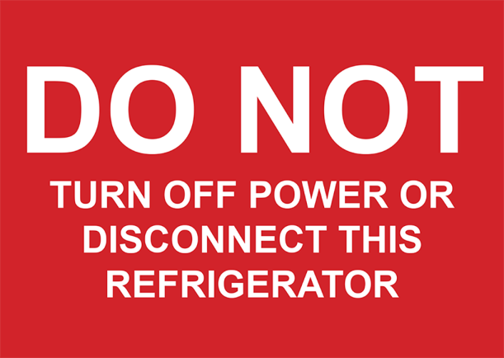 

These stickers can be ordered from the Australian Government Department of Health website: [www.health.gov.au/immunisation](https://www.health.gov.au/immunisation).

## 5.4 Stabilising the vaccine refrigerator temperature

Ensure that the temperature of the vaccine refrigerator is stable before stocking it with vaccine. To do this, monitor the refrigerator for at least 48 hours before storing vaccines to ensure that temperatures are maintained between +2°C and +8°C.

If storing only a few vaccines, the temperature of the refrigerator can be stabilised by placing cooled bottles of water (‘cold mass’) on unused shelves. Frozen products should not be used for cold mass.

Staff should familiarise themselves with the vaccine refrigerator by recording temperatures in various sections of the refrigerator. The key areas to monitor are on each shelf from top to bottom, front to back and side to side. Leave the data logger in each position for a minimum of 24 hours.

### Rationale

Stabilising the refrigerator temperature before stocking — for example, after a refrigerator failure, maintenance service, power outage or purchase of a new refrigerator — will minimise the likelihood of vaccines being exposed to temperature variations.

In some refrigerators, the coldest area is the top shelf; in others, it is the front of the bottom shelf. All models differ, even those from the same manufacturer.

It is important that the cold spots in the refrigerator are identified by detailed monitoring. This can be done by placing data loggers (see Section 4.2) or thermometers in all areas of the refrigerator and noting the different temperatures before using the refrigerator for vaccine storage. More than one data logger or thermometer will be required. Monitoring each area for at least 24 hours will capture all of the fluctuations that occur.

Depending on the type and number of monitors you have, comprehensive temperature monitoring may take some time to complete. While assessing the cold spots, use a cold mass (eg cooled bottles of water; frozen products should not be used) to imitate a batch of vaccine, because refrigerators behave differently when empty. Your state or territory health department may be able to assist with processes for logging temperatures within your refrigerator. See contact details on the last page of these guidelines. It is strongly recommended that all refrigerators be continuously monitored with a data logger.

A temperature recording chart is required to document minimum and maximum temperatures. This written record enables staff to monitor and take action if temperatures go outside the recommended range of +2°C to +8°C. See Appendix 5 for a sample monitoring chart.

**Note: Thermometers for use with vaccines must be accurate — staff should check the accuracy of the thermometer and change its battery at least every 6 to 12 months or as specified by the manufacturer (see Section 4.4 ‘How to check the accuracy of a thermometer [‘slush test’]’). Record when thermometer accuracy checks are done and when the battery is changed.**

## 5.5 Storage

Immunisation service providers must have a well-maintained purpose-built vaccine refrigerator to store vaccines. The refrigerator must have the capacity to accommodate the facility’s vaccine storage needs without overcrowding stock (including during influenza season).

Depending on the quality and design of your purpose-built vaccine refrigerator, it may warm quickly during a power failure.

If the refrigerator has an exposed coil, insert a guard or buffer to prevent vaccines being pushed onto the coil.

The refrigerator should have the following sticker clearly displayed.



This sticker can be ordered from the Australian Government Department of Health website: [www.health.gov.au/immunisation](https://www.health.gov.au/immunisation).

**Vaccines MUST be stored in their original packaging because this helps to protect them from temperature fluctuations and UV light.**

**It is best practice to store vaccines in open-weave plastic containers (with a solid base), in their original packaging. The container should be clearly labelled with the name(s) of the vaccine(s).**

Do not crowd the vaccines by overfilling the shelves. If not using open-weave baskets, allow space between containers for air circulation.

Minimise the number of times you open the refrigerator door.

When storing influenza vaccine, separate and clearly label vaccines for adults, children under 5 years of age and adults over 65 years of age, and store them in separate areas of the refrigerator. Ensure that privately purchased vaccines are clearly marked and separated from National Immunisation Program vaccines.

For a solid-door refrigerator, place a guide on the outside of the refrigerator indicating where each type of vaccine is stored. Place a picture or map of the packed refrigerator on the door (see Figure 1).

* **Do not store food or other goods in the refrigerator.** This would increase the likelihood of a cold chain breach by
* overcrowding the vaccines

increasing the number of times the door is opened.

### Rationale

Storing vaccines in labelled open-weave containers allows them to be easily identified, which reduces the likelihood of vaccine administration errors and minimises the time the refrigerator door remains open. The time spent searching for vaccines can also be reduced by placing a basic map or picture of vaccine locations on the refrigerator door so that staff can go straight to the vaccine they require.

Storing vaccines in their original packaging protects them from light and temperature fluctuations.

**Overstocking the refrigerator places all vaccines at risk. It impedes cold air circulation and reduces the likelihood of achieving consistent, stable temperatures throughout the refrigerator.**

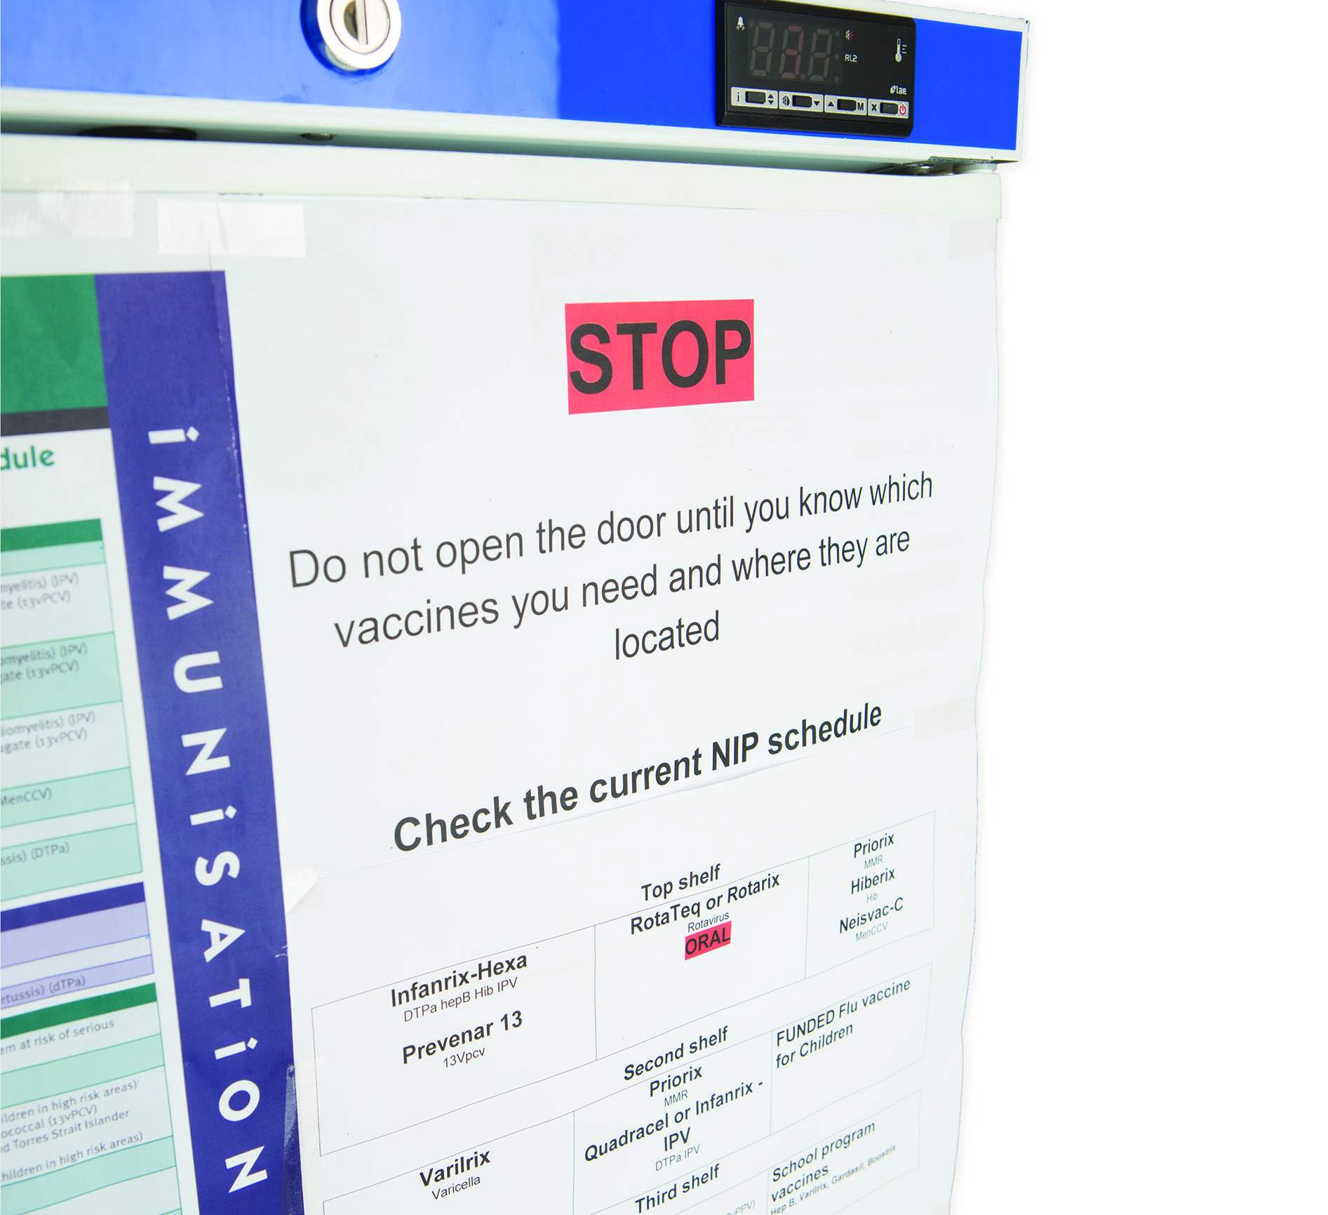

Figure 1: Solid-door purpose-built vaccine refrigerator with map

## 5.6 Monitoring and recording refrigerator temperatures

Ensure that procedures are in place to provide written records of these activities every day the facility is open, in a chart or logbook specific to each refrigerator:

**Check and record the vaccine refrigerator temperature (current, minimum and maximum) twice daily: before the refrigerator is used for the first time and at the end of each day. If the temperatures are outside the recommended +2°C to +8°C range, immediately implement cold chain breach protocols (see Appendix 3). See Appendix 5 for a sample monitoring chart.**

**Check and consider the vaccine refrigerator temperature each time before opening the refrigerator door and retrieving a vaccine; the temperature does not need to be recorded each time.**

**Reset the data logger or thermometer after each reading.**

The refrigerator temperature also needs to be read and recorded:

on receipt of vaccines

following a power failure or other cold chain breach event

hourly during mobile or outreach immunisation clinics

weekly when downloading data loggings

after any routine maintenance on the refrigerator, such as minor cleaning.

The written record of refrigerator temperatures enables staff to monitor temperature fluctuations and take action if temperatures go outside the recommended +2°C to +8°C range. Retain documentation of vaccine temperature recordings according to your state or territory health department policy, or your medico-legal and statutory requirements.

**Note:**

The data logger or thermometer must measure temperatures in Celsius, not Fahrenheit.

Each vaccine refrigerator requires its own temperature-monitoring chart/logbook.

Data loggers provide an accurate indication of the vaccine refrigerator’s temperature at preset 5-minute time intervals, and are useful for mapping cold spots in the refrigerator or investigating cold chain problems (see Section 4.2 ‘Data loggers’).

**If temperature readings are outside the +2°C to +8°C range, follow the cold chain breach protocol, download information from the data logger and contact your state or territory health department for advice. See contact details on the last page of these guidelines.**

### Rationale

Checking and recording the refrigerator temperature before retrieving a vaccine enables problems to be identified before the vaccine (which may be damaged) is administered. Twice-daily temperature checks give an indication of any problems in the refrigerator’s function and temperature fluctuations over the course of the day. However, the temperature needs to be viewed and considered every time the refrigerator is opened.

## 5.7 Maintaining the vaccine refrigerator

Report breakdowns immediately and arrange for alternative monitored storage for vaccines while the refrigerator is repaired.

Have the refrigerator serviced every 12 months and ensure that it is in good working order.

Maintain all documentation and records of refrigerator maintenance — for example, clearly distinguish between electrical checks and servicing by a refrigeration technician.

Check that the refrigerator is free from water or coolant leaks, the compressor operates quietly, the seals are in good condition and sealing tightly, and the door closes properly. Comply with the manufacturer’s directions about keeping the refrigerator level.

If there are exposed coils on the back of the refrigerator, keep them clean and free from dust to improve operating efficiency.

When cleaning the refrigerator, move the vaccines to a second refrigerator (which must be monitored during this time). Alternatively, store and monitor the vaccines in a prepared cooler (see Section 9.3 ‘How to pack a cooler’).

## 5.8 Maintaining equipment

Recalibrate the data logger annually or according to the manufacturer’s recommendations.

Change the data logger battery at least every 6 to 12 months or as indicated by the manufacturer.

Check the accuracy of the thermometer at least every 12 months (see Section 4.4 ‘How to check the accuracy of a thermometer [‘slush test’]’).

Change the thermometer battery at least every 6 to 12 months or as indicated by the manufacturer.

## 5.9 Self-audit

A vaccine storage self-audit must be undertaken by each clinic or practice at least every 12 months and documentation retained. Self-audits should be carried out more frequently if there have been problems with equipment or cold chain breaches (see Appendix 2 ‘Vaccine storage self-audit’).

# 6 Considerations when choosing a purpose-built vaccine refrigerator

What is a purpose-built vaccine refrigerator?

Purpose-built vaccine refrigerators are specifically designed to store vaccines between +2°C and +8°C, and are the only type of refrigerator recommended for storing vaccines.

Purpose-built vaccine refrigerators have the following advantages:

* a stable, uniform and controlled cabinet temperature between +2°C and +8°C
* standard alarm and safety features that alert to and/or prevent irregular temperature fluctuations in the cabinet
* inbuilt digital temperature monitoring (inbuilt data logger) and/or digital temperature indicators (minimum and maximum temperature displays)
* effective temperature recovery after the refrigerator door has been opened
* manufactured to handle ambient temperature changes
* potential for most of the internal space to be used for vaccine storage; refer to the manufacturer’s recommendations on the space required between the side of the refrigerator and the vaccines to accommodate the maximum quantity of vaccines.

Note:

* Purpose-built vaccine refrigerators do not have freezer compartments. An additional refrigerator with a freezer section will be required for storing ice packs and gel packs for use in an emergency or when packing a cooler for transport.
* Not all purpose-built vaccine refrigerators will include an inbuilt data logger. In most cases, a data logger can be added as an additional feature. Alternatively, a portable digital data logger can be used to continuously monitor temperatures. A computer and software are required to download information from the data logger.

## 6.1 Clinical considerations

* Are there manufacturer’s requirements for the placement of the purpose-built vaccine refrigerator in your clinic or practice?
* Is space required for air flow around the refrigerator?
* Will the refrigerator fit into the space allocated in your clinic or practice?
* Do you need to position the refrigerator away from warm external walls and direct sunlight?

Do you require the door(s) of the refrigerator to be lockable?

* Is the purpose-built vaccine refrigerator fit for purpose?
* Is the refrigerator large enough to store your National Immunisation Program vaccines, state-supplied vaccines and private vaccine stock (if required) in open-weave baskets, particularly during the influenza season?
* Does the refrigerator have an inbuilt data logger to continuously monitor temperatures? How easy is it to download the data to a computer? (If there is no inbuilt data logger, see ‘Digital [portable] data loggers’ in Appendix 10.)
* Is there an easily visible external temperature display showing the ‘lagged’ minimum, maximum and current vaccine temperature (not ambient temperature)?
* Is there an audible alarm if the temperature of the refrigerator goes outside the +2°C to +8°C range?
* If the alarm is silenced, will it reset to sound again if the temperature remains outside the +2°C to +8°C range?
* Are castors fitted for ease of moving the refrigerator, if required?

Can the castors be locked to prevent the refrigerator from moving once in position?

**Note:** There is a potential for equipment failure of automated temperature recorders (eg data loggers and remote monitoring systems); therefore, minimum and maximum temperatures must still be recorded twice daily as a quality assurance measure. **Twice-daily minimum and maximum temperatures must be manually recorded as a timely alert to any breach in the cold chain.**

* Does the purpose-built vaccine refrigerator have a glass door or a solid door?
* Purpose-built vaccine refrigerators with glass doors do not always provide good insulation in the event of an interruption to the power supply.
* Purpose-built vaccine refrigerators with solid doors will maintain the temperature between +2°C and +8°C for longer than refrigerators with glass doors; this may be preferable in areas where power supply is not continuous.
* Does the door of the refrigerator close automatically? If not, ask the manufacturer to confirm whether it is acceptable to use a door-closing device or to leverage the refrigerator (front feet higher than back feet) to ensure that the door closes freely.

Does the refrigerator have a ‘door left open’ alarm?

## 6.2 Technical suitability

* How suitable is the purpose-built vaccine refrigerator for use in your clinic or practice?
* Is an internal data logger provided with the refrigerator?

Does the refrigerator have a lagged temperature probe? The refrigerator should already be set up with a temperature probe in specific material (eg glycol) to reduce short-term fluctuations in the refrigerator temperature. Lagging provides a better indication of the actual temperature of vaccines and prevents the alarm going off unnecessarily.

* What kind of alarm systems does the purpose-built vaccine refrigerator have?
* Are there ‘terminal outlets’ to connect an alarm system that will connect to a remote site to monitor power loss, and low and high temperature alarms? This is an option for immunisation service providers if they need to connect to a central alarm system.
* Audible and visual alarms should activate:
  + if the temperature of the lagged probe falls to +2.5°C or reaches +7.5°C
  + if there is an interruption in the electrical supply to the refrigerator.
* Where the audible alarm can be muted, is there a process for its automatic reactivation after a 15- to 30-minute interval?

Any circuit failure should not affect the correct functioning of the basic alarm system.

* What is the quality of the product?

Is the purpose-built vaccine refrigerator made of high-quality material — for example, insulation, shelving and surfaces that require minimal cleaning?

## 6.3 Maintenance

It is important that purpose-built vaccine refrigerators receive annual maintenance to maintain them in optimal operating condition and extend their useful life.

After-sales service, support and maintenance for the purpose-built vaccine refrigerator should be undertaken annually or as per the manufacturer’s recommendations.

A maintenance schedule should be included in the purchase of the refrigerator.

What is the manufacturer’s warranty for the motor and the refrigerator cabinet?

Are training and support provided for the refrigerator being purchased?

What is the availability of spare parts for the refrigerator that you may need to purchase in the future?

How often does the inbuilt minimum/maximum thermometer need to be calibrated?

How often does the inbuilt data logger need to be calibrated?

## 6.4 Other considerations when purchasing a purpose-built vaccine refrigerator

What is the delivery time to your clinic or practice?

Is information available about the past performance of the manufacturer and after-sales service for the purpose-built vaccine refrigerator you are considering?

For more information about data loggers, see Section 4.2.

As always when shopping, think: Is this value for money? Will this purchase deliver what I expect? Ask questions! The quality and design of a purpose-built vaccine refrigerator may determine how quickly it warms during a power failure.

When choosing a purpose-built vaccine refrigerator, consider the following points:

the size of the refrigerator — ensure that it is large enough to meet the facility’s vaccine storage requirements, particularly during peak periods when additional vaccines may be stored, such as the seasonal influenza program

the size of the space in the facility — ensure that there is enough room for air circulation around the back and sides of the purpose-built vaccine refrigerator, as per the manufacturer’s instructions

the need for an alternative freezer to store ice packs and gel packs for use during mobile or outreach immunisation clinics, or in the event of a power failure.

Consider choosing a purpose-built vaccine refrigerator with the following features:

an inbuilt digital temperature monitor/data logger

an alarm system — alarm systems have various options such as the capacity to notify someone remotely, either by automatic telephone dialling or by alert to a central area that is staffed 24 hours a day; choose the alarm system that best suits your needs

a ‘door left open’ alarm

an inbuilt temperature recording system — ensure that the temperature (minimum and maximum) can be easily read; some digital temperature displays may be located at the bottom of the refrigerator.

## 6.5 Questions to ask

Questions to ask the sales representative might include:

What is the difference between solid and glass doors with respect to temperature maintenance?

What is the energy efficiency?

Will the purpose-built vaccine refrigerator require enhancements (eg alarms, temperature-monitoring features such as a data logger), and what are the associated costs?

What are the conditions and durations of the warranty? Pay attention to the back-up support and servicing, including the costs of delivery, maintenance and repairs, particularly in rural and remote areas. What are the supplier/manufacturer quality assurance processes?

How long will the purpose-built vaccine refrigerator remain within the recommended temperature range in the event of a power failure?

Is cold mass support required (eg cooled bottles of water; frozen products should not be used)?

# 7 Caring for vaccines during immunisation clinics

## 7.1 Key issues

Do not use diluents warmer than the vaccine because they can affect the potency of live vaccines.

Be aware of sensitive vaccines. Most vaccines are sensitive to any form of UV light, including fluorescent light, and **MUST** be stored in their original packaging to provide protection from UV light.

Minimise the number of times that the refrigerator door or cooler is opened.

Vaccines are particularly vulnerable at the time of use because:

vials and ampoules have to be opened

freeze-dried vaccines have to be reconstituted

staff must handle many types of vaccines with different requirements.

## 7.2 Mobile or outreach immunisation clinics

Vaccines should be packed and monitored during transport and administration in all venues. This includes school programs conducted by doctors and other immunisation service providers, and influenza mobile or outreach immunisation sessions held outside clinics (eg in nursing homes). See Section 9 ‘Coolers’ for details on the correct packing and monitoring process.

At least 24 hours before each mobile or outreach immunisation clinic, check the number of ice packs/gel packs in the freezer and replenish as needed.

Plan the mobile or outreach immunisation clinic carefully. Take sufficient stock of vaccines, diluent, adrenaline (epinephrine), bubble-wrap, cold chain monitors and ice packs/gel packs.

When using a cooler, store vaccines in their original packaging.

If providing immunisations outdoors, choose a cool, shaded site.

For a mobile service where there is no electric power supply or refrigerator, take an extra cooler containing additional ice packs/gel packs to replace melted ice packs/gel packs in the vaccine cooler.

Take vaccines and diluents (if required) from the cooler only as required. Reconstitute vaccines immediately before administering them.

When the vaccines are outside the vaccine cooler, keep them out of direct sunlight and away from other sources of heat and UV light (eg fluorescent light).

Avoid handling vaccines any more than absolutely necessary.

During mobile or outreach immunisation clinics, monitor and record the current, minimum and maximum temperatures of the cooler every hour. Reset the thermometer after each reading.

When the mobile or outreach immunisation clinic is over, return vaccines that have been continuously stored between +2°C and +8°C to the vaccine refrigerator as soon as possible.

See Appendix 7 for a printable guide for preparing for mobile or outreach immunisation clinics and Appendix 8 for a printable checklist and temperature chart to use during these clinics.

When preparing for long-term storage, or a mobile or outreach immunisation clinic in an extreme climate, use a specialised vaccine cooler (see Section 9.4).

**Report all cold chain breaches that occur during mobile or outreach sessions to your state or territory health department. See contact details on the last page of these guidelines.**

### Reconstituting vaccines with diluent during a mobile or outreach immunisation clinic

Reconstituted vaccines lose potency over time, even when stored between +2°C and +8°C. Storage rules vary depending on the vaccine being used. For vaccine-specific information, refer to the online version of the Australian Immunisation Handbook and to the current version of the relevant vaccine product information (PI) statement. PIs are supplied with all vaccines and are also freely available on the [Therapeutic Goods Administration](http://www.tga.gov.au/) website: [www.tga.gov.au](https://www.tga.gov.au/).

## 7.3 Community pharmacy–acquired vaccine

Doctors who provide a prescription for the purchase of vaccine should advise clients that it is important to purchase the vaccine from the pharmacy immediately before attending the practice or clinic appointment. On arrival, the client should notify reception that they have a vaccine to put in the vaccine refrigerator.

If an immunisation service provider has any concern that a vaccine provided by a client may have been stored outside the recommended +2°C to +8°C range, the vaccine should not be administered. This may result in additional cost to the client.

**Note:** Alfoil bags commonly provided by pharmacists when vaccines are privately purchased are not effective in keeping vaccines at the correct temperature — for example, when the vaccine is left in a car or stored in a domestic refrigerator.

# 8 Managing a power failure

Power failures occur for many reasons. How a power failure is managed in your organisation may depend on the cause of the power outage, whether prior notice was given and the time of day the outage occurs. The safety and wellbeing of staff should always be considered when managing power failures, particularly when they occur outside business hours.

Some power networks send letters or provide text message alerts for power outages. Check with your local power networks whether this service is available in your state or territory.

A printable checklist for managing a power failure is provided in Appendix 9.

## 8.1 Back-up plans

Always have a back-up plan and alternative storage if a power failure occurs.

This will allow vaccines to continue to be stored between the recommended temperatures of +2°C and +8°C, thereby minimising vaccine loss and disruption to your facility’s activities.

Alternative vaccine storage in the event of a power failure may include any of the following:

a back-up power supply (eg generator or battery/solar back-up)

a monitored refrigerator offsite (eg at a local hospital or pharmacy) — ensure that an agreement has been put in place with the relevant organisation before the event, and also consider that this organisation may be affected by the same power failure

a cooler — each facility should ensure that they have enough coolers for an emergency.

If using a cooler, ensure that it will be large enough to accommodate:

all vaccines, loosely packed

ice packs or gel packs

insulating material (eg polystyrene chips or bubble-wrap)

a minimum/maximum thermometer or data logger.

Each immunisation facility should practise implementing its back-up plan, including practising packing vaccines into alternative storage, to ensure that the plan will work in a real power failure situation. Keep in mind that there may be only a short window of time before the vaccine refrigerator temperature rises above +8°C — suitable alternative storage must be ready quickly. Ensure that the back-up plan is clearly documented in the vaccine management protocol. The information provided here is a general guide only and may not be applicable to each facility — careful planning and practice will ensure that your back-up plan will work for your facility.

## 8.2 Purpose-built vaccine refrigerators

Depending on the quality and design of your purpose-built vaccine refrigerator, and the ambient temperature of the facility, the refrigerator may warm quickly during a power failure. Contact the refrigerator manufacturer to establish this time period and document it as part of your power outage plan.

**Note:** Not all purpose-built vaccine refrigerators continue to display the current temperature during a power failure. To overcome this issue, use a separate battery-operated minimum/maximum thermometer or data logger to continuously monitor refrigerator temperatures during power outages.

If the temperature of the refrigerator is about to exceed +8°C for longer than 15 minutes and vaccines are at risk, use alternative monitored storage arrangements.

## 8.3 When power goes off

### During business hours

1. Immediately isolate the vaccines and keep them refrigerated between +2°C and +8°C. Leave the vaccines in the refrigerator with the door closed. Put a sign on the refrigerator door stating: ‘Power out. Do not use vaccines. Keep refrigerator door closed.’

2. Closely monitor the refrigerator temperature using a battery-operated minimum/maximum thermometer or portable data logger. Ideally, this should be done using a standalone minimum/maximum thermometer with an external display to limit the need to open the door.

3. If the temperature rises to +8°C, move vaccines to a prepared cooler, cold box or portable purpose-built vaccine refrigerator. Ensure that all vaccines are packed and monitored with a digital minimum/maximum thermometer or data logger. See Section 9.3 ‘How to pack a cooler’.

4. Ensure that you have a strategy in place for long-term storage. Your state or territory health department may be able to assist you.

**Never transport vaccines to another vaccine refrigerator, cooler or cold box without a minimum/maximum thermometer or data logger to monitor the temperature. Domestic refrigerators (including bar fridges) are not built or designed to store vaccines and must not be used for vaccine storage. Refer to your state or territory health department for further advice. If there is no suitable alternative monitored storage option, isolate the vaccines and leave them in the refrigerator with the door closed for the duration of the power outage.**

### Outside business hours

If there is a power failure outside normal business hours, such as during a storm, the safety, health and wellbeing of staff should be the main priority. Depending on the temperature-monitoring and alarm systems in use, an alert may be sent to the registered user by text message or email (see Section 4.6 ‘Automated temperature-monitoring systems’). The alerted staff member can take action, if safe to do so, to prevent vaccine losses.

## 8.4 When power is returned

Record the minimum and maximum refrigerator temperatures.

Reset the refrigerator temperature when the temperature reaches +8°C or less.

Ensure that the refrigerator temperature has returned to between +2°C and +8°C before returning vaccines.

If a cold chain breach has occurred, isolate vaccines until you seek advice from your state or territory health department. The health department will require vaccine details, data logging and twice-daily readings to assess the breach. See contact details on the last page of these guidelines.

**Do not use or discard vaccines until you have received advice from your state or territory health department.**

Monitor the refrigerator closely (eg hourly) to ensure that the temperature is consistently stable, then return to twice-daily monitoring.

If necessary, follow the cold chain breach protocol described in Appendix 3. This appendix details important information to have on hand when reporting a cold chain breach to your state or territory health department.

# 9 Coolers

A cooler, or esky, is a solid-walled insulated container with a tightly fitting lid, or a vaccine-specific soft-walled cooler. The temperature inside can be maintained using ice packs or gel packs. Coolers are usually portable.

High-quality coolers are available from large boating, fishing or camping suppliers. They have thick refrigerator-grade insulation, and fibreglass or plastic walls. Some may have small ‘feet’, which ensure that the cooler does not contact warm surfaces such as the floor of a car boot. Check with the manufacturer about the technical specifications and performance of the cooler.

Coolers have a limited ‘cold life’ and are therefore not adequate for vaccine storage for prolonged periods (more than 8 hours) or in extreme conditions. In these circumstances, a specialised cooler should be used for storing and transporting vaccines (see Section 9.4).

## 9.1 Tips for using coolers

Immunisation service providers should choose coolers that will meet their facility’s needs.

Freezing episodes can occur in all coolers, usually in the first 2 hours after packing. The minimum size cooler recommended for storing vaccines is 10 litres.

Consider the quantity of vaccines stored in your vaccine refrigerator to determine the minimum number of coolers and equipment you will require if you need to transfer your vaccines to prevent a cold chain breach.

Polystyrene coolers provide limited insulation and are only suitable for storing vaccines for short periods (up to 4 hours).

If using a polystyrene cooler, change to a plastic cooler if the polystyrene cooler is not maintaining a stable temperature.

If using a plastic cooler that is not maintaining a stable temperature, consider upgrading to a higher-quality cooler with refrigeration-type insulation, or a specialised cooler.

The number of ice packs or gel packs required (see Section 9.2) will depend on:

ambient temperature

type and size of cooler

number of vaccines

cooler capacity

size and type of ice packs/gel packs.

When using coolers, always do the following:

Condition the ice packs or gel packs (see Section 9.2).

* Correctly pack the cooler to reduce the risk of freezing (see Section 9.3).
* Pre-chill the cooler before use.

Insulate the vaccines with appropriate material so they do not come into contact with ice packs/gel packs that are at 0°C. For example, loosely wrap vaccines in bubble-wrap, allowing cool air to circulate; avoid wrapping tightly.

Monitor and record the temperature every 15 minutes for the first 2 hours, then at least hourly (provided that temperatures are stable) using a battery-operated minimum/maximum thermometer. The thermometer should be reset after each reading for accuracy.

Ensure that the contents of the cooler are packed securely so they cannot move around during transport.

Keep the cooler out of the direct sun.

Remove vaccines from the cooler only as they are required.

Check that the temperature has remained between +2°C and +8°C before administering the vaccine.

## 9.2 Freezing and conditioning ice packs and gel packs

### Ice packs

Ice packs are water filled and can come out of the freezer at a temperature as low as −18°C, which is significantly lower than the freezing point of the ice pack. Achieving the lower temperature will provide a longer cold life for the ice pack.

#### How to condition ice packs

Condition ice packs as follows:

Remove ice packs from the freezer.

Lay out ice packs in a single row on their sides (where possible), leaving a 5cm space around each ice pack to allow maximum air exposure. This reduces the conditioning time.

Wait until ice packs begin to sweat. This will take up to 1 hour at +20°C.

The ice pack is conditioned as soon as water begins to ‘slosh’ about slightly inside the ice pack.

### Gel packs

Some types of gel packs contain chemicals that depress the freezing point of the pack and ensure that the gel remains colder than 0°C for longer than water-filled ice packs. Before purchasing gel packs, request documentation from the manufacturer that:

validates their claims about the product’s cold life

provides clear instructions on how to freeze and condition the product before use, and how to safely pack a cooler with the gel pack and vaccines.

#### How to condition gel packs

Usually gel packs will take longer to condition than ice packs.

Follow the manufacturer’s instructions for conditioning the gel pack. Although there is no ‘one rule fits all’ approach, there are some industry standards that can be used to guide conditioning if gel packs have been stored in the freezer at −20°C for a minimum of 36 hours.

Conditioning frozen gel packs for the times prescribed below enables the initial chill factor to be removed from the packs.

### Guide to time needed to condition small and large gel packs

#### Gel packs weighing less than 750g

If ambient (room) temperature is **over** +15°C, condition for 45 minutes before use.

If ambient temperature is **under** +15°C, condition for 1 hour before use.

#### Gel packs weighing more than 750g

If ambient (room) temperature is **over** +15°C, condition for 1 hour before use.

If ambient temperature is **under** +15°C, condition for 1½ hours before use.

## 9.3 How to pack a cooler

**One of the greatest risks to vaccines is freezing during transport in a cooler.** The risk of freezing increases if the ice packs/gel packs are not correctly conditioned.

Freezing episodes occur easily in all coolers, usually in the first 2 hours after packing. Monitor the temperature every 15 minutes for the first 2 hours, and then at least hourly.

Option one: Packing vaccines directly into a cooler

This option can be used for storing vaccines in a cooler for up to 8 hours.

1. Chill the inside of the cooler before use by placing ice packs/gel packs in it for a few hours (Figure 2), and then remove the ice packs/gel packs.

2. Place polystyrene chips or other suitable insulating material at the bottom of the container (Figure 3). This eliminates ‘hot’ and ‘cold’ spots. Packaging such as polystyrene chips is preferable to bubble-wrap because it promotes air circulation. If using bubble-wrap, avoid wrapping the vaccines tightly.

3. Place vaccine stock on top of the insulating material (Figure 4).

4. Place a minimum/maximum thermometer (or a dual time–temperature indicator if they are used in your state or territory) or data logger in the centre of the vaccine stock (Figure 5).

5. Place the thermometer probe in an empty vaccine box (with the product information intact) to protect it from lying directly on ice.

6. Surround the vaccines with packing material that allows cold air to circulate.

7. Place the conditioned ice packs/gel packs on top of the insulating material (Figure 6), and close and seal the lid of the cooler. If using a larger cooler, place conditioned ice packs/gel packs around the sides of the cooler as well as on top. Experiment to find the best combination.

8. Ensure that vaccine stock is not in direct contact with the ice packs/gel packs, to minimise the risk of freezing.

9. Place the display screen of the minimum/maximum thermometer on the outside of the cooler for easy monitoring and recording of vaccine temperatures (Figure 7).

10. Commence monitoring before leaving for the session. Monitor the temperature every 15 minutes for the first 2 hours, and then at least hourly throughout the immunisation session, and before administering vaccines (see Appendix 8 ‘Checklist and temperature chart for mobile or outreach immunisation clinics, or emergency storage of vaccines’).

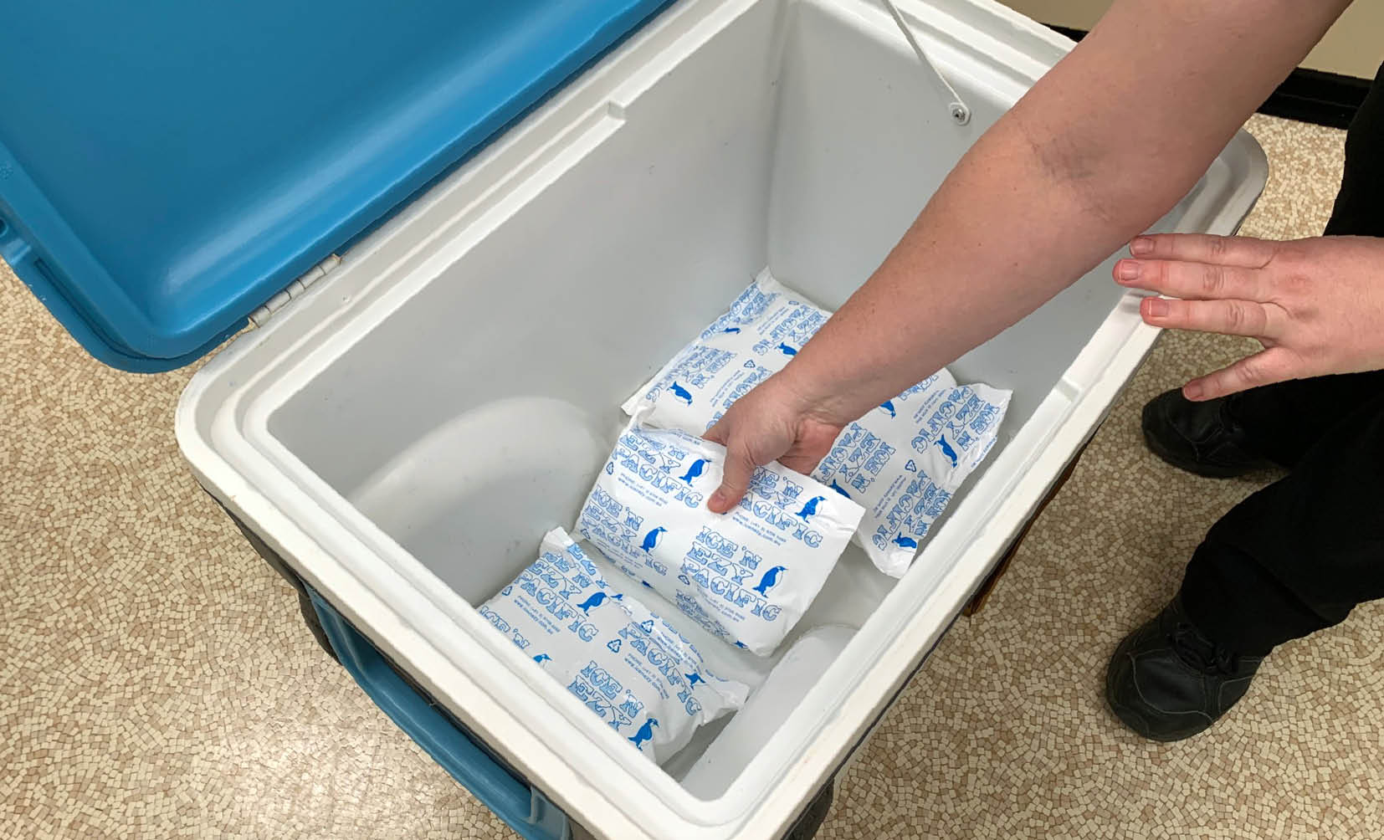

Figure 2: Ice packs/gel packs placed in bottom of cooler to chill cooler

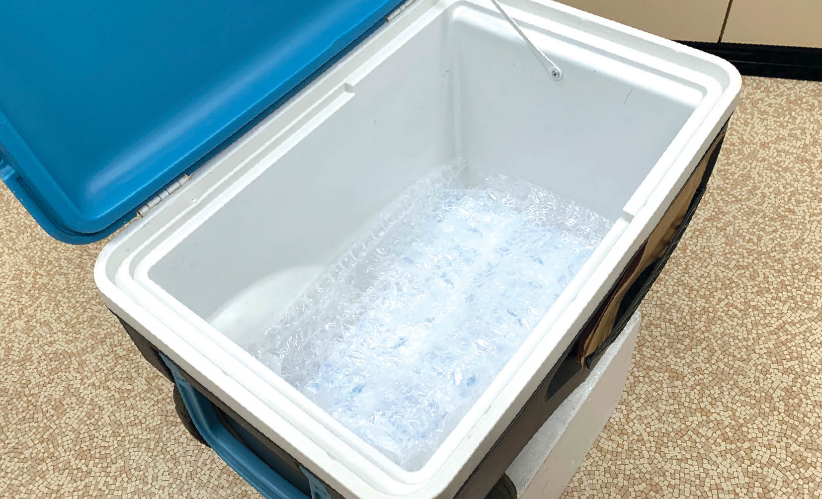

Figure 3: Insulating material placed in bottom of cooler

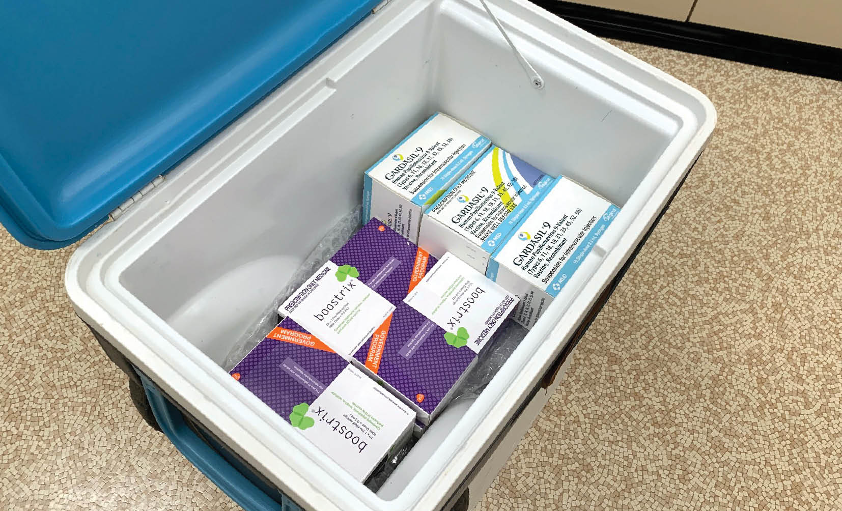

Figure 4: Vaccines packed in cooler

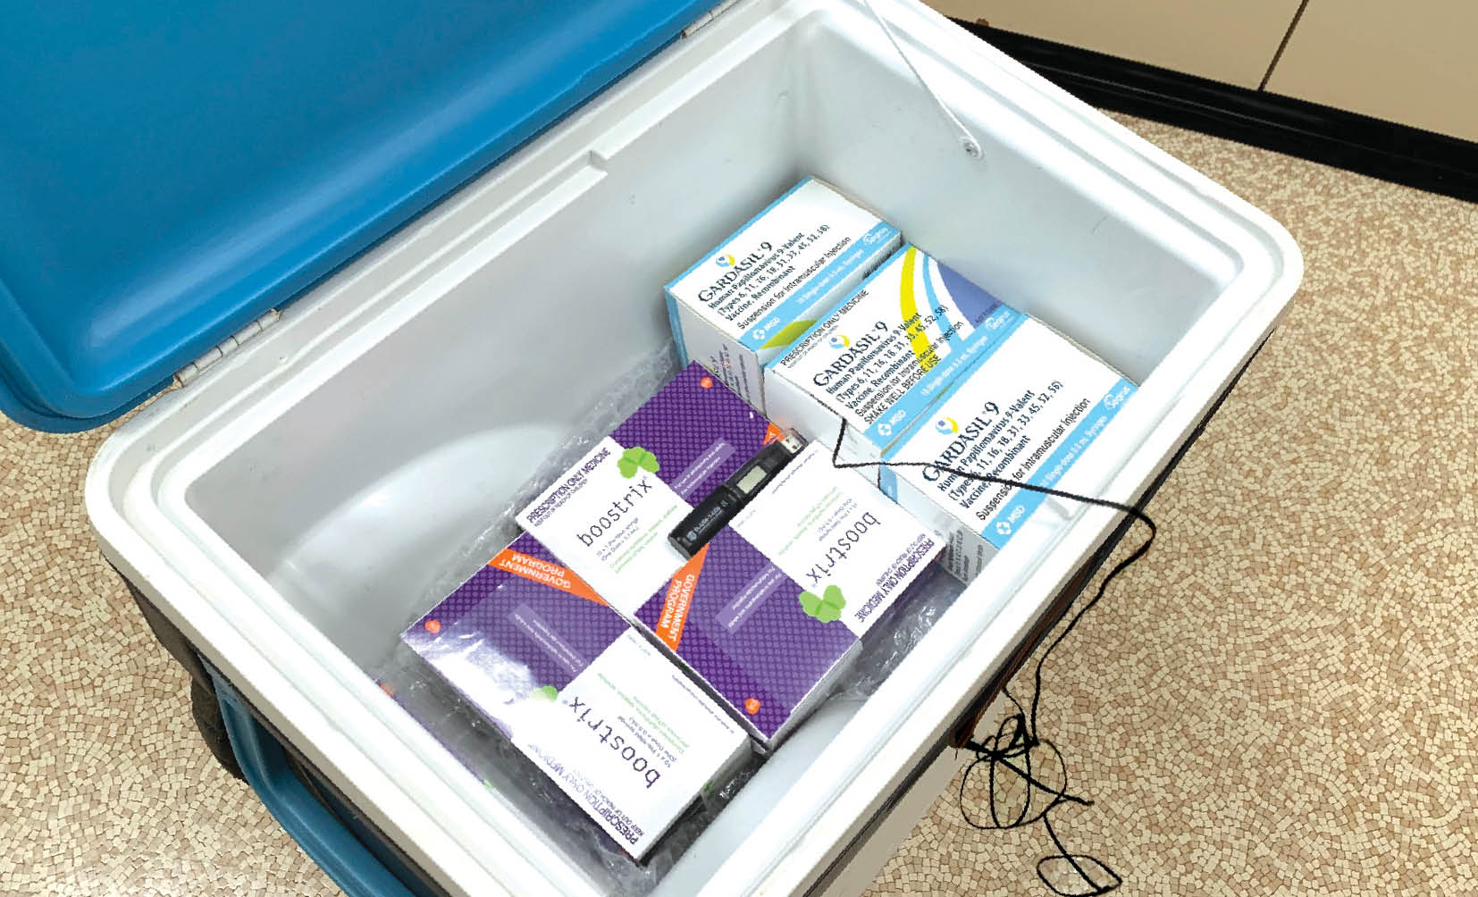

Figure 5: Minimum/maximum thermometer placed in centre of vaccine stock

**Note:** A data logger (if available) can also be placed with the minimum/maximum probe.

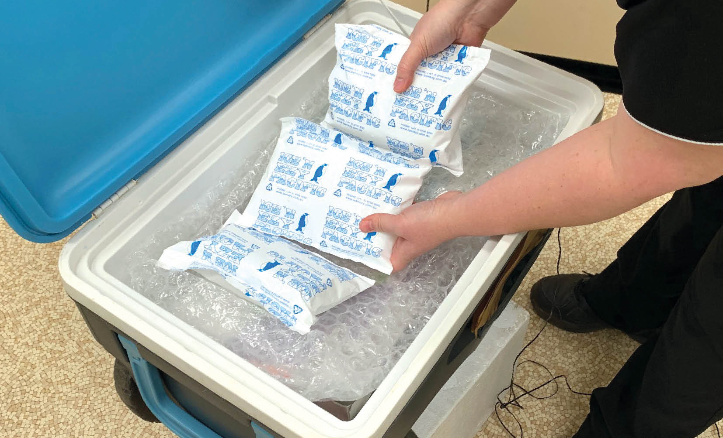

Figure 6: Insulating material placed on top of vaccine stock followed by ice packs/gel packs

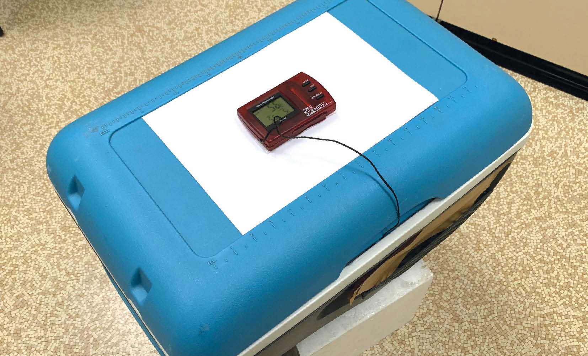

Figure 7: Minimum/maximum thermometer display placed outside cooler

Option two: Packing vaccines into a polystyrene container that is then placed into a larger cooler

1. Choose a suitably sized polystyrene container and chill the inside by placing ice packs/gel packs inside for a few hours.

2. Remove the ice packs/gel packs used to chill the inside and replace with conditioned ice packs/gel packs.

3. Place the vaccines and a minimum/maximum thermometer inside the polystyrene container, and secure the lid.

4. Ensure that the minimum/maximum thermometer probe is placed in the centre of the vaccine stock inside an empty vaccine box with the product information intact. The display screen should be placed on the outside of the cooler to allow recording of the temperature.

5. Pack the polystyrene container inside a large cooler and surround it with ice packs/gel packs. Secure the lid.

6. Monitor the temperature before leaving for the session, upon arrival, before administering vaccines and at least hourly throughout the immunisation session (see Appendix 8 ‘Checklist and temperature chart for mobile or outreach immunisation clinics, or emergency storage of vaccines’).

**Note: Test temperature stability before placing vaccines in the polystyrene container.**

## 9.4 Specialised vaccine coolers

A vaccine cooler is a purpose-built product. It has thick walls and is significantly more expensive than a standard cooler.

The cooler insulation should be at least 30mm thick and, if possible, 80mm thick in the walls and lid. Fibreglass coolers with 50mm refrigeration-grade insulation are available.

For long-term storage (more than 8 hours) or storage in extreme conditions (where the temperature of the storage environment is <0°C or >40°C), a specialised cooler is needed. Specialised coolers are available that meet World Health Organization (WHO) recommendations.

A large cooler should have a minimum cold life of 120 hours when exposed to temperatures up to +43°C without being opened.

WHO specifications are available at: [www.who.int/immunization_standards/vaccine_quality/pqs_e04_insulated_containers/en](https://www.who.int/immunization_standards/vaccine_quality/pqs_e04_insulated_containers/en/).

# APPENDIX 1 Vaccine management protocol

Vaccine storage procedures from National Vaccine Storage Guidelines – Strive for 5, 3rd edition, are available on the Australian Government Department of Health website: <https://beta.health.gov.au/resources/publications/national-vaccine-storage-guidelines-strive-for-5>.

It is suggested that you download this and other Strive for 5 appendixes from the Department of Health website and fill in details for your facility.

A vaccine management protocol should cover the following areas.

Vaccine ordering

The aim when ordering vaccine is the **right** amount at the **right** time.

Stocktake must be carried out before ordering new vaccine.

* Add details about how to order vaccines:
* where order forms are kept
* who they are sent to

how to follow up on orders.

Vaccine delivery

**Note:** States and territories have different methods of vaccine delivery. Some of the points below may not apply in your facility.

The nominated person should accept vaccines from the courier.

Check cold chain monitors and record the data on the minimum/maximum temperature chart.

Transfer vaccines in original packaging to a dedicated purpose-built vaccine refrigerator, as soon as the refrigerator’s temperature monitors have been checked.

Check vaccine expiry dates. Bring vaccines with the shortest dates to the front of the refrigerator.

Record date, numbers of vaccines received, vaccine types and batch numbers.

Record details of who to contact if cold chain monitors show a breach, noting the difference between government-funded and privately purchased vaccines.

Report any discrepancies between the vaccines on the delivery docket and the vaccines received to your state or territory health department.

Temperature monitoring and recording

* Place instructions on how to use the data logger and how to download data in your facility’s vaccine management manual. Record:
* where to store data on the computer
* date of purchase
* date of last calibration

whether the data logger is able to display the minimum, maximum and current temperatures.

* A minimum/maximum thermometer is required if the refrigerator does not have a battery back-up for the inbuilt temperature-monitoring system, generator back-up or uninterrupted power supply (so the refrigerator can be monitored in the event of a power failure):
* Ensure that a thermometer is in place to continuously check the temperature in each vaccine refrigerator.
* Place the thermometer probe in an empty vaccine box (not in fluid) on the middle shelf of the refrigerator.
* Check the thermometer and record the temperature twice every working day.
* Record the minimum and maximum temperatures of the refrigerator, and reset the thermometer.
* Provide the location of new temperature recording charts/logbooks.
* Provide instructions for how to reset the minimum/maximum thermometer.

Record the date of the last accuracy check and battery change.

Provide details of who to contact for advice during a cold chain breach.

Power failure procedure

Provide instructions for what to do in opening hours.

Provide instructions for what to do out of hours.

Cold chain breach

1. Immediately isolate the vaccines.

2. Keep vaccines refrigerated between +2°C and +8°C, and label ‘**Do not use**’. Vaccines may need to be transferred to an alternative purpose-built vaccine refrigerator or cooler.

3. Contact your state or territory health department as soon as possible (during business hours). The health department will require vaccine details, data logging and twice-daily temperature readings to assess the breach.

4. Do not discard any vaccine until advised to do so by your state or territory health department.

5. Take steps to correct the problem and to prevent it from recurring.

6. For privately purchased vaccines, contact the manufacturer for advice.

**See also Appendix 3 ‘Cold chain breach protocol’.**

Documentation

Written procedures, instructions and logbooks need to be readily accessible to explain and record equipment maintenance, vaccine transport and staff education.

Equipment maintenance

Include:

instructions for how and when to change batteries — for example, the batteries in minimum/maximum thermometers require changing at least every 6 to 12 months

refrigerator service contact details — who to contact and when

instructions for when the annual refrigerator self-audit is to be performed

instructions for cleaning the refrigerator.

Transporting vaccines off site

Include instructions for:

how to condition ice packs and gel packs

how to correctly pack a cooler

how often to monitor the cooler temperature.

Staff education — vaccine management

Include:

procedure for orientating new staff and staff with new roles

staff records of ongoing education.

# APPENDIX 2 Vaccine storage self-audit

Immunisation service providers are required to use this checklist to carry out a self-audit at least once every 12 months, and more frequently if there have been problems with equipment or cold chain breaches. Documentation should be stored for future reference.

Print this checklist and use it as required.

**Self-auditing is important because:**

* it is part of routine quality assurance and risk management processes
* it enables staff to have confidence that they are providing a safe and effective vaccine.

Print or photocopy this page and keep it as a record of an audit.

Nominated person responsible for vaccine management:

Nominated back-up person for vaccine management:

Make and model of refrigerator:

Date of self-audit:

Person conducting audit:

PROCEDURES

Checklist for safe vaccine handling and storage

🞎 Have all staff received orientation and/or an annual update on vaccine management?

🞎 Have vaccine management policies been reviewed in the past 12 months to ensure that procedures are up to date?

Date of last revision: .

🞎 Is graph/logbook/chart for temperature recording readily available?

🞎 Is the temperature of the vaccine refrigerator recorded twice a day when the facility is open?

🞎 Are the contact numbers to report a cold chain breach easily accessible?

🞎 Were all deviations outside the +2°C to +8°C range reported to the appropriate state or territory health department?

🞎 Have the responses to all deviations outside the +2°C to +8°C range been documented and recommended actions taken?

EQUIPMENT

Vaccine refrigerator

🞎 Has the refrigerator shown evidence of malfunction (eg poor seals so that the door opens too easily)?

🞎 Is there an appropriate gap between the vaccines and the walls of the refrigerator?

🞎 Can the refrigerator continue to store the required volume of vaccines safely according to these guidelines? (This includes times of increased demand such as the influenza program.) If ‘No’, what action is being taken?

Date refrigerator was last serviced:

🞎 If the refrigerator has a solid door, is a map or guide to where vaccines are stored located on the outside of the door?

🞎 Does the power outlet have a sign ‘Do not turn off or disconnect this refrigerator’?

Monitoring equipment

Date the minimum/maximum thermometer(s) was purchased:

Date the battery for the minimum/maximum thermometer(s) was last changed:

Date and results of thermometer accuracy check at 0°C:   
See *Strive for 5* Section 4.4 ‘How to check the accuracy of a thermometer (‘slush test’)’

🞎 Is the minimum/maximum thermometer temperature probe(s) placed correctly?

Date the data logger(s) battery was last changed:

Date data logger(s) was last serviced:

Alternative vaccine storage

🞎 Is there a readily accessible written procedure for what to do during a power failure?

🞎 Is enough alternative storage (eg cooler, other monitored refrigerator) available for vaccine storage, if necessary (eg vaccine refrigerator breakdown or power failure)?

🞎 Are ice packs/gel packs at the correct temperature available?

🞎 Is there one minimum/maximum thermometer for each cooler?

🞎 Is there enough insulating material for each cooler?

# APPENDIX 3 Cold chain breach protocol

A ‘cold chain breach’ occurs when vaccine storage temperatures deviate outside the recommended range of +2°C to +8°C. The optimal storage temperature for vaccines is +5°C.

This appendix outlines the cold chain breach protocol and important information to have on hand when reporting a cold chain breach.

All vaccine temperatures recorded below +2°C or above +8°C must be reported to your state or territory health department. This does not include temperature deviations or excursions in which the temperature reaches a maximum of up to +12°C for 15 minutes or less.

A poster summarising the cold chain breach protocol can be ordered or downloaded from the Australian Government Department of Health website: [www.health.gov.au/immunisation](https://www.health.gov.au/immunisation).

Cold chain breach protocol

1. Immediately isolate the vaccines and prepare to transfer them into temporary monitored vaccine storage, if necessary. Start conditioning ice packs/gel packs.

2. Keep vaccines refrigerated between +2°C and +8°C for as long as possible, and label them ‘**Do not use**’ while preparing to transfer them.

3. Contact your state or territory health department as soon as possible (during business hours).

4. Do not discard any vaccine until advised to do so by your state or territory health department.

5. Take steps to correct the problem and to prevent it from recurring.

6. For privately purchased vaccines, contact the manufacturer for advice.

Information needed when reporting a cold chain breach

Date and time of the breach

Reason for the cold chain breach (if known) and whether it has been rectified

Brand and size of refrigerator in which the vaccines are stored (eg ABC brand; 381 litres)

Information for the breach period downloaded from your data logger. All refrigerators should have continuous data logging. Download the data before contacting your state or territory health department

Minimum and maximum temperature readings while the vaccines were exposed to temperatures outside the +2°C to +8°C range

Length of time the refrigerator temperature was outside the +2°C to +8°C range

Date the refrigerator was last serviced

Whether the vaccine refrigerator has had any maintenance issues recently

Length of time that these issues have been occurring

Type and number of vaccines in the current stock

Expiry date of the vaccines

Whether any vaccines have been pushed up against the cooling plate or a cold air outlet

Whether all vaccines are in their original packaging

Whether anybody has been vaccinated with potentially affected vaccines

Whether the vaccines have previously been exposed to temperatures outside the +2°C to +8°C range

Whether there is any visible damage to vaccines (eg wet or soggy packaging)

# APPENDIX 4 Frequently asked questions

**Q. Why is it important to protect vaccines from hot and cold temperatures?**

A. Most vaccines are destroyed when exposed to temperatures of 0°C or below. Some vaccines are also sensitive to high temperatures. Generally, lower temperatures affect vaccine potency more than slightly elevated temperatures.

**Q. Who is responsible for cold chain management?**

A. All people who handle vaccines are responsible for maintaining the cold chain, including receptionists and store persons. It is recommended that a key person in each facility is nominated to oversee vaccine management, with a back-up person to act in the key person’s absence.

**Q. Will I be able to tell if a vaccine has been frozen by looking at it?**

A: No. Most vaccines appear normal and can be easily drawn up even after exposure to temperatures of 0°C and below.

**Q. Is the temperature uniform throughout the refrigerator?**

A. No, temperatures can vary throughout the refrigerator, even on the one shelf.

**Q. If I have a purpose-built vaccine refrigerator, do I still need a minimum/maximum** **thermometer?**

A. Yes, you need a minimum/maximum thermometer in case of an emergency when you need to transfer the vaccines into a cold box, or to check the refrigerator temperature during a power outage or mechanical failure. The minimum/maximum temperatures must still be recorded manually, twice daily, if the refrigerator does not have a battery back-up for the inbuilt temperature-monitoring system (or generator back-up or an uninterrupted power supply) as a timely alert to any breach in the cold chain.

**Q. What do I do if I don’t have access to a purpose-built vaccine refrigerator?**

A. Purpose-built vaccine refrigerators are the only suitable option for vaccine storage. Refer to your state or territory health department for further advice.

**Q. Why is it preferable to check the minimum/maximum temperatures twice daily rather than just daily?**

A. Monitoring and recording the refrigerator temperature in the morning before vaccines are used and at the close of business helps to identify a cold chain breach as early as possible so that affected vaccines are not administered.

**Q. If I have a data logger, why do I need to record the minimum/maximum temperatures twice a day on a graph or in a logbook?**

A. Some purpose-built vaccine refrigerators require data download from a data logger twice daily, but most facilities only download the data from the data logger once a week. Check with your state or territory health department if you are unsure what is required. Twice-daily temperature recordings ensure that any temperature deviations outside the recommended range are captured in real time to ensure that vaccines have not been subjected to a cold chain breach before they are administered. If you download and check the data twice daily, and keep these data, you do not need a separate recording chart. However, a record of who checked the minimum/maximum temperatures and the time they were checked should be kept for each refrigerator. The minimum/maximum display should also be checked visually every time before removing vaccines.

**Q. The receptionist is the only person here 5 days a week. Can they read the refrigerator temperature?**

A Anyone who has been trained in the management of cold chain and vaccine storage can read and record the refrigerator temperature, as long as there are clear policies and procedures for them to follow in the case of a cold chain breach.

**Q. What should I do if my refrigerator temperature recording shows that it was outside the +2°C to +8°C range?**

A. See Appendix 3 ‘Cold chain breach protocol’ for details of what to do.

**Q. What do I do if the maximum temperature rises to +11°C degrees for a few minutes when I am doing a stocktake or restocking?**

A. Note the event on the temperature chart and include the reason for the rise in temperature. This is not a cold chain breach and does not need to be reported. Temperature fluctuations in which the temperature reaches a maximum of up to +12°C for 15 minutes or less require no further action.

**Q. What should I do if I am having trouble maintaining my refrigerator temperature?**

A. Contact your vaccine refrigerator manufacturer to have the refrigerator serviced or for advice on how to stabilise the temperature.

**Q. The refrigerator temperature keeps going up or is difficult to cool down. What could be the cause of this?**

A. Possible causes include:

power failure or blackout

refrigerator door left open

refrigerator accidentally turned off or unplugged

overstocked refrigerator

refrigerator faulty and/or malfunctioning.

**Q. Should I cover the front of my glass-door vaccine refrigerator on hot days?**

A. No, air must be able to circulate around the sides and back of the refrigerator. Never place the refrigerator in direct sunlight or in a hot room. Contact your vaccine refrigerator manufacturer for specific advice on maintaining your vaccine refrigerator temperature on hot days if the room temperature rises significantly.

**Q. Why do I need to check the accuracy of the minimum/maximum thermometer if it reads +1°C?**

A. All minimum/maximum thermometers have a differential of ±1°C. Therefore, it is important to check the accuracy of your thermometer by doing a yearly ‘slush test’ (see Section 4.4 ‘How to check the accuracy of a thermometer [‘slush test’]’) in case the actual temperature has dropped to 0°C or below.

**Q. If temperature-monitoring equipment is in place, including thermostat override devices, is there still a need for staff intervention and monitoring of the cold chain?**

A. Yes. Temperature-monitoring equipment and thermostat override devices do not guarantee the safety of vaccines and are not a substitute for good vaccine storage management.

**Q. I have a purpose-built vaccine refrigerator. What should I do if there is a power cut during business hours?**

A. If your purpose-built vaccine refrigerator has glass doors, the temperature of vaccines stored within it could rise above +8°C quickly (within approximately 15 to 20 minutes), depending on the circumstances such as outside air temperature and whether the room is air-conditioned. If the power is likely to remain off for that period, move the vaccines to alternative storage immediately. See Section 8 ‘Managing a power failure’.

**Q. I have a purpose-built vaccine refrigerator. How do I know what the maximum temperature is when there is no power?**

A. A portable minimum/maximum digital thermometer can be used to monitor the temperature of the refrigerator when it does not have a battery back-up for the inbuilt temperature-monitoring system.

**Q. What should I do to stabilise refrigerator temperatures if there is only a small volume of vaccines stored in the refrigerator?**

A. All refrigerators must contain sufficient ‘cold mass’ to maintain a stable temperature. Cold mass can be provided using cooled bottles of water. When placing more water bottles in the refrigerator, ensure that they are filled with cool water to avoid destabilising the vaccine refrigerator environment. Frozen products should not be used.

**Q. My medical practice has moved to a new location — do I need to do anything?**

A. Yes, you should contact your state or territory health department to inform them of your move and change in contact details.

**Q. Clients in my practice have been vaccinated with vaccines that have not been stored between +2°C and +8°C. What should I do?**

A. Each state or territory health department has access to the National Compromised Vaccine Guidelines and will be able to advise you about clients who may require revaccination. You should prepare a list of clients who were vaccinated, their dates of birth, and the vaccines and dose numbers they were administered during this time. Provide this list to your state or territory health department as soon as possible, along with the details of the cold chain breach, including temperature reached and length of time.

# APPENDIX 5 Minimum/maximum vaccine refrigerator temperature chart

Copies of this chart can be ordered or downloaded from the Australian Government Department of Health website: [www.health.gov.au/immunisation](https://www.health.gov.au/immunisation).

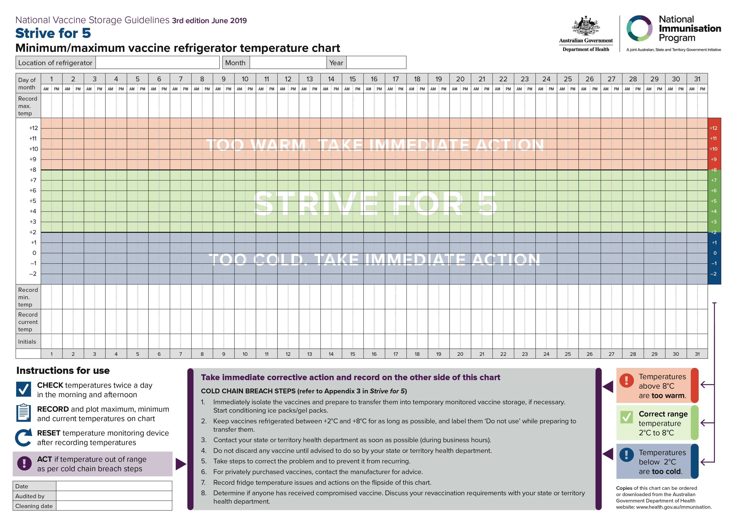

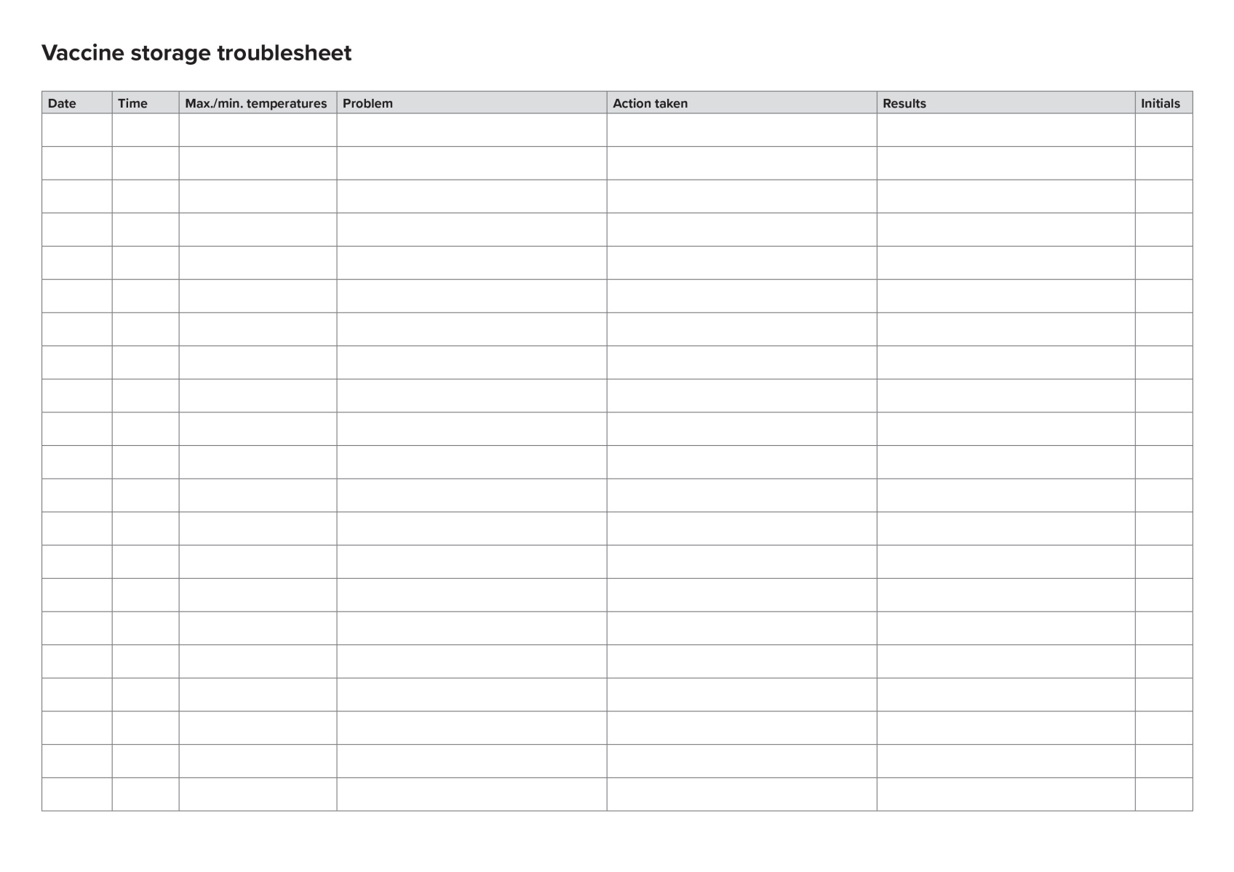

# APPENDIX 6 Quick reference poster

Copies of this poster can be ordered or downloaded from the Australian Government Department of Health website: [www.health.gov.au/immunisation](https://www.health.gov.au/immunisation).

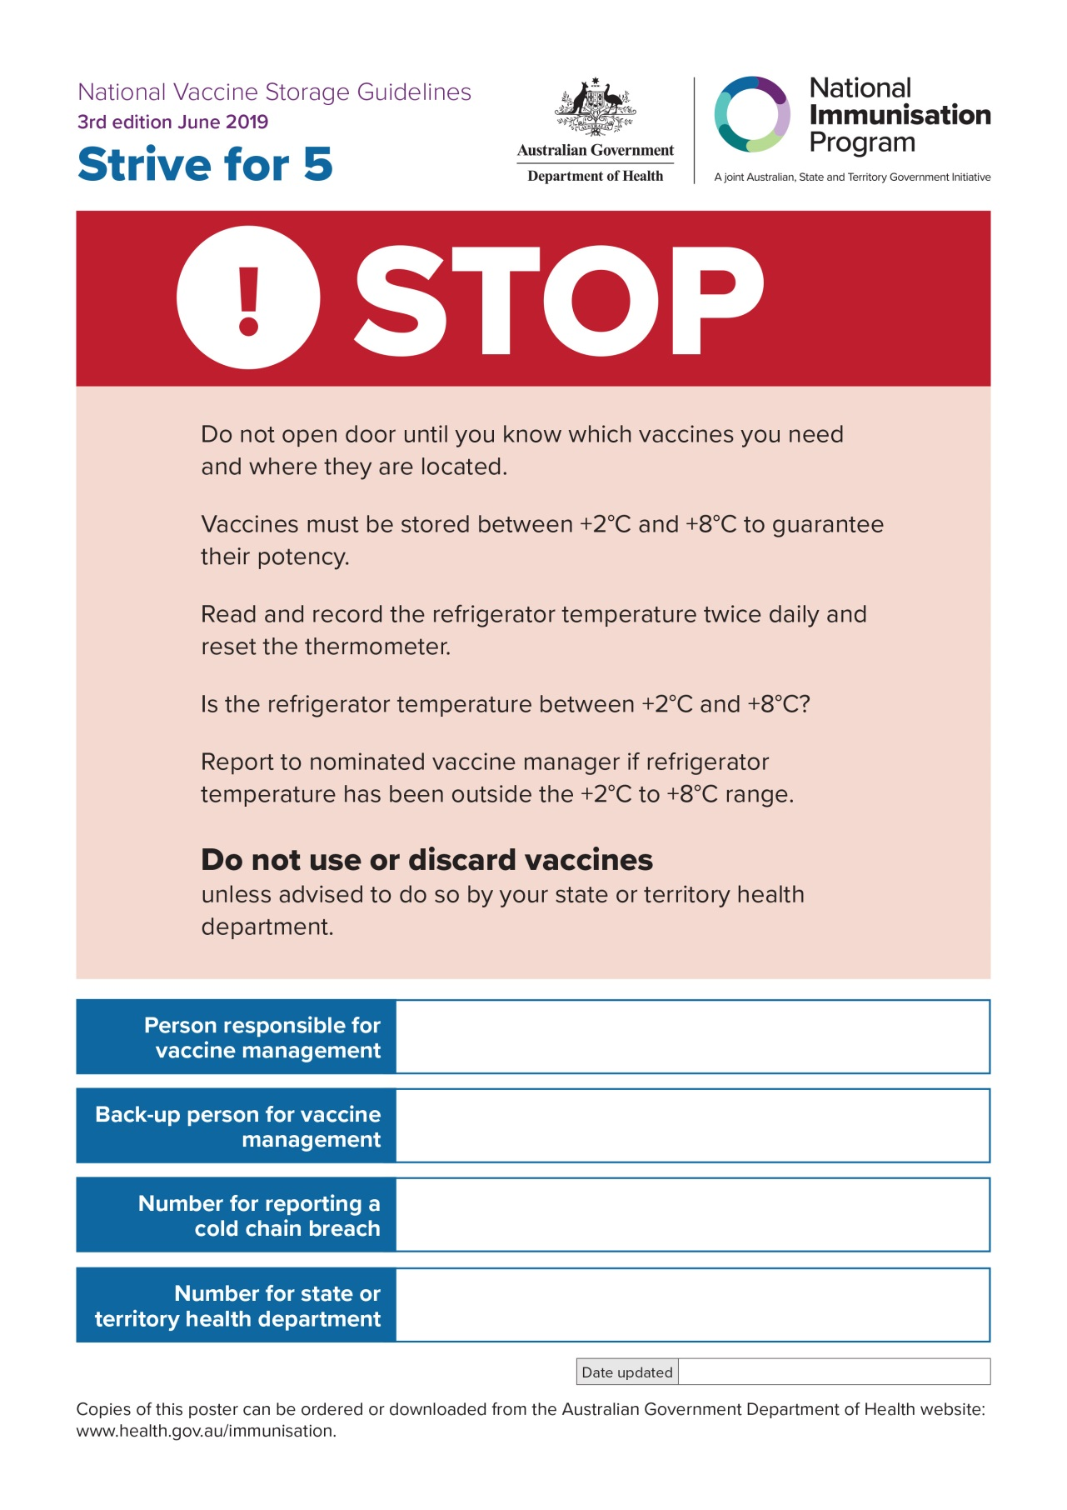

# APPENDIX 7 Preparation for mobile or outreach immunisation clinics

The following information can be used as a guide when preparing vaccines for mobile or outreach immunisation clinics.

* Ensure that the cooler ice packs/gel packs you use for mobile or outreach immunisation clinics have been temperature tested before use.
* Monitor all sections of the cooler by simulating packing and storage of vaccines in mobile or outreach immunisation clinic situations.

Coolers should not be used until testing has been undertaken and they have been assessed as appropriate.

When using coolers for mobile or outreach immunisation clinics, where vaccines are being removed repeatedly, ensure that ice packs/gel packs do not move from their original positions and do not touch vaccines.

Do not remove vaccines from cooler and original vaccine packaging until they are due to be administered, to prevent damage from exposure to light and ambient temperature (this includes not pre-drawing vaccines before administration).

* Because the cooler may be opened frequently to remove vaccines, ensure that the minimum and maximum temperature of the cooler is checked regularly, at least once per hour. Ideally, use both a minimum/maximum thermometer and a data logger for all coolers used to store vaccines.

See Appendix 8 ‘Checklist and temperature chart for mobile or outreach immunisation clinics, or emergency storage of vaccines’.

If the cooler will hold a large quantity of vaccines and be opened frequently by multiple vaccinators, consider distributing vaccines to multiple smaller coolers and restocking from the main cooler during the vaccination sessions.

Before conducting a mobile or outreach immunisation clinic, consider a trial run of preparing and monitoring coolers to ensure that temperatures remain between +2°C and +8°C for the required time.

# APPENDIX 8 Checklist and temperature chart for mobile or outreach immunisation clinics, or emergency storage of vaccines

Checklist for mobile/outreach immunisation clinics or emergency storage of vaccines

Print this checklist and store it along with the following items for your cooler:

minimum/maximum thermometer

temperature chart

packing material.

| Step | What to do | Done ✓/X |
| --- | --- | --- |
| 1 | Remove ice packs/gel packs from the freezer:   * Place the number of packs you require for your cooler on the bench to ‘sweat’ (see *Strive for 5* Section 9.2 for information about conditioning ice packs/gel packs). * Place the ice packs/gel packs in your cooler to chill the inside of the cooler. | 🞎  🞎 |
| 2 | Remove the ice packs/gel packs from the cooler and place insulating material (bubble-wrap or polystyrene chips) in the bottom of the cooler. | 🞎 |
| 3 | Reset the minimum/maximum thermometer and insert the thermometer probe inside an empty vaccine box with the product information intact. | 🞎 |
| 4 | Make sure the minimum/maximum temperature is between +2°C and +8°C at the time the vaccines are placed in the cooler. | 🞎 |
| 5 | **YOU ARE NOW READY TO MOVE YOUR VACCINES INTO THE COOLER.**  Place the vaccine stock in the cooler with the box containing the thermometer probe in the centre.  **Note:** All vaccines should remain in their original packaging until they are administered or returned to a purpose-built vaccine refrigerator — this prevents damage from exposure to light and ambient temperature.  Surround the vaccines with packing material and place conditioned ice packs/gel packs on the top before closing the cooler. Ensure that vaccine stock is not in direct contact with the ice packs/gel packs, to minimise risk of freezing. Close the cooler lid and fix the digital thermometer display to the outside of the cooler. Keep the cooler out of direct sunlight. | 🞎 |
| 6 | Record the date, time, and minimum and maximum temperatures on the temperature chart now. Then record temperatures at the following times:   * every 15 minutes for the first hour * hourly thereafter, provided the temperatures are stable.   **Note:** Freezing vaccines occurs most commonly in the first 2 hours of storage in a cooler. | 🞎 |
| 7 | Ensure that ice packs/gel packs do not become displaced and have direct contact with vaccines — this may freeze the vaccines and render them unviable. Remove vaccines from the cooler only as they are required. | 🞎 |
| 8 | Only move vaccines back to a purpose-built vaccine refrigerator in which the temperature is between +2°C and +8°C. | 🞎 |

**Note:** Change your thermometer battery every 12 months and record the date it is changed. Test the accuracy of your thermometer using the ‘slush test’ method every 12 months (see *Strive for 5* Section 4.4 ‘How to check the accuracy of a thermometer [‘slush test’]’) and record when the accuracy check is done.

When the vaccines are returned to the refrigerator

| Step | What to do | Done ✓/X |
| --- | --- | --- |
| 1 | Record the refrigerator temperature and reset. | 🞎 |
| 2 | Ensure that the refrigerator temperature has returned to between +2°C and +8°C before returning vaccines. | 🞎 |
| 3 | Transfer vaccines to refrigerator. | 🞎 |
| 4 | If a data logger has been transported with the vaccines, download the data before using any vaccines. | 🞎 |
| 5 | If there are temperatures outside the +2°C to +8°C range, isolate vaccines, clearly mark them ‘Do not use’, and keep them refrigerated between +2°C and +8°C. If a cold chain breach has occurred, report it to your state or territory health department. Include all the information outlined in *Strive for 5* Appendix 3 ‘Cold chain breach protocol’. | 🞎 |
| 6 | Continue to monitor the refrigerator closely (eg hourly) to ensure that the temperature is consistently stable, then return to twice-daily monitoring. | 🞎 |

Temperature chart for mobile or outreach immunisation clinics, or emergency storage of vaccines

| Date | Monitoring times  P = vaccines packed  A = arrived at clinic  D = during clinic  B = arrived at base | Time | Minimum temperature | Maximum temperature | Temperatures outside +2°C to +8°C  Yes/No  If yes, must be notified* | Signature |
| --- | --- | --- | --- | --- | --- | --- |
|  |  |  |  |  |  |  |
|  |  |  |  |  |  |  |
|  |  |  |  |  |  |  |
|  |  |  |  |  |  |  |
|  |  |  |  |  |  |  |
|  |  |  |  |  |  |  |
|  |  |  |  |  |  |  |
|  |  |  |  |  |  |  |
|  |  |  |  |  |  |  |
|  |  |  |  |  |  |  |
|  |  |  |  |  |  |  |
|  |  |  |  |  |  |  |
|  |  |  |  |  |  |  |
|  |  |  |  |  |  |  |

* State or territory health department contact number:

# APPENDIX 9 Checklist for managing a power failure

Checklist for emergency storage (eg power or refrigerator failure)

Your vaccine refrigerator may warm quickly during a power failure, depending on the quality and design of the refrigerator, and the ambient temperature of your facility. You may need to contact the refrigerator manufacturer to establish this time period.

If vaccines are at risk, use alternative monitored storage arrangements.

| Step | What to do | Done ✓/X |
| --- | --- | --- |
| 1 | Immediately isolate the vaccines and keep them refrigerated between +2°C and +8°C. Leave the vaccines in the refrigerator with the door closed. Put a sign on the refrigerator door stating: ‘Power out. Do not use vaccines. Keep refrigerator door closed.’ | 🞎 |
| 2 | Closely monitor the refrigerator temperature. Ensure that the display of the minimum/maximum thermometer is outside the refrigerator so that readings can be obtained without opening the refrigerator door. | 🞎 |
| 3 | Immediately begin to condition ice packs/gel packs as per Section 9.2 of Strive for 5. Begin this process even if you have been informed that the power will return shortly. | 🞎 |
| 4 | Place additional ice packs/gel packs in a cooler to pre-chill the cooler. | 🞎 |
| 5 | Transfer vaccines to the cooler when the minimum/maximum thermometer shows that the temperature of the refrigerator is outside the recommended +2°C to +8°C range. If unable to read the thermometer, transfer vaccines as soon as ice packs/gel packs are conditioned. Pack the cooler as per Section 9.3 of Strive for 5. If a minimum/maximum thermometer is available, place the probe in the cooler and the display outside the cooler. | 🞎 |
| 6 | Monitor and record the cooler temperature every 15 minutes for the first 2 hours, then at least hourly (provided the temperatures are stable). | 🞎 |
| 7 | Ensure that a data logger is placed directly next to vaccines in the cooler. | 🞎 |
| 8 | Do not open the cooler until vaccines can be transferred to a purpose-built vaccine refrigerator. | 🞎 |
| 9 | If more suitable vaccine storage is available (eg at a hospital with an essential power generator), transfer vaccines in a cooler to the more suitable option. Ensure that the data logger stays with the vaccines at all times. | 🞎 |
| 10 | If you know that power will be out for more than 24 hours, consider transferring vaccines to alternative vaccine storage, if available, at the nearest facility with power. | 🞎 |

Support systems that may assist you to manage a power failure

* Some power networks provide timely power outage alerts to registered customers by text message or email.
* An automated monitoring system can be installed in purpose-built vaccine refrigerators. This system sends an electronic alert to designated phone number(s) outside business hours if the refrigerator temperature deviates outside the +2°C to +8°C range. The alerted staff member can take action outside business hours if it is safe to do so and may be able to prevent vaccine losses. They can also prevent the administration of potentially compromised vaccines to clients by alerting staff to a potential cold chain breach the next business day.
* A separate battery-operated minimum/maximum thermometer can assist in continuously monitoring refrigerator temperatures. During a power failure, not all purpose-built vaccine refrigerators continue to display the current temperature.

Alternative vaccine storage

In the event of a power failure, an alternative means of monitored vaccine storage is recommended to allow vaccines to continue to be stored between the recommended temperature range of +2°C to +8°C, thereby minimising vaccine loss and disruption to businesses. The recommended options may include any of the following:

* A back-up power supply (eg generator or battery/solar back-up)
* A monitored refrigerator offsite (eg local hospital or pharmacy)  
  – Ensure that an agreement has been put in place with the relevant organisation before the   
   event. Also consider that this organisation may be affected by the same power failure.
* A cooler   
  – Ensure that the cooler is large enough to accommodate:   
   ○ all vaccines   
   ○ ice packs or gel packs   
   ○ insulating material (eg polystyrene chips or bubble-wrap)   
   ○ a minimum/maximum thermometer or data logger  
   ○ a cold chain monitor.

– Pack the cooler as per Section 9.3 of Strive for 5.

– Monitor and record the temperature every 15 minutes for the first 2 hours, then at least   
 hourly (provided the temperatures are stable).

When the power is returned

| Step | What to do | Done ✓/X |
| --- | --- | --- |
| 1 | Record the refrigerator temperature and reset the minimum/maximum thermometer. | 🞎 |
| 2 | Ensure that the refrigerator temperature has returned to between +2°C and +8°C before returning vaccines. | 🞎 |
| 3 | Transfer vaccines to the refrigerator. | 🞎 |
| 4 | If a data logger has been transported with vaccines, download the data before using any vaccines. | 🞎 |
| 5 | If the data show temperatures outside the +2°C to +8°C range, isolate vaccines, clearly mark them ‘Do not use’, and keep them refrigerated between +2°C and +8°C. If a cold chain breach has occurred, report it to your state or territory health department. Include all the information outlined in Appendix 3 ‘Cold chain breach protocol’ of Strive for 5. | 🞎 |
| 6 | Continue to monitor the refrigerator closely (eg hourly) to ensure that the temperature is consistently stable, then return to twice-daily monitoring. | 🞎 |

# APPENDIX 10 Considerations when choosing a purpose-built vaccine refrigerator

As always when shopping, think: Is this value for money? Will this purchase deliver what I expect? Ask questions! The quality and design of a purpose-built vaccine refrigerator may determine how quickly it warms during a power failure. See also Section 6 ‘Considerations when choosing a purpose-built vaccine refrigerator’.

When choosing a purpose-built vaccine refrigerator, consider the following points:

the size of the refrigerator — ensure that it is large enough to meet the facility’s vaccine storage requirements, particularly during peak periods when additional vaccines may be stored, such as the seasonal influenza program

the size of the space in the facility — ensure that there is enough room for air circulation around the back and sides of the refrigerator, as per the manufacturer’s instructions

the need for an alternative freezer to store ice packs and gel packs for use during mobile or outreach immunisation clinics, or in the event of a power failure.

Consider choosing a purpose-built vaccine refrigerator with the following features:

an inbuilt digital temperature monitor/data logger

an alarm system — alarm systems have various options such as the capacity to notify someone remotely, either by automatic telephone dialling or by alert to a central area that is staffed 24 hours a day; choose the alarm system that best suits your needs

a ‘door left open’ alarm

an inbuilt temperature recording system — ensure that the temperature (minimum and maximum) can be easily read; some digital temperature displays may be located at the bottom of the refrigerator.

Questions to ask the sales representative might include:

What is the difference between solid and glass doors with respect to temperature maintenance?

What is the energy efficiency?

Will the purpose-built vaccine refrigerator require enhancements (eg alarms, temperature-monitoring features such as a data logger), and what are the associated costs?

What are the conditions and durations of the warranty? Pay attention to the back-up support and servicing, including the costs of delivery, maintenance and repairs, particularly in rural and remote areas. What are the supplier/manufacturer quality assurance processes?

How long will the purpose-built vaccine refrigerator remain within the recommended temperature range in the event of a power failure?

Is cold mass support required (eg cooled bottles of water; frozen products should not be used)?

Digital (portable) data loggers

Digital data loggers are battery-powered, standalone temperature monitors that **must** be used if the purpose-built vaccine refrigerator does not have an inbuilt data logger.

Ideal temperature monitors continuously monitor and record temperatures. They can indicate adverse temperature exposure and the time vaccines are exposed to temperatures outside the +2°C to +8°C range.

Data logger software is required to download the information from the data logger at least weekly, in addition to twice-daily minimum and maximum temperature recordings.

Data loggers should be set to measure and record temperatures at least every 5 minutes.

Data loggers should be calibrated according to the manufacturer’s recommendations (usually yearly).

It is important to check the memory storage capacity of the data logger and required frequency for downloading reports without losing data; for example, the memory may only store up to 3 months worth of data.

Chart recorders

These units contain graphs and pens that record temperatures continuously on paper over time.

Graph paper must be changed weekly or monthly (depending on the type of chart recorder being used).

If the graph paper is not changed, the temperature recording will not be able to be read accurately, and the record may not be monitored in a power outage.

References

National vaccine storage guidelines – strive for 5. 3rd edition. Canberra: Australian Government Department of Health; 2019. <https://beta.health.gov.au/resources/publications/national-vaccine-storage-guidelines-strive-for-5>

Vaccine storage and handling toolkit. Atlanta: Centers for Disease Control and Prevention; 2018. [www.cdc.gov/vaccines/hcp/admin/storage/toolkit/storage-handling-toolkit.pdf](http://www.cdc.gov/vaccines/hcp/admin/storage/toolkit/storage-handling-toolkit.pdf)

National vaccine storage and handling guidelines for immunization providers 2015. Ottawa: Public Health Agency of Canada; 2015. [www.canada.ca/en/public-health/services/publications/healthy-living/national-vaccine-storage-handling-guidelines-immunization-providers-2015.html](http://www.canada.ca/en/public-health/services/publications/healthy-living/national-vaccine-storage-handling-guidelines-immunization-providers-2015.html)

# Additional reading

Australian Immunisation Handbook **(online version)**

Provides clinical guidelines for health professionals on the safest and most effective use of vaccines in their practice.

Available on the Australian Government Department of Health website: [https://immunisationhandbook.health.gov.au](https://immunisationhandbook.health.gov.au/)

**World Health Organization**

WHO has a list of specifications relating to immunisation at: [www.who.int/immunization/documents/IIP2015_Module2.pdf](https://www.who.int/immunization/documents/IIP2015_Module2.pdf)

# Useful contacts

**Australian General Practice Accreditation Limited:** 1300 362 111

Australian General Practice Accreditation Limited is a leading provider of accreditation and related quality improvement services to general practices.

[www.agpal.com.au](http://www.agpal.com.au/)

**Therapeutics Goods Administration:** 1800 020 653

The Therapeutics Goods Administration (TGA) is Australia's regulatory authority for therapeutic goods. Product information for all vaccines is freely available on the TGA website.

[www.tga.gov.au](https://www.tga.gov.au/)

**National Immunisation Hotline:** 1800 671 811

The National Immunisation Hotline provides advice and information about immunisation, from 8am to 5pm Australian Eastern Standard Time.

[www.health.gov.au/immunisation](https://www.health.gov.au/immunisation)

# State and territory health department contact details

Australian Capital Territory 02 5124 9800

New South Wales 1300 066 055 (to connect to the relevant Public Health Unit)

Northern Territory 08 8922 8044

Queensland 13 432 584

South Australia 1300 232 272

Tasmania 1800 671 738

Victoria 1300 882 008

Western Australia 08 9222 2486

If an immunisation service provider changes address or contact details, they should contact the relevant state or territory health department to inform them of the move and provide new contact details.