**Australian General Practice Training Program**

National report on the 2019 National Registrar Survey

Ali Radloff, Leyna Clarke & Darren Matthews

Australian Council *for* Educational Research

December 2019

# Acknowledgements

The authors would firstly like to acknowledge the support of the Department of Health throughout this project. We also thank the Regional Training Organisations for their assistance and support of the survey, and for promoting the survey to their registrars during fieldwork for the 2019 National Registrar Survey. Last, but definitely not least, we would like to acknowledge and thank all the registrars who participated in the survey for their time, and for sharing their experiences.

Table of Contents

Acknowledgements 2

Acronyms and abbreviations 4

Executive summary 5

Infographic summary of results 7

Setting the Scene 8

Background and context 8

Project overview 9

Methodology 10

Recommendations 10

2019 AGPT NRS findings 11

Survey representativeness, respondent characteristics and training contexts 11

Overall satisfaction 17

Satisfaction by Key Performance Indicators 18

Satisfaction with RTOs 20

Satisfaction with training facilities 21

Qualitative findings 22

Health and wellbeing 23

Aboriginal and Torres Strait Islander Health 24

Registrars’ training choices 24

Registrars’ future plans 25

Appendix A: Table of Figures 27

Appendix B: Table of Tables 27

Appendix C: 2019 AGPT NRS item frequencies 29

Appendix D: 2019 AGPT NRS Instrument 39

Appendix E: Accessible text alternatives for figures 52

Infographic text alternative 52

Text alternative for Figures 54

# Acronyms and abbreviations

| **Acronym** | **Meaning** |
| --- | --- |
| ACER | Australian Council for Educational Research |
| ACRRM | The Australian College of Rural and Remote Medicine |
| ADF | Australian Defence Force |
| AGPT | Australian General Practice Training |
| AGPT RSS | Australian General Practice Training Registrar Satisfaction Survey |
| AGPT NRS | Australian General Practice Training National Registrar Survey |
| AMA | Australian Medical Association |
| AMC | Australian Medical Council |
| AMG | Australian Medical Graduate |
| ARST | Advanced Rural Skills Training |
| AST | Advanced Specialised Training |
| the Department | The Commonwealth Department of Health |
| FRACGP | Fellowship of the Royal Australian College of General Practitioners |
| FACRRM | Fellowship of the Australian College of Rural and Remote Medicine |
| FARGP | Fellowship in Advanced Rural General Practice |
| FTE | Full -time equivalent |
| GP | General Practice or General Practitioner (depending on context) |
| GPET | General Practice Education and Training Limited |
| GPRA | General Practice Registrar Australia |
| GPSA | General Practice Supervisors Australia |
| GPT | General Practice Term |
| HECS | Higher Education Contribution Scheme |
| IMG | International Medical Graduate |
| KPI | Key Performance Indicator |
| PGPPP | Prevocational General Practice Placements Program |
| PRRT | Primary Rural and Remote Training |
| RACGP | The Royal Australian College of General Practitioners |
| RIDE | Registrar Information Data Exchange |
| RTO | Regional Training Organisation |
| RTP | Regional Training Provider |

# Executive summary

The Australian General Practice Training National Registrar Survey (AGPT NRS) is an annual, national survey of GP registrars currently training in the AGPT program. It collects information via an online questionnaire about registrar satisfaction, experience and future career plans. It also collects information about registrars’ demographics and training contexts and other aspects of their training experience. This survey is part of the Department of Health’s (the Department) monitoring and quality improvement activities. The information collected in the AGPT NRS can be used to assure the quality of training provision in the program, enables continuous improvement and allows responses to be benchmarked nationally. This survey was previously known as the AGPT Registrar Satisfaction Survey (AGPT RSS).

From 23 September to 12 November 2019, the Australian Council for Educational Research (ACER) administered the AGPT NRS to registrars enrolled in active training on the AGPT program across 11 training regions and nine regional training organisations in Australia. Around 4000 registrars were invited to reflect on their recent training experience in Semester One, 2019. 1,506 registrars provided a valid response to the survey, representing an overall response rate of 38 per cent. The response rate for registrars within each training region ranged from 31 to 51 per cent. The national response rate was sufficient to yield reliable results at a national level, with most of the Key Performance Indicators described in the report offering accuracy (at the 95 per cent confidence level) within two per cent of the reported average scores.

Registrars were asked to reflect on their overall experience, their experience with their RTO, training facility, and college. Overall, registrars reported high levels of satisfaction.

Overall levels of satisfaction continue to increase from the large dip witnessed in 2016, but are still down on the levels seen from 2013 to 2015. In 2019:

* 88 per cent of registrars were satisfied with the overall education and training
* 84 per cent were satisfied with the overall support
* 86 per cent were satisfied with the overall administration.

In terms of registrars’ satisfaction with their **RTO**:

* 89 per cent of registrars were satisfied with their overall training and education
* 86 per cent were satisfied with the training advice they received
* 90 per cent were satisfied with the induction and orientation they received
* 89 per cent were satisfied with the feedback they received
* 89 per cent were satisfied with the workshops provided
* 89 per cent were satisfied with the training and education resources provided
* 85 per cent were satisfied with the support received for examinations and assessments
* 88 per cent were satisfied with the support they received to meet the training requirements of RACGP while significantly fewer (62%) were satisfied with the support they received to meet ACRRM training requirements (although this has increased from only 55% in 2017).

When asked to reflect on their experience with their **training facility**:

* 91 per cent of registrars were satisfied with the overall training and education they received
* 90 per cent were satisfied with the supervisor support
* 97 per cent were satisfied with the clinical work
* 95 per cent were satisfied with the number of patients or presentations
* 96 per cent were satisfied with the diversity of patients or presentations
* 96 per cent were satisfied with the level of workplace responsibility
* 91% with induction and orientation
* 90% with feedback on training progress
* 89% with training and education resources
* 94% with location of training facility
* 90% with terms and conditions

When asked about the best aspects of their training, registrars most commonly mentioned themes including their practice workplace and colleagues, workshops and education days, their supervisors, the support that they have received and the clinical and procedural experience they have gained. When asked to describe the aspects of their training that needed improvement, the most commonly mentioned areas included exam preparation and support, general support, terms and conditions of employment, supervision and the training or curriculum content or focus.

Registrars were also asked about their career plans for the next five years. The majority of registrars – 88 per cent – plan to be working as a private GP in five years. Most registrars – 82 per cent – would also like to be involved in training other doctors within the next five years.

# Infographic summary of results

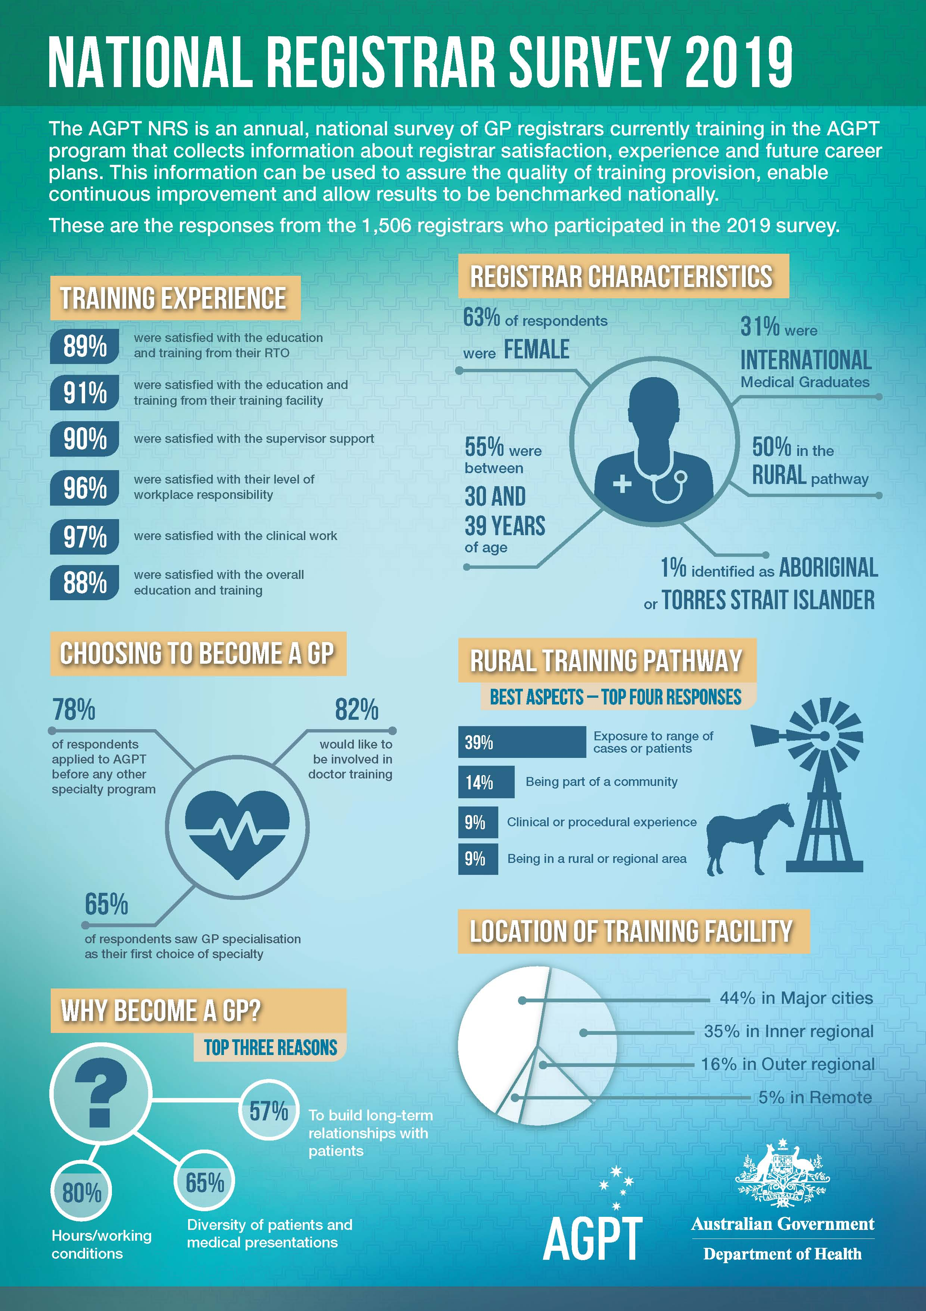

Long text alternative for infographic summary.

# Setting the Scene

## Background and context

General practitioners (GPs) are a vital part of Australia’s health care system. GPs care for a broad range of patients, with broad health needs, and are usually the first point of call Australians make for their health needs. The GP’s role is described by the Royal Australian College of General Practitioners (RACGP) as providing ‘person centred, continuing, comprehensive and coordinated whole person health care to individuals and families in their communities’[1]. The term general practice is described by the Australian College of Rural and Remote Medicine (ACRRM) as ‘the doctor with core responsibility for providing comprehensive and continuing medical care to individuals, families and the broader community.’[2]

These definitions underpin the training that each registrar undertakes as part of the Australian General Practice Training (AGPT) program. There are a number of different organisations involved in administering the AGPT program in Australia, including the two colleges and nine regional training organisations (RTOs) who operate across 11 training regions.

RTOs are required to deliver training which meets the standards and requirements of the vocational training programs of either the RACGP and/or the ACRRM. The completion of either college vocational training program leads to a relevant college fellowship, either the Fellowship of the Royal Australian College of General Practitioners (FRACGP) or the Fellowship of the Australian College of Rural and Remote Medicine (FACRRM). Both fellowships are recognised professional qualifications to enable registrars to gain vocational recognition as GPs under the Medicare legislation. Registrars can additionally obtain the RACGP’s Fellowship in Advanced Rural General Practice (FARGP). GP registrars are required to undertake the initial part of their training in a hospital environment, after which they go on to complete their core training and required skills training. Training is usually completed over a three or four year full time equivalent (FTE) period, but training time can be extended to accommodate those doctors who wish to train on a part-time basis.

It is important that the training Australia’s future GPs receive is educationally relevant, purposeful for all stakeholders and meets the specialist medical training standards of both colleges as determined by the Australian Medical Council (AMC). Achieving this requires RTOs to deliver training programs that help registrars prepare for FACRRM, FRACGP, or FARGP. The FACRRM and FRACGP are the endpoint of specialist GP training (under the AGPT program) and once completed, these fellowships provide entrance to the specialist GP profession in Australia. In order to ensure that RTOs are delivering training to the standards expected by the colleges, RTOs undergo an accreditation process every three years. Each college separately undertakes training accreditation of the RTOs, commencing with a joint review process that involves an assessment of training and education systems, training information, education delivery, and training posts and supervisors.

The AGPT National Registrar Survey (AGPT NRS), previously known as the AGPT Registrar Satisfaction Survey (AGPT RSS) is part of the Department of Health’s (the Department) monitoring and quality improvement activities. The survey results are used by the Department to monitor registrar satisfaction levels with the vocational training delivered by the RTOs and understand registrars’ experience in training. The survey was first introduced by General Practice Education and Training Limited (GPET) in 2004 and has since been conducted annually.

## Project overview

The AGPT NRS is conducted by the Department to enable the continuous improvement of doctor training in the AGPT program. Findings from the survey help ensure that the AGPT program delivered by the nine RTOs across 11 training regions meets the necessary standards and requirements of the Department.

The AGPT NRS is an annual, national survey of GP registrars currently training in the AGPT program. It collects information about registrar satisfaction, experience and future career plans as well as information about registrars’ demographics and training contexts and other aspects of their training experience. This information can be used to assure the quality of training provision, enables continuous improvement and – because the same survey is conducted across all RTOs and training regions - allows results to be benchmarked nationally.

In July 2019, the Department engaged the Australian Council for Educational Research (ACER), an independent and not-for-profit research organisation, to review and update the AGPT NRS instrument to ensure it continues to collect information that is relevant to and useful for the Department and other stakeholders while maintaining data that tracks changes in registrars’ satisfaction and experience over time. ACER had previously administered the AGPT RSS and AGPT NRS from 2013 to 2018.

In 2017, the AGPT NRS went through a major review and revision with detailed consultation from stakeholders including RTOs, RACGP, ACRRM, General Practice Registrars Australia (GPRA), General Practice Supervisors Australia (GPSA), Australian Medical Association (AMA) and representatives from the Department. This workshop involved a discussion of the overall purpose of the survey including its name, a review of the survey instrument, the administration process and the reporting that forms the AGPT NRS. The changes made in 2017 continue to be reflected in the 2019 AGPT NRS. A few very minor changes were made to the 2019 survey instrument.

The 2019 AGPT NRS instrument included a broad range of questions that asked registrars about their experience and satisfaction in the AGPT program. Respondents were asked to reflect particularly on their experience in Semester One, 2019. The 2019 AGPT NRS instrument included questions relating to registrars’:

* demographic and training characteristics
* satisfaction with their RTO, training facilities and college
* health and wellbeing
* involvement in training related to Aboriginal and Torres Strait Islander health
* experience training on the rural pathway
* training choices
* career aspirations and plans.

This report details the background to the project, provides a brief overview of the methodologies employed in the survey collection and explores the findings from the 2019 survey. In addition to this National Report, training region reports have been produced for each training region which provide RTOs with more detail on their registrars’ survey responses. Two college reports have also been prepared for RACGP and ACRRM that focus on the responses given by registrars completing a fellowship with each of the colleges.

## Methodology

The target population for the 2019 AGPT NRS included all registrars who were enrolled in the AGPT program who were in active training during Semester One, 2018. Registrars who were on extended leave during this time period, who were on extension awaiting fellowship, and not in active training, or who were training as a hospital intern (PGY1) were excluded from the target population.

The Department provided ACER with a population list of all registrars in the target population. This information was extracted from the Department’s Registrar Information Data Exchange (RIDE) system. ACER asked RTOs to check the contact details of their registrars, and identify if any registrars had been included or excluded from the population list. This process identified that the full target population for the 2018 AGPT NRS included 4,303 registrars (around 120 fewer registrars than 2018). During fieldwork, 286 registrars opted out from email and SMS correspondence and were removed from the survey population and a further nine registrars’ emails bounced. The survey was conducted as a census of all registrars in the target population.

As in previous administrations of the survey, the 2019 AGPT NRS was administered wholly online. Fieldwork was conducted between September 23 and November 12, 2019. ACER managed the fieldwork operations in-house, including sending out email and SMS invitations and reminders to registrars. RTOs provided invaluable assistance before and during the fieldwork period to promote the survey to their registrars using marketing materials designed by ACER. Survey responses were returned directly to ACER and stored securely and separately from respondents’ personal information to ensure the confidentiality of their responses.

## Recommendations

Based on the experiences of the project team at ACER, discussions with the Department, and feedback from RTOs and registrars there are a few ways in which the methodology of future administrations of the survey could be improved. Firstly, the survey asks registrars to reflect on their experiences during Semester One and as a result, there were a number of registrars who had subsequently fellowed or withdrawn from the AGPT program in the months following the end of Semester One. The level of response was much lower among these registrars, and many registrars got in touch with the project team at ACER to indicate that they did not believe the survey was relevant to them as they had already left the program. Conducting the survey near the end of, or immediately following, Semester One may encourage more registrars to participate and may also make it easier for registrars to recall their experiences during that specific Semester. Feedback received from RTOs during an AGPT NRS workshop held in 2017 also indicated that the ideal timing for the survey – at least from the perspective of RTOs – would be for fieldwork to be conducted in June.

One new challenge for the 2019 AGPT NRS was the introduction of a new national survey of all doctors in training in Australia – the Medical Training Survey. This survey is being conducted by the Medical Board of Australia and AHPRA and was conducted for the first time in August and September 2019. A number of registrars contacted ACER during the fieldwork period and indicated that they either thought they had already participated in the AGPT NRS, when they had likely recently completed the Medical Training Survey, or that they had recently participated in another survey and so would not be participating in another one. Based on this feedback, and the fact that the level of response was somewhat lower than in most previous administrations of the survey, it is likely that some registrars confused the two surveys or felt burdened by an additional survey. As the Medical Training Survey is planned as an annual survey, it would likely improve registrars’ engagement with, and the level of response to, the AGPT NRS if the survey fieldwork is conducted at a different time of year to the Medical Training Survey. Alternatively, given the overlap in survey populations included in the AGPT NRS and the Medical Training Survey, it might even be prudent to explore whether it would be possible to incorporate a revised AGPT NRS into the Medical Training Survey.

During fieldwork for the 2019 AGPT NRS, a number of different email and SMS messages were used, and some new approaches were taken to try to improve the response rate throughout the fieldwork period. After reviewing how well each of the different messages performed, the strongest response appeared to be to messages where the subject line directly addressed the registrar by name or those that included the name of the registrar’s RTO in the subject line. In future administrations of the survey, it is recommended to include some messages that directly address registrars by name in the subject line.

# 2019 AGPT NRS findings

This section provides an overview of the findings from the 2019 AGPT NRS and provides a snapshot of registrars’ experience and satisfaction with their training in Semester One, 2019. Where appropriate, comparisons have been made with results from previous administrations of the survey.

This section reports on the level of response received and the representativeness of the registrars who responded to the 2019 AGPT NRS as well as providing insights into the training contexts of registrars. It then provides an overview of registrars’ overall satisfaction, a summary of the Key Performance Indicators (KPI), and a summary of registrars’ satisfaction with their RTO and training facility. The findings also include insights into registrars’ satisfaction with the health and wellbeing support they receive, their experience of training in Aboriginal and Torres Strait Islander health, the choices they have made in their training, their reasons for choosing their current RTO and fellowship and their future career aspirations.

Response frequencies are given for each item in Appendix C: 2019 AGPT NRS item frequencies, a copy of the questionnaire that was used in the 2019 AGPT NRS is included in Appendix D: 2019 AGPT NRS Instrument, and tabular alternatives for the figures included in the report are included in Appendix E.

## Survey representativeness, respondent characteristics and training contexts

A total of 1,809 registrars commenced the survey. Of these, 193 registrars dropped out before answering any questions in the survey. Twenty registrars were determined to be out-of-scope because they indicated that they were training as a hospital intern (PGY1) or were on extended leave during Semester One, 2019. A further 90 registrars dropped out of the survey before answering any questions relating to their experience or satisfaction with training. The responses from the remaining 1,506 registrars are the focus of this report.

Table 1 shows that the respondents to the survey are representative of the overall population of registrars in the AGPT program. The only difference to note is that there is a higher proportion of registrars with a training status of ‘Enrolled’ and subsequently a lower proportion of those with a training status of ‘Fellowed’ among the respondents. This trend was also seen last year.

Overall, a 38 per cent response rate was achieved in the 2019 APGT NRS. This a similar, or slightly lower response rate, to those achieved in previous five years (2018: 42%; 2017: 40%; 2016: 51%; 2015: 37%; 2014: 44%). The level of response varied by training region from 31 per cent to 51 per cent.

Please note, throughout this report to ensure confidentiality, all cells with a count between 1 and 3 are recorded as <4. Also note, as most of the questions in the survey were non-mandatory, and as some questions were only asked of subsets of registrars, not all questions were answered by all registrars who participated in the survey.

Table 1: 2019 AGPT NRS representativeness of respondents with population for different registrar characteristics

| **Registrar characteristics** | | **Response (n)** | **Response (%)** | **Population (n)** | **Population (%)** |
| --- | --- | --- | --- | --- | --- |
| All registrars | | 1,506 | - | 4,008 | - |
| Gender | Female | 947 | 62.9 | 2,552 | 59.3 |
| Male | 559 | 37.1 | 1,751 | 40.7 |
| Indigenous status | Aboriginal or Torres Strait Islander | 16 | 1.1 | 50 | 1.2 |
| ADF status | Australian Defence Force | 23 | 1.5 | 106 | 2.5 |
| Rural Generalist | Rural Generalist | 72 | 4.8 | 175 | 4.1 |
| Age | 20 to 29 | 301 | 20.0 | 906 | 21.1 |
| 30 to 39 | 835 | 55.4 | 2,528 | 58.7 |
| 40 to 49 | 284 | 18.9 | 695 | 16.2 |
| 50 plus | 86 | 5.7 | 174 | 4.0 |
| Citizenship | Australian Citizen | 1,145 | 76.0 | 3,398 | 79.0 |
| Australian Permanent Resident | 333 | 22.1 | 798 | 18.5 |
| Australian Temporary Resident | <4 | - | 15 | 0.3 |
| New Zealand Citizen or Permanent Resident | 20 | 1.3 | 80 | 1.9 |
| Not Specified | <4 | - | <4 | - |
| Fellowship | FRAGP | 1,272 | 84.5 | 3,789 | 88.1 |
| FACRRM | 127 | 8.4 | 292 | 6.8 |
| FARGP | 37 | 2.5 | 0 | 0.0 |
| FRACGP & FACRRM | 9 | 0.6 | 25 | 0.6 |
| FRACGP & FARGP | 52 | 3.5 | 176 | 4.1 |
| FACRRM & FARGP | <4 | - | 0 | 0.0 |
| FRACGP & FACRRM & FARGP | 7 | 0.5 | 21 | 0.5 |
| Training Status | Completed Time | 19 | 1.3 | 63 | 1.5 |
| Enrolled | 1,360 | 90.3 | 3,489 | 81.1 |
| Enrolled (Partially Fellowed) | <4 | - | 10 | 0.2 |
| Fellowed | 118 | 7.8 | 695 | 16.2 |
| Uncertain | 0 | 0.0 | 0 | 0.0 |
| Withdrawn | 6 | 0.4 | 46 | 1.1 |
| Training region | Eastern Victoria | 114 | 7.6 | 356 | 8.3 |
| South Eastern Queensland | 164 | 10.9 | 582 | 13.5 |
| Tasmania | 50 | 3.3 | 113 | 2.6 |
| North Western Queensland | 182 | 12.1 | 466 | 10.8 |
| North Eastern NSW | 204 | 13.5 | 708 | 16.5 |
| Lower Eastern NSW | 129 | 8.6 | 436 | 10.1 |
| Western NSW | 94 | 6.2 | 237 | 5.5 |
| South Australia | 134 | 8.9 | 352 | 8.2 |
| Western Victoria | 232 | 15.4 | 488 | 11.3 |
| Northern Territory | 45 | 3.0 | 111 | 2.6 |
| Western Australia | 158 | 10.5 | 453 | 10.5 |

*(n=4,008)*

Table 1 shows that 63 per cent of all respondents were female, reflecting the greater proportion of females in the program. Close to 90 per cent of registrars were working towards the FRACGP. Ten per cent of registrars were working towards the FACRRM and seven per cent towards the FARGP, a Fellowship undertaken in combination with the FRACGP. A small proportion of registrars (5%) were working towards more than one fellowship.

Registrars who responded to the 2019 AGPT NRS came from a range of backgrounds. Fewer than half of all respondents were born in Australia, with 72 other countries making up the country of birth of registrars. After Australia, the most common countries of birth for registrars who participated in the survey were India (9%), Sri Lanka (4%), Malaysia (4%) and the United Kingdom (4%).

Just under 70 per cent of registrars who participated in the survey received their medical degrees in Australia. International medical graduates – registrars who did not graduate from medical degrees from either Australia or New Zealand – who participated in the survey were far more likely to be working in regional areas than Australian medical graduates. Figure 1 shows that only a quarter of international medical graduates were working in major cities, compared with over half of registrars holding an Australian medical degree. Similar proportions of Australian and international medical graduates were working in remote or very remote areas. The difference in the proportions of AMG and IMG working in each area is likely due to the Section 19AB restrictions of the *Health Insurance Act 1973.[3]* This generally requires doctors who received their training at an international medical school to work in a district of workforce shortage, which tend to be concentrated in regional and remote parts of Australia.

The population of registrars who responded to the 2019 survey is similar to those who responded to the 2018 survey.

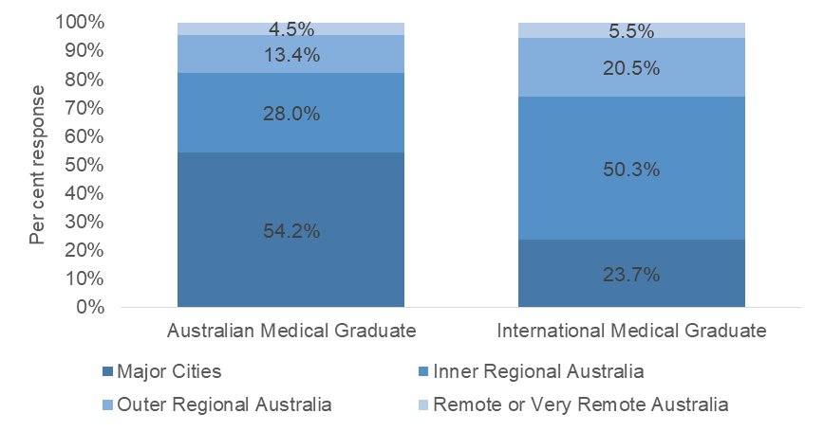

*(n=1,501)*

Figure 1: Proportion of Australian Medical Graduate and International Medical Graduate registrars working in different regions

Most, 70 per cent of registrars were currently training in General Practice Training (GPT) terms one to three, and seven per cent were currently training in Primary Rural and Remote Training (PRRT) terms one to four. Nineteen per cent of registrars indicated that they were training in the areas of Extended Skills, Advanced Rural Skills Training (ARST) or Advanced Specialised Training (AST). These registrars were asked to indicate the area in which this training occurred. The most common areas of Extended Skills, ARST or AST that registrars were undertaking were in the fields of Emergency Medicine, Aboriginal and Torres Strait Islander Health, Obstetrics and Gynaecology, Women’s Health, Skin Cancer Medicine, Dermatology and Adult Internal Medicine.

Registrars were asked about the training they did during Semester One, 2019. Most registrars (84%) were training in just one training facility with less than two per cent of registrars training in three training facilities. The majority of registrars – 72 per cent – were working full-time during Semester One, 2019. As in previous years, a much higher proportion of male registrars (83%) indicated that they were working full time compared with female registrars (66%).More than half of all respondents had dependents (57% of female and 61% of male respondents). Respondents with dependents were more than twice as likely to work part-time (39%) than those with no dependents (14%).

When asked about their experience prior to commencing the AGPT program, many registrars had experience working as a GP through the Prevocational General Practice Placements Program (PGPPP) (12%) or a First Wave Scholarship (5%). A small, but notable proportion of registrars had undertaken training towards another fellowship before starting the AGPT program (16%) or participated in the HECS Reimbursement Scheme (18%). Almost a third of registrars (29%) had completed a term in a Rural Clinical School. This experience seems to be linked to registrars’ training choices with 52 per cent of registrars who were completing a fellowship with ACRRM having experience training in a Rural Clinical School compared with just 27 per cent of RACGP registrars, and 62 per cent of registrars who are Rural Generalists had completed a term in a Rural Clinical School.

Table 2: Registrar training contexts

| **Training contexts** | | **Response**  **(n)** | **Response (%)** |
| --- | --- | --- | --- |
| Full time equivalent load | Less than 0.4 | 74 | 4.9 |
| 0.5 to 0.6 | 210 | 14.0 |
| 0.7 to 0.8 | 130 | 8.7 |
| 0.9 to 1.0 | 1,088 | 72.4 |
| Number of training facilities | One | 1,255 | 83.8 |
| Two | 218 | 14.6 |
| Three | 25 | 1.7 |
| Completed prior to training | Prevocational General Practice Placements Program (PGPPP) | 146 | 12.2 |
| First Wave Scholarship (GP placement in the undergraduate years) | 52 | 4.5 |
| Rural Clinical School | 358 | 29.5 |
| Commonwealth Medical Internships | 123 | 10.6 |
| Bonded Medical Placements (BMP) Scheme | 198 | 16.6 |
| Medical Rural Bonded Scholarship (MRBS) Scheme | 68 | 5.9 |
| Rural Australia Medical Undergraduate Scholarship (RAMUS) | 78 | 6.7 |
| John Flynn Placement program | 113 | 9.7 |
| State rural generalist programs | 84 | 7.3 |
| Remote Vocational Training Scheme | 16 | 1.4 |
| HECS Reimbursement Scheme | 210 | 17.7 |
| RACGP Practice Experience Program (PEP) | 12 | 1.0 |
| ACRRM Independent Pathway | 8 | 0.7 |
| More Doctors for Rural Australia Program | 10 | 0.9 |
| Community Residency Placement (WA) | 23 | 2.0 |
| Training towards any other fellowship | 192 | 16.2 |
| Current training | GPT1 Term | 498 | 33.2 |
| GPT2 Term | 159 | 10.6 |
| GPT3 Term | 423 | 28.2 |
| PRRT1 | 42 | 2.8 |
| PRRT2 | 14 | 0.9 |
| PRRT3 | 28 | 1.9 |
| PRRT4 | 28 | 1.9 |
| Extended Skills | 239 | 15.9 |
| Advanced Rural Skills Training (ARST) | 19 | 1.3 |
| Advanced Specialised Training (AST) | 36 | 2.4 |
| Academic post | 9 | 0.6 |
| GPT4 / Extension Awaiting Fellowship | 103 | 6.9 |
| Mandatory Elective | 8 | 0.5 |

*(n=1,502)*

The majority of registrars (74%) were training in New South Wales, Queensland or Victoria. Fifty-five per cent of the registrars who responded to the survey were training in regional or remote areas of Australia, relatively consistent with registrars who responded to the survey in previous years (Figure 2).

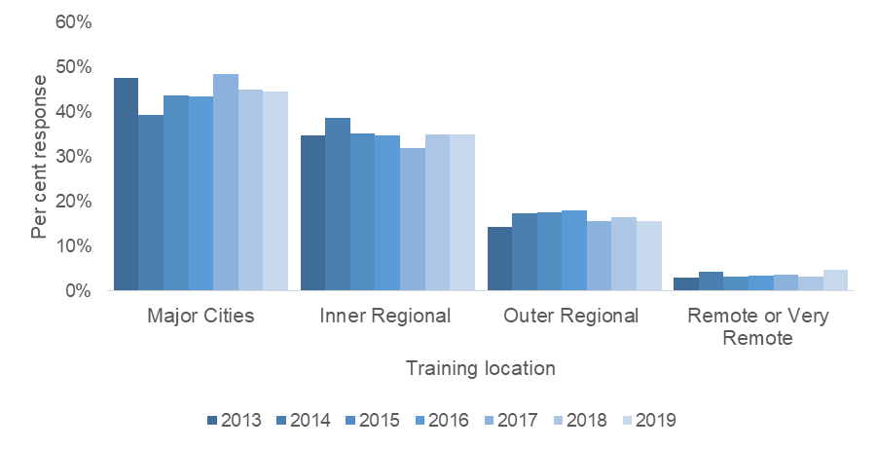

*(n=10,979)*

Figure 2: Location of registrars’ current training facility in 2013 to 2019

Forty-seven per cent of all registrars reported moving to their current region to undertake training. Registrars completing a fellowship with ACRRM (67%) were more likely to have moved to undertake training than registrars completing a fellowship with RACGP (45%). International medical graduates were also more likely to have moved to undertake training (63%) than Australian medical graduates (40%).

The proportion of registrars within each training region who had moved to undertake training ranged from between 31 and 63 per cent of respondents. For those registrars working in major cities, only 21 per cent had moved to complete training compared with between 63 and 76 per cent of respondents training in either inner regional, outer regional, or remote locations.

Figure 3 is a stacked bar graph illustrating the per cent of registrars who did not relocate for training, and who relocated for training for different training locations - major cities, inner regional, outer regional, or remote or very remote areas of Australia. A tabular alternative is listed in Table 18.



*(n=1,466)*

Figure 3: Proportion of registrars who relocated for training by training location

## Overall satisfaction

Registrars were asked to reflect on their training to date and to rate their overall satisfaction with the administration of the program, their education and training, and the support. Registrars are relatively satisfied with their overall training experience, particularly with their education and training. Most registrars were satisfied with the program’s education and training (88%), administration (86%) and support (84%).

Figure 4 shows that the overall mean satisfaction score[4] for administration, education and training, and support significantly decreased in 2016. This coincides with the major reorganisation that took place with training provision at this time. Prior to 2016, training was provided via 17 Regional Training Providers (RTP). These were replaced at this time by nine RTOs operating across 11 training regions. This drop in satisfaction levels remained relatively constant for both education and training as well as support in 2019, however, the level of satisfaction reported among registrars with administration has increased since its low in 2016 which suggests that some of the initial difficulties in the transition no longer exist.

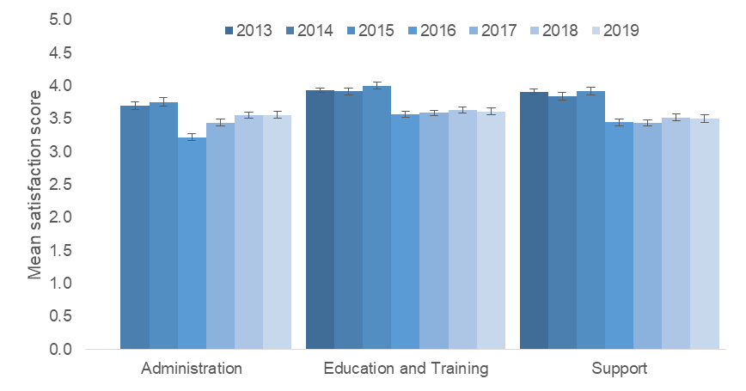

*(2013: n=1,879; 2014: n=1,188; 2015: n=1,156; 2016: n=1,677; 2017: n=1,684; 2018: n=1,675; 2019: n=1,496)*

*Note: In 2013, registrars were asked to rate their satisfaction with their RTP, education and training, and support provided, so this graph only includes the mean satisfaction score for education and training, and support for 2013.*

Figure 4: Mean overall satisfaction of registrars with the AGPT program from 2013 to 2019

When exploring the average rates of overall satisfaction, there are no significant differences found between female and male registrars, registrars in different age groups, Australian Defence Force (ADF) and non-ADF registrars, nor for registrars training in locations (major cities, inner and outer regional and remote and very remote). There are some small significant differences for respondents in different training contexts and different demographic groups. Rural generalist registrars had lower levels of satisfaction than other registrars.

Respondents who were completing a fellowship with RACGP reported higher levels of satisfaction than respondents completing a fellowship with ACRRM. Rural Generalist registrars also reported lower levels of satisfaction than other registrars. International medical graduates reported higher levels of satisfaction than Australian medical graduates and Aboriginal and Torres Strait Islander registrars reported significantly lower levels of satisfaction with education and training than non-Indigenous registrars.

## Satisfaction by Key Performance Indicators

The information collected from registrars through the AGPT NRS is used to generate a number of Key Performance Indicators (KPIs) for the Department. These KPIs provide an overview of registrars’ level of satisfaction with various aspects of the AGPT program.

A number of the KPIs are composite variables, meaning that they are a combination of registrars’ responses to two or more questions in the survey. For these composite variables the percentage of registrars who are satisfied for each question included in the KPI are averaged to create an overall ‘per cent satisfied’ score.

* KPI 1 is a combination of the overall satisfaction items shown in Table 3 relating to administration, education and training, and support.
* KPI 2 is a combination of seven items relating to support and training provided by RTOs, and is calculated only for registrars who *did not* report that they had an adverse incident during their training.
* KPI 3 is the same as KPI 2, but instead is recorded only for registrars who *did* experience an adverse incident during their training.
* The other composite variable is KPI 6 which includes two variables relating to resources at registrars’ RTO and at registrars’ training facility.

Although these KPIs have similar names or terminology to some of the other analyses in this report, the KPIs are composite variables and the results will be different from the results for individual items, such as those reported in the infographic.

In this year’s report we have calculated the KPIs as we have done in the past, as a summary of satisfaction scores with a ‘3’, ‘4’ or ‘5 – very satisfied’ response in Table 3 and Figure 5.

A summary of the KPIs calculated with a ‘3’, ‘4’ or ‘5 – very satisfied’ response are shown in Table 3 along with their error margins reported at a 95 per cent confidence interval. The KPIs for 2019 are statistically reliable to within less than two percentage points, apart from KPI 3 which is statistically reliable to within 6.0 percentage points.

Table 3: Key Performance Indicators 2018

| **Key Performance Indicators** | **Satisfied**  **(%)** | **Error margin**  **(%)** |
| --- | --- | --- |
| KPI 1: Overall satisfaction* | 83.3 | ±1.9 |
| KPI 2: Satisfaction with RTO support (no incident)* | 87.8 | ±1.8 |
| KPI 3: Satisfaction with RTO support (with incident)* | 61.1 | ±6.0 |
| KPI 4: Satisfaction with supervision | 89.5 | ±1.6 |
| KPI 5: Satisfaction with practice location | 93.7 | ±1.2 |
| KPI 6: Satisfaction with infrastructure / resources* | 89.8 | ±1.5 |

*(n=1,492)*

Figure 5 shows the KPI results from the 2013 to 2016 AGPT RSS and the 2017 to 2019 AGPT NRS calculated from responses of ‘3’, ‘4’ or ‘5 – very satisfied’. KPIs were very similar to those in 2018 with most within one or two percentage points of last year’s results. The exception for this was KPI 3 Satisfaction with RTO support (with incident).

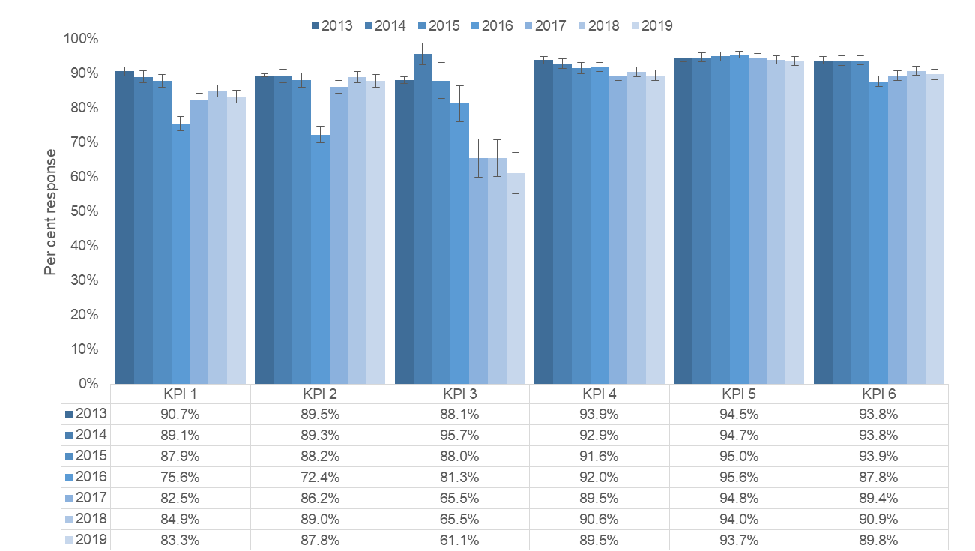

*(2013: n=1942; 2014: n=1261; 2015: n=1234; 2016: n=1696; 2017: n=1700; 2018: n=1695; 2019: n=1,492)*

Figure 5: Key Performance Indicator results, 2013 to 2019

## Satisfaction with RTOs

RTOs have various roles in registrars’ training, including providing registrars with support and advice, helping registrars plan their training and learning, managing the placement matching of registrars and training facilities, providing registrars with training resources, and organising education and training events and activities, among others. The 2019 AGPT NRS included several questions that asked registrars about their satisfaction with different aspects of their RTO.

The results suggest that registrars are satisfied with their experience with their RTOs, with one exception registrars reporting average satisfaction scores of between 3.6 and 3.8 on a five point scale. The average satisfaction scores are shown in Figure 6. Registrars rated the the workshops provided by RTOs and the training and education resources the most positively. One notable exception is that registrars completing a FACRRM were much less likely to feel supported to meet ACRRM’s training requirements (2.9 on the five point scale) than registrars who were completing a FRACGP or FARGP were with support to meet RACGP’s training requirements (3.8).

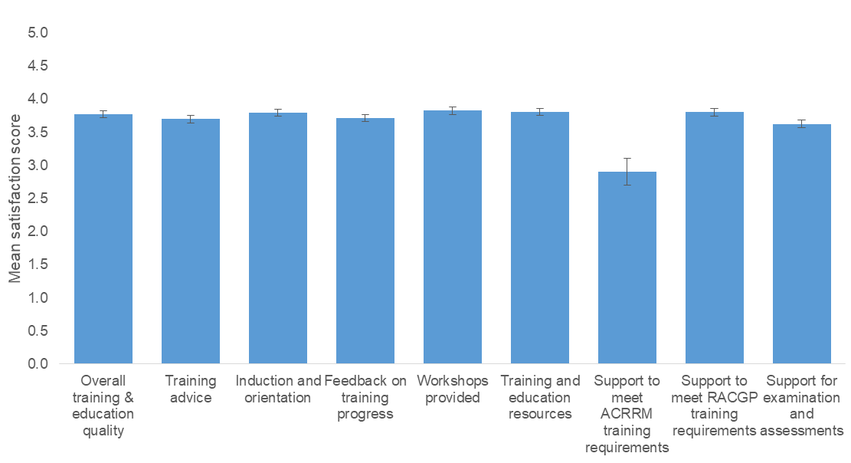

*(n=1,493)*

Figure 6: Satisfaction with different aspects of RTO

## Satisfaction with training facilities

Registrars undertake much of their training while working in general practices, Aboriginal medical services, and other medical facilities. These training facilities have an important role in registrars’ training experience. The 2019 AGPT NRS included several questions that asked registrars about their satisfaction with various aspects of their training facility.

The results suggest that registrars are very satisfied with their experience in their training facilities, with registrars reporting average satisfaction scores of between 3.8 and 4.2 on a five point scale. As shown in Figure 7, registrars were most satisfied with the clinical work, level of workplace responsibility, and the diversity, and number, of patients and presentations.

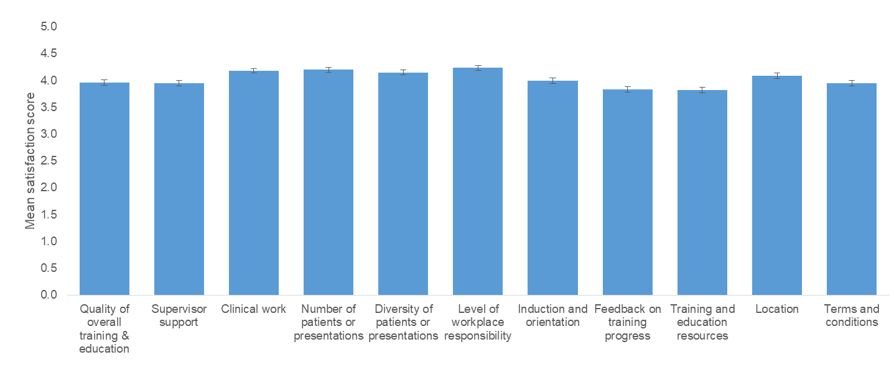

*(n=1,489)*

Figure 7: Satisfaction with different aspects of training facilities

## Qualitative findings

In addition to being asked to rate their level of satisfaction overall, and with specific aspects of their training experience, registrars were also invited to provide open-ended feedback about their overall experience with training on the AGPT program in response to two questions:

* *Given your overall experience with your training, what have been the best aspects of your experience?*
* *Given your overall experience with your training, what aspects of your experience are most in need of improvement?*

Each of the responses provided to these questions were reviewed and thematically coded onto an existing codeframe that had been developed in previous admininstrations of the AGPT NRS. Some additional codes were added to the codeframe where new themes had appeared. Each response could be thematically coded onto multiple areas.This section provides a summary of the main themes that were raised in these responses.

When asked about the best aspects of registrars’ experience with training, the most frequently cited theme related to registrars’ practice workplace and colleagues (16%). These comments related to the level of support provided by supervisors, other clinicians, and administrative staff, as well as the work environment more generally.

“All clinics I’ve worked in have been very supportive and flexible work environments.” – Female FRACGP registrar training on general pathway.   
“Practice in the clinic setting and clinical supervision have been great. The support from supervisors and other doctors in the practice has been excellent.” – Male FRACGP registrar training on general pathway.

Another commonly cited theme included the workshops or education days (15%). The aspects of the workshops and education days that registrars mentioned included both the workshop content, delivery, learning opportunities and also having opportunities to meet with other registrars.

“I found the Day Release sessions early in the training a great place to learn and meet colleagues and future study mates.” – Female FRACGP registrar training on general pathway.

“Mini release sessions to meet other registrars and discuss difficult cases with others.” – Female FRACGP registrar training on rural pathway.

The next most commonly cited theme related to supervisors and supervision (14%). Many registrars mentioned that their supervisors had provided them with significant support and mentorship.

“I have been very lucky throughout my whole journey as a registrar so far having had the opportunity to work with the best supervisors and practice staff you could ever get. This really enhanced my learning experience and have a nice work-life balance.” – Male FRACGP registrar training on general pathway.

“Some of the people within training posts and their kindness in largely unpaid teaching and mentorship”. – Female FACRRM registrar training on rural pathway.

In addition to these themes, registrars also mentioned the level of overall support (14%), the support provided by their RTO (10%), clinical or procedural experience (8%) and gaining exposure to a range of cases or patients (7%).

When asked about the aspects of their experience in training that were most in need of improvement, around six per cent of registrars indicated that nothing in the AGPT program needed improvement. The most commonly mentioned theme was exam preparation or support (16%). A number of registrars mentioned a lack of guidance on how to prepare adequately for the exams, and a lack of set curriculum for exams, as something that needs improvement. Many registrars felt that having more exam support and training would be helpful, as many registrars feel they need to undertake paid exam preparation courses in order to pass exams.

“Exam preparation, I found the KFP examination difficult to prepare for. Many of my peers who studied hard agreed that the study they completed did not feel relevant for the exam.” – Male FRACGP registrar training on general pathway.

“The exams were difficult and I think having more exposure to practice exams that are similiar to the actual exams would be helpful”. – Female FRACGP registrar training on general pathway.

“A definitive curriculum document on which to base exam preparation.” – Female FRACGP registrar training on rural pathway.

Other areas of the AGPT program that registrars indicated needed improvement related to a lack of support (11%), this included well-being support and pastoral care, as well as general support from RTOs and training practices, registrars’ terms and conditions or pay (9%), their supervision or supervisor (9%), the content and focus of training or curriculum (8%), and assessment (7%).

## Health and wellbeing

In 2019, registrars were asked a series of questions regarding their health and wellbeing. As shown in Figure 8, the vast majority of registrars were satisfied with the health and wellbeing support provided to them. Registrars were most satisfied with the health and wellbeing support provided to them by their supervisor and training facility, although the majority of registrars were still satisfied with the level of support received.

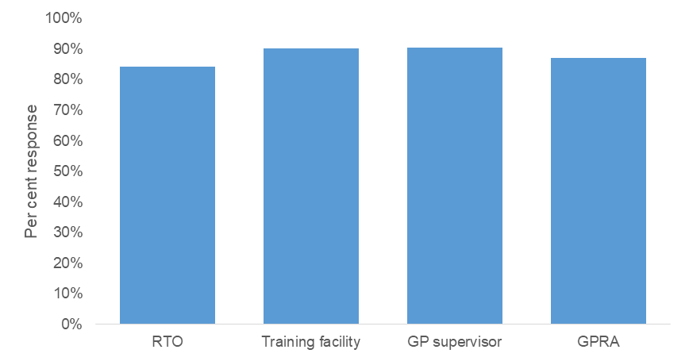

*(n=1,424)*

Figure 8: Satisfaction with health and wellbeing support by source of support

## Aboriginal and Torres Strait Islander Health

Registrars were asked a number of questions relating to their experience, future plans and their support in working in Aboriginal and Torres Strait Islander Health. A significant proportion of registrars are working, or have had experience working in an Aboriginal health training post. Nineteen per cent of registrars were either currently training or had already completed a training post in an Aboriginal health training post (for example an Aboriginal Medical Service or Aboriginal Community Controlled Health Service. Around a third (32%) of registrars who were not currently training, or who had not yet completed training were considering undertaking training in an Aboriginal health training post. In addition, Aboriginal or Torres Strait Islander Health was the second most common area in which registrars were undertaking Extended Skills, ARST or AST.

The vast majority of registrars had received an orientation to Aboriginal and Torres Strait Islander health (93%) and training in Aboriginal and Torres Strait Islander cultural safety (92%). While 72 per cent of registrars who were currently undertaking training in an Aboriginal health training post had access to a formal cultural mentor, and 95 per cent were satisfied with this support.

## Registrars’ training choices

In the 2019 AGPT NRS, registrars were asked a series of questions about when and why they decided to become GP Specialists, whether GP Specialisation was their first choice, and which other speciality programs they applied to before joining the program.

Most registrars indicated that they decided to become GP specialists after they had completed their medical degree (65%) and GP specialisation was reported as the first choice of medical specialisation for 65 per cent of registrars. Twenty-two per cent of registrars indicated that they had applied to other speciality programs prior to starting the AGPT program, these included Emergency Medicine, Basic Physician Training, Paediatrics, Surgical Training, Obstetrics and Gynaecology, and Anaesthesia.

The top three responses for why registrars decided to become GP specialists given in 2019 were the same as those in 2018 and 2017.These reasons included the hours and working conditions for this speciality (80%), the diversity of patients and medical presentations (65%), as well as the ability to build long-term relationships with patients (57%). (n=***1,453)***

Figure 9 lists the top responses given by at least 20 per cent of registrars for choosing a GP specialisation.

Registrars were also asked about their reasons for selecting their RTO. The most common reason given was the location of the RTO (75%) followed by the available training opportunities (26%) and family or partner support (25%).

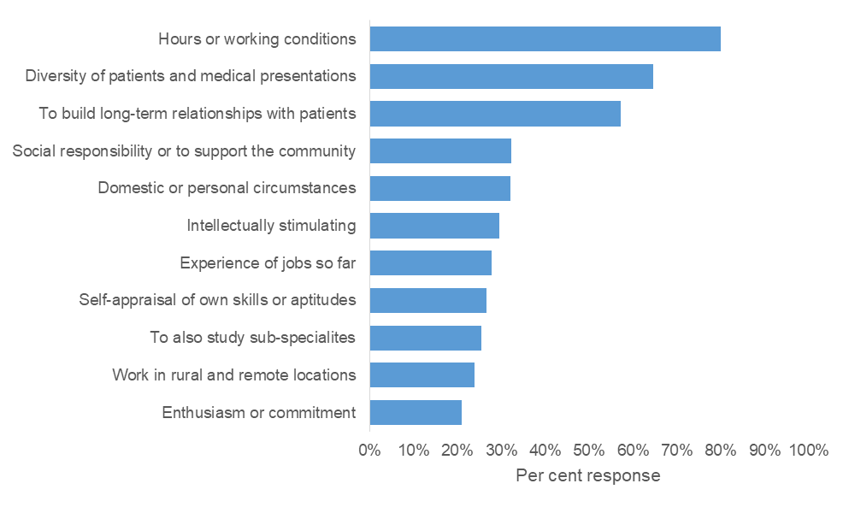

*(n=1,453)*

Figure 9: Why registrars decided to become GP specialists (top reasons given)

## Registrars’ future plans

Registrars were asked about their career plans five years into the future and were asked to select all options that relate to their future plans (Table 4). The responses indicate that most registrars plan to be working as a GP. A total of 88 per cent of registrars plan to work as a private GP with 40 per cent of registrars indicating they plan to be working full time and 52 per cent working part-time. Consistent with the results found in previous years, female registrars planning to work as a private GP are much more likely to be planning to work part-time (70%) than male registrars (41%). Also interesting, in the next five years, twice as many male registrars expect to purchase or buy into an existing practice (22%) than female registrars (11%).

When looking at the responses given by registrars in the rural or general pathway streams, 34 per cent of those in the rural pathway intend to work in a rural or remote location in five years’ time while only nine per cent of those in the general pathway have this same intention. Of registrars on the rural pathway 24 per cent would like to be working as a Rural Generalist, compared with only five per cent of registrars on the general pathway. Of those in the rural pathway 17 per cent intend to be working in Aboriginal Health in five years’ time compared with only 10 per cent of those in the general pathway.

The majority of registrars (82%) indicated that within five years they would like to be involved in medical education, either supervising medical students, registrars or becoming a medical educator. Encouragingly, only a small proportion of registrars indicated that they do not plan to be working as a GP in five years. Many registrars who plan to be doing something else are instead planning to be working in hospital-based specialty training, medical education, public health or academic research.

Table 4: Career plans in five years’ time

| **Career plans** | **Per cent**  **(%)** |
| --- | --- |
| Working full-time as a private GP | 40.1 |
| Working part-time as a private GP | 52.3 |
| To own their own practice | 15.5 |
| To purchase or buy into an existing practice | 17.7 |
| Working in Aboriginal Health | 13.9 |
| Working as a GP in another setting (e.g. aged, palliative, home care) | 19.9 |
| Working in a rural or remote location | 22.3 |
| Working as a Rural Generalist | 14.5 |
| Not working as a GP | 7.1 |
| Other | 3.0 |

*(n=1,454)*

The 47 per cent of registrars who moved to their current location to undertake training were asked about their plans to remain in or relocate from their current location after completing the AGPT program. When asked about their current plans, 36 per cent of these registrars said they plan to stay in their current location, 26 per cent plan to relocate after completing their training and 38 per cent are unsure.

# Appendix A: Table of Figures

Figure 1: Proportion of Australian Medical Graduate and International Medical Graduate registrars working in different regions 14

Figure 2: Location of registrars’ current training facility in 2013 to 2019 16

Figure 3: Proportion of registrars who relocated for training by training location 17

Figure 4: Mean overall satisfaction of registrars with the AGPT program from 2013 to 2019 18

Figure 5: Key Performance Indicator results, 2013 to 2019 20

Figure 6: Satisfaction with different aspects of RTO 21

Figure 7: Satisfaction with different aspects of training facilities 22

Figure 8: Satisfaction with health and wellbeing support by source of support 24

Figure 9: Why registrars decided to become GP specialists (top reasons given) 25

# Appendix B: Table of Tables

Table 1: 2019 AGPT NRS representativeness of respondents with population for different registrar characteristics 12

Table 2: Registrar training contexts 15

Table 3: Key Performance Indicators 2018 19

Table 4: Career plans in five years’ time 26

Table 5: 2019 AGPT NRS item frequencies – demographic and contextual items 29

Table 6: 2019 AGPT NRS item frequencies – satisfaction with RTO 31

Table 7: 2019 AGPT NRS item frequencies – satisfaction with training facility 32

Table 8: 2019 AGPT NRS item frequencies – overall satisfaction 33

Table 9: 2019 AGPT NRS item frequencies – complaints and/or grievance process 33

Table 10: 2019 AGPT NRS item frequencies – adverse event or incidence 34

Table 11: 2019 AGPT NRS item frequencies – registrars’ health and wellbeing 34

Table 12: 2019 AGPT NRS item frequencies – Aboriginal and Torres Strait Islander health and culture 35

Table 13: 2019 AGPT NRS item frequencies – registrars' training choices 36

Table 14: 2019 AGPT NRS item frequencies – choice of RTO 37

Table 15: 2019 AGPT NRS item frequencies – registrars’ future plans 37

Table 16: Proportion of Australian Medical Graduate and International Medical Graduate registrars working in different regions (alternative for Figure 1) 54

Table 17: Location of registrars’ current training facility in 2013 to 2019 (alternative for Figure 2) 54

Table 18: Proportion of registars who relocated for training by training location (alternative for Figure 3) 54

Table 19: Mean overall satisfaction of registrars with the AGPT program from 2013 to 2019 (alternative for Figure 4) 54

Table 20: Key Performance Indicators from the years 2013 to 2019 (alternative for Figure 5) 54

Table 21: Satisfaction with different aspects of RTO (alternative for Figure 6) 55

Table 22: Satisfaction with different aspects of training facilities (alternative for Figure 7) 55

Table 23: Satisfaction with health and wellbeing support by source of support (alternative for Figure 8) 56

Table 24: Why registrars decided to become GP specialists (top reasons given) (alternative for Figure 9) 56

# Appendix C: 2019 AGPT NRS item frequencies

Table 5 to (n=*1,450)*

Table 15 include the item frequencies for the closed items included in the 2019 AGPT NRS.

Table 5: 2019 AGPT NRS item frequencies – demographic and contextual items

| **Item** | **Response options** | **N** | **%** |
| --- | --- | --- | --- |
| In which training region was your GP training delivered in Semester One, 2018? | Eastern Victoria | 114 | 7.6 |
| South Eastern Queensland | 164 | 10.9 |
| Tasmania | 50 | 3.3 |
| North Western Queensland | 182 | 12.1 |
| North Eastern NSW | 204 | 13.5 |
| Lower Eastern NSW | 129 | 8.6 |
| Western NSW | 94 | 6.2 |
| South Australia | 134 | 8.9 |
| Western Victoria | 232 | 15.4 |
| Northern Territory | 45 | 3.0 |
| Western Australia | 158 | 10.5 |
| Which fellowship are you currently working towards? | FRACGP | 1,334 | 88.6 |
| FACRRM | 144 | 9.6 |
| FARGP | 98 | 6.5 |
| At what full time equivalent (FTE) load were you employed during Semester One, 2018? | 0.0 to 0.2 | 29 | 1.9 |
| 0.3 to 0.4 | 45 | 3.0 |
| 0.5 to 0.6 | 210 | 14.0 |
| 0.7 to 0.8 | 130 | 8.7 |
| 0.9 to 1.0 | 1,088 | 72.4 |
| In how many training facilities were you employed during Semester One, 2018? | One | 1,255 | 83.8 |
| Two | 218 | 14.6 |
| Three | 25 | 1.7 |
| What training were you undertaking during Semester One, 2018? | GPT1 Term | 498 | 33.2 |
| GPT2 Term | 159 | 10.6 |
| GPT3 Term | 423 | 28.2 |
| PRRT1 | 42 | 2.8 |
| PRRT2 | 14 | 0.9 |
| PRRT3 | 28 | 1.9 |
| PRRT4 | 28 | 1.9 |
| Extended Skills | 239 | 15.9 |
| Advanced Rural Skills Training (ARST) | 19 | 1.3 |
| Advanced Specialised Training (AST) | 36 | 2.4 |
| Academic post | 9 | 0.6 |
| GPT4 / Extension Awaiting Fellowship | 103 | 6.9 |
| Mandatory Elective | 8 | 0.5 |
| Other | 14 | 0.9 |
| Did you complete any of the following terms prior to commencing the Australian General Practice Training (AGPT) program? | Prevocational General Practice Placements Program (PGPPP) | 146 | 12.2 |
| First Wave Scholarship (GP placement in the undergraduate years) | 52 | 4.5 |
| Rural Clinical School | 358 | 29.5 |
| Commonwealth Medical Internships | 123 | 10.6 |
| Bonded Medical Placements (BMP) Scheme | 198 | 16.6 |
| Medical Rural Bonded Scholarship (MRBS) Scheme | 68 | 5.9 |
| Rural Australia Medical Undergraduate Scholarship (RAMUS) | 78 | 6.7 |
| John Flynn Placement program | 113 | 9.7 |
| State rural generalist programs | 84 | 7.3 |
| Remote Vocational Training Scheme | 16 | 1.4 |
| HECS Reimbursement Scheme | 210 | 17.7 |
| RACGP Practice Experience Program (PEP) | 12 | 1.0 |
| ACRRM Independent Pathway | 8 | 0.7 |
| More Doctors for Rural Australia Program | 10 | 0.9 |
| Community Residency Placement (WA) | 23 | 2.0 |
| Training towards any other fellowship | 192 | 16.2 |
| <IF YES TO AST, EXTENDED SKILLS, OR ARST> Were you training in any of the following areas of Extended Skills (FRACGP), Advanced Specialised Training (FACRRM) or Advanced Rural Skills Training (FARGP) during Semester One, 2018? | Aboriginal and Torres Strait Islander Health | 29 | 14.9 |
| Academic practice | 4 | 2.1 |
| Adult Internal Medicine | 13 | 6.7 |
| Anaesthetics | 14 | 7.2 |
| Dermatology | 13 | 6.7 |
| Emergency Medicine | 31 | 15.9 |
| Medical Education | 6 | 3.1 |
| Men’s Health | <4 |  |
| Mental Health | 8 | 4.1 |
| Obstetrics and Gynaecology | 14 | 7.2 |
| Paediatrics | 9 | 4.6 |
| Palliative Care | 8 | 4.1 |
| Population Health | <4 |  |
| Remote Medicine | <4 |  |
| Skin Cancer Medicine | 14 | 7.2 |
| Small Town Rural General Practice (STRGP) | 4 | 2.1 |
| Surgery | 0 | 0.0 |
| Women’s Health | 14 | 7.2 |
| Other | 21 | 1.4 |
| Are you currently training on the rural or general pathway? | Rural pathway | 749 | 50.2 |
| General pathway | 744 | 49.8 |

*(n=1,506)*

Table 6: 2019 AGPT NRS item frequencies – satisfaction with RTO

| **Item** | **Response options** | **N** | **%** |
| --- | --- | --- | --- |
| How would you rate your satisfaction with the following aspects of your RTO in Semester One, 2019? | | | |
| Overall training & education quality | Very dissatisfied | 59 | 4.0 |
| 2 | 108 | 7.2 |
| 3 | 306 | 20.5 |
| 4 | 659 | 44.1 |
| Very satisfied | 361 | 24.2 |
| Training advice | Very dissatisfied | 65 | 4.4 |
| 2 | 143 | 9.6 |
| 3 | 316 | 21.2 |
| 4 | 618 | 41.5 |
| Very satisfied | 348 | 23.4 |
| Induction and orientation | Very dissatisfied | 54 | 3.7 |
| 2 | 92 | 6.2 |
| 3 | 328 | 22.3 |
| 4 | 626 | 42.5 |
| Very satisfied | 373 | 25.3 |
| Feedback on training progress | Very dissatisfied | 61 | 4.1 |
| 2 | 107 | 7.2 |
| 3 | 349 | 23.4 |
| 4 | 643 | 43.2 |
| Very satisfied | 329 | 22.1 |
| Workshops provided | Very dissatisfied | 61 | 4.1 |
| 2 | 100 | 6.8 |
| 3 | 298 | 20.2 |
| 4 | 593 | 40.2 |
| Very satisfied | 424 | 28.7 |
| Training and education resources | Very dissatisfied | 56 | 3.8 |
| 2 | 111 | 7.4 |
| 3 | 281 | 18.9 |
| 4 | 664 | 44.6 |
| Very satisfied | 378 | 25.4 |
| Support to meet ACRRM training requirements | Very dissatisfied | 23 | 16.2 |
| 2 | 31 | 21.8 |
| 3 | 37 | 26.1 |
| 4 | 38 | 26.8 |
| Very satisfied | 13 | 9.2 |
| Support to meet RACGP training requirements | Very dissatisfied | 63 | 4.7 |
| 2 | 98 | 7.2 |
| 3 | 245 | 18.1 |
| 4 | 583 | 43.1 |
| Very satisfied | 365 | 27.0 |
| Support for examination and assessments | Very dissatisfied | 84 | 5.7 |
| 2 | 134 | 9.0 |
| 3 | 366 | 24.7 |
| 4 | 567 | 38.2 |
| Very satisfied | 332 | 22.4 |

*(n=1,493)*

Table 7: 2019 AGPT NRS item frequencies – satisfaction with training facility

| **Item** | **Response options** | **N** | **%** |
| --- | --- | --- | --- |
| How would you rate your satisfaction with the following aspects of your training facility (e.g. your practice, your hospital) in Semester One, 2019? | | | |
| Quality of overall training and education | Very dissatisfied | 37 | 2.5 |
| 2 | 94 | 6.3 |
| 3 | 262 | 17.6 |
| 4 | 593 | 39.9 |
| Very satisfied | 500 | 33.6 |
| Supervisor support | Very dissatisfied | 54 | 3.6 |
| 2 | 102 | 6.9 |
| 3 | 257 | 17.3 |
| 4 | 523 | 35.1 |
| Very satisfied | 552 | 37.1 |
| Clinical work | Very dissatisfied | 14 | 0.9 |
| 2 | 31 | 2.1 |
| 3 | 210 | 14.1 |
| 4 | 652 | 43.9 |
| Very satisfied | 578 | 38.9 |
| Number of patients or presentations | Very dissatisfied | 16 | 1.1 |
| 2 | 52 | 3.5 |
| 3 | 180 | 12.1 |
| 4 | 608 | 40.9 |
| Very satisfied | 631 | 42.4 |
| Diversity of patients or presentations | Very dissatisfied | 12 | 0.8 |
| 2 | 50 | 3.4 |
| 3 | 228 | 15.3 |
| 4 | 613 | 41.2 |
| Very satisfied | 586 | 39.4 |
| Level of workplace responsibility | Very dissatisfied | 17 | 1.1 |
| 2 | 43 | 2.9 |
| 3 | 142 | 9.5 |
| 4 | 660 | 44.3 |
| Very satisfied | 627 | 42.1 |
| Induction and orientation | Very dissatisfied | 42 | 2.8 |
| 2 | 94 | 6.4 |
| 3 | 233 | 15.8 |
| 4 | 567 | 38.3 |
| Very satisfied | 543 | 36.7 |
| Feedback on training progress | Very dissatisfied | 48 | 3.2 |
| 2 | 108 | 7.3 |
| 3 | 314 | 21.1 |
| 4 | 590 | 39.7 |
| Very satisfied | 427 | 28.7 |
| Training and education resources | Very dissatisfied | 49 | 3.3 |
| 2 | 112 | 7.5 |
| 3 | 317 | 21.3 |
| 4 | 585 | 39.4 |
| Very satisfied | 422 | 28.4 |
| Location | Very dissatisfied | 30 | 2.0 |
| 2 | 64 | 4.3 |
| 3 | 249 | 16.7 |
| 4 | 548 | 36.9 |
| Very satisfied | 596 | 40.1 |
| Terms and conditions | Very dissatisfied | 49 | 3.3 |
| 2 | 94 | 6.3 |
| 3 | 246 | 16.5 |
| 4 | 586 | 39.4 |
| Very satisfied | 512 | 34.4 |

*(n=1,489)*

Table 8: 2019 AGPT NRS item frequencies – overall satisfaction

| **Item** | **Response options** | **N** | **%** |
| --- | --- | --- | --- |
| Thinking about all of your AGPT training to date, overall how satisfied are you with each of the following? | | | |
| Administration | Very dissatisfied | 77 | 5.1 |
| 2 | 130 | 8.7 |
| 3 | 419 | 28.0 |
| 4 | 616 | 41.2 |
| Very satisfied | 254 | 17.0 |
| Education and training | Very dissatisfied | 61 | 4.1 |
| 2 | 117 | 7.8 |
| 3 | 410 | 27.4 |
| 4 | 655 | 43.8 |
| Very satisfied | 251 | 16.8 |
| Support provided | Very dissatisfied | 86 | 5.8 |
| 2 | 148 | 9.9 |
| 3 | 432 | 28.9 |
| 4 | 586 | 39.2 |
| Very satisfied | 243 | 16.3 |

*(n=1,496)*

Table 9: 2019 AGPT NRS item frequencies – complaints and/or grievance process

| **Item** | **Response options** | **N** | **%** |
| --- | --- | --- | --- |
| Are you familiar with your RTO’s formal complaints and/or grievance process? | No | 593 | 39.9 |
| Yes | 564 | 37.9 |
| Unaware process existed | 331 | 22.2 |
| Could you readily access your RTO’s formal complaints and/or grievance process if needed? | No | 479 | 33.4 |
| Yes | 957 | 66.6 |
| Have you ever made a formal written complaint relating to your training on the AGPT program? | No | 1,415 | 95.4 |
| Yes | 68 | 4.6 |

*(n=1,488)*

Table 10: 2019 AGPT NRS item frequencies – adverse event or incidence

| **Item** | **Response options** | **N** | **%** |
| --- | --- | --- | --- |
| Thinking about all of your AGPT training to date, have you experienced an adverse event or incident? | No | 1,225 | 82.6 |
| Yes | 258 | 17.4 |
| <IF YES> From which of the following sources did you seek assistance or support to cope with the adverse event or incident? | RTO | 150 | 58.8 |
| Your training facility | 100 | 39.2 |
| General Practice Registrars Australia (GPRA) | 43 | 16.9 |
| Did not seek assistance or support | 27 | 10.6 |
| AMA | 9 | 3.5 |
| MDO/Insurance Provider | 21 | 8.2 |
| Other | 31 | 12.2 |
| <IF RTO> How would you rate your satisfaction with the assistance or support your RTO provided during or after an adverse event or incident? | Very dissatisfied | 39 | 26.7 |
| 2 | 24 | 16.4 |
| 3 | 22 | 15.1 |
| 4 | 33 | 22.6 |
| Very satisfied | 28 | 19.2 |

*(n=1,483)*

Table 11: 2019 AGPT NRS item frequencies – registrars’ health and wellbeing

| **Item** | **Response options** | **N** | **%** |
| --- | --- | --- | --- |
| How would you rate your satisfaction with the health and wellbeing support provided to you by | | | |
| RTO | Very dissatisfied | 86 | 5.9 |
| 2 | 134 | 9.2 |
| 3 | 298 | 20.4 |
| 4 | 478 | 32.7 |
| Very satisfied | 405 | 27.7 |
| Not applicable | 62 | 4.2 |
| training facility | Very dissatisfied | 38 | 2.6 |
| 2 | 102 | 7.0 |
| 3 | 228 | 15.6 |
| 4 | 491 | 33.6 |
| Very satisfied | 565 | 38.6 |
| Not applicable | 39 | 2.7 |
| GP supervisor | Very dissatisfied | 48 | 3.3 |
| 2 | 87 | 5.9 |
| 3 | 192 | 13.1 |
| 4 | 435 | 29.7 |
| Very satisfied | 649 | 44.3 |
| Not applicable | 53 | 3.6 |
| General Practice Registrar Association (GPRA) | Very dissatisfied | 31 | 2.1 |
| 2 | 109 | 7.5 |
| 3 | 353 | 24.2 |
| 4 | 377 | 25.9 |
| Very satisfied | 208 | 14.3 |
| Not applicable | 379 | 26.0 |
| Do you have your own independent GP? | No | 412 | 28.0 |
| Yes | 1,059 | 72.0 |
| Are you living away from your immediate family? | No | 812 | 55.2 |
| Yes | 659 | 44.8 |
| How many dependents do you have? (e.g. children, parents)? | 0 | 587 | 41.8 |
| 1 or 2 | 604 | 43.0 |
| 3 or 4 | 193 | 13.7 |
| 5 or more | 20 | 1.4 |

*(n=1,471)*

Table 12: 2019 AGPT NRS item frequencies – Aboriginal and Torres Strait Islander health and culture

| **Item** | **Response options** | **N** | **%** |
| --- | --- | --- | --- |
| In Semester One, 2018, were you training in an Aboriginal health training post (e.g. an Aboriginal Medical Service or Aboriginal Community Controlled Health Service)? | No | 1,318 | 90.0 |
| Yes | 146 | 10.0 |
| <IF NO> Have you completed or are you considering undertaking training in an Aboriginal health training post (e.g. an Aboriginal Medical Service or Aboriginal Community Controlled Health Service)? | I have already completed training | 137 | 10.4 |
| I am considering undertaking training | 372 | 28.3 |
| None of the above | 805 | 61.3 |
| Since commencing the AGPT program, have you had an orientation to Aboriginal and Torres Strait Islander health? | No | 103 | 7.0 |
| Yes | 1,362 | 93.0 |
| Since commencing the AGPT program, have you had training in Aboriginal and Torres Strait Islander cultural safety? | No | 116 | 7.9 |
| Yes | 1,351 | 92.1 |
| <IF CURRENTLY WORKING IN AN ABORIGINAL TRAINING POST> Do you have access to a formal cultural mentor for support with issues relevant to Aboriginal and Torres Strait Islander people? | No | 40 | 27.6 |
| Yes | 105 | 72.4 |
| <IF YES> How satisfied are you with the guidance from this cultural mentor on Aboriginal and Torres Strait Islander cultural safety questions? | Very dissatisfied | <4 | - |
| 2 | 4 | 3.8 |
| 3 | 22 | 21.0 |
| 4 | 38 | 36.2 |
| Very satisfied | 40 | 38.1 |

*(n=1,467)*

Table 13: 2019 AGPT NRS item frequencies – registrars' training choices

| **Item** | **Response options** | **N** | **%** |
| --- | --- | --- | --- |
| When did you decide to become a specialist GP? | While I was at school | 88 | 5.8 |
| Early in my medical degree | 234 | 15.5 |
| Late in my medical degree | 231 | 15.3 |
| In my first year out of medical school | 143 | 9.5 |
| More than one year out of medical school | 542 | 36.0 |
| After trying another specialty | 344 | 22.8 |
| While in the Australian Defence Force | 5 | 0.3 |
| When working in another career | 6 | 0.4 |
| When I moved to Australia | 13 | 0.9 |
| After completing another degree, prior to medical degree | 11 | 0.8 |
| Other | 15 | 1.0 |
| Why did you decide to become a specialist GP? | Hours or working conditions | 1,163 | 80.0 |
| Diversity of patients and medical presentations | 940 | 64.7 |
| To build long-term relationships with patients | 832 | 57.3 |
| Social responsibility or to support the community | 469 | 32.3 |
| Domestic or personal circumstances | 467 | 32.1 |
| Intellectually stimulating | 428 | 29.5 |
| Experience of jobs so far | 405 | 27.9 |
| Self-appraisal of own skills or aptitudes | 386 | 26.6 |
| To also study sub-specialities | 369 | 25.4 |
| Work in rural and remote locations | 346 | 23.8 |
| Enthusiasm or commitment | 304 | 20.9 |
| Advice from others | 205 | 14.1 |
| Inclinations before medical school | 204 | 14.0 |
| Student experience of subject | 197 | 13.6 |
| Particular teacher, department or role model | 173 | 11.9 |
| Promotion or career prospects | 150 | 10.3 |
| Eventual financial prospects | 127 | 8.7 |
| The training program is fully funded by the Commonwealth Government | 82 | 5.6 |
| ADF | 7 | 0.5 |
| Does not like hospital setting | 5 | 0.3 |
| Other | 25 | 1.7 |
| Was GP specialisation your first choice of specialty? | No | 515 | 35.4 |
| Yes | 941 | 64.6 |
| Did you apply to any other specialty programs at the same time or before you applied to become a GP specialist? | No | 1,136 | 78.0 |
| Yes | 320 | 22.0 |

*(n=1,460)*

Table 14: 2019 AGPT NRS item frequencies – choice of RTO

| **Item** | **Response options** | **N** | **%** |
| --- | --- | --- | --- |
| What were the main reasons you chose your RTO as your training provider? | Location | 1,082 | 74.6 |
| Training opportunities | 372 | 25.7 |
| Family or partner support | 357 | 24.6 |
| Lifestyle | 249 | 17.2 |
| Reputation of the RTO | 201 | 13.9 |
| Career links with region | 123 | 8.5 |
| Recommended by peers | 121 | 8.3 |
| Only RTO operating in state or region | 60 | 4.1 |
| Did not have a choice over RTO | 44 | 3.0 |
| Australian Defence Force | 10 | 0.7 |
| Did not choose current RTO (transferred from RTP) | 5 | 0.3 |
| Through selection process | <4 | - |
| Other | 6 | 0.4 |

*(n=1,450)*

Table 15: 2019 AGPT NRS item frequencies – registrars’ future plans

| **Item** | **Response options** | **N** | **%** |
| --- | --- | --- | --- |
| Within the next five years, you would like to be… | Would like to be supervising medical students. | 946 | 65.6 |
| Would like to be supervising registrars. | 778 | 54.0 |
| Would like to be a medical educator. | 480 | 33.3 |
| Would not like to be involved in doctor training. | 261 | 18.1 |
| In five years, you would like | to be working full time as a private GP. | 583 | 40.1 |
| to be working part-time as a private GP. | 760 | 52.3 |
| to own your own practice | 225 | 15.5 |
| to purchase or buy into an existing practice | 258 | 17.7 |
| to be working in Aboriginal Health | 202 | 13.9 |
| to be working as a GP in another setting | 290 | 19.9 |
| to be working in a rural or remote location | 324 | 22.3 |
| to be working as a Rural Generalist | 211 | 14.5 |
| to be not working as a GP | 103 | 7.1 |
| other | 44 | 3.0 |
| Did you move to the current region to undertake the AGPT program? | No | 777 | 52.8 |
| Yes | 694 | 47.2 |
| Do you intend to stay in this region after completing the AGPT program? | No | 263 | 17.9 |
| Yes | 795 | 54.2 |
| Unsure | 409 | 27.9 |

*(n=1,454)*

# Appendix D: 2019 AGPT NRS Instrument

Introductory text

The Department of Health has engaged the Australian Council for Educational Research (ACER), an independent and not-for-profit research organisation, to conduct the 2019 Australian General Practice Training National Registrar Survey. The survey results enable the Department of Health to monitor the performance of the program and to help bring emerging issues to the attention of the Department of Health and other GP training stakeholders.

Please take 10 minutes to tell us about your experience as a general practice registrar in Semester One, 2019 by clicking on the ‘Next’ button below. Your responses help the Department of Health, RTOs and Colleges improve your and other registrars’ experience in the Australian General Practice Training (AGPT) program.

Your involvement is voluntary and you are free to withdraw consent at any time. Your response is private, confidential and will be treated according to any applicable law. This survey is run in accordance with the ACT Health Human Research Ethics Committee ethics approval process.

We encourage you to participate in the 2019 Australian General Practice Training National Registrar Survey.

| **Question** | **Item** | **Response options** |
| --- | --- | --- |
| Which regional training organisation (RTO) delivered your GP training in **Semester One, 2019**? | - | Eastern Victoria GP Training General Practice Training Queensland General Practice Training Tasmania GP Synergy GPEx JCU General Practice Training Murray City Country Coast GP Training  Northern Territory General Practice Education Western Australian General Practice Education Training |
| <IF RTO=GP Synergy>In which training region was your GP training delivered in **Semester One, 2019**? | - | North Eastern NSW Lower Eastern NSW Western NSW |
| Which fellowship are you currently working towards?   *If you are undertaking a dual or triple fellowship, please select all that apply.* | FRACGP | Not selected  Selected |
| FACRRM |
| FARGP |
| Other (please specify) | OPEN RESPONSE |
| At what full time equivalent (FTE) load were you employed during **Semester One, 2019**?  *1.0 FTE is equivalent to 38 hours per week, i.e. 0.2 = 1 day.* | - | 0.0 to 0.2  0.3 to 0.4  0.5 to 0.6  0.7 to 0.8  0.9 to 1.0  I was on extended leave from the training program (e.g. parental, sabbatical, long service) for the whole semester |
| <IF ON EXTENDED LEAVE FOR WHOLE SEMESTER>Thank you for taking the time to participate in the Australian General Practice Training National Registrar Survey (AGPT NRS). You are not required to respond this year.  Please press *Next* to finalise your input. | - | *Note that the survey will be terminated here.* |
| If you were training in a hospital during **Semester One, 2019**, which of the following terms were you undertaking? | - | Hospital intern (PGY1)  Hospital resident (PGY2+)  Hospital based extended skills training  I was not undertaking training in a hospital |
| <IF PGY1>Thank you for taking the time to participate in the Australian General Practice Training National Registrar Survey (AGPT NRS). You are not required to respond this year.  Please press *Next* to finalise your input. | - | *Note that the survey will be terminated here.* |
| In how many training facilities were you employed during **Semester One, 2019**? | - | One  Two  Three or more |
| <IF ONE>What is the postcode of the GP training facility where you were employed during **Semester One, 2019**? | - | NUMERICAL RESPONSE |
| <IF MORE THAN ONE> What is the postcode of the GP training facility where you were employed for the most time during **Semester One, 2019**? | - | NUMERICAL RESPONSE |
| What training were you undertaking during **Semester One, 2019**?  *Please select all that apply.* | GPT1 Term | Not selected  Selected |
| GPT2 Term |
| GPT3 Term |
| PRRT1 |
| PRRT2 |
| PRRT3 |
| PRRT4 |
| Extended Skills |
| Advanced Rural Skills Training (ARST) |
| Advanced Specialised Training (AST) |
| Academic post |
| Other (please specify) | OPEN RESPONSE |
| Did you complete any of the following terms prior to commencing the Australian General Practice Training (AGPT) program? | Prevocational General Practice Placements Program (PGPPP) | No  Yes |
| First Wave Scholarship (GP placement in the undergraduate years) |
| Rural Clinical School |
| Commonwealth Medical Internships |
| Bonded Medical Placements (BMP) Scheme |
| Medical Rural Bonded Scholarship (MRBS) Scheme |
| Rural Australia Medical Undergraduate Scholarship (RAMUS) |
| John Flynn Placement program |
| State rural generalist programs |
| Remote Vocational Training Scheme |
| HECS Reimbursement Scheme |
| RACGP Practice Experience Program (PEP) |
| ACRRM Independent Pathway |
| More Doctors for Rural Australia Program |
| Community Residency Placement (WA) |
| Training towards any other fellowship |
| <IF YES TO AST (6h), EXTENDED SKILLS (6e), OR ARST (6f)>  Were you training in any of the following areas of Extended Skills (FRACGP), Advanced Specialised Training (FACRRM) or Advanced Rural Skills Training (FARGP) during **Semester One, 2019**?   *Please select all that apply.* | Aboriginal and Torres Strait Islander Health | Not selected  Selected |
| Academic practice |
| Adult Internal Medicine |
| Anaesthetics |
| Dermatology |
| Emergency Medicine |
| Medical Education |
| Men’s Health |
| Mental Health |
| Obstetrics and Gynaecology |
| Paediatrics |
| Palliative Care |
| Population Health |
| Remote Medicine |
| Skin Cancer Medicine |
| Small Town Rural General Practice (STRGP) |
| Surgery |
| Women’s Health |
| Other (please specify) | OPEN RESPONSE |
| Are you currently training on the rural or general pathway? | - | Rural pathway  General pathway |
| <IF RURAL> What have been the best aspects of training on the rural pathway? | - | OPEN RESPONSE |
| <IF RURAL> What aspects of your experience training on the rural pathway are most in need of improvement? | - | OPEN RESPONSE |
| Please note that unless otherwise stated, all questions referring to *'your RTO'* relate to <INSERT RTO NAME>.  All questions referring to *'your training facility'* relate to the main practice, hospital or academic post where you were assigned in Semester One, 2019.   The following questions ask about your satisfaction with your RTO, training facility and College, and your overall satisfaction. | | |
| How would you rate your satisfaction with the following aspects of **your RTO** in **Semester One, 2019**?  *If any of the following statements do not apply, please leave blank.* | Quality of overall training and education experience | 1 Very dissatisfied  2  3  4  5 Very satisfied |
| Quality of training advice |
| Induction/orientation provided |
| Feedback on your training progress |
| Workshops provided |
| Training and education resources available |
| <IF COLLEGE=ACRRM> Support to meet ACRRM training requirements |
| <IF COLLEGE=RACGP> Support to meet RACGP training requirements |
| Support for examination and assessments |
| How would you rate your satisfaction with the following aspects of **your training facility** (e.g. your practice, your hospital) in **Semester One, 2019**?  *If any of the following statements do not apply, please leave blank.* | Quality of overall training and education experience | 1 Very dissatisfied  2  3  4  5 Very satisfied |
| Quality of supervision |
| Clinical work |
| Number of patients or presentations |
| Diversity of patients or presentations |
| Level of workplace responsibility |
| Induction/orientation provided |
| Feedback on your training progress |
| Training and education resources available |
| Location |
| Terms and conditions of employment at your training facility |
| <IF COLLEGE=ACRRM> Thinking about your experience with **ACRRM**, how would you rate your satisfaction with: | assessment? | 1 Very dissatisfied  2  3  4  5 Very satisfied |
| curriculum? |
| communication? |
| the support they provide to you? |
| <IF COLLEGE= RACGP> Thinking about your experience with **RACGP**, how would you rate your satisfaction with: | assessment? | 1 Very dissatisfied  2  3  4  5 Very satisfied |
| curriculum? |
| communication? |
| the support they provide to you? |
| Thinking about all of your AGPT training to date, overall how satisfied are you with each of the following? | Administration | 1 Very dissatisfied  2  3  4  5 Very satisfied |
| Education and training |
| Support |
| Given your overall experience with your training, what have been the best aspects of your experience? | - | OPEN RESPONSE |
| Given your overall experience with your training, what aspects of your experience are most in need of improvement? | - | OPEN RESPONSE |
| The following questions ask about your RTO's complaints and grievance process. | | |
| Are you familiar with your RTO's formal complaints and/or grievance process? | - | No  Yes  Unaware process exists |
| Could you readily access your RTO's formal complaints and/or grievance process if needed? | - | No  Yes |
| Have you ever made a formal written complaint relating to your training on the AGPT Program? | - | No  Yes |
| Thinking about all of your AGPT training to date, have you experienced an adverse event or incident? | - | No  Yes |
| <IF YES> From which of the following sources did you seek assistance or support to cope with the adverse event or incident?  *Please select all that apply.* | RTO | Not selected  Selected |
| Your training facility |
| General Practice Registrars Australia (GPRA) |
| Did not seek assistance or support |
| Other (please specify) | OPEN RESPONSE |
| <IF RTO> How would you rate your satisfaction with the assistance or support your RTO provided during or after an adverse event or incident? | - | 1 Very dissatisfied  2  3  4  5 Very satisfied |
| <IF DISSATISFIED (1, 2 OR 3)> How could your RTO have supported you better during or after an adverse event or incident? | - | OPEN RESPONSE |
| Please note that unless otherwise stated, all questions referring to *'your RTO*' relate to <YOUR RTO>.  All questions referring to *'your training facility'* relate to the main practice, hospital or academic post where you were assigned in Semester One, 2019. | | |
| How would you rate your satisfaction with the health and wellbeing support provided to you by | your RTO? | 1 Very dissatisfied  2  3  4  5 Very satisfied |
| your training facility? |
| <IF COLLEGE=ACRRM> ACRRM? |
| <IF COLLEGE=RACGP> RACGP? |
| your GP Supervisor? |
| the General Practice Registrar Association (GPRA)? |
| Do you have your own independent GP? |  | No  Yes |
| Are you living away from your immediate family? |  | No Yes |
| How many dependents do you have (e.g. children, parents)? |  | NUMERICAL RESPONSE |
| Did you move to the current region to undertake the AGPT program? | - | No  Yes |
| Do you intend to stay in this region after completing the AGPT program? |  | No  Yes  Unsure |
| The following questions ask about the training related to Aboriginal and Torres Strait Islander culture that you have received. | | |
| In **Semester One, 2019**, were you training in an Aboriginal health training post (e.g. an Aboriginal Medical Service or Aboriginal Community Controlled Health Service)? | - | No  Yes |
| <IF NO> Have you completed or are you considering undertaking training in an Aboriginal health training post (e.g. an Aboriginal Medical Service or Aboriginal Community Controlled Health Service)? | - | I have already completed training I am considering undertaking training None of the above |
| Since commencing the AGPT program, have you had an orientation to Aboriginal and Torres Strait Islander health? | - | No  Yes |
| Since commencing the AGPT program, have you had training in Aboriginal and Torres Strait Islander cultural safety? | - | No  Yes |
| <IF CURRENTLY WORKING IN AN ABORIGINAL TRAINING POST> Do you have access to a formal cultural mentor for support with issues relevant to Aboriginal and Torres Strait Islander people? | - | No  Yes |
| <IF YES> How satisfied are you with the guidance from this cultural mentor on Aboriginal and Torres Strait Islander cultural safety questions? | - | 1 Very dissatisfied  2  3  4  5 Very satisfied |
| Please note that unless otherwise stated, all questions referring to 'your RTO' relate to <YOUR RTO>.   All questions referring to 'your training facility' relate to the main practice, hospital or academic post where you were assigned in **Semester One, 2019**.  The following questions ask about your choice of specialisation, fellowship and RTO, and your future plans. | | |
| When did you decide to become a specialist GP?  *Please select all that apply.* | While I was at school | Not selected  Selected |
| Early in my medical degree |
| Late in my medical degree |
| In my first year out of medical school |
| More than one year out of medical school |
| After trying another specialty |
| Other (please specify) | OPEN RESPONSE |
| Why did you decide to become a specialist GP?  *Please select all that apply.* | To build long-term relationships with patients | Not selected  Selected |
| To also study sub-specialities such as anaesthesia, emergency medicine, paediatrics, obstetrics and gynaecology |
| The training program is fully funded by the Commonwealth Government |
| To work in rural and remote locations |
| Intellectually stimulating |
| Diversity of patients and medical presentations |
| Domestic circumstances |
| Hours/working conditions |
| Eventual financial prospects |
| Promotion/career prospects |
| Self-appraisal of own skills/aptitudes |
| Advice from others |
| Student experience of subject |
| Particular teacher, department or role model |
| Inclinations before medical school |
| Experience of jobs so far |
| Enthusiasm/commitment |
| Social responsibility or to support the community |
| Other (please specify) | OPEN RESPONSE |
| Was GP specialisation your first choice of specialty? | - | No  Yes |
| Did you apply to any other specialty programs at the same time or before you applied to become a GP specialist? | - | No  Yes |
| <If Yes> What other specialty programs did you apply to? |  | OPEN RESPONSE |
| <IF SINGLE FELLOWSHIP> What was your main reason for choosing your GP fellowship? | - | OPEN RESPONSE |
| <IF DUAL FELLOWSHIP> What was your main reason for choosing to undertake a dual GP fellowship? | - | OPEN RESPONSE |
| <IF TRIPLE FELLOWSHIP> What was your main reason for choosing to undertake a triple GP fellowship? | - | OPEN RESPONSE |
| What were the main reasons you chose your RTO as your training provider?  *Please select all that apply.* | Family/partner support | Not selected  Selected |
| Location |
| Lifestyle |
| Training opportunities |
| Career links with region (e.g. earlier placement, Prevocational General Practice Placements Program (PGPPP)) |
| Reputation of the RTO |
| Recommended by peers |
| Other (please specify) | OPEN RESPONSE |
| Within the next five years, you would like to be…  *Please select all that apply.* | teaching or supervising medical students. | Not selected  Selected |
| supervising registrars. |
| a medical educator. |
| not involved in doctor training. |
| In five years, you would like...  *Please select all that apply.* | to be working full time as a private GP. | Not selected  Selected |
| to be working part-time as a private GP. |
| to own your own practice. |
| to purchase or buy into an existing practice. |
| to be working in Aboriginal Health. |
| to be working as a GP in another setting (e.g. aged, palliative, home care). |
| to be working in a rural or remote location. |
| to be working as a Rural Generalist. |
| to be not working as a GP. |
| to be doing something else (please specify). |

Closing text

Thank you for participating in the Australian General Practice Training National Registrar Survey. Once you have completed the survey, please press 'Submit'.

Your responses help the Department of Health, RTOs and Colleges improve registrars’ experience and learning in Australia.

If this survey has raised any concerns about your experience in the AGPT program, please get in touch with your Registrar Liaison Officer (RLO). A directory of RLOs is provided by General Practice Registrars Australia (GPRA): https://gpra.org.au/rlo-directory/.

If you need further assistance, please contact GPRA at registrarenquiries@gpra.org.au or phone 03 9629 8878.

**PRIVACY STATEMENT**

Any Personal Information you provide to ACER is private, confidential and will be treated according to any applicable law. Such Personal Information will only be used for the purposes of this research specified above.

ACER is bound to comply with the Privacy Act 1988 (Cth) and its ACER Privacy Policy locatable at http://www.acer.org/privacy and your personal information will be handled in accordance with that policy which may be updated from time to time.

The policy sets out your rights and processes to: complain about a breach of privacy, and access and have amended your personal information held by ACER. Your involvement is voluntary and you are free to withdraw consent at any time. Should you have any queries please contact the Project Manager, Ali Radloff, ACER, 19 Prospect Hill Road, Camberwell, Victoria 3124, nrs@acer.org.

# Appendix E: Accessible text alternatives for figures

## Infographic text alternative

NATIONAL REGISTRAR SURVEY 2019

The AGPT NRS is an annual, national survey of GP registrars currently training in the AGPT program that collects information about registrar satisfaction, experience and future career plans. This information can be used to assure the quality of training provision, enable continuous improvement and allow results to be benchmarked nationally.

These are the responses from the 1,506 registrars who participated in the 2019 survey.

TRAINING EXPERIENCE

* 89% were satisfied with the education and training from their RTO
* 91% were satisfied with the education and training from their training facility
* 90% were satisfied with the supervisor support
* 96% were satisfied with their level of workplace responsibility
* 97% were satisfied with the clinical work
* 88% were satisfied with the overall education and training

REGISTRAR CHARACTERISTICS

* 63% of respondents were female
* 55% were between 30 and 39 years of age
* 1% identified as Aboriginal or Torres Strait Islander
* 50% in the rural pathway
* 31% were international medical graduates

CHOOSING TO BECOME A GP

* 78% of respondents applied to AGPT before any other speciality program
* 65% of respondents saw GP specialisation as their first choice of speciality
* 82% would like to be involved in doctor training

RURAL TRAINING PATHWAY: BEST ASPECTS – TOP FOUR RESPONSES

* 39% Exposure to a range of cases or patients
* 14% Being part of a community
* 9% Clinical or procedural experience
* 9% Being in a rural or regional area

WHY BECOME A GP?: TOP THREE REASONS

* 80% Hours/working conditions
* 65% Diversity of patients and medical presentations
* 57% To build long-term relationships with patients

LOCATION OF TRAINING FACILITY

* 44% in Major cities
* 35% in Inner regional
* 16% in Outer regional
* 5% in Remote

## Text alternative for Figures

Table : Proportion of Australian Medical Graduate and International Medical Graduate registrars working in different regions (alternative for Figure 1)

| **Training facility location** | **Australian Medical Graduate** | **International Medical Graduate** |
| --- | --- | --- |
| Major cities | 54.2 | 23.7 |
| Inner regional | 28.0 | 50.3 |
| Outer regional | 13.4 | 20.5 |
| Remote or very remote | 4.5 | 5.5 |

Table : Location of registrars’ current training facility in 2013 to 2019 (alternative for Figure 2)

| **Training facility location** | **2013** | **2014** | **2015** | **2016** | **2017** | **2018** | **2019** |
| --- | --- | --- | --- | --- | --- | --- | --- |
| Major cities | 47.6 | 39.4 | 43.7 | 43.5 | 48.6 | 45.1 | 44.6 |
| Inner regional | 34.9 | 38.8 | 35.2 | 34.8 | 32.0 | 35.0 | 35.0 |
| Outer regional | 14.4 | 17.4 | 17.7 | 18.1 | 15.6 | 16.6 | 15.6 |
| Remote or very remote | 3.1 | 4.4 | 3.3 | 3.6 | 3.8 | 3.3 | 4.8 |

Table : Proportion of registars who relocated for training by training location (alternative for Figure 3)

| **Region** | **Did not relocate for training** | **Relocated for training** |
| --- | --- | --- |
| Major cities | 78.6 | 21.4 |
| Inner regional | 36.9 | 63.1 |
| Outer regional | 23.7 | 76.3 |
| Remote or very remote | 24.6 | 75.4 |

Table : Mean overall satisfaction of registrars with the AGPT program from 2013 to 2019 (alternative for Figure 4)

| **Area** | **2013** | **2014** | **2015** | **2016** | **2017** | **2018** | **2019** |
| --- | --- | --- | --- | --- | --- | --- | --- |
| Administration | - | 3.7 | 3.8 | 3.2 | 3.4 | 3.6 | 3.6 |
| Education and training | 3.9 | 3.9 | 4.0 | 3.6 | 3.6 | 3.6 | 3.6 |
| Support | 3.9 | 3.8 | 3.9 | 3.4 | 3.4 | 3.5 | 3.5 |

Table : Key Performance Indicators from the years 2013 to 2019 (alternative for Figure 5)

| **Key Performance Indicators** | **2013**  **(%)** | **2014**  **(%)** | **2015**  **(%)** | **2016**  **(%)** | **2017**  **(%)** | **2018**  **(%)** | **2019**  **(%)** |
| --- | --- | --- | --- | --- | --- | --- | --- |
| KPI 1: Overall satisfaction | 90.7 | 89.1 | 87.9 | 75.6 | 82.5 | 84.9 | 83.3 |
| KPI 2: Satisfaction with RTO support (no incident) | 89.5 | 89.3 | 88.2 | 72.4 | 86.2 | 89.0 | 87.8 |
| KPI 3: Satisfaction with RTO support (with incident) | 88.1 | 95.7 | 88.0 | 81.3 | 65.5 | 65.5 | 61.1 |
| KPI 4: Satisfaction with supervision | 93.9 | 92.9 | 91.6 | 92.0 | 89.5 | 90.6 | 89.5 |
| KPI 5: Satisfaction with practice location | 94.5 | 94.7 | 95.0 | 95.6 | 94.8 | 94.0 | 93.7 |
| KPI 6: Satisfaction with infrastructure / resources | 93.8 | 93.8 | 93.9 | 87.8 | 89.4 | 90.9 | 8938 |

Table : Satisfaction with different aspects of RTO (alternative for Figure 6)

| **Area of RTO satisfaction** | **Average satisfaction score** |
| --- | --- |
| Overall training & education quality | 3.8 |
| Training advice | 3.7 |
| Induction and orientation | 3.8 |
| Feedback on training progress | 3.7 |
| Workshops provided | 3.8 |
| Training and education resources | 3.8 |
| Support to meet ACRRM training requirements | 2.9 |
| Support to meet RACGP training requirements | 3.8 |
| Support for examination and assessments | 3.6 |

Table : Satisfaction with different aspects of training facilities (alternative for Figure 7)

| **Area of training facility satisfaction** | **Average satisfaction score** |
| --- | --- |
| Quality of overall training & education | 4.0 |
| Supervisor support | 4.0 |
| Clinical work | 4.2 |
| Number of patients or presentations | 4.2 |
| Diversity of patients or presentations | 4.1 |
| Level of workplace responsibility | 4.2 |
| Induction and orientation | 4.0 |
| Feedback on training progress | 3.8 |
| Training and education resources | 3.8 |
| Location | 4.1 |
| Terms and conditions | 4.0 |

Table : Satisfaction with health and wellbeing support by source of support (alternative for Figure 8)

| **Source of support** | **Per cent**  **(%)** |
| --- | --- |
| RTO | 84.3 |
| Training facility | 90.2 |
| GP supervisor | 90.4 |
| GPRA | 87.0 |

Table : Why registrars decided to become GP specialists (top reasons given) (alternative for Figure 9)

| **Reasons** | **Per cent**  **(%)** |
| --- | --- |
| Hours or working conditions | 80.0 |
| Diversity of patients and medical presentations | 64.7 |
| To build long-term relationships with patients | 57.3 |
| Social responsibility or to support the community | 32.3 |
| Domestic or personal circumstances | 32.1 |
| Intellectually stimulating | 29.5 |
| Experience of jobs so far | 27.9 |
| Self-appraisal of own skills or aptitudes | 26.6 |
| To also study sub-specialites | 25.4 |
| Work in rural and remote locations | 23.8 |
| Enthusiasm or commitment | 20.9 |

1. RACGP. “Becoming a GP in Australia”. RACGP. <http://www.racgp.org.au/becomingagp/what-is-a-gp/what-is-general-practice/> (accessed 14 November 2019).
2. ACRRM. “Becoming a rural general practitioner” .ACRRM. http://www.acrrm.org.au/about-the-college/about-rural-and-remote-medicine/college-definition-of-general-practice (accessed 14 November 2019).
3. Department of Human Services. “Overseas trained doctors and foreign graduates’ eligibility requirements for Medicare”. <https://www.humanservices.gov.au/organisations/health-professionals/services/medicare/medicare-benefits-health-professionals/eligibility-access-medicare-benefits/overseas-trained-doctors-and-foreign-graduates-eligibility-requirements-medicare> (accessed 27 November 2019).
4. Response scores were averaged across the five-point scale with one being very dissatisfied and five being very satisfied.