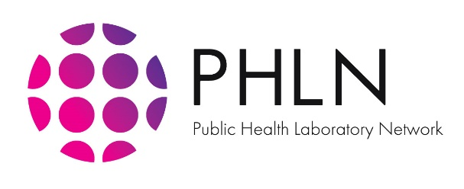

# 20 March 2020

# **Public Health Laboratory Network Statement on Point-of-Care Serology Testing for SARS-CoV-2 (the virus that causes COVID-19)**

In the early stage of the coronavirus 2019 (COVID-19) pandemic, Australia rapidly developed and implemented robust national testing capacity through the Public Health Laboratory Network (PHLN). Testing is now broadly available through a range of hospital and private pathology providers, providing additional valuable support to Australia’s response to this public health emergency.

To support the anticipated global increase in testing demand, a range of new tests for COVID-19 are being rapidly developed and marketed. However, the quality and clinical utility of these emerging tests, in the majority of cases, is uncertain.

*Utility of Point-of-Care Serology Tests*

There is widespread interest in the implementation of point-of-care serological (blood) tests to increase testing capacity in Australia, however there are significant limitations to this approach.

PHLN notes that the Therapeutic Goods Administration (TGA) has recently approved three point-of-care serological assays for COVID-19 subject to conditions. The conditions require that additional evidence to support the ongoing safety and performance of the devices be provided to the TGA within 12 months of approval. This rapid finger-prick test detects antibodies that develop as a result of COVID-19 infection. The antibodies will likely take 5 to 7 days to become detectable by these basic tests. Therefore, these tests are of limited use for the diagnosis of acute infection.

Antibody tests such as these are prone to ‘cross reactivity’ because of other antibodies circulating in the bloodstream which formed as a result of a previous coronavirus infection (for example, circulating seasonal coronaviruses which cause the common cold). This means these sorts of tests can be unreliable if not interpreted in the correct clinical context.

In the early phases of an outbreak, these tests may be useful in persons who present with symptoms which have been present for more than a week. A negative result may exclude COVID-19 (depending on the sensitivity of the test) and the person may be reassured. However, the person would remain susceptible to infection with SARS-CoV-2, the virus that causes COVID-19.

Later in the outbreak, understanding the immune status of the tested population may be important for clearance assessments, such as a rapid return-to-work screen. If a person thinks they had COVID-19, is not ill and tests positive, then this person is likely immune and it is safe for this person to return to work. PHLN recommends that mass surveys of immunity to retrospectively determine the true prevalence of infection should be done with enzyme immunoassays and not lateral flow devices.

Early in the epidemic, if the current testing method (which involves detection of the virus and not human antibodies) becomes limited due to competing global demand on pathology supplies, persons presenting to COVID-19 Clinics within seven days of symptom onset who obtain a positive result from a serological test, may be sufficient to inform the person to remain at home for home isolation, with no further testing being required.

*PHLN Position on Use of Point-of-Care Serology Tests*

* PHLN agrees that there is a need to explore new testing approaches to remain agile and at the forefront of emerging testing technology. However, there are concerns about the quality and clinical utility of rapidly developed tests.
* There are significant limitations to the use of point-of-care serology tests and they are not recommended as first line tests for the diagnosis of acute viral infection.
* If used properly by a trained medical professional, validated serological point of care tests have some utility in determining past infection for screening purposes e.g. return to work.
* PHLN strongly recommends that validation of emerging tests be undertaken by an Australian PHLN laboratory (or another government approved laboratory) before they are approved for use, or through post market assessment, whichever is applicable. A mechanism to urgently validate emerging tests is under consideration, however will require government support.
* PHLN urges that emerging testing technologies are rigorously evaluated prior to use, to safeguard Australia’s world-class testing capability for COVID-19 and ensure that the highest quality testing technology is available to support the Australian community.