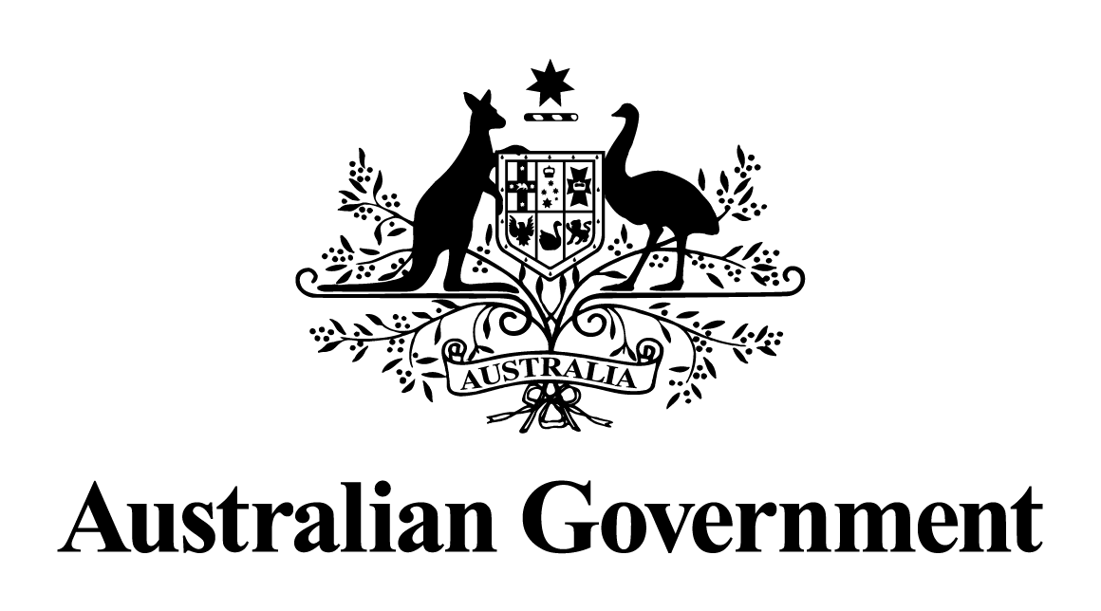

Australian Government response to the House of Representatives Standing Committee on Health, Aged Care and Sport report:

Inquiry into Biotoxin-related Illnesses in Australia

March 2020

**Introduction**

The Australian Government thanks the House of Representatives Standing Committee on Health, Aged Care and Sport (the Standing Committee) for their work in establishing and conducting the Inquiry into Biotoxin-related illnesses.

The Australian Government sympathises with, and is concerned for, those patients who are suffering debilitating symptoms they believe to be associated with exposure to mould and/or biotoxins. At this point in time, further research is required into the link between such symptoms and exposure to mould. The Australian Government acknowledges that there is a need to provide better multidisciplinary care to patients.

Furthermore, given that there are many similarities between such symptom complexes and others, such as symptom complexes attributed to ticks or chronic fatigue-like symptoms, there is an opportunity to take a broad multidisciplinary approach and work with patients, health groups and practitioners and investigate how to provide better care to all patients with complex symptom groups that are not yet medically explained.

The Australian Government further notes that the report’s recommendations include issues that fall primarily within the responsibility of state and territory governments. This response is directed specifically to issues that fall within Commonwealth’s areas of responsibility.

**Recommendations and Australian Government Response**

**Recommendation One**

The Committee recommends that the Department of Health produce and publish in the short term a fact sheet, and in the medium term undertake further research on:

* the potential health effects of exposure to damp and mould;
* the prevalence of dampness and mould in the built environment; and
* advice on the prevention and removal of mould.

The Australian Government accepts this recommendation. State and territory governments have already published several fact sheets on the health effects of mould and dampness. The Australian Government (through the Department of Health) will work with jurisdictions through the Environmental Health Standing Committee (enHealth) of the Australian Health Protection Principal Committee of AHMAC, to develop a new fact sheet that consolidates this advice.

**Recommendation Two**

The Committee recommends that the Australian Government work with the states and territories to conduct further research into, and develop standards and/or accreditation requirements for the mould testing and remediation industries, which should include consideration of:

* the most effective methods of testing and remediation of buildings affected by mould and/or moisture;
* appropriate accreditation requirements for professionals working in these fields; and
* options for greater regulatory oversight of these industries.

The Australian Government accepts this recommendation in relation to determining the most effective methods of testing and remediation of buildings affected by mould and/or moisture. The Minister for Health will refer this issue to the Minister for Industry, Science and Technology, the Hon Karen Andrews MP, as Chair of the Building Ministers’ Forum, for consideration by Building Ministers.

The Building Ministers’ Forum oversees policy and regulatory issues affecting Australia’s building and construction industries, and is comprised of the relevant Commonwealth and State and Territory Ministers, noting constitutional authority for building regulation sits with state and territory governments.

The Australian Government notes the work of the Standing Committee in reporting on concerns relating to standards and accreditation requirements for professionals in the mould testing and remediation industries, however the development of standards and/or accreditation requirements for mould testing and remediation industries is the responsibility of industry and/or relevant regulators. Indoor environmental professionals, certified occupational hygienists, mycologists and building biologists are largely trained through the higher education sector.

Professional cleaners are trained through the vocational education and training (VET) system. The Property Services Industry Reference Committee (IRC) of the Australian Industry and Skills Committee (AISC) is responsible for reviewing the relevant VET qualifications and ensuring they are responsive to current and emerging industry needs. The Property Services IRC is supported by Artibus Innovation[1].

The mould testing and remediation industries are encouraged to engage with the Property Services IRC, through Artibus Innovation, to ensure relevant qualifications address industry skills needs.

**Recommendation Three**

The Committee recommends that the Australian Government work with the states and territories to ensure that tenants in rental properties, aged care facilities, and community, social and public housing are provided with timely information about disclosure and rectification of any previous or existing mould and/or water damage issues in a property before entering into a residential leasing agreement.

The Australian Government will write to states and territories to notify them of this recommendation. While the Australian Government acknowledges the work of the Standing Committee in investigating issues relating to mould and/or water damage in housing, tenancy law and the day-to-day management of community and public housing are the responsibility of individual state and territory governments. This includes decisions about the maintenance of dwellings and determining associated health risks.

The Australian Government provides funding to the states and territories to improve housing outcomes across the spectrum. This includes $1.5 billion in funding each year under the National Housing and Homelessness Agreement. The Aged Care Quality and Safety Commission accredits aged care services subsidised by the Australian Government, and monitors compliance with the Aged Care Quality Standards. The accredited organisation’s service environment, and information provided to consumers, form part of these Quality Standards.

**Recommendation Four**

The Committee recommends that the Australian Government work with states and territories to conduct further research into the adequacy of current building codes and standards related to the prevention and remediation of dampness and mould in buildings.

The Australian Government accepts this recommendation.

The Minister for Health will refer this issue to the Minister for Industry, Science and Technology, the Hon Karen Andrews MP, as Chair of the Building Ministers’ Forum, for consideration by Building Ministers, noting constitutional authority for building regulation sits with state and territory governments.

The Australian Building Codes Board (ABCB) is established and funded by an Intergovernmental Agreement between the Australian Government and all state and territory governments.

The ABCB develops the National Construction Code (NCC) on behalf of the Commonwealth and all state and territory governments. Through the NCC, the ABCB’s objective is to develop and maintain nationally consistent, minimum necessary standards to efficiently achieve safety, health, amenity, accessibility, and sustainability in the design, construction, performance and liveability of building and construction. The NCC only applies to new buildings and new building work in existing buildings.

Avoiding mould arising from condensation in buildings is heavily reliant on occupant behaviour, such as ensuring room ventilation, and therefore regulation such as the NCC and standards relevant to building design have only limited effect on condensation. As discussed in relation to Recommendation One, the Australian Government will work with state and territory governments to issue a new fact sheet that consolidates advice on how to avoid development of mould.

The ABCB has issued guidelines on condensation management, the *Condensation in Buildings Handbook,* updated most recently in July 2019*.* This document assists architects, designers and builders in the assessment and the management of the risk of condensation and its consequences.

The ABCB has conducted research and implemented Stage One condensation mitigation provisions to partly address condensation concerns in NCC 2019 (in residential buildings). Stage Two condensation mitigation provisions are being developed in conjunction with a review of the residential energy efficiency measures and will be considered for inclusion in a subsequent version of the NCC.

It should be noted that the NCC and associated standards cannot influence circumstances where sources of moisture and mould occur as a result of non-compliance with the NCC.

**Recommendation Five**

The Committee recommends the Department of Health conduct a review into the treatment of patients presenting with complex illnesses that are difficult to diagnose such as those with CIRS-like symptoms.

This review should consider:

* methods to ensure patients with complex conditions, such as individuals reporting to have CIRS, are provided with effective and timely treatment and support (with the aim of reducing ‘doctor shopping’); and
* whether doctors require further support in order to: identify environmental impacts on health; manage complex conditions; and provide appropriate treatment.

The Australian Government accepts this recommendation, and appreciates that many patients experiencing debilitating symptom complexes have not been provided with ideal multi-disciplinary care and support, and that there is a need to offer more education to the medical profession in the form of clinical guidelines. The Australian Government notes that the Department of Health will work with practitioners, patient groups and health bodies to develop clinical guidelines (Recommendation Seven) for general practitioners, to assist with the diagnosis, treatment and management of such symptom complexes.

The Australian Government, through the Department of Health, will implement this recommendation through implementation of Recommendation Seven.

**Recommendation Six**

The Committee recommends that the Australian Government commission the National Health and Medical Research Council to conduct research into CIRS-like syndromes with a view to assisting in the diagnosis, treatment and management of patients. Research should also examine any links between mould and biotoxins and complex symptoms most commonly reported as typifying CIRS.

The Australian Government accepts the recommendation and recognises the need to develop a better understanding of how people with chronic symptom complexes, such as those associated with exposure to biotoxins, can be more effectively diagnosed, treated and managed in the health system.

The National Health and Medical Research Council (NHMRC) is the government’s lead agency for funding outstanding health and medical research that contributes to significant improvements in individual and population health. NHMRC awards research funding based on rigorous, competitive peer review that identifies the best science and most significant research.

One of NHMRC’s grant schemes, Targeted Calls for Research (TCR), has a small annual budget allocation to allow for a one-time solicitation of grant applications to address a specific or emerging health issue. The scope, objectives and selection criteria of a TCR are highly specified to ensure successful applications fulfil the desired outcomes of the call and address a specific research gap.

NHMRC will engage relevant experts and patient support groups to discuss the gaps identified by the Inquiry in defining the scope for a TCR that would open in late 2020.

**Recommendation Seven**

The Committee recommends that the Department of Health, in consultation with patient groups, medical practitioners, and health bodies, develop clinical guidelines for general practitioners for the diagnosis, treatment and management of CIRS-like conditions.

The Australian Government supports the development of general clinical guidelines for general practitioners to support the management of patient groups with multiple unexplained symptoms. Given the clear overlap between various syndromes of unexplained symptom complexes, the development of such guidelines outlining the clinical approach to manage patients with multiple unexplained symptom complexes should build on ongoing work to develop a diagnostic pathway for physicians of patients suffering debilitating symptoms attributed to ticks.

These guidelines should emphasise the need for multidisciplinary approach to patient care, involving general practitioners and allied health professionals as well as specialists such as general physicians, infectious diseases physicians, clinical allergists, clinical immunologists and psychiatrists.

1. Artibus Innovation has been commissioned by the Australian Government to support the Industry Reference Committees for Construction, Plumbing and Services and Property Services in their work reviewing, renewing and developing vocational education and training within their sectors