Appendix 4: Example Zika virus infection case investigation form
(This page contains form/s that are intended to be paper based that you can download and complete. If you are using any assistive technology and are unable to use the form please contact us using the Online form and feedback)

Example Zika virus infection case form |  |  |  |  |  |  |  |  |  |  | 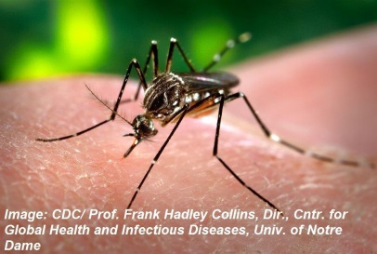
Form date |  |  | Case notification ID |  |  |  |  |  |  | Case status  - Probable  - Confirmed
Case status
- Non-Congenital
- Congenital

Symptoms
- Fever Arthralgia
- Myalgia
- Headache
- Retro-orbital pain
- Non-purulent conjunctivitis/conjunctival hyperaemia
- Maculopapular rash
- Oedema in the lower limbs
- No symptoms
- Other

Sequelae
- Microcephaly (congenital cases only)
- Ventriculomegaly (congenital cases only)
- Calcifications (congenital cases only)
- Abnormal sulcation and gyration (congenital cases only)
- Brain atrophy
- Callosal dygenesis (congenital cases only)
- Microopthalmia (congenital cases only)
- Eye calcifications (congenital cases only)
- Guillain Barré Syndrome (within 2 months of onset only)
- Fetal loss
- No sequelae
- Other
Date sequelae recorded
Date of hospital admission
Number of days hospitalised
Risk factors for infection
- Overseas travel in a Zika-receptive area
- Overseas travel in a Zika-affected area
- Travel in north Queensland
- Sexual activity with person with confirmed/probable/suspected Zika
- Sexual activity with person with travel to a Zika-receptive area
- Mother suspected/probable/confirmed case (Congenital/perinatal cases only)
- No risk factors for infection identified

Transiting through an international airport (<24 hours stay, remaining within the airport) in a Zika-affected or Zika- receptive country is not considered to be a risk factor for infection.
Epidemiological links |  |  |  |  |  | Epi-linked notifications IDs
- Mother (Congenital only)
- Sexual partner
- Travelling companion
Overseas travel dates and destinations
Potential for local vectorborne transmission in Australia
Did the case spend any time in parts of Australia where vectorborne transmission could occur?

Were they a:
- Resident
- Long-term visitor (>2 weeks)
- Short-term visitor (<2 weeks)
- None
Date of arrival in Zika receptive area of Australia |  |  |  |  |  |  | Postcode(s) of residence/visit
Further details if required

