Trachoma - National Guidelines for Public Health Units

CDNA National Guidelines for Public Health Units

The Series of National Guidelines (‘the Guidelines’) have been developed by the Communicable Disease Network Australia and noted by the Australian Health Protection Principal Committee. Their purpose is to provide nationally consistent guidance to public health units (PHUs) in responding to a notifiable or significant disease event.

These guidelines capture the knowledge of experienced professionals, and provide guidance on best practice based upon the best available evidence at the time of completion.

Readers should not rely solely on the information contained within these guidelines. Guideline information is not intended to be a substitute for advice from other relevant sources including, but not limited to, the advice from a health professional. Clinical judgment and discretion may be required in the interpretation and application of these guidelines. Wherever possible, local knowledge and community priorities should always be considered when implementing these guidelines.

The membership of the CDNA and the AHPPC, and the Australian Government as represented by the Department of Health do not warrant or represent that the information contained in the Guidelines is accurate, current or complete. The CDNA, the AHPPC and the Australian Government do not accept any legal liability or responsibility for any loss, damages, costs or expenses incurred by the use of, or reliance on, or interpretation of, the information contained in the guidelines.

Endorsed by CDNA: 11 September 2013  
Endorsed by AHPPC: 28 November 2013  
Released by Health: 31 January 2014

## **Glossary**

Active trachoma

Chronic inflammation of the conjunctiva caused by infection with Chlamydia trachomatis. The World Health Organization (WHO) simplified trachoma grading scheme defines active trachoma as TF and/or TI, where TF (trachomatous inflammation follicular) is the presence of 5 or more follicles in the central part of the upper tarsal conjunctiva, each at least 0.5mm in diameter, and TI (trachomatous inflammation intense) is pronounced inflammatory thickening of the upper tarsal conjunctiva that obscures more than half of the normal deep vessels.[1](https://www1.health.gov.au/internet/main/publishing.nsf/Content/cdna-song-trachoma.htm#1)

At-risk communities

Remote and rural communities are classified as being at risk of trachoma based on 1) no recent data, but historical evidence of endemicity; 2) Data of active trachoma prevalence ≥ 5% in Aboriginal and Torres Strait Islander children aged 5-9 years in the last five years; or 3) Data < 5% active trachoma prevalence but with a recorded prevalence of active trachoma ≥ 5% in the past 5 years.

Blinding trachoma

The indicators for blinding trachoma being eliminated as a public health problem are when TF is sustained at < 5% in children aged 1-9 years and the prevalence of trichiasis is < 0.1% in a community where management for trichiasis is in place.[2](https://www1.health.gov.au/internet/main/publishing.nsf/Content/cdna-song-trachoma.htm#2)

Community

For the purpose of this National Guideline, a "community" is defined as a specific location where people reside and where there is at least one school.

Community-wide

Antibiotic administration to all Aboriginal and Torres Strait Islander people in the treatment community who weigh >3kg and who live in houses with children < 15 years.

Endemic trachoma

Prevalence of active trachoma of ≥5% in Aboriginal and Torres Strait Islander children aged 5-9 years or a prevalence of trichiasis of ≥ 0.1% in the Aboriginal and Torres Strait Islander adult population.

Facial cleanliness

Absence of nasal and ocular discharge on the face.

Hyperendemic trachoma

Prevalence of active trachoma of ≥ 20% in Aboriginal and Torres Strait Islander children aged 5-9 years.

Contact

Anyone who is living and/or sleeping in the same house as a person with trachoma. If the active case lives or sleeps in multiple households, then all members of each household are regarded as contacts.

SAFE strategy

Surgery, Antibiotics, Facial cleanliness, Environmental health

Screening coverage

Defined as the proportion of 5-9 year old Aboriginal and Torres Strait Islander children in a community who were screened for trachoma at the time of community screening. The denominator used to calculate screening coverage is based on the best information available from school enrolments, community health service databases, or other sources. Children who reside in places that do not have a school should be included in the screening coverage calculation for the community of the school which they attend.

Treatment Coverage

Defined as the proportion of Aboriginal and Torres Strait Islander people in a community who weigh >3kg and live in a house with 1 or more children aged <15 years and who were treated for trachoma during each episode of community-wide treatment. The denominator used to calculate treatment coverage should be based on the number of Aboriginal and Torres Strait Islander people in such houses in the community at the time that treatment is being administered. For most communities this will include people in the community over the several days it takes to complete the distribution of treatment; in the case of large communities treatment may take longer. People who reside in places that do not have a school should be included in the treatment coverage calculation for the community of the school their children attend.

## **Abbreviations**

AHPPC - Australian Health Protection Principal Committee

CDNA - Communicable Disease Network Australia

CO - Corneal opacity

GET 2020 - Global Elimination of Trachoma by 2020

NAAT - Nucleic acid amplification test

SAFE - Surgery, Antibiotics, Facial Cleanliness, Environment

SoNG - Series of national guidelines

TF - Trachomatous inflammation - Follicular

TI - Trachomatous inflammation - Intense

TS - Trachomatous conjunctival - Scarring

TT - Trachomatous Trichiasis

WHO - World Health Organization

## **1. Summary**

The National Guidelines for the Public Health Management of Trachoma provide the evidence base and policy framework for coordinated, community-based activities towards eliminating blinding trachoma from within Aboriginal and Torres Strait Islander communities by 2020 in line with Australia’s commitment to the World Health Organization (WHO) GET2020 initiative. The Guidelines adapt the WHO SAFE strategy for trachoma elimination to the Australian context.

The Guidelines focus on the community wide programs required to control and eliminate blinding trachoma in Australia by 2020. Specific objectives of trachoma prevention and control activities in Australia are to:

* Eliminate blinding trachoma in known endemic areas by 2020 through the implementation of the SAFE strategy - surgery for trichiasis, antibiotic administration, promotion of facial cleanliness and environmental improvements to address barriers to facial cleanliness.
* Assess and manage the risk of blinding trachoma in remote and very remote communities in other areas.
* Ensure access to high quality data to monitor and evaluate progress towards trachoma elimination by improving the coverage, completeness and timeliness of surveillance data in accordance with the minimum national trachoma dataset.
* Ensure engagement with the local community when planning, implementing and evaluating trachoma programs.
* Ensure collaboration between public health units, primary health care (including Aboriginal Community Controlled Health Organisations) and other services (including environmental health and education units) working towards trachoma elimination.

The most important priorities for trachoma control are:

* Regular screening of at risk communities for active trachoma;
* Appropriate treatment of individuals and community members;
* Promotion of facial hygiene;
* Improvement of environmental conditions; and
* Detection, referral and surgical intervention for people with trichiasis.

### **Public health priority**

Australia is the only developed country in which trachoma is endemic. Australia is a signatory to the WHO agreement to eliminate blinding trachoma by 2020.

### **Case management**

* Cases of active trachoma identified through screening:

Active trachoma cases are identified through screening at risk populations, and treated together with contacts and the community, according to the prevalence of active trachoma in 5-9 year old Aboriginal and Torres Strait Islander children.

* Cases of active trachoma identified outside of screening programs:

Individual cases of active trachoma diagnosed via spontaneous presentation with signs or symptoms require treatment together with their household contacts.

Cases of active trachoma and their contacts should be treated with single-dose azithromycin.

Cases of trichiasis should be referred for ophthalmological assessment and surgery.

### **Contact management**

a. Contacts of cases identified through community screening:

Active trachoma community prevalence in 5-9 year old Aboriginal and Torres Strait Islander children:  
i. ≥20%: Treat all people >3kg living in households with children <15 years of age.  
ii. ≥5 to < 20% and there is no obvious clustering of cases: Treat all people >3kg living in households with children <15 years of age.  
iii. ≥5 to < 20% and cases are obviously clustered within several households and health staff can easily identify all household contacts of cases: Single-dose azithromycin to all people >3kg living in households with an active trachoma case.  
iv. <5%: Treat all people >3kg living in households with an active trachoma case.

b. Contacts of cases identified outside of screening programs  
Treat people >3kg who living in the same household (s) as the case.

### **Personal and environmental hygiene**

Promote facial and hand hygiene and improvements in environmental conditions.

## **2. The disease**

### **Infectious agents**

Trachoma is a contagious infection of the eye by specific strains of the bacteria Chlamydia trachomatis. The strains of Chlamydia that cause trachoma differ from the genital strains. The C. trachomatisserotypes usually responsible for trachoma are A, B, Ba and C.

### **Reservoir**

C. trachomatis only infects humans and children are the main reservoir, especially pre-school aged children.

### **Mode of transmission**

C. trachomatis is predominantly spread by infected ocular and nasal secretions passed between young children.

* The bacteria are transmitted through the following routes:
  + Direct eye-to-eye spread (e.g. while playing or sharing a bed)
  + Conveyance on fingers
  + Indirect spread via fomites (e.g. shared towels, pillow cases, face cloths)
  + Coughing/sneezing
  + Eye-seeking flies

Trachoma prevalence varies between and within communities. Within communities trachoma is strongly clustered by household. Within households, trachoma is clustered by sleeping room. [3](https://www1.health.gov.au/internet/main/publishing.nsf/Content/cdna-song-trachoma.htm#3)

Trachoma occurs where personal and community hygiene is poor, and is associated with overcrowding, reduced access to or use of water (particularly for face washing), inadequate waste disposal and high numbers of flies.

### **Incubation period**

The incubation period of C. trachomatis is 5 to 10 days.[4](https://www1.health.gov.au/internet/main/publishing.nsf/Content/cdna-song-trachoma.htm#4) However most episodes of infection are reinfections and usually occur in children with already established clinical disease.

### **Infectious period**

The infectious period is 2 to 3 months. It may be shorter with repeated infections and decrease with age.

### **Clinical presentation and outcome**

Cases of active trachoma are often asymptomatic or may present with discharging or red eyes.

Repeated infections lead to long-term inflammation, scarring of the tarsal conjunctivae and distortion of the upper eyelid with inturning of eyelashes (trichiasis) that abrade the cornea. This constant abrasion, in turn, can cause irreversible corneal opacity and blindness. This can be further complicated by secondary bacterial or rarely fungal infection.

### **Persons at increased risk of disease**

In Australia today, trachoma is only found in rural and remote Aboriginal and Torres Strait Islander populations and is endemic in some parts of the NT, SA and WA.

Active trachoma is usually seen in young children and adolescents. The highest ocular chlamydial loads are found in children younger than 5 years, with the greatest risk of infection in younger children. In contrast, trachomatous trichiasis most commonly presents in older adults, usually over the age of 40 years.

Unlike developing countries where active trachoma lasts longer in girls than in boys and where trichiasis is more common among adult women than men, Australian surveys have not identified any sex differences in active trachoma or trichiasis prevalence.[5](https://www1.health.gov.au/internet/main/publishing.nsf/Content/cdna-song-trachoma.htm#5)

### **Disease occurrence and public health significance**

Trachoma is the leading cause of preventable infectious blindness in the world. Endemic in 53 countries, trachoma is responsible for visual impairment in about 2.2 million people worldwide, of whom 1.2 million people are irreversibly blind.[6](https://www1.health.gov.au/internet/main/publishing.nsf/Content/cdna-song-trachoma.htm#6) The prevalence of blindness in Aboriginal and Torres Strait Islander people is 6 times higher than non-Aboriginal people, and trachoma accounts for 9% of this blindness.[6](https://www1.health.gov.au/internet/main/publishing.nsf/Content/cdna-song-trachoma.htm#6)

Australia is the only developed nation in the world to still have endemic trachoma. Although trachoma was eliminated from most parts of Australia by the 1930s, it continues to be a significant public health problem in Aboriginal and Torres Strait Islander communities in many rural and remote areas of the NT, SA and WA. The National Indigenous Eye Health Survey[8](https://www1.health.gov.au/internet/main/publishing.nsf/Content/cdna-song-trachoma.htm#8) in 2008 detected cases in other jurisdictions and mapping is ongoing. In Australia, the prevalence of trichiasis is approximately 1.4% in Aboriginal and Torres Strait Islanders.[5](https://www1.health.gov.au/internet/main/publishing.nsf/Content/cdna-song-trachoma.htm#5)

In line with its Vision 2020 initiative, the World Health Organization (WHO) has adopted a resolution to eliminate blinding trachoma by 2020. Australia is a signatory to this resolution, the Global Elimination of Trachoma (GET 2020).

**Figure 1. Trachoma prevalence in 5-9 year old Aboriginal and Torres Strait Islander children**[**9**](https://www1.health.gov.au/internet/main/publishing.nsf/Content/cdna-song-trachoma.htm#9)**, 2011**

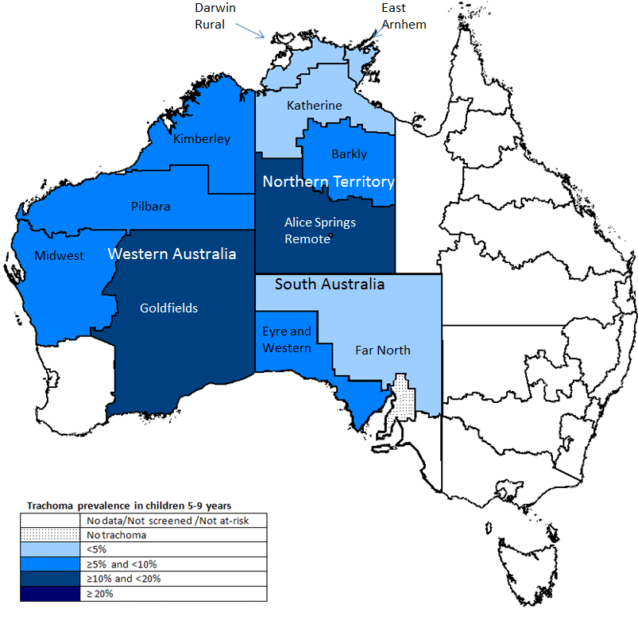

## **3. Routine prevention activities**

The WHO GET 2020 initiative is built on the implementation of the SAFE strategy for the effective prevention and control of trachoma.

* S – Surgery for trichiasis: Surgical procedures to reduce impact of trichiasis
* A – Antibiotics: Antibiotic (azithromycin) treatment of individual active trachoma cases and to reduce the community reservoir of infection
* F – Facial cleanliness: Promote clean faces to reduce spread of infection
* E – Environmental health – improve water access, good sanitation, waste and fly control, and reduce overcrowding

The acronym SAFE covers four public health components, and in order of public health priority are:

**The ‘E’ component** ‘environmental health’ covers a very broad category of potential activities.

Safe access to clean and functioning water supplies, adequate sanitation including clean linen and aired mattresses, improved housing, reducing overcrowding and attempts to minimise fly density are all potentially important factors for trachoma control.

Environmental improvements should focus on reducing the barriers to children washing their hands and faces and achieving facial cleanliness. Time and effort should be spent on checking household and community washing facilities to ensure they are functional and safe for children. Leaky or broken plumbing should be repaired, with bathrooms and laundries properly maintained. Installation of mirrors (so children can actually see whether their faces are clean or dirty) is another way to help reinforce the message and promote clean faces.

**The “F” component** ‘facial cleanliness’ is seen as the key preventive measure that can be taken to prevent infection. Facial cleanliness is the absence of nasal and ocular discharge.[10](https://www1.health.gov.au/internet/main/publishing.nsf/Content/cdna-song-trachoma.htm#10) It requires the proper maintenance of housing, especially washing facilities and bathrooms, and the development of household and personal hygiene skills and behaviours. Facial cleanliness in children should be promoted by including regular face-washing as part of a holistic personal hygiene program, which may also include tooth-brushing, hand washing and general hygiene. Clean faces in children should be promoted as the norm and children, families and communities should be empowered to make the physical and behavioural changes required to achieve this. The program aims for facial cleanliness for all children at all times with the target for at least 85% of children in a community at any one time to have a clean face.

The significance of improved hygiene and environmental improvements should not be diminished by the difficulties in achieving them, as the benefits also include reduced morbidity from other diseases, such as scabies, otitis media, rheumatic fever and gastrointestinal infections, which share similar risk factors.

**The “A” component** ‘antibiotic distribution’ of the strategy has an important role in prevention by reducing the duration of infection (both symptomatic and asymptomatic), thereby reducing disease transmission (see section 9).

**The “S” component** ‘surgery’ of the strategy involves the detection, referral and surgical management of entropion (in-turned eye lid margin) and trichiasis (in-turned eye lashes) to prevent further corneal abrasion and the development of corneal scarring and blindness.

## **4. Surveillance**

### **Objectives**

* To detect and treat cases of active trachoma and their contacts
* To estimate the prevalence of disease and monitor over time
* To determine the need for, frequency and duration of community treatment
* To monitor screening and treatment coverage rates
* To detect cases of trichiasis and refer them for surgery
* To confirm the elimination of blinding trachoma.

Ongoing organized monitoring should also be undertaken to assess facial cleanliness and environmental health.

### **Methods**

An organised surveillance program is an integral part of trachoma control activities, and should be coordinated at all levels of health service delivery; that is at the local, regional and state levels.

Prevalence of trachoma in a community is determined by screening at least 85% of 5-9 year old Aboriginal and Torres Strait Islander children for active trachoma. The denominator used to calculate screening coverage is based on the best information available - from school enrolments, community health service databases, or other sources. Children from places that do not have a school should be included in the screening coverage calculation of the community of the school they attend.

If active trachoma is found during screening, appropriate control measures should be implemented (see Sections 9 & 11).

If primary health care services have their own trachoma control programs, these programs and the data they generate need to contribute towards their jurisdiction’s co-ordinated trachoma control program.

## **5. Data management**

Trachoma is not a notifiable disease, however, all de-identified data regarding trachoma and trichiasis screening and treatment should be collected using the nationally agreed procedures and the data forwarded to the National Trachoma Surveillance and Reporting Unit.[11](https://www1.health.gov.au/internet/main/publishing.nsf/Content/cdna-song-trachoma.htm#11)

De-identified data from endemic jurisdictions regarding trachoma prevalence, rates and coverage of screening and treatment should be reported nationally on an annual basis. The National Trachoma Surveillance and Reporting Unit will monitor the prevalence of trachoma and the effect of trachoma control programs. Data on trachoma in Australia are reported by the Department of Health to WHO annually.

See Appendix 1 for Surveillance Summary Forms.

## **6. Communications**

The detection, treatment, control and ultimate elimination of trachoma require good communication between communities, service providers, various jurisdictions and stakeholders.

Communities need to be engaged in planning, implementation and evaluation of prevention and control programs including screening and treatment. Informed consent for screening and treatment should be obtained from individuals (or their carers) and the community concerned. Feedback to communities is essential after any intervention.

Service providers including health, education and environmental health should be informed about disease prevalence in communities and encouraged to undertake activities that will reduce it.

All primary care providers should report their screening and treatment activities to the surveillance unit in their jurisdiction.

Cases of trichiasis require assessment and timely referral to an ophthalmologist.

Good communication within and between jurisdictions will enable a coordinated and consistent approach to be taken to the reduction and eventual elimination of trachoma.

## **7. Case definition**

### **Active trachoma**

* Defined as Trachomatous inflammation - Follicular (TF) or Trachomatous inflammation - Intense (TI) according to the WHO Guidelines (see section 8 below).

### **Chronic sequelae of trachoma**

* Defined as Trachomatous conjunctival Scarring (TS), Trachomatous Trichiasis (TT) or Corneal Opacity (CO) according to the WHO Guidelines (See Section 8 below).
* For surveillance and certification purposes the definition of trichiasis is "operable trichiasis" which is cases of trichiasis, or evidence of epilation, in people who have not had previous trichiasis surgery or documented refusal of surgery. In some countries, signed evidence of refusal witnessed by a family member and obtained on three separate occasions is taken as documented refusal.

## **8. Clinical diagnosis and laboratory testing**

### **Active Trachoma**

The diagnosis of active trachoma is a clinical diagnosis based on the WHO simplified grading system as outlined below (Table 1). Trachomatous inflammation - Follicular (TF) and Trachomatous inflammation Intense (TI) are indications of active trachoma and are usually found in children and teenagers, but may occasionally occur in older persons. Each sign is individually graded as being absent or present. One or more signs can, and often do, occur together (see Appendix 2).

### **Chronic sequelae of trachoma**

Trachomatous conjunctival Scarring (TS) is sequelae of trachoma and a sign of severe damage which signals the risk of developing trichiasis. Trachomatous Trichiasis (TT) is a result of severe distortion and scarring in the upper eyelid and the rubbing lashes lead to corneal scarring and corneal opacity (CO) which represents late stages; both are usually found in older adults see Table 1).

**Table 1 WHO simplified grading system for trachoma**

|  |  |  |  |
| --- | --- | --- | --- |
| **https://www1.health.gov.au/icons/ecblank.gif** | **Grade** | | **Signs** |
| **Infectious** | TF | Trachomatous inflammation- Follicular | Presence of 5 or more follicles of >0.5mm in diameter on the upper tarsal conjunctiva |
| https://www1.health.gov.au/icons/ecblank.gif | TI | Trachomatous inflammation - Intense | Presence of pronounced inflammatory thickening of the upper tarsal conjunctiva obscuring more than half of the normal deep tarsal vessels |
| **Non-infectious** | TS | Trachomatous conjunctival Scarring | Presence of easily visible scars on the upper tarsal conjunctiva |
| https://www1.health.gov.au/icons/ecblank.gif | TT | Trachomatous Trichiasis | Presence of at least one in-grown eyelash touching the eyeball, or evidence of recent removal of in-turned lashes |
| https://www1.health.gov.au/icons/ecblank.gif | CO | Corneal Opacity | Presence of corneal opacity blurring part of the pupil margin |

See the ‘WHO simplified grading card’ (Appendix 2) and [the on-line training package for clinicians](http://www.iehu1.unimelb.edu.au/trachoma/) at (http://www.iehu1.unimelb.edu.au/trachoma/)

For a list of resources required and directions on how to screen for trachoma see Appendix 3.

**Laboratory tests** including nucleic acid amplification tests (e.g. polymerase chain reaction or PCR) are available but the results do not correlate well with clinical signs and are not recommended for routine use.

### **Trichiasis screening**

* Aboriginal and Torres Strait Islander adults over 40 years of age years and who resided in a remote community during childhood should be screened annually for trichiasis by primary health care providers either opportunistically or as part of an adult health check (a required procedure in the Medicare Benefits Schedule for Aboriginal and Torres Strait Islander Adult Health Checks). It is important to continue to screen adults regularly as trichiasis is an indolent, slowly progressing condition.
* Staff in aged care services, hostels and nursing homes should be educated so that they are aware of trichiasis and encouraged to refer patients with irritated or watery eyes to primary health care services for confirmation and further referral for eyelid surgery if required.
* Trichiasis screening should be included in optometrist consultations.
* Whereas screening for active trachoma should be conducted on a community-wide basis in a short time-frame (to interrupt transmission), this is not necessary for trichiasis screening. Unlike screening for active trachoma, screening for trichiasis should be conducted on an individual rather than a community level and incorporated into the ongoing activities of the community primary health care team.
* Data should be forwarded to the primary health care clinic for the patient's individual health record and for referral (patient identified data), and also to jurisdictional and national databases (patient de-identified data).

For a list of resources required and directions on how to screen for trichiasis see Appendix 3.

## **9. Case Management**

This addresses the antibiotic (A) and surgery (S) elements of the WHO strategy.

### **Active trachoma**

Trachoma control programs should be conducted on a regional or state level. Screening and treatment at a population level is the best method to decrease the prevalence of trachoma. Treatment at a population level reduces the pool of infection circulating in the community. Health services should not conduct opportunistic trachoma screening indiscriminately but should work with the identified at risk communities. However, on the occasion that an individual presents to a clinic with symptoms indicating trachoma, the individual should be examined, and if trachoma is diagnosed, the case and their contacts should be treated at the same time.

### **Response times**

Cases of active trachoma and their contacts should be treated at the same time, regardless of whether the case was found on screening or presented with symptoms (See Contact Management – Section 11). All members of the relevant household/s should be treated within one week of commencement of treatment.

Where community-wide treatment is being undertaken (see Section 11), contacts, including children >3kg, should be treated together at one time and all treatment in the community should be completed within a two week period. As the population in remote communities is highly mobile, completing treatment within this timeframe will minimise the likelihood of re-infection and achieve higher population coverage.

### **Response procedure**

#### **Case investigation**

The diagnosis of active trachoma is based on clinical examination. Contacts of case need to be identified.

#### **Case treatment**

If a diagnosis of trachoma is made clinically the case and all contacts should be treated.

The target is for 100% of active cases to receive treatment, and for 85% of contacts to receive treatment.

It is important to remember that treatment of cases of active trachoma found during screening programs should not be managed separately from the treatment of households and communities. Reducing the prevalence of trachoma in a community is dependent on completing all treatment in as short a timeframe as possible (See Section 11. Contact Management for details).

* Azithromycin in a single dose is recommended for the treatment of both cases and their contacts >3kg.
* The recommended dose is Azithromycin 20mg/kg (maximum dose of 1000mg) orally as a single dose. Dosing guidelines for trachoma management can be found in **Appendix 5**
* Single dose azithromycin is contraindicated only in the case of a known allergy[i](https://www1.health.gov.au/internet/main/publishing.nsf/Content/cdna-song-trachoma.htm#i), and weight less than 3 kg. There are no other contraindications for administration of single dose azithromycin.[12](https://www1.health.gov.au/internet/main/publishing.nsf/Content/cdna-song-trachoma.htm#12)

(See also Section 11. Contact Management and Appendix 5)

#### **Education**

Education should be provided to children, carers, community members, and clinic and school staff about the disease and its transmission. The importance of maintaining good personal hygiene, especially of the face and hands, should be emphasised.

#### **Isolation and restriction**

Not applicable

### **Trichiasis**

### **Response procedure**

#### **Case investigation**

Trichiasis found on screening may need to be confirmed by an experienced practitioner.

#### **Case treatment**

All cases of trichiasis need to be referred to an ophthalmologist. This referral should be at the earliest opportunity in order to preserve the person’s sight.

The aim of surgery is to correct the in-turning of the lashes. However surgery does not provide a definitive cure. The natural progression of the disease may lead to recurrence as early as one year after a procedure, so ongoing annual examination post-surgery is required. This may be undertaken by local primary health care staff, and should be documented in the case management plan.

Removal of 1 or more eye-lashes (epilation) must only be used as a temporary measure to prevent progression whilst the patient is waiting for surgery. It carries the risk of corneal damage due to broken or regrowing lashes. It may be used as a last resort if the patient refuses referral or surgery, in which case more frequent monitoring will be required.

A person with trichiasis who has not had previous surgery for trichiasis should be given at least three opportunities to have surgery. Refusal of surgery should be documented, ideally in the presence of a family member.

#### **Education**

Patients should be informed of the importance of attending appointments in order to save their sight.

Community members, staff in aged care facilities and others who interact with older Aboriginal and Torres Strait Islander people should be informed about the nature of trichiasis, including the early signs, and where to seek help promptly.

Community education should make explicit the link between the trachoma control programs and prevention of trichiasis and blindness in later life.

#### **Isolation and restriction**

Not applicable

## **10. Environmental evaluation**

Environmental evaluation is concerned with assessing the effectiveness of the F & E components as outlined in Section 3.

### **F - Facial cleanliness**

At the time of screening, children should be assessed for facial cleanliness. The aim is for all children to have clean faces and the target is for at least 85% of children in a community at any one time to have a clean face. This can only be achieved by washing faces as often as is necessary to maintain cleanliness.

### **E - Environmental health**

Communities in which trachoma is prevalent should have an environmental assessment with particular attention being paid to whether the infrastructure is required to enable facial and hand hygiene is present in homes, schools and recreational areas. Broader assessment of housing, sanitation, waste disposal and dust control should also be undertaken. This can be used to monitor progress, highlight achievements and provide stakeholders with information about issues that need to be resolved.

## **11. Contact and community management**

### **Screening for active trachoma**

* The target group for screening to determine active trachoma prevalence is Aboriginal and Torres Strait Islander children aged 5-9 years who are in at-risk communities at the time of screening. The denominator for screening coverage calculations should be based on the best information available - from school enrolments, community health service databases, or other sources. Children from places without a school should be included in the screening coverage calculation of the community of the school they attend.
* Screening coverage of the target group should be at least 85%.

The prevalence of active trachoma in Aboriginal and Torres Strait Islander children aged 5-9 years in a community will determine the need for ongoing screening and treatment.

### **Identification of contacts**

### **Contact definitions**

a. Individual contacts

A contact is anyone who is living and/or sleeping in the same household  as a person with trachoma. If the active case lives or sleeps in multiple households, then members of all households in which the active case stays are considered contacts.

b. Community contacts

In communities in which trachoma is endemic, contact management refers to the treatment of household and other community members, depending on the prevalence of active trachoma among the target group, 5 – 9 year old Aboriginal and Torres Strait Islander children,(see Table 2) as determined through a screening program.

### **Treatment Schedules**

Historically, mass drug administration (MDA) for trachoma has been conducted on an annual basis and this has been associated with local elimination in some, but not all, settings.[13](https://www1.health.gov.au/internet/main/publishing.nsf/Content/cdna-song-trachoma.htm#13) [14](https://www1.health.gov.au/internet/main/publishing.nsf/Content/cdna-song-trachoma.htm#14) Modelling studies suggested that more frequent drug administration may be required to achieve elimination in hyperendemic settings, especially where treatment coverage was low.[12](https://www1.health.gov.au/internet/main/publishing.nsf/Content/cdna-song-trachoma.htm#12) In a cluster randomised study of highly endemic communities in Ethiopia, those receiving 6 monthly MDA of azithromycin for 2 years were significantly more likely to achieve local elimination than those receiving annual MDA.[13](https://www1.health.gov.au/internet/main/publishing.nsf/Content/cdna-song-trachoma.htm#13)

Following a community screening program where 85% of target group is screened# antibiotic administration is recommended as shown in Table 2.

Regardless of prevalence in the community, people >3kg living in households with an active trachoma case should be treated with single-dose azithromycin at the same time as the case(s) according to the schedule in Appendix 4. Treatment of the all household members including cases and their contacts should be completed within 1 week of commencement of treatment. Treatment coverage of contacts should be at least 85%.

Treatment coverage of a community is defined as the proportion of Aboriginal and Torres Strait Islander people who weigh >3kg and live in a house with 1 or more children aged <15 years old, who were treated for trachoma at the time of community wide treatment. The denominator used to calculate treatment coverage should be based on the number of Aboriginal and Torres Strait Islander people in such households in the community at the time that treatment is being administered. For most communities this will be people in the community over the several days it takes to complete the distribution of treatment; in the case of large communities treatment may take longer. People from places that do not have a school should be included in the treatment coverage calculation of the community of the school that their children attend.

Consent for each occasion of treatment must be obtained, and both the consent and administration of treatment must be appropriately documented in accordance with the medical records policy of the health service administering the treatment.

Screening and treatment activities within the region, and ideally the, state or territory, should be completed in as short a timeframe as possible to achieve high population coverage and minimise the likelihood of reinfection.

**Table 2. Screening# and treatment schedule of contacts according to prevalence*.**

|  |  |  |  |
| --- | --- | --- | --- |
| **Trachoma prevalence in screened children aged 5-9 years** | **Treatment** | **Treatment frequency** | **Screening frequency** |
| ≥20% | Single-dose azithromycin to people >3kg living in houses with children <15 years of age | 0, 6, 12, 18 & 24 months | Screen at 36 months after the initial screen (12 months after the 5th treatment)* |
| ≥5 to < 20% and there is no obvious clustering of cases | Single-dose azithromycin to people >3kg living in houses with children <15 years of age | 0, 12 & 24 months | Screen at 36 months after the initial screen (12 months after the 3rd treatment)* |
| ≥5 to < 20% and cases are obviously clustered within several households and health staff can easily identify all household contacts of cases | Single-dose azithromycin to people >3kg living in houses with an active trachoma case | Once at 0 months. Further treatment determined by prevalence at next screen | Screen at 1 year to determine prevalence |
| <5% | Single-dose azithromycin to people >3kg living in houses with an active trachoma case | Once at 0 months and retreat if trachoma is found on further screening | Screen at 1, 3 and 5 years, then cease if prevalence <5% at each screen. |

#Community treatment decisions are based on screening at least 85% of the target population. Every effort should be made to reach this coverage level. If 85% coverage is not achieved the public health practitioner will need to make a judgement whether a sufficiently high and representative proportion of the target population has been screened to provide a basis for a valid estimate of prevalence on which decisions regarding treatment can be based.  
* Jurisdictions where treatment coverage of at least 85% is clearly being achieved and with sufficient resources to undertake annual screening should consider doing so. Treatment frequency should be based on prevalence from the most recent screen.

Note: The target is for 100% of active cases to receive treatment, and for 85% of contacts to receive treatment.

See**Appendix 6**for guide to ordering correct amounts of azithromycin for community-wide treatment.

### **Prophylaxis**

As per contact management (above).

### **Education**

Education should be provided to household and community members about the disease and its transmission. The importance of keeping the faces of all children clean and of maintaining good personal hygiene should be emphasised.

### **Isolation and restriction**

N/A

### **Antimicrobial resistance**

Expert opinion is that concern regarding macrolide resistance in Indigenous communities should not discourage use of programmatic azithromycin MDA for the elimination of trachoma. Resistance to macrolide antibiotics occurs very rarely among Chlamydiae and cases of resistance have not been found in the context of MDA.[16](https://www1.health.gov.au/internet/main/publishing.nsf/Content/cdna-song-trachoma.htm#16) The background prevalence of macrolide resistance among pneumococci is much more common, and the proportion of colonising pneumococci which are macrolide resistant increases shortly after MDA due to suppression of macrolide susceptible strains; studies from Australia and elsewhere are inconclusive regarding the duration of this phenomenon.[17](https://www1.health.gov.au/internet/main/publishing.nsf/Content/cdna-song-trachoma.htm#17) This is of minor clinical importance because macrolides have little role in the treatment of pneumococcal infections. No evidence has been presented that MDA promotes erythromycin resistance among Staphylococcus aureus strains. Macrolide resistance among methicillin-resistant Staphylococcus aureus isolates from the Kimberley, Pilbara and Goldfields regions of WA has been falling in recent years (from 62% to 29% between 2004 and 2012; Dr Geoffrey Coombs, PathWest, personal communication). Further, azithromycin use for MDA represents only a fraction of total macrolide use in remote communities, and that alternative antibiotics exist for treating both pneumococcus and MRSA resistance.

## **12. Special situations**

### **Active trachoma in non-endemic situations**

If an individual presents with symptoms consistent with follicular conjunctivitis in an area non-endemic with trachoma the clinician should consider alternative diagnoses, see Appendix 6.

Appropriate history, examination and tests should be carried out and advice sought from an ophthalmologist if required.

Clinical and public health management of cases and contacts of trachoma in non-endemic areas should be in accordance with the trachoma SoNG.

If active trachoma is diagnosed in a non-endemic area in a person who has no epidemiological links with trachoma endemic areas, the person making the diagnosis should inform the regional public health unit.

### **Remote or rural Aboriginal and Torres Strait Islander communities with no surveillance data**

Some remote and rural Aboriginal communities may have environmental and health related features that resemble those of Aboriginal communities where trachoma is, or has been endemic, but where there is no evidence for decision making as to whether trachoma is present. In these situations a prevalence survey in 5-9 year olds should be considered with the goal of determining whether the community is at risk. Such surveys require clinical assessment by health staff trained in trachoma clinical diagnosis. Consideration may be given to obtaining ocular swabs for nucleic acid amplification testing. In these circumstances caution needs to be exercised in interpreting results because of the potential poor specificity of trachoma signs and symptoms in low endemic situations and the relatively weak sensitivity of nucleic acid amplification testing.[15](https://www1.health.gov.au/internet/main/publishing.nsf/Content/cdna-song-trachoma.htm#15)

## **13. References and additional sources of information**

1. [World Health Organization Grading Card](http://www.iehu1.unimelb.edu.au/trachoma/) found at (http://www.iehu1.unimelb.edu.au/trachoma/)
2. World Health Organization. 2nd Global Scientific Meeting on Trachoma, Geneva 2003, WHO/PBD/GET 03.1
3. Bailey R, Osmond C, Mabey DC, et al. Analysis of the household distribution of trachoma in a Gambian village using a Monte Carlo simulation procedure. Int J Epidemiol 1989;18:944-951
4. Mabey D, Solomon AW, Foster A. Trachoma. The Lancet; 2003, 362: 223-229.
5. Taylor HR. Trachoma. A Blinding Scourge from the Bronze Age to the Twenty-first Century. ISBN 9780975769591. Centre for Eye Research Australia, Melbourne 2008.

1. [World Health Organization. Weekly Epidemiological Record. Global WHO Alliance for the Elimination of Blinding Trachoma by 2020. Geneva 2012](http://www.who.int/wer/2012/wer8717/en/index.html). Available from: (http://www.who.int/wer/2012/wer8717/en/index.html)
2. Taylor HR, Xie J, Fox S, Dunn RA, Arnold A and Keeffe JE. The prevalence and causes of vision loss in Indigenous Australians: the National Indigenous Eye Health Survey. Med J Aust 2010; 192 (6): 312-318.
3. Taylor HR, Xie J, Fox S, Dunn RA, Arnold A and Keeffe JE. The prevalence of trachoma in Australia: The National Indigenous Eye Health Survey.  Med J Aust 2010; 192 (5):248-253
4. Cowling C, Liu B et al. Australian Trachoma Surveillance Report 2011. 2012. The Kirby Institute. UNSW.  http://www1.health.gov.au/internet/main/publishing.nsf/Content/health-oatsih-pubs-trachreport
5. King J D, Ngondi J, Kasten J, Diallo M O, Zhu HQ, Cromwell EA, Emerson PM. Randomised trial of face-washing to develop a standard definition of a clean face for monitoring trachoma control programmes. Transactions of the Royal Society of Tropical Medicine and Hygiene, 2011. **105** (1): p. 7-16.

1. [The Kirby Institute](http://www.kirby.unsw.edu.au/projects/national-trachoma-surveillance-and-reporting-unit) (http://www.kirby.unsw.edu.au/projects/national-trachoma-surveillance-and-reporting-unit)
2. Rossi S, (Editor), Australian Medicines Handbook 2012. Adelaide: Australian Medicines Handbook Pty Ltd; 2012
3. Solomon AW, Mohammed Z, Massae PA et al. Impact of mass distribution of azithromycin on the antibiotic susceptibilities of ocular Chlamydia trachomatis. Antimicrob. Agents Chemother. 49,4804–4806 (2005).  
   and  
   Cyrus Hong K, et al. Lack of macrolide resistance in Chlamydia trochomatis after Mass Azithromycin Distributions for Trachoma. Emerg Inf Dis 2009;15(7):1088-90.
4. Batt SL et al. Impact of azithromycin administration for trachoma control on the carriage of antibiotic-resistant Streptococcus pneumonia. Antimicrob Agents Chemother 2003; 47(9):2765-9.  
   and  
   Leach AJ, et al. A prospective study of the impact of community-based azithromycin treatment of trachoma on carriage and resistance of Streptococcus pneumoniae. Clin Inf Dis; 24(3):356-62.
5. Wright H, Taylor, HR. Clinical examination and laboratory tests for estimation of trachoma prevalence in a remote setting: what are they really telling us? The Lancet infectious diseases 2005 (1473-3099) vol:5iss:5 pg: 313-320

i. In cases where unable to treat with azithromycin due to allergy, alternative treatment can be a course of doxycycline or tetracycline – please check for contraindications for these medications and seek expert advice in children < 8 years old

### **Further references for whole of guidelines**

Communicable Disease Network Australia. Guidelines for Public Health Management of trachoma in Australia.  CDNA. 2006.

Centre for Disease Control. Guidelines for Management of Trachoma in the Northern Territory. CDC 2008

Indigenous Eye Health Unit. Trachoma Resource Book. Melbourne School of Population Health, The University of Melbourne. 2009.

Grassly NC, Ward ME, Ferris S, Mabey DC, Bailey RL. The Natural History of Trachoma Infection and Disease in a Gambian Cohort with Frequent Follow-Up. PLOS Neglected Tropical Diseases; 2008, 2(12):e341.

Trachoma and trichiasis screening artwork by Lily McDonnell

## **14. Appendices**

**Appendix 1 - Trachoma screening summary forms**

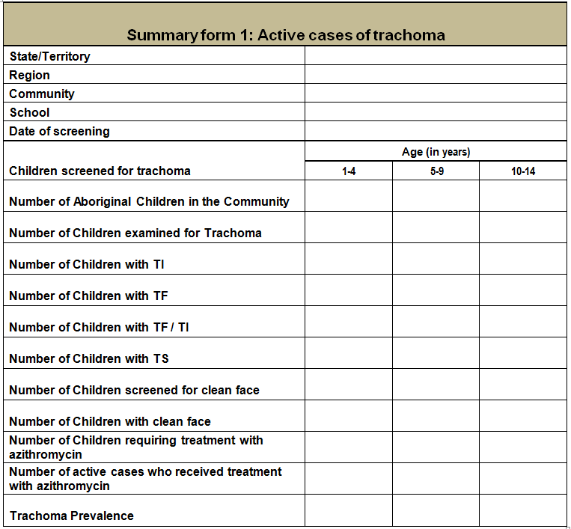 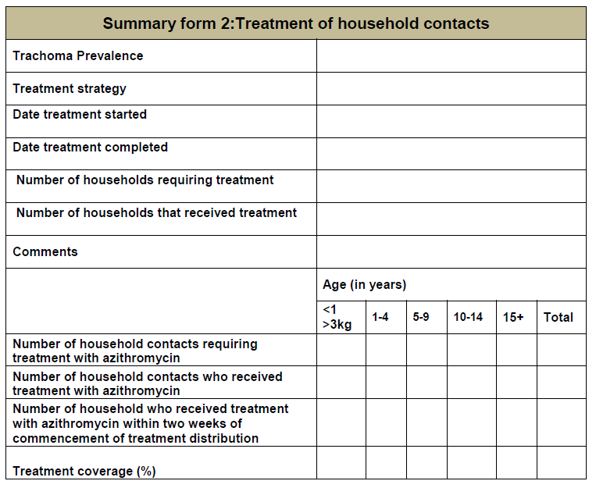 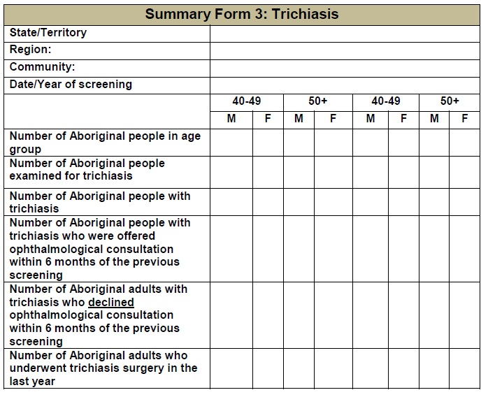 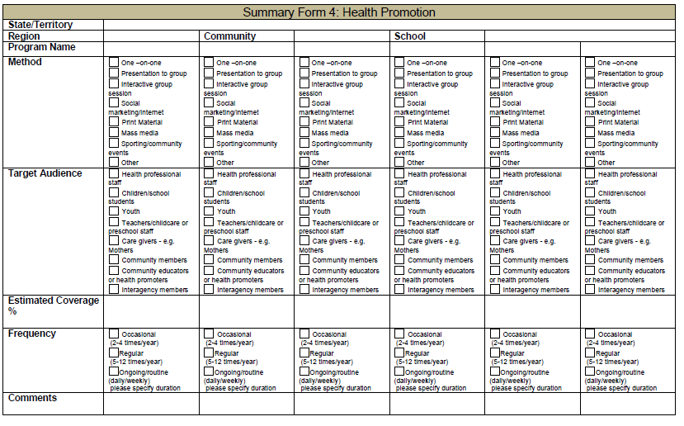

**Appendix 2 - WHO trachoma grading card** (available from the [WHO website](http://www.who.int/blindness/causes/trachoma_documents/en/))

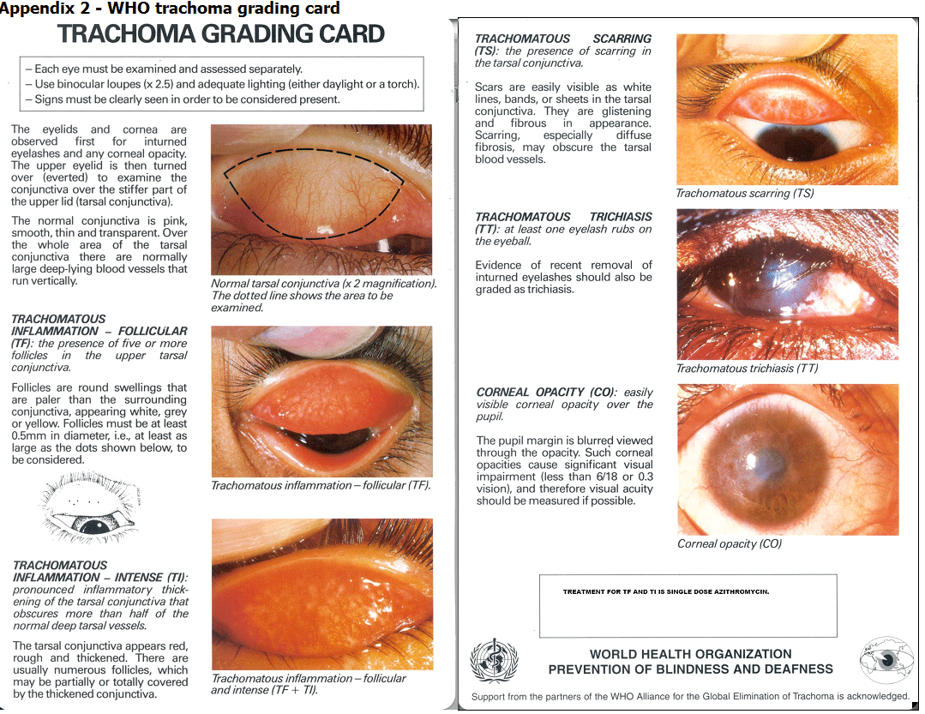

**Appendix 3 - List of resources required and directions on how to screen for trichiasis**

**Equipment required for active trachoma screening:**

* Binocular loupes, 2.5x magnification
* Orange sticks or cotton buds
* Soap, water and a sink or an alcohol-based handwash
* Rubbish disposal bag or bin
* Good lighting (sunlight, torch or headlamp)
* Data collection form
* Pens
* WHO simplified trachoma grading classification system

**To screen for active trachoma:**

* Use 2.5x magnification loupes and good lighting
* Wash hands with soap and water or an alcohol-based handwash
* Signs must be clearly seen if trachoma is to be reported as present
* Observe facial cleanliness (absence of ocular & nasal discharge and no dirt or crusting around the eyes or on the forehead.)
* Refer to the WHO simplified trachoma grading classification system
* Evert the right upper eyelid, examine and record the presence of TF, TI and TS
* Evert the left upper eyelid, examine and record the presence of TF, TI and TS

Everting the upper eyelid:

* Ask the patient to look down
* Gently hold the upper eyelashes between your thumb and first finger
* Using a clean, new orange stick or cotton bud held in your other hand, evert the upper eyelid
* Steady the everted lid and examine for TF, TI and TS
* Gently reinvert the eyelid

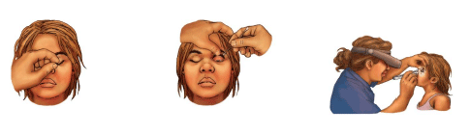

**Equipment required for trichiasis screening:**

* Soap, water and a sink or an alcohol-based handwash
* Torch
* WHO simplified trachoma grading classification system

**To screen for trichiasis, remember the three “T”s**:

* **T**hink about trichiasis at every adult check
* **T**humb: use your thumb to lift the eyelid off the eyeball
* **T**orch: shine the torch and check for in-turned eyelashes

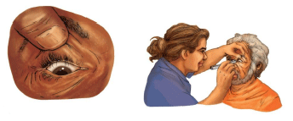

**Appendix 4 - Dosage charts for single dose azithromycin by height and weight**

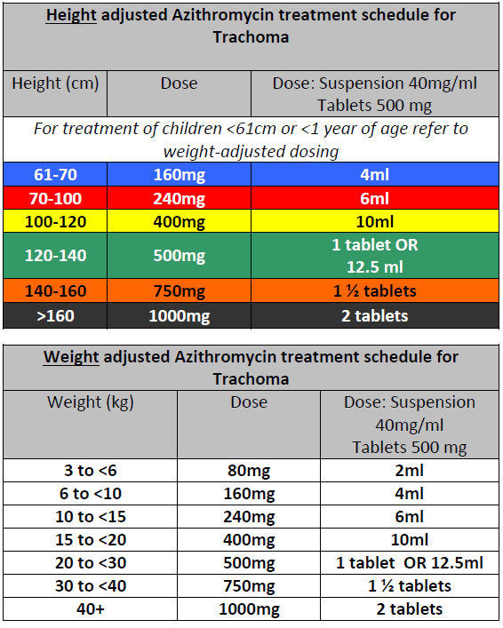

**Appendix 5 - Guide to how much azithromycin to order**

|  |  |  |
| --- | --- | --- |
| **Age** | **Azithromycin Syrup** | **Azithromycin Tablets** |
| Under 5 years | 1 bottle for every 2 children requiring treatment. |  |
| 5-10 years | 1 bottle for every child requiring treatment. |  |
| 10 – 12 years | 1.5 bottles for every child requiring treatment. |  |
| Over 12 years |  | 1000mg = 2 x 500mg tablets for each person requiring treatment. |

**Appendix 6 - Differential diagnosis for follicular conjunctivitis**

|  |  |
| --- | --- |
| **Diagnosis** | **Distinguishing features** |
| Trachoma | Should be suspected in an area thought to have endemic trachoma. Can be confirmed with laboratory evidence of C. Trachomatis infection. |
| Inclusion conjunctivitis | Generally occurs in adults not living in trachoma-endemic areas and is related to the genital strains of C. Trachomatis. |
| Viral conjunctivitis | Isa common cause of follicles; it can be distinguished from trachoma by an acute history and the presence of a mocopurulent discharge |
| Bacterial conjunctivitis | Bacterial infection, such asMoraxella, can be a rare cause of follicle formation. |
| Hypersensitivity conjunctivitis | Occurs following chronic exposure to drugs or eye cosmetics; a careful history is important |
| Vernal conjunctivitis | Is an allergic disorder; patients often have associated atrophy. Symptoms include itchiness, lacrimation, photophobia, foreign body sensation and burning. |
| Parinaud oculoglandular syndrome | Is a rare ophthalmic condition that may cause follicles; it is associated with cat-scratch fever, tuberculosis, syphilis, lymphogranuloma venereum and glandular fever. |

Wright HR, Keeffe JE, Taylor HR. Trachoma and the Need for a Coordinated Community – Wide response: A Case - Based Study. PLoS Med. 2006;3:186-90 Cited in: Taylor HR. Trachoma. A Blinding Scourge from the Bronze Age to the Twenty-first Century. ISBN 9780975769591. Centre for Eye Research Australia, Melbourne 2008.