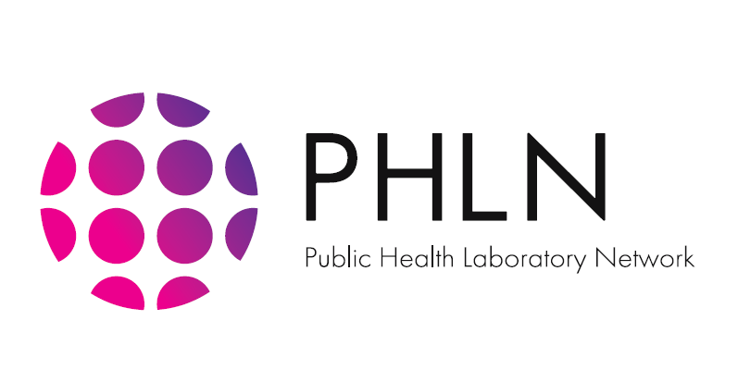

**PHLN guidance on laboratory testing for 2019-nCoV**

Revision History

|  |  |  |
| --- | --- | --- |
| *Version* | *Date* | *Endorsed by* |
| 1.1 | 6 February 2020 | PHLN |
| 1.0 | 23 January 2020 | PHLN |

Patients to be considered for 2019-nCoV testing are described under the suspected case definition. Where applicable, consult with your state/territory communicable diseases agency to seek advice on which laboratories can provide 2019-nCoV testing; appropriate specimen type, collection and transport; and also to facilitate contact management if indicated.

Transmission-based contact and airborne precautions must be used when collecting respiratory specimens. These include:

* For most patients in community settings collection of respiratory specimens is a low risk procedure and can be performed using contact and droplet precautions:
  + perform hand hygiene before donning gown, gloves, eye protection (goggles or face shield) and surgical mask;
  + to collect combined nose and throat or nasopharyngeal swabs, stand slightly to the side of the patient to avoid exposure to respiratory secretions, should the patient cough or sneeze; and
  + at completion of consultation, remove PPE and perform hand hygiene, wipe any contacted/contaminated surfaces with detergent/disinfectant.
* If the patient has severe symptoms (fever, breathing difficulty, suggestive of pneumonia) or frequent, severe or productive coughing episodes then contact and airborne precautions should be observed:
  + if possible, specimens should be collected in a negative pressure room (e.g. in a hospital setting);
  + if this is not possible, then collect the specimens in a room with the door closed and leave the room, which should be left vacant for at least 30 minutes after specimen collection (cleaning can be performed during this time by a person wearing PPE);
  + perform hand hygiene before donning gown, gloves, eye protection (goggles or face shield) and P2/N95 respirator – which should be fit checked;
  + at completion of consultation, remove gown and gloves, perform hand hygiene; remove eye protection and P2/N95 respirator. Do not touch the front of any item of PPE during removal; perform hand hygiene; and
  + the room surfaces should be wiped clean with disinfectant wipes by a person wearing gloves, gown and surgical mask.

Routine tests for acute pneumonia/pneumonitis should be performed where indicated, including bacterial cultures, acute and convalescent serology, urinary antigen testing and nucleic acid tests for respiratory pathogens, according to local protocols.

Serology for 2019-nCoV is not yet available. Collection of serum for storage by the 2019-nCoV testing laboratory is recommended to facilitate retrospective testing, if this is relevant, once serology tests become available.

Laboratory testing for 2019-nCoV continues to evolve rapidly with the accumulation of clinical data, and as reagents and protocols are refined.

The aim of testing is to, if clinically appropriate, exclude common respiratory viruses using local hospital and community nucleic acid testing capacity, and to simultaneously refer onward to a laboratory with capacity to test for 2019-nCov. As co-infection is possible, initial testing protocols should include testing for 2019-nCoV in patients with epidemiological risk, even where another infection is shown to be present.

Samples for testing:

1. upper respiratory tract samples
2. lower respiratory tract sample if the lower tract is involved
3. serum (to be stored pending serology availability)

Upper respiratory tract samples

1. Nasopharyngeal swab and/or oropharyngeal swab, Dacron or Rayon, flocked preferred

* nasopharyngeal: insert a swab into each nostril parallel to the palate, leave the swab in place for a few seconds to absorb secretions
* oropharyngeal: swab the tonsillar beds, avoiding the tongue
* place swabs back into the accompanying transport media

1. Nasal wash/aspirates

* collect 2-3 mL into a sterile, leak-proof, screw-top dry sterile container

Lower respiratory tract samples

1. Bronchoalveolar lavage, tracheal aspirate, pleural fluid

* collect 2-3 mL into a sterile, leak-proof, screw-top sputum collection cup or dry sterile container

1. Sputum

* patient should rinse his/her mouth with water before collection
* expectorate deep cough sputum directly into a sterile, leak-proof, screw-top dry sterile container

As lower respiratory tract specimens contain the highest viral loads in SARS-CoV and MERS-CoV, it is therefore advised that lower respiratory tract specimens should be collected for 2019-nCoV testing where possible. Initial experience in testing for 2019-nCoV seems to be consistent with this prior experience. Repeat testing (especially of lower respiratory tract specimens) in clinically compatible cases should be performed if initial results are negative and there remains a high index of suspicion of infection.

Serology

Serum should be collected during the acute phase of the illness (preferably within the first 7 days of symptom onset), stored, and when serology testing becomes available tested in parallel with convalescent sera collected 3 or more weeks after acute infection. If no acute sample was collected, sera collected 14 or more days after symptom onset may be tested.

# **Specimen handling in the laboratory**

Virology

Laboratory staff should handle specimens under PC2 conditions in accordance with AS/NZS 2243.3:2010 Safety in Laboratories Part 3: Microbiological Safety and Containment. Specimens should be transported in accordance with current regulatory requirements as diagnostic samples for testing.

Clinical Pathology

Standard precautions should be used for non-microbial pathology testing (such as routine biochemistry and hematology). Where possible auto-analysers should be used according to standard practices and/or local protocols. There is evidence that capping and uncapping of samples is not a high risk aersol generating procedure.

Respiratory Virus Diagnostic Testing

Nucleic acid testing of the upper respiratory tract sample is performed for influenza and other common respiratory viruses using  standard protocols and methods of the hospital or community laboratory.

Standard protocols of the testing laboratory for respiratory sample processing should be used. This is expected to consist of PC2 laboratory practices, and use of a Class II Biosafety cabinet for aerosol generating procedures (such as centrifuging without sealed carriers, vortexing, sonicating). Attempted viral culture, which would require higher levels of biocontainment would not be routinely attempted.

The residue (original swab and remaining eluate) of the upper tract sample is forwarded together with the lower tract sample and the serum to the reference laboratory with 2019-nCoV testing capacity requesting 2019-nCoV testing.

Clinical liaison with jurisdictional public health officers is essential to coordinate referral and testing.

Standard protocols should be used for sample packaging and transport as diagnostic samples for testing (ie Category B).

# **2019-nCoV specific testing**

Nucleic acid testing (NAT) using real time polymerase chain reaction (RT-PCR) is the method of choice for detection of 2019-nCoV. Specific diagnostic test approaches for 2019-nCoV will be described here only in broad terms. There is significant variation in PCR assays employed by different PHLN member laboratories, and test algorithms are likely to be further refined over time.

Specific Real Time PCR primer sets to detect the 2019-nCoV are available. Some PHLN member laboratories have designed their own, and some have implemented primer sets recommended to the World Health Organization (WHO) by leading international coronavirus reference laboratories (available at: https://www.who.int/emergencies/diseases/novel-coronavirus-2019/technical-guidance/laboratory-guidance). The majority of PHLN testing capacity now employs relatively swift RT-PCR assays for screening, with a turnaround time of several hours. Confirmation of positives is being done either with RT-PCR assays detecting a different target gene, or broadly reactive PCR tests with sequencing of amplicons (see below).

Well pedigreed PCR primer sets, probes and protocols are available from the WHO/ European Viral Archive (EVAg) (available at: https://www.who.int/docs/default-source/coronaviruse/protocol-v2-1.pdf?sfvrsn=a9ef618c_2).

Many PCR assays, including those available through WHO will also detect other zoonotic coronaviruses such as SARS-CoV, sometimes with a recognisable shift in the cycle threshold value (Ct) compared to the 2019-nCoV target, but not commonly circulating coronaviruses usually detected by commercial assays (eg NL63, 229E strains).

Several Australian PHLN reference laboratories began diagnostic testing for the current outbreak using PCR assays capable of detecting a wide range of coronaviruses, including zoonotic and novel pathogens. A number of these were mapped against the promulgated Chinese nucleic acid sequence of 2019-nCoV early in the course of the outbreak. Nucleic acid sequencing of amplicons from positive tests is used to identify the coronavirus in this approach. These assays have relatively long turnaround times and have largely been replaced by RT-PCR other than in a confirmatory role in some laboratories.

Complementary DNA (cDNA) synthesized from the VIDRL 2019-nCoV has now been made available to all PHLN member laboratories as a test positive control. Synthetic positive control material in the form of nucleic acid templates is also available through WHO/ European Viral Archive (EVAg).

Testing algorithms are likely to be revised pending further information about the virus, and the number of specimens received in the laboratory for testing.

Viral culture should not be performed for routine diagnosis, and should only be attempted in reference laboratories with appropriate experience and containment facilities. Currently where attempted this is being done at Physical Containment Level 3 (PC3), consistent with current recommendations for SARS-CoV, pending specific 2019-nCoV international recommendations.

No Quality Assurance Program (QAP) is currently available internationally specific for 2019-nCoV, although QAPs are available in Australia for respiratory viruses including coronaviruses other than 2019-nCoV. The RCPAQAP with Commonwealth support will introduce a 2019-nCoV specific QAP to supplement previously available SARS-CoV, MERS-CoV and other coronaviruses, during the first half of 2020.