

Caring for Forgotten Australians, Former Child Migrants and Stolen Generations

An information package for aged care services

**Facilitator’s Guide**

© Commonwealth of Australia as represented by the Department of Health 2016

ISBN: 978-1-76007-278-0

Online ISBN: 978-1-76007-279-7

Publications Number: 11400

**Creative Commons Licence**

""

This publication is licensed under the Creative Commons Attribution 4.0 International Public License available fr[om https://creativecommons.org/licenses/by/4.0/legalcode](https://creativecommons.org/licenses/by/4.0/legalcode) (“Licence”). You must read and understand the Licence before using any material from this publication.

**Restrictions**

The Licence may not give you all the permissions necessary for your intended use. For example, other rights (such as publicity, privacy and moral rights) may limit how you use the material found in this publication.

The Licence does not cover, and there is no permission given for, use of any of the following material found in this publication:

the Commonwealth Coat of Arms. (By way of information, the terms under which the Coat of Arms may be used can be found at www.itsanhonour.gov.au);

any logos (including the Department of Health’s logo) and trademarks;

any photographs and images;

any signatures; and

any material belonging to third parties.

**Attribution**

Without limiting your obligations under the Licence, the Department of Health requests that you attribute this publication in your work. Any reasonable form of words may be used provided that you:

include a reference to this publication and where, practicable, the relevant page numbers;

make it clear that you have permission to use the material under the Creative Commons Attribution 4.0 International Public License;

make it clear whether or not you have changed the material used from this publication;

include a copyright notice in relation to the material used. In the case of no change to the material, the words “© Commonwealth of Australia (Department of Health) 2016” may be used. In the case where the material has been changed or adapted, the words: “Based on Commonwealth of Australia (Department of Health) material” may be used; and

do not suggest that the Department of Health endorses you or your use of the material.

**Enquiries**

Enquiries regarding any other use of this publication should be addressed to the Branch Manager, Communication Branch, Department of Health, GPO Box 9848, Canberra ACT 2601, or via e-mail [to copyright@health.gov.au](mailto:copyright@health.gov.au).

**Disclaimers**

While all care has been exercised in ensuring the accuracy of the information in this publication, the Department of Health does not accept any liability for any injury, loss or damage incurred by use of or reliance on the information.

The information in this publication is for general use and a guide only. The Department of Health is not providing professional or medical advice on any particular matter.

Aboriginal and Torres Strait Islander people are warned that this publication may contain images of deceased persons.

It is recommended that this information package be presented by a facilitator that is familiar with the content. If a manager chooses to present this package, they should read and understand this facilitator’s guide before presenting the package.

# What this information package covers

This information package is designed to inform, advise and support those who deliver aged care for ‘Care Leavers’, a special needs group under the *Aged Care Act 1997*.

Care Leavers spent time in institutional care or in out-of-home care, including orphanages and foster care, and include three distinct groups:

1) Forgotten Australians

2) Former Child Migrants

3) Stolen Generations.

The information package provides information about each of these three groups and details some of the emotional or physical issues they might have when seeking aged care services. It also outlines what you can do to help make their aged care experience positive and engaging, and gives you the means to find out more information.

# What are the objectives of the information package?

* increasing understanding about Forgotten Australians, Former Child Migrants and Stolen Generations and how they may feel about accessing aged care services
* providing guidance on how to respond to some issues that members of these groups might raise when accessing aged care services
* enabling aged care service providers to find out more about Forgotten Australians, Former Child Migrants and Stolen Generations
* reducing the tensions and complexities that carers may experience in providing aged care services to Forgotten Australians, Former Child Migrants and Stolen Generations.

# Elements of the information package

This information package is intended to raise awareness and understanding of Forgotten Australians, Former Child Migrants and Stolen Generations and is not to be interpreted as competency based training.

The three elements of the Facilitator’s Pack include: (1) a video, (2) a Facilitator’s Guide (to be used with the PowerPoint presentation) and (3) an information Booklet. The PowerPoint presentation and all components of the pack can be found on the Department of Health website at:

https://agedcare.health.gov.au/careleavers.

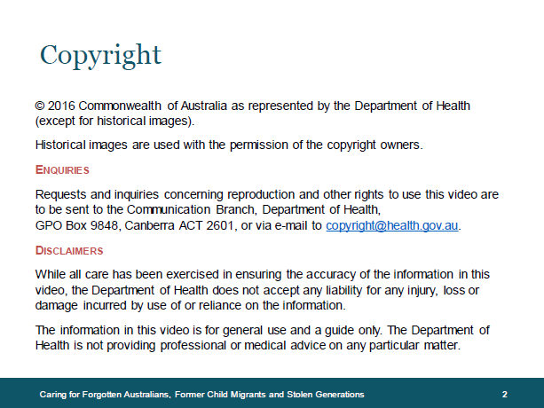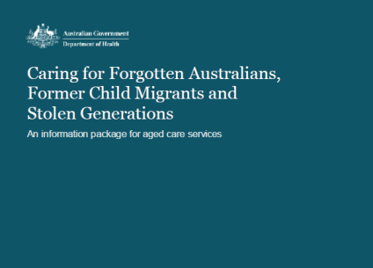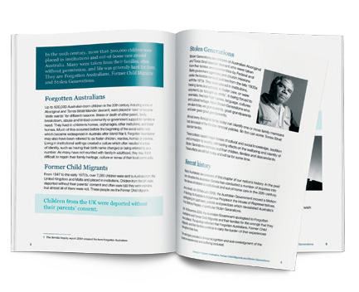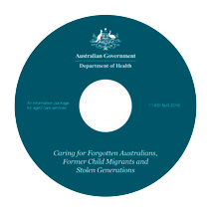

The video is a documentary-style program which recounts the stories and experiences of Forgotten Australians, Former Child Migrants and Stolen Generations in their own words. It can be watched in one screening or in chapters. If watched in chapters, the facilitator can pause at predetermined points to use the PowerPoint presentation as a springboard for discussion.

The PowerPoint presentation has been designed to be viewed by staff and generate discussion on the topics discussed in the video and further illustrate some of the concerns of Forgotten Australians, Former Child Migrants and Stolen Generations.

**Please note**: the talking points have been generalised to apply to all aged care settings, so it is recommended that facilitators adapt these notes to their own organisational settings and sensitivities. Questions for trainers are a guide to be used, if required, to facilitate group discussion.

The A5 booklet provides contextual information about some of the concerns and fears which many Forgotten Australians, Former Child Migrants and Stolen Generations may bring with them into aged care, along with practical suggestions to support them. The booklet may be copied and provided to individual participants as a reminder of the materials in the package or downloaded and printed for staff.

There is a benefit in pointing out that, when addressing a behavioural issue, the first thing staff should do is to ask themselves what they may have done to trigger a specific behaviour and whether or not this practice could be changed. One solution will not work for the same problem each time and may not even work consistently for the same person on each occasion. It is important to continually try and improve quality of care until a solution is identified and then share it with others. This strategy also avoids the need to ‘label’ people. The only thing that would need to be emphasised is that a behaviour of concern may cover a large range of behaviours, some of which could include a client withdrawing or isolating socially. This type of behaviour is as indicative of distress as are the more overt aggressive behaviours. Staff need to constantly check that their own behaviour is not a cause of concern for the client and, most importantly, that they don’t seek to impose their views and norms on a vulnerable person.

# Program timeframe

|  |  |
| --- | --- |
| Time | Content |
| 5 Minutes | Introduction to the program. Who are:   * Forgotten Australians * Former Child Migrants * Stolen Generations |
| 25 Minutes | Understanding the concerns, fears and anxieties of these groups   * Watch the video and listen to real-life accounts from Forgotten Australians, Former Child Migrants and Stolen Generations |
| 60 Minutes | Understanding the concerns, fears and anxieties of these groups  Read and discuss the case studies about the following issues:   * Exploitation and neglect (page 10) * Punishment, brutality and sexual abuse (page 13) * Loss of culture and identity (page 17)   Open the floor to discussion about other ways you could help |
| 10 Minutes | Review and Close   * Discuss any concerns staff may have with the information presented and tell staff where they can find more information about these matters. |

Please be aware, the content of the video may distress some viewers. It contains confronting personal stories. Please take this into consideration when screening the video. Participants may benefit from a debriefing session and should be encouraged to access counselling services if needed after the viewing to discuss how the video may have impacted them.

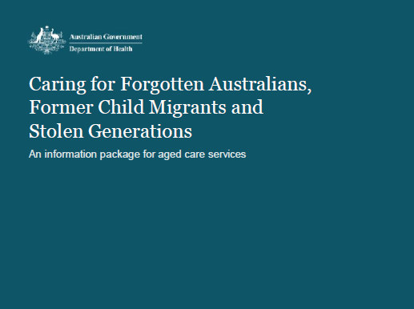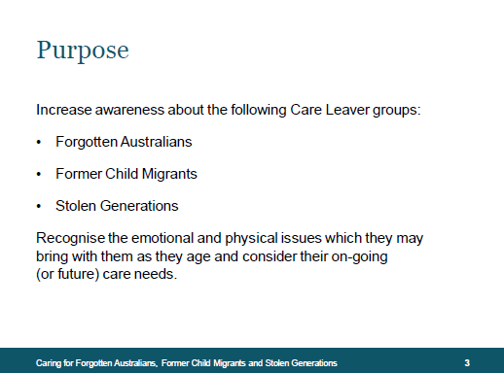

# PowerPoint slides and notes

## Slide three – Purpose

In the 20th century, more than 500,000 children were placed in institutions and out-of-home care around Australia. Many were taken from their families, often without permission, and life was generally hard for them. They are Forgotten Australians, Former Child Migrants and Stolen Generations.

Many people who spent time in children’s homes, orphanages, other institutions or foster care, were deprived of love and a sense of belonging. Most were denied family support, including access to and contact with siblings within the institutions, and experienced loss of trust, separation, and abandonment. Many were separated from the broader community. Often they were lonely and exploited, and experienced rigid rules, punishment, humiliation, and physical and sexual abuse. Many were denied an education, set instead to toil at menial tasks or to work as the virtual slaves of those entrusted with their care. The abuse and humiliation meant that many were denied an identity, lost community connections, lost cultural and community traditions and were taught to fear or hate their cultural heritage. They learned shame, anger and low self-esteem. What they learned has remained in their hearts and minds throughout their lives.

Many Australians, including those who have migrated from overseas and may work in aged care, are unaware of this chapter of our nation’s history. A number of Senate inquiries into the abuse of children in institutional and out-of-home care have taken place over the past two decades.

In 1997, the report on the *National Inquiry into the Separation of Aboriginal and Torres Strait Islander Children from their Families* (the *Bringing Them Home* report) recommended that all Australian parliaments, police forces, churches and other non-government agencies involved, officially acknowledge the responsibility of their predecessors for the laws, policies and practices of the forcible removal of children. It was also recommended that all apologies be accompanied by appropriate reparations.

In April 2001, the report *Lost Innocents: Righting the Record: Report on Child Migration* was released exposing the role of both British and Australian Governments, and their agreement for the migration of children to Australia.

In 2004, the Senate Committee released *Forgotten Australians – a Report on Australians who experienced institutional or out of home care as children*.

On 13 February 2008, the Australian Government moved a Motion of Apology to Australia’s Indigenous Peoples in the House of Representatives, apologising for past laws, policies and practices which devastated Australia’s First Nations Peoples – in particular Stolen Generations. The motion was supported by the Opposition and passed both houses of Parliament.

On 16 November 2009, the Australian Government apologised to Forgotten Australians and Former Child Migrants and their families for the wrongs that they had suffered.

The apology reflected that the Forgotten Australians, Former Child Migrants and their families continue to carry the burden of their experiences throughout their lives. The apology also provided a formal recognition and acknowledgment of the injustices experienced and suffering endured.

On 21 March 2013, the Australian Government delivered a further apology to people affected by forced adoption or removal policies and practices and took responsibility for the effect this had on mothers, fathers, grandparents and the children involved.

These national apologies pointed to treatment of children in institutional care that was often unacceptable and conveyed the hope that acknowledgement of the trauma they experienced would help to begin the healing.

## Slide four – Forgotten Australians. Details on this slide is made in the following text. Slide four – Forgotten Australians

Up to 500,000 Australian-born children in the 20th century, including some of Aboriginal and Torres Strait Islander descent, were placed in ‘care’ or became ‘state wards’ for different reasons: illness or death of either parent, family breakdown, abuse, systemic racism, and limited community or government support for families in need. These children were often denied their childhood. They lived in children’s homes, orphanages, other institutions and foster homes. Much of this occurred before the beginning of social safety nets which became widespread in Australia after World War II. Forgotten Australians may also have been referred to as foster children, wardies, homies or clannies. Living in institutional settings often resulted in a loss of identity, due to birth names being changed or children being referred to as a number. As many have not reunited with family in adulthood, they may find it difficult to regain their family heritage, culture or sense of their local community.

It is important to note that the experiences endured by individuals were not all of the same nature or at the same level. Therefore the aged care considerations for each individual should address individual circumstances and experiences.

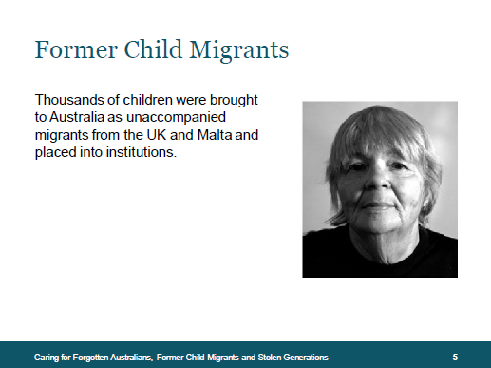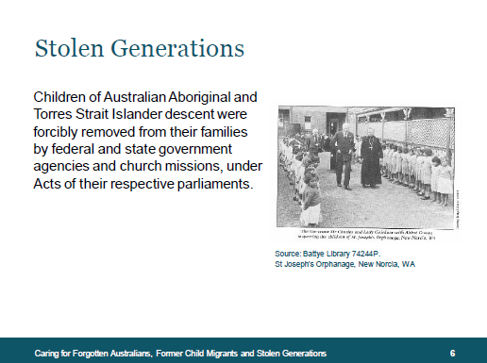

## Slide five – Former Child Migrants

From 1947 to the early 1970s, over 7,000 child migrants were sent to Australia from the United Kingdom and Malta. A feature of this migration scheme, which was agreed between the British and Australian Governments, was that children were placed in residential institutions rather than in foster care or being adopted. Many Former Child Migrants were deported to Australia without their parents’ consent and told they were orphans.

For most of them, their families are still 12,000 miles away, not in Australia. Many of them lost their names, languages and cultural heritage. The distance and loss of cultural identity associated with deportation are particular issues of concern regularly raised by Former Child Migrants.

## Slide six – Stolen Generations

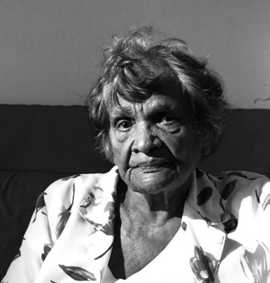Stolen Generations are children of Australian Aboriginal and Torres Strait Islander descent who were forcibly removed from their families and communities by federal and state government agencies and church missions, under acts of their respective parliaments. The removals occurred from the late 1800s to the 1970s. Children were placed in institutions, training farms and schools, foster care or adopted, to be ‘brought up white’. In being forced to assimilate, they lost their names, languages, cultures and cultural heritage. Many have since found it difficult to confirm their identity and their cultural rights to land have also been disrupted.

The definition of Stolen Generations differs from place to place and person to person, depending on the policy in the state or territory concerned. It is best not to assume that everyone had the same experiences or outcomes from the abuse, loss and forced assimilation that they suffered in childhood and adolescence.

Some Aboriginal and Torres Strait Islander care leavers may identify as being from Stolen Generations and some may not. The common experience was institutionalised childhoods. Therefore, it should not be assumed that all Aboriginal and Torres Strait Islander children who grew up in institutions or foster care are part of Stolen Generations.

Racism and discrimination towards Aboriginal and Torres Strait Islander Peoples continue to occur in Australia. This is a double burden for Stolen Generations, quite a number of whom are not accepted by, or have the opportunity to return to, their own communities. Continuing rejection, community dislocation and questions of identity shape their perceptions of care services.

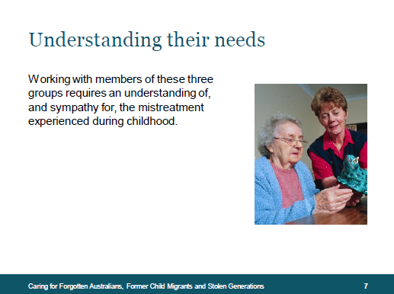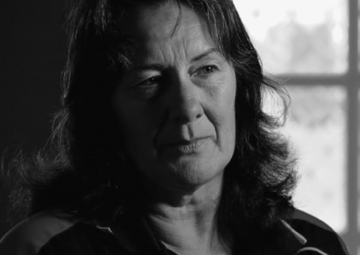

## Slide seven – Understanding their needs

As members of these groups age and contemplate their ongoing (or future) care needs, many find childhood memories return, including recollections of places where they were harmed and memories of experiences when they were abused by those entrusted with their care. Some find the prospect of aged care delivered outside familiar places as frightening.

Working with members of these three groups requires an understanding of and empathy for the mistreatment experienced during childhood. Through no fault of their own, many are burdened with memories which create fear and anxiety, due to the various forms and levels of abuse experienced. If aged care workers can recognise and understand the issues arising from traumatic childhood experiences, they can help to make their time receiving aged care services more positive and engaging.

More than ever, personal care and flexibility in service delivery are priorities in aged care. These are especially important when considering how to care for a member of this special needs group.

The Australian Government’s introduction of Consumer Directed Care (CDC) into home care is of particular relevance to meeting the care needs of Forgotten Australians, Former Child Migrants and Stolen Generations. For these groups, their experiences in childhood resulted in an acute loss of empowerment. CDC allows people to have greater control over their own lives by allowing them, to the extent that they are capable and wish to do so, to make choices about the types of aged care services they access and the delivery of those services, including who will deliver the services, and when.

This approach is likely to result in better outcomes for consumers in respect to their quality of life, independence and satisfaction with care.

Group work

It is recommended the facilitator lead a discussion on participants’ knowledge and understanding of these groups.

## ""Slide 8 – Separation, loss and abandonment, details explained in text below. Slide eight – Separation, loss and abandonment

Many Forgotten Australians, Former Child Migrants and Stolen Generations are afraid to tell their close friends, partners or their children that they were in the ‘care’ system because of the stigma it carried. Many were cut off from all contact with family members and are still looking for them.

It was not just separation and loss of family that caused them to feel abandoned. The feeling was also caused by the betrayal of trust by those in charge, entrusted with their care as children.

On the video, we heard Caroline describe her childhood experiences.

She said:

*‘I don’t even remember asking, “Why haven’t I got a family?”. I don’t even remember being curious about why I didn’t have a family or why I didn’t have brothers or sisters or why was I in this situation and why didn’t I live like other kids lived.’*

Many were cut off from all contact with family members and are still looking for them.

## Slide 9 – Separation, loss and abandonment in terms of belongings, details explained in text below. Slide nine – Separation and loss in terms of belongings

Many people who survived institutional care as children have strong memories of having no personal belongings or of ‘losing’ their personal belongings when, for example, everything was taken away or sent to the laundry when they arrived at an institution. As a result, they are often very attached to personal possessions.

Many may find it difficult to imagine things which, in an aged care setting, others may take for granted – such as sending their clothes to the laundry along with everyone else’s. Some people may be afraid that their clothes will get mixed up, that they won’t get them back, or that someone else will wear them. They may become particularly distressed at the thought of another person wearing their clothes or touching their belongings.

These issues can be approached by applying creative solutions to specific issues of concern.

On the video, Graham said about his belongings: ‘Nothing was yours, you never had any private property, it all belonged to the school or the orphanage.’

CASE STUDY

Peter’s daughter Alyce moved her father into an aged care home two months ago. She had told Karen, a staff member, that her father really enjoyed listening to some CDs that she had brought with her. She specifically asked that people not go into his room and move the CDs without his permission, as he was very possessive.

Karen went out of her way to find a safe spot for Peter to store his favourite CDs and even brought in a portable CD player for Peter to listen to in his room (rather than in the communal area). Karen also went out of her way to talk to Peter about his favourite bands and establish a good rapport with him.

Group work

Facilitator’s note: Participants should be led to an understanding that care practices which work best are those which show respect towards the care recipient and prioritise their preferences. These care practices are generally identified by the individual care recipient. The facilitator may wish to encourage participants to think of creative solutions to specific issues of concern raised in this slide and how these solutions could be effected in the workplace.

## ""Slide ten – Exploitation and neglect

Harsh discipline and exploitation were the norm for some Forgotten Australians, Former Child Migrants and Stolen Generations. This has left a lasting impact on their mental health and emotional wellbeing, as well as on their physical health.

Because of the long-term effects of being severely mistreated during their childhood, many have much lower life expectancies than the majority of Australians and are more reluctant to seek health services, especially in hospitals.

Anecdotal evidence suggests that some people from these groups may require earlier access to aged care services and may have generally poorer health outcomes than is typically the case for their age group. There is a higher prevalence of homelessness, drug or alcohol misuse and mental health issues in these groups than in the broader population.

Not all Forgotten Australians, Former Child Migrants and Stolen Generations experienced harsh discipline, exploitation or abuse. Those who did may be extremely reluctant to discuss this fact, or may deny it if pressed.

Some may fear authority figures.

CASE STUDY

Richard disclosed that he had been institutionalised when he was very young, after his father was imprisoned. He had no idea what had happened to his mother - in fact, for many years he did not know that he had a mother. He only recently found his brother again after many years of separation.

Over a period of 13 years, Richard went through a series of foster homes, interspersed by periods in institutions as each foster home placement broke down. At 15, Richard was ‘placed’ by the state on a cattle farm. With no training, he was expected to live in and look after livestock. Over two years, unsurprisingly, this and a series of further placements broke down. As a result, they said he ‘needed a rest’ and placed him at the Alfred Hospital Psychiatric Unit. Richard says that he can’t remember this time and, in many ways, this may be a good thing.

We have come to understand that Richard never learned how to voice his opinion or that he even had the right to make choices about his life. This has led to him enacting behaviour of concern: he may either become aggressive or withdraw and isolate himself. Staff must continually emphasise his choices, options and rights, respecting his dignity. It’s not so hard, but it is something that Richard has not experienced before. In the past, his aggression led to punishment in one form or other. We now make sure that this is never a consequence for Richard.

Over an 18-month period, Richard has established friendships with three other residents and joined the poker club. His psychiatric illness is well controlled with medication. Richard says he feels ‘in control’ and ’at home’ and that he cannot remember feeling this way many times before.

## ""Slide eleven – Exploitation in relation to education

Education was often denied to Forgotten Australians, Former Child Migrants and Stolen Generations. This has led to some having difficulties reading and writing, though many are too embarrassed to say so, for fear of being humiliated. For some people, this may be expressed as anger at having to fill out forms.

Forgotten Australians, Former Child Migrants and Stolen Generations may often need help to complete forms. When assisting with literacy questions, be flexible in your approach by considering the needs of the individual.

Group work

Leanne and Paul are a married couple who moved into an aged care home together. You have noticed that Paul always fills out documents for Leanne and you’ve even seen him read menus to her when they enter the dining hall.

On Tuesday, Paul had a fall and needed to be admitted to hospital overnight. Leanne needed to fill in the medical forms but, unable to complete the forms, asked if she could take them home, as she had left her glasses there.

When Leanne arrived home, you found her very distressed. What would you do?

Facilitator’s note: Discuss why the idea of completing a form might cause Forgotten Australians, Former Child Migrants or Stolen Generations to become upset or cause them embarrassment. How could you help so that the person can accept assistance without embarrassment?

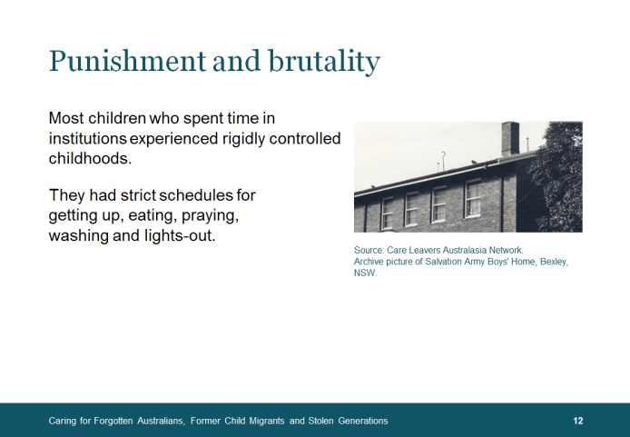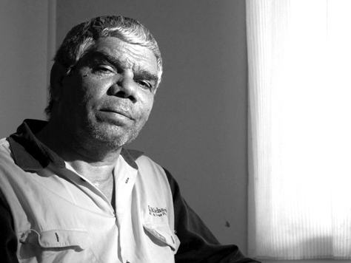

## Slide twelve – Punishment and brutality

Most children who spent time in institutions experienced more rigidly controlled childhoods than those who grew up in a family. They had strict schedules for getting up and eating, praying, washing and lights-out. Unsurprisingly, as adults, many of them dread an institutional arrangement which will force them to follow a strict regime, and remember the punishment that used to follow when they did not comply.

Before you can establish a supportive care plan, you need to find out as much as you can about the care recipient. It is good practice to adapt your routines and services to the needs of the people in your care if they are disturbed by a regimented lifestyle. Every individual has their likes and dislikes. An effective and supportive care plan is always based on mutual interests and respect.

For many Forgotten Australians, Former Child Migrants and Stolen Generations, the thought of being ‘locked in’, or even the sound of someone passing and jangling keys, causes terror.

On the video we heard the thoughts of Lester about authority. He said: *‘The manager took me up to his office and questioned me; he said, “Why did you run away for?” I said, “I’m not saying anything to you, you so and so.” And with that he stripped me naked and flogged me with a six foot cane from head to toe. I’ll never forget it.’*

Forgotten Australians, Former Child Migrants and Stolen Generations often report an entire childhood when they were underfed, badly fed or force-fed. Menus had little variety; the children were made to finish even the most unpalatable food, and were given cold food which should have been hot. Many still dislike fish fingers, porridge or anything with white sauce. Many have a dread of being forced to eat in a communal environment.

Consenting or refusing to eat food is an expression of a person’s autonomy. Uncertainty about how to manage older people who refuse food or can no longer eat is one of the most difficult ethical issues facing families and aged care workers.

Facilitator’s note: Participants should be led to an understanding that care practices which work best are those which show respect towards the care recipient and prioritise their preferences. These care practices are generally identified by the individual care recipient.

CASE STUDY

Susan recently entered an aged care home and was afraid of being punished for not wanting to eat the crumbed fish served for dinner on a Friday night. It reminded her too much of the fish fingers she was forced to eat as a child.

Luckily Gary, a nurse, noticed that Susan wasn’t eating and discussed the issue with her in a friendly way. He chatted in a personal way saying he wasn’t a fan of fish either. He asked if she would like him to ask the chef whether any roast beef had been left over from lunch. Gary established a good working relationship with Susan and she felt comfortable talking it over with him to resolve the issue.

Group work

Discuss other things for which Forgotten Australians, Former Child Migrants and Stolen Generations may have been punished. You would have heard some of these in the video, such as:

• bed wetting

• not eating the food they were given.

## Slide thirteen – Physical or sexual abuse and privacy, details explained in text below. Slide thirteen – Physical or sexual abuse and privacy

Many Forgotten Australians, Former Child Migrants and Stolen Generations were denied privacy as children. They often slept in dormitories and showered or bathed communally. They do not wish to experience this type of invasion of privacy again.

If someone raises privacy concerns, try to seek ideas from them about how their concerns could be addressed.

Many Forgotten Australians, Former Child Migrants and Stolen Generations experienced physical or sexual abuse. In some cases, this causes them to fear people in positions of authority. Care provided for people who have been abused should be sensitive to their experiences, culturally appropriate, and meet their individual needs. This is particularly important to consider when providing daily care services, such as dressing, undressing or bathing.

In the video we heard Jenny (a member of Stolen Generations) recount her sexual abuse experiences, ‘I was told ‘you tell anyone and I’ll kill your dog’... and my dog was my best friend and I was kept locked up, so that everything could be kept quiet and I was just meat for men, really.’

Facilitator’s note: Participants should be led to an understanding that care practices which work best are those which show respect towards the care recipient and prioritise their preferences. These care practices are generally identified by the individual care recipient.

It was common practice for religious or other charitable organisations and governments to run children’s homes or institutions in the 20th century. Sexual abuse was sometimes prevalent in these institutions. Therefore, Forgotten Australians, Former Child Migrants and Stolen Generations may have issues with:

* aged care services which have a name or association with an institution where they spent time in their childhood
* religious icons such as pictures, crucifixes and shrines.

Group work

Discuss the implications that such experiences have on things like trust and forming relationships.

What concerns and fears might someone with these experiences have with accessing aged care services?

## Slide fourteen – Impacts. Details on this slide is made in the following text.Slide fourteen – Impacts

Aged care providers sometimes hear that people choose to live a life of homelessness or social exclusion. This is rarely the case. Instead, people make what they perceive to be the better choice between two bad options.

CASE STUDY

On arrival, Shirley was not a well woman: paranoid, pacing, yelling, and talking constantly to herself, having emotional outbursts and ‘minor’ episodes of self-harm. Shirley appeared totally consumed with internal torment. Her behaviour frightened fellow residents and some staff members. She was also suffering from highly unstable diabetes, morbid obesity and several other conditions commonly associated with years of rough living.

On admission, Shirley gave only a bare skeleton of her life, and it seemed that the details, as they emerged over time, often changed. This alerted us to look for something more in Shirley’s background or life story - something that she might be afraid to disclose. Staff knew we needed to earn Shirley’s trust for her to start telling us her life story. Over time, Shirley disclosed that when she was young, she was institutionalised for 13 years. She went through a series of foster homes, interspersed by periods in institutions as each foster home placement broke down. The next period of Shirley’s life involved a series of work placements, culminating in a gang rape. She did not tell anyone about the rape. In fact, she did not speak at all and she was taken to Winlaton Youth Training Centre and eventually moved to Sunbury Asylum.

In Shirley’s eyes, she was once again forced into care with no say in the matter. She expected ongoing abuse, rules and restrictions and punishment when she did ‘something wrong’. She feared this would soon culminate in being evicted or being moved to another aged care home.

We have come to understand that Shirley never learned how to say “no”. This inability led her to become aggressive or to withdraw into herself. She doesn’t understand what control she has over situations. Staff must continually emphasise her options and her rights, respecting her dignity. Over the next 18 months, Shirley lost weight and she now keeps it at a healthy level. She no longer requires insulin for her diabetes, her psychiatric illness is well controlled with medication, she has established links with some fellow residents and she appears to enjoy a better quality of life. Shirley says she feels ‘safe’ and ‘at home’.

## Slide fifteen – Loss of identity and culture. Details on this slide is made in the following text.Slide fifteen – Loss of identity and culture

### Loss of identity

The loss of identity is an issue forced upon Forgotten Australians, Former Child Migrants and Stolen Generations. As a result of spending time in institutions in their childhood, many are unable to identify with family members and relationships. Many have no birth certificates, some had their birth name changed and some were known during their early years only as numbers. Because of these identity issues, accessing or tracing identity records has been difficult.

Forgotten Australians, Former Child Migrants and Stolen Generations may feel isolated or depressed at times when it is usual to celebrate. These include milestones such as birthdays, Mother’s/Father’s day or family oriented celebrations such as Christmas and Easter or national days like ANZAC Day and Australia Day.

Facilitator’s note: Participants should be led to an understanding that care practices which work best are those which show respect towards the care recipient and prioritise their preferences. These care practices are generally identified by the individual care recipient. The facilitator may wish to encourage participants to think of creative solutions to specific issues of concern.

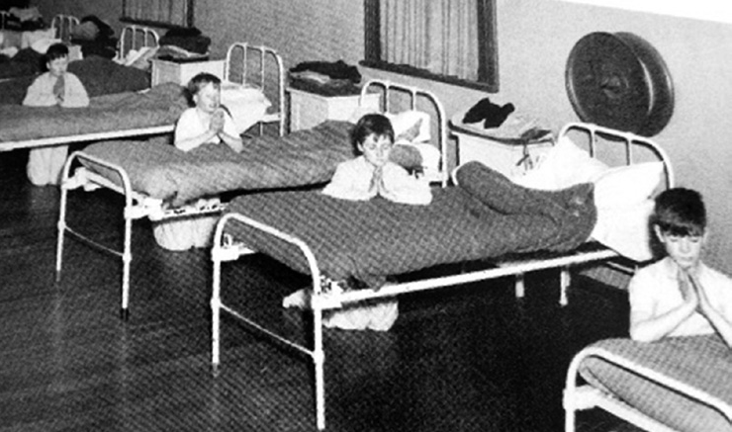

Source: Care Leavers Australasia Network.

Archive picture of Salvation Army Boys’ Home, Bexley, NSW.

CASE STUDY

When I first met Arora, I found it difficult to get her to engage with our services. It was quickly apparent that she did not have any support system. Perhaps not having a family or friends prompted me to wonder how this had occurred and that I needed to understand more about her background to make sure that she got all the help she needed. At first, I visited her at home each week to make sure she was alright with the package and the services we provided. We employ our own carers and I made sure that the same carers looked after her at all times as change and new people did and still can upset her. It quickly became apparent that Arora was unable to initiate things independently. At the first hurdle, she would give up and retreat back home.

Arora told me of an incident at the institution she has never been able to block from her memory. Arora said she got to know one of the girls in the home quite well. She felt a connection with this girl and trusted her enough to tell her real name. Arora said they had to go by saint’s names and not their own. She was known as ‘Bernadette’ while in the home.

She and the other girl used to spend any time allowed together and they did their chores together. One day she saw her friend’s head being held down by one of the nuns in what she thought was a bucket of bleach. Arora could still hear the nun saying to the girl, “Vanity is a sin” and because her hair was long and blonde, the nun decided to ‘burn it off’ with bleach. Arora said that after that day, the girl never spoke another word and only did what she was told. She never went out into the yard with any of the other girls. Arora cried when telling me this story.

Over time, I have come to know her and learn her fears. Arora says she does not fit in anywhere and blames this on her past. She says she is very self-conscious and feels that people do not like her (I feel she is a very likeable person and never complains about anything). Given these feelings, it is not surprising that she suffers from depression. More concerning though, is that she will not stand up for herself. Because of this, I find I must advocate for her. Arora says it is this aspect of my work that means the most to her - having someone on her side who will help her. She becomes easily upset and confused and feels that people do not listen to her. Her own children also tend to make her feel she is not important. She does not get a lot of support from them and she feels that when she needs to ask, they only help because they feel obliged.

Many were separated from their families in difficult circumstances, or forcibly removed from their families.

### ""Loss of culture

Many Forgotten Australians, Former Child Migrants and Stolen Generations were separated from their families in difficult circumstances, or forcibly removed from their families. This has resulted in a loss of cultural heritage for all these groups. As many have not reunited with family in adulthood, they may find it difficult to regain their family heritage, culture or sense of their local community. Where they have been able to reconnect with their family or cultural heritage as an adult, a move to an aged care setting that does not sustain this connection may be felt even more acutely because of the loss they experienced in childhood.

Many may find it difficult to regain their family heritage, culture or sense of their local community.

CASE STUDY

Joe is a Forgotten Australian. While he is not very forthcoming about the days he spent in an institution in Collingwood as a child, he has spoken about the way it has affected his life and in particular the way he identifies himself.

He was born in 1940, and thinks he was institutionalised very soon after he was born. He believes he was put in the institution because his parents had three other children and could not afford to keep him. He lived at the orphanage until he was 13 years old when his older brother collected him and took him to live with his elder sister. Joe said this did not last long as they did not get along, so he went to live with his uncle.

This relationship also broke down as he wasn’t familiar with their ways of life and their cultural traditions. All he knew was the chores in the home and the church. Joe said he never saw the outside of the institution except for when they went to church. He said they were all seated in a particular spot and were not allowed to sit among other parishioners. Nor were they allowed to look at them or smile at them.

From church they would have to go straight back to their chores. He said they worked hard and for most of the day. He said his punishment for not doing something well would be to do it again or be caned. Joe said they were very hard and strict on all the boys in the institution and that the boys were all too scared to do anything which might upset the brothers.

Joe lent me a movie once about boys in an institution in England. He asked me to watch it and asked me to keep in mind that what I saw was what really happened. He said most people would think it was exaggerated, but it was all real, the only difference being that it was set in England.

Joe cries very easily and feels he is a burden to everyone. He is extremely appreciative of the assistance we give him and often tells me he would not know what to do without his Home Care Package and the staff who support him.

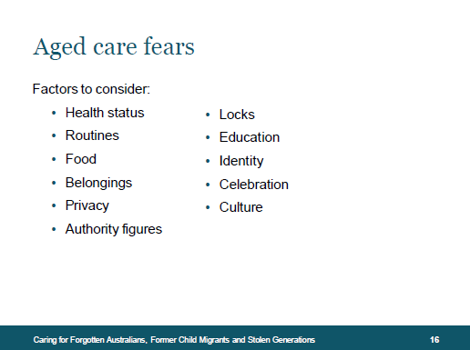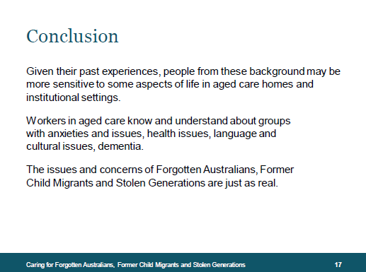

## Slide sixteen – Aged care fears

As Forgotten Australians, Former Child Migrants and Stolen Generations age, they are more likely to need aged care services to support them. The support they need may include anything from Home Support to Home Care to Residential Care. Therefore, you should consider how best to deliver responsive and respectful aged care to them.

Common factors to be considered when offering care to vulnerable members of these three groups include:

* Health status
* Belongings
* Routines
* Food
* Privacy
* Locks
* Education
* Identity
* Culture
* Celebrations
* Authority figures

## Slide seventeen – Conclusion

Open the floor for questions and any further discussions people might have on working with Forgotten Australians, Former Child Migrants and Stolen Generations. Direct them to the booklet and online resources to find more information or use information from within this Facilitator’s Guide.

Invite suggestions of ‘watchwords’ through which participants could express understanding and respond to people with flexibility, patience, empathy, interest and compassion.

## Appropriate and sensitive care

### Emotional support

Older people face tremendous life changes, often within a short period of time. They need ongoing emotional support to cope with the experiences of bereavement and illness, and in adjusting to becoming a person requiring support.

Entering into the aged care system either as a resident in an aged care home or through home support or a Home Care Package is an enormous change for all older people. People may feel loss, anxiety, frustration, anger or grief. This change may also cause some people to relive past traumas The experience can be even more emotionally overwhelming for Forgotten Australians, Former Child Migrants and Stolen Generations. To provide appropriate emotional support to these groups of people you will need to try to understand their history as well as their cultural, linguistic and spiritual needs. Enabling participation can reduce social isolation and facilitate a sense of belonging.

Key considerations:

* identify, address and regularly review their emotional needs. If appropriate, consult family and friends about an individual’s needs and requirements
* assist care recipients to maintain support networks
* explore the availability of volunteers (such as the Community Visitors Scheme) to provide recreational visits
* understand that a person’s expression of emotion, including his or her response to loss and grief, is influenced by history and culture
* ensure that diversity is considered across all services, including health and personal care, food services and leisure activity programs
* ensure care recipients have access to culturally appropriate spiritual support
* ensure that staff are trained in cultural awareness, appropriate communication and have access to cultural supervision.

Older people face tremendous life changes, often within a short period of time.

### Living environment

Help create an immediate and ongoing sense of belonging by considering an individual’s background, and preferences in the aged care home environment.

Being sensitive to diversity in the living environment will create a safe, comfortable and appropriate atmosphere consistent with care needs.

Key considerations:

* consult local support services to find out how your facility can be more appealing and appropriate for Forgotten Australians, Former Child Migrants and Stolen Generations
* consider the needs and preferences of people that you are looking after when designing and decorating private rooms and public living spaces
* provide facilities such as indoor or outdoor spaces and rooms for a variety of religious cultural and spiritual observances.

### Food services

As children, Forgotten Australians, Former Child Migrants and Stolen Generations were often underfed, badly fed or force fed. Some menus had little variety, and children were made to finish unpalatable or cold food. Many now dislike porridge or anything served with white sauce. Many dread having to eat in a communal environment.

Key considerations:

* identify and support spiritual and cultural requirements and preferences on diet and food preparation
* where appropriate, involve care recipients in menu planning and food preparation
* consult a dietician or nutritionist for help in modifying the menu to incorporate culturally appropriate and nutritionally sound meals
* ensure that staff responsible for food preparation are familiar with dietary preferences and culturally determined dietary restrictions (for example totemic foods) and provide training as required
* ensure that staff responsible for assessment of dietary requirements have been trained in cultural awareness and appropriate communication.

### Cultural awareness

Cultural awareness is an essential skill when providing appropriate services that meet the needs of people from diverse backgrounds. It calls for an understanding of how a person’s history and culture may inform their values, behaviour, beliefs and basic assumptions.

Cultural awareness recognises that we are all shaped by our historical and cultural background, that it influences how we interpret the world, how we perceive ourselves and relate to other people. It is always important to identify a person’s individual needs and preferences and remember that no individual can be reduced to a set of cultural norms or judged entirely on the basis of their past.

Within any society, people’s values, behaviour and beliefs can vary enormously. Differences may occur due to different life experience, identification with cultural and spiritual background, migration experiences, socio-economic background, level of education and rural or urban residence. Many Forgotten Australians, Former Child Migrants and Stolen Generations continue to feel the stress of separation from their families and communities, homeland, friends and support networks. They have suffered and may continue to suffer stigma, racial discrimination, changes in lifestyle and socio-economic status and culture shock.

Key considerations:

* be aware of your own historical and cultural influences
* be aware of judging other people’s behaviour and beliefs according to the standards of your own culture or spiritual beliefs
* be aware of making assumptions about cultural and spiritual influences and applying generalisations to individuals
* understand that the behaviour and beliefs of people within society can vary considerably
* increase your knowledge about different cultural and spiritual practices through cultural background information sessions and/or resources and cultural awareness training
* understand the importance of appropriate communication
* increase your knowledge and awareness of childhood trauma and how to implement appropriate trauma informed care and practice.

# For more information?

Groups that offer support for Forgotten Australians, Former Child Migrants or Stolen Generations may help your organisation to better understand these individuals, and explain how you can deliver sensitive and appropriate care to them.

## For Forgotten Australians

### The Alliance for Forgotten Australians

The [Alliance for Forgotten Australians](http://www.forgottenaustralians.org.au) (AFA) is a national advocacy and policy agency. AFA’s mission is to promote and encourage greater recognition for Forgotten Australians.

AFA advocates for national policies and high quality services available in each state and territory, which are tailored to meet the needs and interests of the estimated 500,000 Forgotten Australians.

AFA strongly encourages inclusion of Forgotten Australians in service planning and delivery.

AFA raises the profile and identity of Forgotten Australians in the wider community, distinguishing them from other special needs groups and ensures that the lived experience of Forgotten Australians informs relevant policy development and service delivery.

AFA has developed strategic alliances with a broad range of stakeholders including professionals, community service organisations, and research institutions in collaborative policy and service enhancements.

AFA has developed an informative booklet Forgotten Australians: *Supporting survivors of childhood institutional care in Australia*, 1st, 2nd, 3rd and 4th Ed., © and *DVD Life Stories*©.These resources are available to assist in professional development and training for community and aged care support services.

AFA has made numerous conference and organisational professional development presentations on the impact of childhood institutionalisation, including for the aged care sector.

To engage an AFA speaker on ageing Forgotten Australians, or for further advice, contact:

www.forgottenaustralians.org.au   
0488 460 646

### Care Leavers Australasia Network

[Care Leavers Australasia Network](http://www.clan.org.au) (CLAN) is a national, independent, peak membership body for people who were raised in Australian and New Zealand orphanages, children’s homes and foster care. CLAN has been operating since 2000 and has offices in Sydney and Melbourne.

CLAN represents and advocates for Care Leavers at all levels of government. They assist and support members to access medical, dental and community services.

CLAN offers the following services:

* Free telephone or face to face counselling
* Information about the Royal Commission into Institutional Responses to Child Sexual Abuse, and how to get involved
* Support Care Leavers to go to the Royal Commission
* Social Events in all states
* Reunion support
* A bi-monthly newsletter, the Clanicle
* Help to obtain your state ward or Home file
* Help to write your personal story
* Free advertising in the CLAN newsletter and on the CLAN website to locate lost family members or Home friends
* Photo gallery for Care Leaver Members only
* Advocacy and lobbying Care Leaver issues in all states.

CLAN is also a research and training service, with experienced speakers available to do talks and presentations on the traumatic legacy of being a Care Leaver and how their childhood has affected their adult life.

www.clan.org.au  
1800 008 774

## For Former Child Migrants

### The International Association of Former Child Migrants and their Families

The [International Association of Former Child Migrants](http://www.childmigrantstrust.com/intl-association) and their Families was launched in October 1997 to provide Former Child Migrants worldwide with an organisation run by and for child migrants. The association represents the views and feelings of Former Child Migrants and their families by actively campaigning for justice, for appropriate services and by taking part in relevant events like the International Conference on Child Migration, Parliamentary Inquiries and political apologies.

www.childmigrantstrust.com/intl-association

### Child Migrants Trust

The [Child Migrants Trust](http://www.childmigrantstrust.com) (CMT) is an independent, international social work agency that helps Former Child Migrants and their families. CMT has offices in the UK and Australia. It provides counselling services related to personal and family identity, and from its Nottingham office undertakes family tracing to help reunite Former Child Migrants with their families. CMT also provides counselling to address historic childhood abuse and seeks to help Former Child Migrants to better understand their past so they can achieve a better future. The work of CMT and its Director Margaret Humphreys was featured in the film ‘*Oranges and Sunshine’* (release 2011).

www.childmigrantstrust.com

### Find & Connect Services

The Australian Government has set up a national network of [Find & Connect](https://www.findandconnect.gov.au/) support services to provide personalised support that is respectful and understanding of the experiences of Forgotten Australians and Former Child Migrants. The support services will help Forgotten Australians and Former Child Migrants to:

* access personalised support and counselling
* obtain personal records, trace their history and assist to understand why they were placed into care as children
* connect with other services and support networks that may assist
* reconnect with family, where possible.

To contact the Find & Connect support service in your state or territory freecall 1800 16 11 09 (please note that calls made from mobile phones may incur additional costs).

The support services in each state and territory are:

* New South Wales and the Australia Capital Territory – Wattle Place
* Northern Territory – Relationships Australia NT
* Queensland – Lotus Place
* South Australia – Relationships Australia SA
* Tasmania – Relationships Australia TAS
* Victoria – Open Place
* Western Australia – Lanterns
* Nationally – Child Migrants Trust (freecall: 1800 04 05 09).

https://www.findandconnect.gov.au/

## For Stolen Generations

### National Stolen Generations Alliance

The Australian Government’s 2008 apology marked a new beginning with truth, justice and healing as the guiding principles. The [National Stolen Generations Alliance](http://www.nsga.org.au) (NSGA) sees the removal of Aboriginal children as not just an Aboriginal problem, but one which has negatively affected all Australian citizens and one that requires a collective response to heal not just those affected but the whole nation. The NSGA—Australians for Truth, Justice and Healing was formed as an independent, national organisation in 2007. Its vision is to enable truth, justice, healing and empowerment for Stolen Generations and their descendants. The NSGA advocates on behalf of people from Stolen Generations to government and non-government agencies to ensure better services and for social justice, to make sure their voices are heard and their rights and interests addressed. It also works closely with people from Stolen Generations as they make their journey home to their families and communities.

www.nsga.org.au

### Link-Up Services

[Link-Up](http://www.aiatsis.gov.au/research/finding-your-family/link-services) organisations can be found throughout Australia and provide a range of services to members of Stolen Generations, their families, and foster and adoptive families, including:

* researching family and personal records
* emotional support when accessing family and personal records
* finding family members
* assistance and support at family reunions
* support and counselling before, during and after family reunion.

www.aiatsis.gov.au/research/finding-your-family/link-services  
1800 624 332

### The Aboriginal and Torres Strait Islander Healing Foundation

The [Aboriginal and Torres Strait Islander Healing Foundation](http://www.healingfoundation.org.au) works with Indigenous organisations and communities to address the trauma associated with past government policies of forced removal of children from their families. It funds culturally strong, community based healing programs to address the effects of trauma, training and education initiatives that build the skills of communities and workers to deal with trauma and research into the benefits of Indigenous healing.

The Foundation has developed a working partnership with the National Stolen Generation Alliance and Link-Up family reunification services.

www.healingfoundation.org.au  
(02) 6124 4400

# For more detailed background information

## Forgotten Australians and Former Child Migrants

### History and background

**National Apology to Forgotten Australians and Former Child Migrants**https://www.dss.gov.au/our-responsibilities/families-and-children/programs-services/apology-to-the-forgotten-australians-and-former-child-migrants

**Senate Inquiry – Lost Innocents – righting the record – report on child migration**   
http://www.aph.gov.au/Parliamentary_Business/Committees/Senate/Community_Affairs/completed_inquiries/1999-02/child_migrat/report/index.htm

**Senate Inquiry – Lost Innocents and Forgotten Australians revisited**   
www.aph.gov.auhttp://trove.nla.gov.au/work/28255433

**National Apology for Forced Adoptions**www.ag.gov.au

**National British Apology to Former Child Migrants**www.publications.parliament.uk

On 24 February 2010, the British Prime Minister Gordon Brown issued an apology to child migrants, for the United Kingdom’s role in deporting thousands of children to Australia, Canada, New Zealand, South Africa and Zimbabwe between the 1860’s and 1960’s.

**Exhibition: Inside: Life in Children’s Homes and Institutions**  
www.forgottenaustralianshistory.gov.au

To mark the second anniversary of the apology to Forgotten Australians and Former Child Migrants, the National Museum of Australia opened an exhibition on 15 November 2011 called *Inside: Life in Children’s Homes and Institutions*. The exhibition featured the words, voices and objects of the Forgotten Australians and Former Child Migrants who experienced institutional care as children. More information on Inside: Life in Children’s Homes and Institutions is available at: http://nma.gov.au/blogs/inside/

**Oral History – Forgotten Australians and Former Child Migrants**

http://www.nla.gov.au/

The National Library of Australia conducted an oral history project about Forgotten Australians and Former Child Migrants, which concluded in November 2012. The project ran for three years and documented a rounded history of the experiences of children in institutional and out-of-home care and the lifelong impact of these experiences on their lives and their families. Interviews will be preserved in the National Library and are publicly available, subject to any access conditions imposed by interviewees.

The Library has produced a booklet titled *You can’t forget things like that*. The booklet introduces the Forgotten Australians and Former Child Migrants Oral History collection held at the National Library of Australia and aims to encourage people to listen to the full interviews, and to know and understand the life history and experiences of Forgotten Australians and Former Child Migrants.

The National Library of Australia hosts oral history projects about Forgotten Australians, Former Child Migrants and Stolen Generations.

## Stolen Generations

### History and background

**National Apology to Australia’s Indigenous Peoples, in particular Stolen Generations**http://www.australia.gov.au/about-australia/our-country/our-people/apology-to-australias-indigenous-peoples

***Bringing them home* – Report of the National Inquiry into the Separation of Aboriginal and Torres Strait Islander Children from Their Families**  
https://www.humanrights.gov.au/publications/bringing-them-home-report-1997

In December 1997, in response to the first recommendation of the Human Rights Commission report, *Bringing Them Home: Report of the National Inquiry into the Separation of Aboriginal and Torres Strait Islander Children from Their Families*, the Commonwealth Government announced the National Library would be funded to develop and manage an oral history project. The Bringing Them Home Oral History Project ran from 1998 to 2002 and served to collect and preserve the stories of Indigenous people and others, such as missionaries, police and administrators involved in or affected by the process of child removals.

***Bringing them home* – a video summary of aspects of the report.**   
http://www.nla.gov.au/digicoll/bringing-them-home-online.html

The National Library of Australia ran this oral history project in response to the recommendations of the *Bringing them home* report. A selection of the interviews are now available online.

**Stolen Generations’ Testimonies**

The Stolen Generations’ Testimonies project is an initiative to record on film the personal testimonies of Australia’s Stolen Generations Survivors and share them online.  
http://stolengenerationstestimonies.com/index.php

### Training and awareness raising

**Marumali**

Training course for understanding Stolen Generations  
www.marumali.com.au

**Working Together: Aboriginal and Torres Strait Islander Mental Health and Wellbeing Principles and Practice**  
http://aboriginal.childhealthresearch.org.au/

**Strengthening aged care assessments for Aboriginal consumers: A guide for Aged Care Assessment Services in Victoria**https://www2.health.vic.gov.au/ageing-and-aged-care/aged-care-assessment-services

**National Aboriginal and Torres Strait Islander flexible aged care program**  
http://www.myagedcare.gov.au/aboriginal-andor-torres-strait-islander-people

**More information on tracing family records is available at the following websites:**

http://www.findandconnect.gov.au/contact/  
http://www.aboriginalaffairs.nsw.gov.au/about/family-records-unit  
http://guides.slv.vic.gov.au/content.php?pid=130700&sid=2708235

# Notes

# Notes

www.health.gov.au

All information in this publication is correct as at November 2016