**Gastro Info Kit Sheet 2**



[**www.health.gov.au**](http://www.health.gov.au/)

All information in this publication is correct as of February 2011

D0238 Feb 2011

**Attention all staff**

There are currently a number of cases of gastroenteritis in this facility. We are trying to prevent this illness from spreading.

If you have any of the symptoms of gastroenteritis now (abdominal pain, vomiting, diarrhoea, nausea, fever, headaches and general weakness) you should report to your manager or the DoN immediately. You may be asked to go off work immediately and remain off work until at least 48 hours after your last episode of symptoms.

There is a risk that you will acquire or spread gastroenteritis unless you take precautions.

* Wash your hands with liquid soap and water before and after contact with each resident, or use alcohol-based hand rub if washing facilities are not nearby.
* If you are working with those residents who are sick, avoid contact with other residents and staff working in other areas.
* Wear gloves, gown or apron for all contact with infected residents and their immediate environment i.e. surfaces or items in the resident’s room.
* Change gloves and gowns between each infected resident contact and dispose of used items directly into a waste container before leaving the resident’s room.
* Wear a fluid resistant surgical or medical mask when there is potential for aerosol spray (e.g. when a resident is vomiting or toileting). Remove mask when leaving each room and dispose of it in the appropriate container. Do not reuse masks.
* ***Perform hand hygiene before applying gloves, after removing gloves and again after removing the last protective clothing item before leaving a room.***

Thank you for your cooperation Sincerely

Manager/DoN

**Gastro Info Kit Sheet 3**



[**www.health.gov.au**](http://www.health.gov.au/)

All information in this publication is correct as of February 2011

D0238 Feb 2011

**Gastroenteritis Information**for residents, family and visitors

*Gastroenteritis is a highly infectious illness.* It spreads by direct person to person transmission, airborne spread though aerosolised vomit, consumption of contaminated food or water, or contact with contaminated environmental surfaces or objects.

The period between infection and display of symptoms may range from a few hours to several days. Individuals may continue to carry infectious agents several days after infection. Children, young people and the elderly are most at risk of complications associated with gastroenteritis.

**Family members and visitors:**

It is strongly recommended that you *do not visit a resident* of this aged care facility if you have been in contact with people who have symptoms of gastroenteritis, or if you have any of the following symptoms:

Rapid onset of:

* Abdominal pains • Fever
* Vomiting • Diarrhoea
* Headaches • General weakness

If there are suspected cases of gastroenteritis in an aged care facility that you visit, you can reduce the risk of infection to yourself and others by:

* washing your hands thoroughly with liquid soap and water before you enter a resident’s room;
* minimising physical contact with the residents and staff;
* keeping your visit short;
* only visiting one resident each time you visit;
* washing your hands thoroughly with liquid soap and water as soon as you leave the resident’s room; and
* not visiting when unwell.

**Gastro Info Kit Sheet 4**

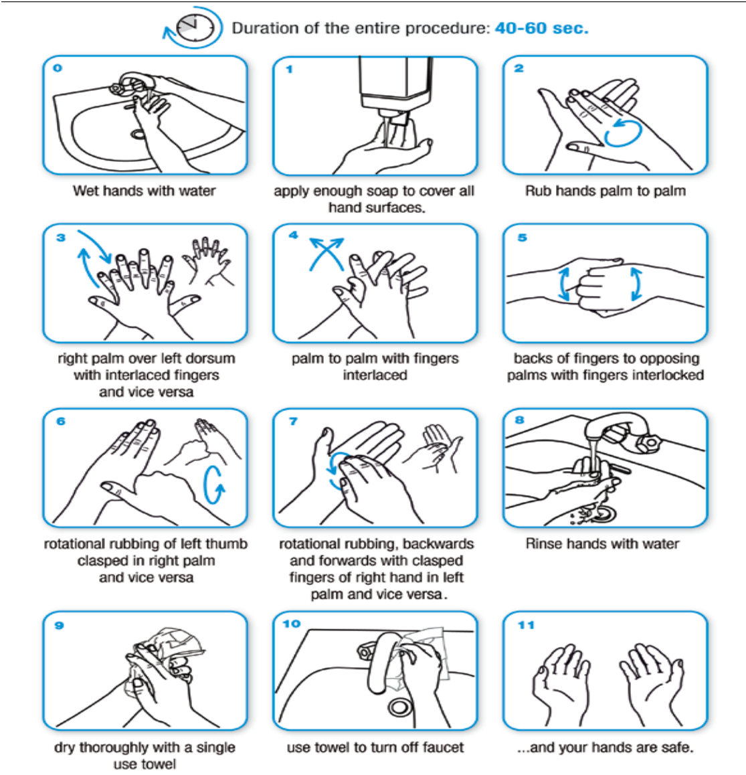

[**www.health.gov.au**](http://www.health.gov.au/)

All information in this publication is correct as of February 2011

D0238 Feb 2011

**How to wash and dry hands with liquid soap and water**

Adapted from World Health Organization

**Gastro Info Kit Sheet 5**

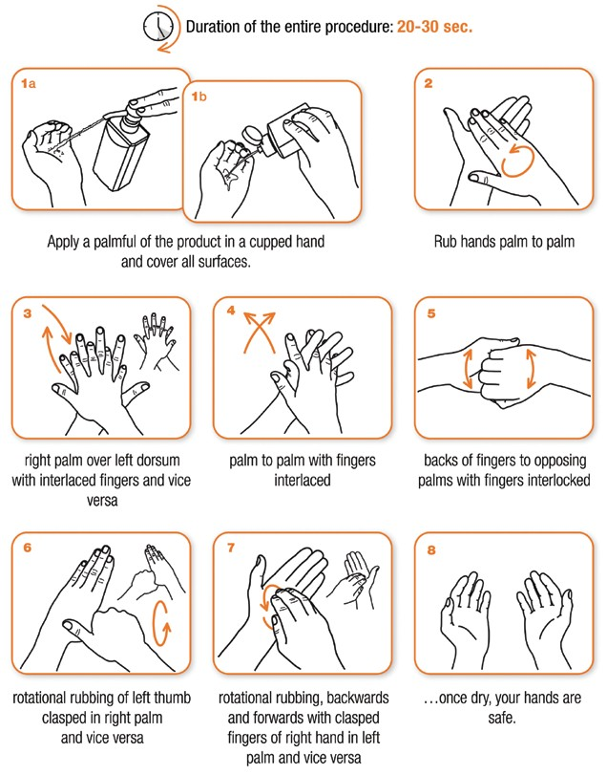

[**www.health.gov.au**](http://www.health.gov.au/)

All information in this publication is correct as of February 2011

D0238 Feb 2011

**How to clean hands using an alcohol-based liquid or hand rub**

Adapted from World Health Organization

**Gastro Info Kit Sheet 6**

**Hand hygiene – when and why?**

The 5 Critical Moments for Hand Hygiene

## Before resident contact

**1**

Before aseptic task

**2**

**WHY?**

To protect resident against harmful organisms on your hands

**WHY?**

To protect resident against harmful organisms

After bodily fluid exposure

**3**

After resident contact

**4**

After contact with resident surroundings

**5**

**WHY?**

To protect yourself and others from harmful organisms

**WHY?**

To protect yourself and others from harmful organisms

**WHY?**

To protect yourself and others from harmful organisms



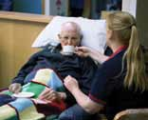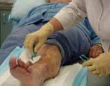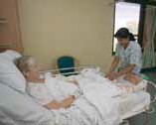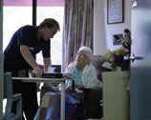

[**www.health.gov.au**](http://www.health.gov.au/)

All information in this publication is correct as of February 2011

D0238 Feb 2011

Hand hygiene must be performed in all situations regardless of whether gloves are used or not

Adapted from World Health Organization

**Gastro Info Kit Sheet 7**



[**www.health.gov.au**](http://www.health.gov.au/)

All information in this publication is correct as of February 2011

D0238 Feb 2011

**Attention Visitors**

**Please be informed that this home is *closed to all visitors* until further notice due to an outbreak of gastroenteritis (diarrhoea and vomiting).**

**Thank you for your cooperation.**

For information about your friend or relative, please contact: Name:

Title:

Phone number:

**Gastro Info Kit Sheet 8**



[**www.health.gov.au**](http://www.health.gov.au/)

All information in this publication is correct as of February 2011

D0238 Feb 2011

**Attention Visitors**

**Please speak to a member of the nursing staff before entering this room.**

**Thank you!**

**Gastro Info Kit Sheet 9**



[**www.health.gov.au**](http://www.health.gov.au/)

All information in this publication is correct as of February 2011

D0238 Feb 2011

**Attention All Visitors**

**A number of residents at this facility have recently had gastroenteritis. We are trying to prevent this illness from spreading.**

**There is a risk of acquiring gastroenteritis by visiting a resident at this time.**

**There is also a risk that you may spread the illness to others.**

**We strongly advise you to consider your need to visit a resident at this time.**

**If you do visit, please speak to the DoN or Manager beforehand. He/she will assist you in following strict hand hygiene practices during your visit.**

Thank you for your co-operation

**Gastro Info Kit Sheet 10**



[**www.health.gov.au**](http://www.health.gov.au/)

All information in this publication is correct as of February 2011

D0238 Feb 2011

**Kitchen Access Restricted**

**Attention all staff:**

**There is currently an outbreak of gastroenteritis within this facility.**

* **Have you had any symptoms of gastroenteritis within the last 48 hours?**

**Symptoms are: abdominal pain, diarrhoea, vomiting, nausea, fever, headaches, and general weakness.**

* **Have you been in contact with potentially infected residents?**
* **Have you been cleaning any potentially contaminated areas?**

**If you answer yes to any these questions, DO NOT enter the kitchen. For further advice and information, please contact:**

**Outbreak Coordinator,**

**or Senior Nurse.**