Decorative imageAustralian Government Department of Health

Exploratory Analysis of Barriers to Palliative Care

Issues Report on Veterans



September 2019

Acknowledgments

Australian Healthcare Associates (AHA) would like to thank the many people who contributed to this project. These included palliative care and other health and social care providers, academics, and peak organisation and government representatives. In particular, we thank the people from the under-served population groups who shared their thoughts and experiences with us.

Contents

Key messages 1

Barriers 1

Promising approaches 1

Recommendations 2

1| Project background 3

This report 4

2| About this population group 5

Context 5

3| Findings 7

Barriers to accessing palliative care 7

Enablers and promising approaches 11

Advance care planning 14

4| Recommendations 15

Addressing facilitators of appropriate palliative care for veterans 16

Addressing underpinning enablers 18

Abbreviations 19

Glossary 20

References 22

Figures and tables

Facilitators and underpinning enablers of quality palliative care 2

Figure 1‑1: Project activities 3

Figure 1‑2: Suite of reports 4

What is palliative care?

Palliative care is a person- and family-centred approach to care. Palliative care services are provided for a person with an active, progressive, advanced disease, who has little or no prospect of cure and who is expected to die, and for whom the primary treatment goal is to optimise quality of life.1 It improves quality of life for individuals and families through the prevention and relief of suffering by means of early identification and correct assessment and treatment of pain and other physical, psychosocial or spiritual problems.3

Palliative care:

* Should be strongly responsive to the needs, preferences and values of people, their families and carers
* Should be available to all people with an active, progressive, advanced disease, regardless of diagnosis

Affirms life while recognising that dying is an inevitable part of life.

This means that palliative care is provided during the time that the person is living with a life-limiting illness, but it is not directed at either bringing forward or delaying death.

Palliative care can be provided in a range of settings, including:

* At home
* At a hospital
* In a hospice
* In an aged care facility

In an institutional setting (such as a correctional facility or accommodation for people living with a disability).

Palliative care involves a range of clinical and other supports delivered by different providers, including volunteers, depending on the patient's needs. These may include:

* General practice and primary care
* Other specialist medical, nursing and allied health practitioners
* Community, disability, aged and social services
* Grief and bereavement services

Specialist palliative care services (comprising multidisciplinary teams with specialised skills, competencies, experience and training in palliative care), for patients with complex needs.

This project adopts a broad view of palliative care, as outlined above, and is not limited to the provision of specialist palliative care services.

Therefore the term ‘palliative care provider’ is used in this document to refer to all health and social care providers involved in the delivery of palliative care.

Where relevant, the term ‘specialist palliative care provider’ is used to differentiate this group of professionals. More broadly, the term ‘health and social care providers’ is used to represent those within this category for whom palliative care is not considered core business.

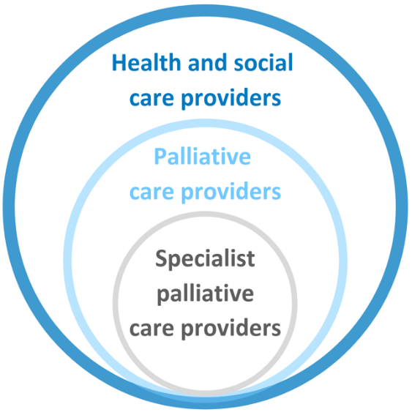

Key messages

Veterans face unique circumstances in relation to accessing palliative care. While not all veterans have experienced active service, military involvement is associated with risk factors that can be detrimental to veterans’ lives. In particular, historical trauma often creates a unique set of needs in this population, and many veterans experience significant health and social challenges.

While many have access to healthcare benefits through Department of Veterans’ Affairs (DVA) entitlements, the scope and extent of available DVA health services and associated eligibility requirements mean that veterans still face challenges when accessing healthcare (including palliative care) that is appropriately tailored to their specific needs.

Barriers and promising approaches for improving access to and experience of palliative care for this population group include:

## Barriers

Veterans’:

* + Lack of awareness/understanding of palliative care
  + Culture of independence and survival

History of trauma and associated issues (including mental health and social issues)

* + Lack of family support

Service providers’:

* + Lack of recognition, awareness and understanding of veterans’ lived experience (especially the likelihood of history of trauma and its potential effects)

Lack of experience working with veterans

* + Gaps in education and training
* Challenges accessing and navigating DVA-administered and other benefits schemes

## Promising approaches

* Community awareness-raising
* Acknowledgment and respect for veterans’ lived experiences
* Trauma-informed approaches to care
* Appropriate information-gathering at start of care pathway (i.e. determining veteran status and service history)
* Expanded and/or simplified access to services funded under DVA benefit schemes

### 

## Recommendations

Recommendations address seven domains that facilitate quality palliative care. These are underpinned by four key enablers, as illustrated below.

Specific recommendations are detailed in section 4.

Facilitators and underpinning enablers of quality palliative care

The facilitators of quality palliative care are: community comfort with death and dying, community awareness and understanding of palliative care, timely initiation of palliative care, provision of person-centred care, greater understanding of under-served populations, appropriate communication and information provision, and advance care planning.
The underpinning enablers are: networks, partnerships and collaborations, workforce development, financial support and resourcing, and research, evaluation and monitoring.

# Project background

Australian Healthcare Associates (AHA) was engaged by the Australian Government Department of Health (the Department) in February 2018, to conduct an exploratory analysis of barriers to accessing quality palliative care for people from under-served populations or people with complex needs (the project). The project ran from February 2018 to June 2019. The main activities that contributed to the project are summarised in Figure 1‑1.

The project generated a high level of engagement from a broad range of stakeholders.

AHA acknowledges that the community members consulted for this project may not be representative of the broader veteran community.

In particular, it is likely that those who participated had a greater understanding of palliative care, and felt more comfortable discussing death and dying, than those who didn't participate and may be more ‘difficult to reach’.

Please refer to the Summary Policy Paper for more information on project methodology and limitations.

Figure 1‑1: Project activities

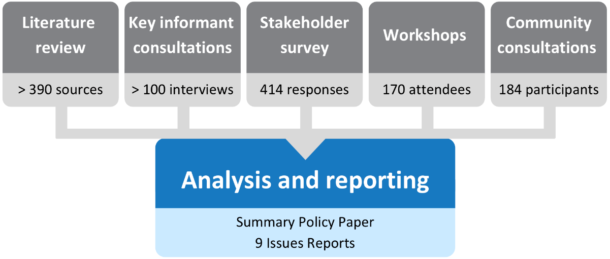

## This report

This issues report describes key barriers and promising approaches for improving veterans’ access to and experience of palliative care in Australia. It also discusses the potential role of advance care planning and provides recommendations for the palliative care and other sectors to improve access and quality of care for veterans.

This issues report is part of a suite of documents developed through the project, as shown in Figure 1‑2.

Figure 1‑2: Suite of reports

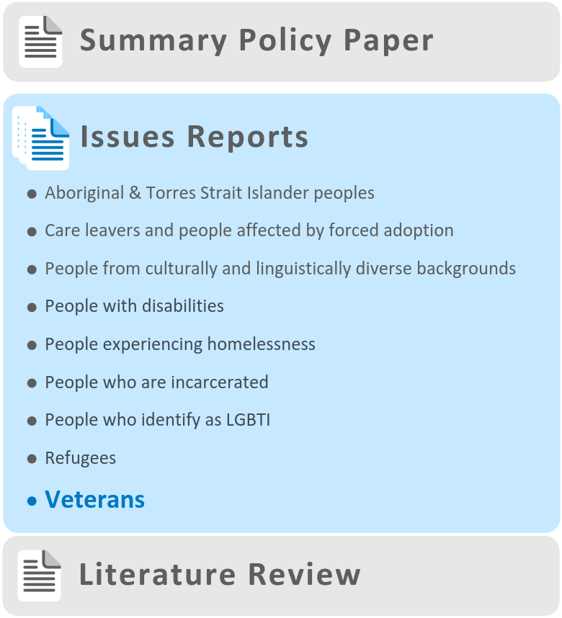

# About this population group

For the purposes of this project, the term ‘veteran’ is defined as ‘a former member of the Australian Defence Force (ADF), irrespective of whether they were deployed or undertook war or warlike service’.2

Veterans face unique circumstances in relation to accessing palliative care. While the veteran population is recognised in aged care legislation as having ‘special needs’, it is important to note that veterans are generally considered to have more opportunity to access healthcare services compared to other ‘under-served’ groups.3 This is generally due to dedicated healthcare benefits that are available to many veterans, which are administered and funded by DVA.4 However, the scope and extent of available DVA health services, along with their associated eligibility requirements, means that veterans still face challenges when accessing healthcare that is appropriately tailored to their specific needs.

## Context

While the exact number of veterans in Australia is unknown, in 2018, DVA estimated the Australian veteran population to be 641,000.5 This figure was derived from ADF enlistment information, and extrapolated from assumptions based on Australian population mortality data.5

The 2014-2015 Australian Bureau of Statistics (ABS) National Health Survey found that of respondents who reported having *ever* served in the ADF:6

* Around 90% were male

Of male respondents, almost half (47%) were aged 65 years or over, compared to only one-quarter (23%) of female respondents.

As noted above, veterans may be entitled to dedicated healthcare, via services administered and funded by DVA.4 Depending on their personal circumstances, veterans may be eligible for DVA-funded services such as medical care—including palliative care—dental care, allied health and specialist services, hospitals, medications, rehabilitation, counselling, transport and home care.7

The two major routes for accessing DVA healthcare services are via the white card and gold card schemes.8

* The white card entitles eligible veterans to healthcare for a specific condition—or set of conditions—that are causally related to previous military service.

The gold card is a more comprehensive healthcare scheme compared to the white card, entitling eligible veterans to (mostly) unrestricted care for all medical conditions, irrespective of causality.

While not all veterans will have experienced active service, military involvement itself is associated with risk factors that can be detrimental to veterans’ lives, and periods of absence from family for training and/or deployment can negatively affect family relationships.9 Historical trauma often creates a unique set of needs in this population, particularly mental health issues, such as post-traumatic stress disorder (PTSD).5,10–12 Indeed, previous service in the ADF means that many veterans experience health and social challenges above those experienced by the general population.5

It is perhaps unsurprising, therefore, that veterans are also more likely to experience homelessness, compared to the general population. Veterans who experience homelessness face additional and specific challenges when it comes to accessing health services, including palliative care. Please refer to the Issues report on people experiencing homelessness for a more detailed discussion.

The literature review undertaken for this project found that the majority of peer-reviewed research was derived from the United States (US), with comparatively little originating from Australia. This can, in part, be explained by the wide disparity in each country’s relative involvement in military action across the world, and may limit the relevance of international literature in the Australian context.

# Findings

During the project it was noted that many of the issues identified as barriers, enablers and promising approaches to accessing palliative care by veteran populations were actually universal factors, i.e. common to the general Australian population, rather than being specific to veterans. These universal factors, along with a range of other factors that are common to all under-served populations, are described in the *Summary Policy Paper* from this project. The discussion below focuses on factors identified as specific to veterans.

Many of the barriers raised through consultations and described below apply to health care and aged care more broadly and are not specific to palliative care.

It is also recognised that the veteran population is heterogeneous, and, while findings and recommendations in this issues report are generalised, they are unlikely to be relevant in all cases.

The barriers and enablers identified in this report have been categorised as ‘consumer-side’ and ‘service-side’. Consumer-side factors relate to characteristics of individuals, families and communities, while service-side factors relate to health professionals, services and organisations, and the healthcare system more broadly. These categories are not intended to lay fault for barriers or responsibility for enablers on one particular side of the palliative care relationship, but rather to provide a framework within which to consider an appropriate service system response.

## 

## Barriers to accessing palliative care

### Consumer-side barriers

By far the most commonly identified barrier for veterans accessing palliative care services was the prevalence of mental health issues, and in particular, PTSD. Veterans in Australia have been found to be at higher risk of developing PTSD and affective and anxiety disorders, among other conditions, compared to the general population.5 According to the National Hospital Morbidity Database, anxiety disorders were the most common reason for DVA-funded hospitalisations for men aged 55 and over in 2015-2016.5

Mental health issues can have a profound personal impact, and serve both to exacerbate and complicate palliative care need, in terms of the types and intensity of supports that may be required. The presence of mental health problems can also severely impact on veterans’ ability and willingness to form trusting therapeutic relationships with health professionals, and indeed, vice versa.

This may in part be due to the fact that mental health conditions—especially PTSD—are commonly stigmatised, and so those living with these issues may be reluctant or unwilling to disclose this information to health professionals. Indeed, it was reported that some veterans prefer not to disclose their veteran status at all, and some (e.g. younger people or those who have not been involved in active service) may not identify as such. Further, the idea of ‘disclosure’ of mental health issues assumes that a formal diagnosis has been made, whereas many veterans may experience underlying problems which are never formally recognised or diagnosed. A lack of consideration of underlying mental health issues can lead these individuals to be mislabelled as ‘aggressive’ or ‘problem patients’. This can, in turn, result in the refusal of health professionals to treat veterans requiring palliative care.

‘You don’t want to tell people, and so you can be quickly written off as an angry or difficult person’ —Veteran

A general lack of awareness and understanding of what palliative care is, and how it might benefit them as they approach end-of-life, is another barrier for veterans. Stakeholders also noted that veterans may be unaware of which palliative care services they are eligible to receive—notably, services administered by DVA as opposed to the ‘mainstream’ services administered by the Australian Government Department of Health.

Indeed, a small retrospective review of the palliative care and other medical records of ten Australian veterans who had died in Victoria in 2009-2010, identified a need for better education about palliative care options and support services for patients and their families.13

Another barrier identified through this project was that service in the armed forces can foster a strong culture of independence and ‘survival’, which becomes entrenched for life. Having a strident, proud attitude of ‘she’ll be right’, means that individuals may be less inclined to seek help—be it from family, friends, or wider society. This could mean that, compared to the general population, veterans are less likely to access healthcare services generally, and by extension, less likely to access palliative care services.

‘They have a perception that they’re super-heroes—they don’t need help, they are survivors’ —Specialist palliative care provider

As mentioned above, veterans are over-represented among the homeless population in Australia14, and veterans experiencing homelessness are likely to face barriers that are significantly compounded and complicated by this dual disadvantage. Please see the Issues Report on people experiencing homelessness for a detailed discussion of barriers related to homelessness.

Other identified barriers for veterans included issues associated with substance use/misuse, family breakdown, and disenfranchisement—the latter often stemming from veterans’ actual or perceived feelings of institutional mistreatment following their return from service.

‘People think they’ll be looked after when they leave the army, but this doesn’t automatically happen’  
—Veteran

The transition from military to civilian life can also manifest as a source of trauma.15

Very few family-related barriers were identified during the project. Where available, the literature did suggest that in many cases veterans lacked family support at end-of-life. This resulted in palliative care being provided in healthcare settings rather than at home, regardless of personal choice.16

### Service-side barriers

A frequently-identified barrier was the lack of recognition for the lived experience of veterans, especially history of trauma and associated PTSD. Trauma, and PTSD more specifically, can manifest in a myriad of ways; for some, symptoms may be constant and readily apparent, while others may only exhibit symptoms when triggered. Trauma may go unrecognised, or individuals may be a reluctant to acknowledge it. As such, clinically significant conditions such as PTSD may not be immediately obvious to, or understood by, health professionals.13

This lack of awareness or understanding may stem from professional ignorance, perhaps from gaps in education or training, and/or be due to a lack of experience working with veterans.

Regardless of the reason, stakeholders noted that the lack of consideration of trauma, and specifically PTSD, by health professionals can cause the unintentional triggering of profoundly uncomfortable, sometimes violent, responses in veterans. Unsurprisingly, this may prove a strong deterrent to veterans seeking out palliative care services, and to health professionals’ willingness to treat veterans with PTSD.

‘Hospital staff don’t understand about war trauma. They don’t understand about the nightmares’ —Veteran

‘There’s an assumption that they’ll have PTSD; that they’ll be a problematic patient’   
—Specialist palliative care provider

By the same token, it was also noted that health professionals should not assume that ***all*** patients who are veterans have PTSD, or that all mental health conditions relate to past trauma. Instead, health professionals should be aware of the possibility of trauma, be mindful of PTSD, and manage individuals accordingly.

Various examples of poor clinical practice were relayed by veterans consulted during the project. These examples centred on health professionals rousing veterans from sleep:

* When a veteran with PTSD is woken at their head-end, e.g. by touching their shoulder, this can cause alarm and trigger a violent reflex, causing them to lash out at the perceived danger.

Similarly, the use of torches during nightly ward-rounds to check on patients can startle those with PTSD from sleep, triggering an intensely negative response which may endanger themselves and/or others.

Instead, health professionals should be mindful of such potential triggers when caring for veterans, and adjust their practice accordingly, for example, by waking sleeping individuals via their foot-end, and avoiding the use of torchlight during nightly ward-rounds.

#### DVA

Another commonly noted barrier for veterans was the challenge of accessing and navigating DVA-administered benefits schemes, via the white card and gold card schemes. Equally, it was noted that not all veterans are ***eligible*** to receive health services under these schemes.

Only a subset of Australian veterans are deemed to be ‘clients of DVA’, that is, eligible for DVA-administered and funded health care (and/or receiving a DVA pension or allowance).7 For example, DVA reports from 2017 suggest:

There were just over 165,000 veterans identified as DVA clients, which is somewhat lower than DVA estimates of the overall population of veterans in Australia (641,000 in 2018).

* Of existing veterans, only one in three who had served in the ADF since the Vietnam war—and only 1 in 5 who had served since 1999—were DVA clients.

Of veterans who were DVA clients, just over two-thirds (67%) held a gold card or a white card.5

The relatively low proportion of veterans registered with DVA may, in part, be due to the fact that the DVA applications and claims processes were found to be complicated and tedious. For veterans who have spent their entire adult life in the army, their experience of paperwork, and/or their ability to manage it, may be limited or non-existent. Similarly, those with mental health difficulties may find the process particularly frustrating and challenging. Indeed, many veterans felt ‘overwhelmed’ by the system before they even attempted to tackle it.

These findings are in line with research from the US, which showed that veterans face significant challenges in navigating the US Department of Veterans Affairs, finding it too complex and difficult to source information and advice.17

Stakeholders also noted that, in a population where mental health issues are so prevalent, a definitive diagnosis is typically required in order for veterans to access DVA-administered services. Obtaining a formal diagnosis may require intensive psychological assessment and examination of past trauma, which many veterans find intolerable. This may therefore deter them from pursuing treatment they would otherwise be eligible to receive.

The challenge of navigating multiple care services which may be administered and funded differently was also identified as a barrier to veterans accessing palliative care. This can occur when a veteran's care needs change, increase or become more complex. It was noted that while the gold card entitles holders to access private healthcare, most palliative care services are publicly funded, which may make it more difficult for veterans to link in to palliative care. The interplay between the different systems can create significant complexity for access and jeopardise continuity of care, leaving veterans to fall through the gap between services.

## Enablers and promising approaches

### Consumer-side enablers

While no particular consumer-side enablers or promising approaches were noted during the project, those related to service-side factors are described below.

### Service-side enablers

Health professionals acknowledging, and fostering a respect for, the lived experience of veterans was identified as a primary enabler for veterans to access quality palliative care. Such acknowledgment and respect was seen as key to creating an environment in which veterans could feel safe and comfortable and be willing to seek help.

Participants identified health professionals’ ability and confidence to ask the right questions about a veteran’s background in a sensitive, non-triggering way as another important enabler. Such information-gathering at the start of the care pathway was considered to be crucial for opening the door to important conversations, and reducing the risk of triggering avoidable negative situations.

‘The main issue was a lack of information, communication and care…No one listened to his story, no one cares about his choices’ —Carer

Indeed, a qualitative review of the palliative care records of veterans that had accessed home-based palliative care in Australia found that services could be improved by health professionals taking the time and effort to consider veteran status and service history.13

That said, it was also noted that veterans can be very private, and those with PTSD may be liable to ‘clam up’ when they feel uncomfortable or under threat. However, engaging with veterans in a sensitive way can reveal useful insights for health professionals, such as the recognition of past trauma. This could be of great value in helping health professionals manage these patients more appropriately.

During the project, it was frequently noted that gaining an understanding of a person’s wider, holistic needs, rather than focusing only on ostensible clinical needs, can promote a more individualised approach to palliative care, leading to better outcomes. Indeed, the sentiment ‘meet me where I am’ emerged as a fundamental theme.

‘You need to look at the big picture’   
—Specialist palliative care provider

#### DVA

As an organisation, DVA was seen as a key enabler for veterans accessing quality palliative care, particularly in relation to the healthcare services administered and funded under the white card and gold card schemes. Indeed, in one Australian study comparing a small sample of veterans and non-veterans, access to DVA-administered health services was found to reduce financial stress on veterans accessing palliative care.13

The gold card scheme entitles eligible veterans to largely unrestricted care for their health conditions (i.e. not just those related to war service, which is the case for the white card scheme)8, and this was seen as a powerful enabler to accessing palliative care services. One stakeholder alluded to the fact that a veterans’ experiences of palliative care could be ‘very different’ depending on which card they held. That said, it is important to reiterate here that a sizeable proportion of veterans hold neither DVA card (see *Service-side barriers*).

Finally, it was noted that under a separate DVA health scheme—called ‘Non-Liability Health Care’18—DVA has recently expanded its offerings to provide funding for mental health conditions.18 This expansion of DVA services may, in time, indirectly support veterans to access DVA-funded palliative care services.

### Asking veterans about their service history

While palliative care services would likely benefit from considering a veteran’s service history to improve care, this is not commonly reported.13

The Palliative Care Network of Wisconsin (US) suggests the following may be useful in guiding such conversations, noting the potential to re-trigger trauma and the need to obtain consent before proceeding.19

**Starting** **questions**

* Are you a veteran?
* Tell me about your military experience?
* What did you do in the military?
* When and where did you serve?
* What branch of the military were you in?
* How has it affected you?

**Detailed questions**

* What was your highest rank?
* Did you see combat or were you in a combat area?
* Did you see enemy fire or casualties?
* Were you a prisoner of war?
* Were you wounded or hospitalised?
* Do you have a service-connected condition?

**Depending on military history:**

* Do you think you were changed as a result of being in the military?
* Do you think your experiences in the military are affecting you today?
* Is there anything about your experiences in the military that is still troubling you today?
* Do you have nightmares about war?
* What was your homecoming like? Is there anything about your homecoming that is still troubling you today?
* Do you think your experiences in the military and your homecoming affected your relationships with family and friends when you returned?
* Do you keep in touch with your war buddies?
* Do you think your military experiences are influencing the way you are now coping with your illness?

Warrnambool and District   
Community Hospice (Vic)

Examples of organisations offering palliative care exclusively to Australian veterans were not uncovered during the project. However, examples of veterans receiving quality palliative care services from more general services were identified, such as in the case below.

The Warrnambool and District Community ‘Hospice in the Home’ (Hospice) is a not-for-profit organisation that supports people who are reaching end-of-life to stay in their own homes—if that is their wish—with support from a team of trained volunteers. Referrals can be made by a community or family member, doctor, the community palliative care team, or other health services.

Hospice supports clients from a wide range of backgrounds, including veterans, to ‘make the most of every moment as their lives draw to a close’.

Dorothy was in the Women’s Auxiliary Air Force (WAAF) as a Morse code operator for three years. She was 16 years old when she joined the wireless telegraphy training, in the Brisbane Women’s Training Unit, in 1940.

Dorothy was referred to Hospice by the South West Healthcare Community Palliative Care Service at the age of 91, in April 2017, following discharge from hospital. She was suffering from end-stage cardiac disease, and her daughter was her primary carer. Like many veterans, Dorothy wanted to die at home, and was waiting for a home care package through My Aged Care.

Dorothy required full-time care because she was often quite confused, was at risk of falls, and suffered from pain due to crushed vertebrae. Care was coordinated by her daughter and the hospice manager. Other community services involved in supporting Dorothy included Community Palliative Care, Baptcare, Returned and Services League (RSL) and the local hospital.

Volunteers would sit with Dorothy and talk, read to her, watch movies or play music, assist her to the toilet, prepare her meals and massage her feet and hands. When she was able, they would take her out for a coffee. Dorothy also loved to have her hair and makeup done, and this was something the volunteers knew would always make her smile.

Twenty-five individual volunteers gave over 1,500 hours of care to Dorothy from April 2017 until November 2018, when she died peacefully at home. Despite her confusion, Dorothy was loved by the volunteers and even though Hospice had to provide care over a much longer period than usual (around 18 months), there was rarely a time when a volunteer shift couldn’t be filled.

For more information about Hospice, see the [Warrnambool and District Community Hospice website](https://www.warrnamboolhospice.org.au/home).[1]

## Advance care planning

The process of advance care planning involves conversations about future healthcare preferences between a competent person, healthcare providers and potential substitute decision-makers. The outcomes of the process can include the development of statutory or non-statutory advance care directives (ACDs), or other, less formal documentation of a person’s preferences and substitute decision-maker.20

In line with the limited availability of general literature on Australian veterans, peer-reviewed research on advance care planning in this population was found to be scant. However, extrapolation of research originating from the US suggests that the level of advance care planning by Australian veterans is likely to be low.21 Through stakeholder consultation, no particular barriers relating to advance care planning were identified for Australian veterans; however, a number of enablers were identified and these are described below.

Interestingly, while the lived experience of veterans was cited as a barrier to accessing palliative care, it was found to be an *enabler* for advance care planning. As a result of their military service, veterans may be more familiar, and comfortable, with the notion of death and dying. This may make veterans less averse to talking about and planning for end-of-life—compared to the general population.

‘There is no hiding from death. When you’re at war you see it every day. I’m open to the reality’  
—Veteran

Capitalising on the willingness of veterans to engage with the topics of death and dying, another identified enabler was health professionals being proactive and introducing the concept of palliative care much earlier in the care pathway. It was further noted that in order to effectively relate to veterans, discussions could be had in a frank and ‘straight-talking’ way. As one veteran candidly stated:

‘If I’m in hospital, I would want them to tell me the truth. No bullsh*tting’   
—Veteran

Another important driver of advance care planning was the critical importance that veterans place on ‘dying with dignity’. In line with their fiercely proud and independent nature, the veteran population was found to give particular prominence to being able to make their own decisions. In proactively planning for their own care needs, veterans can feel more reassured that they will not become an undue burden to their friends and family in the future.

As an example, one stakeholder who was a veteran commented that in articulating and recording his decision to have a ‘Do Not Resuscitate’ (DNR) order in place, he was making a positive personal choice about how he wished to die.

# Recommendations

The *Summary Policy Paper* identifies facilitators of appropriate care in seven domains, underpinned by four key enablers (see p.2).

These domains and enablers are broadly consistent with the National Palliative Care Strategy 2018 and other relevant policy documents. Recommendations arising from the project—including recommendations specific to veterans are framed in this context.

The recommendations reflect a public health approach to palliative care (see Summary Policy Paper for details), which involves multiple sectors—from individuals and families to specialist palliative care service providers and broadly-focused, ‘non-traditional’ partners and collaborators.

These recommendations are designed to bolster the capacity of all relevant sectors to promote access to appropriate, quality palliative care for veterans with a life-limiting illness. In particular, the idea of **person-centred care shines through as the ultimate goal** of all palliative care service provision. Person-centred care is respectful of, and responsive to, the preferences, needs and values of individuals. As a concept, it incorporates respect, emotional support, physical comfort, information and communication, continuity and transition, care coordination, involvement of family and carers and access to care.22 For veterans, trauma-informed approaches represent a key components of person-centred care (see *Summary Policy Paper* for more detail).

It is important to acknowledge that identifying and providing the elements necessary to deliver person-centred care for people from under-served populations, including veterans, is likely to be particularly challenging and resource-intensive.

Person-centred care shines through as the ultimate goal of all palliative care service provision.

It is also important to recognise that implementing the recommendations in this report may require service providers and other organisations to make significant changes to organisational policies and procedures, structures and systems.

It is therefore vital that the underpinning enablers identified through this project—particularly workforce development and financial support and resourcing—are firmly in place. Without this support, efforts to improve access to quality, appropriate palliative care for veterans and other under-served population groups are unlikely to succeed.

Palliative care providers may also need assistance from those with a greater understanding of the needs of veterans to co-design services and optimise person-centred care. Linkages between the palliative care sector and relevant community and support organisations—i.e. those with existing relationships and experience meeting the needs of veterans—are likely to be of particular importance (see *Summary Policy Paper* for further discussion).

## 

## Addressing facilitators of appropriate palliative care for veterans

Increase community comfort with discussing death and dying

* Improve the comfort of all of society in discussing issues relevant to death and dying—including individuals, communities, health and social care providers.

Assist health and social care providers to improve their skill and confidence in talking about these issues with veterans.

Promote community awareness and understanding of palliative care

Improve community understanding about palliative care, through broad social marketing strategies as well as specific efforts focusing on veterans (e.g. education sessions organised through veteran support organisations such as the RSL, Legacy and DVA).

Facilitate timely initiation of palliative care

* Upskill health and social care providers and other relevant support people to identify when palliative care may be needed, engage in discussions with individuals and families and initiate or refer for care as appropriate.

Consider introduction of standard palliative care-related practices and/or referral processes for all at time of diagnosis with a life-limiting illness.

Foster a greater understanding of veterans

* Ensure all health and other relevant care providers are aware of and responsive to the potential impacts of the life experiences of veterans—in particular the increased likelihood of trauma.

Promote cultural understanding, while avoiding cultural stereotyping.

Improve communication and information provision

* Support effective provider-patient communication and the provision of appropriate information. Consider:
  + Information using appropriate terms and styles in different languages and formats
  + Specific information about palliative care options and entitlements—including those available through DVA.

Provide one-on-one support to individuals/families to navigate the relevant system(s), including accessing DVA.

Enhance provision of person-centred care

* Facilitate the identification of veterans in palliative care settings to promote culturally-appropriate care.
* Bolster communities’ capacity to deliver palliative care that is flexible, individualised and delivered in setting(s) of choice where possible.
* Ensure appropriate setting design for veterans, including physical access, accommodation options, decoration/displays etc.
* Consider and respect the role of families (as defined by individuals) and communities in decision-making and person-centred care.
* Engage with veteran communities to co-design services.
* Consider peer support programs for veterans receiving palliative care.

Ensure organisational policies and culture are inclusive and support person-centred care.

Better support advance care planning

* Build on current approaches to enhance advance care planning for veterans, particularly in specific settings such as primary care, aged care and disability support as well as palliative care.
* Continue to explore opportunities for promoting consistency and mutual recognition of advance care planning documentation across Australian jurisdictions.

## Addressing underpinning enablers

Networks, partnerships and collaborations

* Build the capacity of support organisations to undertake a linking role with palliative care services, e.g. to:
  + Assist individuals to navigate services—including health care, palliative care, aged care and other services
  + Serve as a resource for palliative care services to understand the needs of veterans
  + Assist with broader awareness-raising in relation to palliative care and advance care planning within the communities they serve.

Build linkages and reciprocal collaborations between all relevant sectors (e.g. palliative care, other health and community care services as well as support organisations and other services providers) to develop best-practice approaches to palliative care service delivery for veterans.

Workforce development

* Consider training and ongoing professional development initiatives that increase or improve health and social care providers’:
  + Understanding of veterans and their needs
  + Understanding of and ability to provide or support person-centred palliative care
  + Knowledge of and skill applying trauma-informed approaches
  + Comfort and capacity to assist individuals with advance care planning.

Financial support and resourcing

Noting that all recommendations in this document require appropriate levels of resourcing, more specific funding recommendations include:

* Ensure palliative care funding models are flexible to allow delivery of person-centred palliative care—recognising that meeting the needs of veterans may be intensive in terms of both time and resources.
* Improve the alignment of the relevant funding systems (including DVA, aged care, primary and other healthcare) to support seamless transitions.

Fund community-based/population-specific approaches to palliative care, including establishment and maintenance of collaborative arrangements.

Research, evaluation and monitoring

* Consider appropriate research, evaluation and monitoring activities at all levels to understand the needs of veterans and evaluate efforts to improve access for this group.
* Include activities relevant to veterans in palliative care quality assurance and improvement initiatives.

Abbreviations

|  |  |
| --- | --- |
| Abbreviation | Definition |
| ABS | Australian Bureau of Statistics |
| ACD | Advance Care Directive |
| ADF | Australian Defence Force |
| AHA | Australian Healthcare Associates |
| DNR | Do not resuscitate |
| DVA | Department of Veterans' Affairs |
| GP | General Practitioner |
| PTSD | Post-traumatic stress disorder |
| RSL | Returned and Services League |
| the Department | Australian Government Department of Health |
| US | United States [of America] |
| WAAF | Women’s Auxiliary Air Force |

Glossary

Advance care directive (ACD): An advance care directive is a type of written advance care plan recognised by common law or specific legislation. An ACD can only be completed and signed by a competent adult. It may record the person’s values and preferences for future care, and/or include the appointment of a substitute decision-maker to make decisions about health care and personal life management. Forms and requirements vary between states and territories.23

Advance care planning: The process of planning for future health and personal care needs. It provides a way for a person to make their values and preferences known in order to guide decision-making at a future time when they cannot make or communicate their decisions.24

Care leavers: Includes Forgotten Australians, Former Child Migrants and Stolen Generations.

Carers: People who provide personal care, support and assistance to people with a disability, medical condition, mental illness, or frailty due to age. Carers may include family members, friends, relatives, siblings or neighbours. The term ‘carer’ does not include people who provide care for payment (such as a care or support worker), as a volunteer for an organisation, or as part of the requirements of a course of education or training.25

End-of-life care: Includes physical, spiritual and psychosocial assessment, and care and treatment delivered by health professionals and other staff. It includes the support of family and carers, and care of the person’s body after death. People are ‘approaching the end-of-life’ when they are likely to die within the next 12 months.26

Family: Includes people identified by the person as family and may include people who are biologically related and people who joined the family through marriage or other relationships, as well as family of choice and friends.1

Life-limiting illness: Describes illnesses where it is expected that death will be a direct consequence of the specified illness. The term incorporates the concept that people are actively living with such illnesses, not simply dying.1

Palliative care providers: Health and social care providers involved in the clinical management and coordination of care for people living with a life-limiting illness. Palliative care providers may include general practitioners (GPs), geriatricians, oncologists, physicians, paediatricians, renal specialists, cardiologists and other specialists. Other team members will include nurses, allied health professionals and pharmacists.1

Person-centred care: Care that is ‘respectful of, and responsive to, the preferences, needs and values of patients and consumers’.22

Specialist palliative care services: Multidisciplinary teams with specialised skills, competencies, experience and training in palliative care. Care provided through these services is targeted at people with more complex needs, and is referred to as ‘specialist palliative care’.1

Substitute decision-maker: A person appointed or identified by law to make decisions on behalf of a person whose decision-making capacity is impaired. A substitute decision-maker can be:

Someone chosen (and appointed) by the person. Depending on the state or territory, they may be called an enduring guardian, a medical enduring power of attorney, an agent or a decision-maker.

Someone assigned as a decision-maker for the person by law, in the absence of an appointed substitute decision-maker. The hierarchy for appointing a substitute decision-maker varies by jurisdiction. They may be a spouse or de facto spouse, carer, relative or friend.

A substitute decision-maker appointed for the person (e.g. a guardian appointed by a guardianship tribunal).23

Trauma-informed care: ‘An organisational structure and treatment framework that involves understanding, recognising and responding to the effects of all types of trauma’.27

References

1. Palliative Care Australia. Palliative Care Service Development Guidelines. (2018).

2. Foreign Affairs Defence and Trade References Committee. Mental health of Australian Defence Force members and veterans. (Commonwealth of Australia, 2016).

3. Department of Health. Legislated review of aged care 2017. (Commonwealth of Australia, 2017).

4. Gill, G. F., Bain, R. & Seidl, I. Supporting Australia’s new veterans. Aust. Fam. Physician 45, 102 (2016).

5. Australian Institute of Health and Welfare. A profile of Australia’s veterans. (AIHW, 2018).

6. Australian Bureau of Statistics. National Health Survey: First Results, 2014-15. National Health Survey (2015).

7. Australian Government Department of Veterans’ Affairs. Annual Reports 2016-17. (2017).

8. Australian Government Department of Veterans’ Affairs. DVA health cards. Department of Veterans’ Affairs (2018). Available at: https://www.dva.gov.au/providers/dva-health-cards. (Accessed: 15 May 2019).

9. AT-Ease Professionals. Impact of veterans’ experiences on their families. (2019). Available at: https://at-ease.dva.gov.au/professionals/client-resources/mental-health-advice-book/12-impact-veterans-experiences-their. (Accessed: 26 Aug 2019).

10. Goy, E. R. & Ganzini, L. Prevalence and natural history of neuropsychiatric syndromes in veteran hospice patients. J. Pain Symptom Manage. 41, 394–401 (2011).

11. Holland, J. M., Currier, J. M., Kirkendall, A., Keene, J. R. & Luna, N. Sadness, anxiety, and experiences with emotional support among veteran and nonveteran patients and their families at the end of life. J. Palliat. Med. 17, 708–11 (2014).

12. Ganzini, L., Socherman, R., Duckart, J. & Shores, M. End-of-life care for veterans with schizophrenia and cancer. Psychiatr. Serv. 61, 725–728 (2010).

13. O ’Connor, M., Brennan, B., Bloomer, M. J. & Shimoinaba, K. Vulnerability at the end of life: Australian veterans requiring home-based palliative care. Home Health Care Manag. Pract. 26, 134–140 (2014).

14. Bruce, C. 1 in 20 homeless people surveyed are military veterans: new study. (2018). Available at: https://hope1032.com.au/stories/life/news/2018/1-20-homeless-people-surveyed-military-veterans-new-study/. (Accessed: 14 May 2019).

15. Soldier On. Soldier On federal budget submission 2017-2018.

16. Hallenbeck, J. Toolkit for developing hospice and palliative care programs in the Department of Veterans Affairs medical centers. (Department of Veterans Affairs, 2001).

17. Casarett, D. et al. Important aspects of end-of-life care among veterans: Implications for measurement and quality improvement. J. Pain Symptom Manage. 35, 115–25 (2008).

18. Australian Government Department of Veterans’ Affairs. Factsheet HSV109 - Non-liability health care. (2018). Available at: https://www.dva.gov.au/factsheet-hsv109-non-liability-health-care. (Accessed: 4 Jun 2019).

19. Hallarman, L. & Kearns, C. Fact file and concept #152: The military history as a vehicle for exploring end of life care with veterans. (2015). Available at: https://www.mypcnow.org/blank-v6bdf. (Accessed: 30 May 2019).

20. Buck, K. et al. Prevalence of advance care planning documentation in Australian health and residential aged care services, Short Report. (Advance Care Planning Australia, Austin Health, 2017).

21. Pearlman, R. A., Starks, H., Cain, K. C. & Cole, W. G. Improvements in advance care planning in the Veterans Affairs system: Results of a multifaceted intervention. Arch. Intern. Med. 165, 667–674 (2005).

22. Australian Commission on Safety and Quality in Health Care. Patient-centred care: Improving quality and safety through partnerships with patients and consumers. (ACSQHC, 2011).

23. Advance Care Planning Australia and National Ageing Research Institute. Advance care planning in aged care: A guide to support implementation in community and residential settings.

24. Advance Care Planning Australia and National Ageing Research Institute. Advance care planning in aged care: A guide to support implementation in community and residential settings.

25. The Parliament of Australia. Carer Recognition Act No.123, 2010. (2010).

26. Australian Government Department of Health. National Palliative Care Strategy 2018.

27. Victorian Government Department of Health & Human Services. Trauma and mental health: 10-year mental health plan technical paper. (DHHS, 2015).

1. https://www.warrnamboolhospice.org.au/home