Australian Government Department of Health

Exploratory Analysis of Barriers to Palliative Care

Issues Report on Refugees



September 2019

Acknowledgments

Australian Healthcare Associates (AHA) would like to thank the many people who contributed to this project. These included palliative care and other health and social care providers, academics, and peak organisation and government representatives. In particular, we thank the people from the under-served population groups who shared their thoughts and experiences with us.

Contents

Key messages 1

Barriers 1

Promising approaches 1

Recommendations 2

1| Project background 3

This report 4

2| About this population group 5

Context 5

3| Findings 6

Barriers to accessing palliative care 6

Enablers and promising approaches 10

Advance care planning 15

4| Recommendations 17

Addressing facilitators of appropriate palliative care for refugees 18

Addressing underpinning enablers 19

Abbreviations 21

Glossary 22

References 24

Figures and tables

Facilitators and underpinning enablers of quality palliative care 2

Figure 1‑1: Project activities 3

Figure 1‑2: Suite of reports 4

What is palliative care?

Palliative care is a person- and family-centred approach to care. Palliative care services are provided for a person with an active, progressive, advanced disease, who has little or no prospect of cure and who is expected to die, and for whom the primary treatment goal is to optimise quality of life.1 It improves quality of life for individuals and families through the prevention and relief of suffering by means of early identification and correct assessment and treatment of pain and other physical, psychosocial or spiritual problems.3

Palliative care:

* Should be strongly responsive to the needs, preferences and values of people, their families and carers
* Should be available to all people with an active, progressive, advanced disease, regardless of diagnosis

Affirms life while recognising that dying is an inevitable part of life.

This means that palliative care is provided during the time that the person is living with a life-limiting illness, but it is not directed at either bringing forward or delaying death.

Palliative care can be provided in a range of settings, including:

* At home
* At a hospital
* In a hospice
* In an aged care facility

In an institutional setting (such as a correctional facility or accommodation for people living with a disability).

Palliative care involves a range of clinical and other supports delivered by different providers, including volunteers, depending on the patient's needs. These may include:

* General practice and primary care
* Other specialist medical, nursing and allied health practitioners
* Community, disability, aged and social services
* Grief and bereavement services

Specialist palliative care services (comprising multidisciplinary teams with specialised skills, competencies, experience and training in palliative care), for patients with complex needs.

This project adopts a broad view of palliative care, as outlined above, and is not limited to the provision of specialist palliative care services.

Therefore the term ‘palliative care provider’ is used in this document to refer to all health and social care providers involved in the delivery of palliative care.

Where relevant, the term ‘specialist palliative care provider’ is used to differentiate this group of professionals. More broadly, the term ‘health and social care providers’ is used to represent those within this category for whom palliative care is not considered core business.

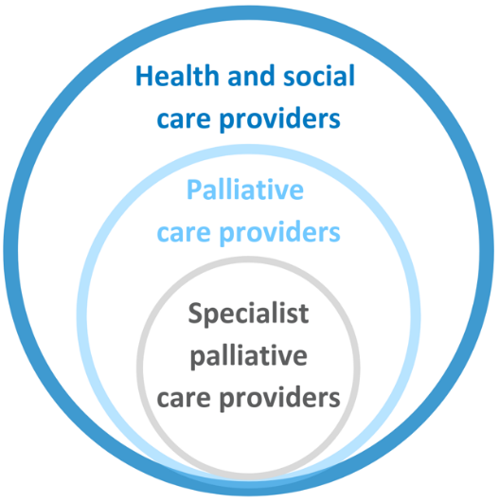

Key messages

Refugees and asylum seekers often face a range of health and social challenges as a result of language and cultural issues, the disruption associated with their life experiences and adverse conditions in the community. They may have relatively poor health and complex needs requiring specialised, longer-term or more intensive services (including palliative care services), but these may be more difficult to access due to cost or eligibility issues.

Barriers and promising approaches for improving access to and experience of palliative care for this population group include:

## Barriers

* Lack of awareness/understanding of palliative care
* Language and communication issues
  + Poor literacy/health literacy
  + Poor access to professional interpretation services
* Mismatching cultural, religious and/or health beliefs and preferences between refugees and service providers
* Difficulty accommodating cultural practices in palliative care settings
* Effects of trauma (including complex mental and physical health symptoms)
* Lack of/late referral to, or initiation of, palliative care
* Fear or distrust of services, reluctance to disclose information
* Social isolation and family separation
* Socioeconomic factors (lack of stable housing, financial resources)
* Eligibility issues (for publicly-funded care); legal, financial and/or duty-of-care considerations for those in detention settings

## Promising approaches

* Community education and awareness-raising
* Cultural champions
* Culturally-appropriate and translated resources
* Access to appropriate professional interpreting services
* Training for professional interpreters (in palliative care concepts and terminology)
* Improved cultural competence within services
  + Education and training to increase understanding of the ‘refugee experience’
  + Culturally-appropriate communication
  + Facilitating cultural elements and practices in service provision
* Taking time to build rapport with individuals, families and communities
* Access to telehealth (especially for those in rural and remote communities)
* Trauma-informed approaches to care
* Policy reform and development to support access to health care

### 

## Recommendations

Recommendations address seven domains that facilitate quality palliative care. These are underpinned by four key enablers, as illustrated below.

Specific recommendations are detailed in section 4.

Facilitators and underpinning enablers of quality palliative care

The facilitators of quality palliative care are: community comfort with death and dying, community awareness and understanding of palliative care, timely initiation of palliative care, provision of person-centred care, greater understanding of under-served populations, appropriate communication and information provision, and advance care planning.
The underpinning enablers are: networks, partnerships and collaborations, workforce development, financial support and resourcing, and research, evaluation and monitoring.

# Project background

Australian Healthcare Associates (AHA) was engaged by the Australian Government Department of Health (the Department) in February 2018, to conduct an exploratory analysis of barriers to accessing quality palliative care for people from under-served populations or people with complex needs (the project). The project ran from February 2018 to June 2019. The main activities that contributed to the project are summarised in Figure 1‑1.

The project generated a high level of engagement from a broad range of stakeholders.

AHA acknowledges that the community members consulted for this project may not be representative of the broader refugee community.

In particular, it is likely that those who participated had a greater understanding of palliative care, and felt more comfortable discussing death and dying, than those who didn't participate and may be more ‘difficult to reach’.

Please refer to the Summary Policy Paper for more information on project methodology and limitations.

Figure 1‑1: Project activities

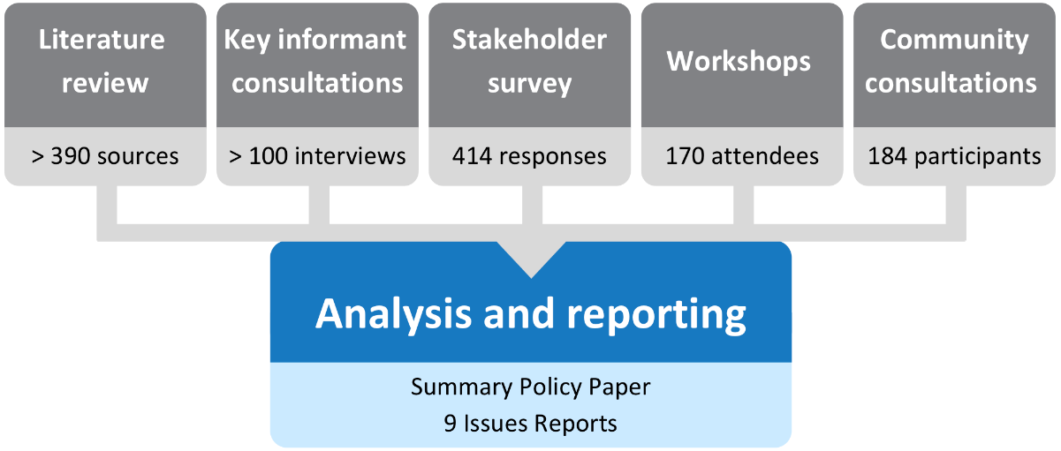

## This report

This issues report describes key barriers and promising approaches for improving refugees’ access to and experience of palliative care in Australia. It also discusses the potential role of advance care planning and provides recommendations for the palliative care and other sectors to improve access and quality of care for refugees.

This issues report is part of a suite of documents developed through the project, as shown in Figure 1‑2.

The Issues report for people from culturally and linguistically diverse backgrounds is also relevant.

Figure 1‑2: Suite of reports

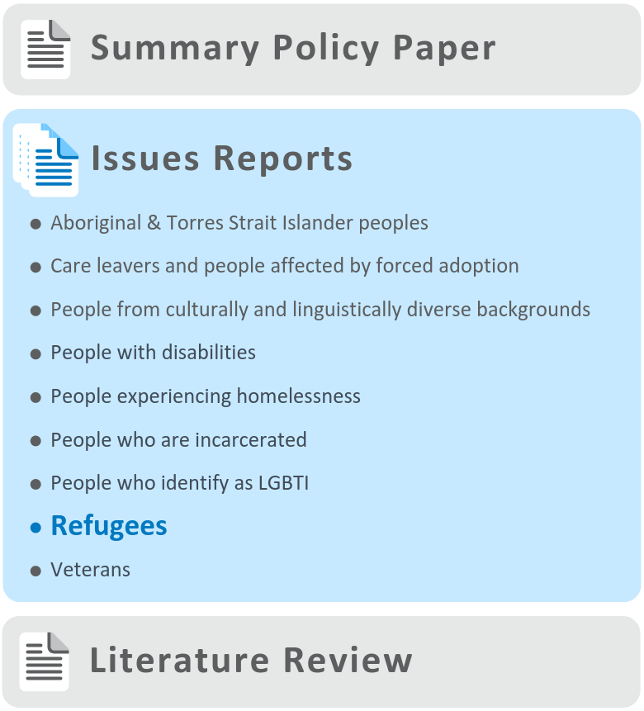

# About this population group

According to the United Nations High Commissioner for Refugees (UNHCR), approximately 68.5 million people worldwide were forcibly displaced at the end of 2017—the highest level in the post-World War II (WWII) era.2 Approximately 25.4 million of those forcibly displaced were considered to be refugees. Refugees may be forced to leave their home or country for a range of reasons, including exposure to conflict, violence, war, persecution, natural disasters or serious environmental changes.3

A refugee is defined as:

Any person who owing to a well-founded fear of being persecuted for reasons of race, religion, nationality, membership of a particular social group or political opinion, is outside the country of his/her nationality and is unable, or owing to such fear, is unwilling to avail himself/herself of the protection of that country.3

Every refugee is initially an asylum seeker—a person whose claim for international protection is yet to be accepted by the country to which it has been submitted.4

## Context

Australia’s population includes refugees from post-WWII Europe, Central and South America, Lebanon, Laos, Cambodia, the former Yugoslavia and Africa, with a recent pattern of refugees originating from Asia and the Middle East.5 Approximately 750,000 people have been accepted under Australia’s Humanitarian Program since WWII, with refugees in the country at the end of 2017 numbering almost 50,000.6 In addition to those recognised as refugees , there are substantial numbers of people seeking asylum in Australia, either on bridging visas in the community, in community-based detention, or in detention facilities located offshore (on Nauru or Manus Island, Papua New Guinea).7 There are different types of visas for refugees and asylum seekers, and each is associated with different levels of access to Medicare benefits. For example, refugees who have been granted a Temporary Protection Visa will typically receive a healthcare card and access to Medicare. However, asylum seekers held in detention with no known visa status will not typically have access to Medicare, and may only receive health care from the International Health & Medical Services.8

Refugees often face a range of health and social challenges as a result of the ‘ interplay of language and cultural issues, the disruption associated with the refugee and resettlement experiences and adverse conditions in the community’.9 Refugees in Australia may have relatively poor health and complex needs,9 having higher rates of mental health problems, some infectious diseases and disabilities, compared with the general population.10 These issues may mean asylum seekers may require specialised, longer-term or more intensive services (including palliative care services), but these may be more difficult to access due to cost or eligibility issues.7

# Findings

During the project it was noted that a number of the issues identified as barriers, enablers and promising approaches to accessing palliative care by refugee populations were actually universal factors, i.e. common to the general Australian population, rather than being specific to refugees. These universal factors, along with a range of other factors that are common to all under-served populations, are described in the *Summary Policy Paper* from this project. The discussion below focuses on factors identified as specific to refugees.

Many of the barriers raised through consultations and described below apply to health care and aged care more broadly and are not specific to palliative care.

It is also recognised that refugees and their communities are heterogeneous, and, while findings and recommendations in this issues report are generalised, they are unlikely to be relevant in all cases.

The barriers and enablers identified in this report have been categorised as ‘consumer-side’ and ‘service-side’. Consumer-side factors relate to characteristics of individuals, families and communities, while service-side factors relate to health professionals, services and organisations, and the health care system more broadly. These categories are not intended to lay fault for barriers or responsibility for enablers on one particular side of the palliative care relationship, but rather to provide a framework within which to consider an appropriate service system response.

## 

## Barriers to accessing palliative care

Barriers to accessing palliative care for refugees are often magnified by prior life experiences. These may include exposure to single or multiple traumatic events and human rights violations, separation from family and friends, and/or discrimination and even criminality in their native country (e.g. due to identifying as lesbian, gay, bisexual, transgender or intersex [LGBTI]). Different transition and settlement journeys, as well as the length of time settled in Australia, may also influence how refugees experience the healthcare system.

‘Every barrier and challenge in communication and relationships is magnified. All barriers in general are amplified and magnified’   
—Palliative medicine physician

### Consumer-side barriers

#### Individual

Language and communication barriers make it difficult for people who are refugees to initiate and actively participate in discussions about palliative care needs and services. Many refugees may not be literate in their own language, which may present barriers when relying on written translated materials for communicating information about palliative care. Furthermore, refugees with co-occurring cognitive decline or dementia may also revert to their ‘mother tongue’ at end of life.11

These barriers may be compounded by a lack of knowledge and understanding about the concept of palliative care. In part, this may be due to the term being unfamiliar, ‘untranslatable’, or not a concept that is recognised due to cultural or other reasons.

‘My experience is, we don’t talk about death, we talk about living’ —Refugee

Refugees may have fear and distrust of health professionals, the healthcare system, and other authority figures, including the Australian Government, due to prior life experiences. This may lead to a reluctance to disclose personal information (such as health status), advocate for their own needs, or report dissatisfaction with services or care. This may be related to fear of persecution, stigma, and/or fear that disclosure may lead to adverse decisions about visas or citizenship status.

‘If you are running from your country, we wonder if someone will tell us to go back, and we live in fear. If I talk, will it affect my visa? It pains me, but we just keep quiet about it. Will the government deport me back to my country? What will happen?’   
—Refugee

In addition, many refugees lack access to stable socioeconomic resources, including stable housing and financial resources, which may be a barrier to accessing palliative care services.

#### Family and community

It is likely that a refugee who requires palliative care in Australia will be the first in their family or community to go through the experience in this country. Consequently, there is often a lack of knowledge and understanding about palliative care, including what it is, who delivers it, and how to find and access services.

In other cases, refugees may rely on their family or community to find out information about palliative care services. When levels of literacy or health literacy are low in the family or community, there is the potential for unhelpful views, or misinformation, about palliative care services to spread. This may perpetuate fear and distrust of palliative care services and the healthcare system more broadly.

‘You are new in a place, you don’t know anything, we rely on the information that we are given by friends’ —Refugee

‘You don’t know what you can access and then it depends on your level of English’ —Refugee

Death and dying may not be commonly discussed topics in many cultures. Some refugees may have an understanding of palliative care, but may avoid talking about it and/or death and dying because of fear, or because it is culturally ‘taboo’. Differences in religious, cultural and/or spiritual beliefs, compared to Australian ‘norms’, may affect an individual’s willingness or comfort to have conversations about death and dying, or to recognise the need for palliative care.

‘There is a perception that you are calling death if you talk about it. People fear death’ —Refugee

In many cases, refugees may be separated from important people in their lives, including family who remain displaced or unaccounted for. Social isolation impacts negatively on psychosocial functioning and quality of life, and may also be a barrier to accessing palliative care, due to a lack of carer support.

Finally, a lack of agency over healthcare planning and decision-making in general may be a barrier to palliative care.

‘I have my family back home. You’re moving and walking around but you feel like you’re in a kind of prison. You don’t know what next step to take, you can’t make a long-term plan. You are in a hopeless situation, and you are separated from family’ —Refugee

### Service-side barriers

#### Health professionals

Through the project, a lack of health professional understanding and awareness of cultural needs was identified as a barrier to palliative care for refugees.

‘There is a perception that culture is a barrier—it’s not; it’s not understanding the culture that is the barrier’ —Stakeholder workshop participant

Similarly, there may be a lack of understanding of how to identify and manage complex mental and physical health symptoms that may manifest as a consequence of traumatic events experienced by many refugees.12

'In the clinical setting you see the results of trauma—symptoms, signs, emotions, which you can connect to background, but there is no framework to structure our assessment or practice’   
—Service provider

A lack of available and adequately trained interpreters was identified as a barrier to accessing palliative care for refugees. This includes a lack of interpreters who are trained in the palliative care setting (i.e. who are competent to manage the complex medical and social issues arising in this context), and those who are refugee-focused. In addition, there may be confusion within the healthcare system about who pays for interpreting services, along with difficulties with interpersonal dynamics (i.e. between health professionals, interpreters, and patients). Patients and families may lack confidence in interpreters’ skills, experience, and cultural appropriateness, and therefore be reluctant to use them. See the Issues report on people from culturally and linguistically diverse backgrounds for further discussion of these issues.

#### Services, organisations, healthcare/other systems

Refugees or asylum seekers may have reduced access to publicly-available health care in Australia due to Medicare eligibility requirements. In other cases, refugees may rely on health care provided by volunteers. Challenges in accessing health care in general may lead to late recognition or diagnosis of life-limiting illnesses, and subsequent delays in **referral** to palliative care (where services are available).

There are **ethical, cultural and practical differences** between the **‘**Western’ medical model—with a focus on patient autonomy**—**and the medical models in some other countries. Refugees and their communities may not understand or identify with the Western model, or may feel it is not culturally appropriate for their needs. This may extend to a lack of appropriate spaces, and reduced options and choices to accommodate beliefs, traditions and customs related to end of life, particularly in institutional settings. Stakeholders suggested that the palliative care system lacks the **flexibility to integrate cultural aspects of care.**

‘Because I grew up here, I know the term [palliative care], and I know the services. But the struggle is, we don’t identify with it. We have some sort of process, but the medical model and system we have here is different to my (and other) cultures’ ––Refugee

Furthermore, stakeholders suggested there is a lack of understanding about community experiences of bereavement and death in the broader healthcare system.

‘In my culture, there are certain ways how you tell people about death. Sometimes mourning can take years. In this system, the community is not thought about. When someone dies, we rally as a community—everyone will cook and help look after the family’ —Refugee

Finally, there may be legal, financial and duty-of-care considerations related to treating refugees or asylum seekers who aren’t eligible for publicly-funded palliative care services and/or those available to the general population (i.e. for those living in detention centres).

‘This [Australian] system is complex. Here, it’s service driven. For us, it’s a foreign system’ —Refugee

## Enablers and promising approaches

There is a lack of research and literature relating to the enablers of access to palliative care for refugees in Australia. Despite this, consultations undertaken during this project did identify a number of enablers and promising approaches to accessing palliative care, and these are presented below.

### Consumer-side enablers

One of the consumer-side enablers that emerged through the project was the engagement of ‘cultural champions’, to educate refugees and their communities about palliative care and how to access it**.** This includes provision of education to improve knowledge, understanding and confidence around what palliative care is, who delivers it, what services are available, and how to access them.

Importantly, stakeholders stressed that ‘cultural champions’ should ideally come from within the community—rather than ‘inside the [Western medical] system’—and should speak the same language(s). Community understanding may also be supported through palliative care and other services’ engagement with community leaders, as well as partnerships and linkages between the palliative care sector and refugee-focused organisations**—**and those with a more general culturally and linguistically diverse (CALD) population focus**—**to deliver training to the community.

As for other multicultural groups, community TV and radio may represent useful channels. See *Issues Report for people from culturally and linguistically diverse backgrounds* for more information.

‘It’s important to upskill and educate the community. Adapt to their own cultural knowledge’ —Refugee

‘There is opportunity for mentorship and peer support through strength and safety in communities’   
—Service provider

### Service-side enablers

**R**aising awareness, knowledge and understanding of the ‘refugee experience’ among health professionals was identified as the main service-side enabler of access to, and appropriate palliative care for, refugees. This involves developing an in-depth understanding and genuine regard for refugees’ faiths, traditions, beliefs and prior life events. This may be facilitated by taking the time to build rapport with individuals, families and communities, and understanding the intrinsic values and traditions of each person on a case-by-case basis. It was suggested that when health professionals have a better understanding of refugee-related issues, it empowers them to deliver care more confidently.

Cultural responsiveness and culturally-appropriate care were considered important enablers to providing general health care to refugees, and are also relevant to palliative care settings. Resources assisting health and social care providers in working with refugee populations are available, such as those highlighted on *pages 12 and 13*.

‘Culturally-appropriate care’ is often suggested in the context of care for all CALD groups, including refugees. However, interpretation of the term often ‘views culture as static and unchanging’, ‘fails to account for diversity within groups’, and leads to ‘stereotyping and a failure to identify the needs of the individual receiving care’.13 Person-centred care for refugees should be culturally appropriate, but exactly what this means will vary between communities and individuals.

Taking the time to build trust and rapport with individuals, families and communities is also important for palliative care service providers and the healthcare system more broadly. This may be especially important when treating individuals who are experiencing their first interaction with the Australian healthcare system. Still, stakeholders acknowledged that many health professionals and organisations are faced with significant time pressures and limited funding, which reduces their capacity to spend the required time to develop and maintain rapport and trust with patients.

‘It’s about building trust—we have to be able to demonstrate that services are “trustable”, but it’s difficult, especially if services have no access to these groups. It’s possible as an individual worker, but harder as an organisation’ —Service provider

At a basic communication level, the project identified the use of interpreters**—**to assist refugees who are not fluent or comfortable conversing in English in the palliative care setting**—**as an important enabler. It was suggested that a strong ‘therapeutic alliance’ is needed between health and social care providers, interpreters and patients to ensure consultations are a helpful experience for all involved. Telehealth consultations and the use of phone- or internet-based interpreting services can help to expand the reach of health and social care providers and interpreters to rural and remote communities.

Given that history of trauma is common among refugees, trauma-informed approaches are also relevant to the palliative care setting and its workforce. Trauma-informed care is based on the knowledge and understanding of how trauma affects people’s lives, and seeks to avoids re-traumatising patients (see the Summary Policy Paper for more detail).

The Australian Refugee Health Practice Guide provides information and guidance for doctors, nurses and other primary care providers to inform on-arrival and ongoing health care for refugees and people seeking asylum, and considers the role of trauma in this context (see p.13 for more information).

There are a number of specialised, non-profit organisations that deliver psychological treatment, other psychosocial supports and/or community interventions intended to assist refugees recover from trauma, provide information or training to health and social care providers and communities, and perform advocacy and policy work. Such organisations may provide trauma-informed and culturally competent care, but are not specific to the palliative care setting. These include (but are not limited to):

* Association for Services to Torture and Trauma Survivors (WA)
* Companion House (ACT)
* Foundation House (Vic)
* Melaleuca Refugee Centre (NT)
* Phoenix Centre (Tas)
* Queensland Program of Assistance to Survivors of Torture and Trauma
* NSW Service for the Treatment and Rehabilitation of Torture and Trauma Survivors

Survivors of Torture and Trauma Assistance and Rehabilitation Service (SA).

Finally, policy reform and development were identified as promising strategies to support refugees and ensure they gain appropriate access to health care, including via access to Medicare.

Culturally Responsive Clinical Practice: Working with People from Migrant and Refugee Backgrounds

[Culturally Responsive Clinical Practice: Working with People from Migrant and Refugee Backgrounds](https://culturaldiversityhealth.org.au/wp-content/uploads/2019/02/Culturally-responsive-clinical-practice-Working-with-people-from-migrant-and-refugee-backgrounds-Jan2019.pdf)[1] is a competency standards framework for clinicians. It was developed by the [Migrant and Refugee Women’s Health Partnership](https://culturaldiversityhealth.org.au/)[2] through a collaborative approach bringing together medical nursing and midwifery colleges, community sector representatives and government. The framework aims to address systemic barriers to healthcare access and outcomes for people from migrant and refugee backgrounds.

Delivering quality and safe care to these population groups requires clinicians to adopt culturally-responsive practices, and utilise competencies**—**clinical expert, communicator, collaborator, leader, health advocate, scholar and professional**—**to communicate and work effectively with this cohort.

Clinicians’ capacity to understand and respond to the diverse cultural, linguistic and religious considerations of migrants and refugees is a key enabler of enhancing access to health care. An understanding of the social determinants of health and wellbeing, and how they impact on migrants and refugees, is also crucial.

The Framework seeks to address this need by establishing recommended and optimal cultural responsiveness competency standards for clinicians. The purpose of the Framework is to support clinical education, training, professional development and practice across all healthcare settings.

The Framework is underpinned by the following principles:

* Person-centred and family-focused care
* Access and equity
* Quality and safety
* Dignity and respect

Effective communication.

The Partnership recognises the important role of interpreters in healthcare settings (as well as their scope of practice), and has produced a [Guide for Working with Interpreters in Healthcare Settings](https://culturaldiversityhealth.org.au/wp-content/uploads/2019/02/Guide-for-clinicians-working-with-interpreters-in-healthcare-settings-Jan2019.pdf)[3] as a companion document to the Framework.

Australian Refugee Health Practice Guide

The [Australian Refugee Health Practice Guide](http://refugeehealthguide.org.au/)[4] is part of a suite of resources to support general practitioners (GPs), nurses and other primary care providers to undertake on-arrival and ongoing care for people from refugee backgrounds and people seeking asylum.

The guide was funded by the Australian Government Department of Health and was updated in 2018 by Foundation House (Victorian Foundation for Survivors of Torture). This update was made in collaboration with GPs, refugee health nurses, practice nurses, paediatricians, infectious disease physicians and others, and in consultation with the Refugee Health Network of Australia (RHeaNA) and the Forum of Australian Services for Survivors of Torture and Trauma (FASSTT).

The guide recognises the important role of general practice and other primary care providers in undertaking post-arrival health assessments, and providing ongoing care for refugees—including managing referrals and coordinating multiple services. In some instances, this may include identifying when patients may benefit from palliative care, and making referrals to specialist palliative care teams and other support services where required.

The guide includes practical information about:

* Approaches to patient care, including how to identify patients from refugee backgrounds, using interpreters, and tips on prescribing
* Refugee health assessment
* Common health concerns among refugees
* Specific considerations for subpopulations, including refugees who are children, adolescents or women, asylum seekers and those with disabilities

Referral contacts.

Recognising the high prevalence of torture and potentially traumatic war-related experiences, the guide includes specific advice on trauma-informed approaches to working with patients from refugee backgrounds.

## Advance care planning

The process of advance care planning involves conversations about future healthcare preferences between a competent person, healthcare providers and potential substitute decision-makers. The outcomes of the process can include the development of statutory or non-statutory advance care directives (ACDs), or other, less formal documentation of a person’s preferences and substitute decision-maker.14

The project highlighted that there may be a lack of understanding in the general population about the nature of advance care planning and ACDs, which may be compounded for people with low levels of literacy and health literacy (and, in particular, refugees).

‘There is a lack of understanding about what the documents mean—and health literacy is part of that’   
—Palliative medicine physician

A further barrier to having advance care planning discussions and completing formal documentation may be **fear of the** **consequences of disclosure** and distrust of the healthcare system. There may also be concern regarding how any information provided on forms might be usedby government departments.

‘There is a lot of fear due to discrimination’ —Service provider

‘A lot of patients come from backgrounds where health care or the government is totalitarian’   
—Palliative medicine physician

While advance care planning conversations may be most relevant in the primary care, hospital or palliative care settings, it is acknowledged that there remain challenges in reaching refugees, particularly those not already engaged in these and other key settings.

To facilitate advance care planning discussions, people who are refugees should feel culturally safe and able to trust that their information is secure, and that their wishes will be followed where appropriate. However, a lack of time and funding may be barriers to service providers spending the time needed to build the trust and rapport necessary to facilitate these key discussions.

‘It’s about feeling safe—and in some cultures you may not want to put things in writing if it will not be respected’   
—Advocate for refugees

Improving communication between health professionals, interpreters and patients was also considered an enabler of advance care planning for people from refugee backgrounds. This includes consideration of language, literacy and cultural factors.

Health and other social care providers’ awareness of diverse family, community, and cultural practices and norms is important in facilitating advance care planning discussions. For example, it may not be culturally appropriate for family members to initiate discussions with members of the family or community who are considered to be seniors, elders or leaders.

‘We do it [planning], it just looks different. We do it in different ways. In a family, or when a family has children, the children don’t have the right to ask those questions. You must wait to be asked. The elders or parent must initiate the conversation’ –Refugee

As with palliative care awareness more generally, stakeholders suggested that responsibility and momentum for education and information-sharing about advance care planning should come from ‘within the community’, by utilising community champions.

*‘When you try and impose that the government wants you to do this, and it’s coming from outside, you feel that they don’t understand your culture—we need to engage community leaders, and the education needs to come from within’   
—Advocate for refugees*

# Recommendations

The *Summary Policy Paper* identifies facilitators of appropriate care in seven domains, underpinned by four key enablers (see p.2).

These domains and enablers are broadly consistent with the *National Palliative Care Strategy 2018* and other relevant policy documents. Recommendations arising from the project—including recommendations specific to refugees—are framed in this context.

The recommendations reflect a public health approach to palliative care (see Summary Policy Paper for details), which involves multiple sectors—from individuals and families to specialist palliative care service providers and broadly-focused, ‘non-traditional’ partners and collaborators.

These recommendations are designed to bolster the capacity of all relevant sectors to promote access to appropriate, quality palliative care for refugees with a life-limiting illness. In particular, the idea of **person-centred care shines through as the ultimate goal** of all palliative care service provision. Person-centred care is respectful of, and responsive to, the preferences, needs and values of individuals. As a concept, it incorporates respect, emotional support, physical comfort, information and communication, continuity and transition, care coordination, involvement of family and carers and access to care.15 For refugees, key components of person-centred care may include culturally-appropriate care and/or trauma-informed approaches (see *Summary Policy Paper* for more detail).”

It is important to acknowledge that identifying and providing the elements necessary to deliver person-centred care for people from under-served populations, including refugees, is likely to be particularly challenging and resource-intensive.

Person-centred care shines through as the ultimate goal of all palliative care service provision.

It is also important to recognise that implementing the recommendations in this report may require service providers and other organisations to make significant changes to organisational policies and procedures, structures and systems.

It is therefore vital that the underpinning enablers identified through this project—particularly workforce development and financial support and resourcing—are firmly in place. Without this support, efforts to improve access to quality, appropriate palliative care for refugees and other under-served population groups are unlikely to succeed.

Palliative care providers may also need assistance from those with a greater understanding of the needs of refugees to co-design services and optimise person-centred care. Linkages between the palliative care sector and relevant community and support organisations—i.e. those with existing relationships and experience meeting the needs of refugees—are likely to be of particular importance (see *Summary Policy Paper* for further discussion).

## 

## Addressing facilitators of appropriate palliative care for refugees

Increase community comfort with discussing death and dying

* Improve the comfort of all of society in discussing issues relevant to death and dying—including individuals, communities, health and social care providers.

Assist health and social care providers to improve their skill and confidence in talking about these issues with refugees.

Promote community awareness and understanding of palliative care

Improve community understanding about palliative care through broad social marketing strategies, as well as specific efforts focusing on refugee groups (e.g. education sessions organised through community organisations, engaging community champions, utilising community media channels).

Facilitate timely initiation of palliative care

* Upskill health and social care providers and other relevant support people to identify when palliative care may be needed, engage in discussions with individuals and families, and initiate or refer for care as appropriate.

Consider introducing standard palliative care-related practices and/or referral processes for all at the time of diagnosis with a life-limiting illness.

Foster a greater understanding of refugees

* Ensure all health and other relevant care providers are aware of and responsive to the potential impacts of the life experiences of refugee communities—in particular the increased likelihood of trauma.

Promote cultural understanding, while avoiding cultural stereotyping.

Improve communication and information provision

* Support effective provider–patient communication and the provision of appropriate information. For example, consider:
  + Information using culturally-appropriate terms and styles in different languages and formats
  + Access to professional interpreting services across all relevant settings (via video or phone, if not available face-to-face)
  + Training programs for professional interpreters in palliative care concepts and communication
  + Specific information about palliative care options and entitlements.

Provide one-on-one support to individuals/families to navigate the relevant system(s).

Enhance provision of person-centred care

* Bolster communities’ capacity to deliver palliative care that is flexible, individualised and delivered in setting(s) of choice where possible.
* Consider the need to accommodate cultural practices, including religion and spirituality, music, food and rituals.
* Ensure appropriate setting design for refugee communities, including accommodation options, decoration/displays, etc.
* Consider and respect the role of families (as defined by individuals) and communities in decision-making and person-centred care.
* Engage with refugee communities to co-design services.

Ensure organisational policies and culture are inclusive and support person-centred care.

Better support advance care planning

* Build on current approaches to enhance advance care planning among refugee populations—particularly in specific settings such as primary care, aged care and disability support as well as palliative care.

Continue to explore opportunities for promoting consistency and mutual recognition of advance care planning documentation across Australian jurisdictions.

## Addressing underpinning enablers

Networks, partnerships and collaborations

* Build the capacity of support organisations to undertake a linking role with palliative care services, e.g. to:
  + Assist individuals to navigate services—including health care, palliative care, aged care and other services
  + Serve as a resource for palliative care services to understand the needs of refugee communities
  + Assist with broader awareness-raising in relation to palliative care and advance care planning within the communities they serve.
* Build linkages and reciprocal collaborations between all relevant sectors (e.g. palliative care and other health and community care services as well as support organisations and other services providers as appropriate) to develop referral pathways and best-practice approaches to palliative care service delivery for refugees.

Build relationships between palliative care providers and community and religious organisations.

Workforce development

Consider training and ongoing professional development initiatives that increase or improve health and social care providers’:

* + Understanding of refugee groups (cultural competence)
  + Understanding of and ability to provide or support person-centred palliative care
  + Knowledge of and skill applying trauma-informed approaches
  + Comfort and capacity to assist individuals with advance care planning
  + Skill and confidence working with interpreters.

Employ CALD (including bilingual and bi-cultural) staff—including refugees —and/or diversity officers or champions across relevant settings.

Financial support and resourcing

Noting that all recommendations in this document require appropriate levels of resourcing, more specific funding recommendations include:

* Ensure palliative care funding models are flexible to allow delivery of person-centred palliative care—recognising that meeting the needs of refugees may be intensive in terms of both time and resources.
* Improve the alignment of the relevant funding systems (including National Disability Insurance Scheme (NDIS), aged care, primary and other healthcare) to support seamless transitions.
* Fund community-based/population-specific approaches to palliative care, including establishment and maintenance of collaborative arrangements.

Consider refugees’ and asylum seekers’ access to healthcare, including Medicare eligibility and arrangements in offshore detention facilities.

Research, evaluation and monitoring

* Consider appropriate research, evaluation and monitoring activities at all levels to understand the needs of refugee populations and evaluate efforts to improve access for these groups.
* Include activities relevant to refugee groups in palliative care quality assurance and improvement initiatives.

Abbreviations

|  |  |
| --- | --- |
| Decorative image | Decorative image |
| Decorative image | Decorative image |
| Decorative image | Decorative image |
| Decorative image | Decorative image |
| Decorative image | Decorative image |
| Decorative image | Decorative image |
| Decorative image | Decorative image |
| Decorative image | Decorative image |
| Decorative image | Decorative image |
| Decorative image | Decorative image |
| Decorative image | Decorative image |
| Decorative image | Decorative image |
| Decorative image | Decorative image |

Glossary

Advance care directive (ACD): An advance care directive is a type of written advance care plan recognised by common law or specific legislation. An ACD can only be completed and signed by a competent adult. It may record the person’s values and preferences for future care, and/or include the appointment of a substitute decision-maker to make decisions about health care and personal life management. Forms and requirements vary between states and territories.16

Advance care planning: The process of planning for future health and personal care needs. It provides a way for a person to make their values and preferences known in order to guide decision-making at a future time when they cannot make or communicate their decisions.16

Care leavers: Includes Forgotten Australians, Former Child Migrants and Stolen Generations.

Carers: People who provide personal care, support and assistance to people with a disability, medical condition, mental illness, or frailty due to age. Carers may include family members, friends, relatives, siblings or neighbours. The term ‘carer’ does not include people who provide care for payment (such as a care or support worker), as a volunteer for an organisation, or as part of the requirements of a course of education or training.17

End-of-life care: Includes physical, spiritual and psychosocial assessment, and care and treatment delivered by health professionals and other staff. It includes the support of family and carers, and care of the person’s body after death. People are ‘approaching the end-of-life’ when they are likely to die within the next 12 months.18

Family: Includes people identified by the person as family and may include people who are biologically related and people who joined the family through marriage or other relationships, as well as family of choice and friends.1

Life-limiting illness: Describes illnesses where it is expected that death will be a direct consequence of the specified illness. The term incorporates the concept that people are actively living with such illnesses, not simply dying.1

Palliative care providers: Health and social care providers involved in the clinical management and coordination of care for people living with a life-limiting illness. Palliative care providers may include General Practitioners (GPs), geriatricians, oncologists, physicians, paediatricians, renal specialists, cardiologists and other specialists. Other team members will include nurses, allied health professionals and pharmacists.1

Person-centred care: Care that is ‘respectful of, and responsive to, the preferences, needs and values of patients and consumers’.15

Specialist palliative care services: Multidisciplinary teams with specialised skills, competencies, experience and training in palliative care. Care provided through these services is targeted at people with more complex needs, and is referred to as ‘specialist palliative care’.1

Substitute decision-maker: A person appointed or identified by law to make decisions on behalf of a person whose decision-making capacity is impaired. A substitute decision-maker can be:

Someone chosen (and appointed) by the person. Depending on the state or territory, they may be called an enduring guardian, a medical enduring power of attorney, an agent or a decision-maker.

Someone assigned as a decision-maker for the person by law, in the absence of an appointed substitute decision-maker. The hierarchy for appointing a substitute decision-maker varies by jurisdiction. They may be a spouse or de facto spouse, carer, relative or friend.

A substitute decision-maker appointed for the person (e.g. a guardian appointed by a guardianship tribunal).16

Trauma-informed care: ‘An organisational structure and treatment framework that involves understanding, recognising and responding to the effects of all types of trauma’.19

References

1. Palliative Care Australia (PCA). *Palliative care service development guidelines*. (PCA, 2018).

2. The UN Refugee Agency Australia for UNHCR. *2017 Annual Report*. (2017).

3. Refugee Council of Australia. Who is a refugee? *Get the facts* (2016). Available at: https://www.refugeecouncil.org.au/who-is-a-refugee/. (Accessed: 30 Apr 2019).

4. United Nations High Commissioner for Refugees. *UNHCR master glossary of terms rev. 1*. (2006).

5. Karlsen, E. *Refugee resettlement to Australia: What are the facts? Research Paper Series, 2016–17*. (Parliament of Australia, 2016).

6. United Nations High Commissioner for Refugees. *Global trends - forced displacement in 2017*. (UNHCR, 2017).

7. Paxton, G. A., Cherian, S. & Zwi, K. J. The Royal Australasian College of Physicians position statement on refugee and asylum seeker health. *Med. J. Aust.* 203, 176–177 (2015).

8. The Royal Children’s Hospital Melbourne. Immigrant Health Service : Asylum seekers. *General medicine* (2019). Available at: https://www.rch.org.au/immigranthealth/clinical/Asylum_seekers/. (Accessed: 20 May 2019).

9. Department of Health and Human Services. *Refugee and asylum seeker health services: guidelines for the community health program*. (DHHS, 2015).

10. Russell, G. *et al.* *Coordinated primary health care for refugees: A best practice framework for Australia*. (Report to the Australian Primary Health Care Research Institute, 2013).

11. Khan, F. Being monolingual, bilingual or multilingual: pros and cons in patients with dementia. *Int. Psychiatry* 8, 96–98 (2011).

12. Ross, L., Harding, C., Seal, A. & Duncan, G. Improving the management and care of refugees in Australian hospitals: A descriptive study. *Aust. Heal. Rev.* 40, 679–685 (2016).

13. Williamson, M. & Harrison, L. Providing culturally appropriate care: A literature review. *Int. J. Nurs. Stud.* 47, 761–769 (2010).

14. Buck, K. *et al.* *Prevalence of advance care planning documentation in Australian health and residential aged care services, Short Report*. (Advance Care Planning Australia, Austin Health, 2017).

15. Australian Commission on Safety and Quality in Health Care. *Patient-centred care: Improving quality and safety through partnerships with patients and consumers*. (ACSQHC, 2011).

16. Advance Care Planning Australia and National Ageing Research Institute. *Advance care planning in aged care: A guide to support implementation in community and residential settings*.

17. The Parliament of Australia. *Carer Recognition Act No.123, 2010*.

18. Australian Government Department of Health. *National Palliative Care Strategy 2018*.

19. Victorian Government Department of Health & Human Services. *Trauma and mental health: 10-year mental health plan technical paper*. (DHHS, 2015).

1. https://culturaldiversityhealth.org.au/wp-content/uploads/2019/02/Culturally-responsive-clinical-practice-Working-with-people-from-migrant-and-refugee-backgrounds-Jan2019.pdf
2. https://culturaldiversityhealth.org.au/
3. https://culturaldiversityhealth.org.au/wp-content/uploads/2019/02/Guide-for-clinicians-working-with-interpreters-in-healthcare-settings-Jan2019.pdf
4. <http://refugeehealthguide.org.au/>