Australian Government Department of Health

Exploratory Analysis of Barriers to Palliative Care

Issues Report on People who are Incarcerated

September 2019



Acknowledgments

Australian Healthcare Associates (AHA) would like to thank the many people who contributed to this project. These included palliative care and other health and social care providers, academics, and peak organisation and government representatives. In particular, we thank the people from the under-served populations who shared their thoughts and experiences with us.

Contents

Key messages 1

Barriers 1

Promising approaches 1

Recommendations 2

1| Project background 3

This report 4

2| About this population group 5

3| Findings 7

Barriers to accessing palliative care 7

Enablers and promising approaches 11

Advance care planning 14

4| Recommendations 15

Addressing facilitators of appropriate palliative care for people who are incarcerated 16

Addressing underpinning enablers 18

Abbreviations 19

Glossary 20

References 22

Figures and tables

Facilitators and underpinning enablers of quality palliative care 2

Figure 1‑1: Project activities 3

Figure 1‑2: Suite of reports 4

What is palliative care?

Palliative care is a person- and family-centred approach to care. Palliative care services are provided for a person with an active, progressive, advanced disease, who has little or no prospect of cure and who is expected to die, and for whom the primary treatment goal is to optimise quality of life.1 It improves quality of life for individuals and families through the prevention and relief of suffering by means of early identification and correct assessment and treatment of pain and other physical, psychosocial or spiritual problems.3

Palliative care:

* Should be strongly responsive to the needs, preferences and values of people, their families and carers
* Should be available to all people with an active, progressive, advanced disease, regardless of diagnosis

Affirms life while recognising that dying is an inevitable part of life.

This means that palliative care is provided during the time that the person is living with a life-limiting illness, but it is not directed at either bringing forward or delaying death.

Palliative care can be provided in a range of settings, including:

* At home
* At a hospital
* In a hospice
* In an aged care facility

In an institutional setting (such as a correctional facility or accommodation for people living with a disability).

Palliative care involves a range of clinical and other supports delivered by different providers, including volunteers, depending on the patient's needs. These may include:

* General practice and primary care
* Other specialist medical, nursing and allied health practitioners
* Community, disability, aged and social services
* Grief and bereavement services

Specialist palliative care services (comprising multidisciplinary teams with specialised skills, competencies, experience and training in palliative care), for patients with complex needs.

This project adopts a broad view of palliative care, as outlined above, and is not limited to the provision of specialist palliative care services.

Therefore the term ‘palliative care provider’ is used in this document to refer to all health and social care providers involved in the delivery of palliative care.

Where relevant, the term ‘specialist palliative care provider’ is used to differentiate this group of professionals. More broadly, the term ‘health and social care providers’ is used to represent those within this category for whom palliative care is not considered core business.

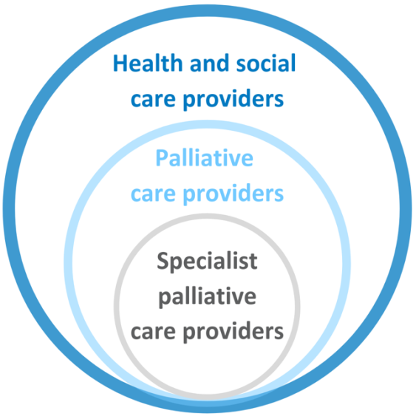

Key messages

The Australian prison population is characterised by poor health and multiple disadvantage. The prison population is growing, and the proportion of older prisoners is increasing. These increases, combined with high rates of multi-morbidity, are likely to increase the need for palliative care services in this setting. However, palliative care can be challenging to deliver and access in this context.

Key barriers and promising approaches for improving access to, and experience of, palliative care for this population group include:

## Barriers

* Lack of awareness and understanding of palliative care
* Attitudes of prison staff and tension between priorities of security and prisoner wellbeing
* Distrust of health services
* Lack of access to health services
* Challenging family relationships
* Physical and cultural environments of prisons are not conducive to provision of quality palliative care
* Lack of effective policies and processes for palliative care

## Promising approaches

* Education and training for palliative care staff, including relevant cultural awareness training and training in trauma-informed approaches
* Development of palliative care-specific guidelines and pathways
* Collaboration and relationship-building between prisons and inpatient/community palliative care services
* Provision of alternative accommodation options for delivery of care
* Prison health literacy programs

### 

## Recommendations

Recommendations address seven domains that facilitate quality palliative care. These are underpinned by four key enablers, as illustrated below.

Specific recommendations are detailed in section 4.

Facilitators and underpinning enablers of quality palliative care

The facilitators of quality palliative care are: community comfort with death and dying, community awareness and understanding of palliative care, timely initiation of palliative care, provision of person-centred care, greater understanding of under-served populations, appropriate communication and information provision, and advance care planning.
The underpinning enablers are: networks, partnerships and collaborations, workforce development, financial support and resourcing, and research, evaluation and monitoring.

# Project background

Australian Healthcare Associates (AHA) was engaged by the Australian Government Department of Health (the Department) in February 2018, to conduct an exploratory analysis of barriers to accessing quality palliative care for people from under-served populations or people with complex needs (the project). The project ran from February 2018 to June 2019. The main activities that contributed to the project are summarised in Figure 1‑1.

The project generated a high level of engagement from a broad range of stakeholders.

Due to ethical considerations, it was not possible to consult directly with people who are incarcerated for this project.

The findings presented in this report are informed by consultation with service providers, academics and government representatives, as well as a comprehensive review of the literature.

Please refer to the Summary Policy Paper for more information on project methodology and limitations.

Figure 1‑1: Project activities

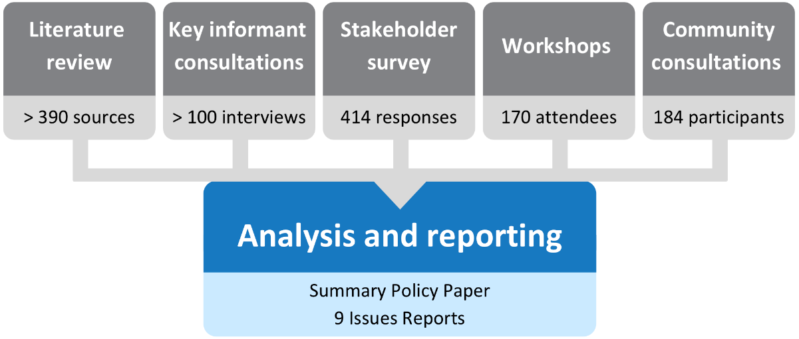

## This report

This issues report describes key barriers and promising approaches for improving the prison populations’ access to and experience of palliative care in Australia. It also discusses the potential role of advance care planning and provides recommendations for the palliative care and other sectors to improve access and quality of care for people who are incarcerated.

This issues report is part of a suite of documents developed through the project, as shown in Figure 1‑2.

Figure 1‑2: Suite of reports

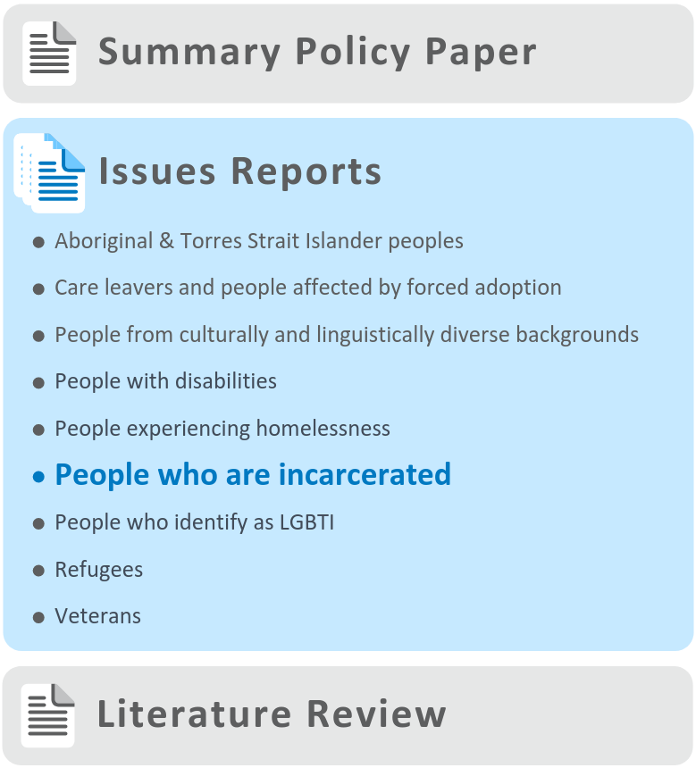

# About this population group

For the purposes of this project, the term ‘people who are incarcerated’ is used interchangeably with ‘prisoners’ and is defined as ‘all persons remanded or sentenced to adult custodial corrective services agencies in each state and territory in Australia’.2

Context

The demographic and health profile of Australia’s prison population is different from that of the broader community. Prisoners are commonly young adult males from lower socioeconomic backgrounds,3 often with a history of trauma. Those entering prison have significant and complex healthcare needs,4 and the prison population is characterised by multiple disadvantage, illustrated by the following:

* One in three prison entrants were homeless in the four weeks before entering prison4
* Almost one-third (29%) of prison entrants reported a long-term health condition or disability that limited their daily activities4
* A similar proportion (30%) of prison entrants reported having one or more chronic conditions4
* Two in five Australian prison entrants report receiving a diagnosis of a mental health condition at some point in their lives4
* Almost two-thirds of Australian prison entrants reported using illicit drugs in the year prior to incarceration4
* Aboriginal and Torres Strait Islander prisoners accounted for 28% of the total Australian prison population (compared with only 2% of the total Australian population aged over 18 years)5

Adults with intellectual disability are significantly over-represented among prisoners, particularly for Aboriginal and Torres Strait Islander prisoners.6

Prisoner health is sufficiently poorer than the general population that prisoners are considered ‘geriatric’ at the age of 50 to 55 years old (compared with 65 for the general population) – a phenomenon known as ‘accelerated ageing’.4

The number of prisoners in adult corrective services is rising, and increased by 4% from 41,202 at 30 June 2017 to 42,974 at 30 June 2018.5 At the same time, the proportion of older prisoners continues to rise; between 2005 and 2015, there were substantial increases in the number of prisoners aged over 50 years (84% increase) and over 65 years (170% increase).7 Increased rates of conviction for historical sexual offences along with longer sentences, mandatory minimum sentences, and reduced options for early release have contributed to this increase.8

These increases in the overall prison population and especially the ageing of the prison population, combined with the higher rates of multi-morbidity seen in the prison population, is likely to increase need for palliative care services.9

Prison health care

In Australia, state and territory governments are responsible for corrective services, including delivery of healthcare to prisoners. All jurisdictions maintain government-operated prison facilities, and private prisons also operate in many jurisdictions.

Responsibility for prisoner healthcare may sit with either the health or justice department in each jurisdiction. State and territory governments can deliver services directly, purchase them through contractual arrangements with a private provider, or use a combination of both. Because prisoner health is a state/territory responsibility, prisoners do not have access to Medicare (including the Pharmaceutical Benefits Scheme[1]) or the National Disability Insurance Scheme (NDIS), as these are administered by the Australian Government.

Primary health care in prisons is predominantly nurse-led, with the health care team also including general practitioners (GP), dentists and allied health professionals. Specialist medical care can be provided through the prison system or through non-prison-based services (such as public hospital inpatient units), depending on the capacity of the prison clinic. Larger prisons may have inpatient beds for prisoners who require hospital care. Alternatively, prisoners may be transferred to public hospitals (in some cases, to secure wards). Transfers to hospital may be planned (e.g. for scheduled surgery/treatment or outpatient specialist appointments), or unplanned (e.g. emergency admissions).10

While the purpose of incarceration for criminal offences is to punish the individual—which primarily involves separating that individual from their family, community and society11—withholding health care, or providing sub-standard health care, should not be part of the punishment. It is widely accepted that, from an ethical standpoint, the standard of healthcare (including palliative care) provided to incarcerated people should be commensurate with that available in the broader community.12–14 Indeed, for many prisoners who tend not to access health services in the general community, prison may provide an opportunity to seek treatment for conditions they would otherwise leave untreated. While some prisoners may benefit from the proximity of health care, the closed environment necessarily means that access to the broad range of healthcare options available in the wider community is limited.

# Findings

A number of the barriers, enablers and promising approaches to accessing palliative care that were identified through this project were actually universal factors, i.e. common to the general Australian population, rather than being specific to people who are incarcerated.

These universal factors, along with a range of other factors that are common to all under-served populations, are described in the Summary Policy Paper from this project. The discussion below focuses on factors identified as specific to people who are incarcerated.

Many of the barriers raised through consultations and described below apply to health care and aged care more broadly and are not specific to palliative care.

It is also recognised that prisoners are heterogeneous, and, while findings and recommendations in this issues report are generalised, they are unlikely to be relevant in all cases.

The barriers and enablers identified in this report have been categorised as ‘consumer-side’ and ‘service-side’. Consumer-side factors relate to characteristics of individuals, families and communities, while service-side factors relate to health professionals, services and organisations, and the healthcare system more broadly. These categories are not intended to lay fault for barriers or responsibility for enablers on one particular side of the palliative care relationship, but rather to provide a framework within which to consider an appropriate service system response.

## 

## Barriers to accessing palliative care

The overarching theme emerging from this project is that the need for palliative care for prisoners is often under-recognised. This is the case both within the prison setting and in the wider community—which, broadly speaking, has little insight into the situation of prisoners (and in many instances, little compassion). This is compounded by a lack of research into palliative care for prisoners in the Australian context.

The literature review undertaken for this project found that the vast majority of literature pertaining to palliative care in prisons comes from the United States (US), due, to some extent, to the much larger prisoner population. However, insights from the US prison setting may not be directly comparable to the Australian context. Our consultations with people who were involved in delivering palliative care for prisoners found that there was broad consensus that the system ‘does not work well’. Reasons for this are outlined below.

### Consumer-side barriers

#### Individuals

As noted in section 2, the Australian prison population is characterised by high levels of disadvantage and high rates of multi-morbidity, including substance use and mental illness. This can add to the complexity of providing healthcare (including palliative care).

A number of factors can deter prisoners from seeking help for health conditions, including life-limiting conditions. These include:

* Distrust of prison staff (including prison health staff) due to the inherent power imbalance. This is often exacerbated for Aboriginal and Torres Strait Islander inmates and people from other minority backgrounds, due to prior life experiences of discrimination and/or abuse.
* Low levels of health literacy. Some prisoners may be unaware that they have conditions that would benefit from healthcare intervention, or may not understand or be able to implement—and maintain—chronic disease self-management. Many have had little or no regular contact with health services prior to incarceration. This extends to a lack of understanding of palliative or end-of-life care, which can lead to challenges in understanding treatment or care options.
* The culture of prisoners, many of whom place a premium on being tough and a ‘survivor’ and so may be reluctant to seek help.

The process involved in accessing specialist medical services can deter inmates from disclosing or taking action on health problems. In many Australian jurisdictions, prisoners are required to transfer to or through a maximum security prison in order to receive specialist services. Inmates may resist transfer due to fear of the maximum security setting, and fear of losing their position or privileges in the lower-security prison (as places tend to be filled immediately due to overcrowding). This can inhibit the timely diagnosis of life-limiting conditions.

Attitudes and behaviours of other prisoners can impact delivery of effective care:

* Some prisoners with life-limiting illness may find themselves isolated within the prison, and lacking the compassion of other prisoners due to the aforementioned ‘survival culture’ that sees illness as a sign of weakness (particularly in men’s prisons).

Diversion of opiate medications. Prisoners who are prescribed opiates as part of palliative care may be targeted by other prisoners, because such drugs are a commodity within the prison.

#### Families

Many prisoners have challenging family relationships, or are estranged from family. This means that there are limited settings in which prisoners may be effectively cared for if they are granted compassionate release (see below), particularly if they are not accustomed to living in the community.

In addition, it is logistically difficult for families to visit prisoners at end-of-life. Restrictive visiting hours, and in some instances, long travel distances from the family’s home to the prison, can make it difficult for family members to be with loved ones at this time.

Because of limited options for care post-release, and because fellow inmates can become a prisoner’s support network, it has been suggested that some inmates (especially ‘lifers’) would prefer to see out their life in prison, despite the lack of comfort and quality care available ‘inside’.

A lack of bereavement support for fellow inmates (and staff) was also been noted by stakeholders.

### Service-side barriers

It is extremely challenging to support dying inmates in the prison setting with any degree of comfort, particularly when their needs are increased (e.g. due to delirium). Consequently, prisoners with high medical needs have to be cared for in a secure hospital unit—either at the prison (where available), or in a secure ward at a public hospital or a public palliative care unit/hospice. In some instances, these prisoners may be granted compassionate release.

Recognising the challenges to providing quality palliative care within prisons, the inquest into the death of Jay Maree Harmer (who died at the Brisbane Women’s Correctional Centre in Wacol, Queensland, in 2016) found that palliative care (as described in the National Palliative Care Standards) is best provided outside the prison setting.15

#### Prison staff

Attitudes and practices of prison staff can impact provision of care in several ways:

* The primary responsibility of corrections officers, which is to maintain security and ensure the safety of staff and prisoners, may conflict with the need to be flexible and responsive in providing health care to prisoners.
* Indifference, or a lack of compassion and empathy toward sick or dying prisoners, has been reported in the literature—including the view that prisoners do not deserve to die with dignity.16

‘Security will always trump everything else’ —Prison healthcare provider

#### Physical environment

The physical environment of prisons creates a literal barrier to providing care. This includes the need to unlock cell doors (which can be a time-consuming process, depending on the security level of the prison), and limited access and visitation rights for health professionals.

In addition, many aspects of the prison environment are inappropriate or unsafe for frail, sick or ageing prisoners with mobility issues. This includes bunk beds (sometimes with no ladders), stairs, and slippery flooring in bathrooms—all of which increase the risk of falls.

Moreover, there is currently very limited capacity for providing assistance with personal care (e.g. showering, dressing, toileting or doing laundry) for those with cognitive impairment, incontinence and/or mobility issues. Other prisoners may provide this support, either informally or through prison ‘buddy’ systems—although some stakeholders expressed concern about the possibility of over-stepping boundaries or of exploitation. Similarly, other needs, such as modified diets, are not able to be met in the prison setting.

Overcrowding of prisons was reported in several jurisdictions, including cases where two people are sharing a cell designed for one. This can lead to a reduction in prisoner movement to ensure security and order are maintained.

Finally, prison infirmaries or medical units can be chaotic places that are not conducive to patient comfort. For example, it would not be uncommon for a patient with terminal cancer to be nursed next to a prisoner who is suffering from drug withdrawal or mental health issues.

#### Logistics and processes

As noted in section *3*, health services within prisons are primarily nurse-led, and delivered through a primary care approach with support from GPs, allied health, counsellors and other staff. In some instance, access to GPs can be limited, which can lead to delays in referrals for palliative care.

A lack of access to electronic health records, restrictions on the use of mobile phones and other electronic devices, and reliance on paper-based notes can affect communication and continuity of care.

Due to bureaucracy, and the involvement of correctional services, approval processes for medications or referrals can also be very slow.

Transfer of prisoners to attend specialist appointments can be logistically difficult and costly, and relies on the availability of escort guards and transport vehicles. It is not uncommon for appointments to be missed or rescheduled for a variety of reasons—including if there is a lock-down within a facility—which can lead to delays of many months for routine external appointments.

Because the need for palliative care in the prison setting is relatively low (albeit growing), prisons do not have policies and processes in place to support delivery of quality care at end-of-life. Prison health care is often crisis-driven and focused on acute care. While specialist palliative care services do provide in-reach to prisons (usually via an initial in-person meeting and then follow up in person or via videoconference), stakeholders suggested that palliative care referrals (by hospital staff or prison GPs) may be delayed or not made at all.

Given the difficulties supporting patients with high acuity palliative care needs within the prison setting, many will be transferred to public hospital palliative care units. In some cases, palliative care units may be reluctant to accept prisoners as patients, due to fear, or a concern for the welfare of other patients. Security precautions may hamper the delivery of effective care in this setting. For example, in some instances, patients will be handcuffed to the bed until they lose consciousness, and be guarded by two security officers. This can cause distress for other patients, family and staff. Further, some stakeholders noted that coronial involvement may be required following expected deaths of prisoners in palliative care units, which can cause additional distress for others in the unit.

In some instances, it may be possible to provide compassionate release to the community; however, this is bureaucratically challenging as it requires ministerial sign-off and may not be achievable in the available timeframes (particularly if it is not recognised early that someone is dying). Depending on the nature of the original crime, decision-makers may resist compassionate release.

Overall, the delivery of palliative care to prisoners is reported to be suboptimal, ad hoc, and lacking continuity. Responsibility for care is complicated by the mix of public and private prisons, and the differing priorities of correctional services and health services. It has been suggested that efforts to improve efficiencies within prisons (particularly privately-operated prisons) may undermine the provision of quality healthcare.

#### Other barriers

A widespread public perception that prisoners are not deserving of compassion is a barrier to driving reform to prison health systems. Perhaps unsurprisingly then, improving justice health is often not seen as a high priority from a political perspective.

Lack of access to Medicare was also noted as a barrier—particularly in relation to transitions between prison health and mainstream health settings.

## Enablers and promising approaches

As noted in *section 3,* there is a lack of Australian literature relating to the needs of ageing or palliative prisoners in the Australian context. Many examples of innovative practice in palliative care can be found in the US—driven by the high incarceration rate and the ageing prison population—and in other countries.

### Consumer-side enablers

Given that most of the barriers to palliative care relate to structural and operational factors, few consumer-side enablers were raised by stakeholders. However, the following were noted:

* Prison health literacy programs, which encourage prisoners to speak up about mental and physical health
* Supporting prisoner advocates to raise awareness of the needs of people with life-limiting illness in prisons

**Reducing restrictions** for family visiting prisoners who are approaching end-of-life.

### Service-side enablers

A number of stakeholders urged for improved guidelines and care pathways as a means to streamline the provision of palliative care. The use of palliative needs rounds has been suggested as a way to monitor the changing needs of people receiving palliative care in prisons.

Close relationships and inter-agency cooperation between prisons, inpatient palliative care services and specialist palliative care services that provide in-reach to prisons, were noted to enable earlier referral to specialist palliative care services, and timely transfers to inpatient units. (See case study on Metropolitan Palliative Care Consultancy Service on p.13).

A number of stakeholders noted the need for purpose-built, specialised alternative accommodation options for prisoners who are elderly or frail, as well as those with palliative care needs. In NSW, the Long Bay Hospital (which is located on the Long Bay Correctional Complex) includes a 15-bed Aged Care and Rehabilitation Unit, as well an additional 25-bed unit for frail aged prisoners with low to moderate needs.17

It was also suggested that the prison environment be re-designed to accommodate prisoners with decreased mobility and/or dementia.

A need for improved education, for prison staff about palliative care, and for palliative care staff about the unique needs of prisoners, was also identified. It was suggested that prisoner advocates may assist in helping health professionals better understand the lived experience of prisoners. The importance of cultural awareness training for staff working with Aboriginal and Torres Strait Islander prisoners, and training in trauma-informed practice, was also raised.

Lessons may be learned from the US, where prison hospice programs have been in place for more than 20 years.18 A key element of the prison hospice model is the engagement of other prisoners as ‘peer supporters’ for those at end-of-life—providing assistance to hospice staff and non-clinical assistance to patients. This approach reportedly has benefits for the patient and the peer volunteers. However, stakeholders interviewed for this project cautioned that there can be associated risks—including managing the volunteer’s expectations that they may be able to perform a similar role (either paid or volunteer) upon release (as their criminal record will preclude this). Concerns were also raised about the potential for the volunteer to take advantage of the person depending on them.

Metropolitan Palliative Care Consultancy Service (WA)

Bethesda Health Care’s [Metropolitan Palliative Care Consultancy Service](https://www.bethesda.org.au/MPaCCS.aspx)[2] (MPaCCS) is a mobile specialist palliative care team based in Perth, WA, which focuses on building the capacity of the residential care sector workforce through training, education, assistance and mentoring. The service provides consultations to residents and patients from a range of under-served population groups, including those living in Perth prisons. The team includes a clinical nurse manager, clinical nurse specialist, four clinical nurses, two social workers and a medical specialist—all with expertise in palliative care.

#### Service delivery model

Since 2010, MPaCCS has worked to build relationships with prisons in its catchment by meeting with prison management and prison medical/infirmary staff. As a result of these relationships, prison healthcare staff are increasingly referring prisoners with palliative care needs to the service.

Referrals are received from the prison GP or hospital specialists. MPaCCS encourages referrals to be made as early as possible.

MPaCCS staff organise to visit the prison to assess the patient, and the prison GP is included in the consultation. In most instances the consultation will occur in the prison infirmary or clinic.

A treatment plan and strategies to address the patient’s symptoms are then put in place.

The patient will be discharged from the service once they and the facility staff are comfortable with the plan, and symptoms are well-controlled.

When the patient’s condition deteriorates, the patient will be re-referred to MPaCCS and re-assessed. When the timing is right, the patient will be referred to an inpatient palliative care facility.

In some instances, rather than being transferred to an inpatient palliative care unit, the patient will be granted compassionate release to the community. In this case MPaCCS will refer them on to community-based palliative care services.

Following a death, bereavement support may be offered to prison staff and other inmates, but is rarely taken up.

While prisoners represent a small proportion of the MPaCCS case-load, the close working relationship they have developed with Perth prisons and inpatient palliative care units means that:

* Prison GPs are more likely to refer patients
* Inpatient palliative care units are more familiar with providing care to prisoners
* Palliative care units are more confident that patients will be transferred at the appropriate time.

## Advance care planning

The process of advance care planning involves conversations about future healthcare preferences between a competent person, healthcare providers and potential substitute decision-makers. The outcomes of the process can include the development of statutory or non-statutory advance care directives (ACDs), or other, less formal documentation of a person’s preferences and substitute decision-maker.19

### Barriers

The uptake of advance care planning in prisons was noted to be low. Stakeholders reported that since the prisoner cohort is relatively young, advance care planning is not a priority. In addition, the necessary systems to document and track ACDs are not in place. While it is theoretically possible for prisoners to develop ACDs, they are not always followed. Stakeholders suggested that even if prisoners have ‘Do Not Resuscitate’ (DNR) orders in place, these can be over-ruled and resuscitation forced on a dying prisoner, unless they are in the prison healthcare unit (in which case the DNR orders are more likely to be followed).

Other barriers to effective advance care planning for prisoners include:

* **Low levels of health literacy.** As prisoners often have little understanding of medical terminology and what is normal and abnormal regarding health states, they are limited in the questions they could ask health professionals.
* **Lack of correctional staff/health professional knowledge** about advance care planning, including the processes in place and the legal validity of ACDs.
* **Lack of family** to act as surrogate decision-makers.

In addition, as **prisoners have little agency over many aspects of their lives in prison**, they may see little value in the advance care planning process. This may be further exacerbated by distrust of prison staff.

### Enablers

It was suggested that education of both staff and prisoners about the potential benefits of advance care planning may improve uptake.

Service providers suggested that, due to their exposure to difficult life experiences, many prisoners (and ex-prisoners) don’t shy away from discussions about death, and instead prefer direct, open conversations.

It was also suggested that the feasibility of including advance care planning in prison intake protocols could be explored.

# Recommendations

The Summary Policy Paper identifies facilitators of appropriate care in seven domains, underpinned by four key enablers (see p.2).

These domains and enablers are broadly consistent with the National Palliative Care Strategy 2018 and other relevant policy documents. Recommendations arising from the project—including recommendations specific to people who are incarcerated—are framed in this context.

The recommendations reflect a public health approach to palliative care (see Summary Policy Paper for details), which involves multiple sectors—from individuals and families to specialist palliative care service providers and broadly-focused, ‘non-traditional’ partners and collaborators.

These recommendations are designed to bolster the capacity of all relevant sectors to promote access to appropriate, quality palliative care for prisoners with a life-limiting illness. In particular, the idea of **person-centred care shines through as the ultimate goal** of all palliative care service provision. Person-centred care is respectful of, and responsive to, the preferences, needs and values of individuals. As a concept, it incorporates respect, emotional support, physical comfort, information and communication, continuity and transition, care coordination, involvement of family and carers and access to care.20 For people who are incarcerated, trauma-informed approaches may represent a key component of person-centred care (see *Summary Policy Paper* for more detail).

It is important to acknowledge that identifying and providing the elements necessary to deliver person-centred care for people from under-served populations, including people who are incarcerated, is likely to be particularly challenging and resource-intensive.

Person-centred care shines through as the ultimate goal of all palliative care service provision.

It is also important to recognise that implementing the recommendations in this report may require service providers and other organisations to make significant changes to organisational policies and procedures, structures and systems.

It is therefore vital that the underpinning enablers identified through this project—particularly workforce development and financial support and resourcing—are firmly in place. Without this support, efforts to improve access to quality, appropriate palliative care for people who are incarcerated and other under-served population groups are unlikely to succeed.

## 

## Addressing facilitators of appropriate palliative care for people who are incarcerated

Increase community comfort with discussing death and dying

* Improve the comfort of all of society in discussing issues relevant to death and dying—including individuals, communities, health and social care providers.

Assist health and social care providers to improve their skill and confidence in talking about these issues people with who are incarcerated.

Promote community awareness and understanding of palliative care

Improve community understanding about palliative care, through broad social marketing strategies as well as specific efforts focusing on prisoners.

Facilitate timely initiation of palliative care

* Consider introducing standard practices/referral processes for all at the time of diagnosis with a life-limiting illness.

Upskill prison and other healthcare staff to identify when palliative care may be needed, engage in discussions with individuals and families, and initiate or refer for care as appropriate.

Foster a greater understanding of people who are incarcerated

* Ensure all health and other relevant care providers are aware of, and responsive to, the needs of people who are incarcerated—including the impact of disadvantage and possible trauma, and the likelihood of complex comorbidities.

Promote cultural understanding, while avoiding cultural stereotyping.

Improve communication and information provision

Ensure prisoners have access to information about palliative care using appropriate language and formats.

Enhance provision of person-centred care

* Bolster capacity to deliver palliative care that is flexible and responsive to the needs of people living in prisons, taking into account the diversity of the prison population—including Aboriginal and Torres Strait Islander people.
* Re-design prison environments to better meet the needs of elderly and/or frail inmates.
* Increase the availability of purpose-built alternative accommodation options that are appropriate for people with poor mobility or cognitive problems, and provide necessary personal care assistance.
* Consider and respect the role of families (as defined by individuals) and communities in decision-making and person-centred care.

Ensure organisational policies and culture are inclusive and support person-centred care.

Better support advance care planning

* Build on current approaches to enhance advance care planning and the interface with palliative care.
* Continue to explore opportunities for promoting consistency and mutual recognition of advance care planning documentation across Australian jurisdictions.

## Addressing underpinning enablers

Networks, partnerships and collaborations

* Build linkages between sectors, including prison and mainstream health services and specialist palliative care services, to develop best-practice approaches to palliative care service delivery for people who are incarcerated.
* Using a partnership approach, develop and embed specific policies and processes to support delivery of palliative care (as opposed to acute care) that address:
  + Early identification of people who would benefit from palliative care
  + Improved availability of telehealth and in-reach by specialist palliative care services
  + Improved access to outpatient specialist clinics and improved timeliness of medical transfers
  + Formalised referral pathways between prisons, specialist palliative care services and inpatient/hospice services
  + Visiting rules, to maximise access for families
  + Guidance around prescription of opioids in prison
  + Streamlined processes, improved transparency and greater capacity for compassionate release
  + Guidance on use of cardiopulmonary resuscitation (CPR).

Workforce development

* Consider training and ongoing professional development initiatives that increase or improve health and other care professionals’:
  + Understanding of the possible needs of people who are incarcerated
  + Understanding of and ability to provide or support person-centred palliative care
  + Knowledge of and skill applying trauma-informed approaches.

Comfort and capacity to assist individuals with advance care planning.

Financial support and resourcing

Noting that all recommendations in this document require appropriate levels of resourcing, more specific funding recommendations include:

* Ensure palliative care funding models are flexible to allow delivery of person-centred palliative care—recognising that meeting the needs of people who are incarcerated may be intensive in terms of both time and resources.

Improve the alignment of the relevant funding systems (including health and corrections) to support seamless transitions.

Research, evaluation and monitoring

Consider appropriate research, evaluation and monitoring activities at all levels, to understand the needs of prisoners and evaluate efforts to improve access for people who are in prison.

Abbreviations

|  |  |
| --- | --- |
| Abbreviation | Definition |
| ACD | Advance care directive |
| AHA | Australian Healthcare Associates |
| CPR | Cardiopulmonary resuscitation |
| DNR | Do not resuscitate |
| GP | General practitioner |
| MPaCCS | Metropolitan Palliative Care Consultancy Service |
| NDIS | National Disability Insurance Scheme |
| the Department | Australian Government Department of Health |
| US | United States [of America] |

Glossary

Advance care directive (ACD): An advance care directive is a type of written advance care plan recognised by common law or specific legislation. An ACD can only be completed and signed by a competent adult. It may record the person’s values and preferences for future care, and/or include the appointment of a substitute decision-maker to make decisions about health care and personal life management. Forms and requirements vary between states and territories.21

Advance care planning: The process of planning for future health and personal care needs. It provides a way for a person to make their values and preferences known in order to guide decision-making at a future time when they cannot make or communicate their decisions.22

Care leavers: Includes Forgotten Australians, Former Child Migrants and Stolen Generations.

Carers: People who provide personal care, support and assistance to people with a disability, medical condition, mental illness, or frailty due to age. Carers may include family members, friends, relatives, siblings or neighbours. The term ‘carer’ does not include people who provide care for payment (such as a care or support worker), as a volunteer for an organisation, or as part of the requirements of a course of education or training.23

End-of-life care: Includes physical, spiritual and psychosocial assessment, and care and treatment delivered by health professionals and other staff. It includes the support of family and carers, and care of the person’s body after death. People are ‘approaching the end-of-life’ when they are likely to die within the next 12 months.24

Family: Includes people identified by the person as family and may include people who are biologically related and people who joined the family through marriage or other relationships, as well as family of choice and friends.1

Life-limiting illness: Describes illnesses where it is expected that death will be a direct consequence of the specified illness. The term incorporates the concept that people are actively living with such illnesses, not simply dying.1

Palliative care providers: Health and social care providers involved in the clinical management and coordination of care for people living with a life-limiting illness. Palliative care providers may include GPs, geriatricians, oncologists, physicians, paediatricians, renal specialists, cardiologists and other specialists. Other team members will include nurses, allied health professionals and pharmacists.1

Person-centred care: Care that is ‘respectful of, and responsive to, the preferences, needs and values of patients and consumers’.20

Specialist palliative care services: Multidisciplinary teams with specialised skills, competencies, experience and training in palliative care. Care provided through these services is targeted at people with more complex needs, and is referred to as ‘specialist palliative care’.1

Substitute decision-maker: A person appointed or identified by law to make decisions on behalf of a person whose decision-making capacity is impaired. A substitute decision-maker can be:

Someone chosen (and appointed) by the person. Depending on the state or territory, they may be called an enduring guardian, a medical enduring power of attorney, an agent or a decision-maker.

Someone assigned as a decision-maker for the person by law, in the absence of an appointed substitute decision-maker. The hierarchy for appointing a substitute decision-maker varies by jurisdiction. They may be a spouse or de facto spouse, carer, relative or friend.

A substitute decision-maker appointed for the person (e.g. a guardian appointed by a guardianship tribunal).21

Trauma-informed care: ‘An organisational structure and treatment framework that involves understanding, recognising and responding to the effects of all types of trauma’.25

References

1. Palliative Care Australia. Palliative Care Service Development Guidelines. (2018).

2. Australian Bureau of Statistics. 4517.0 - Prisoners in Australia, 2017. (2017). Available at: https://www.abs.gov.au/ausstats/abs@.nsf/Lookup/by Subject/4517.0~2017~Main Features~In this issue~2. (Accessed: 20 Mar 2018).

3. AIHW. Prisoners - About. Available at: https://www.aihw.gov.au/reports-data/population-groups/prisoners/about. (Accessed: 17 Apr 2019).

4. Australian Institute of Health and Welfare. The health of Australia’s prisoners 2018. (Cat. no. PHE 246. AIHW, 2019).

5. Australian Bureau of Statistics. 4157.0 - Prisoners in Australia, 2018. (2018).

6. Dias, S., Ware, R., Kinner, S. & Lennox, N. Physical health outcomes in prisoners with intellectual disability: a cross-sectional study. J. Intellect. Disabil. Res. 57, 1191–1196 (2013).

7. Australian Institute of Health and Welfare. Australia’s health 2018. (2018).

8. Ginnivan, N., Butler, T. & Withall, A. The rising health, social and economic costs of Australia’s ageing prisoner population. Med. J. Aust. 209, (2018).

9. World Health Organization. Prisons and Health. (2014).

10. Australian Institute of Health and Welfare. The health of Australia’s prisoners 2015. (Catalogue no. PHE 207, AIHW, 2015).

11. Linder, J. F., Enders, S. R., Craig, E., Richardson, J. & Meyers, F. J. Hospice care for the incarcerated in the United States: An introduction. J. Palliat. Med. 5, 549–552 (2002).

12. Turner, M. & Peacock, M. Palliative care in UK prisons: Practical and emotional challenges for staff and fellow prisoners. J. Correct. Heal. Care 23, 56–65 (2017).

13. Burles, M. C., Peternelj-Taylor, C. A. & Holtslander, L. A ‘good death’ for all?: Examining issues for palliative care in correctional settings. Mortality 21, 93–111 (2016).

14. Walmsley, R. World prison population list. (Institute for Criminal Policy Research, 2016).

15. Coroners Court of Queensland. Inquest into the death of Jay Maree Harmer. (2018).

16. Wright, K. N. & Bronstein, L. An organizational analysis of prison hospice. Prison J. 87, 391–407 (2007).

17. Stevens, B. Do we care about old people behind bars, and should we? (2016).

18. Evans, C., Herzog, R. & Tillman, T. The Louisiana State Penitentiary: Angola prison hospice. J. Palliat. Med. 5, 553–8 (2002).

19. Buck, K. et al. Prevalence of advance care planning documentation in Australian health and residential aged care services, Short Report. (Advance Care Planning Australia, Austin Health, 2017).

20. Australian Commission on Safety and Quality in Health Care. Patient-centred care: Improving quality and safety through partnerships with patients and consumers. (ACSQHC, 2011).

21. Advance Care Planning Australia and National Ageing Research Institute. Advance care planning in aged care: A guide to support implementation in community and residential settings.

22. Advance Care Planning Australia and National Ageing Research Institute. Advance care planning in aged care: A guide to support implementation in community and residential settings.

23. The Parliament of Australia. Carer Recognition Act No.123, 2010. (2010).

24. Australian Government Department of Health. National Palliative Care Strategy 2018.

25. Victorian Government Department of Health & Human Services. Trauma and mental health: 10-year mental health plan technical paper. (DHHS, 2015).

1. With the exception of Schedule 100 items (known as the Highly Specialised Drugs Program)
2. <https://www.bethesda.org.au/MPaCCS.aspx>