
Australian Government Department of Health

Exploratory Analysis of Barriers to Palliative Care

Issues Report on People from Culturally and Linguistically Diverse Backgrounds


September 2019

Acknowledgments
Australian Healthcare Associates (AHA) would like to thank the many people who contributed to this project. These included palliative care and other health and social care providers, academics, and peak organisation and government representatives. In particular, we thank the people from the under-served population groups who shared their thoughts and experiences with us.

Contents

Key messages 1
Barriers 1
Promising approaches 1
Recommendations 2
1| Project background 3
This report 4
2| About this population group 5
3| Findings 6
Barriers to accessing palliative care 6
Enablers and promising approaches 11
Advance care planning 15
4| Recommendations 17
Addressing facilitators of appropriate palliative care for people from culturally and linguistically diverse backgrounds 18
Addressing underpinning enablers 20
Abbreviations 21
Glossary 22
References 24

Figures and tables
Facilitators and underpinning enablers of quality palliative care 2
Figure 1-1: Project activities 3
Figure 1-2: Suite of reports 4

What is palliative care?

Palliative care is a person- and family-centred approach to care. Palliative care services are provided for a person with an active, progressive, advanced disease, who has little or no prospect of cure and who is expected to die, and for whom the primary treatment goal is to optimise quality of life.¹ It improves quality of life for individuals and families through the prevention and relief of suffering by means of early identification and correct assessment and treatment of pain and other physical, psychosocial or spiritual problems.³
Palliative care:
- Should be strongly responsive to the needs, preferences and values of people, their families and carers
- Should be available to all people with an active, progressive, advanced disease, regardless of diagnosis
Affirms life while recognising that dying is an inevitable part of life.
This means that palliative care is provided during the time that the person is living with a life-limiting illness, but it is not directed at either bringing forward or delaying death.
Palliative care can be provided in a range of settings, including:
- At home
- At a hospital
- In a hospice
- In an aged care facility
In an institutional setting (such as a correctional facility or accommodation for people living with a disability).
Palliative care involves a range of clinical and other supports delivered by different providers, including volunteers, depending on the patient's needs. These may include:
- General practice and primary care
- Other specialist medical, nursing and allied health practitioners
- Community, disability, aged and social services
- Grief and bereavement services
Specialist palliative care services (comprising multidisciplinary teams with specialised skills, competencies, experience and training in palliative care), for patients with complex needs.
This project adopts a broad view of palliative care, as outlined above, and is not limited to the provision of specialist palliative care services.
Therefore the term ‘palliative care provider’ is used in this document to refer to all health and social care providers involved in the delivery of palliative care.
Where relevant, the term ‘specialist palliative care provider’ is used to differentiate this group of professionals. More broadly, the term ‘health and social care providers’ is used to represent those within this category for whom palliative care is not considered core business.
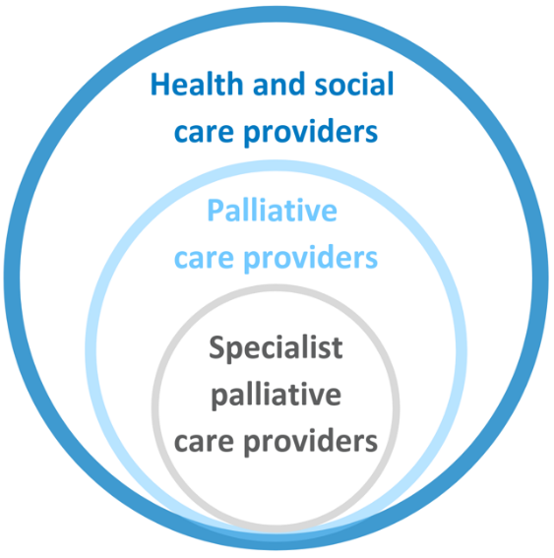

Key messages
People from culturally and linguistically diverse (CALD) backgrounds may experience a range of barriers to accessing and engaging with health and community support services in general, and palliative care in particular.
While CALD populations are, by definition, diverse groups of communities and individuals, culture plays a critical role in end-of-life needs and preferences.
Barriers and promising approaches for improving access to and experience of palliative care for this population group include:

Barriers
- Lack of awareness/understanding of palliative care
- Language and communication issues
  - Reluctance to talk about death and dying
  - Poor literacy/health literacy
  - Lack of translated, culturally-appropriate resources
  - Poor access to professional interpretation services
- Mismatching cultural, religious and/or health beliefs and preferences between CALD individuals and service providers
- Lack of/late referral to, or initiation of, palliative care
- Difficulty accommodating cultural practices in palliative care settings
- Community or individual fear or distrust of services
- Racism and discrimination, cultural stereotyping

Promising approaches
- Community awareness-raising
- Culturally-appropriate and translated resources
- Access to appropriate professional interpreting services
- Training for professional interpreters (in palliative care concepts and terminology)
- Community capacity-building (for palliative care provision and support)
- Improved cultural competence within services
  - Education and training
  - Culturally-appropriate communication
  - Facilitating cultural elements and practices in service provision
  - Identification and inclusion of appropriate decision-makers
- Recruitment of staff from CALD backgrounds and/or employment of diversity champions

Recommendations
Recommendations address seven domains that facilitate quality palliative care. These are underpinned by four key enablers, as illustrated below.
Specific recommendations are detailed in section 4.
Facilitators and underpinning enablers of quality palliative care
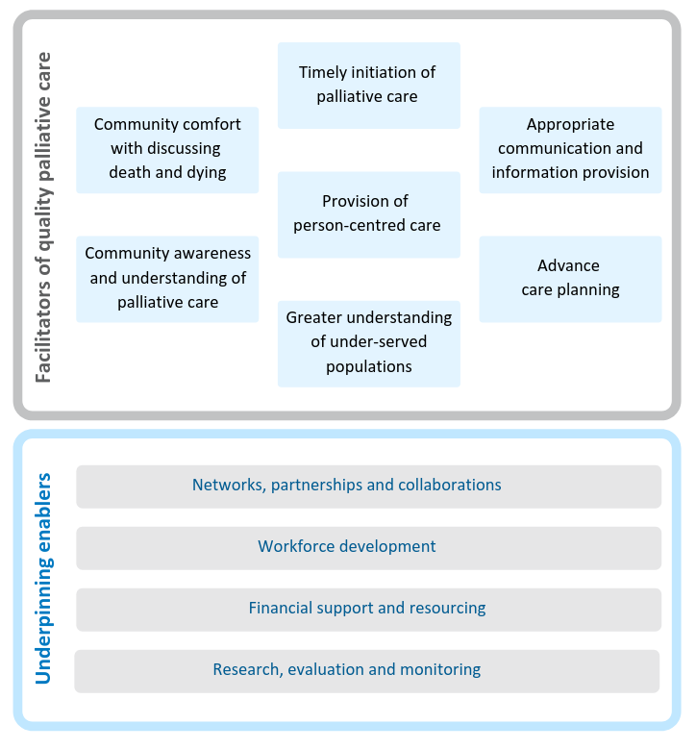

Project background

Australian Healthcare Associates (AHA) was engaged by the Australian Government Department of Health (the Department) in February 2018, to conduct an exploratory analysis of barriers to accessing quality palliative care for people from under-served populations or people with complex needs (the project). The project ran from February 2018 to June 2019. The main activities that contributed to the project are summarised in Figure 1-1.
The project generated a high level of engagement from a broad range of stakeholders.
AHA acknowledges that the community members consulted for this project may not be representative of broader CALD communities.
In particular, it is likely that those who participated had a greater understanding of palliative care, and felt more comfortable discussing death and dying, than those who didn't participate and may be more ‘difficult to reach’.
Please refer to the Summary Policy Paper for more information on project methodology and limitations.

Figure 1-1: Project activities
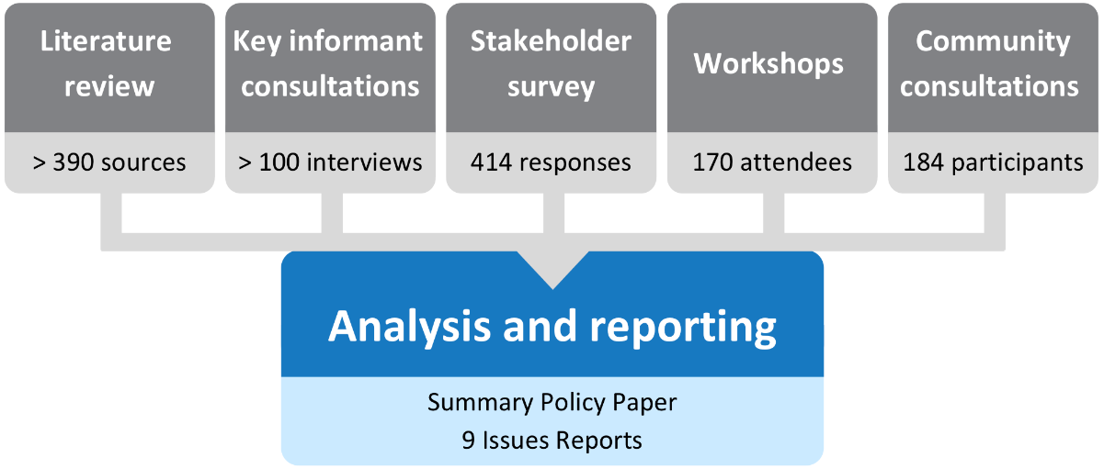

This report

This issues report describes key barriers and promising approaches for improving CALD populations’ access to and experience of palliative care in Australia. It also discusses the potential role of advance care planning and provides recommendations for the palliative care and other sectors to improve access and quality of care for people from CALD backgrounds.
This issues report is part of a suite of documents developed through the project, as shown in Figure 1-2

Figure 1-2: Suite of reports
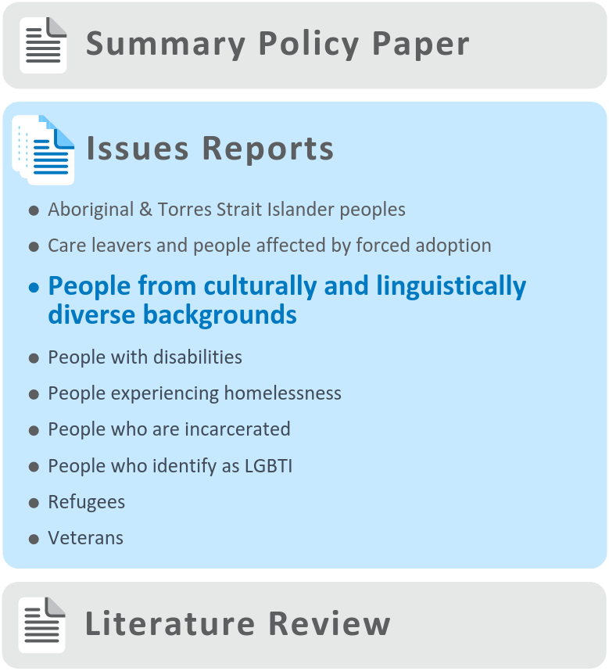

About this population group

The term ‘culturally and linguistically diverse’ is a broad and inclusive descriptor for communities with diverse language, ethnic background, nationality, dress, traditions, food, societal structures, art and religion characteristics.
More specifically, CALD may be used to refer to people from non-English-speaking backgrounds. Issues relating to Aboriginal and Torres Strait Islander peoples and refugees are considered in separate issues reports.

Context
Almost half of the Australian population is either first- or second-generation Australian, and more than 20% speak a language other than English at home. More than one-third of people in Australia aged 65 and over were born overseas, and most of these (61%) were born in non-English speaking countries.²
Prior life experiences, including the experience of migration, may mean that experiences of trauma and their effects are more prevalent in CALD communities than the Australian community as a whole.

People from CALD backgrounds may experience a range of barriers to accessing and engaging with different health and community support services. CALD patients and their families are likely to experience greater communication challenges than other patients, and there is some evidence that they may receive less adequate palliative care.³
It is recognised that CALD populations, by definition, are extremely diverse groups of communities and individuals, with different languages, cultural norms and religious beliefs. However, ‘culture plays a critical role in how patients, families, and healthcare providers view the end-of-life.⁴
It is outside the scope of this report to describe issues relating to discrete populations. Rather, common barriers, enablers and some specific promising approaches are highlighted.

Findings

During the project it was noted that many of the issues identified as barriers, enablers and promising approaches to accessing palliative care by CALD populations were actually universal factors, i.e. common to the general Australian population, rather than being specific to people from CALD backgrounds. These universal factors, along with a range of other factors that are common to all under-served populations, are described in the Summary Policy Paper from this project. The discussion below focuses on factors identified as specific to people from culturally and linguistically diverse backgrounds.
Many of the barriers raised through consultations and described below apply to health care and aged care more broadly and are not specific to palliative care.
It is also recognised that CALD populations are heterogeneous, and, while findings and recommendations in this issues report are generalised, they are unlikely to be relevant in all cases.
The barriers and enablers identified in this report have been categorised as ‘consumer-side’ and ‘service-side’. Consumer-side factors relate to characteristics of individuals, families and communities, while service-side factors relate to health professionals, services and organisations, and the health care system more broadly. These categories are not intended to lay fault for barriers or responsibility for enablers on one particular side of the palliative care relationship, but rather to provide a framework within which to consider an appropriate service system response.

Barriers to accessing palliative care

Consumer-side barriers
Language and communication is an obvious barrier to health care in general, and palliative care in particular, for CALD communities. Even for people who are proficient in English, it is common to revert to their native language in older age or in the context of significant illness (particularly dementia).⁵
Interpreters are often not available—especially in the sometimes time-critical context of palliative care—or are under-utilised. Even when interpreters are used, challenges in communicating about death and dying remain (see page 10). Family members or friends are often used as ad hoc interpreters, but this brings its own challenges as the family member’s own cultural beliefs and preferences may hamper full communication between service providers and patients (see below).
While not applicable to all CALD individuals, a lack of health literacy, or literacy in general (independent of language barriers), may challenge access to many health and community services.
People from CALD backgrounds have different beliefs and approaches to death and dying. For some cultures, conversations about death and dying are considered taboo, or thought to hasten or bring about death. These taboos may affect specific conversations regarding a person’s own, or a loved one’s, end-of-life care, but can also more broadly challenge proactive conversations and education relating to palliative care.
‘If we talk about [death], someone will think “you want me to die!”’
—Vietnamese community member
‘All cultures have a palliative care process of some sort, but the Western model is different to ours’ —Sudanese community member
‘Indians, and especially women, are very reserved and hesitate to talk about sensitive topics even within the family, let alone in public within the community or more broadly. They are very sensitive to issues that have stigma attached to them or the potential to bring shame to family’
—Indian community member
Those with particular religious beliefs may view death (as well as its timing and manner) as ‘God’s will’, outside the scope of clinical intervention. Buddhists may believe that pain must be accepted, and that the mind should be as clear and alert as possible as death approaches, and therefore refuse or wish to minimise pain medications.⁶ Similarly, followers of Islam may hold spiritual objections to palliative sedation.⁷
Some cultures may display a preference for curative treatment and perceive palliative care as ‘giving up’, while others may have a cultural preference for less intensive end-of-life care. Some may be used to, and comfortable with, a more authoritative approach from health service providers, and less comfortable with individual/family choice in making healthcare decisions.
‘Indian children are very sensitive to being judged by the community as having abandoned their parents, “letting them die”, which is what people think when they hear the term “palliative care”’ —Indian community member
These issues may be complicated by cultural preferences regarding truth-telling—in particular a reluctance to give a loved one bad news.
‘We often hear “Don’t tell my dad he has cancer”’
—Palliative medicine physician
‘In Australia, ethically, you have to tell a patient if they’re dying. In my culture, the doctors tell the family’ —Myanmarese community member
Family-based decision-making (rather than individual) is of particular importance in some cultures, highlighting the need in some instances for family-centred (rather than person-centred) care. As discussed in more detail in the Summary Policy Paper, an individual’s preference for communication and decision-making—whether individual, family or community-based—should be considered as an important component of person-centred care.
‘It might be my choice that my family choose’ —Columbian community member
‘A lot of people will say “it’s up to my children”, but as a service provider the person needs to have their say and be involved’ —Service provider
While lack of awareness of palliative care is a universal issue affecting all under-served populations as well as the general population, this barrier may be more fundamental for some CALD groups, in particular where palliative care as a concept does not exist in their culture and/or country of origin. Difficulty communicating and/or understanding the concept of palliative care was frequently reported by CALD community members, service providers and other stakeholders. Beyond this, there is a lack of knowledge within communities regarding what services are available, and how to access them.
For other individuals and families, there is simply a fear that palliative care services will not be delivered in a culturally sensitive or appropriate way, or a more overt distrust of palliative care services or governments (and government-funded services).

Service-side barriers
Service providers may not always be open to, or mindful of, the influence of a person’s culture or religion on their preferences in dying and death. A lack of understanding can result in tensions between a Western model of health and palliative care and the wishes of CALD individuals and families.
‘There is a perception that culture is a barrier [to palliative care]. It’s not:
not understanding the culture is a barrier’
—Stakeholder workshop participant
‘The palliative care team got annoyed when a lady from Afghanistan moved between family members’ houses after they’d set up each house for her. They couldn’t—or wouldn’t—understand that that was how that family “worked”’ —Primary care nurse
Appropriate referrals may not be made to specialist palliative care services—or may not be timely—potentially due to service providers’ lack of awareness of available services, referral processes, or a perception among health and social care providers that services may not be culturally appropriate.
A lack of translated, culturally-appropriate resources was considered to be a barrier to palliative care for CALD communities. However, the development and provision of such resources—particularly in written formats—may have limited impact, as communication difficulties may also arise from a lack of health literacy or literacy in general, as mentioned above.
While described in the literature, institutional racism was not commonly reported as a barrier to palliative care for CALD communities. However, even without overt racism, CALD people may have experienced stigma, discrimination and a lack of understanding from health professionals, resulting in a lack of trust in services.
‘We have to be able to demonstrate that services are “trustable”, but it’s difficult’ —Service provider
There is also the potential for well-meaning service providers to succumb to cultural stereotyping. For example, it may be assumed that CALD individuals have a preference for dying at home with family as carers, but this may or may not be the case.
‘Death at home can lead to police coming and taking the body for an autopsy, which takes a week. This is considered shameful’ —Afghan community member
In some cases, palliative care services may find it difficult to accommodate some cultural practices relevant to end-of-life care for CALD individuals (e.g. provision of food, cultural rituals or burning of oils or candles). Others may not appreciate important cultural imperatives (e.g. a requirement for only a female to see a deceased [Muslim] female). In some settings, even more basic cultural needs and preferences may not be met (e.g. food provided in a hospital setting).
‘Our spiritual and cultural values are important in all respects: the care we receive, the food, music, our sense of community. If these aren’t available, that’s a barrier’ —Indian community member

Professional translation and interpreting services

Conversations between service providers, patients and families are inherently important to appropriate and person-centred palliative care. Language and communication barriers therefore impact on the quality of service provision, as well as on access to services.
‘When English is not someone’s first language, no one makes the extra effort to reach out’ —Stakeholder workshop participant
Logistically, there are key barriers to accessing professional interpreters (especially face-to-face) at the relevant time and place, including in hospital, residential aged care and other settings. While the Australian Government-funded Translating and Interpreting Service (TIS National) can provide some assistance, many stakeholders felt the services are suboptimal in the sensitive and complex context of palliative care.
‘There really aren’t many services beyond [TIS National]. It’s problematic because while it can improve the immediate insufficiency of not being able to understand certain words, there is a lot more to communication than just words’
—Government representative
Even when available and utilised, professional interpreters—and in some cases, CALD health professionals—face significant challenges in communicating complex concepts (including the meaning of ‘palliative care’).
‘Many…can’t find the right words, or find it too confronting to do this work: they feel they shouldn’t be the ones doing this talking’ —Palliative medicine physician
‘How do you say ‘Parkinson’s’ in Portuguese? The words don’t necessarily translate’
—Portuguese community member
Other issues regarding professional interpreter services include:
- Most interpreters are not trained in the area of palliative care, or even health.
- In smaller communities, interpreters are more likely to know the individual and family, raising issues around privacy and confidentiality, and potentially leading to distrust.
- Some minority languages or dialects are difficult to find interpreters for. Even within a language group, nationality/dialect/accent can create difficulties in communicating.
- Health professionals are time poor; conversations involving an interpreter take twice as long, and funding models may not allow for this.
- Consumers or health professionals may lack confidence in interpreters.
- Interpreters may face professional challenges and potential trauma (e.g. being asked not to communicate prognosis to a family member or being asked for clinical advice).
- Phone-based interpreter services are considered suboptimal, particularly in the palliative care setting. Face-to-face is ideal, but videoconferencing may be a pragmatic compromise.
- There is a lack of clarity around who pays for the service (in different settings), and cost may be an issue if consumers are required to pay.

Enablers and promising approaches

Consumer-side enablers
Many CALD people rely on community groups and organisations (including churches)—as well as word of mouth—for information regarding many important topics. Considerable efforts have been put into raising awareness of palliative care through collaborations and co-operative initiatives with CALD community groups and engagement with community leaders.⁸ Although these efforts vary across jurisdictions and geographical areas, interest is often reported as high, with baseline understanding of the relevant issues low (as highlighted above and reflected in consumer consultations for this project).
‘It’s good to raise this issue’
—Afghan community member
‘We know it’s part of life, so we talk’ —Portuguese community member
Formal funding at the local level may be required in order to support and build this engagement, recognising that there are many distinct groups to be reached.
Culturally-appropriate and translated resources were considered to be useful, along with promotion/education regarding palliative care concepts through community radio and TV channels. A number of organisations have developed such resources, including Palliative Care Victoria (see p14).
Community capacity-building approaches may be of particular use in ‘bridging the gap’ between CALD communities and the palliative care sectors—for example training community volunteers or mentors (e.g. through grassroots community organisations) to support patients and families in accessing palliative care services.

Service-side enablers
Cultural competence was a key concept raised as a requirement for providing high-quality palliative care to CALD individuals and families. This concept applies at the individual healthcare provider level, as well as at the service delivery and broader organisational levels.
For service providers, facilitating desired cultural elements and practices in palliative care will make services more appropriate and reduce barriers.
‘Palliative care needs to have a community feel, rather than being sterile like an intensive care unit. It should be able to provide entertainment, spirituality, religion and culturally-appropriate food’ —Indian community member
For individual health care providers, a key enabler of culturally-sensitive care is likely to include language and communication considerations, and identification of the appropriate decision-maker(s) within a family and cultural context.
‘Culturally-appropriate care’ is often suggested in the context of care for people from CALD backgrounds. However, interpretation of this term often ‘views culture as static and unchanging’, ‘fails to account for diversity within groups’, and leads to ‘stereotyping and a failure to identify the needs of the individual receiving care’.⁹ Person-centred care for those from CALD communities should be culturally-appropriate, but exactly what this means will vary between communities and individuals.
Improving services’ cultural competence may involve education and training for staff, and/or recruitment of staff from CALD backgrounds. In some cases, it was suggested that a more diverse workforce may enable health professionals and consumers to be ‘matched’ to facilitate cultural understanding. Alternatively, ‘diversity officers’—or designated diversity champions—may be specifically tasked with assisting CALD individuals and their families to understand options and communicate preferences. Even promoting an understanding among staff regarding their own cultural perspectives and biases may be helpful in promoting culturally-sensitive care.
Partners in Culturally Appropriate Care (PICAC) provides information, training and resources for the aged care that is likely to have relevance to the palliative care context,¹⁰ as well as a summary of cultural attitudes towards palliative care and end-of-life considerations for a large number of cultural groups.¹¹
Identifying a person’s preferences and beliefs—early where possible—can facilitate appropriate referrals and provision of collaborative and culturally-sensitive services. In many cases, the trusted relationships existing between CALD people and their general practitioners (GPs) made primary care a particularly important setting for the management and delivery of palliative care. Strengthening awareness of palliative care and networks between primary care and palliative care services may therefore be a key opportunity to improve access to palliative care. More broadly, appropriate therapeutic alliances (e.g. between palliative care services and other health professionals) are likely to play key roles in referral and support for CALD people in need of palliative care.
As for other under-served population groups, patient navigators have been described in the literature as a means to assist CALD people in navigating health care—including palliative care.¹²
While translation and interpretation services are considered vital to assisting communication and decision-making with non-English speaking people, the issues described on page 10 highlight the many challenges. Education and training for interpreters (in palliative care concepts and terms) may be a useful strategy for improving communication between service providers and CALD people, families and communities.
‘We put on an evening workshop for interpreters to talk about cancer terms and palliative care concepts. We had a great turnout, and the group was very interested in how clinicians viewed interpreting and interpreters and ways to improve patient care. Attendees provided insight into their own experiences of interpreting in challenging situations, and the lack of support they sometimes feel. We discussed ways to support them more, and they helped us understand how palliative care concepts are perceived in different languages and cultures’
—Palliative medicine physician
Given the lack of availability of professional interpreters in healthcare settings, and the sensitive nature of conversations regarding palliative and end-of-life care, the use of technology—including specific translation applications and videoconferencing—may help to provide better access for CALD individuals at the point of care. However, such approaches are not well-developed or without challenges.

Integration and collaboration
Around the country, relationships between palliative care peak bodies, providers and CALD communities are being explored and developed to improve understanding of, and access to, palliative care. These relationships and networks are raising awareness at the community level and improving the capacity of service providers to deliver culturally-appropriate care. Relevant networks (e.g. involving palliative care services, Primary Health Networks, other services and community groups) have the potential to help build both community and sector capacity to improve access to culturally-appropriate palliative care.
‘Improved access needs a comprehensive collaboration and an integrated approach from all involved’ —Stakeholder workshop participant
With adequate support, many CALD communities are likely to have the capability and confidence to provide care using a palliative approach, with access to specialist palliative care support when needed.
‘If the networks aren’t in place it’s very difficult to integrate your service with where the client is at’
—Stakeholder workshop participant

Palliative Care Victoria—Culturally responsive palliative care strategy

Palliative Care Victoria (PCV) and the Ethnic Communities Council of Victoria (ECCV) hosted the first Victorian forum on palliative care for CALD communities in September 2010. A collaborative leadership group was formed later that year, leading to research and consultations that informed the development of the Culturally Responsive Palliative Care Strategy.
The goals of the strategy were to:
- Increase knowledge about and use of palliative care services by people from CALD backgrounds with a life-limiting illness, and their families
Improve the capacity of palliative care services to provide culturally-inclusive and responsive services to people from CALD backgrounds.
Partners in the strategy included ECCV, the Multicultural Centre for Women’s Health, the Centre for Palliative Care, 24 ethnic community organisations, six community palliative care services and three regional palliative care consortia. Funding was provided through numerous sources, including the Victorian Government, PCV, and corporate and charitable philanthropic organisations.
The strategy focused on capacity-building within CALD communities and the palliative care sector. In the community, work included:
- Development of bilingual information in 19 languages, including printed material, electronic resources and podcasts
- Distribution of more than 18,000 bilingual leaflets about palliative care
- Training of bilingual peer educators
Facilitation of information sessions in community languages.
Other outcomes include community profiles for ten CALD communities, information sessions for staff and volunteers of CALD organisations and cultural training for palliative care clinicians across Victoria.
Recent initiatives include:
- Building capacity of community volunteers to facilitate access to palliative care and bereavement support
- Engaging diverse faith leaders in discussions about palliative care
- Developing a new ‘Culture-Centred Care’ education workshop for clinicians in community health and aged care services
A community awareness campaign, launched by PCV, to increase community understanding of palliative care.
‘We believe the vision and passion underpinning this long-term community-based collaboration—across sectors and cultures—has improved equity of access to culturally-inclusive and responsive palliative care services. By building trust and exploring ways of working together, we have built a sound basis for further work and developed a blueprint for achieving similar goals in other areas of health care’

Advance care planning

The process of advance care planning involves conversations about future healthcare preferences between a competent person, healthcare providers and potential substitute decision-makers. The outcomes of the process can include the development of statutory or non-statutory advance care directives (ACDs), or other, less formal documentation of a person’s preferences and substitute decision-maker.¹³
The literature suggests that CALD populations may be less likely than the general population to engage in advance care planning, and may reject the concept outright.¹⁴ However, due to the heterogeneity of CALD groups and individuals, many factors (e.g. age, illness type, income and education) can affect this likelihood, and published literature suggests that, among some communities, interest in and acceptance of the principles of advance care planning is high.^{15–17}
Many community members consulted during this project were not averse to talking about death and dying with family members, and a number had explicitly discussed their end-of-life preferences. In some cases, it was reported that these conversations eased the burden and worry of family members, or would be likely to in the future.
‘It’s helpful if family tell you what their wishes are, it makes the decision easier for you when you have to decide. You feel comfortable that’s their wishes, you feel happier in your heart’ —Portuguese community member
In other instances, conversations often related to post-death elements, such as funeral arrangements or the contents of a will, rather than the dying process and end-of-life care.
Of the CALD community members consulted, many acknowledged a general reluctance to talk about death and dying, and therefore advance care planning, in their own (and other) communities.
‘We do it [planning], it just looks different. In a family, or when a family has children, the children don’t have the right to ask those questions [about diagnosis, plans, death]. You must wait to be asked.
—Rwandan community member
‘I have tried to [talk about death and dying], but my family members—even children in their 20s and 30s—do not want to discuss this, saying that they didn’t want to talk about death, as it made them uncomfortable’
—Indian community member
Beyond conversations with family, the formalisation of end-of-life wishes (through ACDs and appointment of substitute decision-makers) was rare and considered to be problematic, and potentially culturally foreign or inappropriate. A sophisticated understanding of English was felt to be needed to make sense of the relevant documentation. Some CALD community members may have a fear or distrust of the bureaucratic or legal nature of ACDs, concerns about privacy and data safety, or simply a cultural aversion to formalising plans or ‘writing things down’.^{18,19}
Cost (e.g. to prepare an ACD with assistance from a lawyer) was noted as a barrier, and there was a lack of certainty that any wishes contained in an ACD would be honoured ‘when the time came’—either by health professionals or family members.
‘[Getting a doctor to write a letter about their needs] worked, because they had respect for the doctor. They wouldn’t fill out the legal form, because they don’t trust that side of it’
—Peak body representative
As with palliative care, improving the cultural competence of health and social care providers may be an enabler of advance care planning among CALD populations.^{18,20} Recruiting more CALD health professionals who are well-informed about advance care planning may also help.²¹
Again, as with palliative care, stakeholders consulted for the project called for translated and culturally-appropriate resources explaining advance care planning and ACDs and the processes involved, along with individualised support to complete these activities. Such resources have been developed, for example by Advance Care Planning Australia and ACPTalk.²² GPs (or primary care settings more broadly) may have a particular role in supporting CALD people with advance care planning.

Recommendations

The Summary Policy Paper identifies facilitators of appropriate care in seven domains, underpinned by four key enablers (see p.2).
These domains and enablers are broadly consistent with the National Palliative Care Strategy 2018 and other relevant policy documents. Recommendations arising from the project—including recommendations specific to people from culturally and linguistically diverse backgrounds—are framed in this context.
The recommendations reflect a public health approach to palliative care (see Summary Policy Paper for details), which involves multiple sectors—from individuals and families to specialist palliative care service providers and broadly-focused, ‘non-traditional’ partners and collaborators.
These recommendations are designed to bolster the capacity of all relevant sectors to promote access to appropriate, quality palliative care for people from culturally and linguistically diverse backgrounds with a life-limiting illness. In particular, the idea of person-centred care shines through as the ultimate goal of all palliative care service provision. Person-centred care is respectful of, and responsive to, the preferences, needs and values of individuals. As a concept, it incorporates respect, emotional support, physical comfort, information and communication, continuity and transition, care coordination, involvement of family and carers and access to care.²³ For people from CALD backgrounds, key components of person-centred care may include culturally-appropriate care and/or trauma-informed approaches (see Summary Policy Paper for more detail).
It is important to acknowledge that identifying and providing the elements necessary to deliver person-centred care for people from under-served populations, including those from CALD backgrounds, is likely to be particularly challenging and resource-intensive.
Person-centred care shines through as the ultimate goal of all palliative care service provision.
It is also important to recognise that implementing the recommendations in this report may require service providers and other organisations to make significant changes to organisational policies and procedures, structures and systems.
It is therefore vital that the underpinning enablers identified through this project—particularly workforce development and financial support and resourcing—are firmly in place. Without this support, efforts to improve access to quality, appropriate palliative care for people from culturally and linguistically diverse backgrounds and other under-served population groups are unlikely to succeed.
Palliative care providers may also need assistance from those with a greater understanding of the needs of people from CALD backgrounds to co-design services and optimise person-centred care. Linkages between the palliative care sector and relevant community and support organisations—i.e. those with existing relationships and experience meeting the needs of these population groups—are likely to be of particular importance (see Summary Policy Paper for further discussion).

Addressing facilitators of appropriate palliative care for people from culturally and linguistically diverse backgrounds

Increase community comfort with discussing death and dying
- Improve the comfort of all of society in discussing issues relevant to death and dying—including individuals, communities, health and social care providers.
Assist health and social care providers to improve their skill and confidence in talking about these issues with CALD communities.

Promote community awareness and understanding of palliative care
Improve community understanding about palliative care, through broad social marketing strategies as well as specific efforts focusing on CALD groups (e.g. education sessions organised through community organisations, engaging community champions, promotion through community radio and TV channels).

Facilitate timely initiation of palliative care
- Upskill health and social care providers and other relevant support people to identify when palliative care may be needed, engage in discussions with individuals and families and initiate or refer for care as appropriate.
Consider introduction of standard palliative care-related practices and/or referral processes for all at time of diagnosis with a life-limiting illness.

Foster a greater understanding of people from culturally and linguistically diverse backgrounds
- Ensure all health and other relevant care providers are aware of and responsive to the potential impacts of the life experiences of CALD communities.
Promote cultural understanding, while avoiding cultural stereotyping.

Improve communication and information provision
Support effective provider–patient communication and the provision of appropriate information. For example, consider:
  - Information using culturally-appropriate terms and styles in different languages and formats
  - Access to professional interpreting services across all relevant settings (via video or phone, if not available face-to-face)
  - Training programs for professional interpreters in palliative care concepts and communication
  - Specific information about palliative care options and entitlements.
Provide one-on-one support to individuals/families to navigate the relevant system(s).

Enhance provision of person-centred care
- Bolster communities’ capacity to deliver palliative care that is flexible, individualised and delivered in setting(s) of choice where possible.
- Consider the need to accommodate cultural practices, including religion and spirituality, music, food and rituals.
- Ensure appropriate setting design for CALD communities, including accommodation options, decoration/displays etc.
- Consider and respect the role of families (as defined by individuals) and communities in decision-making and person-centred care.
- Engage with CALD communities to co-design services.
Ensure organisational policies and culture are inclusive and support person-centred care.

Better support advance care planning
- Build on current approaches to enhance advance care planning among CALD populations—particularly in specific settings such as primary care, aged care and disability support as well as palliative care.
Continue to explore opportunities for promoting consistency and mutual recognition of advance care planning documentation across Australian jurisdictions.

Addressing underpinning enablers

Networks, partnerships and collaborations
Build the capacity of support organisations to undertake a linking role with palliative care services, e.g. to:
  - Assist individuals to navigate services—including health care, palliative care, aged care and other services
  - Serve as a resource for palliative care services to understand the needs of CALD communities
  - Assist with broader awareness-raising in relation to palliative care and advance care planning within the communities they serve.
- Build linkages and reciprocal collaborations between all relevant sectors (e.g. palliative care and other health and community care services as well as support organisations and other service providers as appropriate) to develop referral pathways and best-practice approaches to palliative care service delivery for CALD groups.
Build relationships between palliative care providers and community and religious organisations.

Workforce development
Consider training and ongoing professional development initiatives that increase or improve health and social care providers’:
  - Understanding of CALD populations (cultural competence)
  - Understanding of and ability to provide or support person-centred palliative care
  - Knowledge of and skill applying trauma-informed approaches
  - Comfort and capacity to assist individuals with advance care planning.
Employ CALD (including bilingual and bi-cultural) staff and/or diversity officers or champions across relevant settings.

Financial support and resourcing
Noting that all recommendations in this document require appropriate levels of resourcing, more specific funding recommendations include:
- Ensure palliative care funding models are flexible to allow delivery of person-centred palliative care—recognising that meeting the needs of CALD people may be intensive in terms of both time and resources.
- Improve the alignment of the relevant funding systems (including NDIS, aged care, primary and other healthcare) to support seamless transitions.
Fund community-based/population-specific approaches to palliative care, including establishment and maintenance of collaborative arrangements.

Research, evaluation and monitoring
- Consider appropriate research, evaluation and monitoring activities at all levels to understand the needs of CALD populations and evaluate efforts to improve access for these groups.
Include activities relevant to CALD groups in palliative care quality assurance and improvement initiatives.

Abbreviations
Abbreviation | Definition
ACD | Advance Care Directive
AHA | Australian Healthcare Associates
CALD | Culturally and linguistically diverse
ECCV | Ethnic Communities Council of Victoria
GP | General Practitioner
NDIS | National Disability Insurance Scheme
PICAC | Partners in Culturally Appropriate Care
PCV | Palliative Care Victoria
the Department | Australian Government Department of Health
TIS | Translating and Interpreting Service

Glossary

Advance care directive (ACD): An advance care directive is a type of written advance care plan recognised by common law or specific legislation. An ACD can only be completed and signed by a competent adult. It may record the person’s values and preferences for future care, and/or include the appointment of a substitute decision-maker to make decisions about health care and personal life management. Forms and requirements vary between states and territories.²⁴
Advance care planning: The process of planning for future health and personal care needs. It provides a way for a person to make their values and preferences known in order to guide decision-making at a future time when they cannot make or communicate their decisions.²⁴
Care leavers: Includes Forgotten Australians, Former Child Migrants and Stolen Generations.
Carers: People who provide personal care, support and assistance to people with a disability, medical condition, mental illness, or frailty due to age. Carers may include family members, friends, relatives, siblings or neighbours. The term ‘carer’ does not include people who provide care for payment (such as a care or support worker), as a volunteer for an organisation, or as part of the requirements of a course of education or training.²⁵
End-of-life care: Includes physical, spiritual and psychosocial assessment, and care and treatment delivered by health professionals and other staff. It includes the support of family and carers, and care of the person’s body after death. People are ‘approaching the end-of-life’ when they are likely to die within the next 12 months.²⁶
Family: Includes people identified by the person as family and may include people who are biologically related and people who joined the family through marriage or other relationships, as well as family of choice and friends.¹
Life-limiting illness: Describes illnesses where it is expected that death will be a direct consequence of the specified illness. The term incorporates the concept that people are actively living with such illnesses, not simply dying.¹
Palliative care providers: Health and social care providers involved in the clinical management and coordination of care for people living with a life-limiting illness. Palliative care providers may include general practitioners (GPs), geriatricians, oncologists, physicians, paediatricians, renal specialists, cardiologists and other specialists. Other team members will include nurses, allied health professionals and pharmacists.¹
Person-centred care: Care that is ‘respectful of, and responsive to, the preferences, needs and values of patients and consumers’.²³
Specialist palliative care services: Multidisciplinary teams with specialised skills, competencies, experience and training in palliative care. Care provided through these services is targeted at people with more complex needs, and is referred to as ‘specialist palliative care’.¹
Substitute decision-maker: A person appointed or identified by law to make decisions on behalf of a person whose decision-making capacity is impaired. A substitute decision-maker can be:
Someone chosen (and appointed) by the person. Depending on the state or territory, they may be called an enduring guardian, a medical enduring power of attorney, an agent or a decision-maker.
Someone assigned as a decision-maker for the person by law, in the absence of an appointed substitute decision-maker. The hierarchy for appointing a substitute decision-maker varies by jurisdiction. They may be a spouse or de facto spouse, carer, relative or friend.
A substitute decision-maker appointed for the person (e.g. a guardian appointed by a guardianship tribunal).²⁴
Trauma-informed care: ‘An organisational structure and treatment framework that involves understanding, recognising and responding to the effects of all types of trauma’.²⁷

References

1. Palliative Care Australia (PCA). Palliative care service development guidelines. (PCA, 2018).
2. Australian Bureau of Statistics. Snapshot of Australia. (2017).
3. Broom, A., Good, P., Kirby, E. & Lwin, Z. Negotiating palliative care in the context of culturally and linguistically diverse patients. Intern. Med. J. 43, 1043–1046 (2013).
4. Kemp, C. Cultural issues in palliative care. Semin. Oncol. Nurs. 21, 44–52 (2005).
5. Khan, F. Being monolingual, bilingual or multilingual: pros and cons in patients with dementia. Int. Psychiatry 8, 96–98 (2011).
6. Chan, T. W., Poon, E. & Hegney, D. G. What nurses need to know about Buddhist perspectives of end-of-life care and dying. Prog. Palliat. Care 19, 61–65 (2011).
7. Muishout, G., van Laarhoven, H. W. M., Wiegers, G. & Popp-Baier, U. Muslim physicians and palliative care: Attitudes towards the use of palliative sedation. Support. Care Cancer 26, 3701–3710 (2018).
8. Lau, R. & O’Connor, M. Behind the rhetoric: Is palliative care equitably available for all? Contemp. Nurse 43, 56–63 (2012).
9. Williamson, M. & Harrison, L. Providing culturally appropriate care: A literature review. Int. J. Nurs. Stud. 47, 761–769 (2010).
10. Australian Government Department of Health. People from diverse backgrounds. (2018). Available at: https://agedcare.health.gov.au/older-people-their-families-and-carers/people-from-diverse-backgrounds. (Accessed: 18 Apr 2018).
11. PICAC NSW & ACT. Bridging cultures: A guide to the diverse cultures in Australia for aged care service providers. (Partners in Culturally Appropriate Care (PICAC) NSW & ACT, 2016).
12. Fischer, S. M., Sauaia, A. & Kutner, J. S. Patient navigation: A culturally competent strategy to address disparities in palliative care. J. Palliat. Med. 10, 1023–1028 (2007).
13. Buck, K. et al. Prevalence of advance care planning documentation in Australian health and residential aged care services, Short Report. (Advance Care Planning Australia, Austin Health, 2017).
14. Johnstone, M. & Kanitsaki, O. Ethics and advance care planning in a culturally diverse society. J. Transcult. Nurs. 20, 405–416 (2009).
15. Con, A. Crosscultural considerations in promoting advance care planning in Canada. (CIHR Cross-Cultural Palliative NET, 2008).
16. Ko, E. & Lee, J. Completion of advance directives among Korean American and non-Hispanic white older adults. Res. Aging 32, 618–644 (2010).
17. Michael, N., O’Callaghan, C. & Sayers, E. Managing ‘shades of grey’: A focus group study exploring community-dwellers’ views on advance care planning in older people. BMC Palliat. Care 16, 1–9 (2017).
18. McDermott, E. & Selman, L. E. Cultural Factors Influencing Advance Care Planning in Progressive, Incurable Disease: A Systematic Review With Narrative Synthesis. J. Pain Symptom Manage. 56, 613–636 (2018).
19. Cain, C. L., Surbone, A., Elk, R. & Kagawa-Singer, M. Culture and palliative care: Preferences, communication, meaning, and mutual decision making. J. Pain Symptom Manage. 55, 1408–19 (2018).
20. Inoue, M., Hughes Rinker, C. & Vargas-Jackson, R. Advance care planning in Medicare/Medicaid-funded agencies: Providing a training in cultural competence. Gerontol. Geriatr. Educ. Dec 8, 1–12 (2018).
21. Hong, M., Yi, E. H., Johnson, K. J. & Adamek, M. E. Facilitators and barriers for advance care planning among ethnic and racial minorities in the U.S: A systematic review of the current literature. J. Immigr. Minor. Heal. 20, 1277–1287 (2018).
22. Pereira-Salgado, A., Mader, P., O’Callaghan, C. & Boyd, L. A website supporting sensitive religious and cultural advance care planning (ACPTalk): Formative and summative evaluation. JMIR Res Protoc 7, e78 (2018).
23. Australian Commission on Safety and Quality in Health Care. Patient-centred care: Improving quality and safety through partnerships with patients and consumers. (ACSQHC, 2011).
24. Advance Care Planning Australia and National Ageing Research Institute. Advance care planning in aged care: A guide to support implementation in community and residential settings.
25. The Parliament of Australia. Carer Recognition Act No.123, 2010.
26. Australian Government Department of Health. National Palliative Care Strategy 2018.
27. Victorian Government Department of Health & Human Services. Trauma and mental health: 10-year mental health plan technical paper. (DHHS, 2015).

https://www.pallcarevic.asn.au/families-patients/community-languages/
https://dr892t1ezw8d7.cloudfront.net/wp-content/uploads/2016/11/Cultural-perspectives-and-values-from-ten-CALD-communities.pdf
https://momentsthatmatter.org.au/
https://www.advancecareplanning.org.au/
https://www.acptalk.com.au/

