Australian Government Department of Health

Exploratory Analysis of Barriers to Palliative Care

Issues Report on People Experiencing Homelessness



September 2019

Acknowledgments

Australian Healthcare Associates (AHA) would like to thank the many people who contributed to this project. These included palliative care and other health and social care providers, academics, and peak organisation and government representatives. In particular, we thank the people from the under-served population groups who shared their thoughts and experiences with us.

Contents

Key messages 1

Barriers 1

Promising approaches 1

Recommendations 2

1| Project background 3

This report 4

2| About this population group 5

3| Findings 7

Barriers to accessing palliative care 7

Enablers and promising approaches 11

Advance care planning 15

4| Recommendations 17

Addressing facilitators of appropriate palliative care for people experiencing homelessness 18

Addressing underpinning enablers 20

Abbreviations 21

Glossary 22

References 24

Figures and tables

Facilitators and underpinning enablers of quality palliative care 2

Figure 1‑1: Project activities 3

Figure 1‑2: Suite of reports 4

What is palliative care?

Palliative care is a person- and family-centred approach to care. Palliative care services are provided for a person with an active, progressive, advanced disease, who has little or no prospect of cure and who is expected to die, and for whom the primary treatment goal is to optimise quality of life.1 It improves quality of life for individuals and families through the prevention and relief of suffering by means of early identification and correct assessment and treatment of pain and other physical, psychosocial or spiritual problems.3

Palliative care:

* Should be strongly responsive to the needs, preferences and values of people, their families and carers
* Should be available to all people with an active, progressive, advanced disease, regardless of diagnosis

Affirms life while recognising that dying is an inevitable part of life.

This means that palliative care is provided during the time that the person is living with a life-limiting illness, but it is not directed at either bringing forward or delaying death.

Palliative care can be provided in a range of settings, including:

* At home
* At a hospital
* In a hospice
* In an aged care facility

In an institutional setting (such as a correctional facility or accommodation for people living with a disability).

Palliative care involves a range of clinical and other supports delivered by different providers, including volunteers, depending on the patient's needs. These may include:

* General practice and primary care
* Other specialist medical, nursing and allied health practitioners
* Community, disability, aged and social services
* Grief and bereavement services

Specialist palliative care services (comprising multidisciplinary teams with specialised skills, competencies, experience and training in palliative care), for patients with complex needs.

This project adopts a broad view of palliative care, as outlined above, and is not limited to the provision of specialist palliative care services.

Therefore the term ‘palliative care provider’ is used in this document to refer to all health and social care providers involved in the delivery of palliative care.

Where relevant, the term ‘specialist palliative care provider’ is used to differentiate this group of professionals. More broadly, the term ‘health and social care providers’ is used to represent those within this category for whom palliative care is not considered core business.

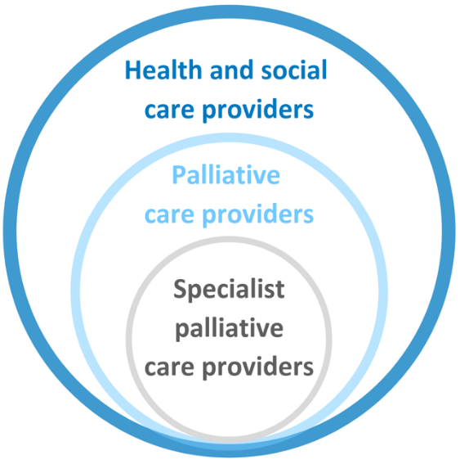

Key messages

People experiencing homelessness face multiple and complex challenges in life, and are more likely to have poorer health and die earlier compared to the general population. At the same time, the homeless population faces significant barriers to accessing services, including healthcare—and, by extension, palliative care.

Barriers and promising approaches for improving access to and experience of palliative care for this population group include:

## Barriers

* Lack of awareness/understanding of palliative care
* Fundamental requirement to prioritise basic day-to-day needs
* Unstable or unsafe living environments
* Fear of being displaced from living environment
* Incompatibility of healthcare services with the realities of homelessness
* High prevalence of mental health and substance use issues
* Social and/or family isolation
* Feared, or actual, stigma and judgement
* Distrust of institutions and authority
* Lack of access to/use of primary care services, leading to crisis presentations
* Service providers’ lack of knowledge, training and experience in providing care for people experiencing homelessness
* Difficulties in making accurate diagnoses and prognoses

## Promising approaches

* Education and training in culturally-appropriate and trauma-informed approaches
* Recognition and consideration of the complex needs of the homeless population
* Collaboration between palliative care services and homeless support services
* Specialist homeless healthcare organisations
* Promoting and facilitating timely engagement between individuals and primary care services
* Flexible services and care environments (e.g. in-reach care in non-conventional care settings)
* Increasing integration and coordination across health and other services
* Adopting a harm reduction approach
* Appropriate funding, including, potentially, increased and protected funding

### 

## Recommendations

Recommendations address seven domains that facilitate quality palliative care. These are underpinned by four key enablers, as illustrated below.

Specific recommendations are detailed in section 4.

Facilitators and underpinning enablers of quality palliative care

The facilitators of quality palliative care are: community comfort with death and dying, community awareness and understanding of palliative care, timely initiation of palliative care, provision of person-centred care, greater understanding of under-served populations, appropriate communication and information provision, and advance care planning.
The underpinning enablers are: networks, partnerships and collaborations, workforce development, financial support and resourcing, and research, evaluation and monitoring.

# Project background

Australian Healthcare Associates (AHA) was engaged by the Australian Government Department of Health (the Department) in February 2018, to conduct an exploratory analysis of barriers to accessing quality palliative care for people from under-served populations or people with complex needs (the project). The project ran from February 2018 to June 2019. The main activities that contributed to the project are summarised in Figure 1‑1.

The project generated a high level of engagement from a broad range of stakeholders.

AHA acknowledges that the community members consulted for this project may not be representative of the broader homeless community.

In particular, it is likely that those who participated had a greater understanding of palliative care, and felt more comfortable discussing death and dying, than those who didn't participate and may be more ‘difficult to reach’.

Please refer to the Summary Policy Paper for more information on project methodology and limitations.

Figure 1‑1: Project activities

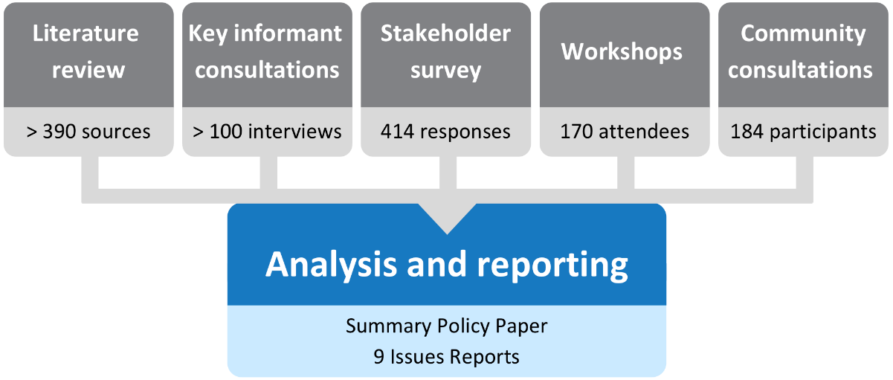

## This report

This issues report describes key barriers and promising approaches for improving homeless people’s access to and experience of palliative care in Australia. It also discusses the potential role of advance care planning and provides recommendations for the palliative care and other sectors to improve access and quality of care for people experiencing homelessness.

This issues report is part of a suite of documents developed through the project, as shown in Figure 1‑2.

Figure 1‑2: Suite of reports

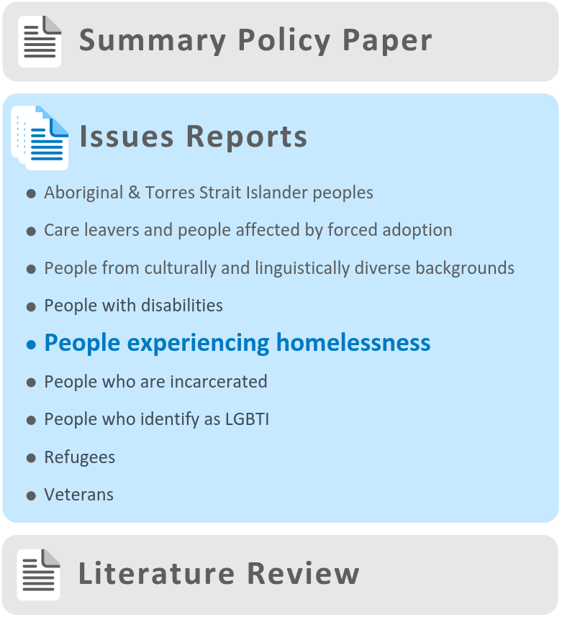

# About this population group

People who are experiencing homelessness may live in a broad and disparate range of living situations. For the purposes of this project, ‘homeless’ and ‘homelessness’ refer to situations where people are:

* Living in non-conventional accommodation or ‘sleeping rough’, or

Living in short-term or emergency accommodation due to a lack of other options.2

Homelessness can have a significant impact on individuals who experience it directly or indirectly, and on society more widely. People who experience homelessness face multiple and complex challenges in life, and are more likely to have poorer health and die earlier compared to the general population.3 Perhaps unsurprisingly, the homeless population faces significant barriers to accessing services, including healthcare—and, by extension, palliative care.4

This section provides an overview of the homeless population in Australia, including some of the specific contextual factors which may impact on palliative care needs in this group.

Context

Enumerating the homelessness population of Australia is inherently difficult, and liable to underestimation.5 However, data from the most recent census (2016) and General Social Survey (GSS) can be used as indicators for estimating the extent of homelessness in Australia.

The 2016 Census identified more than 116,000 Australians as being homeless—0.5% of the total population, and an increase of 14% since the previous census in 2011.6

The 2014 GSS of Australians aged 15 years or older, found that 2.5 million people had experienced homelessness previously, including 351,000 people in the preceding 12 months.7 However, the GSS only surveys those living in ‘private dwellings’—i.e., people who are currently homeless are excluded—leading to an underestimation of the extent of homelessness. Despite this limitation, the GSS highlights that the homeless population is not static, and people may move in and out of homelessness over time.

People aged 55 years and above made up around 15% of the total homeless population in 2016.6 The rate of homelessness in older people is increasing over time, with 29 homeless older persons for every 10,000 people in Australia in 2016, up from 26 homeless older persons per 10,000 people in 2011.

Homelessness, and in particular ‘chronic homelessness’ (defined as lasting for at least six months, or comprised of multiple episodes of homelessness over a 12-month period) is associated with complex personal need. For example, compared to the general population, people who are homeless experience more disability, trauma, physical or mental health problems, substance misuse, and low literacy.8 People experiencing homelessness have been identified as ‘under-served’ by the Australian Government, including in aged care legislation.9

The Australian homeless population is also highly diverse. There is significant crossover with other under-served population groups, which compounds the complexity of need. For example:

* 20% identify as Aboriginal or Torres Strait Islander, compared to only 3% of the general population (2016 data)6
* 5% were veterans,10 compared to an estimated 1.6% of the general population (2013 data)11
* 15% were born overseas and arrived in Australia in the past five years (2016 data)6
* 33.7% of people who identify as lesbian or gay have experienced homelessness compared to 13.4% of people who identify as heterosexual (2014 GSS data).7

# Findings

During the project it was noted that many of the issues identified as barriers, enablers and promising approaches to accessing palliative care by people experiencing homelessness were actually universal factors, i.e. common to the general Australian population, rather than being specific to people experiencing homelessness. These universal factors, along with a range of other factors that are common to all under-served populations, are described in the *Summary Policy Paper* from this project. The discussion below focuses on factors identified as specific to people experiencing homelessness.

Many of the barriers raised through consultations and described below apply to health care and aged care more broadly and are not specific to palliative care.

It is also recognised that people experiencing homelessness as a group are heterogeneous, and, while findings and recommendations in this issues report are generalised, they are unlikely to be relevant in all cases.

The barriers and enablers identified in this report have been categorised as ‘consumer-side’ and ‘service-side’. Consumer-side factors relate to characteristics of individuals, families and communities, while service-side factors relate to health professionals, services and organisations, and the health care system more broadly. These categories are not intended to lay fault for barriers or responsibility for enablers on one particular side of the palliative care relationship, but rather to provide a framework within which to consider an appropriate service system response.

## 

## Barriers to accessing palliative care

### Consumer-side barriers

The most common theme that emerged through this project was the fundamental requirement of homeless people to prioritise their basic day-to-day needs such as shelter, food, and personal care. People experiencing homelessness often exist in survival mode, placing primary emphasis and effort on addressing their more immediate and pressing concerns at the expense of less urgent issues such as healthcare.

‘For many homeless people, thinking about future healthcare need is a long way down the list’   
—Support worker

Living in an unstable environment was also noted as a key barrier, particularly to accessing community-based palliative care. Many health services, including in palliative care, require individuals to have a permanent residence, or fixed address, as a prerequisite for provision of care.

Even with a fixed address, care services may be unwilling, or unable, to enter a person’s residence if it’s judged to be too chaotic, or even unsafe. An example of this could be in the case of hoarding or squalor—circumstances themselves which may exacerbate need, but may mean health services will refuse to enter the residence to provide care.

People experiencing homelessness may also struggle to **securely maintain key health documents and medication**, which can affect their ability to engage with palliative care services and/or comply with treatment plans.

‘Access to meaningful palliative care without housing is impossible’   
—General practitioner

It was noted that the prevalence of mental health issues in the homeless population can lead to avoidance of healthcare services. Individuals affected by mental health issues—often associated with a history of trauma—may lack insight into their health needs, be less able to access health services generally, and have difficulty articulating their care needs.

It was further noted that substance use was an important factor which prevented the homeless population from accessing quality palliative care. Depending on the setting, doctors may be restricted from prescribing, or choose not to prescribe, key pain medication such as opioids to individuals who are current or past substance users because of issues around storage, compliance and safety.12

‘How do you go about safely giving opioids to people with a history of dependence?’ —General practitioner

Conversely, people experiencing homelessness may themselves have concerns about the introduction of medications in the palliative care setting, due to the associated risks of addiction and/or relapse, which may create a reluctance to seek out these services.

Actual or perceived disparities in social status—including lifestyle and education level—were also identified as a barrier. If homeless people feel that health professionals are unable to relate to them or understand their needs, they may be reluctant to seek healthcare services.

Fear of stigma and judgement was also identified as a significant barrier to homeless people engaging with palliative care professionals. Discrimination and stigma may, again, be actual or perceived, and arise from disparities related to socioeconomic status, race, or alcohol and substance use, among others factors.

‘Show people respect and they show it back to you; it’s important to have respect at end-of-life’ —Person experiencing homelessness

Homeless people’s reluctance to access mainstream services can also be related to past negative—often traumatic—experiences, creating a deep-rooted and long-term distrust of institutions and authority. This may lead to behaviour that is perceived as aggressive or challenging, hindering the establishment of trusting reciprocal relationships with health services and health professionals and thereby making it more difficult to access health services, including palliative care.

Many homeless people tend to present to emergency departments as their entry point to health services, because they are not under the regular care of a General Practitioner (GP). Even outside of emergency presentations, it was noted that when homeless people do present to health services, it is often only once a crisis point has been reached. As a result, care provision has to be reactive—a situation which hampers the provision of holistic palliative care, even if such care would otherwise be indicated.

The lack of regular GP or primary care provider removes an important opportunity to access quality preventative care and to receive health information and education, including about palliative care. In line with this finding, stakeholders noted a lack of awareness and understanding about what palliative care is, and what services are available, among the homeless population.

Another barrier identified through this project was that people experiencing homelessness may fear being displaced from their living situation if they were to access palliative care services. This was particularly pertinent when an individual would have to enter residential care in order to receive palliative care. Concerns associated with having to enter a hospital or residential aged care facility (RACF) included the loss of independence, potential restrictions on lifestyle (for example, smoking, drinking or drug use), and an enforced routine—which may be deemed intolerable to people who have been homeless for some time.

‘It can get to the point where residential care is the only option, and people don’t want to go’   
—Support worker

Social isolation was also noted to be a barrier. Being isolated from friends, family and wider society can cause individuals to feel lonely, depressed, undervalued and disenfranchised, and create an aversion to asking for help.

‘When I’m old I just want to be left alone. I have told other people that. I don’t have any friends to call on, just lots of mutual acquaintances’   
—Person experiencing homelessness

Indeed, homelessness is often associated with difficult family relationships, and family breakdown is a common contributing factor to, or product of, individuals becoming homeless. When a person experiencing homeless has limited or no contact with their family, this removes an important emotional support which could otherwise encourage them to consider their options at end-of-life and seek help from palliative care services. Further, having no family support can also mean a lack of practical help, such as assistance with administering medications.

### Service-side barriers

A key barrier identified through this project was the lack of knowledge, training and experience of health professionals in providing care for people experiencing homelessness (as well as a broader concern that many mainstream health providers lack knowledge, training and experience in palliative care—discussed in the *Summary Policy Paper*). Homeless people are less likely to access primary care than the general population, meaning that many GPs and other primary care staff have little or no experience of working with this population.

‘[Health professionals] don’t know how to deal with someone with such a colourful history’ —Social worker

Given health professionals are often ill-equipped to deal with the complex need of the homeless population, they may face particular difficulties in making accurate diagnoses and prognoses. This means that palliative care need is more likely to go unrecognised for people experiencing homelessness compared to the general population.

The incompatibility of healthcare services with the realities of homelessness was noted as a significant barrier. In particular, the ‘chaotic’ lifestyle of the homeless population was noted to be at odds with the rigidity and inflexibility of mainstream health services.

‘Some people don’t have phones, so the best way to get the message out is face-to-face information—word of mouth. People let each other know’ —Person experiencing homelessness

As noted above, it is very difficult to provide palliative care in the absence of stable housing. While some hospital step-down facilities exist, where treatment can be provided post-discharge, the availability of such facilities was noted to be insufficient to meet demand.

It was noted that the policies and procedures of palliative care services often do not ‘fit’ with the specific challenges that affect a homeless person’s ability to participate in treatment. Health professionals may be bound by their own services that hold anti-drug policies, preventing them from treating individuals who take drugs, and thereby disproportionately excluding homeless persons from receiving care.13 Similarly, provision of palliative care may be contingent on setting, and organisational policies may preclude delivery of palliative care in ‘non-conventional accommodation’ such as supportive housing, hostels and shelters.14

## Enablers and promising approaches

### Consumer-side enablers

While no particular consumer-side enablers and promising approaches were noted during the project, those related to service-side factors are described below.

### Service-side enablers

Education and training in culturally-appropriate and trauma-informed approaches was identified as a primary enabler for homeless people accessing palliative care services. This featured prominently in the literature and in consultations, where stakeholders noted that support and training for health professionals were key to fostering attitudes of understanding and respect, and to recognising the rights of homeless people.

‘We need well-educated people working in the right roles’   
—Health professional

Recognition and consideration of the complex needs of the homeless population, including risk factors that may contribute to early death, were seen as necessary for timely referral to palliative care services—particularly when an individual presents repeatedly to health services.

Collaboration between palliative care services and existing homeless services was seen as key to increasing engagement with people who are homeless and improving access to palliative care. Having palliative care health professionals provide in-reach to homelessness services—such as shelters and drop-in centres—could help initiate discussions about palliative care and increase individuals’ understanding and familiarity with the concept.

Specialist homeless healthcare organisations are a vital service that can link people experiencing homelessness with specialist palliative care services, as well as addressing other needs. These services provide healthcare, education and care coordination on an outreach basis, and in some instances, provide short-term residential facilities to support homeless people to access hospital treatment (see for example, the Homeless Healthcare model, described on p.13, which is one of many such models in Australia).

As highlighted in the literature, ‘reciprocal consultations’ between homeless support services (including homeless healthcare organisations) and palliative care services have the potential to create valuable links between the two sectors, facilitating the provision of palliative care to the homeless population in a safe and appropriate setting.15

‘People can access those first level needs—having a shower and a meal—while also creating an opportunity for services to address their health needs’ —GP

Similarly, increasing integration and coordination across health and other services, such as housing, homelessness support and disability services, was identified as integral to improving access to palliative care services for those experiencing homelessness. A need for defined models of care and referral pathways was noted.

‘A whole range of services need to come to the table to deliver good palliative care outcomes’   
—Health professional

A number of stakeholders also highlighted that homelessness organisations could facilitate access to palliative care by **promoting and** **facilitating timely engagement between their clients and primary care services**, for example, by appointment management and transportation assistance.

‘People need some TLC to get them to the doctor, if they don’t know that they need to go’   
—Person experiencing homelessness

Homelessness support providers that offer case management services can facilitate regular engagement with primary care services and may help to increase the likelihood that homeless people use a GP as their first point of entry into health services. This means that health issues can be identified and addressed earlier and more proactively, reducing the risk of medical crises and emergency presentations.

‘Creating a system where the homeless are getting the right care and service when they need it, rather than having to use the emergency department’ —Social worker

A key healthcare system enabler identified during the project was ensuring that health services, and specifically palliative care services, are **flexible** to meet the diverse needs of the homeless population. Moving away from rigid care environments can increase palliative care access for the homeless population by providing **in-reach care** in non-conventional care settings, such as homeless organisations, shelters and drop-in centres.

‘Health services need to come to where homeless people are’   
—Health professional

Recognising that achieving the level of service flexibility required to meet the needs of people experiencing homelessness is likely to be cost- and time-intensive, stakeholders argued that health and palliative care services require specific funding, tied to service delivery expectations and reporting requirements.

The adoption of a harm reduction approach to providing palliative care was also noted as a way to enable those experiencing homelessness to access palliative care services. Rather than denying services based upon the homeless person’s alcohol or drug use, the engagement with health services could instead be used as an opportunity to provide information, advice and support in reducing dependence (see for example, Wintringham Specialist Aged Care, described on p.14).

Further, having robust, yet pragmatic, risk assessment policies within the healthcare system can mitigate against some of the practical issues that create barriers. An example of this would be the assessment of the risk versus benefit of delivering care to individuals in non-conventional accommodation, such as supported housing, hostels and shelters.

As highlighted in the literature, a harm reduction approach can also assist in developing trusting and reciprocal relationships with the homeless population, and embodies ‘a commitment to serving homeless persons and awareness of this population’s life circumstances’.13

A healthcare system which is appropriately funded was commonly identified as another important enabler of access to palliative care services for the homeless population. The provision of increased and protected funding can permit the expansion of flexible palliative care services and the establishment of dedicated hospices for the homeless, which can provide safe and caring environments for those requiring palliative care.

The Medical Recovery Centre, Homeless Healthcare

Homeless Healthcare is a not-for-profit organisation dedicated to providing healthcare to homeless and marginally housed people in Perth. The organisation is a ‘Medical Recovery Centre’ which is targeted at individuals who are sleeping rough and in poor health, but not deemed sick enough for admission to hospital. Homeless people requiring palliative care are able to receive care at the centre.

The 20-bed centre is based on the US respite care model, but with a primary focus on connecting homeless people to stable housing, as well as long-term health and other supports in order to remain housed. A key feature of the Medical Recovery Centre is the establishment of links between homeless clients and primary care services, which then provide follow-up care in the community and can avert future hospital admissions.

Given the high rates of emergency department presentations and hospital re-admissions in the homeless population, Homeless Healthcare’s Medical Recovery Centre may represent an effective (and cost-effective), approach for delivering quality care, including palliative care, to the homeless population.

More information about the Medical Recovery Centre can be found on the [Homeless Healthcare website](http://homelesshealthcare.org.au/hospital-discharges-to-no-fixed-address-heres-a-much-better-way/).[1]

Wintringham Specialist Aged Care

Wintringham is a Victorian-based not-for-profit welfare organisation focusing on the housing and care needs of older people who are homeless or at risk of becoming homeless.

With a dedicated in-house clinical care team, Wintringham aims to ‘maximise health and wellbeing outcomes, while respecting the choices and values of individuals in the community and in residential care’.16

The organisation provides a range of flexible and supportive housing options, from low-care hostels up to facilities offering higher levels of care. The clinical needs of residents are proactively identified and managed by a team of dedicated nurses. All nursing staff are trained in advance care planning, and this support is offered to all residents on admission to Wintringham, and revisited as appropriate.

Individualised care plans are developed for residents requiring palliative care, and specialist palliative care services are brought in for those with particular care or equipment needs. If a resident's palliative care needs change, they can be transferred between residential sites to ensure their needs continue to be met while remaining ‘at home’ at Wintringham ‘until stumps’. This is fundamental to Wintringham’s vision of ‘providing an environment where individuality is respected and honoured and where all receive their rightful entitlement to support and care in a place they call home’.17

Importantly—given their way of life—residents welcome the flexible and non-judgemental palliative care Wintringham is able to offer. Residents are able to benefit from the fact that the organisation does not impose constraints on their lifestyles, such as the ability to smoke or drink, in order for individuals to receive quality palliative care.

‘Given their backgrounds, residents welcome being given the choice around their care, such as knowing they’ll still be able to access pain relief, and not be deprived of alcohol, or cigarettes—they appreciate it’

For more information about the work of this organisation, please refer to the [Wintringham Specialist Aged Care website](https://www.wintringham.org.au/).[2]

## Advance care planning

The process of advance care planning involves conversations about future healthcare preferences between a competent person, healthcare providers and potential substitute decision-makers. The outcomes of the process can include the development of statutory or non-statutory advance care directives (ACDs), or other, less formal documentation of a person’s preferences and substitute decision-maker.18

### Barriers

Homelessness is often associated with family breakdown and social isolation, leaving many homeless people without a next of kin and/or trusted support. This lack of support may hinder an individual’s ability and/or willingness to make decisions around future care planning. Having no trusted support may further impact on a homeless person’s ability to formalise their decisions via an ACD, especially if they are unable to nominate a substitute decision-maker.

The complexity of advance care planning, including completing an ACD, was identified as an important barrier for people experiencing homeless, and especially for those with overlapping mental health, cognitive and/or literacy issues.

The fact that homeless people access primary care services less frequently than the general population was also noted as a barrier to advance care planning. Many homeless people only ever access care in an ad hoc, reactive way—often in an emergency setting—and therefore never experience the continuity of care required to support future care planning.

‘How does a health professional act in an emergency on behalf of someone who is unable to make a decision?’   
—Health professional

Other factors identified as barriers to advance care planning by people experiencing homelessness included fear of loss of autonomy, perceptions that ACDs are paternalistic and controlling, general distrust of healthcare providers, and individuals’ discomfort with the subject of death and dying.

‘Advance care planning denotes choice is available, which is not necessarily the case for the homeless’   
—Health professional

### Enablers

An enabler of advance care planning identified through the project was the use of **centralised electronic records systems** for storing advance care planning documents, which can be accessed by all relevant health service providers. This was seen as particularly important for people experiencing homelessness, who may struggle to safely maintain key documentation and who tend to present to different health services—particularly emergency departments—to access care.

The **timeliness and appropriateness of health professional engagement** with homeless people was also identified as an enabler for advance care planning. It was noted that building trust with a patient who is experiencing homelessness can take a protracted amount of time, and so engaging early to establish a relationship was considered important.

‘They think you’re going to knock them off. You have to pick your moments [to discuss advance care planning]’   
—Health professional

Again, while many homeless people do not have regular access to primary care services, GPs are considered to be key players in enabling advance care planning in this population, by helping to inform decision-making from a medical perspective.

‘There is a need to adjust our world views to meet the client at their world view’ —Specialist palliative care provider

# Recommendations

The *Summary Policy Paper* identifies facilitators of appropriate care in seven domains, underpinned by four key enablers (see p.2).

These domains and enablers are broadly consistent with the National Palliative Care Strategy 2018 and other relevant policy documents. Recommendations arising from the project—including recommendations specific to people experiencing homelessness—are framed in this context.

The recommendations reflect a public health approach to palliative care (see Summary Policy Paper for details), which involves multiple sectors—from individuals and families to specialist palliative care service providers and broadly-focused, ‘non-traditional’ partners and collaborators.

These recommendations are designed to bolster the capacity of all relevant sectors to promote access to appropriate, quality palliative care for people experiencing homelessness with a life-limiting illness. In particular, the idea of **person-centred care shines through as the ultimate goal** of all palliative care service provision. Person-centred care is respectful of, and responsive to, the preferences, needs and values of individuals. As a concept, it incorporates respect, emotional support, physical comfort, information and communication, continuity and transition, care coordination, involvement of family and carers and access to care.19 For people experiencing homelessness, trauma-informed approaches may represent a key component of person-centred care (see *Summary Policy Paper* for more detail).

It is important to acknowledge that identifying and providing the elements necessary to deliver person-centred care for people from under-served populations, including people experiencing homelessness, is likely to be particularly challenging and resource-intensive.

Person-centred care shines through as the ultimate goal of all palliative care service provision.

It is also important to recognise that implementing the recommendations in this report may require service providers and other organisations to make significant changes to organisational policies and procedures, structures and systems.

It is therefore vital that the underpinning enablers identified through this project—particularly workforce development and financial support and resourcing—are firmly in place. Without this support, efforts to improve access to quality, appropriate palliative care for people experiencing homelessness and other under-served population groups are unlikely to succeed.

Palliative care providers may also need assistance from those with a greater understanding of the needs of people experiencing homelessness to co-design services and optimise person-centred care. Linkages between the palliative care sector and relevant community and support organisations—i.e. those with existing relationships and experience meeting the needs of this population group—are likely to be of particular importance (see *Summary Policy Paper* for further discussion).

## 

## Addressing facilitators of appropriate palliative care for people experiencing homelessness

Increase community comfort with discussing death and dying

* Improve the comfort of all of society in discussing issues relevant to death and dying—including individuals, communities, health and social care providers.

Assist health and social care providers to improve their skill and confidence in talking about these issues with people experiencing homelessness.

Promote community awareness and understanding of palliative care

Improve community understanding about palliative care, through broad social marketing strategies as well as specific efforts focusing on people experiencing homelessness.

Facilitate timely initiation of palliative care

* Upskill all health and social care providers and other relevant support people (e.g. homelessness support workers) to identify when palliative care may be needed, engage in discussions with individuals and families and initiate or refer for care as appropriate. Utilise existing programs and resources and tailor where necessary for relevance to homeless populations.
* Consider introducing standard practices and referral processes for all at time of diagnosis with a life-limiting illness.

Promote and facilitate access to primary care to improve continuity of care and, where necessary, enable timely referral to specialist palliative care services.

Foster a greater understanding of people experiencing homelessness

* Ensure all health and other relevant care providers are aware of and responsive to the potential impacts of the life experiences of people experiencing homelessness—in particular the increased likelihood of trauma.

Promote cultural understanding, while avoiding cultural stereotyping.

Improve communication and information provision

Support effective provider–patient communication and the provision of appropriate information. Tailor resources to particular groups when required, and consider:

* + Information using appropriate language in different languages and formats
  + Specific information on palliative care options and entitlements.

Provide one-on-one support to individuals to navigate the relevant system(s) (including healthcare, social welfare, disability, aged care).

Enhance provision of person-centred care

Bolster communities’ capacity to deliver palliative care that is flexible, individualised and delivered in setting(s) of choice where possible.

* + Improve supply of supportive housing and other appropriate settings for provision of palliative care
  + Optimise hospital discharge planning to individuals are discharged to appropriate settings
  + Improve capacity of outreach services.
* Consider and respect the role of families (as defined by individuals) and communities in decision-making and person-centred care.
* Engage with people with lived experience of homelessness to co-design services.

Ensure organisational policies and culture are inclusive and supportive of person-centred care.

Better support advance care planning

* Build on current approaches to enhance advance care planning among those experiencing homelessness—particularly in specific settings such as primary care, aged care and disability services as well as palliative care.

Continue to explore opportunities for promoting consistency and mutual recognition of advance care planning documentation across Australian jurisdictions.

## Addressing underpinning enablers

Networks, partnerships and collaborations

Build the capacity of support organisations to undertake a linking role with palliative care services, e.g. to:

* + Assist individuals to navigate services—including health care, palliative care, aged care and other services
  + Serve as a resource for palliative care services to understand the needs of people experiencing homelessness
  + Assist with broader awareness-raising in relation to palliative care and advance care planning within the communities they serve.

Build linkages and reciprocal collaborations between all relevant sectors (e.g. palliative care, health, homelessness support and other community organisations) to develop best-practice approaches to palliative care service delivery.

Workforce development

Consider training and ongoing professional development initiatives that increase or improve health and social care providers’:

* + Understanding of possible needs of people experiencing homelessness
  + Understanding of and ability to provide or support person-centred palliative care
  + Knowledge of and skill applying trauma-informed approaches
  + Comfort and capacity to assist individuals with advance care planning.

Financial support and resourcing

Noting that all recommendations in this document require appropriate levels of resourcing, more specific funding recommendations include:

* Ensure palliative care funding models are flexible to allow delivery of person-centred palliative care.
* Improve the alignment of the relevant funding systems (including disability, aged care, primary and other healthcare) to support seamless transitions.

Fund community-based/population-specific approaches to palliative care, including establishment and maintenance of collaborative arrangements.

Research, evaluation and monitoring

* Consider appropriate research, evaluation and monitoring activities at all levels to understand the needs of people experiencing homelessness and evaluate efforts to improve access for these groups.

Abbreviations

|  |  |
| --- | --- |
| Abbreviation | Definition |
| ACD | Advance care directive |
| AHA | Australian Healthcare Associates |
| GP | General practitioner |
| GSS | General Social Survey |
| RACF | Residential aged care facility |
| the Department | Australian Government Department of Health |
| US | United States [of America] |

Glossary

Advance care directive (ACD): An advance care directive is a type of written advance care plan recognised by common law or specific legislation. An ACD can only be completed and signed by a competent adult. It may record the person’s values and preferences for future care, and/or include the appointment of a substitute decision-maker to make decisions about health care and personal life management. Forms and requirements vary between states and territories.20

Advance care planning: The process of planning for future health and personal care needs. It provides a way for a person to make their values and preferences known in order to guide decision-making at a future time when they cannot make or communicate their decisions.20

Care leavers: Includes Forgotten Australians, Former Child Migrants and Stolen Generations.

Carers: People who provide personal care, support and assistance to people with a disability, medical condition, mental illness, or frailty due to age. Carers may include family members, friends, relatives, siblings or neighbours. The term ‘carer’ does not include people who provide care for payment (such as a care or support worker), as a volunteer for an organisation, or as part of the requirements of a course of education or training.21

End-of-life care: Includes physical, spiritual and psychosocial assessment, and care and treatment delivered by health professionals and other staff. It includes the support of family and carers, and care of the person’s body after death. People are ‘approaching the end-of-life’ when they are likely to die within the next 12 months.22

Family: Includes people identified by the person as family and may include people who are biologically related and people who joined the family through marriage or other relationships, as well as family of choice and friends.1

Life-limiting illness: Describes illnesses where it is expected that death will be a direct consequence of the specified illness. The term incorporates the concept that people are actively living with such illnesses, not simply dying.1

Palliative care providers: Health and social care providers involved in the clinical management and coordination of care for people living with a life-limiting illness. Palliative care providers may include GPs, geriatricians, oncologists, physicians, paediatricians, renal specialists, cardiologists and other specialists. Other team members will include nurses, allied health professionals and pharmacists.1

Person-centred care: Care that is ‘respectful of, and responsive to, the preferences, needs and values of patients and consumers’.19

Specialist palliative care services: Multidisciplinary teams with specialised skills, competencies, experience and training in palliative care. Care provided through these services is targeted at people with more complex needs, and is referred to as ‘specialist palliative care’.1

Substitute decision-maker: A person appointed or identified by law to make decisions on behalf of a person whose decision-making capacity is impaired. A substitute decision-maker can be:

Someone chosen (and appointed) by the person. Depending on the state or territory, they may be called an enduring guardian, a medical enduring power of attorney, an agent or a decision-maker.

Someone assigned as a decision-maker for the person by law, in the absence of an appointed substitute decision-maker. The hierarchy for appointing a substitute decision-maker varies by jurisdiction. They may be a spouse or de facto spouse, carer, relative or friend.

A substitute decision-maker appointed for the person (e.g. a guardian appointed by a guardianship tribunal).20

Trauma-informed care: ‘An organisational structure and treatment framework that involves understanding, recognising and responding to the effects of all types of trauma’.23

References

1. Palliative Care Australia (PCA). *Palliative care service development guidelines*. (PCA, 2018).

2. Australian Institute of Health and Welfare. Homelessness services glossary. (2017). Available at: https://www.aihw.gov.au/reports-statistics/health-welfare-services/homelessness-services/glossary. (Accessed: 26 Feb 2018).

3. Flatau, P. *et al.* *The state of homelessness in Australia’s cities: a health and social cost too high*. (2018).

4. Riley, C. The homeless community: Breaking down the barriers to primary care. *Int. Paramed. Pract.* 7, 26–30 (2017).

5. Australian Bureau of Statistics. *ABS review of counting the homeless methodology - position paper*. (2011).

6. Australian Bureau of Statistics. *2049.0 - Census of Population and Housing: Estimating homelessness, 2016*. (2018).

7. Australian Bureau of Statistics. *4159.0 - General Social Survey: Summary Results, Australia, 2014*. (2014).

8. Australian Institute of Health and Welfare. *Sleeping Rough, a profile of specialist homelessness services clients*. (2018).

9. Department of Health. *Legislated review of aged care 2017*. (Commonwealth of Australia, 2017).

10. Bruce, C. 1 in 20 homeless people surveyed are military veterans: new study. (2018). Available at: https://hope1032.com.au/stories/life/news/2018/1-20-homeless-people-surveyed-military-veterans-new-study/. (Accessed: 14 May 2019).

11. Department of Veterans’ Affairs. Snapshot of the veteran community. *Annual reports 2017-18* (2017). Available at: https://www.dva.gov.au/about-dva/accountability-and-reporting/veterans-affairs-portfolio-annual-reports/annual-reports-2-11. (Accessed: 31 May 2019).

12. MacWilliams, J., Bramwell, M., Brown, S. & O’Connor, M. Reaching out to Ray: Delivering palliative care services to a homeless person in Melbourne, Australia. *Int. J. Palliat. Nurs.* 20, 83–88 (2014).

13. McNeil, R., Guirguis-Younger, M. & Dilley, L. B. Recommendations for improving the end-of-life care system for homeless populations: A qualitative study of the views of Canadian health and social services professionals. *BMC Palliat. Care* 11, 14 (2012).

14. Stajduhar, K. I. & Mollison, A. *Too little too late: How we fail vulnerable Canadians as they die and what to do about it*. (University of Victoria Institute on Aging & Lifelong Health, 2018).

15. Klop, H. T. *et al.* The views of homeless people and health care professionals on palliative care and the desirability of setting up a consultation service: A focus group study. *J. Pain Symptom Manage.* 56, 327–336 (2018).

16. Wintringham Specialist Aged Care. Wintringham - an overview. (2019). Available at: https://www.wintringham.org.au/company-overview.html. (Accessed: 31 May 2019).

17. Wintringham Specialist Aged Care. Vision and mission. (2019). Available at: https://www.wintringham.org.au/vision_and_mission.html. (Accessed: 31 May 2019).

18. Buck, K. *et al.* *Prevalence of advance care planning documentation in Australian health and residential aged care services, Short Report*. (Advance Care Planning Australia, Austin Health, 2017).

19. Australian Commission on Safety and Quality in Health Care. *Patient-centred care: Improving quality and safety through partnerships with patients and consumers*. (ACSQHC, 2011).

20. Advance Care Planning Australia and National Ageing Research Institute. *Advance care planning in aged care: A guide to support implementation in community and residential settings*.

21. The Parliament of Australia. *Carer Recognition Act No.123, 2010*.

22. Australian Government Department of Health. *National Palliative Care Strategy 2018*.

23. Victorian Government Department of Health & Human Services. *Trauma and mental health: 10-year mental health plan technical paper*. (DHHS, 2015).

1. <http://homelesshealthcare.org.au/hospital-discharges-to-no-fixed-address-heres-a-much-better-way/>
2. <https://www.wintringham.org.au/>