Australian Government Department of Health

Exploratory Analysis of Barriers to Palliative Care

Issues Report on Care Leavers and People Affected by Forced Adoption



September 2019

Acknowledgments

Australian Healthcare Associates (AHA) would like to thank the many people who contributed to this project. These included palliative care and other health and social care providers, academics, and peak organisation and government representatives. In particular, we thank the people from the under-served populations who shared their thoughts and experiences with us.

Contents

Key messages 1

Barriers 1

Promising approaches 1

Recommendations 2

1| Project background 3

This report 4

2| About this population group 5

3| Findings 7

Barriers to accessing palliative care 7

Enablers and promising approaches 11

Advance care planning 16

4| Recommendations 17

Addressing facilitators of appropriate palliative care for care leavers and people affected by forced adoption 18

Addressing underpinning enablers 20

Abbreviations 21

Glossary 22

References 24

Figures and tables

Facilitators and underpinning enablers of quality palliative care 2

Figure 1‑1: Project activities 3

Figure 1‑2: Suite of reports 4

What is palliative care?

Palliative care is a person- and family-centred approach to care. Palliative care services are provided for a person with an active, progressive, advanced disease, who has little or no prospect of cure and who is expected to die, and for whom the primary treatment goal is to optimise quality of life.1 It improves quality of life for individuals and families through the prevention and relief of suffering by means of early identification and correct assessment and treatment of pain and other physical, psychosocial or spiritual problems.3

Palliative care:

* Should be strongly responsive to the needs, preferences and values of people, their families and carers
* Should be available to all people with an active, progressive, advanced disease, regardless of diagnosis

Affirms life while recognising that dying is an inevitable part of life.

This means that palliative care is provided during the time that the person is living with a life-limiting illness, but it is not directed at either bringing forward or delaying death.

Palliative care can be provided in a range of settings, including:

* At home
* At a hospital
* In a hospice
* In an aged care facility

In an institutional setting (such as a correctional facility or accommodation for people living with a disability).

Palliative care involves a range of clinical and other supports delivered by different providers, including volunteers, depending on the patient's needs. These may include:

* General practice and primary care
* Other specialist medical, nursing and allied health practitioners
* Community, disability, aged and social services
* Grief and bereavement services

Specialist palliative care services (comprising multidisciplinary teams with specialised skills, competencies, experience and training in palliative care), for patients with complex needs.

This project adopts a broad view of palliative care, as outlined above, and is not limited to the provision of specialist palliative care services.

Therefore the term ‘palliative care provider’ is used in this document to refer to all health and social care providers involved in the delivery of palliative care.

Where relevant, the term ‘specialist palliative care provider’ is used to differentiate this group of professionals. More broadly, the term ‘health and social care providers’ is used to represent those within this category for whom palliative care is not considered core business.

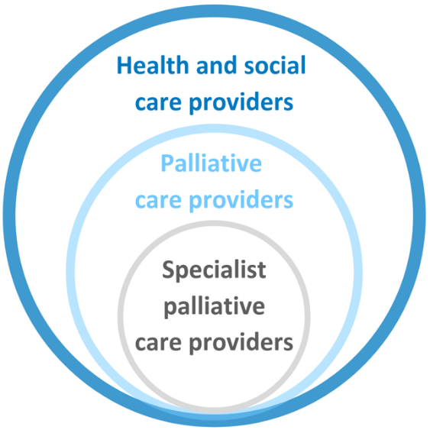

Key messages

While care leavers and people affected by forced adoption represent distinct groups with different issues and needs, the impact of traumatic life experiences for both groups contribute to barriers in accessing quality palliative care.

Barriers and promising approaches for improving access to, and experience of, palliative care for this population group include:

## Barriers

* Lack of awareness/understanding of palliative care
* Distrust of the health system and government
* Health providers lack of understanding of impact of past experiences
* Impact of past trauma
* Challenging/dysfunctional family dynamics

Lack of flexibility in institutional settings

## Promising approaches

* Awareness-raising activities—including through existing support groups
* Education and training for health and social care providers
* Peer and advocacy support
* Trauma-informed approaches to care

Flexible care options that centre on provision of care at home

### 

## Recommendations

Recommendations address seven domains that facilitate quality palliative care. These are underpinned by four key enablers, as illustrated below.

Specific recommendations are detailed in section 4.

Facilitators and underpinning enablers of quality palliative care

The facilitators of quality palliative care are: community comfort with death and dying, community awareness and understanding of palliative care, timely initiation of palliative care, provision of person-centred care, greater understanding of under-served populations, appropriate communication and information provision, and advance care planning.
The underpinning enablers are: networks, partnerships and collaborations, workforce development, financial support and resourcing, and research, evaluation and monitoring.

# Project background

Australian Healthcare Associates (AHA) was engaged by the Australian Government Department of Health (the Department) in February 2018, to conduct an exploratory analysis of barriers to accessing quality palliative care for people from under-served populations or people with complex needs (the project). The project ran from February 2018 to June 2019. The main activities that contributed to the project are summarised in Figure 1‑1.

The project generated a high level of engagement from a broad range of stakeholders.

AHA acknowledges that the community members consulted for this project may not be representative of other people who are care leavers or affected by forced adoption.

In particular, it is likely that those who participated had a greater understanding of palliative care, and felt more comfortable discussing death and dying, than those who didn't participate and may be more ‘difficult to reach’.

Please refer to the Summary Policy Paper for more information on project methodology and limitations.

Figure 1‑1: Project activities

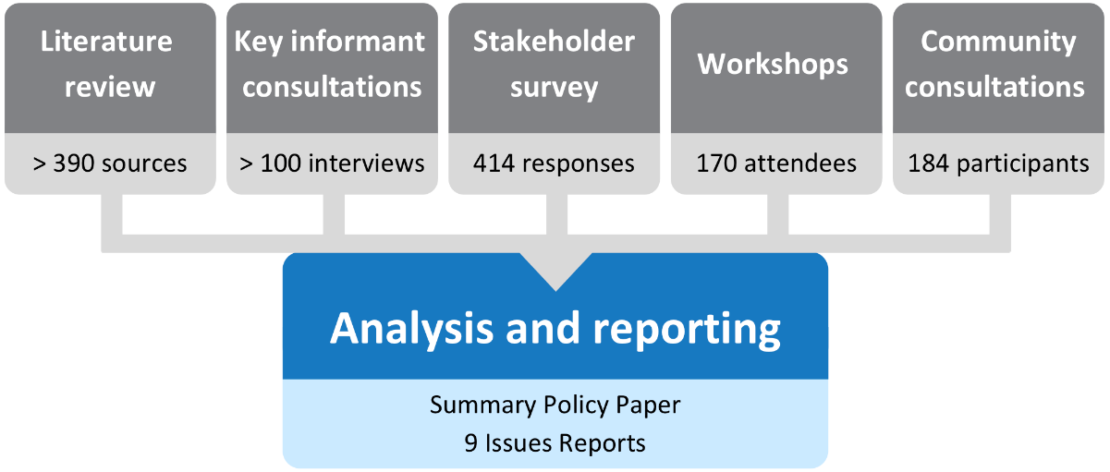

## This report

This issues report describes key barriers and promising approaches for improving access to and experience of palliative care for people who are care leavers or affected by forced adoption. It also discusses the potential role of advance care planning and provides recommendations for the palliative care and other sectors to improve access and quality of care for these groups.

This issues report is part of a suite of documents developed through the project, as shown in Figure 1‑2.

Figure 1‑2: Suite of reports

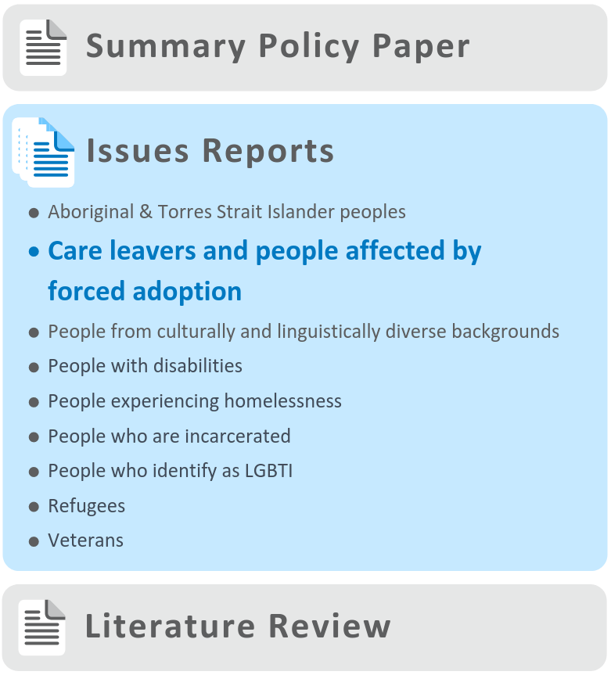

# About this population group

A **care leaver** is ‘a person who was in institutional care or another form of out-of-home care, including foster care, as a child or youth during the 20th century’, including:

* Forgotten Australians[1]
* Former Child Migrants

Stolen Generations.2

Forced adoption refers to ‘adoption where a child’s natural parent, or parents, were compelled to relinquish a child for adoption’.3

While care leavers and people affected by forced adoption represent distinct groups with different issues and needs, they have been considered together for the purposes of this project. Both groups have been identified as special needs groups in the Aged Care Act 1997,4 and may also face considerable barriers in accessing quality palliative care. It is also noted that there is a degree of overlap between the groups, with some care leavers subsequently being affected by forced adoption, and some children separated from their parents spending time in out-of-home care.

Context

It is estimated that, throughout the 1900s, more than half a million children in Australia (Forgotten Australians) were placed in institutional and out-of-home care under various arrangements.5 Also, in the mid-20th century, more than 7,000 children from the UK and Malta were sent to Australia as Child Migrants.6

Between the late 1800s and the 1970s, many Aboriginal and Torres Strait Islander children were forcibly removed from their families—so many that ‘almost every Aboriginal family today can identify one or more family members lost’ as part of the Stolen Generations.6

While it is not possible to enumerate the number of people affected by forced adoptions, ‘tens of thousands’ of people have been affected, and the associated trauma can be transgenerational.7

Over the past two decades, there has been increased recognition of the past harms done to people from each of these groups, including formal government apologies to Stolen Generations (2008), Forgotten Australians and Former Child Migrants (2009) and people affected by forced adoption (2013).

Given the high number of people who are care leavers or are affected by forced adoption, it is likely that they are part of the clientele of health, palliative care and aged care services—whether recognised or not.

There is a lack of published literature relating to the palliative care needs of these groups. However, information of relevance to this project includes:

* There is some evidence that care leavers may have higher rates of chronic health conditions than the general population8
* Many care leavers were physically or sexually abused in their settings of ‘care’. Homelessness, drug and alcohol misuse and mental health issues are more prevalent in this group than among the Australian population overall6 and such abuse may contribute to transgenerational effects5

People affected by forced adoption may have complex mental health issues including depression, anxiety, complex and/or pathological grief and loss, post-traumatic stress disorder (PTSD), abandonment, identity and attachment disorders, and personality disorders.9

Additional barriers to accessing palliative care experienced by Aboriginal and Torres Strait Islander peoples, many of which are relevant to members of the Stolen Generations, are discussed in a separate issues report.

# Findings

During the project it was noted that many of the issues identified as barriers, enablers and promising approaches to accessing palliative care by care leavers and people affected by forced adoption were actually universal factors, i.e. common to the general Australian population, rather than being specific to care leavers and people affected by forced adoption. These universal factors, along with a range of other factors that are common to all under-served populations, are described in the Summary Policy Paper from this project. The discussion below focuses on factors identified as specific to care leavers and people affected by forced adoption.

Many of the barriers raised through consultations and described below apply to health care and aged care more broadly and are not specific to palliative care.

It is also recognised that these populations are heterogeneous, and, while findings and recommendations in this issues report are generalised, they are unlikely to be relevant in all cases.

The barriers and enablers identified in this report have been categorised as ‘consumer-side’ and ‘service-side’. Consumer-side factors relate to characteristics of individuals, families and communities, while service-side factors relate to health providers, services and organisations, and the healthcare system more broadly. These categories are not intended to lay fault for barriers or responsibility for enablers on one particular side of the palliative care relationship, but rather to provide a framework within which to consider an appropriate service system response.

## 

## Barriers to accessing palliative care

### Consumer-side barriers

#### Individuals

Many care leavers and people affected by forced adoption have faced a range of harmful life experiences, which include separation from family, deprivation of love, loss of identity, and physical, emotional or sexual abuse. As a result of their experiences, they have complex and specialised needs—including mental health needs—which are often not met by mainstream health and social services. Care leavers may leave care settings with insufficient support networks, and have poorer outcomes across a number of domains including such as housing, education and employment.10

Among the care leavers and people affected by forced adoption consulted for this project, low levels of awareness and understanding of palliative care were common. Beliefs and expectations about palliative care were influenced by the experiences of the deaths of parents or other loved ones, in hospitals, aged care facilities or, in some instances, in hospices. Many of these experiences were painful and stressful, with limited evidence of palliative care having been provided. Because of the tendency to equate palliative care with ‘the care provided at the time of death’, many interviewees had negative perceptions of palliative care.

Fear and mistrust of government agencies and services are key barriers to accessing health care services for care leavers and people affected by forced adoption. For care leavers in particular, fear of institutions (including hospitals and aged care facilities) is a powerful barrier. Both the physical elements of institutions (e.g. corridors, smell of disinfectant, dark panelling, locked doors) as well as the associated routines (e.g. time-tables, lack of choice of meals) can be triggering.

‘I don’t want to be told what to do and when to do it. I like flexibility and need my freedom’ —Care leaver

‘Care leavers can be triggered by a lot of things and carers need to know about this. Like meals: meals and meal times can cause distress. It’s important to give people choice of a meal, not just bland mushy food’ —Care leaver

For members of the Stolen Generations, this fear may extend to non-Aboriginal people coming into their homes, as this may trigger memories of being forcibly removed from their families.

As a result of this distress, people may find it very difficult to engage with health providers in institutional settings, which may impact on effective care planning.

Many care leavers are distrustful of healthcare services that are associated with religious organisations due to past experiences of abuse and neglect. Given the number of palliative care organisations associated with religious organisations, this is a significant concern for many.

For many care leavers and people affected by forced adoption, it can be very difficult to develop trust with other people (including with service providers), because of experiences of separation, abandonment and deception (e.g. many children were told—untruthfully—that their parents had died, or did not care about them). Mothers who were affected by forced adoption may have enduring distrust of the medical, legal and social work professions:

‘They were the three fields engaged in this conspiracy; this conspiracy is a big barrier to us trusting health professions’ —Mother affected by forced adoption

Fear of losing autonomy or control over one’s body is an important concern shaping consumers’ views of palliative care. This may include a fear of being touched, of having their bodies ‘invaded’, or of losing consciousness, arising from experiences of forced medical procedures or medication. Mothers who were forced to relinquish their babies at the time of birth reported having trauma that is triggered by needles.

‘I want control of my life. The [medical system] took it away once, and they’re not going to do it again’ —Mother affected by forced adoption

‘I’m a traumatised person, and that trauma happened in a clinical setting’ —Mother affected by forced adoption

‘I would hate to be in a closed room—that would send me over the top’  
—Mother affected by forced adoption

As a result of their experiences, care leavers and people affected by forced adoption may find it difficult or impossible to speak up about their needs, wishes or concerns, particularly where additional vulnerabilities (e.g. mental health issues, homelessness) are present. For care leavers, this may arise from childhood experiences of being told that they would not be believed if they spoke up about their abuse—which can lead to a reluctance in adulthood to speak of their experiences. This may be exacerbated in institutional settings (e.g. hospitals) or when dealing with bureaucracy.

‘We often need an advocate to speak for us. Nurses don’t understand that we are traumatised, and we won’t speak up for ourselves. It’s too hard for us to explain without upsetting ourselves’ —Care leaver

Similarly, perceptions of discrimination and feelings of stigma may deter people from speaking about the past, expressing their needs or disclosing their trauma. This may limit the capacity of health providers to understand their trauma and respond appropriately. Others would prefer not to be ‘pigeon-holed’ by their experiences, and do not identify with the terms commonly used to describe people from these groups—such as ‘Forgotten Australians’ or ‘relinquishing mothers’.

‘I am scared to share; scared to explain in case they think I’m crazy and put me in an institution again. It’s not safe to share’ —Care leaver

Several care leavers spoke of how traumatic childhood experiences may re-emerge for people with dementia in aged care or hospital settings:

‘I know of someone with dementia who was an orphan. She was scared the nuns were going to hit her’   
—Care leaver

‘A lady I knew was shown her room in the nursing home and asked, ‘Do I have to clean it? What time do I have to clean it?’ —Care leaver

#### Families

While fear of institutions may lead to a preference for care in the home, rather than in hospitals, hospices or aged care facilities, a lack of family support may pose challenges to the effective delivery of care within the home. Relationship difficulties and isolation (at least in part attributed to their childhood experiences) are common.

‘A lot of this cohort are on their own and disengaged from their families’   
—Care leaver

Many people are motivated to connect with family members at the end of their lives. This may be hampered by difficulties in accessing their records—which may be closed, incomplete or non-existent.

While not specifically a barrier to accessing care, fractured or fragile relationships can complicate the process of caring for family members at end-of-life, and can be ‘conflicted and stressful’. This points to the need for palliative care services to consider the psychosocial and emotional needs of family or carers, as well as the patient.

Other barriers to accessing services in general include cost, lack of services or information about them, and lack of transport.

### Service-side barriers

Lack of awareness or understanding of the impact of past experiences may impact the quality of care received. A need for workforce training and support has been recognised—to avoid the need for consumers to repeat their stories, to understand what language to use/avoid, and to appreciate how trauma may present as behavioural issues (e.g. anger, withdrawal etc, or, alternatively, passive compliance).

A key challenge for service providers is how best to ‘screen’ people to identify whether they may be care leavers or affected by forced adoption, given the reluctance of many to identify. It was recognised as important that service providers give individuals an opportunity to disclose their history if they wish, without requiring them to go into detail if they would prefer not to.

Lack of flexibility in institutional settings was noted as a barrier. This includes regimented schedules, lack of choice of meals, and restricted visiting times.

Due to fear of institutions, many would prefer to receive palliative care in the home setting, if at all possible—however there is a lack of capacity within the system to provide home-based care, especially outside of the major cities, and for those without family support. Continuity of nursing/support staff was seen as critically important because of the stress involved in having to re-tell one’s story, explain one’s triggers and develop trust.

Some consumers felt that while the government had come some way in recognising the unique needs of these groups, the recognition of care leavers and people affected by forced adoption as special needs groups in the Aged Care Act did not translate into meaningful understanding or practical support. One focus group participant recounted her experience of phoning the My Aged Care contact centre, and asking what special support may be available for her mother, who was affected by forced adoption. The contact centre worker was unfamiliar with the term ‘forced adoption’ and did not know what support was available, leading to extreme frustration and anger for the caller. Similar experiences have been noted elsewhere, with recognition that ‘service delivery agencies can seem faceless and hostile to people who don’t expect to be heard or treated fairly’.5

## Enablers and promising approaches

### Consumer-side enablers

**Building awareness and understanding** of palliative care is considered key to overcoming barriers to accessing palliative care by:

* Reducing fear and addressing misconceptions

Helping people to understand their options, and what supports might be available.

Peer support was seen as an important way of sharing information about palliative care and providing support. Camaraderie among people from these groups is often high because of shared experience and understanding.

Having an advocate—either a family member or friend, or a paid/professional advocate, was seen as helpful for navigating the health, aged care and palliative care systems. Consumers stressed that this person needs to be someone with whom the person has a trusting relationship—and it might take years to achieve the required level of trust.

‘I wouldn’t necessarily trust a paid advocate. The advocate is still a stranger’   
—Care leaver

**Connections with existing support services** that specialise in the needs of people from these cohorts were noted to be critical. These services provide counselling as well as support to search for records or family members. Australian government-funded organisations include:

* Organisations funded as Forced Adoption Support Services
* Find & Connect Support Services (primarily for Forgotten Australians and Former Child Migrants)
* Link-Up, for Stolen Generations

Other advocacy organisations, such as Care Leavers Australia Network (CLAN)

There are also many other organisations at state/territory and local level that provide specialist support for care leavers and people affected by forced adoption.

Stakeholders noted the importance of offering support to deal with trauma. However, the importance of allowing individuals to choose whether or not to disclose their trauma was stressed, along with a need to avoid medicalising or pathologising the individual’s situation.

‘Dignity therapy’11 was suggested as an approach through which patients and their families can make sense of the impact of life experiences as one is approaching death.

While trauma is very common among care leavers and people affected by forced adoption, many people from these cohorts identify as ‘survivors’, and have strengths and coping mechanisms that are in themselves an enabler. One care leaver viewed her childhood experiences through a positive lens:

‘I’m institutionalised so well that I fit in pretty well anywhere, and I’m a rebel enough to push the envelope’ —Care leaver

Involving care leavers and people affected by forced adoption in the design of programs was noted as important because it validates their experiences, demonstrates respect, and provides reassurance.

Recognition of care leavers

Many Forgotten Australians have been advocating for an identity card that briefly explains what the term Forgotten Australian means, and how the trauma of their childhoods may affect the way they interact with people. Such a card means they may not have to continuously tell their story, particularly to health providers. Based on examples previously developed by the Historical Abuse Network in Queensland, the Alliance for Forgotten Australians (AFA) developed a pilot card in 2018 and more than 4,000 were distributed across Australia. Feedback from users of the card has been very positive. Forgotten Australians would like the card to become a formal document issued by government, and include their name and possibly other identifying information.

‘With disability you can see it. For us it’s invisible. If you have a disability sticker on your car you get compassion and understanding’   
—Care leaver

### Service-side enablers

As noted earlier, building the knowledge and skills to better understand the experiences of people who are care leavers or affected by forced adoption is noted as critically important to better meeting their needs. Training provided by support or advocacy organisations (and led/informed by people with lived experience) is seen as a key enabler. In Victoria, an extensive education program through Open Place, a support service funded by the Victorian and Australian Governments, has a large audience of aged care providers.

Similarly, information resources, directed at health providers or aged care providers, are also useful for improving service provider knowledge. In 2016, the Australian Government Department of Health published [Caring for Forgotten Australians, Former Child Migrants and Stolen Generations information package](https://agedcare.health.gov.au/sites/default/files/documents/03_2017/forgotten_australians_booklet_-_print_version.pdf)[2]. The package, which includes a booklet, facilitator guide and PowerPoint presentation, was produced with the input of Forgotten Australians and other survivor groups. The package was intended to assist professionals working in aged care understand care leavers’ concerns, fears and anxieties around being re-institutionalised when they access aged care. While the AFA received some funding to promote the package, it feels that more work is required to disseminate these resources widely.

While some consumers see a need for advocates to support them to navigate systems and to exercise choice, other stakeholders have recognised the potential benefits of creating a support role (perhaps titled ‘Palliative and Aged Care Service Support Officer’) that does not just sit ‘on the side’ of the consumer (as an advocate would), but who can also act as a resource for palliative care or other health care providers working with the consumer.

By assisting with warm referrals of consumers to services, the support officer could open a dialogue that builds the understanding and capacity of healthcare workers (e.g. awareness of triggers, language to avoid, considerations of institutional environmental factors). The support officer could:

* Provide support to individual staff
* Provide training and awareness-raising as part of professional development for other staff

Support individuals and families navigating palliative and aged care services to maximise effective transition and in order to maintain ongoing engagement with services.

To be effective in such a role, it is recommended that the worker have a deep understanding of the needs of the population group, and have also established a strong relationship of trust with the cohort. Organisations that are funded to provide support to care leavers (e.g. Find and Connect services) or people affected by forced adoption (e.g. Forced Adoption Support Services) would be well placed to host such positions—but are currently not funded to do so.

Helping Hand—Real Care the Second Time Around

Helping Hand is a South Australian not-for-profit organisation that provides residential care homes, retirement living and home care services to over 7,000 clients in metropolitan and regional areas.

Recognising that many care leavers are ageing and facing the prospect of entering aged care or accessing home care services, Helping Hand has formulated a guide that outlines the organisation’s commitment to support aged care services to recognise and respond to the needs of Forgotten Australians. The guide, [Real Care the Second Time Around](http://www.helpinghand.org.au/wp-content/uploads/2019/01/Position-Statement-Forgotten-Australians.pdf)[3], was created through a co-design process that included Forgotten Australians who use Helping Hand services and those from Elm Place, a support service for care leavers run by Relationships Australia South Australia. The guide includes information for staff members to better assist Forgotten Australian clients—recognising that for many, the prospect of returning to institutional care settings is very frightening. The guide also has relevance to Former Child Migrants and members of the Stolen Generations.

The guide addresses three main themes, which are critical to ensuring appropriate care for Forgotten Australians. While developed for aged care, the concepts are applicable to other types and settings of care—including palliative care.

Embracing identity:

Recognising each person’s individuality and that this individuality is central to caring for them.

* For people whose identities have been stolen, lost or ignored, understanding that ‘take me as I am’ takes on the greatest significance. This is especially so when a sense of identity has been so compromised by past actions, and is still subject to change as pasts are revealed and unravelled.
* Understand that to be listened to, and believed, about past events is central to embracing identity.
* Respect that trust is not easily won.

Accept that affected individuals may not identify with the terms used, nor wish to disclose details of past harms and this does not affect our need to support everyone in our care.

Offering care based on choice, transparency and understanding:

* Staff understanding how to reduce the impact of past trauma on those who we care for now and into the future, and knowing how to support different individuals as they age.
* Demonstrating care and respect for the rights of Forgotten Australians so that they may exercise choice and control over their lives.
* Committing to building trust and offering transparency about services and care so that there is open disclosure and complaints processes related to care.
* A determination to engage in person-centred care planning that considers past trauma and the wrongs of past care experiences.

Recognition that exercising choice and control can be a challenge for those not accustomed to such opportunities.

Support to realise the expression of individuals’ rights:

* Provide information about care options and ways of respecting privacy and cultural differences, maintaining dignity and independence as this is central to the expression of rights.

Offer access to support and information about rights, choices and decision-making in order to provide safety to those in care, particularly for those who lack wider support networks.

The guide was launched in January 2019. In April 2019, Helping Hand received Australian Government funding to build on this work by developing practical tools to help individuals and aged care providers to:

* Build the capacity of Forgotten Australians to engage with aged care.
* Respond to the aged care needs of Forgotten Australians (including implementing trauma-informed approaches to care).

Communicate and share information about care delivery.

This body of work will be co-designed with Forgotten Australians, with research support from Flinders University (SA).

## Advance care planning

The process of advance care planning involves conversations about future healthcare preferences between a competent person, healthcare providers and potential substitute decision-makers. The outcomes of the process can include the development of statutory or non-statutory advance care directives (ACDs), or other, less formal documentation of a person’s preferences and substitute decision-maker.13

Consistent with the broader population, relatively few people who are care leavers or who are affected by forced adoption appear to be undertaking advance care planning.

Among community members interviewed, there was a general reluctance to talk about dying and death (although it is not uncommon for people to have written detailed instructions about funeral arrangements). Some felt that due to more immediate concerns and pressures, advance care planning may not be considered a priority.

‘I haven’t spoken to my daughter yet. I’m not at that stage’ —Care leaver

Others felt confident that their children would make the right decisions for them.

Practical barriers to advance care planning included:

* Low levels of literacy, which may make completing the ACD paperwork a daunting prospect
* Reluctance to engage with ACD documentation because it appears to be formal or bureaucratic
* Lack of access to (and continuity of) trusted health and social care providers (e.g. general practitioners (GP), support workers) with experience in advance care planning, who could facilitate the process
* Lack of family, or lack of sufficiently close relationships, to be able to have advance care planning conversations.

Education about advance care planning and its potential benefits, and the support of GPs, advocates or other health and social care providers, were suggested as ways to improve uptake of advance care planning.

‘If you’ve got no next of kin, who makes these decisions?’ —Care leaver

# Recommendations

The Summary Policy Paper identifies facilitators of appropriate care in seven domains, underpinned by four key enablers (see p.2).

These domains and enablers are broadly consistent with the National Palliative Care Strategy 2018 and other relevant policy documents. Recommendations arising from the project—including recommendations specific to care leavers and people affected by forced adoption—are framed in this context.

The recommendations reflect a public health approach to palliative care (see Summary Policy Paper for details), which involves multiple sectors—from individuals and families to specialist palliative care service providers and broadly-focused, ‘non-traditional’ partners and collaborators.

These recommendations are designed to bolster the capacity of all relevant sectors to promote access to appropriate, quality palliative care for care leavers and people affected by forced adoption with a life-limiting illness. In particular, the idea of **person-centred care shines through as the ultimate goal** of all palliative care service provision. Person-centred care is respectful of, and responsive to, the preferences, needs and values of individuals. As a concept, it incorporates respect, emotional support, physical comfort, information and communication, continuity and transition, care coordination, involvement of family and carers and access to care.14 For care leavers and people affected by forced adoption, trauma-informed approaches may be a key component of person-centred care (see *Summary Policy Paper* for more detail).

It is important to acknowledge that identifying and providing the elements necessary to deliver person-centred care for people from under-served populations, including care leavers and people affected by forced adoption, is likely to be particularly challenging and resource-intensive.

Person-centred care shines through as the ultimate goal of all palliative care service provision.

It is also important to recognise that implementing the recommendations in this report may require service providers and other organisations to make significant changes to organisational policies and procedures, structures and systems.

It is therefore vital that the underpinning enablers identified through this project—particularly workforce development and financial support and resourcing—are firmly in place. Without this support, efforts to improve access to quality, appropriate palliative care for under-served population groups, including care leavers and people affected by forced adoption, are unlikely to succeed.

Palliative care providers may also need assistance from those with a greater understanding of the needs of care leavers and people affected by forced adoption to co-design services and optimise person-centred care. Linkages between the palliative care sector and relevant community and support organisations—i.e. those with existing relationships and experience meeting the needs of this population group—are likely to be of particular importance (see *Summary Policy Paper* for further discussion).

## 

## Addressing facilitators of appropriate palliative care for care leavers and people affected by forced adoption

Increase community comfort with discussing death and dying

* Improve the comfort of all of society in discussing issues relevant to death and dying—including individuals, communities, health and social care providers.

Assist health and social care providers to improve their skill and confidence in talking about these issues with care leavers and people affected by forced adoption.

Promote community awareness and understanding of palliative care

* Upskill all health and social care providers to identify when palliative care may be needed, engage in discussions with individuals and families and initiate or refer for care as appropriate.

Consider introducing standard practices/referral processes at time of diagnosis with a life-limiting illness.

Facilitate timely initiation of palliative care

* Improve community understanding of palliative care through broad social marketing strategies, as well as specific efforts focusing on care leavers and people affected by forced adoption (e.g. education sessions organised through existing support groups—noting that some people may not access such services).

Foster a greater understanding of care leavers and people affected by forced adoption

* Ensure all health, social and aged care providers are aware of and responsive to the impacts of the life experiences of care leavers and people affected by forced adoption, including preferred language, and possible triggers. For those working with care leavers, the principles outlined in the Helping Hand [Real Care the Second Time Around](http://www.helpinghand.org.au/wp-content/uploads/2019/01/Position-Statement-Forgotten-Australians.pdf) resource should be considered.

Promote cultural understanding, while avoiding cultural stereotyping.

Improve communication and information provision

* Support effective provider–patient communication and the provision of appropriate information. Where required, tailor information to the specific needs of care leavers and people affected by forced adoption, and consider:
  + Palliative care information that uses appropriate language in different languages and formats
  + Specific information about palliative care options and entitlements—including any benefits that may arise from belonging to a group identified as a special needs group in aged care legislation.
* Provide one-on-one support to individuals/families to navigate the relevant system(s).

Enhance provision of person-centred care

Bolster communities’ capacity to deliver palliative care that is flexible, individualised and delivered in setting(s) of choice where possible. Consider:

* + Increasing capacity to provide palliative care in people’s homes, given the preference of many to avoid institutions
  + Where possible, ensuring continuity of care providers, so that individuals are not required to repeat their stories
  + Avoid possible triggers arising from rigid care practices
* Recognise that individuals may need time and support to be able to express their needs and preferences.
* Ensure appropriate setting design. This includes avoiding likely triggers in the physical environment.

Consider and respect the role of families (as defined by individuals) and communities in decision-making and person-centred care:

* + Provide ongoing support for care leavers and people affected by forced adoption to access records and reconnect with family where desired.
  + Be mindful that complex family dynamics, or absence of family, may affect the delivery of person-centred care.
* Embed cultural competency in relevant services (i.e. palliative care, primary care, aged care etc).
* Engage with care leavers and people affected by forced adoption to co-design the services that support them.

Ensure organisational policies and culture are inclusive and support person-centred care.

Better support advance care planning

* Build on current approaches to enhance advance care planning:
  + Particularly in specific settings such as primary care, aged care and disability support as well as palliative care
  + Including through the provision of planning tools/resources that are appropriate for those with low literacy levels, and that minimise technical or bureaucratic language.

Continue to explore opportunities for promoting consistency and mutual recognition of advance care planning documentation across Australian jurisdictions.

## Addressing underpinning enablers

Networks, partnerships and collaborations

Build the capacity of support organisations to undertake a linking role with palliative care services, e.g. to:

* + Assist individuals to navigate services—including health care, palliative care, aged care and other services
  + Serve as a resource for palliative care services to understand the needs of care leavers and people affected by forced adoption
  + Assist with broader awareness-raising in relation to palliative care and advance care planning within the communities they serve.

Build linkages and reciprocal collaborations between all relevant sectors to develop best-practice approaches to palliative care service delivery for care leavers and people affected by forced adoption. This could include palliative care and other health and community care services, as well as support organisations and other services providers as appropriate.

Workforce development

Consider training and ongoing professional development initiatives that increase or improve health and social care providers’:

* + Understanding of the possible needs of care leavers and people affected by forced adoption. Training should be informed by (and, where possible, delivered by) people from these groups
  + Understanding of and ability to provide or support person-centred palliative care.
  + Knowledge of and skill applying trauma-informed approaches
  + Comfort and capacity to assist individuals with advance care planning.

Financial support and resourcing

Noting that all recommendations in this document require appropriate levels of resourcing, more specific funding recommendations include:

* Ensure palliative care funding models are flexible to allow delivery of person-centred palliative care—recognising that meeting the needs of care leavers and people affected by forced adoption may be intensive in terms of both time and resources.
* Improve the alignment of the relevant funding systems (including disability, aged care, primary and other healthcare) to support seamless transitions.

Fund community-based/population-specific approaches to palliative care, including establishment and maintenance of collaborative arrangements.

Research, evaluation and monitoring

Consider appropriate research, evaluation and monitoring activities at all levels to understand the needs of care leavers and people affected by forced adoption and evaluate efforts to improve access for these groups.

Abbreviations

|  |  |
| --- | --- |
| Abbreviation | Definition |
| ACD | Advance care directive |
| AFA | Alliance for Forgotten Australians |
| AHA | Australian Healthcare Associates |
| CLAN | Care Leavers Australia Network |
| GP | General practitioner |
| PTSD | Post-traumatic stress disorder |
| the Department | Australian Government Department of Health |

Glossary

Advance care directive (ACD): An advance care directive is a type of written advance care plan recognised by common law or specific legislation. An ACD can only be completed and signed by a competent adult. It may record the person’s values and preferences for future care, and/or include the appointment of a substitute decision-maker to make decisions about health care and personal life management. Forms and requirements vary between states and territories.15

Advance care planning: The process of planning for future health and personal care needs. It provides a way for a person to make their values and preferences known in order to guide decision-making at a future time when they cannot make or communicate their decisions.16

Care leavers: Includes Forgotten Australians, Former Child Migrants and Stolen Generations.

Carers: People who provide personal care, support and assistance to people with a disability, medical condition, mental illness, or frailty due to age. Carers may include family members, friends, relatives, siblings or neighbours. The term ‘carer’ does not include people who provide care for payment (such as a care or support worker), as a volunteer for an organisation, or as part of the requirements of a course of education or training.17

End-of-life care: Includes physical, spiritual and psychosocial assessment, and care and treatment delivered by health and social care providers. It includes the support of family and carers, and care of the person’s body after death. People are ‘approaching the end-of-life’ when they are likely to die within the next 12 months.18

Family: Includes people identified by the person as family and may include people who are biologically related and people who joined the family through marriage or other relationships, as well as family of choice and friends.1

Life-limiting illness: Describes illnesses where it is expected that death will be a direct consequence of the specified illness. The term incorporates the concept that people are actively living with such illnesses, not simply dying.1

Palliative care providers: Health and social care providers involved in the clinical management and coordination of care for people living with a life-limiting illness. Palliative care providers may include general practitioners (GP), geriatricians, oncologists, physicians, paediatricians, renal specialists, cardiologists and other specialists. Other team members will include nurses, allied health professionals and pharmacists.1

Person-centred care: Care that is ‘respectful of, and responsive to, the preferences, needs and values of patients and consumers’.14

Specialist palliative care services: Multidisciplinary teams with specialised skills, competencies, experience and training in palliative care. Care provided through these services is targeted at people with more complex needs, and is referred to as ‘specialist palliative care’.1

Substitute decision-maker: A person appointed or identified by law to make decisions on behalf of a person whose decision-making capacity is impaired. A substitute decision-maker can be:

Someone chosen (and appointed) by the person. Depending on the state or territory, they may be called an enduring guardian, a medical enduring power of attorney, an agent or a decision-maker.

Someone assigned as a decision-maker for the person by law, in the absence of an appointed substitute decision-maker. The hierarchy for appointing a substitute decision-maker varies by jurisdiction. They may be a spouse or de facto spouse, carer, relative or friend.

A substitute decision-maker appointed for the person (e.g. a guardian appointed by a guardianship tribunal).15

Trauma-informed care: ‘An organisational structure and treatment framework that involves understanding, recognising and responding to the effects of all types of trauma’.19

References

1. Palliative Care Australia. *Palliative Care Service Development Guidelines*. (2018).

2. Australian Government Department of Health. People from diverse backgrounds. (2018). Available at: https://agedcare.health.gov.au/older-people-their-families-and-carers/people-from-diverse-backgrounds. (Accessed: 18 Apr 2018).

3. Senate Community Affairs Reference Committee. *Commonwealth contribution to former forced adoption policies and practices*. (Commonwealth of Australia, 2012).

4. Australian Government Department of Health. Aged Care Diversity Framework - relevant legislation. (2017). Available at: https://agedcare.health.gov.au/support-services/people-from-diverse-backgrounds/aged-care-diversity-framework-relevant-legislation. (Accessed: 24 Apr 2018).

5. Harrison, E. J. *Forgotten Australians: Supporting survivors of childhood institutional care in Australia*. (Alliance for Forgotten Australians, 2014).

6. Department of Health. *Caring for Forgotten Australians, Former Child Migrants and Stolen Generations: An information package for aged care services*. (Department of Health, 2016).

7. National Archives of Australia. Overview of forced adoption practices in Australia. Available at: http://forcedadoptions.naa.gov.au/content/overview-forced-adoption-practices-australia. (Accessed: 18 Apr 2018).

8. Fernandez, E. *et al.* *No child should grow up like this: Identifying long term outcomes of Forgotten Australians, Child Migrants and the Stolen Generations*. (University of New South Wales, 2016).

9. Kenny, P., Higgins, D. & Morley, S. *Good practice principles in providing services to those affected by forced adoption and family separation*. (Australian Institute of Family Studies, 2015).

10. Mendes, P. & McCurdy, S. Policy and practice supports for young people transitioning from out-of-home care: An analysis of six recent inquiries in Australia. *J. Soc. Work* https://doi.org/10.1177/1468017319852702 (2019).

11. Martínez, M. *et al.* ‘Dignity therapy’, a promising intervention in palliative care: A comprehensive systematic literature review. *Palliat. Med.* 31, 492–509 (2017).

12. Helping Hand. *Real care the second time around*. (2019).

13. Buck, K. *et al.* *Prevalence of advance care planning documentation in Australian health and residential aged care services, Short Report*. (Advance Care Planning Australia, Austin Health, 2017).

14. Australian Commission on Safety and Quality in Health Care. *Patient-centred care: Improving quality and safety through partnerships with patients and consumers*. (ACSQHC, 2011).

15. Advance Care Planning Australia and National Ageing Research Institute. *Advance care planning in aged care: A guide to support implementation in community and residential settings*.

16. Advance Care Planning Australia and National Ageing Research Institute. *Advance care planning in aged care: A guide to support implementation in community and residential settings*.

17. The Parliament of Australia. *Carer Recognition Act No.123, 2010.* (2010).

18. Australian Government Department of Health. *National Palliative Care Strategy 2018*.

19. Victorian Government Department of Health & Human Services. *Trauma and mental health: 10-year mental health plan technical paper*. (DHHS, 2015).

1. Different terms are used to refer to people from these groups. Many do not identify with the term ‘Forgotten Australians’ and may prefer the terms ‘care leavers’, ‘homies’, ‘state wards’ or ‘ex-residents’. Others would prefer not to be labelled at all.
2. https://agedcare.health.gov.au/sites/default/files/documents/03_2017/forgotten_australians_booklet_-_print_version.pdf
3. <http://www.helpinghand.org.au/wp-content/uploads/2019/01/Position-Statement-Forgotten-Australians.pdf>