Review of the Transition Care Programme

**Department of Health**

**Final report**

March 2019

Disclaimer

**Inherent Limitations**

This report has been prepared as outlined in the Scope Section. The services provided in connection with this engagement comprise an advisory engagement, which is not subject to assurance or other standards issued by the Australian Auditing and Assurance Standards Board and, consequently no opinions or conclusions intended to convey assurance have been expressed.

No warranty of completeness, accuracy or reliability is given in relation to the statements and representations made by, and the information and documentation provided by, Department of Health stakeholders consulted as part of the process.

KPMG have indicated within this report the sources of the information provided. We have not sought to independently verify those sources unless otherwise noted within the report.

KPMG is under no obligation in any circumstance to update this report, in either oral or written form, for events occurring after the report has been issued in final form.

The findings in this report have been formed on the above basis.

**Third Party Reliance**

This report is solely for the purpose set out in the Scope Section and for Department of Health’s information, and is not to be used for any other purpose or distributed to any other party without KPMG’s prior written consent.

This report has been prepared at the request of Department of Health in accordance with the terms of KPMG’s contract dated 8 October 2018. Other than our responsibility to Department of Health, neither KPMG nor any member or employee of KPMG undertakes responsibility arising in any way from reliance placed by a third party on this report. Any reliance placed is that party’s sole responsibility.

**Accessibility**

To comply with the Commonwealth Government’s accessibility requirements for publishing on the internet, two versions of this report are available: a KPMG-branded PDF version and an unbranded Microsoft Word version. The KPMG-branded PDF version of this report remains the definitive version.

Glossary

ACAP (ACAT and ACAS): Aged Care Assessment Program. The ACAP operates nationally and is provided by Aged Care Assessment Teams (ACATs) in most jurisdictions and Aged Care Assessment Services (ACASs) in Victoria.

ACT: Australian Capital Territory

ADL: Activities of daily living

AIHW: Australian Institute of Health and Welfare

ANZSGM: Australian and New Zealand Society for Geriatric Medicine

AROC: Australian Rehabilitation Outcomes Centre

BRASS: Blaylock Risk Screening Assessment Tool

CALD: Culturally and linguistically diverse

CBMS: Community Balance and Mobility Scale

CHSP: Commonwealth Home Support Programme

CREST: Community Rehabilitation Enablement and Support Team

CSI: Carer Strain Index

CTI: Care Transitions Intervention, an American program

DHB: District Health Board (New Zealand)

DHHS: Department of Health and Human Services

EADL: The Nottingham Extended Activities of Daily Living

FECCA: Federation of Ethnic Communities Councils of Australia

FIM + FAM: Functional Independence Measure and Functional Assessment Measure

GCCSA: Greater Capital City Spatial Areas

GDS: Geriatric Depression Scale

HHS: Hospital and Health Service (Queensland)

ICR: Intermediate Care and Reablement, a British program

LHD: Local Health District (New South Wales)

LOS: Length of stay

MBI: Modified Barthel Index

MOCA: Montreal Cognitive Assessment

MMSE: Mini Mental State Examination

NDIS: National Disability Insurance Scheme

NGO: Non-government organisation

NHP: Nottingham Health Profile

NSW: New South Wales

NT: Northern Territory

SA: South Australia

SF-36: Short Form 36-item

START: Supported Transfer Accelerated Rehabilitation Team, a program in New Zealand

STRC: Short Term Restorative Care

TCP: Transition Care Programme

Telehealth: The use of telecommunication techniques for the purpose of providing telemedicine, medical education, and health education over a distance.

The Programme: Transition Care Programme

TIS: Translating and Interpreting Service

TUG: Timed up and go

WA: Western Australia

Executive summary

Introduction

KPMG was engaged by the Department of Health (the Department) to review the Transition Care Programme (TCP or the Programme), which provides short term assistance in the form of restorative care for older Australians following discharge from hospital.

The review focused on improving the administrative, operational and data collection components to enhance the TCP for consumers. The review:

* Examined the ongoing effectiveness, appropriateness and efficiency of the delivery and management of the TCP to enhance the consumer experience;
* Identified and developed options for improvements to the TCP to address the administrative and operational issues identified;
* Examined the effectiveness of the TCP Guidelines (Guidelines), and their application by States and Territories;
* Examined expanding key performance indicators for care recipient outcomes beyond the Modified Barthel Index (MBI) by including primary diagnoses, secondary diagnosis, and any other relevant indicator;
* Examined the appropriate point for someone to enter transition care after a hospital admission;
* Examined the ideal length of time for someone to be in transition care;
* Mapped services of the TCP; and
* Examined how Commonwealth and State and Territory funding is being spent.

The interaction with the Short Term Restorative Care (STRC) program, the level of Commonwealth funding for TCP, and the number of TCP places funded by the Commonwealth were out of scope of the review.

Our approach drew on a range of qualitative and quantitative evidence drawn from consultations with a broad range of stakeholders and data extracted from Department of Health records and the GEN Aged Care Data Clearinghouse.

Current operations

Since its launch in 2005/06, the TCP has provided short term assistance in the form of restorative care for older Australians following discharge from hospital. The TCP is delivered with the aim of helping older people to improve their level of independence and functioning, ultimately delaying entry into residential aged care.[1] The TCP can be received as home based care or in residential settings and can be provided for up to 12 weeks, with a potential extension of up to a further six weeks.

The TCP is largely operationalised by State and Territory governments and, consequently, implementation varies across the different jurisdictions. As an example, some jurisdictions broker services to aged care providers to deliver the TCP, while others deliver their services directly through hospitals and health services. The settings in which the TCP is delivered are also dependent on local need, with some areas only offering the TCP in the community, while others operate the Programme in both residential and home settings. The Northern Territory (NT) has also recently successfully piloted an innovative model to deliver the TCP in remote areas.

Key themes

From our analysis, our findings can be grouped into three broad themes:

1. Matters relating to the Programme overall;
2. Issues relevant to the care recipients of the TCP; and
3. The variation in practice between jurisdictions.

The Programme overall

**The TCP is seen as a very positive programme**

* Overwhelmingly, stakeholders reported that the TCP is a very positive Programme with high quality, multidisciplinary expertise. Stakeholders reported that the main benefits of the Programme are that it enables people to be discharged from hospital earlier, into supported care, and can also prevent early entry into residential care.
* In relative terms, the Programme does not attract many complaints, evidenced through the low number of complaints received by the Commissioner since the Programme’s inception (13 complaints since commencement).

**The TCP has remained the same while the surrounding aged care space has reformed**

* Government stakeholders reported that the Programme seems disconnected from the rest of aged care policy/programs. For example, a government stakeholder raised that the entire landscape of aged care has reformed in recent years, while TCP remains unchanged.
* A number of stakeholders reported that the Guidelines require updating to remain relevant to the current policy and program landscape. This is at a global level in terms of a refresh in terminology, but also in specific sections that have been made less relevant as a result of the aged care reforms.
* For some States and Territories, stakeholders noted that pricing disparities will become a significant challenge for the Programme.

**Stakeholders want greater flexibility around leave provisions, hospital readmissions and occupancy rates**

* The majority of stakeholders raised leave provisions as a major issue that could be easily improved. It was noted repeatedly that the current leave provisions are too short, and did not allow for flexibility. However, on review of the Guidelines, legislation and subordinate legislation it was noted that leave (except for hospital admissions) was not explicitly specified. The basis for not allowing leave appears to be historical rather than structural, and could be amended to allow for greater flexibility for care recipients.
* Hospital readmissions was another significant issue, with the majority of stakeholders noting that the requirement to discharge care recipients from the Programme if they are readmitted for longer than an overnight stay is not flexible enough for the TCP’s target cohort.
* A number of jurisdictions suggested it would be beneficial if occupancy rate requirements could flexibly shift throughout the year in response to times of low and high demand.

**There are some challenges with the current assessment and intake processes**

* Some stakeholders expressed the view there is ‘over assessment’ of care recipients. With Aged Care Assessment Service (ACAS) assessing for eligibility, and TCP teams assessing for suitability, this is reportedly disrupting the care recipient experience and causing confusion for families.
* It was noted that the Guidelines are clear in their approach to assessment practices, and that ‘over assessment’ may be a result of locally implemented processes; rather than the Programme structure.
* Stakeholders requested flexibility around the requirement to be discharged directly from hospital into the Programme.

**There is a need for alternative outcome measures to capture the holistic care provided by TCP**

* Stakeholders believed the MBI was quick and simple to use for monitoring changes in care recipients’ physical function. However, many stakeholders noted that the TCP provided holistic care beyond improving physical functioning, yet there were no other outcomes measures that captured holistic aspects of care.
* Further, for many care recipients the MBI could potentially be misleading in assessing their overall status.
* Any changes to the outcome measures should be tested with care recipients before implementation.

Care recipients

**Care recipients of the TCP are increasingly becoming more complex**

* Similar to trends being seen in the broader aged care landscape, multiple stakeholders noted that the TCP care recipient cohort are trending towards more complex and frail. Stakeholders were concerned that this issue will increase over the time and the TCP will not be equipped to meet the needs of an ageing population.

**Stakeholders reported challenges in safely discharging care recipients from the TCP to other services**

* A number of government agencies and providers expressed concerns about discharging care recipients from the TCP without appropriate supports in place. Service providers identified that it is difficult to maintain a duty of care for their recipients following the care period as there is not enough availability in the Commonwealth Home Support Programme (CHSP) or Home Care Packages (HCP) for ongoing support. Similarly, stakeholders identified delays in the National Disability Insurance Scheme (NDIS) process as a challenge for care recipients under the age of 65. Indeed, care recipients with ongoing disabilities, and their carers, reported having their TCP care period extended so they could remain supported until they received an approved NDIS plan.

**The TCP is not accessible for some population groups**

* Aboriginal and Torres Strait Islander people are under-represented in the TCP (as a proportion of the Aboriginal and Torres Strait Islander population in each State and Territory).
* Stakeholders reported barriers for care recipients from culturally and linguistically diverse backgrounds.
* The co-payment can be a financial barrier; however, providers report being flexible in the fees they collect from care recipients.
* Access for people in rural and remote areas is an ongoing issue due to the availability of local services.

Variation across jurisdictions

**The delivery and operation of the TCP varies across jurisdictions**

* There are variations in service types offered by each jurisdiction.
* The application of the Guidelines varies, with reported differences in accepting different cohorts of people (such as care recipients with delirium and non-weight bearing fractures).
* There are examples of the TCP being used as a ‘stop gap’ measure. Specifically, some jurisdictions have used the TCP as a method of socialising ongoing residential facilities for families who may be reluctant to put someone into permanent care.
* The extent of data collection also varies across the country, with some jurisdictions reporting only what is mandated by the Commonwealth, while others have significant data collection processes at a State and/or local level.
* Government and non-government stakeholders reported issues and matters specific to the operation of the TCP in their jurisdiction, which are detailed in Section 3.3.1.

**Government stakeholders would like more opportunities to network**

* A number of State and Territory government stakeholders raised previous aged care networking forums that allowed information sharing with the Commonwealth and other jurisdictions, which were reported to be helpful and valuable. These included quarterly meetings with the Department, and broad data reports on State and Territory performance.
* In the absence of these initiatives, jurisdictions are not aware of their performance in comparison to other States and Territories, nor are they aware of challenges and opportunities happening elsewhere in the country.

Recommendations

The high-level recommendations to improve the efficiency and effectiveness of the TCP programme are presented below. These are explored in more detail in Section 5.

1. *Update the Guidelines completely with the new terminology and any changes to the Transition Care Programme. This should also include any updates to safety and quality parameters.*
2. *Extend leave provisions to align to practices in the STRC.*
3. *Extend the time period a care recipient can be in hospital without needing to exit the Transition Care Programme to 72 hours.*
4. *Extend the time period from when care recipients can be admitted into the Programme to 48 hours, to better support care recipients who will access the Transition Care Programme in a home setting, whilst ensuring appropriate hospital patient flow. Health services should remain responsible for ensuring safe discharge practices are followed.*
5. *Directly engage with* *The National Advisory Group for Aboriginal and Torres Strait Islander Aged Care to determine how the Programme can be accessed and delivered in a more culturally appropriate and safe environment for Aboriginal and Torres Strait Islander people.*
6. *Care recipients of the Transition Care Programme may be asked to pay fees to contribute to the Programme. The expectations of consumers to pay fees, and the ability for providers to waive fees for those with financial hardship, should be made more explicit within the Programme Guidelines. This will improve consistency across TCP.*
7. *Consider adding additional Key Performance Indicators to assist with understanding the value of the Programme, especially around activity participation and psychosocial domains. These should be tested with providers and care recipients before their full implementation.*
8. *Safety and quality expectations need to be made explicit to providers, given the new Aged Care Quality Standards apply to TCP from 1 July 2019.*
9. *The appropriate length of stay for a Transition Care Programme care recipient should be investigated further.*
10. *Consider managing total care days across an entire year, not daily, in order to provide flexibility for seasonal demand in the Transition Care Programme.*
11. *The Department of Health should consider implementing more regular meetings between State and Territory health departments to improve collaboration and innovation.*
12. *Promote the Commonwealth funded Translating and Interpreting Service to all service providers.*
13. *Data reporting should be made more consistent, especially in relation to Annual Accountability Reports.*

Contents

Glossary ii

Executive summary iv

1 Introduction 9

1.1 Background for this Review 9

1.2 Project scope and method 10

2 Current operations 12

2.1 Overview of the Transition Care Programme 12

2.2 Funding of the Transition Care Programme 13

2.3 The operations of the Transition Care Programme 16

2.4 Length of stay within the Programme 17

2.5 The effectiveness of the Programme 18

3 Key themes 23

3.1 The Programme overall 23

3.2 Care recipients 30

3.3 Variation across jurisdictions 34

4 Transition care programs internationally 38

4.1 United States of America 38

4.2 United Kingdom 39

4.3 New Zealand 39

4.4 Canada 40

5 Recommendations 41

Appendix A : Evidence of alternative key performance indicators 44

Appendix B : Location of care recipients 54

Appendix C : Service provider mapping 65

Appendix D : Modified Barthel Index scores on admission and exit from the Programme 69

# Introduction

## Background for this Review

KPMG was engaged by the Department of Health (the Department) to review the Transition Care Programme (TCP or the Programme), which provides short term assistance in the form of restorative care for older Australians, following discharge from hospital.

This review occurs at a time of a wider reform agenda in aged care and an increased focus on quality and safety within the sector. The aged care sector in and of itself is currently undergoing significant reform aimed at providing consumers with more choice and information about services. In addition, there has been a significant shift across the service provider landscape to focus on the customer and meet their needs and wants above those of the provider organisation.

The first reform period concluded in June 2017 with $3.7 billion invested over five years focusing on:

* Promoting greater choice, including more care at home;
* Improving access to support and care services;
* Changing the way people contribute to aged care costs; and
* Improving safety, security and quality of aged care services.

The next phase of reforms commenced in 2017, following recommendations from a number of independent reviews including the Aged Care Legislative Review (Tune Report) and Carnell Paterson Review of National Aged Care Quality Regulatory Processes. Further, the outcomes of the Royal Commission into Aged Care Safety and Quality are likely to be a catalyst for many subsequent changes in the sector.

These changes have had a limited effect on the TCP, with minimal changes being made to its operational guidelines (the Guidelines) since 2015. The way the TCP is funded has remained constant (i.e. funding is held by providers not consumers) and, due to the arrangements of co-contributions from States and Territories, the service has not been subject to tender arrangements. In addition, the way consumers contribute to the cost of their care is largely unchanged, and admission and leave processes have not been significantly altered. This means there has been limited flexibility afforded to care recipients which is in contrast to other aged care programs. Finally, the way in which safety and quality is managed is variable, with service providers assessed either under the Aged Care Quality Standards or through the National Safety and Quality Health Service Standards. The renewed focus on safety and quality will bring the TCP into line with other aged care services, with it being managed under the new Aged Care Quality Standards.

Given the raft of changes to the aged care sector in recent years, as well as the broader focus on the quality of services in aged care, a review of the TCP is timely.

The focus of this review was established during the Department of Health’s TCP stakeholder engagement meeting held in May 2018 that considered the following six themes:

* TCP Guidelines and Payment Agreements;
* TCP Quality Improvement Framework;
* Rural, Remote and Very Remote TCP Provision;
* Systems Issues;
* Data and Reporting;
* Modified Barthel Index (MBI) scores; and
* Other issues.[2]

Outcomes from the workshop contributed to informing the requirements of the review. The overarching objective for the review was to examine changes which can enhance the operation of the TCP for consumers. It was also anticipated that a number of pain points for providers and funders would also be addressed as a result of the review, which may assist in improving the overall efficiency of the Programme.

## Project scope and method

### Scope

The review focussed on improving the administrative, operational and data collection components to enhance the TCP for consumers. The review:

* Examined the ongoing effectiveness, appropriateness and efficiency of the delivery and management of the TCP to enhance the consumer experience;
* Identified and developed options for improvements to the TCP to address the administrative and operational issues identified;
* Examined the effectiveness of the TCP Guidelines, and their application by State and Territories;
* Examined expanding key performance indicators for care recipient outcomes beyond the MBI by including primary diagnoses, secondary diagnosis, and any other relevant indicator;
* Examined the appropriate point for someone to enter transition care after a hospital admission;
* Examined the ideal length of time for someone to be in transition care;
* Mapped services of the TCP; and
* Examined how Commonwealth and State and Territory funding is being spent.

The interaction with the Short Term Restorative Care (STRC) program, the level of Commonwealth funding, and the number of TCP places funded by the Commonwealth were out of scope of the review.

### Method

Our approach drew on a range of qualitative and quantitative evidence drawn from consultation with a broad range of stakeholders and data extracted from Department records and the GEN Aged Care Data Clearinghouse.

Consultations were conducted in person and by teleconference. Stakeholders consulted included:

* The Department;
* All State and Territory government departments responsible for the operation of the TCP;
* State and Territory Aged Care Assessment Teams (ACATs)/Aged Care Assessment Service (ACAS)/Aged Care Assessment Program (ACAP);
* Australian Aged Care Quality Agency (now the Aged Care Quality and Safety Commission);
* Aged Care Complaints Commission (now the Aged Care Quality and Safety Commission);
* A selection of peak bodies and advocacy groups (Council of the Ageing, Dementia Australia, Federation of Ethnic Communities Councils of Australia (FECCA), and Australian and New Zealand Society for Geriatric Medicine (ANZSGM);
* Hospital staff from States and Territories; and
* TCP care recipients/carers from States and Territories.

Data about the Programme’s operations and its recipients was received from:

* The Department; and
* Australian Institute of Health and Welfare (AIHW) through the GEN Aged Care Data Clearinghouse.

### Data limitations

While a significant amount of data was provided as part of the review, there were some limitations in the data the team was able to access. This included restrictions around linked data. The review team has made comments throughout this report where there were limitations in the data provided, but a summary is also provided below:

* There is significant variation across jurisdictions in how each completes its acquittals at the end of the financial year. This means that detailed financial analysis is difficult to undertake as direct comparisons between States and Territories are not always possible.
* The data provided to the reviewers in relation to care recipient outcomes was not identifiable, nor linked in any way. This means that all comments about improvements to a care recipient’s MBI score have been based on improvements at an aggregate level.
* Although the Programme began in 2005/06, only data from 2006/07 onwards was used in the analysis as many of the data sets from 2005/06 were incomplete.

# Current operations

## Overview of the Transition Care Programme

Since it commenced in 2005/06, the TCP has provided short term assistance in the form of restorative care for older Australians following discharge from hospital. The TCP is delivered with the aim of assisting older people to improve their level of independence and functioning, ultimately delaying entry into residential aged care.[3] The TCP can be delivered as home based care or in a residential setting and can be provided for up to 12 weeks, with a potential extension of up to a further six weeks. Eligibility for the TCP is assessed by ACATs while the potential care recipient is in hospital. The mix and degree of services received is based on care recipients’ needs and eligibility.[4] The types of services received through the TCP may include: allied health (such as occupational therapy, physiotherapy, social work, speech pathology, and podiatry); nursing support; and personal care.

The TCP is jointly funded by the Commonwealth and State and Territory governments. The Commonwealth is responsible for the largest proportion of funding (about 70 per cent year-on-year).[5] Funding for the Programme, and the responsibilities of Commonwealth and the State and Territory governments, are determined by the *Aged Care Act* *1997* and its subordinate legislation. Section 111 of the subordinate legislation, the *Subsidy Principles 2014*, stipulates that the TCP is a jointly funded programme; however, it is not explicit as to the exact level of funding required from States and Territories. Historical data suggests that jurisdictions have contributed up to 30 per cent of the total funding for the TCP.

The TCP is operationalised through service agreements between the Commonwealth and State and Territory governments. To date, there has been no competitive tender for these service agreements, which are renewed in a rolling fashion.

As the TCP is operationalised by State and Territory governments, implementation varies across each jurisdiction. As an example, some jurisdictions broker services to aged care providers to deliver the TCP, while others deliver their services directly through hospitals and health services (see the State and Territory comparison below). The settings in which the TCP is delivered are also dependent on local need and the local operating models. Thus, the TCP can be delivered in the home, in a residential aged care facility, or a combination of both (mixed). Places in the TCP are attributed to these settings, and variations to how these are used (such as a home based place being used in a residential care setting) must be agreed with the Commonwealth before they occur.

##### State and territory comparison

New South Wales (NSW)

Funding: Managed centrally by the Ministry of Health and distributed to Local Health Districts (LHDs)

Service delivery: Mix of direct delivery and sub-contracted providers, depending on the needs of the LHD

Care Type: Community places: 85 per cent. Residential places: 10 per cent. Mixed places: 4 per cent

Victoria

Funding: Managed centrally by the Department of Health and Human Services (DHHS) and distributed to Primary Health Networks

Service delivery: Sub-contracted providers

Care Type: Community places: 27 per cent. Residential places: 67 per cent. Mixed places: 6 per cent.

Queensland

Funding: Managed centrally by Queensland Health and distributed to Hospital and Health Services (HHS)

Service delivery: Mix of direct delivery and sub-contracted providers, depending on the needs of the HHS

Care Type: Community places: 68 per cent. Residential places: 26 per cent. Mixed places: 6 per cent.

Western Australia (WA)

Funding: Managed centrally by WA Health

Service delivery: Sub-contracted providers

Care Type: Community places: 12 per cent. Residential places: 80 per cent. Mixed places: 8 per cent.

South Australia (SA)

Funding: Managed centrally by the SA Health and distributed to Local Health Networks

Service delivery: Sub-contracted providers drawn from a pre-approved panel procured through SA Health. Exception is Country Health SA, which delivers almost all the TCP in their regions.

Care type: Community places: 44 per cent. Residential places: 49 per cent. Mixed places: 6 per cent.

Tasmania

Funding: Managed by the Tasmania Health Service regions

Service delivery: Mix of direct delivery and sub-contracted providers

Care type: Community places: 40 per cent. Residential places: 51 per cent. Mixed places: 9 per cent.

Australian Capital Territory (ACT)

Funding: Managed centrally by ACT Health

Service delivery: Single sub-contracted provider

Care type: Community places: 53 per cent. Residential places: 41 per cent. Mixed places: 6 per cent.

Northern Territory (NT)

Funding: Managed centrally by Department of Health

Service delivery: Some direct delivery, but the majority of services are brokered

Care type: Community places: 95 per cent. Residential places: 2 per cent. Mixed places: 4 per cent.

## Funding of the Transition Care Programme

The total expenditure on the TCP in 2017/18 was $397 million. As described in Section 2.1, funding of the TCP is provided by the Commonwealth and State and Territory governments. Jurisdictions have the discretion to contribute their co-funding through either direct funding (dollars), or through in-kind support. Figure 1 explores the total amount of State and Territory government funding for the TCP, while Figure 2 demonstrates the proportion of direct contributions (dollars versus in-kind) that makes up this funding.

Important to note is that Tasmania and the NT provide in-kind funding only. It is unclear what the effect on care recipients is (if any) if funding was provided in-kind as opposed to directly. These figures demonstrate that the level of funding and the type of contribution is variable between jurisdictions.

Figure 1: Proportion of total TCP funding provided by State/Territory in 2016/17 and 2017/2018

In NSW in 2016/17 25% of TCP funding was provided by the jurisdiction
In NSW in 2017/18 26% of TCP funding was provided by the jurisdiction
In VIC in 2016/17 37% of TCP funding was provided by the jurisdiction
In VIC in 2017/18 37% of TCP funding was provided by the jurisdiction
In QLD in 2016/17 25% of TCP funding was provided by the jurisdiction
In QLD in 2017/18 27% of TCP funding was provided by the jurisdiction
In WA in 2016/17 35% of TCP funding was provided by the jurisdiction
In WA in 2017/18 34% of TCP funding was provided by the jurisdiction
In SA in 2016/17 25% of TCP funding was provided by the jurisdiction
In SA in 2017/18 25% of TCP funding was provided by the jurisdiction
In TAS in 2016/17 43% of TCP funding was provided by the jurisdiction
In TAS in 2017/18 40% of TCP funding was provided by the jurisdiction
In ACT in 2016/17 20% of TCP funding was provided by the jurisdiction
In ACT in 2017/18 21% of TCP funding was provided by the jurisdiction
In NT in 2016/17 19% of TCP funding was provided by the jurisdiction
In NT in 2017/18 19% of TCP funding was provided by the jurisdiction
In AUS in 2016/17 30% of TCP funding was provided by the jurisdictions
In AUS in 2017/18 30% of TCP funding was provided by the jurisdictions

Source: Department of Health

Figure 2: Proportion of State/Territory funding provided as 'direct' funding in 2016/17 and 2017/18

In NSW in 2016/17 100% of direct funding was provided by the jurisdiction
In NSW in 2017/18 100% of direct funding was provided by the jurisdiction
In VIC in 2016/17 100% of direct funding was provided by the jurisdiction
In VIC in 2017/18 100% of direct funding was provided by the jurisdiction
In QLD in 2016/17 85% of direct funding was provided by the jurisdiction
In QLD in 2017/18 86% of direct funding was provided by the jurisdiction
In WA in 2016/17 99% of direct funding was provided by the jurisdiction
In WA in 2017/18 100% of direct funding was provided by the jurisdiction
In SA in 2016/17 100% of direct funding was provided by the jurisdiction
In SA in 2017/18 97% of direct funding was provided by the jurisdiction
In TAS in 2016/17 0% of direct funding was provided by the jurisdiction
In TAS in 2017/18 0% of direct funding was provided by the jurisdiction
In ACT in 2016/17 100% of direct funding was provided by the jurisdiction
In ACT in 2017/18 100% of direct funding was provided by the jurisdiction
In NT in 2016/17 0% of direct funding was provided by the jurisdiction
In NT in 2017/18 0% of direct funding was provided by the jurisdiction
In AUS in 2016/17 93% of direct funding was provided by the jurisdictions
In AUS in 2017/18 93% of direct funding was provided by the jurisdictions

Source: Department of Health

The cost of providing the TCP is variable across each jurisdiction, with Tasmania and Victoria having the highest cost of service ($355.70 and $348.68 per day, respectively), and the ACT the lowest ($247.34 per day). This appears to be driven by the proportion of residential care as a total of TCP places, with Victoria having a high proportion (67 per cent of all admissions in FY18) of places in residential care facilities, compared with ACT (41 per cent delivered in residential care). This may indicate the TCP is more cost effective to provide in a community setting (noting there may be other variables that impact on the cost of service). There also appears to be some additional costs to providing care in rural and remote settings which have been highlighted by Queensland (26 per cent of care provided in residential care) and the NT (2 per cent of care provided in residential care). Costs to provide care in these locations are anecdotally higher due to travel costs and the reduced economies of scale. See Section 2.3 for a discussion of the care places offered by each individual jurisdiction.

SA has experienced a high rate of year-on-year growth of cost of delivering the TCP. Anecdotally, this is due to increased pressure from brokered service providers to be paid more to provide TCP services. One government stakeholder cited rising costs, and the fact that the TCP subsidy is lower than other, less intensive, programs.

For some States and Territories, it was noted that pricing disparities have the potential to become a significant challenge in delivering the Programme. For example, a service provider based in Queensland highlighted the differences in prices for their therapy services: a private therapy appointment and an appointment through the National Disability Insurance Scheme (NDIS) attracts $180; whereas a TCP visit attracts $105. In SA – where a large proportion of the TCP places are brokered to, and delivered in, residential care facilities – there was concern that providers may be financially reluctant to continue to provide the TCP in a residential care setting. This was particularly the case where providers perceived they were supporting more complex care recipients (explored further in Section 3.2.1). For example, a government stakeholder noted that the cost and increased frequency of dressings for complex wound care means that they have to renegotiate the price with providers regularly, and that other programs (both State and Commonwealth funded) were more financially attractive.

## The operations of the Transition Care Programme

From the TCP’s inception in 2005/06 to 2017/18, there have been 187,718 care recipients who have entered and left the Programme. In 2017/18, there were 25,113 care recipients. The average age of all care recipients was 81 years, and 60 per cent were female.

The number of TCP admissions nationally has increased since the Programme’s inception. During this time, the proportion of places where care was provided (care types), such as in the home (community) and in residential care, has remained fairly constant over time.

Further, the service delivery models are varied across jurisdictions with a number of jurisdictions (such as NSW) providing the majority of services ‘in house’ (i.e. through state health agencies), while other jurisdictions broker the majority of services to non-government organisations (NGOs) (for example, SA).

Due to the variation in service models across jurisdictions, there are also differences in the volumes and types of care offered by States and Territories. For example, the TCP provided in WA and Victoria is proportionally higher in residential aged care settings, which is largely driven by the way in which the TCP is used in these jurisdictions. WA and Victoria appear to use the TCP as a trial of residential care for some care recipients as they await permanent residential care placement. This was confirmed in consultations with stakeholders and by examining both the discharge destination of care recipients and the movement between categories of MBI, as care recipients in WA and Victoria showed the least movement between functional categories of the MBI at an aggregate level compared to other jurisdictions (see Appendix D for further information).

Variations in service models also result in variations to cost drivers between jurisdictions. Salaries as a proportion of total expenditure varied between jurisdictions but was consistently a source of major expenditure. Salaries varied from 29 per cent of expenditure in SA (due to its brokerage model) to 84 per cent in the ACT. ‘Other costs’ includes miscellaneous expenditure, such as travel, training and consumables. It should be noted that different jurisdictions have variations in how they complete their acquittals. This has implications on how comparisons can be made between jurisdictions at an aggregate level, reducing the ability to compare expenditure between jurisdictions in a logical and meaningful way.

Completion of the Programme (the number of care recipients who have completed the Programme and not withdrawn from care (this excludes discharges to hospital or due to deaths)) has remained consistent nationally since 2005/06. Specifically, the data shows:

* The proportion of completed episodes (relative to the total number of episodes nationally) averaged 91.8 per cent annually, and ranged between 91.4 per cent and 92.4 per cent for any individual year across Australia;
* Across all jurisdictions, the average annual proportion of episodes completed within any individual jurisdiction ranged from 91.5 per cent to 93.2 per cent between 2005/06 and 2017/18;
* In 2017/18, the proportion of episodes completed was high across all age groups averaging 91.4 per cent and ranging from 88.5 per cent among 60-64 year olds to 96.9 per cent among those under 50 years of age. Excluding 0-49 year olds, the highest completion was 92.1 per cent among 70-74 and 75-79 year olds; and
* Aside from 0-49 year olds having the highest proportion of completed episodes, there was no obvious trend with age.

This analysis suggests that care recipients who enter the TCP appear appropriate, as many go on to complete the Programme. This notion is further supported by findings from the consultations, where stakeholders indicated that care recipients regard this Programme as positive in improving their health and their ability to work towards reablement. Further, it supports the rationale for keeping the core of the Programme consistent with its current operations.

## Length of stay within the Programme

The average length of stay nationally has remained relatively constant since 2005/06.

Despite the fact that, at a national level, length of stay has remained consistent over time, there is variation amongst the States and Territories. There are some differences between the average length of stay by jurisdiction between 2006/07 and 2017/18 among males and females. For example, among both males and females, in WA the average length of stay has been gradually trending down from 60 days to 45 days, whereas over the same period of time the average length of stay has been trending up in the NT from 28 days to as high as 72 days in 2016/17 among males and from as low as 22 days in 2006/07 to 75 days in 2014/15 among females. Anecdotally, this may be due to the service model used in WA, where many care recipients are referred to the TCP while they are awaiting transfer to residential aged care. As availability in residential care increases, the TCP length of stay will decrease.

Assessing the ‘correct’ length of stay for the TCP is difficult as the Programme also has benefits for the broader health and aged care systems by reducing demand for residential aged care and preventing hospital readmissions.[6] The 2014 AIHW’s *Transition care for older people leaving hospital* report highlighted that, of the 87 per cent of TCP recipients who completed the Programme during 2005-2013, 76 per cent experienced improvements in their independence and level of functioning. Furthermore, more than half returned to live in the community once they completed their TCP.[7]

Stakeholders report that the length of stay is adequate, and that the ability to extend care recipients is welcome where care recipients require more time to reach their goals. The reviewers note that it is difficult, under current reporting requirements, to determine if the current length of stay is too long or too short. More frequent data points would need to be collected to determine if the length of the Programme could be attenuated; however, international examples indicate that good outcomes can be achieved in less time (see Section 4 for further discussion). Further research is required to understand the appropriate length of stay for TCP care recipients; however, in comparing the TCP to rehabilitation programs within Australia the length of stay is significantly longer.

Figure 3 below compares the national average length of stay against a range of comparative lengths of stay (LOS) sourced from the Australian Rehabilitation Outcomes Centre (AROC).[8] The reviewers note that drawing direct parallels between the AROC data and the TCP length of stay data has its challenges; however, it provides an interesting view as to whether the length of stay for TCP care recipient care recipients can be reduced to more closely align with international examples and inpatient rehabilitation.

Figure 3: Average length of stay (care days) against rehabilitation lengths of stay

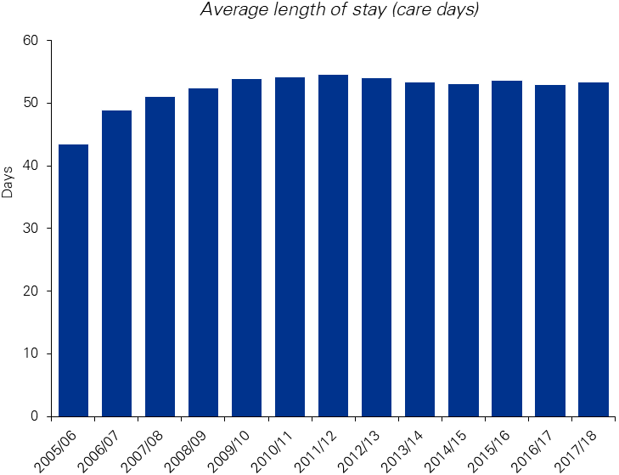

Reconditioning (inpatient) LOS: 16.5 days

Orthopaedic fracture (inpatient) LOS: 20.6 days

Orthopaedic fracture (ambulatory) LOS: 55.6 days

Reconditioning (ambulatory) LOS: 61.1 days

Source: Department of Health and AROC

## The effectiveness of the Programme

During the course of the review, the majority of stakeholders have repeatedly asserted that the Programme is effective in both meeting its aims and in improving the life of care recipients. The feedback from care recipients was overwhelmingly positive (this is explored further in Section 3.1.1). There is a high volume of subjective evidence that the Programme is effective.

When reviewing the quantitative data, the reviewers could only compare aggregate entry and exit MBI scores.

The MBI has four categories of function:

1. Total dependency;
2. Severe dependency;
3. Moderate dependency; and
4. Slight dependency.

Specifically, the reviewers looked at the change in the proportion of care recipients in a particular functional category at discharge. For example, the national graph shows consistently positive values for ‘slight dependency’, meaning that the proportion of individuals in this category has increased from admission to discharge. The same trend can be seen across jurisdictions suggesting that each State/Territory has care recipients moving into higher functioning categories on discharge. This is correlated by the fact that ‘moderate’ and ‘severe’ dependency consistently show negative values, suggesting care recipients are moving out of these categories over the course of care.

Other quantitative evidence suggests that the increases in ‘total dependency’ over the course of the Programme are due to how MBI scores are coded on care recipient discharge from the Programme. Care recipients who leave the programme to present or be admitted to hospital, or those who die are allocated ‘zero’ scores in the MBI. Deaths within the Programme are low (one per cent of total participants); meaning that the large number of ‘zero’ scores originate from those entering hospital, effectively skewing the overall results. Figure 4 over page shows the changes in proportion of MBI scores between admission and discharge. Figure 5 shows this same movement but adjusts the data to remove zero scores i.e. those care recipients who have returned from hospital or died – which demonstrates a larger proportion of care recipients moving into the highest functional category (slight dependency).

Thus, the movements of care recipients into higher functional categories supports the notion that the TCP is effective in improving a care recipients’ function. Additional indicators would assist in determining the full effectiveness of the Programme to address care recipients’ psychosocial needs.

Figure 4: Change in the proportion of MBI scores nationally

In 2006/2007;

The proportion of participants with an MBI score of 0-19 increased by 13% from admission to discharge;

The proportion of participants with an MBI score of 20-59 decreased by 12% from admission to discharge;

The proportion of participants with an MBI score of 60-89 decreased by 21% from admission to discharge;

The proportion of participants with an MBI score of 90+ increased by 20% from admission to discharge;

In 2007/2008;

The proportion of participants with an MBI score of 0-19 increased by 12% from admission to discharge;

The proportion of participants with an MBI score of 20-59 decreased by 10% from admission to discharge;

The proportion of participants with an MBI score of 60-89 decreased by 24% from admission to discharge;

The proportion of participants with an MBI score of 90+ increased by 22% from admission to discharge;

In 2008/2009;

The proportion of participants with an MBI score of 0-19 increased by 13% from admission to discharge;

The proportion of participants with an MBI score of 20-59 decreased by 11% from admission to discharge;

The proportion of participants with an MBI score of 60-89 decreased by 25% from admission to discharge;

The proportion of participants with an MBI score of 90+ increased by 23% from admission to discharge;

In 2009/2010;

The proportion of participants with an MBI score of 0-19 increased by 12% from admission to discharge;

The proportion of participants with an MBI score of 20-59 decreased by 10% from admission to discharge;

The proportion of participants with an MBI score of 60-89 decreased by 26% from admission to discharge;

The proportion of participants with an MBI score of 90+ increased by 24% from admission to discharge;

In 2010/2011;

The proportion of participants with an MBI score of 0-19 increased by 15% from admission to discharge;

The proportion of participants with an MBI score of 20-59 decreased by 10% from admission to discharge;

The proportion of participants with an MBI score of 60-89 decreased by 28% from admission to discharge;

The proportion of participants with an MBI score of 90+ increased by 23% from admission to discharge;

In 2011/2012;

The proportion of participants with an MBI score of 0-19 increased by 16% from admission to discharge;

The proportion of participants with an MBI score of 20-59 decreased by 10% from admission to discharge;

The proportion of participants with an MBI score of 60-89 decreased by 29% from admission to discharge;

The proportion of participants with an MBI score of 90+ increased by 23% from admission to discharge;

In 2012/2013;

The proportion of participants with an MBI score of 0-19 increased by 17% from admission to discharge;

The proportion of participants with an MBI score of 20-59 decreased by 11% from admission to discharge;

The proportion of participants with an MBI score of 60-89 decreased by 29% from admission to discharge;

The proportion of participants with an MBI score of 90+ increased by 23% from admission to discharge; 

In 2013/2014;

The proportion of participants with an MBI score of 0-19 increased by 16% from admission to discharge;

The proportion of participants with an MBI score of 20-59 decreased by 11% from admission to discharge;

The proportion of participants with an MBI score of 60-89 decreased by 28% from admission to discharge;

The proportion of participants with an MBI score of 90+ increased by 23% from admission to discharge;

In 2014/2015;

The proportion of participants with an MBI score of 0-19 increased by 16% from admission to discharge;

The proportion of participants with an MBI score of 20-59 decreased by 12% from admission to discharge;

The proportion of participants with an MBI score of 60-89 decreased by 27% from admission to discharge;

The proportion of participants with an MBI score of 90+ increased by 23% from admission to discharge;

In 2015/2016;

The proportion of participants with an MBI score of 0-19 increased by 15% from admission to discharge;

The proportion of participants with an MBI score of 20-59 decreased by 11% from admission to discharge;

The proportion of participants with an MBI score of 60-89 decreased by 26% from admission to discharge;

The proportion of participants with an MBI score of 90+ increased by 23% from admission to discharge;

In 2016/2017;

The proportion of participants with an MBI score of 0-19 increased by 17% from admission to discharge;

The proportion of participants with an MBI score of 20-59 decreased by 12% from admission to discharge;

The proportion of participants with an MBI score of 60-89 decreased by 27% from admission to discharge;

The proportion of participants with an MBI score of 90+ increased by 22% from admission to discharge;

In 2017/2018;

The proportion of participants with an MBI score of 0-19 increased by 17% from admission to discharge;

The proportion of participants with an MBI score of 20-59 decreased by 13% from admission to discharge;

The proportion of participants with an MBI score of 60-89 decreased by 26% from admission to discharge;

The proportion of participants with an MBI score of 90+ increased by 22% from admission to discharge.

Source: Department of Health

Figure 5: Change in the proportion of MBI scores nationally – excluding 'zero' scores on exit

In 2006/2007;

The proportion of participants with an MBI score of 0-19 decreased by 3% from admission to discharge;

The proportion of participants with an MBI score of 20-59 decreased by 9% from admission to discharge;

The proportion of participants with an MBI score of 60-89 decreased by 15% from admission to discharge;

The proportion of participants with an MBI score of 90+ increased by 27% from admission to discharge;

In 2007/2008;

The proportion of participants with an MBI score of 0-19 decreased by 2% from admission to discharge;

The proportion of participants with an MBI score of 20-59 decreased by 8% from admission to discharge;

The proportion of participants with an MBI score of 60-89 decreased by 19% from admission to discharge;

The proportion of participants with an MBI score of 90+ increased by 29% from admission to discharge;

In 2008/2009;

The proportion of participants with an MBI score of 0-19 decreased by 2% from admission to discharge;

The proportion of participants with an MBI score of 20-59 decreased by 9% from admission to discharge;

The proportion of participants with an MBI score of 60-89 decreased by 20% from admission to discharge;

The proportion of participants with an MBI score of 90+ increased by 30% from admission to discharge;

In 2009/2010;

The proportion of participants with an MBI score of 0-19 decreased by 2% from admission to discharge;

The proportion of participants with an MBI score of 20-59 decreased by 8% from admission to discharge;

The proportion of participants with an MBI score of 60-89 decreased by 21% from admission to discharge;

The proportion of participants with an MBI score of 90+ increased by 31% from admission to discharge;

In 2010/2011;

The proportion of participants with an MBI score of 0-19 decreased by 2% from admission to discharge;

The proportion of participants with an MBI score of 20-59 decreased by 8% from admission to discharge;

The proportion of participants with an MBI score of 60-89 decreased by 21% from admission to discharge;

The proportion of participants with an MBI score of 90+ increased by 32% from admission to discharge;

In 2011/2012;

The proportion of participants with an MBI score of 0-19 decreased by 2% from admission to discharge;

The proportion of participants with an MBI score of 20-59 decreased by 8% from admission to discharge;

The proportion of participants with an MBI score of 60-89 decreased by 23% from admission to discharge;

The proportion of participants with an MBI score of 90+ increased by 33% from admission to discharge;

In 2012/2013;

The proportion of participants with an MBI score of 0-19 decreased by 2% from admission to discharge;

The proportion of participants with an MBI score of 20-59 decreased by 8% from admission to discharge;

The proportion of participants with an MBI score of 60-89 decreased by 23% from admission to discharge;

The proportion of participants with an MBI score of 90+ increased by 33% from admission to discharge;

In 2013/2014;

The proportion of participants with an MBI score of 0-19 decreased by 2% from admission to discharge;

The proportion of participants with an MBI score of 20-59 decreased by 8% from admission to discharge;

The proportion of participants with an MBI score of 60-89 decreased by 22% from admission to discharge;

The proportion of participants with an MBI score of 90+ increased by 32% from admission to discharge;

In 2014/2015;

The proportion of participants with an MBI score of 0-19 decreased by 1% from admission to discharge;

The proportion of participants with an MBI score of 20-59 decreased by 9% from admission to discharge;

The proportion of participants with an MBI score of 60-89 decreased by 21% from admission to discharge;

The proportion of participants with an MBI score of 90+ increased by 32% from admission to discharge;

In 2015/2016;

The proportion of participants with an MBI score of 0-19 decreased by 1% from admission to discharge;

The proportion of participants with an MBI score of 20-59 decreased by 9% from admission to discharge;

The proportion of participants with an MBI score of 60-89 decreased by 20% from admission to discharge;

The proportion of participants with an MBI score of 90+ increased by 31% from admission to discharge;

In 2016/2017;

The proportion of participants with an MBI score of 0-19 decreased by 2% from admission to discharge;

The proportion of participants with an MBI score of 20-59 decreased by 9% from admission to discharge;

The proportion of participants with an MBI score of 60-89 decreased by 20% from admission to discharge;

The proportion of participants with an MBI score of 90+ increased by 31% from admission to discharge;

In 2017/2018;

The proportion of participants with an MBI score of 0-19 decreased by 2% from admission to discharge;

The proportion of participants with an MBI score of 20-59 decreased by 10% from admission to discharge;

The proportion of participants with an MBI score of 60-89 decreased by 19% from admission to discharge;

The proportion of participants with an MBI score of 90+ increased by 32% from admission to discharge.

Source: Department of Health

**Key findings – Current Operations**

* The TCP fills a unique space within the health and aged care landscapes. It allows for clients to transition into home safely, and provides health services with an option to improve patient flow.
* The TCP is jointly funded by the Commonwealth and State and Territory governments. Jurisdictions have the discretion to contribute their co-funding through either direct contribution (cash) or in-kind support. The type and level of funding is variable across jurisdictions.
* The TCP is operationalised by State and Territory governments, and has evolved slightly differently across the jurisdictions. In practice, this has led to a number of different operating models. Some jurisdictions (such as NSW) provide the majority of services ‘in-house’ through State health services, while others (such as SA) broker the majority of services to NGOs.
* The cost of service per care day is variable across jurisdictions and appears to be influenced by the level of remoteness of service provision and the proportion of places that are provided in residential care. The cost of service deliver ranges from $247.34 per day to $355.70.
* From the TCP’s inception to 2017/18, there have been 187,718 care recipients who have entered and left the Programme. In 2017/18, there were 25,113 care recipients. The average age of these recipients was 81 years, and 60 per cent were female.
* The total number of care recipients receiving the TCP has increased year-on-year, directly proportionate to the total level of funding provided to the Programme.
* There is a high episode of care completion rate, indicating that care recipients who enter the TCP appear appropriate, as many go on to complete the Programme
* Although there is a defined acquittal process in place to account for funding provided to each jurisdiction, there are variable ways in which jurisdictions define their expenditure, making direct comparisons between jurisdictions difficult.
* Determining the ideal length of stay for care recipients requires further investigation, as the available data does not provide an adequate level of insight.
* The TCP appears to be an effective programme in improving the function of care recipients.

# Key themes

This section seeks to explore the major themes that were raised during the extensive consultation process. Where stakeholders have asserted certain concerns about the Programme, the reviewers have sought to validate this with quantitative data wherever possible.

From our analysis, our findings can be grouped into three broad themes:

1. Matters relating to the Programme overall;
2. Issues relevant to the care recipients of the TCP; and
3. The variation in practice between the jurisdictions.

## The Programme overall

A number of findings relate to the operation and administration of the Programme overall. Namely:

* Overall, the Programme is regarded positively;
* However, the TCP has largely been left to operate in its original form while the rest of the aged care landscape has changed;
* The Programme would benefit from greater flexibility around leave provisions, hospital readmissions and occupancy rates;
* There are some challenges with the current assessment and intake processes, which are potentially impacting efficiency and the care experience; and
* There is a need for alternative outcome measures to capture the holistic care provided by the TCP.

### The TCP is viewed positively by the majority of stakeholders

Overwhelmingly, stakeholders reported that the TCP is a very positive programme with high quality, multidisciplinary service provision. Service providers stated that the main strength of the TCP is the strong allied health programme that underpins it. Hospital staff felt comfortable discharging care recipients into the Programme as there is a strong therapeutic and case management component, and as such they feel confident their care recipients’ functionality will continue to improve. It was noted that it is a care recipient-centred programme which can be tailored for each individual and therefore offers flexibility beyond what hospital rehabilitation services can provide.

The main benefits of the Programme were identified as the way in which it enables people to be discharged from hospital earlier into supported care, and its ability to prevent early entry into residential care. Some stakeholders noted that it was beneficial to have access to a restorative programme for older Australians, especially for those who completed rehabilitation within the Health system. Geriatricians consulted stated that the TCP is very effective for people who are not independent enough to go home without services as it enables independence. Representatives of advocacy groups raised that the main thing the Programme gives consumers is hope, and that care recipients respond very strongly to the fact that they can improve in their own home, outside of a hospital or residential facility (see comments from care recipients and their carers below in Box 1). Further, a carer based in NSW reported benefits for both her and her mother, a recipient of the TCP, as not only did it improve her mother’s function and reduce her social isolation, but also in engaging with the social worker and various therapists provided under the TCP it gave her new skills and confidence in managing her mother’s care.

Comments from care recipients and carers about the TCP include:

* “I couldn’t have gone home without it. I don’t know anyone in Darwin who could help me.” – Care recipient, NT
* “I like everything in the Programme. They were there when I needed help.” – Care recipient, ACT
* “It’s all new to us so I didn’t know what to do or what was out there. [The TCP provided us with] a great social worker who has helped immensely.” – Carer, Queensland
* “They saved my mother’s life and mine.” – Carer, NSW.

Further, in relative terms the Programme does not attract many complaints. The Aged Care Complaints Commission reported that just 13 complaints have been received since the TCP’s launch in 2005/06, with the majority resolved to the consumer’s and/or the Commission’s satisfaction. The limited number of complaints related to a lack of communication/consultation, healthcare/medical review (though the Commission noted that some of these were based in poor communication and therefore a lack of understanding of what medical reviews entailed for the consumer), cleanliness of the environment, and fees and charges.

### The TCP has remained the same while the surrounding aged care space has reformed

The TCP has remained largely unchanged in its approach to care and its operations since its inception in 2005/06. This is in stark contrast to the other aged care programs funded by the Commonwealth, which have been the subject of significant reforms. As a result, State and Territory government stakeholders reported that the Programme appears disconnected from the rest of aged care policy/programs. It was reported that the Programme needs to be in the same “rhythm of change” as other aged care programs. Further, government representatives noted the TCP was not included in national aged care meetings, which they felt perpetuated the perception that the Programme is operated separately to the rest of aged care programs.

A number of participants reported that the Guidelines require updating to remain relevant to the current policy and program landscape. These relate to a range of issues including:

* The TCP Guidelines require a complete review to remove outdated terminology (for example, the references to the former Home and Community Care program);
* State and Territory governments requested the removal of text stating *“At least one responsible person is continuously on call in the facility in which transition care is delivered to provide emergency assistance”*[9] as it was considered this does not reflect the nature of the Programme as low intensity therapy which can be delivered in the home;
* To be consistent with guidelines of other restorative care programs, the TCP Guidelines would benefit from information on what can/should trigger a discharge. For example, care recipients who do not participate do not trigger a discharge based on non-participation as this is not in the current guidelines. Instead, as their goals have not been met, these care recipients are then extended, potentially preventing a more active participant from being accepted onto the TCP.
* Stakeholders advocated for the Guidelines to clarify how the TCP interacts with the NDIS. A number of jurisdictions accept people younger than 65 into the TCP and reported being unclear whether being an NDIS participant impacts on eligibility for the Programme;
* Concerns were raised about care recipients who are eligible for insurance payments (for example, injuries resulting from a car accident) and care recipients who are based overseas. The Guidelines are not clear on whether these care recipients are eligible for the TCP and, in the event they are, which agency is responsible for the payment of the TCP in these cases;
* A number of stakeholders suggested explicitly including references to particular cohorts of care recipients. Benefits of the TCP were identified for care recipients with dementia, mental health issues, and in palliative care; however, due to the TCP being framed as a purely functional programme, it was reported that these care recipients may not be referred as often as they could be. The reviewers note that TCP is not designed for clients on a palliative pathway, but rather to prevent early access to residential aged care. Thus, the structural barriers to palliative care clients may be expected; and
* The Guidelines state that, “*The role of hospitals in relation to the programme is to … ensure that the care recipient is medically stable and ready for discharge before they are referred for ACAT assessment”*.[10] Stakeholders requested greater clarification on what constitutes medically stable. For example, a care recipient is unlikely to be referred while they are receiving intravenous antibiotics in hospital, though their functionality is likely to be the same as at the point of discharge.

### Greater flexibility around leave provisions, hospital readmissions and occupancy rates is required

Leave provisions were identified as a major issue by the majority of stakeholders. It was noted repeatedly that the current leave provisions are too short, and did not allow for flexibility. Stakeholders gave examples of times when greater time to travel is required for care recipients, such as around the Christmas period when people often travel and for those in more remote areas who need to travel greater distances. It was noted that greater flexibility in leave provisions were particularly essential for Aboriginal and Torres Strait Islander care recipients as they may need to return to country for cultural obligations. There is also an opportunity to align with practices in the STRC program, which allows seven days of leave from the program. It was suggested that allowing for different categories of leave with different time provisions may be a potential solution.

On review of the Guidelines, legislation and subordinate legislation it was noted that leave (except for hospital admissions) was not explicitly specified. While the flexible care subsidy payment would not be provided on days when the TCP care recipient was not receiving care, the basis for not allowing leave appears to be historical rather than structural, and could be amended to allow for greater flexibility for care recipients.

Hospital readmissions was another significant issue identified by the majority of stakeholders. Currently, the Guidelines state that, *“If a transition care recipient requires re-admission to hospital for longer than an overnight stay, the transition care episode will cease, i.e. the care recipient must be discharged from the programme*.*”*[11] Providers noted that this is not flexible enough and gave the example of someone who has their surgery rescheduled to the next day having to be discharged from the TCP. It was noted that this lack of flexibility does not take into consideration the comorbidities of the TCP’s target cohort.

A number of jurisdictions suggested it would be beneficial if occupancy rate requirements could flexibly shift throughout the year in response to times of low and high demand. For example, the period around Christmas was identified as a period of typically low demand (and therefore greater vacancies in the TCP). Conversely, winter was a period of typically high demand due to illness and February/March was a peak period due to the heat (and as such, the TCP has fewer vacancies). State and Territory governments stated that the occupancy target should be 100 per cent spread flexibly across the year, which would allow them to fully utilise the Programme.

In reviewing the official occupancy rates over a five year period, there is a noticeable drop in occupancy in January each year. In addition, occupancy rates are consistently highest over the winter months. This supports the commentary from stakeholders that there is seasonal variation in demand. Therefore, it appears reasonable that more could be done to increase access to care recipients across each year.

### There are some challenges with the current assessment and intake processes

ACATs and service providers commented that there is ‘over assessment’ of care recipients, noting that assessment from both ACATs and TCP teams can disrupt the care experience and be confusing for families. Hospital staff queried whether these assessment processes could be combined to provide a more seamless experience. Further, service providers proposed that the ACAT assessment for the TCP should be valid for the duration of the time the care recipient is in the Programme, rather than having a reassessment requirement after 28 days.

Currently, ACAT assessments are required under the Act to determine care recipient eligibility for the aged care subsidy. While many of the TCP providers feel obliged to re-assess clients, there is no stipulation to do so under the Act or the Guidelines. The ACAT comprehensive assessment should be used to assist TCP providers in developing a care plan and understanding a potential care recipient’s suitability for the Programme.

Stakeholders requested flexibility around the requirement to be discharged directly from hospital into the Programme. Currently, in line with legislation, the Guidelines state, *“A care recipient can only enter transition care directly upon discharge from hospital in order to derive maximum benefit from a time-limited episode of low intensity therapeutic interventions.”*[12] Both government representatives and service providers raised the issue of care recipients being discharged over the weekend. As some services only operate from Monday to Friday, the requirement for the care recipient to be discharged directly into the Programme means that they either must be kept in hospital over the weekend or not participate in the Programme. This is particularly the case when receiving the TCP within the home setting. While it would be preferential for many TCP providers and consumers to be discharged directly from hospital to community based TCP, it is imperative that this only occur when safe to do so. The responsibility of safe discharge, including duty of care, are best left to the hospital in which the care recipient is receiving care, who have detailed knowledge of each individual case.

### There is a need for alternative outcome measures to capture the holistic care provided by the TCP

Currently, the MBI is the only outcome measure captured by the Programme. The MBI is a tool for assessing self-care and mobility activities of daily living, measuring and monitoring functional independence. The MBI is used in the absence of all other clinical data, including primary diagnoses. Stakeholders believed the MBI was quick and simple to use for monitoring changes in care recipients’ physical function. However, many noted that the TCP provided holistic care beyond improving physical functioning, yet there were no other outcomes measures that captured other aspects of care. As a result, many stakeholders regarded the MBI as being insufficient as a standalone measure for monitoring progress of care recipients through the TCP.

Further, for many care recipients, the MBI could potentially be misleading in assessing their overall status. For example, physically independent care recipients may score highly, but the same care recipients may have goals unrelated to physical function, which they are not progressing well against.

Similarly, care recipients often receive the TCP services to address multiple issues. It was noted that even when the primary diagnosis was related to physical function, other issues such as social issues or problems related to secondary diagnoses were being managed by the Programme. Specific domains identified as not being required by the MBI included cognitive impairment, quality of life and measuring the care recipient’s confidence across the Programme. Some of this information was already being captured, but this was inconsistent as it was not part of routine monitoring and usually only performed when clinically indicated. For example, occupational therapists were already using the Montreal Cognitive Assessment (MOCA) and the Mini-Mental State Examination (MMSE) tools for a cognitive assessment of care recipients in the TCP.

It was noted in consultations that multiple aspects of alternative outcome measures needed to be considered, such as the time taken to administer and the practicality of using the measure including ensuring that staff will complete any proposed tools accurately. Stakeholders also considered alternative measures to the MBI, such as the Functional Independence Measure and Functional Assessment Measure (FIM + FAM). In this regard, it was acknowledged that the FIM + FAM might be time-consuming to administer.

As part of the review, KPMG considered a range of alternative relevant metrics and assessed their applicability for the TCP. A high level overview is available below with greater detail available in Appendix A. KPMG notes that any changes to the outcome measures should be tested with care recipients and their carers (where applicable) to ensure that they are relevant, meaningful, and that they are not overly onerous for the care recipient.

##### Summary of alternative metrics

MBI

*Findings*

The MBI has been validated as a tool to measure and monitor functional independence. It can also be reliably administered by different observers face-to-face or by telephone with short administration times. It can also be self-administered by care recipients.[13],[14]

*Suitability for the TCP*

The MBI remains a suitable outcome measure for TCP care recipients. While there may be a ceiling effect, the tool is quick and simple to administer and retains historical data for comparison.

The Nottingham Extended Activities of Daily Living (EADL)

*Findings*

The EADL also assesses functional independence, but has also been validated for use via postal administration. However, evidence of validity and reliability is based on its application to neurological conditions such as stroke and multiple sclerosis.[15],[16]

*Suitability for the TCP*

Tool is suitable for the TCP; however, is not recommended as is a similar measure as the MBI.

Community Balance and Mobility Scale (CBMS)

*Findings*

The CBMS also assesses functional independence but includes a more granular assessment of movement including specific domains such as ‘balance’. Again, evidence comes from specific care recipient cohorts - care recipients with traumatic brain injury, where CBMS has been shown to be a valid predictor of rehabilitation requirements.[17],[18] The test takes 20-30 minutes to administer.[19],[20]

*Suitability for the TCP*

The CBMS focusses on a specific cohort that might not apply in a TCP setting (traumatic brain injury). It also takes a long time to administer. The CBMS is not suitable for the TCP.

FIM + FAM

*Findings*

The FIM+FAM assesses cognitive and psychosocial function in addition to physical capacity to perform basic ADLs.[21],[22] FIM + FAM is considered to have excellent validity and reliability based on evidence from neurorehabilitation settings.[23],[24] However, there is a significant training burden required to be able to administer FIM+FAM with day-long workshops mandated as minimum in many settings. The tool also takes 20-30 minutes to administer.[25],[26],[27]

*Suitability for the TCP*

While the FIM and FAM would provide a comparison tool against the current measures of function in rehabilitation environments. The tool is difficult to administer and requires training. It is a suitable measure and one that could be considered in the future.

Blaylock Risk Screening Assessment Tool (BRASS)

*Findings*

There is evidence from geriatric rehabilitation settings that BRASS can be used during an acute care episode to identify care recipients at risk of prolonged hospital admissions and predict discharge planning requirements. BRASS accounts for physical function, and other aspects relevant to discharge planning such as recent hospital admissions, past medical and medication history, sensory deficits, cognition, behaviour and social support.[28] The tool is quick to administer, does not require specific training, and has good inter-rater reliability, but poor internal consistency.[29],[30]

*Suitability for the TCP*

BRASS may be used by acute care teams who are assessing the needs of care recipient; however, it is not a suitable KPI for the TCP.

Timed up and go (TUG)

*Findings*

The TUG is quick and simple to administer with excellent inter-rater reliability, but has been shown in a systematic review not be valid at identifying elderly adults at high risk of falls in the community when used in isolation. [31],[32],[33]

*Suitability for the TCP*

The TUG should be considered as an additional measure to the MBI. It is quick to administer and provides an easy measure of functional improvement.

Geriatric Depression Scale (GDS)

*Findings*

The GDS can be self-administered by care recipients. It has good internal consistency and is a useful tool for in screening for depression.[34],[35] It takes 5 minutes to complete, and the yes/no format facilitates use by care recipients with cognitive impairments.

*Suitability for the TCP*

The GDS is a screening tool and therefore not suitable for the TCP as an outcome measure.

MOCA and MMSE

*Findings*

Both the MMSE and MOCA are already widely used by health professionals to assess cognitive impairment, taking approximately 10 minutes to complete. The MOCA is often used to validate findings from the MMSE.[36]

*Suitability for the TCP*

While these tools are suitable for use in the TCP, they are designed for care recipients who have potential cognitive impairment. It is not appropriate to subject all care recipients to these measures.

Carer Strain Index (CSI)

*Findings*

The CSI is considers strain on carers, is self-explanatory and can be completely quickly self-administered.[37]

*Suitability for the TCP*

The CSI could be considered as an additional outcome measure for the TCP.

Short Form 36-item (SF-36), Short Form 12-item (SF-12) and Nottingham Health Profile (NHP)

*Findings*

Both the SF-36 and NHP assess quality of life and can be self-administered in 7-10 minutes and the SF-12 in 2-3 minutes. Valid comparisons can be made assessing in quality of life across multiple conditions. Reliability varies with different domains, but overall is good. However, computerised scoring algorithms are necessary to assist in scoring because different domains contribute in different proportions and the overall score is weighted differently in different countries. Further research is needed to assess the comparability between SF-12 and SF-36 in specific clinical settings.[38],[39],[40],[41]

*Suitability for the TCP*

The SF-12, SF-36 or NHP could be used as an additional outcome measure to capture the psychosocial improvements to care recipients that are reported by stakeholders.

## Care recipients

In the consultation process, a number of issues emerged in relation to the care recipients of the TCP. These included:

* Multiple jurisdictions reporting that care recipients of the TCP are getting more complex;
* Stakeholders reported challenges in safely discharging care recipients from the TCP to other services; and
* For some population groups (such as Aboriginal and Torres Strait Islander people, people from culturally and linguistically diverse (CALD) backgrounds, those experience financial hardship, and those living in rural and remote areas), there can be barriers to accessing the Programme.

### Care recipients are perceived to be getting more complex

Similar to trends being seen in the broader aged care landscape, multiple stakeholders noted that the TCP care recipient cohort appears to be trending towards becoming more complex and frail, with greater clinical, physical and psychosocial needs. This is presenting through reported increased numbers of care recipients with dementia, mental health issues and/or in early stages of palliative care. Providers are also increasingly recognising social issues in the process of delivering services, such as elder abuse and homelessness.

WA providers stated that this changing acuity means that a high component of their services have to be provided and managed by registered nurses, whereas their equivalent HCPs can be managed by a non-clinical case manager. The increased complexity results in care recipients often requiring an increased intensity of therapy. For example, a provider in Queensland reported that some care recipients require physiotherapy three to five times a week. NSW providers are concerned that this issue will increase over the time and the TCP will not be equipped to meet the needs of an ageing population due to the increase of demand on the service. Box 2 below explores some care recipients’ responses as to the level of complexity in their care.

In addition, stakeholders commented that accessing specialist equipment (such as bariatric equipment or high cost special fixtures for wheelchairs) can be challenging, as this is not provided for under the Programme and State and Territory support is limited. This makes safe discharge and care challenging for certain complex clients. The reviewers note that access to specialist equipment is not an issue that is peculiar to the TCP and exists across the health, disability and aged care spectrum.

Comments from care recipients and carers about the TCP include:

* “My husband broke his leg last year and needed surgery. He wasn’t healing and he’s non-weight bearing, so they’ve put him on transition care in [a residential facility] to see if he can improve.” – Carer, Victoria
* “My wife was hospitalised for six months after having a series of strokes. She is paralysed and the TCP has hired and supplied all the equipment for us.” – Carer, Queensland.

Interestingly, MBI data does not support the assertion from stakeholders that care recipients are more complex, at least at a functional level. Over time the cohort of people entering the TCP have remained stable in regard to their level of function (see dot points below and Appendix D for details). The exceptions to this are the NT, where care recipients have become more functionally independent, and WA, where care recipients have become more dependent (and likely more complex). While the MBI is not a measure of complexity, but rather function, it is expected that there would be some correlation between increased complexity/frailty and reduced function.

**MBI scores on admission nationally from 2006/07 to 2017/18**

* In 2006/07: 8% of participants had a score of 0-19 indicating total dependency, 25% of participants had a score of 20-59 indicating severe dependency, 52% of participants had a score of 60-89 indicating moderate dependency, and 15% of participants had a score of 90+ indicating slight dependency.
* In 2007/08: 6% of participants had a score of 0-19 indicating total dependency, 22% of participants had a score of 20-59 indicating severe dependency, 55% of participants had a score of 60-89 indicating moderate dependency, and 17% of participants had a score of 90+ indicating slight dependency.
* In 2008/09: 5% of participants had a score of 0-19 indicating total dependency, 225% of participants had a score of 20-59 indicating severe dependency, 56% of participants had a score of 60-89 indicating moderate dependency, and 17% of participants had a score of 90+ indicating slight dependency.
* In 2009/10: 5% of participants had a score of 0-19 indicating total dependency, 20% of participants had a score of 20-59 indicating severe dependency, 57% of participants had a score of 60-89 indicating moderate dependency, and 18% of participants had a score of 90+ indicating slight dependency.
* In 2010/11: 5% of participants had a score of 0-19 indicating total dependency, 20% of participants had a score of 20-59 indicating severe dependency, 58% of participants had a score of 60-89 indicating moderate dependency, and 17% of participants had a score of 90+ indicating slight dependency.
* In 2011/12: 5% of participants had a score of 0-19 indicating total dependency, 19% of participants had a score of 20-59 indicating severe dependency, 59% of participants had a score of 60-89 indicating moderate dependency, and 17% of participants had a score of 90+ indicating slight dependency.
* In 2012/13: 5% of participants had a score of 0-19 indicating total dependency, 20% of participants had a score of 20-59 indicating severe dependency, 58% of participants had a score of 60-89 indicating moderate dependency, and 17% of participants had a score of 90+ indicating slight dependency.
* In 2013/14: 5% of participants had a score of 0-19 indicating total dependency, 20% of participants had a score of 20-59 indicating severe dependency, 57% of participants had a score of 60-89 indicating moderate dependency, and 17% of participants had a score of 90+ indicating slight dependency.
* In 2014/15: 6% of participants had a score of 0-19 indicating total dependency, 21% of participants had a score of 20-59 indicating severe dependency, 56% of participants had a score of 60-89 indicating moderate dependency, and 16% of participants had a score of 90+ indicating slight dependency.
* In 2015/16: 6% of participants had a score of 0-19 indicating total dependency, 2% of participants had a score of 20-59 indicating severe dependency, 56% of participants had a score of 60-89 indicating moderate dependency, and 17% of participants had a score of 90+ indicating slight dependency.
* In 2016/17: 6% of participants had a score of 0-19 indicating total dependency, 22% of participants had a score of 20-59 indicating severe dependency, 56% of participants had a score of 60-89 indicating moderate dependency, and 16% of participants had a score of 90+ indicating slight dependency.
* In 2017/18: 5% of participants had a score of 0-19 indicating total dependency, 24% of participants had a score of 20-59 indicating severe dependency, 55% of participants had a score of 60-89 indicating moderate dependency, and 16% of participants had a score of 90+ indicating slight dependency.

Stakeholders reported challenges in safely discharging care recipients from the TCP to other services

Figure 6 below explores the discharge destinations of care recipients admitted to the Programme. Of particular note is the low death rates of care recipients in the Programme (one per cent), as well as the discharge destinations for Victoria and WA. Here, reflecting the service model and the higher number of residential care TCP places, the services discharge a higher proportion of people to residential aged care services. This is in contrast to jurisdictions such as NSW where the majority of care recipients return to the community (with varying levels of supports).

Figure 6: Discharge destinations for TCP care recipients

In NSW
3% of clients were discharged to residential aged care services
24% of clients were discharged to hospital
26% of clients were discharged to the community without support
11% of clients were discharged to the community with HCP
28% of clients were discharged to the community with CHSP
5% of clients were discharged with other
1% of clients died
2% of clients moved to another TC service

In VIC
33% of clients were discharged to residential aged care services
24% of clients were discharged to hospital
8% of clients were discharged to the community without support
6% of clients were discharged to the community with HCP
18% of clients were discharged to the community with CHSP
7% of clients were discharged with other
3% of clients died
<1% of clients moved to another TC service

In QLD
7% of clients were discharged to residential aged care services
23% of clients were discharged to hospital
14% of clients were discharged to the community without support
9% of clients were discharged to the community with HCP
37% of clients were discharged to the community with CHSP
9% of clients were discharged with other
1% of clients died
<1% of clients moved to another TC service

In WA
51% of clients were discharged to residential aged care services
20% of clients were discharged to hospital
10% of clients were discharged to the community without support
6% of clients were discharged to the community with HCP
7% of clients were discharged to the community with CHSP
2% of clients were discharged with other
2% of clients died
1% of clients moved to another TC service

In SA
6% of clients were discharged to residential aged care services
18% of clients were discharged to hospital
20% of clients were discharged to the community without support
8% of clients were discharged to the community with HCP
37% of clients were discharged to the community with CHSP
8% of clients were discharged with other
1% of clients died
1% of clients moved to another TC service

In TAS
18% of clients were discharged to residential aged care services
21% of clients were discharged to hospital
11% of clients were discharged to the community without support
5% of clients were discharged to the community with HCP
34% of clients were discharged to the community with CHSP
10% of clients were discharged with other
1% of clients died
<1% of clients moved to another TC service

In ACT
1% of clients were discharged to residential aged care services
30% of clients were discharged to hospital
32% of clients were discharged to the community without support
11% of clients were discharged to the community with HCP
18% of clients were discharged to the community with CHSP
6% of clients were discharged with other
<1% of clients died
1% of clients moved to another TC service

In NT
1% of clients were discharged to residential aged care services
26% of clients were discharged to hospital
17% of clients were discharged to the community without support
8% of clients were discharged to the community with HCP
37% of clients were discharged to the community with CHSP
8% of clients were discharged with other
1% of clients died
1% of clients moved to another TC service

Source: Department of Health

The Guidelines state that, “*The service provider has a responsibility to assist in the admission of a care recipient to the programme, in their return to hospital should this be required, and in their subsequent transfer to their preferred long-term care option at the end of their transition care episode*.” However, several jurisdictions identified delays securing timely support for ongoing aged care programs as a key challenge in achieving this. Service providers identified that it is difficult to maintain a duty of care for their recipients following the care period as there is not enough availability in the CHSP or HCP for ongoing support. Government agencies, service providers and care recipients (see Box 3 below) reported that the HCP waitlist is challenging, as care recipients may be approved for an ongoing aged care package but supports may not be available at the time of discharge from the TCP.

Comments from care recipients and carers about the TCP include:

* “The only problem was when I was left to my own devices. I was extended for another six weeks but I had to shop around to find services so I wouldn’t be left in the lurch after the TCP finished. I am getting services under CHSP now.” – Care recipient, ACT

Similarly, stakeholders identified delays in the NDIS process as a challenge for care recipients under the age of 65. Indeed, care recipients with ongoing disabilities, and their carers, reported having their TCP care period extended so they could remain supported until they received an approved NDIS plan (see Box 4 below). Consultation participants reported that these challenges are of particular concern for care recipients with complex comorbidities.

Comments from care recipients and carers about the TCP include:

* “We’ve just been extended for another six weeks because it wasn’t enough. The NDIS has just come into our region and I thought ‘they can’t leave me now’. We had a planning meeting with NDIS last week so hopefully that will take over once the extension is done. I need more equipment and more therapy for her; she’s been doing so well with what she’s been getting, so it can’t stop now.” – Carer, Queensland
* “I’m waiting on someone to ring me back from the NDIS and I have to go to a meeting. When I finish the TCP, I have to make sure I have money in my [NDIS] funding for all the equipment I need.” – Care recipient, Queensland

### The TCP is less accessible for some population groups

Aboriginal and Torres Strait Islander people

Aboriginal and Torres Strait Islander people are under-represented in the TCP (as a proportion of the Aboriginal and Torres Strait Islander population in each State and Territory). Both government agencies and service providers reported that a barrier for Aboriginal and Torres Strait Islander participation is the requirement that the TCP follow a hospital stay. Amongst Aboriginal and Torres Strait Islander people, further complications arising from past traumatic experiences[42] and a lack of cultural understanding[43] has perpetuated a distrust of mainstream, western healthcare providers[44], including hospitals. Aboriginal and Torres Strait Islander peoples in remote communities are particularly disadvantaged due to the lack of available healthcare services.[45] Where services do exist, it is often difficult to build lasting relationships with healthcare providers due to the high turnover of staff.[46] As such, the hospital access point into the Programme is likely to be problematic for Aboriginal and Torres Strait Islander people.

People from CALD backgrounds

Multiple stakeholders reported that interpreters are not always available for CALD care recipients in both assessment for and delivery of the TCP. When the reviewers pointed out the availability of the Commonwealth Translating and Interpreting Service (TIS), stakeholders reported experiencing significant delays in accessing TIS and sourcing a translator. The NSW ACAT representative reported that this slows down the process for CALD care recipients and noted it was the biggest cause of delay for their Northern, Southern Eastern Sydney and Sydney LHDs, which share a pool of interpreters. In Tasmania, stakeholders stated that there are privacy issues in smaller communities as the interpreter may be known to the family, which has resulted in some care recipients refusing interpreters. A service provider in SA stated that, where the family of the care recipient cannot be used, they have sourced a private provider, the payment of which is drawn from the care recipient’s care budget.

People experiencing financial disadvantage

In relation to fees collected from care recipients for the Programme, providers reported being flexible and responsive to the circumstances of individual care recipients. Despite this, co-payment was still identified as an issue and a potential barrier to Programme access. The Guidelines state that, “*Service providers may ask care recipients to pay a care fee as a contribution to the cost of their care. Any fees should be fully explained to the care recipient and the amount charged should form part of the agreement between the care recipient and service provider … In determining a care recipient’s capacity to pay fees, the service provider should take into account any exceptional and unavoidable expenses incurred by the care recipient, such as high pharmaceutical bills.*”[47] Indeed, representatives reported that the cost of the Programme can be off-putting for potential care recipients, despite jurisdictions minimising or waiving the fees where possible. Further, the NT stated their care recipient contribution is $25 per week; however, this is negotiable with each care recipient.

People living in rural and remote areas

Access for people in rural and remote areas is an ongoing issue due to the availability of local services. The NT reported that their TCP operates up to 180km outside of Darwin where there are no local therapists, resulting in therapists traveling out or the care recipient being transported in, both of which have cost implications. This was supported by representatives from Tasmania, who reported difficulty in sourcing service providers that can meet care recipient needs in more remote areas. NSW providers reported having to cluster services in remote areas due to transport issues. Providers based in Queensland stated that it is difficult to make service provision to regional and rural areas financially viable and have declined referrals for people based in these areas on this basis. While telehealth is available, these providers stated it was not always appropriate as they cannot provide the appropriate level of service. SA representatives reported using tele-rehabilitation services more often and SA Health has a digital telehealth network in every health unit. Care recipients can use iPads for increased frequency of service (however, reception is challenging in very remote areas). SA and the NT also reported that they use a fly in service for very remote areas of their jurisdictions. This service maintains a regular roster of health staff who work across age groups and programs; however, some therapists only work on the TCP. The cost of chartering flights for this service and the travel time involved are ongoing challenges for the TCP in the State.

## Variation across jurisdictions

This section details the two major findings relevant to the variations of the delivery of the TCP across Australia:

* The delivery and operation of the TCP varies across jurisdictions; and
* To help manage and alleviate variations, government stakeholders would like more opportunities to network with each other and the Commonwealth.

### The delivery and operation of the TCP varies across jurisdictions

There are variations in service types offered by each jurisdiction. As Figure 7 demonstrates, WA and Victoria have the highest proportion of ‘residential only’ services types offered in 2017/18, comprising 79.6 per cent and 67 per cent of services offered in each of these States, respectively. In contrast, NSW, Queensland and the NT offered ‘community only’ services types at a proportion of 94.6 per cent, 85.3 per cent, and 68.4 per cent respectively. It is likely that this impacts the variation in expenditure seen across the States and Territories, as operating costs as a proportion of all major expenditure in each State and Territory were highest in WA and Victoria.

Figure 7: Types of services offered by States/Territories as a proportion of all services offered by each jurisdiction in 2017/18

In NSW 11% were residential only, 84% were community only and 55% were both residential and community 
In VIC 67% were residential only, 26% were community only and 79% were both residential and community 
In QLD 20% were residential only, 72% were community only and 8% were both residential and community 
In WA 76% were residential only, 19% were community only and 5% were both residential and community 
In SA 48% were residential only, 44% were community only and 8% were both residential and community 
In TAS 49% were residential only, 43% were community only and 8% were both residential and community 
In ACT 42% were residential only, 46% were community only and 12% were both residential and community 
In NT 29% were residential only, 67% were community only and 5% were both residential and community 

Source: Department of Health

The application of the Guidelines varies, with reported differences in accepting different cohorts of people. For example:

* in WA, the TCP accepts care recipients with delirium and non-weight bearing fractures who are not suitable for traditional rehabilitation programs;
* in SA, the TCP also accepts care recipients with non-weight bearing fractures; but
* in NSW, the TCP will not accept any care recipients with delirium nor non-weight bearing fractures.

Related to this issue, there are examples of the TCP being used as a ‘stop gap’ measure. Specifically, some jurisdictions have used the TCP as a method of socialising ongoing residential facilities for families who may be reluctant to put someone into ongoing residential care. TCP providers in Victoria stated that the TCP is often used as a pathway into residential care. Representatives reported that entering into ongoing care can be a difficult process for the care recipient and their family, so the TCP is used to help them process this change. SA stakeholders also stated that the Programme allows the care recipient and their family to be supported as they transition towards ongoing care. Further, WA stakeholders identified a major cohort of their care recipients as people who need permanent care, describing the TCP as a “sanctuary” for this group.

The extent of data collection also varies across the country. The majority of jurisdictions only collect and provide financial and MBI data as required by the Department. Notably, Victoria’s data collection and reporting is more extensive. In addition to Commonwealth reporting requirements, Victoria has key performance indicators that service providers must report against to ensure that a high standard of quality is delivered. Service providers are required to submit to local DHHS monthly data reports on occupancy, average length of stay, number of falls and MBI data. DHHS also collects feedback from care recipients and families on their experiences and actions any complaints they receive about the Programme.

Some government and non-government representatives reported issues and matters specific to the operation of the TCP in their jurisdiction. States and Territories that are not identified below had no specific issues related to the unique conditions of their jurisdiction.

* In the **NT**:
* The vast majority of the TCP packages are community based. This limits the availability of the TCP for people who live in remote areas and on country; a nurse based in Darwin reported that, if the TCP in residential settings was available, these people could be placed in a bed for the duration of their care and then return home;
* Related to this point, government representatives from the NT reported that care recipients reside in varied housing arrangements. For example, some live on boats while some live in very basic dwellings that may be overcrowded. This presents challenges in delivering the TCP in the home;
* There are a high number of fly in/fly out therapists servicing rural and remote areas, which has cost and time implications for the operation of the TCP;
* The NT reported a significant number of their care recipients live interstate but are hospitalised while traveling in the Territory. If that person returns to their home State during the care period, the file cannot be transferred on the My Aged Care portal. Instead, the Department will leave the file open and the home jurisdiction will advise of the final MBI score upon discharge.
* In **Queensland**, it was reported that it can be difficult to engage Aboriginal and Torres Strait Islander people in the Programme and deliver supports if they are moving regularly (this is also relevant to other jurisdictions with a high Aboriginal and Torres Strait Islander population living on country).
* In **SA**:
* The TCP is predominantly delivered in residential care. As identified in Section 3.1.2, SA Health is concerned that service providers in future are more likely opt for the more financially stable long-term bonded bed, rather than retain beds for the TCP; and
* Similar to the NT, there are a high number of fly in/fly out therapists servicing rural and remote areas.
* In **Tasmania**, there are fewer allied health therapists as well as a significant older population, which is a challenging combination to deliver TCP.
* In the **ACT** there is only one provider servicing the jurisdiction, enabling a central point for managing care recipients. This is beneficial for ACT Health as it allows the agency a high level of oversight of the delivery of the Programme.

### Government stakeholders would like more opportunities to network

A number of State and Territory government representatives raised previous networking forums that allowed information sharing with the Commonwealth and other jurisdictions, which were reported to be helpful and valuable. State Officers of the Department of Health reported not receiving a lot of feedback about the quality and effectiveness of the TCP in their jurisdictions, instead assuming that the Programme is progressing well unless they receive a complaint. One representative stated, “*We don’t have a strong involvement in how it’s managed … We haven’t heard any bad news. I presume we would be the ones who would be contacted if something bad were to happen.*” Another representative stated that it would be beneficial to have more involvement in the operation of the TCP, similar to how the State Officers are involved in other aged care programs. Most jurisdictions independently raised that networking and information sharing about the TCP between the jurisdictions and with the Commonwealth used to happen; however, it was found that these forums stakeholders spoke of, were not TCP specific. For example, SA Health reported that that the following initiatives used to take place in regards to the TCP:

* Quarterly meetings with the Department (now reportedly held once or twice a year via teleconference); and
* Broad data reports on State and Territory performance.

In the absence of these initiatives, jurisdictions are not aware of their performance in comparison to other States and Territories, nor are they aware of challenges and opportunities happening elsewhere in the country.

**Key findings – Key Themes**

* The TCP is viewed as a very positive programme by a wide range of stakeholders. There are relatively few complaints (13 since programme inception) that have been received by the Commissioner.
* The TCP Guidelines and its core delivery model have remained largely the same since programme inception. This is in contrast to other aged care programs where there has been a significant shift in operations and policy.
* All stakeholders reported that there should be greater levels of flexibility around:
* The need to discharge clients if they spend greater than 24 hours in hospital – stakeholders thought that 48-72 hours was more reasonable;
* Leave provisions to align with STRC; and
* The need to accept clients directly from hospital – a grace period of 24 hours was often requested.
* Some stakeholders reported that the MBI, while a useful outcome measure, did not capture all important aspects of the TCP. KPIs could be expanded to capture psychosocial domains.
* Stakeholders have reported that the complexity of clients is increasing; however, this is currently not supported by the data collected by the Department.
* There is reported difficulty in safely discharging some clients to a home setting due to reduced availability of CHSP and HCP programs.
* The TCP appears to be less accessible to a number of population groups including:
* Aboriginal and Torres Strait Islander people
* CALD people
* People experiencing financial disadvantage
* People living in rural and remote areas.
* Service providers and State and Territory government officials would like more chances to network and come together to discuss and identify opportunities for the continuous improvement of the TCP.

# Transition care programs internationally

The following content has been gleaned from a desktop review of similar programs in international jurisdictions. The reviewers have chosen to reflect the language used by each jurisdiction, including the adoption of ‘clients’ in place of consumer. This explains the inconsistency in terminology from the TCP.

## United States of America

Dozens of transitional care interventions have been implemented across the United States with the purpose of reducing unnecessary hospital readmissions and improving the quality of care during transitions. The interventions range from small-scale transitional care services in research hospitals to initiatives that are fully funded as part of health plans.[48]

The Care Transitions Intervention (CTI) is a well-established model and is more medically-focussed than the TCP. It is centred on medication compliance, identifying health conditions and recording progress in a personally controlled electronic health record, scheduling follow up visits, recognising ‘red flags’ and escalating care appropriately.[49],[50] Care is aimed at the elderly and is provided for four weeks, targeting clients with one or more of 11 mostly medical diagnoses (including stroke, congestive heart failure, coronary artery disease, cardiac arrhythmias, chronic obstructive pulmonary disease, diabetes mellitus, spinal stenosis, hip fracture, peripheral vascular disease, deep venous thrombosis, and pulmonary embolism).[51],[52] CTI consists of engaging patients while they’re still in hospital to discuss any concerns, arranging a home follow up visit with accompanying phone calls to increase self-management, develop goals, and ensure continuity of care across the transition.

A quasi-experimental cohort study found that CTI was reasonably effective. It compared CTI with those who declined the service or were lost to follow-up (internal control group) and found that, six months after discharge, those receiving CTI had significantly less cost-shifting onto other parts of the health system post-discharge, such as emergency department visits or other outpatient services. Total health care costs were also 22 per cent lower and the cost avoided per patient receiving an intervention was $3,752 compared to the internal control group.[53]

**Considerations for the TCP**

Given the impact CTI has had on reducing overall health system costs based on similar principles to the TCP, the current TCP could be leveraged to enhance all aspects of transitional care. For example, the TCP already has the established infrastructure to provide care to specific care recipients during a critical juncture in their care recipient journey. The TCP could be leveraged to provide more holistic transitional care by coordinating short-term restorative care with care recipients’ primary care physicians to ensure medical care is not only optimised but also works towards the same goals as short-term restorative goals.

## United Kingdom

The Intermediate Care and Reablement (ICR) program is managed and funded by the National Health Service. Similar to the TCP, it aims to reduce unnecessary hospital admissions, help clients be as independent as possible after an unplanned hospital admission and avoid clients moving prematurely or permanently into a care home. Unlike the TCP, clients do not necessarily need to have to be inpatients to be eligible for care; ICR also offers assistance for clients living at home with increasing difficulty with activities of daily living (ADLs) due to illness or disability. ICR lasts up to six weeks and offers care in community and residential settings and also includes ‘crisis care’ with care commencing within 48 hours. Though ICR is available for all those over 18 years, the majority of clients are elderly. Care offered varies with the types of intermediate care, but similar services are offered to the TCP including nursing, social work and other specialist therapy services including occupational therapy in similar settings in the clients’ home and community, and in residential facilities.[54]

A review of the evidence of ICR applied in the British context found that patients experiencing acute medical events were more likely to benefit from services than patients experiencing more complex acute-on-chronic episodes. However, patients with greater assessed need were found to potentially benefit the most from services. This group would incur higher costs of care in Intermediate Care service delivery. It was hypothesised there would be cost savings from avoiding future hospital admissions, however this has not been evaluated.[55]

**Considerations for the TCP**

* The evidence on ICR indicates that complex care recipients could potentially benefit the most from care. This is relevant in Australia’s context of an ageing population with increasingly complex disease burdens.
* There are benefits in identifying care recipients declining in performing their ADLs while they are still at home. Much of the stakeholder feedback addressed the rigidity of the eligibility criteria with many expressing the desire to have flexibility in the requirement to discharge care recipients directly from hospital to the TCP. ICR demonstrates that care can be offered at multiple transitions of care if services are tiered, while still maintaining a six week program across the program. This is roughly at half the length of the TCP, suggesting that transitional care can be provided in shorter time-frames.

## New Zealand

Waikato District Health Board (DHB)’s Supported Transfer Accelerated Rehabilitation Team (START) program is available for people 65 years and over who require rehabilitation and have been discharged from hospital or emergency department. It offers similar services to the TCP with a registered nurse, physiotherapist and occupational therapist who all visit the patient at their home to set goals. However, care lasts up to six weeks and includes a health care assistant who may visit up to three times per day to support patients to achieve their goals.[56]

CREST was initiated by Canterbury DHB and has very similar criteria to the START program. Unlike the TCP, Community Rehabilitation Enablement and Support Team (CREST) offers services to patients referred by general practitioner. CREST liaison workers who identify care recipients in hospital eligible for CREST and a case manager who tailors their rehabilitation program, goals and care plan. Registered nurses or trained support workers visit the patient at home to deliver rehabilitation services.[57] [58]

**Considerations for TCP**

CREST, like the ICR, demonstrates that the Canterbury DHB has recognised the importance of referring care recipients for TCP-like services via multiple pathways.

## Canada

Canada Regional Health Authorities have recently started introducing restorative care units to support those aged 65 years and older to transition from the hospital to the community, similar to the residential TCP. Patients admitted to restorative care units are assessed by a multidisciplinary team consisting of a physician, occupational therapist, physiotherapist, dietician, nurse, social worker, and recreation specialist. An individual care plan is developed for each client that includes client goals.[59]

An evaluation was conducted of all patients discharged from restorative care units within the first year of their operation in Newfoundland and Labrador. The review found that 71 per cent of all patients returned to their prior living arrangement. Clients also experienced statistically significant improvements in function. The average Barthel Index score on admission was 54.20, consistent with clients being dependent for some aspects of ADLs, on discharge the average was 78.75; suggesting clients improved their physical function, reaching a high degree of independence on discharge. There was also an impact on the health system with applications for long-term care initiated in acute care settings decreasing.[60]

**Considerations for the TCP**

* In the Canadian model, the use of restorative care units have been leveraged to produce significant improvements in clients’ physical function with positive impacts on the health system more broadly. In Australia, there is a variation in the TCP services delivered between the states in terms of the mix between community and residential care. The residential care units in Newfoundland and Labrador demonstrate that an investment in the TCP in a residential setting can create broader benefits.
* However, cost data was not publicly available, which is necessary to determine what the optimal mix of services should be. There is a need to assess the impact of the TCP on the broader health system to justify any investments to modify or enhance the scope of services offered by the Programme

# Recommendations

This Review has found that the TCP is generally operating effectively and efficiently in a number of areas. The Programme has attracted a significant amount of positive feedback from stakeholders, especially care recipients.

The following recommendations should be viewed as potential improvements to the current Programme to address pain points and inefficiencies, rather than wholesale changes to a popular and effective aged care programme.

**Recommendation one**

*Update the Guidelines completely with the new terminology and any changes to the Transition Care Programme. This should also include any updates to safety and quality parameters.*

The Guidelines were last updated in 2015. Since then there have been a number of changes within the aged care sector. The Guidelines should be reviewed and terminology updated. Any accepted recommendations above should also be incorporated within the Guidelines.

**Recommendation two**

*Extend leave provisions to align to practices in the STRC.*

Leave provisions for the TCP should align to those of the STRC. Specifically, care recipients should be able to take up to a maximum of seven days unpaid leave from the Programme, which should be stipulated in the Guidelines.

This will allow for care recipients to attend important events in their lives that may require travel from their current place of residence.

**Recommendation three**

*Extend the time period a care recipient can be in hospital without needing to exit the Transition Care Programme to 72 hours.*

Currently, care recipients must spend no longer than 24 hours within a hospital setting. If they do, then they are discharged from the TCP. In addition, if their TCP approval was provided more than four weeks earlier, a care recipient will require a new ACAT assessment to re-enter the TCP.

To provide a care recipient with sufficient time to be assessed and treated in a hospital setting, the service time period should be extended from 24 hours to 72 hours.

**Recommendation four**

*Extend the time period from when care recipients can be admitted into the Programme to 48 hours, to better support care recipients who will access the Transition Care Programme in a home setting, whilst ensuring appropriate hospital patient flow. Health services should remain responsible for ensuring safe discharge practices are followed.*

Care recipients are currently required to enter the Programme directly on discharge from hospital. In practice, this can be challenging for care recipients, hospitals and service providers to coordinate.

Extending the window from hospital discharge to admission to the TCP to 48 hours will allow for more flexibility for care recipients, and prevent care recipients either staying in hospital unnecessarily, or missing out on the Programme.

This extension should only be applicable for those care recipients who will access the TCP within a home setting. Care recipients who will be discharged to a residential care setting should not be eligible for the extension due to concerns about their safety post-discharge.

Duty of care will reside with the treating health service until the care recipient is admitted to the TCP by the service provider.

**Recommendation five**

*Directly engage with The National Advisory Group for Aboriginal and Torres Strait Islander Aged Care to determine how the Programme can be accessed and delivered in a more culturally appropriate and safe environment for Aboriginal and Torres Strait Islander people.*

Participation rates of Aboriginal and Torres Strait Islander peoples are relatively low within the TCP. While it is anticipated the Recommendations One and Three will assist in reducing some structural barriers to participation, more work needs to be completed to understand how to make the TCP more appealing and accessible to Aboriginal and Torres Strait Islander people.

**Recommendation six**

*Care recipients of the Transition Care Programme may be asked to pay fees to contribute to the Programme. The ability for providers to waive fees for those with financial hardship, should be made more explicit within the Programme Guidelines. This will improve consistency across the TCP.*

While the Guidelines are relatively comprehensive in relation to the setting of care fees, there remains some confusion and inconsistency in how and when fees can be waived especially in relation to financially disadvantaged care recipients.

A clear position stated in the Guidelines (for example, that fees should be waived for those care recipients who are financially disadvantage) would provide clearer guidance and consistency, especially in jurisdictions with brokered service models.

**Recommendation seven**

*Consider adding additional Key Performance Indicators to assist with understanding the value of the Programme, especially around activity participation and psychosocial domains. These should be tested with providers and care recipients before their full implementation.*

Additional KPIs should be considered to better understand the value of the Programme. These should be trialled with providers to understand the impact on service provision and data reporting. These KPIs should be in addition to the MBI and may include:

* SF-12;
* SF-36;
* Caregiver Strain Index (CSI); and/or
* Primary diagnosis.

These measures will allow the Department to more fully understand the impact the TCP has on care recipients, and the casemix of care recipients which the TCP services. Implementing measures, such as the CSI, will also be beneficial, as this may be used by ACATs as part of the assessment process – thereby increasing the number of outcome measures collected upon a care recipient’s journey through the aged care system.

Before implementation, these (or other identified) measures they should be tested with care recipients to determine their practicality and suitability.

**Recommendation eight**

*Safety and quality expectations need to be made explicit to providers, given the new Aged Care Quality Standards apply to TCP from 1 July 2019.*

With the introduction of the Aged Care Quality Standards, all providers should be assessed against these Standards. This will help reduce any perceived, or real, confusion as to the safety and quality expectations that exist for providers.

**Recommendation nine**

*The appropriate length of stay for a Transition Care Programme care recipient should be investigated further.*

A pilot of MBI data being collected at the three week mark should be undertaken to determine if care recipient outcomes can be achieved in similar timeframes to other restorative and rehabilitation programmes.

**Recommendation ten**

*Consider managing total care days across an entire year, not daily, in order to provide flexibility for seasonal demand in the Transition Care Programme.*

The Department should investigate the management of total care places each financial year to account for seasonal variation in the demand for the TCP. Currently demand is highest in the winter months, and the TCP is often underutilised over the summer months. It is recognised that this would require a change to current legislation.

**Recommendation eleven**

*The Department of Health should consider implementing more regular meetings between State and Territory health departments to improve collaboration and innovation.*

The Department should seek to increase the frequency of meetings with State and Territory health departments to improve communication, facilitate information sharing and networking and provide a forum for service innovation.

**Recommendation twelve**

*Promote the Commonwealth funded Translating and Interpreting Service to all service providers.*

The Department should promote widely the TIS to all service providers. Throughout consultations it was noted that awareness of this service was low. Increased awareness and access of the service would improve access to the TCP for CALD care recipients.

**Recommendation thirteen**

*Data reporting should be made more consistent, especially in relation to Annual Accountability Reports.*

The Department should seek to make the reporting of expenditure more consistent to improve the ability to benchmark expenditure across jurisdictions, and fully understand how the TCP subsidies, care recipient contributions, and State and Territory monies, are utilised. This could include the development of clear definitions to ensure that costs and expenditure are itemised consistently.

1. : Evidence of alternative key performance indicators

A desktop review was performed to identify potential key performance indicators for care recipient outcomes beyond the MBI, considering different domains including: validity, reliability, time to administer, and training requirements. Based on the extensiveness and quality of the evidence available, each of the metrics was given a rating across specific domains. Table 3 describes the criteria used to rate the metrics across specific domains and Table 4 provides a summary of the evidence on alternative metrics.

These ratings have been developed specifically with the TCP in mind. They encompass the practicalities in delivering a TCP service and include:

* Types of care recipients accessing the Programme;
* Staff mix; and
* Resources available.

**Rating criteria across specific metric domains**

Time to administer

Red: >20 minutes

Amber: 10-20 minutes

Green: <10 minutes

Validity

Red: There is evidence that the metric is either not valid or should be used with caution for its intended purpose.

Amber: There is evidence that the metric has been validated in specific circumstances that would only apply to specific cohorts of TCP care recipients, or, the evidence is limited.

Green: There is evidence that the metric has been validated for intended purpose.

Reliability

Red: Reliability is consistently poor across multiple domains and across multiple aspects of reliability.

Amber: Reliability is mixed, varying with different components within the metric or varying with different aspects of reliability.

Green: Reliability is consistent across different domains within the metric and across multiple aspects of reliability including inter-rater reliability, test-retest reliability, and internal consistency.

Training requirements

Red: Can only be administered by a health professional who needs to have undertaken specific course/s and/or scoring requires specialised services.

Amber: Needs to be administered by health professionals, but with minimal training

Green: Can be self-administered by care recipients.

**Summary of the evidence of alternative metrics across specific domains**

**MBI[61],[62],[63],[64]**

Summary

Assesses functional performance of activities of daily living (ADLs), and predicts clinical outcomes and quality of life.

Time to administer

GREEN

2-5 minutes by a health professional, 5 minutes minimum if observational method used.

Self-administration approximately 10 minutes.

Validity

GREEN

15-item MBI is valid for measuring and monitoring functional independence.

Reliability

GREEN

There are a range of Modified Barthel Indices, but, the 15-item MBI has been demonstrated to be reliable when administered face to face, by telephone and by different observers.

Training requirements

GREEN

Questionnaire is self-explanatory.

Potential application

Can be used to monitor the impact of the TCP on physical function, comparing scores on entry and exit.

**EADL[65],[66]**

Summary

Assesses 4 subscales across mobility, kitchen tasks, domestic tasks and leisure.

Time to administer

GREEN

5 minutes.

Validity

GREEN

Compared to formal assessments of functional abilities, the EADL was more cost and time effective. EADL has been validated as a postal questionnaire used in stroke rehabilitation.

Reliability

AMBER

Among multiple sclerosis care recipients, internal consistency is good and test-retest reliability satisfactory.

Training requirements

GREEN

Can be self-administered by care recipients and sent via post.

Potential application

Can be used as part of a suite of measures to assess physical function, and provides an alternative that can be administered remotely.

**CBMS[67],[68]**

Summary

Assesses postural instability, motor skills, balance and mobility status in an ambulatory adults returning to the community following an intervention for the management of traumatic brain injury.

Time to administer

RED

20-30 minutes depending on the care recipient’s ability.

Validity

AMBER

CBMS is valid at predicting rehabilitation requirements following traumatic brain injury.

Reliability

GREEN

CBMS has high intra-, inter- and test-retest reliability.

Training requirements

AMBER

Does not require specific training, but therapists should understand the tool and its use.

Potential application

Potential to assess rehabilitation requirements prior to entry into the TCP among specific care recipient cohorts.

**FIM + FAM[69],[70],[71], [72], [73],[74], [75]**

Summary

The FIM comprises 3 domains: basic ADLs, mobility, cognitive function; FAM, focuses on cognitive and psychosocial function.

Time to administer

RED

20-30 minutes by observation or by telephone interview.

Validity

AMBER

In the context of head injury rehabilitation, it was found to have good validity.

Reliability

AMBER

In a neurorehabilitation setting FIM+FAM was found to have excellent inter-rater, reliability and test-retest agreement.

Training requirements

RED

Training varies internationally but usually includes a minimum training day/workshop(s) +- formal examination.

Potential application

Consider use in specific care recipient cohorts, e.g. head injury care recipients. Costs of training and administering tool should be considered.

**BRASS[76],[77],[78]**

Summary

Identifies care recipients at risk of prolonged hospital admissions, and predicts discharge planning requirements.

Time to administer

GREEN

5-10 minutes.

Validity

GREEN

A positive association has been demonstrated between BRASS scores and outcomes post-hospitalisation in geriatrics rehabilitation settings.

Reliability

AMBER

Inter-rater reliability was good, but internal consistency reliability was very poor.

Training requirements

AMBER

Questionnaire can be completed by health professionals without specific training.

Potential application

Assessing care recipients while still admitted in an acute care setting to predict need for the TCP.

**TUG[79],[80]**

Summary

Assesses falls risk and mobility in the elderly. TUG measures the time taken for a care recipient to rise from an arm chair, walk comfortably and safely 3 metres, then turn, and walk back to the chair and sit down again.

Time to administer

GREEN

1-2 minutes.

Validity

RED

However, TUG alone has been demonstrated in a systematic review not be a valid metric to identify elderly adults at high risk of falls in the community when used in isolation.

Reliability

GREEN

Inter-rater reliability is excellent.

Training requirements

AMBER

Self-explanatory.

Potential application

Should be considered as part of a suite of metrics to assess falls risk, but should be used with caution given poor validity.

**GDS[81],[82], [83],[84]**

Summary

Screens for clinical depression among the elderly using a simple yes/no response format.

Time to administer

GREEN

5-10 minutes.

Validity

GREEN

The GDS was found to be useful as a screening tool for depression with good sensitivity and specificity compared to structured clinical interviews.

Reliability

GREEN

Internal consistency reliability was also good in the elderly.

Training requirements

GREEN

GDS is a self-report instrument that requires no training. The simple yes/no format facilitates use by those with impaired cognitive functions

Potential application

Consider to screen care recipients for depression at any relevant point in the care recipient journey.

**MOCA[85]**

Summary

The Montreal Cognitive Assessment (MOCA) tool is used to identify individuals with cognitive impairment.

Time to administer

AMBER

Approximately 10-15 minutes

Validity

GREEN

The MOCA has been identified as a good tool to measure mild cognitive impairment.

Reliability

GREEN

Evidence supports that the MOCA tool, widely used by occupation therapists, is a reliable tool to identify mild cognitive impairment.

Training requirements

AMBER

Questionnaire often administered by occupational therapists, doctors and other health professionals.

Potential application

When clinically indicated

**MMSE[86]**

Summary

The Mini-Mental State Examination (MMSE) is a short, 30 question test used to evaluate cognitive function.

Time to administer

AMBER

Approximately 10 minutes

Validity

GREEN

Occupational therapists often validate the results of the MMSE by completing the MOCA tool.

Reliability

GREEN

Relatively reliable tool to assess cognitive function, however, results are often verified with the MoCA.

Training requirements

AMBER

Questionnaire often administered by occupational therapists, doctors and other health professionals.

Potential application

When clinically indicated

**CSI[87]**

Summary

Assesses the impact on carers across three strain dimensions- perception of caregiving, care-recipient characteristics and emotional status.

Time to administer

GREEN

5 minutes.

Validity

GREEN

CSI is a useful measure to detect strain levels among informal caregivers.

Reliability

GREEN

CSI had good internal and retest reliability.

Training requirements

GREEN

Questionnaire is self-explanatory

Potential application

Consider administering to carers either routinely or when indicated.

**SF-36[88],[89],[90]**

Summary

Evaluates health-related quality of life across eight scales: physical functioning, role physical, bodily pain, general health, vitality, social functioning, emotional and mental health.

SF-36 can be used in general and clinical populations and make comparisons across disease groups and against the general population.

Time to administer

GREEN

Self-administration, approximately 7-10 minutes.

Interview administration by telephone, approximately 16-17 minutes.

Validity

GREEN

The SF-36 has been used in specific conditions and to measure the efficacy of interventions. Measures of health status are most accurate when administered by a health professional.

Unclear if SF-36 captures the broad range of health states. Overall validity is good and it can detect large improvements in health status. However, validity varies based on scale, setting and condition.

Reliability

AMBER

Multiple studies show scores are consistently lower when self-administered compared to interviewer administered.

Good internal consistency. Test-retest reliability low on mental health, role emotional role physical and vitality.

Large intra-individual variations- most suitable for detecting treatment impact and changes at the group rather than individual level.

Training requirements

RED

Questionnaire is self-explanatory.

The scale contribute in different proportions to 2 aggregate measures- physical and mental component summaries (PCS & MCS). Australia has a country-specific weighting. Computerised scoring algorithms can be purchased and requires basic knowledge of statistical software.

Potential application

The TCP provides a holistic care approach, but much of this in not currently captured. SF-36 can be used to assess the impact on quality of life of the TCP on entry and exit.

**SF-12[91],[92]**

Summary

The SF-12 is a shorter version of the SF-36 that uses 12 instead of 36 to assess health-related quality of life, but covers the same eight domains as SF-36. Sf-12 reproduces the two summary scores of SF-36 (the physical component summary [PCS] and mental component scores [MCS])

Time to administer

GREEN

Can be self-administered, takes 2-3 minutes.

Self and interview administration as low as one third the time of SF-36.

Validity

AMBER

SF-12 is able to reproduce the PCS and MCS of SF-36 with a similar ability to check changes in health status. However, SF-12 is less well-researched than SF-36 so findings are not necessarily transferrable.

Reliability

AMBER

The internal consistency is high and test-retest reliability is good in the general population. However more evidence is required in clinical settings.

Training requirements

RED

Questionnaire is self-explanatory.

However, like SF-36, SF-12 uses country-specific weights and computerised scoring algorithms.

Potential application

Similar to SF-36 with lower administration times. However, more research is needed to determine its comparability with SF-36 and applications in specific clinical settings.

**NHP[93],[94]**

Summary

Measures the impact of illness on care recipients and changes in health status over time. Part 1 covers the health status of the individual (energy levels, pain, emotional reactions, sleep, social isolation and physical abilities); part 2 the impact of ill health on daily life (paid employment, home duties, social life, home life, sex life, interests, hobbies and vacations). Can be used to make comparisons across disease groups.

Time to administer

GREEN

Self-administration, approximately 5-10 minutes to complete.

Validity

GREEN

NHP has been used in a range of conditions and to measure changes in health status following surgical and rehabilitation interventions.

Good construct validity. Lower sensitivity to change in condition than comparable instruments.

Reliability

AMBER

Good internal consistency.

Test-retest reliability is good, but low in emotion and social domains.

Training requirements

RED

Questionnaire is self-explanatory. It is designed to be self-administered.

Scoring can be cumbersome if done by hand- a scoring algorithm can be purchased. However, no specific training is required for scoring or administration.

Potential application

Similarly, NHP can be used to capture QoL and the impact of holistic care delivered by the TCP.

1. : Location of care recipients

This section examines where care recipients reside in Australia. While majority of service provision will occur within this geographical location – or close by – it is possible that some care recipients in rural and remote areas would have received their care in a location different from their home address. This is most likely true for those clients who received their care in a residential setting; however, the reviewers believe this number to be small and the following maps indicative of where service provision actually occurs.

* 1. Analysis of TCP data by financial year and postcode/suburb

Supplied TCP data provided insights into the number of clients, the number of episodes and the days of support and the location of these clients (postcode and suburb) for the period 2005/06 to 2017/18. The data was supplied with some caveats. These included:

* Data extracted 29 January 2019. Results may vary from published results due to retrospective changes to the data.
* Location is based on the client record, rather than the location of the service provider. On this point some postcodes in the supplied data were special postcodes or PO boxes.[95]
* Episodes of care ongoing at 30 June 2018 have been excluded. This explains the lower count of clients in 2017/18.

TCP can be provided for a period of 12 weeks (84 days) with an extension of a further 6 weeks (42 days). There were instances throughout the data where support had been provided for longer than this maximum of 126 days (84 + 42). These could only be identified for postcodes that had one client, one episode of care and a total day figure. For example there was an instance of a client receiving 224 days of support in 2016/17.

To supplement this data Australian Bureau of Statistics correspondences were used to code the postcodes to remoteness areas[96] (Major city, Inner Regional, Outer Regional, Remote, Very Remote) and to greater capital city spatial areas[97].

* + 1. Clients, episodes and total days

The supplied data provided insight into the national trends in clients, episodes and total days of support over the period 2005/06 to 2017/18. Over the full period there has been a marked increase in the total number of clients. The overall trend was a noticeable increase in clients between 2005/06 and 2012/13. Between 2013/14 and 2017/18 there has been no increase in clients and the number of clients has remained steady at about approximately 25,000. This overall trend is repeated closely for episodes and total days of support. The drop-off in clients and episodes between 2016/17 and 2017/18 is likely attributable to the caveats outlined above.

* + 1. Clients by remoteness area

Remoteness areas were used to explore whether:

* The distribution of TCP care recipients reflects the population distribution by remoteness area;
* The number TCP care recipients grew in line with population growth by remoteness area; and
* Whether the distribution of TCP care recipient by remoteness area changed over time.

The distribution of TCP care recipients in 2016/17 closely mirrors the distribution of persons aged 65 years and over by remoteness area. The largest percentage point difference is for outer regional Australia, where 9.9 per cent of the population aged 65 and over are based but only 7.8 per cent of TCP care recipients are located in outer regional Australia.

**Population distribution by remoteness area for estimated resident population, persons over 65 years and TCP care recipients**

Major Cities of Australia

2017 population : 17,666,685 (71.8%)

Persons aged 65 years and over (June 2017): 2,498,196 (65.9%)

2016/2017 TCP care recipients: 16,917 (66.7%)

Inner Regional Australia

2017 population : 4,390,400 (17.8%)

Persons aged 65 years and over (June 2017): 861,236 (22.7%)

2016/2017 TCP care recipients: 6,257 (24.7%)

Outer Regional Australia

2017 population : 2,047,790 (8.3%)

Persons aged 65 years and over (June 2017): 374,994 (9.9%)

2016/2017 TCP care recipients: 1,982 (7.8%)

Remote Australia

2017 population : 292,070 (1.2%)

Persons aged 65 years and over (June 2017): 39,865 (1.1%)

2016/2017 TCP care recipients: 136 (0.5%)

Very Remote Australia

2017 population : 200,583 (0.8%)

Persons aged 65 years and over (June 2017): 16,500 (0.4%)

2016/2017 TCP care recipients: 33 (0.1%)

Grand Total

2017 population : 24,597,528

Persons aged 65 years and over (June 2017): 3,790,791

2016/2017 TCP care recipients: 25,346

For the period 2012 to 2017 there has been noticeable variation in the population (estimated resident population) growth across remoteness areas. The population in Major Cities grew 10.0 per cent over this period while remote and very remote areas decreased by 3.7 per cent and 5.4 per cent respectively.[98] TCP care recipient growth has been above population growth for this period across all remoteness areas apart from very remote Australia. However there are only a small number of clients in very remote Australia and as such larger variations in client numbers are not surprising.

**Population and percentage growth between 2012 and 2017**

Major Cities of Australia

Population 2012: 16,062,163

Population 2017 : 17,666,685

Population % change: 10.0%

TCP care recipient 2011/12: 14,739

TCP care recipient 2016/17: 16,917

TCP % change: 14.8%

Inner Regional Australia

Population 2012: 4,155,240

Population 2017 : 4,390,400

Population % change: 5.7%

TCP care recipient 2011/12: 5,342

TCP care recipient 2016/17: 6,257

TCP % change: 17.1%

Outer Regional Australia

Population 2012: 2,000,819

Population 2017 : 2,047,790

Population % change: 2.3%

TCP care recipient 2011/12: 1,711

TCP care recipient 2016/17: 1,982

TCP % change: 15.8%

Remote Australia

Population 2012: 303,208

Population 2017 : 292,070

Population % change: -3.7%

TCP care recipient 2011/12: 106

TCP care recipient 2016/17: 136

TCP % change: 28.3%

Very Remote Australia

Population 2012: 212,035

Population 2017 : 200,583

Population % change: -5.4%

TCP care recipient 2011/12: 46

TCP care recipient 2016/17: 33

TCP % change: -28.3%

Total

Population 2012: 22,733,465

Population 2017 : 24,597,528

Population % change: 8.2%

TCP care recipient 2011/12: 21,962

TCP care recipient 2016/17: 25,346

TCP % change: 15.4%

The distribution of TCP care recipients by remoteness area has remained consistent between 2010/11 and 2016/17. For example in 2016/17 66.7 per cent of clients were from major cities and in 2010/11 67.7 per cent of clients were from major cities. T

* + 1. Clients by Greater Capital City Spatial Areas (GCCSA)

Maps of the count of clients by postcode for 2016/17 provide have been created based on the supplied data. The postcodes were mapped to the GCCSA as defined by the ABS.[99]

Figure 8: 2016/17 TCP care recipients by postcode for Sydney GCCSA

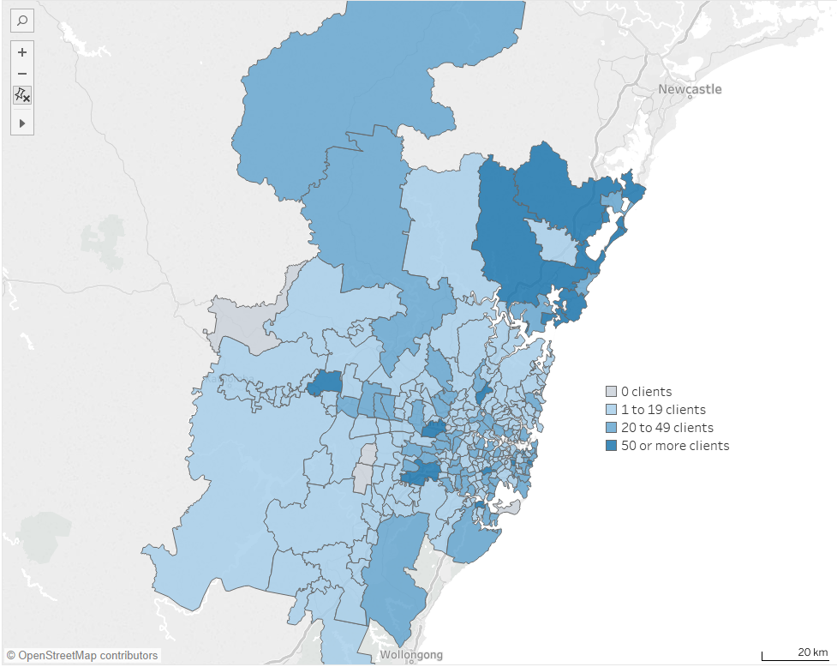

Figure 9: 2016/17 TCP care recipients by postcode for Melbourne GCCSA

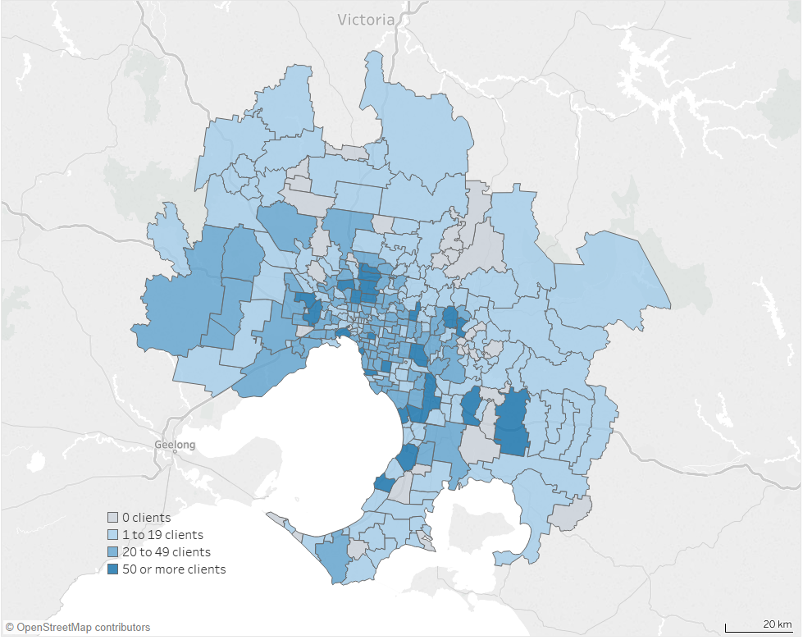

Figure 10: 2016/17 TCP care recipients by postcode for Brisbane GCCSA

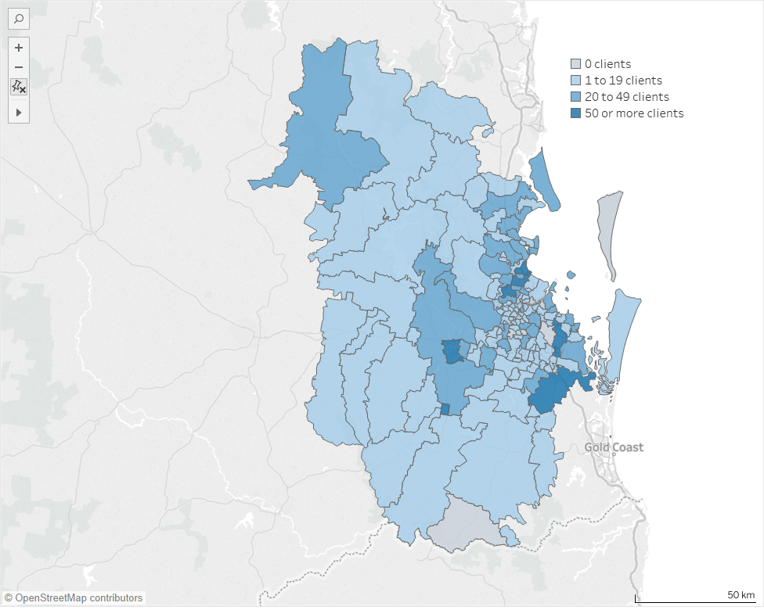

Figure 11: 2016/17 TCP care recipients by postcode for Adelaide GCCSA

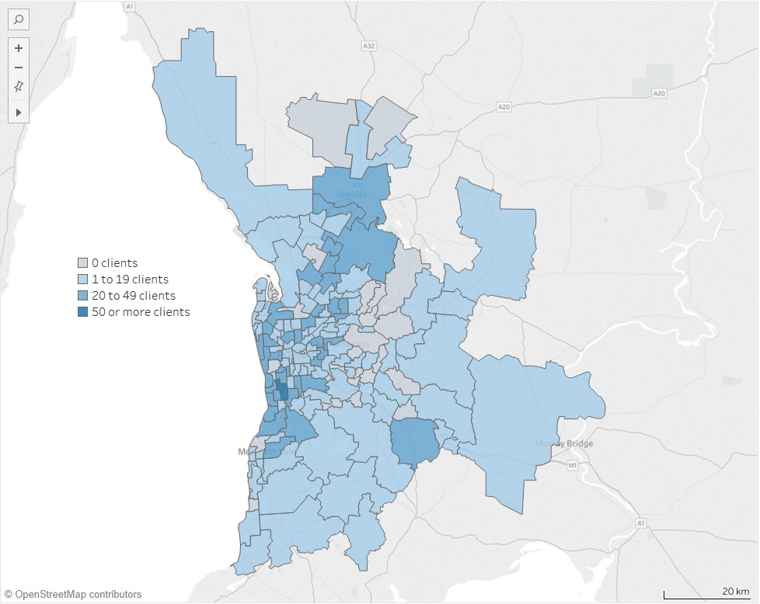

Figure 12: 2016/17 TCP care recipients by postcode for Perth GCCSA

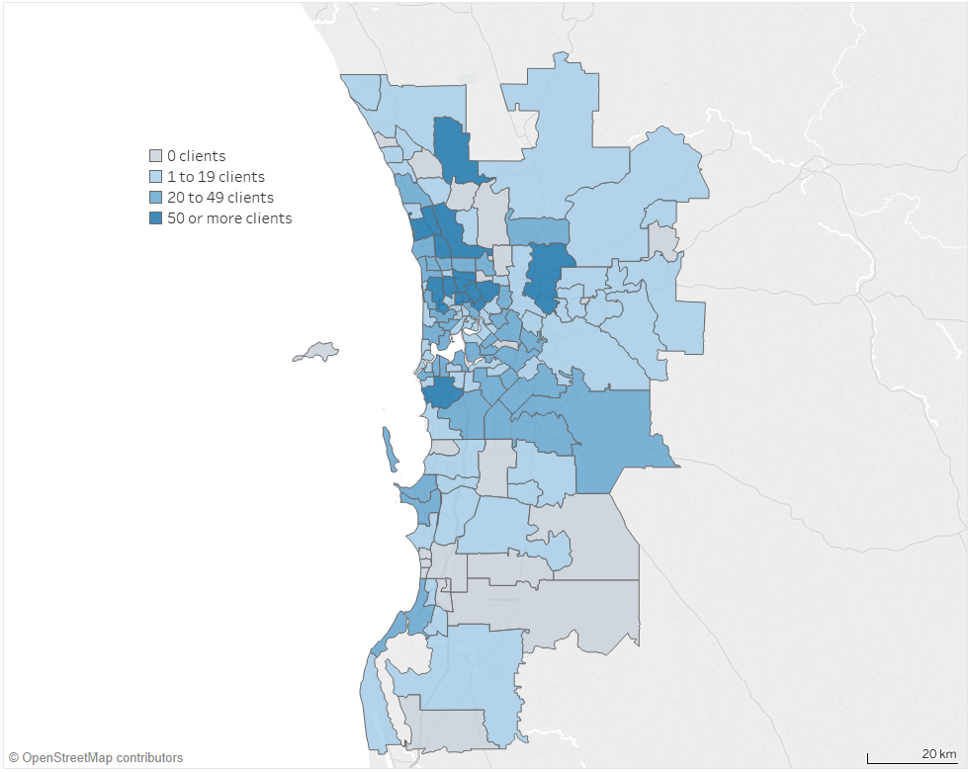

Figure 13: 2016/17 TCP care recipients by postcode for Hobart GCCSA

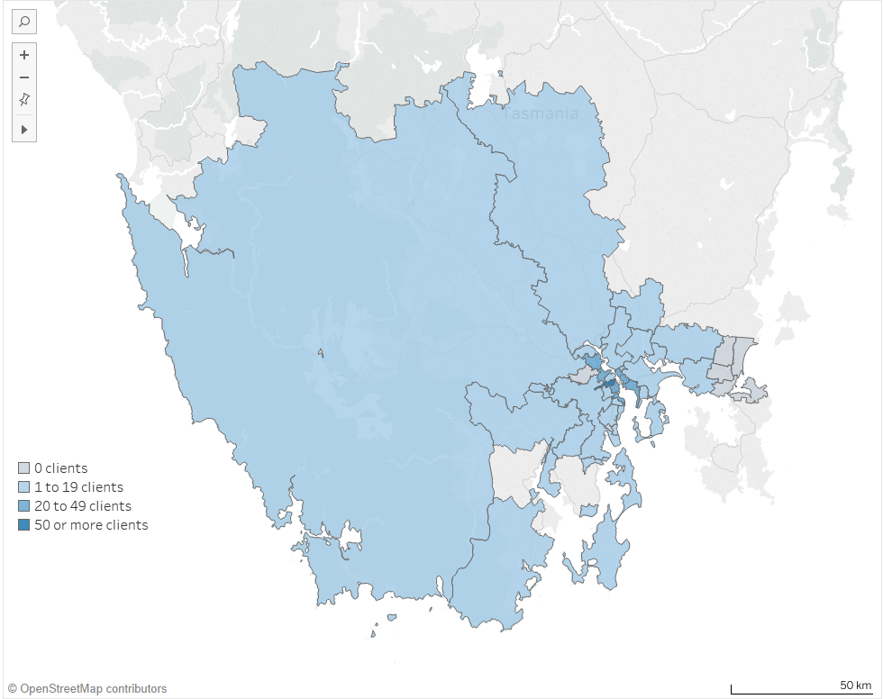

Figure 14: 2016/17 TCP care recipients by postcode for Darwin GCCSA

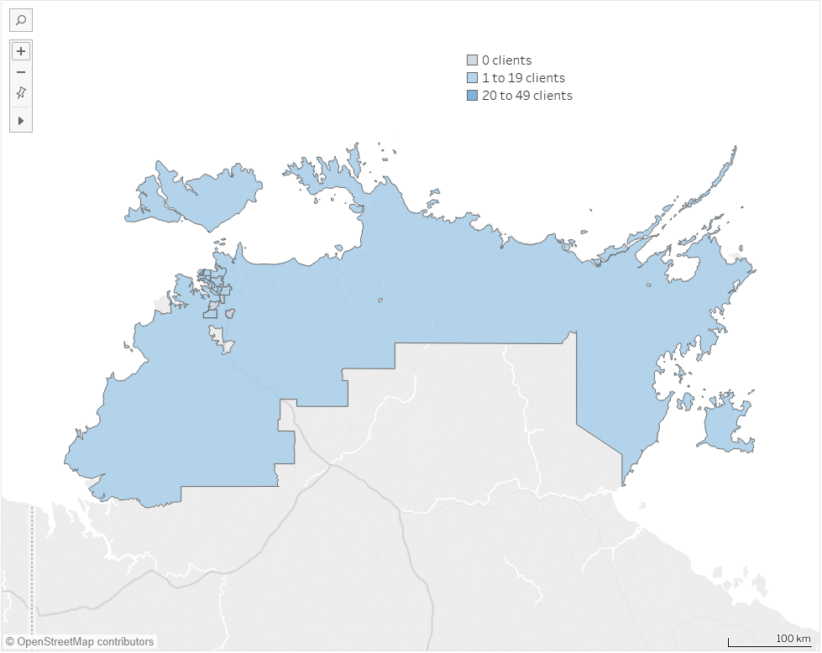

Figure 15: 2016/17 TCP care recipients by postcode for ACT GCCSA

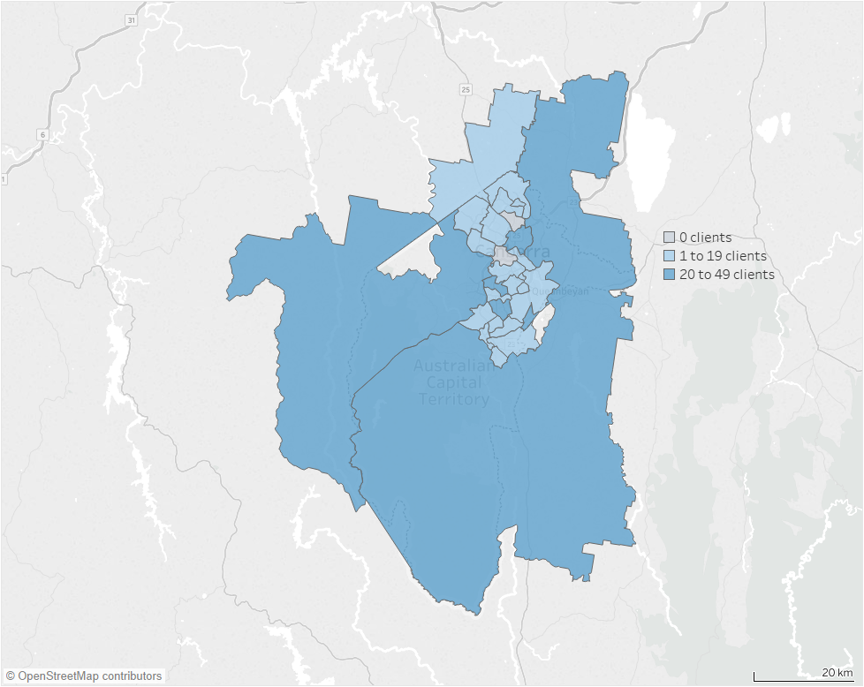

1. : Service provider mapping

The following sections maps the service provider locations of the TCP across Australia, and then in some of the major cities. The below is not a complete picture of where services are delivered as it only takes into account where the physical offices are for providers. To fully understand the reach of the TCP, see Appendix B above.

* 1. Service locations across Australia

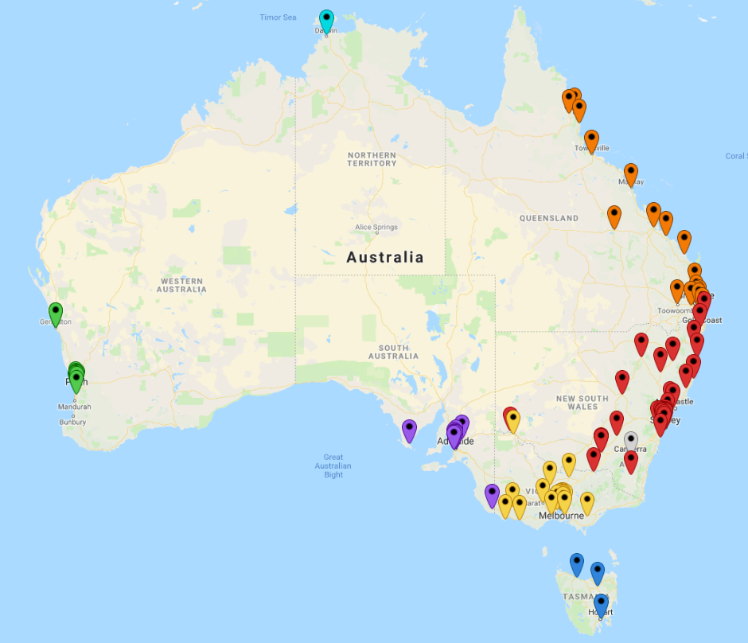

Source: Department of Health

* + 1. Service locations in major cities

##### Sydney

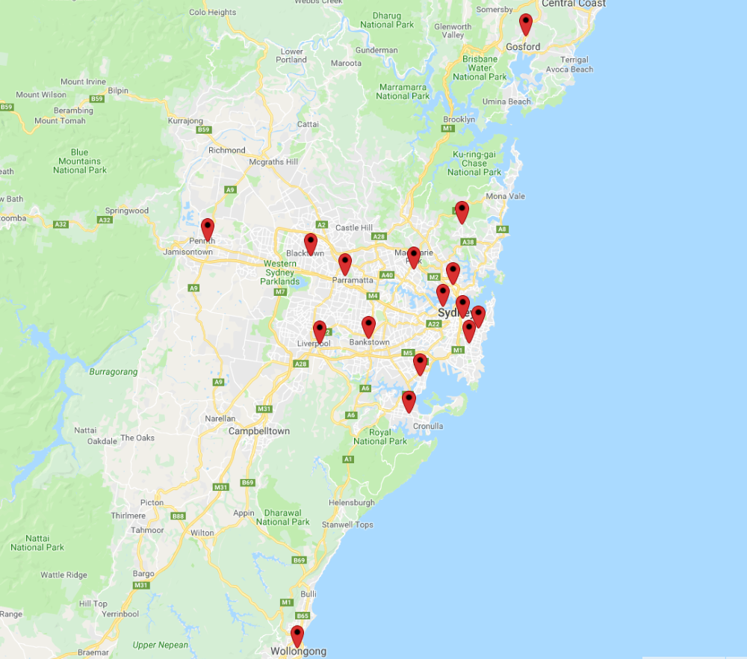

Source: Department of Health

##### Melbourne

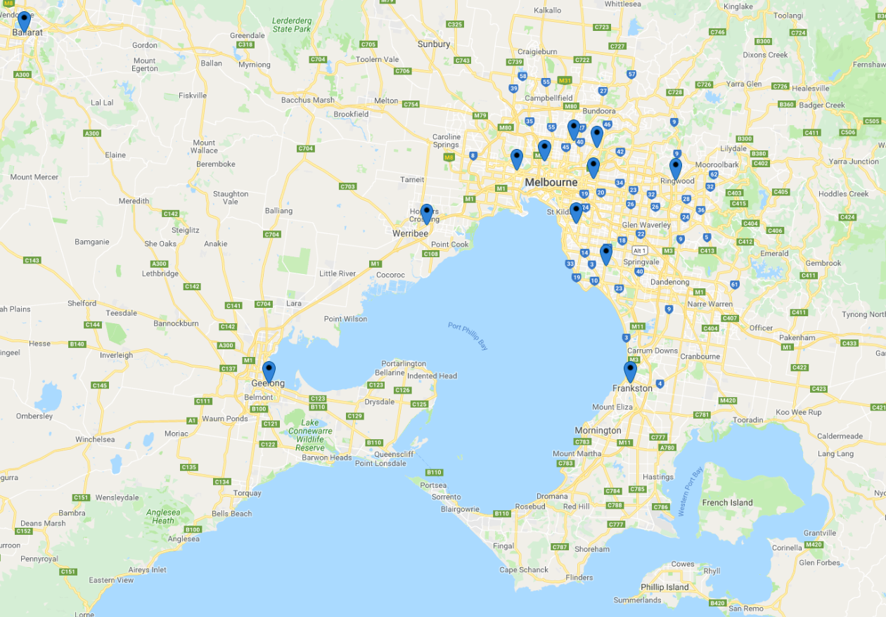

Source: Department of Health

##### Brisbane



Source: Department of Health

##### Adelaide

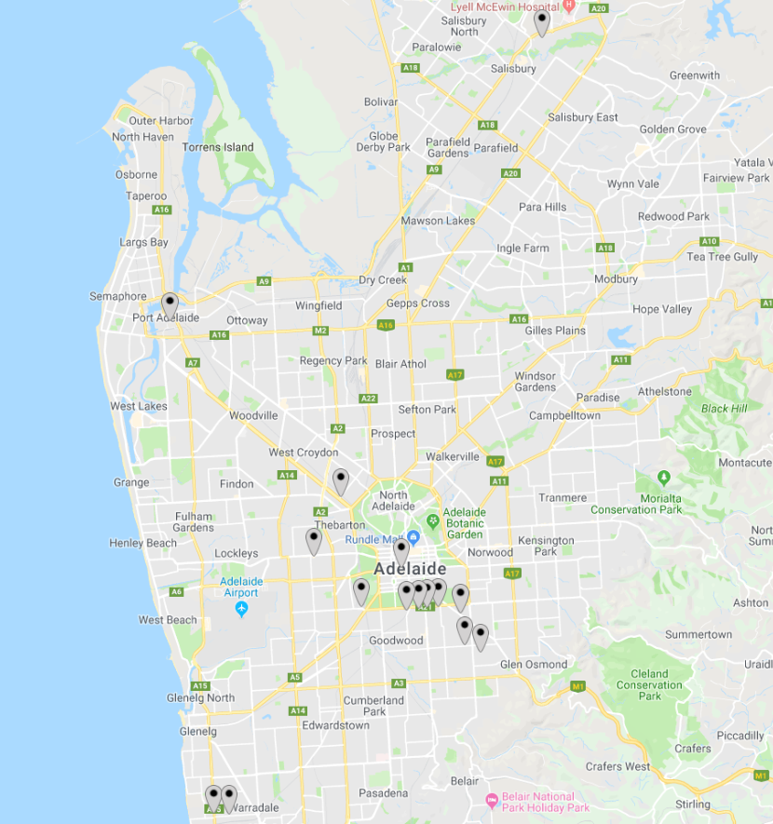

Source: Department of Health

1. : Modified Barthel Index scores on admission and exit from the Programme
   * 1. MBI data on admission and discharge

The information below shows further detail comparing the distribution of MBI scores on entry and exit for each jurisdiction. Considering entry MBI scores, nationally, the proportion of care recipients admitted under each category has remained constant suggesting the casemix of patients admitted to the TCP has remained constant since 2006/07. However, there is variation between jurisdictions with the ACT and NT admitting proportionately fewer complex patients over time. On the other hand, WA has been admitting increasingly complex patients over time.

The information demonstrates that Victoria has consistently been admitting a higher proportion of more complex patients compared to the other jurisdictions.

The MBI exit scores correlate what was discussed earlier with respect to the effectiveness of the Programme. Comparing entry and exit scores for each jurisdiction we can see the shift in the concentration of care recipients from lower functioning to higher functioning categories from entry to exit. Again, the data is skewed by the over-representation of zero scores on exit

**MBI admission scores nationally**

In 2006/07: 2% of participants had a score of 0, 2% of participants had a score of 1-9, 4% of participants had a score of 10-19, 4% of participants had a score of 20-29, 5% of participants had a score of 30-39, 7% of participants had a score of 40-49, 9% of participants had a score of 50-59, 13% of participants had a score of 60-69, 17% of participants had a score of 70-79, 22% of participants had a score of 80-89, and 15% of participants had a score of 90+.

In 2007/08: 2% of participants had a score of 0, 2% of participants had a score of 1-9, 3% of participants had a score of 10-19, 3% of participants had a score of 20-29, 4% of participants had a score of 30-39, 6% of participants had a score of 40-49, 8% of participants had a score of 50-59, 13% of participants had a score of 60-69, 18% of participants had a score of 70-79, 24% of participants had a score of 80-89, and 17% of participants had a score of 90+.

In 2008/09: 2% of participants had a score of 0, 1% of participants had a score of 1-9, 2% of participants had a score of 10-19, 3% of participants had a score of 20-29, 4% of participants had a score of 30-39, 6% of participants had a score of 40-49, 9% of participants had a score of 50-59, 12% of participants had a score of 60-69, 19% of participants had a score of 70-79, 25% of participants had a score of 80-89, and 17% of participants had a score of 90+.

In 2009/10: 2% of participants had a score of 0, 1% of participants had a score of 1-9, 2% of participants had a score of 10-19, 3% of participants had a score of 20-29, 4% of participants had a score of 30-39, 5% of participants had a score of 40-49, 8% of participants had a score of 50-59, 12% of participants had a score of 60-69, 19% of participants had a score of 70-79, 26% of participants had a score of 80-89, and 18% of participants had a score of 90+.

In 2010/11: 2% of participants had a score of 0, 1% of participants had a score of 1-9, 2% of participants had a score of 10-19, 3% of participants had a score of 20-29, 4% of participants had a score of 30-39, 5% of participants had a score of 40-49, 8% of participants had a score of 50-59, 12% of participants had a score of 60-69, 19% of participants had a score of 70-79, 27% of participants had a score of 80-89, and 17% of participants had a score of 90+.

In 2011/12: 1% of participants had a score of 0, 1% of participants had a score of 1-9, 2% of participants had a score of 10-19, 3% of participants had a score of 20-29, 3% of participants had a score of 30-39, 5% of participants had a score of 40-49, 8% of participants had a score of 50-59, 12% of participants had a score of 60-69, 20% of participants had a score of 70-79, 27% of participants had a score of 80-89, and 17% of participants had a score of 90+.

In 2012/13: 1% of participants had a score of 0, 2% of participants had a score of 1-9, 2% of participants had a score of 10-19, 3% of participants had a score of 20-29, 3% of participants had a score of 30-39, 5% of participants had a score of 40-49, 8% of participants had a score of 50-59, 12% of participants had a score of 60-69, 19% of participants had a score of 70-79, 27% of participants had a score of 80-89, and 17% of participants had a score of 90+.

In 2013/14: 1% of participants had a score of 0, 2% of participants had a score of 1-9, 2% of participants had a score of 10-19, 3% of participants had a score of 20-29, 4% of participants had a score of 30-39, 5% of participants had a score of 40-49, 9% of participants had a score of 50-59, 12% of participants had a score of 60-69, 19% of participants had a score of 70-79, 26% of participants had a score of 80-89, and 17% of participants had a score of 90+.

In 2014/15: 1% of participants had a score of 0, 2% of participants had a score of 1-9, 3% of participants had a score of 10-19, 3% of participants had a score of 20-29, 4% of participants had a score of 30-39, 6% of participants had a score of 40-49, 9% of participants had a score of 50-59, 12% of participants had a score of 60-69, 18% of participants had a score of 70-79, 26% of participants had a score of 80-89, and 16% of participants had a score of 90+.

In 2015/16: 1% of participants had a score of 0, 2% of participants had a score of 1-9, 3% of participants had a score of 10-19, 3% of participants had a score of 20-29, 4% of participants had a score of 30-39, 6% of participants had a score of 40-49, 9% of participants had a score of 50-59, 12% of participants had a score of 60-69, 19% of participants had a score of 70-79, 26% of participants had a score of 80-89, and 17% of participants had a score of 90+.

In 2016/17: 2% of participants had a score of 0, 2% of participants had a score of 1-9, 2% of participants had a score of 10-19, 3% of participants had a score of 20-29, 4% of participants had a score of 30-39, 6% of participants had a score of 40-49, 9% of participants had a score of 50-59, 12% of participants had a score of 60-69, 18% of participants had a score of 70-79, 25% of participants had a score of 80-89, and 16% of participants had a score of 90+.

In 2017/18: 1% of participants had a score of 0, 2% of participants had a score of 1-9, 2% of participants had a score of 10-19, 3% of participants had a score of 20-29, 4% of participants had a score of 30-39, 6% of participants had a score of 40-49, 10% of participants had a score of 50-59, 13% of participants had a score of 60-69, 18% of participants had a score of 70-79, 24% of participants had a score of 80-89, and 16% of participants had a score of 90+.

**MBI exit scores nationally**

In 2006/07: 17% of participants had a score of 0, 1% of participants had a score of 1-9, 3% of participants had a score of 10-19, 3% of participants had a score of 20-29, 3% of participants had a score of 30-39, 4% of participants had a score of 40-49, 4% of participants had a score of 50-59, 6% of participants had a score of 60-69, 9% of participants had a score of 70-79, 16% of participants had a score of 80-89, and 35% of participants had a score of 90+.

In 2007/08: 15% of participants had a score of 0, 1% of participants had a score of 1-9, 2% of participants had a score of 10-19, 2% of participants had a score of 20-29, 2% of participants had a score of 30-39, 3% of participants had a score of 40-49, 4% of participants had a score of 50-59, 6% of participants had a score of 60-69, 8% of participants had a score of 70-79, 16% of participants had a score of 80-89, and 39% of participants had a score of 90+.

In 2008/09: 15% of participants had a score of 0, 1% of participants had a score of 1-9, 2% of participants had a score of 10-19, 2% of participants had a score of 20-29, 2% of participants had a score of 30-39, 3% of participants had a score of 40-49, 4% of participants had a score of 50-59, 5% of participants had a score of 60-69, 9% of participants had a score of 70-79, 16% of participants had a score of 80-89, and 40% of participants had a score of 90+.

In 2009/10: 15% of participants had a score of 0, 1% of participants had a score of 1-9, 1% of participants had a score of 10-19, 2% of participants had a score of 20-29, 2% of participants had a score of 30-39, 3% of participants had a score of 40-49, 4% of participants had a score of 50-59, 5% of participants had a score of 60-69, 9% of participants had a score of 70-79, 17% of participants had a score of 80-89, and 42% of participants had a score of 90+.

In 2010/11: 18% of participants had a score of 0, 1% of participants had a score of 1-9, 1% of participants had a score of 10-19, 2% of participants had a score of 20-29, 2% of participants had a score of 30-39, 2% of participants had a score of 40-49, 4% of participants had a score of 50-59, 5% of participants had a score of 60-69, 9% of participants had a score of 70-79, 17% of participants had a score of 80-89, and 40% of participants had a score of 90+.

In 2011/12: 18% of participants had a score of 0, 1% of participants had a score of 1-9, 1% of participants had a score of 10-19, 1% of participants had a score of 20-29, 2% of participants had a score of 30-39, 2% of participants had a score of 40-49, 4% of participants had a score of 50-59, 5% of participants had a score of 60-69, 9% of participants had a score of 70-79, 16% of participants had a score of 80-89, and 41% of participants had a score of 90+.

In 2012/13: 19% of participants had a score of 0, 1% of participants had a score of 1-9,1% of participants had a score of 10-19, 1% of participants had a score of 20-29, 2% of participants had a score of 30-39, 2% of participants had a score of 40-49, 4% of participants had a score of 50-59, 5% of participants had a score of 60-69, 8% of participants had a score of 70-79, 15% of participants had a score of 80-89, and 41% of participants had a score of 90+.

In 2013/14: 19% of participants had a score of 0, 1% of participants had a score of 1-9, 1% of participants had a score of 10-19, 2% of participants had a score of 20-29, 2% of participants had a score of 30-39, 3% of participants had a score of 40-49, 4% of participants had a score of 50-59, 5% of participants had a score of 60-69, 8% of participants had a score of 70-79, 15% of participants had a score of 80-89, and 40% of participants had a score of 90+.

In 2014/15: 18% of participants had a score of 0, 2% of participants had a score of 1-9, 1% of participants had a score of 10-19, 2% of participants had a score of 20-29, 2% of participants had a score of 30-39, 3% of participants had a score of 40-49, 4% of participants had a score of 50-59, 5% of participants had a score of 60-69, 8% of participants had a score of 70-79, 15% of participants had a score of 80-89, and 39% of participants had a score of 90+.

In 2015/16: 17% of participants had a score of 0, 2% of participants had a score of 1-9, 2% of participants had a score of 10-19, 2% of participants had a score of 20-29, 2% of participants had a score of 30-39, 3% of participants had a score of 40-49, 4% of participants had a score of 50-59, 5% of participants had a score of 60-69, 9% of participants had a score of 70-79, 16% of participants had a score of 80-89, and 39% of participants had a score of 90+.

In 2016/17: 20% of participants had a score of 0, 1% of participants had a score of 1-9, 1% of participants had a score of 10-19, 2% of participants had a score of 20-29, 2% of participants had a score of 30-39, 3% of participants had a score of 40-49, 4% of participants had a score of 50-59, 5% of participants had a score of 60-69, 8% of participants had a score of 70-79, 15% of participants had a score of 80-89, and 39% of participants had a score of 90+.

In 2017/18: 20% of participants had a score of 0, 1% of participants had a score of 1-9, 1% of participants had a score of 10-19, 2% of participants had a score of 20-29, 2% of participants had a score of 30-39, 3% of participants had a score of 40-49, 4% of participants had a score of 50-59, 6% of participants had a score of 60-69, 8% of participants had a score of 70-79, 15% of participants had a score of 80-89, and 38% of participants had a score of 90+.

**MBI admission scores from 2006/07 to 2017/18 for NSW**

In 2006/07: 1% of participants had a score of 0, 0% of participants had a score of 1-9, 2% of participants had a score of 10-19, 1% of participants had a score of 20-29, 3% of participants had a score of 30-39, 6% of participants had a score of 40-49, 9% of participants had a score of 50-59, 11% of participants had a score of 60-69, 18% of participants had a score of 70-79, 27% of participants had a score of 80-89, and 22% of participants had a score of 90+.

In 2007/08: 0% of participants had a score of 0 , 0% of participants had a score of 1-9, 1% of participants had a score of 10-19, 1% of participants had a score of 20-29, 3% of participants had a score of 30-39, 4% of participants had a score of 40-49, 5% of participants had a score of 50-59, 11% of participants had a score of 60-69, 19% of participants had a score of 70-79, 31% of participants had a score of 80-89, and 25% of participants had a score of 90+.

In 2008/09: 1% of participants had a score of 0, 0% of participants had a score of 1-9, 0% of participants had a score of 10-19, 1% of participants had a score of 20-29, 2% of participants had a score of 30-39, 4% of participants had a score of 40-49, 6% of participants had a score of 50-59, 10% of participants had a score of 60-69, 19% of participants had a score of 70-79, 32% of participants had a score of 80-89, and 26% of participants had a score of 90+.

In 2009/10: 0% of participants had a score of 0, 0% of participants had a score of 1-9, 0% of participants had a score of 10-19, 1% of participants had a score of 20-29, 2% of participants had a score of 30-39, 3% of participants had a score of 40-49, 5% of participants had a score of 50-59, 10% of participants had a score of 60-69, 19% of participants had a score of 70-79, 33% of participants had a score of 80-89, and 27% of participants had a score of 90+.

In 2010/11: 1% of participants had a score of 0, 0% of participants had a score of 1-9, 0% of participants had a score of 10-19, 1% of participants had a score of 20-29, 2% of participants had a score of 30-39, 3% of participants had a score of 40-49, 6% of participants had a score of 50-59, 10% of participants had a score of 60-69, 20% of participants had a score of 70-79, 35% of participants had a score of 80-89, and 24% of participants had a score of 90+.

In 2011/12: 1% of participants had a score of 0, 0% of participants had a score of 1-9, 0% of participants had a score of 10-19, 0% of participants had a score of 20-29, 1% of participants had a score of 30-39, 2% of participants had a score of 40-49, 5% of participants had a score of 50-59, 10% of participants had a score of 60-69, 19% of participants had a score of 70-79, 34% of participants had a score of 80-89, and 26% of participants had a score of 90+.

In 2012/13: 1% of participants had a score of 0, 0% of participants had a score of 1-9, 1% of participants had a score of 10-19, 1% of participants had a score of 20-29, 1% of participants had a score of 30-39, 3% of participants had a score of 40-49, 5% of participants had a score of 50-59, 11% of participants had a score of 60-69, 19% of participants had a score of 70-79, 34% of participants had a score of 80-89, and 24% of participants had a score of 90+.

In 2013/14: 1% of participants had a score of 0, 0% of participants had a score of 1-9, 1% of participants had a score of 10-19, 1% of participants had a score of 20-29, 1% of participants had a score of 30-39, 3% of participants had a score of 40-49, 5% of participants had a score of 50-59, 10% of participants had a score of 60-69, 19% of participants had a score of 70-79, 34% of participants had a score of 80-89, and 25% of participants had a score of 90+.

In 2014/15: 0% of participants had a score of 0, 0% of participants had a score of 1-9, 1% of participants had a score of 10-19, 1% of participants had a score of 20-29, 1% of participants had a score of 30-39, 3% of participants had a score of 40-49, 5% of participants had a score of 50-59, 10% of participants had a score of 60-69, 19% of participants had a score of 70-79, 34% of participants had a score of 80-89, and 25% of participants had a score of 90+.

In 2015/16: 1% of participants had a score of 0, 0% of participants had a score of 1-9, 1% of participants had a score of 10-19, 1% of participants had a score of 20-29, 2% of participants had a score of 30-39, 3% of participants had a score of 40-49, 6% of participants had a score of 50-59, 9% of participants had a score of 60-69, 19% of participants had a score of 70-79, 33% of participants had a score of 80-89, and 26% of participants had a score of 90+.

In 2016/17: 1% of participants had a score of 0, 0% of participants had a score of 1-9, 1% of participants had a score of 10-19, 1% of participants had a score of 20-29, 2% of participants had a score of 30-39, 3% of participants had a score of 40-49, 5% of participants had a score of 50-59, 9% of participants had a score of 60-69, 19% of participants had a score of 70-79, 34% of participants had a score of 80-89, and 26% of participants had a score of 90+.

In 2017/18: 1% of participants had a score of 0, 0% of participants had a score of 1-9, 1% of participants had a score of 10-19, 1% of participants had a score of 20-29, 1% of participants had a score of 30-39, 3% of participants had a score of 40-49, 5% of participants had a score of 50-59, 10% of participants had a score of 60-69, 20% of participants had a score of 70-79, 33% of participants had a score of 80-89, and 26% of participants had a score of 90+.

**MBI exit scores from 2006/07 to 2017/18 for NSW**

In 2006/07: 21% of participants had a score of 0, 0% of participants had a score of 1-9, 1% of participants had a score of 10-19, 1% of participants had a score of 20-29, 1% of participants had a score of 30-39, 2% of participants had a score of 40-49, 2% of participants had a score of 50-59, 4% of participants had a score of 60-69, 6% of participants had a score of 70-79, 15% of participants had a score of 80-89, and 47% of participants had a score of 90+.

In 2007/08: 16% of participants had a score of 0,0% of participants had a score of 1-9, 0% of participants had a score of 10-19, 1% of participants had a score of 20-29, 0% of participants had a score of 30-39, 1% of participants had a score of 40-49, 2% of participants had a score of 50-59, 4% of participants had a score of 60-69, 6% of participants had a score of 70-79, 15% of participants had a score of 80-89, and 54% of participants had a score of 90+.

In 2008/09: 16% of participants had a score of 0, 0% of participants had a score of 1-9, 0% of participants had a score of 10-19, 0% of participants had a score of 20-29, 1% of participants had a score of 30-39, 1% of participants had a score of 40-49, 2% of participants had a score of 50-59, 3% of participants had a score of 60-69, 7% of participants had a score of 70-79, 15% of participants had a score of 80-89, and 53% of participants had a score of 90+.

In 2009/10: 17% of participants had a score of 0, 0% of participants had a score of 1-9, 0% of participants had a score of 10-19, 0% of participants had a score of 20-29, 1% of participants had a score of 30-39, 1% of participants had a score of 40-49, 2% of participants had a score of 50-59, 3% of participants had a score of 60-69, 7% of participants had a score of 70-79, 14% of participants had a score of 80-89, and 55% of participants had a score of 90+.

In 2010/2011: 18% of participants had a score of 0, 0% of participants had a score of 1-9, 0% of participants had a score of 10-19, 1% of participants had a score of 20-29, 1% of participants had a score of 30-39, 1% of participants had a score of 40-49, 2% of participants had a score of 50-59, 3% of participants had a score of 60-69, 7% of participants had a score of 70-79, 15% of participants had a score of 80-89, 53% of participants had a score of 90+.

In 2011/2012: 19% of participants had a score of 0, 0% of participants had a score of 1-9, 0% of participants had a score of 10-19, 0% of participants had a score of 20-29, 1% of participants had a score of 30-39, 1% of participants had a score of 40-49, 2% of participants had a score of 50-59, 3% of participants had a score of 60-69, 6% of participants had a score of 70-79, 14% of participants had a score of 80-89, and 54% of participants had a score of 90+.

In 2012/13: 20% of participants had a score of 0, 0% of participants had a score of 1-9, 0% of participants had a score of 10-19, 0% of participants had a score of 20-29, 1% of participants had a score of 30-39, 1% of participants had a score of 40-49, 1% of participants had a score of 50-59, 3% of participants had a score of 60-69, 6% of participants had a score of 70-79, 13% of participants had a score of 80-89, and 53% of participants had a score of 90+.

In 2013/14: 20% of participants had a score of 0, 0% of participants had a score of 1-9, 0% of participants had a score of 10-19, 0% of participants had a score of 20-29, 0% of participants had a score of 30-39, 1% of participants had a score of 40-49, 1% of participants had a score of 50-59, 3% of participants had a score of 60-69, 6% of participants had a score of 70-79, 13% of participants had a score of 80-89, and 54% of participants had a score of 90+.

In 2014/15: 19% of participants had a score of 0, 1% of participants had a score of 1-9, 0% of participants had a score of 10-19, 0% of participants had a score of 20-29, 0% of participants had a score of 30-39, 1% of participants had a score of 40-49, 2% of participants had a score of 50-59, 3% of participants had a score of 60-69, 6% of participants had a score of 70-79, 13% of participants had a score of 80-89, and 55% of participants had a score of 90+.

In 2015/16: 19% of participants had a score of 0, 1% of participants had a score of 1-9, 1% of participants had a score of 10-19, 0% of participants had a score of 20-29, 1% of participants had a score of 30-39, 1% of participants had a score of 40-49, 2% of participants had a score of 50-59, 3% of participants had a score of 60-69, 5% of participants had a score of 70-79, 14% of participants had a score of 80-89, and 54% of participants had a score of 90+.

In 2016/17: 21% of participants had a score of 0, 0% of participants had a score of 1-9, 0% of participants had a score of 10-19, 0% of participants had a score of 20-29, 0% of participants had a score of 30-39, 1% of participants had a score of 40-49, 1% of participants had a score of 50-59, 3% of participants had a score of 60-69, 4% of participants had a score of 70-79, 13% of participants had a score of 80-89, and 55% of participants had a score of 90+.

In 2017/18: 21% of participants had a score of 0, 0% of participants had a score of 1-9, 0% of participants had a score of 10-19, 0% of participants had a score of 20-29, 0% of participants had a score of 30-39, 1% of participants had a score of 40-49, 1% of participants had a score of 50-59, 3% of participants had a score of 60-69, 5% of participants had a score of 70-79, 13% of participants had a score of 80-89, and 55% of participants had a score of 90+.

**MBI admission scores from 2006/07 to 2017/18 for VIC**

In 2006/07: 6% of participants had a score of 0, 5% of participants had a score of 1-9, 8% of participants had a score of 10-19, 7% of participants had a score of 20-29, 10% of participants had a score of 30-39, 9% of participants had a score of 40-49, 9% of participants had a score of 50-59, 12% of participants had a score of 60-69, 12% of participants had a score of 70-79, 12% of participants had a score of 80-89, and 9% of participants had a score of 90+.

In 2007/08: 5% of participants had a score of 0, 4% of participants had a score of 1-9, 6% of participants had a score of 10-19, 6% of participants had a score of 20-29, 8% of participants had a score of 30-39, 11% of participants had a score of 40-49, 9% of participants had a score of 50-59, 13% of participants had a score of 60-69, 14% of participants had a score of 70-79, 15% of participants had a score of 80-89, and 9% of participants had a score of 90+.

In 2008/09: 4% of participants had a score of 0, 4% of participants had a score of 1-9, 6% of participants had a score of 10-19, 6% of participants had a score of 20-29, 7% of participants had a score of 30-39, 8% of participants had a score of 40-49, 10% of participants had a score of 50-59, 13% of participants had a score of 60-69, 16% of participants had a score of 70-79, 16% of participants had a score of 80-89, 11% of participants had a score of 90+.

In 2009/10: 4% of participants had a score of 0, 3% of participants had a score of 1-9, 5% of participants had a score of 10-19, 5% of participants had a score of 20-29, 6% of participants had a score of 30-39, 7% of participants had a score of 40-49, 10% of participants had a score of 50-59, 12% of participants had a score of 60-69, 17% of participants had a score of 70-79, 18% of participants had a score of 80-89, and 14% of participants had a score of 90+.

In 2010/11: 3% of participants had a score of 0, 3% of participants had a score of 1-9, 5% of participants had a score of 10-19, 5% of participants had a score of 20-29, 6% of participants had a score of 30-39, 6% of participants had a score of 40-49, 10% of participants had a score of 50-59, 14% of participants had a score of 60-69, 17% of participants had a score of 70-79, 19% of participants had a score of 80-89, and 12% of participants had a score of 90+.

In 2011/12: 2% of participants had a score of 0, 3% of participants had a score of 1-9, 4% of participants had a score of 10-19, 5% of participants had a score of 20-29, 5% of participants had a score of 30-39, 7% of participants had a score of 40-49, 10% of participants had a score of 50-59, 14% of participants had a score of 60-69, 19% of participants had a score of 70-79, 18% of participants had a score of 80-89, and 13% of participants had a score of 90+.

In 2012/13: 2% of participants had a score of 0, 3% of participants had a score of 1-9, 4% of participants had a score of 10-19, 5% of participants had a score of 20-29, 5% of participants had a score of 30-39, 6% of participants had a score of 40-49, 10% of participants had a score of 50-59, 13% of participants had a score of 60-69, 19% of participants had a score of 70-79, 20% of participants had a score of 80-89, and 12% of participants had a score of 90+.

In 2013/14: 3% of participants had a score of 0, 3% of participants had a score of 1-9, 4% of participants had a score of 10-19, 5% of participants had a score of 20-29, 5% of participants had a score of 30-39, 7% of participants had a score of 40-49, 11% of participants had a score of 50-59, 13% of participants had a score of 60-69, 18% of participants had a score of 70-79, 20% of participants had a score of 80-89, and 11% of participants had a score of 90+.

In 2014/15: 3% of participants had a score of 0, 4% of participants had a score of 1-9, 4% of participants had a score of 10-19, 5% of participants had a score of 20-29, 6% of participants had a score of 30-39, 8% of participants had a score of 40-49, 10% of participants had a score of 50-59, 14% of participants had a score of 60-69, 16% of participants had a score of 70-79, 18% of participants had a score of 80-89, and 12% of participants had a score of 90+.

In 2015/16: 3% of participants had a score of 0, 3% of participants had a score of 1-9, 4% of participants had a score of 10-19, 5% of participants had a score of 20-29, 6% of participants had a score of 30-39, 8% of participants had a score of 40-49, 10% of participants had a score of 50-59, 13% of participants had a score of 60-69, 17% of participants had a score of 70-79, 19% of participants had a score of 80-89, and 11% of participants had a score of 90+.

In 2016/17: 3% of participants had a score of 0, 3% of participants had a score of 1-9, 4% of participants had a score of 10-19, 5% of participants had a score of 20-29, 6% of participants had a score of 30-39, 7% of participants had a score of 40-49, 10% of participants had a score of 50-59, 13% of participants had a score of 60-69, 17% of participants had a score of 70-79, 18% of participants had a score of 80-89, and 13% of participants had a score of 90+.

In 2017/18: 3% of participants had a score of 0, 3% of participants had a score of 1-9, 4% of participants had a score of 10-19, 5% of participants had a score of 20-29, 6% of participants had a score of 30-39, 8% of participants had a score of 40-49, 11% of participants had a score of 50-59, 14% of participants had a score of 60-69, 18% of participants had a score of 70-79, 17% of participants had a score of 80-89, and 12% of participants had a score of 90+.

**MBI exit scores from 2006/07 to 2017/18 for VIC**

In 2006/07: 17% of participants had a score of 0, 4% of participants had a score of 1-9, 6% of participants had a score of 10-19, 6% of participants had a score of 20-29, 8% of participants had a score of 30-39, 7% of participants had a score of 40-49, 7% of participants had a score of 50-59, 8% of participants had a score of 60-69, 10% of participants had a score of 70-79, 12% of participants had a score of 80-89, and 15% of participants had a score of 90+.

In 2007/08: 16% of participants had a score of 0, 4% of participants had a score of 1-9, 4% of participants had a score of 10-19, 5% of participants had a score of 20-29, 6% of participants had a score of 30-39, 6% of participants had a score of 40-49, 7% of participants had a score of 50-59, 9% of participants had a score of 60-69, 11% of participants had a score of 70-79, 15% of participants had a score of 80-89, and 17% of participants had a score of 90+.

In 2008/09: 15% of participants had a score of 0, 3% of participants had a score of 1-9, 5% of participants had a score of 10-19, 5% of participants had a score of 20-29, 5% of participants had a score of 30-39, 6% of participants had a score of 40-49, 7% of participants had a score of 50-59, 8% of participants had a score of 60-69, 11% of participants had a score of 70-79, 15% of participants had a score of 80-89, and 21% of participants had a score of 90+.

In 2009/10: 15% of participants had a score of 0, 3% of participants had a score of 1-9, 4% of participants had a score of 10-19, 3% of participants had a score of 20-29, 4% of participants had a score of 30-39, 5% of participants had a score of 40-49, 6% of participants had a score of 50-59, 8% of participants had a score of 60-69, 12% of participants had a score of 70-79, 17% of participants had a score of 80-89, and 24% of participants had a score of 90+.

In 2010/11: 25% of participants had a score of 0, 2% of participants had a score of 1-9, 3% of participants had a score of 10-19, 3% of participants had a score of 20-29, 3% of participants had a score of 30-39, 4% of participants had a score of 40-49, 6% of participants had a score of 50-59, 7% of participants had a score of 60-69, 10% of participants had a score of 70-79, 16% of participants had a score of 80-89, and 21% of participants had a score of 90+.

In 2011/12: 25% of participants had a score of 0, 2% of participants had a score of 1-9, 3% of participants had a score of 10-19, 3% of participants had a score of 20-29, 3% of participants had a score of 30-39, 3% of participants had a score of 40-49, 5% of participants had a score of 50-59, 6% of participants had a score of 60-69, 10% of participants had a score of 70-79, 15% of participants had a score of 80-89, and 24% of participants had a score of 90+.

In 2012/13: 25% of participants had a score of 0, 2% of participants had a score of 1-9, 3% of participants had a score of 10-19, 2% of participants had a score of 20-29, 3% of participants had a score of 30-39, 3% of participants had a score of 40-49, 5% of participants had a score of 50-59, 7% of participants had a score of 60-69, 10% of participants had a score of 70-79, 17% of participants had a score of 80-89, and 24% of participants had a score of 90+.

In 2013/14: 25% of participants had a score of 0, 2% of participants had a score of 1-9, 2% of participants had a score of 10-19, 3% of participants had a score of 20-29, 3% of participants had a score of 30-39, 4% of participants had a score of 40-49, 5% of participants had a score of 50-59, 7% of participants had a score of 60-69, 9% of participants had a score of 70-79, 17% of participants had a score of 80-89, and 22% of participants had a score of 90+.

In 2014/15: 25% of participants had a score of 0, 4% of participants had a score of 1-9, 3% of participants had a score of 10-19, 3% of participants had a score of 20-29 , 3% of participants had a score of 30-39, 4% of participants had a score of 40-49, 5% of participants had a score of 50-59, 7% of participants had a score of 60-69, 9% of participants had a score of 70-79, 15% of participants had a score of 80-89, and 22% of participants had a score of 90+.

In 2015/16: 23% of participants had a score of 0, 3% of participants had a score of 1-9, 3% of participants had a score of 10-19, 3% of participants had a score of 20-29, 4% of participants had a score of 30-39, 4% of participants had a score of 40-49, 5% of participants had a score of 50-59, 7% of participants had a score of 60-69, 10% of participants had a score of 70-79, 16% of participants had a score of 80-89, and 23% of participants had a score of 90+.

In 2016/17: 25% of participants had a score of 0, 2% of participants had a score of 1-9, 3% of participants had a score of 10-19, 2% of participants had a score of 20-29, 3% of participants had a score of 30-39, 4% of participants had a score of 40-49, 5% of participants had a score of 50-59, 7% of participants had a score of 60-69, 10% of participants had a score of 70-79, 15% of participants had a score of 80-89 and 23% of participants had a score of 90+.

In 2017/18: 26% of participants had a score of 0, 2% of participants had a score of 1-9, 2% of participants had a score of 10-19, 3% of participants had a score of 20-29, 3% of participants had a score of 30-39, 3% of participants had a score of 40-49, 6% of participants had a score of 50-59, 7% of participants had a score of 60-69, 10% of participants had a score of 70 -79, 15% of participants had a score of 80-89, and 22% of participants had a score of 90+.

**MBI admission scores from 2006/07 to 2017/18 for QLD**

In 2006/07: 0% of participants had a score of 0, 0% of participants had a score of 1-9, 0% of participants had a score of 10-19, 0% of participants had a score of 20-29, 1% of participants had a score of 30-39, 2% of participants had a score of 40-49, 6% of participants had a score of 50-59, 10% of participants had a score of 60-69, 17% of participants had a score of 70-79, 39% of participants had a score of 80-89, and 24% of participants had a score of 90+.

In 2007/08: 0% of participants had a score of 0, 0% of participants had a score of 1-9, 0% of participants had a score of 10-19, 1% of participants had a score of 20-29, 1% of participants had a score of 30-39, 3% of participants had a score of 40-49, 4% of participants had a score of 50-59, 11% of participants had a score of 60-69, 19% of participants had a score of 70-79, 34% of participants had a score of 80-89, and 26% of participants had a score of 90+.

In 2008/09: 0% of participants had a score of 0, 0% of participants had a score of 1-9, 0% of participants had a score of 10-19, 2% of participants had a score of 20-29, 2% of participants had a score of 30-39, 4% of participants had a score of 40-49, 6% of participants had a score of 50-59, 10% of participants had a score of 60-69, 23% of participants had a score of 70-79, 33% of participants had a score of 80-89, and 19% of participants had a score of 90+.

In 2009/10: 0% of participants had a score of 0, 0% of participants had a score of 1-9, 1% of participants had a score of 10-19, 2% of participants had a score of 20-29, 3% of participants had a score of 30-39, 4% of participants had a score of 40-49, 7% of participants had a score of 50-59, 9% of participants had a score of 60-69, 20% of participants had a score of 70-79, 34% of participants had a score of 80-89, and 21% of participants had a score of 90+.

In 2010/11: 0% of participants had a score of 0, 0% of participants had a score of 1-9, 1% of participants had a score of 10-19, 2% of participants had a score of 20-29, 3% of participants had a score of 30-39, 5% of participants had a score of 40-49, 6% of participants had a score of 50-59, 9% of participants had a score of 60-69, 20% of participants had a score of 70-79, 33% of participants had a score of 80-89, and 21% of participants had a score of 90+.

In 2011/12: 0% of participants had a score of 0, 0% of participants had a score of 1-9, 0% of participants had a score of 10-19, 1% of participants had a score of 20-29, 2% of participants had a score of 30-39, 3% of participants had a score of 40-49, 7% of participants had a score of 50-59, 10% of participants had a score of 60-69, 21% of participants had a score of 70-79, 35% of participants had a score of 80-89, and 20% of participants had a score of 90+.

In 2012/13: 1% of participants had a score of 0, 0% of participants had a score of 1-9, 0% of participants had a score of 10-19, 2% of participants had a score of 20-29, 2% of participants had a score of 30-39, 3% of participants had a score of 40-49, 6% of participants had a score of 50-59, 11% of participants had a score of 60-69, 19% of participants had a score of 70-79, 34% of participants had a score of 80-89, and 23% of participants had a score of 90+.

In 2013/14: 0% of participants had a score of 0, 1% of participants had a score of 1-9, 2% of participants had a score of 10-19, 2% of participants had a score of 20-29, 3% of participants had a score of 30-39, 5% of participants had a score of 40-49, 7% of participants had a score of 50-59, 12% of participants had a score of 60-69, 19% of participants had a score of 70-79, 30% of participants had a score of 80-89, and 19% of participants had a score of 90+.

In 2014/15: 1% of participants had a score of 0, 1% of participants had a score of 1-9, 2% of participants had a score of 10-19, 3% of participants had a score of 20-29, 3% of participants had a score of 30-39, 5% of participants had a score of 40-49, 7% of participants had a score of 50-59, 12% of participants had a score of 60-69, 21% of participants had a score of 70-79, 30% of participants had a score of 80-89, and 16% of participants had a score of 90+.

In 2015/16: 0% of participants had a score of 0, 1% of participants had a score of 1-9, 2% of participants had a score of 10-19, 3% of participants had a score of 20-29, 4% of participants had a score of 30-39, 5% of participants had a score of 40-49, 7% of participants had a score of 50-59, 12% of participants had a score of 60-69, 21% of participants had a score of 70-79, 29% of participants had a score of 80-89, and 15% of participants had a score of 90+.

In 2016/17: 1% of participants had a score of 0, 1% of participants had a score of 1-9, 2% of participants had a score of 10-19, 3% of participants had a score of 20-29, 4% of participants had a score of 30-39, 5% of participants had a score of 40-49, 7% of participants had a score of 50-59, 13% of participants had a score of 60-69, 22% of participants had a score of 70-79, 28% of participants had a score of 80-89, and 14% of participants had a score of 90+.

In 2017/18: 1% of participants had a score of 0, 1% of participants had a score of 1-9, 2% of participants had a score of 10-19, 3% of participants had a score of 20-29, 4% of participants had a score of 30-39, 6% of participants had a score of 40-49, 7% of participants had a score of 50-59, 13% of participants had a score of 60-69, 21% of participants had a score of 70-79, 28% of participants had a score of 80-89, and 14% of participants had a score of 90+.

**MBI exit scores from 2006/07 to 2017/18 for QLD**

In 2006/07: 16% of participants had a score of 0, 0% of participants had a score of 1-9, 1% of participants had a score of 10-19, 0% of participants had a score of 20-29, 1% of participants had a score of 30-39, 1% of participants had a score of 40-49, 1% of participants had a score of 50-59, 2% of participants had a score of 60-69, 7% of participants had a score of 70-79, 13% of participants had a score of 80-89, and 56% of participants had a score of 90+.

In 2007/08: 18% of participants had a score of 0, 0% of participants had a score of 1-9, 0% of participants had a score of 10-19, 0% of participants had a score of 20-29, 0% of participants had a score of 30-39, 1% of participants had a score of 40-49, 1% of participants had a score of 50-59, 2% of participants had a score of 60-69, 5% of participants had a score of 70-79, 12% of participants had a score of 80-89, and 60% of participants had a score of 90+.

In 2008/09: 17% of participants had a score of 0, 0% of participants had a score of 1-9, 0% of participants had a score of 10-19, 1% of participants had a score of 20-29, 1% of participants had a score of 30-39, 1% of participants had a score of 40-49, 2% of participants had a score of 50-59, 3% of participants had a score of 60-69, 5% of participants had a score of 70-79, 16% of participants had a score of 80-89, and 54% of participants had a score of 90+.

In 2009/10: 16% of participants had a score of 0, 0% of participants had a score of 1-9, 0% of participants had a score of 10-19, 1% of participants had a score of 20-29, 1% of participants had a score of 30-39, 2% of participants had a score of 40-49, 2% of participants had a score of 50-59, 3% of participants had a score of 60-69, 6% of participants had a score of 70-79, 15% of participants had a score of 80-89, and 55% of participants had a score of 90+.

In 2010/ 11: 16% of participants had a score of 0, 0% of participants had a score of 1-9, 1% of participants had a score of 10-19, 1% of participants had a score of 20-29, 1% of participants had a score of 30-39, 1% of participants had a score of 40-49, 2% of participants had a score of 50-59, 3% of participants had a score of 60-69, 6% of participants had a score of 70-79, 14% of participants had a score of 80-89, and 55% of participants had a score of 90+.

In 2011/12: 15% of participants had a score of 0, 0% of participants had a score of 1-9, 0% of participants had a score of 10-19, 1% of participants had a score of 20-29, 1% of participants had a score of 30-39, 1% of participants had a score of 40-49, 3% of participants had a score of 50-59, 3% of participants had a score of 60-69, 6% of participants had a score of 70-79, 15% of participants had a score of 80-89, and 54% of participants had a score of 90+.

In 2012/13: 18% of participants had a score of 0, 0% of participants had a score of 1-9, 0% of participants had a score of 10-19, 0% of participants had a score of 20-29, 1% of participants had a score of 30-39, 1% of participants had a score of 40-49, 2% of participants had a score of 50-59, 3% of participants had a score of 60-69, 6% of participants had a score of 70-79, 14% of participants had a score of 80-89, and 54% of participants had a score of 90+.

In 2013/14: 19% of participants had a score of 0, 1% of participants had a score of 1-9, 1% of participants had a score of 10-19, 1% of participants had a score of 20-29, 1% of participants had a score of 30-39, 2% of participants had a score of 40-49, 2% of participants had a score of 50-59, 4% of participants had a score of 60-69, 6% of participants had a score of 70-79, 15% of participants had a score of 80-89, and 49% of participants had a score of 90+.

In 2014/15: 18% of participants had a score of 0, 1% of participants had a score of 1-9, 1% of participants had a score of 10-19, 1% of participants had a score of 20-29, 2% of participants had a score of 30-39, 2% of participants had a score of 40-49, 3% of participants had a score of 50-59, 4% of participants had a score of 60-69, 8% of participants had a score of 70-79, 15% of participants had a score of 80-89, and 45% of participants had a score of 90+.

In 2015/16: 16% of participants had a score of 0, 2% of participants had a score of 1-9, 1% of participants had a score of 10-19, 2% of participants had a score of 20-29, 2% of participants had a score of 30-39, 2% of participants had a score of 40-49, 3% of participants had a score of 50-59, 5% of participants had a score of 60-69, 9% of participants had a score of 70-79, 15% of participants had a score of 80-89, and 43% of participants had a score of 90+.

In 2016/17: 20% of participants had a score of 0, 1% of participants had a score of 1-9, 1% of participants had a score of 10-19, 1% of participants had a score of 20-29, 2% of participants had a score of 30-39, 2% of participants had a score of 40-49, 3% of participants had a score of 50-59, 5% of participants had a score of 60-69, 8% of participants had a score of 70-79, 16% of participants had a score of 80-89, and 42% of participants had a score of 90+.

In 2017/18: 20% of participants had a score of 0, 1% of participants had a score of 1-9, 1% of participants had a score of 10-19, 1% of participants had a score of 20-29, 2% of participants had a score of 30-39, 2% of participants had a score of 40-49, 2% of participants had a score of 50-59, 4% of participants had a score of 60-69, 7% of participants had a score of 70-79, 17% of participants had a score of 80-89, and 43% of participants had a score of 90+.

**MBI admission scores from 2006/07 to 2017/18 for WA**

In 2006/07: 1% of participants had a score of 0, 1% of participants had a score of 1-9, 4% of participants had a score of 10-19, 5% of participants had a score of 20-29, 5% of participants had a score of 30-39, 9% of participants had a score of 40-49, 10% of participants had a score of 50-59, 18% of participants had a score of 60-69, 19% of participants had a score of 70-79, 18% of participants had a score of 80-89, and 10% of participants had a score of 90+.

In 2007/2008: 2% of participants had a score of 0, 1% of participants had a score of 1-9, 2% of participants had a score of 10-19, 3% of participants had a score of 20-29, 3% of participants had a score of 30-39, 6% of participants had a score of 40-49, 13% of participants had a score of 50-59, 18% of participants had a score of 60-69, 20% of participants had a score of 70-79, 23% of participants had a score of 80-89, and 10% of participants had a score of 90+.

In 2008/2009: 1% of participants had a score of 0, 2% of participants had a score of 1-9, 1% of participants had a score of 10-19, 4% of participants had a score of 20-29, 6% of participants had a score of 30-39, 7% of participants had a score of 40-49, 13% of participants had a score of 50-59, 13% of participants had a score of 60-69, 21% of participants had a score of 70-79, 20% of participants had a score of 80-89, and 11% of participants had a score of 90+.

In 2009/2010: 3% of participants had a score of 0, 3% of participants had a score of 1-9, 4% of participants had a score of 10-19, 4% of participants had a score of 20-29, 5% of participants had a score of 30-39, 9% of participants had a score of 40-49, 10% of participants had a score of 50-59, 14% of participants had a score of 60-69, 20% of participants had a score of 70-79, 18% of participants had a score of 80-89, and 10% of participants had a score of 90+.

In 2010/2011: 4% of participants had a score of 0, 4% of participants had a score of 1-9, 5% of participants had a score of 10-19, 5% of participants had a score of 20-29, 7% of participants had a score of 30-39, 7% of participants had a score of 40-49, 10% of participants had a score of 50-59, 14% of participants had a score of 60-69, 18% of participants had a score of 70-79, 18% of participants had a score of 80-89, and 8% of participants had a score of 90+.

In 2011/2012: 3% of participants had a score of 0, 4% of participants had a score of 1-9, 6% of participants had a score of 10-19, 6% of participants had a score of 20-29, 7% of participants had a score of 30-39, 9% of participants had a score of 40-49, 12% of participants had a score of 50-59, 16% of participants had a score of 60-69, 15% of participants had a score of 70-79, 14% of participants had a score of 80-89, and 8% of participants had a score of 90+.

In 2012/2013: 3% of participants had a score of 0, 5% of participants had a score of 1-9, 5% of participants had a score of 10-19, 6% of participants had a score of 20-29, 8% of participants had a score of 30-39, 10% of participants had a score of 40-49, 13% of participants had a score of 50-59, 14% of participants had a score of 60-69, 16% of participants had a score of 70-79, 13% of participants had a score of 80-89, and 7% of participants had a score of 90+.

In 2013/2014: 3% of participants had a score of 0, 4% of participants had a score of 1-9, 5% of participants had a score of 10-19, 6% of participants had a score of 20-29, 7% of participants had a score of 30-39, 9% of participants had a score of 40-49, 12% of participants had a score of 50-59, 15% of participants had a score of 60-69, 17% of participants had a score of 70-79, 15% of participants had a score of 80-89, and 7% of participants had a score of 90+.

In 2014/2015: 2% of participants had a score of 0, 5% of participants had a score of 1-9, 7% of participants had a score of 10-19, 7% of participants had a score of 20-29, 7% of participants had a score of 30-39, 9% of participants had a score of 40-49, 11% of participants had a score of 50-59, 12% of participants had a score of 60-69, 16% of participants had a score of 70-79, 15% of participants had a score of 80-89, and 7% of participants had a score of 90+.

In 2015/2016: 3% of participants had a score of 0, 4% of participants had a score of 1-9, 6% of participants had a score of 10-19, 6% of participants had a score of 20-29, 8% of participants had a score of 30-39, 10% of participants had a score of 40-49, 12% of participants had a score of 50-59, 13% of participants had a score of 60-69, 15% of participants had a score of 70-79, 16% of participants had a score of 80-89, and 6% of participants had a score of 90+.

In 2016/2017: 3% of participants had a score of 0, 4% of participants had a score of 1-9, 5% of participants had a score of 10-19, 6% of participants had a score of 20-29, 9% of participants had a score of 30-39, 13% of participants had a score of 40-49, 15% of participants had a score of 50-59, 15% of participants had a score of 60-69, 15% of participants had a score of 70-79, 10% of participants had a score of 80-89, and 6% of participants had a score of 90+.

In 2017/2018: 3% of participants had a score of 0, 4% of participants had a score of 1-9, 6% of participants had a score of 10-19, 8% of participants had a score of 20-29, 12% of participants had a score of 30-39, 13% of participants had a score of 40-49, 17% of participants had a score of 50-59, 14% of participants had a score of 60-69, 12% of participants had a score of 70-79, 9% of participants had a score of 80-89, and 3% of participants had a score of 90+.

**MBI exit scores from 2006/07 to 2017/18 for WA**

In 2006/2007: 24% of participants had a score of 0, 0% of participants had a score of 1-9, 2% of participants had a score of 10-19, 2% of participants had a score of 20-29, 2% of participants had a score of 30-39, 3% of participants had a score of 40-49, 4% of participants had a score of 50-59, 5% of participants had a score of 60-69, 12% of participants had a score of 70-79, 14% of participants had a score of 80-89, and 31% of participants had a score of 90+.

In 2007/2008: 27% of participants had a score of 0, 0% of participants had a score of 1-9, 1% of participants had a score of 10-19, 2% of participants had a score of 20-29, 1% of participants had a score of 30-39, 2% of participants had a score of 40-49, 2% of participants had a score of 50-59, 4% of participants had a score of 60-69, 9% of participants had a score of 70-79, 20% of participants had a score of 80-89, and 32% of participants had a score of 90+.

In 2008/2009: 24% of participants had a score of 0, 0% of participants had a score of 1-9, 1% of participants had a score of 10-19, 1% of participants had a score of 20-29, 2% of participants had a score of 30-39, 1% of participants had a score of 40-49, 2% of participants had a score of 50-59, 6% of participants had a score of 60-69, 11% of participants had a score of 70-79, 21% of participants had a score of 80-89, and 30% of participants had a score of 90+.

In 2009/2010: 22% of participants had a score of 0, 2% of participants had a score of 1-9, 1% of participants had a score of 10-19, 2% of participants had a score of 20-29, 2% of participants had a score of 30-39, 4% of participants had a score of 40-49, 5% of participants had a score of 50-59, 6% of participants had a score of 60-69, 11% of participants had a score of 70-79, 19% of participants had a score of 80-89, and 26% of participants had a score of 90+.

In 2010/2011: 21% of participants had a score of 0, 3% of participants had a score of 1-9, 3% of participants had a score of 10-19, 4% of participants had a score of 20-29, 4% of participants had a score of 30-39, 4% of participants had a score of 40-49, 6% of participants had a score of 50-59, 7% of participants had a score of 60-69, 12% of participants had a score of 70-79, 18% of participants had a score of 80-89, and 18% of participants had a score of 90+.

In 2011/2012: 24% of participants had a score of 0, 3% of participants had a score of 1-9, 3% of participants had a score of 10-19, 3% of participants had a score of 20-29, 4% of participants had a score of 30-39, 5% of participants had a score of 40-49, 7% of participants had a score of 50-59, 9% of participants had a score of 60-69, 13% of participants had a score of 70-79, 14% of participants had a score of 80-89, and 15% of participants had a score of 90+.

In 2012/2013: 25% of participants had a score of 0, 3% of participants had a score of 1-9, 3% of participants had a score of 10-19, 4% of participants had a score of 20-29, 4% of participants had a score of 30-39, 5% of participants had a score of 40-49, 8% of participants had a score of 50-59, 9% of participants had a score of 60-69, 13% of participants had a score of 70-79, 13% of participants had a score of 80-89, and 13% of participants had a score of 90+.

In 2013/2014: 20% of participants had a score of 0, 3% of participants had a score of 1-9, 3% of participants had a score of 10-19, 5% of participants had a score of 20-29, 4% of participants had a score of 30-39, 6% of participants had a score of 40-49, 7% of participants had a score of 50-59, 10% of participants had a score of 60-69, 13% of participants had a score of 70-79, 14% of participants had a score of 80-89, and 15% of participants had a score of 90+.

In 2014/2015: 16% of participants had a score of 0, 7% of participants had a score of 1-9, 4% of participants had a score of 10-19, 4% of participants had a score of 20-29, 4% of participants had a score of 30-39, 5% of participants had a score of 40-49, 6% of participants had a score of 50-59, 9% of participants had a score of 60-69, 13% of participants had a score of 70-79, 16% of participants had a score of 80-89, and 17% of participants had a score of 90+.

In 2015/2016: 17% of participants had a score of 0, 4% of participants had a score of 1-9, 4% of participants had a score of 10-19, 3% of participants had a score of 20-29, 5% of participants had a score of 30-39, 7% of participants had a score of 40-49, 7% of participants had a score of 50-59, 9% of participants had a score of 60-69, 13% of participants had a score of 70-79, 16% of participants had a score of 80-89, and 15% of participants had a score of 90+.

In 2016/2017: 21% of participants had a score of 0, 3% of participants had a score of 1-9, 3% of participants had a score of 10-19, 4% of participants had a score of 20-29, 5% of participants had a score of 30-39, 7% of participants had a score of 40-49, 9% of participants had a score of 50-59, 11% of participants had a score of 60-69, 12% of participants had a score of 70-79, 13% of participants had a score of 80-89, and 12% of participants had a score of 90+.

In 2017/2018: 19% of participants had a score of 0, 3% of participants had a score of 1-9, 4% of participants had a score of 10-19, 4% of participants had a score of 20-29, 6% of participants had a score of 30-39, 8% of participants had a score of 40-49, 11% of participants had a score of 50-59, 12% of participants had a score of 60-69, 12% of participants had a score of 70-79, 12% of participants had a score of 80-89, and 10% of participants had a score of 90+.

**MBI admission scores from 2006/07 to 2017/18 for SA**

In 2006/2007: 0% of participants had a score of 0, 2% of participants had a score of 1-9, 4% of participants had a score of 10-19, 5% of participants had a score of 20-29, 5% of participants had a score of 30-39, 9% of participants had a score of 40-49, 13% of participants had a score of 50-59, 15% of participants had a score of 60-69, 22% of participants had a score of 70-79, 17% of participants had a score of 80-89, and 8% of participants had a score of 90+.

In 2007/2008: 0% of participants had a score of 0, 1% of participants had a score of 1-9, 3% of participants had a score of 10-19, 5% of participants had a score of 20-29, 6% of participants had a score of 30-39, 8% of participants had a score of 40-49, 12% of participants had a score of 50-59, 16% of participants had a score of 60-69, 23% of participants had a score of 70-79, 19% of participants had a score of 80-89, and 7% of participants had a score of 90+.

In 2008/2009: 0% of participants had a score of 0, 0% of participants had a score of 1-9, 1% of participants had a score of 10-19, 3% of participants had a score of 20-29, 4% of participants had a score of 30-39, 10% of participants had a score of 40-49, 16% of participants had a score of 50-59, 18% of participants had a score of 60-69, 22% of participants had a score of 70-79, 18% of participants had a score of 80-89, and 7% of participants had a score of 90+.

In 2009/2010: 0% of participants had a score of 0, 0% of participants had a score of 1-9, 2% of participants had a score of 10-19, 4% of participants had a score of 20-29, 5% of participants had a score of 30-39, 8% of participants had a score of 40-49, 13% of participants had a score of 50-59, 15% of participants had a score of 60-69, 22% of participants had a score of 70-79, 21% of participants had a score of 80-89, and 9% of participants had a score of 90+.

In 2010/2011: 0% of participants had a score of 0, 1% of participants had a score of 1-9, 2% of participants had a score of 10-19, 4% of participants had a score of 20-29, 6% of participants had a score of 30-39, 9% of participants had a score of 40-49, 13% of participants had a score of 50-59, 17% of participants had a score of 60-69, 22% of participants had a score of 70-79, 20% of participants had a score of 80-89, and 7% of participants had a score of 90+.

In 2011/2012: 0% of participants had a score of 0, 1% of participants had a score of 1-9, 2% of participants had a score of 10-19, 4% of participants had a score of 20-29, 4% of participants had a score of 30-39, 9% of participants had a score of 40-49, 14% of participants had a score of 50-59, 17% of participants had a score of 60-69, 23% of participants had a score of 70-79, 22% of participants had a score of 80-89, and 6% of participants had a score of 90+.

In 2012/2013: 0% of participants had a score of 0, 0% of participants had a score of 1-9, 1% of participants had a score of 10-19, 3% of participants had a score of 20-29, 4% of participants had a score of 30-39, 9% of participants had a score of 40-49, 17% of participants had a score of 50-59, 16% of participants had a score of 60-69, 20% of participants had a score of 70-79, 21% of participants had a score of 80-89, and 8% of participants had a score of 90+.

In 2013/2014: 0% of participants had a score of 0, 0% of participants had a score of 1-9, 1% of participants had a score of 10-19, 3% of participants had a score of 20-29, 4% of participants had a score of 30-39, 7% of participants had a score of 40-49, 15% of participants had a score of 50-59, 17% of participants had a score of 60-69, 23% of participants had a score of 70-79, 22% of participants had a score of 80-89, and 9% of participants had a score of 90+.

In 2014/2015, 0% of participants had a score of 0, 0% of participants had a score of 1-9, 1% of participants had a score of 10-19, 3% of participants had a score of 20-29, 4% of participants had a score of 30-39, 8% of participants had a score of 40-49, 17% of participants had a score of 50-59, 16% of participants had a score of 60-69, 22% of participants had a score of 70-79, 20% of participants had a score of 80-89, and 8% of participants had a score of 90+.

In 2015/2016: 0% of participants had a score of 0, 0% of participants had a score of 1-9, 1% of participants had a score of 10-19, 2% of participants had a score of 20-29, 3% of participants had a score of 30-39, 7% of participants had a score of 40-49, 15% of participants had a score of 50-59, 18% of participants had a score of 60-69, 22% of participants had a score of 70-79, 22% of participants had a score of 80-89, and 10% of participants had a score of 90+

In 2016/2017: 0% of participants had a score of 0, 0% of participants had a score of 1-9, 1% of participants had a score of 10-19, 3% of participants had a score of 20-29, 4% of participants had a score of 30-39, 8% of participants had a score of 40-49, 15% of participants had a score of 50-59, 17% of participants had a score of 60-69, 19% of participants had a score of 70-79, 22% of participants had a score of 80-89, and 10% of participants had a score of 90+.

In 2017/2018: 0% of participants had a score of 0, 0% of participants had a score of 1-9, 1% of participants had a score of 10-19, 2% of participants had a score of 20-29, 3% of participants had a score of 30-39, 7% of participants had a score of 40-49, 16% of participants had a score of 50-59, 18% of participants had a score of 60-69, 21% of participants had a score of 70-79, 23% of participants had a score of 80-89, and 9% of participants had a score of 90+.

**MBI exit scores from 2006/07 to 2017/18 for SA**

In 2006/2007: 3% of participants had a score of 0, 0% of participants had a score of 1-9, 2% of participants had a score of 10-19, 2% of participants had a score of 20-29, 2% of participants had a score of 30-39, 5% of participants had a score of 40-49, 8% of participants had a score of 50-59, 9% of participants had a score of 60-69, 17% of participants had a score of 70-79, 27% of participants had a score of 80-89, and 25% of participants had a score of 90+.

In 2007/2008: 4% of participants had a score of 0, 0% of participants had a score of 1-9, 1% of participants had a score of 10-19, 2% of participants had a score of 20-29, 2% of participants had a score of 30-39, 5% of participants had a score of 40-49, 8% of participants had a score of 50-59, 11% of participants had a score of 60-69, 14% of participants had a score of 70-79, 26% of participants had a score of 80-89, and 27% of participants had a score of 90+.

In 2008/2009: 11% of participants had a score of 0, 2% of participants had a score of 1-9, 1% of participants had a score of 10-19, 1% of participants had a score of 20-29, 2% of participants had a score of 30-39, 4% of participants had a score of 40-49, 6% of participants had a score of 50-59, 8% of participants had a score of 60-69, 14% of participants had a score of 70-79, 22% of participants had a score of 80-89, and 30% of participants had a score of 90+.

In 2009/2010: 2% of participants had a score of 0, 1% of participants had a score of 1-9, 1% of participants had a score of 10-19, 1% of participants had a score of 20-29, 2% of participants had a score of 30-39, 3% of participants had a score of 40-49, 4% of participants had a score of 50-59, 7% of participants had a score of 60-69, 14% of participants had a score of 70-79, 27% of participants had a score of 80-89, and 38% of participants had a score of 90+.

In 2010/2011: 1% of participants had a score of 0, 1% of participants had a score of 1-9, 1% of participants had a score of 10-19, 2% of participants had a score of 20-29, 2% of participants had a score of 30-39, 3% of participants had a score of 40-49, 5% of participants had a score of 50-59, 7% of participants had a score of 60-69, 12% of participants had a score of 70-79, 27% of participants had a score of 80-89, and 39% of participants had a score of 90+.

In 2011/2012: 1% of participants had a score of 0, 1% of participants had a score of 1-9, 1% of participants had a score of 10-19, 2% of participants had a score of 20-29, 2% of participants had a score of 30-39, 4% of participants had a score of 40-49, 5% of participants had a score of 50-59, 7% of participants had a score of 60-69, 14% of participants had a score of 70-79, 25% of participants had a score of 80-89, and 38% of participants had a score of 90+.

In 2012/2013: 1% of participants had a score of 0, 0% of participants had a score of 1-9, 1% of participants had a score of 10-19, 2% of participants had a score of 20-29, 2% of participants had a score of 30-39, 4% of participants had a score of 40-49, 7% of participants had a score of 50-59, 9% of participants had a score of 60-69, 13% of participants had a score of 70-79, 22% of participants had a score of 80-89, and 39% of participants had a score of 90+.

In 2013/2014: 1% of participants had a score of 0, 0% of participants had a score of 1-9, 1% of participants had a score of 10-19, 2% of participants had a score of 20-29, 2% of participants had a score of 30-39, 4% of participants had a score of 40-49, 6% of participants had a score of 50-59, 7% of participants had a score of 60-69, 12% of participants had a score of 70-79, 24% of participants had a score of 80-89, and 42% of participants had a score of 90+.

In 2014/2015: 2% of participants had a score of 0, 0% of participants had a score of 1-9, 1% of participants had a score of 10-19, 1% of participants had a score of 20-29, 2% of participants had a score of 30-39, 3% of participants had a score of 40-49, 6% of participants had a score of 50-59, 8% of participants had a score of 60-69, 12% of participants had a score of 70-79, 23% of participants had a score of 80-89, and 42% of participants had a score of 90+.

In 2015/2016: 1% of participants had a score of 0, 0% of participants had a score of 1-9, 1% of participants had a score of 10-19, 1% of participants had a score of 20-29, 2% of participants had a score of 30-39, 2% of participants had a score of 40-49, 5% of participants had a score of 50-59, 7% of participants had a score of 60-69, 11% of participants had a score of 70-79, 24% of participants had a score of 80-89, and 45% of participants had a score of 90+.

In 2016/2017: 11% of participants had a score of 0, 0% of participants had a score of 1-9, 0% of participants had a score of 10-19, 1% of participants had a score of 20-29, 2% of participants had a score of 30-39, 3% of participants had a score of 40-49, 5% of participants had a score of 50-59, 6% of participants had a score of 60-69, 9% of participants had a score of 70-79, 20% of participants had a score of 80-89, and 44% of participants had a score of 90+.

In 2017/2018: 4% of participants had a score of 0, 0% of participants had a score of 1-9, 0% of participants had a score of 10-19, 1% of participants had a score of 20-29, 1% of participants had a score of 30-39, 3% of participants had a score of 40-49, 4% of participants had a score of 50-59, 8% of participants had a score of 60-69, 11% of participants had a score of 70-79, 20% of participants had a score of 80-89, and 47% of participants had a score of 90+.

**MBI admission scores from 2006/07 to 2017/18 for TAS**

In 2006/2007: 1% of participants had a score of 0, 0% of participants had a score of 1-9, 1% of participants had a score of 10-19, 2% of participants had a score of 20-29, 1% of participants had a score of 30-39, 10% of participants had a score of 40-49, 17% of participants had a score of 50-59, 23% of participants had a score of 60-69, 20% of participants had a score of 70-79, 19% of participants had a score of 80-89, and 6% of participants had a score of 90+.

In 2007/2008: 1% of participants had a score of 0, 2% of participants had a score of 1-9, 2% of participants had a score of 10-19, 2% of participants had a score of 20-29, 3% of participants had a score of 30-39, 11% of participants had a score of 40-49, 14% of participants had a score of 50-59, 16% of participants had a score of 60-69, 21% of participants had a score of 70-79, 21% of participants had a score of 80-89, and 7% of participants had a score of 90+.

In 2008/2009: 1% of participants had a score of 0, 2% of participants had a score of 1-9, 2% of participants had a score of 10-19, 1% of participants had a score of 20-29, 7% of participants had a score of 30-39, 9% of participants had a score of 40-49, 15% of participants had a score of 50-59, 19% of participants had a score of 60-69, 24% of participants had a score of 70-79, 15% of participants had a score of 80-89, and 6% of participants had a score of 90+.

In 2009/2010: 0% of participants had a score of 0, 0% of participants had a score of 1-9, 3% of participants had a score of 10-19, 3% of participants had a score of 20-29, 7% of participants had a score of 30-39, 11% of participants had a score of 40-49, 11% of participants had a score of 50-59, 20% of participants had a score of 60-69, 19% of participants had a score of 70-79, 18% of participants had a score of 80-89, and 5% of participants had a score of 90+.

In 2010/2011: 0% of participants had a score of 0, 0% of participants had a score of 1-9, 1% of participants had a score of 10-19, 3% of participants had a score of 20-29, 5% of participants had a score of 30-39, 8% of participants had a score of 40-49, 16% of participants had a score of 50-59, 13% of participants had a score of 60-69, 16% of participants had a score of 70-79, 26% of participants had a score of 80-89, and 12% of participants had a score of 90+.

In 2011/2012: 0% of participants had a score of 0, 1% of participants had a score of 1-9, 2% of participants had a score of 10-19, 3% of participants had a score of 20-29, 4% of participants had a score of 30-39, 7% of participants had a score of 40-49, 15% of participants had a score of 50-59, 11% of participants had a score of 60-69, 16% of participants had a score of 70-79, 24% of participants had a score of 80-89, and 16% of participants had a score of 90+.

In 2012/2013: 0% of participants had a score of 0, 0% of participants had a score of 1-9, 2% of participants had a score of 10-19, 3% of participants had a score of 20-29, 9% of participants had a score of 30-39, 10% of participants had a score of 40-49, 15% of participants had a score of 50-59, 20% of participants had a score of 60-69, 15% of participants had a score of 70-79, 19% of participants had a score of 80-89, and 8% of participants had a score of 90+.

In 2013/2014: 0% of participants had a score of 0, 0% of participants had a score of 1-9, 2% of participants had a score of 10-19, 3% of participants had a score of 20-29, 6% of participants had a score of 30-39, 11% of participants had a score of 40-49, 13% of participants had a score of 50-59, 19% of participants had a score of 60-69, 18% of participants had a score of 70-79, 21% of participants had a score of 80-89, and 8% of participants had a score of 90+.

In 2014/2015: 0% of participants had a score of 0, 1% of participants had a score of 1-9, 1% of participants had a score of 10-19, 5% of participants had a score of 20-29, 5% of participants had a score of 30-39, 9% of participants had a score of 40-49, 13% of participants had a score of 50-59, 14% of participants had a score of 60-69, 15% of participants had a score of 70-79, 25% of participants had a score of 80-89, and 12% of participants had a score of 90+.

In 2015/2016: 0% of participants had a score of 0, 2% of participants had a score of 1-9, 4% of participants had a score of 10-19, 3% of participants had a score of 20-29, 5% of participants had a score of 30-39, 11% of participants had a score of 40-49, 13% of participants had a score of 50-59, 14% of participants had a score of 60-69, 17% of participants had a score of 70-79, 22% of participants had a score of 80-89, and 11% of participants had a score of 90+.

In 2016/2017: 0% of participants had a score of 0, 2% of participants had a score of 1-9, 2% of participants had a score of 10-19, 4% of participants had a score of 20-29, 5% of participants had a score of 30-39, 10% of participants had a score of 40-49, 11% of participants had a score of 50-59, 14% of participants had a score of 60-69, 15% of participants had a score of 70-79, 23% of participants had a score of 80-89, and 13% of participants had a score of 90+.

In 2017/2018: 0% of participants had a score of 0, 0% of participants had a score of 1-9, 2% of participants had a score of 10-19, 4% of participants had a score of 20-29, 9% of participants had a score of 30-39, 13% of participants had a score of 40-49, 13% of participants had a score of 50-59, 14% of participants had a score of 60-69, 16% of participants had a score of 70-79, 18% of participants had a score of 80-89, and 11% of participants had a score of 90+.

**MBI exit scores from 2006/07 to 2017/18 for TAS**

In 2006/2007: 3% of participants had a score of 0, 1% of participants had a score of 1-9, 1% of participants had a score of 10-19, 0% of participants had a score of 20-29, 3% of participants had a score of 30-39, 3% of participants had a score of 40-49, 5% of participants had a score of 50-59, 7% of participants had a score of 60-69, 7% of participants had a score of 70-79, 21% of participants had a score of 80-89, and 51% of participants had a score of 90+.

In 2007/2008: 4% of participants had a score of 0, 1% of participants had a score of 1-9, 3% of participants had a score of 10-19, 1% of participants had a score of 20-29, 3% of participants had a score of 30-39, 4% of participants had a score of 40-49, 4% of participants had a score of 50-59, 9% of participants had a score of 60-69, 12% of participants had a score of 70-79, 18% of participants had a score of 80-89, and 43% of participants had a score of 90+.

In 2008/2009: 3% of participants had a score of 0, 1% of participants had a score of 1-9, 0% of participants had a score of 10-19, 2% of participants had a score of 20-29, 2% of participants had a score of 30-39, 3% of participants had a score of 40-49, 5% of participants had a score of 50-59, 8% of participants had a score of 60-69, 16% of participants had a score of 70-79, 17% of participants had a score of 80-89, and 42% of participants had a score of 90+.

In 2009/2010: 2% of participants had a score of 0, 1% of participants had a score of 1-9, 1% of participants had a score of 10-19, 3% of participants had a score of 20-29, 3% of participants had a score of 30-39, 4% of participants had a score of 40-49, 5% of participants had a score of 50-59, 10% of participants had a score of 60-69, 9% of participants had a score of 70-79, 22% of participants had a score of 80-89, and 40% of participants had a score of 90+.

In 2010/2011: 2% of participants had a score of 0, 0% of participants had a score of 1-9, 2% of participants had a score of 10-19, 2% of participants had a score of 20-29, 2% of participants had a score of 30-39, 3% of participants had a score of 40-49, 5% of participants had a score of 50-59, 7% of participants had a score of 60-69, 9% of participants had a score of 70-79, 23% of participants had a score of 80-89, and 45% of participants had a score of 90+.

In 2011/2012: 10% of participants had a score of 0, 1% of participants had a score of 1-9, 1% of participants had a score of 10-19, 1% of participants had a score of 20-29, 1% of participants had a score of 30-39, 2% of participants had a score of 40-49, 4% of participants had a score of 50-59, 7% of participants had a score of 60-69, 8% of participants had a score of 70-79, 14% of participants had a score of 80-89, and 50% of participants had a score of 90+.

In 2012/2013: 13% of participants had a score of 0, 0% of participants had a score of 1-9, 2% of participants had a score of 10-19, 1% of participants had a score of 20-29, 2% of participants had a score of 30-39, 3% of participants had a score of 40-49, 6% of participants had a score of 50-59, 6% of participants had a score of 60-69, 8% of participants had a score of 70-79, 14% of participants had a score of 80-89, and 44% of participants had a score of 90+.

In 2013/2014: 14% of participants had a score of 0, 0% of participants had a score of 1-9, 1% of participants had a score of 10-19, 2% of participants had a score of 20-29, 3% of participants had a score of 30-39, 2% of participants had a score of 40-49, 5% of participants had a score of 50-59, 6% of participants had a score of 60-69, 9% of participants had a score of 70-79, 13% of participants had a score of 80-89, and 46% of participants had a score of 90+.

In 2014/2015: 11% of participants had a score of 0, 0% of participants had a score of 1-9, 2% of participants had a score of 10-19, 2% of participants had a score of 20-29, 2% of participants had a score of 30-39, 2% of participants had a score of 40-49, 5% of participants had a score of 50-59, 7% of participants had a score of 60-69, 10% of participants had a score of 70-79, 18% of participants had a score of 80-89, and 42% of participants had a score of 90+.

In 2015/2016: 1% of participants had a score of 0, 1% of participants had a score of 1-9, 3% of participants had a score of 10-19, 1% of participants had a score of 20-29, 3% of participants had a score of 30-39, 4% of participants had a score of 40-49, 4% of participants had a score of 50-59, 8% of participants had a score of 60-69, 10% of participants had a score of 70-79, 20% of participants had a score of 80-89, and 46% of participants had a score of 90+.

In 2016/2017: 11% of participants had a score of 0, 1% of participants had a score of 1-9, 2% of participants had a score of 10-19, 1% of participants had a score of 20-29, 2% of participants had a score of 30-39, 4% of participants had a score of 40-49, 5% of participants had a score of 50-59, 5% of participants had a score of 60-69, 10% of participants had a score of 70-79, 17% of participants had a score of 80-89, and 42% of participants had a score of 90+.

In 2017/2018, 15% of participants had a score of 0, 1% of participants had a score of 1-9, 2% of participants had a score of 10-19, 2% of participants had a score of 20-29, 2% of participants had a score of 30-39, 3% of participants had a score of 40-49, 6% of participants had a score of 50-59, 6% of participants had a score of 60-69, 9% of participants had a score of 70-79, 16% of participants had a score of 80-89, and 38% of participants had a score of 90+.

**MBI admission scores from 2006/07 to 2017/18 for ACT**

In 2006/2007: 0% of participants had a score of 0, 0% of participants had a score of 1-9, 0% of participants had a score of 10-19, 1% of participants had a score of 20-29, 2% of participants had a score of 30-39, 2% of participants had a score of 40-49, 4% of participants had a score of 50-59, 22% of participants had a score of 60-69, 38% of participants had a score of 70-79, 26% of participants had a score of 80-89, and 5% of participants had a score of 90+.

In 2007/2008: 0% of participants had a score of 0, 0% of participants had a score of 1-9, 0% of participants had a score of 10-19, 0% of participants had a score of 20-29, 0% of participants had a score of 30-39, 0% of participants had a score of 40-49, 5% of participants had a score of 50-59, 12% of participants had a score of 60-69, 31% of participants had a score of 70-79, 42% of participants had a score of 80-89, and 11% of participants had a score of 90+.

In 2008/2009: 0% of participants had a score of 0, 0% of participants had a score of 1-9, 0% of participants had a score of 10-19, 0% of participants had a score of 20-29, 0% of participants had a score of 30-39, 0% of participants had a score of 40-49, 4% of participants had a score of 50-59, 14% of participants had a score of 60-69, 25% of participants had a score of 70-79, 35% of participants had a score of 80-89, and 22% of participants had a score of 90+.

In 2009/2010: 0% of participants had a score of 0, 0% of participants had a score of 1-9, 0% of participants had a score of 10-19, 0% of participants had a score of 20-29, 0% of participants had a score of 30-39, 0% of participants had a score of 40-49, 7% of participants had a score of 50-59, 18% of participants had a score of 60-69, 26% of participants had a score of 70-79, 30% of participants had a score of 80-89, and 18% of participants had a score of 90+.

In 2010/2011: 0% of participants had a score of 0, 0% of participants had a score of 1-9, 0% of participants had a score of 10-19, 0% of participants had a score of 20-29, 0% of participants had a score of 30-39, 0% of participants had a score of 40-49, 5% of participants had a score of 50-59, 19% of participants had a score of 60-69, 37% of participants had a score of 70-79, 27% of participants had a score of 80-89, and 12% of participants had a score of 90+.

In 2011/2012: 0% of participants had a score of 0, 0% of participants had a score of 1-9, 0% of participants had a score of 10-19, 0% of participants had a score of 20-29, 1% of participants had a score of 30-39, 1% of participants had a score of 40-49, 2% of participants had a score of 50-59, 14% of participants had a score of 60-69, 34% of participants had a score of 70-79, 31% of participants had a score of 80-89, and 17% of participants had a score of 90+.

In 2012/2013: 4% of participants had a score of 0, 0% of participants had a score of 1-9, 0% of participants had a score of 10-19, 0% of participants had a score of 20-29, 0% of participants had a score of 30-39, 0% of participants had a score of 40-49, 1% of participants had a score of 50-59, 10% of participants had a score of 60-69, 19% of participants had a score of 70-79, 40% of participants had a score of 80-89, and 26% of participants had a score of 90+.

In 2013/2014: 1% of participants had a score of 0, 0% of participants had a score of 1-9, 0% of participants had a score of 10-19, 0% of participants had a score of 20-29, 0% of participants had a score of 30-39, 0% of participants had a score of 40-49, 0% of participants had a score of 50-59, 4% of participants had a score of 60-69, 9% of participants had a score of 70-79, 30% of participants had a score of 80-89, and 55% of participants had a score of 90+.

In 2014/2015: 2% of participants had a score of 0, 0% of participants had a score of 1-9, 0% of participants had a score of 10-19, 0% of participants had a score of 20-29, 1% of participants had a score of 30-39, 1% of participants had a score of 40-49, 1% of participants had a score of 50-59, 3% of participants had a score of 60-69, 16% of participants had a score of 70-79, 45% of participants had a score of 80-89, and 31% of participants had a score of 90+.

In 2015/2016: 0% of participants had a score of 0, 0% of participants had a score of 1-9, 0% of participants had a score of 10-19, 0% of participants had a score of 20-29, 0% of participants had a score of 30-39, 0% of participants had a score of 40-49, 2% of participants had a score of 50-59, 3% of participants had a score of 60-69, 17% of participants had a score of 70-79, 46% of participants had a score of 80-89, and 31% of participants had a score of 90+.

In 2016/2017, 2% of participants had a score of 0, 0% of participants had a score of 1-9, 0% of participants had a score of 10-19, 0% of participants had a score of 20-29, 0% of participants had a score of 30-39, 0% of participants had a score of 40-49, 0% of participants had a score of 50-59, 4% of participants had a score of 60-69, 19% of participants had a score of 70-79, 42% of participants had a score of 80-89, and 31% of participants had a score of 90+.

In 2017/2018: 0% of participants had a score of 0, 0% of participants had a score of 1-9, 0% of participants had a score of 10-19, 0% of participants had a score of 20-29, 0% of participants had a score of 30-39, 0% of participants had a score of 40-49, 0% of participants had a score of 50-59, 7% of participants had a score of 60-69, 14% of participants had a score of 70-79, 34% of participants had a score of 80-89, and 44% of participants had a score of 90+.

**MBI exit scores from 2006/07 to 2017/18 for ACT**

In 2006/2007: 14% of participants had a score of 0, 0% of participants had a score of 1-9, 0% of participants had a score of 10-19, 0% of participants had a score of 20-29, 1% of participants had a score of 30-39, 1% of participants had a score of 40-49, 1% of participants had a score of 50-59, 3% of participants had a score of 60-69, 10% of participants had a score of 70-79, 18% of participants had a score of 80-89, and 53% of participants had a score of 90+.

In 2007/2008: 3% of participants had a score of 0, 0% of participants had a score of 1-9, 0% of participants had a score of 10-19, 0% of participants had a score of 20-29, 0% of participants had a score of 30-39, 0% of participants had a score of 40-49, 2% of participants had a score of 50-59, 5% of participants had a score of 60-69, 6% of participants had a score of 70-79, 19% of participants had a score of 80-89, and 65% of participants had a score of 90+.

In 2008/2009: 1% of participants had a score of 0, 0% of participants had a score of 1-9, 0% of participants had a score of 10-19, 0% of participants had a score of 20-29, 0% of participants had a score of 30-39, 0% of participants had a score of 40-49, 1% of participants had a score of 50-59, 3% of participants had a score of 60-69, 5% of participants had a score of 70-79, 18% of participants had a score of 80-89, and 72% of participants had a score of 90+.

In 2009/2010: 1% of participants had a score of 0, 0% of participants had a score of 1-9, 0% of participants had a score of 10-19, 0% of participants had a score of 20-29, 0% of participants had a score of 30-39, 0% of participants had a score of 40-49, 1% of participants had a score of 50-59, 3% of participants had a score of 60-69, 5% of participants had a score of 70-79, 18% of participants had a score of 80-89, and 72% of participants had a score of 90+.

In 2010/2011: 0% of participants had a score of 0, 0% of participants had a score of 1-9, 0% of participants had a score of 10-19, 0% of participants had a score of 20-29, 0% of participants had a score of 30-39, 0% of participants had a score of 40-49, 1% of participants had a score of 50-59, 4% of participants had a score of 60-69, 9% of participants had a score of 70-79, 15% of participants had a score of 80-89, and 70% of participants had a score of 90+.

In 2011/2012: 1% of participants had a score of 0, 0% of participants had a score of 1-9, 0% of participants had a score of 10-19, 1% of participants had a score of 20-29, 1% of participants had a score of 30-39, 0% of participants had a score of 40-49, 1% of participants had a score of 50-59, 3% of participants had a score of 60-69, 7% of participants had a score of 70-79, 21% of participants had a score of 80-89, and 65% of participants had a score of 90+.

In 2012/2013: 4% of participants had a score of 0, 0% of participants had a score of 1-9, 0% of participants had a score of 10-19, 0% of participants had a score of 20-29, 0% of participants had a score of 30-39, 1% of participants had a score of 40-49, 1% of participants had a score of 50-59, 4% of participants had a score of 60-69, 4% of participants had a score of 70-79, 15% of participants had a score of 80-89, and 71% of participants had a score of 90+.

In 2013/2014: 1% of participants had a score of 0, 0% of participants had a score of 1-9, 0% of participants had a score of 10-19, 1% of participants had a score of 20-29, 0% of participants had a score of 30-39, 0% of participants had a score of 40-49, 0% of participants had a score of 50-59, 1% of participants had a score of 60-69, 2% of participants had a score of 70-79, 11% of participants had a score of 80-89, and 83% of participants had a score of 90+.

In 2014/2015: 2% of participants had a score of 0, 0% of participants had a score of 1-9, 1% of participants had a score of 10-19, 0% of participants had a score of 20-29, 0% of participants had a score of 30-39, 0% of participants had a score of 40-49, 0% of participants had a score of 50-59, 2% of participants had a score of 60-69, 7% of participants had a score of 70-79, 22% of participants had a score of 80-89, and 66% of participants had a score of 90+.

In 2015/2016: 1% of participants had a score of 0, 0% of participants had a score of 1-9, 0% of participants had a score of 10-19, 0% of participants had a score of 20-29, 0% of participants had a score of 30-39, 0% of participants had a score of 40-49, 2% of participants had a score of 50-59, 2% of participants had a score of 60-69, 7% of participants had a score of 70-79, 23% of participants had a score of 80-89, and 64% of participants had a score of 90+.

In 2016/2017: 15% of participants had a score of 0, 0% of participants had a score of 1-9, 0% of participants had a score of 10-19, 0% of participants had a score of 20-29, 0% of participants had a score of 30-39, 0% of participants had a score of 40-49, 0% of participants had a score of 50-59, 1% of participants had a score of 60-69, 6% of participants had a score of 70-79, 11% of participants had a score of 80-89, and 66% of participants had a score of 90+.

In 2017/2018: 25% of participants had a score of 0, 0% of participants had a score of 1-9, 0% of participants had a score of 10-19, 0% of participants had a score of 20-29, 0% of participants had a score of 30-39, 1% of participants had a score of 40-49, 0% of participants had a score of 50-59, 2% of participants had a score of 60-69, 4% of participants had a score of 70-79, 5% of participants had a score of 80-89, and 63% of participants had a score of 90+.

**MBI admission scores from 2006/07 to 2017/18 for NT**

In 2006/2007: 0% of participants had a score of 0, 4% of participants had a score of 1-9, 4% of participants had a score of 10-19, 11% of participants had a score of 20-29, 14% of participants had a score of 30-39, 18% of participants had a score of 40-49, 18% of participants had a score of 50-59, 14% of participants had a score of 60-69, 18% of participants had a score of 70-79, 0% of participants had a score of 80-89, and 0% of participants had a score of 90+.

In 2007/2008: 0% of participants had a score of 0, 2% of participants had a score of 1-9, 8% of participants had a score of 10-19, 9% of participants had a score of 20-29, 11% of participants had a score of 30-39, 8% of participants had a score of 40-49, 11% of participants had a score of 50-59, 21% of participants had a score of 60-69, 11% of participants had a score of 70-79, 9% of participants had a score of 80-89, and 9% of participants had a score of 90+.

In 2008/2009: 1% of participants had a score of 0, 0% of participants had a score of 1-9, 3% of participants had a score of 10-19, 0% of participants had a score of 20-29, 0% of participants had a score of 30-39, 6% of participants had a score of 40-49, 17% of participants had a score of 50-59, 24% of participants had a score of 60-69, 12% of participants had a score of 70-79, 22% of participants had a score of 80-89, and 14% of participants had a score of 90+.

In 2009/2010: 2% of participants had a score of 0, 1% of participants had a score of 1-9, 0% of participants had a score of 10-19, 1% of participants had a score of 20-29, 1% of participants had a score of 30-39, 7% of participants had a score of 40-49, 12% of participants had a score of 50-59, 14% of participants had a score of 60-69, 22% of participants had a score of 70-79, 16% of participants had a score of 80-89, and 24% of participants had a score of 90+.

In 2010/2011: 0% of participants had a score of 0, 1% of participants had a score of 1-9, 4% of participants had a score of 10-19, 0% of participants had a score of 20-29, 2% of participants had a score of 30-39, 4% of participants had a score of 40-49, 8% of participants had a score of 50-59, 11% of participants had a score of 60-69, 17% of participants had a score of 70-79, 44% of participants had a score of 80-89, and 11% of participants had a score of 90+.

In 2011/2012: 0% of participants had a score of 0, 1% of participants had a score of 1-9, 1% of participants had a score of 10-19, 0% of participants had a score of 20-29, 1% of participants had a score of 30-39, 2% of participants had a score of 40-49, 11% of participants had a score of 50-59, 17% of participants had a score of 60-69, 22% of participants had a score of 70-79, 32% of participants had a score of 80-89, and 14% of participants had a score of 90+.

In 2012/2013: 0% of participants had a score of 0, 0% of participants had a score of 1-9, 1% of participants had a score of 10-19, 1% of participants had a score of 20-29, 1% of participants had a score of 30-39, 3% of participants had a score of 40-49, 4% of participants had a score of 50-59, 14% of participants had a score of 60-69, 17% of participants had a score of 70-79, 37% of participants had a score of 80-89, and 23% of participants had a score of 90+.

In 2013/2014: 1% of participants had a score of 0, 0% of participants had a score of 1-9, 0% of participants had a score of 10-19, 2% of participants had a score of 20-29, 1% of participants had a score of 30-39, 2% of participants had a score of 40-49, 2% of participants had a score of 50-59, 7% of participants had a score of 60-69, 16% of participants had a score of 70-79, 39% of participants had a score of 80-89, and 31% of participants had a score of 90+.

In 2014/2015: 0% of participants had a score of 0, 0% of participants had a score of 1-9, 2% of participants had a score of 10-19, 0% of participants had a score of 20-29, 0% of participants had a score of 30-39, 1% of participants had a score of 40-49, 5% of participants had a score of 50-59, 4% of participants had a score of 60-69, 17% of participants had a score of 70-79, 44% of participants had a score of 80-89, and 28% of participants had a score of 90+.

In 2015/2016: 0% of participants had a score of 0, 0% of participants had a score of 1-9, 0% of participants had a score of 10-19, 1% of participants had a score of 20-29, 0% of participants had a score of 30-39, 5% of participants had a score of 40-49, 1% of participants had a score of 50-59, 9% of participants had a score of 60-69, 9% of participants had a score of 70-79, 33% of participants had a score of 80-89, and 42% of participants had a score of 90+.

In 2016/2017: 0% of participants had a score of 0, 0% of participants had a score of 1-9, 0% of participants had a score of 10-19, 0% of participants had a score of 20-29, 3% of participants had a score of 30-39, 1% of participants had a score of 40-49, 3% of participants had a score of 50-59, 5% of participants had a score of 60-69, 18% of participants had a score of 70-79, 34% of participants had a score of 80-89, and 36% of participants had a score of 90+.

In 2017/2018: 0% of participants had a score of 0, 0% of participants had a score of 1-9, 0% of participants had a score of 10-19, 1% of participants had a score of 20-29, 2% of participants had a score of 30-39, 0% of participants had a score of 40-49, 2% of participants had a score of 50-59, 5% of participants had a score of 60-69, 17% of participants had a score of 70-79, 31% of participants had a score of 80-89, and 43% of participants had a score of 90+.

**MBI exit scores from 2006/07 to 2017/18 for NT**

In 2006/2007: 9% of participants had a score of 0, 5% of participants had a score of 1-9, 0% of participants had a score of 10-19, 5% of participants had a score of 20-29, 5% of participants had a score of 30-39, 9% of participants had a score of 40-49, 23% of participants had a score of 50-59, 5% of participants had a score of 60-69, 27% of participants had a score of 70-79, 9% of participants had a score of 80-89, and 5% of participants had a score of 90+.

In 2007/2008: 6% of participants had a score of 0, 4% of participants had a score of 1-9, 4% of participants had a score of 10-19, 8% of participants had a score of 20-29, 10% of participants had a score of 30-39, 4% of participants had a score of 40-49, 10% of participants had a score of 50-59, 13% of participants had a score of 60-69, 19% of participants had a score of 70-79, 10% of participants had a score of 80-89, and 13% of participants had a score of 90+.

In 2008/2009: 4% of participants had a score of 0, 0% of participants had a score of 1-9, 5% of participants had a score of 10-19, 0% of participants had a score of 20-29, 2% of participants had a score of 30-39, 6% of participants had a score of 40-49, 11% of participants had a score of 50-59, 12% of participants had a score of 60-69, 5% of participants had a score of 70-79, 25% of participants had a score of 80-89, and 30% of participants had a score of 90+.

In 2009/2010: 6% of participants had a score of 0, 0% of participants had a score of 1-9, 0% of participants had a score of 10-19, 1% of participants had a score of 20-29, 1% of participants had a score of 30-39, 1% of participants had a score of 40-49, 4% of participants had a score of 50-59, 5% of participants had a score of 60-69, 12% of participants had a score of 70-79, 28% of participants had a score of 80-89, and 42% of participants had a score of 90+.

In 2010/2011: 1% of participants had a score of 0, 1% of participants had a score of 1-9, 2% of participants had a score of 10-19, 1% of participants had a score of 20-29, 1% of participants had a score of 30-39, 2% of participants had a score of 40-49, 3% of participants had a score of 50-59, 9% of participants had a score of 60-69, 12% of participants had a score of 70-79, 22% of participants had a score of 80-89, and 47% of participants had a score of 90+.

In 2011/2012: 0% of participants had a score of 0, 1% of participants had a score of 1-9, 0% of participants had a score of 10-19, 1% of participants had a score of 20-29, 0% of participants had a score of 30-39, 3% of participants had a score of 40-49, 5% of participants had a score of 50-59, 4% of participants had a score of 60-69, 8% of participants had a score of 70-79, 26% of participants had a score of 80-89, and 53% of participants had a score of 90+.

In 2012/2013: 0% of participants had a score of 0, 0% of participants had a score of 1-9, 2% of participants had a score of 10-19, 0% of participants had a score of 20-29, 0% of participants had a score of 30-39, 2% of participants had a score of 40-49, 1% of participants had a score of 50-59, 6% of participants had a score of 60-69, 6% of participants had a score of 70-79, 27% of participants had a score of 80-89, and 56% of participants had a score of 90+.

In 2013/2014: 1% of participants had a score of 0, 0% of participants had a score of 1-9, 0% of participants had a score of 10-19, 3% of participants had a score of 20-29, 0% of participants had a score of 30-39, 1% of participants had a score of 40-49, 2% of participants had a score of 50-59, 2% of participants had a score of 60-69, 9% of participants had a score of 70-79, 23% of participants had a score of 80-89, and 60% of participants had a score of 90+.

In 2014/2015: 1% of participants had a score of 0, 0% of participants had a score of 1-9, 1% of participants had a score of 10-19, 1% of participants had a score of 20-29, 0% of participants had a score of 30-39, 2% of participants had a score of 40-49, 2% of participants had a score of 50-59, 2% of participants had a score of 60-69, 9% of participants had a score of 70-79, 14% of participants had a score of 80-89, and 70% of participants had a score of 90+.

In 2015/2016: 1% of participants had a score of 0, 0% of participants had a score of 1-9, 2% of participants had a score of 10-19, 0% of participants had a score of 20-29, 2% of participants had a score of 30-39, 2% of participants had a score of 40-49, 2% of participants had a score of 50-59, 5% of participants had a score of 60-69, 4% of participants had a score of 70-79, 13% of participants had a score of 80-89, and 70% of participants had a score of 90+.

In 2016/2017: 5% of participants had a score of 0, 0% of participants had a score of 1-9, 0% of participants had a score of 10-19, 0% of participants had a score of 20-29, 0% of participants had a score of 30-39, 2% of participants had a score of 40-49, 3% of participants had a score of 50-59, 2% of participants had a score of 60-69, 6% of participants had a score of 70-79, 20% of participants had a score of 80-89, and 62% of participants had a score of 90+.

In 2017/2018: 5% of participants had a score of 0, 0% of participants had a score of 1-9, 0% of participants had a score of 10-19, 1% of participants had a score of 20-29, 3% of participants had a score of 30-39, 1% of participants had a score of 40-49, 0% of participants had a score of 50-59, 5% of participants had a score of 60-69, 5% of participants had a score of 70-79, 17% of participants had a score of 80-89, and 64% of participants had a score of 90+.

* + 1. Changes to the proportion of MBI scores

The graphs below illustrate the change in proportion of individuals in any given category of the MBI. Specifically, the change in the proportion of care recipients in a particular functional category[100] at discharge. For example, the national graph shows consistently positive values for ‘slight dependency’ meaning that the proportion of individuals in this category has increased from admission to discharge. The same trend can be seen across jurisdictions suggesting that in each State or Territory care recipients are moving into higher functioning categories. This is correlated by the fact that ‘moderate’ and ‘severe’ dependency consistently show negative values suggesting care recipients are moving out of these categories over the course of care.

Both qualitative and quantitative evidence suggests that the increases in ‘total dependency’ over the course of the Programme are due to care recipients leaving the Programme – largely to attend hospital or through death – being given zero scores.

Figure 16: Change in the proportion of MBI scores nationally

In 2006/2007, from admission to discharge, the proportion of participants with an MBI score of: 
0-19 increased by 13%
20-59 decreased by 12%
60-89 decreased by 21%
90+ increased by 20%

In 2007/2008, from admission to discharge, the proportion of participants with an MBI score of: 
0-19 increased by 12%
20-59 decreased by 10%
60-89 decreased by 24%
90+ increased by 22%

In 2008/2009, from admission to discharge, the proportion of participants with an MBI score of: 
0-19 increased by 13%
20-59 decreased by 11%
60-89 decreased by 25%
90+ increased by 23%

In 2009/2010, from admission to discharge, the proportion of participants with an MBI score of: 
0-19 increased by 12%
20-59 decreased by 10%
60-89 decreased by 26%
90+ increased by 24%

In 2010/2011, from admission to discharge, the proportion of participants with an MBI score of: 
0-19 increased by 15%
20-59 decreased by 10%
60-89 decreased by 28%
90+ increased by 23%

In 2011/2012, from admission to discharge, the proportion of participants with an MBI score of: 
0-19 increased by 16%
20-59 decreased by 10%
60-89 decreased by 29%
90+ increased by 23%

In 2012/2013;
From admission to discharge, the proportion of participants with an MBI score of: 
0-19 increased by 17%
20-59 decreased by 11%
60-89 decreased by 29%
90+ increased by 23%

In 2013/2014, from admission to discharge, the proportion of participants with an MBI score of: 
0-19 increased by 16%
20-59 decreased by 11%
60-89 decreased by 28%
90+ increased by 23%

In 2014/2015, from admission to discharge, the proportion of participants with an MBI score of:
0-19 increased by 16%
20-59 decreased by 12%
60-89 decreased by 27%
90+ increased by 23%

In 2015/2016, from admission to discharge, the proportion of participants with an MBI score of:
0-19 increased by 15%
20-59 decreased by 11%
60-89 decreased by 26%
90+ increased by 23%

In 2016/2017, from admission to discharge, the proportion of participants with an MBI score of:
0-19 increased by 17%
20-59 decreased by 12%
60-89 decreased by 27%
90+ increased by 22%

In 2017/2018, from admission to discharge, the proportion of participants with an MBI score of:
0-19 increased by 17%
20-59 decreased by 13%
60-89 decreased by 26%
90+ increased by 22%

Figure 17: Change in the proportion of MBI scores in NSW

In 2006/2007, from admission to discharge, the proportion of participants with an MBI score of: 
0-19 increased by 20%
20-59 decreased by 61%
60-89 decreased by 32%
90+ increased by 25%

In 2007/2008, from admission to discharge, the proportion of participants with an MBI score of: 
0-19 increased by 15%
20-59 decreased by 8%
60-89 decreased by 36%
90+ increased by 29%

In 2008/2009, from admission to discharge, the proportion of participants with an MBI score of: 
0-19 increased by 16%
20-59 decreased by 8%
60-89 decreased by 35%
90+ increased by 27%

In 2009/2010, from admission to discharge, the proportion of participants with an MBI score of: 
0-19 increased by 16%
20-59 decreased by 6%
60-89 decreased by 39%
90+ increased by 29%

In 2010/2011, from admission to discharge, the proportion of participants with an MBI score of: 
0-19 increased by 17%
20-59 decreased by 6%
60-89 decreased by 40%
90+ increased by 29%

In 2011/2012, from admission to discharge, the proportion of participants with an MBI score of: 
0-19 increased by 18%
20-59 decreased by 6%
60-89 decreased by 40%
90+ increased by 28%

In 2012/2013;
From admission to discharge, the proportion of participants with an MBI score of: 
0-19 increased by 19%
20-59 decreased by 7%
60-89 decreased by 41%
90+ increased by 29%

In 2013/2014, from admission to discharge, the proportion of participants with an MBI score of: 
0-19 increased by 19%
20-59 decreased by 7%
60-89 decreased by 41%
90+ increased by 29%

In 2014/2015, from admission to discharge, the proportion of participants with an MBI score of:
0-19 increased by 18%
20-59 decreased by 7%
60-89 decreased by 41%
90+ increased by 30%

In 2015/2016, from admission to discharge, the proportion of participants with an MBI score of:
0-19 increased by 18%
20-59 decreased by 7%
60-89 decreased by 39%
90+ increased by 28%

In 2016/2017, from admission to discharge, the proportion of participants with an MBI score of:
0-19 increased by 19%
20-59 decreased by 7%
60-89 decreased by 41%
90+ increased by 29%

In 2017/2018, from admission to discharge, the proportion of participants with an MBI score of:
0-19 increased by 20%
20-59 decreased by 7%
60-89 decreased by 42%
90+ increased by 29%

*Figure 18: Change in the proportion of MBI scores in VIC*

In 2006/2007, from admission to discharge, the proportion of participants with an MBI score of: 
0-19 increased by 8%
20-59 decreased by 8%
60-89 decreased by 6%
90+ increased by 6%

In 2007/2008, from admission to discharge, the proportion of participants with an MBI score of: 
0-19 increased by 8%
20-59 decreased by 10%
60-89 decreased by 6%
90+ increased by 8%

In 2008/2009, from admission to discharge, the proportion of participants with an MBI score of: 
0-19 increased by 10%
20-59 decreased by 9%
60-89 decreased by 11%
90+ increased by 10%

In 2009/2010, from admission to discharge, the proportion of participants with an MBI score of: 
0-19 increased by 10%
20-59 decreased by 9%
60-89 decreased by 11%
90+ increased by 10%

In 2010/2011, from admission to discharge, the proportion of participants with an MBI score of: 
0-19 increased by 19%
20-59 decreased by 11%
60-89 decreased by 17%
90+ increased by 9%

In 2011/2012, from admission to discharge, the proportion of participants with an MBI score of: 
0-19 increased by 21%
20-59 decreased by 13%
60-89 decreased by 19%
90+ increased by 11%

In 2012/2013;
From admission to discharge, the proportion of participants with an MBI score of: 
0-19 increased by 20%
20-59 decreased by 13%
60-89 decreased by 19%
90+ increased by 12%

In 2013/2014, from admission to discharge, the proportion of participants with an MBI score of: 
0-19 increased by 20%
20-59 decreased by 13%
60-89 decreased by 17%
90+ increased by 11%

In 2014/2015, from admission to discharge, the proportion of participants with an MBI score of:
0-19 increased by 21%
20-59 decreased by 14%
60-89 decreased by 17%
90+ increased by 10%

In 2015/2016, from admission to discharge, the proportion of participants with an MBI score of:
0-19 increased by 19%
20-59 decreased by 14%
60-89 decreased by 16%
90+ increased by 11%

In 2016/2017, from admission to discharge, the proportion of participants with an MBI score of:
0-19 increased by 19%
20-59 decreased by 14%
60-89 decreased by 16%
90+ increased by 10%

In 2017/2018, from admission to discharge, the proportion of participants with an MBI score of:
0-19 increased by 20%
20-59 decreased by 15%
60-89 decreased by 16%
90+ increased by 10%

Figure 19: Change in the proportion of MBI scores in QLD

In 2006/2007, from admission to discharge, the proportion of participants with an MBI score of: 
0-19 increased by 16%
20-59 decreased by 6%
60-89 decreased by 43%
90+ increased by 32%

In 2007/2008, from admission to discharge, the proportion of participants with an MBI score of: 
0-19 increased by 18%
20-59 decreased by 6%
60-89 decreased by 45%
90+ increased by 34%

In 2008/2009, from admission to discharge, the proportion of participants with an MBI score of: 
0-19 increased by 17%
20-59 decreased by 10%
60-89 decreased by 42%
90+ increased by 35%

In 2009/2010, from admission to discharge, the proportion of participants with an MBI score of: 
0-19 increased by 15%
20-59 decreased by 9%
60-89 decreased by 40%
90+ increased by 34%

In 2010/2011, from admission to discharge, the proportion of participants with an MBI score of: 
0-19 increased by 16%
20-59 decreased by 10%
60-89 decreased by 39%
90+ increased by 33%

In 2011/2012, from admission to discharge, the proportion of participants with an MBI score of: 
0-19 increased by 15%
20-59 decreased by 8%
60-89 decreased by 42%
90+ increased by 35%

In 2012/2013;
From admission to discharge, the proportion of participants with an MBI score of: 
0-19 increased by 17%
20-59 decreased by 8%
60-89 decreased by 40%
90+ increased by 31%

In 2013/2014, from admission to discharge, the proportion of participants with an MBI score of: 
0-19 increased by 17%
20-59 decreased by 10%
60-89 decreased by 36%
90+ increased by 29%

In 2014/2015, from admission to discharge, the proportion of participants with an MBI score of:
0-19 increased by 16%
20-59 decreased by 10%
60-89 decreased by 36%
90+ increased by 30%

In 2015/2016, from admission to discharge, the proportion of participants with an MBI score of:
0-19 increased by 16%
20-59 decreased by 10%
60-89 decreased by 34%
90+ increased by 28%

In 2016/2017, from admission to discharge, the proportion of participants with an MBI score of:
0-19 increased by 17%
20-59 decreased by 11%
60-89 decreased by 34%
90+ increased by 27%

In 2017/2018, from admission to discharge, the proportion of participants with an MBI score of:
0-19 increased by 19%
20-59 decreased by 13%
60-89 decreased by 34%
90+ increased by 28%

*Figure 20: Change in the proportion of MBI scores in WA*

In 2006/2007, from admission to discharge, the proportion of participants with an MBI score of: 
0-19 increased by 20%
20-59 decreased by 18%
60-89 decreased by 24%
90+ increased by 21%

In 2007/2008, from admission to discharge, the proportion of participants with an MBI score of: 
0-19 increased by 24%
20-59 decreased by 19%
60-89 decreased by 27%
90+ increased by 22%

In 2008/2009, from admission to discharge, the proportion of participants with an MBI score of: 
0-19 increased by 21%
20-59 decreased by 24%
60-89 decreased by 16%
90+ increased by 19%

In 2009/2010, from admission to discharge, the proportion of participants with an MBI score of: 
0-19 increased by 15%
20-59 decreased by 15%
60-89 decreased by 16%
90+ increased by 17%

In 2010/2011, from admission to discharge, the proportion of participants with an MBI score of: 
0-19 increased by 14%
20-59 decreased by 12%
60-89 decreased by 13%
90+ increased by 10%

In 2011/2012, from admission to discharge, the proportion of participants with an MBI score of: 
0-19 increased by 16%
20-59 decreased by 15%
60-89 decreased by 8%
90+ increased by 7%

In 2012/2013;
From admission to discharge, the proportion of participants with an MBI score of: 
0-19 increased by 18%
20-59 decreased by 16%
60-89 decreased by 7%
90+ increased by 6%

In 2013/2014, from admission to discharge, the proportion of participants with an MBI score of: 
0-19 increased by 14%
20-59 decreased by 13%
60-89 decreased by 10%
90+ increased by 8%

In 2014/2015, from admission to discharge, the proportion of participants with an MBI score of:
0-19 increased by 12%
20-59 decreased by 16%
60-89 decreased by 6%
90+ increased by 10%

In 2015/2016, from admission to discharge, the proportion of participants with an MBI score of:
0-19 increased by 12%
20-59 decreased by 15%
60-89 decreased by 6%
90+ increased by 9%

In 2016/2017, from admission to discharge, the proportion of participants with an MBI score of:
0-19 increased by 14%
20-59 decreased by 17%
60-89 decreased by 4%
90+ increased by 6%

In 2017/2018, from admission to discharge, the proportion of participants with an MBI score of:
0-19 increased by 13%
20-59 decreased by 22%
60-89 increased by 1%
90+ increased by 8%

Figure 21: Change in the proportion of MBI scores in SA

In 2006/2007, from admission to discharge, the proportion of participants with an MBI score of: 
0-19 decreased by 2%
20-59 decreased by 15%
60-89 decreased by 1%
90+ increased by 18%

In 2007/2008, from admission to discharge, the proportion of participants with an MBI score of: 
0-19 increased by 1%
20-59 decreased by 15%
60-89 decreased by 6%
90+ increased by 20%

In 2008/2009, from admission to discharge, the proportion of participants with an MBI score of: 
0-19 increased by 11%
20-59 decreased by 22%
60-89 decreased by 13%
90+ increased by 23%

In 2009/2010, from admission to discharge, the proportion of participants with an MBI score of: 
0-19 increased by 1%
20-59 decreased by 20%
60-89 decreased by 10%
90+ increased by 29%

In 2010/2011, from admission to discharge, the proportion of participants with an MBI score of: 
0-19 remained the same
20-59 decreased by 20%
60-89 decreased by 13%
90+ increased by 32%

In 2011/2012, from admission to discharge, the proportion of participants with an MBI score of: 
0-19 increased by 1%
20-59 decreased by 18%
60-89 decreased by 15%
90+ increased by 32%

In 2012/2013;
From admission to discharge, the proportion of participants with an MBI score of: 
0-19 remained the same
20-59 decreased by 18%
60-89 decreased by 14%
90+ increased by 31%

In 2013/2014, from admission to discharge, the proportion of participants with an MBI score of: 
0-19 increased by 1%
20-59 decreased by 15%
60-89 decreased by 18%
90+ increased by 32%

In 2014/2015, from admission to discharge, the proportion of participants with an MBI score of:
0-19 increased by 1%
20-59 decreased by 20%
60-89 decreased by 15%
90+ increased by 34%

In 2015/2016, from admission to discharge, the proportion of participants with an MBI score of:
0-19 increased by 1%
20-59 decreased by 16%
60-89 decreased by 20%
90+ increased by 35%

In 2016/2017, from admission to discharge, the proportion of participants with an MBI score of:
0-19 increased by 10%
20-59 decreased by 20%
60-89 decreased by 24%
90+ increased by 34%

In 2017/2018, from admission to discharge, the proportion of participants with an MBI score of:
0-19 increased by 3%
20-59 decreased by 18%
60-89 decreased by 23%
90+ increased by 38%

*Figure 22: Change in the proportion of MBI scores in TAS*

In 2006/2007, from admission to discharge, the proportion of participants with an MBI score of: 
0-19 increased by 3%
20-59 decreased by 20%
60-89 decreased by 28%
90+ increased by 45%

In 2007/2008, from admission to discharge, the proportion of participants with an MBI score of: 
0-19 increased by 2%
20-59 decreased by 18%
60-89 decreased by 20%
90+ increased by 36%

In 2008/2009, from admission to discharge, the proportion of participants with an MBI score of: 
0-19 remained the same
20-59 decreased by 20%
60-89 decreased by 16%
90+ increased by 36%

In 2009/2010, from admission to discharge, the proportion of participants with an MBI score of: 
0-19 remained the same
20-59 decreased by 18%
60-89 decreased by 17%
90+ increased by 35%

In 2010/2011, from admission to discharge, the proportion of participants with an MBI score of: 
0-19 increased by 2%
20-59 decreased by 20%
60-89 decreased by 15%
90+ increased by 33%

In 2011/2012, from admission to discharge, the proportion of participants with an MBI score of: 
0-19 increased by 8%
20-59 decreased by 20%
60-89 decreased by 22%
90+ increased by 34%

In 2012/2013;
From admission to discharge, the proportion of participants with an MBI score of: 
0-19 increased by 13%
20-59 decreased by 24%
60-89 decreased by 25%
90+ increased by 36%

In 2013/2014, from admission to discharge, the proportion of participants with an MBI score of: 
0-19 increased by 13%
20-59 decreased by 20%
60-89 decreased by 31%
90+ increased by 37%

In 2014/2015, from admission to discharge, the proportion of participants with an MBI score of:
0-19 increased by 11%
20-59 decreased by 22%
60-89 decreased by 19%
90+ increased by 30%

In 2015/2016, from admission to discharge, the proportion of participants with an MBI score of:
0-19 decreased by 1%
20-59 decreased by 20%
60-89 decreased by 14%
90+ increased by 36%

In 2016/2017, from admission to discharge, the proportion of participants with an MBI score of:
0-19 increased by 9%
20-59 decreased by 18%
60-89 decreased by 20%
90+ increased by 29%

In 2017/2018, from admission to discharge, the proportion of participants with an MBI score of:
0-19 increased by 15%
20-59 decreased by 25%
60-89 decreased by 17%
90+ increased by 27%

Figure 23: Change in the proportion of MBI scores in NT

In 2006/2007, from admission to discharge, the proportion of participants with an MBI score of: 
0-19 increased by 6%
20-59 decreased by 20%
60-89 increased by 9%
90+ increased by 5%

In 2007/2008, from admission to discharge, the proportion of participants with an MBI score of: 
0-19 increased by 4%
20-59 decreased by 9%
60-89 increased by 1%
90+ increased by 4%

In 2008/2009, from admission to discharge, the proportion of participants with an MBI score of: 
0-19 increased by 3%
20-59 decreased by 14%
60-89 decreased by 7%
90+ increased by 18%

In 2009/2010, from admission to discharge, the proportion of participants with an MBI score of: 
0-19 increased by 3%
20-59 decreased by 14%
60-89 decreased by 7%
90+ increased by 18%

In 2010/2011, from admission to discharge, the proportion of participants with an MBI score of: 
0-19 increased by 1%
20-59 decreased by 6%
60-89 decreased by 29%
90+ increased by 36%

In 2011/2012, from admission to discharge, the proportion of participants with an MBI score of: 
0-19 decreased by 1%
20-59 decreased by 5%
60-89 decreased by 33%
90+ increased by 39%

In 2012/2013;
From admission to discharge, the proportion of participants with an MBI score of: 
0-19 increased by 1%
20-59 decreased by 5%
60-89 decreased by 29%
90+ increased by 34%

In 2013/2014, from admission to discharge, the proportion of participants with an MBI score of: 
0-19 remained the same
20-59 decreased by 1%
60-89 decreased by 28%
90+ increased by 29%

In 2014/2015, from admission to discharge, the proportion of participants with an MBI score of:
0-19 remained the same
20-59 decreased by 2%
60-89 decreased by 40%
90+ increased by 42%

In 2015/2016, from admission to discharge, the proportion of participants with an MBI score of:
0-19 increased by 2%
20-59 decreased by 2%
60-89 decreased by 29%
90+ increased by 28%

In 2016/2017, from admission to discharge, the proportion of participants with an MBI score of:
0-19 increased by 5%
20-59 decreased by 1%
60-89 decreased by 29%
90+ increased by 25%

In 2017/2018, from admission to discharge, the proportion of participants with an MBI score of:
0-19 increased by 5%
20-59 remained the same
60-89 decreased by 25%
90+ increased by 21%

Figure 24: Change in the proportion of MBI scores in ACT

In 2006/2007, from admission to discharge, the proportion of participants with an MBI score of: 
0-19 increased by 14%
20-59 decreased by 6%
60-89 decreased by 55%
90+ increased by 47%

In 2007/2008, from admission to discharge, the proportion of participants with an MBI score of: 
0-19 increased by 3%
20-59 decreased by 2%
60-89 decreased by 54%
90+ increased by 53%

In 2008/2009, from admission to discharge, the proportion of participants with an MBI score of: 
0-19 increased by 1%
20-59 decreased by 2%
60-89 decreased by 49%
90+ increased by 49%

In 2009/2010, from admission to discharge, the proportion of participants with an MBI score of: 
0-19 increased by 1%
20-59 decreased by 6%
60-89 decreased by 51%
90+ increased by 56%

In 2010/2011, from admission to discharge, the proportion of participants with an MBI score of: 
0-19 remained the same
20-59 decreased by 4%
60-89 decreased by 55%
90+ increased by 59%

In 2011/2012, from admission to discharge, the proportion of participants with an MBI score of: 
0-19 increased by 1%
20-59 remained the same
60-89 decreased by 49%
90+ increased by 48%

In 2012/2013;
From admission to discharge, the proportion of participants with an MBI score of: 
0-19 increased by 1%
20-59 increased by 1%
60-89 decreased by 47%
90+ increased by 45%

In 2013/2014, from admission to discharge, the proportion of participants with an MBI score of: 
0-19 remained the same
20-59 increased by 1%
60-89 decreased by 29%
90+ increased by 28%

In 2014/2015, from admission to discharge, the proportion of participants with an MBI score of:
0-19 increased by 1%
20-59 decreased by 2%
60-89 decreased by 34%
90+ increased by 34%

In 2015/2016, from admission to discharge, the proportion of participants with an MBI score of:
0-19 remained the same
20-59 remained the same
60-89 decreased by 33%
90+ increased by 33%

In 2016/2017, from admission to discharge, the proportion of participants with an MBI score of:
0-19 increased by 13%
20-59 remained the same
60-89 decreased by 48%
90+ increased by 35%

In 2017/2018, from admission to discharge, the proportion of participants with an MBI score of:
0-19 increased by 24%
20-59 remained the same
60-89 decreased by 43%
90+ increased by 18%
In 2006/2007, from admission to discharge, the proportion of participants with an MBI score of: 
0-19 increased by 14%
20-59 decreased by 6%
60-89 decreased by 55%
90+ increased by 47%

In 2007/2008, from admission to discharge, the proportion of participants with an MBI score of: 
0-19 increased by 3%
20-59 decreased by 2%
60-89 decreased by 54%
90+ increased by 53%

In 2008/2009, from admission to discharge, the proportion of participants with an MBI score of: 
0-19 increased by 1%
20-59 decreased by 2%
60-89 decreased by 49%
90+ increased by 49%

In 2009/2010, from admission to discharge, the proportion of participants with an MBI score of: 
0-19 increased by 1%
20-59 decreased by 6%
60-89 decreased by 51%
90+ increased by 56%

In 2010/2011, from admission to discharge, the proportion of participants with an MBI score of: 
0-19 remained the same
20-59 decreased by 4%
60-89 decreased by 55%
90+ increased by 59%

In 2011/2012, from admission to discharge, the proportion of participants with an MBI score of: 
0-19 increased by 1%
20-59 remained the same
60-89 decreased by 49%
90+ increased by 48%

In 2012/2013;
From admission to discharge, the proportion of participants with an MBI score of: 
0-19 increased by 1%
20-59 increased by 1%
60-89 decreased by 47%
90+ increased by 45%

In 2013/2014, from admission to discharge, the proportion of participants with an MBI score of: 
0-19 remained the same
20-59 increased by 1%
60-89 decreased by 29%
90+ increased by 28%

In 2014/2015, from admission to discharge, the proportion of participants with an MBI score of:
0-19 increased by 1%
20-59 decreased by 2%
60-89 decreased by 34%
90+ increased by 34%

In 2015/2016, from admission to discharge, the proportion of participants with an MBI score of:
0-19 remained the same
20-59 remained the same
60-89 decreased by 33%
90+ increased by 33%

In 2016/2017, from admission to discharge, the proportion of participants with an MBI score of:
0-19 increased by 13%
20-59 remained the same
60-89 decreased by 48%
90+ increased by 35%

In 2017/2018, from admission to discharge, the proportion of participants with an MBI score of:
0-19 increased by 24%
20-59 remained the same
60-89 decreased by 43%
90+ increased by 18%  
Source: Department of Health

**kpmg.com.au**

1. Transition Care Programme Guidelines, 2015.
2. Stakeholder Meeting Report Transition Care Program: Informing the development of a review brief for the Transition Care program, 2018
3. AIHW, 2012. [Older people leaving hospital: a statistical overview of the Transition Care Program 2009-10 and 2010-11](https://www.aihw.gov.au/reports/aged-care/older-people-leaving-hospital-2009-10-2010-11/contents/summary).
4. Commonwealth of Australia, 2018. [Transition care (care after a hospital stay)](https://www.myagedcare.gov.au/after-hospital-care-transition-care). [Accessed 23 August 2018]
5. Data sourced from Department of Health
6. Gray, L.C., Peel, N.M., Crotty, M., Kurrle, S.E., Giles, L.C. and Cameron, I.D., 2012. How effective are programs at managing transition from hospital to home? A case study of the Australian transition care program. *BMC geriatrics*, *12*(1), p.6.
7. Australian Institute of Health and Welfare (AIHW), 2014. *Transition care for older people leaving hospital.*
8. [AROC inpatient and ambulatory data sets](https://ahsri.uow.edu.au/aroc/dataset/index.html). Length of stay for ambulatory care recipients has been adapted from Length of Program data
9. Department of Health. 2015. Transition Care Programme Guidelines, p.35.
10. Department of Health. 2015. Transition Care Programme Guidelines, p.13.
11. Department of Health. 2015. Transition Care Programme Guidelines, p.19.
12. Department of Health. 2015. Transition Care Programme Guidelines, p.16.
13. Sainsbury, A., Seebass, G., Bansal, A. and Young, J.B., 2005. Reliability of the Barthel Index when used with older people. *Age and Ageing*, *34*(3), pp.228-232.
14. Western University, 2018. [BioPsychoSocial Assessment Tools for the Elderly - Assessment Summary Sheet: Modified Barthel Index](https://instruct.uwo.ca/kinesiology/9641/Assessments/Biological/Mod_Barthel.html). [Accessed 17 January 2018]
15. Nicholl, C.R., Lincoln, N.B. and Playford, E.D., 2002. The reliability and validity of the Nottingham Extended Activities of Daily Living Scale in patients with multiple sclerosis. *Multiple Sclerosis Journal*, *8*(5), pp.372-376.
16. Lincoln, N.B. and Gladman, J.R., 1992. The extended activities of daily living scale: a further validation. *Disability and rehabilitation*, *14*(1), pp.41-43.
17. The Centre for Outcome Measurement in Brain Injury, 2012. CB&M Properties. Available online: http://www.tbims.org/combi/cbm/cbmprop.html [Accessed 17 January 2019]
18. Howe, J.A., Inness, E.L., Venturini, A., Williams, J.I. and Verrier, M.C., 2006. The Community Balance and Mobility Scale-a balance measure for individuals with traumatic brain injury. *Clinical Rehabilitation*, *20*(10), pp.885-895.
19. The Centre for Outcome Measurement in Brain Injury, 2012. CB&M Properties. Available online: http://www.tbims.org/combi/cbm/cbmprop.html [Accessed 17 January 2019]
20. Howe, J.A., Inness, E.L., Venturini, A., Williams, J.I. and Verrier, M.C., 2006. The Community Balance and Mobility Scale-a balance measure for individuals with traumatic brain injury. *Clinical Rehabilitation*, *20*(10), pp.885-895.
21. Hershkovitz, A., Kalandariov, Z., Hermush, V., Weiss, R. and Brill, S., 2007. Factors affecting short-term rehabilitation outcomes of disabled elderly patients with proximal hip fracture. *Archives of physical medicine and rehabilitation*, *88*(7), pp.916-921.
22. Nayar, M., Vanderstay, R., Siegert, R.J. and Turner-Stokes, L., 2016. The uk functional assessment measure (uk fim+ fam): Psychometric evaluation in patients undergoing specialist rehabilitation following a stroke from the national uk clinical dataset. *PloS one*, *11*(1), p.e0147288.
23. Willemse-van Son, A.H., Ribbers, G.M., Hop, W.C. and Stam, H.J., 2009. Community integration following moderate to severe traumatic brain injury: a longitudinal investigation. *Journal of Rehabilitation Medicine*, *41*(7), pp.521-527.
24. Law, J., Fielding, B., Jackson, D. and Turner-Stokes, L., 2009. The UK FIM+ FAM Extended Activities of Daily Living module: evaluation of scoring accuracy and reliability. *Disability and rehabilitation*, *31*(10), pp.825-830.
25. The Centre for Outcome Measurement in Brain Injury, 2012. [Introduction to the Functional Assessment Measure](http://www.tbims.org/FAM/index.html). [Accessed 17 January 2019]
26. The University of Wollongong, 2018. [Training and Credentialing for FIM / WeeFIM](https://ahsri.uow.edu.au/aroc/training/index.html). [Accessed 17 January 2019]
27. King’s College London, 2019. [FIM+FAM - The Functional Independence Measure and Functional Assessment Measure](https://www.kcl.ac.uk/nursing/departments/cicelysaunders/resources/tools/fimfam.aspx). [Accessed 17 January 2019]
28. O’Brien, K., Welsh, D., Barnable, A., Wiseman, G. and Colbourne, A., 2017. The impact of introducing restorative care on client outcomes and health system effectiveness in an integrated health authority. *Home Health Care Management & Practice*, *29*(1), pp.13-19
29. Panella, L., La, F.P., Caselli, S., Marchisio, S. and Tennant, A., 2012. Predicting the need for institutional care shortly after admission to rehabilitation: Rasch analysis and predictive validity of the BRASS Index. *European journal of physical and rehabilitation medicine*, *48*(3), pp.443-454.
30. Mistiaen, P., Duijnhouwer, E., Prins‐Hoekstra, A., Ros, W. and Blaylock, A., 1999. Predictive validity of the BRASS index in screening patients with post‐discharge problems. *Journal of advanced nursing*, *30*(5), pp.1050-1056.
31. Barry, E., Galvin, R., Keogh, C., Horgan, F. and Fahey, T., 2014. Is the Timed Up and Go test a useful predictor of risk of falls in community dwelling older adults: a systematic review and meta-analysis. *BMC geriatrics*, *14*(1), p.14.
32. Langley, F.A. and Mackintosh, S.F., 2007. Functional balance assessment of older community dwelling adults: a systematic review of the literature. *Internet Journal of Allied Health Sciences and Practice*, *5*(4), p.13.
33. Barry, E., Galvin, R., Keogh, C., Horgan, F. and Fahey, T., 2014. Is the Timed Up and Go test a useful predictor of risk of falls in community dwelling older adults: a systematic review and meta-analysis. *BMC geriatrics*, *14*(1), p.14.
34. Marc, L.G., Raue, P.J. and Bruce, M.L., Screening performance of the geriatric depression scale (GDS-15) in a diverse elderly home care population (2008). *Am J Geriatr Psychiatry*, *16*(11), pp.914-921.
35. Van Marwijk, H.W., Wallace, P., de Bock, G.H., Hermans, J.O., Kaptein, A.A. and Mulder, J.D., 1995. Evaluation of the feasibility, reliability and diagnostic value of shortened versions of the geriatric depression scale. *Br J Gen Pract*, *45*(393), pp.195-199.
36. Hoops, S., Nazem, S., Siderowf, A.D., Duda, J.E., Xie, S.X., Stern, M.B. and Weintraub, D., 2009. Validity of the MoCA and MMSE in the detection of MCI and dementia in Parkinson disease. *Neurology*, *73*(21), pp.1738-1745.
37. Thornton, M. and Travis, S.S., 2003. Analysis of the reliability of the modified caregiver strain index. *The Journals of Gerontology Series B: Psychological Sciences and Social Sciences*, *58*(2), pp.S127-S132.
38. Ware Jr, J.E., 2000. SF-36 health survey update. *Spine*, *25*(24), pp.3130-3139.
39. Busija, L., Pausenberger, E., Haines, T.P., Haymes, S., Buchbinder, R. and Osborne, R.H., 2011. Adult measures of general health and health‐related quality of life: Medical Outcomes Study Short Form 36‐Item (SF‐36) and Short Form 12‐Item (SF‐12) Health Surveys, Nottingham Health Profile (NHP), Sickness Impact Profile (SIP), Medical Outcomes Study Short Form 6D (SF‐6D), Health Utilities Index Mark 3 (HUI3), Quality of Well‐Being Scale (QWB), and Assessment of Quality of Life (AQOL). *Arthritis care & research*, *63*(S11), pp.S383-S412.
40. Jenkinson, C., Fitzpatrick, R. and Argyle, M., 1988. The Nottingham Health Profile: an analysis of its sensitivity in differentiating illness groups. *Social Science & Medicine*, *27*(12), pp.1411-1414.
41. Ware Jr, J.E., Kosinski, M. and Keller, S.D., 1996. A 12-Item Short-Form Health Survey: construction of scales and preliminary tests of reliability and validity. *Medical care*, *34*(3), pp.220-233.
42. McBain-Rigg KE, Veitch C. 20110. Cultural barriers to health care for Aboriginal and Torres Strait Islanders in Mt. Australian Journal of Rural Health, 19:20–7.
43. Fredericks B. 2010. What health services within rural communities tell us about Aboriginal people and Aboriginal health. Rural Society, 20:10–20.
44. O'Donoghue L. 1999. Towards a culture of improving Aboriginal and Torres Strait Islander health in Australia. Australian Journal of Rural Health, 7:64–9.
45. Australian Government Department of Health and Ageing. 2008. Report on the audit of the health workforce in rural and regional Australia. Commonwealth of Australia: Canberra.
46. Alford, K. 2005. Comparing Australian with Canadian and New Zealand primary care health systems in relation to Aboriginal and Torres Strait Islander populations: Literature review and analysis, Onemda VicHealth Koori Health Unit, Editor. University of Melbourne: Melbourne, Victoria.
47. Department of Health. 2015. Transition Care Programme Guidelines, p.23.
48. Zlatinov, A., 2015. Transitional Care Models for the Elderly
49. Zlatinov, A., 2015. Transitional Care Models for the Elderly.
50. Voss, R., Gardner, R., Baier, R., Butterfield, K., Lehrman, S. and Gravenstein, S., 2011. The care transitions intervention: translating from efficacy to effectiveness. *Archives of internal medicine*, *171*(14), pp.1232-1237.
51. Coleman, E.A., Parry, C., Chalmers, S. and Min, S.J., 2006. The care transitions intervention: results of a randomized controlled trial. *Archives of internal medicine*, *166*(17), pp.1822-1828.
52. Gage, B., 1999. Impact of the BBA on post-acute utilization. *Health Care Financing Review*, *20*(4), p.103.
53. Gardner, R., Li, Q., Baier, R.R., Butterfield, K., Coleman, E.A. and Gravenstein, S., 2014. Is implementation of the care transitions intervention associated with cost avoidance after hospital discharge?. *Journal of general internal medicine*, *29*(6), pp.878-884.
54. Age UK, 2018. [Intermediate care and reablement](https://www.ageuk.org.uk/globalassets/age-uk/documents/factsheets/fs76_intermediate_care_and_reablement_fcs.pdf). [Accessed 17 January 2019]
55. Pearson, M., Hunt, H., Cooper, C., Shepperd, S., Pawson, R. and Anderson, R., 2013. Intermediate care: a realist review and conceptual framework. *Final Report. Southampton: NIHR Service Delivery and Organisation programme*.
56. Waikato District Health Board, 2018. START (Supported Transfer Accelerated Rehabilitation Team). Available online: https://www.waikatodhb.health.nz/about-us/a-z-of-services/older-persons-rehabilitation-and-allied-health/start/ [Accessed 17 January 2019]
57. Canterbury District Health Board, 2018. CREST Available online: http://www.cdhbcareers.co.nz/All-About-Us/How-We-Do-What-We-Do/CREST/ [Accessed 17 January 2019]
58. Ministry of Health New Zealand, 2016. *Healthy Ageing Strategy*
59. O’Brien, K., Welsh, D., Barnable, A., Wiseman, G. and Colbourne, A., 2017. The impact of introducing restorative care on client outcomes and health system effectiveness in an integrated health authority. *Home Health Care Management & Practice*, *29*(1), pp.13-19.
60.
61. Liu, W., Unick, J., Galik, E. and Resnick, B., 2015. Barthel index of activities of daily living: item response theory analysis of ratings for long-term care residents. *Nursing research*, *64*(2), pp.88-99..
62. Western University, 2018. [BioPsychoSocial Assessment Tools for the Elderly - Assessment Summary Sheet: Modified Barthel Index](https://instruct.uwo.ca/kinesiology/9641/Assessments/Biological/Mod_Barthel.html). [Accessed 17 January 2018]
63. Sainsbury, A., Seebass, G., Bansal, A. and Young, J.B., 2005. Reliability of the Barthel Index when used with older people. *Age and Ageing*, *34*(3), pp.228-232.
64. Western University, 2018. [BioPsychoSocial Assessment Tools for the Elderly - Assessment Summary Sheet: Modified Barthel Index](https://instruct.uwo.ca/kinesiology/9641/Assessments/Biological/Mod_Barthel.html). [Accessed 17 January 2018]
65. Nicholl, C.R., Lincoln, N.B. and Playford, E.D., 2002. The reliability and validity of the Nottingham Extended Activities of Daily Living Scale in patients with multiple sclerosis. *Multiple Sclerosis Journal*, *8*(5), pp.372-376.
66. Lincoln, N.B. and Gladman, J.R., 1992. The extended activities of daily living scale: a further validation. *Disability and rehabilitation*, *14*(1), pp.41-43.
67. Howe, J.A., Inness, E.L., Venturini, A., Williams, J.I. and Verrier, M.C., 2006. The Community Balance and Mobility Scale-a balance measure for individuals with traumatic brain injury. *Clinical Rehabilitation*, *20*(10), pp.885-895.
68. The Centre for Outcome Measurement in Brain Injury, 2012. CB&M Properties. Available online: http://www.tbims.org/combi/cbm/cbmprop.html [Accessed 17 January 2019]
69. The Centre for Outcome Measurement in Brain Injury, 2012. [Introduction to the Functional Assessment Measure](http://www.tbims.org/FAM/index.html). [Accessed 17 January 2019]
70. Hershkovitz, A., Kalandariov, Z., Hermush, V., Weiss, R. and Brill, S., 2007. Factors affecting short-term rehabilitation outcomes of disabled elderly patients with proximal hip fracture. *Archives of physical medicine and rehabilitation*, *88*(7), pp.916-921.
71. Nayar, M., Vanderstay, R., Siegert, R.J. and Turner-Stokes, L., 2016. The uk functional assessment measure (uk fim+ fam): Psychometric evaluation in patients undergoing specialist rehabilitation following a stroke from the national uk clinical dataset. *PloS one*, *11*(1), p.e0147288.
72. Willemse-van Son, A.H., Ribbers, G.M., Hop, W.C. and Stam, H.J., 2009. Community integration following moderate to severe traumatic brain injury: a longitudinal investigation. *Journal of Rehabilitation Medicine*, *41*(7), pp.521-527.
73. The University of Wollongong, 2018. [Training and Credentialing for FIM / WeeFIM](https://ahsri.uow.edu.au/aroc/training/index.html). [Accessed 17 January 2019]
74. King’s College London, 2019. [FIM+FAM - The Functional Independence Measure and Functional Assessment Measure](https://www.kcl.ac.uk/nursing/departments/cicelysaunders/resources/tools/fimfam.aspx). [Accessed 17 January 2019]
75. Law, J., Fielding, B., Jackson, D. and Turner-Stokes, L., 2009. The UK FIM+ FAM Extended Activities of Daily Living module: evaluation of scoring accuracy and reliability. *Disability and rehabilitation*, *31*(10), pp.825-830.
76. O’Brien, K., Welsh, D., Barnable, A., Wiseman, G. and Colbourne, A., 2017. The impact of introducing restorative care on client outcomes and health system effectiveness in an integrated health authority. *Home Health Care Management & Practice*, *29*(1), pp.13-19.
77. Mistiaen, P., Duijnhouwer, E., Prins‐Hoekstra, A., Ros, W. and Blaylock, A., 1999. Predictive validity of the BRASS index in screening patients with post‐discharge problems. *Journal of advanced nursing*, *30*(5), pp.1050-1056.
78. Panella, L., La, F.P., Caselli, S., Marchisio, S. and Tennant, A., 2012. Predicting the need for institutional care shortly after admission to rehabilitation: Rasch analysis and predictive validity of the BRASS Index. *European journal of physical and rehabilitation medicine*, *48*(3), pp.443-454.
79. Barry, E., Galvin, R., Keogh, C., Horgan, F. and Fahey, T., 2014. Is the Timed Up and Go test a useful predictor of risk of falls in community dwelling older adults: a systematic review and meta-analysis. *BMC geriatrics*, *14*(1), p.14.
80. Langley, F.A. and Mackintosh, S.F., 2007. Functional balance assessment of older community dwelling adults: a systematic review of the literature. *Internet Journal of Allied Health Sciences and Practice*, *5*(4), p.13.
81. Marc, L.G., Raue, P.J. and Bruce, M.L., Screening performance of the geriatric depression scale (GDS-15) in a diverse elderly home care population (2008). *Am J Geriatr Psychiatry*, *16*(11), pp.914-921.
82. Shirley Ryan Ability Lab, 2019. Geriatric Depression Scale. Available online: https://www.sralab.org/rehabilitation-measures/geriatric-depression-scale[Accessed 17 January 2019]
83. Van Marwijk, H.W., Wallace, P., de Bock, G.H., Hermans, J.O., Kaptein, A.A. and Mulder, J.D., 1995. Evaluation of the feasibility, reliability and diagnostic value of shortened versions of the geriatric depression scale. *Br J Gen Pract*, *45*(393), pp.195-199.
84. Marc, L.G., Raue, P.J. and Bruce, M.L., Screening performance of the geriatric depression scale (GDS-15) in a diverse elderly home care population (2008). *Am J Geriatr Psychiatry*, *16*(11), pp.914-921.
85. Hoops, S., Nazem, S., Siderowf, A.D., Duda, J.E., Xie, S.X., Stern, M.B. and Weintraub, D., 2009. Validity of the MoCA and MMSE in the detection of MCI and dementia in Parkinson disease. *Neurology*, *73*(21), pp.1738-1745.
86. Hoops, S., Nazem, S., Siderowf, A.D., Duda, J.E., Xie, S.X., Stern, M.B. and Weintraub, D., 2009. Validity of the MoCA and MMSE in the detection of MCI and dementia in Parkinson disease. *Neurology*, *73*(21), pp.1738-1745.
87. Thornton, M. and Travis, S.S., 2003. Analysis of the reliability of the modified caregiver strain index. *The Journals of Gerontology Series B: Psychological Sciences and Social Sciences*, *58*(2), pp.S127-S132.
88. Ware Jr, J.E., 2000. SF-36 health survey update. *Spine*, *25*(24), pp.3130-3139.
89. Ware Jr, J.E. and Sherbourne, C.D., 1992. The MOS 36-item short-form health survey (SF-36): I. Conceptual framework and item selection. *Medical care*, pp.473-483.
90. Busija, L., Pausenberger, E., Haines, T.P., Haymes, S., Buchbinder, R. and Osborne, R.H., 2011. Adult measures of general health and health‐related quality of life: Medical Outcomes Study Short Form 36‐Item (SF‐36) and Short Form 12‐Item (SF‐12) Health Surveys, Nottingham Health Profile (NHP), Sickness Impact Profile (SIP), Medical Outcomes Study Short Form 6D (SF‐6D), Health Utilities Index Mark 3 (HUI3), Quality of Well‐Being Scale (QWB), and Assessment of Quality of Life (AQOL). *Arthritis care & research*, *63*(S11), pp.S383-S412.
91. Busija, L., Pausenberger, E., Haines, T.P., Haymes, S., Buchbinder, R. and Osborne, R.H., 2011. Adult measures of general health and health‐related quality of life: Medical Outcomes Study Short Form 36‐Item (SF‐36) and Short Form 12‐Item (SF‐12) Health Surveys, Nottingham Health Profile (NHP), Sickness Impact Profile (SIP), Medical Outcomes Study Short Form 6D (SF‐6D), Health Utilities Index Mark 3 (HUI3), Quality of Well‐Being Scale (QWB), and Assessment of Quality of Life (AQOL). *Arthritis care & research*, *63*(S11), pp.S383-S412.
92. Ware Jr, J.E., Kosinski, M. and Keller, S.D., 1996. A 12-Item Short-Form Health Survey: construction of scales and preliminary tests of reliability and validity. *Medical care*, *34*(3), pp.220-233.
93. Busija, L., Pausenberger, E., Haines, T.P., Haymes, S., Buchbinder, R. and Osborne, R.H., 2011. Adult measures of general health and health‐related quality of life: Medical Outcomes Study Short Form 36‐Item (SF‐36) and Short Form 12‐Item (SF‐12) Health Surveys, Nottingham Health Profile (NHP), Sickness Impact Profile (SIP), Medical Outcomes Study Short Form 6D (SF‐6D), Health Utilities Index Mark 3 (HUI3), Quality of Well‐Being Scale (QWB), and Assessment of Quality of Life (AQOL). *Arthritis care & research*, *63*(S11), pp.S383-S412.
94. Jenkinson, C., Fitzpatrick, R. and Argyle, M., 1988. The Nottingham Health Profile: an analysis of its sensitivity in differentiating illness groups. *Social Science & Medicine*, *27*(12), pp.1411-1414.
95. There are some client postcodes in the supplied data that are “spatially invalid” i.e. they don’t map to a geography as they are PO boxes or special postcodes. This occurs, for example, for 7 clients in 2017/18 (minimum) and 77 clients in 2014/15 (maximum). This cohort of clients accounted for less than 0.2 per cent of clients in in each financial year (e.g. total of 30,817 clients in 2014/15). They have been excluded from the maps.
96. Australian Bureau of Statistics (ABS) 2018. Postcode 2018 to Remoteness Area 2016. ABS, Canberra.
97. Australian Bureau of Statistics (ABS) 2018. Postcode 2018 to Greater Capital City Statistical Area 2016. ABS, Canberra.
98. Australian Bureau of Statistics (ABS) 2018. Regional Population Growth, Australia. Table 1. Estimated Resident Population, Remoteness Areas, Australia. Cat. No. 3218.
99. Note that some postcodes, particularly in the NT, can cover large areas. In fact postcode 0822 covers multiple remoteness areas (Outer regional, remote and very remote Australia) and is also classified as part of Greater Darwin and the rest of NT. For postcodes such as this they have been mapped to the remoteness area with which they have the largest overlap.
100. Shah, S., Vanclay, F. and Cooper, B., 1989. Improving the sensitivity of the Barthel Index for stroke rehabilitation. *Journal of clinical epidemiology*, *42*(8), pp.703-709.