

Structural and individual costs of residential aged care services in Australia

The Resource Utilisation and Classification Study: Report 3

**February 2019**

Jenny McNamee

Conrad Kobel

Nicole Rankin

This series of papers report on different aspects of a major national study into needs, costs and classification of residential aged care called the Resource Utilisation and Classification Study (RUCS). The RUCS was undertaken during 2018.

This report (Report 3) presents the findings of the analysis of structural and individual costs of residential aged care services in Australia.

A summary of the overall RUCS work program and associated reports is provided in Appendix 1.

1. The Australian National Aged Care Classification (AN-ACC)
2. The AN-ACC assessment model
3. **Structural and individual costs of residential aged care services in Australia** (this report)
4. Modelling the impact of the AN-ACC in Australia
5. AN-ACC: A funding model for the residential aged care sector
6. AN-ACC: A national classification and funding model for residential aged care: Synthesis and consolidated recommendations
7. AN-ACC Technical appendices

**Suggestion citation:**

McNamee J, Kobel C, and Rankin N (2019) *Structural and individual costs of residential aged care services in Australia. The Resource Utilisation and Classification Study: Report 3*. Australian Health Services Research Institute, University of Wollongong. ISBN: 978-1-74128-297-9.

Contents

Acknowledgements i

Abbreviations ii

Glossary of Terms iii

Key messages 1

1 Introduction 2

1.1 Ethical approval 3

2 Selection and recruitment of Study Two sites 4

2.1 Sample methodology 4

2.2 Sample site recruitment 5

3 Study design and data collection 6

3.1 Overview of design 6

3.2 Data collection and quality review process 7

4 Data preparation 9

4.1 Identifying fixed care costs 9

5 Study Two data analysis 11

5.1 Analysis approach and statistical methods 11

5.2 Descriptive analysis - Fixed care costs 11

5.3 The effect of seasonality on cost 16

6 Fixed care costs drivers 17

7 Discussion 19

7.1 Key findings 19

7.2 Funding system implications 19

7.3 The AN-ACC funding model 20

Appendix 1 21

Overview of the Resource Utilisation and Classification Study (RUCS) 21

Appendix 2 25

List of participating facilities 25

Appendix 3 28

Study Two data collection items 28

Appendix 4 30

Residential Care Definitions 30

List of tables

Table 1 The Study Two stratified sampling matrix 5

Table 2 Study Two data collection template overview 6

Table 3 Cost results by facility size 13

Table 4 Cost results by facility location 14

Table 5 Cost results by aggregated facility location 15

Table 6 Cost results by type of facility specialisation 16

Table 7 Fixed care cost RVUs per occupied bed day 18

List of figures

Figure 1 The RUCS allocated cost data model 10

Figure 2 Fixed cost per occupied bed day by size and occupancy rate 12

Figure 3 Fixed cost per occupied bed day by size groups and occupancy rate 13

Figure 4 Branching model of fixed care cost RVUs 17

# Acknowledgements

We wish to acknowledge and thank all of those who supported this study and in particular the 107 aged care provider organisations and facilities who committed their staff time and provided their data for analysis.

Thank you also to the members of our clinical expert panels and project advisory bodies, in particular the Sector Reference Group. The study design and data analysis for Study Two drew heavily on the advice received from those within the sector who are most familiar with the issues faced and the capacity of residential aged care facilities to participate in studies such as this.

Particular thanks go to Melissa Crampton and Rob Montefiore-Gardner and the team in the Funding Reform Section within the Residential and Flexible Aged Care Division of the Commonwealth Department of Health.

Finally, we wish to acknowledge the work of StewartBrown in supporting this study; for providing advice on the data collection design and for coordinating and quality checking the data collection; and for providing assistance to aged care organisations in the provision of their data.

# Abbreviations

| **Abbreviation** | **Full term** |
| --- | --- |
| ACFI | Aged Care Funding Instrument |
| AHSRI | Australian Health Services Research Institute |
| AN-ACC | Australian National Aged Care Classification |
| ANOVA | Analysis of variance |
| CALD | Culturally and Linguistically Diverse |
| CV | Coefficient of variation |
| The Department | Commonwealth Department of Health |
| MMM | Modified Monash Model |
| NWAU | National Weighted Activity Unit |
| RAC | Residential Aged Care |
| RACF | Residential Aged Care Facility |
| RN | Registered nurse |
| RUCS | Resource Utilisation and Classification Study |
| RVU | Relative Value Unit |

# Glossary of Terms

| **Term** | **Description** |
| --- | --- |
| Aged Care Funding Instrument (ACFI) | The existing resource allocation instrument used to determine care subsidies in Australian residential aged care. |
| Australian National Aged Care Classification (AN-ACC) system | Consists of the AN-ACC assessment, AN-ACC casemix classification and AN-ACC funding model. |
| Casemix | A system that allocates service recipients into classes. Care recipients within a class will have similar clinical attributes and their care will involve similar levels of resource consumption. |
| Coefficient of variation (CV) | A statistical measure of homogeneity within a group. This is calculated as the standard deviation divided by the mean (x 100) and in casemix systems is usually measured for care costs or care time. A low CV is a measure of good homogeneity within a class. |
| Corporate costs | The costs of the corporate operations of the organisation or the ‘head office’ operations. These include executive functions, finance, human resources and payroll services and information technology. |
| Fixed care costs | The costs of care-related services that are not driven by the care needs of individual residents but by care costs consumed equally by all residents plus facility characteristics. These include the costs of shared care and a proportion of the costs of facility management, care co-ordination, administration and education. In a blended funding model these costs are funded through a fixed payment per day for each facility type. |
| Hotel costs | The non-care related costs of providing accommodation within an aged care facility. These include catering, cleaning, laundry, maintenance and utilities. Hotel costs are out of scope for this analysis. |
| Individual care | Care that is is tailored to the needs of an individual resident. Differences in individual care time between residents are likely to be associated with differences in assessed function, cognition, behaviour and health status. |
| Modified Monash Model | A geographical classification system based on population data that categorises metropolitan, regional, rural and remote into seven levels according to geographical remoteness and town size. |
| National Weighted Activity Unit (NWAU) | In the context of this study, a measure of relative price. An NWAU of 1.2 means that the price of the activity is 20% above the national average. An NWAU of 0.5 means that the price is 50% below national average. |
| Permanent resident | A person who enters residential aged care as their ongoing place of residence. |
| Relative Value Unit (RVU) | In the context of this study, a measure of relative resource consumption (staff time or dollars). An RVU of 1.2 means that the cost is 20% above the national average. An RVU of 0.5 means that the cost is 50% below national average. |
| Residential aged care | Personal and/or nursing care that is provided to a person in a residential aged care service. In addition to care, the person is also provided with accommodation that includes meals, cleaning services, furniture and equipment. The residential aged care service must meet certain building standards and appropriate staffing in supplying the provision of that care and accommodation. |
| Respite care | Short term care for a person within a residential care facility for short periods of time on a once-off or regular basis. The main purpose of respite is to provide relief for the usual carer. |
| Shared care | Care that is not tailored to individual resident needs and that all residents generally benefit from equally. This includes activities such as general supervision in common areas, night supervision clinical care management and quality activities and incidental brief interactions with residents. |
| Total care costs | This is the total of costs identified as care related in both Study One and Study Two. It is the total of the individual costs of care and the shared and fixed costs of care for a facility. Total care costs exclude the costs of hotel services. |
| Variable costs | The costs of providing care that is in response to the assessed care needs of individual residents. These costs include a proportion of care staff salary costs that relate to individual care (as opposed to shared care) and the related costs of clinical supplies. In a blended funding model these costs are funded based on the casemix class of the resident. |

# Key messages

* This report describes the study design, analysis and results of the fixed and variable cost analysis report (Study Two) of the Resource Utilisation and Classification Study (RUCS).
* The purpose of the cost analysis study was to identify the drivers of fixed care-related costs for residential aged care facilities. These are costs that relate to shared care and the characteristics of facilities rather than the care needs of individual residents.
* Study Two was undertaken using a nationally representative sample of facilities across Australia which included an oversampling of remote and very remote facilities.
* The sample facilities reported, on average, 69 approved residential care places. This ranged from very small facilities (eight places) up to large facilities with more than 150 approved places. The fixed care related costs across all facilities was 3% higher than the average cost of individual care identified in the service utilisation and classification development study (Study One).
* The overall proportion of fixed care costs in residential facilities (i.e. relating to care management or shared care) is 51% with 49% of costs being related to individual care.
* The fixed care costs include the costs of managing care within the facility, the costs of providing direct care that is shared across all residents roughly equally (such as general supervision of meals, recreation and night shift cover) and the relevant proportion of corporate overheads.
* This report confirms that there are significant differences in fixed care related costs of residential aged care that are associated with characteristics of the facility.
* The facility characteristics associated with significant differences in fixed care cost drivers are remoteness, facility size of less than 30 approved beds in remote locations, and the provision of specialised care for indigenous or homeless people.
* The findings of this study relating to the total average care cost per day and the proportion of fixed and individual care components are consistent with the high level findings of Study One. Combining the findings of the two studies supports the development of a single harmonised funding model.
* The findings included in this report in combination with the findings of Study One are the evidence underpinning the design of a new blended payment model for Australian residential aged care. This model includes a variable payment based on the Australian National Aged Care Classification (AN-ACC) and a fixed payment based on fixed costs of care.

# Introduction

The Australian Health Services Research Institute (AHSRI), University of Wollongong, was commissioned by the Commonwealth Department of Health (the Department) in August 2017 to undertake the ‘Resource Utilisation and Classification Study’ (RUCS). The RUCS is an important national study commissioned by the Department to inform the development of future funding models for residential aged care in Australia.

The purpose of the analysis covered in this report is to identify the drivers of care related costs that are fixed for residential aged care facilities. These are costs that relate to the characteristics of facilities rather than the care needs of individual residents. This study was the second of four separate but interrelated and overlapping studies undertaken to inform the design and implementation strategies for future funding reforms in the Australian residential aged care sector. A brief outline of the overall RUCS is provided in Appendix 1.

The overall design of the fixed and variable costs analysis study (Study Two) was developed following extensive consultation with stakeholders across the aged care industry. The consultation process commenced in early 2017 with the development and delivery of the initial options paper, *Alternative Aged Care Assessment, Classification System and Funding Models[1],* and continued into the final stages of the study design in early 2018. Consultations involved presentations and discussions at a number of stakeholder forums, a national ‘roadshow’ of 10 separate information sessions and meetings of a Sector Reference Group convened by the Department.

The identification of costs that are fixed, and not driven by the care needs of individual residents, is a critical element in the design of the residential aged care blended funding model. A blended model considers separately the costs related to individualised care and the fixed care costs and calculates an appropriate level of funding based on the cost drivers in each case. The conceptual basis for this model is that variable costs are driven by individual resident care needs and that fixed care costs are related to the characteristics of the facility as well as care costs that are shared equally by all residents.

The fixed care costs include activities such as clinical management, supervision and training as well as the costs of providing shared care within the facility. Shared care is care that is provided generally for the benefit of all residents. It includes time spent in supervising residents during meals and during recreational activities in lounge areas and other common spaces. It also includes supervision across the whole facility during night shift and brief interactions with residents during which individualised care is not provided. The increased costs of accessing appropriate care staffing and clinical supplies due to remoteness are also facility characteristic related costs and these are included in the fixed care costs analysis.

Study Two involved the collection of detailed financial, activity and facility profile data from a nationally representative sample of facilities across Australia. Unlike Study One, no resident level assessment or care activity data were collected for this study. The data were collected retrospectively for the eighteen month period July 2016 – December 2017. The profile and activity data were analysed along with the financial data to identify the characteristics of facilities that are associated with observed significant differences in fixed care costs and that may be cost drivers.

StewartBrown – Chartered Accountants were engaged to support the data collection for the study and to provide advice on the design of the data collection tool. The aim of the tool design was to meet the requirements of the study without placing undue burden of data collection on the participating facilities.

The main deliverable for Study Two was the results of fixed cost analysis and the identification of drivers of the fixed costs of providing residential aged care. These drivers were expected to be identified from a set of facility characteristics that include size (number of beds), regional location, facility ownership and different areas of specialisation such as dementia care, and provision of care to indigenous communities.

The scope for the detailed financial analysis in Study Two includes:

* corporate costs for the facility (where a facility is part of a larger organisation, these are proportionally allocated to the facility)
* costs of clinical management of the facility
* costs of clinical supervision, training and care quality assurance
* care staff salaries related to shared care time.

In addition to the costs that were in scope for detailed analysis, the study also examined hotel and accommodation costs. Although these costs are out of scope for the proposed funding model, analysis of differences in overall service costs provides a better understanding of issues such as overall service sustainability, particularly for small facilities and those in remote regions. Service sustainability is addressed through supplementary payments under the current funding model. While not included in this report, a separate analysis of hotel and accommodation costs could be used to inform future decisions regarding supplementary payments.

The findings of Study Two were used to inform fixed payment design elements of the fixed and variable blended payment system modelled and tested in the casemix profiling study (Study Three).

## Ethical approval

Ethical approval for all components of the RUCS was granted prior to its commencement by the University of Wollongong and Illawarra Shoalhaven Local Health District Health and Medical Human Research Ethics Committee (approval date 21/02/2018, Ethics Number 2017/546).

# Selection and recruitment of Study Two sites

## Sample methodology

This study was designed to include a nationally representative sample of residential aged care facilities. The sampling framework included state/territory, remoteness (as measured by the ‘Australian Standard Geographical Classification – Remoteness Areas’), ownership (‘Business Entity Type’) and size.

To calculate the required sample size for this study, the following assumptions were applied:

* The statistic of interest was the average Aged Care Funding Instrument (ACFI) payment per resident per day (as an indicator of resident care cost). The statistic was based on the 2014/15 Commonwealth daily funding allocation per facility. The average payment per day across all facilities for this period was $150 with a standard deviation of $35 (x ̅ ≅ $150, s ≅ $35).
* A 95% confidence interval in the sample size determination.
* Sensitivity analysis of the margin of error was performed in order to estimate the sample size required for this study. It was determined that with a margin of error of $10 per day, the sample size required would be approximately 80 non-remote facilities.
* As it is likely that remoteness is a key influencing factor in facility level fixed costs, a census of facilities in remote areas (approximately 30) was proposed in addition to the 80 identified by the sensitivity analysis. This oversampling of remote and very remote services would enable valid analysis of remoteness as a driver of fixed cost.

Based on these assumptions the total sample size required was 110 facilities.

The levels of stratification identified within the sample included:

* large (100+ beds), medium (50-99 beds) and small (less than 50 beds) facilities
* major city/metropolitan, inner regional, outer regional, remote and very remote facilities
* private for profit, not for profit, and government run facilities.

The number of facilities included within each of the stratified sampling groups is provided in Table 1.

Facilities were initially selected randomly within the stratification levels after excluding from the available pool any facilities subject to sanctions for issues of care quality. The overall selection was then reviewed to ensure that it contained a mix of facilities providing services to target populations such as indigenous, culturally and linguistically diverse (CALD), disability and mental health and people with a history of homelessness and drug and alcohol issues. We also ensured that the sample provided a reasonable mix of facilities operated by large and small provider organisations and stand-alone facilities.

Table 1 The Study Two stratified sampling matrix

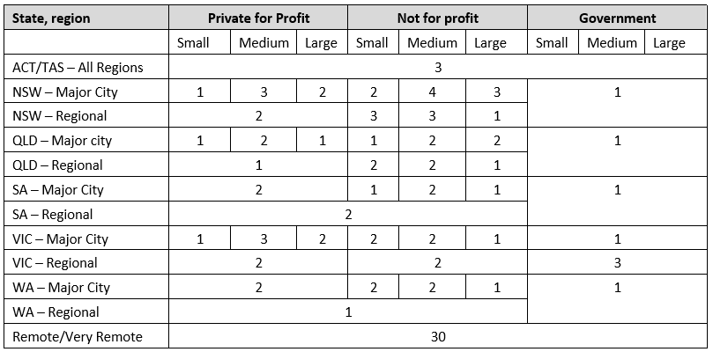

## Sample site recruitment

A key contact within each sample facility or parent organisation, as appropriate, was formally approached by AHSRI through a letter of invitation to participate in Study Two. In cases where a facility declined, another facility from the same sampling cell was invited to participate. Agreement to participate was confirmed in writing.

In some instances more detailed information about the study, including the study protocol, was provided to organisations for their consideration and an offer of support for the data collection process through StewartBrown was made in cases where limited local resources would make participation difficult.

The recruitment process occurred over the period from January to August 2018. On confirmation of participation the relevant contact details for each participating facility were provided to StewartBrown to initiate the data collection process.

The list of facilities recruited to the study is provided in Appendix 2.

# Study design and data collection

## Overview of design

The overall design of Study Two consisted of two main components; the design and methodology for data collection and the cost allocation and analysis.

The design of the data collection template was finalised with input from StewartBrown. As StewartBrown operates a financial benchmarking program involving approximately 900 residential facilities across Australia, it was considered that study participation would be facilitated by aligning the data collection wherever possible with their process. The Study Two data collection tool was therefore developed based on the StewartBrown template with adjustments made, as appropriate, to accommodate the specific cost analysis requirements.

The data collection tool is an Excel workbook with five separate tabs. Four of these tabs were used for the collection of data and the fifth included statements of scope and data item definitions to support the collection. Each of the four data collection tabs are listed in Table 2 below with the purpose of collecting the data identified in each case. The full list of data items included in the collection and the corresponding data definitions are provided in Appendix 3 and Appendix 4.

Table 2 Study Two data collection template overview

| **Tab – Data collected** | **Purpose of collection** |
| --- | --- |
| Tab 1 - Residential facility profile data | To enable the analysis of characteristics of facilities other than size, geographical location and ownership type that may drive costs. These included building design and service delivery model. |
| Tab 2 - Financial data | To enable the analysis of fixed cost per bed day across different facilities. Expense data was provided in a detailed breakdown by salary and non-salary expense types to enable analysis at a granular level. Data were provided for corporate, direct and indirect care related and hotel and accommodation expenses. |
| Tab 3 - Bed day and occupancy data | To enable the analysis of changes in occupancy and potential seasonal effects. |
| Tab 4 - Staff hours | To enable an analysis of differential costs across salary groups and to distinguish between the salary and agency staff related costs. |

The data collection process was supported by StewartBrown through the provision of the data collection tool to participants, managing the data submission process and providing assistance and advice on the completion of the template as required. StewartBrown were in a position to enhance the data collection process using their established relationships and extensive knowledge of the sector and conducted the first level of data quality checking on receipt of submissions.

A critical design feature of the RUCS was that the cost data collections and the costing processes for the Study One and Study Two facilities were aligned. This enabled comparison across the two collections and was an additional source of overall data validation. This also ensured that results of Study One and Study Two could be harmoniously combined in the development of the blended (fixed and variable) funding system. The cost allocation methodology is described in Report 7.

## Data collection and quality review process

The data collection process was managed by StewartBrown and was initiated for each facility as formal confirmation of study participation was received by AHSRI. The data collection process occurred between March and August 2018. Weekly teleconferences were held between AHSRI and StewartBrown to monitor progress with data collection and to discuss any issues. Facilities with limited capability were offered additional assistance from StewartBrown in the provision of data.

Data quality checking for Study Two submissions was undertaken through a number of different mechanisms. The data collection tool itself included calculated fields and check validations to provide feedback at the time of data entry. StewartBrown undertook high level data quality validation checks on the submissions as they were returned and contacted the facility to seek clarification or corrections to the submissions.

The data checks undertaken by StewartBrown included:

* Internal validation checks to identify any missing data and/or outliers.
* Consistency and reasonableness checks on the data. These were undertaken by comparing individual facility financial performance data with measures of industry average performance. These measures were based on the aggregated data to the StewartBrown Aged Care Financial Performance Survey results for the same period.
* The exploration of significant discrepancies in a data submission through the detailed investigation of the facility profile and characteristics.

Although 110 facilities initially agreed to participate in Study Two, data were received for 107 facilities only. The data were forwarded to AHSRI as they cleared the StewartBrown quality checks.

The subsequent AHSRI review of data determined that data for 106 of the 107 participating facilities was suitable for fixed cost analysis. Due to the variable levels of resources and capability within the participating organisations there were differing levels of compliance with full completion of the template:

* 104 facilities provided year-to-date for the two financial year periods.
* In addition, 17 of these facilities were able to provide monthly data across a financial, bed activity and staffing measures.
* Two facilities provided data for only one of the financial year periods (i.e. FY 2016/17 or July to December 2017).
* All facilities were able to provide monthly bed activity data.
* One facility provided data for only the first six months of the financial year 2016/17 and the month of December 2017 as it was closed for renovation for a large part of the data collection period. This facility was excluded from the study analysis.
* 100 facilities provided hotel related expense data.

In summary, data received for Study Two included:

* Profile data including characteristics of the facility that may provide some insight regarding differences in cost. This facility profile data included details such as the nature of facility ownership (i.e. private for-profit, private not-for-profit or government), physical layout of the facility or history of building works or renovation, and the use of casual, agency staff and volunteers in the provision of care.
* Two separate sets of expense data; one for the 12 month period July 2016 to June 2017 and a separate one for the six months July to December 2017. Facilities were asked to provide these data on a monthly basis if possible. However, a number of facilities had reporting systems that did not support reporting of retrospective periods on a month by month basis. These facilities therefore provided data on a year-to-date basis for both financial reporting periods.
* Monthly bed occupancy data summarised on a quarterly and annual basis. Where an annual occupancy rate was less than 80%, an explanation for this was sought. The bed occupancy data included both permanent and respite care residents.
* Paid staff time data with a detailed breakdown for normal and overtime hours and paid leave. This was requested on a monthly basis wherever possible.

# Data preparation

The submissions from across the two financial year periods for each facility were combined into a single data set. Issues identified through the AHSRI data quality checks were addressed to prepare the data for analysis. These issues were each resolved as follows:

* A number of facilities did not report corporate expenses for their facilities. In these cases, corporate costs were estimated based on the average corporate expense reported for other facilities in the same size category (excluding government facilities and single facility providers).
* Hotel costs were not provided for six facilities. In these cases, these were estimated based on the average proportion of hotel costs across all sample facilities. It is important to note that none of these six facilities were remote and that these estimations were not used in the Study Two analysis of hotel costs, but for the distribution of corporate and indirect costs only.
* Where the hours of work were reported by staff type but the salary costs reported in total (four facilities only), the salary costs were split across the staff types based on the hours worked weighted by the national average hourly rates by staff category.
* A small number of facilities (five) reported high care management staff costs and no registered nurse and enrolled nurse salary costs. These tended to be smaller facilities. The care management staff costs in these cases were split between individual care and shared care based on the registered nurse split (i.e. 47% individual/53% shared care).

## Identifying fixed care costs

The total operating costs for each facility were divided into corporate, direct care, facility indirect and hotel related costs. These were clearly defined in the data collection tool and include the following types of costs:

* **Corporate** – Executive operations, finance, information technology, human resources and payroll services.
* **Facility indirect** – Non-care staff salaries, facility administration, workers compensation and other insurances.
* **Direct care** – Salary costs for care staff and care related consumables.
* **Hotel** – Cleaning, laundry, utilities, building maintenance.

A standard health cost allocation methodology was used to distribute the corporate and facility indirect costs across the direct care and hotel related cost areas. The care-related costs were then separated into individual resident care costs and the fixed care-related costs. This was based on the output of the Study One cost analysis which used resident-level service utilisation data to identify individual care costs.

The review of the Australian National Aged Care Classification (AN-ACC) profile by facility type in Study One identified that the residents in specialised homelessness facilities tended to be more mobile and require less assistance in self-care tasks than the general population of residents in care. A lesser amount of the total costs per bed day for those facilities was, therefore, identified as individual care related. For all other types of facilities the facility characteristics were not found to be a determinant of resident complexity.

The average overall casemix complexity for all facilities other than homelessness care facilities was set at a relative value unit (RVU) of 1.00, and for homelessness care facilities at an RVU of 0.78. This was based on an analysis of data from Study One.

The result of the cost allocation process was the identification of three distinct types of costs within each facility:

* **Individual care costs** - The costs of direct individual resident care.
* **Fixed care costs** - The costs of direct shared care and care related indirect costs.
* **Hotel costs** - Hotel and non-care related indirect costs which are out of scope for fixed care cost analysis.

Figure 1 illustrates the different types of costs identified for analysis. The individual care costs were the focus of the Study One analysis and the basis for the development of the AN-ACC classification system. The fixed care costs were the subject of analysis in Study Two. The cost allocation methodology is outlined in detail in Report 7.

Figure 1 The RUCS allocated cost data model

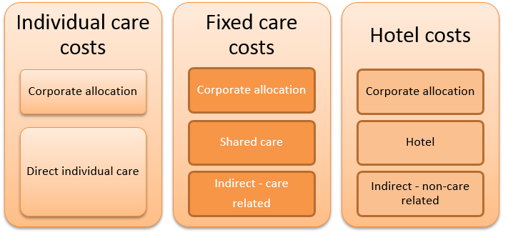

# Study Two data analysis

## Analysis approach and statistical methods

The goal of the analysis was the identification of cost drivers and facility characteristics that are associated with substantial differences in fixed care cost per bed day. These findings inform the calculation of base care tariffs for different facility types in the blended funding model.

Initial high level data analysis was performed to identify any potential data issues. There were 12 government facilities in the sample. Those facilities reported substantially different costs and care staff mix and data on individualised care costs were not available as government facilities had been excluded from Study One. On this basis, they were removed from further analysis. A further five facilities were identified as low cost outliers for the fixed care cost per occupied bed day. These additional low cost outlier facilities were also removed from the analysis.

The data are presented below in a series of tables that present key characteristics such as facility size (based on number of approved beds). Fixed costs per bed day is calculated in each case based on both the approved bed numbers and the actual occupied bed days. The Coefficient of Variation (CV) of cost is also presented to provide an indication of cost variability within each category. The mean cost calculation takes into account that, depending on their size, facilities contribute differently to the average cost per bed day. The CV, however, is calculated on the facility-level cost per bed day (occupied or approved) regardless of individual facility bed numbers.

Statistical testing was undertaken to determine whether any observed group differences constituted statistically significant differences using either t-tests or analysis of variance (ANOVA). A multi-level modelling using a classification tree approach was developed to identify the most relevant cost drivers and quantify their relative impact. For the statistical analysis p-values < 0.05 were considered as statistically significant.

***The cost results in this analysis were calibrated based on the average individual care cost per day identified in Study One. This was assigned an RVU of 1.00***.

## Descriptive analysis - Fixed care costs

Cost data were received for 106 facilities. After removal of government facilities and low cost outliers the final sample size was 89 facilities. These facilities reported an average of 69 approved places ranging from small facilities with as few as 8 places up to 176 places. The average total care costs across all facilities (i.e. fixed care plus individual care) had a value of 2.02 RVU per occupied bed day. This was very similar to the high level Study One finding of a total care cost of 2.12 RVU per occupied bed day.

This alignment of high level costing results between Study One and Study Two is an important finding for the overall RUCS project. This result means that:

* The separate samples of facilities used in the two studies are not biased.
* The single month of data collection for each facility in Study One was not adversely impacted by either seasonal effects or the month-to-month fluctuations.
* The two data collections support the development of a single harmonised funding model.

The average total fixed care cost per occupied bed day for this sample was 1.03 RVU. This equates to 51% of the total care cost per occupied bed day RVU of 2.02.

Figure 2 shows the fixed care cost distribution by size and occupancy rate with each dot representing a single facility. The x-axis represents the number of facility approved places, and the y-axis indicates the fixed cost per occupied bed day. The different coloured dots indicate different occupancy rates. It can be observed that dots are generally scattered around the sample average of 1.03 RVU with the most notable exceptions being the smaller facilities which also tend to have lower occupancy rates.

Figure 2 Fixed cost per occupied bed day by size and occupancy rate

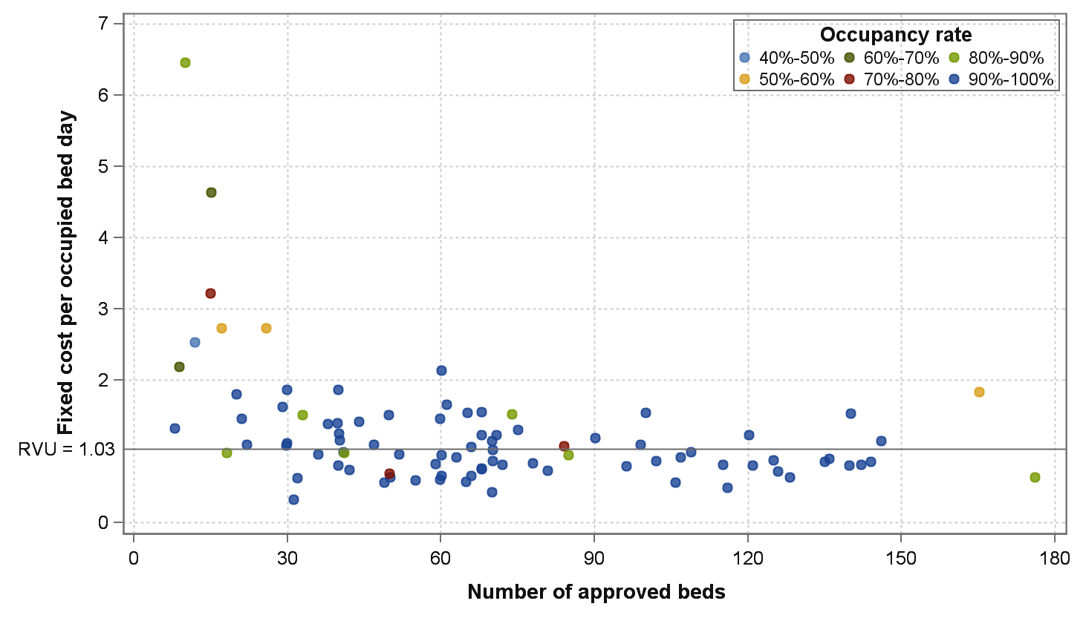

Figure 3 is similar to the previous figure in that is displays size, cost and occupancy rates. But the facilities are now grouped based on the number of approved places in 30 bed increments. The dots for each facility are overlayed by boxplots to visualise the central tendency (mean) and spread. The smaller sized facilities are clearly associated with higher cost per occupied bed day and increased amounts of cost variability.

Figure 3 Fixed cost per occupied bed day by size groups and occupancy rate

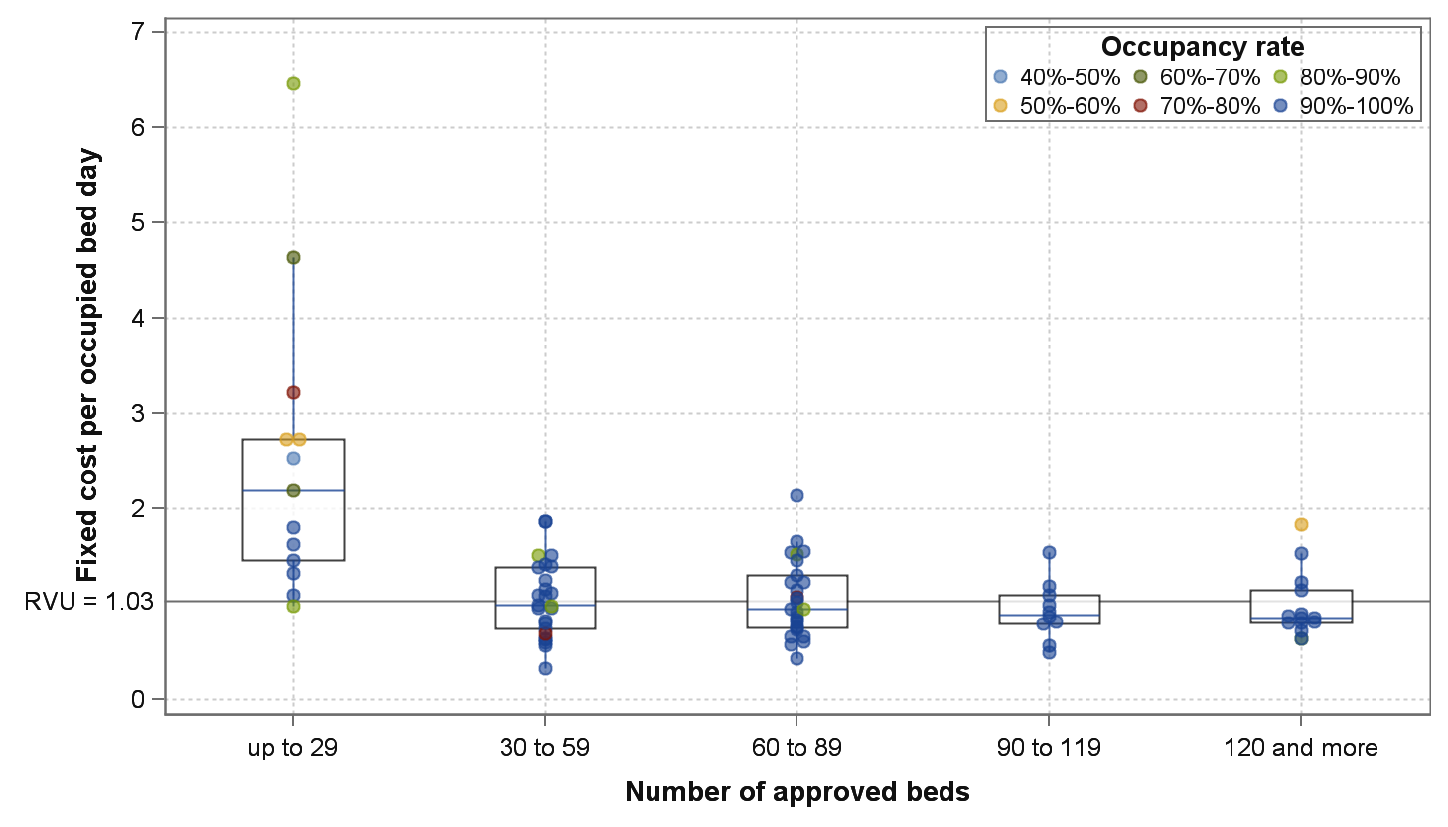

### Facility size

Table 3 includes the fixed care cost results by facility size (number of approved beds), with facilities grouped based on 30 bed increments. There was a good spread of size across the sample. The mean total care cost RVU per occupied bed day for the facilities with up to 29 beds (referred to as ‘small’), the highest cost group, was 3.17. This group also reported the highest fixed care costs and the largest within-group fixed care related cost variability – evidenced by the higher CV. The costs per bed day across the remaining facility size groupings differed very little with RVUs ranging from only 1.91 to 2.04 for total cost per occupied bed day and 0.91 to 1.04 for fixed care cost per occupied bed day. The difference observed between small facilities and all other facilities was statistically significant.

Table 3 Cost results by facility size

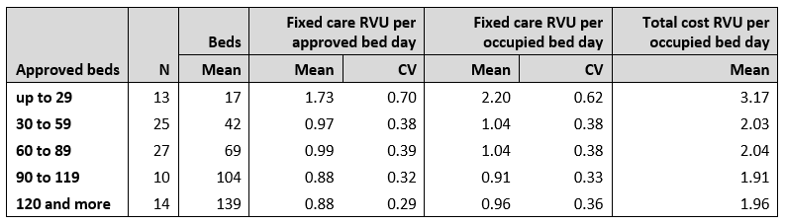

While not presented in the table above, the facility groups were investigated for potential skewness towards larger or smaller size facilities within each group. However, it could be confirmed that this was not the case as the mean and median bed numbers were almost identical for each group.

The fixed care RVUs are presented based on both the costs per approved bed day and per occupied bed day. It is interesting to note that, apart from having higher costs, the group of facilities with less than 30 beds also reports a much larger difference between the cost per occupied and approved bed days than the larger facilities. This suggests that small facilities are more likely to experience lower or variable occupancy rates and that they are impacted by the increased costs per bed day as a result. This issue can also be seen in Figure 2 and Figure 3.

### Facility location

Table 4 presents the cost results based on facility location using the Modified Monash Model (MMM) classification. This model classifies locations (i.e. suburb and postcode) from 1 = most metropolitan to 7 = most remote. While there is no official terminology for those classes, in this report class 1 will be referred to as metropolitan, 2 to 5 as regional and 6 and 7 as remote. When a distinction is made between MMM classes 6 and 7, they are referred to as ‘remote’ and ‘very remote’. There is an uneven spread of facilities across the MMM classes in the sample. This is the result of the nationally representative sampling of metropolitan and regional areas and the oversampling of facilities in remote locations. The number of facilities included in the individual MMM classes 3, 4 and 5 is relatively small and results for these classes should be considered with caution.

The mean facility bed numbers for facilities in each MMM class is presented in this table and it shows clearly that the average facility size is much smaller in MMM classes 6 and 7, the remote and very remote regions of the country. These facilities also report significantly higher fixed care and total care related costs. It is interesting to note that the MMM 7 facilities report very similar costs to group of facilities with less than 30 beds in Table 3. This suggests a substantial level of correspondence between the facility categories of ‘small’ and ‘very remote’.

Table 4 Cost results by facility location

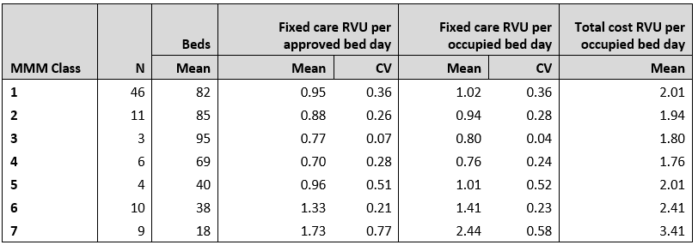

The Table 4 results also suggest that the average fixed care costs in regional facilities are lower than both metropolitan and remote services. These results should also be considered with caution as the sample size for each of the regional MMM classes is small. This may also be related to the fact that metropolitan facilities have had a greater ability to access Commonwealth funding under the current ACFI system. Further reviews in future may be required to explore this finding.

The costs reported for MMM classes 6 and 7 are much higher than the metropolitan and regional areas with total cost RVUs of 2.41 and 3.41 respectively, and fixed care cost RVUs also substantially higher than those of non-remote facilities. These observed differences between remote and non-remote facilities are statistically significant.

To test whether there are real differences in fixed care costs between the facilities in regional locations (MMM 2-5), the geographic location classes have been combined into three groups in Table 5 below. The metropolitan group includes MMM class 1 only, the regional group combines MMM classes 2-5, and the remote group combines MMM Class 6 and 7. In this table the CVs are low, particularly for the metropolitan and regional groups, suggesting that the aggregation of MMM classes is appropriate for the analysis of fixed care costs. The greatest level of variability remains within the group of remote facilities.

Table 5 Cost results by aggregated facility location

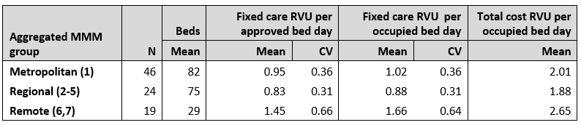

### Facility specialisation

In Table 6 the results of the review of costs for areas of facility specialisation are presented. Areas of specialisation were identified by the facility within the data collection template and this was validated based on a review of the facility’s website. Facilities were only considered to be providers of specialised care where their description of care services on their website contained evidence of how services are tailored to the specific needs of their target resident populations. The cost RVUs for each area of specialisation are presented alongside the results for facilities that do not provide the specialised service in each case.

Table 6 Cost results by type of facility specialisation

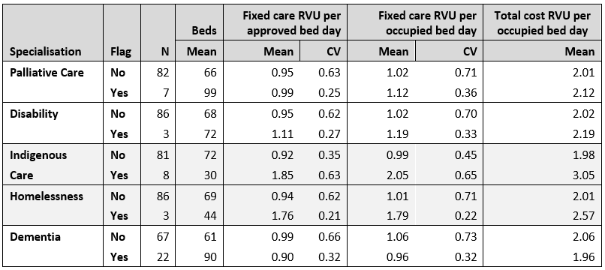

Specialisation in palliative care or dementia was not found to be associated with increased fixed care costs. Instead, the costs for these services are associated with the individual care needs of residents and captured by the AN-ACC classification.

The costs for facilities that provided specialised services for those with backgrounds of financial disadvantage were also reviewed. Although the costs were reported as higher, the facilities in this group were substantially the same facilities as those providing specialised services for homeless and indigenous people. It was therefore considered not to be a distinct area of specialisation and removed.

Significantly higher costs were found for facilities with specialisations in indigenous care (although these services also tend to be small and remote), and homelessness services.

## The effect of seasonality on cost

The issue of seasonality was also tested in this data set. This was done for two main reasons. The first was to understand whether, for different parts of the country, there was a seasonal affect that should be considered in a funding model. The second was to ascertain whether the single month of data collection in each of the Study One facilities could have been impacted by seasonal affects that would require adjustment. This was informed by the 18 months of data in Study Two.

Only 16 facilities were able to provide monthly financial data for this analysis. While there is some monthly variation across the year, no seasonal effect or pattern was detected. This remains true when adjusting for other characteristics of facilities such as state/territory, geographical location and size. The significant monthly fluctuations that were seen within facilities may be due to other issues including the timing of financial accounting transactions.

# Fixed care costs drivers

The analysis presented in Section 5.2 clearly identified fixed care cost differences that were associated with the facility characteristics of remoteness, size, low bed occupancy, and indigenous and homelessness service specialisations. These characteristics were subsequently included in multi-level modelling to determine the relative cost increases attributable to these characteristics.

In Figure 4 the combinations of these characteristics that are associated with differences in fixed care costs are presented in a branching model which contains six distinct facility type categories. The first level of split is for remote (MMM 6 and 7) versus non remote facilities and within the remote branch the key cost driver is indigenous specialisation – within which there is a large cost difference between the remote and very remote services. For remote non-indigenous services, the facility size is the most significant driver of fixed care cost. In non-remote facilities the most significant driver of fixed care costs is the provision of homelessness care.

Figure 4 Branching model of fixed care cost RVUs

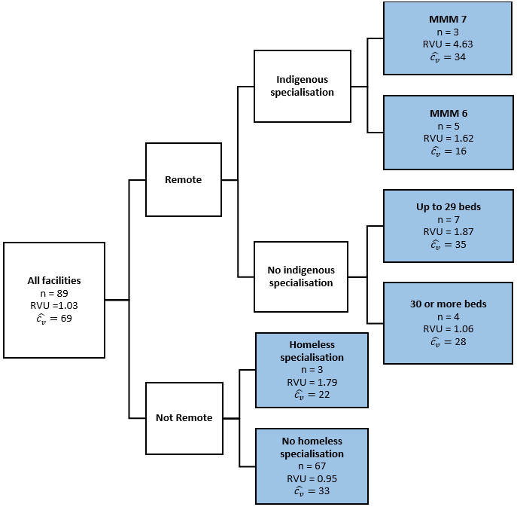

In Table 7 each of the six combinations of facility characteristics that are key drivers of fixed care costs are listed along with the number of facilities in the sample and the relative cost represented by the RVU. The overall RVU is 1.03 indicating that the average daily fixed care costs per resident across this national sample is about 3% higher than the average daily cost of individual care represented across the 13 AN-ACC classes (see Report 1).

There is almost a five-fold cost difference between Category 1 (very remote indigenous services) and Category 6 (the vast majority of facilities).

The overall CV of 0.69 across all facility type categories is reduced substantially at the level of individual category. This indicates that the groupings have the ability to explain a lot of the variation in fixed care costs between facilities and that there is a high level of cost homogeneity within the categories. This is a key finding in considering the use of these categories as a basis for funding.

Table 7 Fixed care cost RVUs per occupied bed day

Row 1 (header row): Column one: Cat code, Column two: Category description, Column three: N, Column four: Fixed care RVU per occupied bed day, column 5: Fixed care CV.
Row 1: Cat code: 1, Category description: Very remote (MMM=7), indigenous care, N: 3, Fixed care RVU per occupied bed day: 4,63 Fixed care CV: 0.34.
Row 2: Cat code: 2, Category description: Remote (MMM=6), indigenous care, N: 5, Fixed care RVU per occupied bed day: 1,62, Fixed care CV: 0.16.
Row 3: Cat code 3, Category description: Remote (MMM=6-7), non-indigenous, up to 29 approved beds, N: 7, Fixed care RVU per occupied bed day: 1.87, Fixed care CV: 0.35.
Row 4: Cat code 4, Category description: Remote (MMM=6-7), non-indigenous, 30 or more approved beds, N: 4, Fixed care RVU per occupied bed day: 1.06, Fixed care CV: 0.28.
Row 5: Cat code 5, Category description: Specialised homeless, N: 3, Fixed care RVU per occupied bed day: 1.79, Fixed care CV: 0.22.
Row 6: Cat code 6, All other Residential Aged Care Facilities (RACFs), N 67, Fixed care RVU per occupied bed day: 0.95, Fixed care CV: 0.33.
Row 7: Total, Total N: 89, Total Fixed care RVU per occupied bed day: 1.03, Total Fixed care CV: 0.69.


# Discussion

This is the first time that the fixed care costs of Australian residential aged care have been calculated. This was done after accounting for the cost of individual resident care. The key finding is that, after adjusting for differences in the casemix profile of residents, fixed care costs are consistent and predictable based on facility type. This provides the evidence for a blended payment model for residential aged care that provides greater certainty and stability for both the government (as funder) and aged care providers.

## Key findings

The key outcome of this study is the categorisation of facilities into six levels defined by fixed care costs. Within each category, the fixed care cost per bed day is very similar.

Related to this, the additional findings are that:

* Differences in fixed care cost between facilities is substantially explained by the degree of remoteness of facility location, the facility size in remote locations and whether they provide specialised care for people from an indigenous background or with a personal history of homelessness.
* The cost homogeneity within these categories is very high which indicates that the fixed care cost per bed day is highly predictable based on these facility characteristics.
* Cost relativities per occupied bed day range from an RVU of 4.63 for indigenous services in very remote locations to 0.95 for facilities that provide care that is not targeted to either geographically or socioeconomically disadvantaged groups.
* For the vast majority of facilities (Category 6), the fixed care cost per bed day is 0.95 of the daily average cost. In contrast, the fixed care cost for Category 1 is 4.63 times the average individual care bed day.
* Overall, fixed care costs account for just over 50% of the daily total cost of providing residential care.

## Funding system implications

The findings of this study support the development of a blended funding model that comprises a fixed per diem price for the fixed costs of care, including shared, non-individualised care, and a variable price per day for the costs of individual care.

Cost relativities (RVUs) are a key element in a more simplified funding model based on a single price. Fixed care cost RVUs are converted into a **base care tariff national weighted activity unit** (NWAU) for each facility category and combined with an NWAU payment for individualised care. The resulting total NWAU is then paid at the rate of a single overall price per NWAU. Further details are available in Report 5.

The analysis in this report, particularly related to facility size and remoteness indicates that remote facilities (that are typically very small) have very high costs per bed day, due in part to low and variable levels of occupancy. This is evidence to support a funding model that funds remote facilities on the basis of approved rather than occupied bed days. Compared to funding on occupied bed days, this would result in a lower rate of payment per day, but would increase the security and stability of funding, as the same fixed care payment would be received whether or not all beds were occupied.

With the development of NWAUs and a single price the potential emerges to deal with supplements in a similar way. If costs related to the appropriate payment of supplements is determined, these may be converted to NWAUs using the same base cost relativities and paid at the single aged care daily price. This is addressed further in Report 5.

It is important to note that this report includes the results of a cost analysis only. It provides a clear understanding of the cost drivers and of the magnitude of cost difference between facilities with the lowest and highest levels of fixed care cost. This report does not directly inform the level of funding to be allocated or the components of funding system design that are related to other factors. The individual care related cost factors are covered in the AN-ACC classification development study, but there are a number of other elements such as supplements and adjustments having been separately determined in the AN-ACC funding model.

## The AN-ACC funding model

Detailed information on the AN-ACC funding model is provided in other reports within the RUCS series. The funding model is described in detail in Report 5, and a consolidated set of recommendations is included in Report 6.

## 

# Appendix 1

# Overview of the Resource Utilisation and Classification Study (RUCS)

The Resource Utilisation and Classification Study (RUCS) is an important national study commissioned by the Department to inform the development of future funding models for residential aged care in Australia. The overall aim of the RUCS was to:

* Identify the clinical and need characteristics of aged care residents that influence the cost of care (cost drivers).
* Identify the proportion of care costs that are shared across residents (shared costs) and the proportion that are related to individual needs (individual costs).
* Develop a casemix classification based on identified cost drivers that can underpin a funding model that recognises both shared and individual costs.
* Develop a new funding assessment that efficiently allows for each resident to be assigned to a payment class based on their needs.
* Test the feasibility of implementing the recommended classification and funding model across the Australian residential aged care sector.

In considering the results and recommendations included in this report, it is necessary to distinguish between three key ideas:

#### Cost

The cost of care for people living in residential aged care is in scope for the RUCS. Capital accommodation and ‘hotel’ services are out of scope, as is respite care for non-permanent residents.

#### Funding (payment) model and policy

Funding and payment issues are in scope. The role of the RUCS research team is to develop the funding model and provide policy advice on its potential implementation.

#### Price

Price is out of scope for the RUCS as price is ultimately a decision for payers (both government and consumers). But the RUCS has generated significant evidence that can aid decision-making about pricing.

**Key elements of the AN-ACC assessment and funding model**

The new assessment and funding model has been termed the Australian National Aged Care Classification (AN-ACC) system. The AN-ACC assessment and funding model is based on six key design elements:

1. Resident assessment for funding to be separate from resident assessment for care planning purposes.
2. Assessment for funding purposes to be undertaken by external assessors capturing the information necessary to assign a resident to a payment class.
3. Assessment related to care planning to be undertaken by the residential aged care facility based on resident needs and underpinned by consumer-directed care principles.
4. Provision of a one-off adjustment payment for each new resident that recognises additional, but time-limited, resource requirements when someone initially enters residential care.
5. A fixed price per day for the costs of care that are shared equally by all residents. This may vary by location and other factors.
6. A variable price per day for the costs of individualised care for each resident based on their AN-ACC casemix class.

**The four RUCS studies**

The RUCS comprised four separate but closely related studies. Each study included separate data collection and analysis elements that have been synthesised to produce a classification and associated funding model that is suitable for implementation across the Australian residential aged care sector.

#### Study One – Service utilisation and classification development study

Study One involved a prospective and comprehensive collection of resident assessment, service utilisation and financial data which were analysed to develop a casemix classification. Study One involved 30 facilities clustered in three geographic regions in Queensland, New South Wales and Victoria.

Study One was completed between October 2017 and October 2018.

#### Study Two – Fixed and variable cost analysis study

Study Two involved a larger nationally representative sample of 110 facilities. The purpose of this study was to understand differences in cost drivers between different types of facilities (including facility size and location) as well as differences that may result from seasonal effects. This analysis informed the design of the funding model. Study Two examined facility, rather than resident, level costs.

Study Two was completed between November 2017 and October 2018.

#### Study Three – Casemix profiling study

Study Three involved the collection of variables included in the classification from an additional nationally representative sample of 69 facilities. In combination with the data from Study One, the primary purpose of Study Three was to develop a national casemix profile of residents in aged care in Australia.

Study Three was completed between September 2018 and December 2018.

#### Study Four – Reassessment study

Study Four was added to the RUCS work program in mid-2018 in recognition of value that could be added by collecting additional information about the rate and extent of change in residents’ care needs over time. Study Four involved conducting re-assessments of approximately half of the residents assessed as part of Study One four to six months after their initial assessment.

Study Four was completed between August 2018 and December 2018.

**The RUCS reports**

Given the complexity of the RUCS, it has been written up in a series of reports as follows:

**Report 1: The Australian National Aged Care Classification (AN-ACC)**

Report 1 covers the design and conduct of the study undertaken to develop the AN-ACC Version 1.0 (Study One). It covers the design and use of the AN-ACC assessment tool and the resource utilisation study undertaken to develop AN-ACC Version 1.0, including the preparation and analysis of the data collection. It discusses the results, the classification development process and key outcomes including the statistical analysis and clinical validation.

**Report 2: The AN-ACC assessment model**

Report 2 presents detailed findings relating to the external assessment tool and assessment process (informed by Studies One, Three and Four). This includes the development of the assessment tool using expert clinical panels and a summary of feedback from assessors regarding the use of the tool and the suitability of individual instruments. The skills and competencies required for the assessment workforce and other implications for implementation of the external assessment model are considered as well as triggers and protocols for reassessment.

**Report 3: Structural and individual costs of residential aged care services in Australia**

Report 3 presents the analysis and findings of Study Two which identified the proportions of total care costs that are fixed (including shared care) and variable (relating to individualised resident care). The analysis focused on the differences in fixed costs between different types of facilities, characterised by ownership, size, remoteness and service specialisation. It includes an analysis of the drivers of fixed care costs.

**Report 4: Modelling the impact of the AN-ACC in Australia**

Report 4 presents an analysis of modelling the introduction of the AN-ACC across Australia. This is based on the findings of Study Three. The sampling and assessment data collection process and the casemix of residents in aged care across Australia are described. The focus of this report is on modelling the introduction of the AN-ACC to replace the ACFI.

**Report 5: AN-ACC: A funding model for the residential aged care sector**

Report 5 presents the design of a new funding model based on the AN-ACC. It includes a consideration of other payment issues such as existing payment supplements, a discussion of incentives in funding model design and key issues in implementing the new model.

**Report 6: AN-ACC: A national classification and funding model for residential aged care: synthesis and consolidated recommendations**

This report synthesises and consolidates the findings presented in other reports and provides a consolidated set of recommendations.

**Report 7: AN-ACC Technical appendices**

This report is a series of technical appendices that contain detailed data for reference purposes.

# Appendix 2

# List of participating facilities

| **Facility Name** | **Suburb** | **State** |
| --- | --- | --- |
| BaptistCare Carey Gardens Centre | Red Hill | ACT |
| St Andrews Village Hostel | Hughes | ACT |
| UnitingCare Ageing Mirinjani Hostel | Weston | ACT |
| Anglican Care Cedar Wharf Lodge | Bulahdelah | NSW |
| Blue Haven Care | Kiama | NSW |
| Bupa Ashfield | Ashfield | NSW |
| Dougherty Apartments | Chatswood | NSW |
| Estia Health Bexley | Bexley | NSW |
| Heritage Lodge Assisted Aged Care | Murwillumbah | NSW |
| Jonathan Rogers GC House | Nowra | NSW |
| McCauley Lodge | Thirroul | NSW |
| Pennant Hills Aged Care Facility | Pennant Hills | NSW |
| Uniting Kari Court St Ives | St Ives | NSW |
| Uniting Starrett Lodge Hamlyn Terrace | Hamlyn Terrace | NSW |
| Uniting Wesley Gardens Belrose | Belrose | NSW |
| UnitingCare Mayflower Village Gerringong | Gerringong | NSW |
| Wesley Tebbutt Dundas | Ermington | NSW |
| Ainslie House | Sussex Inlet | NSW |
| BlueWave Living | Woy Woy | NSW |
| Cardinal Stepinac Village | St Johns Park | NSW |
| Coastal Waters Aged Care | Worrowing Heights | NSW |
| Constitution Hill Aged Care | Northmead | NSW |
| Harbison Memorial Retirement Village | Burradoo | NSW |
| Inasmuch Community Hostel | Sussex Inlet | NSW |
| Presbyterian Aged Care - Apsley Riverview | Walcha | NSW |
| Presbyterian Aged Care - Wescott | Stockton | NSW |
| RFBI Basin View Masonic Village | Basin View | NSW |
| RFBI Berry Masonic Village | Berry | NSW |
| The Whiddon Group - Kookaburra Court | Walgett | NSW |
| The Whiddon Group - River Gum Lodge | Bourke | NSW |
| Flynn Lodge | Alice Springs | NT |
| Hetti Perkins | Connellan | NT |
| Old Timers | Alice Springs | NT |
| Rocky Ridge | Katherine | NT |
| Glasshouse Views | Beerwah | QLD |
| Redland Residential Care | Cleveland | QLD |
| Sandbrook Assisted Aged Care | Burleigh Waters | QLD |
| Arcare Helensvale St James | Helensvale | QLD |
| Benevolent Aged Care | The Range | QLD |
| Bolton Clarke Fairview Retirement Community | Pinjarra Hills | QLD |
| Bolton Clarke Pioneers Hostel | Longreach | QLD |
| Bolton Clarke Pioneers Nursing Home | Longreach | QLD |
| Carinity Aged Care- Kepnock Grove | Kepnock | QLD |
| Carramar Hostel | Tewantin | QLD |
| Churches of Christ Care Amaroo Aged Care Services | Gatton | QLD |
| Churches of Christ Care Marana Gardens Aged Care Service | Southport | QLD |
| Churches of Christ Care Warrawee Aged Care Service | St George | QLD |
| Clifford House Care Centre | Wooloowin | QLD |
| Kabara Hostel | Cooroy | QLD |
| Keperra Sanctuary Hostel | Keperra | QLD |
| Kuba Natha Hostel | Wellesley Islands | QLD |
| Kukatja Place | Normanton | QLD |
| Mortimer Aged Care | Acacia Ridge | QLD |
| Ngooderi House | Nicholson | QLD |
| Parklands | Urangan | QLD |
| Southern Cross Care Taroom - Leichhardt Villa | Taroom | QLD |
| Wongaburra Garden Settlement Hostel | Beaudesert | QLD |
| Melaleuca Court Nursing Home | Minlaton | SA |
| Oaklands Park Lodge | Oaklands Park | SA |
| Bupa Campbelltown | Campbelltown | SA |
| Eldercare Elanora | Stansbury | SA |
| Eldercare Oxford | Hove | SA |
| Eldercare The Village | Maitland | SA |
| Hawksbury Gardens Aged Care Facility | Salisbury North | SA |
| Matthew Flinders Home | Port Lincoln | SA |
| Resthaven Leabrook | Leabrook | SA |
| Resthaven Murray Bridge | Murray Bridge | SA |
| Restvale Hostel | Lobethal | SA |
| Flinders Island Multipurpose Centre | Whitemark | TAS |
| Uniting AgeWell Aldersgate Village | Legana | TAS |
| Sandhurst Aged Care | Carrum Downs | VIC |
| Bowhaven Hostel | Rainbow | VIC |
| Bupa Barrabool | Belmont | VIC |
| Bupa Coburg | Coburg | VIC |
| Central Park Aged Care Home | Windsor | VIC |
| Chestnut Gardens Aged Care Home | Doveton | VIC |
| Estia Health Bendigo | Ironbark | VIC |
| Gilgunya Village | Coburg | VIC |
| Havilah on Palmerston | Maryborough | VIC |
| Heathcote Health High Care Service | Heathcote | VIC |
| Heathcote Health Low Care Service | Heathcote | VIC |
| Hopetoun Hostel | Hopetoun | VIC |
| Hopetoun Nursing Home | Hopetoun | VIC |
| Karingal Seymour | Seymour | VIC |
| McLean Lodge Hostel | Travancore | VIC |
| Mercy Place Abbottsford Nursing Home | Abbotsford | VIC |
| Mirridong Aged Care Home | Kennington | VIC |
| Ron Conn Nursing Home | Avondale Heights | VIC |
| Southern Cross Care Templestowe | Templestowe Lower | VIC |
| Uniting AgeWell Box Hill | Box Hill | VIC |
| Uniting AgeWell Kalkee Murray | Belmont | VIC |
| Uniting AgeWell Kingsville | Kingsville | VIC |
| Weeah Lodge | Rainbow | VIC |
| Aegis Ellenvale | Broadwater | WA |
| Aegis Woodlake | Kingsley | WA |
| Aegis Hilton Park | Hilton | WA |
| Brightwater The Oaks | Waikiki | WA |
| Brightwater The Village | Inglewood | WA |
| Juniper Elimatta | Menora | WA |
| Juniper Marlgu Village | Wyndham | WA |
| Juniper Ngamang Bawoona | Derby | WA |
| Juniper Numbala Nunga | Derby | WA |
| Karlarra House | South Hedland | WA |
| Peter Arney Home | Salter Point | WA |
| Springhaven Lodge | Kojonup | WA |
| Wearne Home | Dudley Park | WA |
| Yaandina Frail Aged Hostel | Roebourne | WA |

# Appendix 3

# Study Two data collection items

**Residential Profile Data:**

* facility level data including Residential Aged Care (RAC) ID, address, Australian Bureau of Statistics (ABS) remoteness and provider type
* facility design including year built, year of last renovation, single/multi-level, single/multi bed rooms and specialisation
* service delivery model with estimates of casual and agency staff usage
* use of volunteers including estimate of time and types of activities involved
* fees for additional services if charged and if these relate to delivery of care
* organisation level data including identifying types of other business units operated and the basis that shared corporate/services costs are allocated.

**Residential Financial data:**

* fees for additional services
* direct care labour costs by staff designation – Care management, Registered nurse, Enrolled/licenced nurse, Personal care staff/unlicensed nurse, Allied health and lifestyle and Agency staff
* medical, incontinence and nutritional supplies
* chaplaincy/pastoral care costs
* other resident care costs
* indirect care costs such as quality and education relating to care staff
* workers compensation premium costs
* administration and support services including administration recharges, administration labour costs, other administration costs, insurances, workers compensation and quality and education allocation to non-care staff
* total facility expenditure.

**Residential Bed Days:**

* number of approved places
* respite occupied bed days by month
* total occupied bed days by month
* reason to explain occupancy level (e.g. renovations).

**Residential Staff Paid Hours:**

* by designation – Care management, Registered nurse, Enrolled/licenced nurse, Personal care staff/unlicensed nurse, Allied health and lifestyle, administration staff and quality and education staff
* by normal, overtime, agency and other.

**Hotel Services Costs:**

* catering
* cleaning and laundry
* utilities
* maintenance and repairs and other costs.

# Appendix 4

# Residential Care Definitions

| **Expense type** | **Definition and description** |  |
| --- | --- | --- |
|  | **Inclusions** | **Exclusions** |
| **CARE EXPENDITURE** |  |  |
| **Care labour costs** |  |  |
| Care management | Wages, allowances, leave, fringe benefits, superannuation, workers compensation excesses and wages paid to, or in respect of, care management staff. Typically this would be the DON, DDON, Facility Manager, Clinical Manager and in some cases a specialist position relating to care plans or ACFI assessments. This would also include an allocation of the costs of this position should it be shared between facilities but typically these would be included as part of the administration recharge. DO NOT allocate between administration wages and care management. Total cost of facility manager should be allocated to this position. | Share of workers compensation premium |
| Registered nurses | Wages, allowances, leave, fringe benefits, superannuation, workers compensation excesses and wages paid to, or in respect of, registered nurses. | Share of workers compensation premium |
| Enrolled and licensed nurses *(registered with the NMBA)* | Wages, allowances, leave, fringe benefits, superannuation, workers compensation excesses and wages paid to, or in respect of, Enrolled and other licensed nurses who are **registered with the Nursing and Midwifery Board of Australia (NMBA)** | Share of workers compensation premium |
| Other unlicensed nurses/personal care staff | Wages, allowances, leave, fringe benefits, superannuation, workers compensation excesses and wages paid to, or in respect of, other nursing and/or personal care staff who are **not licensed with the relevant state professional nursing body or midwifery board.** | Share of workers compensation premium |
| Allied health & lifestyle | Wages, allowances, leave, fringe benefits, superannuation cost, workers compensation excesses and wages paid to, or in respect of, diversional therapy, physiotherapy, podiatry and other allied health professionals, recreational officers. Includes agency or contracted professionals. | Share of workers compensation premium |
| Agency staff | Total cost of all direct care agency staff | Excludes allied health & lifestyle agency |
| **Other direct care costs** |  |  |
| Medical supplies | Cost of medication and other medical supplies such as bandages, ointments, as well as the cost of packaging and distributing the medication such as Webster or similar system. |  |
| Incontinence supplies | Cost of incontinence systems and supplies. |  |
| Nutritional supplements | Includes costs of nutritional supplements. Also include cost of medical gases and enteral feeding costs. |  |
| Chaplaincy | Cost of providing a chaplain or religious or pastoral services to residents. |  |
| Other resident care | Other sundry items relating to resident care - include cost of therapy supplies, activity costs, unrecovered cost of bus hire, public telephone cost, entertainment etc. |  |
| **Workers' compensation** |  |  |
| Total premium costs for all staff | Total workers compensation premium paid for all staff employed at the facility |  |
| Total wages for all staff | Total wages paid for all staff employed at the facility | Share of workers compensation premium |
| Total premium costs as a percentage of total wages | ***Calculation of total premium costs divided by total wages*** |  |
| **ADMINISTRATION AND SUPPORT SERVICES** |  |  |
| Administration recharges | Apportionment of administration costs from the Organisation's administration cost centre and/or corporate head office - if applicable. |  |
| Labour costs - Administration | Wages, allowances, leave, fringe benefits, superannuation, workers compensation excesses and wages paid to, or in respect of, administration and clerical staff employed directly by or charged directly to the residential care facility. | Workers compensation premium. Labour costs associate with the facility/care management. This should appear in Care management labour costs as part of resident care expenses. For facility manager/care manager no allocation should be made against administration. |
| Other administration costs | Includes all other administration line items including, advertising for staff, accounting fees, accreditation costs, audit fees, computer expenses including maintenance contracts on hardware and software, consulting fees, general expenses, legal fees, postage & courier, printing & stationery, recruitment costs, safety management (OH&S), subscription & library costs, telephone, travel & accommodation. | Administration charge, workers compensation premiums. |
| Workers' compensation | ***Calculated and allocated workers compensation premium paid for care staff employed at the facility.*** |  |
| Quality & education - labour costs | Wages, allowances, leave, fringe benefits, superannuation, workers compensation excesses and wages paid to, or in respect of personnel carrying our duties such as education, quality control, quality improvement, policy development and WH&S. | Wages and associated costs of those attending education sessions, quality or OH&S meetings etc. These should be included in the wage cost area normally associated with the attendees. |
| Quality & education - other | All other costs associated with areas such as education, quality control and improvement, policy development and WH&S. This will include the cost of consultants, materials, software (not capitalised) or course costs for courses run by 3rd parties. |  |
| Insurances | All insurances except workers compensation. | Workers compensation insurance |
| Fees for additional services | Additional daily fees charged to residents for additional services purchased by the resident and/or in an extra services place. **DO NOT use this line for other/sundry income.** |  |
| **HOTEL SERVICES EXPENDITURE** |  |  |
| Catering | ***Total costs of catering including labour costs, consumables, contract catering, and income from sale of meals as defined below.*** |  |
|  | Labour costs: - Wages, allowances, leave, fringe benefits, superannuation, workers compensation excesses and wages paid to, or in respect of, catering staff | Workers compensation premium. |
|  | Consumables: - Cost of all consumable supplies used in the preparation and serving of resident, staff and visitor meals. Includes crockery and cutlery, and cooking utensils. | Paper products and cleaning products used in the kitchen. Nutritional supplements. |
|  | Contract catering:-Cost of contract catering services where this service is contracted to a third party. This will include the costs when the contractor uses an in-house kitchen and employs the kitchen staff under the contract. This also includes the situation where a shared kitchen provides catering services to multiple facilities in the organisation and allocates costs as if it was a contract service. |  |
|  | Income from sale of meals:-Income received from sale of meals to staff, visitors and others. |  |
| Cleaning | ***Total costs of cleaning including labour costs, consumables and contract cleaning as defined below:*** |  |
|  | Labour costs: - Wages, allowances, leave, fringe benefits, superannuation, workers compensation excesses and wages paid to, or in respect of, cleaning staff | Workers compensation premium |
|  | Consumables: - All cleaning materials including solvents, liquid and powder cleansers, brooms, mops, buckets, paper towels, toilet rolls etc. |  |
|  | Contract cleaning: - Cost of permanent or casual contract cleaning services. Include carpet cleaning and window cleaning services. |  |
| Laundry | ***Total costs of laundry including labour costs, consumables and contract laundry as defined below.*** |  |
|  | Labour costs: - Wages, allowances, leave, fringe benefits, superannuation, workers compensation excesses and wages paid to, or in respect of, cleaning staff | Workers compensation premium |
|  | Consumables: - Cost of all consumables used in washing and drying clothes and bedding as well as replacement bedding and linen items. |  |
|  | Contract laundry: - Cost of contract laundry service, if applicable. |  |
| Utilities | ***Total cost of all utilities as defined below.*** |  |
|  | Electricity costs: - Electricity costs associated with the facility -An apportionment of total electricity cost is appropriate if one bill is shared among a number of facilities. |  |
|  | Gas: - Cost of gas including that used by kitchen. | Medical gases such as oxygen. |
|  | Rates: - All council rates including land and water. | Garbage removal and tip fees. |
|  | Rubbish removal: - Garbage removal, hazardous materials and toxic waste removal, including council and other third party contractors. Include tip fees. |  |
| Maintenance and repairs | ***Total costs for all routine maintenance and repairs of the residential aged care facility as defined below.*** |  |
|  | Labour costs: - Wages, allowances, leave, fringe benefits, superannuation, workers compensation excesses and wages paid to, or in respect of, maintenance and grounds staff. | Workers compensation premium |
|  | Maintenance and repairs: - Materials and other third party costs in maintaining and repairing the assets of the facility. Contract labour for repairs and maintenance (under one-off arrangement). This should also include costs of any long term maintenance contracts. Will also include items such as fire protection, pest control, security and minor asset purchases or replacements. |  |
| Other hotel service costs not listed | ***Other hotel service costs not listed above.*** |  |

1. McNamee J, Poulos C, Seraji H et al. (2017) *Alternative Aged Care Assessment, Classification System and Funding Models - Final Report.* Centre for Health Service Development, Australian Health Services Research Institute, University of Wollongong.