

The AN-ACC assessment model

The Resource Utilisation and Classification Study: Report 2

**February 2019**

Anita Westera

Milena Snoek

Cathy Duncan

Karen Quinsey

Peter Samsa

Jenny McNamee

Kathy Eagar

This series of papers report on different aspects of a major national study into needs, costs and classification of residential aged care called the Resource Utilisation and Classification Study (RUCS). The RUCS was undertaken during 2018.

This report (Report 2) presents the findings of the proposed assessment model for residential aged care services in Australia.

A summary of the overall RUCS work program and associated reports is provided at Appendix 1.

1. The Australian National Aged Care Classification (AN-ACC)
2. **The AN-ACC assessment model** (this report)
3. Structural and individual costs of residential aged care services in Australia
4. Modelling the impact of the AN-ACC in Australia
5. AN-ACC: A funding model for the residential aged care sector
6. AN-ACC: A national classification and funding model for residential aged care: Synthesis and consolidated recommendations
7. AN-ACC Technical appendices

**Suggested citation:**

Westera A et al. (2019) *The AN-ACC assessment model. The Resource Utilisation and Classification Study: Report 2.* Australian Health Services Research Institute, University of Wollongong. ISBN 978-74128-296-2.

Contents

Acknowledgements i

Abbreviations ii

Glossary of Terms iii

Key messages 1

1. Introduction and background 2

1.1 Key elements of the AN-ACC system 2

1.2 Ethical approval 3

2. AN-ACC Assessment Model - overview 4

2.1 External independent assessment for funding 4

2.2 AN-ACC Clinical Panels 5

2.3 Clinical Panel outcomes 6

3. AN-ACC Assessment Tool development 7

3.1 Cost drivers and how they are assessed 7

3.2 Initial RUCS Assessment Tool 9

3.3 Refinement of the tool by inclusion of the BRUA 9

4. The AN-ACC Assessment Tool Version 1.0 11

5. Implementation 12

5.1 Initial AN-ACC assessment 12

5.2 Capabilities approach 12

5.3 Assessor attributes 13

5.4 Training and support 13

5.5 AN-ACC assessment workforce strategy 14

5.6 Sector development 14

6. AN-ACC reassessment 15

6.1 The reassessment study 15

6.2 Significant events between assessment and reassessment 17

6.3 Class profile at assessment and reassessment 19

6.4 Summary of changes by AN-ACC payment class between initial assessment and reassessment 21

6.5 Implications for reassessment protocols 22

7. Discussion and recommendations 24

7.1 Adoption of the AN-ACC Assessment Model 24

7.2 Reassessment protocol 24

7.3 Clinical assessments for care planning 25

7.4 Assessor workforce 25

7.5 Sector engagement 26

7.6 Measuring and benchmarking resident outcomes 26

Appendix 1 27

Overview of the Resource Utilisation and Classification Study (RUCS) 27

Appendix 2 30

RUCS clinical advisory panels membership 30

Appendix 3 32

Summary of clinical panel recommendations 32

Appendix 4 33

Assessor selection criteria 33

Appendix 5 33

AN-ACC Assessment Tool 33

List of tables

Table 1 Key results for the reassessment study 16

Table 2 Significant events (numbers) by AN-ACC class between assessment and reassessment 17

Table 3 Significant events (percentages) by AN-ACC class between assessment and reassessment 18

Table 4 Percentage moving to a higher paying class at reassessment 22

Table 5 Analysis of significant events as triggers for reassessment 23

List of figures

Figure 1 Mortality rates by class 4-6 months after initial AN-ACC assessment 18

Figure 2 Class profile at assessment and reassessment 19

Figure 3 Assessment class profile for residents aged less than 85 years 20

Figure 4 Assessment class profile for residents aged 85 years or older 20

Figure 5 Summary of changes by AN-ACC payment class between assessment and reassessment 21

# Acknowledgements

We would like to acknowledge the many stakeholders who contributed to this study. First, we extend our deep thanks to the residents who allowed us to conduct this study. We would also like to thank the residents and staff of the 100 facilities who welcomed our assessors into their homes for over the nine months during which the resident assessments were undertaken.

Thank you also to the assessors who so willingly and enthusiastically participated in this study, undertaking more than 5,000 assessments whilst ensuring that the welfare of residents was paramount. Your efforts to make this study a success are greatly appreciated.

We also acknowledge the members of the clinical advisory panels whose expert advice was critical to the study. Finally, our thanks go to Melissa Crampton, Rob Montefiore-Gardner and the team in the Funding Reform Section within the Residential and Flexible Aged Care Division of the Commonwealth Department of Health for their ongoing support during this study.

# Abbreviations

| **Abbreviation** | **Full term** |
| --- | --- |
| ACAP | Aged Care Assessment Program |
| ACAT | Aged Care Assessment Team |
| ACFI | Aged Care Funding Instrument |
| ADL | Activities of Daily Living |
| AHPRA | Australian Health Practitioners Regulation Agency |
| AHSRI | Australian Health Services Research Institute |
| AKPS | Australia-modified Karnofsky Performance Status |
| AM-FIM | Australian Modified Functional Independence Measure |
| AN-ACC | Australian National Aged Care Classification |
| BRUA | Behaviour Resource Utilisation Assessment |
| CALD | Culturally and Linguistically Diverse |
| CDC | Consumer Directed Care |
| DEMMI | De Morton Mobility Index |
| The Department | Commonwealth Department of Health |
| FIM | Functional Independence Measure |
| NPI-NH | Neuropsychiatric Inventory – Nursing Home |
| RUCS | Resource Utilisation and Classification Study |
| RUG-ADL | Resource Utilisation Groups – Activities of Daily Living |
| RVU | Relative Value Unit |

# Glossary of Terms

| **Term** | **Description** |
| --- | --- |
| Aged Care Assessment Team (ACAT) | A multidisciplinary team of health professionals responsible for determining eligibility for entry to residential aged care and other types of care under the Aged Care Act 1997. In Victoria this function is carried out by the Aged Care Assessment Service. |
| Aged Care Funding Instrument (ACFI) | The existing resource allocation instrument used to determine care subsidies in Australian residential aged care. |
| Activities of daily living (ADLs) | Self-care tasks that include, but are not limited to: functional mobility, bathing and showering, dressing, self-feeding, personal hygiene and grooming and toileting. |
| Australian National Aged Care Classification (AN-ACC) system | Consists of the AN-ACC assessment, AN-ACC casemix classification and AN-ACC funding model. |
| Casemix | A system that allocates service recipients into classes. Care recipients within a class will have similar clinical attributes and their care will involve similar levels of resource consumption. |
| Consumer Directed Care (CDC) | CDC is an approach to the planning and management of care, which allows consumers and carers more power to influence the design and delivery of the services they receive, and allows them to exercise a greater degree of choice in what services are delivered, where and when they are delivered. |
| Dependency | A subjective, secondary need for support in the domain of care to compensate a self-care deficit. |
| Frailty | A chronic condition acquired with aging and associated with adverse outcomes, such as ADL impairment, falls, institutionalisation, and death. |
| Functional Independence Measure (FIM) | A basic indicator of patient disability. It involves 18 items that are ranked on a 7 point scale indicating dependence. |
| Individual care | Care that is tailored to the needs of an individual resident. Differences in individual care time between residents are typically due to differences in assessed function, cognition, behaviour and health status. |
| Outcome | A change in an individual or group of individuals that can be attributed (at least in part) to an intervention or series of interventions. |
| Permanent resident | A person who enters residential aged care as their ongoing place of residence. |
| Reablement | Targeted, time-limited interventions that address functional loss, or that help the resident regain their confidence or capacity to resume activities – implemented by aged care facility staff. |
| Relative Value Unit (RVU) | In the context of this study, a measure of relative resource consumption (staff time or dollars). An RVU of 1.2 means that the cost is 20% above the national average. An RVU of 0.5 means that the cost is 50% below national average. |
| Residential aged care | Personal and/or nursing care that is provided to a person in a residential aged care service. In addition to care, the person is also provided with accommodation that includes meals, cleaning services, furniture and equipment. The residential aged care service must meet certain building standards and appropriate staffing in supplying the provision of that care and accommodation. |
| Restorative care | Support for the provision of this type of care needs longer term consideration. It is similar to reablement but implemented by clinical staff such as allied health and medical clinicians, possibly externally based. Requirements for restorative care would be externally assessed and based on sound, objective criteria involving accredited providers. |
| Shared care | Care that is not tailored to individual resident needs and that all residents generally benefit from equally. This includes activities such as general supervision in common areas, night supervision clinical care management and quality activities and incidental brief interactions with residents. |

# Key messages

This is the second in a series of reports on the Resource Utilisation and Classification Study (RUCS). This volume describes the assessment model for the new Australian National Aged Care Classification (AN-ACC) system.

The AN-ACC assessment model is based on three design principles:

* Separation of assessment for funding purposes from assessment for care planning purposes.
* Assessment for funding purposes to be undertaken by external assessors capturing the information necessary to assign a resident to a payment class.
* Assessment related to care planning to be undertaken by the residential aged care facility based on resident needs and underpinned by consumer directed care (CDC) principles.

The AN-ACC casemix classification and its associated assessment model have been informed by expert clinical advisory panels comprising over 30 expert clinicians and researchers.

All panels agreed that the most significant cost drivers in residential aged care were admission for palliative care; frailty; mobility; activities of daily living (ADL) function; cognition, communication and behaviour. Additional cost drivers included mental health, risk of pressure wounds and technical nursing requirements.

These cost drivers may be due to one or more underlying diagnoses. But a medical diagnosis is not, per se, a cost-driver.

The AN-ACC Assessment Tool reflects these drivers, and includes the following instruments:

* + The Resource Utilisation Groups – Activities of Daily Living instrument (RUG-ADL)
  + The Australia-modified Karnofsky Performance Status (AKPS)
  + The Rockwood Clinical Frailty Scale
  + The Braden Scale
  + The modified De Morton Mobility Index (DEMMI)
  + The Australian Modified Functional Independence Measure (AM-FIM)
  + The Behaviour Resource Utilisation Assessment (BRUA).

The assessment model testing involved assessing approximately 5,000 aged care residents, including 1,000 reassessments, in approximately 100 aged care facilities nationally.

Future AN-ACC assessors should be credentialed individuals from appropriate professional groups whose undergraduate degree includes function and mobility as a core component i.e. nursing (registered), occupational therapy and physiotherapy.

The AN-ACC Assessment Tool should be used to assess all new residents entering care as well as existing residents whose care needs increase. Protocols for reassessment have been included in the AN-ACC funding model (see Report 5).

# Introduction and background

The Australian Health Services Research Institute (AHSRI), University of Wollongong, was commissioned by the Commonwealth Department of Health (the Department) in August 2017 to undertake the ‘Resource Utilisation and Classification Study’ (RUCS). This followed an earlier review of the Aged Care Funding Instrument (ACFI)[1] which concluded that ACFI did not reflect the care needs of residents nor did payments reflect the relative costs of providing care. The ACFI review recommended the development of a new casemix classification and funding assessment framework.

The RUCS comprised four separate but closely related studies, each of which included separate data collection and analysis elements that have been synthesised to produce a classification and associated funding model, the Australian National Aged Care Classification (AN-ACC), for implementation across the Australian residential aged care sector. A brief outline of the RUCS is provided in Appendix 1.

This is the second of a series of reports that present the results of the body of work completed as part of the overall RUCS program. This report (Report 2) describes the new assessment model developed to support the AN-ACC. It contains details of the AN-ACC Assessment Tool including its development using expert clinical panels, field-testing outcomes, and the recommended business rules regarding assessment, reassessment protocols and triggers. The report also describes the skills and competencies necessary for the AN-ACC assessment workforce.

## Key elements of the AN-ACC system

The AN-ACC system comprises a funding model, casemix classification and assessment model. It has six key design elements:

1. Resident assessment for funding to be separate from resident assessment for care planning purposes.
2. Assessment for funding purposes to be undertaken by external assessors capturing the information necessary to assign a resident to a payment class.
3. Assessment related to care planning to be undertaken by the residential aged care facility based on resident needs and underpinned by consumer directed care (CDC) principles.
4. Provision of a one-off adjustment payment for each new resident that recognises additional, but time-limited, resource requirements when someone initially enters residential care.
5. A fixed price per day for the costs of care that are shared equally by all residents. This may vary by location and other factors.
6. A variable price per day for the costs of individualised care for each resident based on their AN-ACC casemix classification.

The first three elements relate to the new assessment model, which is the subject of this report. The model has been developed with input from four clinical advisory panels involving more than 30 expert clinicians and researchers, and trialled as part of the RUCS. This report details the factors that have influenced the design of the new model, outcomes of the studies in which it has been trialled, and provides recommendations for future implementation to support the AN-ACC system.

## Ethical approval

Ethical approval for all components of the RUCS was granted prior to its commencement by the University of Wollongong and Illawarra Shoalhaven Local Health District Health and Medical Human Research Ethics Committee (Approval date 21/02/2018, Ethics Number 2017/546).

# AN-ACC Assessment Model - overview

The AN-ACC assessment model provides for independent external assessment of aged care residents. It separates assessment for funding purposes from care planning, with the former undertaken by a workforce of experienced clinicians who are independent from residential care providers and the latter undertaken by care home staff who know the resident well.

This is a significant change from the current approach to assessment using ACFI. The ACFI model involves staff within the residential aged care facilities assessing each resident and submitting results to the Commonwealth for funding purposes; the same information is often used as a basis for care planning purposes.

The model has been developed in consultation with expert clinicians and researchers, and extensively tested; these are discussed in more detail in the following chapters of this report.

The AN-ACC Assessment Tool has been designed to capture the core attributes that drive care costs in residential aged care. This is a fundamentally different type of assessment to one that would be undertaken for care planning. It is designed to be robust and concise and able to be undertaken by an external expert clinician who is not familiar with the resident. The structure of the tool aligns to the AN-ACC Version 1.0 branching classification that has been developed.

The model includes protocols for assessment and reassessment, based on the data analysis conducted throughout the service utilisation studies. Depending on the circumstances, initial assessment for funding and classification purposes can be conducted prior to entry into the care home (with the assessment occurring in a health facility, or the person’s home), or within the first four weeks after the person’s entry into the care home. Reassessment and potential class reallocation is expected to occur if the resident experiences major hospital stays, significant changes in mobility capacity and/or increasing frailty or deterioration in health status.

The AN-ACC funding model is underpinned by an explicit incentive for high quality of care with a focus on restorative care and reablement, with no requirement for reassessment and potential reassignment to a lower payment class if the capability of a resident improves after entry to the care home.

The assessment process uses a capabilities framework that relies on a skilled and credentialed workforce. It is designed to be conducted in a conversational style and requires assessors to use their clinical judgement in terms of the best approach, sequencing of assessments and interpretation of outcomes. Ethical considerations for the conduct of assessments include ensuring consumer consent and sensitivity to potential signs of discomfort or distress, as well as an assessment of risk associated with undertaking the assessment, both to assessor and the person being assessed.

## External independent assessment for funding

The AN-ACC assessment model is underpinned by the principle of separation of assessment for funding purposes from assessment for care planning. This is consistent with policy developments in relation to assessment for social services more broadly, and which also underpin the directions outlined in the Department’s proposed streamlined assessment processes for aged care.[2]

There are potent arguments to separate assessment for funding from care planning, not least due to the perceived conflict of interest if the provider is also the assessor. The Alternative Aged Care Assessment, Classification System and Funding Models project,[3] commonly referred to as the ACFI review, found there was strong evidence that ACFI was being used as a proxy measure of resident need. For example, the pain management item is rated based on what the resident receives (e.g., the frequency of therapeutic message and interventions involving technical equipment) irrespective of whether these interventions are what the individual resident actually requires. The review also found a widespread belief in the sector that the current model creates perverse disincentives, particularly in relation to restorative and reablement programs, because it rewards dependency and thus creates disincentives for restorative care. This is because, under the ACFI, higher levels of need and dependency result in higher subsidies.

With its focus on assessment for classification and funding purposes, the AN-ACC is designed to be robust and concise and able to be completed on average within one hour. Care planning requires a far more comprehensive approach which draws on a thorough knowledge of the resident and uses assessment tools that have greater specificity and sensitivity related to their care needs. Underpinned by a CDC approach, it engages with residents and their family members and/or carers to ensure individual preferences and priorities are appropriately incorporated within the care plan.

## AN-ACC Clinical Panels

In addition to the international literature review conducted as part of the ACFI review (above), [4] the AN-ACC system was developed in consultation with four expert clinical advisory panels. More than 30 clinicians and researchers, recognised experts in their respective fields, participated in the panels (including some members from sectors other than aged care), including rehabilitation, geriatric medicine, psychiatry, wound management and end of life specialists. The membership of each panel is included in Appendix 2. The panels focussed on the four areas of clinical need:

* function, cognition and behaviour
* wound management
* end of life
* technical nursing.

The panels clarified the key characteristics or attributes of residents that drive the cost of care which, in turn, have been used to clarify the casemix classes. They were also used to inform the most relevant assessment tools which could ensure the robustness of the data as well as test the feasibility of the external assessment model. The following key questions were considered by each of the panels:

* What are the resident attributes that drive resource consumption?
* What care costs are related to shared care versus individual care?

What assessment tools best assess the cost drivers of individual care?

A key consideration was whether a resident’s medical diagnosis/diagnoses was a direct driver of resource consumption, i.e., dementia, stroke etc. The consensus across all clinical panels was that it is not the diagnosis per se but rather the impact of the diagnosis on the residents’ ability to mobilise, to undertake daily self-care activities and to understand their environment that drives cost. This was a critical point of consensus as it guided the assessment tool selection considerations towards resident function and capability as cost drivers rather than diagnoses.

## Clinical Panel outcomes

The most significant cost drivers in residential aged care, agreed by all clinical panels, are:

* end of life care needs
* frailty
* mobility
* activities of daily living (ADL) function
* cognition and communication

behaviour/harm/anxiety/distress

risk of pressure wounds and

technical nursing requirements.

Agreement was reached across all panels through the active engagement by the research team and individual members, with each panel being kept appraised of the deliberations of others. This supported the development of a consensus across all panels on the domains to be captured within the AN-ACC classification and assessment process.

# AN-ACC Assessment Tool development

Development of the AN-ACC Assessment Tool was guided by the following principles:

* the tool is suitable for external assessment
* the tool is able to be completed in one session, with minimal burden to the person being assessed
* the tool is appropriate for reassessment purposes
* the tool is psychometrically sound
* the items selected do not result in perverse incentives that could reward substandard care, and
* instruments incorporated in the tool are not subject to royalty or copyright restrictions.

Several high-level decisions were agreed by the panels that influenced the design, hierarchy and implementation approach of the AN-ACC system and the assessment tool design. These are discussed below and summarised in Appendix 3, and the AN-ACC Assessment Tool is included as Appendix 5.

The AN-ACC assessment model was tested and refined through three studies undertaken as part of RUCS. These three studies included approximately 6,000 assessments:

**Service utilisation and classification development study**: Approximately 2,000 assessments undertaken in 30 aged facilities in three regional clusters (see Report 1).

**Casemix profiling study**: Approximately 3,000 assessments in 69 facilities nationally (see Report 4).

**Reassessment study**: Approximately 1,000 reassessments of residents initially assessed in Study One (see Section 6 of this report).

## Cost drivers and how they are assessed

#### Palliative Care

Residents entering a facility for palliative reasons are a distinct group with a predictable care trajectory and costs. In Version 1.0 of the AN-ACC, this group is defined as those having a palliative care plan developed by a palliative care team nurse or physician and/or appropriate medical practitioner on admission to the care home; a life expectancy of three months or less; and, a score of 40 or less on the Australia-modified Karnofsky Performance Status (AKPS).

#### Mobility

The degree to which a resident can mobilise is a significant cost driver and proved to be the basis for the three main branches in the AN-ACC Version 1.0. The De Morton Mobility Index (DEMMI Modified) is the selected tool to assess this variable. The DEMMI was modified for an aged care cohort and does not include questions 13 – 15 of the standardised DEMMI tool.

#### Function

The third high level attribute that impacts on cost of care is function (the ability to manage ADLs). Two functional measures are included in the AN-ACC.

The Resource Utilisation Group – Activities of Daily Living (RUG-ADL) instrument is included as the scoring is weighted on nursing burden and measures functions lost very late in life (bed mobility, toileting, transferring, eating).

In addition, the physical function measures of the Australian Modified Functional Independence Measure (AM-FIM) are included. The Australian modifications to the FIM are twofold. The first is that the assessor uses a capabilities approach to assess what the person is capable of doing rather than assessing what they currently do. Capability in an AM-FIM assessment takes account of more than just physical abilities; it also includes cognition, communication and mental health issues. The second change has been the removal of the stairs item, as it was considered redundant for the residential aged care cohort. These two modifications make it a different instrument to the original FIM and the results using the two measures cannot be compared.

#### Frailty

Closely related to function is frailty as a key determinant of cost of care. Frailty is measured through the Rockwood Frailty score and questions around falls and weight loss.

#### Cognition, communication, behaviour and mental health

The two tools initially incorporated to capture the costs associated with cognition, communication, behaviour and mental health were the FIM Cognition subscale and the Neuropsychiatric Inventory – Nursing Home (NPI-NH).

The NPI-NH was replaced in the final version of the AN-ACC assessment tool with the Behaviour Resource Utilisation Assessment (BRUA) following feedback from assessors regarding logistical difficulties and scoring of the former and testing of the BRUA in both the reassessment and the profile studies. These studies found that the BRUA’s outcomes are comparable to the NPI-NH for classification and funding purposes (refer Section 3.3 below).

#### Wound care

The Braden Scale is included as residents with *high risk* for wounds have similar care needs to those who have wounds; this ensures there is no risk of introducing any perverse financial incentives that may occur with the development of wounds.

#### Technical nursing

Eight complex nursing requirements have been addressed within the tool due to their impact on cost of care, including need for oxygen; enteral feeding; tracheostomy, catheter and stoma care; peritoneal dialysis; daily injections; and, complex wound management. An additional question is included regarding transfers and locomotion to address costs associated with bariatric residents.

## Initial RUCS Assessment Tool

The service utilisation and classification development study involved a comprehensive, prospective data collection across 30 facilities in three geographic clusters. The study involved 1,877 resident assessments and 315,029 staff time activity records collected by 1,600 staff. It represented the most significant data collection in the Australian residential aged care sector to date (see Report 1 in this series for detailed findings).

As discussed in Report 1, the clinical profile of study residents supported the hypothesis that costs are driven by care burden associated with end of life needs, frailty, functional decline, cognition, behaviour and technical nursing needs. The staff time data collection found that close to 50% of staff time was spent delivering care tailored to the specific needs of the resident, while the remaining 50% was spent delivering shared care across all residents. This finding supports a funding model that comprises a fixed per diem price for the costs of shared care and a variable price per day for the costs of individual care.

Overall, the overwhelming finding emerging from the service utilisation and classification development study was that the assessment tool can effectively be completed by suitably qualified external assessors and that, on average, the assessment can be completed in one hour. This finding supports the proposed approach of assessment for funding purposes being separated from assessment for care planning purposes.

## Refinement of the tool by inclusion of the BRUA

As described previously, the NPI-NH was initially chosen to assess behaviour as it is a multi-concept tool with individual items, subscales and totals that could also be used to assess compounding factors. The tool has 12 ‘screening’ questions, with a further drill down to three domains for frequency, severity and occupational disruptiveness (where indicated).

Several issues with the use of the NPI-NH were identified in the initial study. Assessors reported that the tool was very time-consuming, typically consuming 30% of the total assessment time. It was further noted that the 12 screening questions in the NPI-NH required the assessor to make judgements about aspects of the resident’s neuropsychiatric symptoms that could not be easily observed during an initial one hour interview. This required assessors to rely on staff reporting to rate the resident. Some assessors reported a lack of confidence in rating a resident on the tool based on how they presented during a face to face discussion (occurring during the day) when afternoon or night staff reported very different behaviours to those observed by the assessor.

Following advice from members of the Function, Cognition and Behaviour Clinical Advisory Panel, the decision was made to test the replacement of the NPI-NH with a simpler alternative tool, the BRUA. The NPI-NH was used in all three studies and the BRUA was subsequently introduced and tested in the final two. Training was provided for the assessors on the use of the BRUA and guidelines were incorporated into their resource manual.

The reassessment study (see Section 6.1) provided an opportunity for each resident to be assessed with both the NPI-NH and the BRUA and the results compared. It also provided an opportunity to seek assessor feedback on the use of both instruments. The assessment forms included an assessor feedback section that was completed after each resident assessment to collect data on sources of information, time taken and confidence in the ratings for both the NPI-NH and the BRUA.

The casemix profiling study also collected both the NPI-NH and the BRUA. The structure of the assessment form used in this study positioned the BRUA ahead of the NPI-NH. Concerns were raised regarding the potential for the BRUA findings to influence the ratings within the subsequent NPI-NH. To address this, the final 500 assessments were conducted using the BRUA as a stand-alone tool rather than being incorporated in the assessment form with the NPI-NH.

An assessment of this latter process indicated that the BRUA was able to be completed independently and provided sufficient detail, with a few minor changes to the definitions, to include in the final tool in place of the NPI-NH.

# The AN-ACC Assessment Tool Version 1.0

As described in Section 3.1, the AN-ACC Assessment Tool includes the following instruments:

* The Resource Utilisation Groups – Activities of Daily Living instrument (RUG-ADL)
* The Australia-modified Karnofsky Performance Status (AKPS)
* The Rockwood Clinical Frailty Scale
* The Braden Scale
* The modified De Morton Mobility Index (DEMMI)
* The Australian Modified Functional Independence Measure (AM-FIM)
* The Behaviour Resource Utilisation Assessment (BRUA).

In addition, there are questions about palliative care needs, technical nursing requirements, falls history and weight loss.

There are a number of areas of duplication within the assessment tool, with items such as ‘bed mobility’ and ‘transfers’ included in more than one of the functional tools. This is because the tool has been developed using a series of validated instruments and therefore have subtle differences in scoring. In some tools items are defined slightly differently, and rating scales very across the tools i.e., in the AM-FIM, a score of 7 is used for most independent while in the RUG-ADL, a score of 1 is used for most independent.

Maintaining these differences maintains the integrity of the tool and enables a set of ‘error checks’ to be developed to flag assessments that are clinically inconsistent and need to be reviewed. This is critical when the assessment is undertaken in a funding context.

The AN-ACC Assessment Tool is used to allocate residents into one of thirteen classes within the AN-ACC Version 1.0. including one class for residential aged care admission for palliative care and twelve classes based on the results of a clinically informed classification model. The three main branches of the classification are defined by the resident’s mobility and each branch has classes defined by other variables, including whether or not a resident has ‘compounding factors.’

# Implementation

The AN-ACC assessment model uses a capabilities framework that relies on a skilled and credentialed workforce which is external to the aged care home. The comprehensive training and support offered to the assessors during the studies identified a number of key lessons for future implementation of a national assessment workforce. The following discussion outlines the core elements required to ensure the outcomes of the assessments are not only robust for funding purposes, but are able to inform the quality and outcomes for the sector going forward.

## Initial AN-ACC assessment

The AN-ACC assessment for funding purposes focuses on the drivers of cost of care. The funding assessment should be undertaken within four weeks of entry into care. Depending on the circumstances, this could be an assessment prior to entry (with the assessment occurring in a health facility or the person’s home), or within the first four weeks after the person’s entry into the care home.

To ensure there are no incentives for preferential resident selection by the care home it is proposed that, where an AN-ACC assessment for funding is undertaken prior to entry, the care home is not advised of the specific AN-ACC class assigned. The home would, however, receive the relevant documentation from the aged care assessment team (ACAT) and referral information as they do now. The only information restriction would be the specific AN-ACC class.

If the AN-ACC assessment is undertaken after entry to the care home, the recommended entry payment default is Class 2, the lowest payment class. Once the assessment is AN-ACC assessment is completed and the correct class assigned, payments can be retrospectively adjusted back to the date of entry.

Assessment for care planning continues to be the responsibility of the care home staff, who know the resident best. The AN-ACC model includes provision of a one-off Adjustment Payment in recognition of the additional, but time-limited, resource requirements when someone initially enters residential care. This is discussed in more detail in Report 5 of this series.

## Capabilities approach

The AN-ACC assessment uses a ‘capabilities’ approach to determine the functional care needs of residents. A capability approach, or determining what a person ‘can do’, requires assessors to take account holistically of the person’s physical functions, cognition, behaviour, motivation, and organisational ability. It takes into account the functional consequences of health conditions such as pain, cognitive impairment, mental health issues etc. on staff time. For example, a person may have the physical capability to shower independently. However, if they no longer have the planning skills required due to a cognitive impairment, the assessor determines that they are not independent and require assistance.

The assessment of behaviour is the one exception to a capabilities approach. The behavioural care needs of a resident is assessed based on what the person does; i.e. a ‘do, do’ approach, as opposed to what they are capable of doing. For example, there may be evidence that they can become physically aggressive in response to certain situations or to certain triggers; the tool records the monitoring and supervision required by staff to care for the resident and reduce the occurrence of these behaviours.

The AN-ACC capabilities assessment approach aligns with the new 2018 Aged Care Quality Framework’s Standards, in particular around consumer dignity and choice and especially in relation to risk, and assessment being conducted in partnership with consumers.

## Assessor attributes

The assessment tool is designed to be implemented using a conversational approach rather than a formal clinical review. It utilises a range of strategies to gather information about the capabilities of the person being assessed, including observation, conversation with co-residents and key informants – family, carers, friends, staff; external health providers – as well as review of relevant documentation.

The AN-ACC assessment requires a high degree of professional judgement that takes into consideration variance in a person’s abilities and behaviours over a 24 hour period, where assessors may have to ‘piece together’ sometimes conflicting information to make a judgement regarding the person’s capabilities. Assessors will be required to make clinical judgements in a relatively short period of time and therefore need to have expert clinical skills in aged care assessment, and sophisticated professional and organisational capabilities.

The major cost drivers in residential aged care are related to end of life needs, frailty, functional decline, cognition, behaviour and technical nursing needs. Assessors need to be drawn from professional groups that have these domains as core components in their undergraduate training. Consequently, the AN-ACC assessment workforce should be comprised of credentialed registered nurses, occupational therapists and physiotherapists who have experience in aged care, have completed approved AN-ACC assessment training, have current unrestricted registration with the Australian Health Practitioners Regulation Agency (AHPRA) and comply with relevant continuing professional development requirements. Appendix 4 sets out the criteria for selecting suitable assessors.

## Training and support

Assessors will be required to undertake specialised training in the assessment model with its capabilities approach. At least initially, this needs to be face to face and involve case scenarios. This is necessary to allow the successful transition from the traditional, long-term clinical approach of assessment for care planning purposes. Assessors will need a good understanding of, and know how to apply the logic behind, assessment for funding purposes.

The studies used to inform the AN-ACC were underpinned by a comprehensive and strategic training and support program designed to support assessors, ensure consistency of data collection and provide regular opportunities for feedback on the overall assessment model and tool elements. An initial full-day face to face training combined a series of lectures and interactive case scenarios, based on the training manual developed as a reference guide. New assessors were ‘buddied’ with experienced assessors to provide an initial ‘on the job’ orientation and support. Assessors were also supported via an email group, enabling standard responses to questions (Frequently Asked Questions documents) to be provided to all assessors, and weekly assessor teleconferences. It also provided a forum for ensuring that assessors remained consistent in their application of the assessment approach and tools. Assessors were also able to contact a member of the RUCS research team if they had specific questions. A log of issues was maintained by the study team, and participants were surveyed regarding the usability of the assessment and their experience of the external assessor model.

Going forward, the Aged Care Assessment Program (ACAP) training strategy could be used as a model for the AN-ACC assessment workforce. However, initially a more structured training and support approach would need to be employed until the AN-ACC assessment model has been fully operationalised.

## AN-ACC assessment workforce strategy

There is a need for an AN-ACC assessment workforce model and strategy. A useful prototype model is the Australian Aged Care Quality Agency’s[5] assessment workforce. At a minimum, the strategy should include:

accredited training program for purposes of assessor credentialing

comprehensive resource development – training manuals, operational procedures

regular communication mechanism (teleconferences, newsletters) – to ensure consistency in a distributed, national workforce

continuing professional development activities

help desk function to support assessors as required e.g., in the field, complex cases, expert clinical advice.

The AN-ACC assessment model is agnostic in relation to the broader organisational context from which credentialed assessors are drawn. The Aged Care Assessment Team (ACAT) program role is likely to be unchanged, with ACATs retaining their current role of ‘gatekeeper’ to packaged aged care across community and residential settings. The AN-ACC assessment function could sit within an ACAT. Alternately, it could be undertaken by a separate agency or network of appropriately credentialed assessors.

## Sector development

The AN-ACC and external assessment process represents a major change for the residential aged care sector. It is recommended that a widespread education for the aged care sector be provided to ensure that residential aged care providers and care staff are familiar with the new funding approach and what is required of them when an external assessor is present in the care home.

# AN-ACC reassessment

The design and implementation of the AN-ACC funding model allows for a person to be assigned to a higher paying class if their needs change significantly either due to deterioration over time or as a result of a specific event. At the same time, the model does not create incentives for frequent unnecessary reassessments due to the payment and classification structure. That is, the individualised payment represents, on average, only half the daily payment for a facility; the base care tariff (fixed care payment) does not change as the result of a reassessment. The small number of classes between which individuals can potentially move also provides less scope for change.

The AN-ACC funding model is underpinned by an explicit incentive for high quality of care with a focus on restorative care and reablement by having no formal requirement for reassessment for funding purposes. That is, if the capability of a resident improves after entry to the care home, there is no requirement for reassessment and potential reassignment to a lower payment class.

The reassessment study described in this section of the report identified three core triggers for reassessment and class reallocation:

hospitalisation of five days or more or, in the event of a patient who has a general anaesthetic, two days or more

significant change in mobility capacity (i.e., from independent/assisted to assisted/non-mobile)

time, to account for changes associated with increasing frailty and/or deterioration in health status.

## The reassessment study

The core components of the AN-ACC assessment model have been extensively tested and validated as appropriate for implementation within the Australian residential aged care context (reported on in Reports 1 and 4 of this series). However, several issues required further clarification, including the reassessment triggers and protocols; this was addressed through a separate reassessment study. The study sought to confirm:

Assessor skills – initial studies recruited assessors who were registered nurses with five years of aged care experience. The potential for experienced occupational therapists and physiotherapists to conduct assessments was explored.

Information sources required – particularly in regards to assessment of cognition and behaviour and the input provided by care staff.

Workforce issues – recruitment, training and support and organisational contexts to support a national assessment workforce.

Reassessment – triggers and protocols for reassessment of residents to account for increasing care needs over time.

The study involved a reassessment of residents who had participated in the initial study (service utilisation and classification development study) in order to clarify changes in their care needs and capability over a four to six month period. The same assessment tool was used, with some additional data items to facilitate the analysis of significant events and other relevant factors. The reassessment data were then compared to the initial assessments along with the additional data collected about significant events that had occurred during the intervening period, such as falls, hospitalisation and other medical events.

The assessment workforce for the reassessment study was expanded to include a number of experienced occupational therapists and physiotherapists along with registered nurses who had previously been involved in the initial study. The 31 assessors recruited for the reassessment study included 21 registered nurses (including one nurse practitioner); six physiotherapists; and four occupational therapists.

Table 1 below shows summary statistics for the reassessment study. In total, 961 residents were eligible to be included in the sample for reassessment. Their distribution between the AN-ACC classes (based on their initial assessment) is shown in this table as well as the percentage who died or had a significant event between their initial assessment and their reassessment. Class 1 (admit for palliative care) is excluded. For ease of reference, this table also includes the Relative Value Unit (RVU) (index of relative costliness) and the branch of the AN-ACC tree. Branch 1 is for those who are independently mobile (as assessed by the DEMMI), branch 2 is for those who can mobilise with assistance and branch 3 is for those who are not mobile at all.

Table 1 Key results for the reassessment study

| **Classes** | **RVU** | **Branch** | **Description** | **Class at 1st assessment** | **% died** | **Significant event %** |
| --- | --- | --- | --- | --- | --- | --- |
| Class 2 | 0.37 | 1 | Independent without compounding factors (CF) | 118 | 6% | 10% |
| Class 3 | 0.61 | 1 | Independent with CF | 46 | 4% | 9% |
| Class 4 | 0.41 | 2 | Assisted mobility, high cognition, without CF | 72 | 8% | 10% |
| Class 5 | 0.73 | 2 | Assisted mobility, high cognition, with CF | 188 | 11% | 8% |
| Class 6 | 0.69 | 2 | Assisted mobility, medium cognition, without CF | 84 | 7% | 13% |
| Class 7 | 0.95 | 2 | Assisted mobility, medium cognition, with CF | 51 | 14% | 18% |
| Class 8 | 1.05 | 2 | Assisted mobility, low cognition | 62 | 15% | 18% |
| Class 9 | 1.06 | 3 | Not mobile, higher function, without CF | 82 | 10% | 16% |
| Class 10 | 1.70 | 3 | Not mobile, higher function, with CF | 54 | 20% | 7% |
| Class 11 | 1.63 | 3 | Not mobile, lower function, lower pressure sore risk | 51 | 10% | 12% |
| Class 12 | 1.59 | 3 | Not mobile, lower function, higher pressure sore risk, without CF | 50 | 20% | 6% |
| Class 13 | 1.95 | 3 | Not mobile, lower function, higher pressure sore risk, with CF | 103 | 22% | 9% |
| **Number included in sample for the reassessment study** | | | | **961** | **12%** | **11%** |

## Significant events between assessment and reassessment

Of those who had both a complete initial assessment and a complete reassessment, 775 had data recorded on significant events between the two assessments (typically 4-6 months apart). Residents could have more than one significant event recorded.[6]

Of these 775 residents, 94 (12.1%) had one or more significant events between the two assessments. The most common of these were a significant fall resulting in a change of care requirements for seven days or more (32 residents), a hospital admission (28 residents), and an acute illness lasting seven days or more (27 residents). Six residents participated in a structured reablement or restorative care program while three had a palliative care plan developed.

The detailed results are presented both as numbers in Table 2 and as percentages in Table 3 below.

Table 2 Significant events (numbers) by AN-ACC class between assessment and reassessment

| **Class number** | **No significant event** | **More than one significant event** | **Palliative care plan developed** | **Significant fall** | **Reablement or restorative care** | **Acute illness >6 days** | **Hospital admission >1 day with anaesthetic** | **Hospital admission >4 days without anaesthetic** | **Other significant events** | **Residents with significant events (excl.death)** | **Number of residents with assessment & reassessment** | **Deaths** |
| --- | --- | --- | --- | --- | --- | --- | --- | --- | --- | --- | --- | --- |
| Class 2 | 93 | 1 | 0 | 2 | 1 | 2 | 3 | 4 | 0 | 11 | 104 | 7 |
| Class 3 | 38 | 1 | 0 | 3 | 1 | 0 | 0 | 1 | 0 | 4 | 42 | 2 |
| Class 4 | 57 | 0 | 0 | 2 | 0 | 5 | 0 | 0 | 0 | 7 | 64 | 6 |
| Class 5 | 144 | 4 | 0 | 6 | 2 | 3 | 3 | 3 | 1 | 13 | 157 | 20 |
| Class 6 | 57 | 1 | 1 | 6 | 0 | 0 | 1 | 2 | 1 | 10 | 67 | 6 |
| Class 7 | 24 | 1 | 1 | 3 | 0 | 1 | 1 | 1 | 2 | 7 | 31 | 7 |
| Class 8 | 38 | 0 | 0 | 7 | 0 | 0 | 0 | 2 | 1 | 10 | 48 | 9 |
| Class 9 | 54 | 1 | 0 | 1 | 0 | 7 | 2 | 0 | 2 | 11 | 65 | 8 |
| Class 10 | 35 | 0 | 0 | 1 | 0 | 3 | 0 | 0 | 0 | 4 | 39 | 11 |
| Class 11 | 38 | 1 | 0 | 0 | 1 | 3 | 2 | 0 | 1 | 6 | 44 | 5 |
| Class 12 | 36 | 1 | 1 | 0 | 1 | 1 | 0 | 0 | 1 | 3 | 39 | 10 |
| Class 13 | 67 | 1 | 0 | 1 | 0 | 2 | 0 | 3 | 3 | 8 | 75 | 23 |
| **All** | **681** | **12** | **3** | **32** | **6** | **27** | **12** | **16** | **12** | **94** | **775** | **114** |

Table 3 Significant events (percentages) by AN-ACC class between assessment and reassessment

| **Class number** | **Class as % of those with no event** | **Palliative care plan developed** | **Significant fall** | **Reablement or restorative care** | **Acute illness >6 days** | **Hospital admission >1 day with anaesthetic** | **Hospital admission > 4 days without anaesthetic** | **Other significant events** | **Any significant event (excl death)** | **% with no significant event (incl death)** |
| --- | --- | --- | --- | --- | --- | --- | --- | --- | --- | --- |
| Class 2 | 13.7% | 0.0% | 6.3% | 16.7% | 7.4% | 25.0% | 25.0% | 0.0% | 13.4% | 83.8% |
| Class 3 | 5.6% | 0.0% | 9.4% | 16.7% | 0.0% | 0.0% | 6.3% | 0.0% | 5.4% | 86.4% |
| Class 4 | 8.4% | 0.0% | 6.3% | 0.0% | 18.5% | 0.0% | 0.0% | 0.0% | 8.3% | 81.4% |
| Class 5 | 21.1% | 0.0% | 18.8% | 33.3% | 11.1% | 25.0% | 18.8% | 8.3% | 20.3% | 81.4% |
| Class 6 | 8.4% | 33.3% | 18.8% | 0.0% | 0.0% | 8.3% | 12.5% | 8.3% | 8.6% | 78.1% |
| Class 7 | 3.5% | 33.3% | 9.4% | 0.0% | 3.7% | 8.3% | 6.3% | 16.7% | 4.0% | 63.2% |
| Class 8 | 5.6% | 0.0% | 21.9% | 0.0% | 0.0% | 0.0% | 12.5% | 8.3% | 6.2% | 66.7% |
| Class 9 | 7.9% | 0.0% | 3.1% | 0.0% | 25.9% | 16.7% | 0.0% | 16.7% | 8.4% | 74.0% |
| Class 10 | 5.1% | 0.0% | 3.1% | 0.0% | 11.1% | 0.0% | 0.0% | 0.0% | 5.0% | 70.0% |
| Class 11 | 5.6% | 0.0% | 0.0% | 16.7% | 11.1% | 16.7% | 0.0% | 8.3% | 5.7% | 77.6% |
| Class 12 | 5.3% | 33.3% | 0.0% | 16.7% | 3.7% | 0.0% | 0.0% | 8.3% | 5.0% | 73.5% |
| Class 13 | 9.8% | 0.0% | 3.1% | 0.0% | 7.4% | 0.0% | 18.8% | 25.0% | 9.7% | 68.4% |
| **All** | **100.0%** | **100.0%** | **100.0%** | **100.0%** | **100.0%** | **100.0%** | **100.0%** | **100.0%** | **100.0%** | **70.9%** |

Figure 1 Mortality rates by class 4-6 months after initial AN-ACC assessment

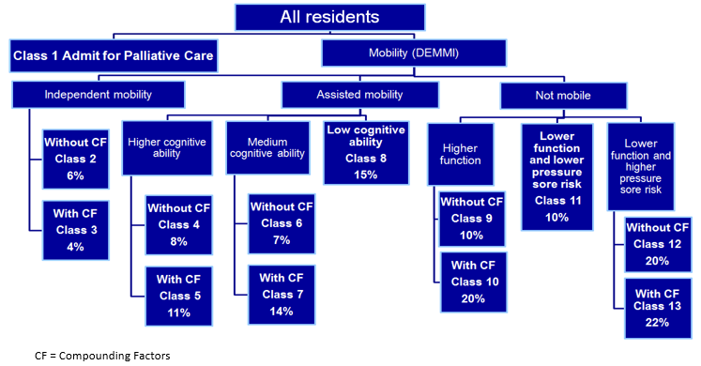

Figure 1 shows the same mortality data but this time presented graphically. The independently mobile branch had the lowest mortality rate. Not surprisingly, residents who were not mobile, unable to undertake activities of daily living and at greatest risk of a pressure sore, had the highest mortality rate. Their death rate was four times that of residents in the independently mobile branch.

## Class profile at assessment and reassessment

Figure 2 shows the profile of each of the twelve classes (the palliative care class is excluded) at both the initial assessment and at the subsequent reassessment.

The ‘died’ percentage is deaths as a percentage of all residents in the class. The percentage for both initial assessments and reassessments is based only on those residents who were assessed at the two time points. The data shows that residents have become more dependent in the intervening period and that the percentage assigned to classes with ‘compounding factors’ (CF) has increased. In other words, residents overall became more dependent. This is what would be expected given the overall frailty of the residential aged care cohort.

The major changes that can be seen are proportional increases in Class 5 (Assisted mobility, high cognition, with CF) and Class 11 (Not mobile, lower function, lower pressure sore risk) and a proportional decrease in Class 9 (Not mobile, higher function, without CF) (see summaries in Table 1 above).

In considering this profile, it should be noted that an explicit feature of the proposed new funding model is that residents are only reassigned to a new AN-ACC payment class if their needs increase. This same approach has been adopted in this analysis.

If a resident becomes more independently mobile, they are not assigned to a lower paying class in the AN-ACC payment model. A resident is only reassessed if their care needs increase. This is deliberately designed to provide incentives for best practice models of care.

Figure 2 Class profile at assessment and reassessment

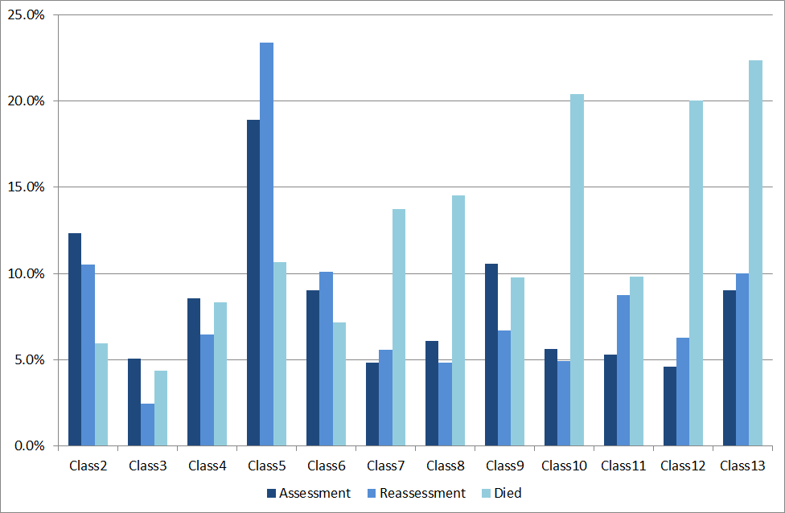

Figure 3 Assessment class profile for residents aged less than 85 years

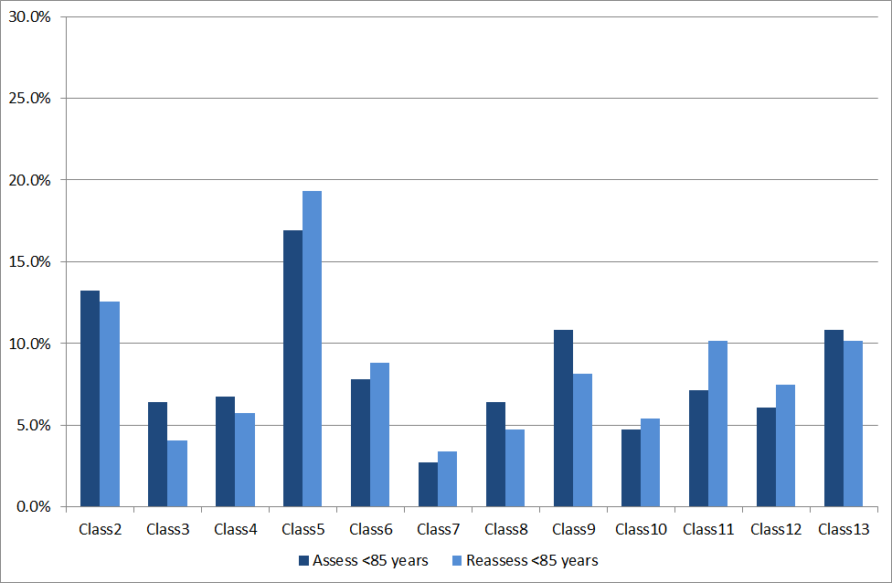

Figure 4 Assessment class profile for residents aged 85 years or older

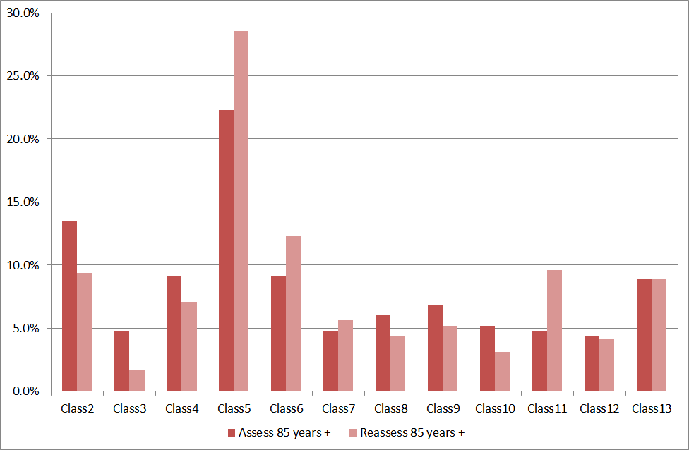

Figure 3 presents the same information but only for those aged less than 85 years at the time of their first assessment. This group includes 28 people who were aged less than 65 years.

Figure 4 shows this same information for those aged 85 or more at the time of their initial assessment. The major changes for this older cohort are the proportional increases in Class 5 and Class 11. Proportional reductions are more evenly distributed in this older aged group. In contrast, the younger cohort shown in Figure 3 had a more pronounced reduction in Class 9.

## Summary of changes by AN-ACC payment class between initial assessment and reassessment

Figure 5 summarises the changes by AN-ACC payment class between the initial assessment and the reassessment some 4-6 months later. Across the whole cohort, 12% died, 64% would stay in the same payment class and 23% would be assigned to a higher payment class. Excluding those who died, 74% would stay in the same AN-ACC class and 26% would be assigned to a higher paying class.

Figure 5 Summary of changes by AN-ACC payment class between assessment and reassessment

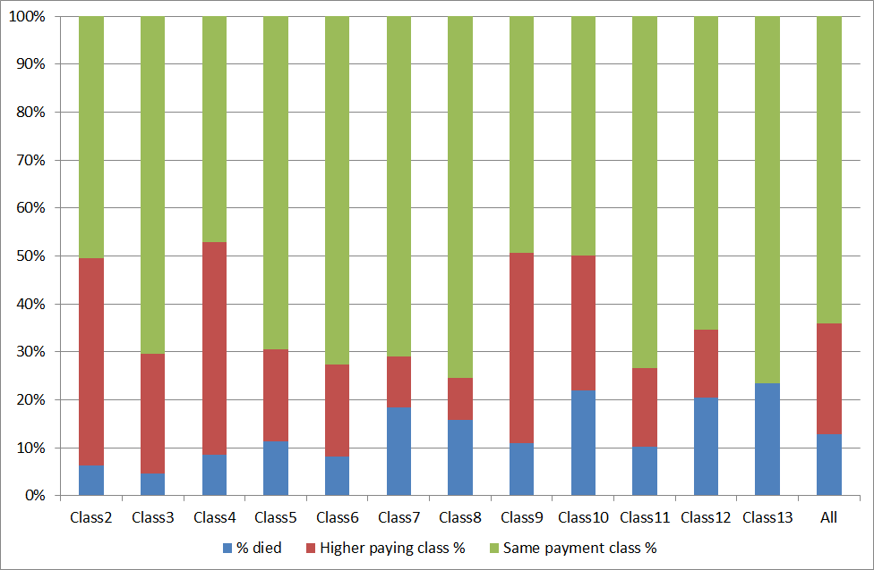

However, the results vary considerably according to the resident’s initial AN-ACC class. This can be clearly seen in Table 4, where the classes have been sorted based on the percentage who would move to a higher paying class. Those in the Class 4 have the highest rate of change, with 48% being assigned to a new class at reassessment. No one in the highest paying class (Class 13) is reassigned. This is simply because they are already in the highest paying group. Setting them aside, the rate varies from 10.4% to 48.4%, a fivefold difference between the classes.

Table 4 Percentage moving to a higher paying class at reassessment

| **Class** | **Descriptor** | **% same paying class** | **% to higher paying class** |
| --- | --- | --- | --- |
| Class 4 | Assisted mobility, high cognition, without CF | 51.6% | 48.4% |
| Class 9 | Not mobile, higher function, without CF | 55.4% | 44.6% |
| Class 2 | Independent without CF | 53.8% | 46.2% |
| Class 10 | Not mobile, higher function, with CF | 64.1% | 35.9% |
| Class 3 | Independent with CF | 73.8% | 26.2% |
| Class 5 | Assisted mobility, high cognition, with CF | 78.3% | 21.7% |
| Class 6 | Assisted mobility, medium cognition, without CF | 79.1% | 20.9% |
| Class 11 | Not mobile, lower function, lower pressure sore risk | 81.8% | 18.2% |
| Class 12 | Not mobile, lower function, higher pressure sore risk, with CF | 82.1% | 17.9% |
| Class 7 | Assisted mobility, medium cognition, with CF | 87.1% | 12.9% |
| Class 8 | Assisted mobility, low cognition | 89.6% | 10.4% |
| Class 13 | Not mobile, lower function, higher pressure sore risk, without CF | 100.0% | 0.0% |

## Implications for reassessment protocols

The results of the reassessment study suggest that many residents undergo significant change in only a matter of months. In total, 12% of residents died during the period and a further 12% underwent a significant event. Just under a quarter (23%) of residents were assigned to a higher paying class at the second assessment than they were after their initial assessment.

These results have important implications for the reassessment protocols. The core of the AN-ACC funding model is that a resident is assessed at entry to residential aged care with capacity for the resident to be reassessed (and potentially assigned to a higher paying class) if their needs change significantly. At the same time, the model should not create incentives for frequent unnecessary reassessments. This is easier to achieve with the new funding model as the individualised payment represents, on average, only half the daily payment.

The threshold point for reassessment would be when the home anticipates that the person’s individualised payment would increase by more than 20% above the national average per day i.e., a total payment increase of 10% on average. The Department may introduce reassessment charges for any home that routinely triggers unnecessary reassessments.

Significant event data was analysed to determine whether any event could be considered a trigger for reassessment. Of the six significant events that were collected, ‘significant fall’ and ‘acute illnesses of > 6 days’ occurred with sufficient frequently to warrant statistical analysis. ‘Hospital admissions of >1 day with anaesthetic’ and ‘hospital admissions of >4 days without anaesthetic’ each had small sample populations, and were grouped into ‘significant hospitalisation’ to allow for further analysis. The remaining significant events were not analysed due to insufficient data.

A z-test was performed to determine whether residents were more likely to be assigned to a higher paying class on the second assessment after having had a significant event. The results in Table 5 show that residents who had a ‘significant hospitalisation’ were more likely to move into a higher paying class than those who did not (p=0.00, α=0.05).

Table 5 Analysis of significant events as triggers for reassessment

| **Significant event** | **% with a significant event with higher paying class** | **% without a significant event with higher paying class** | **# with a significant event** | **# without a significant event** | **p-value** |
| --- | --- | --- | --- | --- | --- |
| Significant Fall | 37.5% | 26.0% | 32 | 743 | 0.07 |
| Acute illness >6 days | 37.0% | 26.1% | 27 | 748 | 0.22 |
| Significant Hospitalisation | 48.1% | 25.7% | 27 | 748 | 0.00 |

Based on the reassessment study, three grounds for reassessment have been identified.

#### Significant hospitalisation

A home may request a reassessment if the resident has been hospitalised for five days or more or, in the event of a patient who has a general anaesthetic, two days or more. Other significant events captured in the national reassessment study did not significantly result in a change of class.

#### Significant change in mobility

A home may request a reassessment if the resident’s mobility capacity has changed such that they move between the three mobility branches in the AN-ACC (i.e., from independent/assisted to assisted/non-mobile as measured by the DEMMI).

#### A standard time period for reassessment

A home may request a reassessment after a specified period for any resident who is becoming progressively more frail and/or whose health status is deteriorating. The standard time should be twelve months for Classes 2 to 8 (those classes with lower mortality rate) and six months for Classes 9 to 12 (classes for people who are not mobile and are expected to deteriorate at a higher rate).

# Discussion and recommendations

This report details the development, testing and implementation of the new external assessment model of the AN-ACC system. The results demonstrate that the model is feasible for use within residential aged care. It aligns with contemporary policy directions, provides a platform for ongoing quality improvement and is an essential platform for building the evidence base for best practice residential aged care. Some important lessons have derived from this process as well as opportunities for future developments. These are discussed below.

## Adoption of the AN-ACC Assessment Model

The outcomes of the studies discussed in this report confirm the appropriateness and feasibility of the AN-ACC assessment model. Feedback from those involved indicates the data collection burden associated with AN-ACC is modest and could be implemented routinely across the sector. There will, in fact be a significant reduction in the overall data collection burden associated with AN-ACC relative to the requirements of the current funding instrument.

Not all items in the AN-ACC assessment are used in the assignment of residents to a class in AN-ACC Version 1.0. However, we recommend that implementation of the new AN-ACC assessment system includes routine collection of all items in the assessment tool. This will provide an important source of information for modifications to be made in future versions of the classification. Further, it will provide an invaluable source of information and provides the basis of a national minimum data set for the sector more broadly.

#### Recommendations:

That the Australian National Aged Care Classification (AN-ACC) Version 1.0 Assessment Tool be adopted as the national standard funding assessment for residential aged care.

That all new residents be assessed by an independent assessor using the AN-ACC Assessment Tool within four weeks of entering residential aged care.

That residents requiring reassessment be assessed by an independent assessor using the AN-ACC Assessment Tool.

## Reassessment protocol

The core of the AN-ACC funding model is that a resident is assessed at entry to residential aged care with capacity for the resident to be reassessed (and potentially assigned to a higher paying class) if their needs change significantly.

At the same time, the model should not create incentives for frequent unnecessary reassessments. Indeed, the model includes an incentive for high quality services with a focus on restorative care and reablement.

#### Recommendations:

That the new AN-ACC funding model allow for reassessment based on significantly increased needs as indicated by (1) a significant hospitalisation (2) a significant change in mobility and/or (3) a standard time period, twelve months for Classes 2 to 8 (those classes with lower mortality rate) and six months for Classes 9 to 12 (classes for people who are not mobile and are expected to deteriorate at a higher rate).

That the Commonwealth consider the introduction of reassessment charges for any home that routinely triggers unnecessary reassessments.

There be no requirement for reassessment in the AN-ACC funding model.

## Clinical assessments for care planning

The AN-ACC is premised on a separation of assessment for funding from assessment for care planning. Assessment for funding moves to an external assessor, and assessment related to care planning is the responsibility of the residential aged care facility.

In order to drive systematic improvements in care planning, residential aged care facilities need to be equipped with care planning tools. These should be used for assessments by suitably trained nursing and allied health clinicians. The development of a nationally standardised care planning assessment toolkit is proposed.

This assessment tool should be used by homes to guide the identification of resident needs and to guide individualised care planning. In addition to capturing functional and clinical needs, it should also capture strengths, personal preferences and opportunities to work with residents to increase their independence.

#### Recommendations:

That a best practice needs identification and care planning assessment tool be developed for use by residential aged care facilities.

That, as a condition of subsidy, each resident undergo a care planning assessment at least annually and that the outcomes of this assessment be discussed with residents and carers and be used as the basis of an annual care plan.

## Assessor workforce

The AN-ACC model requires the development of a workforce of credentialed assessors who are external to the aged care home. It is likely that additional focus of effort will be required to recruit and support assessors for specific population groups such as those from culturally and linguistically diverse (CALD) backgrounds, Aboriginal and Torres Strait Islander communities etc. There are also likely to be shortages of external assessors in rural and remote areas.

One option may be that residential aged care facility clinical staff may be accredited as independent assessors for other organisations. It is also possible that the use of tele-health may assist in these assessments. These options will need to be explored during the detailed design phase.

#### Recommendations:

That, in the context of broader reform proposed for aged care assessment, the Commonwealth adopt a national networked external assessment model for the AN-ACC funding assessment.

Irrespective of the broader organisational aspects, external assessment be undertaken by credentialed registered nurses, occupational therapists and physiotherapists who have experience in aged care, have completed approved AN-ACC assessment training and comply with continuing professional development requirements.

## Sector engagement

This funding model represents a significant change for the residential aged care sector. The government and the sector need to enter into a partnership to implement the new model, recognising that this is in the interests of residents, providers and government.

This includes access to expertise on how to use the data to better measure the needs and changing needs of residents, the measurement of resident outcomes and adverse events and the use of the data to predict future demand for residential aged care.

#### Recommendation:

That the Commonwealth work with peak bodies to develop and implement a change management strategy.

## Measuring and benchmarking resident outcomes

The results presented in this report also suggest the potential of the AN-ACC to provide a meaningful system for measuring and benchmarking resident outcomes. Mortality rates and rates of outcome measures such as falls vary significantly by AN-ACC class. Reporting resident outcome measures by AN-ACC class allows for resident outcomes to be routinely evaluated taking into account the mix of residents in each facility.

If this were implemented in routine practice, it would allow (for the first time) consumers, providers and government to make meaningful judgements about the quality and outcomes of residential aged care and to fairly compare the quality of care provided at different facilities.

#### Recommendation:

That Government commit to an ongoing aged care research and development agenda that builds on the work of the RUCS and that includes assessment, classification, costing and outcome studies.

# Appendix 1

## Overview of the Resource Utilisation and Classification Study (RUCS)

The Resource Utilisation and Classification Study (RUCS) is an important national study commissioned by the Department to inform the development of future funding models for residential aged care in Australia. The overall aim of the RUCS was to:

* Identify the clinical and need characteristics of aged care residents that influence the cost of care (cost drivers).
* Identify the proportion of care costs that are shared across residents (shared costs) and the proportion that are related to individual needs (individual costs).
* Develop a casemix classification based on identified cost drivers that can underpin a funding model that recognises both shared and individual costs.
* Develop a new funding assessment that efficiently allows for each resident to be assigned to a payment class based on their needs.
* Test the feasibility of implementing the recommended classification and funding model across the Australian residential aged care sector.

In considering the results and recommendations included in this report, it is necessary to distinguish between three key ideas:

#### Cost

The cost of care for people living in residential aged care is in scope for RUCS. Capital accommodation and ‘hotel’ services are out of scope, as is respite care for non-permanent residents.

#### Funding (payment) model and policy

Funding and payment issues are in scope. The role of the RUCS research team is to develop the funding model and provide policy advice on its potential implementation.

#### Price

Price is out of scope for RUCS as price is ultimately a decision for payers (both government and consumers). But the RUCS has generated significant evidence that can aid decision-making about pricing.

**The four RUCS studies**

The RUCS comprised four separate but closely related studies. Each study included separate data collection and analysis elements that have been synthesised to produce a classification and associated funding model that is suitable for implementation across the Australian residential aged care sector.

#### Study One – Service utilisation and classification development study

Study One involved a prospective and comprehensive collection of resident assessment, service utilisation and financial data which were analysed to develop a casemix classification. Study One involved 30 facilities clustered in three geographic regions in Queensland, New South Wales and Victoria.

Study One was completed between October 2017 and October 2018.

#### Study Two – Fixed and variable cost analysis study

Study Two involved a larger nationally representative sample of 110 facilities. The purpose of this study was to understand differences in cost drivers between different types of facilities (including facility size and location) as well as differences that may result from seasonal effects. This analysis informed the design of the funding model. Study Two examined facility, rather than resident, level costs.

Study Two was completed between November 2017 and October 2018.

#### Study Three – Casemix profiling study

Study Three involved the collection of variables included in the classification from an additional nationally representative sample of 69 facilities. In combination with the data from Study One, the primary purpose of Study Three was to develop a national casemix profile of residents in aged care in Australia.

Study Three was completed between September 2018 and December 2018.

#### Study Four – Reassessment study

Study Four was added to the RUCS work program in mid-2018 in recognition of value that could be added by collecting additional information about the rate and extent of change in residents’ care needs over time. Study Four involved conducting re-assessments of approximately half of the residents assessed as part of Study One four to six months after their initial assessment.

Study Four was completed between August 2018 and December 2018.

**The RUCS reports**

Given the complexity of RUCS, it has been written up in a series of reports as follows:

**Report 1: The Australian National Aged Care Classification (AN-ACC)**

Report 1 covers the design and conduct of the study undertaken to develop the Australian National Aged Care Classification (AN-ACC) Version 1.0 (Study One). It covers the design and use of the AN-ACC assessment tool and the resource utilisation study undertaken to develop AN-ACC Version 1.0, including the preparation and analysis of the data collection. It discusses the results, the classification development process and key outcomes including the statistical analysis and clinical validation.

**Report 2: The AN-ACC assessment model**

Report 2 presents detailed findings relating to the external assessment tool and assessment process (informed by Studies One, Three and Four). This includes the development of the assessment tool using expert clinical panels and a summary of feedback from assessors regarding the use of the tool and the suitability of individual instruments. The skills and competencies required for the assessment workforce and other implications for implementation of the external assessment model are considered as well as triggers and protocols for reassessment.

**Report 3: Structural and individual costs of residential aged care services in Australia**

Report 3 presents the analysis and findings of Study Two which identified the proportions of total care costs that are fixed (including shared care) and variable (relating to individualised resident care). The analysis focused on the differences in fixed costs between different types of facilities, characterised by ownership, size, remoteness and service specialisation. It includes an analysis of the drivers of fixed care costs.

**Report 4: Modelling the impact of the AN-ACC in Australia**

Report 4 presents an analysis of modelling the introduction of the AN-ACC across Australia. This is based on the findings of Study Three. The sampling and assessment data collection process and the casemix of residents in aged care across Australia are described. The focus of this report is on modelling the introduction of the AN-ACC to replace the ACFI.

**Report 5: AN-ACC: A funding model for the residential aged care sector**

Report 5 presents the design of a new funding model based on the AN-ACC. It includes a consideration of other payment issues such as existing payment supplements, a discussion of incentives in funding model design and key issues in implementing the new model.

**Report 6: AN-ACC: A national classification and funding model for residential aged care: synthesis and consolidated recommendations**

This report syntheses and consolidates the findings presented in other reports and provides a consolidated set of recommendations.

**Report 7: AN-ACC Technical appendices**

This report is a series of technical appendices that contain detailed data for reference purposes.

# Appendix 2

## RUCS clinical advisory panels membership

**Function, cognition and behaviour panel members**

| **Name** | **Position/Organisation** |
| --- | --- |
| Professor Chris Poulos | HammondCare |
| Dr Rod McKay | Director Psychiatry and Mental Health Programs, NSW Health |
| Professor Maria Crotty | Professor of Rehabilitation and Aged Care |
| Professor Sue Kurrle | Curran Professor in Health Care of Older People, University of Sydney |
| Tim Dixon | Policy Manager, HammondCare |
| Rebecca Forbes | Projects Coordinator, Policy and Planning Office, HammondCare |
| Dr Catriona Lorang | Psychologist, The Dementia Care, HammondCare |
| Dr Bruce Walmsley | Psychologist, HammondCare |
| Dr Lyn Phillipson | NHMRC Dementia Fellow, Australian Health Services Research Institute |
| Anita Westera | Research Fellow, Australian Health Services Research Institute |
| Jacqui Capell | Research Fellow, Australasian Rehabilitation Outcomes Centre |
| Diane Whiting | Research Fellow, Australasian Rehabilitation Outcomes Centre |

**End-of-life panel members**

| **Name** | **Position/Organisation** |
| --- | --- |
| Annie Dullow | Director, Palliative Care Section, Department of Health |
| Deborah Stidwell | Chief Operations Officer, Brooke Street Medical Centre, Woodend Victoria. EoL CRE |
| Jacqui Culver | Palliative Care Nurse Practitioner, experience across Res Care & Home Care Derrick |
| Tanya McIver | Clinical Manager Anglicare SA |
| Professor Claire Johnson | Vivian Bullwinkel Chair of Palliative Care Nursing at Monash University |
| Dr Peta McVey | Senior Lecturer, Sydney Nursing School, University of Sydney |
| Dr Pippa Blackburn | Facilitator, Palliative Care Outcomes Collaboration |
| Jane Healey | Facilitator, Palliative Care Outcomes Collaboration |

**Wound care panel members**

| **Name** | **Position/Organisation** |
| --- | --- |
| Professor Helen Edwards | Assistant Dean (International and Engagement), Faculty of Health, Queensland University of Technology |
| Professor Keryln Carville | Professor Primary Health Care and Community Nursing Silver Chain Group |
| Prosper Sithole | Nurse Practitioner, BUPA Aged Care, Bendigo |
| Jessica Traeger | Clinical Manager, Eldercare SA |

**Technical nursing panel members**

| **Name** | **Position/Organisation** |
| --- | --- |
| Jessica Traeger | Clinical Manager, Eldercare SA |
| Leonie Robson | Senior Manager Clinical Services, Resthaven, Adelaide |
| Leah Franklin | Group ACFI Manager at McKenzie Aged Care Group Pty Ltd |
| Amanda Caruana | BUPA Aged Care, Bendigo |
| Julie Heany | Manager Nazareth Calvary Aged Care Facility - Belmont |
| Debra Thoms | Chief Nursing and Midwifery Officer Department of Health |
| Karen Hales | Professional Officer and BPSO Clinical Lead at Australian Nursing and Midwifery Federation (SA Branch) |
| Jenny Hurley | Nursing Director, Operating Room Service at Royal Adelaide Hospital |
| Peter Samsa | Research Fellow, Australian Health Services Research Institute |
| Cathy Duncan | Research Fellow, Australian Health Services Research Institute |
| Anita Westera | Research Fellow, Australian Health Services Research Institute |

# Appendix 3

## Summary of clinical panel recommendations

| **Panel** | **Outcomes** |
| --- | --- |
| Function, cognition and behaviour specialist advisory panel | * Domains and assessment tools:   + Function – FIM Motor (Modified), DEMMI, RUG-ADL   + Cognition/Communication – FIM Cognition   + Behaviour, Harm, Anxiety, Distress – NPI-NH   + Frailty – Rockwood, History of falls, Weight loss |
| End of life specialist advisory panel | * Language – “palliative care” * Collect Australia-modified Karnofsky Performance Status (AKPS) on everyone * Admit for residential palliative care:   + Prognosis <3 months   + Existing palliative care plan (primary care or palliative care team)   + Collect AKPS, RUG-ADL, Phase, Malignancy (yes/no) * Residents who become palliative while in residential care are re-assessed as per any other change in care requirements |
| Wound care specialist advisory panel | * Residents with high risk for wounds have similar care needs to those with wounds * Wounds to be considered as a compounding factor * All assessed using the 6 item Braden Scale for Predicting Pressure Sore Risk: sensory perception, moisture, activity, mobility, nutrition and friction/shear * No reassessment protocol for wounds required |
| Nursing specialist advisory panel | * Technical nursing care requirements:   + Oxygen   + Enteral feeding   + Tracheostomy care   + Catheter care   + Stoma care   + Peritoneal dialysis   + Daily injections   + Complex wound management   + Bariatric care |

# Appendix 4

## Assessor selection criteria

| **Category** | **Selection criteria** |
| --- | --- |
| Qualifications | Tertiary qualifications as registered nurse, physiotherapist or occupational therapist |
| Registration | Current unrestricted registration with the Australian Health Practitioners Regulation Agency (AHPRA) |
| Experience and expertise | * Demonstrated experience of working in aged care in Australia including people with dementia * Five years clinical experience in aged care (or related health care) * Demonstrated experience conducting clinical assessments using a range of assessment tools * Ability to follow direction, work independently and as part of a team * Effective organisational and administrative skills * Excellent communication skills, with a variety of stakeholders including consumers, families and managers |

# Appendix 5

## AN-ACC Assessment Tool

1. McNamee J, Poulos C, Seraji H et al. (2017) *Alternative Aged Care Assessment, Classification System and Funding Models Final Report.* Centre for Health Service Development, Australian Health Services Research Institute, University of Wollongong.
2. Department of Health (2018) Streamlined Consumer Assessment for Aged Care. Discussion Paper, December 2018
3. McNamee J, Poulos C, Seraji H et al. (2017) Alternative Aged Care Assessment, Classification System and Funding Models Final Report. Centre for Health Service Development, Australian Health Services Research Institute, University of Wollongong.
4. ibid
5. Now incorporated in the Aged Care Quality and Safety Commission
6. Of the 961 in the sample, 114 died and 72 were missing either a complete assessment, a complete reassessment or a record of significant events.