**Resource Utilisation and Classification Study – Revised Tables**

AN-ACC NWAU values have been updated slightly from those presented in Reports 4, 5 and 6, due to technical aspects of the conversions between Australian dollars, RVUs and NWAUs.

The Tables below replace those presented in Report 4, Report 5 and Report 6, and are consistent with the figures presented by Professor Eagar to the sector on 14 March 2019.

**Report 4, Table 8: Capturing clinical complexity by AN-ACC class**

Table 8 shows the distribution of residents across the AN-ACC classes as well as the average relative value unit (RVU) of residents in the class. These RVUs represent the relative clinical complexity (as measured by cost) of each AN-ACC class. The ACFI payment RVUs have been calculated in the same way to ensure comparability between the ACFI and the AN-ACC. 
This table is to be read as a series of rows from left to right ('AN-ACC class' then 'records (percentage)' then 'mean AN-ACC RVU' then 'mean ACFI payment' then 'ACFI payment (standard error)' then 'ACFI Score 1xHigh (percentage)' then 'ACFI Score 2XHigh (percentage)' then 'ACFI Score 3XHigh (percentage)', top to bottom.


**Report 5, Table 2: AN-ACC Version 1.0 NWAUs**

Table 2 shows the 13 classes of AN-ACC Version 1.0, their resident descriptions and NWAUs. This table is to be read as a series of rows from left to right ('AN-ACC class' then 'resident description' then 'AN-ACC NWAU').

**Report 5, Appendix 2**

This table is divided into three sections to be read in rows from left to right. 
The first section shows the Fund Code, description of payment and NWAU for the Adjustment payment. This section is to be read as a series of rows from left to right ('fund code' then 'description of payment' then 'NWAU'), top to bottom.
The second section shows tarrifs, facility descriptions and NWAUs for the Base care tariff. This section is to be read as a series of rows from left to right ('tariff' then 'facility description' then 'NWAU').
This third section shows classes, resident descriptions and NWAUs for the AN-ACC class payment. This section is to be read as a series of rows from left to right ('class' then 'resident description' then 'NWAU').

CF = Compounding Factors (see Report 1)  
MMM = Modified Monash Model. A measure of geographic remoteness where 7=most remote and 1=major metropolitan

**Report 6, Table 1: Base care tariff and AN-ACC Version 1.0 NWAUs**

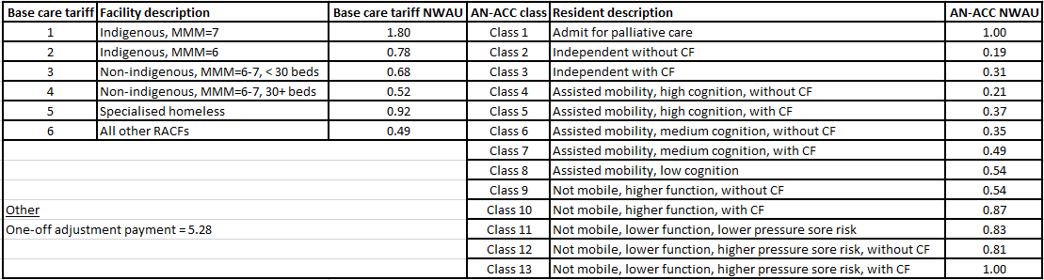CF = Compounding Factors (see Report 1)  
MMM = Modified Monash Model. A measure of geographic remoteness where 7=most remote and 1=major metropolitan