Psychogeriatric Assessment Scales

# User’s Guide 4th Edition (Electronic Distribution)

Anthony Jorm & Andrew Mackinnon

ANUTECH Pty Ltd

# Acknowledgements

The development of the PAS was supported by a grant from the Commonwealth Department of Human Services and Health.

The adaption of the PAS for electronic distribution was made possible by a generous donation to the Mental Health Research Institute by Mr Eric Bauer.

## Psychogeriatric Assessment Scales User’s Guide

4th Edition

ISBN: 978-1-76007-273-5

Commonwealth Department of Health  
PO Box 9848, Canberra ACT 2601

Anthony Jorm  
Melbourne School of Population and Global Health  
University of Melbourne  
Carlton Vic 3010

Andrew Mackinnon  
Centre for Youth Mental Health   
Locked Bag No. 10  
Parkville Vic 3052  
Australia

© 1995 Jorm & Mackinnon  
first edition 1994  
second edition 1995  
third edition 1997  
fourth edition 2016*

*Updates to the fourth edition were made by the Commonwealth Department of Health

# PAS User’s Guide

Contents

User’s Guide 4th Edition (Electronic Distribution) 1

Acknowledgements 2

Psychogeriatric Assessment Scales User’s Guide 2

PAS User’s Guide 3

What the PAS Aims To Do 5

The PAS aims to assist a wider range of people to carry out psychogeriatric assessment. 5

The PAS assesses psychogeriatric disorders on scales rather than as categories. 5

Overview of the PAS 6

Subject Interview 6

Informant Interview 6

Relationship to other tests and questionnaires 7

Subject Interview 7

Informant Interview 7

How to Administer the PAS 8

Necessary preliminaries 8

Instructions for administering the scales 9

Scoring the Response 9

Handling difficulties which may arise 11

How to score a PAS scale 12

Using the PAS Summary Profile 14

Psychogeriatric Assessment Scales: Summary Profile 14

Psychogeriatric Assessment Scales: Summary Profile 15

How to interpret the PAS 16

Psychogeriatric Assessment Scales: Summary Profile 16

Subject Interview 16

Informant Interview 16

Psychogeriatric Assessment Scales: Summary Profile 17

Psychogeriatric Assessment Scales: Summary Profile 18

Some issues in interpretation 18

μPAS: A Compact Response Sheet for the PAS 20

Distribution and Use of PAS Materials 21

Copying of PAS materials 21

PAS materials for non-English speakers 21

Before using the PAS for research or clinical purposes 21

Technical Appendix 22

Item selection 22

Reliability 22

Validity 23

Norms 23

# What the PAS Aims To Do

The PAS is designed to gather information on the major psychogeriatric disorders: dementia and depression. It differs from conventional approaches to psychogeriatric assessment in a number of important ways.

## The PAS aims to assist a wider range of people to carry out psychogeriatric assessment.

Psychogeriatric assessment is generally the province of people with extensive specialist training in geriatrics or psychiatry. The PAS provides a straightforward method of gathering and interpreting the relevant information without the necessity for prolonged training.

## The PAS assesses psychogeriatric disorders on scales rather than as categories.

In conventional thinking, people suffering from dementia or depression are in a distinct category from ‘normal’ people. It is true that when people with psychogeriatric disorders are seen by health care workers they appear to be categorically distinct from other people. However, when the whole elderly population is looked at, dementia and depression are seen as part of a continuum. For example, there is a continuum ranging from successful cognitive ageing at one end to severe dementia at the other. There is another continuum ranging from positive well-being in old age to severe depression. The PAS aims to place people along a number of relevant continua.

While the PAS provides a method of assessing psychogeriatric disorders, **it does not tell the user what action to take if problems are found**. The PAS helps by gathering information in a systematic way. It gives guidance on how this information should be interpreted by comparing the results to the normal range found in the community.

**It is up to the user to decide on the appropriate use of this information to determine options for care. Although the PAS can be competently given after brief training, use of the information to guide care decisions must be based on the user’s professional expertise.**

# Overview of the PAS

The PAS consists of two sections: an interview with the subject who may be a client or patient and an interview with an informant who may be a relative, carer or other person who knows the subject well. These sections are referred to as the **Subject Interview** and the **Informant Interview** respectively. The two interviews are designed to provide different perspectives on the subject’s functioning.

A number of scales are derived from the interviews. A scale is a set of questions which are scored to give a summary of how the subject is functioning in a particular area. The following scales are derived from the PAS:

## Subject Interview

| **Subject** | **Scales** |
| --- | --- |
| Stroke | This scale assesses 6 symptoms of cerebrovascular disease. It gives an indication of whether cognitive impairment might be due to vascular dementia or to Alzheimer’s disease. |
| Depresssion | This scale assesses 12 symptoms of depression over the previous 2 weeks. |
| Cognitive Impairment | This scale consists of 9 questions to test the subject’s memory and other cognitive functions. |

## Informant Interview

| **Subject** | **Scales** |
| --- | --- |
| Stroke | This scale is identical to the Stroke scale given to the subject. It gives an independent source of information on cerebrovascular disease. |
| Cognitive Decline | This scale asks the informant 10 questions about changes in the subject’s everyday cognitive functioning. |
| Behaviour Change | This scale has 15 questions which assess changes in personality and disturbances in behaviour which may occur in dementia. |

# Relationship to other tests and questionnaires

Many other tests and questionnaires are available for psychogeriatric assessment. They vary in terms of the skills needed to use them and the information they provide. The PAS scales provide similar information to some well-known scales as described below:

## Subject Interview

| **Subject** | **Scales** |
| --- | --- |
| Stroke | A simple alternative to the Hachinski Ischemic Score. |
| Depression | Provides similar information to the Geriatric Depression Scale (GDS). |
| Cognitive Impairment | Provides similar information to other brief cognitive tests such as the Mini-Mental State Examination (MMSE) and the Abbreviated Mental Test Score (AMTS). |

## Informant Interview

| **Subject** | **Scales** |
| --- | --- |
| Stroke | As for the Subject Stroke scale. |
| Cognitive Decline | Provides similar information to the Informant Questionnaire on Cognitive Decline in the Elderly (IQCODE). |
| Behaviour Change | There are no other scales in wide use which are similar to this scale. |

# How to Administer the PAS

At this point it is a good idea to browse through the PAS to get a general idea of the content of each scale. The PAS is given in the second part of this Users’ Guide. After browsing, return to this point in the Guide.

## Necessary preliminaries

Before administering the PAS it is important to establish a relationship with the subject and the informant. In most instances, the interviewer will not have met the subject or informant before, so they need to feel at ease before they can comfortably answer the PAS questions, many of which cover personal and sensitive areas.

It is also important to establish that the subject and informant have adequate comprehension of English before beginning the interviews. The PAS is only suitable for use with people who have English as their native language or are fluent in English as a second language. However, even if the subject has insufficient English to be interviewed, it is possible to carry out an Informant Interview if the informant is fluent.

To ease the subject and informant into the interviews, the PAS begins with some general questions about social background, such as age, country of birth and education. These questions cover the minimum amount of background information needed before giving the scales. However, some users may wish to collect further information relevant to their own needs, such as details of medical history or use of medication.

The Subject and Informant Interviews are designed to give independent perspectives on the subject’s behaviour. It is therefore important that the subject and informant are interviewed separately. In particular, the informant may feel constrained about reporting changes in the behaviour of the subject if the subject is present during the interview.

It is not necessary to interview the subject and informant on the one occasion. Neither is it necessary to complete a whole Subject or Informant Interview on the one occasion. If the subject or informant appear tired, or if there are time constraints, it would be better to break an interview and continue it at a later time.

The scales of the PAS can be treated as independent modules. A user might be interested in giving 1 or 2 scales rather than a complete interview. Also, the order of administering the scales can be varied if the situation warrants it. However, the instructions and wording within each scale must be strictly adhered to.

# Instructions for administering the scales

The PAS interviews are like the scripts for a play - they tell the user exactly what to say and do. It is vital that users stick exactly to the script. Otherwise the PAS may not provide a valid assessment.

In order to make the PAS as easy to administer as possible, all questions share a common format.

The PAS tells the user what to say and do using different types of format:

**Statements in this typeface are instructions about actions the user must perform.**

*Statements italic typeface should be read aloud by the user.*

Statements in this upright typeface are alternative answers from which the user must choose to code the subject’s responses.

As an example, look at the question below which is taken from the Background Information section of the Subject Interview:

**1.** *“Please spell your last name (for me). And your first name?”*

* Correctly spelled 0
* Cannot give both names correctly (one minor spelling error allowed), does not know 1

Score:

To ask this question you read the words: Please spell your last name (for me). And your first name?

The words in brackets are optional. Use them if you feel it improves the flow of the questions.

## Scoring the Response

Each question will yield a score of either 0 or 1.

For this question you should decide whether the subject has spelt his or her name correctly. A correct answer is given a score of 0. An incorrect answer gets a score of 1.

The score for each question should be written into the score box.

Note that for this question you do not need to write what the subject says. If details are required, space is provided.

The responses listed often give some guide about specific criteria for scoring when this is needed. For this question, one minor spelling error is allowed before the response is treated as incorrect.

It may seem counter-intuitive to score a correct answer 0. This is done because this scale is measuring impairment. Make sure that you choose the correct code for the answer given by the subject.

The next example comes from the Cognitive Impairment scale of the Subject Interview:

**C1**. *I am going to give you a piece of paper. Would you please write any complete sentence on that piece of paper for me?*

If sentence is illegible, ask “*Could you read it for me?*”, and copy sentence onto sheet.

Sentence should have a subject and a verb, and make sense.

Spelling and grammatical errors are acceptable.

* Correct 0
* Incorrect or refusal 1
* Not asked (e.g., Sensory or motor impairment) ?

Score:

Note that this example contains italic type to be read aloud, bold type to tell the user what to do and ordinary type for the alternative answers.

For this question there are three alternative scores, 0, 1 or ?. If the subject cannot do the writing task because they have a physical disability, then you should circle the ? alternative. On the other hand, if the subject refuses to do the task, this is regarded as an error and a 1 is circled.

For most of the scales it is fairly simple for the interviewer to choose the appropriate answer from the alternatives given and little judgement is required. However, for some of the questions the subject may not give an answer which exactly corresponds to any of the alternatives. Take as an example the following question from the Depression scale of the Subject Interview:

**D2.** *Have you had trouble sleeping over the past two weeks?*

* No 0
* Depends on situation 0
* Yes 1
* Does not know ?

The subject may not give a simple “yes” or “no” answer. For example, they might say “Yes, I had a bad night last night”. In this case the interviewer has to judge which of the three alternative answers fits the best. If last night was an unusual night and they slept well all the other nights of the past two weeks then the interviewer would select the “Depends” alternative. On the other hand, if the subject said “Yes, I have trouble getting to sleep most nights”, then the interviewer would select the “Yes” alternative.

Sometimes the subject will give a reason for why they are sleeping poorly. For example, they might say “I have had trouble sleeping because of the pain in my leg” or “I can’t sleep because it is so hot”. These reasons should be ignored in selecting the appropriate answer. The interviewer should not make a judgement about whether or not the sleeping difficulty is due to depression or some other factor. Whatever the reason given, if the subject has had consistent trouble sleeping over the previous two weeks, the interviewer should choose the “Yes” alternative. This principle applies to all the questions in the Depression scale: **In selecting the appropriate answer, ignore any explanation the subject gives for a depression symptom.**

The final example is taken from the Behaviour Change scale of the Informant Interview:

B1. *Is Subject lacking in initiative?*

* No 0
* Yes *Is this a change from earlier?*
  + - No 0
    - Yes 1
    - Does not know ?
* Does not know ?

Score:

Here the word SUBJECT is printed in grey to show that it is not to be read out. Instead the user should substitute whatever name is appropriate to the situation e.g. *Is your mother lacking in initiative?* or *Is Mrs Smith lacking in initiative?*

This question also illustrates another type of situation. If the informant answers yes, then a second question *Is this a change from earlier?* must be asked.

For this question, a 0 is circled if the subject is not lacking in initiative or has been lacking in initiative all their life, a 1 is circled if the subject is lacking in initiative and this is a change from earlier in life, and a ? is circled if the informant does not know. In both the Cognitive Decline and Behaviour Change scales of the Informant Interview, the emphasis is on measuring changes from earlier in life rather than life-long characteristics.

# Handling difficulties which may arise

The PAS gives the interviewer a script of what to say and specific instructions of what to do. However, there will be occasions where these are not enough and the interviewer will have to exercise judgement. Below are some of the more common circumstances where difficulties arise and advice on how to handle them:

The subject or informant does not understand a question. For example, if an informant is asked Is your mother lacking in initiative? they may ask What do you mean? In such circumstances, the interviewer may give an explanation of the meaning. However, this should only be done if the person being interviewed asks for explanation or obviously does not understand. Sometimes the subject or informant may answer a question without any hesitation, but it is apparent from their answer that they have not properly understood the question. In this case, it is best to repeat the question and only give a further explanation if it is still not understood. Where the person being interviewed has repeated difficulties understanding the questions, it is best to skip that scale and proceed to the next one.

The subject’s or informant’s answer does not fit any of the alternatives. Usually the interviewer will have no trouble selecting the alternative which corresponds to the subject’s or informant’s answer. However, sometimes it will not be clear. For example, in the Depression section the subject is asked: In the past two weeks, how frequently have you felt lacking in self-confidence or felt inadequate? If the subject answers “It depends”, the interviewer has to decide whether to record “Never”, “Some of the time”, “Most of the time” or “All of the time”. In such cases the interviewer should clarify the answer by reading out the alternatives. For example, the interviewer could ask: Would you say: Never, Some of the time, Most of the time or All of the time?

The subject is concerned about whether they have answered correctly. In the Cognitive Impairment section, subjects can become concerned about whether the answer they are giving is right or wrong. The interviewer should not indicate any judgement of the answers by using words such as Good or Great. However, the interviewer can use neutral phrases of acknowledgment after a subject has completed a question, whether correctly or incorrectly. Appropriate phrases would be OK, Thank you, Thank you very much, or Now let’s try this.

# How to score a PAS scale

Each question in the PAS has a box next to it. At the end of the interviews, the answers circled have to be transferred to the boxes. Then the boxes are added up to give a separate score for each scale. Instructions on how to do this are given in bold format at the end of each scale. Below is an example from the Stroke scale in the Subject Interview:

Add boxes S1 to S6 to give you S

Number of boxes with ?’s gives you a ? score

If ? is not zero, score should be pro-rated using formula: 6 x S/(6-?) = S’

Scoring is straightforward if there is a number in each box. However, it becomes more complex if some boxes have a ? in them. In such cases the scores have to be pro-rated to give an estimate of what the score would have been if there were no missing information.

Imagine that for the Stroke scale there is one ? and three 1s. The scoring would then be as follows:

Add boxes S1 to S6 to give you 3S

Number of boxes with ?’s gives you a 1 ?

If ? is not zero, score should be pro-rated using formula: 6 x S/(6-?) = S’, 6 x 3 / (6 – 1) = 4S’

The calculation gives an exact answer of 3.6, but this should be rounded to the nearest whole number which is 4.

It is important to remember that pro-rating is only necessary if there are ? answers in some of the boxes. If there were no ? answers, the S' box in the example above would be left blank. When pro-rating is necessary it is advisable to use a calculator to avoid arithmetic errors.

If either a Subject scale or an Informant scale has a large number of ? answers (e.g., more than 20% are ?) then it is best to ignore the data from that scale altogether. It is not unusual to have ? answers with elderly subjects. Whether a scale can be reliably interpreted when a subject has given ? answers depends on the reason they have occurred. If the subject has a visual, hearing or physical disability that prevents them from answering a question but is unrelated to their cognitive state, then the presence of ? responses will not bias the results. On the other hand, if these responses are due to cognitive impairment, the score you calculate for the scale will not accurately reflect the subject’s true state.

The most extreme example of missing information is where the subject is too impaired to interview and only an Informant Interview will be possible. Alternatively, some subjects will have no available informant, so only the Subject Interview will be possible.

Sometimes the subject will be too impaired to give sensible answers to the Depression and Stroke scales. To allow for this possibility, the section on Background Information in the Subject Interview is used to filter out subjects who have severe difficulties with the questions. If the subject cannot answer all of the four Background Information questions, then the user has to omit the Stroke and Depression scales and skip straight to Cognitive Impairment. For such subjects, the skipped scales would of course be missing. Shown below are the instructions on how to skip which are at the end of Background Information.

Add boxes

If total is 1 or more, skip to the Cognitive Impairment scale.

# Using the PAS Summary Profile

For each of the PAS scales, the higher the score the greater the impairment. A score of 0 implies that no impairment was detected by the scale. However, the numbers have no intuitively obvious meaning in themselves. Using these ‘raw’ scores it is not possible to say that a subject is more disabled in one area of functioning than another. For example, if a subject scores 3 on Cognitive Impairment and 2 on Depression, we cannot necessarily conclude that the person’s main impairment is cognitive rather than depressive.

It is possible to display the scores from each PAS scale to show how extreme or ‘bad’ a subject’s disability is compared to other people in the population. This may aid identification of an individual’s particular problems. With the PAS scales, this is done by converting the scores to percentile ranks. A percentile rank shows the percentage of the population who get that score or lower. For the PAS, the reference population used for comparison is people aged 70 or over.

## Psychogeriatric Assessment Scales: Summary Profile

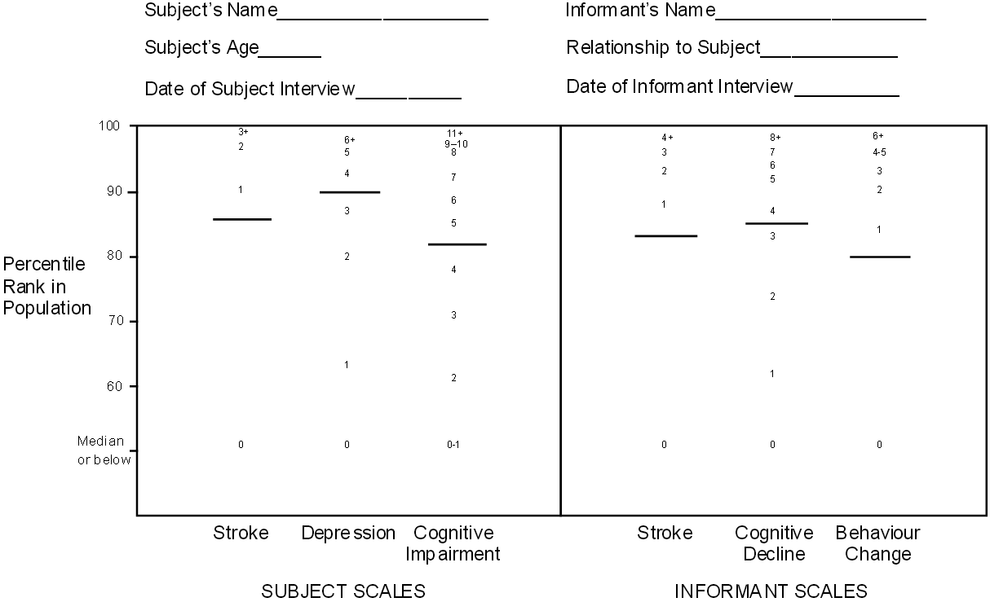

As an example, a score of 2 on the Depression scale gives a percentile rank of 80. In other words, a score of 2 or under is found for 80% of the population aged 70+. For the Cognitive Impairment scale, a score of 3 gives a percentile rank of 71. Thus, a person scoring 2 on Depression and 3 on Cognitive Impairment is relatively more impaired in depression (percentile rank of 80) than in cognitive function (percentile rank of 71). The general principle is that the higher the percentile rank, the more impaired the person is. A percentile rank of 100 is the highest possible, while a percentile rank of 0 is the lowest possible. A percentile rank of 50 is called the median and is the ‘middle’ score which 50% of people score higher than and 50% lower than.

The PAS Summary Profile, shown page 13, makes it easy to convert raw scores to percentile ranks. The possible raw scores for each scale are in small print on the profile. A subject’s score can be indicated by placing a mark on the appropriate number. The equivalent percentile rank for the score is then shown on the vertical axis.

## Psychogeriatric Assessment Scales: Summary Profile

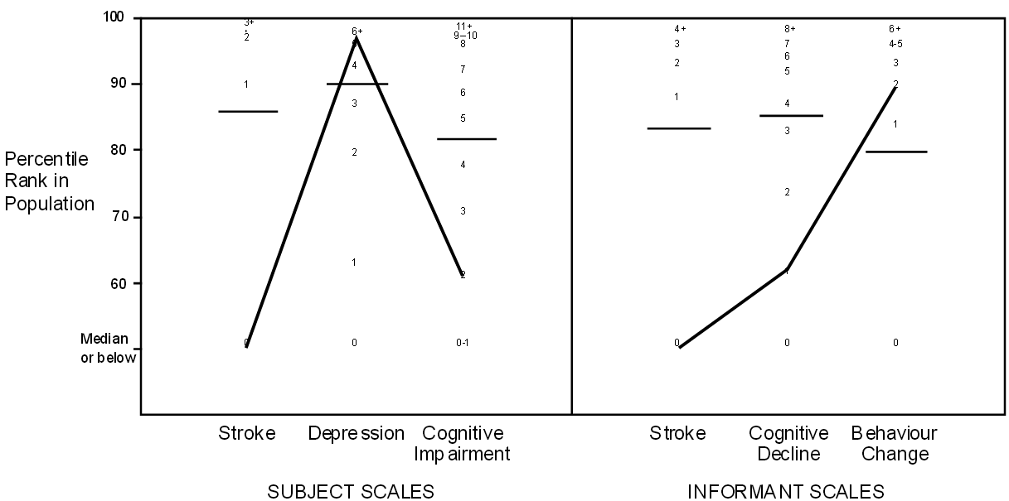

By joining up the points for each scale it is possible to create a profile like the one shown below. This is the profile for a subject with raw scores of 0 on Stroke (subject scale), 5 on Depression, 2 on Cognitive Impairment, 0 on Stroke (informant scale), 1 on Cognitive Decline and 2 on Behaviour Change . It can be readily seen that this subject’s main impairments are in the areas of Depression and Behaviour Change.

Sometimes the PAS will be given on two separate occasions so as to monitor progress of impairments over time. Where this is the case, two separate lines can be drawn on the same Summary Profile (using different coloured pens or types of line) so that areas of deterioration or improvement are apparent.

Although the percentile ranks on the PAS Summary Profile use people aged 70 or over as the reference population, this does not mean that the PAS cannot be used at younger ages. It would be quite appropriate to use the PAS with, say, a 60 year old subject. However, in interpreting the Summary Profile the user would have to bear in mind that a 60 year old is being compared to an older reference group. Any impairments found for younger subjects could appear even worse if they were compared to a reference group of their own age.

# How to interpret the PAS

As stated earlier, the PAS assesses psychogeriatric disorders along a continuum rather than as a category. However, it can aid interpretation to know how scores correspond to diagnoses of dementia or depression. Each scale on the PAS Summary Profile has a horizontal bar to show where most diagnosed cases lie. It has been found that 80% of diagnosed cases have scores above these bars. Conversely, 20% of cases fall below the bars. The bars therefore give an indication of whether a subject’s scores are typical of those seen in diagnosed cases.

## Psychogeriatric Assessment Scales: Summary Profile

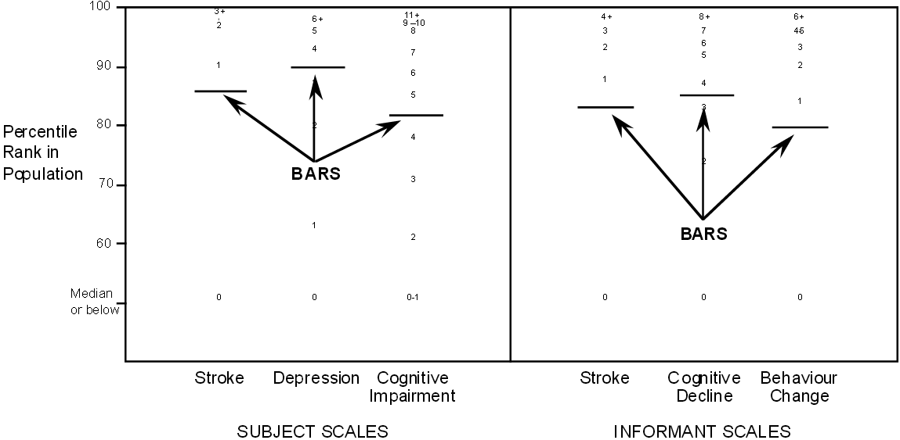

The bars have been placed separately for each PAS scale as follows:

### Subject Interview

| **PAS** | **Score** |
| --- | --- |
| Stroke | Approximately 80% of vascular dementia cases fall above the bar (a score of 1 or more). |
| Depression | Approximately 80% of depression cases fall above the bar (a score of 4 or more) |
| Cognitive Impairment | Approximately 80% of dementia cases fall above the bar (a score of 5 or more) |

### Informant Interview

| **PAS** | **Score** |
| --- | --- |
| Stroke | Approximately 80% of vascular dementia cases fall above the bar (a score of 1 or more). |
| Cognitive Decline | Approximately 80% of dementia cases fall above the bar (a score of 4 or more) |
| Behaviour Change | Approximately 80% of both dementia and depression cases fall above the bar (a score of 1 or more) |

From experience giving the PAS to many subjects suffering from dementia or depression, it has been possible to produce average or typical profiles. Shown below are average profiles for cases of dementia and depression.

## Psychogeriatric Assessment Scales: Summary Profile

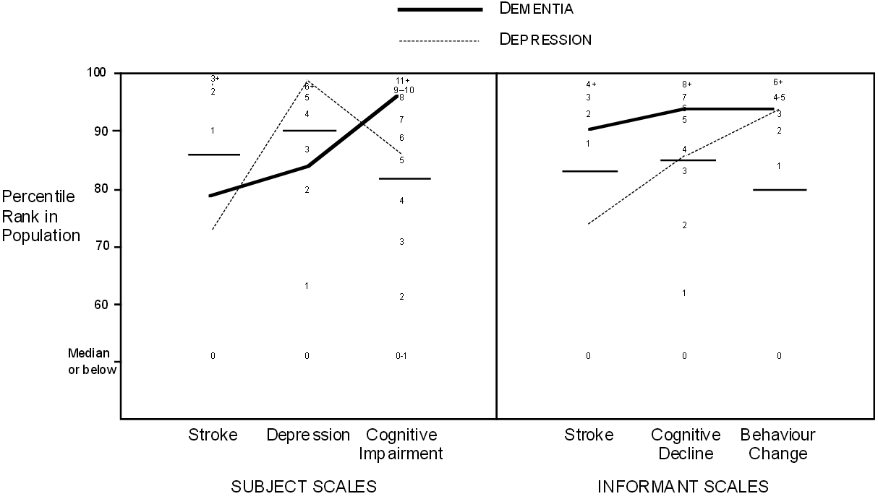

The dementia cases have higher average scores on Cognitive Impairment and Cognitive Decline. The depression cases have higher average scores on Depression. Despite these differences, there are similarities between the disorders. Both dementia and depression cases tend to have high scores on the Behaviour Change scale. It is also apparent that the depressed cases often have some degree of cognitive impairment, although not as much as the dementia cases. Similarly, the dementia cases often have some degree of depression. An advantage of looking at psychogeriatric disorders as a continuum is that it reveals similarities such as these which may be hidden by diagnostic labels such as ‘dementia’ or ‘depression’.

It is also possible to use the PAS to look at specific types of dementia. Below are average profiles for cases of Alzheimer’s disease and vascular dementia. It can be seen that these two types of dementia are similar except on the Stroke scales where the vascular dementia cases have higher average scores

## Psychogeriatric Assessment Scales: Summary Profile

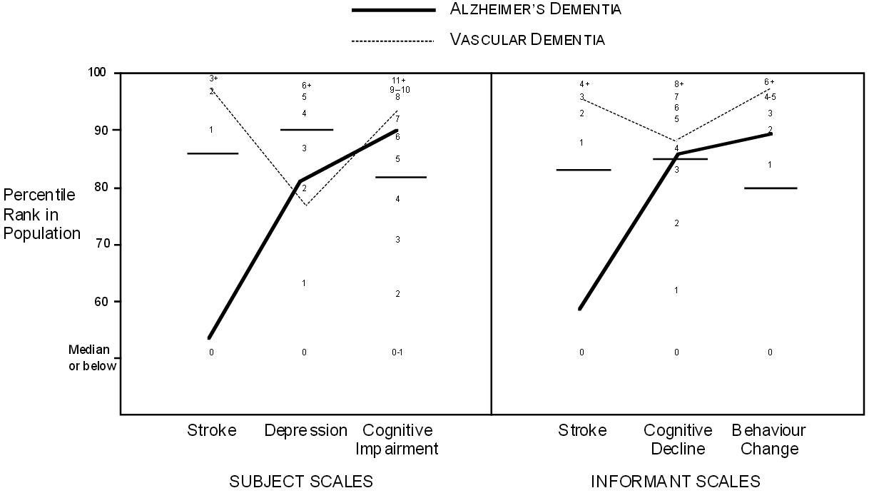

It would be possible to make average profiles for other types of dementia (e.g. alcoholic dementia, Pick’s disease), but as yet sufficient data have not been collected on people with these disorders.

It must be emphasised that the PAS is designed to assess psychogeriatric disorders as a continuum. The bars are not meant to be simple cut-off scores for making a diagnosis. A subject who scores 4 on Cognitive Impairment (which is below the bar) may not be functioning all that differently from a subject who scores 5. A person who falls just below the bars on several scales may have problems worthy of as much attention as another person who scores above the bar on only one scale.

## Some issues in interpretation

As with all tests, scores on the PAS may be influenced by factors other than psychogeriatric disorders. It is important to be aware of this. Two situations to be aware of are poor education and emotional distress.

Poor education in the subject: Subjects who are poorly educated or not very intelligent may get a high score on the Cognitive Impairment scale. This high score might reflect life-long cognitive difficulties rather than the beginning of a decline. The Cognitive Decline scale is not influenced by education or intelligence earlier in life. This scale avoids such contamination by asking about changes in everyday cognitive functioning from earlier life. If a subject has had a limited education and performs poorly on the Cognitive Impairment scale, but not poorly on Cognitive Decline, you should consider whether a low cognitive ability has been life-long.

Emotional distress in the informant: How the informant describes the subject can be influenced by the informant’s emotional state, in particular whether the informant is depressed. Depression is not unusual in informants who have the role of caring for a disabled subject. Depression can affect how people see themselves and how they see others close to them. It is known that depressed informants tend to report more cognitive and behaviour changes in the subject. So if the Cognitive Decline and Behaviour Change scales give high scores, but the Cognitive Impairment and Depression scales do not, then this could be due to the informant’s emotional state.

A major advantage of the PAS is that it collects information independently from both the subject and their informant. Where there are discrepancies between the two sources of information, the possible reasons for this must be considered.

# μPAS: A Compact Response Sheet for the PAS

The PAS interview forms are designed to be as easy as possible to use and score, with the questions to be asked and the scoring procedure printed on each form. However, a consequence of the easy-to-use design is that the interview forms use quite a bit of paper. Paper use can be cut down by photocopying the forms back-to-back or by using photocopy reduction so that two pages fit on one side of a sheet of paper. The μPAS (pronounced microPAS) has been developed as a further way of saving paper and filing space when administering the PAS.

The μPAS is a response sheet designed to record both subjects’ and informants’ answers to the PAS questions. It is included as part of the test materials supplied with this manual. μPAS is designed to be used in conjunction with the PAS by interviewers who are familiar with its content and experienced in its administration. Each interview is recorded on one page, with each scale occupying a column of the answer sheet. Background information is recorded in the first column, above the Stroke scales. μPAS incorporates a number of prompts to ensure the interview is undertaken properly. Each question is numbered and has a word or phrase to remind the interviewer of the content of the question.

Where an action is required which is not associated with the question about to be given, this is indicated by a block of text preceded by an Arrow Two examples are shown below. After collecting background information from the subject, the interviewer should skip to the Cognitive Impairment section if the subject is so impaired as to have made one or more errors in this first section. In the Cognitive Impairment scale, the interviewer must give the subject words to be recalled later. In this example, the presentation of the three words is prompted . Later in the scale, other actions are prompted in a similar manner.

* It total is 1 or more, skip to Cognitive Impairment.
* Apple, Table, Penny

New pages in the full PAS are indicated by a wavy white line:

This helps to keep the recording of answers on the μPAS sheet in synchrony with the full PAS and helps to prevent skipping questions. The basic scoring instructions for each scale are provided at the bottom of the column. Scores are then plotted on the PAS profile in the normal manner.

It is important to note that μPAS is not a substitute for using the full PAS in its original form. All questions must be asked as written in the PAS. It is critical that the recording of answers also be carried out as specified in the PAS. The way answers are recorded varies considerably. This is particularly the case where refusals, “depends” and “don’t knows” are concerned. However, a basic principle to remember is that the PAS scales measure impairment. Unlike many cognitive tests, correct answers to cognitive questions receive a score of 0, while incorrect answers are generally scored 1. The basic scoring principles are set out in the Question Scoring box on each side of the μPAS, but the full criteria for using a response code must always be used.

**The μPAS is recommended only for experienced users of the PAS. Beginning users should always use the full interview forms until they are thoroughly familiar with all aspects of the scale.**

**Failure to administer the PAS as set out in the User’s Guide may result in unreliable or invalid data being collected, with the possibility that incorrect conclusions may be reached about the person being assessed.**

# Distribution and Use of PAS Materials

## Copying of PAS materials

The PAS forms, including the interview itself and the PAS Summary Profile sheets, may be freely copied for use. To assist copying using photocopiers with automatic paper feed, the PAS interview materials have also been provided in loose leaf form. This Users’ Guide may also be freely copied in whole or part. However, copyright over the content of the PAS and the design of the questionnaire and summary profile sheet is retained by the authors in all cases.

## PAS materials for non-English speakers

The PAS is designed for subjects and informants who are native speakers of English or are fluent in English as a second language. However, versions of the PAS are available in several languages other than English. Some of these versions are designed for use in non-English speaking countries, whereas others are designed for immigrants to Australia whose English is not fluent enough for the standard PAS. For information on the availability of the PAS in other languages, write to the authors at the address/es provided on page 2 (Acknowledgements) of this document.

### **Before using the PAS for research or clinical purposes**

**it is important to be thoroughly familiar with this manual and with the PAS interview forms and the Summary Profile. You should practise using the PAS on several volunteers to ensure familiarity before using it on subjects.**

**To use the PAS without adequate preparation could be regarded as unethical behaviour.**

# Technical Appendix

The preceding sections of this guide give all the information that is needed for using the PAS. It is not necessary for most users to know the technical details of how the PAS was developed. Such information is primarily of interest to researchers who may want to do further psychometric work on the PAS. Below is a summary of the research on which the PAS is based. A full technical report on this work is available in the following journal article:

JORM, A.F., MACKINNON, A.J., HENDERSON, A.S., SCOTT, R., CHRISTENSEN, H., KORTEN,A.E., CULLEN, J.S. & MULLIGAN, R. (1995) The Psychogeriatric Assessment Scales: A multi-dimensional alternative to categorical diagnoses of dementia and depression in the elderly. Psychological Medicine, 25, 447-460.

## Item selection

The PAS items were taken from the Canberra Interview for the Elderly (CIE). This is a standardised interview for the diagnosis for dementia, depression and related disorders by ICD- 10 and DSM-III-R criteria. The CIE involves an interview with an informant as well as one with the subject. Responses are scored by a computer program to produce the diagnoses. The aim in developing the PAS was to produce a set of short scales made up of the best of the CIE items.

CIE data were available from an epidemiological study of 1045 persons aged 70+ living in Canberra or the adjacent town of Queanbeyan. This sample involved people living in the community as well as in institutions, with approximately equal numbers of males and females. There were 683 subjects who had relatively complete data on both the subject and informant sections of the CIE. Data from these subjects were analysed by principal components analysis followed by varimax rotation. A scree plot was used to determine that 5 factors should be rotated. These were labelled: Cognitive Impairment, Depression, Cognitive Decline, Behaviour Change and Stroke. The items loading highest on the Cognitive Impairment and Depression factors were all from the subject interview of the CIE, while the highest loading items for the Cognitive Decline and Behaviour Change factors were from the informant interview. The items loading on the Stroke factor were a mixture of both subject and informant items.

Items with loadings of 0.3 or greater on a factor were regarded as candidates for inclusion in a scale. Final selection of items was based on a two-parameter latent trait analysis. Items from each factor were analysed separately, confirming the unidimensional nature of the factor and giving separate slope and threshold parameters for each item. Items were selected to have steep slopes (i.e. to be highly discriminating items) and to have a range of thresholds (i.e. to cover a range of severity). The Stroke items were split into separate subject and informant scales, each having parallel items.

## Reliability

Reliability was assessed in the Canberra general population sample as well as with two clinic samples. The first clinic sample consisted of 76 geriatric and psychogeriatric patients from Sydney and the second consisted of 60 patients from Geneva (who had the questions administered in French). The patients in the two clinic samples had the items administered twice a few days apart, allowing the assessment of test-retest reliability. Internal consistency reliability was assessed in all three samples using Cronbach’s alpha. Test-retest reliability was found to be high for all the scales, with alpha generally lower, reflecting the fact that alpha is an estimate of the lower bound of reliability. Reliability was generally higher for the informant scales than for the subject scales.

## Validity

Validity was assessed against clinical diagnoses of dementia and depression using receiver operating characteristic (ROC) analysis. Diagnoses were available from the CIE computer program as well as from independent clinicians using the ICD-10 and DSM-III-R criteria. The Cognitive Impairment and Cognitive Decline scales were found to perform well as screening tests for dementia, while the Depression scale performed well as a screening test for depression. The Behaviour Change scale was non-specific, being affected by both dementia and depression. The Stroke scales performed well at discriminating vascular from non-vascular (mainly Alzheimer) types of dementia.

Further evidence of validity came from correlations with other commonly used scales. In the Canberra sample, the Cognitive Impairment scale correlated 0.80 with the MMSE and 0.45 with the IQCODE. The Cognitive Decline scale correlated 0.48 with the MMSE and 0.78 with the IQCODE. The Depression scale correlated 0.67 and 0.60 respectively with the Goldberg depression and anxiety scales. The Stroke scales correlated 0.71 and 0.65 with the Hachinski Ischemic Score.

## Norms

Percentile rank norms were developed from the Canberra general population sample. Data on PAS scores were weighted by age group, sex and place of residence (community or institution) to match the structure of the population living in Canberra and Queanbeyan in 1990. The norms cover the whole population, including cases of dementia and depression. The main difference between the Canberra population and the rest of Australia is the higher level of education. However, only the Cognitive Impairment scale is affected by education, with a correlation of 0.18 in the Canberra sample.

The cut-offs on the PAS Summary Profile were set to detect around 80% of diagnosed cases of dementia and depression. To get sufficiently large groups for this analysis, cases were pooled from the Canberra, Sydney and Geneva samples. Individuals were included as a case if they satisfied either the ICD-10 or DSM-III-R criteria. The average profiles for cases of dementia and depression were also developed from these pooled data. The average profiles for cases of vascular and Alzheimer’s dementia were based only on the Canberra data, as specific types of dementia were not diagnosed in the Sydney and Geneva studies.