# Wellness and Reablement Report Outcomes 2018

## Executive Summary

In late 2018, the department conducted the first annual Wellness and Reablement report via a survey to service providers in all states and territories (except in Victoria). The first survey sought to clarify the status of CHSP funded organisations in implementing a wellness approach and identify any implementation issues and supports needed.

The department received 1,025 responses from CHSP service providers in all states and territories except in Victoria. Key results self-reported by providers show that most organisations believe they understand the benefits of wellness and reablement and have embedded these approaches in service delivery. More than half of service providers reported they would also benefit from more support information around wellness and reablement. Service providers reporting on the alignment of certain service types showed mixed responses, particular lack of alignment of wellness and reablement approaches for meals, home maintenance and transport. Further information is detailed in the report.

Outcomes of the report also shows that:

* 83 per cent of service providers believe they have a good understanding of the benefits of wellness and reablement.
* 80 per cent of service providers report that they understand and implement wellness and reablement approaches in CHSP service delivery.
* 79 per cent of providers have embedded wellness approaches in CHSP service delivery practices.
* 74 per cent of service providers’ policy and procedures promote wellness and reablement approaches to service delivery.
* 55 per cent of service providers’ wellness and reablement approaches are successfully increasing clients’ independence and reducing reliance on on-going services.
* 53 per cent of service providers require more support and information about how to embed wellness and reablement approaches in to CHSP service delivery.
* 127 service providers reported particular service type(s) that do not align with the wellness and reablement approaches.

## Acknowledgements

The department would like to thank the service providers for their responses. The feedback provided will assist the department to understand the status and gaps in implementing a wellness and reablement approach in service delivery for the CHSP, and will inform further activities to progress towards embedding wellness approaches in service delivery.

## Background and Context

Using wellness and reablement approaches to deliver support to older people is a key objective of the Commonwealth Government’s home-based care programs.

Under the CHSP a wellness approach is expected to underpin all aspects of the client journey from the initial assessment and support planning stages through to service delivery and regular reviews. Service providers maintain responsibility for service provision and client monitoring. Following on from the assessment and support planning stage, CHSP service providers are responsible for working directly with clients and assisting them to achieve their goals through wellness and reablement focussed methods of service delivery. They are also responsible for updating a client’s information and referring them back to My Aged Care should their needs change.

Since its implementation in July 2015, service providers funded under the CHSP have been required to work towards adopting a wellness approach in their service delivery practices. To assist with this, the department developed and published the *Living well at home: CHSP Good Practice Guide* in June 2015. The *Good Practice Guide* was developed to complement the CHSP Program Manual and support the take up of wellness approaches in home support services.

In addition, from 1 July 2018, the department has implemented new funding conditions under the CHSP to provide a greater focus on activities that support independence and wellness and provide more choice for consumers.

From 1 July 2018, service providers funded under the CHSP must:

* actively work towards embedding a wellness approach in their service delivery practices,
* review the client’s Home Support Assessment and support plan documentation and ensure that service provision is targeted towards assisting clients to achieve their agreed goals,
* offer choice to clients, where practicable, on their service delivery preferences,
* accept referrals to deliver short-term services as well as ongoing services,
* enter the service provider service information in the My Aged Care client record (including start date, volume and frequency of services and the service end date if applicable),
* review all client’s support services (12 monthly as a minimum), and
* comply with wellness reporting requirements as outlined under sections 2.6.1 and 6.3.4 (Embedding a wellness approach – reporting) of the CHSP Program manual.

Although a requirement since July 2015, the department is aware that nationally many service providers are at different stages of implementing a wellness approach in their service delivery practices.

In order to review progress towards embedding wellness approaches in service delivery, CHSP providers are required to submit a wellness report to the department annually outlining service level information regarding the implementation of a wellness approach within their organisation.

The first wellness report template was issued to service providers in late 2018. This first wellness report template sought to clarify the status of CHSP funded organisations in implementing a wellness approach and identify any implementation issues and supports needed.

Subsequent wellness reports will be required annually and will be used to measure overall progress towards embedding a wellness approach in the CHSP.

## Methodology

In late 2018 CHSP service providers were required to submit the first wellness and reablement report in the form of a survey and short answers via the online platform Citizen Space (see **Attachment B**).

Service providers funded under all service types were obligated to report on the implementation of wellness and reablement in its service delivery except for service providers that are only receiving funding for Sector Support and Development. The department received 1,025 responses from CHSP service providers in every state and territory with the exception of Victoria (given Victorian providers are yet to transition to the new CHSP grant agreement with this requirement).

The profile of CHSP services that responded to the survey can be found at **Attachment A**.

## December 2018 Survey Findings

**Embedding wellness and reablement approaches in service delivery (Q19, 22)**

Of the 1,025 providers that responded, 79 per cent reported having embedded wellness and reablement approaches in service delivery practices.

The majority of service providers agreed or strongly agreed that information on wellness and reablement approaches, including implementation strategies, is communicated across its organisation. Table 1 shows further provider-reported results in relation to their wellness and reablement approaches.

Table 1: Percentage of providers that Agreed or Strongly Agreed with the report Statements (Q22)

| **Statement** | **% Agreed or  Strongly Agreed** |
| --- | --- |
| My organisation has a good understanding of the concepts of wellness and reablement and how to apply these approaches to CHSP service delivery. | 84% |
| My organisation has embedded wellness and/or reablement approaches in CHSP service delivery practices. | 79% |
| Information on wellness and reablement approaches, including implementation strategies, is communicated across my organisation. | 73% |
| My organisation's policy and procedures promote wellness and reablement approaches to service delivery. | 74% |
| My organisation ensures that the wellness and reablement approaches provided are culturally safe and inclusive. | 83% |
| Workers within my organisation have received training on incorporating wellness and reablement approaches in service delivery. | 68% |
| Workers within my organisation understand the difference between wellness and reablement in the service delivery context. | 62% |
| My organisation has a good relationship with the RAS | 65% |
| My organisation regularly accepts referrals to deliver short-term CHSP services. | 62% |
| Information sharing between my organisation and the RAS is effective | 55% |

Service provider examples of embedding wellness approaches into service delivery include:

* Care workers encouraging clients to work with them, such by:

- washing and hanging out smaller items using a trolley and easy to reach drying rack

- develop specific strategies on how to step in and out of the shower safely to help build capacity and regain confidence in showering.

* Client having difficulty pouring water in a glass due to visual impairment. The care professional introduced a glass with a liquid level indicator – the client found the liquid level indicator useful in notifying her to stop pouring. The client was able to maintain her hydration independently. A five times (5x) magnification mirror was also introduced so she was able to maintain her personal hygiene with dignity and independently.
* Client could no longer write due to decline in motor skills. She had her own personal goal to be able to write again. The support worker assisted the client with improving her fine motor skills such as hand stitching. Through this activity, she achieved her goal and learnt how to write again.
* A social support program offering a digital literacy program to clients. Clients learn how to email and use social media and skype to increase social inclusion and decrease loneliness. Clients also receive mentoring in accessing the MyGov website, online banking and shopping to increase client independence.

While providers reported having a good relationship with the Regional Assessment Service (64 per cent agreed or strongly agreed), only 55 per cent of providers reported information sharing with the RAS as effective.

**Client scenario**

A service provider revised its social inclusion model from a ‘one size fits all’ program, to developing individual plans matched more suitably to each client’s needs. This included continuous tailoring with a trial and error approach.

The service provider found that the client loves horses and going to the races. The client had been going to the races by herself, which was not as enjoyable for her. The service provider matched the client with a volunteer that also enjoyed the races.

This new approach improves visibility of each client’s underlying needs and often extends beyond social inclusion goals to focus on achieving physical, mental and behavioural outcomes for clients.

**Benefits of wellness and reablement approaches in service delivery (Q20, 21)**

Of the 1,025 providers that responded, some 57 per cent of providers reported that they measure outcomes of wellness and reablement approaches. The most common methods of measuring client outcomes are in the form of surveys, care plans and feedback from clients.

Other innovative approaches identified by service providers included:

* Trialling software to measure clients’ care and wellbeing;
* Developing a personal wellbeing index for each client and reviewing the scale yearly or as required; and
* Consistently observing changes in clients’ motivation and confidence.

The majority of service providers (88 per cent) identified benefits for clients from wellness and reablement approaches. Benefits that were identified included promoting autonomy and independence and maintaining and/or building on clients’ strengths and physical capacities.

Some 56 per cent of providers reported that wellness and reablement approaches are successfully increasing clients’ independence and reducing reliance on ongoing services.

Only 38 per cent of providers reported that clients, their carers and family members have a good understanding of the benefits of wellness and reablement approaches. However, around 66 per cent of providers reported that clients understand how the services being delivered help them to achieve their goals.

Figure 1: Clients’ understanding of the benefits of wellness and reablement approaches to service delivery

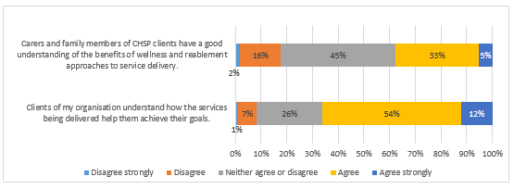

**Client scenario**

A 71-year-old client who lives alone was provided a referral for community transport, as she does not drive. The client’s care plan identified that she had anxiety and suffered from panic attacks that limited socialisation. A carer and a designated community transport driver (volunteer) was appointed for the client to build trust and rapport. The community transport driver was provided with information on how to deal with anxiety and panic attacks.

By the third trip, the client reported that she has increased confidence with accessing community transport, and she is happy that she has been able to independently access medical appointments and “look after herself” without a carer.   
  
The client has made enquiries about accessing community transport to visit old friends and re-connect with her community without the need of a carer.

**Challenges to embedding wellness and reablement approaches**

Service providers identified a number of barriers and challenges to implementing a wellness and reablement approach across the organisation. They included:

* Client’s, carer’s and family’s lack of understanding of wellness and reablement;
* Lack of translated material for CALD clients, their families and carers;
* Clients’ dependency on services and the adjustment to a wellness and reablement approach;
* Transient and under-trained volunteers in adopting wellness and reablement approach; and
* Difficulty working with wellness and reablement approaches with clients that have a debilitating and/or terminal condition.

Only 12 per cent of service providers reported a lack of alignment of certain service types with implementing a wellness and reablement approach – predominately transport, home maintenance and meals, as shown in Figure 2. Some service providers have reported more than one service type that does not align with a wellness and reablement approach.

Figure 2: Service types that do not align with a wellness and reablement approach

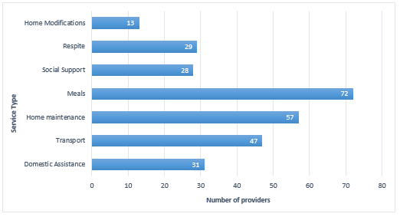

Other providers delivering the same service types focused on the value of ongoing service provision for the wellness of clients. For example:

* Meals: good nutrition leads to increased health and wellness, reduced illness and premature institutionalisation. Having regular meals enables clients to engage in their communities, feel connected and improve their quality of life thus encouraging clients to focus on making improvements (reablement).
* Transport: transport ensures clients have access to social and medical appointments, which enables them to feel connected and valued within their communities.
* Home maintenance: allows safety around the clients’ homes so that they can access their surroundings and live independently in and around their own homes.

**Provider scenarios**

1) All staff and volunteers have had training in wellness. Doing "with" rather than "for" people is well entrenched within work health and safety parameters.

2) Mobility is encouraged wherever possible. For example, one client started travelling on our bus and now uses public transport independently. A volunteer was initially allocated to the client to assist her in taking the bus to go shopping, with a focus on working on improving her familiarity with the trip and her confidence in doing so by herself. Emotional improvement was evident and some program participants have recovered enough to become volunteers.

3) When consulting with clients we find they are more self-confident when their opinions are valued and willing to make suggestions as to how to make programs more suitable for themselves. Staff as well as family members notice and praise their progress in appearance, mobility and behaviour - a chain of improvement, self-confidence, self-sufficiency and better quality of life follows.

# **Support requirements of providers**

Additional support for providers was a recurring theme in providers’ responses. Key suggestions from service providers included:

* Supporting material: there was broad support for resource materials for providers, volunteers, clients and carers in the form of case studies, practical examples, fact sheets, and guidelines on expectations with embedding wellness and reablement approaches.
* Training: some service providers highlighted that staff do not understand the difference between wellness and reablement in the service delivery context. Training for staff and volunteers was a common theme for the providers that indicated they required further support.
* Cohesion: service providers reported that information sharing between organisations and the Regional Assessment Service (RAS) could be improved and organisations would benefit from more cohesion around wellness and reablement approaches at the assessment stage. Furthermore, some service providers noted the relationship with the RAS could be improved. It was identified that it would help providers if RAS teams identified appropriate goals and wellness and reablement approaches in client support plans, so it can be better implemented in service delivery.

**Next steps**

A reablement focused assessment model is currently being trialled at various locations around Australia. The trials that began in March 2019 will be complemented by the development of a range of resources and supporting materials to assist service providers, senior Australians and their families and carers to better understand the benefits of wellness and reablement approaches to care.

This report will be shared with the consultants involved in conducting and evaluating the trials and developing supporting materials.

The outcomes of this report will also inform the design of the next annual wellness report due on 31 October 2019. This report will aim to assess performance and progress towards embedding wellness and reablement approaches in service delivery. The department intends to focus on continual improvement by way of effectiveness and efficiencies as an overarching objective.

**Attachment A - Provider profile and quantitative survey responses**

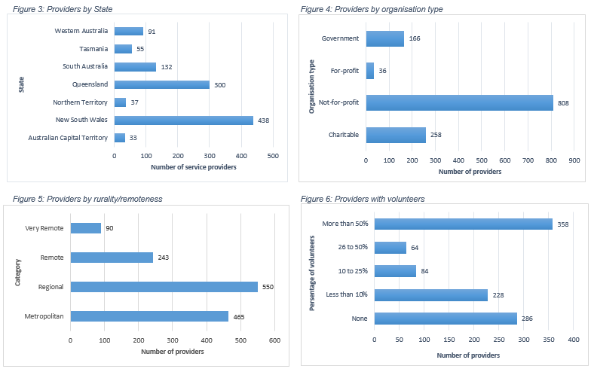

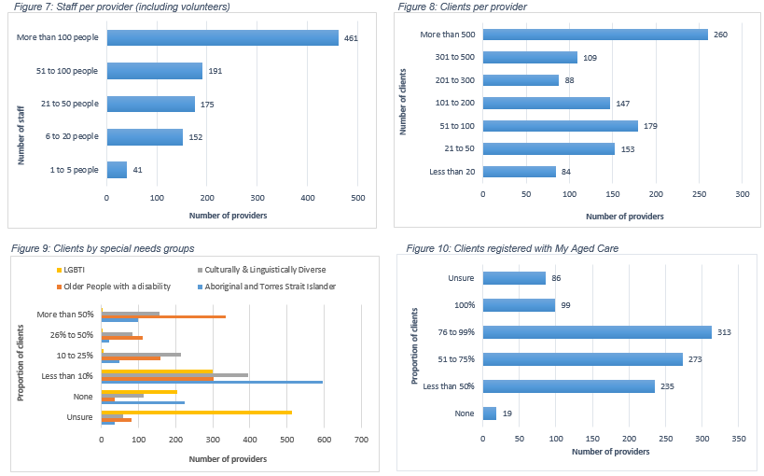

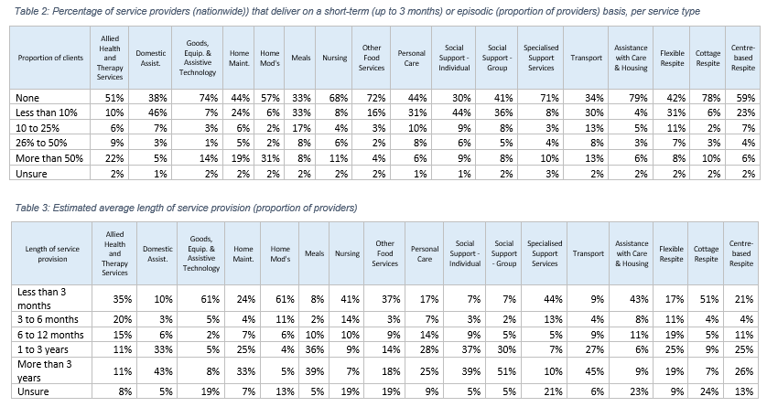

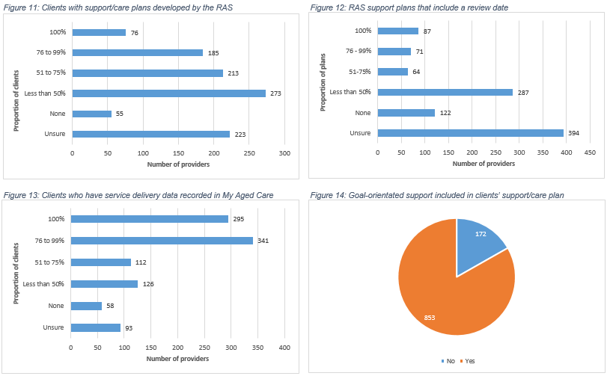 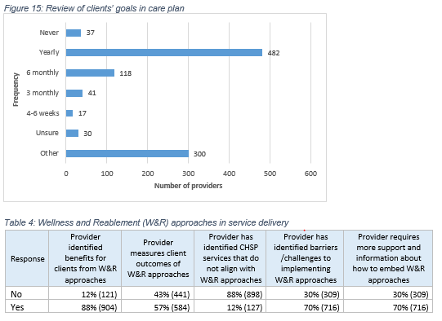

**Attachment B – Survey template**

Wellness and Reablement Report

Overview

The CHSP Wellness and Reablement Report will assist the Department of Health evaluate the implementation of wellness and reablement approaches in CHSP service delivery.

While it has been a requirement since July 2015, the department acknowledges that service providers are at different stages of implementing wellness and reablement approaches in their service delivery practices. In order to review progress towards embedding these approaches in service delivery, CHSP providers are required to submit an annual Wellness and Reablement Report to the department.

Further information about wellness and reablement approaches and CHSP funded service provider responsibilities can be found in Chapter 2 and Chapter 6 of the CHSP Program Manual.

**Submitting the report**  Mark boxes like thisThis shows an example of how a check box will appear throughout the survey with a ' This shows how a marked check box should appear throughout the survey ' by clicking on them (multiple selections are allowed).

Mark radio buttons like this This shows an example of how a radio button will appear throughout the survey by clicking on them (only one selection for each question/line).

Check that you have answered all the questions and submit the completed report to your Grant Agreement Manager.

Details of your organisation

1. Program Schedule ID (Located at the top of page 4 of your CHSP Grant Agreement)
2. Organisation Name
3. Which state/territory is your Grant Agreement Manager based?

This can be found in your CHSP Grant Agreement at Item F. Party representatives and address for notices.





1. Which of the following best describes your organisation? (Select all that apply)



1. How would you describe the location/s of your CHSP service delivery area?

(Select all that apply)



1. Which state/s or territories do you provide CHSP services in? (Select all that apply)

 



1. How many people work in your organisation (including volunteers)? (Select one option)



1. What proportion of your CHSP workforce are volunteers? (Select one option)

 

Your organisation’s CHSP services and clients

1. Approximately how many clients does your organisation provide CHSP services to? (Select one option)

    

1. What proportion of your CHSP clients fit within the following special needs groups?

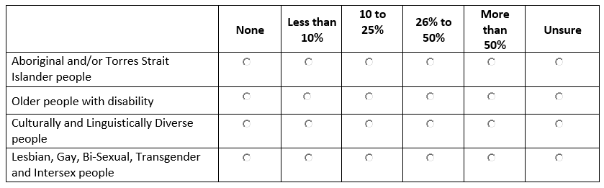(Select one option for each special needs group)

1. For each service type you are funded to deliver, what proportion of services are delivered on a short-term or episodic basis? Short-term is considered to be for a period of up to 3 months. (Select one option for each funded service type) 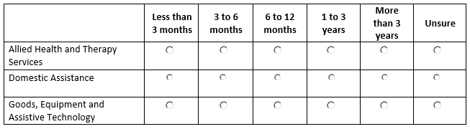

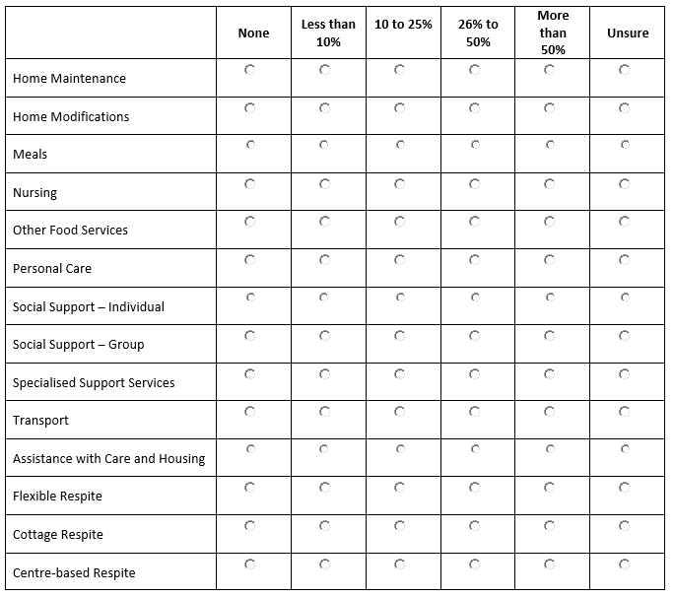

1. For each service type you are funded to deliver, what is the estimated average length of time of service provision? (Select one option for each funded service type)

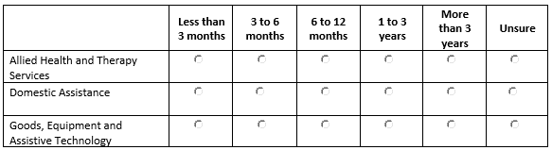

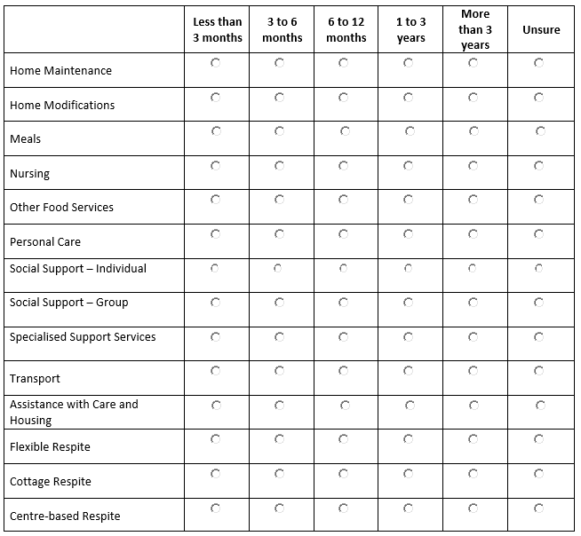

Client support plans and My Aged Care

1. What proportion of your CHSP clients are registered with My Aged Care? (Select one option)



1. What proportion of your CHSP clients have a support plan in place that was developed by the RAS?



1. What proportion of the RAS developed support plans include a review date? (Select one option)



1. For what proportion of your My Aged Care registered clients has your organisation's service delivery data been entered into My Aged Care (includes service commencement date, volume and frequency of services delivered and, if applicable, service cessation date)? (Select one option)



1. Is goal-orientated support included in your clients' care/service plan (developed by your organisation)?



1. How often does your organisation review clients' agreed goals within the care/service plans?

(Select one option)

    

Please explain your organisation's approach if none of the above time periods apply:

Wellness and reablement approaches in service delivery

1. How is your organisation embedding wellness approaches into service delivery? Please provide examples.

Note: If available, you may wish to attach de-identified case studies. The department may use case studies provided for education and training purposes (optional).

1. Has your organisation identified any benefits for your clients from implementing wellness and reablement approaches?



If yes, please provide examples (in less than 250 words)

1. Does your organisation measure consumer outcomes of wellness and reablement approaches?



If yes, please provide examples (in less than 250 words)

1. How much do you agree or disagree with the following statements?

(Select one option for each statement)

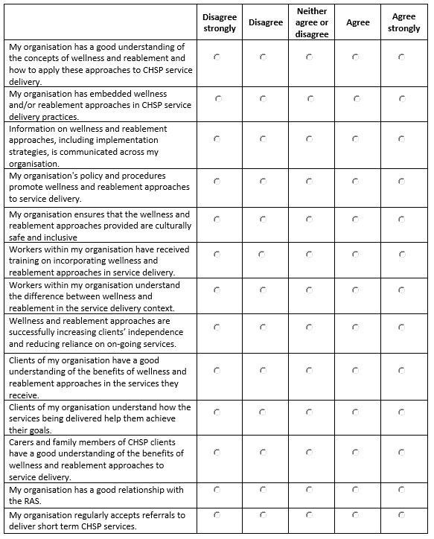

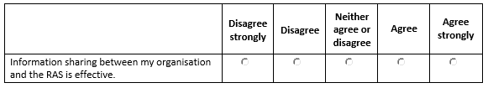

Challenges to embedding wellness and reablement approaches in CHSP

1. Do any CHSP services delivered by your organisation not align with wellness and reablement approaches?

(Select one option)



If yes, which services do not align with a wellness and reablement approach? and why?

(in less than 250 words)

1. Have you identified any barriers/challenges to implementing wellness and reablement approaches in your organisation's service delivery?



If yes, please explain below (in less than 250 words)

1. Do you require more support or information about how to embed wellness and reablement approaches into your CHSP service delivery practices?



If yes, what type of support do you require? (in less than 250 words)

Additional comments/attachments (optional)

Please provide any additional attachments or comments in the text box below (optional).

Declaration



Full Name:

Position/role (e.g. CEO, General Manager, Business Manager, etc.):

Contact Number:

Email Address: